

ELECTRICITY MARKET DEVELOPMENT REPORT 2017

This report is published within the scope of Official Statistics Program.

All the information, tables and figures provided in this report are reserved and cannot be used without reference.

REPUBLIC OF TURKEY
ENERGY MARKET REGULATORY AUTHORITY

Strategy Development Department

ANKARA, 2018

Important Notice:
- Licensees may revise their own data submitted before, through correction requests. Therefore, there may be some nonconformity between previous reports and present report published.
- In this report Turkish punctuation rules are adopted for numbers.

PRESIDENT’s MeSSAGE

After 2014, 2015 and 2016, which were striving for a number of regulations and other legislations that were put into effect in the framework of the Electricity Market Law numbered 6446, which entered into force in 2013, a significant process was made in 2017 on the light of these regulations as moving towards a more liberal, competitive, transparent and foreseeable structure on the market.
As known, players in the electricity market started to submit notifications related to market activities using electronic signature through the Energy Market Notification System at the beginning of 2015 and data obtained from the notification system was largely used in the preparation of market development reports. In coming years, we are planning to prepare the market development reports in a shorter period and more extensively with the collection of data in the notification system. Apart from our this aim within the scope of our annual report, the aim of publishing fundamental data in the electricity market in the form of monthly reports came into life by the publishment of monthly report of January 2016 and this practice has been carried on vigorously.
We give great importance to collect and analyze the data obtained from the notification system on time and in an accurate manner and to share it with all related parties and the public. In this sense, it is very important that notifications defined in the system are submitted in time and complete manner in order to ensure the integrity, consistency and reliability of the data contained in the report.
Once again, I would like to indicate that as EMRA we are open to all kind of constructive opinion and suggestion and I wish the Electricity Market Development Report of 2017 will be useful to all related parties, intitutions and organisations.

Mustafa YILMAZ
President

EXECUTIVE SUMMARY

- Installed Capacity and Peak Demand

  - Installed capacity in 2017 was 81.563,32 MW increasing by 5,16% compared to previous year.

  - In 2016-2017, licensed installed capacity according to resource type is given below:
Resource Type | 2016  (MW) | Share  (%) | 2017  (MW) | Share  (%) | Change  (%)  2016-2017
NATURAL GAS | 25.348,52 | 32,68 | 26.333,61 | 32,29 | 3,89
HYDRO DAM | 19.525,12 | 25,17 | 19.742,95 | 24,21 | 1,12
LIGNITE | 9.266,90 | 11,95 | 9.267,12 | 11,36 | 0,00
IMPORTED COAL | 7.616,35 | 9,82 | 8.936,35 | 10,96 | 17,33
RUN OF RIVER | 7.146,13 | 9,21 | 7.522,68 | 9,22 | 5,27
WIND | 5.735,90 | 7,40 | 6.488,12 | 7,95 | 13,11
GEOTHERMAL | 820,86 | 1,06 | 1.063,73 | 1,30 | 29,59
FUEL OIL | 755,49 | 0,97 | 712,27 | 0,87 | -5,72
HARD COAL | 559,57 | 0,72 | 616,15 | 0,76 | 10,11
BIOMASS | 362,98 | 0,47 | 449,72 | 0,55 | 23,90
ASPHALTITE COAL | 405,00 | 0,52 | 405,00 | 0,50 | 0,00
SOLAR | 12,90 | 0,02 | 17,90 | 0,02 | 38,76
NAPTHA | 4,74 | 0,01 | 4,74 | 0,01 | 0,00
LNG | 1,95 | 0,00 | 1,95 | 0,00 | 0,00
DIESEL | 1,04 | 0,00 | 1,04 | 0,00 | 0,00
Total | 77.563,44 | 100,00 | 81.563,32 | 100,00 | 5,16

  - The share of renewable energy sources (including hydraulic) within the installed capacity was 43,26% in 2017, while it was 43,32% in 2016. The ratio of total thermal installed capacity was 56,74% in 2017, while it was 56,68% in 2016.

  - Peak demand reached to 47.659,65 MW increasing by 6,54%.

- Licensed Generation and Consumption

  - Electricity generation reached to 292.574,58 GWh in 2017, increasing by 7,34% compared to 2016.

  - In 2016-2017, licensed installed capacity according to resource type is given below:

Resource Type | 2016  (MWh) | Share  (%) | 2017  (MWh) | Share  (%) | Change  (%)  2016-2017
NATURAL GAS | 88.244.574,12 | 32,38 | 108.771.841,89 | 37,18 | 23,26
IMPORTED COAL | 47.741.879,99 | 17,52 | 51.172.215,19 | 17,49 | 7,19
HYDRO DAM | 48.906.203,33 | 17,94 | 41.278.222,47 | 14,11 | -15,60
LIGNITE | 38.543.567,01 | 14,14 | 40.545.711,72 | 13,86 | 5,19
WIND | 15.501.030,56 | 5,69 | 17.859.858,19 | 6,10 | 15,22
RUN OF RIVER | 18.396.857,05 | 6,75 | 17.130.234,37 | 5,85 | -6,88
GEOTHERMAL | 4.818.523,69 | 1,77 | 5.969.481,97 | 2,04 | 23,89
HARD COAL | 3.292.613,86 | 1,21 | 3.453.865,10 | 1,18 | 4,90
ASPHALTITE COAL | 2.873.837,86 | 1,05 | 2.394.637,82 | 0,82 | -16,67
BIOMASS | 1.590.695,39 | 0,58 | 2.005.069,82 | 0,69 | 26,05
DIESEL | 1.554.168,77 | 0,57 | 1.008.826,40 | 0,34 | -35,09
FUEL OIL | 1.054.049,86 | 0,39 | 957.859,46 | 0,33 | -9,13
SOLAR | 2.636,79 | 0,00 | 24.557,68 | 0,01 | 831,35
LNG | 42.988,21 | 0,02 | 2.196,00 | 0,00 | -94,89
Total | 272.563.626,49 | 100,00 | 292.574.578,09 | 100,00 | 7,34

  - The share of renewable energy sources (including hydraulic) within the installed capacity was 28,80% in 2017, while it was 32,73% in 2016. The ratio of total thermal installed capacity was 71,20% in 2017, while it was 67,27% in 2016.

  - The amount of consumption reached to 292.003,54 GWh in 2017 which increased by 5,22% compared to 2016.

- Unlicensed Generation

  - In 2017, unlicensed installed capacity reached to 3.173,32 MW increasing by 202,74 % compared to previous year. 93,87% of this amount was obtained from solar (photovoltaic) energy.

  - In 2016-2017, unlicensed installed capacity according to resource type is given below:

Resource Type | 2016 |  | 2017
Resource Type | Installed Capacity  (MWe) | Share  (%) | Installed Capacity  (MWe) | Share  (%)
Solar (Photovoltaic) | 939,19 | 89,60 | 2.978,84 | 93,87
Natural Gas | 51,85 | 4,95 | 85,88 | 2,71
Biomass | 36,42 | 3,47 | 66,72 | 2,10
Wind | 13,75 | 1,31 | 32,20 | 1,01
Hydraulic | 5,78 | 0,55 | 8,69 | 0,27
Solar  (Concentrated) | 1,22 | 0,12 | 1,00 | 0,03
Total | 1.048,21 | 100,00 | 3.173,32 | 100,00

  - In 2017, amount of unlicensed generation reached to 3.031,50 GWh increasing by 166,42 % compared to previous year. 93,57% of this amount was obtained from solar (photovoltaic) energy.

  - In 2016-2017, unlicensed generation according to resource type is given below:

Resource Type | 2016 |  | 2017
Resource Type | The amount of energy given to the system as surplus (MWh) | Share  (%) | The amount of energy given to the system as surplus (MWh) | Share (%)
Solar (Photovoltaic) | 1.031.358,00 | 90,64 | 2.836.553,09 | 93,57
Biomass | 92.129,90 | 8,10 | 138.657,08 | 4,57
Wind | 8.268,44 | 0,73 | 36.801,92 | 1,21
Hydraulic | 6.115,42 | 0,54 | 19.434,29 | 0,64
Natural Gas | 0,00 | 0,00 | 111,67 | 0,00
Total | 1.137.871,75 | 100,00 | 3.031.558,05 | 100,00

- Invoiced Consumption

Consumer Type | Consumption Amount of Consumers Connected to the Distribution Voltage Level (MWh) |  | Consumption Amount of Consumers Connected to Transmission Voltage Level (MWh |  | Total (MWh)
 | 2016 | 2017 | 2016 | 2017 | 2016 | 2017
Non-eligible Consumer | 74.556.571,56 | 80.768.336,36 | 6.543.398,54 | 19.685.372,29 | 81.099.970,10 | 100.453.708,65
Eligible Consumer | 87.991.038,42 | 90.762.663,09 | 43.237.757,91 | 34.497.156,39 | 131.228.796,33 | 125.259.819,48
Grand Total | 162.547.609,98 | 171.530.999,45 | 49.781.156,45 | 54.182.528,68 | 212.328.766,43 | 225.713.528,13

  - In 2017, invoiced electricity consumption reached to 225,71 TWh increasing by 6,30 % compared to previous year. 54,18 TWh of this amount was sold to consumers connected to the transmission voltage level and the remaining 171,53 TWh was sold to consumers connected to the distribution voltage level.

  - In addition, 125,26 TWh of the total amount was consumed by eligible consumers, while the rest 100,45 TWh was consumed by non-eligible consumers.

- Imports and Exports

  - In 2017, electricity imports decreased by 57,36% to 2,73 TWh compared to previous year.

  - Electricity exports increased by 128,84% to 3,30 TWh.

- Day-Ahead Market and Balancing Market

  - In 2017, the Weighted Average Market Clearing Price (MCP) increased by 13,35% to 168,12 TL/MWh compared to previous year.

  - The highest MCP value was 967,15 TL/MWh (14:00 on 11 September 2017), while the lowest MCP value was 1,04 TL/MWh with the date of 01 January 2017.

  - In 2017, the Average System Marginal Price (SMP) increased by 17,87% to 164,78 TL/MWh compared to 2016.

  - The highest SMP was 400,00 TL/MWh (14:00 on 11 September 2017) while the lowest SMP value 0 TL/MWh for five hours.

  - In 2017, due to the orders in the Balancing Power Market, an additional cost of 884,16 million TL was occurred in the electricity market.

- RES Support Mechanism

  - In 2017, the number of licensed participants benefiting from the Renewable Energy Resources Support Mechanism reached to 647. The installed capacity of these participants was 17.400 MW.

  - The electricity generation of RES Support Mechanism participants TWh increasing by 10,18 % to 50,5 TWh compared to 2016. 48,35% of this amount was obtained from hydraulic, 33,20% from wind.

  - In 2017, the average price of RES Support Mechanism reached to 274,7 TL/MWh increased by 16,59% compared to previous year.

  - In 2017, an additional cost of RES Support Mechanism which means additional cost to the weighted average MCP for RES Support Mechanism per invoiced unit energy amount, increased by 26,62% to 23,84 TL/ MWh compared to previous year.

- Market Openness

  - In 2017, the eligible consumer limit was set at 2.400 kWh and the theoretical market openness rate for demand side was calculated as 90%.

  - Eligible consumers’ consumption in 2017 was 125,26 TWh. In 2016, actual market openness was 61,8% while this proportion decreased to 55,5% in 2017.

  - By the end of 2017, the number of eligible consumers reached 4 million 579 thousands. This number corresponds to 10,77 % of the total number of consumers.

- Transmission

- By the end of 2017, there were 1.234 transformer centers in the transmission system and 2.164 transformers with 193.961 MVA capacity.

- By the end of 2017, the length of transmission lines was 66.285 km.

- In 2017, total investment of the transmission company was 2,6 billion TL.
  - In 2017, the transmission loss rate was 2,09 %.

- Distribution

  - By the end of 2017, the number of consumers using the distribution system was 42,51 million. The regions with the highest number of consumers were the Boğaziçi with 5.04 million and the Başkent with 4.21 million.

  - By the end of 2017, the total invoiced consumption in the distribution regions was realized as 171,53 TWh. The regions with the highest consumption amounts were the Boğaziçi with 24,84 TWh and the Toroslar with 15,23 TWh.

  - The highest loss rates were seen in Dicle with 64,82 %, Vangölü with 24,55 % and Aras with 25,68 %.

  - The lowest loss rates were seen in the distribution regions of Trakya with 5,09%, ADM with 5,26%, and Uludağ with 4,14 %.

  - By the end of 2017, 55.199 people were employed in the electricity distribution sector. Of those, 16.100 were employed as permanent staff in distribution companies and 39.099 were employed as subcontractor company personnel.

- By the end of 2017, there were 450.827 transformers in the distribution system with 154.319 MVA power.

- By the end of 2017, the length of distribution lines was 1.128.550. 935.522 km of this number was overhead lines and 193.028 km was underground lines.

- In 2017, the distribution companies invested 5,93 billion TL in current prices. The highest investment expenditure was realized in the regions of Toroslar with 703,67 million TL and the Başkent with 606,59 million TL.

ELECTRICITY MARKET OVERVIEW IN 2017
Parameters | Unit | 2016 Figures | 2017 Figures | Change (%)
Licensed Installed Capacity* | MWe | 77.563,44 | 81.563,32 | 5,16
Licensed Generation* | MWh | 272.563.626,49 | 292.574.578,09 | 7,34
Highest Peak Demand | MW | 44.734 | 47.660 | 6,54
Lowest Peak Demand | MW | 17.448 | 18.336 | 5,09
Unlicensed Generation** | MWh | 1.137.871,75 | 3.031.558,05 | 166,42
Unlicensed Installed Capacity | MWe | 1.048,21 | 3.173,32 | 202,74
RES Support Mechanism Generation*** | MWh | 45.830.502,47 | 50.530.722,34 | 10,26
RES Support Mechanism Amount of Payment | TL | 10.796.370.753,89 | 13.869.601.064,94 | 28,47
Average RES Support Mechanism Price | TL/MWh | 235,57 | 274,66 | 16,59
RES Support Mechanism Additional Cost **** | TL/MWh | 18,82 | 23,84 | 26,67
Actual Consumption | MWh | 277.522.012,26 | 292.003.542,76 | 5,22
Invoice-based Consumption | MWh | 212.328.766,43 | 225.713.528,13 | 6,30
Number of Consumer | Number | 41.030.690 | 42.514.836 | 3,62
Import | MWh | 6.400.129,12 | 2.729.060,87 | -57,36
Export | MWh | 1.442.081,65 | 3.300.096,20 | 128,84
Weighted Average MCP***** | TL/MWh | 148,32 | 168,12 | 13,35
Weighted Average SMP****** | TL/MWh | 139,80 | 164,78 | 17,87

*Licensed Generation: Includes the installed capacity and generation values of Independent Generation Companies, Build-Operate, Transfer of Operating Rights and Build-Operate-Transfer Power Plants.

**Unlicensed Generation: Generation in accordance with Article 14 of the Electricity Market Law No. 6446, that is granted to the system as a surplus by those who are exempted from the obligation to obtain license and establish a company.

*** RES Support Mechanism generation includes unlicensed generation values.

**** RES Support Mechanism additional cost: Additional cost to the weighted average MCP for RES Support Mechanism per invoiced unit energy amount
*****MCP: Market Clearing Price
******SMP: System Marginal Price
TABLE OF CONTENTS

1. LICENSED GENERATION AND INSTALLED CAPACITY, UNLICENSED GENERATION, CONSUMPTION, IMPORT AND EXPORT 17
1.1 Overview 17
1.2 Licensed Generation 18
1.3 Licensed Installed Capacity 26
1.4 Unlicensed Generation 31
1.5 Invoiced Electricity Consumption 39
1.6 Import and Export 47
2. WHOLESALE MARKET 49
1.1 Day-Ahead Market 49
2.2 Balancing Power Market 55
2.3 Intra-Day Market 61
2.4 Bilateral Agreements 63
2.5 RES Support Mechanism 66
3. COMPETITION 72
3.1 Supply Side 72
3.2 Demand Side 77
4. TRANSMISSION 84
4.1 Transmission System 84
4.2 Transmission System Connection Applications 86
4.3 Tariffs 86
4.4 Amount of Investment 88
4.5 Losses 89
5. DISTRIBUTION 90
5.1 Number of Consumers 90
5.2 Ratio of Losses 91
5.3 Employment 93
5.4 Information about Network 94
5.5 Quality Indicators 100
5. Investment Amount of Distribution Companies 104
5.7 Information about Organized Industrial Zones (OIZ) 107
6. PRICING 108

LIST OF TABLES

Table.1.1: Licensed and Unlicensed Installed Capacity, Peak Demand, Licensed and Unlicensed Electricity Generation, Consumption, Import and Export Data 17
Table.1.2: Distribution of Licensed Electricty Generation by Provinces(MWh-%) 24
Table 1.3 Distribution of Licensed Installed Capacity by Provinces (MW-%) 29
Table 1.4: The Status of Unlicensed Electricity Generation Applications by the End of 2017 (MW) 31
Table 1.5: Distribution of Unlicensed Installed Capacity by Sources (MW-%) 32
Table 1.6: Distribution of Unlicensed Installed Capacity by Province (MW- %) 33
Table 1.7: Distribution of Unlicensed Electricity Generation by Sources (MWh-%) 35
Table 1.8: Distribution of Unlicensed Electricity Generation by Provinces (MWh-%) 36
Table 1.9: Distribution of the Amount of Payment Made Within the Scope of Unlicensed Electricity Generation by Sources (TL-%) 38
Table 1.10: Sales to Eligible and Non-Eligible Consumers in 2017 (MWh) 39
Table 1.11: Distribution of Invoiced Consumption by Distribution Regions in 2017 (MWh-%) 40
Table 1.12: Distribution of Invoiced Consumption by Consumer Type as Eligible and Non-Eligible Consumers in 2017 (MWh) 41
Table 1.13: Distribution of Invoiced Consumption by Province (MWh - %) 41
Table 1.14: Distribution of Invoiced Consumption by Province and Consumer Type (MWh) 44
Table.2.2.1: Additional Costs of Orders (Million TL) 59
Table 2.5.1: Number of RES Support Mechanism Participants by Years 66
Table 2.5.2: Installed Capacity of the RES Support Mechanism Participants by Years (MW) * 67
Table 2.5.3: Yearly Generation of RES Support Mechanism Participants by years (MWh)* 68
Table 3.1: HHI Values by Generation and Capacity 73
Table 3.2: Sales, Market Shares and HHI Values of Supply License Owners 74
Table 3.3: The Monthly Distribution Number of Eligible Consumers Switching Their Supplier Based on Province 81
Table 3.4: Distribution of Eligible Consumers’ Switches by Supplier Type 83
Table 4.1: Transformer Center Information 84
Table 4.2: TEİAŞ Transmission Lines 85
Table 4.3: Connection Applications to the Transmission System (Number-MW) 86
Table 4.4: System Usage and System Operation Tariffs (TL/MW-Year) 87
Table 4.5: Comparison of 2016 and 2017 Investment Amount (TL-%) 88
Table 5.1: Number of Consumers Using Distribution System by the end of 2017 (Number-%) 90
Table 5.2: Loss Rates of Distribution Companies (%) 91
Table 5.3: Number of Employees of Distribution Companies (Number) 93
Table 5.4: Line Lengths, Number of Transformers and Transformer Capacities Based on Distribution Companies by end of 2017 (Km-MVA-Number) 95
Tablo 5.5: The Lengths of Distribution Lines (Km) 96
Table 5.6: Line Lengths at Distribution Voltage Levels, Number of Transformers and Transformer Capacities by Provinces in 2017 (Km-MVA-Number) 98
Table 5.7: Reported and Unreported Customer Average Interruption Duration Indices of Distribution Companies in 2017 (min) 100
Table 5.8: Customer Average Interruption Duration Indices of Distribution Companies by reason in 2017 (min) 101
Table 5.9: Customer Average Interruption Frequency Indices of Distribution Companies in 2016 and 2017(Number/Year) 102
Table 5.10: Distribution Companies’ Customer Average Interruption Frequency Indices of Distribution Companies by Reason in 2017 (Number/Year) 103
Table 5.11: List of Distribution Investments in 2011 and 2017 and Comparison by 2016-2017 (TL-%) 104
Tablo 5.12: Investment Amounts of Distribution Companies in 2017 (Current Prices-million TL) 105
Tablo 5.13: Realized Investment Amounts by Investment Type in 2017 (TL) 106
Tablo 5.14: Information About Organized Industrial Zones 107

LIST OF FIGURES

Figure 1.1: Electric Energy Demand and Rate of Increase by Years (GWh-%) 18
Figure.1.2: Peak Demand and Rate of Increase by Years (MW-%) 19
Figure 1.3: Rate of Increase of Demand and Peak Demand by Year (%) 19
Figure 1.4: Monthly Distribution of Licensed Electricity Generation and Consumption in 2017 (GWh) 20
Figure 1.5: Distribution of Licensed Electricity Generation in 2017 by Corporations (%) 20
Figure 1.6: The Change of Licensed Electricity Generation as Public-Private by Years (%) 21
Figure 1.7: The Distribution of Licensed Electricity Generation by Sources in 2017 (%) 22
Figure 1.8: Source-Based Development of Licensed Electricity Generation by Years (GWh) 22
Figure 1.9: Daily Licensed Electricity Generation in 2017 (MWh) 23
Figure 1.10: Hour-Based Electricity Generation in 2017 (MWh)) 23
Figure 1.11: The Share of First 10 Companies within Electricity Generation in 2017 (%) 25
Figure 1.12: Distribution of Licensed Installed Capacity by Sources at the End of 2017 (%) 26
Figure 1.13: Distribution of Licensed Installed Capacity by Organizations at the End of 2017 (%) 27
Figure 1.14: Distribution of Activated and Deactivated Power Plants’ Installed Capacity in 2017 by Sources 27
Figure 1.15: The Development of Licensed Installed Capacity According to Source by Years (MW) 28
Figure 1.16: The Development of the Share of the Sources within the Installed Capacity by Years (%) 28
Figure 1.17: The Share of the First 10 Companies in Installed Capacity at the End of 2017 (%) 30
Figure 1.18: Distribution of Unlicensed Installed Capacity by Sources at the End of 2017 (%) 32
Figure 1.19: Distribution of Unlicensed Electricity Generation by Sources in 2017 (%) 36
Figure 1.20: Distribution of Invoiced Consumption by Consumer Type in 2017 (%) 41
Figure 1.21: Distribution of Invoiced Consumption by Months (MWh) 46
Figure 1.22: Development of Gross Consumption by Years (GWh) 47
Figure 1.23: Electricity Imports in 2017 by Months (MWh) 48
Figure 1.24: Electricity Exports in 2017 by Months (MWh) 48
Figure.2.1.1: Hourly Development of Weighted Average Market Clearing Price in 2017 (TL/MWh) 51
Figure 2.1.2: Organized Weighted Average MCP in 2017 (TL/MWh) 51
Figure 2.1.3: Weighted Average MCP by Years (TL/MWh) 52
Figure 2.1.4: Monthly Weighted Average MCP of the Last Two Years (TL/MWh) 53
Figure 2.1.5: Monthly Day-Ahead Market Trading Volume (MWh) 53
Figure 2.1.6: The Share of Top 10 Buyer Companies in Day-Ahead Market (%) 54
Figure 2.1.7: The Share of Top 10 Seller Companies in Balancing Power Market (%) 54
Figure.2.2.1: Per-Hour Based Development of System Marginal Price (TL/MWh) 55
Figure 2.2.2: Organized Sytem Marginal Price (TL/MWh) 55
Figure 2.2.3: Monthly Weighted Average Prices of the Last Two Years in Balancing Power Market (TL/MWh) 56
Figure 2.2.4: Monthly Trading Volumes in Balancing Power Market (MWh) 56
Figure 2.2.5: The Share of Top 10 Buyer Companies in Balancing Power Market (%) 57
Figure 2.2.6: The Share of Top 10 Seller Companies in Balancing Power Market 57
Figure 2.2.7: Rates of Order Volumes Given in Balancing Power Market in 2017 (%) 58
Figure 2.2.8: Distribution of the Orders Given in the Balancing Power Market by Hours in 2017 (MW) 58
Figure 2.2.9: Development of Additional Costs of Orders by Months in 2017 (Million TL) 59
Figure 2.2.10: Development of Zero Balance Adjustment Component by Years (TL) 60
Figure 2.3.1: Monthly Development of Trading Volume and Average Price in the Intra-Day Market (MWh - TL / MWh) 61
Figure 2.3.2: Distribution of Purchases of Intra-Day Market by Companies and the Share of Top 10 Companies (%) 62
Figure 2.3.3: Distribution of Sales in Intra-Day Market by Companies and the Share of Top 10 Companies (%) 62
Figure 2.4.1: Monthly Bilateral Agreement Volume by Years (MWh) 63
Figure 2.4.2: Distribution of Purchases of Bilateral Agreement by Companies and the Share of Top 10 Companies (%) 64
Figure 2.4.3: Distribution of Sales with Bilateral Agreement by Companies and the Share of Top 10 Companies (%) 64
Figure 2.4.4: TETAŞ Wholesale Prices Between 2010-2017 (kr / kWh) 65
Figure 2.5.1: Distribution of Installed Capacity by Sources in 2017 (%) 67
Figure 2.5.2: Distribution of Generation in RES Support Mechanism by Sources in 2017 68
Figure 2.5.3: Monthly Development of RES Support Mechanism Generation in 2017 (MWh) 69
Figure 2.5.4: Monthly Development of RES Support Mechanism Feed-in Tariffs and MCP in 2017 (MWh) 69
Figure 2.5.5: Average of RES Support Mechanism and MCP in 2017 (Kr./kWh) 70
Figure 2.5.6: Monthly Payments Made within the Scope of the RES Support Mechanism in 2017 (TL) 70
Figure 2.5.7 Monthly Improvement of Average RES Support Mechanism Additional Cost in 2017 (TL/MWh) 71
Figure 3.1: Eligible Consumer Limit and Market Openness Ratio by Years (kWh-%) 78
Figure 3.2: Number of Eligible Consumer by Months in 2017 (Number) 78
Figure 3.3: Distribution of Eligible Consumers by Distribution Regions by end of 2017 (Number) 79
Figure 3.4: Distribution of Eligible Consumer Consumption by Suppliers Type (%) 80
Figure 3.5: Monthly Changes in Number and Consumptions of Eligible Consumers Switching Their Supplier (Number-MWh) 80
Figure 4.1: Changes in TEİAŞ Transmission Line Lengths by Years (km) 85
Figure 4.2: System Usage and System Operation Tariffs (TL/MW-Year) 88
Figure 4.3: Transmission System Losses (GWh-%) 89
Figure 5.1: Number and Consumption of Consumers (Number- MWh) 91
Figure 5.2: Real and Target Loss Rates in 2017 (%) 92
Figure 5.3: Number of Employees of Distribution Companies by Year 2017 (Number) 94
Figure 5.4: Line Lengths and Transformer Capacities on the Basis of 96
Distribution Companies at the end of 2017 (Km-MVA) 96
Figure 5.5: The Length of Lines on the Basis of Distribution Companies at the end of 2017(Km) 97
Figure 5.6: Investment Amounts of Distribution Companies in 2017 (Current Prices-million TL) 106
Figure 6.1: Change in Retail Electric Energy Prices in the Last Five Years (Kr/kWh) 108
Figure 6.2: Change in Network Costs (Distribution, Transmission and Loss) by Years (Kr / kWh) 109
Figure 6.3: Change in Electricity Tariffs before Taxes and Funds by Years (kr / kWh) 109
Figure 6.4: Share of Items on Residence Electricity Invoice in 2017 (%) 110
Figure 6.5: Share of Items on Industry Electricity Invoice in 2017 (%) 110

ABBREVIATIONS

BPM : Balancing Power Market
EMRA : Energy Market Regulatory Authority
EXIST : Energy Exchange Istanbul
EÜAŞ : Electricity Generation Company
IDM : Intra-Day Market
DAM : Day-Ahead Market
MCP : Market Clearing Price (Day-Ahead Price)
MFSC : Market Financial Settlement Center
SMP : System Marginal Price (Real Time Price)
BO : Build Operate
BOT : Build Operate Transfer
TOR : Transfer of Operating Rights
TEİAŞ : Turkish Electricity Transmission Company
TETAŞ : Turkish Electricity Trading and Contracting Company
RES Support Mechanism : Renewable Energy Sources Support Mechanism

- LICENSED GENERATION AND INSTALLED CAPACITY, UNLICENSED GENERATION, CONSUMPTION, IMPORT AND EXPORT

This section shall examine, licensed electricity generation and installed capacity, unlicensed electricity generation, consumption, export and import data for the year 2017. In addition, interpretations and comparisons shall be expressed according to the previous years.

1.1 Overview

Table 1.1 shows licensed and unlicensed installed capacity, peak demand, licensed and unlicensed electricity generation, consumption, import and export data by the end of 2017, combined with previous years’ data.

Table.1.1: Licensed and Unlicensed Installed Capacity, Peak Demand, Licensed and Unlicensed Electricity Generation, Consumption, Import and Export Data
 | Unit | 2014 | 2015 | 2016 | Change (%) 2015→2016 | 2017 | Change (%) 2016→2017
Licensed Installed Capacity | MW | 69.520 | 73.146,90 | 77.563,44 | 6,04 | 81.563,32 | 5,16
Unlicensed Installed Capacity | MW | 29,99 | 359,04 | 1.048,21 | 191,95 | 3.173,32 | 202,74
Peak Demand | MW | 41.003 | 43.289,00 | 44.733,98 | 3,34 | 47.659,65 | 6,54
Licensed Generation | GWh | 251.962 | 261.783,30 | 272.563,63 | 4,12 | 292.574,58 | 7,34
Unlicensed Generation | GWh | 3,92 | 222,72 | 1.137,87 | 410,89 | 3.031,56 | 166,42
Consumption | GWh | 257.220 | 265.724,40 | 277.522,01 | 4,44 | 292.003,54 | 5,22
Import | GWh | 7.953 | 7.411,10 | 6.400,13 | -13,64 | 2.729,06 | -57,36
Export | GWh | 2.696 | 2.964,60 | 1.442,08 | -51,36 | 3.300,10 | 128,84

As can be seen from the Table, consumption and licensed generation in 2017 increased by 5,22 % and 7,34 % respectively and peak demand and licensed installed capacity increased by 6,54 % and 5,16 % respectively compared to 2016. Unlicensed installed capacity and unlicensed electricity generation had been growing rapidly by %202,74 and %166,42 sequentially.

Compared to the previous year, imports decreased 57,36 % which ended up as 2,73 TWh. On the other hand, exports ended up as 3,30 TWh by increasing 128,84 %. The ratio between exports and imports was 22,53 % in 2016 whereas in 2017 it increased to 120,92%.

1.2 Licensed Generation

Figure 1.1 shows the electricity demand and rate of its increase by years. As seen in the figure, demand for electric energy had increased steadily since 2009, with a decrease especially in the rate of increase from 2011 to 2013. In 2017, the greatest increase in the last 5 years was realized with 5,22 %.

Figure 1.1: Electric Energy Demand and Rate of Increase by Years (GWh-%)
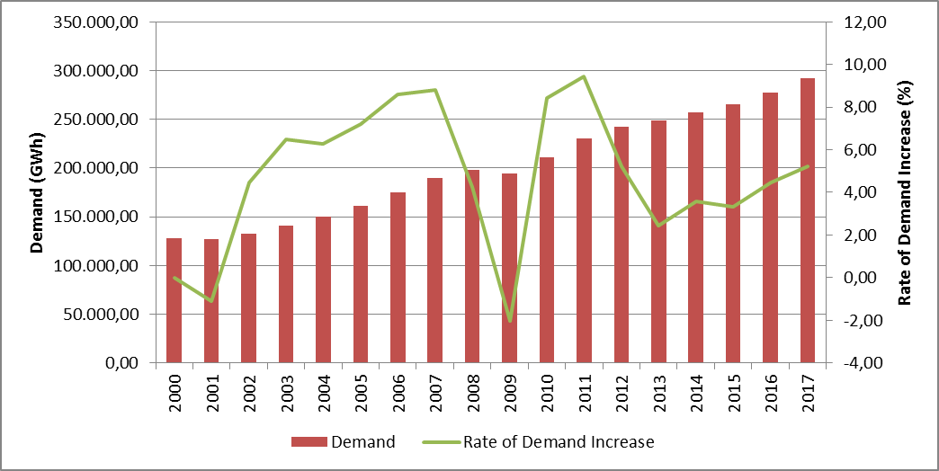

The development of peak demand and its rate of increase are provided in Figure 1.2. The change of peak demand is generally seen as it is in energy demand Figure 1.1, but it is more variable. In year 2017, the increment of peak demand can be seen as 6,54 %.

Figure.1.2: Peak Demand and Rate of Increase by Years (MW-%)
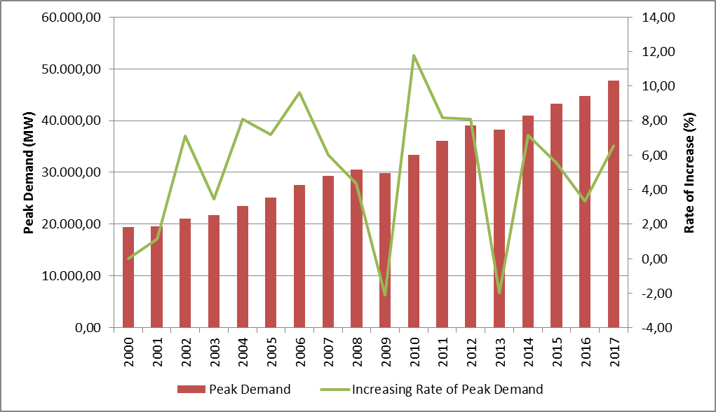

In Figure 1.3, peak demand and its relations with electric energy demand are given. As can be seen from the Figure 1.2, the rate of increase/decrease of electric energy demand and peak demand were happened to be close to each other.

Figure 1.3: Rate of Increase of Demand and Peak Demand by Year (%)
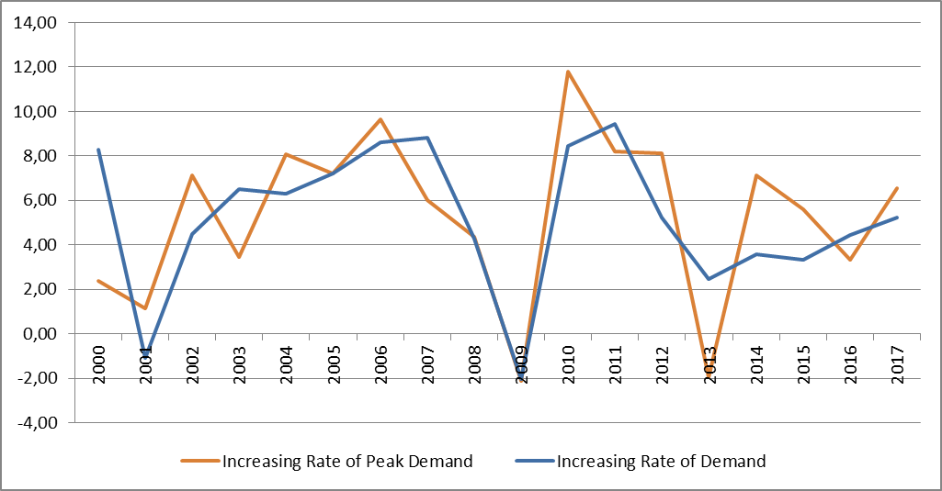
In Figure 1.4, monthly changes of licensed electricity generation and electric consumption are represented. The highest points of generation and consumption were achieved in July.

Figure 1.4: Monthly Distribution of Licensed Electricity Generation and Consumption in 2017 (GWh)
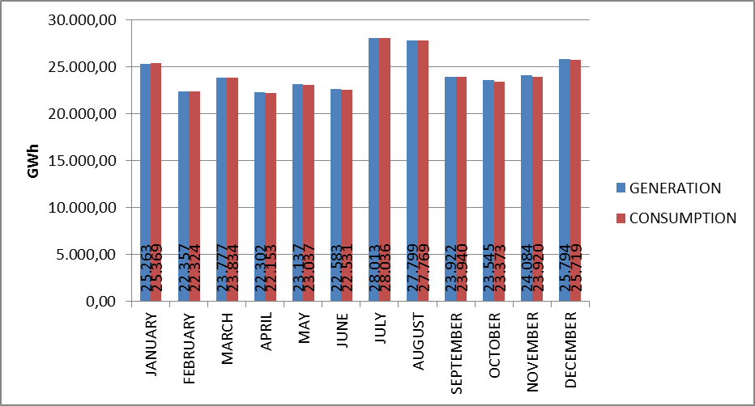
The distribution of licensed electricity generation to companies in 2017 is shown in Figure 1.5. The biggest share in generation belongs to independent power producers with 65,68 %. The share of the power plants of EÜAŞ was 16,10 % and the power plants that were operated under the existing contracts had the share of 18,22 % in the total generation.

Figure 1.5: Distribution of Licensed Electricity Generation in 2017 by Corporations (%)
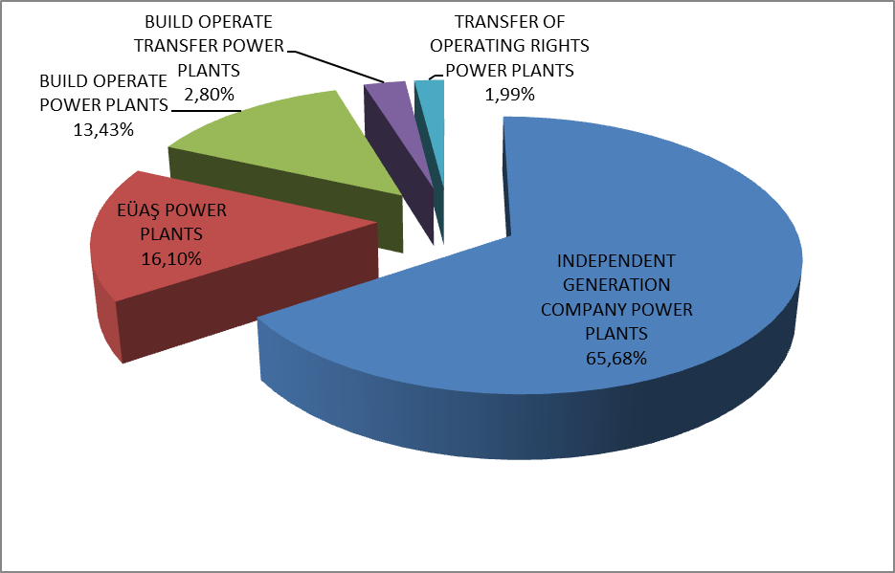
The distribution of licensed electricity generation under private, public and existing contracts are given in Figure 1.6. In 2016 the share of public in generation (including existing contracts) was 38.52%, whereas in 2017 it decreased to 34.32 %. Similarly, in 2016 the share of independent generation was 61.48 % which in 2017 increased to 65.68 %.

Figure 1.6: The Change of Licensed Electricity Generation as Public-Private by Years (%)
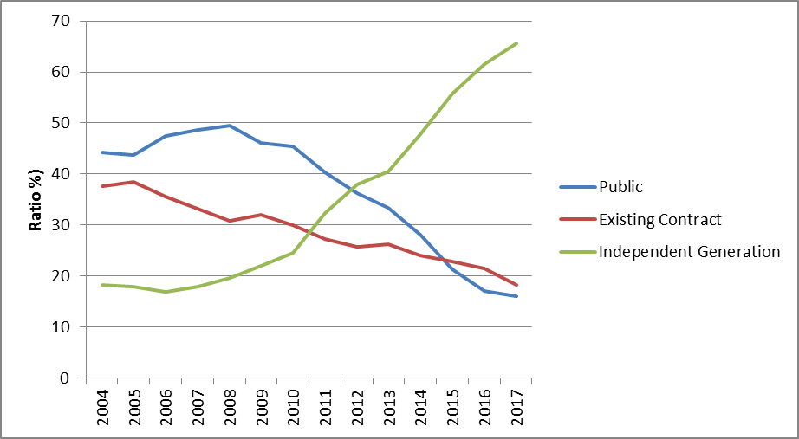

Figure 1.6 reflects the fact that the share of independent generation was still increasing. There are two reasons behind this increment. Firstly, most of the new investments were done by independent power producers. Secondly, due to privatization, the ownership of the existing public power plants was going under private sector.
The distribution of licensed electricity generation by resources is shown in Figure 1.7. The share of natural gas-fired power plants in licensed electricty generation was 32.16 % in 2016 which in 2017 increased to 37,18 %, in wind power plants from 5,69% to 6,10 %, in geothermal power plants from 1,77 % to 2,04 %. For the hydroelectric power plants, the share was 24,69% which decreased to 19,96 % in 2017. On the other hand, the share of domestic coal (lignite, hard coal and asphaltite) power plants was 19,78 % in 2016, which decreased to 15,86%, in imported coal power plants from 17,52 % to 17,49%.

Figure 1.7: The Distribution of Licensed Electricity Generation by Sources in 2017 (%)
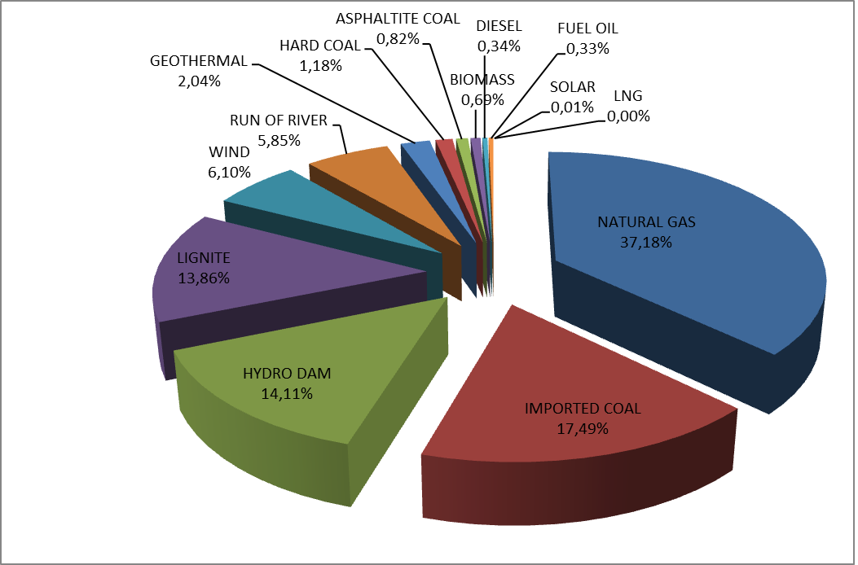

The development of licensed electricity generation on the basis of resources since 1990 is shown in Figure 1.8. As can be seen from the figure, the share in electricity generation of resources like geothermal, wind, solar and biomass had increased every year.

Figure 1.8: Source-Based Development of Licensed Electricity Generation by Years (GWh)
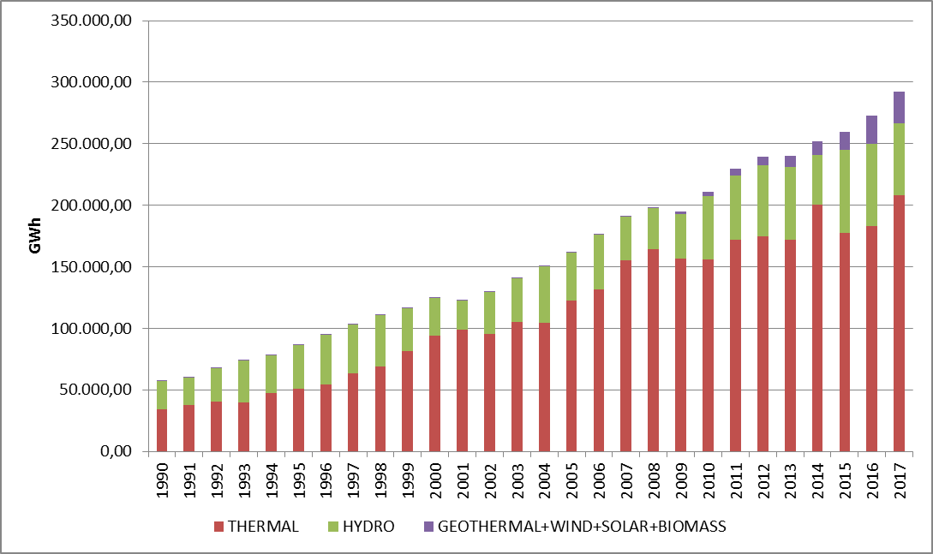
Day-based development of licensed electricity generation in Turkey is shown in Figure 1.9. Licensed electricity generation was at its highest point in July and lowest in June. Considering day-based chart, the highest electricity generation occurred on 26 July 2017, lowest on 25 June 2017.

Figure 1.9: Daily Licensed Electricity Generation in 2017 (MWh)
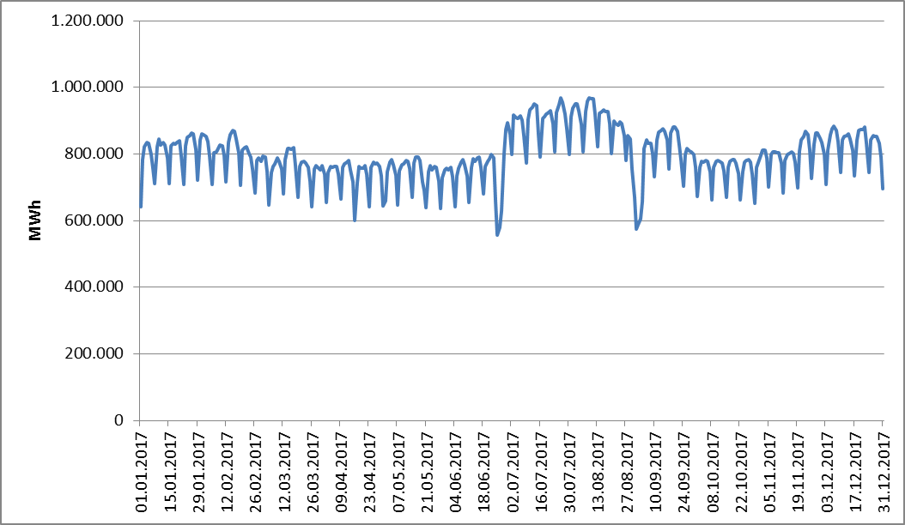
Hour-based licensed electricity generation in Turkey is shown at Figure 1.10. The highest generation was at 11:00 o’clock and the lowest was at 05:00 o’clock.

Figure 1.10: Hour-Based Electricity Generation in 2017 (MWh))
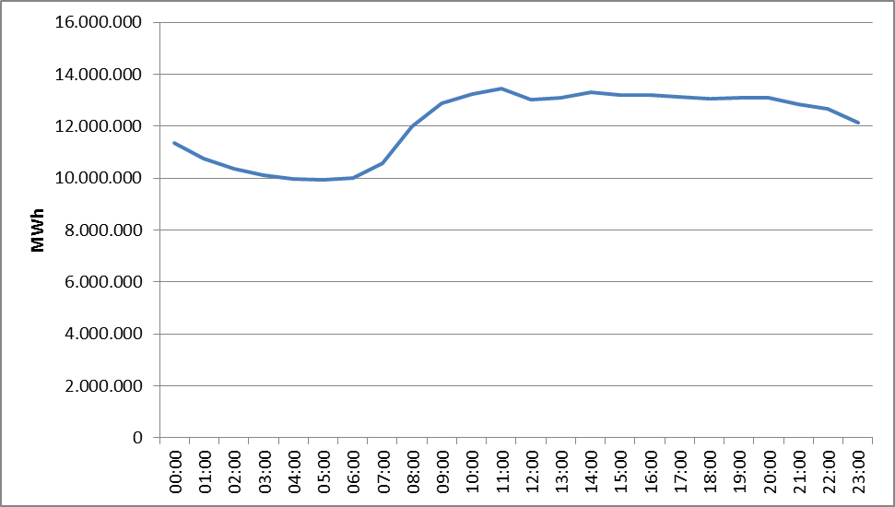

The distribution of licensed electricity generation by provinces is given in Table 1.2. The highest electricity generation in 2017 was in İzmir, Zonguldak, Adana, Sakarya, Hatay and Çanakkale provinces, the lowest was in Bartın, Bitlis, Yozgat, Niğde, Ağrı and Mardin provinces respectively.

Table.1.2: Distribution of Licensed Electricty Generation by Provinces(MWh-%)
PROVINCE | Generation (MWh) | Share (%) | PROVINCE | Generation (MWh) | Share (%)
İZMİR | 19.611.109,13 | 6,70 | SİİRT | 884.231,23 | 0,30
ZONGULDAK | 19.114.455,26 | 6,53 | YALOVA | 725.089,24 | 0,25
ADANA | 16.860.131,85 | 5,76 | ERZİNCAN | 722.281,05 | 0,25
SAKARYA | 15.730.416,43 | 5,38 | KARABÜK | 662.690,06 | 0,23
HATAY | 15.620.106,18 | 5,34 | GAZİANTEP | 654.462,47 | 0,22
ÇANAKKALE | 15.173.356,93 | 5,19 | AFYONKARAHİSAR | 625.457,87 | 0,21
MUĞLA | 12.235.212,38 | 4,18 | ESKİŞEHİR | 620.518,41 | 0,21
SAMSUN | 11.641.069,95 | 3,98 | SİNOP | 612.188,10 | 0,21
BALIKESİR | 11.277.052,93 | 3,85 | AMASYA | 598.454,56 | 0,20
İSTANBUL | 9.910.369,87 | 3,39 | KIRŞEHİR | 579.467,26 | 0,20
MANİSA | 8.766.405,14 | 3,00 | ISPARTA | 485.807,06 | 0,17
ANKARA | 8.411.556,76 | 2,88 | EDİRNE | 484.989,86 | 0,17
KOCAELİ | 8.283.232,62 | 2,83 | ADIYAMAN | 450.318,40 | 0,15
BURSA | 8.171.776,83 | 2,79 | MUŞ | 441.747,61 | 0,15
KIRIKKALE | 7.745.206,05 | 2,65 | ÇORUM | 370.073,45 | 0,13
TEKİRDAĞ | 7.673.468,23 | 2,62 | ARDAHAN | 326.486,87 | 0,11
KAHRAMANMARAŞ | 7.065.906,44 | 2,42 | NEVŞEHİR | 321.921,16 | 0,11
ŞANLIURFA | 6.813.586,30 | 2,33 | KARS | 274.960,22 | 0,09
KÜTAHYA | 6.436.793,20 | 2,20 | DÜZCE | 266.541,80 | 0,09
DENİZLİ | 6.265.458,16 | 2,14 | KONYA | 259.140,38 | 0,09
ELAZIĞ | 6.208.506,32 | 2,12 | TUNCELİ | 249.750,87 | 0,09
DİYARBAKIR | 6.131.138,69 | 2,10 | BİLECİK | 216.579,72 | 0,07
ANTALYA | 6.002.242,86 | 2,05 | BURDUR | 176.961,62 | 0,06
AYDIN | 4.973.950,74 | 1,70 | KASTAMONU | 170.288,76 | 0,06
ARTVİN | 4.203.999,26 | 1,44 | BATMAN | 169.477,86 | 0,06
SİVAS | 3.918.363,51 | 1,34 | VAN | 162.129,94 | 0,06
KIRKLARELİ | 3.861.702,68 | 1,32 | UŞAK | 144.438,65 | 0,05
MERSİN | 3.295.128,84 | 1,13 | MALATYA | 144.437,83 | 0,05
OSMANİYE | 2.496.135,86 | 0,85 | HAKKARİ | 109.377,65 | 0,04
ŞIRNAK | 2.402.111,83 | 0,82 | ÇANKIRI | 108.813,69 | 0,04
GİRESUN | 2.099.881,50 | 0,72 | BİNGÖL | 80.584,24 | 0,03
BOLU | 2.083.060,19 | 0,71 | BAYBURT | 74.046,86 | 0,03
KARAMAN | 1.504.238,29 | 0,51 | IĞDIR | 44.604,20 | 0,02
KAYSERİ | 1.482.677,87 | 0,51 | AKSARAY | 43.696,16 | 0,01
TRABZON | 1.339.243,57 | 0,46 | MARDİN | 17.187,84 | 0,01
GÜMÜŞHANE | 1.339.055,17 | 0,46 | AĞRI | 5.743,10 | 0,00
TOKAT | 1.268.332,52 | 0,43 | NİĞDE | 5.063,17 | 0,00
RİZE | 975.225,73 | 0,33 | YOZGAT | 4.028,45 | 0,00
ORDU | 945.525,09 | 0,32 | BİTLİS | 820,16 | 0,00
ERZURUM | 942.245,85 | 0,32 | BARTIN | 283,28 | 0,00
 |  |  | Grand Total | 292.574.578,09 | 100,00

In Figure 1.11, 10 companies that have the highest contribution in licensed electricity generation in 2017 and their share are shown. As can be seen from the figure, first 10 companies were EÜAŞ, Eren Enerji Elektrik Üretim A.Ş., Enerjisa Enerji Üretim A.Ş., Gebze Elektrik Üretim Ltd.Şti., İzmir Elektrik Üretim Ltd.Şti. , İskenderun Enerji Üretim Ve Tic.A. Ş., İçdaş Elektrik Enerji Üretim Ve Yat. A.Ş. Atlas Enerji Üretim San. A.Ş., Yeniköy Kemerköy Elektrik Üretim Ve Tic.A. Ş. ve İç Anadolu Doğal Gaz Elektrik Üretim and Tic.A. Ş respectively.

Figure 1.11: The Share of First 10 Companies within Electricity Generation in 2017 (%)
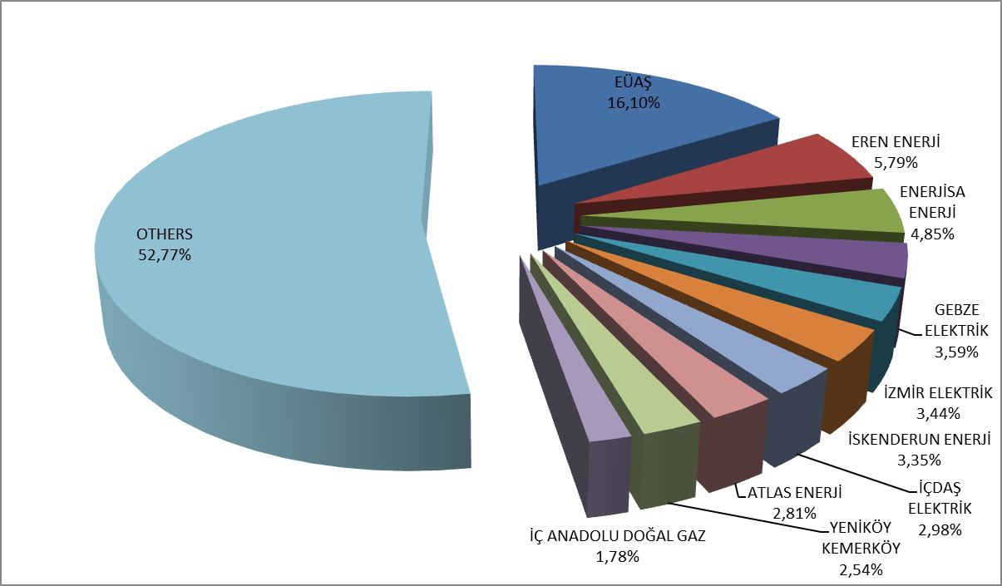

1.3 Licensed Installed Capacity

The distribution of licensed installed capacity by fuel types is given in Figure 1.12. By the end of 2016, the share of natural gas power plants (including liquid and natural gas power plants) in the installed capacity was 32,68%, whereas decreased to 32,29% while the share of hydroelectric power plants was 25,17% which decreased to 24,21%, and the share of lignite power plants was 11,95% which decreased to 11,36% in 2017.
On the other hand, at the end of 2017, the share of imported coal power plants within the total installed capacity had increased from 9,82% to 10,96%, the share of wind power plants increased from 7,40% to 7,95%, the share of run of river-hydroelectric power plants increased from 9,21% to 9,22%, and the share of geothermal power plants increased from 1,06% to 1,30%. The share of renewable energy sources (including hydro) had decreased from 43,32 % to 43,26 %, and the share of total thermal installed capacity increased from 56,68 % to 56,74 % compared to 2016.

Figure 1.12: Distribution of Licensed Installed Capacity by Sources at the End of 2017 (%)
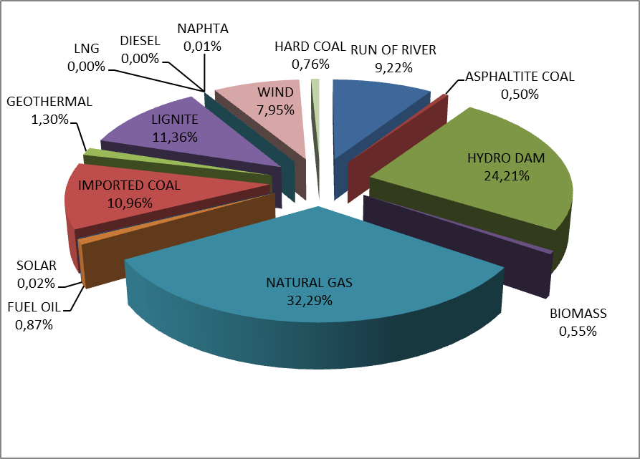
The distribution of licensed installed capacity by organizations is given in Figure 1.13. The share of EÜAŞ power plants within the installed capacity in 2016 was 25,86 %, whereas in 2017 decreased to 25,86 %, the share of power plants that were operated under the existing contracts was 11,86 % which in 2017 decreased to 11,40%. The share of independent power producers in total installed capacity had increased from 62,28 % to 64,20 % compared to previous year.

Figure 1.13: Distribution of Licensed Installed Capacity by Organizations at the End of 2017 (%)
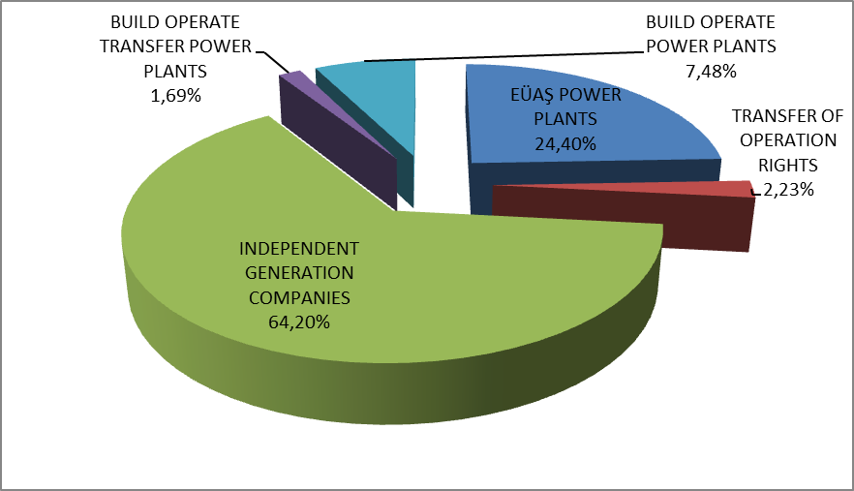

Figure 1.14 shows the distribution of activated and deactivated installed capacity of the power plants by sources in 2017.

Figure 1.14: Distribution of Activated and Deactivated Power Plants’ Installed Capacity in 2017 by Sources
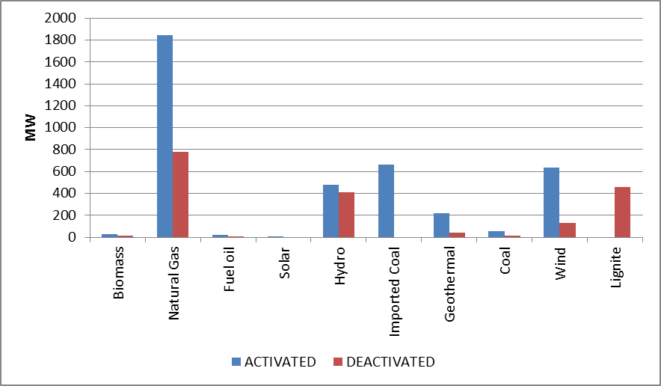
The development of licensed installed capacity since 1990 is given in Figure 1.15. As can be seen from the figure, the share of renewable energy sources, such as geothermal, wind, solar and biomass resources, had increased over years.

Figure 1.15: The Development of Licensed Installed Capacity According to Source by Years (MW)
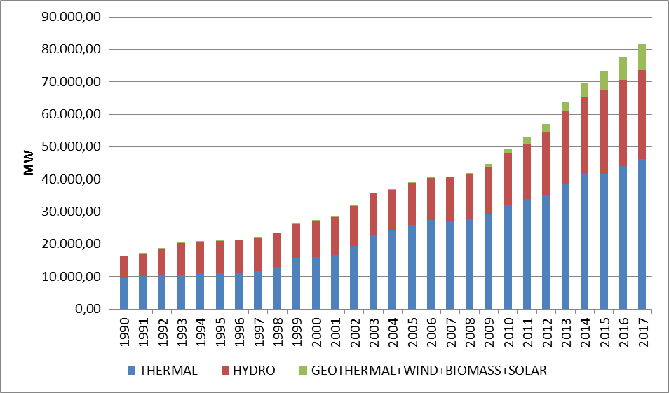

As in Figure 1.15, the development of sources within the installed capacity since 1990 is given in Figure 1.16.

Figure 1.16: The Development of the Share of the Sources within the Installed Capacity by Years (%)
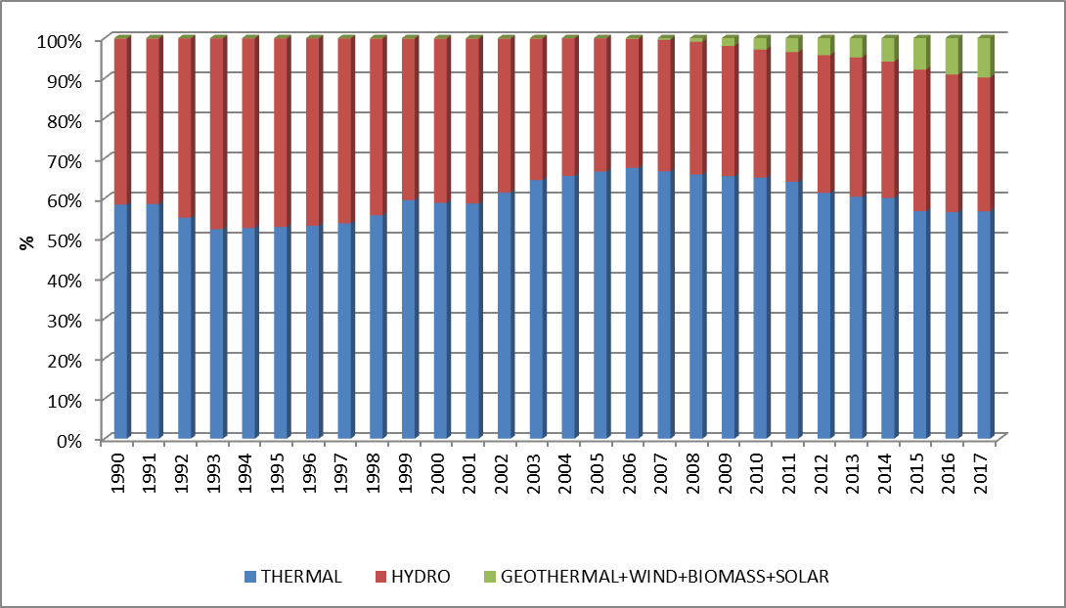
The distribution of licensed installed capacity based on provinces is shown in Table 1.3. The provinces that had the highest installed capacity in 2017 were İzmir, Kahramanmaraş, Samsun, Adana, Çanakkale and Şanlıurfa, the lowests were de Bitlis, Çankırı, Ağrı, Niğde, Iğdır and Bayburt respectively.

Table 1.3 Distribution of Licensed Installed Capacity by Provinces (MW-%)
PROVINCE | Inst.Cap. (MW) | Share (%) | PROVINCE | Inst.Cap. (MW) | Share (%)
İZMİR | 4.318,74 | 5,29 | ERZURUM | 402,15 | 0,49
KAHRAMANMARAŞ | 4.244,08 | 5,20 | ÇORUM | 370,79 | 0,45
SAMSUN | 3.811,17 | 4,67 | SİİRT | 344,49 | 0,42
ADANA | 3.727,07 | 4,57 | RİZE | 336,60 | 0,41
ÇANAKKALE | 3.573,80 | 4,38 | ERZİNCAN | 318,65 | 0,39
ŞANLIURFA | 3.465,22 | 4,25 | AMASYA | 284,39 | 0,35
ZONGULDAK | 3.312,73 | 4,06 | ISPARTA | 276,33 | 0,34
İSTANBUL | 2.999,58 | 3,68 | YALOVA | 242,88 | 0,30
BURSA | 2.802,40 | 3,44 | ADIYAMAN | 238,87 | 0,29
BALIKESİR | 2.752,91 | 3,38 | AFYONKARAHİSAR | 237,08 | 0,29
HATAY | 2.726,30 | 3,34 | TUNCELİ | 235,17 | 0,29
ANKARA | 2.556,74 | 3,13 | MUŞ | 182,66 | 0,22
SAKARYA | 2.504,16 | 3,07 | KIRŞEHİR | 179,90 | 0,22
ELAZIĞ | 2.303,13 | 2,82 | EDİRNE | 162,49 | 0,20
DİYARBAKIR | 2.250,13 | 2,76 | ARDAHAN | 160,75 | 0,20
MUĞLA | 2.192,70 | 2,69 | KONYA | 159,97 | 0,20
MANİSA | 2.146,44 | 2,63 | MARDİN | 159,00 | 0,19
KOCAELİ | 2.067,13 | 2,53 | KARS | 154,67 | 0,19
ARTVİN | 1.967,89 | 2,41 | KARABÜK | 146,25 | 0,18
KIRIKKALE | 1.936,98 | 2,37 | KASTAMONU | 132,18 | 0,16
ANTALYA | 1.878,01 | 2,30 | BİLECİK | 124,79 | 0,15
KIRKLARELİ | 1.777,12 | 2,18 | DÜZCE | 107,18 | 0,13
TEKİRDAĞ | 1.613,23 | 1,98 | BURDUR | 89,45 | 0,11
DENİZLİ | 1.544,56 | 1,89 | UŞAK | 80,47 | 0,10
AYDIN | 1.090,22 | 1,34 | VAN | 66,83 | 0,08
KÜTAHYA | 1.068,04 | 1,31 | MALATYA | 64,66 | 0,08
GİRESUN | 1.066,13 | 1,31 | BATMAN | 57,00 | 0,07
OSMANİYE | 1.053,48 | 1,29 | HAKKARİ | 47,71 | 0,06
MERSİN | 978,25 | 1,20 | BİNGÖL | 47,42 | 0,06
SİVAS | 844,51 | 1,04 | NEVŞEHİR | 40,13 | 0,05
KARAMAN | 601,57 | 0,74 | YOZGAT | 37,60 | 0,05
KAYSERİ | 599,73 | 0,74 | SİNOP | 34,95 | 0,04
ŞIRNAK | 577,58 | 0,71 | AKSARAY | 27,69 | 0,03
TRABZON | 568,87 | 0,70 | BARTIN | 26,41 | 0,03
GAZİANTEP | 559,82 | 0,69 | BAYBURT | 25,70 | 0,03
TOKAT | 554,17 | 0,68 | IĞDIR | 22,58 | 0,03
ESKİŞEHİR | 548,40 | 0,67 | NİĞDE | 22,33 | 0,03
ORDU | 476,55 | 0,58 | AĞRI | 9,50 | 0,01
GÜMÜŞHANE | 426,62 | 0,52 | ÇANKIRI | 2,75 | 0,00
BOLU | 416,14 | 0,51 | BİTLİS | 0,60 | 0,00
 |  |  | Grand Total | 81.563,32 | 100,00

Figure 1.17 shows the shares of the first 10 companies that had the highest share of licensed installed capacity at the end of 2017. As can be seen from the figure, first 10 companies EÜAŞ, Eren Enerji Elektrik Üretim A.Ş. , Enerjisa Enerji Üretim A.Ş. , Gebze Elektrik Üretim Ltd.Şti., İzmir Elektrik Üretim Ltd.Şti., Cenal Elektrik Üretim A.Ş., İskenderun Enerji Üretim Ve Ticaret A.Ş. , Hamitabat Elektrik Üretim Ve Ticaret A.Ş. , Atlas Enerji Üretim Sanayi A.Ş. , İçdaş Elektrik Enerjisi Üretim and Yatırım A.Ş. respectively.

Figure 1.17: The Share of the First 10 Companies in Installed Capacity at the End of 2017 (%)
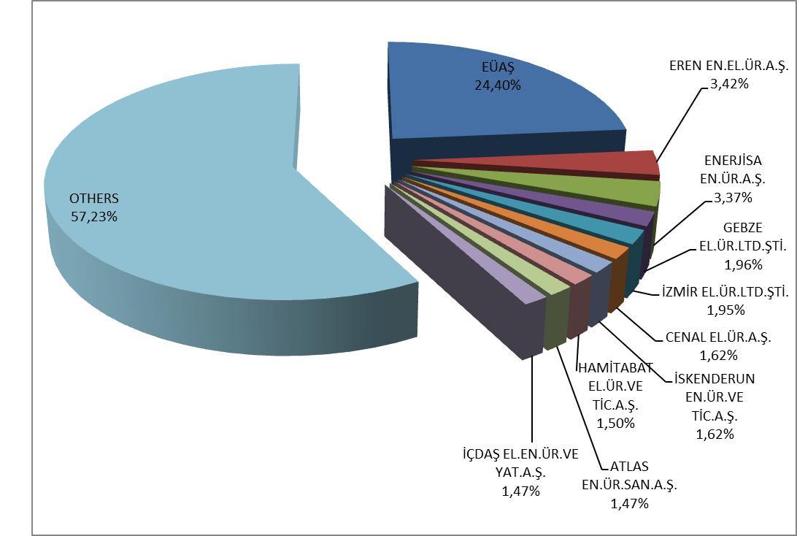

1.4 Unlicensed Generation

In the first sub clause of Article 14 of the Electricity Market Law No. 6446, the production facilities exempted from the license to install and establish a company are as follows;
“a) Generation facilities not connected to emergency generator groups or transmission or distribution systems
b) Generation facilities with the installed power based on maximum one-megawatt renewable energy sources
c) Electricity generation facilities of municipalities installed to dispose the sludge of solid waste facilities and of treatment plants
d) Those of micro-cogeneration facilities and cogeneration facilities having the productivity value to be determined by the Ministry, and in the category to be determined by the Board
e) Generation facilities using the entire amount of energy generated without feeding to a transmission or distribution system and having its generation and consumption at the same measurement point, and based upon the renewable energy sources”

The current status of unlicensed electricity generation applications by 2017 is shown in Table 1.4.

Table 1.4: The Status of Unlicensed Electricity Generation Applications by the End of 2017 (MW)
Status | Stream | Biomass | Multifuel | Wave | Nat. gas | Solar  (PV) | Solar (CSP) | Hydro | Geoth. | Wind | Total
Application period for connection agreement has expired |  | 13,44 |  |  | 20,33 | 593,93 |  | 2,21 |  | 37,57 | 667,47
Connection agreement done |  | 17,90 | 16,92 |  | 77,91 | 3.026,43 |  | 12,38 |  | 77,73 | 3.229,27
Connection agreement expired |  | 1,56 |  |  | 5,05 | 123,26 |  |  |  | 2,20 | 132,07
Under evaluation |  | 28,57 | 6,00 |  | 10,41 | 134,57 |  |  |  | 1,00 | 180,56
Installed and Activated |  | 66,72 | 2,40 |  | 83,48 | 2.978,84 | 1,00 | 8,69 |  | 32,20 | 3.173,32
Accepted |  | 49,38 | 2,67 |  | 52,04 | 548,43 | 0,08 | 7,57 | 5,57 | 79,44 | 745,17
Rejected | 0,50 | 148,49 | 11,45 | 0,40 | 71,62 | 14.186,95 |  | 47,77 |  | 334,26 | 14.801,44

The distribution of unlicensed installed capacity by sources is given in Table 1.5 and Figure 1.18. Unlicensed installed capacity tripled to 3.173,32 MW in 2017, which was 1.048,21 MW at the end of 2016. The biggest share, as it was in 2016, belongs to solar power plants with 93,90 % and natural gas with 2,71 % and biomass with 2,10 % are following it.

Table 1.5: Distribution of Unlicensed Installed Capacity by Sources (MW-%)
Resource Type | 2016 |  | 2017
Resource Type | Installed Capacity (MW) | Share (%) | Installed Capacity (MW) | Share (%)
Solar (Photovoltaic) | 939,19 | 89,60 | 2.978,84 | 93,87
Natural Gas | 51,85 | 4,95 | 85,88 | 2,71
Biomass | 36,42 | 3,47 | 66,72 | 2,10
Wind | 13,75 | 1,31 | 32,20 | 1,01
Hydraulic | 5,78 | 0,55 | 8,69 | 0,27
Solar (Concentrated) | 1,22 | 0,12 | 1,00 | 0,03
Total | 1.048,21 | 100,00 | 3.173,32 | 100,00

Figure 1.18: Distribution of Unlicensed Installed Capacity by Sources at the End of 2017 (%)
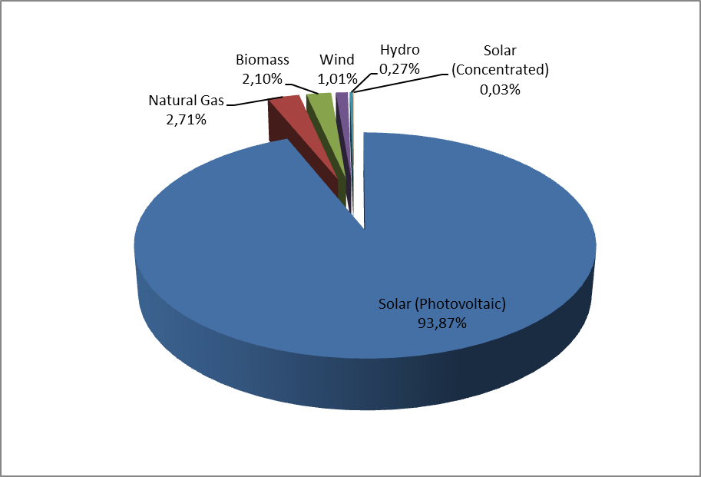

The distribution of unlicensed installed capacity by provinces is shown in Table 1.6. As it was in 2016, the highest installed capacity belongs to Konya with 437,61 MW in 2017. After Konya, the following sequences are Kayseri with 279,64 MW, Ankara with 158,78 MW, Afyonkarahisar with 134,67 MW, Antalya with 117,88 MW, Mersin with 114,37 MW, and Gaziantep with 93,38 MW respectively. The total unlicensed installed capacity belongs to these seven provinces with the rate of 42%. In addition, in 2017 total unlicensed installed capacity increased to 68 with the following new provinces Bayburt, Bolu, Edirne, Kars and Ordu whereas this number was 63 in 2016.

Table 1.6: Distribution of Unlicensed Installed Capacity by Province (MW- %)
PROVINCE | 2016 |  | 2017
PROVINCE | Installed Capacity (MW) | Share (%) | Installed Capacity (MW) | Share (%)
KONYA | 199,236 | 19,01 | 437,610 | 13,79
KAYSERİ | 127,408 | 12,15 | 279,644 | 8,81
ANKARA | 54,872 | 5,23 | 158,775 | 5,00
AFYONKARAHİSAR | 25,601 | 2,44 | 134,668 | 4,24
ANTALYA | 48,211 | 4,60 | 117,885 | 3,71
MERSİN | 54,202 | 5,17 | 114,372 | 3,60
GAZİANTEP | 26,015 | 2,48 | 93,375 | 2,94
KAHRAMANMARAŞ | 33,341 | 3,18 | 88,150 | 2,78
NİĞDE | 30,745 | 2,93 | 84,092 | 2,65
ISPARTA | 39,226 | 3,74 | 83,207 | 2,62
ADANA | 24,782 | 2,36 | 81,414 | 2,57
ELAZIĞ | 0,620 | 0,06 | 81,084 | 2,56
NEVŞEHİR | 29,106 | 2,78 | 79,115 | 2,49
AKSARAY | 29,386 | 2,80 | 76,006 | 2,40
ŞANLIURFA | 10,570 | 1,01 | 73,749 | 2,32
ESKİŞEHİR | 9,314 | 0,89 | 72,855 | 2,30
DENİZLİ | 38,007 | 3,63 | 69,270 | 2,18
UŞAK | 5,300 | 0,51 | 68,804 | 2,17
MANİSA | 36,791 | 3,51 | 62,602 | 1,97
BALIKESİR | 5,210 | 0,50 | 61,331 | 1,93
AYDIN | 11,003 | 1,05 | 59,037 | 1,86
İZMİR | 6,614 | 0,63 | 56,669 | 1,79
ADIYAMAN | 12,128 | 1,16 | 53,797 | 1,70
MUĞLA | 4,381 | 0,42 | 51,420 | 1,62
ERZURUM | 9,442 | 0,90 | 50,401 | 1,59
BURDUR | 40,748 | 3,89 | 50,277 | 1,58
KARAMAN | 10,021 | 0,96 | 49,236 | 1,55
SİVAS | 6,896 | 0,66 | 44,281 | 1,40
KÜTAHYA | 1,950 | 0,19 | 41,190 | 1,30
OSMANİYE | 5,078 | 0,48 | 38,275 | 1,21
İSTANBUL | 14,695 | 1,40 | 38,015 | 1,20
MALATYA | 9,731 | 0,93 | 34,414 | 1,08
ÇORUM | 11,430 | 1,09 | 30,468 | 0,96
YOZGAT | 11,275 | 1,08 | 27,827 | 0,88
KIRŞEHİR | 1,676 | 0,16 | 26,579 | 0,84
KIRIKKALE | 0,999 | 0,10 | 25,821 | 0,81
ERZİNCAN | 0,572 | 0,05 | 21,689 | 0,68
BURSA | 8,514 | 0,81 | 21,480 | 0,68
TOKAT | 4,597 | 0,44 | 15,143 | 0,48
AMASYA | 0,708 | 0,07 | 13,757 | 0,43
KİLİS | 11,260 | 1,07 | 11,260 | 0,35
ÇANAKKALE | 3,472 | 0,33 | 11,100 | 0,35
SAKARYA | 4,415 | 0,42 | 8,790 | 0,28
KARABÜK | 1,670 | 0,16 | 8,635 | 0,27
KOCAELİ | 6,597 | 0,63 | 8,421 | 0,27
SAMSUN | 0,922 | 0,09 | 7,631 | 0,24
HATAY | 1,812 | 0,17 | 6,335 | 0,20
ÇANKIRI | 1,000 | 0,10 | 5,987 | 0,19
BİLECİK | 0,140 | 0,01 | 5,045 | 0,16
BAYBURT | 0,000 | 0,00 | 5,029 | 0,16
DİYARBAKIR | 4,310 | 0,41 | 4,645 | 0,15
BİTLİS | 1,990 | 0,19 | 3,490 | 0,11
TEKİRDAĞ | 3,150 | 0,30 | 3,150 | 0,10
KARS | 0,000 | 0,00 | 2,760 | 0,09
ZONGULDAK | 2,480 | 0,24 | 2,480 | 0,08
BOLU | 0,000 | 0,00 | 2,248 | 0,07
MUŞ | 1,998 | 0,19 | 2,158 | 0,07
VAN | 0,530 | 0,05 | 1,420 | 0,04
DÜZCE | 0,990 | 0,09 | 1,005 | 0,03
ORDU | 0,000 | 0,00 | 0,980 | 0,03
TUNCELİ | 0,018 | 0,00 | 0,974 | 0,03
EDİRNE | 0,000 | 0,00 | 0,840 | 0,03
MARDİN | 0,320 | 0,03 | 0,415 | 0,01
BARTIN | 0,250 | 0,02 | 0,250 | 0,01
KASTAMONU | 0,250 | 0,02 | 0,250 | 0,01
SİİRT | 0,192 | 0,02 | 0,192 | 0,01
BATMAN | 0,044 | 0,00 | 0,044 | 0,00
SİNOP | 0,004 | 0,00 | 0,004 | 0,00
Grand Total | 1.048,21 | 100,00 | 3.173,32 | 100,00

The distribution of unlicensed electricity generation by sources is given in Table 1.7 and at Figure 1.19. In 2016, the amount of energy supplied to the grid within the scope of unlicensed electricity generation was 1.137.871,75 MWh, but it increased to 3.031.558,05 MWh in 2017. 93,57% came from solar, 4,57% from biomass, and 1,86% includes wind, hydrolic and natural gas.

Table 1.7: Distribution of Unlicensed Electricity Generation by Sources
(MWh-%)
Resource Type | 2016 |  | 2017
Resource Type | The amount of energy given to the system as surplus (MWh) | Share  (%) | The amount of energy given to the system as surplus (MWh) | Share  (%)
Solar (Photovoltaic) | 1.031.358,00 | 90,64 | 2.836.553,09 | 93,57
Biomass | 92.129,90 | 8,10 | 138.657,08 | 4,57
Wind | 8.268,44 | 0,73 | 36.801,92 | 1,21
Hydro | 6.115,42 | 0,54 | 19.434,29 | 0,64
Natural Gas | 0,00 | 0,00 | 111,67 | 0,00
Grand Total | 1.137.871,75 | 100,00 | 3.031.558,05 | 100,00

Figure 1.19: Distribution of Unlicensed Electricity Generation by Sources in 2017 (%)
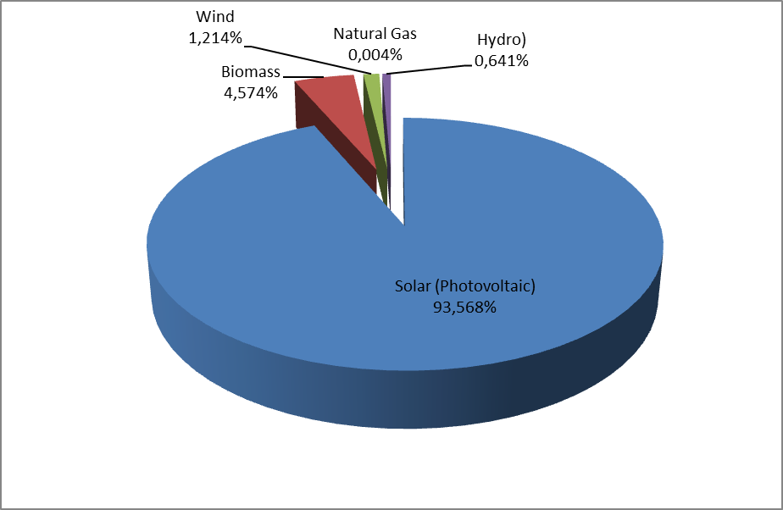

The distribution of energy that is given to the system as a result of unlicensed electricity generation by provinces is shown in Table 1.8. The highest generation was in Kayseri in 2016, but in 2017 the highest generation was in Konya. Mersin, Afyonkarahisar, Ankara, Aksaray, Antalya, and Gaziantep were other important provinces in unlicensed electricity generation.

Table 1.8: Distribution of Unlicensed Electricity Generation by Provinces (MWh-%)
PROVINCE | 2016 |  | 2017
PROVINCE | The amount of energy given to the system as surplus (MWh) | Share (%) | The amount of energy given to the system as surplus (MWh | Share (%)
KONYA | 197.328,31 | 17,34 | 541.727,99 | 17,87
KAYSERİ | 202.559,64 | 17,80 | 396.470,72 | 13,08
MERSİN | 97.764,47 | 8,59 | 147.460,17 | 4,86
AFYONKARAHİSAR | 22.340,49 | 1,96 | 103.910,00 | 3,43
ANKARA | 43.023,20 | 3,78 | 100.849,57 | 3,33
AKSARAY | 19.106,17 | 1,68 | 99.666,31 | 3,29
ANTALYA | 38.337,40 | 3,37 | 98.080,69 | 3,24
GAZİANTEP | 20.650,85 | 1,81 | 95.426,10 | 3,15
DENİZLİ | 55.710,74 | 4,90 | 88.831,00 | 2,93
NİĞDE | 35.235,40 | 3,10 | 87.890,84 | 2,90
BURDUR | 52.426,64 | 4,61 | 79.345,54 | 2,62
ESKİŞEHİR | 15.475,56 | 1,36 | 79.240,86 | 2,61
ISPARTA | 33.845,76 | 2,97 | 77.065,63 | 2,54
KAHRAMANMARAŞ | 31.437,52 | 2,76 | 67.322,36 | 2,22
NEVŞEHİR | 36.121,61 | 3,17 | 65.813,63 | 2,17
AYDIN | 6.843,22 | 0,60 | 60.395,15 | 1,99
ŞANLIURFA | 14.432,87 | 1,27 | 58.423,03 | 1,93
MANİSA | 18.285,19 | 1,61 | 54.552,84 | 1,80
UŞAK | 6.565,79 | 0,58 | 47.828,89 | 1,58
ADIYAMAN | 12.170,32 | 1,07 | 47.402,32 | 1,56
ADANA | 16.407,35 | 1,44 | 45.561,10 | 1,50
MUĞLA | 5.621,90 | 0,49 | 44.997,60 | 1,48
KARAMAN | 12.837,56 | 1,13 | 43.901,46 | 1,45
İZMİR | 22.596,65 | 1,99 | 41.081,94 | 1,36
MALATYA | 25.415,35 | 2,23 | 37.943,06 | 1,25
YOZGAT | 8.246,34 | 0,72 | 33.855,04 | 1,12
ERZURUM | 1.509,54 | 0,13 | 33.059,16 | 1,09
BALIKESİR | 2.595,67 | 0,23 | 32.525,48 | 1,07
SİVAS | 1.565,65 | 0,14 | 27.762,07 | 0,92
KÜTAHYA | 1.750,06 | 0,15 | 27.236,19 | 0,90
BURSA | 6.382,60 | 0,56 | 26.952,41 | 0,89
ELAZIĞ | 3.653,25 | 0,32 | 26.415,91 | 0,87
KIRIKKALE | 2.814,87 | 0,25 | 24.234,15 | 0,80
ÇORUM | 5.601,44 | 0,49 | 21.689,20 | 0,72
OSMANİYE | 6.202,61 | 0,55 | 21.162,10 | 0,70
KİLİS | 14.418,62 | 1,27 | 19.729,09 | 0,65
KIRŞEHİR | 1.039,26 | 0,09 | 17.120,66 | 0,56
KOCAELİ | 8.459,95 | 0,74 | 16.105,48 | 0,53
TOKAT | 8.315,09 | 0,73 | 15.248,30 | 0,50
ZONGULDAK | 10.657,02 | 0,94 | 10.767,44 | 0,36
ÇANAKKALE | 139,00 | 0,01 | 8.723,72 | 0,29
BAYBURT |  |  | 7.142,70 | 0,24
BİLECİK | 69,93 | 0,01 | 6.340,18 | 0,21
AMASYA | 206,59 | 0,02 | 6.071,22 | 0,20
HATAY | 2.502,98 | 0,22 | 5.287,67 | 0,17
İSTANBUL | 1.465,68 | 0,13 | 4.790,74 | 0,16
RİZE |  |  | 3.738,28 | 0,12
DİYARBAKIR | 795,01 | 0,07 | 3.447,94 | 0,11
BİTLİS | 2.028,45 | 0,18 | 3.271,21 | 0,11
MUŞ | 1.195,38 | 0,11 | 3.089,95 | 0,10
ÇANKIRI | 265,66 | 0,02 | 2.702,09 | 0,09
KARABÜK | 371,15 | 0,03 | 2.691,64 | 0,09
EDİRNE | 855,42 | 0,08 | 1.911,34 | 0,06
ERZİNCAN | 421,50 | 0,04 | 1.375,06 | 0,05
SAMSUN | 110,71 | 0,01 | 1.079,20 | 0,04
BATMAN | 34,83 | 0,00 | 879,82 | 0,03
ORDU |  |  | 872,05 | 0,03
MARDİN | 382,00 | 0,03 | 857,39 | 0,03
TEKİRDAĞ | 644,77 | 0,06 | 545,96 | 0,02
VAN | 64,98 | 0,01 | 421,78 | 0,01
DÜZCE | 22,86 | 0,00 | 336,52 | 0,01
BOLU |  |  | 322,89 | 0,01
SİİRT | 240,55 | 0,02 | 263,58 | 0,01
SAKARYA | 33,16 | 0,00 | 121,93 | 0,00
KASTAMONU | 6,30 | 0,00 | 120,00 | 0,00
BARTIN | 116,21 | 0,01 | 77,55 | 0,00
TUNCELİ | 23,17 | 0,00 | 22,34 | 0,00
SİNOP | 1,37 | 0,00 | 1,82 | 0,00
KIRKLARELİ | 122,16 | 0,01 | 0,00 | 0,00
Grand Total | 1.137.871,75 | 100,00 | 3.031.558,05 | 100,00

The distribution of the amount of payment made within the scope of unlicensed electricity generation by resources by the end of 2017 is given in Table 1.9. 94 % of the amount of payment, as it is in generation and installed capacity, was made to solar (photovoltaic) power plants.

Table 1.9: Distribution of the Amount of Payment Made Within the Scope of Unlicensed Electricity Generation by Sources (TL-%)
Resource Type | 2016 |  | 2017 |  | Change (%)  2016→2017
Resource Type | The amount of payment made for the purchased surplus energy (TL) | Share (%) | The amount of payment made for the purchased surplus energy (TL) | Share  (%) | Change (%)  2016→2017
Solar (Photovoltaic) | 427.946.838,22 | 90,65 | 1.394.110.605,71 | 94,13 | 225,77
Biomass | 40.868.850,06 | 8,66 | 71.776.216,62 | 4,84 | 75,63
Wind | 1.949.623,01 | 0,41 | 10.038.095,17 | 0,68 | 414,87
Hydro | 1.316.242,55 | 0,28 | 5.227.757,72 | 0,35 | 297,17
Grand Total | 472.081.553,85 | 100,00 | 1.481.654.308,03 | 100,00 | 213,86

1.5 Invoiced Electricity Consumption

This part gives information about the consumption of invoiced electric energy. In this sense, the consumption that are not subject to invoicing (technical and non-technical losses and unacceptable consumption), are not included in this section and dataset. Therefore, in the scope of Article 7 of the Electricity Market Law, the production that is made in order to meet the needs of the facilities that are rented, acquired through financial leasing, being inherited the operational right or the energy produced in the premises without leaving the transmission or distribution system, which are done by legal entities that own generation license, are not included in the invoiced consumption data since they are not regarded as a sales to the final consumer. Also, the electric energy that the facilities used for their own need from the system are not included in the invoiced consumption. In addition, real consumption data and consumption data contained in this section may vary due to differences in invoicing period.
The information about invoiced consumption in 2017 is given in Table 1.10. 24% of the 225,71 TWh was sold to consumers connected to the transmission voltage level with 54,18 TWh, while the remaining 76 % (171,53 TWh) was distributed to consumers connected to the distribution voltage level.
While 125,26 TWh sold to eligible consumers, consumption of non-eligible consumers was 100,45 TWh. The share of eligible consumers’ invoiced consumption was 55,50 %, while non-eligible consumers’ share was 44,50 %.

Table 1.10: Sales to Eligible and Non-Eligible Consumers in 2017 (MWh)
Consumer Type | Consumption Amount of Consumers Connected to the Distribution Voltage Level (MWh) | Consumption Amount of Consumers Connected to Tranmission Voltage Level (MWh) | Total (MWh)
Non-Eligible Consumer | 80.768.336,36 | 19.685.372,29 | 100.453.708,65
Eligible Consumer | 90.762.663,09 | 34.497.156,39 | 125.259.819,48
Grand Total | 171.530.999,45 | 54.182.528,68 | 225.713.528,13

Distribution of consumption by distribution regions is given in Table 1.11. The highest consumption was in Toroslar EDAŞ region with 27,51 TWh and the lowest consumption with 1,92 TWh was in Vangölü EDAŞ region. The region where the highest consumption connected to distribution voltage level was Boğaziçi EDAŞ, whereas the lowest region was Vangölü EDAŞ. In addition, the region where the consumption connected to transmission was the highest in Toroslar and the lowest in Çoruh EDAŞ region.

Table 1.11: Distribution of Invoiced Consumption by Distribution Regions in 2017 (MWh-%)
Distribution Regions | Consumption of Consumers Connected to Distribution (MWh) | Consumption of Consumers Connected to Transmission (MWh) | Total (MWh) | Share (%)
TOROSLAR EDAŞ | 15.231.835,06 | 12.274.572,31 | 27.506.407,37 | 12,19
BOĞAZİÇİ EDAŞ | 24.845.008,93 | 1.473.721,15 | 26.318.730,08 | 11,66
GDZ EDAŞ | 14.322.936,34 | 6.693.359,59 | 21.016.295,93 | 9,31
ULUDAĞ EDAŞ | 11.865.279,65 | 6.958.421,88 | 18.823.701,53 | 8,34
BAŞKENT EDAŞ | 15.014.405,15 | 2.340.598,52 | 17.355.003,67 | 7,69
SAKARYA EDAŞ | 9.042.922,10 | 6.610.743,99 | 15.653.666,09 | 6,94
İST. AND. YAK. EDAŞ | 11.536.256,60 | 1.255.714,53 | 12.791.971,13 | 5,67
MERAM EDAŞ | 8.491.254,28 | 1.498.796,12 | 9.990.050,40 | 4,43
AKDENİZ EDAŞ | 8.531.512,20 | 1.349.097,33 | 9.880.609,53 | 4,38
TRAKYA EDAŞ | 6.427.141,17 | 3.335.120,29 | 9.762.261,46 | 4,33
OSMANGAZİ EDAŞ | 6.119.296,04 | 3.406.014,23 | 9.525.310,27 | 4,22
ADM EDAŞ | 8.463.635,28 | 907.393,85 | 9.371.029,13 | 4,15
DİCLE EDAŞ | 7.947.965,33 | 849.884,17 | 8.797.849,50 | 3,90
YEŞİLIRMAK EDAŞ | 4.866.005,89 | 917.818,43 | 5.783.824,32 | 2,56
AKEDAŞ EDAŞ | 3.876.708,67 | 1.388.452,38 | 5.265.161,05 | 2,33
KAYSERİ VE CİVARI ETAŞ | 2.309.228,14 | 1.373.291,87 | 3.682.520,01 | 1,63
ÇORUH EDAŞ | 3.562.034,39 | 66.865,23 | 3.628.899,62 | 1,61
FIRAT EDAŞ | 2.462.519,84 | 806.000,46 | 3.268.520,30 | 1,45
ÇAMLIBEL EDAŞ | 2.471.261,30 | 427.100,20 | 2.898.361,50 | 1,28
ARAS EDAŞ | 2.320.864,59 | 154.695,16 | 2.475.559,75 | 1,10
VANGÖLÜ EDAŞ | 1.822.928,50 | 94.866,99 | 1.917.795,49 | 0,85
Grand Total | 171.530.999,45 | 54.182.528,68 | 225.713.528,13 | 100,00

The distribution of invoiced consumption by consumer type is shown in Figure 1.20 and Table 1.12. The industrial consumption was the first with a share of 42,07 %. The consumption of the commercial sector was the second with 29,39 % and the household consumption was the third with 23,71 %. The total electricity consumption used in lighting and agricultural irrigation was 4,83 %.

Table 1.12: Distribution of Invoiced Consumption by Consumer Type as Eligible and Non-Eligible Consumers in 2017 (MWh)
Consumer Type | Consumption Amount (MWh)
Consumer Type | Non Eligible Consumer | Share  (%) | Eligible Consumer | Share  (%) | Total | Share  (%)
Industry | 33.365.763,58 | 33,22 | 61.597.523,39 | 49,18 | 94.963.286,96 | 42,07
Commercial | 15.336.980,88 | 15,27 | 51.005.729,13 | 40,72 | 66.342.710,01 | 29,39
Household | 41.807.333,73 | 41,62 | 11.702.954,84 | 9,34 | 53.510.288,56 | 23,71
Irrigation | 5.797.193,93 | 5,77 | 762.801,21 | 0,61 | 6.559.995,13 | 2,91
Lighting | 4.146.436,53 | 4,13 | 190.810,93 | 0,15 | 4.337.247,46 | 1,92
Grand Total | 100.453.708,65 | 100,00 | 125.259.819,48 | 100,00 | 225.713.528,13 | 100,00

Figure 1.20: Distribution of Invoiced Consumption by Consumer Type in 2017 (%)
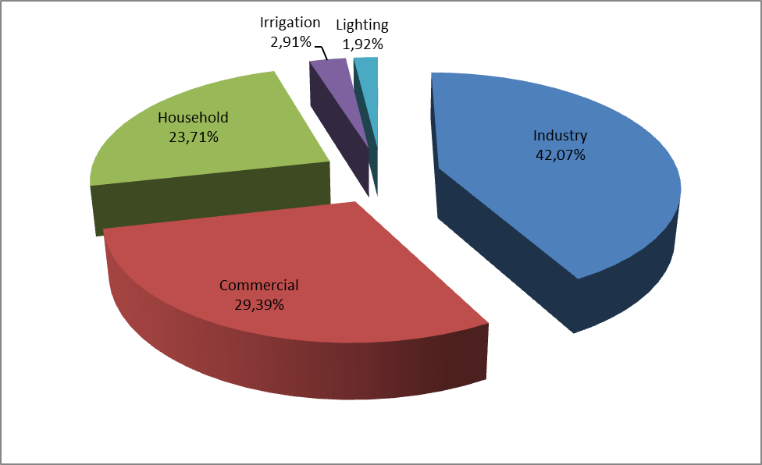
The distribution of invoiced consumption by provinces is shown in Table 1.13. The highest consumption was in Istanbul with 36,93 TWh and corresponded to 17,39 % of total consumption. Following provinces were Izmir with a share of 7,64 %, Ankara with a share of 5,78 %, Bursa with 4,64 % and Kocaeli with 4,22 %.

Table 1.13: Distribution of Invoiced Consumption by Province (MWh - %)
PROVINCE | Consumption of Consumers Connected to Dist. Vol. (MWh) | Consumption of Consumers Connected to Trans.Vol. (MWh) | Total (MWh) | Share (%)
İSTANBUL (TÜMÜ) | 36.381.265,53 | 2.729.435,68 | 39.110.701,21 | 17,33
İST. AVRUPA | 24.845.008,93 | 1.473.721,15 | 26.318.730,08 | 11,66
İZMİR | 11.235.113,09 | 5.173.608,81 | 16.408.721,90 | 7,27
İST. ASYA | 11.536.256,60 | 1.255.714,53 | 12.791.971,13 | 5,67
ANKARA | 11.548.244,44 | 1.745.997,53 | 13.294.241,97 | 5,89
BURSA | 7.224.720,54 | 4.539.798,31 | 11.764.518,85 | 5,21
KOCAELİ | 5.218.442,56 | 4.491.991,67 | 9.710.434,23 | 4,30
ANTALYA | 7.084.130,99 | 702.766,11 | 7.786.897,10 | 3,45
GAZİANTEP | 3.149.737,00 | 4.317.602,68 | 7.467.339,68 | 3,31
ADANA | 4.640.617,33 | 1.930.828,12 | 6.571.445,45 | 2,91
TEKİRDAĞ | 3.833.693,52 | 2.737.068,26 | 6.570.761,78 | 2,91
KONYA | 5.131.954,75 | 855.041,63 | 5.986.996,38 | 2,65
MERSİN | 3.865.292,99 | 766.743,70 | 4.632.036,69 | 2,05
MANİSA | 3.087.823,25 | 1.519.750,78 | 4.607.574,03 | 2,04
HATAY | 2.667.310,28 | 1.852.051,34 | 4.519.361,62 | 2,00
KAHRAMANMARAŞ | 3.040.878,63 | 1.150.136,64 | 4.191.015,27 | 1,86
OSMANİYE | 684.299,31 | 3.375.484,48 | 4.059.783,79 | 1,80
SAKARYA | 2.172.891,09 | 1.777.193,60 | 3.950.084,69 | 1,75
KAYSERİ | 2.303.116,56 | 1.373.291,87 | 3.676.408,43 | 1,63
ŞANLIURFA | 3.162.705,16 | 349.453,51 | 3.512.158,67 | 1,56
DENİZLİ | 2.956.573,48 | 495.711,62 | 3.452.285,10 | 1,53
MUĞLA | 3.003.207,41 | 318.679,50 | 3.321.886,91 | 1,47
ÇANAKKALE | 1.167.663,22 | 2.123.163,88 | 3.290.827,10 | 1,46
BALIKESİR | 2.863.241,82 | 295.459,69 | 3.158.701,51 | 1,40
ESKİŞEHİR | 1.748.570,05 | 1.084.800,46 | 2.833.370,51 | 1,26
SAMSUN | 2.019.735,62 | 730.159,16 | 2.749.894,78 | 1,22
AYDIN | 2.503.854,39 | 93.002,73 | 2.596.857,12 | 1,15
DİYARBAKIR | 2.087.436,09 | 178.773,90 | 2.266.209,99 | 1,00
KIRKLARELİ | 1.421.551,72 | 594.915,59 | 2.016.467,31 | 0,89
BİLECİK | 1.067.646,56 | 735.376,88 | 1.803.023,44 | 0,80
AFYONKARAHİSAR | 1.454.531,98 | 289.760,30 | 1.744.292,28 | 0,77
MALATYA | 1.121.370,11 | 488.551,46 | 1.609.921,57 | 0,71
UŞAK | 780.406,10 | 802.492,15 | 1.582.898,25 | 0,70
KÜTAHYA | 1.068.141,34 | 493.584,44 | 1.561.725,78 | 0,69
TRABZON | 1.410.029,96 | 46.549,75 | 1.456.579,71 | 0,65
SİVAS | 1.097.985,40 | 251.205,81 | 1.349.191,21 | 0,60
MARDİN | 1.187.898,28 | 140.805,18 | 1.328.703,46 | 0,59
ELAZIĞ | 923.393,17 | 317.449,00 | 1.240.842,17 | 0,55
ORDU | 1.191.364,06 | 41.925,37 | 1.233.289,43 | 0,55
ZONGULDAK | 1.054.683,38 | 170.852,52 | 1.225.535,90 | 0,54
EDİRNE | 1.171.895,93 | 3.136,44 | 1.175.032,37 | 0,52
ISPARTA | 910.484,38 | 259.899,38 | 1.170.383,76 | 0,52
ADIYAMAN | 835.830,04 | 238.315,74 | 1.074.145,78 | 0,48
NİĞDE | 807.112,09 | 266.203,39 | 1.073.315,48 | 0,48
DÜZCE | 819.210,11 | 247.337,05 | 1.066.547,16 | 0,47
VAN | 973.009,95 |  | 973.009,95 | 0,43
AKSARAY | 831.735,17 | 127.578,65 | 959.313,82 | 0,43
ERZURUM | 891.528,76 | 66.382,62 | 957.911,38 | 0,42
BOLU | 832.378,34 | 94.221,67 | 926.600,01 | 0,41
BURDUR | 536.896,82 | 386.431,84 | 923.328,66 | 0,41
ÇORUM | 752.421,87 | 81.129,64 | 833.551,51 | 0,37
KASTAMONU | 650.212,72 | 181.924,80 | 832.137,52 | 0,37
TOKAT | 683.458,64 | 141.909,99 | 825.368,63 | 0,37
BATMAN | 631.342,54 | 168.424,92 | 799.767,46 | 0,35
KARAMAN | 585.292,06 | 175.557,54 | 760.849,60 | 0,34
NEVŞEHİR | 745.019,10 |  | 745.019,10 | 0,33
YOZGAT | 695.928,84 | 33.984,40 | 729.913,24 | 0,32
RİZE | 713.656,41 |  | 713.656,41 | 0,32
GİRESUN | 652.032,27 |  | 652.032,27 | 0,29
YALOVA | 609.654,07 |  | 609.654,07 | 0,27
AMASYA | 554.061,46 | 48.421,76 | 602.483,22 | 0,27
KARABÜK | 462.528,18 | 85.199,32 | 547.727,50 | 0,24
KIRIKKALE | 455.430,74 | 69.442,37 | 524.873,11 | 0,23
ŞIRNAK | 490.954,07 |  | 490.954,07 | 0,22
BARTIN | 472.383,85 | 4.772,95 | 477.156,80 | 0,21
KIRŞEHİR | 390.141,12 | 74.414,91 | 464.556,03 | 0,21
ÇANKIRI | 370.921,84 | 82.409,03 | 453.330,87 | 0,20
ERZİNCAN | 323.467,81 | 88.304,21 | 411.772,02 | 0,18
GÜMÜŞHANE | 386.698,01 | 20.280,38 | 406.978,39 | 0,18
SİİRT | 387.629,20 | 12.426,66 | 400.055,86 | 0,18
ARTVİN | 399.617,75 | 35,10 | 399.652,85 | 0,18
MUŞ | 299.200,39 | 94.866,99 | 394.067,38 | 0,17
SİNOP | 348.422,88 | 16.182,50 | 364.605,38 | 0,16
AĞRI | 359.882,88 | 8,33 | 359.891,21 | 0,16
BİTLİS | 351.193,68 |  | 351.193,68 | 0,16
KARS | 326.209,36 |  | 326.209,36 | 0,14
BİNGÖL | 294.732,65 |  | 294.732,65 | 0,13
KİLİS | 224.578,15 | 31.861,99 | 256.440,14 | 0,11
HAKKARİ | 199.524,47 |  | 199.524,47 | 0,09
IĞDIR | 196.866,04 |  | 196.866,04 | 0,09
TUNCELİ | 123.023,91 |  | 123.023,91 | 0,05
ARDAHAN | 121.662,66 |  | 121.662,66 | 0,05
BAYBURT | 101.247,09 |  | 101.247,09 | 0,04
Grand Total | 171.530.999,45 | 54.182.528,68 | 225.713.528,13 | 100,00

Table 1.14: Distribution of Invoiced Consumption by Province and Consumer Type (MWh)
Province | Lighting | Household | Industry | Agricultural Irrigation | Commerce | Grand Total | Share (%)
ADANA | 98.358,03 | 1.731.610,63 | 2.994.357,24 | 158.272,90 | 1.588.846,65 | 6.571.445,45 | 2,91
ADIYAMAN | 30.373,29 | 257.093,60 | 458.409,39 | 61.762,98 | 266.506,52 | 1.074.145,78 | 0,48
AFYONKARAHİSAR | 54.932,24 | 346.640,30 | 581.314,40 | 135.689,66 | 625.715,68 | 1.744.292,28 | 0,77
AĞRI | 19.147,64 | 175.140,45 | 13.063,26 | 120,44 | 152.419,43 | 359.891,21 | 0,16
AKSARAY | 25.341,43 | 202.398,50 | 218.051,91 | 240.700,42 | 272.821,55 | 959.313,82 | 0,43
AMASYA | 29.506,09 | 196.321,49 | 168.669,23 | 20.707,47 | 187.278,93 | 602.483,22 | 0,27
ANKARA | 263.868,95 | 3.874.613,05 | 3.463.270,51 | 147.694,52 | 5.544.794,95 | 13.294.241,97 | 5,89
ANTALYA | 129.575,15 | 2.390.167,83 | 1.102.169,45 | 162.170,35 | 4.002.814,33 | 7.786.897,10 | 3,45
ARDAHAN | 9.729,80 | 43.045,79 | 1.653,94 | 0,00 | 67.233,13 | 121.662,66 | 0,05
ARTVİN | 27.498,78 | 120.307,03 | 135.912,22 | 133,43 | 115.801,40 | 399.652,85 | 0,18
AYDIN | 75.856,28 | 931.526,10 | 576.915,57 | 75.633,62 | 936.925,55 | 2.596.857,12 | 1,15
BALIKESİR | 101.527,30 | 887.556,09 | 1.167.324,54 | 43.362,24 | 958.931,34 | 3.158.701,51 | 1,40
BARTIN | 23.028,05 | 124.789,74 | 224.977,62 | 695,51 | 103.665,88 | 477.156,80 | 0,21
BATMAN | 24.786,98 | 278.831,14 | 252.695,02 | 4.421,93 | 239.032,39 | 799.767,46 | 0,35
BAYBURT | 8.775,96 | 40.409,13 | 3.401,93 | 165,34 | 48.494,73 | 101.247,09 | 0,04
BİLECİK | 19.412,63 | 112.581,06 | 1.443.165,55 | 5.767,37 | 222.096,83 | 1.803.023,44 | 0,80
BİNGÖL | 10.402,72 | 111.731,61 | 58.028,70 | 425,54 | 114.144,08 | 294.732,65 | 0,13
BİTLİS | 21.422,47 | 130.376,70 | 28.001,22 | 39.016,58 | 132.376,71 | 351.193,68 | 0,16
BOLU | 28.018,60 | 178.331,30 | 391.577,36 | 1.730,75 | 326.942,00 | 926.600,01 | 0,41
BURDUR | 20.948,65 | 144.680,17 | 550.641,56 | 35.807,77 | 171.250,52 | 923.328,66 | 0,41
BURSA | 130.061,90 | 1.931.360,11 | 7.320.343,93 | 84.245,68 | 2.298.507,23 | 11.764.518,85 | 5,21
ÇANAKKALE | 43.876,58 | 347.441,34 | 2.391.965,76 | 35.374,55 | 472.168,87 | 3.290.827,10 | 1,46
ÇANKIRI | 20.644,63 | 99.236,84 | 211.701,12 | 2.394,16 | 119.354,12 | 453.330,87 | 0,20
ÇORUM | 39.851,91 | 290.442,32 | 230.189,67 | 17.955,12 | 255.112,49 | 833.551,51 | 0,37
DENİZLİ | 77.107,26 | 700.516,45 | 1.822.503,95 | 72.045,87 | 780.111,57 | 3.452.285,10 | 1,53
DİYARBAKIR | 44.312,74 | 730.958,75 | 477.674,44 | 111.284,17 | 901.979,89 | 2.266.209,99 | 1,00
DÜZCE | 28.661,48 | 221.375,33 | 577.771,72 | 534,73 | 238.203,90 | 1.066.547,16 | 0,47
EDİRNE | 27.392,37 | 280.118,94 | 391.035,36 | 124.996,13 | 351.489,57 | 1.175.032,37 | 0,52
ELAZIĞ | 33.762,18 | 277.088,13 | 507.966,49 | 42.155,02 | 379.870,34 | 1.240.842,17 | 0,55
ERZİNCAN | 20.378,10 | 115.551,10 | 106.958,80 | 8.926,20 | 159.957,81 | 411.772,02 | 0,18
ERZURUM | 52.379,17 | 366.050,00 | 131.372,50 | 4.136,30 | 403.973,42 | 957.911,38 | 0,42
ESKİŞEHİR | 45.947,73 | 538.002,38 | 1.342.935,69 | 154.829,76 | 751.654,95 | 2.833.370,51 | 1,26
GAZİANTEP | 73.559,40 | 1.190.993,63 | 4.889.198,69 | 138.143,10 | 1.175.444,86 | 7.467.339,68 | 3,31
GİRESUN | 57.987,15 | 299.630,92 | 70.756,94 | 280,38 | 223.376,88 | 652.032,27 | 0,29
GÜMÜŞHANE | 16.040,09 | 67.273,34 | 252.764,72 | 544,13 | 70.356,11 | 406.978,39 | 0,18
HAKKARİ | 13.598,97 | 79.109,47 | 2.940,68 | 27,85 | 103.847,50 | 199.524,47 | 0,09
HATAY | 78.442,17 | 1.114.746,97 | 2.237.752,62 | 189.261,49 | 899.158,37 | 4.519.361,62 | 2,00
IĞDIR | 12.460,34 | 84.071,59 | 4.853,29 | 515,85 | 94.964,97 | 196.866,04 | 0,09
ISPARTA | 33.158,95 | 262.159,10 | 474.448,98 | 54.861,81 | 345.754,93 | 1.170.383,76 | 0,52
İSTANBUL | 444.298,99 | 11.295.568,45 | 10.056.801,26 | 4.835,19 | 17.309.197,31 | 39.110.701,21 | 17,33
İZMİR | 209.436,97 | 4.181.525,44 | 7.728.127,05 | 381.435,20 | 3.908.197,24 | 16.408.721,90 | 7,27
KAHRAMANMARAŞ | 51.036,62 | 456.202,02 | 2.771.064,29 | 61.504,36 | 851.207,99 | 4.191.015,27 | 1,86
KARABÜK | 22.898,07 | 144.498,22 | 225.456,96 | 761,29 | 154.112,97 | 547.727,50 | 0,24
KARAMAN | 15.189,42 | 129.985,00 | 249.156,92 | 201.696,46 | 164.821,81 | 760.849,60 | 0,34
KARS | 14.426,59 | 110.232,10 | 62.713,64 | 244,47 | 138.592,56 | 326.209,36 | 0,14
KASTAMONU | 42.536,52 | 211.206,56 | 366.480,08 | 4.494,52 | 207.419,84 | 832.137,52 | 0,37
KAYSERİ | 103.971,57 | 759.683,44 | 1.907.686,30 | 158.569,68 | 746.497,43 | 3.676.408,43 | 1,63
KIRIKKALE | 20.560,54 | 153.661,73 | 174.573,46 | 3.731,66 | 172.345,73 | 524.873,11 | 0,23
KIRKLARELİ | 22.611,58 | 233.593,68 | 1.443.384,77 | 9.183,64 | 307.693,64 | 2.016.467,31 | 0,89
KIRŞEHİR | 21.015,83 | 131.347,82 | 137.228,51 | 27.775,73 | 147.188,14 | 464.556,03 | 0,21
KİLİS | 9.447,75 | 73.298,52 | 38.473,57 | 16.019,12 | 119.201,19 | 256.440,14 | 0,11
KOCAELİ | 89.798,99 | 1.192.196,15 | 6.991.569,48 | 6.514,92 | 1.430.354,69 | 9.710.434,23 | 4,30
KONYA | 139.836,58 | 1.200.533,48 | 1.907.461,13 | 1.178.529,03 | 1.560.636,15 | 5.986.996,38 | 2,65
KÜTAHYA | 44.692,09 | 289.858,23 | 860.200,98 | 5.969,83 | 361.004,66 | 1.561.725,78 | 0,69
MALATYA | 48.305,34 | 390.531,94 | 601.506,83 | 100.127,88 | 469.449,59 | 1.609.921,57 | 0,71
MANİSA | 75.299,65 | 908.172,32 | 2.295.004,03 | 293.251,13 | 1.035.846,91 | 4.607.574,03 | 2,04
MARDİN | 31.718,23 | 349.068,41 | 383.689,80 | 178.558,00 | 385.669,02 | 1.328.703,46 | 0,59
MERSİN | 89.599,84 | 1.462.085,40 | 1.519.754,56 | 177.862,51 | 1.382.734,39 | 4.632.036,69 | 2,05
MUĞLA | 71.157,35 | 952.979,48 | 750.434,73 | 41.332,89 | 1.505.982,46 | 3.321.886,91 | 1,47
MUŞ | 6.427,52 | 152.011,28 | 105.566,45 | 1.800,35 | 128.261,79 | 394.067,38 | 0,17
NEVŞEHİR | 30.964,50 | 174.774,04 | 155.671,90 | 164.116,65 | 219.492,02 | 745.019,10 | 0,33
NİĞDE | 30.847,69 | 174.234,28 | 502.548,19 | 170.909,46 | 194.775,86 | 1.073.315,48 | 0,48
ORDU | 64.398,62 | 463.834,83 | 357.251,19 | 210,50 | 347.594,29 | 1.233.289,43 | 0,55
OSMANİYE | 26.638,08 | 316.923,14 | 3.438.271,18 | 14.438,69 | 263.512,69 | 4.059.783,79 | 1,80
RİZE | 44.150,79 | 239.168,62 | 213.570,96 | 4,21 | 216.761,83 | 713.656,41 | 0,32
SAKARYA | 61.032,40 | 638.107,32 | 2.514.303,92 | 8.976,46 | 727.664,59 | 3.950.084,69 | 1,75
SAMSUN | 96.197,75 | 837.005,26 | 1.027.737,82 | 27.822,72 | 761.131,24 | 2.749.894,78 | 1,22
SİİRT | 19.222,53 | 127.911,89 | 125.819,82 | 2.242,24 | 124.859,38 | 400.055,86 | 0,18
SİNOP | 22.977,53 | 154.513,08 | 82.386,67 | 2.086,28 | 102.641,82 | 364.605,38 | 0,16
SİVAS | 53.382,41 | 308.423,04 | 616.621,71 | 41.689,83 | 329.074,23 | 1.349.191,21 | 0,60
ŞANLIURFA | 61.357,25 | 879.695,71 | 634.333,68 | 936.706,14 | 1.000.065,89 | 3.512.158,67 | 1,56
ŞIRNAK | 14.269,10 | 159.503,36 | 43.459,81 | 14.094,33 | 259.627,47 | 490.954,07 | 0,22
TEKİRDAĞ | 40.705,82 | 610.762,43 | 5.050.583,20 | 14.408,74 | 854.301,60 | 6.570.761,78 | 2,91
TOKAT | 42.793,94 | 292.944,59 | 228.962,81 | 6.831,21 | 253.836,08 | 825.368,63 | 0,37
TRABZON | 81.677,51 | 627.475,75 | 211.313,07 | 795,01 | 535.318,36 | 1.456.579,71 | 0,65
TUNCELİ | 9.207,20 | 41.620,71 | 10.609,23 | 837,75 | 60.749,01 | 123.023,91 | 0,05
UŞAK | 26.719,16 | 195.017,67 | 973.702,79 | 16.348,25 | 371.110,38 | 1.582.898,25 | 0,70
VAN | 36.858,21 | 428.252,89 | 121.421,82 | 2.306,33 | 384.170,70 | 973.009,95 | 0,43
YALOVA | 17.246,56 | 200.543,41 | 177.856,24 | 5.665,65 | 208.342,21 | 609.654,07 | 0,27
YOZGAT | 38.090,25 | 196.390,81 | 176.129,79 | 97.957,17 | 221.345,21 | 729.913,24 | 0,32
ZONGULDAK | 72.109,98 | 390.667,66 | 445.660,41 | 558,53 | 316.539,32 | 1.225.535,90 | 0,54
Grand Total | 4.337.247,46 | 53.510.288,56 | 94.963.286,96 | 6.559.995,13 | 66.342.710,01 | 225.713.528,13 | 100,00

The distribution of invoiced consumption by months is shown in Figure 1.21. The highest consumption was in August, the lowest consumption was in June.

Figure 1.21: Distribution of Invoiced Consumption by Months (MWh)
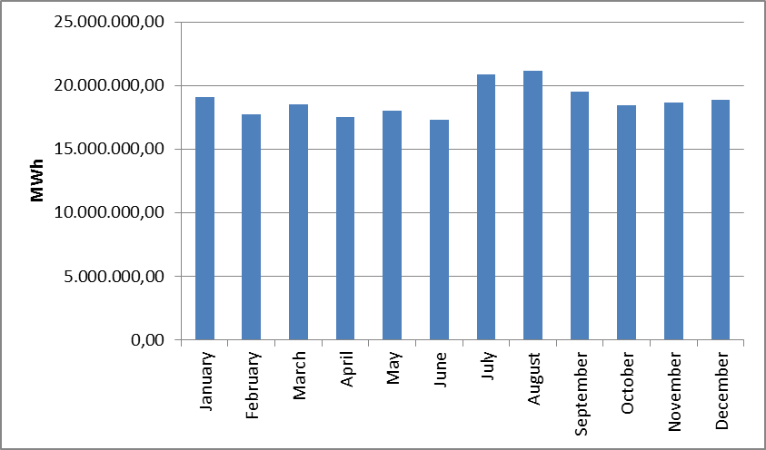

The development of consumption over years is shown in Figure 1.22. The consumption decreased only in 2001 and 2009 compared to the previous years, with the effect of economic crisis. The highest increase rate compared to the previous year was 13,75 % in 1997.

Figure 1.22: Development of Gross Consumption by Years (GWh)
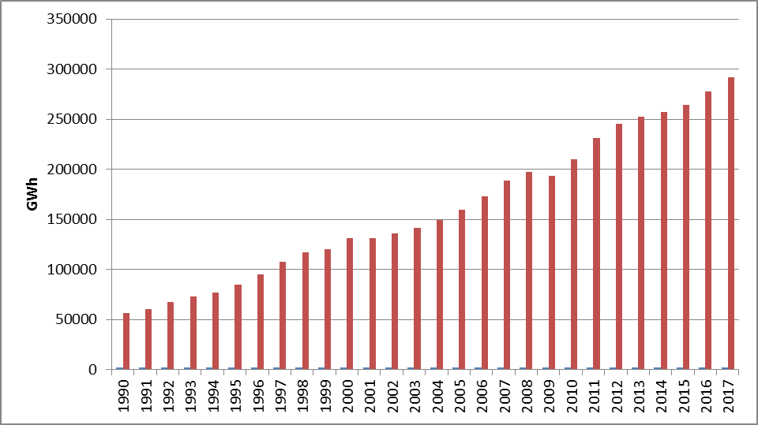

1.6 Import and Export

1.6.1 Import

The data on electricity imports in 2017 by months is shown in Figure 1.23. 76,02 % of the total 2.729.060,87 MWh electricity imports in 2017 were from Bulgaria, 18,08 % from Georgia, 5,88 % from Iran and 0,02 % from Greece. On the monthly basis, the highest electricity imports were made in January, while the lowest was in October.

Figure 1.23: Electricity Imports in 2017 by Months (MWh)
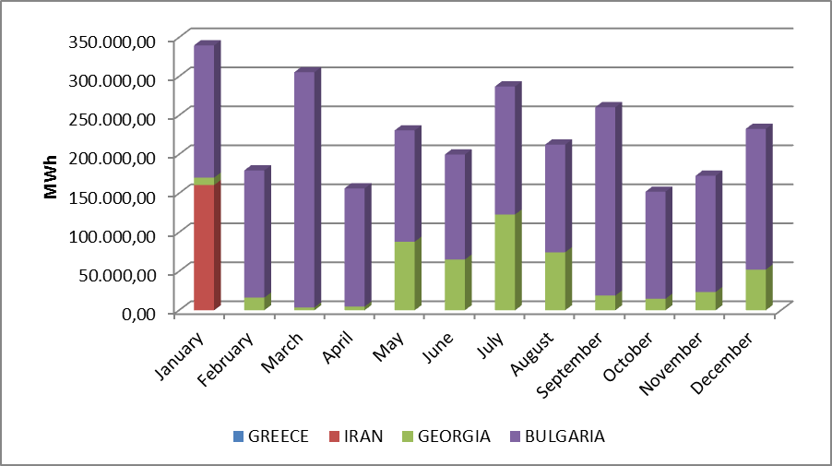

1.6.2 Export
The data on electricity exports in 2017 by months is shown in Figure 1.24. 96,97 % of the total 3.300.096,20 MWh electricity exports in 2017 were to Greece, and the remaining 3,03% to Bulgaria and Georgia. On the monthly basis, the highest electricity exports were made in November and the lowest in February.

Figure 1.24: Electricity Exports in 2017 by Months (MWh)
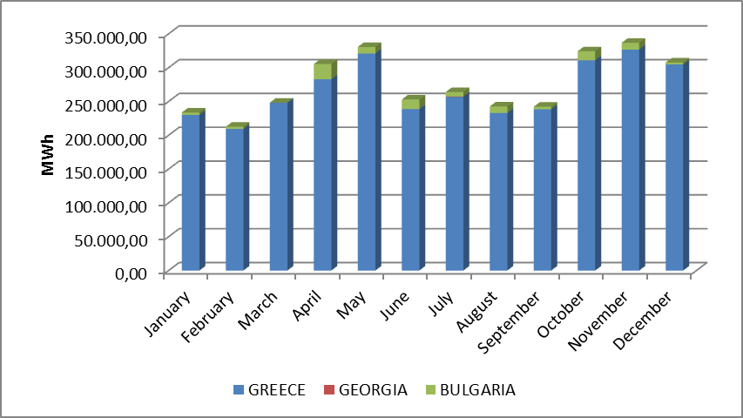

- WHOLESALE MARKET

In this section, the developments that occurred in the wholesale market were examined in the year 2017. In this context; the prices of the Day-Ahead Market (DAM), the Intra-Day Market (IDM) and the Balancing Power Market (BPM) are presented with the volumes and the orders given. Moreover, the changes that occurred in the market structure are explained.

  - Day-Ahead Market

Liberalization process started with Electricity Market Law aimed for creation of an electricity market based on transparency, integrity and competition; and integrated with other countries’ electricity markets. In line with this aim, numerous planned steps were taken and significant progress had been achieved for transforming stronger and more dynamic electricity market in which market participants take an active role and market operators manage and monitor by best means.

First step carried out for transformation of electricity market from a single buyer-single seller model to liberal and competitive model was transition to monthly 3 period financial settlement system on 1 July 2006. Next step was the start of operations for Day-Ahead Planning system on 1 December 2009. These transition periods have great importance regarding to transformation of electricity market into stronger and more dynamic structure. Parties took role in market operations and activities provided significant experience and foresight for new market models from their practices at earlier market stages. 1 December 2011 date became a milestone for Turkish Electricity Market and creation of currently used Day-Ahead Market system has been established which is deemed as biggest step towards formation of targeted electricity market structure. Establishment of Day-Ahead Market stimulated a new dynamism and vision for Turkish Electricity Market and allowed formation of market structure based on values of competition.

With the new market structure, the collateral mechanism has been implemented and in this context, the market participants registered with MFSC must provide a guarantee to the market operator for the transactions they have made in DAM. In addition to this arrangement, it is possible for participants to create portfolios. Lastly, in the event that system constraints continue systematically, TEİAŞ is given the opportunity to switch to regional pricing by considering the constraints.
Following the completion of the registration process on 18 March 2015, the Energy Exchange Istanbul (EXIST) was formally established, under the provisions of the Turkish Commercial Code of the 14.03.2013 dated and numbered 6446 with the Electricity Market Act of 6102.
In accordance with the proposals offered by the market participants in the Day-Ahead Market operated by EXIST, the market exchange prices and the purchase and sales quantities are announced.
The software used on December 1, 2011, which has an outdated software technology and algorithm as part of the Day-Ahead Market transactions, was insufficient to meet the needs and expectations of the sector, the source code was closed to access, due to these facts developing and error handling activities caused external dependence so that a new software needed to be developed by EXIST to respond to the increasing number of market participants, to meet industry expectations and to create a Day-Ahead Market software at the level of advanced market operators, which gave start to "Domestic Day-Ahead Market Project".
The Day-Ahead Market software and optimization model was put into use by market participants as a test on March 18, 2016, while the test process was completed on June 1, 2016, and replaced the old software in the real environment. Thus, market exchange prices are calculated by the software and optimization infrastructure that uses the technology and knowledge required by the era, developed with EXIST’s own sources since 1 June 2016 delivery day.

The prices of the DAM in 2017 are given in Figure 2.1.1 with the weighted average price.

Figure.2.1.1: Hourly Development of Weighted Average Market Clearing Price in 2017 (TL/MWh)
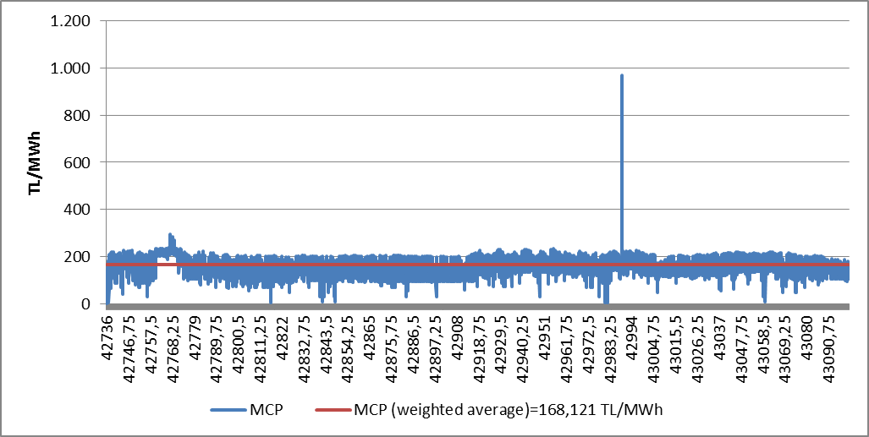

Figure 2.1.2: Organized Weighted Average MCP in 2017 (TL/MWh)
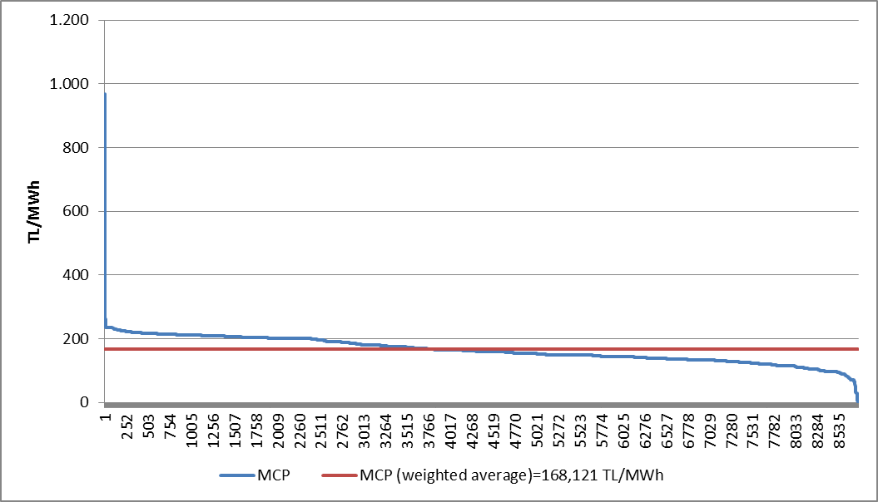
As shown in the figures, the prices were generally observed in the 100-250 TL/MWh range, in 2017 the value observed 250 and above 250 TL/MWh just for 13 hours. The price reached 967,15 TL/MWh with the highest value at 14:00 on 11 September 2017. The lowest MCP value observed 1,04 TL/MWh at 08:00 on 01 January 2017 .
In Figure 2.1.3, the weighted average MCP is given in Day-Ahead Market by years. In 2017, the weighted average of the MCP increased by 13,35% compared to 2016 and reached 168,12 TL/MWh.

Figure 2.1.3: Weighted Average MCP by Years (TL/MWh)
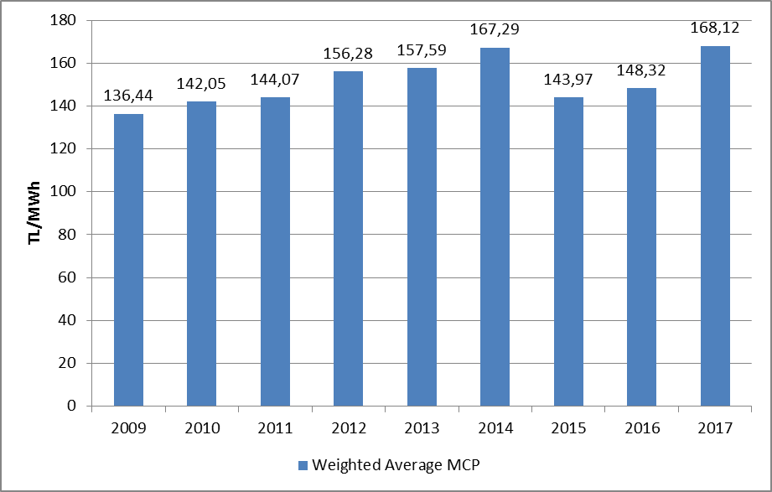

Figure 2.1.4 shows the monthly weighted average MCP for 2016 and 2017. In 2017, the average monthly price was the highest value of 188,044 TL/MWh in January, and the lowest value of 147,977 TL/MWh in April.

As shown in tables and figures in the first chapter, monthly electricity consumption falls with the softening of the air during the spring and autumn months. In addition, in the spring months, the water capacity of hydroelectric power plantsincreased and the lowest prices of the year are generally seen in spring time.
On the other hand, due to air conditioning and consumption of agricultural irrigation in the summer months and the need for warming and enlightenment in the winter, electricity demand increases and the increase in the average prices in parallel to the increase in consumption is observed.

Figure 2.1.4: Monthly Weighted Average MCP of the Last Two Years (TL/MWh)
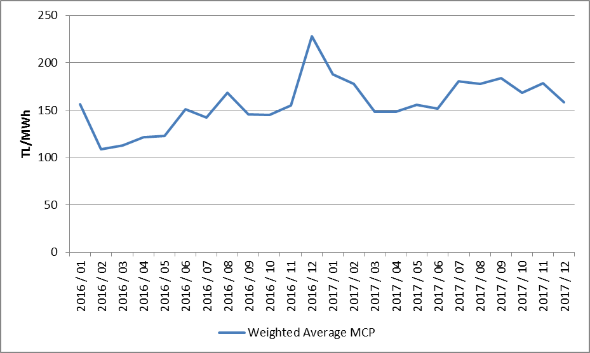
The following figure 2.1.5 shows the trading volume in the DAM by months, the distribution of the quantities of DAM buying in Figure 2.1.6 and the share of the top 10 companies, the distribution of sales quantities in Figure 2.1.7 and the share of the top 10 company.

Figure 2.1.5: Monthly Day-Ahead Market Trading Volume (MWh)
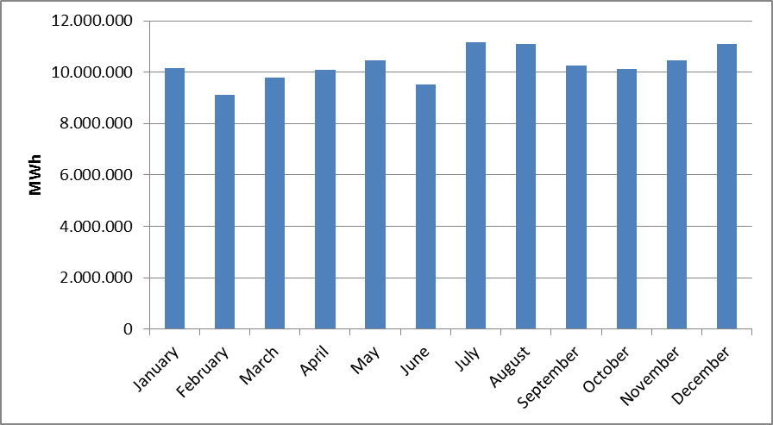

Figure 2.1.6: The Share of Top 10 Buyer Companies in Day-Ahead Market (%)
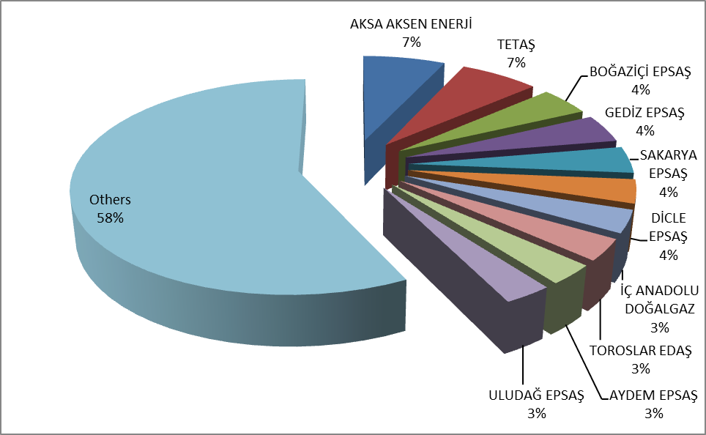

Figure 2.1.7: The Share of Top 10 Seller Companies in Balancing Power Market (%)
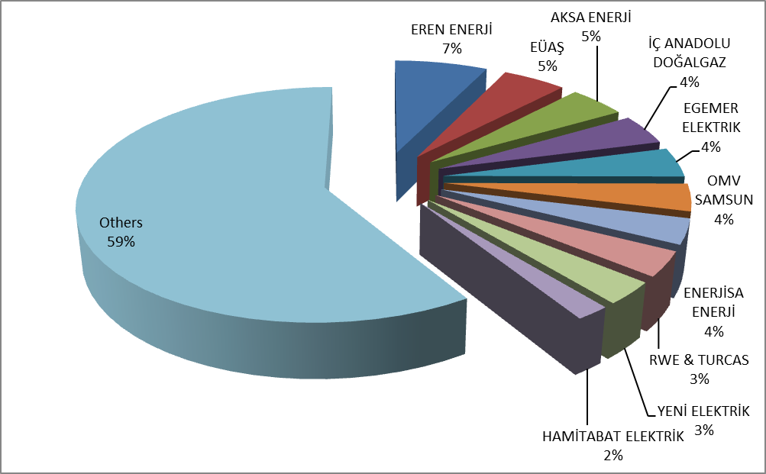

2.2 Balancing Power Market

Balancing Power Market is operated in real time by TEİAŞ. This section provides data on the development of prices and volumes in the BPM. In 2017, the system marginal prices (real time price) at the BPM are shown at Figure 2.2.1 on a per-hour basis. Also, Figure 2.2.2 provides the organized system marginal prices.

Figure.2.2.1: Per-Hour Based Development of System Marginal Price (TL/MWh)
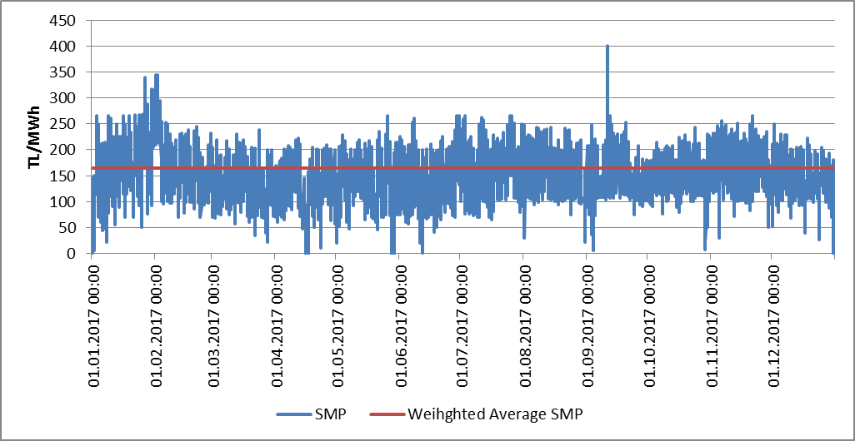

Figure 2.2.2: Organized Sytem Marginal Price (TL/MWh)
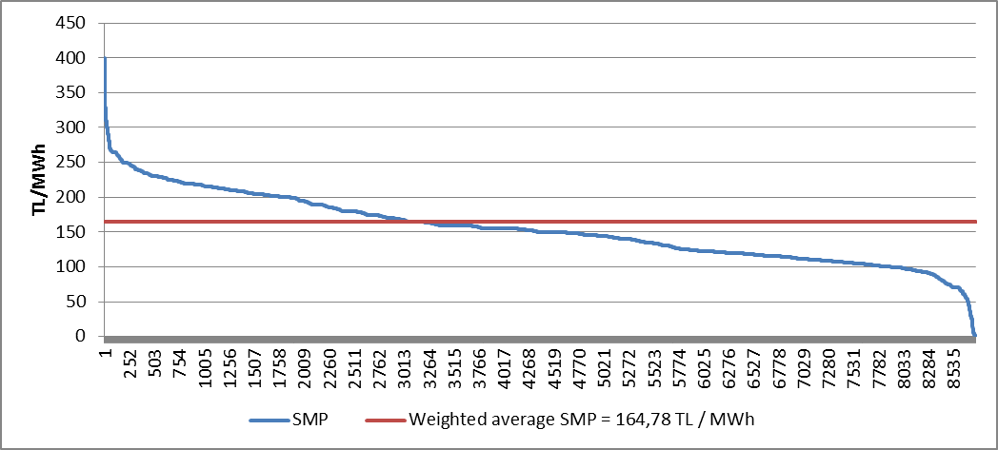
Similar to the prices of the DAM, the prices in the BPM were generally between 100 and 250 TL/MWh. The price was highest on September 11, 2017 at 14:00, 400,00 TL/MWh, and it was over 300 TL/MWh for 29 hours. At the BPM, the price was 0 TL/MWh for 5 hours during 2017.

The annual weighted average of the price in BPM was 164,78 TL/MWh, increased by 17,87 % compared to the previous year.
The monthly weighted average prices of the Balancing Power Market in 2017 are shown in Figure 2.2.3 below. SMP was seen in April as the lowest with the value of 141,377 TL/MWh, and the highest value was realized in July with the value of 184,383 TL/MWh.

Figure 2.2.3: Monthly Weighted Average Prices of the Last Two Years in Balancing Power Market (TL/MWh)
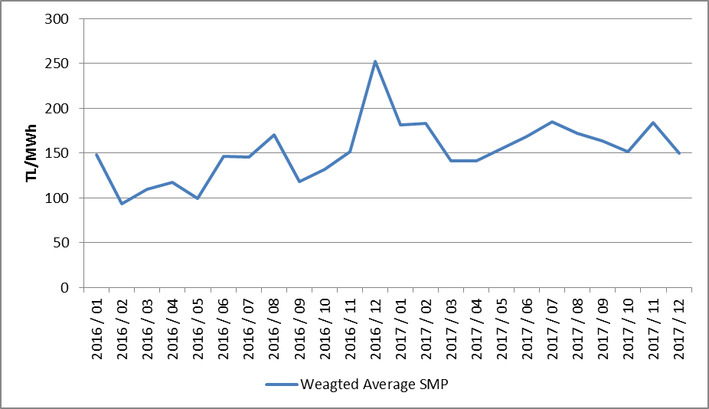
Below Figure 2.2.4 shows monthly trading volumes in BPM in 2017.

Figure 2.2.4: Monthly Trading Volumes in Balancing Power Market (MWh)
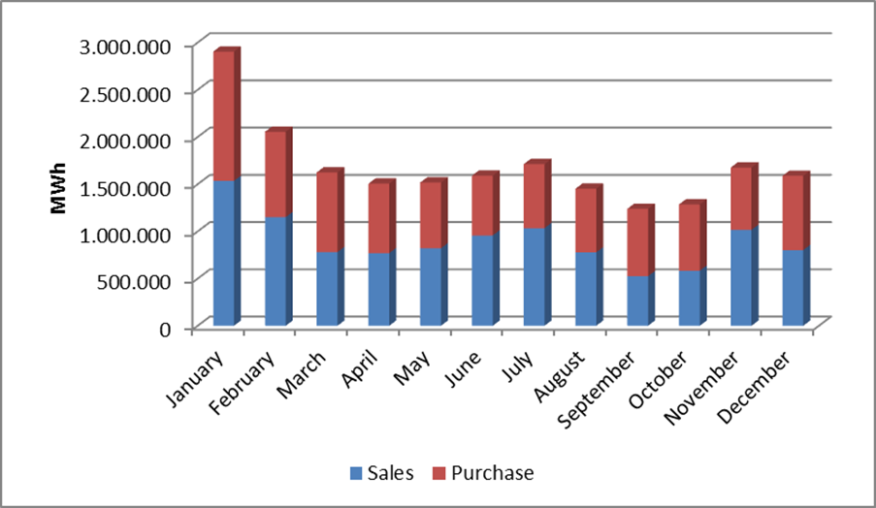
In the following Figure 2.2.5 the distribution of the BPM buying quantities on the basis of the company and the share of the top 10 buyer companies and in Figure 2.2.6, the distribution of BPM sales quantities on company basis and the share of the top 10 companies are shown.

Figure 2.2.5: The Share of Top 10 Buyer Companies in Balancing Power Market (%)
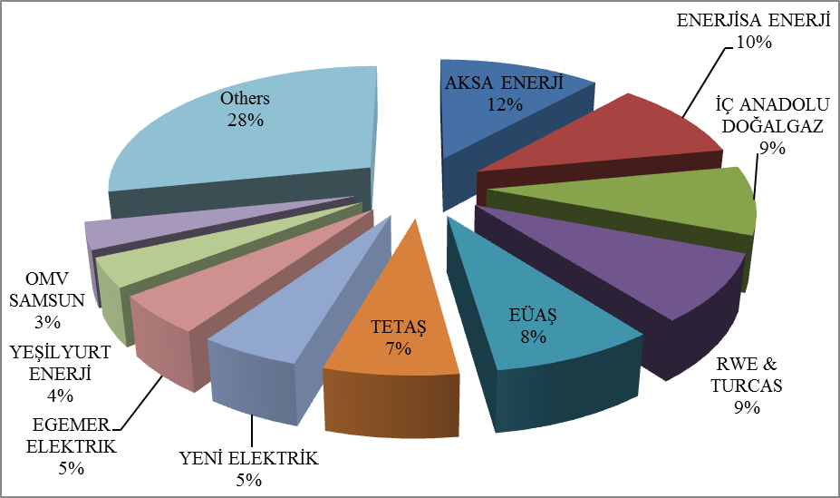

Figure 2.2.6: The Share of Top 10 Seller Companies in Balancing Power Market
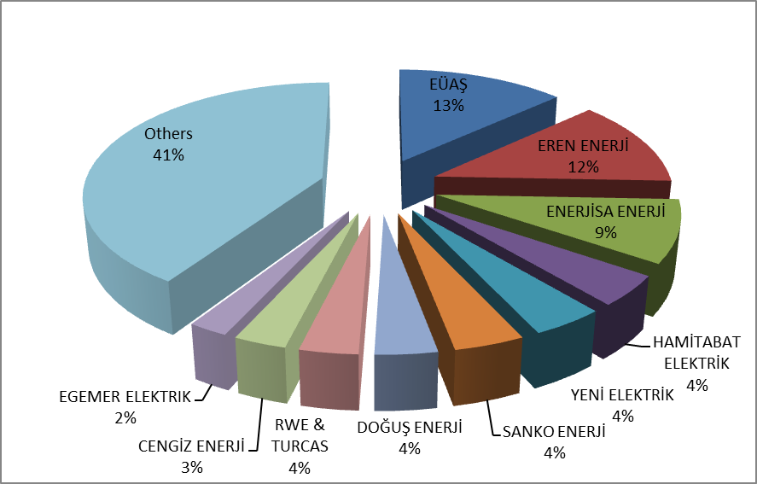(%)

The ratios of orders given in the BPM in 2017 are shown below in Figure 2.2.7, and on a per-hour basis in Figure 2.2.8. Loading orders constitute 58% of the total amount.

Figure 2.2.7: Rates of Order Volumes Given in Balancing Power Market in 2017 (%)
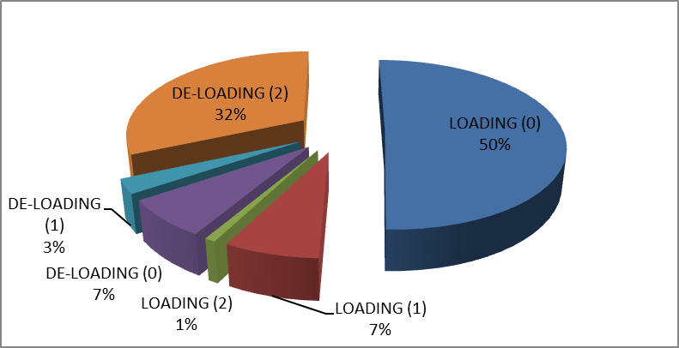

As shown in the figure, the 0-coded orders constitute 57% of the total amount. The remaining volume consists of 1 and 2 coded orders produced due to system requirements.

Figure 2.2.8: Distribution of the Orders Given in the Balancing Power Market by Hours in 2017 (MW)
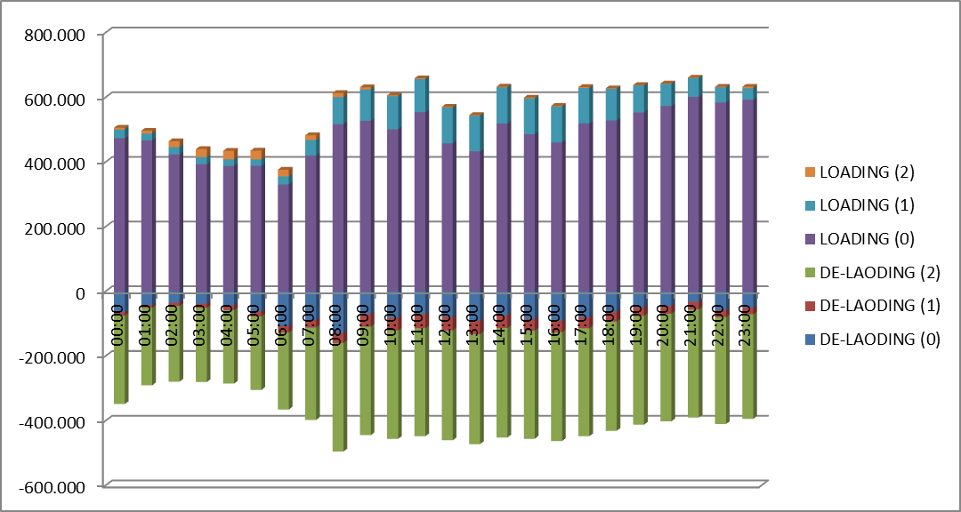
Additional costs arising from those orders are shown in Table 2.2.1 below. In 2017, the orders given in the BPM caused an additional cost of 884,16 million TL. About 44 % of these costs were 1 coded and the remaining 56 % were due to 2 coded orders.

Table.2.2.1: Additional Costs of Orders (Million TL)
Type of Instruction | Loading | De-Loading | Grand Total
1 Coded | 331,60 | 57,86 | 389,47
2 Coded | 28,69 | 466,01 | 494,70
Grand Total | 360,29 | 523,87 | 884,16

The development of additional costs occurred due to the given 1 and 2 coded orders in 2017 are shown in Figure 2.2.9 below.

Figure 2.2.9: Development of Additional Costs of Orders by Months in 2017 (Million TL)
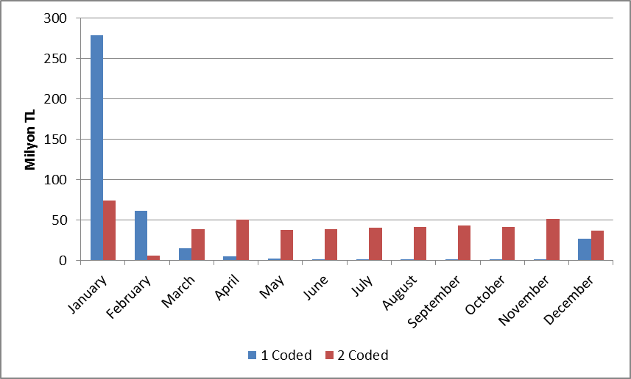

The development of the Zero Balance Adjustment Component (ZBAC) is shown in Figure 2.9.10. ZBAC decreased by 12,34 % to 1,24 billion TL compared to the previous year.

Figure 2.2.10: Development of Zero Balance Adjustment Component by Years (TL)
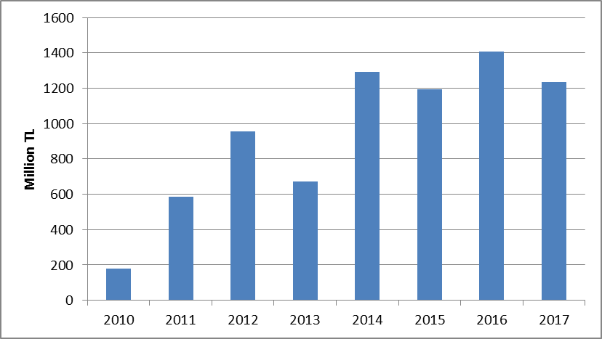

2.3 Intra-Day Market

Efforts are continuing to ensure that the Turkish Electricity Market is more transparent and efficient, financially strong, integrated with the European Union electricity markets. On 1 July 2015, the Intra-Day Market was in operation to ensure that participants in the Turkish electricity market, which is constantly evolving and advancing for free market, playing more balanced and effective role.
Day-Ahead, Ancillary Services and Balancing Power Markets currently in operation, with the addition of Intra-Day Market, provide real-time trading opportunities and offermarket participants the opportunity to manage short-term portfolios.
In Figure 2.3.1 below, monthly volume of the Intra-Day Market and the weighted average price in 2017 is given.

Figure 2.3.1: Monthly Development of Trading Volume and Average Price in the Intra-Day Market (MWh - TL / MWh)
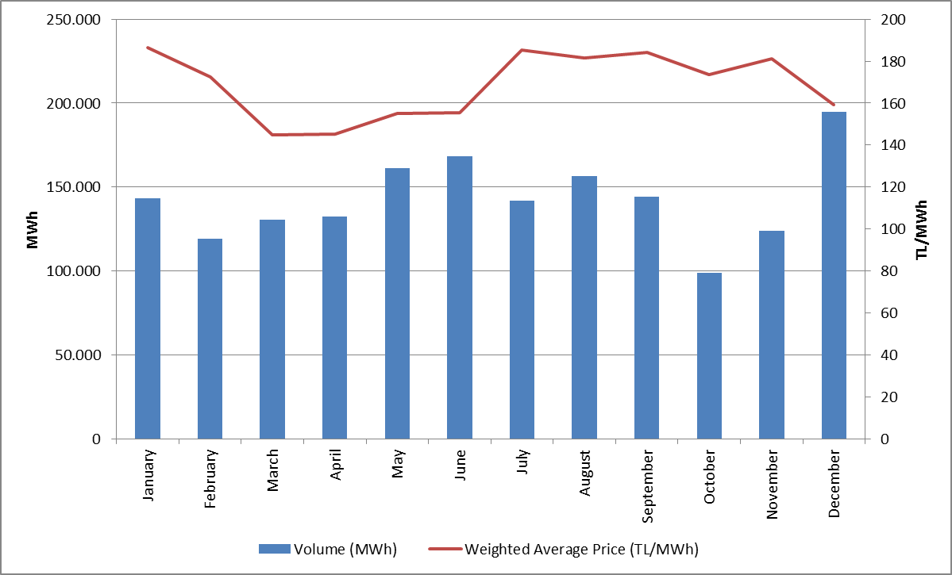
In Figure 2.3.2 the distribution of purchases of IDM on the basis of company and the share of first 10 companies and in Figure 2.3.3, the distribution of sales in IDM on the basis of the company and the share of top 10 seller companies are shown.

Figure 2.3.2: Distribution of Purchases of Intra-Day Market by Companies and the Share of Top 10 Companies (%)
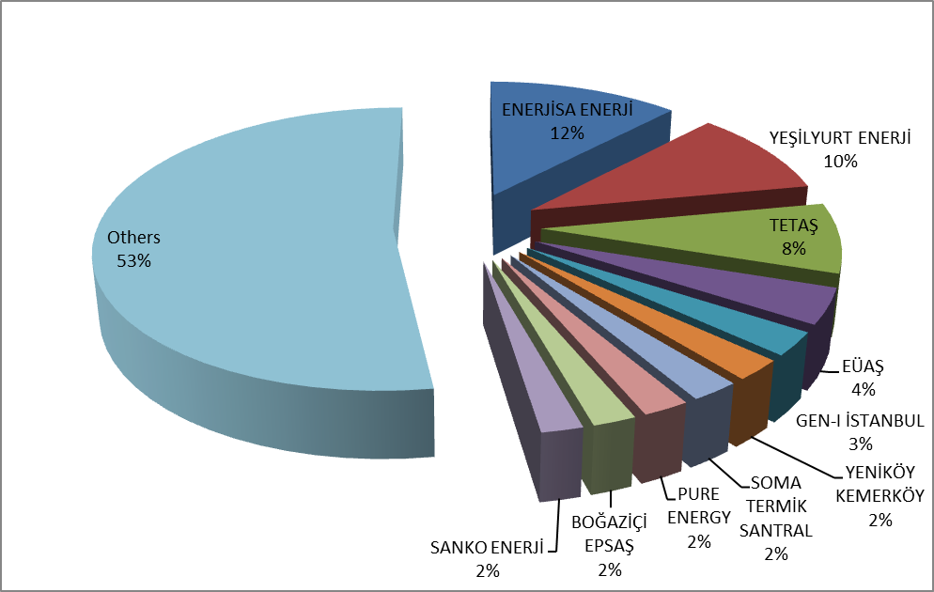

Figure 2.3.3: Distribution of Sales in Intra-Day Market by Companies and the Share of Top 10 Companies (%)
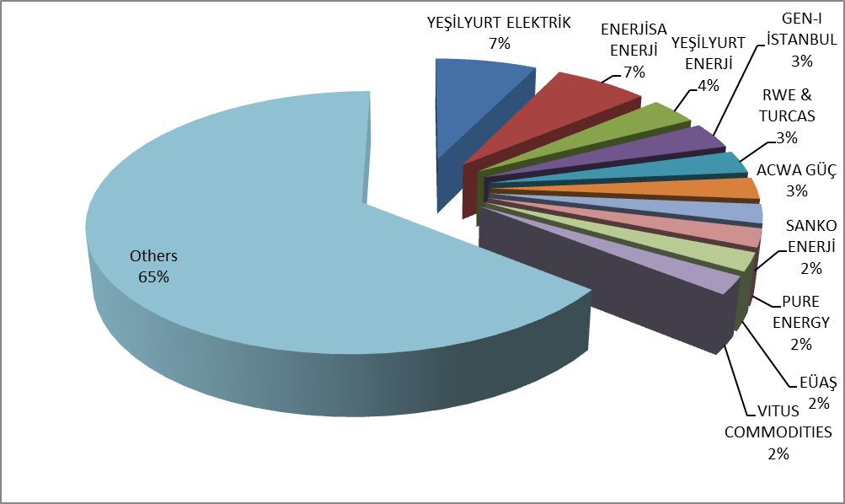

2.4 Bilateral Agreements

Bilateral agreements are based on the construction of the Turkish electricity market, and the other organized markets are designed in the figure complementing the market. Most of the energy traded in the market is traded on bilateral agreements. Bilateral agreements are free between market participants and are not subject to regulation. However, the majority of the existing bilateral agreement volume is the ones signed by TETAŞ with the incumbent supply companies. Distribution companies also have energy purchases from TETAŞ for losses and general lighting purposes under bilateral agreements.
In the following Figure 2.4.1 monthly bilateral agreement volumes in 2015-2017 are shown.

Figure 2.4.1: Monthly Bilateral Agreement Volume by Years (MWh)
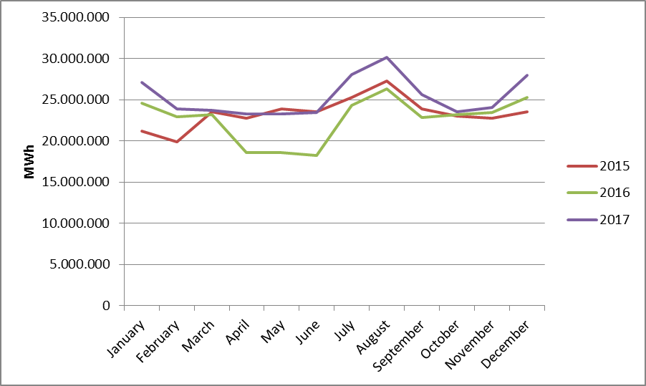

In the following Figure 2.4.2 the distribution of purchases with bilateral agreement on the basis of the company and the share of top 10 buyer companies and in Figure 2.4.3, the distribution of sales with bilateral agreement on the basis of the company and the share of top 10 seller companies are shown.

Figure 2.4.2: Distribution of Purchases of Bilateral Agreement by Companies and the Share of Top 10 Companies (%)
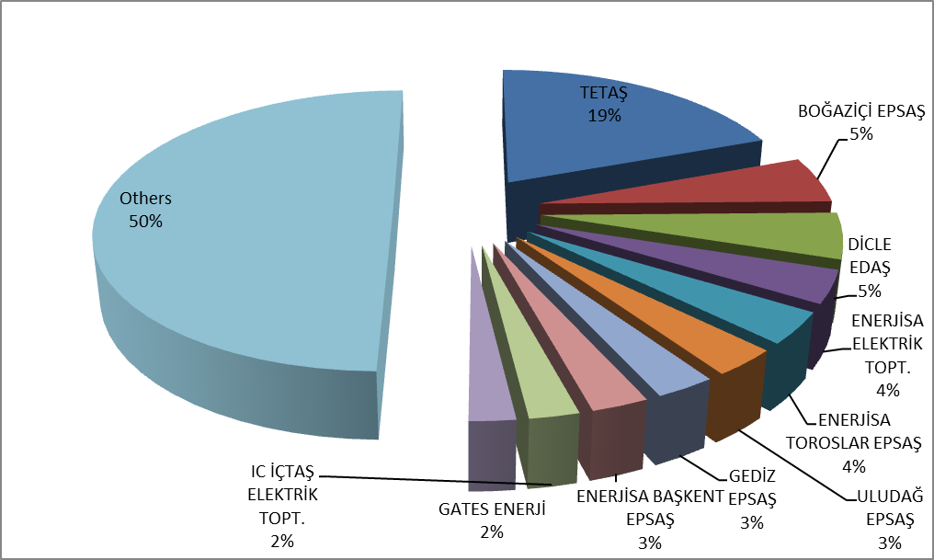

Figure 2.4.3: Distribution of Sales with Bilateral Agreement by Companies and the Share of Top 10 Companies (%)
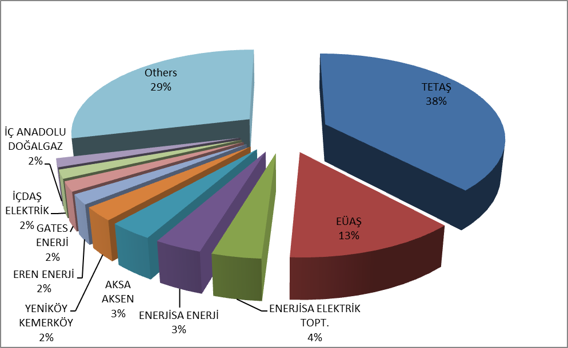

The wholesale tariffs of TETAŞ are determined by Board Decision and it is considered that TETAŞ fulfills its obligations arising from existing contracts. In the following Figure 2.4.4 the change in TETAŞ wholesale prices over periods are shown.

Figure 2.4.4: TETAŞ Wholesale Prices Between 2010-2017 (kr / kWh)
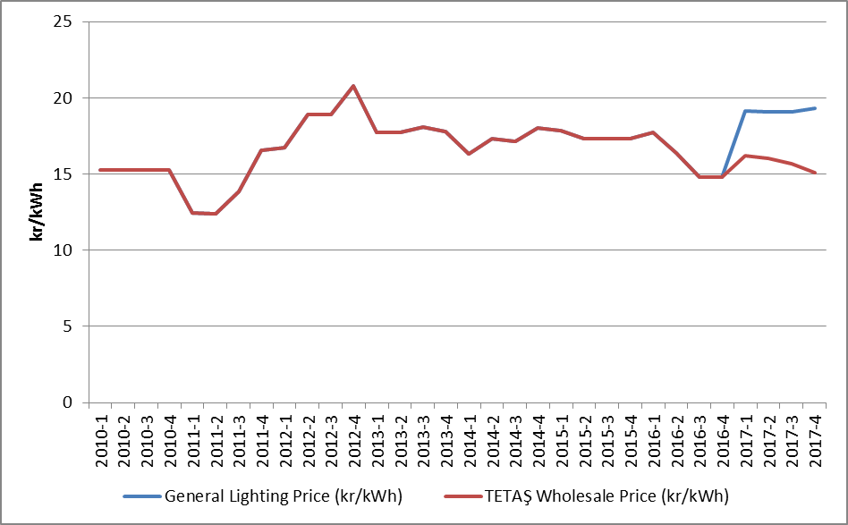

  - RES Support Mechanism

“The Amendment of the Law on “Utilization of Renewable Energy Resources for Generation of Electrical Energy” Law Numbered 6094 published in the Official Gazette dated 08/01/2011 and numbered 27809 provides incentive for renewable energy sources according to the source type and the locality rate. In this context, the regulations prepared by EMRA and the details Mechanism of Supporting Renewable Energy Sources are determined with the regulations prepared by EMRA.
“Regulation on Certification and Support of Renewable Energy Sources” was published in the Official Gazette dated 01/10/2013 and numbered 28782 and came into force. With the Regulation, in order to encourage the generation of electricity based on renewable energy sources, principles regarding the provision of Renewable Energy Source Document and the establishment and operation of RES Support Mechanismissued to the generation license holders.
In the following Table 2.5.1, the number of the RES Support Mechanism participants is given by years. In 2017, there were 647 companies with a total installed capacity of 17.399,94 MW operating in the scope of the RES Support Mechanism.

Table 2.5.1: Number of RES Support Mechanism Participants by Years
Type | 2011 | 2012 | 2013 | 2014 | 2015 | 2016 | 2017
Solar | - | - | - | - | - | - | 2
Hydraulic | 4 | 44 | 14 | 40 | 126 | 388 | 418
Wind | 9 | 22 | 3 | 21 | 60 | 106 | 141
Biomass | 3 | 8 | 15 | 23 | 34 | 42 | 57
Geothermal | 4 | 4 | 6 | 9 | 14 | 20 | 29
Total | 20 | 78 | 38 | 93 | 234 | 556 | 647

When the numbers are examined from Table 2.5.1, hydraulic plants had the highest share with 11.096,26 MW and wind plants following it with 5.238,70 MW.

Table 2.5.2: Installed Capacity of the RES Support Mechanism Participants by Years (MW) *
Type | 2011 | 2012 | 2013 | 2014 | 2015 | 2016 | 2017
Solar | - | - | - | - | - | - | 12,90
Hydraulic | 21 | 930 | 217 | 598 | 2.116,33 | 9.960,00 | 11.096,26
Wind | 469 | 685 | 76 | 825 | 2.732,14 | 4.319,83 | 5.238,70
Geothermal | 72 | 72 | 140 | 228 | 389,92 | 599,16 | 752,11
Biomass | 45 | 73 | 101 | 147 | 185,23 | 203,72 | 299,97
Total | 608 | 1.760 | 534 | 1.798 | 5.423,63 | 15.082,72 | 17.399,94

* In addition, by the end of 2017, all of unlicensed installed capacity of 3.173,32 MW is covered by RES Support Mechanism. Details are given at "Unlicensed Electricity Generation" in Section 1.3,
Share of installed capacity in the scope of the RES Support Mechanism in Turkey's total installed capacity in 2016 was 19,4%, while this share reached to 24,48 % in 2017.
In the following Figure 2.5.1, distribution of installed capacity based on sources in 2017 is given.

Figure 2.5.1: Distribution of Installed Capacity by Sources in 2017 (%)
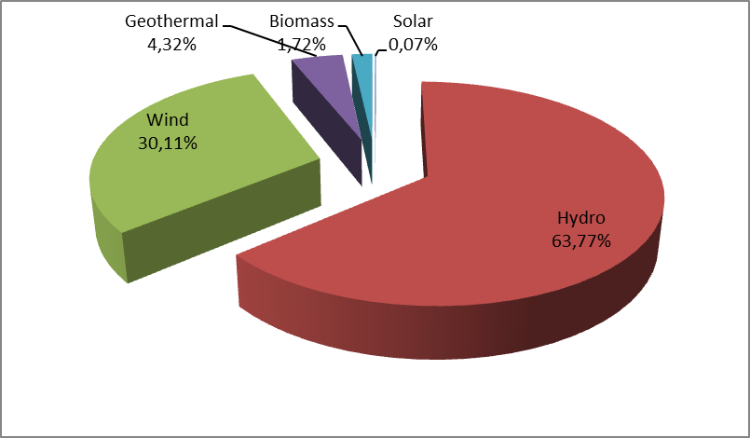
Development of the generation within the scope of RES Support Mechanism is shown at Table 2.5.3. Generation in 2017 increased by 10,18% and reached to 50,5 TWh.

Table 2.5.3: Yearly Generation of RES Support Mechanism Participants by years (MWh)*
Type | 2012 | 2013 | 2014 | 2015 | 2016 | 2017
Solar | - | - | - | - | - | 24.268
Unlicensed | - | - | - | 222.724 | 1.134.024 | 3.031.558
Hydraulic | 2.296.047 | 528.646 | 1.072.832 | 5.683.331 | 25.520.255 | 24.417.133
Wind | 2.081.745 | 234.000 | 2.378.819 | 8.275.992 | 14.163.403 | 16.765.418
Geothermal | 487.364 | 857.527 | 1.436.579 | 2.710.856 | 3.706.764 | 4.503.345
Biomass | 374.002 | 750.715 | 925.516 | 1.050.796 | 1.306.057 | 1.789.053
Total | 5.239.158 | 2.370.888 | 5.813.746 | 17.943.699 | 45.830.503 | 50.530.776

Distribution of generation in 2017 by source types is shown at Figure 2.5.2. The highest generation was obtained from hydro and wind power plants respectively.

Figure 2.5.2: Distribution of Generation in RES Support Mechanism by Sources in 2017
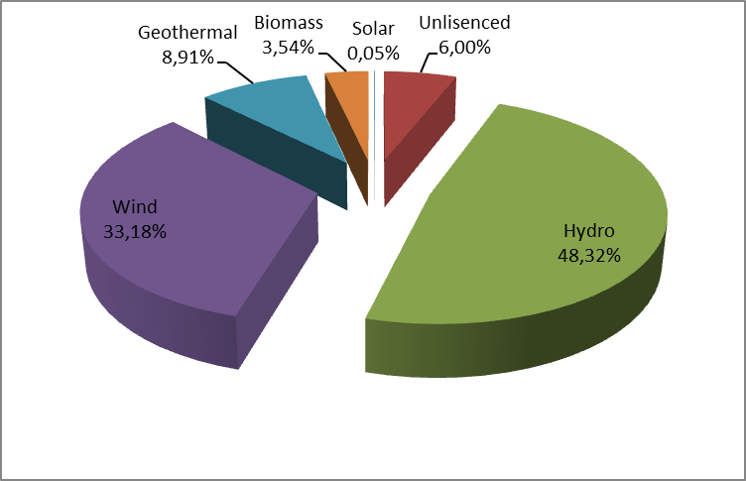
Share of the generation within the scope of the RES Support Mechanism in total generation was 17,26 % in 2017, while this ratio was 16,8 % in 2016.
Monthly development of the 2017 RES Support Mechanism is seen at Figure 2.5.3. Because of rainfalls in spring, hydraulic generation and therefore the generation of RES Support Mechanism increased. For other sources, more stable generation was realized during the year.

Figure 2.5.3: Monthly Development of RES Support Mechanism Generation in 2017 (MWh)
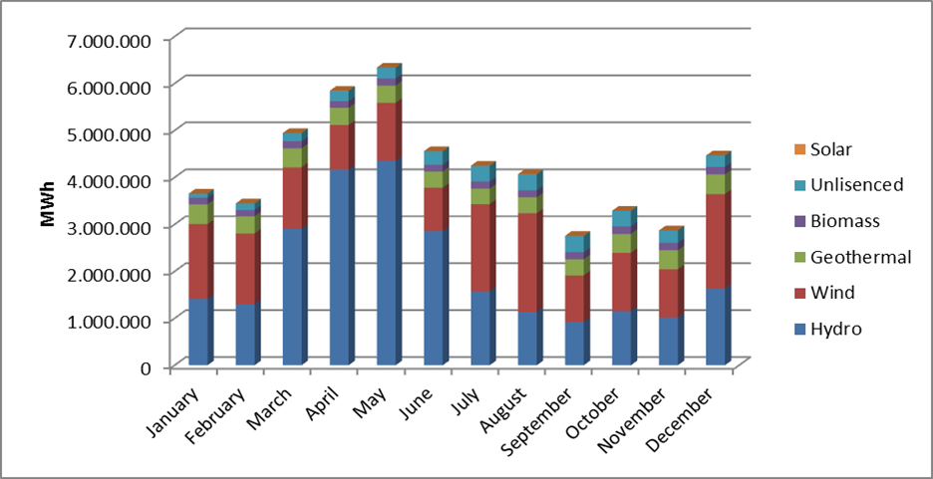
Figure 2.5.4, the monthly weighted average MCP and RES Support Mechanism feed-in tariffs are given for 2017.

Figure 2.5.4: Monthly Development of RES Support Mechanism Feed-in Tariffs and MCP in 2017 (MWh)
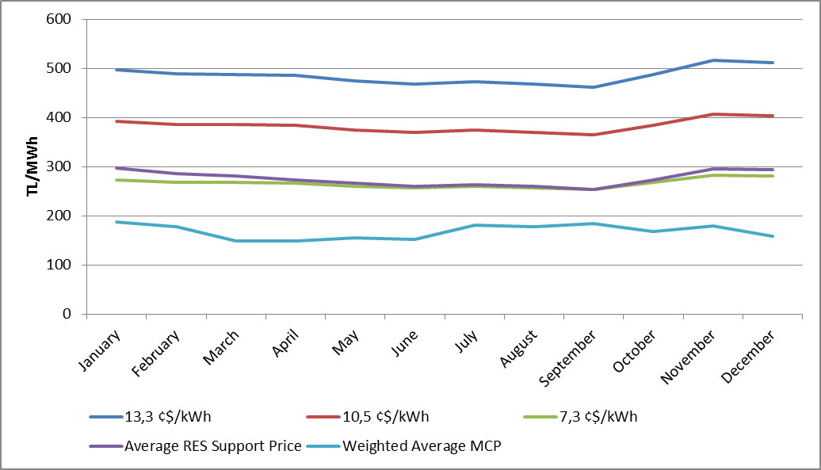
In the following Figure 2.5.5, feed-in tariffs in RES Support Mechanism are shown together with MCP. When the feed-in tariffs for RES Support Mechanism are compared with the monthly average MCP, it is observed that even the lowest incentive amount is realized above the MCP. The difference between the RES Support Mechanism price and the MCP is observed to enlarge in spring months.

Figure 2.5.5: Average of RES Support Mechanism and MCP in 2017 (Kr./kWh)
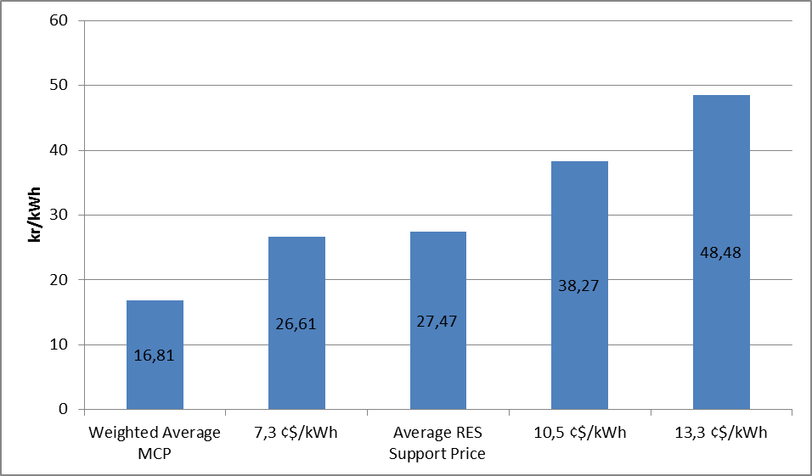
In Figure 2.5.6, monthly development of payments made within the scope of RES Support Mechanism.

Figure 2.5.6: Monthly Payments Made within the Scope of the RES Support Mechanism in 2017 (TL)
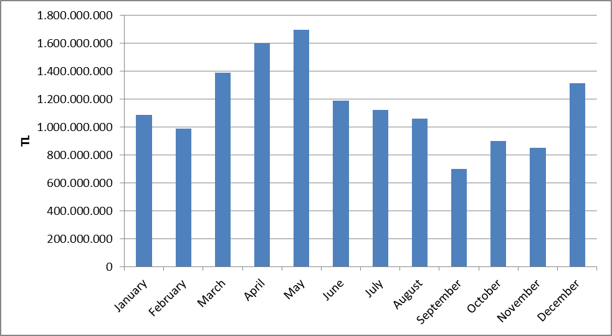
Figure given below shows the improvement of monthly additional cost of RES Support Mechanism per invoiced unit energy amount. In 2017, RES Support Mechanism additional cost increased by 26,62% and reached to 23,84 TL/MWh compared to previous year.

Figure 2.5.7 Monthly Improvement of Average RES Support Mechanism Additional Cost in 2017 (TL/MWh)
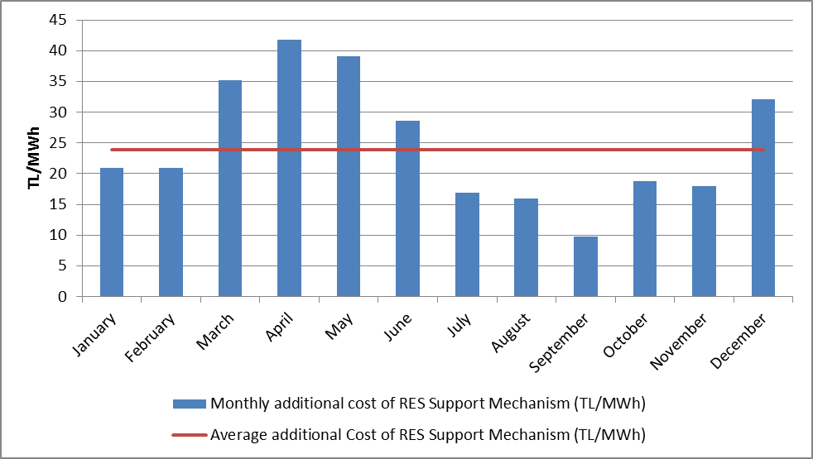

- COMPETITION

The main aim of the Electricity Market Law is to improve competition by creating an open market structure. Among the functions of the Authority, to prevent competition distruptions in the parts of the market open tocompetition by detecting the market power. EMRA also increases the number of consumers who can choose their supplier at the demand side by decreasing the eligible consumer limit for the following year at the end of each year. In this framework, development of supply and demand that open to negotiations on the wholesale market, are critical to the establishment of competition.

3.1 Supply Side

It is considered that open electricity markets provide the most effective investment and generation incentives theoretically and in practice. Nevertheless, it may be necessary to make regulations to ensure competition and supply security because of low level of flexibility of demand and incapability of network about energy storage. For this reason, these issues are also regulated by various countries and the European Union with various market share limits and mechanisms.
The indices used to follow the competition generally measure the supply side concentration in the market and the producers' ability to intervene. The HHI is used for measuring the market concentration with the addition of squares of market shares. The index can be calculated separately on generation and installed capacity.

Table 3.1: HHI Values by Generation and Capacity
 | HHI Values
 | Generation |  |  |  | Installed Capacity
Years | 2014 | 2015 | 2016 | 2017 | 2014 | 2015 | 2016 | 2017
EÜAŞ and TETAŞ separately | 1416 | 1123 | 673 | 696 | 1132 | 996 | 873 | 789
EÜAŞ and TETAŞ together | 2748 | 2153 | 1241 | 1276 | 1918 | 1645 | 1483 | 1345

As shown in Table 3.1 the HHI in 2017, which is based on generation and installed capacity, has decreased compared to the previous year. In addition, HHI which is depending on generation has slightly increased. With the completion of privatizations and the continuing expiration of existing contracts, the decrease in these index values is expected to continue.
The sales of supplier license holders to end-users are shown in Table 3.2. The HHI, which is calculated according to the supplier shares, was 375,54 in 2016. The value of 2017 was calculated as 437,5. Relevant rise of index value results from the share of the total sales of the 21 incumbent suppliers in the total sales volume of all the supply licensed companies was 79,37% in 2017, whereas 69,45 % in 2016. As known, the limit of the eligible consumer in the electricity market could not reach to zero yet. In other words, not all consumers in the market are eligible consumers. It is not legally possible for any supplier to sell energy to non-eligible consumers, except for incumbent supply companies. Therefore, in order to properly evaluate the competitive environment in the market of sales made to the final consumers, it is important that an environment in which all consumers are eligible and can provide energy from any supplier.

Table 3.2: Sales, Market Shares and HHI Values of Supply License Owners
Supply Company Title | Sales  (MWh) | Share  (%)
CK BOĞAZİÇİ ELEKTRİK PERAKENDE SATIŞ ANONİM ŞİRKETİ | 18.774.121,05 | 9,66
ENERJİSA TOROSLAR ELEKTRİK PERAKENDE SATIŞ ANONİM ŞİRKETİ | 16.105.233,41 | 8,29
LİMAK ULUDAĞ ELEKTRİK PERAKENDE SATIŞ ANONİM ŞİRKETİ | 12.805.465,72 | 6,59
GEDİZ ELEKTRİK PERAKENDE SATIŞ ANONİM ŞİRKETİ | 11.826.051,15 | 6,08
SAKARYA ELEKTRİK PERAKENDE SATIŞ ANONİM ŞİRKETİ | 10.561.280,43 | 5,43
ENERJİSA BAŞKENT ELEKTRİK PERAKENDE SATIŞ ANONİM ŞİRKETİ | 10.029.911,61 | 5,16
AYDEM ELEKTRİK PERAKENDE SATIŞ ANONİM ŞİRKETİ | 9.998.134,33 | 5,14
ENERJİSA İSTANBUL ANADOLU YAKASI ELEKTRİK PERAKENDE SATIŞ A.Ş. | 8.716.613,99 | 4,48
DİCLE ELEKTRİK PERAKENDE SATIŞ ANONİM ŞİRKETİ | 7.768.951,33 | 4,00
CK AKDENİZ ELEKTRİK PERAKENDE SATIŞ ANONİM ŞİRKETİ | 7.046.519,03 | 3,63
MERAM ELEKTRİK PERAKENDE SATIŞ ANONİM ŞİRKETİ | 6.752.656,18 | 3,47
OSMANGAZİ ELEKTRİK PERAKENDE SATIŞ ANONİM ŞİRKETİ | 5.945.767,39 | 3,06
TRAKYA ELEKTRİK PERAKENDE SATIŞ ANONİM ŞİRKETİ | 5.880.350,81 | 3,03
YEŞİLIRMAK ELEKTRİK PERAKENDE SATIŞ ANONİM ŞİRKETİ | 5.110.965,01 | 2,63
AKEDAŞ ELEKTRİK PERAKENDE SATIŞ ANONİM ŞİRKETİ | 4.431.892,81 | 2,28
IC İÇTAŞ ELEKTRİK TOPTAN SATIŞ VE TİCARET ANONİM ŞİRKETİ | 3.041.997,24 | 1,56
AKSA ELEKTRİK SATIŞ ANONİM ŞİRKETİ | 2.761.459,19 | 1,42
KAYSERİ ELEKTRİK PERAKENDE SATIŞ ANONİM ŞİRKETİ | 2.759.901,50 | 1,42
ÇORUH ELEKTRİK PERAKENDE SATIŞ ANONİM ŞİRKETİ | 2.650.888,90 | 1,36
CK ÇAMLIBEL ELEKTRİK PERAKENDE SATIŞ ANONİM ŞİRKETİ | 2.561.691,36 | 1,32
YAĞMUR GROUP ELEKTRİK ENERJİSİ TOPTAN SATIŞ ANONİM ŞİRKETİ | 2.229.350,07 | 1,15
CENGİZ ELEKTRİK TOPTAN SATIŞ A.Ş. | 2.138.030,32 | 1,10
FIRAT ELEKTRİK PERAKENDE SATIŞ ANONİM ŞİRKETİ | 2.075.596,17 | 1,07
DOĞUŞ ENERJİ TOPTAN ELEKTRİK TİC.AŞ. | 1.627.753,18 | 0,84
ZORLU ELEKTRİK ENERJİSİ İTHALAT, İHRACAT VE TOPTAN TİCARET A.Ş. | 1.610.858,16 | 0,83
EREN ELEKTRİK ENERJİSİ TOPTAN SATIŞ ANONİM ŞİRKETİ | 1.524.382,97 | 0,78
DOĞRUDAN ELEKTRİK ENERJİSİ TOPTAN SATIŞ VE TEDARİK A.Ş | 1.514.517,69 | 0,78
ARAS ELEKTRİK PERAKENDE SATIŞ ANONİM ŞİRKETİ | 1.253.388,41 | 0,64
TÜRKERLER VANGÖLÜ ELEKTRİK PERAKENDE SATIŞ ANONİM ŞİRKETİ | 1.216.819,68 | 0,63
ZEEMA ELEKTRİK ENERJİSİ TOPTAN SATIŞ ANONİM ŞİRKETİ | 1.194.869,37 | 0,61
TTES ELEKTRİK SATIŞ ANONİM ŞİRKETİ | 1.056.104,26 | 0,54
AYEN ELEKTRİK TİCARET ANONİM ŞİRKETİ | 973.337,40 | 0,50
ODAŞ ELEKTRİK PERAKENDE SATIŞ ANONİM ŞİRKETİ | 940.946,69 | 0,48
MERAM ELEKTRİK ENERJİSİ TOPTAN SATIŞ ANONİM ŞİRKETİ | 863.541,75 | 0,44
SARI PERAKENDE ENERJİ SATIŞ VE TİCARET ANONİM ŞİRKETİ | 836.996,32 | 0,43
TÜRKİYE ELEKTRİK TİCARET VE TAAHHÜT ANONİM ŞİRKETİ | 791.691,43 | 0,41
2M ENERJİ TOPTAN ELEKTRİK TİCARET ANONİM ŞİRKETİ | 784.625,24 | 0,40
KOLEN ELEKTRİK TOPTAN SATIŞ İTH. VE İHR. ANONİM ŞİRKETİ | 731.051,28 | 0,38
ELTEK ELEKTRİK ENERJİSİ İTHALAT İHRACAT VE TOPTAN TİCARET A.Ş | 627.534,97 | 0,32
GATES ENERJİ TİCARET ANONİM ŞİRKETİ | 596.292,22 | 0,31
ÇELİKLER ELEKTRİK ENERJİ TOPTAN SATIŞ ANONİM ŞİRKETİ | 595.771,20 | 0,31
TOSYALI ELEKTRİK ENERJİSİ TOPTAN SATIŞ İTHALAT İHRACAT A.Ş. | 582.681,15 | 0,30
OMV ENERJİ TİCARET ANONİM ŞİRKETİ | 556.215,06 | 0,29
ÜRÜNDÜL ELEKTRİK ENERJİSİ TOPTAN SATIŞ ANONİM ŞİRKETİ | 511.392,18 | 0,26
ENERJİM PERAKENDE ENERJİ TİCARET ANONİM ŞİRKETİ | 500.454,94 | 0,26
KET KİPAŞ ELEKTRİK ENERJİSİ TOPTAN SATIŞ TİCARET ANONİM ŞİRKETİ | 499.653,20 | 0,26
RÖNESANS ELEKTRİK ENERJİ TOPTAN SATIŞ ANONİM ŞİRKETİ | 444.117,63 | 0,23
LİMAK ENERJİ TİCARETİ ANONİM ŞİRKETİ | 432.354,40 | 0,22
D TES ELEKTRİK ENERJİSİ TOPTAN SATIŞ ANONİM ŞİRKETİ | 427.845,21 | 0,22
UNİT ELEKTRİK ENERJİSİ TOPTAN SATIŞ İHRACAT VE İTHALAT A.Ş. | 427.742,03 | 0,22
AXPO TURKEY ENERJİ ANONİM ŞİRKETİ | 425.583,05 | 0,22
EKSİM ELEKTRİK ENERJİSİ İTHALAT, İHRACAT VE TOPTAN SATIŞ A.Ş. | 419.116,50 | 0,22
BOSEN ELEKTRİK ENERJİSİ TOPTAN SATIŞ ANONİM ŞİRKETİ | 382.524,40 | 0,20
İPRAGAZ ANONİM ŞİRKETİ | 358.435,43 | 0,18
BORDO ELEKTRİK ENERJİSİ TOPTAN SATIŞ ANONİM ŞİRKETİ | 357.784,25 | 0,18
FİNA ELEKTRİK ENERJİSİ İTHALAT İHRACAT VE TOPTAN SATIŞ A.Ş | 352.734,44 | 0,18
OZAN ELEKTRİK ENERJİSİ İTH. İHR. VE TOPTAN TİCARET ANONİM ŞİRKETİ | 352.385,46 | 0,18
SÜPER ELEKTRİK ENERJİSİ TOPTAN SATIŞ ANONİM ŞİRKETİ | 332.474,21 | 0,17
EWE ENERJİ ANONİM ŞİRKETİ | 322.864,57 | 0,17
KGM ENERJİ TİCARET LİMİTED ŞİRKETİ | 311.122,68 | 0,16
MARMARA ELEKTRİK ENERJİSİ İTHALAT İHRACAT VE TOPTAN TİC. A.Ş. | 306.548,54 | 0,16
ŞİŞECAM ENERJİ ANONİM ŞİRKETİ | 273.216,46 | 0,14
AVEL AVRUPA ELEKTRİK ENERJİSİ TOPTAN SATIŞ ANONİM ŞİRKETİ | 270.509,82 | 0,14
BALKAYA ENERJİ TOPTAN SATIŞ ANONİM ŞİRKETİ | 245.558,38 | 0,13
YETAŞ YILDIRIM ENERJİ TEDARİK A.Ş. | 244.364,59 | 0,13
DOEL ELEKTRİK ENERJİSİ TOPTAN SATIŞ ANONİM ŞİRKETİ | 220.302,90 | 0,11
ENERYA ELEKTRİK TİCARET ANONİM ŞİRKETİ | 217.498,86 | 0,11
AKFEN ELEKTRİK ENERJİSİ TOPTAN SATIŞ ANONİM ŞİRKETİ | 211.958,40 | 0,11
AYCAN TOPTAN ELEKTRİK TİCARET ANONİM ŞİRKETİ | 208.755,78 | 0,11
BATIÇİM ENERJİ TOPTAN SATIŞ ANONİM ŞİRKETİ | 202.574,38 | 0,10
ATA ELEKTRİK ENERJİSİ TOPTAN SATIŞ ANONİM ŞİRKETİ | 196.036,15 | 0,10
AGE ELEKTRİK ENERJİSİ TOPTAN SATIŞ ANONİM ŞİRKETİ | 179.150,07 | 0,09
ENKO ENERJİ SANAYİ VE TİCARET ANONİM ŞİRKETİ | 175.114,32 | 0,09
SOYAK ENERJİ TİCARET ANONİM ŞİRKETİ | 173.137,98 | 0,09
YEŞİLYURT ELEKTRİK ENERJİSİ TOPTAN SATIŞ VE İTHALAT İHRACAT A.Ş. | 154.850,72 | 0,08
ENOVA ELEKTRİK ENERJİSİ TOPTAN SATIŞ ANONİM ŞİRKETİ. | 139.516,13 | 0,07
ELEKTRA ENERJİ TOPTAN SATIŞ VE İTHALAT İHRACAT ANONİM ŞİRKETİ | 128.897,42 | 0,07
EOS ELEKTRİK ENERJİSİ TOPTAN SATIŞ ANONİM ŞİRKETİ | 125.466,41 | 0,06
YAREN GRUP ELEKTRİK ENERJİSİ TOPTAN SATIŞ ANONİM ŞİRKETİ | 115.558,44 | 0,06
HALİS ELEKTRİK ENERJİSİ TOPTAN SATIŞ VE İTH. İHR. ANONİM ŞİRKETİ | 115.277,97 | 0,06
DOĞAN KENT ELEKTRİK ENERJİSİ TOPTAN SATIŞ ANONİM ŞİRKETİ | 103.356,12 | 0,05
PALPORT ELEKTRİK TİCARET ANONİM ŞİRKETİ | 88.980,89 | 0,05
ENSAT ELEKTRİK ENERJİSİ TEDARİK TİCARET ANONİM ŞİRKETİ | 82.070,74 | 0,04
AVEM ELEKTRİK ENERJİSİ TOPTAN SATIŞ ANONİM ŞİRKETİ | 80.941,51 | 0,04
TENERA ENERJİ TİCARET ANONİM ŞİRKETİ | 80.636,73 | 0,04
ORTADOĞU ELEKTRİK ENERJİSİ TOPTAN SATIŞ A.Ş. | 73.877,50 | 0,04
BON ELEKTRİK TEDARİK İTHALAT İHRACAT ANONİM ŞİRKETİ | 64.356,17 | 0,03
MAC ELEKTRİK ENERJİSİ TOPTAN SATIŞ ANONİM ŞİRKETİ | 60.001,44 | 0,03
FİDES ELEKTRİK ENERJİSİ TOPTAN ALIŞ SATIŞ ANONİM ŞİRKETİ | 59.160,64 | 0,03
İÇDAŞ ELEKTRİK ENERJİSİ TOPTAN SATIŞ İTHALAT VE İHRACAT A.Ş. | 57.211,11 | 0,03
TEKİN ELEKTRİK ENERJİSİ TEDARİK TOPTAN SATIŞ İTHALAT İHRACAT A.Ş. | 50.981,28 | 0,03
DOASAN ENERJİ TOPTAN SATIŞ LİMİTED ŞİRKETİ | 50.851,43 | 0,03
TİNMAR ENERJİ TİCARET LİMİTED ŞİRKETİ | 50.161,98 | 0,03
YKS ELEKTRİK ENERJİSİ TOPTAN SATIŞ DIŞ TİCARET LİMİTED ŞİRKETİ | 49.819,39 | 0,03
COREN ELEKTRİK ENERJİSİ İTHALAT İHRACAT VE TOPTAN SATIŞ A.Ş. | 48.972,36 | 0,03
TRANSPOWER ENERJİ ELEKTRİK TOPTAN SATIŞ ANONİM ŞİRKETİ | 45.567,17 | 0,02
ATEK ELEKTRİK ENERJİSİ TOPTAN SATIŞ ANONİM ŞİRKETİ | 45.064,14 | 0,02
CFC ELEKTRİK ENERJİSİ TOPTAN SATIŞ ANONİM ŞİRKETİ | 43.470,45 | 0,02
KİBAR ENERJİ ANONİM ŞİRKETİ | 43.403,18 | 0,02
SEDSAL ELEKTRİK ENERJİSİ TOPTAN SATIŞ LİMİTED ŞİRKETİ | 41.286,89 | 0,02
VOLTAN ELEKTRİK TOPTAN SATIŞ İTHALAT VE İHRACAT ANONİM ŞİRKETİ | 39.271,07 | 0,02
KİNESİS TOPTAN ELEKTRİK SATIŞI ANONİM ŞİRKETİ | 38.538,04 | 0,02
CAN ENERJİ TOPTAN ELEKTRİK TİCARET ANONİM ŞİRKETİ | 37.504,83 | 0,02
İMC ELEKTRİK ENERJİSİ TOPTAN SATIŞ İTHALAT İHRACAT LİMİTED ŞİRKETİ | 37.186,30 | 0,02
TESAŞ ELEKTRİK ENERJİSİ TOPTAN SATIŞ ANONİM ŞİRKETİ | 31.217,00 | 0,02
BARA ENERJİ TOPTAN TİCARET ANONİM ŞİRKETİ | 30.880,44 | 0,02
EG ELEKTRİK ENERJİSİ TOPTAN SATIŞ ANONİM ŞİRKETİ | 26.170,41 | 0,01
AKS GRUP ELEKTRİK ENERJİSİ TOPTAN ALIŞ VE SATIŞ LİMİTED ŞİRKETİ | 25.672,98 | 0,01
KIVANÇ ELEKTRİK TOPTAN SATIŞ ANONİM ŞİRKETİ | 23.017,81 | 0,01
EKO GRUP ELEKTRİK TİCARET ANONİM ŞİRKETİ | 22.676,48 | 0,01
ENGİE ENERJİ TİCARET VE PAZARLAMA ANONİM ŞİRKETİ | 21.384,07 | 0,01
ŞEMS ENERJİ ELEKTRİK EN. TOPT. SATIŞ İTH. İHR. SANAYİ VE TİC. LTD. ŞTİ. | 18.852,62 | 0,01
BİR ENERJİ ELEKTRİK TOPTAN SATIŞ İTHALAT İHRACAT ANONİM ŞİRKETİ | 18.007,79 | 0,01
SHELL ENERJİ ANONİM ŞİRKETİ | 17.575,58 | 0,01
METRO GRUP ELEKTRİK ENERJİSİ TOPTAN SATIŞ ANONİM ŞİRKETİ | 15.684,52 | 0,01
CS ULUSLARARASI ELEKTRİK ENERJİSİ TOPTAN SATIŞ A.Ş. | 15.150,23 | 0,01
Pİ ENERJİ ELEKTRİK TOPTAN SATIŞ ANONİM ŞİRKETİ | 14.542,54 | 0,01
PARK TOPTAN ELEKTRİK ENERJİSİ SATIŞ SANAYİ VE TİCARET A.Ş. | 14.415,19 | 0,01
ARSET ELEKTRİK TEDARİK ANONİM ŞİRKETİ | 12.531,59 | 0,01
ADB ELEKTRİK ENERJİSİ TOPTAN SATIŞ LİMİTED ŞİRKETİ | 12.020,19 | 0,01
PROPER ELEKTRİK İTHALAT İHRACAT TOPTAN SATIŞ ANONİM ŞİRKETİ | 9.317,95 | 0,00
VTC ENERJİ ANONİM ŞİRKETİ | 8.978,75 | 0,00
ÜNDEM ELEKTRİK ENERJİSİ TOPTAN SATIŞ TİCARET A.Ş. | 8.101,17 | 0,00
EAG ELEKTRİK ENERJİSİ TOPTAN SATIŞI ANONİM ŞİRKETİ | 6.168,14 | 0,00
ASYA ELEKTRİK ENERJİSİ TOPTAN SATIŞ ANONİM ŞİRKETİ | 5.633,33 | 0,00
BİSEN ELEKTRİK SATIŞ ANONİM ŞİRKETİ | 5.341,76 | 0,00
HGÇ TOPTAN EL. EN. TİCARET ANONİM ŞİRKETİ | 3.530,62 | 0,00
NYK ELEKTRİK ENERJİSİ TOPTAN SATIŞ ANONİM ŞİRKETİ | 3.260,62 | 0,00
İDEAL PERAKENDE ELEKTRİK SATIŞ ANONİM ŞİRKETİ | 3.131,79 | 0,00
EE ELEKTRİK ENERJİSİ TOPTAN SATIŞ ANONİM ŞİRKETİ | 2.796,42 | 0,00
AKENERJİ ELEKTRİK ENERJİSİ İTHALAT İHRACAT VE TOPTAN TİCARET A.Ş. | 2.634,72 | 0,00
TÜRKMEN İN ALTIN ASRI ELEKTRİK ENERJİ TOPTAN SATIŞ A.Ş. | 2.533,55 | 0,00
AKSA AKSEN ENERJİ TİCARETİ A.Ş. | 2.039,04 | 0,00
ESKO ELEKTRİK ENERJİSİ İTHALAT İHRACAT VE TOPTAN SATIŞ A.Ş. | 1.955,12 | 0,00
FREKANS ELEKTRİK ENERJİSİ TOPTAN SATIŞ İTH. İHR. ANONİM ŞİRKETİ | 1.862,06 | 0,00
HİDİV ELEKTRİK ENERJİSİ TOPTAN SATIŞ ANONİM ŞİRKETİ | 1.679,82 | 0,00
EKODAŞ ELEKTRİK İTHALAT İNRACAT VE TOPTAN SATIŞ ANONİM ŞİRKETİ | 1.226,56 | 0,00
TURKCELL ENERJİ ÇÖZÜMLERİ VE ELEKTRİK SATIŞ TİCARET A.Ş. | 407,37 | 0,00
SETEL ELEKTRİK ENERJİSİ İHR.İTH. VE TOPTAN SATIŞ ANONİM ŞİRKETİ | 373,50 | 0,00
ALEN ALARKO ENERJİ TİCARET ANONİM ŞİRKETİ | 292,09 | 0,00
ENERJİSA ELEKTRİK ENERJİSİ TOPTAN SATIŞ ANONİM ŞİRKETİ | 264,58 | 0,00
PEKER ELEKTRİK ENERJİSİ TOPTAN SATIŞ ANONİM ŞİRKETİ | 20,39 | 0,00
Total | 194.379.105,89 | 100
HHI of Suppliers | 437,5

3.2 Demand Side

According to EMRA Board Decision 22/12/2016 dated and 6800 numbered eligible consumer limit was set as 2400 kWh for 2017. The theoretical market openness corresponding to the eligible consumer limit was calculated as 90%. The eligible consumer limit and the corresponding market openness rate over the years are given in Figure 3.1.

Figure 3.1: Eligible Consumer Limit and Market Openness Ratio by Years (kWh-%)
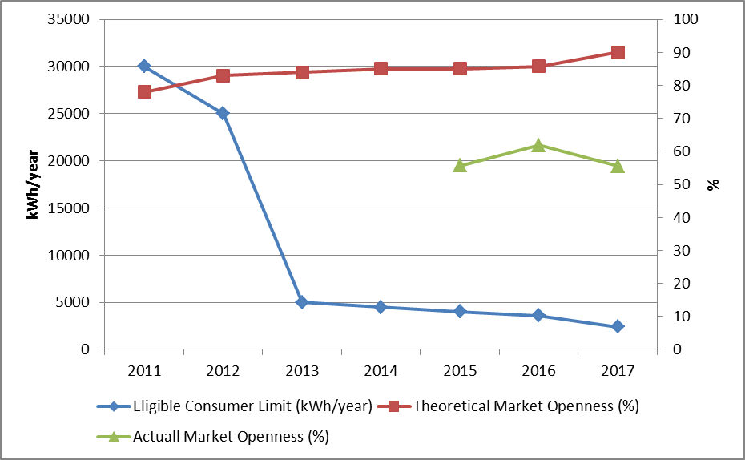

Although the theoretical market openness ratio is high, share of consumers using their rights coming from eligible consumer status in pratice was observed to be lower. Consumption of eligible consumers in 2017 was 125,26 TWh, which corresponds to approximately 55,5 % of total invoiced consumption.
The development of the number of eligible consumers in 2017 is shown in Figure 3.2.

Figure 3.2: Number of Eligible Consumer by Months in 2017 (Number)
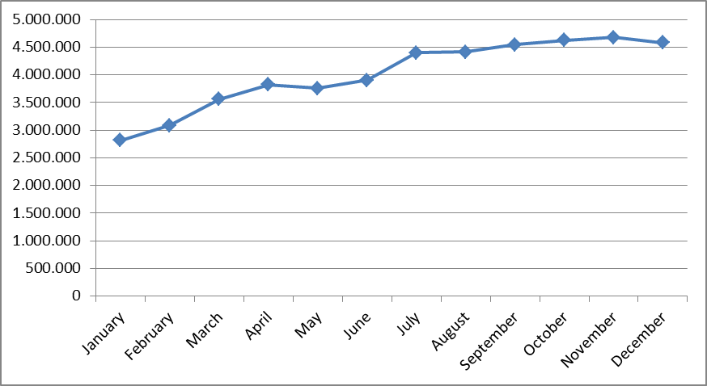
As of January 2016, the number of eligible consumer meters was 2 millions 48 thousands, which were increased by 123,6 % and reached to 4 millions 579 thousands by the end of 2017. This number corresponds to 10,77 % of the total number of consumer meters.
The number of eligible consumers on the basis of distribution regions is shown in Figure 3.3. When the graph is examined, it is seen that the biggest shares were of Boğaziçi, Gdz, Toroslar and Akdeniz regions respectively. The share of eligible consumers in these four regions was 49,67 % of the total number of eligible consumers in the country.

Figure 3.3: Distribution of Eligible Consumers by Distribution Regions by end of 2017 (Number)
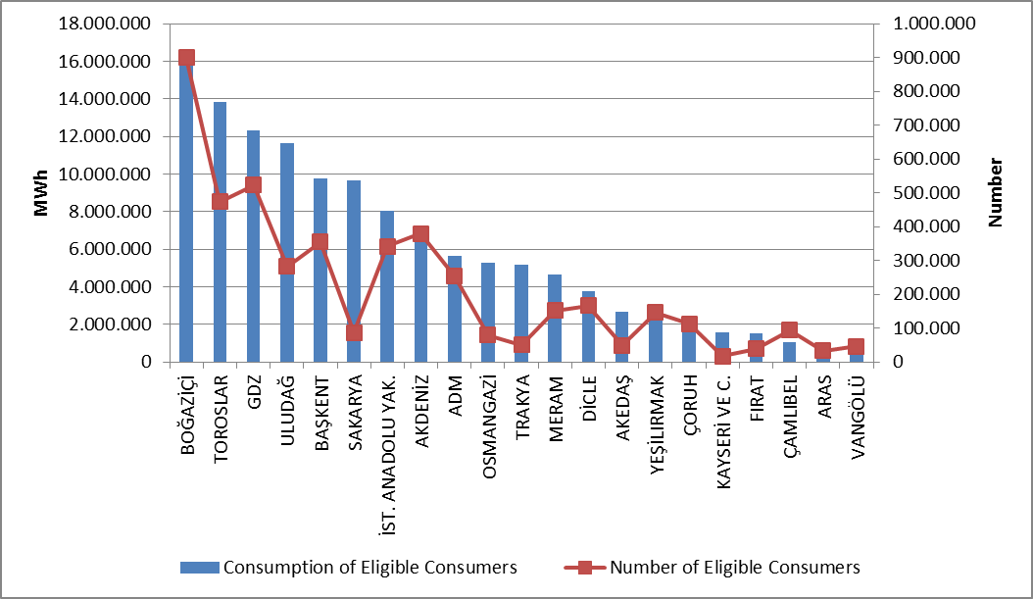

When the figure examined according to distrubition region, the four regions where eligible consumers had the highest consumption were Boğaziçi, Toroslar, GDZ and Uludağ distribution regions. Total consumption of eligible consumers in these regions constituted 44,08 % of the total eligible consumer consumption in the country.
Figure 3.4 below shows the distribution of eligible consumers’ consumption by supplier type. In 2017, the share of incumbent suppliers was increased compared to 2016, and the share of other suppliers was decreased.

Figure 3.4: Distribution of Eligible Consumer Consumption by Suppliers Type (%)
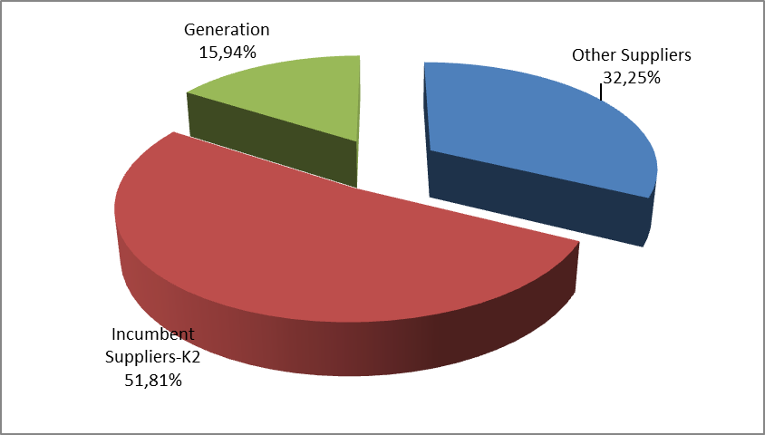
One of the important indicators for competition in the market is the number of eligible consumers switching their suppliers. In this frame, Figure 3.5 shows the monthly changes in the number of consumers switching supplier and their consumption.

Figure 3.5: Monthly Changes in Number and Consumptions of Eligible Consumers Switching Their Supplier (Number-MWh)
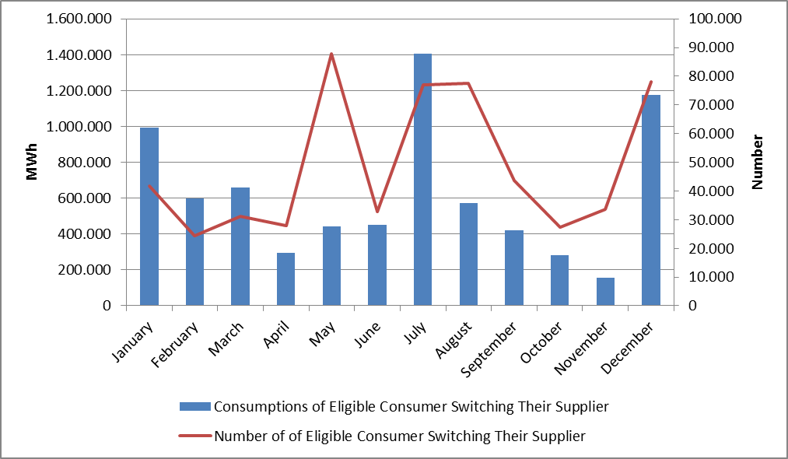
In 2017, the number of eligible consumers switched their suppliers was 583 thousands. The total consumption of eligible consumers switching suppliers was 7,44 TWh, which corresponds to 3,3 % of total invoiced consumption.
In the following Table 3.3 the number of eligible consumers that switch monthly supplier based on provinces is shown.

Table 3.3: The Monthly Distribution Number of Eligible Consumers Switching Their Supplier Based on Province
PROVINCE | January | February | March | April | May | June | July | August | September | October | November | December | Total
ADANA | 1.089 | 1.526 | 1.682 | 1.223 | 1.030 | 1.722 | 3.268 | 2.283 | 2.696 | 1.792 | 956 | 809 | 20.076
ADIYAMAN | 152 | 17 | 28 | 24 | 20 | 105 | 116 | 133 | 50 | 24 | 66 | 100 | 835
AFYONKARAHİSAR | 204 | 129 | 138 | 70 | 172 | 153 | 311 | 240 | 165 | 264 | 266 | 615 | 2.727
AĞRI | 47 | 29 | 31 | 47 | 44 | 99 | 64 | 18 | 14 | 97 | 10 | 144 | 644
AKSARAY | 181 | 119 | 775 | 49 | 52 | 42 | 58 | 41 | 88 | 58 | 76 | 64 | 1.603
AMASYA | 265 | 37 | 20 | 61 | 13 | 15 | 89 | 13 | 65 | 18 | 90 | 431 | 1.117
ANKARA | 3.287 | 1.662 | 1.920 | 1.720 | 1.551 | 3.126 | 3.609 | 2.997 | 3.744 | 2.625 | 1.013 | 1.426 | 28.680
ANTALYA | 1.110 | 813 | 956 | 738 | 382 | 1.373 | 1.688 | 13.081 | 1.368 | 1.071 | 1.220 | 4.674 | 28.474
ARDAHAN | 60 | 25 |  | 10 | 4 | 10 | 42 | 20 | 4 | 27 |  | 37 | 239
ARTVİN | 77 | 42 | 87 | 22 | 60 | 37 | 56 | 39 | 27 | 37 | 55 | 119 | 658
AYDIN | 1.763 | 1.346 | 182 | 1.800 | 494 | 455 | 3.772 | 791 | 1.049 | 310 | 720 | 356 | 13.038
BALIKESİR | 404 | 354 | 218 | 251 | 396 | 433 | 1.387 | 3.278 | 2.211 | 398 | 214 | 1.897 | 11.441
BARTIN | 70 | 78 | 41 | 31 | 44 | 85 | 113 | 83 | 78 | 59 | 24 | 51 | 757
BATMAN | 34 | 152 | 57 | 149 | 372 | 7 | 154 | 36 | 28 | 161 | 10 | 1.325 | 2.485
BAYBURT | 49 | 2 | 1 | 8 | 2 | 5 | 8 | 7 | 5 | 16 | 1 | 64 | 168
BİLECİK | 107 | 42 | 35 | 36 | 64 | 78 | 75 | 87 | 83 | 58 | 72 | 222 | 959
BİNGÖL | 125 | 21 | 59 | 77 | 51 | 31 | 48 | 170 | 27 | 25 | 21 | 32 | 687
BİTLİS | 68 | 53 | 268 | 10 | 188 | 1.111 | 25 | 77 | 233 | 11 | 326 | 190 | 2.560
BOLU | 254 | 17 | 99 | 33 | 113 | 51 | 93 | 91 | 92 | 31 | 61 | 109 | 1.044
BURDUR | 83 | 20 | 15 | 13 | 20 | 37 | 66 | 2.337 | 37 | 45 | 63 | 282 | 3.018
BURSA | 686 | 730 | 761 | 702 | 968 | 933 | 3.377 | 10.397 | 4.241 | 1.151 | 627 | 5.386 | 29.959
ÇANAKKALE | 357 | 211 | 147 | 117 | 184 | 143 | 402 | 1.584 | 1.480 | 110 | 99 | 677 | 5.511
ÇANKIRI | 68 | 17 | 43 | 38 | 44 | 58 | 64 | 46 | 83 | 68 | 15 | 88 | 632
ÇORUM | 209 | 27 | 11 | 32 | 30 | 9 | 114 | 103 | 32 | 22 | 171 | 520 | 1.280
DENİZLİ | 319 | 253 | 1.081 | 459 | 419 | 472 | 2.313 | 915 | 1.610 | 202 | 348 | 432 | 8.823
DİYARBAKIR | 141 | 189 | 159 | 28 | 1.353 | 63 | 356 | 106 | 32 | 533 | 27 | 5.008 | 7.995
DÜZCE | 358 | 81 | 189 | 32 | 178 | 59 | 98 | 132 | 119 | 78 | 163 | 148 | 1.635
EDİRNE | 315 | 43 | 174 | 95 | 16.105 | 122 | 104 | 152 | 133 | 63 | 66 | 101 | 17.473
ELAZIĞ | 233 | 67 | 123 | 234 | 179 | 81 | 317 | 132 | 104 | 64 | 177 | 568 | 2.279
ERZİNCAN | 153 | 34 | 14 | 79 | 27 | 38 | 72 | 94 | 48 | 53 | 12 | 206 | 830
ERZURUM | 115 | 39 | 48 | 85 | 37 | 169 | 175 | 34 | 81 | 74 | 9 | 319 | 1.185
ESKİŞEHİR | 321 | 132 | 184 | 479 | 240 | 250 | 280 | 367 | 229 | 218 | 440 | 506 | 3.646
GAZİANTEP | 563 | 694 | 699 | 503 | 690 | 1.449 | 1.493 | 2.018 | 1.544 | 1.281 | 865 | 1.401 | 13.200
GİRESUN | 123 | 161 | 94 | 88 | 118 | 41 | 92 | 75 | 29 | 71 | 181 | 157 | 1.230
GÜMÜŞHANE | 101 | 11 | 16 | 18 | 9 | 7 | 15 | 8 | 26 | 4 | 4 | 21 | 240
HAKKARİ | 41 | 48 | 89 | 4 | 80 | 813 | 40 | 5 | 137 | 1 | 2 | 104 | 1.364
HATAY | 204 | 423 | 966 | 328 | 489 | 717 | 672 | 781 | 894 | 633 | 276 | 317 | 6.700
IĞDIR | 40 | 16 | 11 | 31 | 6 | 34 | 58 | 13 | 17 | 29 | 8 | 97 | 360
ISPARTA | 274 | 54 | 24 | 25 | 19 | 34 | 68 | 1.077 | 34 | 40 | 33 | 318 | 2.000
İSTANBUL | 7.395 | 6.879 | 6.194 | 5.285 | 5.892 | 5.724 | 7.672 | 13.062 | 7.481 | 6.787 | 7.959 | 26.249 | 106.579
İZMİR | 5.846 | 1.460 | 1.078 | 5.886 | 942 | 2.901 | 18.050 | 8.851 | 2.734 | 2.146 | 7.709 | 1.840 | 59.443
KAHRAMANMARAŞ | 381 | 79 | 53 | 165 | 308 | 632 | 217 | 134 | 424 | 198 | 236 | 571 | 3.398
KARABÜK | 85 | 98 | 92 | 72 | 64 | 112 | 102 | 144 | 124 | 113 | 25 | 71 | 1.102
KARAMAN | 89 | 55 | 478 | 43 | 32 | 11 | 44 | 28 | 65 | 28 | 63 | 66 | 1.002
KARS | 92 | 22 | 38 | 49 | 8 | 67 | 85 | 19 | 26 | 54 | 5 | 138 | 603
KASTAMONU | 130 | 107 | 95 | 67 | 73 | 257 | 191 | 119 | 251 | 123 | 76 | 134 | 1.623
KAYSERİ | 444 | 137 | 109 | 232 | 100 | 207 | 941 | 248 | 142 | 212 | 302 | 281 | 3.355
KIRIKKALE | 65 | 90 | 65 | 37 | 45 | 102 | 93 | 82 | 112 | 60 | 38 | 180 | 969
KIRKLARELİ | 234 | 123 | 192 | 125 | 12.869 | 80 | 97 | 87 | 108 | 44 | 62 | 89 | 14.110
KIRŞEHİR | 58 | 22 | 81 | 36 | 26 | 18 | 21 | 40 | 12 | 18 | 25 | 40 | 397
KİLİS | 31 | 68 | 56 | 57 | 41 | 91 | 117 | 80 | 93 | 108 | 33 | 46 | 821
KOCAELİ | 1.682 | 177 | 615 | 178 | 531 | 214 | 373 | 493 | 286 | 317 | 401 | 485 | 5.752
KONYA | 745 | 616 | 3.713 | 356 | 291 | 239 | 518 | 479 | 769 | 259 | 466 | 566 | 9.017
KÜTAHYA | 176 | 81 | 103 | 107 | 69 | 252 | 107 | 174 | 119 | 233 | 164 | 358 | 1.943
MALATYA | 364 | 68 | 136 | 298 | 180 | 122 | 269 | 149 | 388 | 166 | 177 | 375 | 2.692
MANİSA | 2.500 | 335 | 192 | 836 | 366 | 814 | 12.480 | 2.122 | 714 | 438 | 2.517 | 352 | 23.666
MARDİN | 109 | 43 | 51 | 41 | 387 | 35 | 212 | 16 | 45 | 208 | 47 | 2.264 | 3.458
MERSİN | 1.013 | 899 | 983 | 630 | 804 | 1.409 | 1.633 | 1.513 | 1.856 | 1.039 | 478 | 519 | 12.776
MUĞLA | 1.579 | 869 | 964 | 1.193 | 622 | 1.231 | 2.711 | 1.072 | 1.315 | 214 | 857 | 1.552 | 14.179
MUŞ | 109 | 68 | 203 | 53 | 235 | 596 | 47 | 46 | 252 | 19 | 31 | 226 | 1.885
NEVŞEHİR | 68 | 80 | 462 | 63 | 43 | 45 | 67 | 171 | 46 | 132 | 61 | 51 | 1.289
NİĞDE | 132 | 49 | 687 | 45 | 37 | 16 | 85 | 62 | 93 | 30 | 42 | 114 | 1.392
ORDU | 347 | 75 | 69 | 64 | 90 | 63 | 198 | 206 | 88 | 59 | 296 | 556 | 2.111
OSMANİYE | 77 | 165 | 134 | 110 | 164 | 229 | 198 | 231 | 218 | 172 | 103 | 138 | 1.939
RİZE | 130 | 61 | 102 | 88 | 150 | 98 | 114 | 106 | 78 | 54 | 26 | 73 | 1.080
SAKARYA | 555 | 195 | 687 | 324 | 521 | 310 | 654 | 581 | 365 | 318 | 580 | 479 | 5.569
SAMSUN | 564 | 144 | 154 | 73 | 76 | 89 | 157 | 309 | 87 | 32 | 362 | 850 | 2.897
SİİRT | 22 | 14 | 14 | 48 | 115 | 7 | 53 | 4 | 4 | 34 | 2 | 919 | 1.236
SİNOP | 59 | 17 | 13 | 12 | 5 | 15 | 60 | 11 | 21 | 8 | 142 | 76 | 439
SİVAS | 116 | 62 | 15 | 44 | 28 | 52 | 631 | 318 | 29 | 44 | 256 | 604 | 2.199
ŞANLIURFA | 103 | 191 | 163 | 350 | 1.462 | 60 | 846 | 191 | 78 | 681 | 36 | 3.923 | 8.084
ŞIRNAK | 11 | 180 | 11 | 12 | 620 | 1 | 156 | 41 | 19 | 161 | 6 | 884 | 2.102
TEKİRDAĞ | 430 | 174 | 420 | 266 | 33.421 | 359 | 181 | 289 | 614 | 145 | 157 | 247 | 36.703
TOKAT | 66 | 20 | 28 | 56 | 25 | 30 | 298 | 294 | 91 | 160 | 281 | 536 | 1.885
TRABZON | 730 | 270 | 234 | 245 | 148 | 123 | 183 | 265 | 139 | 113 | 200 | 261 | 2.911
TUNCELİ | 153 | 2 | 11 | 130 | 26 | 18 | 21 | 9 | 20 | 10 | 4 | 147 | 551
UŞAK | 312 | 129 | 108 | 106 | 111 | 79 | 306 | 199 | 77 | 207 | 157 | 524 | 2.315
VAN | 381 | 120 | 541 | 86 | 477 | 1.048 | 115 | 164 | 664 | 40 | 65 | 458 | 4.159
YALOVA | 84 | 106 | 92 | 102 | 126 | 107 | 305 | 577 | 329 | 121 | 107 | 706 | 2.762
YOZGAT | 134 | 22 | 45 | 31 | 13 | 15 | 674 | 277 | 29 | 21 | 140 | 424 | 1.825
ZONGULDAK | 167 | 222 | 229 | 253 | 164 | 348 | 447 | 426 | 397 | 228 | 122 | 269 | 3.272
Total | 41.818 | 24.308 | 31.155 | 28.003 | 87.954 | 32.693 | 76.881 | 77.550 | 43.739 | 27.376 | 33.603 | 77.962 | 583.042

In the following Table 3.4 distribution of eligible consumers’ switches by supplier type is shown.

Table 3.4: Distribution of Eligible Consumers’ Switches by Supplier Type
Former Supplier Type | New Supplier Type |  |  |  | Total
Former Supplier Type | Other Supply | Incumbent  Supplier-K1 | Incumbent  Supplier-K2 | Generation | Total
Other Supply | 16.239 | 46.086 | 26.682 | 637 | 89.644
Incumbent  Supplier-K2 | 32.194 | 432.286 | 25.225 | 615 | 490.320
Generation | 1.151 | 709 | 669 | 549 | 3.078
Total | 49.584 | 479.081 | 52.576 | 1.801 | 583.042

- TRANSMISSION

In this section, summary information about the transmission system and changes of transmission system with tables and figures according to the years are given.

  - Transmission System

Transformer center in the transmission system by the end of 2017 is shown in the table below. As seen in the table, most of the transformer centers in the system are of 154 kV voltage level. There are 1.234 transformer centers, 815 in TEİAŞ ownership and 419 in private ownership. The transformer capacity reached to 193.961 MVA. 162.466 MVA of this capacity belongs to TEİAŞ ownership, and the remaining which is 31.495 MVA belongs to private ownership.

Table 4.1: Transformer Center Information
 | Voltage (kV) | Number of Centers | Number of Transformers | Capacity (MVA)
TEİAŞ  Ownership | 380 | 102 | 318 | 65.890
TEİAŞ  Ownership | 220 | 1 | 2 | 400
TEİAŞ  Ownership | 154 | 696 | 1.390 | 95.784
TEİAŞ  Ownership | 66 | 16 | 26 | 392
TEİAŞ  Ownership | TEİAŞ Total | 815 | 1.736 | 162.466
Private  Ownership | 380 | 53 | 48 | 7.320
Private  Ownership | 220 | 0 | 0 | 0
Private  Ownership | 154 | 365 | 379 | 24.162
Private  Ownership | 66 | 1 | 1 | 13
Private  Ownership | Private Total | 419 | 428 | 31.495
 | Grand Total | 1.234 | 2.164 | 193.961

65,62 % of the 66.285 km total transmission lines are working at 154 kV voltage level. Almost all of the remaining lines are working at 380 kV and the lines at the voltage level of 220 kV and 66 kV are only 195 km.

Table 4.2: TEİAŞ Transmission Lines
 | 2016 | 2017 | Change  (%) | 2016 | 2017 | Change  (%)
Voltage (kV) | Number of Lines |  | Change  (%) | Length(km) |  | Change  (%)
380 | 245 | 270 | 10,20 | 20.250 | 22.596 | 11,58
220 | 1 | 1 | 0,00 | 16 | 85 | 430,13
154 | 1.483 | 1.587 | 7,01 | 40.883 | 43.495 | 6,39
66 | 17 | 17 | 0,00 | 121 | 110 | -9,36
Total | 1.746 | 1.875 | 7,39 | 61.269 | 66.285 | 8,19

Figure 4.1: Changes in TEİAŞ Transmission Line Lengths by Years (km)
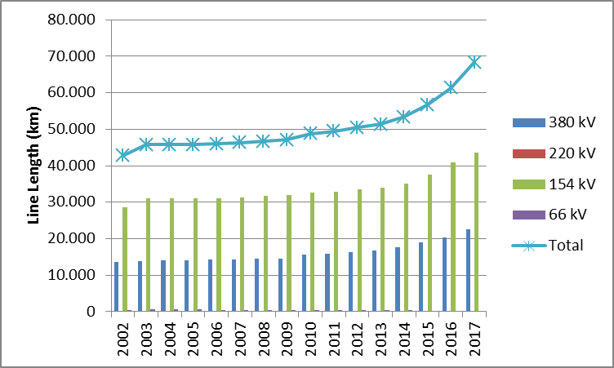

In the last 15 years, there was a 55% increase in transmission line lengths.
  - Transmission System Connection Applications

The table below shows the number of applications and capacity for connection to the transmission system in 2017 with information on acceptance, rejection and evaluation stages are shown.

Table 4.3: Connection Applications to the Transmission System (Number-MW)
 | Connection Application |  | Acccepted |  | Rejected |  | In the Evaluation Stage
 | Number | Capacity (MW) | Number | Capacity  (MW) | Number | Capacity  (MW) | Number | Capacity  (MW)
Licensed Producer | 231 | 9.054,00 | 231 | 9.054,00 |  |  | 16 | 198,70
Consumer | 39 | 2.180,75 | 37 | 2.130,75 | 2 | 50,00

In 2017, a total of 9.054 MW connection applications were made by producers and all of them accepted. In addition, 198,70 MW applications left from last year was in the evaluation stage.
Consumers’ application was for 2.180,75 MW capacity, and 2.130,75 MW of these applications were accepted when the remaining part of 50,00 MW rejected.

  - Tariffs

Transmission system usage and system operation tariffs, applied for producers and consumers in 14 regions by TEİAŞ, determined with EMRA Board Decision dated 29/12/2016 and numbered 6818 and shown in Table 4.4.

Table 4.4: System Usage and System Operation Tariffs (TL/MW-Year)
Region | Generation (*) (**) |  |  | Consumption (*)
Region | System Usage Tariffs |  | System  Operation  Tariffs | System Usage Tariffs |  | System  Operation Tarifss
Region | TL/MW-Year | TL/MWh | TL/MWh | TL/MW-Year | TL/MWh | TL/MWh
1 | 14.901,10 | 6,26 | 3,19 | 24.846,95 | 5,14 | 3,09
2 | 16.245,30 | 6,26 | 3,19 | 24.140,14 | 5,14 | 3,09
3 | 16.393,68 | 6,26 | 3,19 | 24.190,57 | 5,14 | 3,09
4 | 16.605,85 | 6,26 | 3,19 | 23.938,23 | 5,14 | 3,09
5 | 17.327,96 | 6,26 | 3,19 | 23.562,36 | 5,14 | 3,09
6 | 18.209,12 | 6,26 | 3,19 | 22.933,27 | 5,14 | 3,09
7 | 18.313,61 | 6,26 | 3,19 | 22.375,17 | 5,14 | 3,09
8 | 20.172,19 | 6,26 | 3,19 | 21.705,30 | 5,14 | 3,09
9 | 20.964,72 | 6,26 | 3,19 | 20.972,45 | 5,14 | 3,09
10 | 23.279,50 | 6,26 | 3,19 | 19.979,67 | 5,14 | 3,09
11 | 24.519,67 | 6,26 | 3,19 | 19.226,54 | 5,14 | 3,09
12 | 25.567,59 | 6,26 | 3,19 | 18.545,76 | 5,14 | 3,09
13 | 26.663,51 | 6,26 | 3,19 | 18.070,38 | 5,14 | 3,09
14 | 28.600,95 | 6,26 | 3,19 | 16.652,35 | 5,14 | 3,09
(*) Transmission Surcharge not included.
(**) 50 % discount is applied for generation connections within the scope of temporary article 4 of the Electricity Market Law numbered 6446.

Figure 4.2: System Usage and System Operation Tariffs (TL/MW-Year)
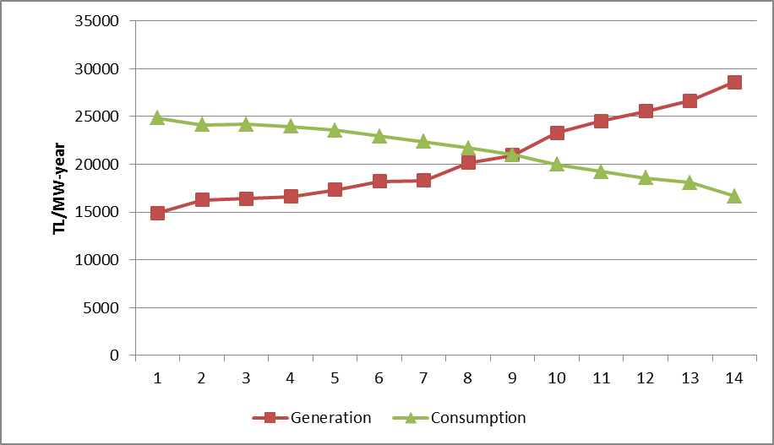

  - Amount of Investment

The amount of investment made by TEİAŞ are shown in table 4.5. It is observed that the investment amount in 2017 increased by 37,43 %.

Table 4.5: Comparison of 2016 and 2017 Investment Amount (TL-%)
 | 2016 |  | 2017 |  | Differences  (%)
Investment Payment Type | Amount (TL) | Share (%) | Amount (TL) | Share (%) | Differences  (%)
New Transformer Investment | 931.837.000 | 49,15 | 1.242.394.000 | 47,68 | 33,33
New Line Investment | 835.355.000 | 44,06 | 1.134.077.000 | 43,52 | 35,76
Operational Investment | 43.766.000 | 2,31 | 111.203.109 | 4,27 | 154,09
Machine and Equipment | 78.256.000 | 4,13 | 113.517.017 | 4,36 | 45,06
Other | 6.846.000 | 0,36 | 4.658.226 | 0,18 | -31,96
Total | 1.896.060.000 | 100,00 | 2.605.849.352 | 100,00 | 37,43

  - Losses

The transmission system loss rate changes depending on the demand in the system, load flows, temperature and investments. It is calculated on an hourly basis and the change in annual averages over the years is shown in Figure 4.3. The loss of the transmission system established by European standards in accordance with the population density of our country, the location of the supply sources and the geographical conditions is at the international performance level.

Figure 4.3: Transmission System Losses (GWh-%)
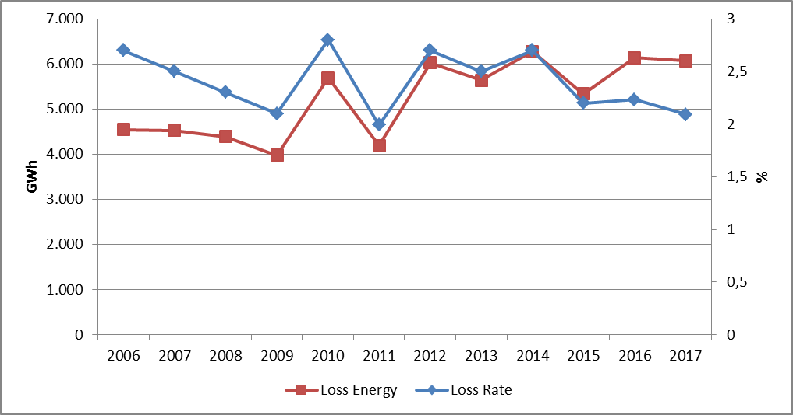

Figure 4.4: Transmission System Losses by Hour (%)
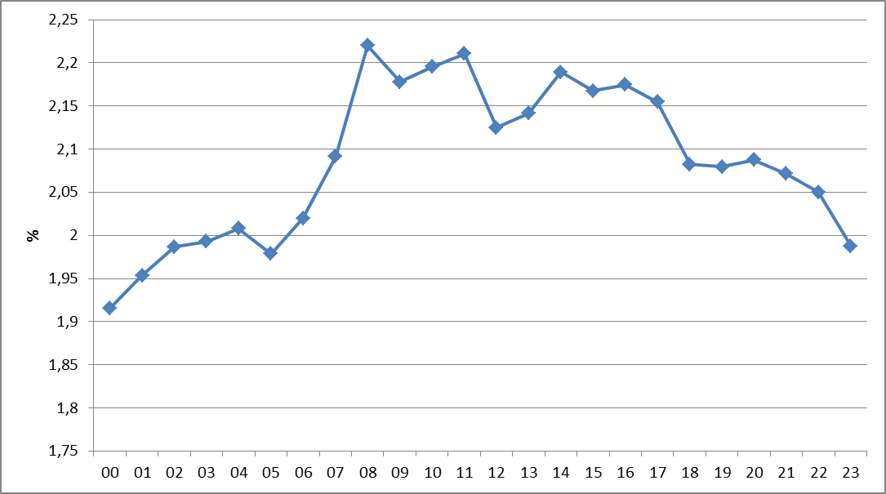

When the graph is analyzed, it is seen that the loss ratio was parallel to the generation amount and considered that it was caused by system constraints.
- DISTRIBUTION

  - Number of Consumers

By 2017, the total number of consumers using the distribution system was increased by 3,55 % and reached to 42.514.302.

Table 5.1: Number of Consumers Using Distribution System by the end of 2017 (Number-%)
Distribution Company | Number of Consumers |  |  | 2016-2017 Change (%)
Distribution Company | 2015 | 2016 | 2017 | 2016-2017 Change (%)
BOĞAZİÇİ | 4.732.112 | 4.872.387 | 5.041.801 | 3,48
BAŞKENT | 3.969.789 | 4.099.788 | 4.218.812 | 2,90
TOROSLAR | 3.505.182 | 3.669.912 | 3.805.358 | 3,69
GDZ | 2.971.756 | 3.061.100 | 3.165.847 | 3,42
ULUDAĞ | 2.893.903 | 2.983.810 | 3.092.199 | 3,63
İ.ANADOLU | 2.676.318 | 2.751.857 | 2.834.800 | 3,01
AKDENİZ | 1.941.193 | 2.000.386 | 2.076.167 | 3,79
MERAM | 1.889.687 | 1.964.377 | 2.027.866 | 3,23
YEŞİLIRMAK | 1.884.597 | 1.938.042 | 1.998.388 | 3,11
ADM | 1.778.773 | 1.787.566 | 1.834.517 | 2,63
DİCLE | 1.588.562 | 1.675.698 | 1.757.417 | 4,88
SAKARYA | 1.578.224 | 1.654.546 | 1.742.528 | 5,32
OSMANGAZİ | 1.611.585 | 1.661.395 | 1.720.217 | 3,54
ÇORUH | 1.237.935 | 1.269.278 | 1.303.909 | 2,73
TRAKYA | 968.459 | 991.026 | 1.042.995 | 5,24
ARAS | 906.537 | 935.816 | 963.072 | 2,91
ÇAMLIBEL | 898.618 | 917.913 | 946.381 | 3,10
FIRAT | 858.178 | 888.483 | 917.488 | 3,26
KAYSERİ VE CİVARI | 654.578 | 673.432 | 695.210 | 3,23
AKEDAŞ | 631.557 | 635.620 | 678.775 | 6,79
VANGÖLÜ | 599.921 | 623.483 | 650.555 | 4,34
Total | 39.777.464 | 41.055.915 | 42.514.302 | 3,55

It is seen from Table 5.1 that the distribution regions with the highest number of consumers were Boğaziçi with 5.04 million, Başkent with 4.21 million and Toroslar with 3.80 million.
In the following figure, the number of consumers connected to distribution network and the total consumption of these consumers by 2017 are shown.

Figure 5.1: Number and Consumption of Consumers (Number- MWh)
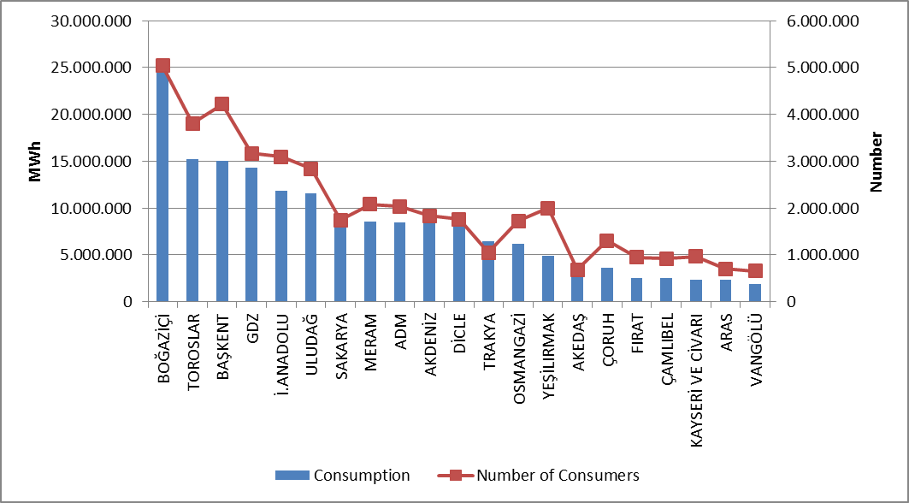

  - Ratio of Losses

In following Table 5.2, targeted and realized loss rates of distribution companies are shown.

Table 5.2: Loss Rates of Distribution Companies (%)
DISTRIBUTION COMPANY | REALIZED LOSS RATES |  |  | TARGETED LOSS RATES | DIFFERENCE OF REALIZED&TARGETED LOSS RATES
DISTRIBUTION COMPANY | 2016 | 2017 | 2016-2017 Difference | 2017 | 2017
DİCLE | 67,64 | 64,82 | 2,82 | 71,78 | 6,96
VANGÖLÜ | 56,42 | 53,30 | 3,12 | 60,35 | 7,05
ARAS | 25,68 | 24,55 | 1,13 | 29,37 | 4,81
TOROSLAR | 12,12 | 11,36 | 0,77 | 13,32 | 1,96
FIRAT | 10,56 | 10,95 | -0,39 | 10,99 | 0,03
ÇORUH | 9,25 | 8,11 | 1,14 | 9,08 | 0,97
YEŞİLIRMAK | 8,20 | 7,43 | 0,77 | 8,95 | 1,52
GDZ | 7,32 | 7,25 | 0,07 | 8,31 | 1,06
OSMANGAZİ | 5,75 | 6,97 | -1,22 | 7,93 | 0,97
BOĞAZİÇİ | 9,61 | 6,74 | 2,87 | 8,00 | 1,26
AKDENİZ | 6,31 | 6,67 | -0,36 | 8,73 | 2,06
ÇAMLIBEL | 5,97 | 6,59 | -0,61 | 7,82 | 1,24
SAKARYA | 6,59 | 6,41 | 0,18 | 7,34 | 0,94
İST. AND. YAK. | 6,78 | 6,10 | 0,68 | 7,63 | 1,53
BAŞKENT | 6,98 | 6,05 | 0,94 | 7,75 | 1,71
KAYSERİ VE CİVARI | 5,87 | 6,03 | -0,16 | 7,17 | 1,13
MERAM | 6,65 | 5,77 | 0,88 | 7,70 | 1,93
AKEDAŞ | 7,22 | 5,48 | 1,74 | 7,07 | 1,59
ADM | 5,74 | 5,26 | 0,49 | 7,46 | 2,20
TRAKYA | 5,46 | 5,09 | 0,37 | 7,29 | 2,20
ULUDAĞ | 5,57 | 4,14 | 1,43 | 7,47 | 3,32

When Table 5.2 is examined, all of the 21 distribution companies achieved the targeted loss rate for 2017. According to the targets, the regions with the highest development were Vangölü (%7,05) Dicle (%6,96) and Aras (%4,81) regions.
Also, as can be seen from Table 5.2, the highest loss rates in 2017 were in Dicle (%64,82), Vangölü (%53,30) and Aras (%24,55) regions, as it was in 2016.
The following Figure 5.2 the realized and targeted loss rates are shown.

Figure 5.2: Real and Target Loss Rates in 2017 (%)
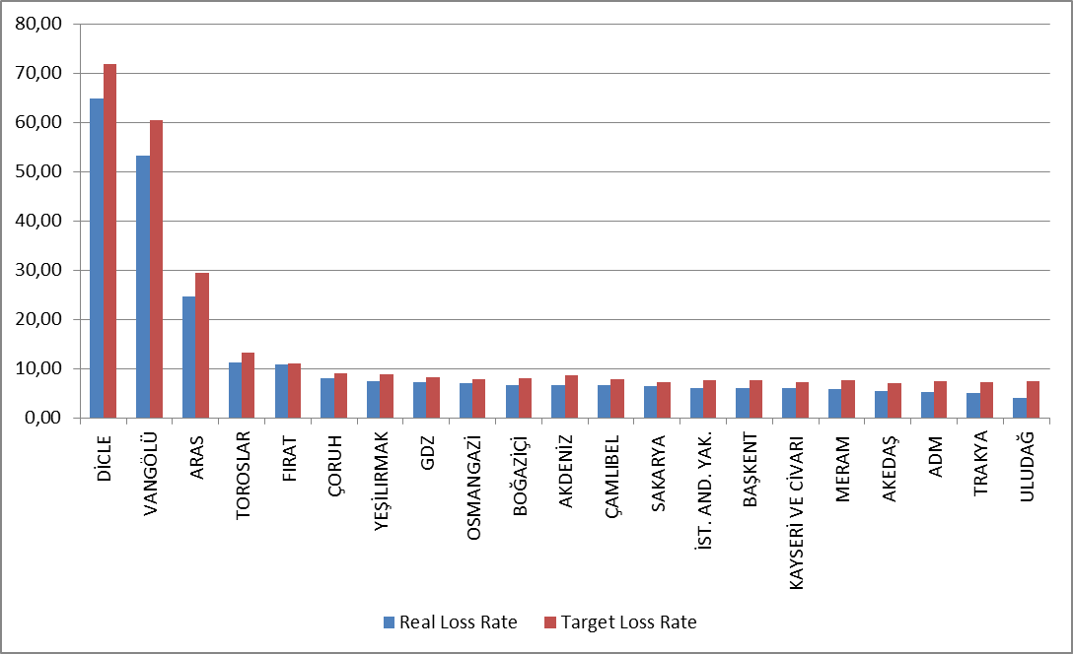

5.3 Employment

By the end of 2017, 55.199 people were employed in electricity distribution sector; 16.100 people were employed as permanent employee and 39.099 people were employed as subcontractor employee. Toroslar EDAŞ had the highest number of employees with a total of 5.663 while the distribution company with the highest number of permanent employee was Dicle EDAŞ with 2.277 people, and Toroslor EDAŞ with the number of personnel with the highest number of subcontract employee was 4.886. Kayseri EDAŞ wast the distribution company with the lowest number of employees with 915 people.

Table 5.3: Number of Employees of Distribution Companies (Number)
Distribution Company | Number of Permanent Employees | Number of Subcontractor Employees | Total
TOROSLAR | 777 | 4.886 | 5.663
DİCLE | 2.277 | 3.187 | 5.464
BAŞKENT | 1.061 | 4.165 | 5.226
BOĞAZİÇİ | 769 | 2.852 | 3.621
GDZ | 696 | 2.479 | 3.175
ULUDAĞ | 540 | 2.390 | 2.930
OSMANGAZİ | 1.271 | 1.385 | 2.656
İ.ANADOLU | 995 | 1.575 | 2.570
ÇORUH | 454 | 2.059 | 2.513
AKDENİZ | 285 | 2.127 | 2.412
MERAM | 708 | 1.625 | 2.333
FIRAT | 350 | 1.898 | 2.248
SAKARYA | 1.651 | 516 | 2.167
YEŞİLIRMAK | 648 | 1.485 | 2.133
VANGÖLÜ | 653 | 1.261 | 1.914
ARAS | 510 | 1.369 | 1.879
ADM | 554 | 1.211 | 1.765
ÇAMLIBEL | 226 | 1.203 | 1.429
AKEDAŞ | 383 | 802 | 1.185
TRAKYA | 786 | 215 | 1.001
KAYSERİ VE CİVARI | 506 | 409 | 915
Total | 16.100 | 39.099 | 55.199

Figure 5.3: Number of Employees of Distribution Companies by Year 2017 (Number)
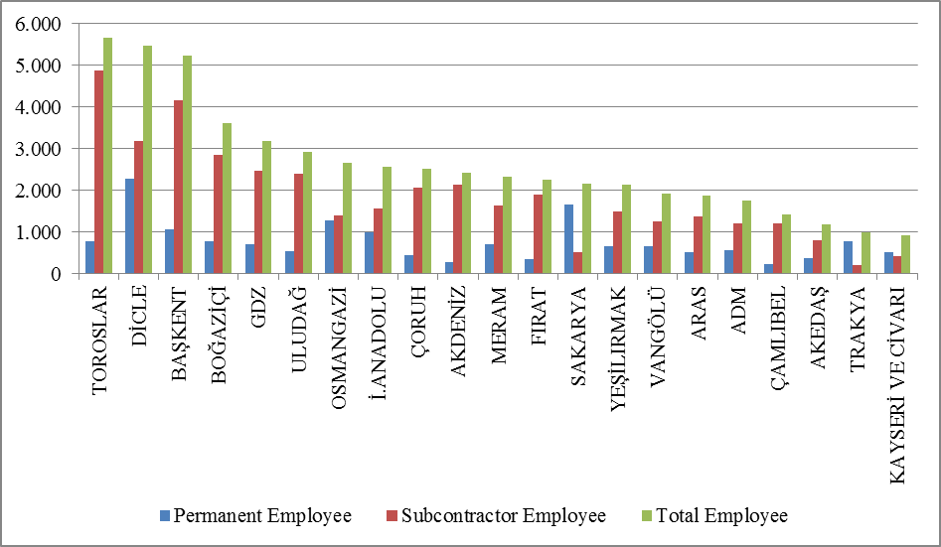

5.4 Information about Network

This section contains basic data on the distribution system. In this context, information on line lengths, transformer capacities and transformer numbers in the distribution voltage level is included in the following tables and figures.
As it is known, almost whole of Turkey has access to electricity. Except for industrial plants with large consumption, all small and medium-sized consumers provide electric energy through the distribution system. As seen from Table 5.4, the total distribution line length of Turkey reached to 1.128.550 km. When considering the line lengths according to the distribution regions, the distribution regions of Başkent, Toroslar, Meram, Yeşilırmak and Dicle were the first five regions. It is seen that the distribution line lengths have a direct correlation with the size of the distribution region.
On the other hand, regarding transformer capacity, it is seen that the electricity distribution regions of Boğaziçi, Toroslar, Gdz, Başkent and Dicle were the top five respectively.

Table 5.4: Line Lengths, Number of Transformers and Transformer Capacities Based on Distribution Companies by end of 2017 (Km-MVA-Number)
Distribution Company | Line length  (Km) | Transformer Capacity  (MVA) | Number of Transformers
ADM | 66.536 | 7.856 | 21.055
AKDENİZ | 58.628 | 7.057 | 18.674
AKEDAŞ | 25.908 | 3.294 | 11.557
ARAS | 55.830 | 2.891 | 13.289
BAŞKENT | 109.718 | 13.370 | 30.647
BOĞAZİÇİ | 43.819 | 17.179 | 14.069
ÇAMLIBEL | 45.242 | 2.446 | 11.818
ÇORUH | 58.412 | 2.842 | 11.683
DİCLE | 71.333 | 11.878 | 59.144
FIRAT | 46.515 | 2.720 | 11.853
GDZ | 54.830 | 13.553 | 30.879
İ. ANADOLU | 23.520 | 8.610 | 7.388
KAYSERİ VE CİVARI | 23.245 | 2.411 | 7.227
MERAM | 84.063 | 10.462 | 52.382
OSMANGAZİ | 45.912 | 6.018 | 23.078
SAKARYA | 36.167 | 7.350 | 16.329
TOROSLAR | 86.682 | 14.116 | 43.768
TRAKYA | 21.612 | 4.679 | 10.839
ULUDAĞ | 48.753 | 8.254 | 23.711
VANGÖLÜ | 39.991 | 2.743 | 10.590
YEŞİLIRMAK | 81.834 | 4.590 | 20.847
Grand Total | 1.128.550 | 154.319 | 450.827

Figure 5.4: Line Lengths and Transformer Capacities on the Basis of

Distribution Companies at the end of 2017 (Km-MVA)
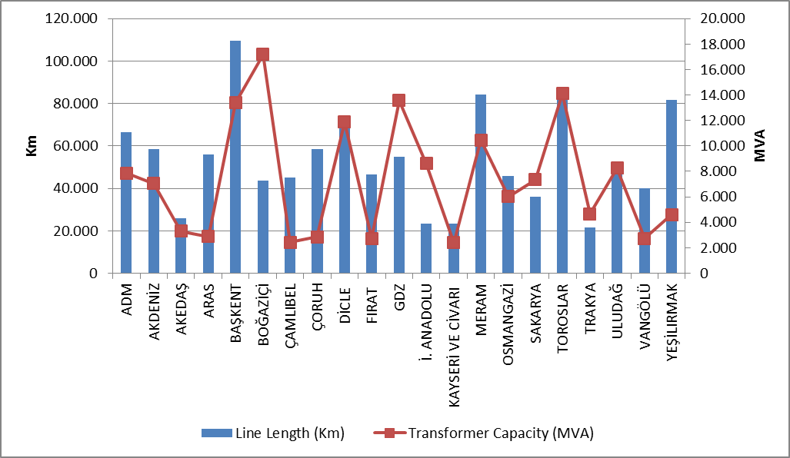
The lengths of distribution lines are shown in Table 5.5. As seen in the table, 84,64 % of the total distribution lines was overhead lines. The share of underground lines in total distribution lines was 15,36 %. This indicates that the distribution lines were open to external influence. The external effects could be natural, climate or human originated, disasters such as extreme precipitations, storms etc. could directly or indirectly damage distribution lines.

Tablo 5.5: The Lengths of Distribution Lines (Km)
Distribution Company | Overhead(Km) | Underground (Km) | Total (Km)
ADM | 58.001 | 8.534 | 66.536
AKDENİZ | 47.040 | 11.589 | 58.628
AKEDAŞ | 23.330 | 2.579 | 25.908
ARAS | 50.893 | 4.937 | 55.830
BAŞKENT | 89.565 | 20.152 | 109.718
BOĞAZİÇİ | 11.526 | 32.293 | 43.819
ÇAMLIBEL | 40.601 | 4.641 | 45.242
ÇORUH | 53.853 | 4.559 | 58.412
DİCLE | 62.790 | 8.543 | 71.333
FIRAT | 42.673 | 3.842 | 46.515
GDZ | 45.026 | 9.804 | 54.830
İ. ANADOLU | 5.642 | 17.878 | 23.520
KAYSERİ VE CİVARI | 18.030 | 5.215 | 23.245
MERAM | 76.950 | 7.113 | 84.063
OSMANGAZİ | 40.596 | 5.316 | 45.912
SAKARYA | 30.490 | 5.677 | 36.167
TOROSLAR | 76.031 | 10.651 | 86.682
TRAKYA | 18.068 | 3.544 | 21.612
ULUDAĞ | 38.168 | 10.584 | 48.753
VANGÖLÜ | 38.056 | 1.935 | 39.991
YEŞİLIRMAK | 68.190 | 13.643 | 81.834
Grand Total | 935.522 | 193.028 | 1.128.550

Figure 5.5: The Length of Lines on the Basis of Distribution Companies at the end of 2017(Km)
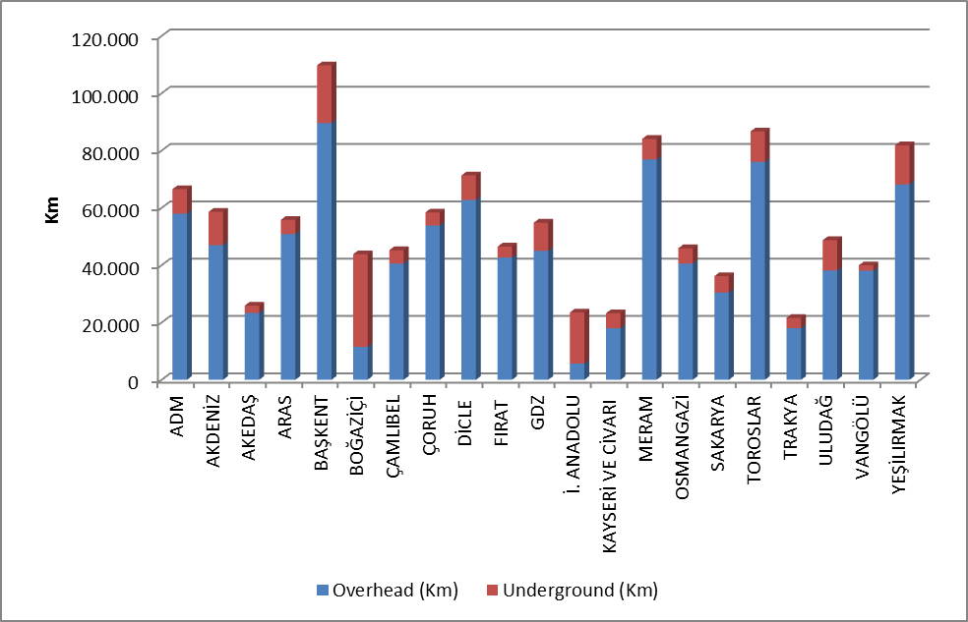

As seen in the figure above, the share of underground line lengths in the Boğaziçi and İstanbul Anadolu Side was higher than the share of overhead lines.
Table 5.6 includes distribution line lengths and transformer capacities. Regarding distribution line lengths was the first five provinces were İstanbul, Ankara, Konya, Antalya and İzmir, respectively.

Regarding the transformer capacities, the first five provinces were İstanbul, İzmir, Ankara, Konya and Antalya, respectively.
Regarding the number of transformers, the first five provinces were Konya, Şanlıurfa, İstanbul, İzmir and Ankara, repectively.

Table 5.6: Line Lengths at Distribution Voltage Levels, Number of Transformers and Transformer Capacities by Provinces in 2017 (Km-MVA-Number)
Province | Line Length  (Km) | Transformer Capacity(MVA) | Number of Transformers  (Number)
ADANA | 26.973 | 4.104 | 11.395
ADIYAMAN | 9.091 | 885 | 4.783
AFYONKARAHİSAR | 14.125 | 1.662 | 9.222
AĞRI | 12.717 | 527 | 2.448
AKSARAY | 9.918 | 1.046 | 6.137
AMASYA | 8.013 | 551 | 2.756
ANKARA | 58.810 | 10.033 | 16.735
ANTALYA | 40.291 | 5.482 | 12.910
ARDAHAN | 4.718 | 124 | 870
ARTVİN | 6.719 | 302 | 1.523
AYDIN | 20.239 | 2.546 | 6.750
BALIKESİR | 17.925 | 2.274 | 7.505
BARTIN | 4.029 | 357 | 1.387
BATMAN | 5.825 | 909 | 3.869
BAYBURT | 2.902 | 147 | 696
BİLECİK | 3.931 | 785 | 1.804
BİNGÖL | 6.381 | 318 | 1.776
BİTLİS | 7.234 | 462 | 2.493
BOLU | 7.029 | 678 | 2.703
BURDUR | 8.667 | 625 | 2.811
BURSA | 18.556 | 4.438 | 10.689
ÇANAKKALE | 9.679 | 1.068 | 4.434
ÇANKIRI | 6.318 | 395 | 1.736
ÇORUM | 14.666 | 923 | 4.424
DENİZLİ | 20.838 | 2.355 | 6.308
DİYARBAKIR | 16.638 | 2.942 | 11.808
DÜZCE | 5.457 | 679 | 1.987
EDİRNE | 6.930 | 1.002 | 3.887
ELAZIĞ | 11.833 | 949 | 3.723
ERZİNCAN | 6.903 | 440 | 2.044
ERZURUM | 17.349 | 1.063 | 4.488
ESKİŞEHİR | 11.919 | 1.903 | 6.487
GAZİANTEP | 14.051 | 2.440 | 10.100
GİRESUN | 15.682 | 587 | 2.919
GÜMÜŞHANE | 6.228 | 297 | 1.235
HAKKARİ | 7.895 | 336 | 1.601
HATAY | 17.275 | 3.470 | 10.279
IĞDIR | 5.031 | 224 | 1.102
ISPARTA | 9.670 | 949 | 2.953
İSTANBUL | 67.339 | 25.789 | 21.457
İZMİR | 33.599 | 10.587 | 19.070
KAHRAMANMARAŞ | 16.817 | 2.409 | 6.774
KARABÜK | 4.400 | 523 | 1.577
KARAMAN | 6.580 | 703 | 4.002
KARS | 6.210 | 367 | 1.641
KASTAMONU | 13.166 | 724 | 4.384
KAYSERİ | 23.245 | 2.411 | 7.227
KIRIKKALE | 11.265 | 438 | 1.447
KIRKLARELİ | 5.226 | 907 | 2.203
KIRŞEHİR | 5.578 | 431 | 2.019
KİLİS | 2.022 | 212 | 930
KOCAELİ | 11.634 | 4.138 | 6.948
KONYA | 44.978 | 6.031 | 28.826
KÜTAHYA | 8.987 | 935 | 3.146
MALATYA | 23.412 | 1.299 | 5.120
MANİSA | 21.231 | 2.966 | 11.809
MARDİN | 11.129 | 2.192 | 11.178
MERSİN | 19.693 | 3.289 | 8.899
MUĞLA | 25.459 | 2.956 | 7.997
MUŞ | 7.553 | 452 | 2.110
NEVŞEHİR | 8.085 | 1.169 | 6.091
NİĞDE | 8.924 | 1.082 | 5.307
ORDU | 24.089 | 856 | 4.442
OSMANİYE | 6.667 | 602 | 2.165
RİZE | 9.174 | 543 | 2.209
SAKARYA | 12.047 | 1.855 | 4.691
SAMSUN | 27.111 | 1.908 | 7.243
SİİRT | 4.055 | 351 | 1.648
SİNOP | 7.955 | 352 | 1.982
SİVAS | 18.691 | 1.014 | 4.512
ŞANLIURFA | 28.608 | 4.720 | 27.152
ŞIRNAK | 5.080 | 764 | 3.489
TEKİRDAĞ | 9.455 | 2.770 | 4.749
TOKAT | 13.381 | 689 | 3.180
TRABZON | 20.608 | 1.113 | 3.797
TUNCELİ | 4.889 | 154 | 1.234
UŞAK | 6.950 | 733 | 2.419
VAN | 17.308 | 1.493 | 4.386
YALOVA | 2.593 | 474 | 1.083
YOZGAT | 13.170 | 743 | 4.126
ZONGULDAK | 11.730 | 900 | 3.381
Grand Total | 1.128.550 | 154.319 | 450.827

5.5 Quality Indicators

Data on the technical quality of the electricity provided by the distribution companies are compiled and the tables below show Customer Average Interruption Duration Index (CAIDI) and Customer Average Interruption Frequency Index (CAIFI).

Table 5.7: Reported and Unreported Customer Average Interruption Duration Indices of Distribution Companies in 2017 (min)
 | 2016 |  |  | 2017 |  |  | Change (%)
Distribution  Company | Reported CAIDI (min) | Unreported CAIDI(min) | Total  CAIDI (min) | Reported  CAIDI (min) | Unreported  CAIDI (min) | Total  CAIDI(min) | Change (%)
VANGÖLÜ | 323,6 | 3.587,8 | 3.911,4 | 658,4 | 5.952,9 | 6.611,3 | 69,03
ARAS | 227,9 | 2.656,5 | 2.884,3 | 269,6 | 2.562,5 | 2.832,1 | -1,81
MERAM | 873,0 | 1.091,4 | 1.964,4 | 1.064,8 | 1.330,8 | 2.395,6 | 21,95
TRAKYA | 534,2 | 1.493,3 | 2.027,6 | 548,0 | 1.470,3 | 2.018,3 | -0,46
TOROSLAR | 878,6 | 906,2 | 1.784,8 | 577,3 | 1.384,5 | 1.961,8 | 9,92
FIRAT | 69,5 | 1.089,5 | 1.158,9 | 212,6 | 1.666,8 | 1.879,4 | 62,17
SAKARYA | 425,6 | 1.145,1 | 1.570,6 | 508,7 | 1.247,2 | 1.755,9 | 11,79
DİCLE* | 0,0 | 0,0 | 0,0 | 10,9 | 1.691,8 | 1.702,7 | -
GDZ | 360,5 | 1.052,5 | 1.413,0 | 410,5 | 1.203,2 | 1.613,7 | 14,21
ÇAMLIBEL | 350,4 | 553,0 | 903,4 | 506,0 | 960,4 | 1.466,3 | 62,32
BOĞAZİÇİ | 198,0 | 1.334,5 | 1.532,4 | 215,1 | 1.129,4 | 1.344,5 | -12,27
YEŞİLIRMAK | 610,0 | 1.303,9 | 1.913,9 | 477,9 | 746,3 | 1.224,2 | -36,04
ADM | 378,4 | 627,9 | 1.006,3 | 432,8 | 691,5 | 1.124,2 | 11,72
ÇORUH | 188,2 | 1.646,3 | 1.834,4 | 242,8 | 850,5 | 1.093,2 | -40,41
AKDENİZ | 226,5 | 779,2 | 1.005,7 | 302,3 | 785,3 | 1.087,7 | 8,15
AKEDAŞ | 506,6 | 610,5 | 1.117,1 | 435,9 | 616,3 | 1.052,3 | -5,80
ULUDAĞ | 2.274,0 | 803,7 | 3.077,7 | 473,7 | 500,1 | 973,8 | -68,36
OSMANGAZİ | 262,5 | 398,0 | 660,5 | 274,2 | 473,2 | 747,4 | 13,16
BAŞKENT | 225,2 | 372,6 | 597,9 | 205,2 | 363,8 | 569,1 | -4,82
İSTANBUL AN.Y. | 291,0 | 328,4 | 619,4 | 178,6 | 377,5 | 556,2 | -10,21
KAYSERİ VE CİVARI | 180,3 | 212,6 | 392,9 | 210,7 | 203,4 | 414,1 | 5,39
*Dicle distribution region was exempted from the technical quality obligations in 2016 since the loss&theft ratio is over 40% in all the provinces in 2015.

The table above shows the reported, unreported and total Customer Average Interruption Duration Index in 2016 and 2017. While the first three regions were Meram, Vangölü and Toroslar regions according to reported interruptions, Vangölü, Aras and Dicle regions were the first three regarding unreported interruptions.
The highest Customer Average Interruption Duration Index was observed in Vangölü region with 6.611,3 minutes and Aras region with 2.832,1 minutes.

Table 5.8: Customer Average Interruption Duration Indices of Distribution Companies by reason in 2017 (min)
Distribution  Company | External | Security | Force Major | Network Operator | Total
VANGÖLÜ | 0,0 | 0,0 | 0,0 | 6.611,3 | 6.611,3
ARAS | 12,9 | 8,4 | 1.605,3 | 1.205,5 | 2.832,1
MERAM | 112,3 | 4,6 | 89,7 | 2.189,1 | 2.395,6
TRAKYA | 2,4 | 0,6 | 0,0 | 2.015,3 | 2.018,3
TOROSLAR | 23,4 | 33,8 | 0,0 | 1.904,6 | 1.961,8
FIRAT | 3,3 | 1,2 | 38,5 | 1.836,5 | 1.879,4
SAKARYA | 65,8 | 43,9 | 39,1 | 1.607,1 | 1.755,9
DİCLE | 0,0 | 0,0 | 0,0 | 1.702,7 | 1.702,7
GDZ | 39,5 | 0,0 | 0,0 | 1.574,3 | 1.613,7
ÇAMLIBEL | 9,3 | 17,3 | 0,0 | 1.439,8 | 1.466,3
BOĞAZİÇİ | 94,8 | 4,0 | 0,0 | 1.245,7 | 1.344,5
YEŞİLIRMAK | 23,4 | 49,8 | 0,0 | 1.150,9 | 1.224,2
ADM | 34,9 | 3,3 | 6,7 | 1.079,4 | 1.124,2
ÇORUH | 0,9 | 0,0 | 4,3 | 1.088,1 | 1.093,2
AKDENİZ | 63,7 | 78,9 | 22,9 | 922,1 | 1.087,7
AKEDAŞ | 11,3 | 0,5 | 6,7 | 1.033,7 | 1.052,3
ULUDAĞ | 9,3 | 2,3 | 0,0 | 962,1 | 973,8
OSMANGAZİ | 9,6 | 1,5 | 0,4 | 735,9 | 747,4
BAŞKENT | 9,7 | 27,1 | 0,0 | 532,3 | 569,1
İSTANBUL ANADOLU Y. | 10,5 | 14,2 | 0,0 | 531,5 | 556,2
KAYSERİ VE CİVARI | 50,3 | 0,4 | 0,0 | 363,4 | 414,1

The table above shows the distribution of CAIDI according to the reasons. It seems that the highest interruption duration was caused by the network operator.
The following table shows the average interruption frequency of distribution companies. The highest CAIFI was 52,2 per customer in the Vangölü region, followed by the Sakarya region with 36,3 (Customer/Year).

Table 5.9: Customer Average Interruption Frequency Indices of Distribution Companies in 2016 and 2017(Number/Year)
 | 2016 |  |  |  | 2017 |  |  |  | Change  (%)
Distribution Company | Reported | Unreported | Short | Total | Reported | Unreported | Short | Total | Change  (%)
VANGÖLÜ | 1,0 | 55,7 | 16,2 | 72,9 | 1,7 | 50,1 | 0,4 | 52,2 | -28,37
SAKARYA | 2,5 | 28,0 | 3,9 | 34,4 | 2,7 | 30,1 | 3,6 | 36,3 | 5,72
DİCLE | 0,0 | 0,0 | 0,0 | 0,0 | 0,2 | 30,9 | 0,0 | 31,1 | -
TRAKYA | 2,0 | 17,5 | 5,7 | 25,2 | 2,0 | 19,7 | 4,7 | 26,4 | 4,68
ARAS | 0,7 | 16,7 | 0,2 | 17,6 | 0,9 | 17,5 | 0,1 | 18,5 | 5,05
AKEDAŞ | 3,7 | 11,4 | 3,1 | 18,1 | 3,4 | 11,6 | 2,6 | 17,5 | -3,20
MERAM | 3,7 | 11,9 | 0,0 | 15,6 | 4,4 | 12,4 | 0,0 | 16,8 | 7,44
GDZ | 2,4 | 13,5 | 0,1 | 16,0 | 1,8 | 13,9 | 0,0 | 15,8 | -1,46
ADM | 1,6 | 13,1 | 0,3 | 15,0 | 1,8 | 13,3 | 0,0 | 15,1 | 0,67
YEŞİLIRMAK | 2,8 | 14,7 | 0,3 | 17,8 | 2,2 | 12,0 | 0,4 | 14,6 | -18,02
ÇAMLIBEL | 1,7 | 7,9 | 0,1 | 9,8 | 1,8 | 12,2 | 0,3 | 14,4 | 47,17
OSMANGAZİ | 1,0 | 10,7 | 0,1 | 11,8 | 1,2 | 13,0 | 0,0 | 14,2 | 20,25
BOĞAZİÇİ | 0,9 | 13,8 | 0,2 | 15,0 | 0,8 | 11,8 | 0,0 | 12,6 | -16,04
TOROSLAR | 2,8 | 9,4 | 0,1 | 12,3 | 1,6 | 10,5 | 0,1 | 12,2 | -0,37
AKDENİZ | 0,8 | 11,2 | 0,3 | 12,3 | 1,0 | 10,4 | 0,5 | 11,9 | -3,31
ÇORUH | 1,2 | 10,2 | 0,0 | 11,4 | 1,2 | 9,3 | 0,5 | 11,0 | -3,61
FIRAT | 0,3 | 5,6 | 0,0 | 5,9 | 0,7 | 9,0 | 0,0 | 9,7 | 65,22
KAYSERİ VE C. | 0,9 | 4,5 | 1,8 | 7,2 | 1,7 | 4,0 | 2,9 | 8,6 | 19,51
ULUDAĞ | 7,8 | 7,7 | 0,4 | 15,9 | 1,7 | 5,0 | 0,5 | 7,3 | -54,16
BAŞKENT | 0,7 | 4,0 | 0,0 | 4,7 | 0,7 | 3,8 | 0,1 | 4,7 | -1,29
İSTANBUL AN. Y. | 1,2 | 4,0 | 0,0 | 5,1 | 0,6 | 3,9 | 0,1 | 4,6 | -10,20

Table 5.10: Distribution Companies’ Customer Average Interruption Frequency Indices of Distribution Companies by Reason in 2017 (Number/Year)
Distribution Company | External | Security | Short | Force Majeure | Network Operator | Total
VANGÖLÜ | 0,0 | 0,0 | 0,4 | 0,0 | 51,8 | 52,2
SAKARYA | 1,1 | 0,2 | 3,6 | 0,1 | 31,4 | 36,3
DİCLE | 0,0 | 0,0 | 0,0 | 0,0 | 31,0 | 31,1
TRAKYA | 0,0 | 0,0 | 4,7 | 0,0 | 21,7 | 26,4
ARAS | 0,2 | 0,0 | 0,1 | 5,3 | 12,9 | 18,5
AKEDAŞ | 0,2 | 0,0 | 2,6 | 0,1 | 14,6 | 17,5
MERAM | 1,0 | 0,0 | 0,0 | 0,4 | 15,3 | 16,8
GDZ | 0,5 | 0,0 | 0,0 | 0,0 | 15,2 | 15,8
ADM | 0,4 | 0,0 | 0,0 | 0,0 | 14,6 | 15,1
YEŞİLIRMAK | 0,4 | 0,4 | 0,4 | 0,0 | 13,3 | 14,6
ÇAMLIBEL | 0,1 | 0,1 | 0,3 | 0,0 | 13,9 | 14,4
OSMANGAZİ | 0,2 | 0,0 | 0,0 | 0,0 | 13,9 | 14,2
BOĞAZİÇİ | 0,6 | 0,0 | 0,0 | 0,0 | 11,9 | 12,6
TOROSLAR | 0,1 | 0,2 | 0,1 | 0,0 | 11,8 | 12,2
AKDENİZ | 0,6 | 0,5 | 0,5 | 0,0 | 10,4 | 11,9
ÇORUH | 0,0 | 0,0 | 0,5 | 0,0 | 10,5 | 11,0
FIRAT | 0,0 | 0,0 | 0,0 | 0,0 | 9,7 | 9,7
KAYSERİ VE CİVARI | 1,2 | 0,0 | 2,9 | 0,0 | 4,5 | 8,6
ULUDAĞ | 0,1 | 0,0 | 0,5 | 0,0 | 6,6 | 7,3
BAŞKENT | 0,1 | 0,1 | 0,1 | 0,0 | 4,3 | 4,7
İSTANBUL ANADOLU Y. | 0,1 | 0,1 | 0,1 | 0,0 | 4,4 | 4,6

5. Investment Amount of Distribution Companies

With the decision of the Board dated 24/11/2015 and numbered 5885/7, the "Procedures and Principles for Investments in Electricity Market Distribution System" were approved and entered into force.
Electricity distribution companies started on 01/01/2016 with the Board Decision dated 18/11/2015 and numbered 5875/9 III. It was decided to set the Real Reasonable Rate of Return to be taken into consideration during the implementation period as 12,66 % (real and pre-tax) and the Adjusted Real Reasonable Rate of Return as 11,91 % (real and pre-tax).
With the Board Decision dated 18/11/2015 and numbered 5875/6, the period of redemption for distribution companies and investments in the third implementation period was determined as 10 years.
The following table provides information about the amount of investment made by the Distribution Companies.

Table 5.11: List of Distribution Investments in 2011 and 2017 and Comparison by 2016-2017 (TL-%)
Distribution Company | 2011 | 2012 | 2013 | 2014 | 2015 | 2016 | 2017 | 2016-2017 Change  (%)
ADM | 128,5 | 155,3 | 141,7 | 129,0 | 202,1 | 203,7 | 220,5 | 8,3
AKDENİZ | 22,2 | 78,9 | 181,6 | 214,0 | 159,8 | 159,6 | 172,2 | 7,9
AKEDAŞ | 41,1 | 41,9 | 52,7 | 35,2 | 109,5 | 130,9 | 123,2 | -5,9
ARAS | 0,1 | 118,2 | 241,2 | 128,6 | 163,9 | 155,2 | 163,1 | 5,0
BAŞKENT | 320,9 | 306,2 | 303,1 | 287,9 | 403,1 | 602,2 | 508,2 | -15,6
BOĞAZİÇİ | 10,2 | 77,5 | 201,8 | 202,6 | 352,8 | 381,6 | 326,4 | -14,5
ÇAMLIBEL | 7,4 | 63,6 | 117,3 | 57,6 | 98,7 | 92,6 | 106,7 | 15,2
ÇORUH | 56,8 | 85,1 | 94,6 | 65,2 | 56,9 | 97,0 | 151,1 | 55,8
DİCLE | 26,8 | 101,9 | 179,6 | 95,1 | 254,6 | 231,4 | 332,1 | 43,6
FIRAT | 22,5 | 80,3 | 127,3 | 47,8 | 65,9 | 75,3 | 136,3 | 81,0
GDZ | 16,0 | 44,8 | 150,0 | 136,6 | 226,2 | 288,6 | 305,0 | 5,7
İSTANBUL A.Y.EDAŞ | 81,3 | 110,1 | 45,2 | 132,5 | 200,5 | 256,9 | 215,2 | -16,2
KAYSERİ | 65,7 | 45,5 | 81,7 | 84,3 | 56,9 | 109,3 | 137,1 | 25,5
MERAM | 26,6 | 248,5 | 170,6 | 74,0 | 187,6 | 266,1 | 251,7 | -5,4
OSMANGAZİ | 69,7 | 22,2 | 46,2 | 25,0 | 47,1 | 15,7 | 355,6 | 2168,3
SAKARYA | 48,6 | 110,8 | 119,1 | 71,7 | 82,6 | 126,4 | 122,4 | -3,2
TOROSLAR | 15,2 | 76,1 | 187,8 | 238,6 | 353,4 | 621,2 | 589,5 | -5,1
TRAKYA | 7,4 | 72,6 | 79,6 | 59,3 | 50,7 | 85,1 | 125,0 | 46,9
ULUDAĞ | 34,2 | 107,4 | 232,2 | 105,0 | 262,6 | 238,9 | 200,3 | -16,1
VANGÖLÜ | 6,5 | 68,2 | 68,3 | 43,9 | 91,8 | 84,3 | 130,5 | 54,8
YEŞİLIRMAK | 124,9 | 139,1 | 102,5 | 124,8 | 154,4 | 270,3 | 295,2 | 9,2
Total | 1.132,6 | 2.154,4 | 2.923,9 | 2.358,7 | 3.581,2 | 4.492,1 | 4.967,3 | 10,6

Tablo 5.12: Investment Amounts of Distribution Companies in 2017 (Current Prices-million TL)
Distribution Company | 2017 Investment Amount  (Current Prices-TL)
TOROSLAR | 703.666.534,90
BAŞKENT | 606.591.259,52
OSMANGAZİ | 424.441.150,72
DİCLE | 396.478.056,05
BOĞAZİÇİ | 389.643.240,36
GDZ | 364.110.306,00
YEŞİLIRMAK | 352.358.727,85
MERAM | 300.489.923,72
ADM | 263.241.323,20
İSTANBUL A.Y.EDAŞ | 256.937.785,03
ULUDAĞ | 239.158.377,14
AKDENİZ | 205.510.473,92
ARAS | 194.646.540,40
ÇORUH | 180.375.711,65
KAYSERİ | 163.689.077,77
FIRAT | 162.715.059,98
VANGÖLÜ | 155.785.302,77
TRAKYA | 149.178.042,98
AKEDAŞ | 147.016.404,80
SAKARYA | 146.112.822,96
ÇAMLIBEL | 127.357.645,29
TOTAL | 5.929.503.767,02

Total investment made in 2017 was increased by 10,58 % compared to 2016 and reached to 5,93 billion TL at current prices. The highest investment expenditure for 2017, including investment expenditures from 2011-2015, was realized in the Toroslar region of 703,67 million TL and in the Başkent region of 606,59 million TL.

Figure 5.6: Investment Amounts of Distribution Companies in 2017 (Current Prices-million TL)
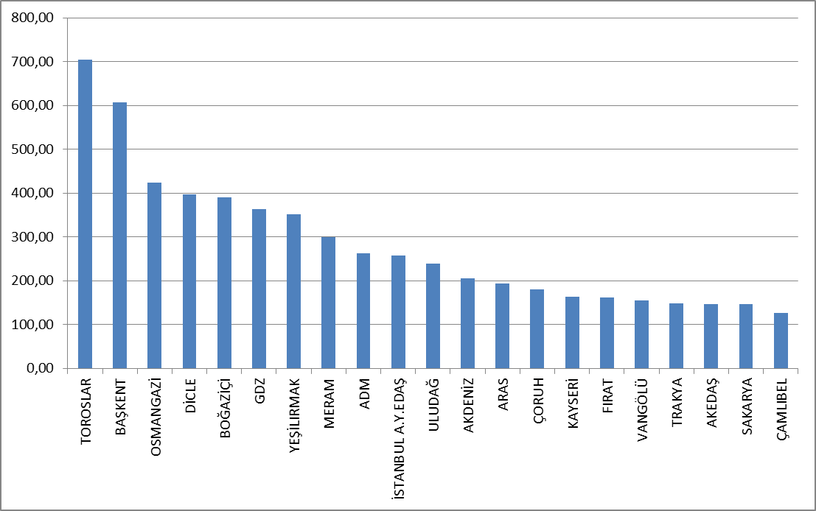

Investment expenditures according to investment type in 2017 are shown in the table below. Network investments constitute the majority of the investment.

Tablo 5.13: Realized Investment Amounts by Investment Type in 2017 (TL)
Distribution Company | Investment Type | 2017 Investment Amount  (CPI June.2017:309,78)
21 EDAŞ | Network Investments | 4.774.227.653,95
21 EDAŞ | Investments with Environmental, Security and Other Legal Obligations | 517.964.455,51
21 EDAŞ | Network Operating System Investments | 442.832.456,90
21 EDAŞ | Counter Investment | 110.416.476,34
21 EDAŞ | Network Investments (Other investments) | 84.062.724,31
21 EDAŞ | Total | 5.929.503.767,01

5.7 Information about Organized Industrial Zones (OIZ)

The following table shows the data related to OIZ Distribution License Owners.

Tablo 5.14: Information About Organized Industrial Zones
Number of Participant AG | 48.850
Number of Participant OG | 11.971
Number of Total Participant | 60.821
Line Lenght AG | 3.871
Line Length OG | 13.462
Total Line Length | 17.333
Number of Employee (Electricity Transmission) | 883
Number of Transformer (number) | 16.645
Installed Capacity of Transformer (MVA) | 17.402
Annual puant value of previous year (MW) | 6.590

As of the end of 2017, the total number of participants in Organized Industrial Zones was 48,850 in low voltage,and 11.971 in medium voltage. 883 personnel was employed in electricity distribution in OIZ distribution regions.
Total OIZ line length was 17.333 km. Total OIZ Transformer Capacity reached to 17.402 MVA level. The sum of the peak values for the previous year in the OIZ regions was 6.590 MW.

- PRICING

The Electricity Market Law predicts a market structure based on bilateral agreements. The price of electric energy in the market is determined by mutual agreement of buyer and seller. Therefore, the prices determined by bilateral agreements are within the knowledge of related parties and are not shared with public. On the other hand, a significant portion of consumers supply electricity from the regulated prices. For this reason, the change in prices and price components over the years is important. There is data about the changes in the prices and components that constitute the price within the years.
The following table shows the annual change in retail energy tariffs (system fees, excluding tax and funding, retail sale services) by tariff groups.

Figure 6.1: Change in Retail Electric Energy Prices in the Last Five Years (Kr/kWh)
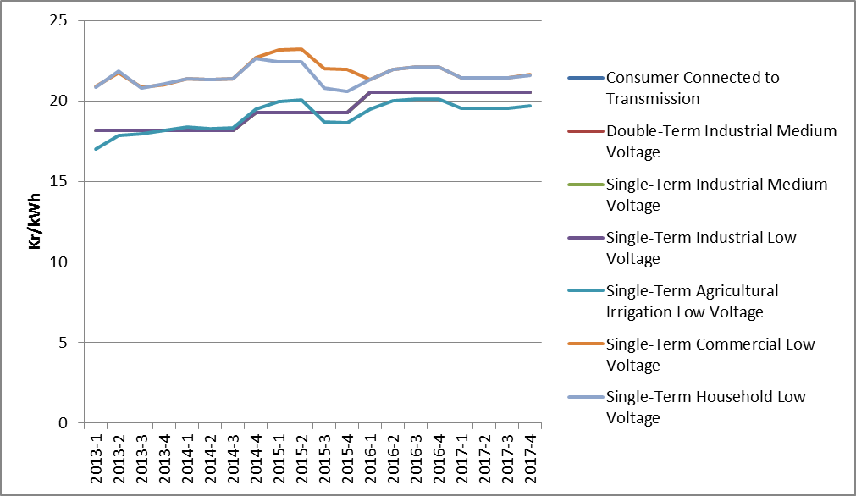

As it is known, it is necessary to use transmission and distribution lines to deliver energy from producer to the consumer. The figure below shows the change in distribution costs by years. Those include distribution, transmission costs and technical and non-technical losses.

Figure 6.2: Change in Network Costs (Distribution, Transmission and Loss) by Years (Kr / kWh)
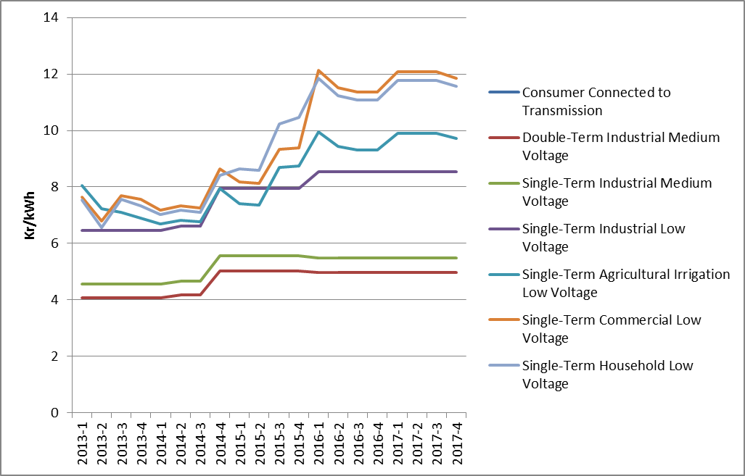
As a result of the addition of the distribution cost to energy cost, the pre-tax unit energy cost is calculated. The figure below shows the change in unit energy cost by years except for taxes and funds (energy fund, TRT share, electricity and gas consumption tax and VAT).

Figure 6.3: Change in Electricity Tariffs before Taxes and Funds by Years (kr / kWh)
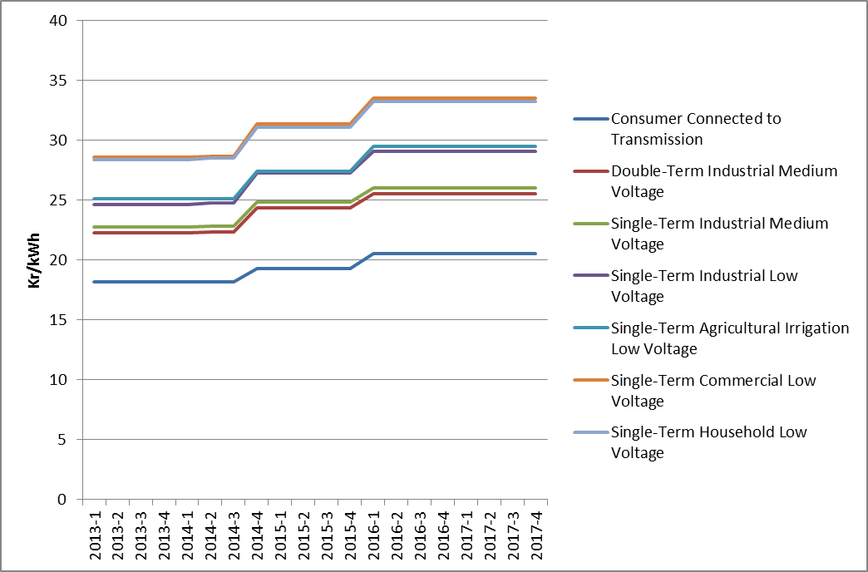
As seen in the figure above, the consumer groups with the highest unit energy costs before taxes and funds were of households and commercials. The lowest unit energy cost before taxes and funds were of the consumers who are connected through the transmission system.

Figure 6.4: Share of Items on Residence Electricity Invoice in 2017 (%)
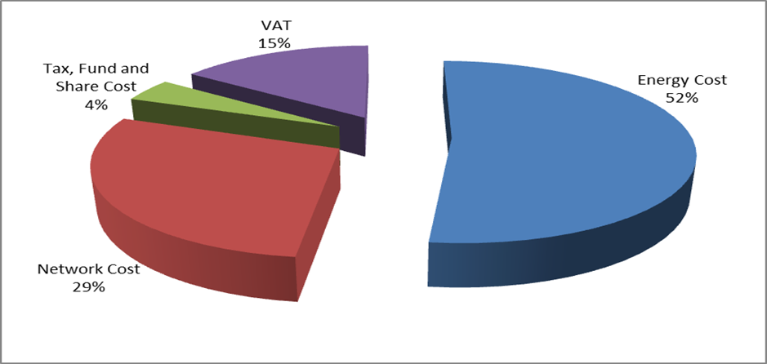

As it can be seen from Figure 6.4, the most important item in the invoices of consumers in the household, excluding the retail energy cost, was the network cost with 29% share.

Figure 6.5: Share of Items on Industry Electricity Invoice in 2017 (%)
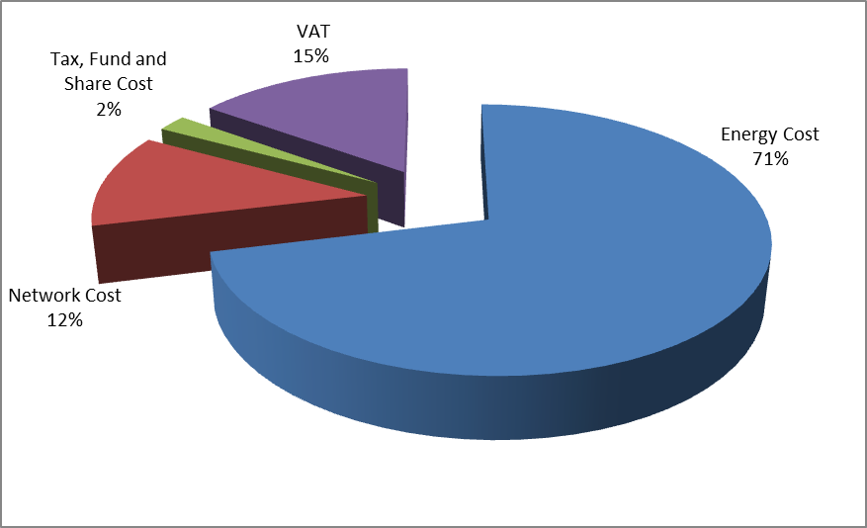
As shown in Figure 6.5, in the invoice components of the consumers in the industrial group compared to the invoice components of the consumers in the households in Figure 6.4; it is seen that the share of retail energy cost was higher and the share of distribution (network) was lower, while VAT, tax, fund and share costs were almost same.

The average feed-in tariffs of RES support mechanism is calculated with monthly average currency rates declared by Turkish Republic Central Bank.
The HHI values are evaluated as a competitive market indicator. If HHI is under 1000 the market is competitive, medium intensity if HHI is between 1000 -1800, and an oligopoly market if HHI is above 1800. In the same way, if the HHI increases by more than 100 points in mergers and acquisitions, it is considered that competitiveness is reduced.
Includes all sales made to eligible and non-eligible consumers for sales volumes of incumbent supply companies.
Including the data about facilities owned by customers.

