

ELECTRICITY MARKET
SECTOR REPORT 2020

All the information, tables and figures provided in this report are reserved and cannot be used without reference.

REPUBLIC OF TURKEY ENERGY MARKET REGULATRORY AUTHORITY
Strategy Development Department

ANKARA, 2021

Important Reminder: Licensees can make corrections to the data they previously submitted to the Authority by requesting correction within the framework of the relevant provisions of the Energy Market Notification Regulation. For this reason, there may be data differences between the published reports.
* In this report, Turkish punctuation rules are adopted for numbers.
*This report is published under the Official Statistics Programme.
THE MESSAGE OF THE PRESIDENT

After the period in which secondary regulations were emphasized within the framework of the Electricity Market Law No. 6446, efforts were made for many regulations and other legislation that came into force. In 2020, significant progress has been made in transforming the market into a structure that operates in a more liberal, competitive, transparent, and predictable manner in the light of these regulations.
Electricity demand, which is one of the most important indicators of economic growth, has experienced great fluctuations due to the measures taken to prevent the Covid-19 pandemic. The effect of the measures taken in this context to slow down the economic activity was also seen in electricity demand as of the end of the year. Turkey has been one of the countries that was least affected by the pandemic with an increase of 0.8 percent in electricity demand.
Structural arrangements that we have made in recent years to encourage the use of renewable energy sources instead of imported sources in electricity production continued to show their results despite the developments experienced during and as a result of the Covid-19 pandemic in the markets. In this context, the share of renewable energy sources, which was 45.4% in total electricity installed power in 2019, increased to 48% in 2020.
Market developments reports, which we submit to our stakeholders by our Institution, are compiled and analyzed from the data submitted to our Authority by using the Energy Market Notification System, mainly. It is one of our main objectives to ensure the integrity, consistency and reliability of the data contained in these reports, which are of great importance to be shared accurately and timely with all relevant parties and the public.
While underlining that we, as EMRA, are open to all kinds of constructive opinions and suggestions, I would like to thank all our sector stakeholders for their devoted work during the pandemic process, and I hope that the Electricity Market Sector Report for 2020 will be beneficial to all relevant parties, institutions and organizations.

Mustafa YILMAZ
President

EXECUTIVE SUMMARY

- Number of Licenses in Electricity Market in 2020
License Type | License Application | Grant of License | Expired License | License Revocation | Number of Licenses at Operation at the end of the Term
Distribution License | - | - | - | - | 21
Transmission License | - | - | - | - | 1
OIZ Transmission License | 5 | 4 | - | - | 181
OIZ Generation License | - | - | - | - | 3
Pre-License | 170 | 175 | 169 | - | 321
Market Operation License | - | - | - | - | 2
Supply License | 10 | 13 | 9 | 1 | 217
Generation License | 150 | 186 | 52 | 1 | 1.782
Total | 335 | 378 | 230 | 2 | 2.528

- Distribution of Pre-License and Generation License by the end of 2020
Resource Type | Pre-License |  | Production License
Resource Type | License Number | Installed Power Assigned to License (MWe) | License Number | Installed Power Assigned to License (MWe)
Hydraulic | 91 | 3.807,57 | 778 | 33.838,94
Wind | 87 | 3.688,44 | 262 | 11.429,76
Geothermal | 10 | 350,80 | 63 | 1.803,63
Biomass | 126 | 743,64 | 242 | 1.759,57
Solar |  |  | 38 | 1.488,81
Import Coal | 1 | 800,00 | 13 | 11.766,80
Domesric Coal | 3 | 519,83 | 27 | 13.761,89
Coal |  |  | 17 | 1.629,56
Fuel-oil |  |  | 24 | 1.054,51
Natural Gas | 3 | 810,75 | 279 | 26.846,70
Uranium |  |  | 1 | 4.800,00
Other Thermal |  |  | 38 | 889,81
Grand Total | 321 | 10.721,03 | 1.782 | 111.070,00

- Installed Capacity and Production by Resources at the End of 2020

RESOURCE TYPE | TOTAL INSTALLED CAPACITY* (MW) | SHARE  (%) | TOTAL PRODUCTION*  (GWh) | SHARE  (%)
HYDRAULIC | 30.983,90 | 32,3 | 78.114,95 | 25,6
NATURAL GAS | 26.041,93 | 27,2 | 69.277,54 | 22,7
LIGNITE | 10.119,92 | 10,6 | 38.163,85 | 12,5
IMPORT COAL | 8.986,85 | 9,4 | 62.466,47 | 20,5
WIND | 8.832,40 | 9,2 | 24.680,83 | 8,1
SOLAR | 6.667,42 | 7,0 | 11.242,48 | 3,7
GEOTHERMAL | 1.613,19 | 1,7 | 9.929,41 | 3,3
BIOMASS | 1.115,59 | 1,2 | 5.501,94 | 1,8
HARD COAL | 810,77 | 0,8 | 3.415,83 | 1,1
ASPHALTITE | 405,00 | 0,4 | 2.222,88 | 0,7
FUEL OIL | 305,93 | 0,3 | 313,04 | 0,1
NAPHTA | 4,74 | 0,0 | 0,00 | 0,0
LNG | 1,95 | 0,0 | 0,00 | 0,0
DIESEL | 1,04 | 0,0 | 1,00 | 0,0
TOTAL | 95.890,61 | 100,00 | 305.330,21 | 100,00
*Licensed and unlicensed power plants are included.

- Licensed Installed Capacity and Peak Demand

- Licensed installed capacity in 2020 was 89.067,14 MW increasing by 4,8% compared to previous year.

- In 2019-2020, licensed installed capacity according to resource type is given below:

Resource Type | 2019  (MW) | Share  (%) | 2020  (MW) | Share  (%) | Change  2019-2020(%)
NATURAL GAS | 25.936,72 | 30,5 | 25.639,26 | 28,8 | -1,1
HYDRO DAM | 20.619,42 | 24,3 | 22.925,03 | 25,7 | 11,2
LIGNITE | 10.101,03 | 11,9 | 10.119,92 | 11,4 | 0,2
IMPORT COAL | 8.966,85 | 10,6 | 8.986,85 | 10,1 | 0,2
WIND | 7.520,28 | 8,9 | 8.761,57 | 9,8 | 16,5
RIVER | 7.877,23 | 9,3 | 8.050,23 | 9,0 | 2,2
GEOTHERMAL | 1.514,69 | 1,8 | 1.613,19 | 1,8 | 6,5
BIOMASS | 724,62 | 0,9 | 1.031,88 | 1,2 | 42,4
HARD COAL | 810,77 | 0,9 | 810,77 | 0,9 | 0,0
SOLAR | 169,69 | 0,2 | 409,80 | 0,5 | 141,5
ASPHALITE COAL | 405,00 | 0,5 | 405,00 | 0,5 | 0,0
FUEL OIL | 305,93 | 0,4 | 305,93 | 0,3 | 0,0
NAPHTA | 4,74 | 0,0 | 4,74 | 0,0 | 0,0
LNG | 1,95 | 0,0 | 1,95 | 0,0 | 0,0
DIESEL | 1,04 | 0,0 | 1,04 | 0,0 | 0,0
Total | 84.959,96 | 100,0 | 89.067,14 | 100,0 | 4,8

While the share of renewable energy resources (including hydraulic) in total installed power was 45,4% by the end of 2019, it increased to 48% in 2020 and while the ratio of total installed thermal power was 54,6% in 2019, it decreased to 52% in 2020.

  - Peak demand reached to 49.851,9 MW increasing by 1,2%.

- Licensed Electricity Generation

  - The amount of licensed electricity generation in 2020 decreased by 0,1% compared to 2019 and reached to 294.084,7 GWh.

  - In 2019-2020, licensed electricity generation according to resource type is given below:

Resource Type | 2019  (GWh) | Share  (%) | 2020  (GWh) | Share  (%) | Change  2019-2020 (%)
HYDRAULIC | 88.850,20 | 30,2 | 78.087,88 | 26,6 | -12,1
NATURAL GAS | 56.522,70 | 19,2 | 69.277,54 | 23,6 | 22,6
IMPORT COAL | 60.381,30 | 20,5 | 62.466,47 | 21,2 | 3,5
LIGNITE | 46.893,70 | 15,9 | 38.163,85 | 13,0 | -18,6
WIND | 21.636,30 | 7,4 | 24.561,36 | 8,4 | 13,5
GEOTHERMAL | 8.929,70 | 3,0 | 9.929,41 | 3,4 | 11,2
BIOMASS | 4.266,30 | 1,4 | 5.228,50 | 1,8 | 22,6
HARD COAL | 3.518,90 | 1,2 | 3.415,83 | 1,2 | -2,9
ASPHALTITE COAL | 2.324,00 | 0,8 | 2.222,88 | 0,8 | -4,4
SOLAR | 194,40 | 0,1 | 416,98 | 0,1 | 114,5
FUEL OIL | 732,90 | 0,2 | 313,04 | 0,1 | -57,3
DIESEL | 1,00 | 0,0 | 1,00 | 0,0 | -0,1
Total | 294.251,30 | 100,0 | 294.084,73 | 100,0 | -0,1

The share of renewable energy sources (including hydraulics) in total licensed electricity generation was 42,1% in 2019 and 40,2% in 2020. The ratio of the total installed thermal power was 57,9% in 2019 and 59,8% in 2020.

- Unlicensed Installed Capacity

  - In 2020, unlicensed installed capacity increased by 8,1% compared to previous year and became 6.823,47 MW. 91,71% of this amount represents the solar power plants.

  - The development of unlicensed installed capacity by resources in 2019 and 2020 is shown below:

Resource Type | 2019 |  | 2020
Resource Type | Installed Capacity  (MWe) | Share  (%) | Installed Capacity (MWe) | Share  (%)
Solar | 5.825,46 | 92,33 | 6.257,61 | 91,71
Natural Gas | 328,66 | 5,21 | 402,67 | 5,90
Biomass | 75,67 | 1,20 | 83,71 | 1,23
Wind | 70,83 | 1,12 | 70,83 | 1,04
Hydraulic | 8,65 | 0,14 | 8,65 | 0,13
Total | 6.309,27 | 100,00 | 6.823,47 | 100,00

- Unlicensed Generation

  - In 2020, unlicensed generation increased by 14,4% compared to previous year and became 11.245.481,50 MWh. 96,27% of this amount is generated from solar energy.

  - In 2019-2020, unlicensed installed generation according to resource type is given below:

Resource Type | 2019 |  | 2020
Resource Type | The amount of energy that given to system as a surplus (MWh) | Share  (%) | The amount of energy that given to system as a surplus (MWh) | Share  (%)
Solar | 9.425.911,41 | 95,90 | 10.825.501,82 | 96,27
Biomass | 255.486,63 | 2,60 | 273.446,13 | 2,43
Wind | 113.558,01 | 1,16 | 119.466,89 | 1,06
Hydraulic | 34.437,65 | 0,35 | 27.066,66 | 0,24
Total | 9.829.393,70 | 100,00 | 11.245.481,50 | 100,00

- Invoiced and Actual Consumption

Consumer Type | Consumption Amount of Consumers Connected to the Distribution Voltage (GWh) |  | Consumption Amount of Consumers Connected to the Transmission Voltage (GWh) |  | Total (GWh)
Consumer Type | 2019 | 2020 | 2019 | 2020 | 2019 | 2020
Non-eligible | 134.409,69 | 103.709,28 | 1.278,91 | 808,04 | 135.688,60 | 104.517,32
Eligible | 41.494,79 | 73.676,50 | 52.414,53 | 55.242,79 | 93.909,32 | 128.919,29
Total | 175.904,48 | 177.385,78 | 53.693,43 | 56.050,83 | 229.597,91 | 233.436,61

  - Electricity consumption, which was invoiced in 2020, increased by 1,7% compared to the previous year and reached to 233.436,61 GWh. 56.050,83 GWh of this amount was sold to consumers at the transmission voltage level, while the remaining 177.385,78 GWh was sold to consumers at the distribution voltage level.
  - Besides, 128.919,29 GWh of 233.436,61 Gwh consumption was consumed by eligible consumers and 104.517,32 GWh by non-eligible consumers.
  - Actual consumption was increased by 0,8% compared to 2019 and it reached to 304.394,9 GWh.

- Import and Export

  - In 2020, electricity import decreased by 14,6% compared to previous year and it reached to 1,89 TWh.

  - Electricity export decreased by 10,9% compared to previous year and it reached to 2,48 TWh.

- Day-Ahead Market and Balancing Market

  - In 2020, the weighted average Market Clearing Price (PTF) increased by 6,5% compared to 2019 and it became 285,87 TL/MWh.

  - The highest PTF value was on September 17, 2020 at 16:00 with 982,00 TL/MWh. In 2020, PTF was realized as 0 TL / MWh for a total of 34 hours.

  - In 2020, the average System Marginal Price (SMF) increased by 12,9% compared to 2019 and it became 282,47 TL/MWh.

  - The highest SMF value was 2000 TL/MWh on September 3 2020 at 16:00 and the lowest SMF value was 0 TL/MWh for a total of 256 hours.

  - The additional cost caused by the instructions given in Day-Ahead Market in 2020 decreased by %80,6 compared to 2019 and it reached to 121,47 million TL.

- RESSUM

  - In 2020, the number of licensed participants benefiting from the Renewable Energy Resources Support Mechanism reached to 821 and the installed capacity of these participants was 21.146,1 MW.

  - In 2020, the electricity generation of RESSUM participants increased by 4,2% compared to 2019 and it reached to 73,48 TWh. %40,4 of this amount was obtained from hydraulic, 28% of it was obtained from wind.

  - The average price of RERSUM increased by 27,2% compared to 2019 and it reached to 630,4 TL/MWh.

  - In 2020, an additional cost of RESSUM, which means additional cost to the weighted average MCP for RESSUM per invoiced unit energy amount, increased by 42,9% and became108,5 TL/MWh.

- Market Openness

  - The eligible consumer limit for 2020 was set to 1.400 kWh, and the theoretical market openness rate on the demand side corresponding to this limit was calculated as 96,8%.

  - Eligible consumers' consumption in 2020 was 135,10 TWh. While the actual market opening was 44% in 2019, this rate increased to 58,3% in 2020.

  - At the end of 2020, the number of eligible consumers increased by 215% compared to 2019 and it reached to 1 million 15 thousand. This number corresponds to 2,4% of the total number of consumers.

- Transmission

- By the end of 2020, there were 1.214 transformer centers in the transmission system and 2.327 transformers with 210.920 capacity.

- By the end of 2020, the length of the transmission lines was 71.098 km.

- In 2020, 3,40 billion TL was invested by the transmission company.

  - In 2020, the transmission system loss rate was 1,9%.

- Distribution

  - By the end of 2020, the number of consumers using the distribution system was 46,07 million. The regions with the highest number of consumers were the Boğaziçi with 5,2 million, and the Başkent with 4,4 million.

  - By the end of 2020, the total invoiced consumption in the distribution regions was 177,39 TWh. The regions with the highest consumption amounts were the Boğaziçi with 23,94 TWh and the Toroslar with 16,13 TWh Toroslar.

  - The highest loss rates were seen in Dicle with 46,3%, Vangölü with 44,6% and Aras with 20,6%.

  - The lowest loss rates were seen in the distribution regions of İstanbul Anadolu Yakası with 5,4%, Trakya with 5,6%, Uludağ with 5,9%.

  - By the end of 2020, 57.624 people were employed in the electricity distribution sector. 24.099 of those were employed as permanent staff in distribution companies and the remaining 33.525 were employed as subcontractor company personnel.

- By the end of 2020, there were 499.736 transformers in the distribution system with 177.102 MVA power.

- By the end of 2020, the length of distribution lines is 1.204.979 km. 967.378 km of it is overhead line and the 237.601 km of it is underground lines.

- In 2020, the distribution companies invested 8,8 billion TL in current prices. The highest investment expenditure was in Başkent with 1,1 billion TL and Toroslar with 1,0 billion TL.

Electricity Market Overview in 2020
Parameters | Unit | 2018 | 2019 | 2020 | 2019-2020 Change (%)
Licensed Installed Capacity | MWe | 83.187,1 | 84.960,0 | 89.067,1 | 4,8
Licensed Generation* | GWh | 296.003,7 | 294.251,3 | 294.084,7 | -0,1
Highest Peak Demand | MW | 46.160 | 45.324 | 49.852 | 10,0
Lowest Peak Demand | MW | 18.212 | 18.300 | 15.690 | -14,3
Unlicensed Generation** | GWh | 8.212,8 | 9.829,5 | 11.245,5 | 14,4
Unlicensed Installed Capacity | MWe | 5.310,6 | 6.309,3 | 6.823,5 | 8,1
RESSUM Generation*** | MWh | 62.505.431 | 76.668.087 | 73.482.227 | -4,2
RESSUM Payment Amount | TL | 26.169.350.612 | 38.012.077.764 | 46.335.283.734 | 21,9
Average RESSUM Price | TL/MWh | 418,7 | 495,8 | 630,4 | 27,2
RESSUM Additional Cost**** | TL/MWh | 31,8 | 75,9 | 108,5 | 42,9
Actual Consumption | GWh | 302.772,3 | 301.982,7 | 304.394,9 | 0,8
Invoiced Consumption | GWh | 233.610,0 | 229.597,9 | 233.436,6 | 1,7
Number of Consumers | Number | 43.653.910 | 44.958.924 | 46.082.473 | 2,5
Import | GWh | 2.466,0 | 2.211,5 | 1.888,3 | -14,6
Export | GWh | 3.073,6 | 2.788,7 | 2.484,0 | -10,9
Weighted Average MCP | TL/MWh | 233,1 | 268,5 | 285,9 | 6,5
Weighted Average SMF | TL/MWh | 233,3 | 250,3 | 282,5 | 12,9

*Licensed Generation: Includes the installed capacity and generation values of Independent Generation Companies, Build-Operate, Transfer of Operating Rights and Build-Operate-Transfer Power Plants.

**Unlicensed Generation: Generation in accordance with Article 14 of the Electricity Market Law No. 6446, that is granted to the system as a surplus by those who are exempted from the obligation to obtain license and a company.
***RESSUM generation includes unlicensed generation values.

****RESSUM Additional Cost: Additional cost to the weighted average MCP for RESSUM per invoiced unit energy amount.

Contents
1. LICENSED GENERATION AND INSTALLED CAPACITY, UNLICENSED GENERATION, INVOICED AND ACTUAL CONSUMPTION, IMPORT AND EXPORT 18
1.1 Overview 18
1.2 Licensed Generation 19
1.3 Licensed Installed Capacity 27
1.4 Unlicensed Generation 31
1.5 Invoiced Electricity Consumption 40
1.6 Import and Export 50
2. WHOLESALE MARKET 52
2.1 Day-Ahead Market 52
2.2 Balancing Power Market 58
2.3 Intra-Day Market 64
2.4 Bilateral Agreements 66
2.5 Renewable Energy Sources Support Mechanism (RESSUM) 69
3. COMPETITION 75
3.1 Supply Side 75
3.2 Demand Side 80
4. TRANSMISSON 84
4.1 Transmission System 84
4.2 Transmission System Connection Applications 86
4.3 Tariffs 86
4.4 Amount of Investment 88
4.5 Losses 88
5. DISTRIBUTION 90
5.1 Number of Consumers 90
5.2 Ratio of Losses 91
5.3 Employment 94
5.4 Information about Network 95
5.5 Quality Indicators 101
5.6 Investment Amount of Distribution Companies 104
5.7 Information about Organized Industrial Zones (OIZ) 107
6. PRICING 108

Table List
Table 1.1: Licensed and Unlicensed Installed Capacity, Peak Demand, Licensed and Unlicensed Electricity Generation, Consumption, Import and Export Data 18
Table 1.2: Licensed Electricity Generation by Provinces (GWh-%) 24
Table 1.3 Distribution of Licensed Installed Capacity by Province (MW-%) 30
Table 1.4: The Status of Unlicensed Electricity Generation Applications at the End of 2020 (MWe) 32
Table 1.5: Distribution of Unlicensed Installed Capacity by Resources (MWe-%) 33
Table 1.6: Distribution of Unlicensed Installed Capacity by Province (MWe-%) 34
Table 1.7: Distribution of Unlicensed Electricity Generation by Resources (MWh-%) 36
Table 1.8: Distribution of Unlicensed Electricity Generation by Provinces (MWh-%) 37
Table 1.9: Distribution of the Amount of Payment Made Within the Scope of Unlicensed Electricity Generation by Resources (TL-%) 40
Table 1.10: Sales to Eligible and Non-Eligible Consumers in 2020 (MWh) 41
Table 1.11: Distribution of Invoiced Consumption by Distribution Regions in 2020 (MWh-%) 41
Table 1.12: Distribution of Invoiced Consumption by Consumer Type as Eligible and Non-Eligible Consumers in 2020 (MWh) 42
Table 1.13: Development of Invoiced Consumption by Consumer Type by Years (MWh) 43
Table 1.14: Distribution of Invoiced Consumption by Province (MWh - %) 44
Table 1.15: Distribution of Invoiced Consumption by Province and Consumer Type (MWh) 46
Table 2.2.1: Additional Costs of Orders (Million TL) 62
Table 2.5.1: Number of YEKDEM Participants by Years 69
Table 2.5.2: Distribution of RESSU. Installed Capacity by Resources (MW)* 70
Table 2.5.3: Yearly Generation of RESSUM Participants by Years (MWh)* 71
Table 3.1: HHI Values with respect to Generation and Installed Capacity 75
Table 3.2: Sales, Market Shares and HHI Index of Supply License Owners 76
Table 3.3: Distribution of Eligible Consumers' Supplier Changes by Supplier Type 83
Table 4.1: Transformer Center Information 84
Table 4.2: TEİAŞ Transmission Lines 85
Table 4.3: Connection Applications to the Transmission System (Number - MW) 86
Table 4.4: System Usage and System Operation Tariffs Applied in 2020 (TL/MW-Year, TL/MWh) 87
Table 4.5: Comparison of 2019 and 2020 Investment Amount (TL-%) 88
Table 5.1: Number of Consumers Using Distribution System by the end of 2020 (Number-%) 90
Table 5.2: Loss Rates of Distribution Companies (%) 92
Table 5.3: Number of Employees of Distribution Companies 94
Table 5.4: Line Lengths, Number of Transformers and Transformer Capacities Based on Distribution Companies at the end of 2020 (km-MVA-Number) 96
Table 5.5: The Lengths of Distribution Lines (km) 97
Table 5.6: Line Lengths at Distribution Voltage Levels, Number of Transformers and Transformer Capacities by Provinces at the end of 2020 (km-MVA-Number) 99
Table 5.7: Reported and Unreported System Average Interruption Duration Indices of Distribution Companies in 2019-2020 (min) 101
Table 5.8: System Average Interruption Duration Indices of Distribution Companies by Reason in 2020 (min) 102
Table 5.9: System Average Interruption Frequency Indices of Distribution Companies in 2019 and 2020 (Number/Year) 103
Table 5.10: Distribution Companies’ System Average Interruption Frequency Indices of Distribution Companies by Reason in 2019 (Number/Year) 103
Table 5.11: Comparison of Distribution Investment Amounts in 2019-2020 (Current Prices - Million TL-%) 105
Table 5.12: Realized Investment Amounts in 2020 by Investment Types (TL) 106
Table 5.13: Information about Organized Industrial Zones 107

Figure List

Figure 1.1: Electric Energy Demand and Rate of Increase by Years (GWh-%) 21
Figure 1.2: Peak Demand and Increase Rate Over Years (MW-%) 21
Figure 1.3: Rate of Increase of Demand and Peak Demand by Year (%) 22
Figure 1.4: Monthly Distribution of Licensed Electricity Generation and Consumption in 2020 (GWh) 22
Figure 1.5: Distribution of Licensed Electricity Generation in 2020 by Corporations(%) 23
Figure 1.6: Change of Licensed Electricity Generation as Public-Private by Years (%) 23
Figure 1.7: The Distribution of Licensed Electricity Generation by Sources in 2020 (%) 24
Figure 1.8: Source-Based Development of Licensed Electricity Generation by Years (GWh) 25
Figure 1.9: Licensed Electricity Generation Per Day in 2020 (MWh) 25
Figure 1.10: Hour-Based Electricity Generation in 2020 (MWh) 26
Figure 1.11: The share of First 10 Companies within Electricity Generation in 2020(%) 28
Figure 1.12: Distribution of Licensed Installed Capacity by Sources at the End of 2020 (%) 29
Figure 1.13: Distribution of Licensed Installed Capacity by Organizations at the End of 2020 (%) 30
Figure 1.14: The Development of Licensed Installed Capacity by Source over the Years (MW) 31
Figure 1.15: The Development of the Share of the Sources within the Installed Capacity by Years (%) 31
Figure 1.16: The Share of the First 10 Companies in Installed Capacity at the End of 2020 (%) 33
Figure 1.18: Distribution of Unlicensed Installed Capacity by Sources at the End of 2020 (%) 35
Figure 1.19: Distribution of Unlicensed Electricity Generation by Resources in 2020 (%) 39
Figure 1.20: Distribution of Invoiced Consumption by Consumer Type in 2020 (%) 45
Figure 1.21: Distribution of Invoiced Consumption by Months (MWh) 51
Figure 1.22: Development of Actual Consumption by Years (GWh) 51
Figure 1.23: Electricity Imports in 2020 by Months (MWh) 52
Figure 1.24: Electricity Exports in 2020 by Months (MWh) 53
Figure 2.1.1: Hourly Development of Weighted Average Market Clearing Price and Market Clearing Price in 2020 (TL/MWh) 56
Figure 2.1.2: Organized and Weighted Average MCP in 2020 (TL/MWh) 56
Figure 2.1.3: Weighted Average MCP by Years (TL/MWh) 57
Figure 2.1.4: Monthly Weighted Average MCP of the Last Two Years (TL/MWh) 58
Figure 2.1.5: Monthly Day-Ahead Market Trading Volume (MWh) 58
Figure 2.1.6: The Share of Top 10 Buyer Companies in Day-Ahead Market (%) 59
Figure 2.1.7: The Share of Top 10 Seller Companies in Day-Ahead Market (%) 59
Figure 2.2.1: Development of System Marginal Price in Hour Based (TL/MWh) 60
Figure 2.2.2: Organized System Marginal Price (TL/MWh) 60
Figure 2.2.3: Monthly Weighted Average Prices of the Last Two Years in Balancing Power Market (TL/MWh) 61
Figure 2.2.4: Monthly Trading Volumes in Balancing Power Market (MWh) 62
Figure 2.2.5: The Share of Top 10 Buyer Companies in Balancing Power Market (%) 62
Figure 2.2.6: The Share of Top 10 Seller Companies in Balancing Power Market (%) 63
Figure 2.2.7: Rates of Order Volumes Given in Balancing Power Market in 2020 (%) 63
Figure 2.2.8: Distribution of the Orders Given in the Balancing Power Market by Hours in 2020 (MW) 64
Figure 2.2.9: Development of Additional Costs of Orders by Months in 2020 (Million TL) 65
Figure 2.2.10: Development of Zero Balance Adjustment Component by Years (TL) 65
Figure 2.3.1: Monthly Development of Trading Volume and Average Price in the Intra-Day Market (MWh – TL/MWh) 66
Figure 2.3.2: Distribution of Purchases of Intra-Day Market by Companies and the Share of Top 10 Companies (%) 67
Figure 2.3.3: Distribution of Sales in IDM on the Basis of the Company and The Share of Top 10 Seller Companies (%) 67
Figure 2.4.1: Monthly Bilateral Agreement Volume by Years (MWh) 68
Figure 2.4.2: Distribution of Purchases of Bilateral Agreement by Companies and the Share of Top 10 Companies (%) 69
Figure 2.4.3: Distribution of Sales with Bilateral Agreement by Companies and the Share of Top 10 Companies (%) 69
Figure 2.4.4: EÜAŞ Wholesale Prices Between 2011-2019 (kr/kWh) 70
Figure 2.5.1: Distribution of YEKDEM Installed Capacity to Resources in 2020 (%) 72
Figure 2.5.2: Distribution of RESSUM Generation by Resources in 2020 (%) 73
Figure 2.5.3: Monthly Development of YEKDEM Generation in 2020 (MWh) 74
Figure 2.5.4: Monthly Development of RESSUM and DAM Prices in 2020 75
Figure 2.5.5: Average of RESSUM and MCP in 2020 (kr/kWh) 75
Figure 2.5.6 Monthly Payments Made within the Scope of the YEKDEM in 2020 (TL) 76
Figure 2.5.7 Monthly Improvement of Average RESSUM Additional Cost in 2020 (TL/MWh) 76
Figure 3.1: Eligible Consumer Limit and Market Openness Ratio by Years (kWh-%) 82
Figure 3.2: Number of Eligible Consumer by Months in 2020 83
Figure 3.3: Distribution of Eligible Consumers and Their Consumptions by Distribution Regions in 2020 83
Figure 3.4: Distribution of Eligible Consumer Consumption by Supplier Type (%) 84
Figure 3.5: Monthly Changes in Number and Consumptions of Eligible Consumers Switching Their Supplier (Number-MWh) 84
Figure 4.1: Changes in TEİAŞ Transmission Line Lengths by Years (km) 87
Figure 4.2: Capacity Based Regional Transmission System Usage Tariffs Applied in 2020 (TL/MW-Year) 89
Figure 4.3: Transmission System Losses (GWh-%) 90
Figure 5.1: Number of Consumers and Consumption Amounts (Number - MWh) 93
Figure 5.2: Actual and Targeted Loss Rates in 2020 (%) 95
Figure 5.3: Number of Employees of Distribution Companies by the end of 2020 97
Figure 5.4: Line Lengths and Transformer Capacities on the Basis of Distribution Companies at the end of 2020 (km-MVA) 99
figure 5.5: The Length of Lines on the Basis of Distribution Companies at the end of 2020 (km) 100
Figure 5.6: Investment Amounts of Distribution Companies in 2020 (Current Prices-Million TL) 108
Figure 6.1: Retail Price Excluding Taxes and Funds by Years (Energy+PSH) (kr/kWh) 110
110
Figure 6.2: Change in Network Costs (Distribution, Transmission and Loss) by Years (kr/kWh) 111
Figure 6.3: Change in Electricity Tariffs before Taxes and Funds by Years (kr/kWh) 111
Figure 6.4: Share of Items on Household Electricity Invoice in 2020 (%) 112
Figure 6.5: Share of Items on Industry Electricity Invoice in 2020 (%) 112

ABBREVIATIONS TABLE

BPM : Balancing Power Market
CPI : Consumer Price Index
EMRA : Energy Market Regulatory Authority
EPİAŞ : Energy Exchange Istanbul
EÜAŞ : Electricity Generation Company
IDM : Intra-Day Market
DAM : Day-Ahead Market
MCP : Market Clearing Price (Day-Ahead Price)
SMP : System Marginal Price (Real Time Price)
BO : Build Operate
BOT : Build Operate Transfer
TEİAŞ : Turkish Electricity Transmission Company
TETAŞ : Turkish Electricity Trading and Contracting Company Inc.
RESSUM : Renewable Energy Sources Support Mechanism

- LICENSED GENERATION AND INSTALLED CAPACITY, UNLICENSED GENERATION, INVOICED AND ACTUAL CONSUMPTION, IMPORT AND EXPORT

This section shall examine, licensed and unlicensed electricity generation and installed capacity, invoiced and actual consumption, export and import data for the year 2020. In addition, determinations have been made regarding the change of the data in question over the years.

1.1 Overview

Table 1.1 shows the licensed and unlicensed installed capacity, peak demand, licensed and unlicensed electricity generation, invoiced and actual consumption, import and export data by the end of 2020, combined with previous years’ data.

Table 1.1: Licensed and Unlicensed Installed Capacity, Peak Demand, Licensed and Unlicensed Electricity Generation, Consumption, Import and Export Data
 | Unit | 2017 | 2018 | 2019 | Change (%) 2018-2019 | 2020 | Change (%) 2019-2020
Licensed Installed Capacity | MW | 81.506,4 | 83.187,0 | 84.960,0 | 2,1 | 89.067,1 | 4,8
Unlicensed Installed Capacity | MW | 3.173,3 | 5.310,6 | 6.309,3 | 18,8 | 6.823,5 | 8,1
Peak Demand | MW | 48.831,8 | 49.515,7 | 49.281,4 | -0,5 | 49.851,9 | 1,2
Licensed Generation | GWh | 292.595,4 | 295.402,3 | 294.251,3 | -0,4 | 294.084,7 | -0,1
Unlicensed Generation | GWh | 3.031,3 | 8.212,8 | 9.829,4 | 19,7 | 11.245,5 | 14,4
Invoiced Consumption | GWh | 225.830,2 | 233.610,0 | 229.597,9 | -1,7 | 233.436,6 | 1,7
Actual Consumption | GWh | 292.003,5 | 302.772,3 | 301.977,5 | -0,3 | 304.394,9 | 0,8
Import | GWh | 2.729,1 | 2.466,0 | 2.211,5 | -10,3 | 1.888,3 | -14,6
Export | GWh | 3.300,1 | 3.073,6 | 2.788,7 | -9,3 | 2.484,0 | -10,9

When the table is analyzed, compared to 2019, licensed installed capacity, unlicensed installed capacity, peak demand, unlicensed generation, invoiced and actual consumption increased by 4,8%, 8,1%, 1,2%, 14,4%, 1,7% and 0,8% respectively and licensed generation decreased by %0,1.
Imports decreased by 14,6% compared to previous year and reached 1,89 TWh. Exports also decreased by 10,9% and reached 2,48 TWh. While the ratio of exports to imports was 126,1% in 2019, it increased to 131,5% in 2020.

1.2 Licensed Generation

Figure 1.1 shows the electric energy and increase rate over the years. As it seen in the figure, electric energy demand decreased in 2009 and 2019, in the last 20 years. In the 2020, the demand is increased by 0,80% compared to previous year.

Figure 1.1: Electric Energy Demand and Rate of Increase by Years (GWh-%)
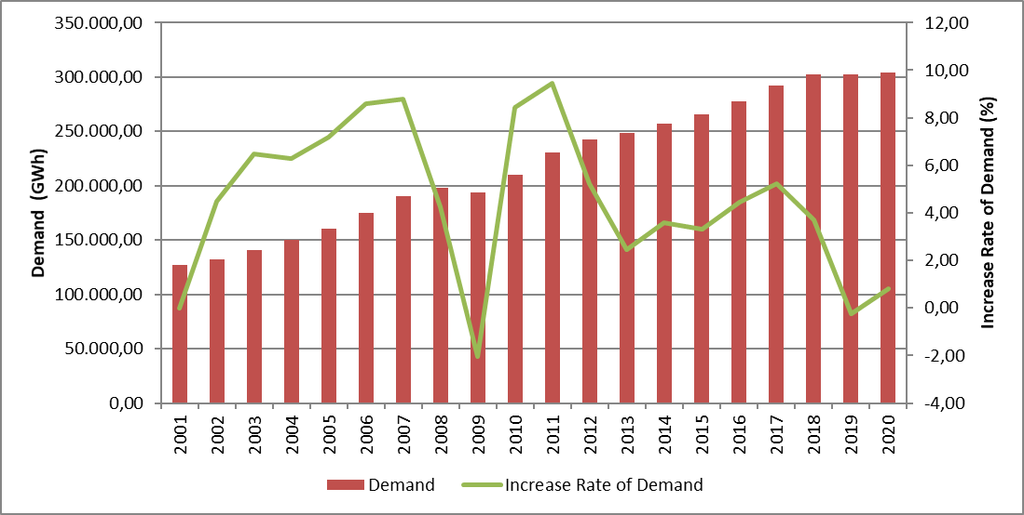
The development and increase rate of peak demand is presented in Figure 1.2. The change in peak demand generally occurred in the figure similar to energy demand, but it is more variable. It is seen that peak demand decreased by 1,16% in 2020 compared to the previous year.

Figure 1.2: Peak Demand and Increase Rate Over Years (MW-%)
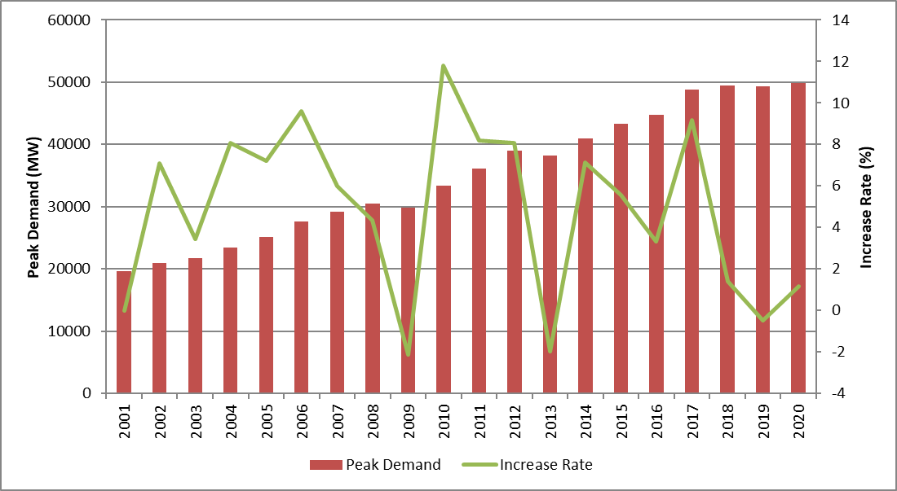
Figure 1.3 shows the relationship between peak demand and electrical energy demand over the years. As can be seen from the figure, the increase rates of electricity demand and peak demand were generally close to each other.

Figure 1.3: Rate of Increase of Demand and Peak Demand by Year (%)

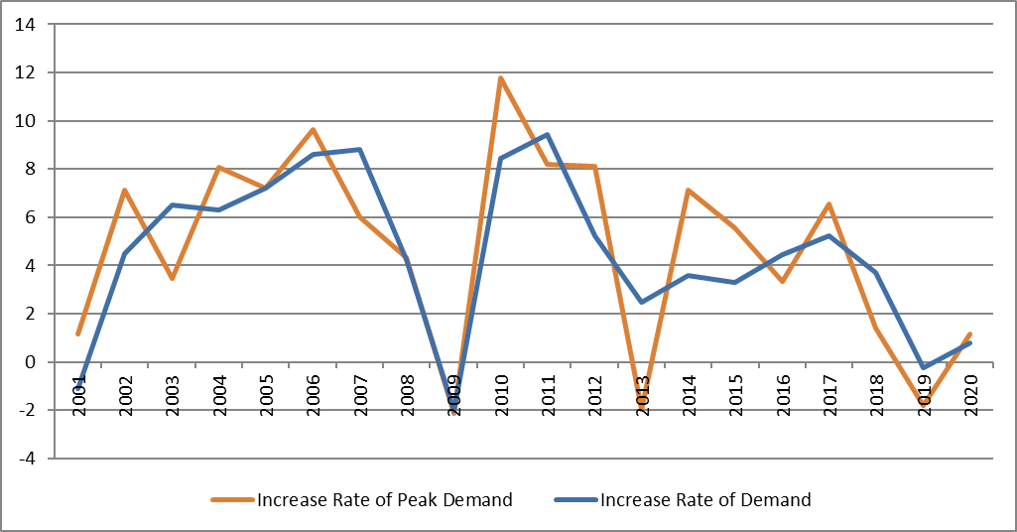

Figure 1.4 shows the licensed electricity generation and monthly change in electricity consumption. Monthly licensed electricity generation and consumption reached their highest values in August.

Figure 1.4: Monthly Distribution of Licensed Electricity Generation and Consumption in 2020 (GWh)
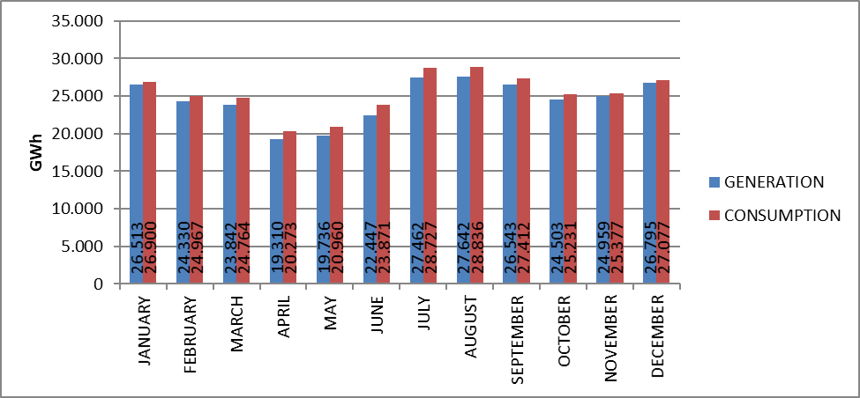
Distribution of licensed electricity generation by organizations in 2020 is shown in Figure 1.5. Independent generation companies have the highest share in production with 78,20%. The share of EÜAŞ power plants was 18,97%, and the share of power plants operating under existing contracts in total production was 2,83%.

Figure 1.5: Distribution of Licensed Electricity Generation in 2020 by Corporations(%)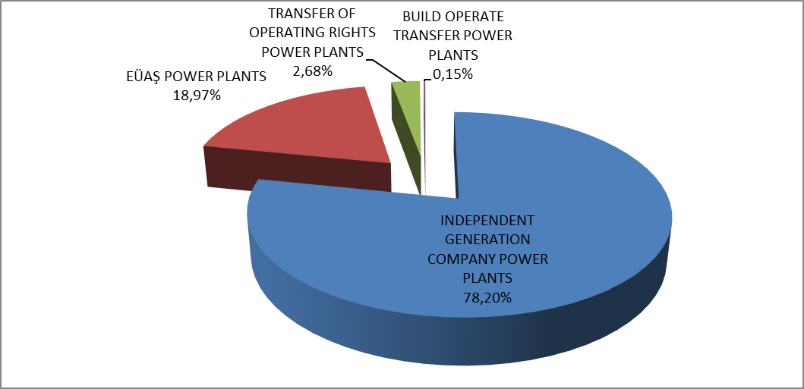
The distribution of licensed electricity production under public, private and existing contracts is given in Figure 1.6. While the total share of the public sector in production (including existing contracts) was 28,06% in 2019, this rate decreased to 21,80% in 2020. Similarly, the share of independent generation, which was 71,94% in 2019, increased to 78,20% in 2020.

Figure 1.6: Change of Licensed Electricity Generation as Public-Private by Years (%)
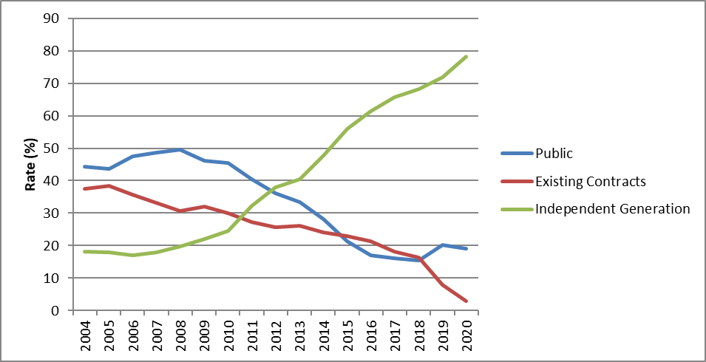
As seen in the Figure 1.6, the share of independent generation continues to increase. There are two main reasons of this increment. Firstly, most of the new investments were done by independent power producers. Second reason is that existing contracts of build operate power plants have expired.
The distribution of licensed electricity generation by resources is shown in Figure 1.7. While the share of natural gas-fired power plants in licensed electricity generation in 2019 was 19,21%, it increased to 23,56% in 2020, while the share of imported coal plants 20,52%, it increased to 21,24%, while the share of wind power plants was 7,35%, it increased to 8,35% and while the share of geothermal plants was %3,03, it increased to %3,38. On the other hand, the share of hydroelectric power plants was 30,20% in 2019 and decreased to 26,55%. The share of domestic coal (lignite, hard coal and asphaltite) power plants decreased from %17,92 to %14,89.

Figure 1.7: The Distribution of Licensed Electricity Generation by Sources in 2020 (%)
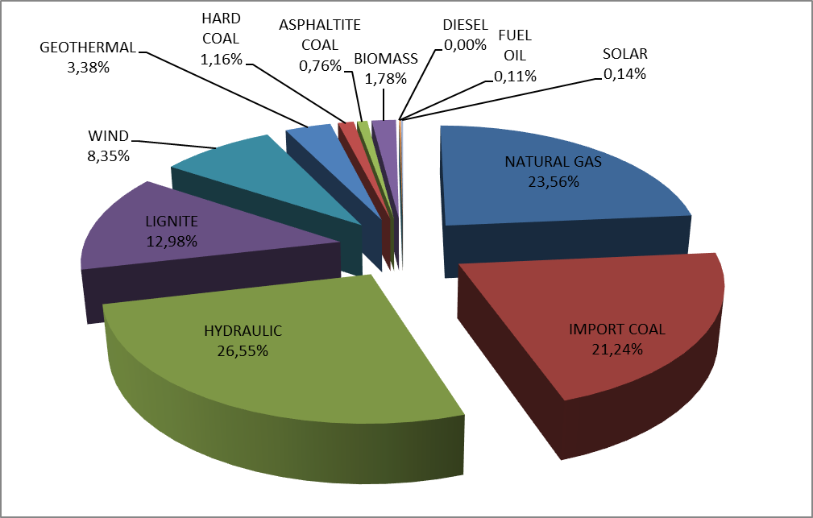
The development of licensed electricity generation on the basis of resources since 1990 is shown in Figure 1.8. As can be seen from the figure, the share of renewable energy sources such as geothermal, wind, solar and biomass in electricity generation has increased every year.

Figure 1.8: Source-Based Development of Licensed Electricity Generation by Years (GWh)
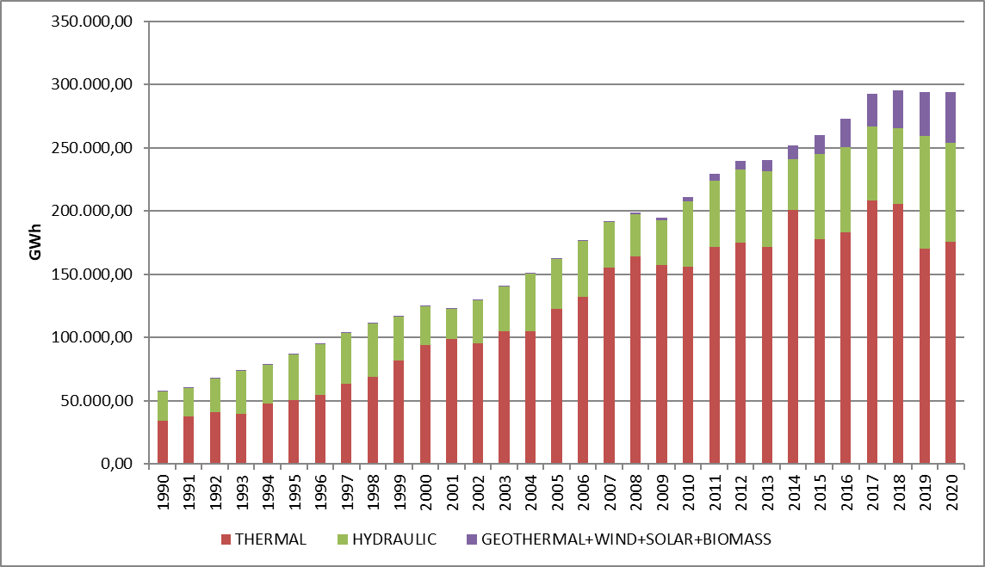
The day-based development of licensed electricity generation in Turkey is shown in Figure 1.9. Licensed electricity generation was highest in August and lowest in April. When it considered on a daily basis, electricity generation was highest on September 3, 2020 and lowest May 24, 2020.

Figure 1.9: Licensed Electricity Generation Per Day in 2020 (MWh)
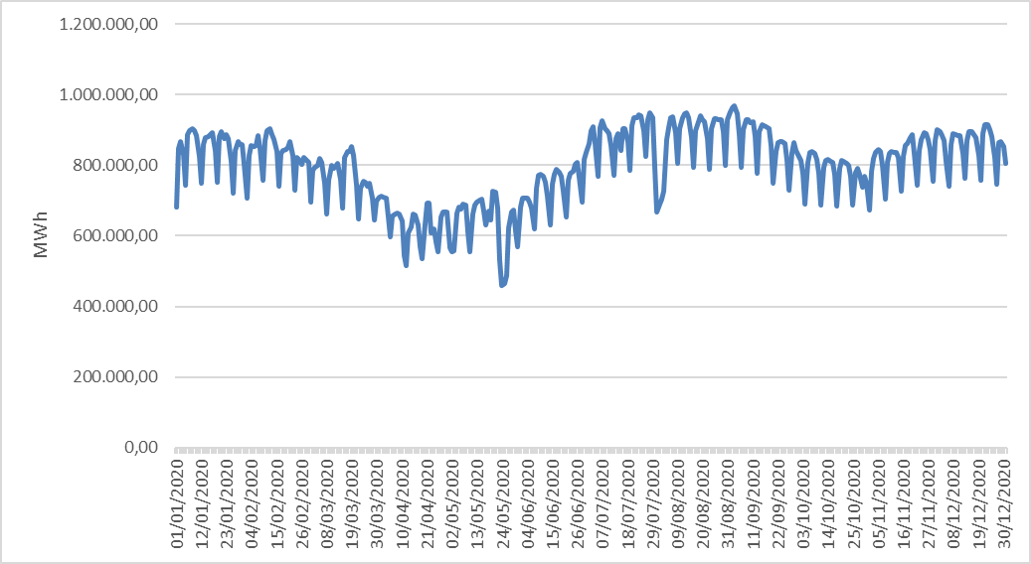
Hour-based licensed electricity generation in Turkey is shown in Figure 1.10. Licensed electricity generation was highest at 20:00, lowest at 06:00.

Figure 1.10: Hour-Based Electricity Generation in 2020 (MWh)
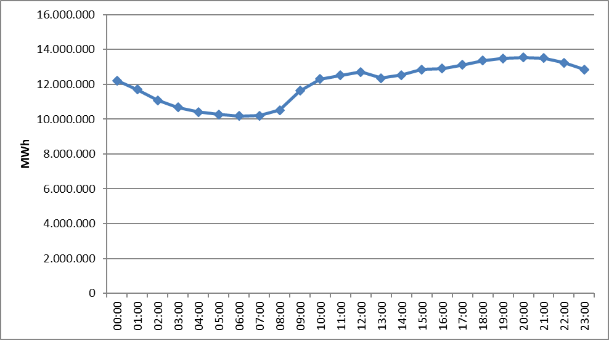
The distribution of licensed electricity generation by province is shown in Table 1.2. In 2019, the highest electricity production was realized in Çanakkale, Zonguldak, Adana, Hatay, İzmir and Balıkesir provinces, the lowest electricity production was in Çankırı, Niğde, Bartın, Aksaray, Iğdır and Bayburt provinces respectively.

Table 1.2: Licensed Electricity Generation by Provinces (GWh-%)
PROVINCE | Generation (GWh) | Share (%) | PROVINCE | Generation (GWh) | Share (%)
ÇANAKKALE | 26.207,92 | 8,91 | ORDU | 1.157,43 | 0,39
ZONGULDAK | 21.114,63 | 7,18 | RİZE | 1.094,16 | 0,37
ADANA | 18.864,62 | 6,41 | KONYA | 997,61 | 0,34
HATAY | 14.646,79 | 4,98 | GAZİANTEP | 995,58 | 0,34
BALIKESİR | 13.105,13 | 4,46 | ERZURUM | 965,29 | 0,33
İZMİR | 12.940,77 | 4,40 | YALOVA | 884,97 | 0,30
MANİSA | 12.850,83 | 4,37 | ERZİNCAN | 884,42 | 0,30
MUĞLA | 11.662,29 | 3,97 | ADIYAMAN | 875,16 | 0,30
ŞANLIURFA | 10.004,50 | 3,40 | AMASYA | 862,36 | 0,29
KIRIKKALE | 9.102,58 | 3,10 | KARABÜK | 763,78 | 0,26
KAHRAMANMARAŞ | 8.843,45 | 3,01 | ESKİŞEHİR | 700,85 | 0,24
SAMSUN | 8.761,30 | 2,98 | SAKARYA | 586,33 | 0,20
DİYARBAKIR | 8.054,84 | 2,74 | ÇORUM | 581,03 | 0,20
BURSA | 8.012,87 | 2,72 | KIRŞEHİR | 553,90 | 0,19
ELAZIĞ | 7.848,14 | 2,67 | EDİRNE | 536,50 | 0,18
İSTANBUL | 7.339,09 | 2,50 | MUŞ | 525,27 | 0,18
KIRKLARELİ | 6.661,42 | 2,27 | ISPARTA | 469,27 | 0,16
DENİZLİ | 6.660,16 | 2,26 | SİNOP | 442,86 | 0,15
ANKARA | 6.172,98 | 2,10 | ARDAHAN | 396,46 | 0,13
AYDIN | 6.024,01 | 2,05 | TUNCELİ | 343,65 | 0,12
ARTVİN | 4.842,17 | 1,65 | DÜZCE | 323,56 | 0,11
ANTALYA | 4.722,72 | 1,61 | KARS | 302,99 | 0,10
KOCAELİ | 4.358,44 | 1,48 | NEVŞEHİR | 282,93 | 0,10
MERSİN | 4.038,92 | 1,37 | MALATYA | 269,34 | 0,09
SİVAS | 3.360,14 | 1,14 | VAN | 241,12 | 0,08
OSMANİYE | 3.355,89 | 1,14 | BİLECİK | 204,45 | 0,07
TEKİRDAĞ | 2.898,83 | 0,99 | BURDUR | 182,92 | 0,06
BOLU | 2.479,97 | 0,84 | KASTAMONU | 180,96 | 0,06
ŞIRNAK | 2.278,33 | 0,77 | BATMAN | 172,40 | 0,06
MARDİN | 2.210,07 | 0,75 | UŞAK | 150,18 | 0,05
KARAMAN | 2.201,59 | 0,75 | HAKKARİ | 143,08 | 0,05
TOKAT | 2.055,26 | 0,70 | YOZGAT | 122,48 | 0,04
GİRESUN | 1.873,07 | 0,64 | BİTLİS | 91,84 | 0,03
KÜTAHYA | 1.850,06 | 0,63 | BAYBURT | 74,87 | 0,03
KAYSERİ | 1.830,24 | 0,62 | NİĞDE | 73,73 | 0,03
BİNGÖL | 1.756,66 | 0,60 | IĞDIR | 59,15 | 0,02
SİİRT | 1.589,44 | 0,54 | AKSARAY | 52,42 | 0,02
TRABZON | 1.387,38 | 0,47 | ÇANKIRI | 29,67 | 0,01
GÜMÜŞHANE | 1.336,30 | 0,45 | BARTIN | 28,50 | 0,01
AFYONKARAHİSAR | 1.176,45 | 0,40 | Total | 294.084,73 | 100,00

Figure 1.11 shows the shares of the top 10 companies with the highest share in licensed electricity production in 2020. As shown in the figure, the top 10 companies are EÜAŞ, Eren En.El.Ür.A.Ş. , Enerjisa En.Ür.A.Ş. , Cenal El.Ür.A.Ş. , İskenderun En.Ür.Ve Tic.A.Ş. , Atlas En.Ür.San.A.Ş. , İçdaş El.En.Ür.Ve Yat. A.Ş. , Yeniköy Kemerköy El.Ür.Ve Tic.A.Ş. , Hamitabat El.Ür.Ve Tic.A.Ş. and Akenerji El.Ür.A.Ş., respectively.

Figure 1.11: The share of First 10 Companies within Electricity Generation in 2020(%)
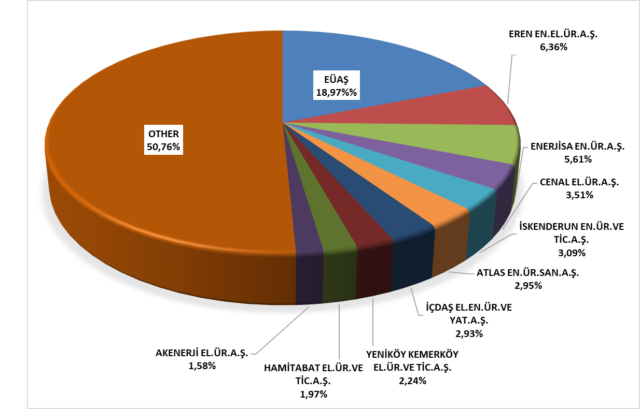

1.3 Licensed Installed Capacity

The distribution of licensed installed capacity by resource types is shown in Figure 1.12. While the share of natural gas power plants (including liquid and natural gas fired power plants) in licensed installed capacity was 30,53% at the end of 2019, it increased to 28,79% in 2020. While the share of power plants based on import coal was 10,55%, it decreased to %10,09 and while the share of lignite power plants was 11,89%, it decreased to 11,36% and while the share of river-hydroelectric power plants was 9,24%, it decreased to 9,04% in 2020.
On the other hand, the share of dam-hydroelectric power plants in licensed installed capacity was 24,30% at the end of 2019 and it increased to 25,74%, the share of wind power plants was 8,85% and it increased to %9,84%, the share of geothermal power plants was 1,78% and it increased to 1,81%.
While the share of renewable energy resources (including hydraulic) in total installed capacity at the end of 2019 45,4%, it increased to 48% in 2020. While the ratio of total installed thermal capacity was 54,6% in 2019, it decreased to 52%.

Figure 1.12: Distribution of Licensed Installed Capacity by Sources at the End of 2020 (%)

The distribution of the licensed installed power according to organizations is shown in Figure 1.13. The share of EÜAŞ Power Plants in total installed capacity was 23,05% in 2019 and it increased to 24,05% in 2020.
On the other hand, while the share of free production companies operating under free market conditions was 72,72% in 2019, it decreased to 72,62% in 2020, the share of power plants operating under existing contracts in total installed capacity was %4,23 in 2019 and it decreased to 4,21% in 2020.

Figure 1.13: Distribution of Licensed Installed Capacity by Organizations at the End of 2020 (%)
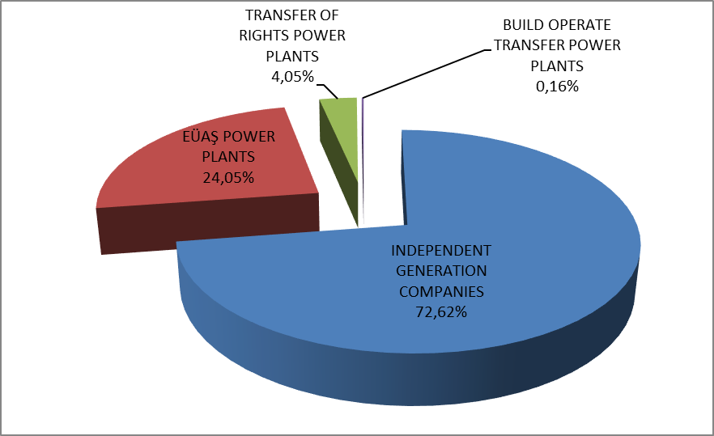

The development of licensed installed capacity based on resources since 2020 is shown in Figure 1.14. As shown in the figure, the share of geothermal, wind, solar and biomass resources in installed capacity have increased every year.

Figure 1.14: The Development of Licensed Installed Capacity by Source over the Years (MW)

Similar to Figure 1.14, the development of the shares of licensed power resources since 2000 is also included in Figure 1.15.

Figure 1.15: The Development of the Share of the Sources within the Installed Capacity by Years (%)
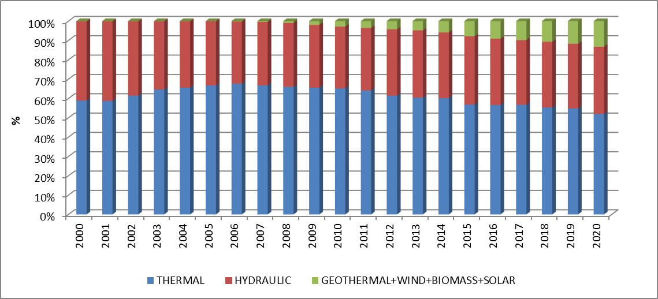
The distribution of licensed installed capacity by province is shown in Table 1.3. In 2020, the provinces that have highest installed power were İzmir, Kahramanmaraş, Çanakkale, Adana, Şanlıurfa and Zonguldak respectively and the provinces that have lowest installed power were Ağrı, Çankırı, Bartın, Iğdır, Bayburt and Aksaray.

Table 1.3 Distribution of Licensed Installed Capacity by Province (MW-%)
PROVINCE | Installed  Capacity (MW) | Share (%) | PROVINCE | Installed Capacity (MW) | Share (%)
İZMİR | 5.347,66 | 6,00 | SİNOP | 571,95 | 0,64
KAHRAMANMARAŞ | 4.397,79 | 4,94 | GAZİANTEP | 537,34 | 0,60
ÇANAKKALE | 4.319,28 | 4,85 | ESKİŞEHİR | 501,06 | 0,56
ADANA | 3.686,76 | 4,14 | ORDU | 498,90 | 0,56
ŞANLIURFA | 3.430,36 | 3,85 | BOLU | 425,37 | 0,48
ZONGULDAK | 3.370,25 | 3,78 | ŞIRNAK | 412,64 | 0,46
SAMSUN | 3.219,52 | 3,61 | AFYONKARAHİSAR | 402,33 | 0,45
BALIKESİR | 2.973,17 | 3,34 | ÇORUM | 395,03 | 0,44
MANİSA | 2.864,19 | 3,22 | RİZE | 364,73 | 0,41
İSTANBUL | 2.857,13 | 3,21 | ERZİNCAN | 316,27 | 0,36
HATAY | 2.787,44 | 3,13 | KIRŞEHİR | 315,91 | 0,35
BURSA | 2.647,65 | 2,97 | AMASYA | 314,66 | 0,35
SAKARYA | 2.589,03 | 2,91 | ISPARTA | 290,65 | 0,33
ELAZIĞ | 2.461,07 | 2,76 | ADIYAMAN | 257,08 | 0,29
ANKARA | 2.393,57 | 2,69 | YALOVA | 252,45 | 0,28
MUĞLA | 2.265,95 | 2,54 | KARS | 251,66 | 0,28
DİYARBAKIR | 2.253,67 | 2,53 | ARDAHAN | 235,90 | 0,26
KOCAELİ | 2.032,87 | 2,28 | MUŞ | 211,81 | 0,24
KIRIKKALE | 1.957,52 | 2,20 | KARABÜK | 148,43 | 0,17
ANTALYA | 1.811,29 | 2,03 | EDİRNE | 145,81 | 0,16
ARTVİN | 1.809,29 | 2,03 | BİLECİK | 133,18 | 0,15
KIRKLARELİ | 1.752,12 | 1,97 | DÜZCE | 124,91 | 0,14
DENİZLİ | 1.742,12 | 1,96 | KASTAMONU | 114,43 | 0,13
TEKİRDAĞ | 1.510,19 | 1,70 | VAN | 109,68 | 0,12
MARDİN | 1.371,96 | 1,54 | TUNCELİ | 106,95 | 0,12
AYDIN | 1.369,37 | 1,54 | BURDUR | 104,53 | 0,12
BİNGÖL | 1.323,34 | 1,49 | MALATYA | 94,58 | 0,11
OSMANİYE | 1.064,28 | 1,19 | NEVŞEHİR | 89,13 | 0,10
KÜTAHYA | 1.063,43 | 1,19 | UŞAK | 88,87 | 0,10
SİVAS | 975,01 | 1,09 | BATMAN | 60,12 | 0,07
MERSİN | 958,04 | 1,08 | NİĞDE | 53,55 | 0,06
GİRESUN | 920,66 | 1,03 | YOZGAT | 50,70 | 0,06
ERZURUM | 805,18 | 0,90 | HAKKARİ | 48,75 | 0,05
SİİRT | 767,91 | 0,86 | BİTLİS | 48,25 | 0,05
TOKAT | 677,01 | 0,76 | AKSARAY | 28,88 | 0,03
GÜMÜŞHANE | 656,80 | 0,74 | BAYBURT | 27,26 | 0,03
KARAMAN | 633,35 | 0,71 | IĞDIR | 23,79 | 0,03
TRABZON | 604,58 | 0,68 | BARTIN | 20,06 | 0,02
KONYA | 598,58 | 0,67 | ÇANKIRI | 12,81 | 0,01
KAYSERİ | 596,47 | 0,67 | AĞRI | 10,91 | 0,01
 |  |  | Total | 89.067,14 | 100,00

Figure 1.16 shows shares of the first 10 companies that had the highest share of licensed installed capacity at the end of 2020. As shown in the figure, the first ten companies are EÜAŞ, Enerjisa En.Ür.A.Ş. , Eren En.El.Ür.A.Ş. , Gebze El.Ür.Ltd.Şti. , İzmir El.Ür.Ltd.Şti., Afşin Elbistan El.Ür.Ve Tic.A.Ş. , Cenal El.Ür.A.Ş. , İskenderun En.Ür.Ve Tic.A.Ş. , Akenerji El.Ür.A.Ş. and Hamitabat Elektrik Üretim Ve Ticaret A.Ş. , respectively.

Figure 1.16: The Share of the First 10 Companies in Installed Capacity at the End of 2020 (%)
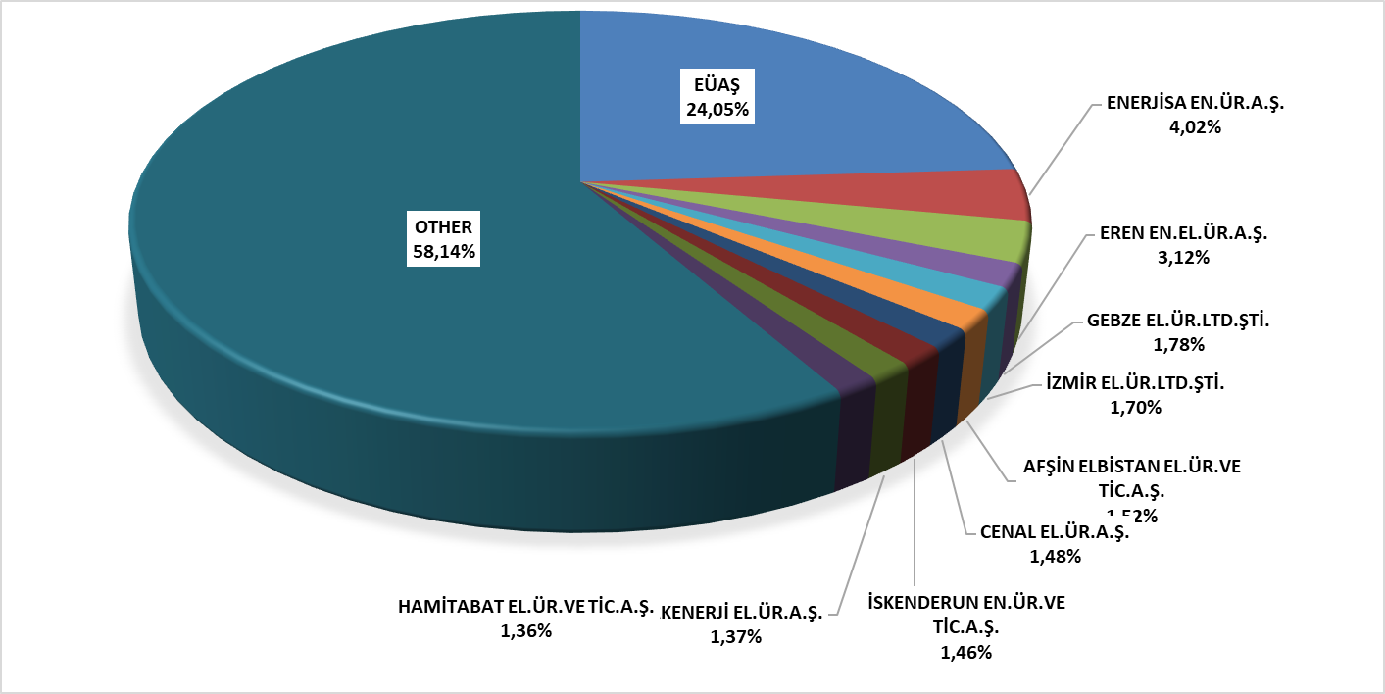

1.4 Unlicensed Generation

In the first sub clause of Article 14 of the Electricity Market Law No. 6446, the production facilities exempted from the license to install and establish a company are as follows;

“a) Generation facilities not connected to emergency generator groups or transmission or distribution systems
b) Generation facilities with the installed power based on maximum one-megawatt renewable energy sources
c) Electricity generation facilities of municipalities installed to dispose the sludge of solid waste facilities and of treatment plants
d) Those of micro-cogeneration facilities and cogeneration facilities having the productivity value to be determined by the Ministry, and in the category to be determined by the Board
d) A generation facility based on renewable energy sources, which uses all of the energy it produces without giving it to the transmission or distribution system, and whose production and consumption are at the same measurement point
e) (Attachment: 21/3 / 2018-7103 / 84 art.) Market activities carried out within the scope of the limits determined by the Board and electricity storage and demand side participation within the framework of the procedures and principles determined by the Ministry.
f) (Attachment: 19/4 / 2018-7139 / 56 art.) Electricity subscription in order to meet the electricity needs of the agricultural irrigation facilities owned by the General Directorate of State Hydraulic Works, the contract power of the installed power agricultural irrigation plant is production facility based on renewable energy sources established and operated by the General Directorate of State Hydraulic Works, provided that the total
g) (Attachment:25/11/2020-7257/35 art.) Generation facility based on renewable energy resources, provided that it is limited to the contract power in the connection agreement

The current status of unlicensed electricity generation applications by 2020 is shown in Table 1.4.

Table 1.4: The Status of Unlicensed Electricity Generation Applications at the End of 2020 (MWe)
Status/Source | Biomass | Solar | Hydraulic | Geothermal | Cogeneration | Microgeneration | Wind
In connection agreement stage | 17,88 | 1.295,65 | 5,10 |  | 91,84 | 0,04 | 111,61
Call letter stage | 9,29 | 1.379,76 | 2,57 |  | 43,30 | 0,04 | 55,71
Rejected | 150,30 | 3.797,39 | 69,48 | 0,13 | 113,02 | 0,48 | 264,68
Began operating | 83,71 | 6.257,61 | 8,65 |  | 402,67 |  | 70,83

Distribution of unlicensed installed capacity by resources is shown in Table 1.5 and Figure 1.18. The amount of capacity that entered the facility, which was 6.309,27 MWe at the end of 2019, increased by 8,15% and reached to 6.823,47 MWe in 2020. As it was in 2019, the highest share belongs to solar power plants with %91,71 in 2020 followed by natural gas with %5,90 and biomass with 1,23%.

Table 1.5: Distribution of Unlicensed Installed Capacity by Resources (MWe-%)
Resource Type | 2019 |  | 2020
Resource Type | Installed Capacity  (MWe) | Share  (%) | Installed Capacity  (MWe) | Share  (%)
Solar | 5.825,46 | 92,33 | 6.257,61 | 91,71
Natural Gas | 328,66 | 5,21 | 402,67 | 5,90
Biomass | 75,67 | 1,20 | 83,71 | 1,23
Wind | 70,83 | 1,12 | 70,83 | 1,04
Hydraulic | 8,65 | 0,14 | 8,65 | 0,13
Total | 6.309,27 | 100,00 | 6.823,47 | 100,00

Figure 1.18: Distribution of Unlicensed Installed Capacity by Sources at the End of 2020 (%)
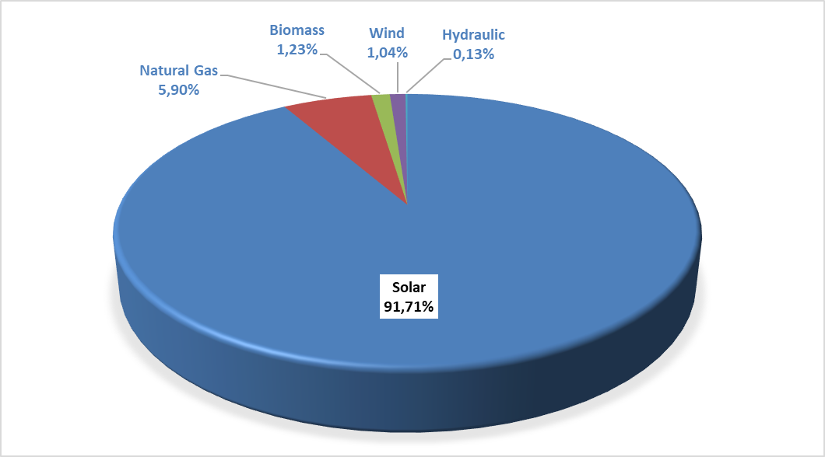

Unlicensed installed capacity by province was shown in Table 1.6. As it was in 2019, the highest installed capacity was in Konya with 548,36 MWe. Konya is followed by Ankara with 404,76 MWe, Şanlıurfa with 368,72 MWe, Kayseri with 329,85 MWe, İzmir with 309,34 MWe, Kahramanmaraş with 243,96, Afyonkarahisar with 241,45 MWe. Approximately 36% of the total unlicensed installed capacity was in these 7 provinces.

Table 1.6: Distribution of Unlicensed Installed Capacity by Province (MWe-%)
PROVINCE | 2019 |  | 2020
PROVINCE | Installed Capacity  (MWe) | Share (%) | Installed Capacity  (MWe) | Share (%)
KONYA | 503,19 | 7,98 | 548,36 | 8,04
ANKARA | 362,29 | 5,74 | 404,76 | 5,93
ŞANLIURFA | 341,99 | 5,42 | 368,72 | 5,40
KAYSERİ | 317,72 | 5,04 | 329,85 | 4,83
İZMİR | 274,75 | 4,35 | 309,34 | 4,53
KAHRAMANMARAŞ | 220,19 | 3,49 | 243,96 | 3,58
AFYONKARAHİSAR | 232,15 | 3,68 | 241,45 | 3,54
MANİSA | 216,73 | 3,44 | 228,74 | 3,35
MERSİN | 191,60 | 3,04 | 204,37 | 3,00
DENİZLİ | 165,56 | 2,62 | 178,39 | 2,61
ESKİŞEHİR | 175,12 | 2,78 | 175,12 | 2,57
GAZİANTEP | 145,99 | 2,31 | 173,76 | 2,55
ELAZIĞ | 168,61 | 2,67 | 170,61 | 2,50
ANTALYA | 155,66 | 2,47 | 168,68 | 2,47
ISPARTA | 152,81 | 2,42 | 166,31 | 2,44
ADANA | 151,27 | 2,40 | 159,68 | 2,34
NEVŞEHİR | 133,57 | 2,12 | 139,76 | 2,05
BALIKESİR | 110,17 | 1,75 | 123,34 | 1,81
AYDIN | 121,52 | 1,93 | 123,05 | 1,80
KÜTAHYA | 116,64 | 1,85 | 118,59 | 1,74
ÇORUM | 104,86 | 1,66 | 117,82 | 1,73
MALATYA | 102,84 | 1,63 | 114,20 | 1,67
ADIYAMAN | 109,21 | 1,73 | 111,98 | 1,64
NİĞDE | 100,31 | 1,59 | 106,04 | 1,55
UŞAK | 91,84 | 1,46 | 104,66 | 1,53
MUĞLA | 102,73 | 1,63 | 104,38 | 1,53
ERZURUM | 98,13 | 1,56 | 95,13 | 1,39
AKSARAY | 88,82 | 1,41 | 90,78 | 1,33
BURSA | 70,54 | 1,12 | 88,74 | 1,30
BİLECİK | 77,01 | 1,22 | 85,31 | 1,25
SİVAS | 76,89 | 1,22 | 78,29 | 1,15
İSTANBUL | 52,06 | 0,83 | 77,63 | 1,14
OSMANİYE | 72,01 | 1,14 | 77,29 | 1,13
BURDUR | 66,14 | 1,05 | 70,40 | 1,03
KARAMAN | 69,18 | 1,10 | 69,65 | 1,02
YOZGAT | 63,65 | 1,01 | 67,27 | 0,99
DİYARBAKIR | 58,35 | 0,92 | 63,63 | 0,93
ÇANKIRI | 51,25 | 0,81 | 56,18 | 0,82
KIRŞEHİR | 46,14 | 0,73 | 51,13 | 0,75
KIRIKKALE | 49,15 | 0,78 | 50,36 | 0,74
SAMSUN | 41,84 | 0,66 | 43,33 | 0,64
ERZİNCAN | 42,24 | 0,67 | 43,04 | 0,63
AMASYA | 38,17 | 0,60 | 40,89 | 0,60
TEKİRDAĞ | 28,31 | 0,45 | 35,12 | 0,51
ÇANAKKALE | 31,79 | 0,50 | 34,97 | 0,51
VAN | 29,07 | 0,46 | 34,07 | 0,50
BİTLİS | 20,83 | 0,33 | 28,18 | 0,41
KİLİS | 21,30 | 0,34 | 24,10 | 0,35
SAKARYA | 16,90 | 0,27 | 23,11 | 0,34
TOKAT | 21,85 | 0,35 | 22,81 | 0,33
BİNGÖL | 20,55 | 0,33 | 22,50 | 0,33
KOCAELİ | 16,22 | 0,26 | 19,30 | 0,28
HATAY | 17,14 | 0,27 | 19,28 | 0,28
BATMAN | 18,78 | 0,30 | 19,02 | 0,28
ŞIRNAK | 18,00 | 0,29 | 18,00 | 0,26
MARDİN | 17,51 | 0,28 | 17,75 | 0,26
AĞRI | 4,95 | 0,08 | 14,55 | 0,21
KARABÜK | 12,62 | 0,20 | 12,82 | 0,19
BAYBURT | 11,99 | 0,19 | 11,99 | 0,18
BOLU | 8,31 | 0,13 | 9,91 | 0,15
KASTAMONU | 8,63 | 0,14 | 8,63 | 0,13
EDİRNE | 6,58 | 0,10 | 8,58 | 0,13
DÜZCE | 6,99 | 0,11 | 6,99 | 0,10
KIRKLARELİ | 4,50 | 0,07 | 6,86 | 0,10
SİİRT | 6,64 | 0,11 | 6,64 | 0,10
KARS | 5,74 | 0,09 | 5,74 | 0,08
BARTIN | 5,25 | 0,08 | 5,25 | 0,08
MUŞ | 3,30 | 0,05 | 3,99 | 0,06
YALOVA | 3,83 | 0,06 | 3,83 | 0,06
GİRESUN | 1,40 | 0,02 | 2,66 | 0,04
ORDU | 2,10 | 0,03 | 2,64 | 0,04
ZONGULDAK | 2,48 | 0,04 | 2,63 | 0,04
ARDAHAN | 1,10 | 0,02 | 2,37 | 0,03
RİZE | 1,59 | 0,03 | 1,59 | 0,02
TUNCELİ | 0,86 | 0,01 | 0,86 | 0,01
GÜMÜŞHANE | 0,80 | 0,01 | 0,80 | 0,01
IĞDIR | 0,50 | 0,01 | 0,50 | 0,01
SİNOP | 0,00 | 0,00 | 0,46 | 0,01
Grand Total | 6.309,27 | 100,00 | 6.823,47 | 100,00

The distribution of unlicensed electricity generation by resources is shown in Table 1.7 and Figure 1.19. While the amount of energy supplied to the grid within the scope of unlicensed electricity generation was 9.829.393,70 MWh in 2019, it increased by 14,41% and became 11.245.481,50 in 2020. 96,27% of it was from solar, 2,43% of it was from biomass and 1,30% of it was generated from wind and hydraulic.

Table 1.7: Distribution of Unlicensed Electricity Generation by Resources (MWh-%)
Resource Type | 2019 |  | 2020
Resource Type | The amount of energy supplied to the system as surplus (MWh) | Share  (%) | The amount of energy supplied to the system as surplus (MWh) | Share  (%)
Solar | 9.425.911,41 | 95,90 | 10.825.501,82 | 96,27
Biomass | 255.486,63 | 2,60 | 273.446,13 | 2,43
Wind | 113.558,01 | 1,16 | 119.466,89 | 1,06
Hydraulic | 34.437,65 | 0,35 | 27.066,66 | 0,24
Grand Total | 9.829.393,70 | 100,00 | 11.245.481,50 | 100,00

Figure 1.19: Distribution of Unlicensed Electricity Generation by Resources in 2020 (%)
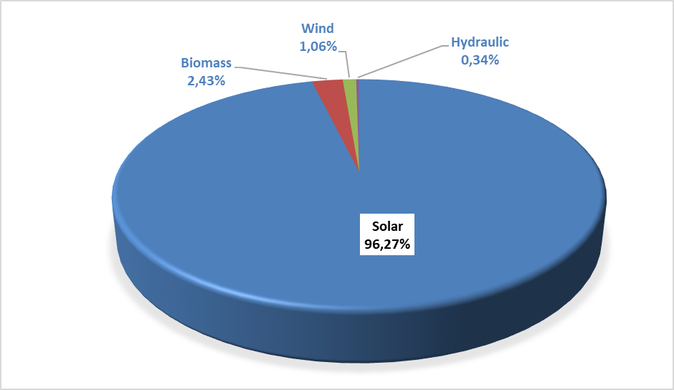

The distribution of unlicensed electricity generation and energy delivered to the system by provinces is given in Table 1.8 and in 2020, the highest generation was in Konya as it was in 2019. Apart from Konya, Şanlıurfa, Ankara, Kayseri, İzmir, Afyonkarahisar, Manisa and Eskişehir are the provinces that rank first among unlicensed electricity generation.

Table 1.8: Distribution of Unlicensed Electricity Generation by Provinces (MWh-%)
PROVINCES | 2019 |  | 2020
PROVINCES | The amount of energy supplied to the system as surplus  (MWh) | Share  (%) | The amount of energy supplied to the system as surplus (MWh) | Share (%)
KONYA | 896.102,75 | 9,12 | 951.272,71 | 8,46
ŞANLIURFA | 569.672,72 | 5,80 | 654.198,16 | 5,82
ANKARA | 501.259,77 | 5,10 | 622.015,21 | 5,53
KAYSERİ | 566.861,17 | 5,77 | 586.980,66 | 5,22
İZMİR | 367.294,72 | 3,74 | 460.513,43 | 4,10
AFYONKARAHİSAR | 392.648,19 | 3,99 | 444.492,50 | 3,95
MANİSA | 343.718,60 | 3,50 | 381.797,74 | 3,40
ESKİŞEHİR | 352.373,70 | 3,58 | 358.066,85 | 3,18
KAHRAMANMARAŞ | 314.882,98 | 3,20 | 347.107,64 | 3,09
MERSİN | 294.345,92 | 2,99 | 328.021,88 | 2,92
DENİZLİ | 262.200,19 | 2,67 | 305.223,03 | 2,71
ELAZIĞ | 288.706,65 | 2,94 | 303.053,75 | 2,69
GAZİANTEP | 244.262,17 | 2,49 | 267.375,61 | 2,38
ANTALYA | 224.711,80 | 2,29 | 265.937,56 | 2,36
AYDIN | 244.196,94 | 2,48 | 257.967,13 | 2,29
MALATYA | 168.782,43 | 1,72 | 256.006,82 | 2,28
ISPARTA | 203.615,14 | 2,07 | 241.990,22 | 2,15
NEVŞEHİR | 232.842,69 | 2,37 | 237.493,78 | 2,11
KÜTAHYA | 189.037,54 | 1,92 | 219.884,48 | 1,96
NİĞDE | 175.482,54 | 1,79 | 207.217,71 | 1,84
ADANA | 174.316,68 | 1,77 | 204.527,18 | 1,82
ADIYAMAN | 173.433,60 | 1,76 | 202.740,85 | 1,80
ÇORUM | 144.446,40 | 1,47 | 200.290,17 | 1,78
MUĞLA | 177.302,71 | 1,80 | 198.534,10 | 1,77
BALIKESİR | 167.085,87 | 1,70 | 189.543,60 | 1,69
AKSARAY | 164.770,05 | 1,68 | 177.301,18 | 1,58
UŞAK | 150.707,85 | 1,53 | 165.885,16 | 1,48
ERZURUM | 144.324,24 | 1,47 | 160.575,58 | 1,43
BİLECİK | 106.646,38 | 1,08 | 133.571,13 | 1,19
SİVAS | 130.142,41 | 1,32 | 133.150,51 | 1,18
BURDUR | 114.423,06 | 1,16 | 127.234,81 | 1,13
KARAMAN | 124.818,84 | 1,27 | 126.708,46 | 1,13
OSMANİYE | 102.742,72 | 1,05 | 119.955,54 | 1,07
YOZGAT | 108.463,77 | 1,10 | 117.486,17 | 1,04
DİYARBAKIR | 98.140,83 | 1,00 | 112.874,49 | 1,00
ÇANKIRI | 84.179,08 | 0,86 | 100.270,03 | 0,89
KIRIKKALE | 71.981,69 | 0,73 | 94.964,49 | 0,84
BURSA | 97.251,79 | 0,99 | 88.808,44 | 0,79
KIRŞEHİR | 86.398,11 | 0,88 | 88.129,22 | 0,78
ERZİNCAN | 79.887,29 | 0,81 | 82.199,93 | 0,73
ÇANAKKALE | 29.917,61 | 0,30 | 61.579,62 | 0,55
AMASYA | 47.396,72 | 0,48 | 58.979,46 | 0,52
VAN | 18.160,17 | 0,18 | 54.093,99 | 0,48
SAMSUN | 37.439,79 | 0,38 | 45.005,16 | 0,40
KİLİS | 24.082,42 | 0,25 | 44.065,81 | 0,39
TOKAT | 38.956,91 | 0,40 | 43.516,55 | 0,39
BİTLİS | 28.411,53 | 0,29 | 41.133,10 | 0,37
BİNGÖL | 13.850,98 | 0,14 | 38.090,69 | 0,34
ŞIRNAK | 29.908,76 | 0,30 | 35.026,94 | 0,31
BATMAN | 27.919,40 | 0,28 | 33.078,41 | 0,29
MARDİN | 13.388,43 | 0,14 | 32.705,45 | 0,29
HATAY | 25.684,87 | 0,26 | 31.086,01 | 0,28
AĞRI | 3.126,83 | 0,03 | 26.553,82 | 0,24
BAYBURT | 21.958,16 | 0,22 | 22.557,77 | 0,20
KOCAELİ | 23.810,20 | 0,24 | 22.390,84 | 0,20
KARABÜK | 14.757,35 | 0,15 | 17.116,83 | 0,15
KASTAMONU | 11.905,09 | 0,12 | 14.969,79 | 0,13
ZONGULDAK | 10.954,92 | 0,11 | 14.895,33 | 0,13
SİİRT | 8.768,70 | 0,09 | 10.954,34 | 0,10
EDİRNE | 7.265,19 | 0,07 | 10.130,13 | 0,09
KARS | 6.671,85 | 0,07 | 10.057,79 | 0,09
YALOVA | 8.876,13 | 0,09 | 9.355,92 | 0,08
RİZE | 9.144,81 | 0,09 | 7.919,92 | 0,07
İSTANBUL | 7.253,93 | 0,07 | 7.693,51 | 0,07
TEKİRDAĞ | 6.242,69 | 0,06 | 6.515,54 | 0,06
MUŞ | 3.076,30 | 0,03 | 5.689,48 | 0,05
BOLU | 3.838,49 | 0,04 | 4.130,58 | 0,04
ARDAHAN | 1.914,49 | 0,02 | 2.925,45 | 0,03
ORDU | 4.846,23 | 0,05 | 2.729,33 | 0,02
GİRESUN | 183,73 | 0,00 | 2.712,83 | 0,02
TUNCELİ | 1.885,08 | 0,02 | 2.054,53 | 0,02
GÜMÜŞHANE | 1.934,08 | 0,02 | 1.945,05 | 0,02
SAKARYA | 166,73 | 0,00 | 756,74 | 0,01
KIRKLARELİ | 647,04 | 0,01 | 637,13 | 0,01
IĞDIR | 96,16 | 0,00 | 563,64 | 0,01
DÜZCE | 403,54 | 0,00 | 344,04 | 0,00
BARTIN | 82,00 | 0,00 | 97,60 | 0,00
SİNOP | 4,45 | 0,00 | 52,05 | 0,00
TRABZON | 0,00 | 0,00 | 2,44 | 0,00
Grand Total | 9.829.393,70 | 100,00 | 11.245.481,50 | 100,00

The distribution of the amount of payments made within the scope of unlicensed electricity production by the end of 2020 by resources is shown in Table 1.9. %96,83 of the amount of payment was made to solar power plants.

Table 1.9: Distribution of the Amount of Payment Made Within the Scope of Unlicensed Electricity Generation by Resources (TL-%)
Resource Type | 2019 |  | 2020 |  | Change (%)  2019→2020
Resource Type | Amount of payments made for the amount of surplus energy purchased (TL) | Share (%) | Amount of payments made for the amount of surplus energy purchased (TL) | Share (%) | Change (%)  2019→2020
Solar | 7.093.881.142,10 | 96,56 | 10.048.892.854,64 | 96,83 | 41,66
Biomass | 191.223.293,51 | 2,60 | 254.517.281,12 | 2,45 | 33,10
Wind | 46.532.124,12 | 0,63 | 60.837.578,10 | 0,59 | 30,74
Hydraulic | 14.118.588,25 | 0,19 | 13.520.863,75 | 0,13 | -4,23
Other | 668.578,09 | 0,01 | 0,00 | 0,00 | -100,00
Grand Total | 7.346.423.726,07 | 100,00 | 10.377.768.577,61 | 100,00 | 41,47

1.5 Invoiced Electricity Consumption

This section comprises information about invoiced electricity consumption. The consumption that is not included in the invoice (technical and non-technical losses and the sales that are not accepted as sales) are not included in the data in this section. Therefore, as the production done by the legal entities holding generation license within the scope of Article 7 of the Electricity Market Law without transferring the energy produced in their facilities to the transmission or distribution system, is not considered as sales to the final consumer, electricity consumption is not included in the invoiced consumption figures. Besides, the amount of electricity generated by the generation facilities from the system for their own needs is not included in the invoiced consumption value. In addition, the actual consumption data and consumption data in this section may vary due to differences in the billing period.
Invoiced consumption data of 2020 is given in Table 1.10 below. 56.05 TWh of the 233.44 TWh sold electricity, which corresponds to 24.01%, is connected to consumers at the transmission voltage level, and 177.38 TWh, which corresponds to 75.99%, is connected to the distribution voltage level sold to consumers.
While 128,92 TWh was sold to eligible consumers, consumption of non-eligible (non-eligible and those who do not use the right of being eligible consumer) consumers was 104,52 TWh. Accordingly, while the share of eligible consumers in invoiced consumption was %55,23, the share of non-eligible consumers was %44,77.

Table 1.10: Sales to Eligible and Non-Eligible Consumers in 2020 (MWh)
Consumer Type | Consumption Amount of Consumers Connected to the Distribution Voltage (MWh) | Consumption Amount of Consumers Connected to the Transmission Voltage Level (MWh) | Total (MWh)
Non-Eligible | 103.709.281,53 | 808.039,66 | 104.517.321,19
Eligible | 73.676.500,22 | 55.242.793,40 | 128.919.293,62
Grand Total | 177.385.781,75 | 56.050.833,06 | 233.436.614,81

The distribution of consumption to distribution regions is given in Table 1.11. The highest consumption in 2020 was Toroslar EDAŞ region with 28,65 TWh, lowest consumption was in Vangölü EDAŞ region with 2,1 TWh. The region with the highest consumption from distribution was Boğaziçi EDAŞ, the region with the lowest was Vangölü EDAŞ, the region with the highest consumption from transmission was Toroslar, the region with the lowest consumption was Çoruh EDAŞ.

Table 1.11: Distribution of Invoiced Consumption by Distribution Regions in 2020 (MWh-%)
Distribution Regions | Consumption of Consumers Connected to Distribution (MWh) | Consumption of Consumers Connected to Transmission (MWh) | Total (MWh) | Share (%)
TOROSLAR EDAŞ | 16.128.065,17 | 12.522.248,56 | 28.650.313,73 | 12,27
BOĞAZİÇİ EDAŞ | 23.940.462,95 | 1.715.853,38 | 25.656.316,33 | 10,99
GDZ EDAŞ | 15.305.296,66 | 4.242.805,96 | 19.548.102,62 | 8,37
BAŞKENT EDAŞ | 14.783.318,48 | 4.298.481,85 | 19.081.800,33 | 8,17
ULUDAĞ EDAŞ | 11.948.161,38 | 6.434.991,31 | 18.383.152,69 | 7,88
SAKARYA EDAŞ | 9.072.350,23 | 6.959.065,71 | 16.031.415,94 | 6,87
İST. AND. YAK. EDAŞ | 11.445.378,06 | 1.385.938,96 | 12.831.317,02 | 5,50
DİCLE EDAŞ | 11.152.888,91 | 1.379.827,20 | 12.532.716,11 | 5,37
MERAM EDAŞ | 9.594.630,98 | 1.891.894,51 | 11.486.525,49 | 4,92
OSMANGAZİ EDAŞ | 6.334.243,41 | 3.999.142,26 | 10.333.385,67 | 4,43
AKDENİZ EDAŞ | 8.246.533,39 | 1.894.340,18 | 10.140.873,57 | 4,34
TRAKYA EDAŞ | 6.801.241,32 | 2.967.383,00 | 9.768.624,32 | 4,18
ADM EDAŞ | 8.682.079,96 | 683.080,62 | 9.365.160,58 | 4,01
YEŞİLIRMAK EDAŞ | 4.962.299,47 | 1.386.802,62 | 6.349.102,09 | 2,72
AKEDAŞ EDAŞ | 3.632.786,80 | 1.350.775,56 | 4.983.562,36 | 2,13
KAYSERİ VE CİVARI ETAŞ | 2.350.184,51 | 1.477.801,42 | 3.827.985,93 | 1,64
ÇORUH EDAŞ | 3.657.070,41 | 72.522,89 | 3.729.593,30 | 1,60
FIRAT EDAŞ | 2.564.992,10 | 737.641,00 | 3.302.633,10 | 1,41
ARAS EDAŞ | 2.399.788,68 | 376.361,36 | 2.776.150,04 | 1,19
ÇAMLIBEL EDAŞ | 2.378.776,22 | 175.024,03 | 2.553.800,25 | 1,09
VANGÖLÜ EDAŞ | 2.005.232,65 | 98.850,68 | 2.104.083,33 | 0,90
Grand Total | 177.385.781,75 | 56.050.833,06 | 233.436.614,81 | 100,00

Distribution of invoiced consumption by consumer type is shown in Table 1.12 and Figure 1.20 and the industry consumption has the highest share with %42,74. Household consumption was the second with %25,76 and commercial consumption was the third with %24,69. %. The total electricity consumption used in lighting and agricultural irrigation was %6,81.

Table 1.12: Distribution of Invoiced Consumption by Consumer Type as Eligible and Non-Eligible Consumers in 2020 (MWh)
Consumer Type | Consumption Amount (MWh)
Consumer Type | Non-Eligible Consumer | Share  (%) | Eligible Consumer | Share  (%) | Total | Share  (%)
Industry | 7.263.913,24 | 6,95 | 92.503.427,34 | 71,75 | 99.767.340,58 | 42,74
Household | 59.953.439,19 | 57,36 | 180.548,56 | 0,14 | 60.133.987,76 | 25,76
Commercial | 23.169.303,38 | 22,17 | 34.464.178,49 | 26,73 | 57.633.481,86 | 24,69
Irrigation | 9.155.971,85 | 8,76 | 1.649.996,63 | 1,28 | 10.805.968,48 | 4,63
Lighting | 4.974.693,53 | 4,76 | 121.142,60 | 0,09 | 5.095.836,13 | 2,18
Grand Total | 104.517.321,19 | 100,00 | 128.919.293,62 | 100,00 | 233.436.614,81 | 100,00

Figure 1.20: Distribution of Invoiced Consumption by Consumer Type in 2020 (%)
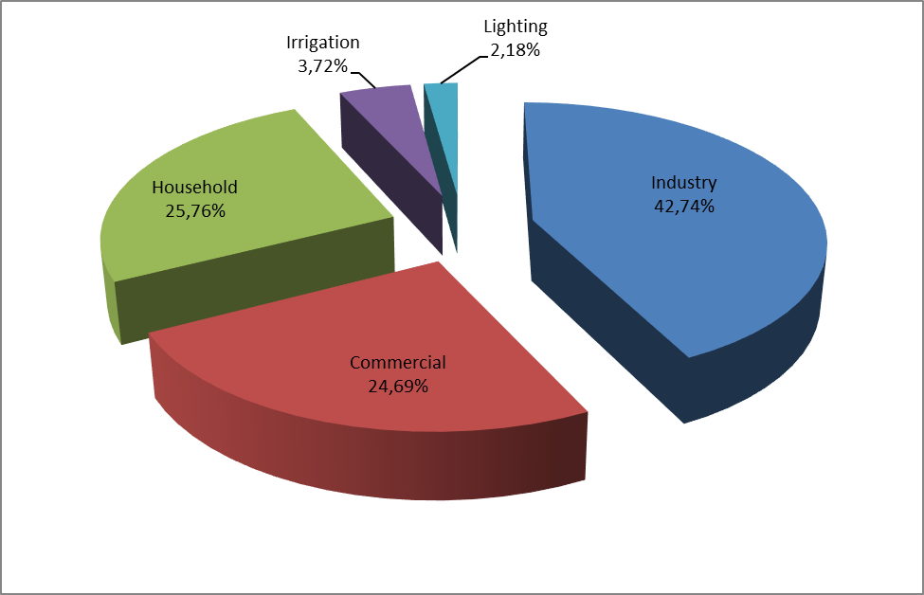

Table 1.13: Development of Invoiced Consumption by Consumer Type by Years (MWh)
Consumer Type | Consumption Amount (MWh)
Consumer Type | 2017 | 2018 | 2019 | 2020
Industry | 94.965.626 | 96.995.771 | 94.462.699 | 99.767.341
Household | 53.531.711 | 54.769.980 | 56.389.775 | 60.133.988
Commercial | 66.454.453 | 68.289.254 | 65.150.389 | 57.633.482
Irrigation | 6.537.065 | 8.799.145 | 8.553.367 | 10.805.968
Lighting | 4.341.373 | 4.755.803 | 5.041.683 | 5.095.836
Total | 225.830.227 | 233.609.953 | 229.597.914 | 233.436.615

Distribution of invoiced consumption by provinces is shown in Table 1.14. The highest consumption was in Istanbul with 38,49 TWh which corresponds to 16,49% of the total consumption. İstanbul is followed by İzmir with the share of 6,53, Ankara with the share of 6,04%, Bursa with the share of 5,50% and Kocaeli with the share of 4,88.

Table 1.14: Distribution of Invoiced Consumption by Province (MWh - %)
PROVINCE | Amount of Consumption of Consumers Connected to Distribution (MWh) | Amount of Consumption of Consumers Connected to Transmission (MWh) | Total (MWh) | Share (%)
İSTANBUL (TOTAL) | 35.385.841,01 | 3.101.792,34 | 38.487.633,35 | 16,49
İSTANBUL (EUROPEAN SIDE) | 23.940.462,95 | 1.715.853,38 | 25.656.316,33 | 10,99
İZMİR | 12.076.941,25 | 3.162.031,75 | 15.238.973,00 | 6,53
ANKARA | 11.341.394,11 | 2.758.008,52 | 14.099.402,63 | 6,04
İSTANBUL (ANATOLIAN SIDE) | 11.445.378,06 | 1.385.938,96 | 12.831.317,02 | 5,50
BURSA | 7.025.013,83 | 4.355.857,44 | 11.380.871,27 | 4,88
KOCAELİ | 5.079.375,87 | 5.100.624,93 | 10.180.000,80 | 4,36
GAZİANTEP | 3.160.101,46 | 4.993.236,66 | 8.153.338,12 | 3,49
ANTALYA | 6.822.361,97 | 698.958,40 | 7.521.320,37 | 3,22
TEKİRDAĞ | 4.205.959,33 | 2952150,36 | 7.158.109,69 | 3,07
ADANA | 4.869.474,41 | 2.282.758,96 | 7.152.233,37 | 3,06
KONYA | 5.855.624,93 | 997.717,77 | 6.853.342,70 | 2,94
ŞANLIURFA | 4.982.665,61 | 367.791,94 | 5.350.457,55 | 2,29
MERSİN | 4.164.296,74 | 868.088,19 | 5.032.384,93 | 2,16
HATAY | 2.886.209,62 | 1802600 | 4.688.809,62 | 2,01
MANİSA | 3.228.355,42 | 1.080.774,21 | 4.309.129,63 | 1,85
OSMANİYE | 742.669,12 | 3.305.581,72 | 4.048.250,84 | 1,73
KAYSERİ | 2.343.706,55 | 1.477.801,42 | 3.821.507,97 | 1,64
KAHRAMANMARAŞ | 2.805.908,89 | 976.723,47 | 3.782.632,36 | 1,62
SAKARYA | 2.316.514,85 | 1.462.595,53 | 3.779.110,38 | 1,62
BALIKESİR | 2.918.915,88 | 563.599,02 | 3.482.514,90 | 1,49
DENİZLİ | 2.992.553,87 | 441.855,83 | 3.434.409,70 | 1,47
SAMSUN | 2.051.864,34 | 1182211,17 | 3.234.075,51 | 1,39
MUĞLA | 3.199.645,15 |  | 3.199.645,15 | 1,37
ESKİŞEHİR | 1.904.465,17 | 1.129.469,72 | 3.033.934,89 | 1,30
DİYARBAKIR | 2.468.467,93 | 389.865,12 | 2.858.333,05 | 1,22
ÇANAKKALE | 1.246.101,43 | 1.515.534,85 | 2.761.636,28 | 1,18
AYDIN | 2.489.880,93 | 241.224,79 | 2.731.105,72 | 1,17
KIRKLARELİ | 1.571.298,06 | 505.983,76 | 2.077.281,82 | 0,89
MARDİN | 1.884.197,21 | 154.750,07 | 2.038.947,28 | 0,87
BİLECİK | 1.067.378,99 | 960.208,45 | 2.027.587,44 | 0,87
AFYONKARAHİSAR | 1.591.380,18 | 294.792,38 | 1.886.172,56 | 0,81
UŞAK | 788.921,71 | 1.001.786,34 | 1.790.708,05 | 0,77
MALATYA | 1.140.747,84 | 479.911,29 | 1.620.659,13 | 0,69
KÜTAHYA | 982.097,36 | 612.885,37 | 1.594.982,73 | 0,68
TRABZON | 1.419.696,24 | 48.373,39 | 1.468.069,63 | 0,63
ORDU | 1.234.296,53 | 55.733,81 | 1.290.030,34 | 0,55
SİVAS | 989.409,46 | 282.846,84 | 1.272.256,30 | 0,55
ELAZIĞ | 992.918,99 | 257.729,71 | 1.250.648,70 | 0,54
NİĞDE | 935.583,17 | 306.843,47 | 1.242.426,64 | 0,53
ADIYAMAN | 826.877,91 | 374.052,09 | 1.200.930,00 | 0,51
ZONGULDAK | 989.009,78 | 196096,02 | 1.185.105,80 | 0,51
AKSARAY | 946.169,88 | 189.112,18 | 1.135.282,06 | 0,49
BOLU | 835.400,84 | 247201,18 | 1.082.602,02 | 0,46
VAN | 1.030.678,58 | 18.461,45 | 1.049.140,03 | 0,45
KASTAMONU | 755.632,36 | 283.286,53 | 1.038.918,89 | 0,45
EDİRNE | 1.023.983,93 | 3.495,46 | 1.027.479,39 | 0,44
DÜZCE | 841.058,68 | 148.644,07 | 989.702,75 | 0,42
ISPARTA | 903.711,24 | 72.391,51 | 976.102,75 | 0,42
BATMAN | 731.798,78 | 172.826,61 | 904.625,39 | 0,39
ERZURUM | 893.633,87 |  | 893.633,87 | 0,38
KARAMAN | 672.955,42 | 212.811,90 | 885.767,32 | 0,38
TOKAT | 719.864,94 | 144.111,50 | 863.976,44 | 0,37
BURDUR | 520.460,18 | 327.293,59 | 847.753,77 | 0,36
ÇORUM | 767.947,79 | 77.301,40 | 845.249,19 | 0,36
NEVŞEHİR | 764.513,59 |  | 764.513,59 | 0,33
YALOVA | 758.130,24 |  | 758.130,24 | 0,32
RİZE | 745.654,82 |  | 745.654,82 | 0,32
YOZGAT | 675.979,79 | 30.877,76 | 706.857,55 | 0,30
GİRESUN | 696.175,46 | 2.851,49 | 699.026,95 | 0,30
BARTIN | 369.761,86 | 296.521,35 | 666.283,21 | 0,29
ŞIRNAK | 644.289,82 | 34,77 | 644.324,59 | 0,28
ERZİNCAN | 330.277,02 | 304.062,49 | 634.339,51 | 0,27
AMASYA | 555.037,70 | 49.697,13 | 604.734,83 | 0,26
KARABÜK | 464.451,31 | 125.997,42 | 590.448,73 | 0,25
KIRIKKALE | 481.191,28 | 65.679,71 | 546.870,99 | 0,23
ÇANKIRI | 381.877,77 | 132.588,25 | 514.466,02 | 0,22
KİLİS | 305.313,81 | 185.409,19 | 490.723,00 | 0,21
AĞRI | 415.846,94 | 72.298,87 | 488.145,81 | 0,21
SİİRT | 441.469,55 | 11.746,62 | 453.216,17 | 0,19
ARTVİN | 441.803,46 |  | 441.803,46 | 0,19
KIRŞEHİR | 419.783,99 | 11.737,18 | 431.521,17 | 0,18
MUŞ | 321.789,53 | 80.389,23 | 402.178,76 | 0,17
GÜMÜŞHANE | 353.740,43 | 21298,01 | 375.038,44 | 0,16
SİNOP | 353.153,12 | 21.859,11 | 375.012,23 | 0,16
BİTLİS | 365.624,90 |  | 365.624,90 | 0,16
KARS | 319.354,09 |  | 319.354,09 | 0,14
BİNGÖL | 303.740,41 |  | 303.740,41 | 0,13
HAKKARİ | 287.139,65 |  | 287.139,65 | 0,12
IĞDIR | 206.595,14 |  | 206.595,14 | 0,09
ARDAHAN | 130.666,35 |  | 130.666,35 | 0,06
TUNCELİ | 127.584,85 |  | 127.584,85 | 0,05
BAYBURT | 103.415,28 |  | 103.415,28 | 0,04
Grand Total | 177.385.781,75 | 56.050.833,06 | 233.436.614,81 | 100,00

Table 1.15: Distribution of Invoiced Consumption by Province and Consumer Type (MWh)
Province | Lighting | Household | Industry | Irrigation | Commercial | Grand | Share
 |  |  |  |  |  | Total | (%)
ADANA | 122.231 | 1.977.459 | 3.374.489 | 178.531 | 1.499.523 | 7.152.233 | 3,06
ADIYAMAN | 33.790 | 280.696 | 583.885 | 56.835 | 245.725 | 1.200.930 | 0,51
AFYONKARAHİSAR | 66.619 | 418.996 | 754.076 | 226.231 | 420.251 | 1.886.173 | 0,81
AĞRI | 33.330 | 213.886 | 87.503 | 624 | 152.803 | 488.146 | 0,21
AKSARAY | 32.110 | 237.595 | 292.876 | 339.914 | 232.787 | 1.135.282 | 0,49
AMASYA | 30.468 | 217.100 | 159.192 | 34.512 | 163.462 | 604.735 | 0,26
ANKARA | 296.782 | 4.334.394 | 4.766.136 | 205.082 | 4.497.009 | 14.099.403 | 6,04
ANTALYA | 172.523 | 2.805.494 | 1.257.636 | 206.469 | 3.079.199 | 7.521.320 | 3,22
ARDAHAN | 13.706 | 47.200 | 1.612 | 5 | 68.143 | 130.666 | 0,06
ARTVİN | 35.889 | 133.466 | 145.795 | 176 | 126.478 | 441.803 | 0,19
AYDIN | 81.910 | 1.040.532 | 679.994 | 101.126 | 827.543 | 2.731.106 | 1,17
BALIKESİR | 93.120 | 989.164 | 1.495.250 | 131.691 | 773.290 | 3.482.515 | 1,49
BARTIN | 27.126 | 132.690 | 413.941 | 1.731 | 90.796 | 666.283 | 0,29
BATMAN | 25.903 | 318.297 | 284.119 | 16.458 | 259.847 | 904.625 | 0,39
BAYBURT | 12.760 | 46.249 | 3.744 | 269 | 40.393 | 103.415 | 0,04
BİLECİK | 22.093 | 128.719 | 1.744.723 | 17.474 | 114.579 | 2.027.587 | 0,87
BİNGÖL | 16.126 | 129.972 | 53.042 | 1.308 | 103.294 | 303.740 | 0,13
BİTLİS | 28.129 | 139.778 | 28.220 | 34.973 | 134.524 | 365.625 | 0,16
BOLU | 27.943 | 202.451 | 538.397 | 74.911 | 238.900 | 1.082.602 | 0,46
BURDUR | 28.919 | 160.057 | 457.312 | 51.570 | 149.895 | 847.754 | 0,36
BURSA | 119.150 | 2.116.882 | 6.853.566 | 143.092 | 2.148.181 | 11.380.871 | 4,88
ÇANAKKALE | 43.570 | 394.834 | 1.807.187 | 54.131 | 461.915 | 2.761.636 | 1,18
ÇANKIRI | 24.436 | 114.377 | 281.599 | 5.019 | 89.034 | 514.466 | 0,22
ÇORUM | 43.584 | 320.065 | 211.164 | 33.746 | 236.691 | 845.249 | 0,36
DENİZLİ | 81.957 | 740.922 | 1.821.058 | 106.193 | 684.280 | 3.434.410 | 1,47
DİYARBAKIR | 53.737 | 906.677 | 675.683 | 474.571 | 747.666 | 2.858.333 | 1,22
DÜZCE | 31.127 | 255.680 | 485.637 | 9.925 | 207.334 | 989.703 | 0,42
EDİRNE | 32.706 | 237.503 | 379.962 | 20.165 | 357.144 | 1.027.479 | 0,44
ELAZIĞ | 40.658 | 309.042 | 428.427 | 43.793 | 428.729 | 1.250.649 | 0,54
ERZİNCAN | 25.420 | 128.155 | 329.115 | 15.199 | 136.451 | 634.340 | 0,27
ERZURUM | 67.602 | 390.992 | 56.110 | 3.867 | 375.063 | 893.634 | 0,38
ESKİŞEHİR | 52.150 | 616.480 | 1.561.062 | 255.255 | 548.988 | 3.033.935 | 1,30
GAZİANTEP | 91.310 | 1.338.973 | 5.577.939 | 119.905 | 1.025.212 | 8.153.338 | 3,49
GİRESUN | 66.218 | 325.856 | 69.553 | 490 | 236.909 | 699.027 | 0,30
GÜMÜŞHANE | 23.097 | 72.027 | 218.801 | 705 | 60.408 | 375.038 | 0,16
HAKKARİ | 12.935 | 129.817 | 3.164 | 113 | 141.111 | 287.140 | 0,12
HATAY | 105.979 | 1.330.828 | 2.259.335 | 170.005 | 822.664 | 4.688.810 | 2,01
IĞDIR | 17.721 | 89.706 | 10.550 | 959 | 87.659 | 206.595 | 0,09
ISPARTA | 41.691 | 283.158 | 279.997 | 68.349 | 302.908 | 976.103 | 0,42
İSTANBUL | 490.885 | 12.485.292 | 11.192.462 | 10.757 | 14.308.238 | 38.487.633 | 16,49
İZMİR | 224.604 | 4.527.701 | 6.289.033 | 462.017 | 3.735.618 | 15.238.973 | 6,53
KAHRAMANMARAŞ | 74.172 | 569.611 | 2.546.242 | 73.965 | 518.642 | 3.782.632 | 1,62
KARABÜK | 26.871 | 152.830 | 279.261 | 3.938 | 127.547 | 590.449 | 0,25
KARAMAN | 20.451 | 146.512 | 294.471 | 249.004 | 175.330 | 885.767 | 0,38
KARS | 19.088 | 122.118 | 55.001 | 368 | 122.779 | 319.354 | 0,14
KASTAMONU | 50.682 | 243.691 | 540.015 | 6.504 | 198.027 | 1.038.919 | 0,45
KAYSERİ | 115.309 | 875.961 | 2.007.526 | 196.657 | 626.054 | 3.821.508 | 1,64
KIRIKKALE | 24.569 | 173.748 | 193.781 | 5.529 | 149.244 | 546.871 | 0,23
KIRKLARELİ | 31.628 | 230.416 | 1.405.403 | 2.066 | 407.769 | 2.077.282 | 0,89
KIRŞEHİR | 23.598 | 142.975 | 95.730 | 36.456 | 132.762 | 431.521 | 0,18
KİLİS | 11.705 | 113.621 | 193.664 | 19.838 | 151.894 | 490.723 | 0,21
KOCAELİ | 97.053 | 1.368.381 | 7.352.857 | 17.520 | 1.344.191 | 10.180.001 | 4,36
KONYA | 168.490 | 1.382.878 | 2.225.101 | 1.582.349 | 1.494.525 | 6.853.343 | 2,94
KÜTAHYA | 48.860 | 326.110 | 945.127 | 11.488 | 263.397 | 1.594.983 | 0,68
MALATYA | 59.602 | 442.424 | 598.104 | 86.114 | 434.417 | 1.620.659 | 0,69
MANİSA | 84.408 | 1.020.321 | 1.928.969 | 392.848 | 882.583 | 4.309.130 | 1,85
MARDİN | 35.840 | 430.722 | 398.814 | 818.816 | 354.755 | 2.038.947 | 0,87
MERSİN | 121.140 | 1.649.364 | 1.769.721 | 217.577 | 1.274.584 | 5.032.385 | 2,16
MUĞLA | 85.380 | 1.180.648 | 485.914 | 77.955 | 1.369.748 | 3.199.645 | 1,37
MUŞ | 23.656 | 157.005 | 94.516 | 2.517 | 124.485 | 402.179 | 0,17
NEVŞEHİR | 37.018 | 201.424 | 135.287 | 180.018 | 210.767 | 764.514 | 0,33
NİĞDE | 36.535 | 213.536 | 563.043 | 209.098 | 220.214 | 1.242.427 | 0,53
ORDU | 84.038 | 518.845 | 372.027 | 542 | 314.580 | 1.290.030 | 0,55
OSMANİYE | 31.814 | 368.840 | 3.369.268 | 23.241 | 255.088 | 4.048.251 | 1,73
RİZE | 50.495 | 263.818 | 218.500 | 209 | 212.632 | 745.655 | 0,32
SAKARYA | 67.762 | 763.636 | 2.272.733 | 49.894 | 625.085 | 3.779.110 | 1,62
SAMSUN | 111.303 | 920.450 | 1.458.288 | 46.773 | 697.261 | 3.234.076 | 1,39
SİİRT | 18.972 | 142.404 | 170.330 | 6.696 | 114.814 | 453.216 | 0,19
SİNOP | 26.417 | 161.759 | 80.897 | 2.574 | 103.365 | 375.012 | 0,16
SİVAS | 56.525 | 341.876 | 532.739 | 44.680 | 296.437 | 1.272.256 | 0,55
ŞANLIURFA | 58.434 | 1.122.199 | 804.014 | 2.532.902 | 832.909 | 5.350.458 | 2,29
ŞIRNAK | 16.599 | 205.366 | 45.178 | 45.022 | 332.159 | 644.325 | 0,28
TEKİRDAĞ | 106.175 | 527.712 | 5.599.797 | 9.208 | 915.218 | 7.158.110 | 3,07
TOKAT | 48.527 | 331.104 | 236.161 | 9.322 | 238.863 | 863.976 | 0,37
TRABZON | 101.971 | 659.748 | 218.305 | 1.423 | 486.623 | 1.468.070 | 0,63
TUNCELİ | 11.175 | 47.319 | 9.101 | 1.586 | 58.404 | 127.585 | 0,05
UŞAK | 33.414 | 233.278 | 1.288.167 | 44.555 | 191.293 | 1.790.708 | 0,77
VAN | 48.303 | 476.977 | 172.114 | 3.566 | 348.180 | 1.049.140 | 0,45
YALOVA | 17.194 | 223.561 | 313.405 | 7.364 | 196.607 | 758.130 | 0,32
YOZGAT | 39.716 | 218.916 | 144.674 | 103.517 | 200.035 | 706.858 | 0,30
ZONGULDAK | 78.937 | 392.725 | 439.750 | 4.120 | 269.574 | 1.185.106 | 0,51
Grand Total | 5.095.836 | 60.133.988 | 99.767.341 | 10.805.968 | 57.633.482 | 233.436.615 | 100,00

The distribution of invoiced consumption by months is shown in Figure 1.21. The highest consumption was in August, the lowest consumption was in May.

Figure 1.21: Distribution of Invoiced Consumption by Months (MWh)
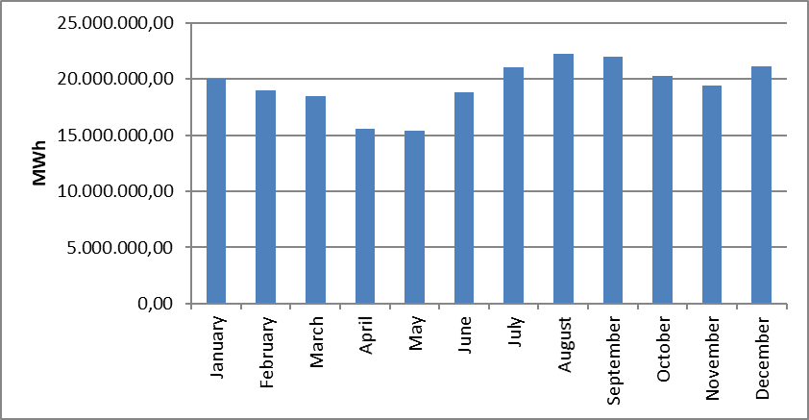
The distribution of actual consumption by years is shown in Figure 1.22. Considering last 20 years, actual consumption decreased in 2001, 2009 and 2019 compared to previous year. In 2020, it increased by 0,8% compared to previous year.

Figure 1.22: Development of Actual Consumption by Years (GWh)
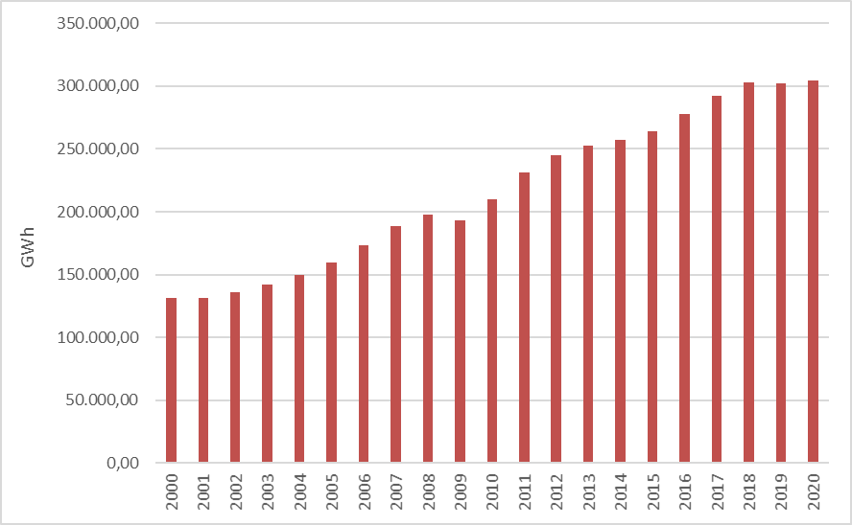

1.6 Import and Export

1.6.1 Import

The data on electricity imports in 2020 is shown in Figure 1.23 on the basis of months. 89,42% of the total 1.888.286,50 MWh electricity imports in 2020 was from Bulgaria, 8,99% from Georgia and 1,59% from Greece. On a monthly basis, the highest electricity import was in June, while the lowest electricity import was in November.

Figure 1.23: Electricity Imports in 2020 by Months (MWh)
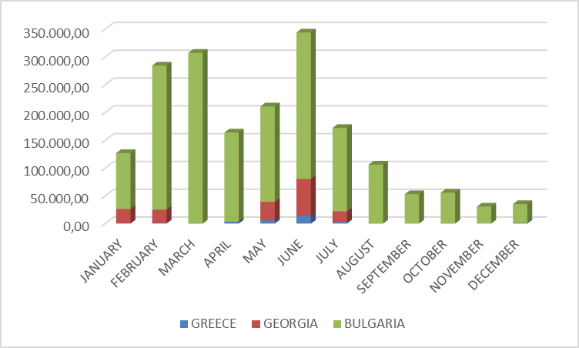

1.6.2 Export

The data on electricity exports in 2020 by months is shown in Figure 1.24. 74,10% of the total electricity exports (2.483.990,38 MWh) was exported to Greece, 13,17% to Bulgaria, 12,68% to Georgia, and the remaining was exported to Syria in 2020. On a monthly basis, the highest electricity export was in November, while the lowest electricity export was in June.

Figure 1.24: Electricity Exports in 2020 by Months (MWh)
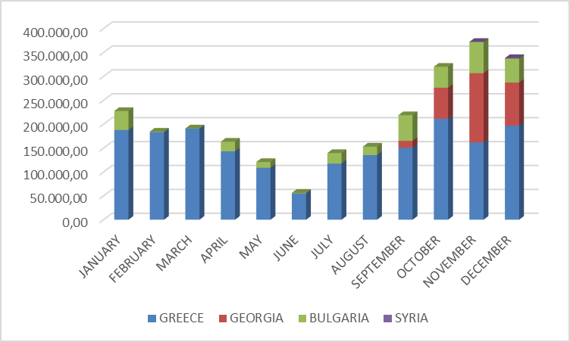

- WHOLESALE MARKET

In this section, the developments that occurred in the wholesale market in 2020 were analyzed. In this context, the prices of the Day-Ahead Market (DAM), the Intra-Day Market (IDM) and the Balancing Power Market (BPM) are presented with the volumes and the orders given. In addition, the changes that occurred in the market structure are explained.
Primary Frequency Control (PFC) brings the system frequency to a new equilibrium point by automatically increasing or decreasing the unit active power with the speed regulator in response to the decrease or rise of the system frequency. PFC reserve is obtained from production facilities determined to be capable of providing PFC services as a result of PFC performance tests in Electricity Network Regulation.
Secondary Frequency Control (SFC) brings the system frequency to the nominal value and to the programmed value of the total electrical energy exchange with neighboring country electricity networks by increasing or decreasing the active power output of the production facilities participating in the SFC service by the signals sent automatically from the National Load Dispatch Center. SFC reserve is provided by the production facilities which are determined to be capable of providing SFC services as a result of the SFC performance tests in the Electricity Network Regulation.
Pursuant to the Electricity Market Ancillary Services Regulation published on the Official Gazette dated 26 November 2017 and numbered 30252, participation in PFC and SFC services has ceased to be compulsory and PFC and SFC reserves have been procured on a voluntary basis. Currently, between 200-300 MW PFC reserve and 700-1100 MW SFC reserve are kept at different times of the day.

2.1 Day-Ahead Market

In the process that started with the Electricity Market Law, it was aimed to create an electricity market that is transparent, reliable, competitive and integrated with the electricity markets of other countries. In line with this goal, many planned steps have been taken, and significant progress has been made in each step taken to make the electricity market stronger and more dynamic, for market participants to take a more active role in the electricity market, and for those who operate the market to manage and follow the market in the best way.
First step carried out for transformation of electricity market from a single buyer-single seller model to liberal and competitive model was transition to monthly 3 period financial settlement system on 1 July 2006. Next step was the start of operations for Day-Ahead Planning system on 1 December 2009. These transition periods have great importance regarding to transformation of electricity market into stronger and more dynamic structure. Parties took role in market operations and activities provided significant experience and foresight for new market models from their practices at earlier market stages. 1 December 2011 date became a milestone for Turkish Electricity Market and creation of currently used Day-Ahead Market system has been established which is deemed as biggest step towards formation of targeted electricity market structure. Establishment of Day-Ahead Market stimulated a new dynamism and vision for Turkish Electricity Market and allowed formation of market structure based on values of competition.
With the new market structure, the collateral mechanism has been implemented and, in this context, the market participants registered with MFSC must provide a guarantee to the market operator for the transactions they have made in DAM. In addition to this arrangement, it is possible for participants to create portfolios. Lastly, in the event that system constraints continue systematically, TEİAŞ is given the opportunity to switch to regional pricing by considering the constraints.
Following the completion of the registration process on 18 March 2015, the Energy Exchange Istanbul (EXIST) was formally established, under the provisions of the Turkish Commercial Code of the 14.03.2013 dated and numbered 6446 with the Electricity Market Act of 6102.
In accordance with the proposals offered by the market participants in the Day-Ahead Market operated by EPİAŞ, the market exchange prices, and the purchase and sales quantities are announced.
For the year 2020, prices of DAM are given in Figure 2.1.1 and Figure 2.1.2 with the weighted average price.

Figure 2.1.1: Hourly Development of Weighted Average Market Clearing Price and Market Clearing Price in 2020 (TL/MWh)
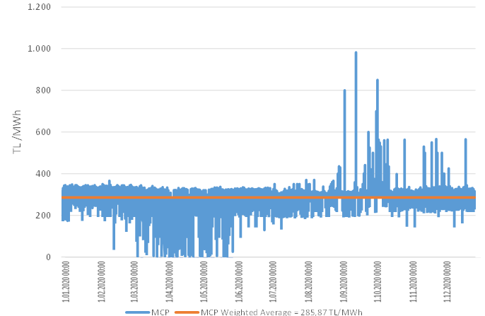

Figure 2.1.2: Organized and Weighted Average MCP in 2020 (TL/MWh)
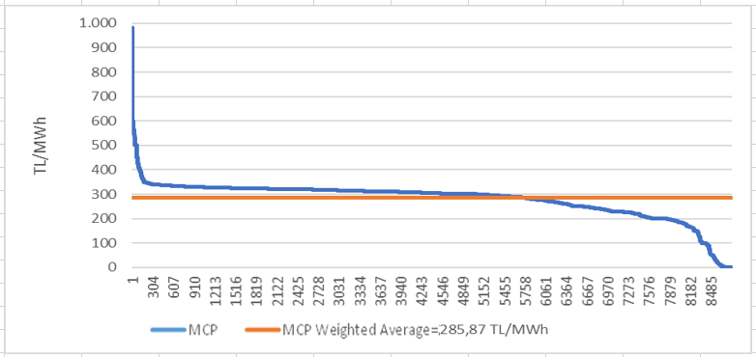
As shown in figures above, prices have generally been in the range of 150-350 TL/MWh. The price reached its highest value of 982,00 TL/MWh on September 17, 2020 at 16:00. In 2020, MCP was 0 TL/MWh for a total of 34 hours.
In Figure 2.1.3, the weighted average MCP is given in Day-Ahead Market by years. In 2020, the weighted average of the MCP increased by 6,48% compared to 2019 and it reached to 285,87 TL/MWh.

Figure 2.1.3: Weighted Average MCP by Years (TL/MWh)
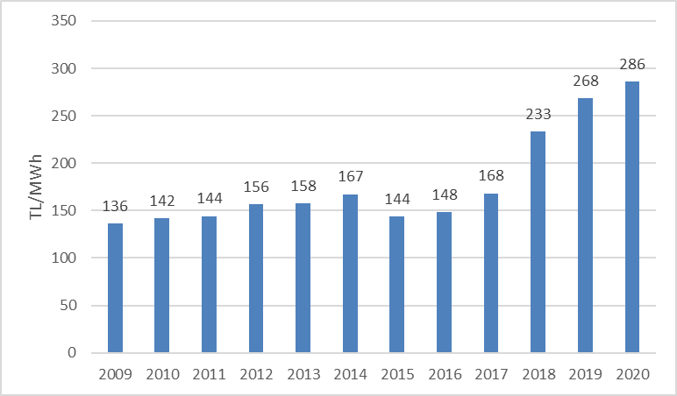

In Figure 2.1.4 below, monthly weighted average Day-Ahead Market prices for the last two years are shown. In 2020, the highest value was seen in October with 323,993 TL/MWh and the lowest value was in April with 184,25 TL/MWh.
Electricity consumption on a monthly basis decreases in the spring and autumn months with the temperate climate. In addition, the water revenues of hydroelectric power plants increase with the high precipitation especially in spring, and the lowest prices of the year are generally in spring.
On the other hand, due to the consumption of air conditioning and agricultural irrigation in the summer months, the need for warming and enlightenment in the winter months, electricity demand increases and in parallel with the increase in consumption, the average prices also increase.

Figure 2.1.4: Monthly Weighted Average MCP of the Last Two Years (TL/MWh)
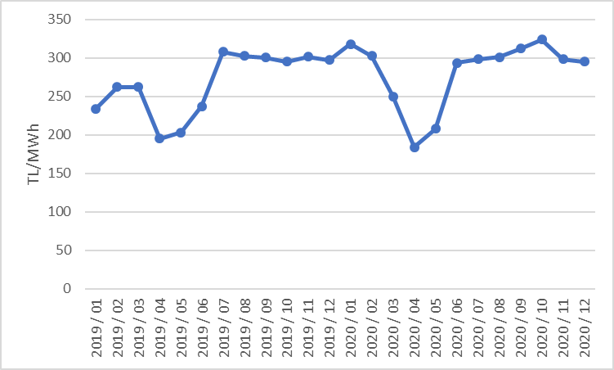
The following Figure 2.1.5 shows the trading volume in the DAM by months, the distribution of the quantities of DAM buying in Figure 2.1.6 and the share of the top 10 companies, the distribution of sales quantities in Figure 2.1.7 and the share of the top 10 company.

Figure 2.1.5: Monthly Day-Ahead Market Trading Volume (MWh)
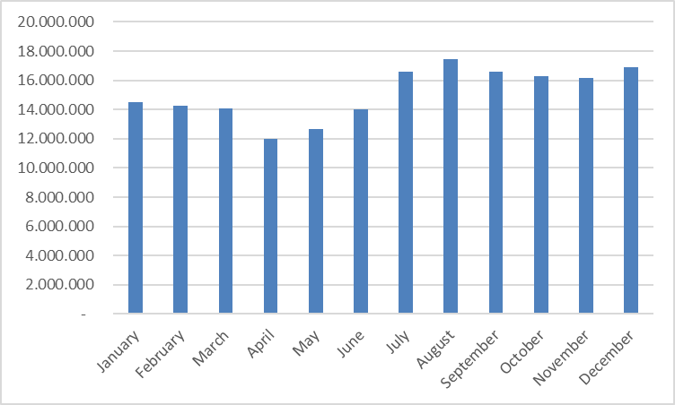

Figure 2.1.6: The Share of Top 10 Buyer Companies in Day-Ahead Market (%)
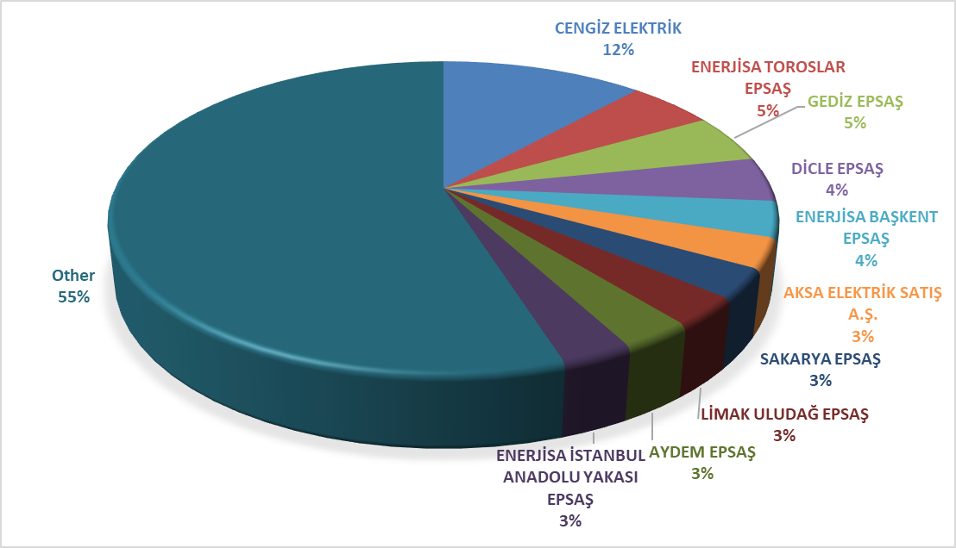

Figure 2.1.7: The Share of Top 10 Seller Companies in Day-Ahead Market (%)

,

2.2 Balancing Power Market

Balancing Power Market is operated by TEİAŞ. This section provides data on the development of prices and volumes in the BPM. The system marginal prices (real time price) at the BPM in 2020 are shown in Figure 2.2.1 and Figure 2.2.2.

Figure 2.2.1: Development of System Marginal Price in Hour Based (TL/MWh)
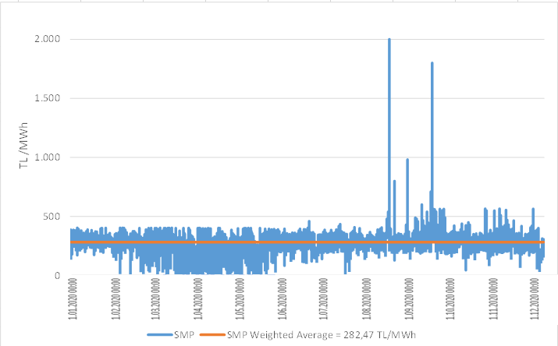

Figure 2.2.2: Organized System Marginal Price (TL/MWh)
Similar to the prices of the DAM, the prices in the BPM were generally between 150 and 350 TL/MWh. The price was highest on September 3, 2020 at 16:00 with 2.000 TL/MWh, and it was over 400 TL/MWh for 354 hours. At the BPM, the price was 0 TL/MWh for 256 hours during 2020.
The annual weighted average of the price in BPM increased by 12,88% and reached to 282,47 TL/MWh.
Monthly weighted average prices in the Balancing Power Market for the last two years are shown in Figure 2.2.3 below. In 2020, SMF was seen as the lowest 134,609 TL/MWh in April and the highest value was in October with 377,219 TL/MWh.

Figure 2.2.3: Monthly Weighted Average Prices of the Last Two Years in Balancing Power Market (TL/MWh)
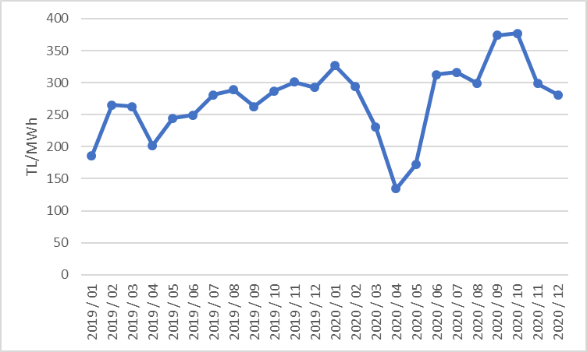

Figure 2.2.4 shows the monthly trading volumes in BPM in 2020.

Figure 2.2.4: Monthly Trading Volumes in Balancing Power Market (MWh)

Figure 2.2.5 shows the distribution of the BPM buying quantities on the basis of the company and the share of the top 10 buyer companies, and in Figure 2.2. the distribution of BPM sales quantities on company basis and the share of the top 10 companies are shown.

Figure 2.2.5: The Share of Top 10 Buyer Companies in Balancing Power Market (%)
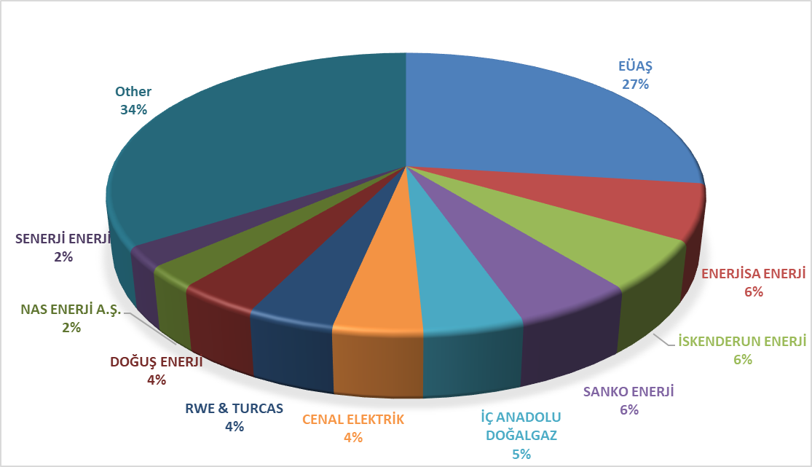

Figure 2.2.6: The Share of Top 10 Seller Companies in Balancing Power Market (%)
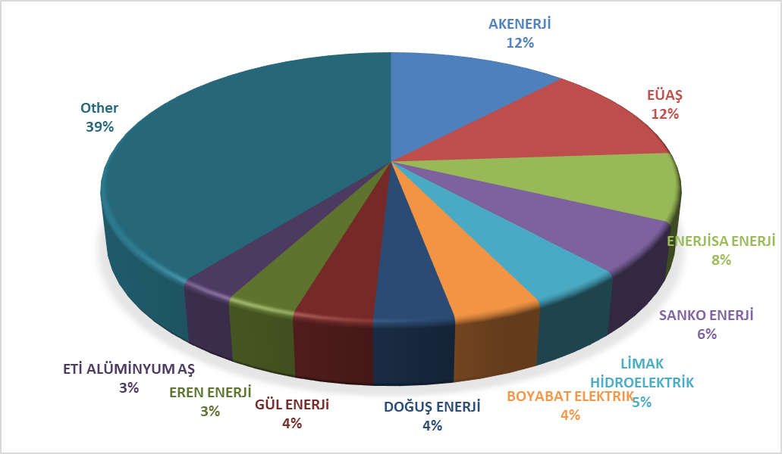
As of 2020, the rates of instruction volumes given in DGP are shown in Figure 2.2.7 below and their distribution on hourly basis is shown in Figure 2.2.8. 28% of the instructions were 1 coded, given due to system constraints. As of February 2018, since the procurement system was implemented in the side services, there were no 2 coded instructions.

Figure 2.2.7: Rates of Order Volumes Given in Balancing Power Market in 2020 (%)
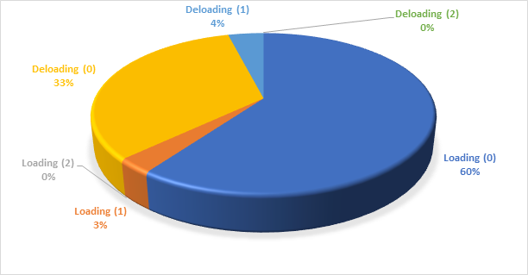

Figure 2.2.8: Distribution of the Orders Given in the Balancing Power Market by Hours in 2020 (MW)
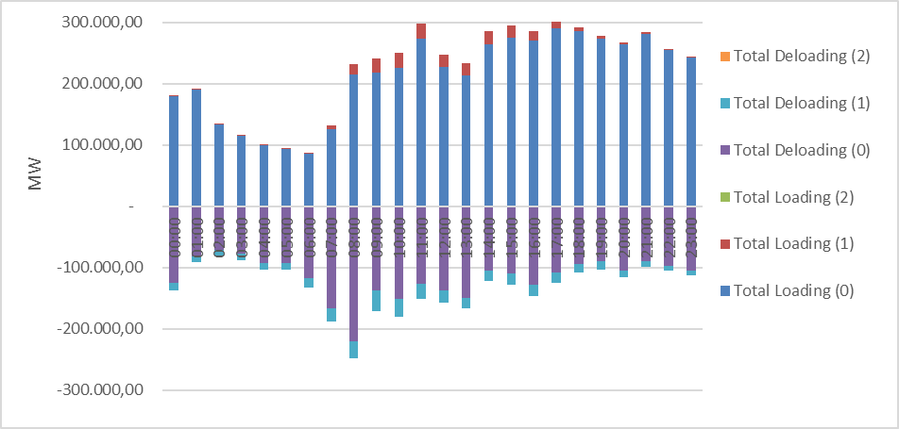

Additional costs arising from those instructions are shown in Table 2.2.1 below. While the additional cost caused by the instructions given in DGP was 625,8 million TL in 2019, it was 121,47 million TL in 2020. All of these costs are caused by 1 coded instruction, and since there are no 2 codes, there are no costs occurred.

Table 2.2.1: Additional Costs of Orders (Million TL)
Type of Instruction | Loading | De-loading | Total
1 Coded | 54,69 | 66,78 | 121,47

The development of additional costs that occurred due to the 1 coded instruction was shown on a monthly basis in Figure 2.2.9 below. The majority of the additional costs was in March, November and December in 2020.

Figure 2.2.9: Development of Additional Costs of Orders by Months in 2020 (Million TL)
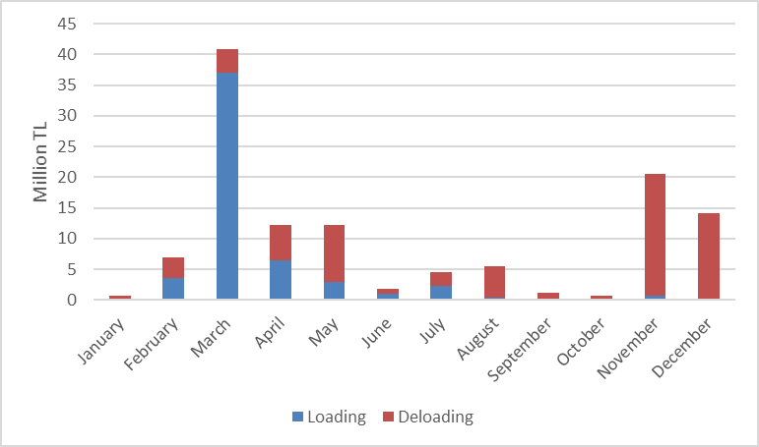
The change of the Zero Balance Adjustment Amount (ZBAC) by years is shown in Figure 2.2.10. While ZBAC was -654,09 million TL in 2019, it was 106,14 million TL in 2020.

Figure 2.2.10: Development of Zero Balance Adjustment Component by Years (TL)
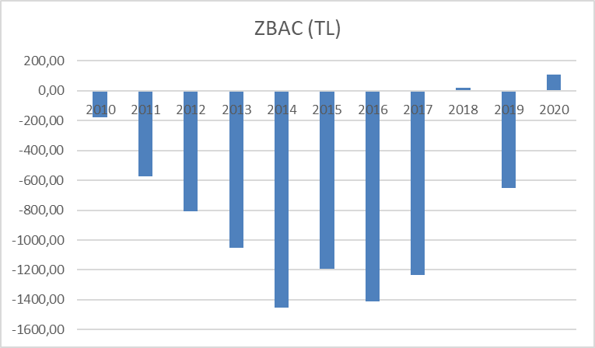

2.3 Intra-Day Market

Efforts are continuing to ensure that the Turkish Electricity Market is more transparent and efficient, financially strong, integrated with the European Union electricity markets. On 1 July 2015, the Intra-Day Market was in operation to ensure that participants in the Turkish electricity market, which is constantly evolving and advancing for free market, playing more balanced and effective role.
Day-Ahead, Ancillary Services and Balancing Power Markets that is currently in operation, with the addition of Intra-Day Market, provide real-time trading opportunities and offer market participants the opportunity to manage short-term portfolios.
In Figure 2.3.1 below, monthly volume of the Intra-Day Market and the weighted average price in 2020 is given.

Figure 2.3.1: Monthly Development of Trading Volume and Average Price in the Intra-Day Market (MWh – TL/MWh)
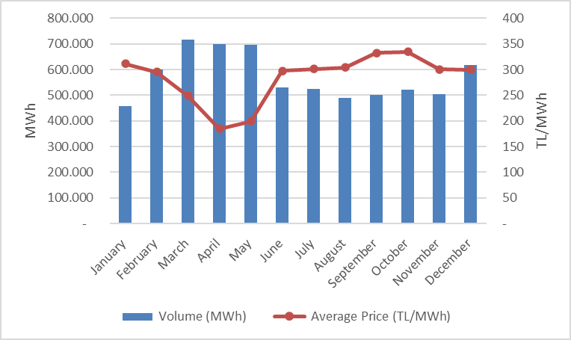
In Figure 2.3.2 below, the distribution of purchases of IDM on the basis of company and the share of first 10 companies, and in Figure 2.3.3, the distribution of sales in IDM on the basis of the company and the share of top 10 seller companies are shown.

Figure 2.3.2: Distribution of Purchases of Intra-Day Market by Companies and the Share of Top 10 Companies (%)
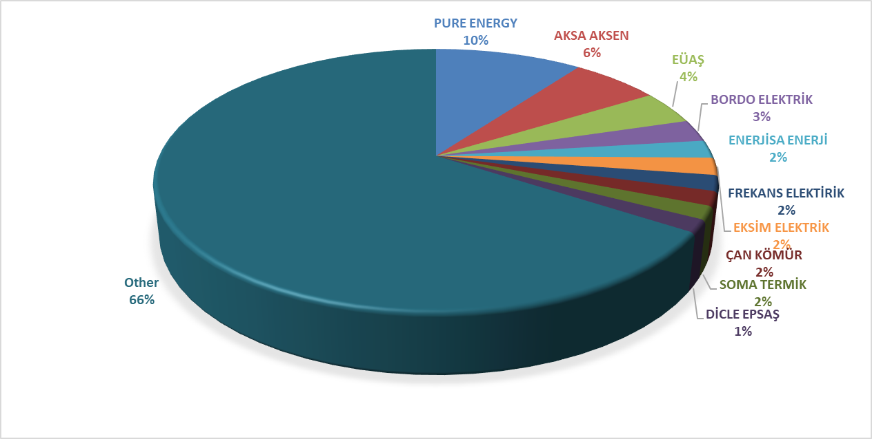

Figure 2.3.3: Distribution of Sales in IDM on the Basis of the Company and The Share of Top 10 Seller Companies (%)
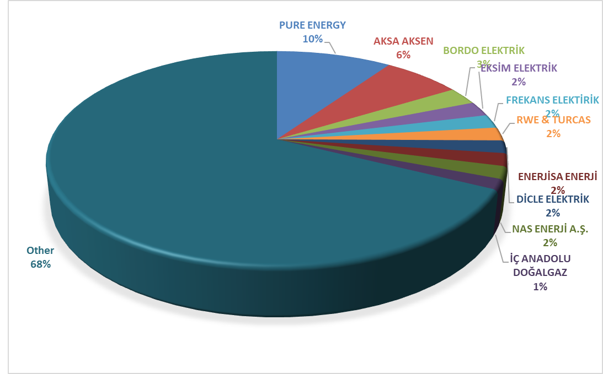

2.4 Bilateral Agreements

The structure of the Turkish electricity market is based on bilateral agreements and other organized markets are designed to complement the market. In this framework, most of the energy traded in the market is traded through bilateral agreements. Bilateral agreements are made freely between market participants and are not regulated. However, bilateral agreements signed between EÜAŞ (annulled TETAŞ) and commissioned supply companies are the majority of the existing bilateral agreement volume in the framework of transitional contracts. Additionally, distribution companies have energy purchases from EÜAŞ (annulled TETAŞ) for losses and general lighting purposes under bilateral agreements.
In Figure 2.4.1, monthly bilateral agreement volumes in 2018-2019-2020 are shown.

Figure 2.4.1: Monthly Bilateral Agreement Volume by Years (MWh)
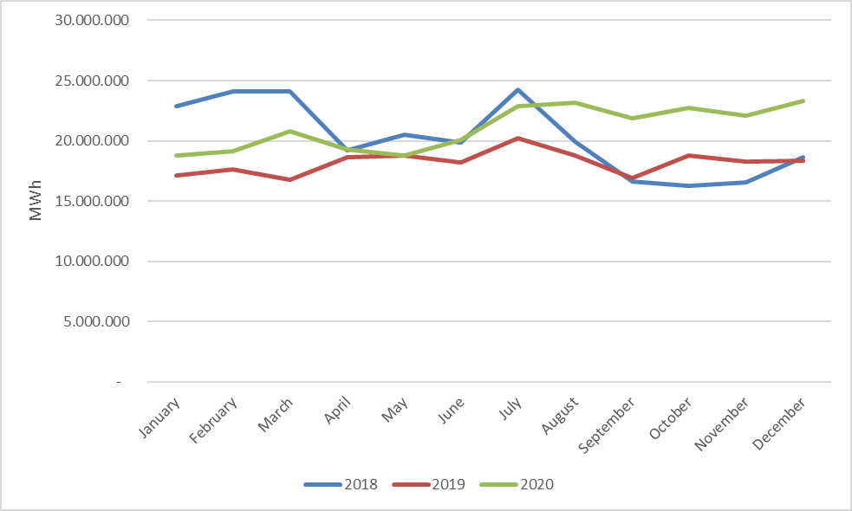

In Figure 2.4.2 the distribution of purchases with bilateral agreement on the basis of the company and the share of top 10 buyer companies, and in Figure 2.4.3 the distribution of sales with bilateral agreement on the basis of the company and the share of top 10 seller companies are shown.

Figure 2.4.2: Distribution of Purchases of Bilateral Agreement by Companies and the Share of Top 10 Companies (%)
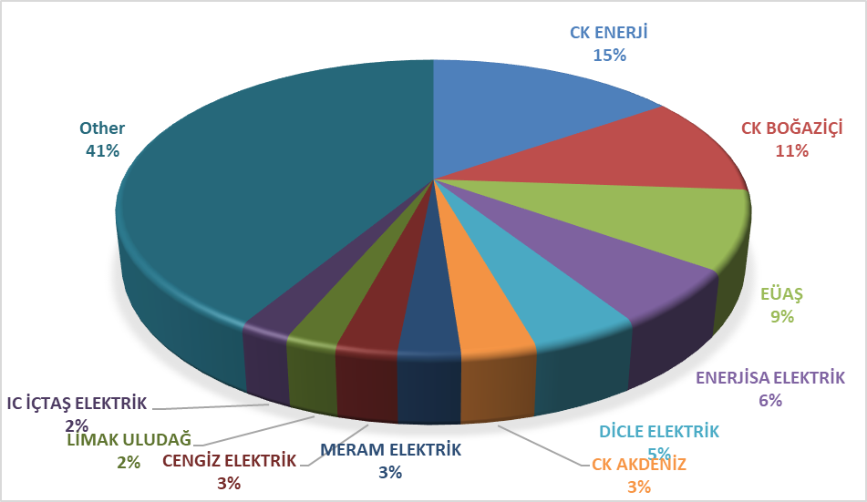

Figure 2.4.3: Distribution of Sales with Bilateral Agreement by Companies and the Share of Top 10 Companies (%)
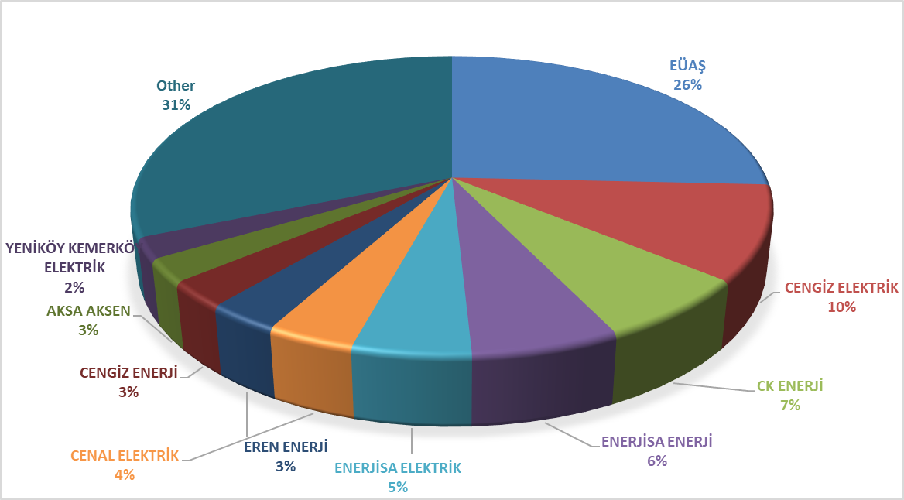

The wholesale tariffs of EÜAŞ (annulled TETAŞ) are determined by the Board Decision and the fulfillment of the obligations of EÜAŞ arising from existing contracts is taken into account. While a single price was announced for wholesale tariff of EÜAŞ (annulled TETAŞ) previously, a separate price has been determined for the general lighting price since 2017.
Figure 2.4.4 shows the change in the wholesale prices of EÜAŞ between 2011 and 2020.

Figure 2.4.4: EÜAŞ Wholesale Prices Between 2011-2019 (kr/kWh)

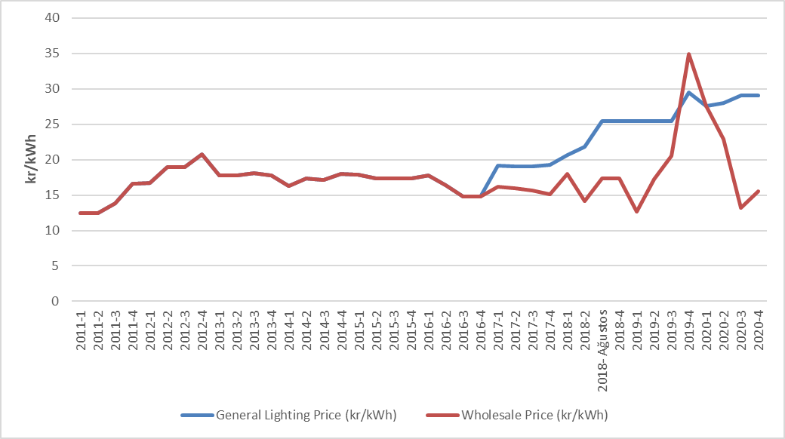

  - Renewable Energy Sources Support Mechanism (RESSUM)

“The Amendment of the Law on “Utilization of Renewable Energy Resources for Generation of Electrical Energy” Law Numbered 6094 published in the Official Gazette 08/01/2011 dated and 27809 numbered provide incentive for renewable energy sources according to the source type and the locality rate. In this context, the regulations prepared by EMRA and the details Mechanism of Supporting Renewable Energy Sources are determined with the regulations prepared by EMRA.
Regulation on Certification and Support of Renewable Energy Sources” was published in the Official Gazette dated 01/10/2013 and numbered 28782 and came into force. With the Regulation, in order to encourage the generation of electricity based on renewable energy sources, principles regarding the provision of Renewable Energy Source Document and the establishment and operation of YEKDEM issued to the generation license holders.
In Table 2.5.1, the number of the RES Support participants is given by years. The increment in participant number and installed capacity continues. In 2020, there were 821 companies with a total installed capacity of 21.146,1 MW which operates in the scope of the RES Support.

Table 2.5.1: Number of YEKDEM Participants by Years
Type | 2011 | 2012 | 2013 | 2014 | 2015 | 2016 | 2017 | 2018 | 2019 | 2020
Solar | - | - | - | - | - | - | 2 | 3 | 9 | 17
Hydraulic | 4 | 44 | 14 | 40 | 126 | 388 | 418 | 447 | 463 | 463
Wind | 9 | 22 | 3 | 21 | 60 | 106 | 141 | 151 | 160 | 165
Biomass | 3 | 8 | 15 | 23 | 34 | 42 | 57 | 70 | 100 | 126
Geothermal | 4 | 4 | 6 | 9 | 14 | 20 | 29 | 37 | 45 | 50
Grand Total | 20 | 78 | 38 | 93 | 234 | 556 | 647 | 708 | 777 | 821

When the installed capacity by resources is considered, it is seen that hydraulic power plants have the highest share with 12.434,7 MW and the wind power plants have the second-highest share with 6.440,0 MW.

Table 2.5.2: Distribution of RESSU. Installed Capacity by Resources (MW)*
Type | 2011 | 2012 | 2013 | 2014 | 2015 | 2016 | 2017 | 2018 | 2019 | 2020
Solar | - | - | - | - | - | - | 12,9 | 13,9 | 81,7 | 162,7
Hydraulic | 21 | 930 | 217 | 598 | 2.116,3 | 9.960,0 | 11.096,3 | 11.706,4 | 12.588,5 | 12.434,7
Wind | 469 | 685 | 76 | 825 | 2.732,1 | 4.319,8 | 5.238,7 | 6.200,0 | 6.495,6 | 6.440,0
Geothermal | 72 | 72 | 140 | 228 | 389,9 | 599,2 | 752,1 | 996,8 | 1.252,7 | 1.437,5
Biomass | 45 | 73 | 101 | 147 | 185,2 | 203,7 | 300,0 | 349,2 | 503,1 | 671,2
Grand Total | 608 | 1.760 | 534 | 1.798 | 5.423,6 | 15.082,7 | 17.399,9 | 19.266,3 | 20.921,5 | 21.146,1

* In addition, by the end of 2020, 6.823,47 MW of unlicensed installed capacity (natural gas plants excluded) are covered by YEKDEM. Details are given at "Unlicensed Electricity Generation" in Section 1.3.
Including unlicensed power plants, the share of installed capacity in the scope of the RES Support in Turkey’s total installed power in 2019 22,92%, while this rate is 22,07% in 2020.
In Figure 2.5.1, the distribution of installed capacity based on resources in 2020 is given.

Figure 2.5.1: Distribution of YEKDEM Installed Capacity to Resources in 2020 (%)
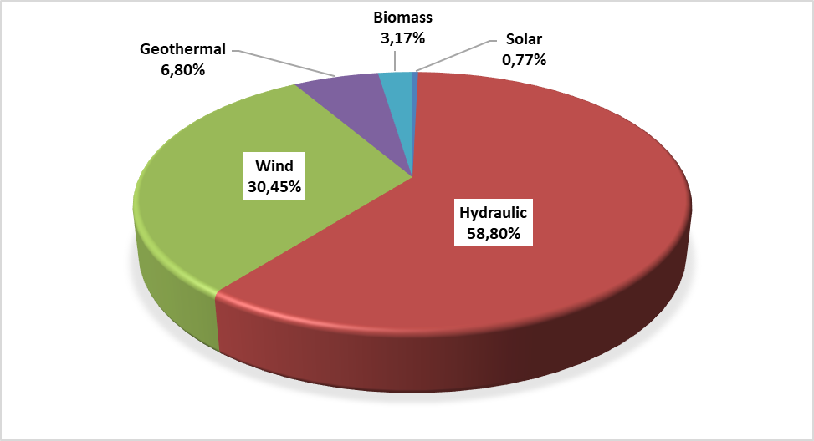
The development of RESSUM participants' productions over the years is shown in Table 2.5.3. RESSUM production in 2020, including unlicensed power plants, decreased by approximately 4,16% and it reached to 73,48 TWh.

Table 2.5.3: Yearly Generation of RESSUM Participants by Years (MWh)*
Type | 2013 | 2014 | 2015 | 2016 | 2017 | 2018 | 2019 | 2020
Solar | - | - | - | - | 24.269 | 39.140 | 159.961 | 375.476
Unlicensed | 884 | 29.316 | 223.537 | 1.134.023 | 2.997.551 | 8.078.418 | 9.830.849 | 11.229.723
Hydraulic | 528.427 | 1.072.832 | 5.651.215 | 16.212.717 | 17.213.394 | 27.369.727 | 36.961.886 | 29.671.021
Wind | 223.243 | 2.378.819 | 8.275.992 | 14.163.402 | 16.765.418 | 19.002.863 | 19.900.973 | 20.658.797
Geothermal | 857.527 | 1.436.579 | 2.710.856 | 3.706.764 | 4.503.345 | 5.968.202 | 6.997.209 | 7.816.509
Biomass | 750.715 | 957.223 | 1.082.913 | 10.613.594 | 8.992.792 | 2.047.082 | 2.817.209 | 3.730.699
Grand Total | 2.360.795 | 5.874.769 | 17.944.514 | 45.830.502 | 50.496.769 | 62.505.431 | 76.668.087 | 73.482.227

The distribution of generation within the scope of RESSUM is shown in Figure 2.5.2. The highest generation was obtained from hydraulic and wind, respectively.

Figure 2.5.2: Distribution of RESSUM Generation by Resources in 2020 (%)
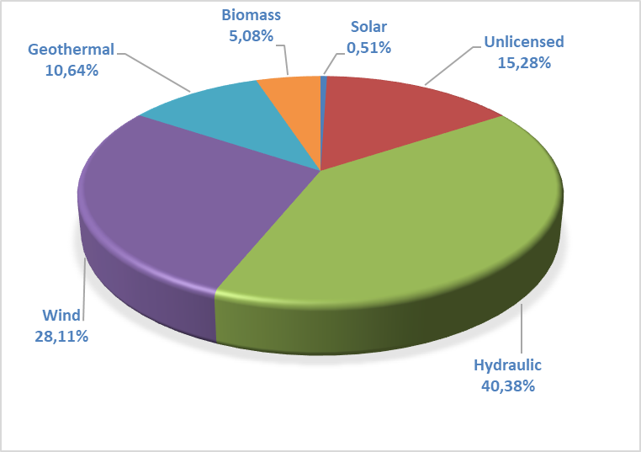
While the ratio of the generation in RESSUM to the total electricity generation of the country was 25,21% in 2019, this rate decreased to 24,07% in 2020.
Considering the monthly development of RESSUM generation in Figure 2.5.3, it is seen that hydraulic production and therefore RESSUM production increased due to the rains in spring months. The production from other resources is more stable throughout the year.

Figure 2.5.3: Monthly Development of YEKDEM Generation in 2020 (MWh)
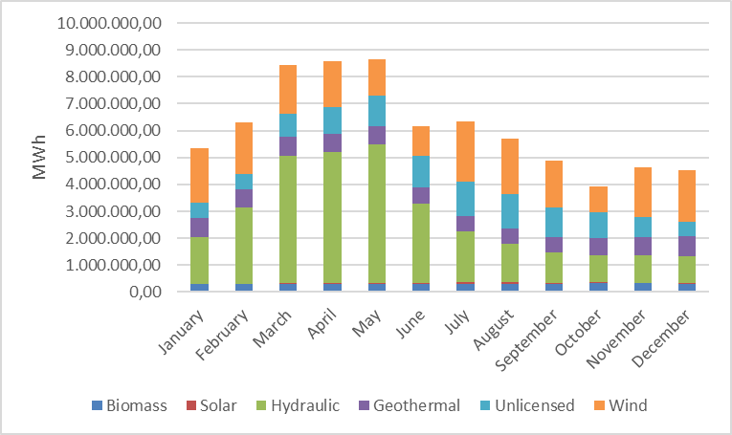
Figure 2.5.4 the monthly course of the weighted average MCP prices formed in 2020 RESSUM and DAM are shown together. When the incentive prices applied in RESSUM are compared with the monthly average MCP prices, it is observed that even the lowest incentive amount is above the MCP price, in the spring months, the difference between RESSUM price and MCP price has been observed.

Figure 2.5.4: Monthly Development of RESSUM and DAM Prices in 2020

Figure 2.5.5 shows the RESSUM prices for power plants and Average RESSUM Price and DAM price in 2020 are shown together.

Figure 2.5.5: Average of RESSUM and MCP in 2020 (kr/kWh)
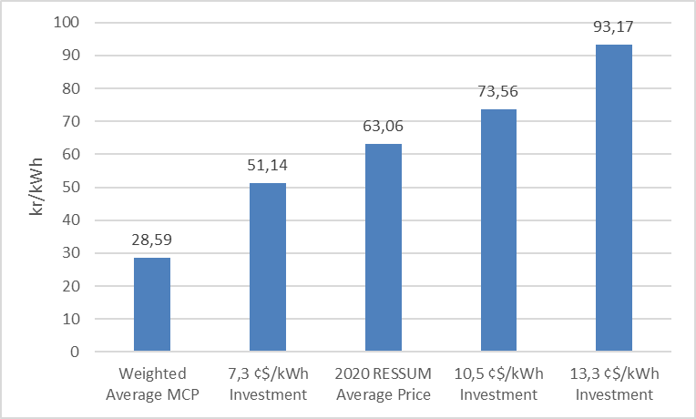

Figure 2.5.6 shows the monthly development of payments made within the scope of RESSUM is shown.

Figure 2.5.6 Monthly Payments Made within the Scope of the YEKDEM in 2020 (TL)
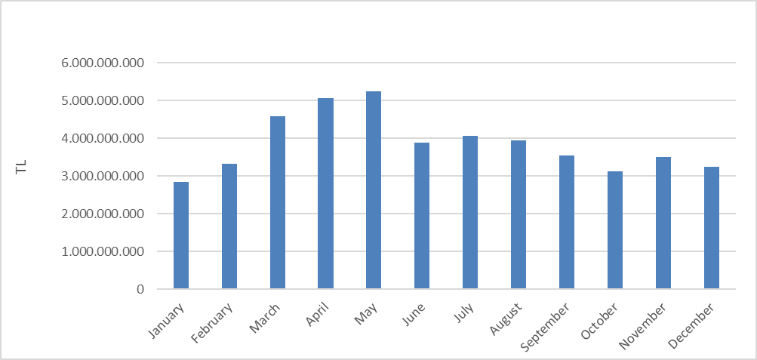
Figure given below shows the improvement of monthly additional cost of RESSUM per invoiced unit energy amount. In 2020, RESSUM additional cost was increased by 42,97% compared to previous year and it reached to 108,5 TL/MWh.

Figure 2.5.7 Monthly Improvement of Average RESSUM Additional Cost in 2020 (TL/MWh)

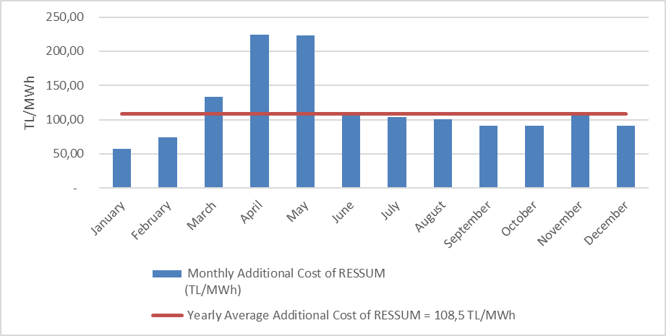
- COMPETITION

The main purpose of the Electricity Market Law is to develop competition by creating a free market structure. The main duties of the institution include determining anti-competitive behavior and market power in areas open to competition and taking preventive measures. EMRA also reduces the eligible consumer limit for the next year at the end of each year, ensuring that the number of consumers who can choose their supplier on the demand side increases. In this framework, the development of open negotiation supply and demand in the wholesale market is critical in establishing competition.

3.1 Supply Side

It is considered that open electricity markets provide the most effective investment and generation incentives is supported by theoretical and practical studies. However, there may be a need for regulation regarding the protection of competition and ensuring the security of supply due to reasons such as very low demand elasticity and the network not being able to store energy. For this reason, these issues are regulated by various market share limits and mechanisms in many countries and by the European Union.
The indices used to follow the competition generally measure the supply side concentration in the market and the producers' ability to intervene. The HHI is used for measuring the market concentration with the addition of squares of market shares. The index can be calculated separately on generation and installed capacity.

Table 3.1: HHI Values with respect to Generation and Installed Capacity
 | HHI Index
 | 2014 | 2015 | 2016 | 2017 | 2018 | 2019 | 2020
Generation | 1416 | 1123 | 673 | 696 | 575 | 550 | 508
Installed Capacity | 1132 | 996 | 873 | 789 | 682 | 599 | 461

As shown in Table 3.1, there was a decrease in the HHI index calculated on both production and installed power compared to the previous year in 2020.
The sales of the supply license holders for final consumption are included in Table 3.2. While the HHI index, which is calculated according to the supplier shares, was 413,6 in 2019, this value was calculated as 371,1 in 2020. The decrease in the index value is due to the decrease in the total sales amount of 21 companies in charge of the total sales in the total sales amount of companies with all supply licenses, from 76.37% in 2019 to 72.07% in 2020.
As it is known, the eligible consumer limit in the electricity market has not been reset yet. In other words, not all consumers in the market are eligible consumers. It is not legally possible for any supplier to sell, except for supplier companies that are assigned to non-eligible consumers. Therefore, it is important to create an environment, where all consumers are eligible consumers and can supply energy from the supplier, they wish in order to evaluate the competitive environment in sales to end consumers, properly.

Table 3.2: Sales, Market Shares and HHI Index of Supply License Owners
Supplier Company | Sale Amount (MWh) | Share (%)
CK BOĞAZİÇİ ELEKTRİK PERAKENDE SATIŞ ANONİM ŞİRKETİ | 17.940.197 | 8,36
ENERJİSA TOROSLAR ELEKTRİK PERAKENDE SATIŞ ANONİM ŞİRKETİ | 13.601.947 | 6,34
GEDİZ ELEKTRİK PERAKENDE SATIŞ ANONİM ŞİRKETİ | 12.915.187 | 6,02
DİCLE ELEKTRİK PERAKENDE SATIŞ ANONİM ŞİRKETİ | 11.670.387 | 5,44
LİMAK ULUDAĞ ELEKTRİK PERAKENDE SATIŞ ANONİM ŞİRKETİ | 11.162.950 | 5,20
ENERJİSA BAŞKENT ELEKTRİK PERAKENDE SATIŞ ANONİM ŞİRKETİ | 10.594.044 | 4,93
SAKARYA ELEKTRİK PERAKENDE SATIŞ ANONİM ŞİRKETİ | 9.820.120 | 4,57
ENERJİSA İSTANBUL ANADOLU YAKASI ELEKTRİK PERAKENDE SATIŞ ANONİM ŞİRKETİ | 9.736.553 | 4,54
MERAM ELEKTRİK PERAKENDE SATIŞ ANONİM ŞİRKETİ | 7.610.326 | 3,54
AYDEM ELEKTRİK PERAKENDE SATIŞ ANONİM ŞİRKETİ | 7.390.359 | 3,44
AKSA ELEKTRİK SATIŞ ANONİM ŞİRKETİ | 6.861.057 | 3,20
CK ENERJİ ORTAKLIĞI TOPTAN ELEKTRİK SATIŞI ANONİM ŞİRKETİ | 6.644.025 | 3,09
CK AKDENİZ ELEKTRİK PERAKENDE SATIŞ ANONİM ŞİRKETİ | 6.497.556 | 3,03
OSMANGAZİ ELEKTRİK PERAKENDE SATIŞ ANONİM ŞİRKETİ | 5.565.468 | 2,59
KAYSERİ ELEKTRİK PERAKENDE SATIŞ ANONİM ŞİRKETİ | 5.562.141 | 2,59
TRAKYA ELEKTRİK PERAKENDE SATIŞ ANONİM ŞİRKETİ | 5.238.213 | 2,44
YEŞİLIRMAK ELEKTRİK PERAKENDE SATIŞ ANONİM ŞİRKETİ | 4.908.922 | 2,29
GAZİANTEP OSB ELEKTRİK ENERJİSİ TEDARİK TOPTAN SATIŞ TİCARET ANONİM ŞİRKETİ | 3.737.660 | 1,74
AKEDAŞ ELEKTRİK PERAKENDE SATIŞ ANONİM ŞİRKETİ | 3.663.111 | 1,71
MERAM ELEKTRİK ENERJİSİ TOPTAN SATIŞ ANONİM ŞİRKETİ | 2.868.996 | 1,34
ENERJİSA ELEKTRİK ENERJİSİ TOPTAN SATIŞ ANONİM ŞİRKETİ | 2.612.193 | 1,22
ARAS ELEKTRİK PERAKENDE SATIŞ ANONİM ŞİRKETİ | 2.559.617 | 1,19
ÇORUH ELEKTRİK PERAKENDE SATIŞ ANONİM ŞİRKETİ | 2.525.887 | 1,18
SOCAR ENERJİ TİCARET ANONİM ŞİRKETİ | 2.466.939 | 1,15
KOLEN ELEKTRİK TOPTAN SATIŞ İTH. VE İHR. ANONİM ŞİRKETİ | 2.384.080 | 1,11
OMV ENERJİ TİCARET ANONİM ŞİRKETİ | 2.332.264 | 1,09
CK ÇAMLIBEL ELEKTRİK PERAKENDE SATIŞ ANONİM ŞİRKETİ | 1.952.507 | 0,91
CENGİZ ELEKTRİK TOPTAN SATIŞ A.Ş. | 1.948.838 | 0,91
FIRAT ELEKTRİK PERAKENDE SATIŞ ANONİM ŞİRKETİ | 1.944.885 | 0,91
TÜRKERLER VANGÖLÜ ELEKTRİK PERAKENDE SATIŞ ANONİM ŞİRKETİ | 1.868.636 | 0,87
FİNA ELEKTRİK ENERJİSİ İTHALAT İHRACAT VE TOPTAN SATIŞ ANONİM ŞİRKETİ | 1.544.957 | 0,72
TOSYALI ELEKTRİK ENERJİSİ TOPTAN SATIŞ İTHALAT İHRACAT ANONİM ŞİRKETİ | 1.534.231 | 0,71
ZORLU ELEKTRİK ENERJİSİ İTHALAT, İHRACAT VE TOPTAN TİCARET ANONİM ŞİRKETİ | 1.522.004 | 0,71
IC İÇTAŞ ELEKTRİK TOPTAN SATIŞ VE TİCARET ANONİM ŞİRKETİ | 1.509.773 | 0,70
ELEKTRİK ÜRETİM ANONİM ŞİRKETİ (EÜAŞ) | 1.332.449 | 0,62
ŞİŞECAM ENERJİ ANONİM ŞİRKETİ | 1.258.066 | 0,59
TURKCELL ENERJİ ÇÖZÜMLERİ VE ELEKTRİK SATIŞ TİCARET ANONİM ŞİRKETİ | 1.141.189 | 0,53
NYK ENERJİ TİCARET ANONİM ŞİRKETİ | 1.123.500 | 0,52
EREN ELEKTRİK ENERJİSİ TOPTAN SATIŞ ANONİM ŞİRKETİ | 1.008.588 | 0,47
ADANA OSB ELEKTRİK ENERJİSİ TEDARİK TOPTAN SATIŞ ANONİM ŞİRKETİ | 990.854 | 0,46
TTES ELEKTRİK SATIŞ ANONİM ŞİRKETİ | 980.571 | 0,46
ENKO ENERJİ SANAYİ VE TİCARET ANONİM ŞİRKETİ | 886.560 | 0,41
YETAŞ YILDIRIM ENERJİ TEDARİK A.Ş. | 862.560 | 0,40
OYAK ELEKTRİK ENERJİSİ TOPTAN SATIŞ ANONİM ŞİRKETİ | 844.580 | 0,39
ELTEK ELEKTRİK ENERJİSİ İTHALAT İHRACAT VE TOPTAN TİCARET ANONİM ŞİRKETİ | 825.558 | 0,38
AXPO TURKEY ENERJİ ANONİM ŞİRKETİ | 774.145 | 0,36
DOSEN ENERJİ ELEKTRİK TEDARİK VE TOPTAN SATIŞ ANONİM ŞİRKETİ | 702.880 | 0,33
İPRAGAZ ANONİM ŞİRKETİ | 589.004 | 0,27
YEŞİLYURT ELEKTRİK ENERJİSİ TOPTAN SATIŞ VE İTHALAT İHRACAT ANONİM ŞİRKETİ | 585.153 | 0,27
VTC ENERJİ ANONİM ŞİRKETİ | 523.420 | 0,24
EKSİM ELEKTRİK ENERJİSİ İTHALAT, İHRACAT VE TOPTAN SATIŞ ANONİM ŞİRKETİ | 499.153 | 0,23
UŞAK OSB ELEKTRİK ENERJİSİ TEDARİK TOPTAN SATIŞ İTHALAT VE İHRACAT ANONİM ŞİRKETİ | 494.550 | 0,23
BORDO ELEKTRİK ENERJİSİ TOPTAN SATIŞ ANONİM ŞİRKETİ | 455.772 | 0,21
YYH YILDIZ ENERJİ TEDARİK VE TOPTAN SATIŞ ANONİM ŞİRKETİ | 372.615 | 0,17
RÖNESANS ELEKTRİK ENERJİ TOPTAN SATIŞ ANONİM ŞİRKETİ | 333.803 | 0,16
ZORLU TRADE ELEKTRİK TOPTAN SATIŞ ANONİM ŞİRKETİ | 332.746 | 0,15
DOĞRUDAN ELEKTRİK ENERJİSİ TOPTAN SATIŞ VE TEDARİK ANONİM ŞİRKETİ | 320.252 | 0,15
EÇE ENERJİ TİCARETİ ANONİM ŞİRKETİ | 314.672 | 0,15
SELENKA ELEKTRİK ENERJİSİ TOPTAN SATIŞ VE TEDARİK ANONİM ŞİRKETİ | 309.414 | 0,14
ENGİE ENERJİ TİCARET VE PAZARLAMA ANONİM ŞİRKETİ | 289.640 | 0,13
AVEL AVRUPA ELEKTRİK ENERJİSİ TOPTAN SATIŞ ANONİM ŞİRKETİ | 283.374 | 0,13
OZAN ELEKTRİK ENERJİSİ İTH. İHR. VE TOPTAN TİCARET ANONİM ŞİRKETİ | 268.823 | 0,13
GATES ENERJİ TİCARET ANONİM ŞİRKETİ | 268.132 | 0,12
BATIÇİM ENERJİ TOPTAN SATIŞ ANONİM ŞİRKETİ | 265.527 | 0,12
YKS ELEKTRİK ENERJİSİ TOPTAN SATIŞ DIŞ TİCARET LİMİTED ŞİRKETİ | 197.804 | 0,09
ELEKTRA ENERJİ TOPTAN SATIŞ VE İTHALAT İHRACAT ANONİM ŞİRKETİ | 184.593 | 0,09
FIRAT ENERJİ TOPTAN SATIŞ TİCARET ANONİM ŞİRKETİ | 171.442 | 0,08
STANDART DOĞALGAZ TİCARET VE ELEKTRİK ENERJİSİ TEDARİK ANONİM ŞİRKETİ | 170.153 | 0,08
SEDSAL ELEKTRİK ENERJİSİ TOPTAN SATIŞ LİMİTED ŞİRKETİ | 168.034 | 0,08
SOYAK ENERJİ TİCARET ANONİM ŞİRKETİ | 165.358 | 0,08
ENOVA ELEKTRİK ENERJİSİ TOPTAN SATIŞ ANONİM ŞİRKETİ. | 144.617 | 0,07
AVEM ELEKTRİK ENERJİSİ TOPTAN SATIŞ ANONİM ŞİRKETİ | 118.847 | 0,06
MARMARA ELEKTRİK ENERJİSİ İTHALAT İHRACAT VE TOPTAN TİCARET ANONİM ŞİRKETİ | 116.033 | 0,05
VOYTRON ENERJİ ELEKTRİK PERAKENDE SATIŞ ANONİM ŞİRKETİ | 113.850 | 0,05
FİDES ELEKTRİK ENERJİSİ TOPTAN ALIŞ SATIŞ ANONİM ŞİRKETİ | 103.711 | 0,05
EOS ELEKTRİK ENERJİSİ TOPTAN SATIŞ ANONİM ŞİRKETİ | 87.536 | 0,04
AGE ELEKTRİK ENERJİSİ TOPTAN SATIŞ ANONİM ŞİRKETİ | 80.706 | 0,04
EKVATOR PERAKENDE ENERJİ TİCARET ANONİM ŞİRKETİ | 73.226 | 0,03
ÇELİKLER ELEKTRİK ENERJİ TOPTAN SATIŞ ANONİM ŞİRKETİ | 66.688 | 0,03
AYEN ELEKTRİK TİCARET ANONİM ŞİRKETİ | 64.608 | 0,03
DESA ELEKTRİK ENERJİSİ TEDARİK VE TOPTAN SATIŞ TİCARET ANONİM ŞİRKETİ | 64.191 | 0,03
EMY TOPTAN ELEKTRİK TİCARET ANONİM ŞİRKETİ | 62.379 | 0,03
PURE ENERGY ELEKTRİK TEDARİK ANONİM ŞİRKETİ | 58.895 | 0,03
EKO GRUP ELEKTRİK TİCARET ANONİM ŞİRKETİ | 54.626 | 0,03
ENERJİM PERAKENDE ENERJİ TİCARET ANONİM ŞİRKETİ | 52.575 | 0,02
İVES ELEKTRİK ENERJİSİ TEDARİK TOPTAN SATIŞ LİMİTED ŞİRKETİ | 50.400 | 0,02
KGM ENERJİ TİCARET LİMİTED ŞİRKETİ | 44.472 | 0,02
MAC ELEKTRİK ENERJİSİ TOPTAN SATIŞ ANONİM ŞİRKETİ | 39.466 | 0,02
TENERA ENERJİ TİCARET ANONİM ŞİRKETİ | 37.609 | 0,02
KET KİPAŞ ELEKTRİK ENERJİSİ TOPTAN SATIŞ TİCARET ANONİM ŞİRKETİ | 31.752 | 0,01
ADB ELEKTRİK ENERJİSİ TOPTAN SATIŞ LİMİTED ŞİRKETİ | 25.733 | 0,01
EE ELEKTRİK ENERJİSİ TOPTAN SATIŞ ANONİM ŞİRKETİ | 25.024 | 0,01
HGÇ TOPTAN EL. EN. TİCARET ANONİM ŞİRKETİ | 22.425 | 0,01
HIZLI ELEKTRİK ENERJİSİ TEDARİK TOPTAN SATIŞ ANONİM ŞİRKETİ | 18.186 | 0,01
ENSAT ELEKTRİK ENERJİSİ TEDARİK TİCARET ANONİM ŞİRKETİ | 17.247 | 0,01
SHELL ENERJİ ANONİM ŞİRKETİ | 16.245 | 0,01
ORT ELEKTRİK TOPTAN SATIŞ ANONİM ŞİRKETİ | 16.087 | 0,01
EPTAŞ ENERJİ TİCARET ANONİM ŞİRKETİ | 14.834 | 0,01
BORNOVA ELEKTRİK ENERJİSİ TEDARİK SATIŞ LİMİTED ŞİRKETİ | 12.919 | 0,01
UZ ENERGY DIŞ TİCARET ANONİM ŞİRKETİ | 10.160 | 0,00
MAX ELEKTRİK ENERJİSİ TİCARET ANONİM ŞİRKETİ | 7.978 | 0,00
AWA ENERJİ SANAYİ VE TİCARET ANONİM ŞİRKETİ | 7.954 | 0,00
AKS GRUP ELEKTRİK ENERJİSİ TOPTAN ALIŞ VE SATIŞ LİMİTED ŞİRKETİ | 5.586 | 0,00
ATA ELEKTRİK ENERJİSİ TOPTAN SATIŞ ANONİM ŞİRKETİ | 5.091 | 0,00
STATKRAFT ELEKTRİK ENERJİSİ TOPTAN SATIŞ LİMİTED ŞİRKETİ | 4.272 | 0,00
DOASAN ENERJİ TOPTAN SATIŞ LİMİTED ŞİRKETİ | 3.225 | 0,00
CAN ENERJİ TOPTAN ELEKTRİK TİCARET ANONİM ŞİRKETİ | 2.767 | 0,00
OKKA ENERJİ ELEKTRİK TEDARİK TOPTAN SATIŞ İTHALAT VE İHRACAT ANONİM ŞİRKETİ | 1.962 | 0,00
VOLTAN ELEKTRİK TOPTAN SATIŞ İTHALAT VE İHRACAT ANONİM ŞİRKETİ | 1.778 | 0,00
FREKANS ELEKTRİK ENERJİSİ TOPTAN SATIŞ İTH. İHR. ANONİM ŞİRKETİ | 1.008 | 0,00
SETEL ELEKTRİK ENERJİSİ İHR.İTH. VE TOPTAN SATIŞ ANONİM ŞİRKETİ | 508 | 0,00
İDEAL PERAKENDE ELEKTRİK SATIŞ ANONİM ŞİRKETİ | 501 | 0,00
DİLER ELEKTRİK ENERJİSİ TEDARİK TOPTAN SATIŞ ANONİM ŞİRKETİ | 443 | 0,00
DOEL ELEKTRİK ENERJİSİ TOPTAN SATIŞ ANONİM ŞİRKETİ | 77 | 0,00
ESKO ELEKTRİK ENERJİSİ İTHALAT İHRACAT VE TOPTAN SATIŞ ANONİM ŞİRKETİ | 25 | 0,00
Grand Total | 214.679.190 | 100,00
HHI of Suppliers | 371,1

3.2 Demand Side

In accordance with the paragraph (b) of the sixth paragraph of Article 5 of the Law on the Organization and Duties of the Energy Market Regulatory Authority numbered 4628 and the 25th article of the Electricity Market Consumer Services Regulation,
it was decided to apply the eligible consumer limit as 1400 kWh for 2020. The theoretical market openness corresponding to the eligible consumer limit was calculated as 96,8%. The free consumer limit and the corresponding market openness rate over the years are given in Figure 3.1.

Figure 3.1: Eligible Consumer Limit and Market Openness Ratio by Years (kWh-%)
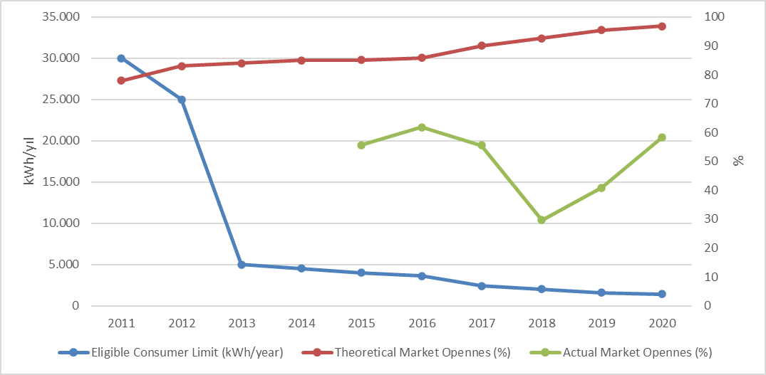

Although the theoretical market openness rate is high, the rate of consumers using the eligible consumer right in total consumption was lower. Consumption of eligible consumers was 128,92 TWh in 2020. This rate corresponds to 58,27% of the total invoiced consumption.
The development of the number of eligible consumers in 2020 is shown in Figure 3.2.

Figure 3.2: Number of Eligible Consumer by Months in 2020
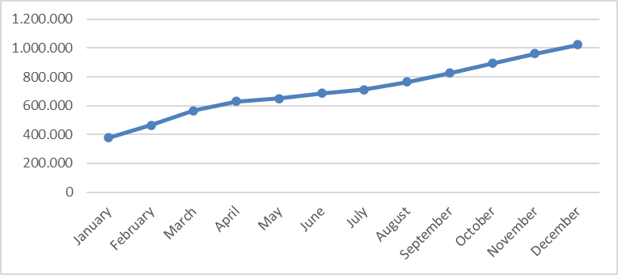
The number of eligible consumers, which was 339 thousand as of the end 2019, increased by 215% at the end of 2020 and it reached to 1 million 15 thousand. This number corresponds to approximately 2,43% of the total number of consumers.
Distribution of eligible consumers and their consumption by distribution regions (excluding eligible consumers from transmission) is shown in Figure 3.3. When the distribution is analyzed, it is seen that the highest number of eligible consumers is in Uludağ, Boğaziçi and Toroslar regions.

Figure 3.3: Distribution of Eligible Consumers and Their Consumptions by Distribution Regions in 2020
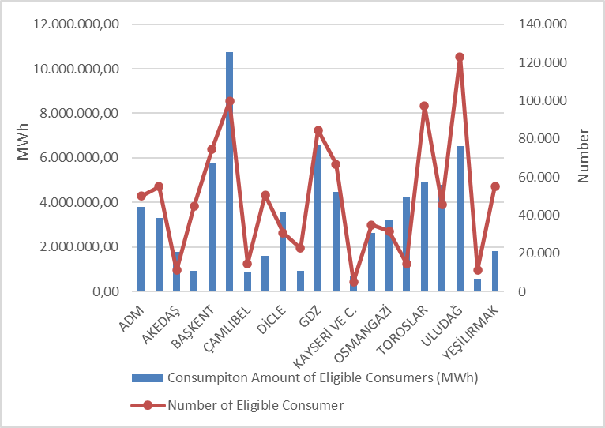
Considering the distribution of the consumption of eligible consumers on the basis of distribution regions, Boğaziçi, GDZ, Uludağ and Başkent constitute the four regions with the highest consumption.
Figure 3.4 shows the distribution of eligible consumer consumption by supplier type.

Figure 3.4: Distribution of Eligible Consumer Consumption by Supplier Type (%)
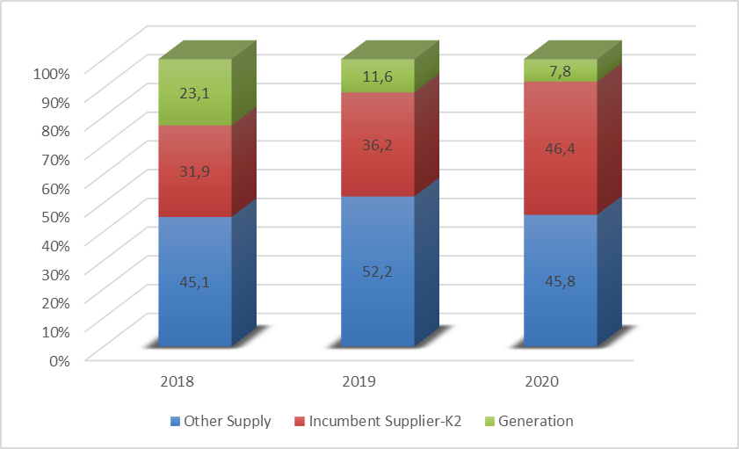
The number of eligible consumers which switched their suppliers and their consumption change on a monthly basis are shown in Figure 3.5.

Figure 3.5: Monthly Changes in Number and Consumptions of Eligible Consumers Switching Their Supplier (Number-MWh)
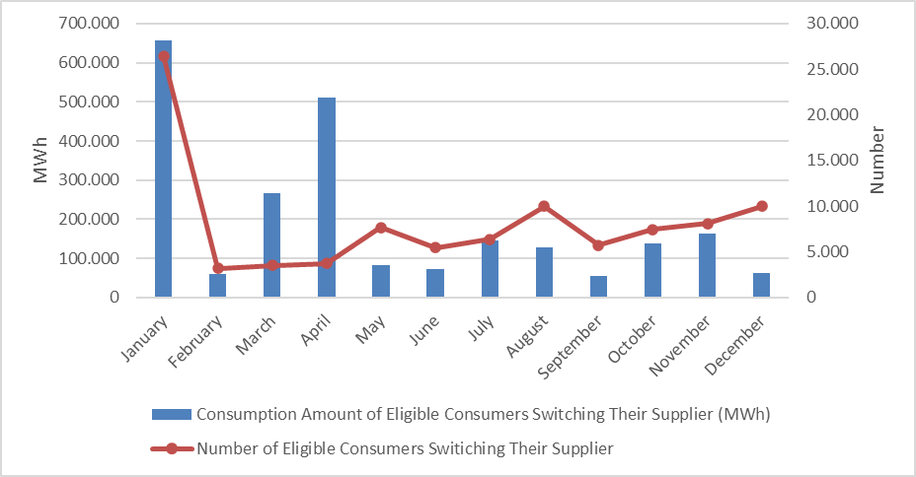
The number of eligible consumers switched their suppliers in 2020 was 97.656 and their total consumption was 2,35 TWh., which corresponds to 1% of total invoiced consumption.
Table 3.3 shows the distribution of eligible consumers' supplier changes by supplier type. It is seen that majority of supplier changes are consumers who switched to regulated tariffs.

Table 3.3: Distribution of Eligible Consumers' Supplier Changes by Supplier Type
Former Supplier Type | New Supplier Type |  |  |  | Grand Total
Former Supplier Type | Other Supply | Incumbent Supplier-K1 | Incumbent Supplier-K2 | Generation | Grand Total
Other Supply | 1.531 | 12.134 | 2.353 | 634 | 16.652
Incumbent Supplier-K2 | 5.447 | 63.757 | 8.540 | 393 | 78.137
Generation | 2.438 | 300 | 91 | 38 | 2.867
Grand Total | 9.416 | 76.191 | 10.984 | 1.065 | 97.656

- TRANSMISSON

In this section, summary information about the transmission system and changes of transmission system with tables and figures by the years are given.

4.1 Transmission System

The information about transformer center in the transmission system by the end of 2020 is shown in Table 4.1. As shown in the table, most of the transformer centers in the system are of 154 kV voltage level. There are 1.214 transformer centers, of which 723 are in TEİAŞ ownership and 491 are in private ownership. Transformer capacity reached to 210.920 MVA. 175.578 MVA of this capacity is in TEİAŞ ownership and the remaining 35.342 MVA is in private ownership.

Table 4.1: Transformer Center Information
 | Voltage (kV) | Number of Centers | Number of Transformers | Capacity (MVA)
TEİAŞ | 380 | 109 | 328 | 68.340
Ownership | 220 | 1 | 0 | 400
 | 154 | 609 | 1.461 | 106.579
 | 66 | 4 | 17 | 259
 | TEİAŞ Total | 723 | 1.806 | 175.578
Private Ownership | 380 | 54 | 44 | 6.875
Private Ownership | 220 | 0 | 0 | 0
Private Ownership | 154 | 434 | 476 | 28.454
Private Ownership | 66 | 3 | 1 | 13
Private Ownership | Private Total | 491 | 521 | 35.342
 | TOTAL | 1.214 | 2.327 | 210.920

%65,93 of the transmission lines, which are 71.098 km in total, constitute lines with a voltage level of 154 kV. Almost all the remaining part is at 380 kV voltage level, and lines at 220 kV and 66 kV voltage level are only 195 km.

Table 4.2: TEİAŞ Transmission Lines
 | 2019 | 2020 | Change (%) | 2019 | 2020 | Change (%)
Voltage (kV) | Number of Lines |  | Change (%) | Length (km) |  | Change (%)
380 | 288 | 299 | 3,82 | 23.940 | 24.029 | 0,37
220 | 2 | 2 | 0,00 | 85 | 85 | 0,00
154 | 1.712 | 1.779 | 3,91 | 45.889 | 46.874 | 2,15
66 | 11 | 14 | 27,27 | 110 | 110 | 0,00
Total | 2.013 | 2.094 | 4,02 | 70.024 | 71.098 | 1,53

Figure 4.1: Changes in TEİAŞ Transmission Line Lengths by Years (km)
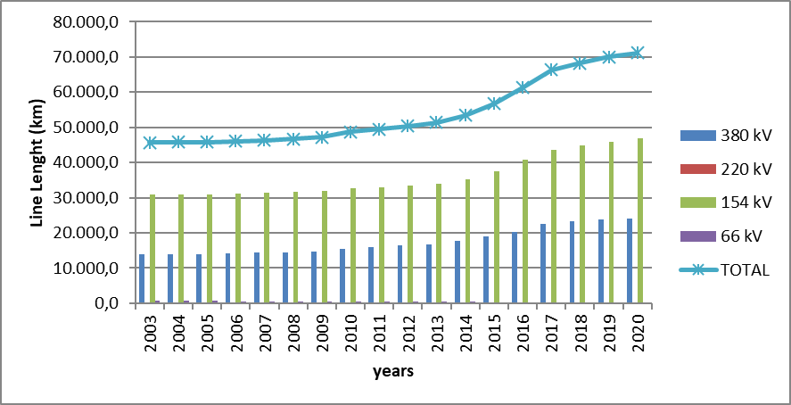

In the last 17 years, there was a 55,5% increase in the length of transmission lines.
  - Transmission System Connection Applications

The table below shows the number and capacity of applications made in 2020 for connection to the transmission system, as well as information about applications accepted, rejected and in the evaluation stage.

Table 4.3: Connection Applications to the Transmission System (Number - MW)
 | Connection Application |  | Accepted |  | Rejected |  | In the Evaluation Stage
 | Number | Capacity (MW) | Number | Capacity (MW) | Number | Capacity (MW) | Number | Capacity (MW)
Licensed Producers | 233 | 2.331,54 | 226 | 2.176,54 | 7 | 155,00 | 0 | 0,00
Unlicensed Producers | 3 | 49,34 | 3 | 49,34 | 0 | 0,00 | 0 | 0,00
Consumer | 19 | 1.544,00 | 18 | 1.494,00 | 0 | 0,00 | 1 | 50,00

In 2020, a total 2.331,54 MW connection applications were made by licensed producers. 226 applications of 2.176,54 MW were accepted, and 7 applications of 155 MW were rejected.
In addition, 3 connection capacity applications of 49.34 MW were made by unlicensed producers and all of these applications were accepted.
On the other hand, a connection capacity application of 1.544,00 MW was made by consumers, and 1.494,00 MW of these applications have been accepted and the remaining 50,00 MW is still under evaluation.
  - Tariffs

Transmission system usage and system operation tariffs applied by TEİAŞ to be implemented as of 01/01/2019 have been determined by the Board Decision dated 20/12/2018 and numbered 8272 for manufacturers and consumers on 14 regions basis. In addition, with the Decision No. 8121, dated 12/10/2018, in accordance with subparagraph (h) of sub-paragraph (h) and sub-paragraph (e) of sub-paragraph (a) of Article 5 of the Law on the Organization and Duties of the Energy Market Regulatory Authority No. 4628 2019 in the applied transmission surcharge, Turkey Electricity transmission Corporation 0,5% of the company's transmission tariffs ratio is determined.
System use and system operation tariffs implemented in 2020 are shown in Table 4.4 for production and consumption in 14 regions. The system usage and system operation tariffs applied in 2020 are shown in Table 4.4 for production and consumption on the basis of 14 regions.

Table 4.4: System Usage and System Operation Tariffs Applied in 2020 (TL/MW-Year, TL/MWh)
Region No. | Generation |  |  | Consumption
Region No. | System Usage Tariffs |  | System  Operation  Tariffs | System Usage Tariffs |  | System  Operation  Tariffs
Region No. | TL/MW-Year | TL/MWh | TL/MWh | TL/MW-Year | TL/MWh | TL/MWh
1 | 42.584,67 | 9,93 | 3,10 | 77.273,98 | 8,75 | 3,08
2 | 46.426,15 | 9,93 | 3,10 | 75.075,78 | 8,75 | 3,08
3 | 46.850,18 | 9,93 | 3,10 | 75.232,63 | 8,75 | 3,08
4 | 47.456,55 | 9,93 | 3,10 | 74.447,85 | 8,75 | 3,08
5 | 49.520,20 | 9,93 | 3,10 | 73.278,88 | 8,75 | 3,08
6 | 52.038,40 | 9,93 | 3,10 | 71.322,42 | 8,75 | 3,08
7 | 52.337,00 | 9,93 | 3,10 | 69.586,73 | 8,75 | 3,08
8 | 57.678,50 | 9,93 | 3,10 | 67.503,45 | 8,75 | 3,08
9 | 59.913,41 | 9,93 | 3,10 | 65.224,28 | 8,75 | 3,08
10 | 66.528,63 | 9,93 | 3,10 | 62.136,74 | 8,75 | 3,08
11 | 70.072,82 | 9,93 | 3,10 | 59.794,51 | 8,75 | 3,08
12 | 73.067,59 | 9,93 | 3,10 | 57.677,28 | 8,75 | 3,08
13 | 76.199,53 | 9,93 | 3,10 | 56.198,84 | 8,75 | 3,08
14 | 81.736,38 | 9,93 | 3,10 | 51.788,78 | 8,75 | 3,08

Figure 4.2: Capacity Based Regional Transmission System Usage Tariffs Applied in 2020 (TL/MW-Year)
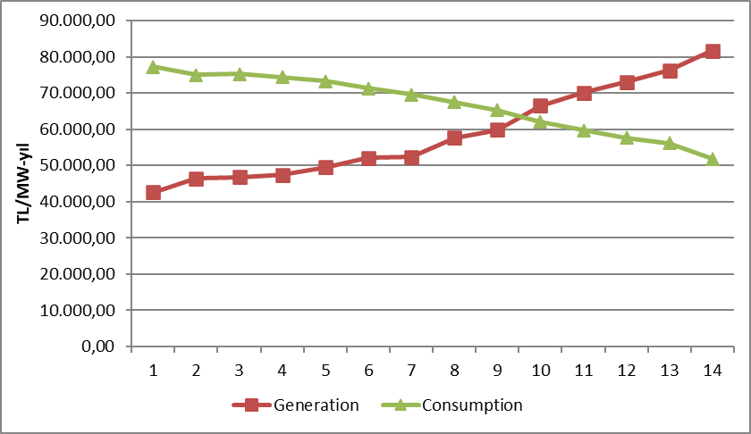
  - Amount of Investment

The amount of investment made by TEİAŞ is shown in Table 4.5. It is observed that the amount of investment increased by 24,74% in 2020.

Table 4.5: Comparison of 2019 and 2020 Investment Amount (TL-%)
 | 2019 |  | 2020 |  | Change (%)
Investment Payment Type | Amount (TL) | Share (%) | Amount (TL) | Share (%) | Change (%)
New Transformer Investment | 1.545.469.910 | 56,76 | 1.544.105.000 | 45,47 | -0,09
New Line Investment | 822.659.320 | 30,21 | 777.377.000 | 22,89 | -5,50
Operational Investment | 208.307.000 | 7,65 | 954.486.000 | 28,10 | 358,21
Machine and Equipment | 146.318.000 | 5,37 | 49.664.000 | 1,46 | -66,06
Communication System Information Infrastructure | 0 | 0,00 | 65.082.000 | 1,92 | 0,00
Etudes | 0 | 0,00 | 5.521.000 | 0,16 | 0,00
Grand Total | 2.722.754.230 | 100,00 | 3.396.235.000 | 100,00 | 24,74

  - Losses

The transmission system loss (TSL) rate varies depending on the demand, load flows, temperature, and investments in the system. It is calculated hourly and the annual average change over the years is shown in Figure 4.3. The transmission system losses established according to European standards in accordance with the population density of our country, the location of the supply sources and geographical conditions are at the level of international performance.
While the transmission system loss was 2,15% in 2019, it was 1,94% in 2020.

Figure 4.3: Transmission System Losses (GWh-%)
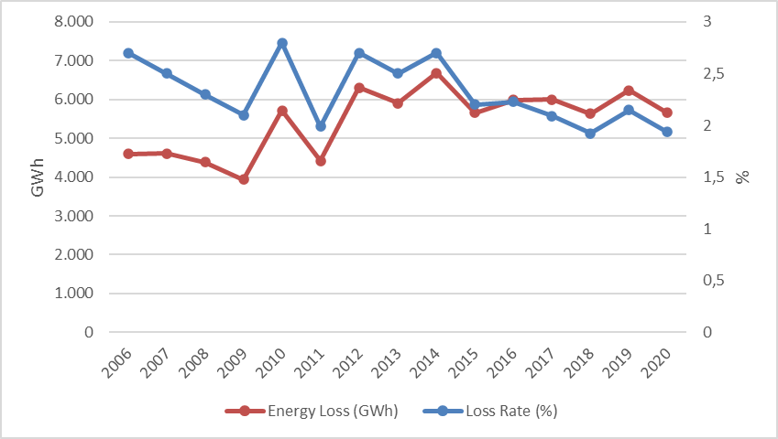
Figure 4.4: Transmission System Losses by Hour (%)
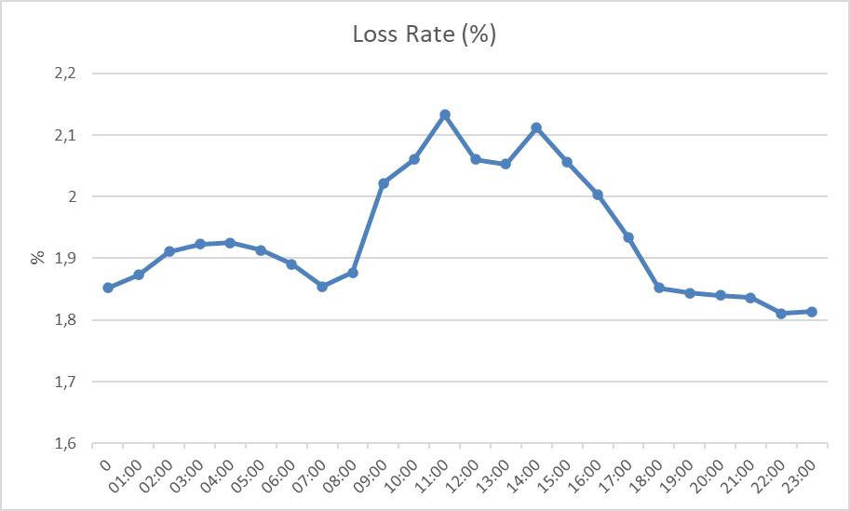
Considering the development of transmission system loss according to hours, it is seen that the highest loss rate is at 11:00.
- DISTRIBUTION

  - Number of Consumers

The total number of consumers using the distribution system increased by 2,50% compared to previous year and it reached 46.081.856 in 2020.

Table 5.1: Number of Consumers Using Distribution System by the end of 2020 (Number-%)
Distribution Company | Number of Consumers |  |  | Change  2019-2020 (%)
Distribution Company | 2018 | 2019 | 2020 | Change  2019-2020 (%)
BOĞAZİÇİ | 5.029.273 | 5.134.980 | 5.206.237 | 1,39
BAŞKENT | 4.199.135 | 4.278.785 | 4.364.492 | 2,00
TOROSLAR | 3.877.734 | 3.997.925 | 4.095.347 | 2,44
GDZ | 3.312.515 | 3.421.183 | 3.524.199 | 3,01
ULUDAĞ | 3.189.831 | 3.285.323 | 3.380.111 | 2,89
İ.ANADOLU | 2.854.123 | 2.928.586 | 2.986.337 | 1,97
AKDENİZ | 2.163.700 | 2.220.744 | 2.261.116 | 1,82
MERAM | 2.094.254 | 2.169.733 | 2.227.181 | 2,65
YEŞİLIRMAK | 2.073.523 | 2.147.103 | 2.206.997 | 2,79
ADM | 1.902.358 | 1.966.146 | 2.021.409 | 2,81
DİCLE | 1.838.929 | 1.934.641 | 1.993.050 | 3,02
SAKARYA | 1.831.677 | 1.905.188 | 1.963.823 | 3,08
OSMANGAZİ | 1.786.452 | 1.839.538 | 1.888.406 | 2,66
ÇORUH | 1.359.781 | 1.389.748 | 1.431.106 | 2,98
TRAKYA | 1.089.247 | 1.125.936 | 1.168.941 | 3,82
ARAS | 1.002.743 | 1.029.869 | 1.059.704 | 2,90
ÇAMLIBEL | 974.544 | 1.005.503 | 1.017.033 | 1,15
FIRAT | 957.081 | 977.424 | 1.012.087 | 3,55
KAYSERİ VE CİVARI | 718.723 | 748.858 | 770.120 | 2,84
AKEDAŞ | 713.348 | 740.416 | 758.175 | 2,40
VANGÖLÜ | 684.366 | 710.697 | 745.985 | 4,97
Grand Total | 43.653.337 | 44.958.326 | 46.081.856 | 2,50

When Table 5.1 is considered, it is seen that the distribution regions with the highest number of consumers are Boğaziçi with 5.20 million, Başkent with 4.36 million and Toroslar with 4.09 million.
Figure 5.1 shows the number of consumers connected to distribution network and the total consumption of these consumers in 2020.

Figure 5.1: Number of Consumers and Consumption Amounts (Number - MWh)
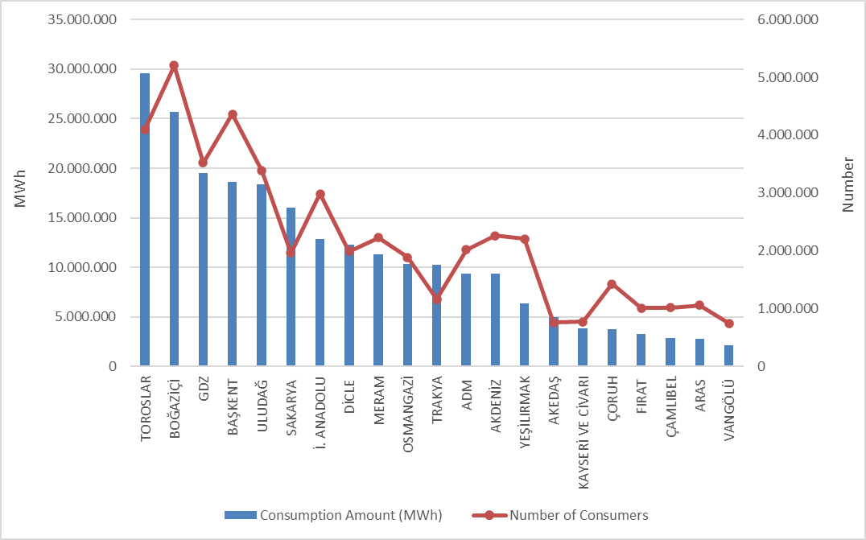

  - Ratio of Losses

The targeted and actual loss values on the basis of the distribution company is shown in Table 5.2.

Table 5.2: Loss Rates of Distribution Companies (%)
Distribution Company | ACTUAL LOSS RATE |  |  | TARGET LOSS RATE | DIFFERENCE BETWEEN TARGET AND ACTUAL LOSS RATES
Distribution Company | 2019 | 2020 | 2019-2020  Change | 2020 | 2020
DİCLE | 51,32% | 46,32% | 5,00% | 60,45% | 14,13%
VANGÖLÜ | 47,56% | 44,57% | 2,99% | 51,42% | 6,85%
ARAS | 21,64% | 20,56% | 1,08% | 23,89% | 3,33%
AYEDAŞ | 5,05% | 5,40% | -0,35% | 7,15% | 1,75%
SAKARYA | 5,96% | 5,93% | 0,03% | 7,25% | 1,32%
MERAM | 6,22% | 6,05% | 0,17% | 7,19% | 1,15%
GDZ | 7,55% | 6,43% | 1,12% | 7,53% | 1,10%
KAYSERİ | 6,02% | 6,08% | -0,06% | 7,15% | 1,07%
AKEDAŞ | 6,46% | 6,10% | 0,36% | 7,12% | 1,02%
BAŞKENT | 5,89% | 6,18% | -0,29% | 7,18% | 1,01%
TRAKYA | 4,50% | 5,58% | -1,08% | 6,49% | 0,91%
ÇORUH | 7,38% | 7,33% | 0,05% | 8,22% | 0,89%
OSMANGAZİ | 6,61% | 6,54% | 0,07% | 7,20% | 0,66%
FIRAT | 9,93% | 9,81% | 0,11% | 10,42% | 0,61%
YEŞİLIRMAK | 7,13% | 7,28% | -0,15% | 7,88% | 0,59%
ADM | 5,63% | 6,18% | -0,55% | 6,75% | 0,58%
ULUDAĞ | 4,82% | 5,86% | -1,04% | 6,30% | 0,44%
TOROSLAR | 11,76% | 11,37% | 0,39% | 11,54% | 0,17%
BOĞAZİÇİ | 7,96% | 7,64% | 0,32% | 7,80% | 0,16%
AKDENİZ | 5,91% | 7,08% | -1,18% | 7,10% | 0,02%
ÇAMLIBEL | 4,75% | 7,57% | -2,82% | 6,95% | -0,62%

When Table 5.2 is analyzed; all distribution companies except Çamlıbel achieved the targeted loss rate for 2020 and it is seen that the distribution companies performed successfully in 2020 in terms of loss targets. Considering to the aim, the highest development occurred in Dicle (%14,13), Vangölü (%6,85) and Aras (%3,33) distribution regions.
In addition, as shown in Table 5.2, in 2020, the highest loss rates were in Dicle (%46,32), Vangölü (%44,57) and Aras (%20,56) regions as it was in 2019.
In the figure below, the actual and targeted loss rates are shown together.

Figure 5.2: Actual and Targeted Loss Rates in 2020 (%)
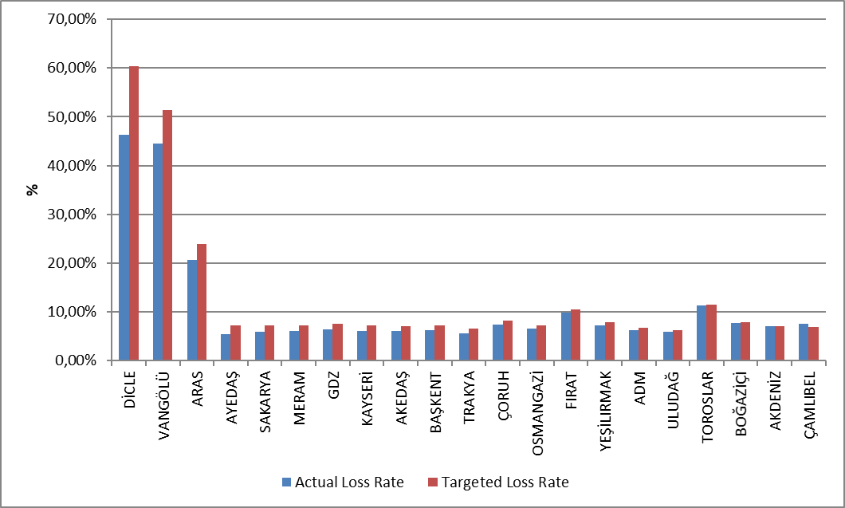

5.3 Employment

By the end of 2020, 57.624 people are employed in the electricity distribution sector; 24.099 people work as distribution company staff, 33.525 people work as subcontractor staff. The table below shows the number of employees by distribution companies. While Dicle EDAŞ had the highest number of employees with a total of 6.777 098 employees, the distribution company with the highest number of permanent staff was Toroslar EDAŞ with 3.846 personnel, and the region with the highest number of subcontractors was Boğaziçi EDAŞ with 3.804 personnel. Kayseri EDAŞ, on the other hand, became the distribution company with the lowest number of employees with 911 personnel.

Table 5.3: Number of Employees of Distribution Companies
Distribution Company | Number of Permanent Employees | Number of Subcontractor Employees | Total
DİCLE ELEKTRİK DAĞITIM ANONİM ŞİRKETİ | 3.010 | 3.767 | 6.777
TOROSLAR ELEKTRİK DAĞITIM ANONİM ŞİRKETİ | 3.846 | 2.121 | 5.967
BAŞKENT ELEKTRİK DAĞITIM ANONİM ŞİRKETİ | 3.681 | 1.839 | 5.520
BOĞAZİÇİ ELEKTRİK DAĞITIM ANONİM ŞİRKETİ | 703 | 3.804 | 4.507
GDZ ELEKTRİK DAĞITIM ANONİM ŞİRKETİ | 806 | 2.912 | 3.718
İSTANBUL ANADOLU YAKASI ELEKTRİK DAĞITIM A.Ş. | 1.887 | 982 | 2.869
ULUDAĞ ELEKTRİK DAĞITIM ANONİM ŞİRKETİ | 452 | 2.287 | 2.739
ADM ELEKTRİK DAĞITIM ANONİM ŞİRKETİ | 616 | 1.931 | 2.547
MERAM ELEKTRİK DAĞITIM ANONİM ŞİRKETİ | 728 | 1.643 | 2.371
VANGÖLÜ ELEKTRİK DAĞITIM ANONİM ŞİRKETİ | 957 | 1.227 | 2.184
SAKARYA ELEKTRİK DAĞITIM ANONİM ŞİRKETİ | 1.592 | 589 | 2.181
AKDENİZ ELEKTRİK DAĞITIM ANONİM ŞİRKETİ | 257 | 1.885 | 2.142
ÇORUH ELEKTRİK DAĞITIM ANONİM ŞİRKETİ | 330 | 1.807 | 2.137
YEŞİLIRMAK ELEKTRİK DAĞITIM ANONİM ŞİRKETİ | 588 | 1.440 | 2.028
FIRAT ELEKTRİK DAĞITIM ANONİM ŞİRKETİ | 285 | 1.668 | 1.953
ARAS ELEKTRİK DAĞITIM ANONİM ŞİRKETİ | 524 | 1.305 | 1.829
OSMANGAZİ ELEKTRİK DAĞITIM ANONİM ŞİRKETİ | 1.252 | 498 | 1.750
ÇAMLIBEL ELEKTRİK DAĞITIM ANONİM ŞİRKETİ | 212 | 1.077 | 1.289
AKEDAŞ ELEKTRİK DAĞITIM ANONİM ŞİRKETİ | 858 | 273 | 1.131
TRAKYA ELEKTRİK DAĞITIM ANONİM ŞİRKETİ | 798 | 276 | 1.074
KAYSERİ VE CİVARI ELEKTRİK TÜRK ANONİM ŞİRKETİ | 717 | 194 | 911
Grand Total | 24.099 | 33.525 | 57.624

Figure 5.3: Number of Employees of Distribution Companies by the end of 2020 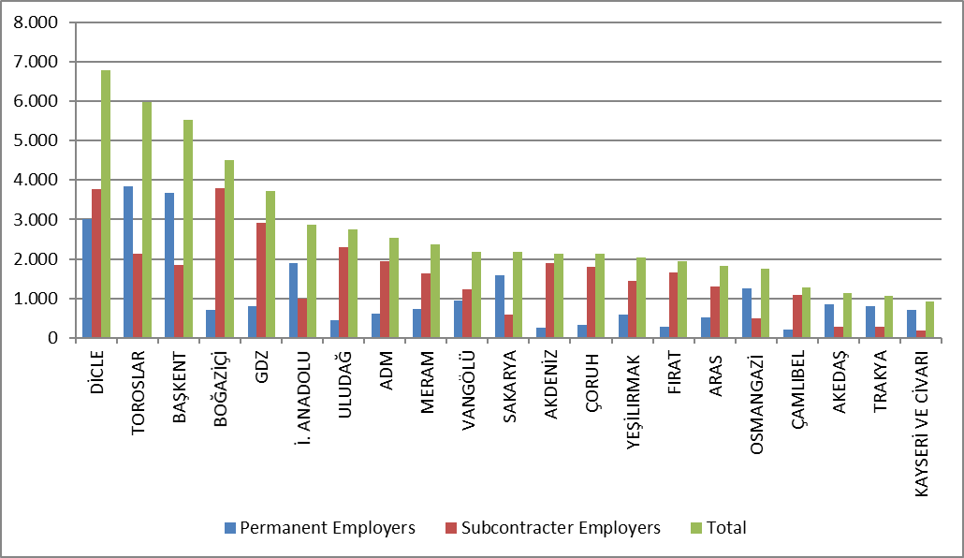

5.4 Information about Network

This section includes basic data on the distribution system. In this context, information about line lengths, transformer capacities and transformer numbers in the distribution voltage level is included in the following tables and figures.
As it is known, the electricity network has reached the whole of Turkey, with exceptions. Except for the industrial facilities with high consumption, all small and medium-sized consumers obtain electrical energy through the distribution system. As it shown in Table 5.4, total distribution line length of Turkey has reached 1.204.979 km. Considering the line lengths by distribution regions, Başkent, Toroslar, Meram, Yeşilırmak and Dicle distribution regions constitute the first five regions in terms of distribution line length. It is also seen from this order that there is a correct ratio between the distribution line lengths and the width of the distribution region and the distribution network.
On the other hand, considering the distribution regions in terms of transformer capacity, it is seen that the Boğaziçi, Toroslar, Başkent, Gdz and Dicle electricity distribution regions are in the top five.

Table 5.4: Line Lengths, Number of Transformers and Transformer Capacities Based on Distribution Companies at the end of 2020 (km-MVA-Number)
Distribution Company | Line Length (km) | Transformer Capacity (MVA) | Number of Transformers
ADM | 70.636 | 8.369 | 22.017
AKDENİZ | 68.531 | 8.098 | 19.993
AKEDAŞ | 26.825 | 3.681 | 12.572
ARAS | 57.674 | 3.016 | 13.764
BAŞKENT | 115.723 | 16.130 | 34.396
BOĞAZİÇİ | 50.650 | 18.432 | 15.057
ÇAMLIBEL | 48.317 | 2.792 | 12.903
ÇORUH | 59.707 | 3.400 | 12.711
DİCLE | 78.003 | 14.081 | 67.761
FIRAT | 44.806 | 3.151 | 13.069
GDZ | 59.398 | 15.555 | 33.974
İST. ANATOLIAN | 25.230 | 8.954 | 7.827
KAYSERİ VE CİVARI | 26.009 | 2.688 | 8.136
MERAM | 91.830 | 12.406 | 59.019
OSMANGAZİ | 50.787 | 7.855 | 26.955
SAKARYA | 37.916 | 8.188 | 17.505
TOROSLAR | 95.111 | 16.432 | 48.606
TRAKYA | 29.104 | 5.398 | 11.710
ULUDAĞ | 51.551 | 10.734 | 26.754
VANGÖLÜ | 31.155 | 2.819 | 12.275
YEŞİLIRMAK | 86.018 | 4.922 | 22.732
Grand Total | 1.204.979 | 177.102 | 499.736

Figure 5.4: Line Lengths and Transformer Capacities on the Basis of Distribution Companies at the end of 2020 (km-MVA)
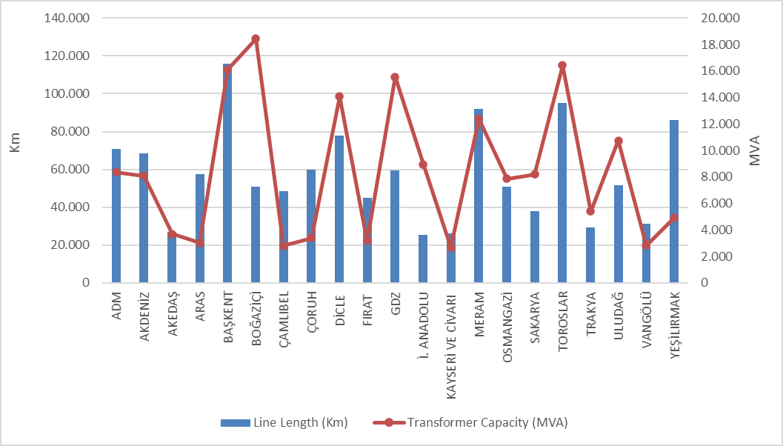
The lengths of distribution lines can be seen in Table 5.5. As shown in the table, overhead lines are 80,28% of the total distribution lines. The share of underground lines within the total distribution lines is 19,72%. This shows that the distribution lines are vulnerable to external conditions. The mentioned external conditions may be natural disasters, climate, or human. In particular, natural events such as heavy rains and heavy winds can directly or indirectly cause damage to the distribution lines.

Table 5.5: The Lengths of Distribution Lines (km)
 | Overhead (km) | Underground (km) | Total (km)
ADM | 60.302 | 10.334 | 70.636
AKDENİZ | 52.142 | 16.389 | 68.531
AKEDAŞ | 23.727 | 3.097 | 26.825
ARAS | 49.950 | 7.724 | 57.674
BAŞKENT | 91.943 | 23.780 | 115.723
BOĞAZİÇİ | 14.100 | 36.550 | 50.650
ÇAMLIBEL | 41.813 | 6.505 | 48.317
ÇORUH | 54.952 | 4.754 | 59.707
DİCLE | 67.244 | 10.759 | 78.003
FIRAT | 39.298 | 5.508 | 44.806
GDZ | 47.030 | 12.368 | 59.398
İST. ANATOLIAN | 5.531 | 19.699 | 25.230
KAYSERİ VE CİVARI | 19.223 | 6.786 | 26.009
MERAM | 82.128 | 9.702 | 91.830
OSMANGAZİ | 42.519 | 8.268 | 50.787
SAKARYA | 31.380 | 6.536 | 37.916
TOROSLAR | 80.677 | 14.434 | 95.111
TRAKYA | 23.828 | 5.276 | 29.104
ULUDAĞ | 39.017 | 12.534 | 51.551
VANGÖLÜ | 28.985 | 2.169 | 31.155
YEŞİLIRMAK | 71.588 | 14.430 | 86.018
Grand Total | 967.378 | 237.601 | 1.204.979

figure 5.5: The Length of Lines on the Basis of Distribution Companies at the end of 2020 (km)
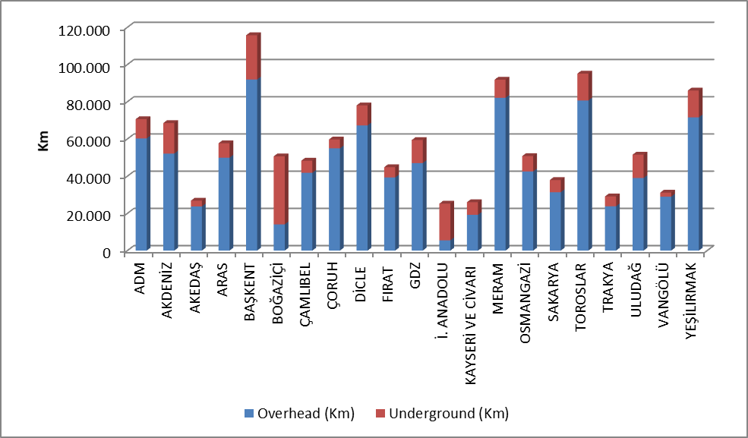

As shown in the figure above, the share of underground line lengths in Boğaziçi and İstanbul Anatolian Side regions where the population is dense, is higher than the share of overhead lines.
Table 5.6 shows the distribution line lengths and transformer capacities by provinces. According to the table, the first five provinces in the distribution line length ranking; İstanbul, Ankara, Konya, Antalya and İzmir.
Considering the transformer capacities in the distribution system of the provinces, the first five provinces in terms of transformer capacity; İstanbul, Ankara, İzmir, Konya and Antalya.
Considering the number of transformers in the distribution system of the provinces, the first five provinces in terms of the number of transformers; Konya, Şanlıurfa, İstanbul, İzmir and Ankara.

Table 5.6: Line Lengths at Distribution Voltage Levels, Number of Transformers and Transformer Capacities by Provinces at the end of 2020 (km-MVA-Number)
Provinces | Line Length (km) | Transformer Capacity (MVA) | Transformer Number
ADANA | 28.743 | 4.624 | 12.653
ADIYAMAN | 8.920 | 1.074 | 5.219
AFYONKARAHİSAR | 15.675 | 2.269 | 10.627
AĞRI | 10.628 | 521 | 2.783
AKSARAY | 10.807 | 1.255 | 7.121
AMASYA | 8.300 | 596 | 2.971
ANKARA | 62.722 | 12.048 | 19.570
ANTALYA | 48.085 | 6.224 | 13.843
ARDAHAN | 4.503 | 153 | 917
ARTVİN | 7.049 | 414 | 1.758
AYDIN | 21.487 | 2.742 | 7.086
BALIKESİR | 18.742 | 3.052 | 8.331
BARTIN | 4.242 | 438 | 1.444
BATMAN | 6.235 | 1.052 | 3.918
BAYBURT | 3.337 | 170 | 678
BİLECİK | 4.402 | 988 | 2.060
BİNGÖL | 6.888 | 446 | 1.959
BİTLİS | 5.907 | 563 | 2.941
BOLU | 7.141 | 724 | 2.793
BURDUR | 9.599 | 754 | 3.014
BURSA | 19.867 | 5.668 | 12.162
ÇANAKKALE | 10.229 | 1.365 | 5.013
ÇANKIRI | 6.712 | 515 | 1.952
ÇORUM | 15.178 | 964 | 4.856
DENİZLİ | 22.087 | 2.491 | 6.643
DİYARBAKIR | 19.470 | 3.560 | 13.530
DÜZCE | 5.748 | 755 | 2.096
EDİRNE | 9.192 | 1.079 | 4.077
ELAZIĞ | 13.711 | 1.164 | 4.259
ERZİNCAN | 8.983 | 402 | 2.039
ERZURUM | 18.091 | 1.152 | 4.601
ESKİŞEHİR | 13.402 | 2.596 | 8.152
GAZİANTEP | 15.815 | 2.928 | 11.133
GİRESUN | 15.878 | 706 | 3.156
GÜMÜŞHANE | 6.240 | 319 | 1.308
HAKKARİ | 4.094 | 350 | 1.700
HATAY | 19.027 | 3.877 | 11.114
IĞDIR | 4.829 | 241 | 1.107
ISPARTA | 10.847 | 1.120 | 3.136
İSTANBUL | 75.880 | 27.386 | 22.884
İZMİR | 36.661 | 11.878 | 21.030
KAHRAMANMARAŞ | 17.905 | 2.608 | 7.353
KARABÜK | 4.628 | 638 | 1.706
KARAMAN | 7.234 | 825 | 4.424
KARS | 7.303 | 376 | 1.639
KASTAMONU | 13.567 | 862 | 4.620
KAYSERİ | 26.009 | 2.688 | 8.136
KIRIKKALE | 11.576 | 525 | 1.595
KIRKLARELİ | 6.995 | 1.041 | 2.470
KIRŞEHİR | 6.053 | 538 | 2.269
KİLİS | 2.291 | 265 | 1.106
KOCAELİ | 12.358 | 4.711 | 7.571
KONYA | 49.282 | 7.093 | 32.662
KÜTAHYA | 9.756 | 1.174 | 3.461
MALATYA | 19.794 | 1.360 | 5.600
MANİSA | 22.736 | 3.677 | 12.944
MARDİN | 11.882 | 2.447 | 12.091
MERSİN | 21.998 | 3.992 | 10.150
MUĞLA | 27.062 | 3.136 | 8.288
MUŞ | 6.997 | 512 | 2.301
NEVŞEHİR | 8.784 | 1.386 | 6.558
NİĞDE | 9.669 | 1.308 | 5.985
ORDU | 25.042 | 931 | 4.872
OSMANİYE | 7.237 | 746 | 2.450
RİZE | 9.687 | 667 | 2.381
SAKARYA | 12.668 | 1.997 | 5.045
SAMSUN | 29.253 | 2.054 | 7.796
SİİRT | 4.261 | 419 | 1.722
SİNOP | 8.245 | 377 | 2.237
SİVAS | 20.128 | 1.166 | 5.041
ŞANLIURFA | 31.092 | 5.637 | 32.591
ŞIRNAK | 5.063 | 965 | 3.909
TEKİRDAĞ | 12.917 | 3.279 | 5.163
TOKAT | 14.245 | 776 | 3.402
TRABZON | 20.852 | 1.294 | 4.108
TUNCELİ | 4.413 | 180 | 1.251
UŞAK | 7.552 | 827 | 2.655
VAN | 14.157 | 1.394 | 5.333
YALOVA | 2.713 | 649 | 1.248
YOZGAT | 13.944 | 850 | 4.460
ZONGULDAK | 12.276 | 1.104 | 3.509
Grand Total | 1.204.979 | 177.102 | 499.736

5.5 Quality Indicators

Data on the technical quality of the electricity provided by the distribution companies are compiled and the tables below show System Average Interruption Duration Index (SAIDI) and System Average Interruption Frequency Index (SAIFI).

Table 5.7: Reported and Unreported System Average Interruption Duration Indices of Distribution Companies in 2019-2020 (min)
DISTRIBUTION COMPANY | 2019 |  |  | 2020 |  |  | Change  (%)
DISTRIBUTION COMPANY | Reported SAIDI  (min) | Unreported SAIDI  (min) | Total SAIDI  (min) | Reported  SAIDI (min) | Unreported  SAIDI  (min) | Total  SAIDI  (min) | Change  (%)
VANGÖLÜ | 367,5 | 2.553,4 | 2.920,9 | 572,2 | 3.905,8 | 4.478,0 | 53,31
TOROSLAR | 916,9 | 2.816,3 | 3.733,2 | 1.007,8 | 2.842,8 | 3.850,6 | 3,14
DİCLE | 507,0 | 1.469,1 | 1.976,1 | 873,9 | 1.952,3 | 2.826,2 | 43,02
ÇORUH | 622,0 | 1.390,1 | 2.012,1 | 514,7 | 1.583,2 | 2.097,8 | 4,26
ÇAMLIBEL | 462,7 | 713,9 | 1.176,6 | 515,6 | 1.365,9 | 1.881,5 | 59,91
BAŞKENT | 523,8 | 1.681,3 | 2.205,1 | 520,1 | 1.295,4 | 1.815,5 | -17,67
OSMANGAZİ | 598,3 | 1.702,2 | 2.300,5 | 497,8 | 1.285,2 | 1.783,0 | -22,50
MERAM | 722,4 | 1.030,7 | 1.753,0 | 683,7 | 1.005,6 | 1.689,3 | -3,63
SAKARYA | 420,3 | 1.204,3 | 1.624,7 | 372,6 | 1.295,4 | 1.668,0 | 2,67
AKDENİZ | 398,3 | 1.146,8 | 1.545,2 | 668,7 | 924,0 | 1.592,7 | 3,08
FIRAT | 317,4 | 1.366,9 | 1.684,2 | 435,9 | 1.102,8 | 1.538,7 | -8,64
ARAS | 442,0 | 1.815,9 | 2.257,9 | 621,9 | 871,8 | 1.493,7 | -33,85
YEŞİLIRMAK | 395,0 | 1.222,3 | 1.617,3 | 425,8 | 851,3 | 1.277,1 | -21,03
TRAKYA | 824,0 | 862,0 | 1.686,0 | 439,8 | 793,8 | 1.233,6 | -26,84
GDZ | 523,5 | 926,7 | 1.450,2 | 557,9 | 650,9 | 1.208,8 | -16,64
AKEDAŞ | 288,7 | 1.117,3 | 1.406,0 | 253,7 | 833,9 | 1.087,6 | -22,65
ADM | 231,7 | 826,8 | 1.058,5 | 417,2 | 662,0 | 1.079,1 | 1,95
BOĞAZİÇİ | 271,0 | 1.457,4 | 1.728,4 | 215,5 | 829,9 | 1.045,4 | -39,52
ULUDAĞ | 365,7 | 507,4 | 873,0 | 295,7 | 429,4 | 725,1 | -16,94
KAYSERİ VE CİVARI | 169,4 | 494,1 | 663,5 | 174,1 | 503,6 | 677,8 | 2,15
İSTANBUL AN. YK. | 278,7 | 468,4 | 747,1 | 168,3 | 354,0 | 522,3 | -30,09

The table above shows the reported, unreported, and total System Average Interruption Duration Index in 2019 and 2020. While the first three regions were Toroslar, Dicle and Meram regions according to reported interruptions; Van Gölü, Toroslar and Dicle regions were the first three regarding unreported interruptions.
The region with the highest average total interruption period was Van Gölü with 4.478,0 minutes and Toroslar distribution region took the second place with 3.850,6 minutes.

Table 5.8: System Average Interruption Duration Indices of Distribution Companies by Reason in 2020 (min)
DISTRIBUTION COMPANY | External | Security | Force Major | Network Operator | Total
VANGÖLÜ | 1,8 | 0,7 |  | 4.475,5 | 4.478,0
TOROSLAR | 45,0 | 92,0 |  | 3.713,6 | 3.850,6
DİCLE | 33,8 | 19,9 |  | 2.772,5 | 2.826,2
ÇORUH | 30,6 | 197,4 | 198,9 | 1.671,0 | 2.097,8
ÇAMLIBEL | 45,0 | 3,8 |  | 1.832,7 | 1.881,5
BAŞKENT | 17,4 | 26,1 |  | 1.772,0 | 1.815,5
OSMANGAZİ | 14,2 | 0,5 | 1,9 | 1.766,3 | 1.783,0
MERAM | 100,7 | 35,3 | 22,3 | 1.531,1 | 1.689,3
SAKARYA | 37,2 | 24,7 |  | 1.606,1 | 1.668,0
AKDENİZ | 65,9 | 218,4 | 9,8 | 1.298,6 | 1.592,7
FIRAT | 32,3 | 14,2 | 197,0 | 1.295,2 | 1.538,7
ARAS | 0,1 | 0,7 | 0,5 | 1.492,3 | 1.493,7
YEŞİLIRMAK | 23,6 | 3,6 | 2,3 | 1.247,7 | 1.277,1
TRAKYA | 11,7 |  |  | 1.221,9 | 1.233,6
GDZ | 23,6 | 27,9 |  | 1.157,3 | 1.208,8
AKEDAŞ | 14,4 | 9,0 |  | 1.064,3 | 1.087,6
ADM | 17,1 | 8,3 |  | 1.053,8 | 1.079,1
BOĞAZİÇİ | 58,2 | 2,4 |  | 984,8 | 1.045,4
ULUDAĞ | 22,8 | 6,1 |  | 696,3 | 725,1
KAYSERİ VE CİVARI | 18,1 | 5,6 |  | 654,0 | 677,8
İSTANBUL AN. YK. | 7,3 | 4,3 |  | 510,7 | 522,3

The table above shows the distribution of the average downtime by reason. It is seen that the highest downtime is due to the network operator.
The following table shows the average interruption frequency of distribution companies. The highest customer average interruption duration was 115,9 Number/Year per customer in Van Gölü region, followed by the Dicle region with 57,5 Number/Year.

Table 5.9: System Average Interruption Frequency Indices of Distribution Companies in 2019 and 2020 (Number/Year)
DISTRIBUTION | 2019 |  |  |  | 2020 |  |  |  | Change (%)
DISTRIBUTION | Reported | Unreported | Short | Total | Reported | Unreported | Short | Total | Change (%)
VANGÖLÜ | 0,9 | 20,2 | 27,1 | 48,2 | 2,3 | 76,5 | 37,1 | 115,9 | 140,50
DİCLE | 3,5 | 34,5 | 16,9 | 54,8 | 7,2 | 41,7 | 8,6 | 57,5 | 4,89
OSMANGAZİ | 2,1 | 21,0 | 6,1 | 29,2 | 1,9 | 25,0 | 19,1 | 46,1 | 57,90
ÇAMLIBEL | 1,6 | 9,6 | 0,8 | 12,0 | 2,6 | 18,6 | 23,3 | 44,4 | 270,40
FIRAT | 2,4 | 18,2 | 1,1 | 21,7 | 3,6 | 27,4 | 9,8 | 40,8 | 88,13
SAKARYA | 2,3 | 30,7 | 3,7 | 36,7 | 1,9 | 30,9 | 5,1 | 37,9 | 3,30
TOROSLAR | 2,7 | 24,4 | 0,9 | 28,0 | 3,0 | 30,5 | 2,0 | 35,5 | 26,84
ÇORUH | 2,5 | 17,4 | 1,3 | 21,2 | 3,1 | 28,4 | 2,2 | 33,6 | 58,72
AKEDAŞ | 2,1 | 20,0 | 6,8 | 28,9 | 1,1 | 20,7 | 10,2 | 31,9 | 10,20
KAYSERİ VE C. | 1,2 | 11,4 | 10,1 | 22,7 | 1,1 | 15,6 | 12,2 | 28,9 | 27,15
AKDENİZ | 1,4 | 21,6 | 3,7 | 26,7 | 5,3 | 13,0 | 5,8 | 24,1 | -9,63
BOĞAZİÇİ | 1,6 | 17,7 | 6,8 | 26,1 | 1,4 | 14,2 | 6,8 | 22,4 | -14,24
YEŞİLIRMAK | 1,6 | 14,2 | 2,2 | 18,1 | 2,0 | 12,8 | 7,6 | 22,3 | 23,42
BAŞKENT | 1,6 | 21,8 | 2,2 | 25,6 | 1,5 | 17,5 | 1,7 | 20,7 | -18,98
ADM | 1,0 | 15,9 | 1,1 | 18,0 | 1,7 | 13,3 | 2,6 | 17,5 | -2,53
ARAS | 1,2 | 18,4 | 0,2 | 19,8 | 2,1 | 11,0 | 4,1 | 17,2 | -12,93
GDZ | 3,0 | 12,6 | 0,5 | 16,1 | 3,7 | 12,0 | 1,5 | 17,2 | 6,89
MERAM | 4,4 | 11,6 | 0,0 | 16,0 | 4,4 | 12,4 | 0,1 | 17,0 | 6,27
TRAKYA | 2,8 | 13,2 | 3,1 | 19,1 | 1,7 | 9,8 | 2,2 | 13,8 | -27,62
ULUDAĞ | 2,3 | 8,3 | 3,0 | 13,6 | 2,6 | 8,1 | 2,4 | 13,0 | -4,29
İSTANBUL AN. Y. | 1,1 | 9,6 | 0,5 | 11,2 | 0,7 | 6,7 | 0,4 | 7,8 | -30,13

Table 5.10: Distribution Companies’ System Average Interruption Frequency Indices of Distribution Companies by Reason in 2019 (Number/Year)
DISTRIBUTION COMPANY | External | Security | Short | Major Force | Network Operator | Total
VANGÖLÜ | 0,0 | 0,0 | 37,1 | 0,0 | 78,8 | 115,9
DİCLE | 0,4 | 0,3 | 8,6 | 0,0 | 48,3 | 57,5
OSMANGAZİ | 0,2 | 0,0 | 19,1 | 0,0 | 26,7 | 46,1
ÇAMLIBEL | 0,5 | 0,0 | 23,3 | 0,0 | 20,6 | 44,4
FIRAT | 0,4 | 0,2 | 9,8 | 3,4 | 27,0 | 40,8
SAKARYA | 0,7 | 0,1 | 5,1 | 0,0 | 32,0 | 37,9
TOROSLAR | 0,2 | 0,3 | 2,0 | 0,0 | 33,0 | 35,5
ÇORUH | 0,4 | 1,5 | 2,2 | 1,3 | 28,4 | 33,6
AKEDAŞ | 0,4 | 0,0 | 10,2 | 0,0 | 21,3 | 31,9
KAYSERİ VE CİVARI | 0,2 | 0,0 | 12,2 | 0,0 | 16,4 | 28,9
AKDENİZ | 1,0 | 1,3 | 5,8 | 0,1 | 16,0 | 24,1
BOĞAZİÇİ | 0,8 | 0,0 | 6,8 | 0,0 | 14,8 | 22,4
YEŞİLIRMAK | 0,2 | 0,0 | 7,6 | 0,0 | 14,5 | 22,3
BAŞKENT | 0,1 | 0,1 | 1,7 | 0,0 | 18,8 | 20,7
ADM | 0,2 | 0,1 | 2,6 | 0,0 | 14,6 | 17,5
ARAS | 0,0 | 0,0 | 4,1 | 0,0 | 13,1 | 17,2
GDZ | 0,4 | 0,1 | 1,5 | 0,0 | 15,3 | 17,2
MERAM | 1,7 | 0,5 | 0,1 | 0,1 | 14,5 | 17,0
TRAKYA | 0,1 | 0,0 | 2,2 | 0,0 | 11,5 | 13,8
ULUDAĞ | 0,3 | 0,1 | 2,4 | 0,0 | 10,3 | 13,0
İSTANBUL AND. YAK. | 0,1 | 0,0 | 0,4 | 0,0 | 7,3 | 7,8

5.6 Investment Amount of Distribution Companies

With the decision of the Board dated 24/11/2015 and numbered 5885/7, "Procedures and Principles Regarding Electricity Market Distribution System Investments" was approved and entered into force. The said Procedures and Principles were amended by Board Decisions dated 28/11/2016 and numbered 6623, dated 21/09/2017 and numbered 7296, 08/11/2018 and numbered 8168.
With the Board Decision No. 5875-9 dated 18/11/2015, electricity distribution companies will start on 01/01/2016. It was decided to determine the Real Reasonable Return Rate to be taken into consideration during the implementation period as 12,66% (real and before tax) and to apply the Adjusted Real Reasonable Return Rate as 11,91% (real and before tax).
Subsequently, with the Board Decision dated 7/12/2018 and numbered 7501-12 due to the changes in economic and financial parameters, the real reasonable rate of return will cover the years 2018-2020. It has been decided to apply as 13,61% (before real and tax).
With the Board Decision No. 5875-6 dated 18/11/2015, the redemption period that will be valid for the distribution companies and the third implementation period investments has been determined as 10 years.
The table below contains information on the actual investment amounts declared by the Distribution Companies.

Table 5.11: Comparison of Distribution Investment Amounts in 2019-2020 (Current Prices - Million TL-%)
Distribution Company | 2018 | 2019 | 2020 | Change  2019-2020 (%)
ADM | 212,6 | 382,4 | 265,3 | -30,62%
AKDENİZ | 181,2 | 277,1 | 345,5 | 24,69%
AKEDAŞ | 91,9 | 105,1 | 101,0 | -3,86%
ARAS | 162,1 | 154,2 | 208,4 | 35,14%
İSTANBUL A.Y. | 271,6 | 274,1 | 395,6 | 44,33%
BAŞKENT | 718,7 | 645,5 | 1.099,8 | 70,38%
BOĞAZİÇİ | 444,3 | 836,8 | 688,5 | -17,72%
ÇAMLIBEL | 129,5 | 141,6 | 167,6 | 18,42%
ÇORUH | 165 | 141,9 | 262,0 | 84,64%
DİCLE | 320,8 | 523,5 | 782,0 | 49,39%
FIRAT | 167,1 | 105,9 | 170,7 | 61,24%
GDZ | 294,2 | 569,1 | 519,5 | -8,73%
KAYSERİ | 178,2 | 135,6 | 199,4 | 47,05%
MERAM | 384,6 | 521,2 | 505,7 | -2,97%
OSMANGAZİ | 63,4 | 1.221,3 | 527,1 | -56,85%
SAKARYA | 175,5 | 135,3 | 197,0 | 45,67%
TOROSLAR | 853,8 | 669,7 | 1.001,1 | 49,48%
TRAKYA | 92,2 | 327,5 | 209,0 | -36,18%
ULUDAĞ | 313,5 | 165,2 | 452,3 | 173,85%
VANGÖLÜ | 141,8 | 139,0 | 340,1 | 144,65%
YEŞİLIRMAK | 318,6 | 166,3 | 367,2 | 120,87%
TOTAL | 5.680,60 | 7.638,1 | 8.804,9 | 15,28%
* The unit price is calculated according to the June CPI: 465,84
** Investments starting in the II. Implementation Period and complemented in the III. Implementation Period are included.
*** The table has been prepared based on the investment realization statements of the companies approved by the Board for the investment amounts in 2019.
****The table has been prepared based on the investment estimation statements submitted by the companies through the notification system for the investment amounts in 2020.

Total investment realization for 2020 increased by 15.28% compared to 2019 and reached TL 8.80 billion (at current prices). The highest investment expenditures for 2020 were realized in Başkent with 1.1 billion TL and Toroslar with 1.0 billion TL.

Figure 5.6: Investment Amounts of Distribution Companies in 2020 (Current Prices-Million TL)
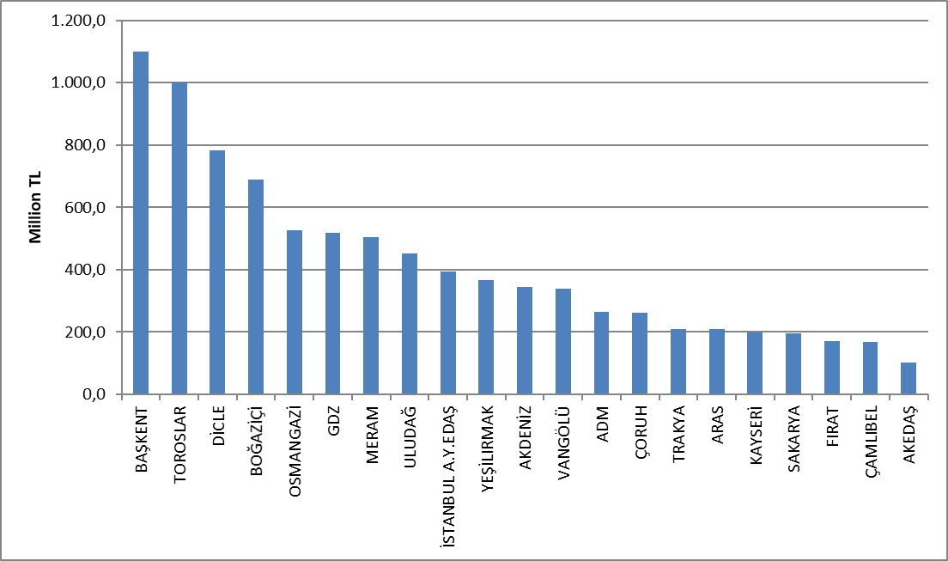

Investment expenditures by investment type in 2020 are shown in the table below. Majority of investments is the network investments.

Table 5.12: Realized Investment Amounts in 2020 by Investment Types (TL)
Distribution Company | Investment Type | 2020 Investment Amount (TL)  (CPI June 2020:65,84)
21 EDAŞ | Network Investments | 6.138.314.056
21 EDAŞ | Investments with Environmental, Security and Other Legal Obligations | 1.257.624.828
21 EDAŞ | Network Operating System Investments | 824.216.423
21 EDAŞ | Counter Investment | 290.551.121
21 EDAŞ | Other Expenditures as Investment Spending | 294.151.912
21 EDAŞ | Grand Total | 8.804.858.340
* The unit price is calculated according to the June CPI:465,84.
** Investments starting in the II. Implementation Period and complemented in the III. Implementation Period are included.

***The tables are prepared on the basis of the declarations made by the companies via the notification system.

5.7 Information about Organized Industrial Zones (OIZ)

The following table shows the data related to OIZ Distribution License Owners.

Table 5.13: Information about Organized Industrial Zones
Number of Participants AG | 49.188
Number of Participants OG | 14.253
Number of Total Participants | 63.441
Line Length AG | 3.854
Line Length OG | 8.306
Total Line Length | 12.160
Number of Employees (Electricity Distribution) | 914
Number of Transformers | 19.921
Installed Capacity of Transformers (MVA) | 19.383
Annual Peak Value of Previous Year (MW) | 6.783
As of the end of 2020, the total number of participants in Organized Industrial Zones was 63,441, of which 49,188 were in low voltage and 14,523 in medium voltage. 914 personnel are employed in electricity distribution in OIZ distribution regions.
Total OIZ line length was 12.160 km. Total OIZ Transformer capacity has reached 19.383 MVA with 19.921. The sum of the peak values for the previous year in the OIZ regions is 6.783 MW.

- PRICING

The Electricity Market Law foresee a market structure based on bilateral agreements. In this market the price of electricity determined by mutual agreement of buyers and sellers. Therefore, the prices determined by bilateral agreements are within the knowledge of relevant parties and are not shared with the public. On the other hand a significant portion of consumers provide energy from regulated price in Turkish Electricity Market. Therefore, yearly changes regulated prices and price components are very important. This section contains data on regulated prices and the changes in price components over the years.
In the Figure below, there is a change of retail energy tariffs (including system fees, tax and funds, including PSH) with respect to tariff groups by years.

Figure 6.1: Retail Price Excluding Taxes and Funds by Years (Energy+PSH) (kr/kWh)

As it is known, transmission and distribution lines must be used to deliver energy from power plants to the consumer. The figure below shows the change in the distribution price over the years. The price in question includes distribution, transmission, and technical and non-technical loss costs.

Figure 6.2: Change in Network Costs (Distribution, Transmission and Loss) by Years (kr/kWh)
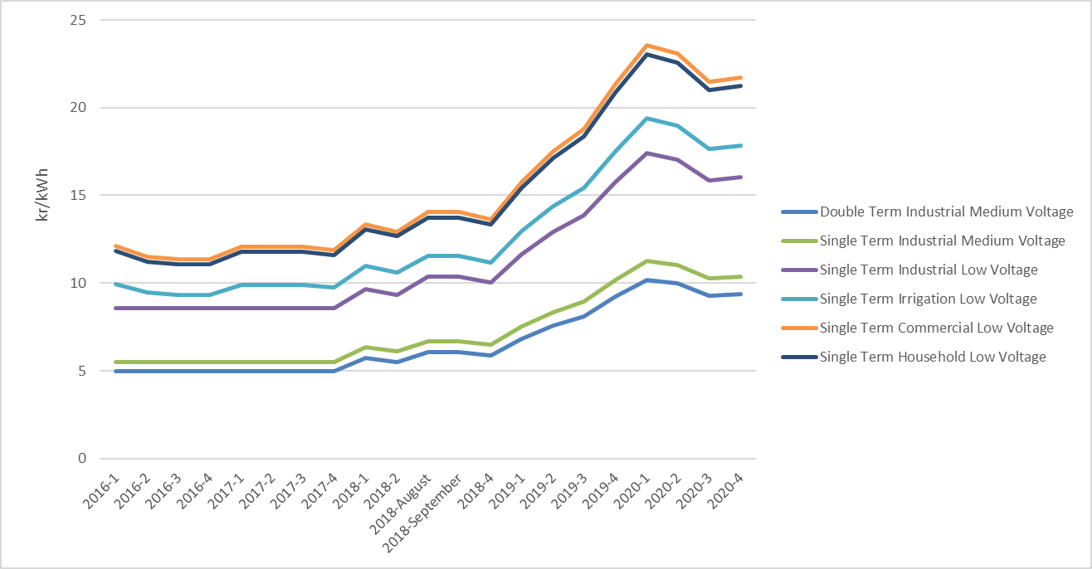
As a result of adding the distribution cost to the energy cost, the pre-tax unit energy cost is reached. The figure below shows the change in unit energy cost by years, excluding taxes and funds (energy fund, TRT share, electricity and gas consumption tax and VAT).

Figure 6.3: Change in Electricity Tariffs before Taxes and Funds by Years (kr/kWh)
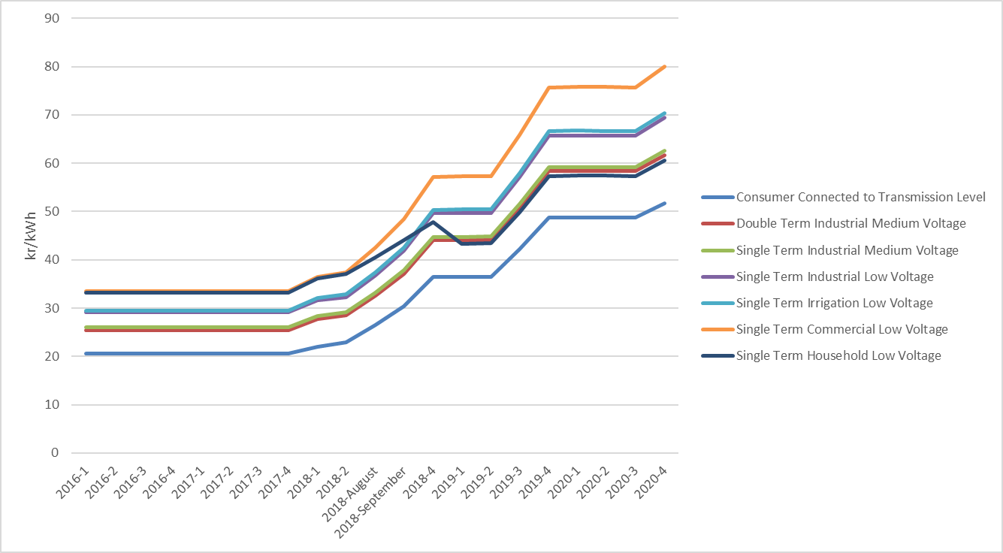
As seen in the figure above, the consumer group with the highest unit energy price before taxes and funds was commercials. The lowest unit energy price before taxes and funds was the consumers connected to the transmission system.

Figure 6.4: Share of Items on Household Electricity Invoice in 2020 (%)
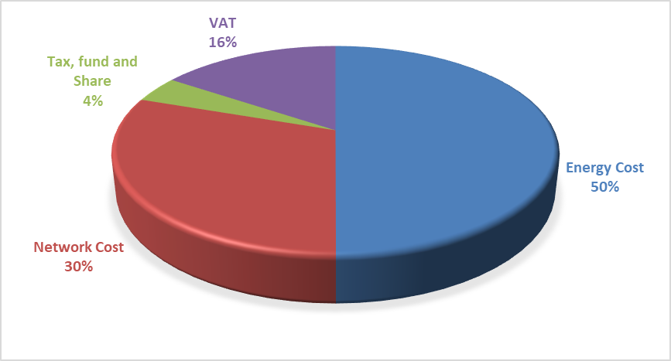

As can be seen from Figure 6.4, the most important item out of the retail energy amount is the network amount with 30% share from the components in the invoices of consumers in the residential group.

Figure 6.5: Share of Items on Industry Electricity Invoice in 2020 (%)
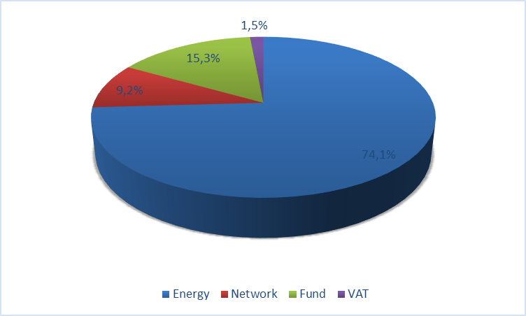
As Figure 6.5 and Figure 6.4 compared, industrial consumers have a higher share of retail energy amount and a lower share of distribution (network) in the invoice components of the industrial group compared to households.

Monthly average exchange rates of Central Bank is used for calculating the average YEKDEM Price.
The HHI values are evaluated as a competitive market indicator. If HHI is under 1000 the market is competitive, medium intensity if HHI is between 1000 -1800, and an oligopoly market if HHI is above 1800. In the same way, if the HHI increases by more than 100 points in mergers and acquisitions, it is considered that competitiveness is reduced.
Includes all sales made to eligible and non-eligible consumers for sales volumes of incumbent supply companies. Sales by production companies to eligible consumers are not included.
Including the data about facilities owned by customers.

