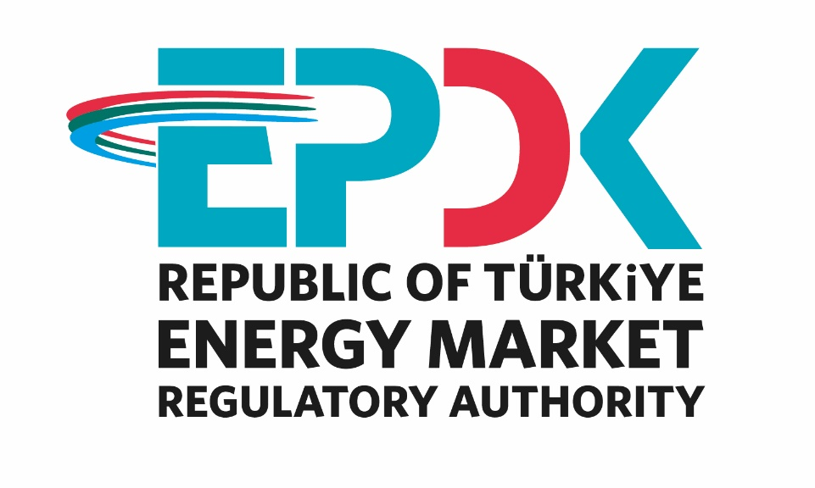

ELECTRICITY MARKET
SECTOR REPORT 2023

All the information, tables and figures provided in this report are reserved and cannot be used without reference.

REPUBLIC OF TÜRKİYE
ENERGY MARKET REGULATORY AUTHORITY

Strategy Development Department

ANKARA, 2024

Important Reminder: Licensee companies can make corrections to the data they previously submitted to the Authority by requesting a correction of the notification within the framework of the relevant provisions of the Energy Market Notification Regulation. For this reason, there may be data differences between the published reports.

*This report is published under the Official Statistics Programme.

The message of the president

Under the Electricity Market Law No. 6446, following a period in which secondary regulations were emphasized and efforts were made for many regulations and other legislation that entered into force, significant progress was made in 2023 to transform the market into a structure that operates in a more liberal, competitive, transparent and predictable manner in the light of these regulations.
In this context, the share of renewable energy sources in total installed electricity capacity, including unlicensed, increased from 53,95% in 2022 to 56,28% in 2023. In addition, electricity generation facilities with storage, which were included in our legislation in late 2022 and licensing procedures started in 2023, it is aimed to increase the installed capacity based on wind and solar energy and to expand the installation of electricity storage systems. In this context, pre-licenses for electricity generation facilities with storage were started to be granted during the capacity allocation process in 2023 and the pre-licensing process was largely completed in 2023.
On the other hand, within the scope of the aggregation activity, which was included in our legislation at the end of the previous year, it is aimed to contribute to demand side participation and meeting the flexibility needs of the system as a result of the aggregation and operation of the consumption or generation of grid users by aggregators, and secondary legislation studies on the subject were started in 2023. With the widespread use of electric vehicles, demand response will become even more important in terms of system balance.
In addition, both our nation and our sector showed a great example of solidarity following the disaster of the century, which took place on February 6, 2023 and plunged our country into mourning. In this context, our Authority had also endeavoured to ensure that the wounds are healed quickly and in cooperation by rapidly implementing all necessary decisions in the electricity market.
The market development reports that we present to our stakeholders are largely compiled and analyzed from the data submitted to our Authority using the Energy Market Notification System. One of our main objectives is to ensure the integrity, consistency and reliability of the data in these reports, which are of great importance to be shared with all relevant parties and the public in an accurate and timely manner. While underlining once again that we, as EMRA, are open to all kinds of constructive opinions and suggestions, I would like to thank all our sector stakeholders for their devoted work in the forward-looking development process of our country's energy market under all circumstances, and I hope that the 2023 Electricity Market Development Report will be beneficial to all relevant persons, institutions and organizations.

Mustafa YILMAZ
President

- EXECUTIVE SUMMARY

- Number of Licenses in Electricity Market in 2023
License Type | License Application | Grant of License | Expired License | License Revocation | Number of Licenses at Operation at the end of the Term
Distribution License | - | - | - | - | 21
Transmission License | - | - | - | - | 1
OIZ Distribution License | 7 | 8 | - | - | 204
OIZ Generation License | - | - | - | - | 3
Pre-License | 2.947 | 624 | 83 | - | 782
Market Operation License | - | - | - | - | 2
Charging Network Operator License | 63 | 93 | 2 |  | 168
Supply License | 41 | 39 | 3 | 3 | 344
Generation License | 39 | 56 | 51 | 1 | 1.892
Total | 3.097 | 820 | 139 | 4 | 3.417

- Distribution of Pre-License and Generation License by the end of 2023
Resource Type | Pre-License |  | Generation License
Resource Type | License Number | Installed Power Assigned to License (MWe) | License Number | Installed Power Assigned to License (MWe)
Hydraulic | 62 | 2.577,78 | 785 | 33.584,63
Wind | 259 | 17.320,94 | 290 | 14.302,88
Geothermal | 11 | 221,28 | 66 | 1.860,63
Biomass | 43 | 378,65 | 344 | 2.671,2
Solar | 402 | 14.454,21 | 39 | 1.668,81
Import Coal |  |  | 15 | 12.869,80
Domestic Coal |  |  | 22 | 10.143,37
Coal |  |  | 15 | 599,48
Fuel-oil |  |  | 21 | 991,51
Natural Gas | 1 | 2,00 | 261 | 26.737,84
Uranium |  |  | 1 | 4.800,00
Other Thermal | 4 | 21,98 | 36 | 889,307
Grand Total | 782 | 34.976,84 | 1.895 | 111.119,45

Installed Capacity and Production by Resources by the end of 2023
RESOURCE TYPE | TOTAL INSTALLED CAPACITY* (MW) | SHARE (%) | TOTAL GENERATION* (MWh) | SHARE (%)
HYDRAULIC | 31.962,06 | 29,23 | 63.854.222,03 | 19,66
WIND | 11.806,50 | 10,80 | 34.069.727,56 | 10,49
SOLAR | 13.998,25 | 12,80 | 18.606.600,61 | 5,73
BIOMASS | 2.080,40 | 1,90 | 9.706.500,32 | 2,99
GEOTHERMAL | 1.691,34 | 1,55 | 10.997.593,06 | 3,39
RENEWABLE | 61.538,54 | 56,28 | 137.234.643,58 | 42,25
NATURAL GAS | 25.728,79 | 23,53 | 68.562.811,54 | 21,11
IMPORT COAL | 10.373,80 | 9,49 | 72.123.040,56 | 22,21
LIGNITE | 10.193,96 | 9,32 | 40.929.632,45 | 12,60
HARD COAL | 840,77 | 0,77 | 3.650.625,09 | 1,12
ASPHALTITE | 405 | 0,37 | 1.588.317,06 | 0,49
FUEL OIL | 260,13 | 0,24 | 702.473,79 | 0,22
NAPHTHA | 4,74 | 0,00 | 0,00 | 0,00
LNG | 1,95 | 0,00 | 0,00 | 0,00
DIESEL | 1,04 | 0,00 | 2.307,18 | 0,00
THERMIC | 47.810,18 | 43,72 | 187.559.207,68 | 57,75
TOTAL | 109.348,72 | 100,00 | 324.793.851,25 | 100,00

*Licensed and unlicensed power plants are included.

- Licensed Installed Capacity and Peak Demand

  - In 2023, licensed installed capacity increased by 1,21% compared to the previous year and reached 96.308,18 MW.

  - The development of licensed installed capacity by resource in 2022-2023 is shown below:

Resource Type | 2022 Value (MW) | Share (%) | 2023 Value (MW) | Share (%) | 2022-2023 Change (%)
DAM | 23.279,82 | 24,46 | 23.650,21 | 24,56 | 1,59
WIND | 11.307,45 | 11,88 | 11.706,67 | 12,16 | 3,53
RIVER | 8.274,77 | 8,70 | 8.297,26 | 8,62 | 0,27
BIOMASS | 1.823,06 | 1,92 | 1.985,69 | 2,06 | 8,92
GEOTHERMAL | 1.691,34 | 1,78 | 1.691,34 | 1,76 | 0,00
SOLAR | 1.468,81 | 1,54 | 1.664,65 | 1,73 | 13,33
RENEWABLE | 47.845,24 | 50,28 | 48.995,82 | 50,87 | 2,40
NATURAL GAS | 25.233,09 | 26,52 | 25.230,98 | 26,20 | -0,01
IMPORT COAL | 10.373,80 | 10,90 | 10.373,80 | 10,77 | 0,00
LIGNITE | 10.193,96 | 10,71 | 10.193,96 | 10,58 | 0,00
HARD COAL | 840,77 | 0,88 | 840,77 | 0,87 | 0,00
ASPHALTITE COAL | 405,00 | 0,43 | 405,00 | 0,42 | 0,00
FUEL OIL | 260,13 | 0,27 | 260,13 | 0,27 | 0,00
NAPHTHA | 4,74 | 0,00 | 4,74 | 0,00 | 0,00
LNG | 1,95 | 0,00 | 1,95 | 0,00 | 0,00
DİESEL | 1,04 | 0,00 | 1,04 | 0,00 | 0,00
THERMIC | 47.314,47 | 49,72 | 47.312,36 | 49,13 | 0,00
Grand Total | 95.159,71 | 100,00 | 96.308,18 | 100,00 | 1,21

The share of renewable energy sources (including hydropower) in total licensed installed capacity was 50,28% in 2022 and 50,87% in 2023, while the share of total thermal installed capacity was 49,72% in 2022 and 49,13% in 2023.

  - Peak demand increased by 5.42% to 55.118,91MW.

- Licensed Electricity Generation

  - In 2023, the amount of licensed electricity generation decreased by 0,85% compared to 2022 to 309.997,21 GWh.

  - In 2022-2023, licensed electricity generation according to resource type is given below:

Resource Type | 2022 Value (GWh) | Share (%) | 2023 Value (GWh) | Share (%) | 2022--2023 Change (%)
Hydraulic | 66.736,28 | 21,34 | 63.784,81 | 20,58 | -4,42
Wind | 34.754,78 | 11,12 | 33.897,47 | 10,93 | -2,47
Solar | 2.997,78 | 0,96 | 4.161,98 | 1,34 | 38,84
Geothermal | 11.116,88 | 3,56 | 10.997,59 | 3,55 | -1,07
Biomass | 9.114,81 | 2,92 | 9.619,83 | 3,10 | 5,54
Renewable | 124.720,53 | 39,89 | 122.461,69 | 39,50 | -1,81
Import Coal | 63.414,86 | 20,28 | 72.123,04 | 23,27 | 13,73
Natural Gas | 73.825,48 | 23,61 | 68.539,12 | 22,11 | -7,16
Lignite | 45.140,25 | 14,44 | 40.929,63 | 13,20 | -9,33
Hard Coal | 3.596,10 | 1,15 | 3.650,63 | 1,18 | 1,52
Asphaltite Coal | 1.568,24 | 0,50 | 1.588,32 | 0,51 | 1,28
Fuel Oil | 382,48 | 0,12 | 702,47 | 0,23 | 83,67
Diesel | 10,41 | 0,00 | 2,31 | 0,00 | -77,84
Thermic | 187.937,83 | 60,11 | 187.535,52 | 60,50 | -0,21
Grand Total | 312.658,36 | 100,00 | 309.997,21 | 100,00 | -0,85

The share of renewable energy resources (including hydroelectricity) in total licensed electricity generation decreased from 39,89% in 2022 to 39,50% in 2023. The share of thermal resources increases from 60,11% in 2022 to 60,50% in 2023.

- Unlicensed Installed Capacity

  - In 2023, unlicensed installed capacity increased by 30,03% compared to the previous year and reached 13.040,53 MW. Solar power plants account for 94,58% of this amount.

  - The development of unlicensed installed capacity by resource in 2022-2023 is shown below:

Source Type | 2022 |  | 2023 |  | 2022-2023 Change (%)
Source Type | Installed Capacity (MWe) | Share (%) | Installed Capacity (MWe) | Share (%) | 2022-2023 Change (%)
Solar | 9.362,05 | 93,35 | 12.333,60 | 94,58 | 31,74
Natural gas | 481,80 | 4,80 | 497,81 | 3,82 | 3,32
Wind | 79,03 | 0,79 | 99,83 | 0,77 | 26,32
Biomass | 93,71 | 0,93 | 94,71 | 0,73 | 1,07
Hydraulics | 12,01 | 0,12 | 14,59 | 0,11 | 21,47
Grand Total | 10.028,60 | 100,00 | 13.040,53 | 100,00 | 30,03

- Unlicensed Generation

  - In 2023, the gross unlicensed generation amount increased by 16,76% compared to 2022 and reached 14.796,64 GWh. Of this amount, 97,62% was obtained from solar energy.

  - The development of gross unlicensed generation by resource in 2022-2023 is shown below:

Source Type | 2022 |  | 2023 |  | 2022-2023  Change (%)
Source Type | Unlicensed Generation (GWh) | Share (%) | Unlicensed Generation (GWh) | Share (%) | 2022-2023  Change (%)
Solar | 12.315,93 | 97,18 | 14.444,62 | 97,62 | 17,28
Wind | 149,55 | 1,18 | 172,26 | 1,16 | 15,18
Biomass | 129,56 | 1,02 | 86,67 | 0,59 | -33,11
Hydraulics | 54,67 | 0,43 | 69,41 | 0,47 | 26,96
Natural Gas | 23,50 | 0,19 | 23,69 | 0,16 | 0,81
Grand Total | 12.673,21 | 100,00 | 14.796,64 | 100,00 | 16,76

- Invoiced and Actual Consumption
Consumer Type | Consumption Amount of Consumers Connected to the Distribution Voltage (GWh) |  | Consumption Amount of Consumers Connected to the Transmission Voltage (GWh) |  | Total (GWh)
Consumer Type | 2022 | 2023 | 2022 | 2023 | 2022 | 2023
Non-eligible | 122.665,91 | 130.193,36 | 1.662,94 | 1.162,32 | 124.328,85 | 131.355,68
Eligible | 69.949,50 | 63.548,94 | 59.343,10 | 60.163,40 | 129.292,60 | 123.712,34
Grand Total | 192.615,41 | 193.742,30 | 61.006,04 | 61.325,71 | 253.621,45 | 255.068,02

  - In 2023, invoiced electricity consumption increased by 0,57% compared to the previous year and amounted to 255.068,02 GWh. Of this amount, 61.325,71 GWh was sold to consumers connected at transmission voltage level and the remaining 193.742,30 GWh was sold to consumers connected at distribution voltage level.

  - In addition, 123.712,34 GWh of the 255.068,02 GWh consumption was sold to eligible consumers and 131.355,68 GWh to subscribers.

  - In 2023, actual consumption increased by 0,17% compared to 2022 and amounted to 328.580 GWh.

- Import and Export

  - In 2023, electricity imports decreased by 9,2% year-on-year to 5,82 TWh.

  - In 2023, electricity exports decreased by 45,1% compared to the previous year and amounted to 2,04 TWh.

- DAM and Balancing Power Market
  - In 2023, the weighted average Market Clearing Price (MCP) decreased by 11,51% compared to 2022 to 2.237,38 TL/MWh.

  - The highest hourly MCP value was calculated as 4.200 TL/MWh and the highest daily arithmetic MCP average was calculated as 3.857,55 TL/MWh.

  - In 2023, the average System Marginal Price (SMP) decreased by 15,22% compared to 2022 and became 2.160,84 TL/MWh.

  - The highest SMF value was realized as 4.200 TL/MWh for 219 hours and the lowest SMF value was realized as 0 TL/MWh for 66 hours.

  - The additional cost caused by the instructions given in Balancing Power Market (BPM) in 2023 increased by 39,9% compared to 2022 and it reached to 1.315,10 million TL.

- YEKDEM

  - In 2023, the number of power plants benefiting from the YEK Support Mechanism (YEKDEM) was 884 and the operating power of these participants was 19.259,2 MW.

  - In 2023, the generation of YEKDEM participants, including unlicensed power plants, decreased by 13,58% compared to the previous year to 72,47 TWh. Of this amount, 32,2% was generated from wind, 20,4% from hydroelectricity and 20,9% from unlicensed plants.

  - In 2023, the average YEKDEM price increased by 49,02% compared to 2022 to 2.336,12 TL/MWh.

  - In 2023, the average YEKDEM cost turned positive and was realized as 28,06 TL/MWh, while it was -317,53 TL/MWh last year.

- Market Openness

  - The eligible consumer limit for 2023 was set as 1.000 kWh and the theoretical market openness rate on the demand side corresponding to this limit was calculated as 91,9%.

  - The consumption of subscribers who are eligible as eligible consumers and use this right in 2023 was realized as 123,71 TWh. While the actual market openness rate was 50,98% in 2022, this rate decreased to 48,5% in 2023.

  - At the end of 2023, the number of consumers exercising the right of eligible consumer increased by 10,01% compared to the end of 2022 and reached 133 thousand. This number corresponds to approximately 0,27% of the total number of consumers.

- Transmission

  - By the end of 2023, there are 1.370 substations and 2.785 transformers with a capacity of 271.423,05 MVA in the transmission system.

  - By the end of 2023, the length of transmission lines is 74.667 km.

  - TL 18,79 billion was invested by the transmission company in 2023.

  - In 2023, the transmission system loss rate was realized as 2,01%.

- Distribution

  - By the end of 2023, the number of consumers using the distribution system was 49,73 million. The regions with the highest number of consumers were Boğaziçi with 5,46 million and Başkent with 4,59 million.

  - As of the end of 2023, total invoiced consumption in the regions of distribution companies amounted to 193,74 TWh. The regions with the highest consumption amounts were Boğaziçi with 26,33 TWh and Toroslar with 16,73 TWh.

  - The highest loss rates were realized in Dicle with 42,79%, Vangölü with 32,35% and Aras with 16,61%.

  - The lowest loss rates were realized in Istanbul Anatolian Side (4,74%), Thrace (4,92%) and Uludağ (5,16%) distribution regions.

  - By the end of 2023, 65.501 people were employed in the electricity distribution sector. Of these, 27.200 were permanent employees of the distribution company and 38.301 were subcontracted employees.

  - By the end of 2023, there are 540.669 transformers with a capacity of 207.448 MVA in the distribution system.

  - By the end of 2023, the length of distribution lines is 1.446.215 km. Of this figure, 1.102.716 km are overhead lines and 343.498 km are underground lines.

  - In 2023, distribution companies invested 36,73 billion TL at current prices. The highest investment expenditures were realized in Toroslar and Başkent regions with TL 4,6 billion and TL 4,1 billion, respectively.

Electricity Market Overview in 2023
Topic Title | Unit | 2021 | 2022 | 2023 | 2022-2023 Change (%)
Licensed Installed Capacity | MW | 92.273 | 95.160 | 96.308 | 1,21
Licensed Generation* | GWh | 320.081 | 312.658 | 309.997 | -0,85
Highest Peak Demand | MW | 56.303 | 52.286 | 55.119 | 5,42
Lowest Peak Demand | MW | 20.611 | 19.451 | 19.337 | -0,59
Unlicensed Installed Capacity | MW | 7.547 | 10.029 | 13.041 | 30,03
Amount of Unlicensed Generation Purchased in Surplus ** | GWh | 11.950 | 12.261 | 12.642 | 3,11
Gross Unlicensed Generation Amount** | GWh | 12.217 | 12.673 | 14.797 | 16,76
YEKDEM Generation*** | MWh | 74.156.245 | 83.852.638 | 72.468.092 | -13,58
YEKDEM Payment Amount | TL | 61.442.093.854 | 131.455.875.292 | 169.294.027.092 | 28,78
Actual Consumption**** | GWh | 330.440 | 328.036 | 328.580 | 0,17
Invoiced Consumption | GWh | 253.057 | 253.621 | 255.068 | 0,57
Number of Consumers | Adet | 47.311.986 | 48.563.459 | 49.726.481 | 2,39
Imports | GWh | 2.329 | 6.414 | 5.824 | -9,20
Export | GWh | 4.187 | 3.710 | 2.038 | -45,07
Average YEKDEM price | TL/MWh | 828,55 | 1.567,70 | 2.336,12 | 49,02
YEKDEM Additional Cost***** | TL/MWh | 93,98 | -317,53 | 28,06 | -108,84
Weighted Average MCP | TL/MWh | 507,85 | 2.528,12 | 2.237,38 | -11,51
Arithmetic Average SMP | TL/MWh | 498,8 | 2.548,65 | 2.160,84 | -15,22
*Licensed Generation: Includes installed capacity and generation values of independent generation companies, EÜAŞ, Transfer of Operating Rights and Build-Operate-Transfer plants. Transfer of Operating Rights refers to privatized EÜAŞ power plants.
**Unlicensed Generation: Within the scope of Article 14 of the Electricity Market Law No. 6446, it is the generation given to the system as surplus by persons exempt from the obligation to obtain a license and establish a company.
***YEKDEM Generation includes unlicensed generation value.
****Actual Consumption = Licensed Generation + Gross Unlicensed Generation + Import - Export
*****YEKDEM Cost: The amount paid to YEKDEM users in addition to the weighted average MCP per unit of energy billed.
CONTENTS
1. LICENSED GENERATION AND INSTALLED CAPACITY, UNLICENSED GENERATION, INVOICED AND ACTUAL CONSUMPTION, IMPORT AND EXPORT 18
1.1 Overview 18
1.2 Licensed Generation 19
1.3 Licensed Installed Capacity 26
1.4 Unlicensed Generation 30
1.5 Invoiced Electricity Consumption and Number of Consumers 38
1.6 Import and Export 66
2. WHOLESALE MARKET 68
2.1 Day Ahead Market 68
2.2 Balancing Power Market 74
2.3 Intraday Market 80
2.4 Bilateral Contracts Market 82
2.5 Renewable Energy Sources Support Mechanism (YEKDEM) 86
2.6 Power Futures Market 92
2.7 Environmental Markets 95
3. COMPETITION 100
3.1 Supply Side 100
3.2 Demand Side 106
4. TRANSMISSON 110
4.1 Transmission System 110
4.2 Transmission System Connection Applications 112
4.3 Tariffs 112
4.4 Investment Amount 114
4.5 Losses 114
5. DISTRIBUTION 116
5.1 Consumer Numbers 116
5.2 Loss Rates 117
5.3 Employment 119
5.4 Information About Network 121
5.5 Quality Indicators 126
5.6 Investment Amount of Distribution Companies 129
5.7 Information on Organized Industrial Zones 132
6. PRICING 133

TABLE LIST
Table 1.1: Licensed and Unlicensed Installed Capacity, Peak Demand, Licensed and Unlicensed Electricity Generation, Consumption, Import and Export Data 18
Table 1.2: Licensed Electricity Generation by Provinces (GWh-%) 23
Table 1.3 Distribution of Licensed Installed Capacity by Province (MW-%) 28
Table 1.4: Status of Unlicensed Electricity Generation Applications by the End of 2023 (MWe) 31
Table 1.5: Distribution of Unlicensed Installed Capacity by Resources (MWe-%) 31
Table 1.6: Distribution of Unlicensed Installed Capacity by Province (MWe-%) 32
Table 1.7: Distribution of Unlicensed Electricity Generation by Resources (MWh-%) 34
Table 1.8: Distribution of Unlicensed Electricity Generation by Provinces (MWh-%) 35
Table 1.9: Distribution of the Amount of Payment Made Within the Scope of Unlicensed Electricity Generation by Resources (TL-%) 37
Table 1.10: Sales to Eligible and Non-Eligible Consumers in 2023 (GWh) 38
Table 1.11 Distribution of Invoiced Consumption by Distribution Regions in 2023 (GWh-%) 39
Table 1.12: Distribution of Invoiced Consumption by Consumer Type as Eligible and Non-Eligible Consumers in 2023 (MWh) 40
Table 1.13: Development of Invoiced Consumption by Consumer Type by Years (MWh) 40
Table 1.14: Distribution of Invoiced Consumption by Province (MWh - %) 41
Table 1.15: Distribution of Invoiced Consumption by Provinces and Consumer Type (MWh) 43
Table 1.16 Distribution of Number of Consumer by Consumer Type in 2023 (Number-%) 56
Table 1.17 Distribution of the Number of Consumers in 2023 by Province and Consumer Type (Number-%) 56
Table 2.2.1: Additional Costs of Orders (Million TL) 79
Table 2.5.1: Number of Licensed YEKDEM Power Plants by Years 87
Table 2.5.2: Number of YEKDEM Participants by Years 88
Table 2.5.3: Distribution of YEKDEM Installed Capacity by Resources (MW)* 88
Table 2.5.4: Yearly Generation of YEKDEM Participants by Years (MWh)* 89
Table 3.1: HHI Values with respect to Generation and Installed Capacity 101
Table 3.2: Sales, Market Shares and HHI Index of Supply License Owners 101
Table 3.3: Distribution of Eligible Consumers' Supplier Changes by Supplier Type in 2023 109
Table 4.1: Transformer Center Information 110
Table 4.2: TEİAŞ Transmission Lines 111
Table 4.3: Connection Applications to the Transmission System (Number - MW) 112
Table 4.4: System Usage and System Operation Tariffs Applied in 2023 (TL/MW Year, TL/MWh) 113
Table 4.5: Comparison of Investment Realizations in 2022 and 2023 (TL-%) 114
Table 5.1: Number of Consumers Using the Distribution System as of 2021 2022-2023 (Pcs-%) 116
Table 5.2: Loss Rates of Distribution Companies (%) 117
Table 5.3: Number of Employees of Distribution Companies as of the End of 2023 (Number) 119
Table 5.4: Line Lengths, Number of Transformers and Transformer Capacities by Distribution Companies as of the End of 2023 (km-MVA-Piece) 121
Table 5.5: The Lengths of Distribution Lines at the end of 2023 (km) 122
Table 5.6: Line at Distribution Voltage Level by Province as of the End of 2023 Lengths, Number of Transformers and Transformer Capacities (km-MVA-Piece) 124
Table 5.7: Notified and Unnotified SAIDI of Distribution Companies in 2022-2023 126
Table 5.8: SAIDI of Distribution Companies in 2023 (min) 127
Table 5.9: SAIFI of Distribution Companies in 2022 and 2023(Number/year) 128
Table 5.10: SAIFI of Distribution Companies by Reason in 2023 (Number/Year) 129
Table 5.11: Comparison of Distribution Investment Amounts for 2021-2022-2023 (Current Prices - Million TL-%) 130
Table 5.12: Realized Investment Amounts in 2023 by Investment Types (Tl) 131
Table 5.13: Information on Organized Industrial Zones 132

LIST OF FIGURES
Figure 1.1: Electric Energy Demand and Rate of Increase by Years (GWh-%) 19
Figure 1.2: Peak Demand and Increase Rate Over Years (MW-%) 19
Figure 1.3 Rate of Increase of Electrical Energy Demand and Peak Demand by Year (%) 20
Figure 1.4: Monthly Distribution of Licensed Electricity Generation and Consumption in 2023 (GWh) 20
Figure 1.5: Distribution of Licensed Electricity Generation by Institutions in 2023 (%) 21
Figure 1.6: Change of Licensed Electricity Generation as Public-Private by Years (%) 21
Figure 1.7: Distribution of Licensed Electricity Generation by Sources in 2023 (%) 22
Figure 1.8: Source-Based Development of Licensed Electricity Generation by Years (GWh) 22
Figure 1.9: Licensed Electricity Generation Per Day in 2023 (MWh) 23
Figure 1.10: First 10 Companies within Electricity Generation in 2023 (%) 25
Figure 1.11: Distribution of Licensed Installed Capacity by Sources at the end of 2023 (%) 26
Figure 1.12: Distribution of Licensed Installed Capacity by Organizations at the end of 2023 (%) 27
Figure 1.13: Development of Licensed Installed Capacity by Source over the Years (MW) 27
Figure 1.14: The Development of the Share of the Sources within the Installed Capacity by Years (%) 28
Figure 1.15: Share of the Top 10 Companies in Licensed Installed Capacity at the End of 2023 (%) 29
Figure 1.16: Distribution of Unlicensed Installed Capacity by Sources by the End of 2023 (%) 31
Figure 1.17: Distribution of Unlicensed Electricity Generation by Sources as of the End of 2023 (%) 34
Figure 1.18: Distribution of Invoiced Consumption in 2023 by Consumer Type (%) 40
Figure 1.19: Distribution of Invoiced Consumption by Month (MWh) 55
Figure 1.20: Development of Actual Consumption over the Years (GWh) 55
Figure 1.21: Electricity Imports (MWh) by Months in 2023 67
Figure 1.22: Electricity Exports by Months in 2023 (MWh) 67
Figure 2.1.1: Hourly Development of Weighted Average Market Clearing Price an Market Clearing Price in 2023 (TL/MWh) 70
Figure 2.1.2: Organized and Weighted Average MCP in 2023 (TL/MWh) 70
Figure 2.1.3: Weighted Average MCP by Years (TL/MWh) 71
Figure 2.1.4: Monthly Weighted Average MCP of the Last Two Years (TL/MWh) 72
Figure 2.1.5: Monthly Day-Ahead Market Matching Quantity (MWh) 73
Figure 2.1.6: Share of Top 10 Companies by Purchase Amount in Day-Ahead Market (%) 73
Figure 2.1.7: Share of Top 10 Companies by Sales Amount in the Day Ahead Market (%) 74
Figure 2.2.1: Hourly System Marginal Price (SMP) (TL/MWh) 74
Figure 2.2.2: Organized System Marginal Price (TL/MWh) 75
Figure 2.2.3: Monthly Arithmetic Average Prices of the Last Two Years in Balancing Power Market (TL/MWh) 76
Figure 2.2.4: Monthly Trading Volumes in Balancing Power Market (MWh) 76
Figure 2.2.5: Share of Top 10 Companies by Purchase Amount in Balancing Power Market (%) 77
Figure 2.2.6: Share of Top 10 Companies by Sales Amount in Balancing Power Market (%) 77
Figure 2.2.7: Rates of Order Volumes Given in Balancing Power Market in 2023 (%) 78
Figure 2.2.8: Hourly Distribution of Orders Given in the Balancing Power Market in 2023 (MW) 78
Figure 2.2.9: Monthly Development of Additional Costs of Orders in 2023 (Million TL) 79
Figure 2.2.10: Yearly Development of Zero Balance Adjustment Component in 2023 (TL) 80
Figure 2.3.1: Monthly Development of Trading Volume and Average Price in the Intra-Day Market (MWh – TL/MWh) 81
Figure 2.3.2: Share of Top 10 Companies by Purchase Amount in Intra-Day Market (%) 81
Figure 2.3.3: Share of Top 10 Companies by Sales Amount in Intra-Day Market (%) 82
Figure 2.4.1: Monthly Bilateral Contracts Volumes by Years (MWh) 83
Figure 2.4.2: Share of Top 10 Companies by Purchase Amount with Bilateral Contracts (%) 83
Figure 2.4.3: Share of Top 10 Companies by Sales Amount with Bilateral Contracts (%) 84
Figure 2.4.4: Wholesale Prices of EÜAŞ Between 2016-2023 (kr/kWh) 85
Figure 2.5.1: Distribution of YEKDEM Installed Capacity by Resources in 2023 (%) 89
Figure 2.5.2: Distribution of YEKDEM Generation by Resources in 2023 (%) 90
Figure 2.5.3: Monthly Development of YEKDEM Generation in 2023 (MWh) 90
Figure 2.5.4: Monthly Development of YEKDEM and DAM Prices in 2023 (TL/MWh) 91
Figure 2.5.5: 2023 Monthly Payment Amount Made within the Scope of YEKDEM (TL) 91
Figure 2.5.6: 2023 Monthly Development of Average YEKDEM Additional Cost (TL/MWh) 92
Figure 2.6.1: Daily Index Price in PFM vs. MCP (TL/MWh) 93
Figure 2.6.2: Last Daily Index Price in PFM vs. MCP (TL/MWh) 94
Figure 2.6.3: Matching Prices and Amounts in PFM (TL/MWh – MW) 94
Figure 2.6.4: Contract Based Match Amounts and Trading Volume (MWh – Million TL) 95
Figure 2.7.1: Amount of Export in YEK-G System 96
Figure 2.7.2: Amount of Bilateral Contract in YEK-G System 96
Figure 2.7.3: Amount of Cancellation in the YEK-G System 97
Figure 2.7.4: Amount of Match in Organized YEK-G Market 97
Figure 2.7.5: Organized YEK-G Market Annual Weighted Average Price on Contract Basis 98
Figure 2.7.6: Organized YEK-G Market Average Price 98
Figure 2.7.7: Organized YEK-G Market Trading Volume 99
Figure 3.1: Eligible Consumer Limit and Market Openness Ratio by Years (kWh-%) 106
Figure 3.2: Number of Eligible Consumer by Months in 2023 107
Figure 3.3: Distribution of Eligible Consumers and Their Consumptions by Distribution Regions in 2023* 107
Figure 3.4: Distribution of Eligible Consumer Consumption by Supplier Type (%) 108
Figure 3.5: Monthly Changes in Number and Consumptions of Eligible Consumers Switching Their Supplier (Number-MWh) 109
Figure 4.1: Change in TEİAŞ Transmission Line Lengths by Years (km) 111
Figure 4.2: Capacity-Based Regional Transmission System Usage Tariffs Applied in 2023 (TL/MW-Year) 113
Figure 4.3: Transmission System Losses (GWh-%) 114
Figure 5.1: Number of Consumers and Consumption Amounts as of the End of 2023 (Piece - MWh) 117
Figure 5.2: Realized and Targeted Loss Rates in 2023 (%) 119
Figure 5.3: Number of Employees of Distribution Companies at the End of 2023 (Number) 120
Figure 5.4: Line Lengths and Transformer Capacities by Distribution Companies as of the End Of 2023 (Km-Mva) 122
Figure 5.5: The Length of Lines on the Basis of Distribution Companies at the end of 2023 (km) 123
Figure 5.6: Investment Amounts of Distribution Companies in 2023 (Current Prices-Million TL) 130
Figure 6.1: Retail Price Excluding Taxes and Funds by Years (Energy+PSH) (kr/kWh) 133
Figure 6.2: Change in Network Costs (Distribution, Transmission and Loss) by Years (kr/kWh) 134
Figure 6.3: Change in Electricity Tariffs before Taxes and Funds by Years (kr/kWh) 135
Figure 6.4: Share of Items on Household Electricity Invoice in 2023 (%) 136
Figure 6.5: Share of Prices in the Industrial Electricity Bill of 2023 (%) 137

ABBREVIATIONS TABLE

BPM: Balancing Power Market
EMRA: Energy Market Regulatory Authority
EPİAŞ: Energy Markets Operation Inc.
EÜAŞ: Electricity Generation Company
DIP: Daily Index Price
DAM: Day-Ahead Market
MCP: Market Clearing Price (Day-Ahead Price)
SMP: System Marginal Price (Real Time Price)
PFM: Power Futures Market
BO: Build-Operate
BOT: Build-Operate-Transfer
TEİAŞ: Turkish Electricity Transmission Company
TETAŞ: Turkish Electricity Trading and Contracting Company Inc.
YEKDEM: Renewable Energy Resources Support Mechanism
YEK-G System: Renewable Energy Resource Guarantee (YEK-G) System
ECT: Electricity Consumption Tax
- LICENSED GENERATION AND INSTALLED CAPACITY, UNLICENSED GENERATION, INVOICED AND ACTUAL CONSUMPTION, IMPORT AND EXPORT

This section includes assessments on licensed and unlicensed electricity installed capacity, licensed and unlicensed electricity generation, invoiced and actual consumption, import and export data for 2023. In addition, determinations have been made regarding the change in these data over the years.

  - Overview
Table 1.1 shows the data for licensed and unlicensed installed capacity, peak demand, licensed and unlicensed electricity generation, billed and actual consumption, imports, and exports as of the end of 2023, along with values from previous years.

Table 1.1: Licensed and Unlicensed Installed Capacity, Peak Demand, Licensed and Unlicensed Electricity Generation, Consumption, Import and Export Data
 | Unit | 2020 | 2021 | 2022 | Change (%) 2022-2021 | 2023 | Change (%) 2022-2023
Licensed Installed Capacity | MW | 89.067 | 92.273 | 95.160 | 3,1 | 96.308 | 1,2
Unlicensed Installed Capacity | MW | 6.823 | 7.547 | 10.029 | 32,9 | 13.041 | 30,0
Peak Demand | MW | 49.852 | 56.304 | 52.286 | -7,1 | 55.119 | 5,4
Licensed Generation | GWh | 294.248 | 320.081 | 312.658 | -2,3 | 309.997 | -0,9
Unlicensed Generation | GWh | 11.347 | 12.217 | 12.673 | 3,7 | 14.797 | 16,8
Invoiced Consumption | GWh | 233.397 | 253.057 | 253.621 | 0,2 | 255.068 | 0,6
Actual Consumption | GWh | 304.999 | 330.440 | 328.036 | -0,7 | 328.580 | 0,2
Import | GWh | 1.888 | 2.329 | 6.414 | 175,4 | 5.824 | -9,2
Export | GWh | 2.484 | 4.187 | 3.710 | -11,4 | 2.038 | -45,1

When examining the table, it can be seen that compared to 2022, in 2023, the licensed and unlicensed installed capacity, peak demand, unlicensed generation, invoiced consumption, and actual consumption increased by 1,2%, 30%, 5,4%, 16,8%, 0,6%, and 0,2%, respectively. On the other hand, licensed generation, imports, and exports decreased by 0,9%, 9,2%, and 45,1%, respectively.
While the ratio of exports to imports was 57,84% in 2022, it decreased to 34,99% in 2023.
  - Licensed Generation

Figure 1.1 shows the electricity demand and its rate of increase over the years. As seen in the figure, electricity demand has decreased in 2009, 2019 and 2022 compared to the previous year in the last 20 years. In 2023, it increased by 0,17% compared to the previous year.

Figure 1.1: Electric Energy Demand and Rate of Increase by Years (GWh-%)
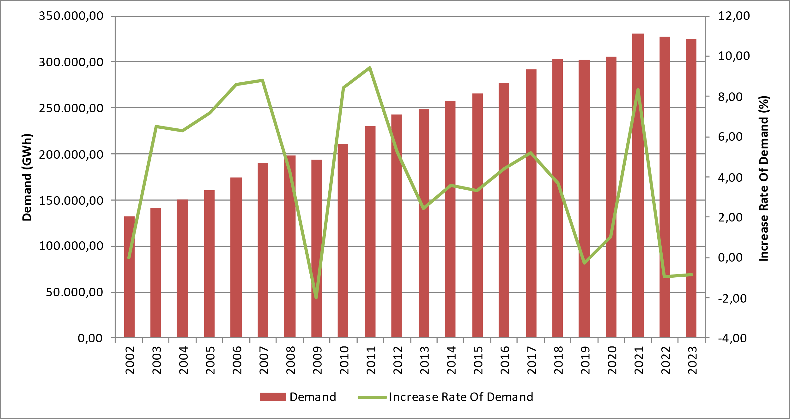
The development and growth rate of peak demand is presented in Figure 1.2. In 2023, peak demand increased by 5,42% compared to the previous year and reached 55.118,91 MW.

Figure 1.2: Peak Demand and Increase Rate Over Years (MW-%)
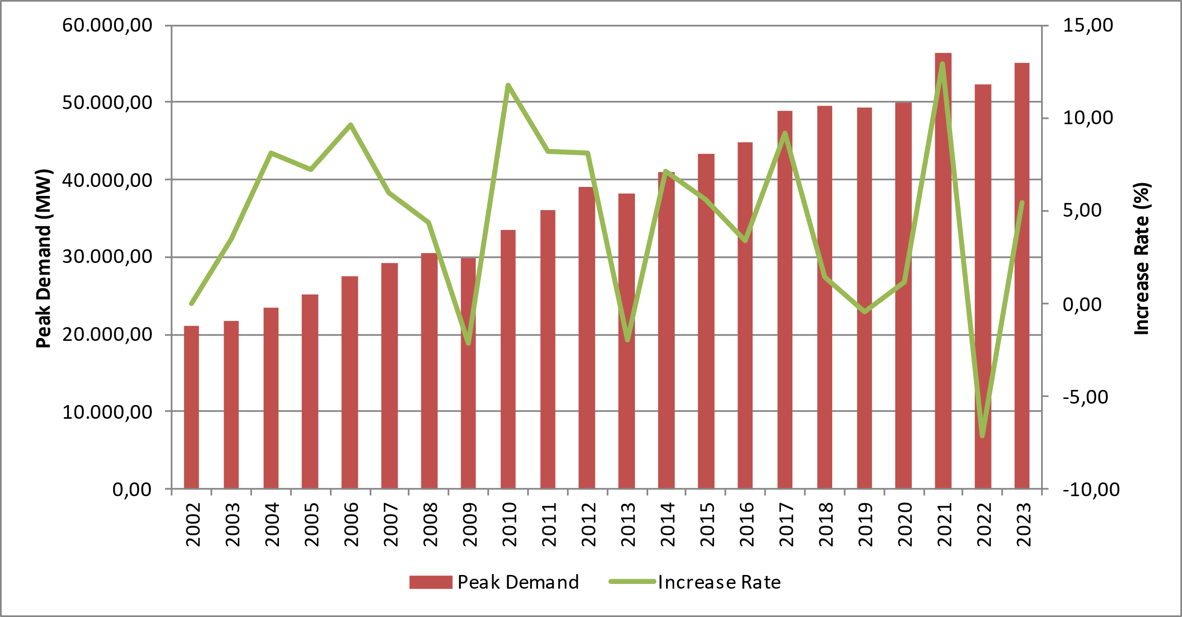
Figure 1.3 shows the relationship between peak demand and electricity demand by years.

Figure 1.3 Rate of Increase of Electrical Energy Demand and Peak Demand by Year (%)
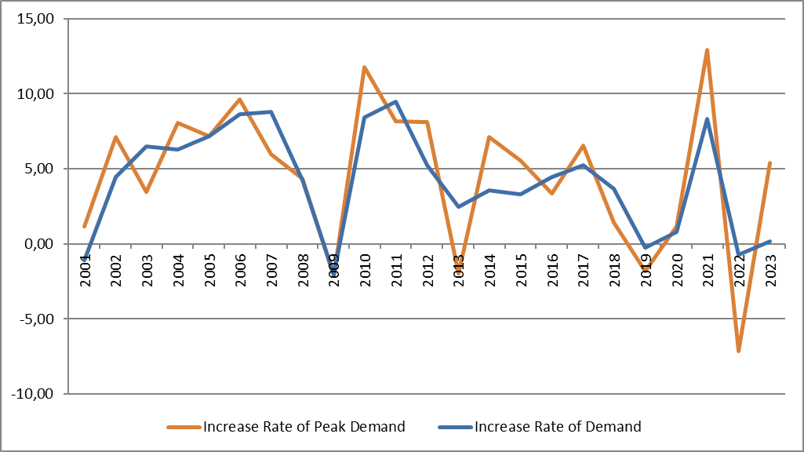
Figure 1.4 shows the monthly changes in licensed electricity generation and electricity consumption. Monthly generation and consumption reached their highest values in August.

Figure 1.4: Monthly Distribution of Licensed Electricity Generation and Consumption in 2023 (GWh)
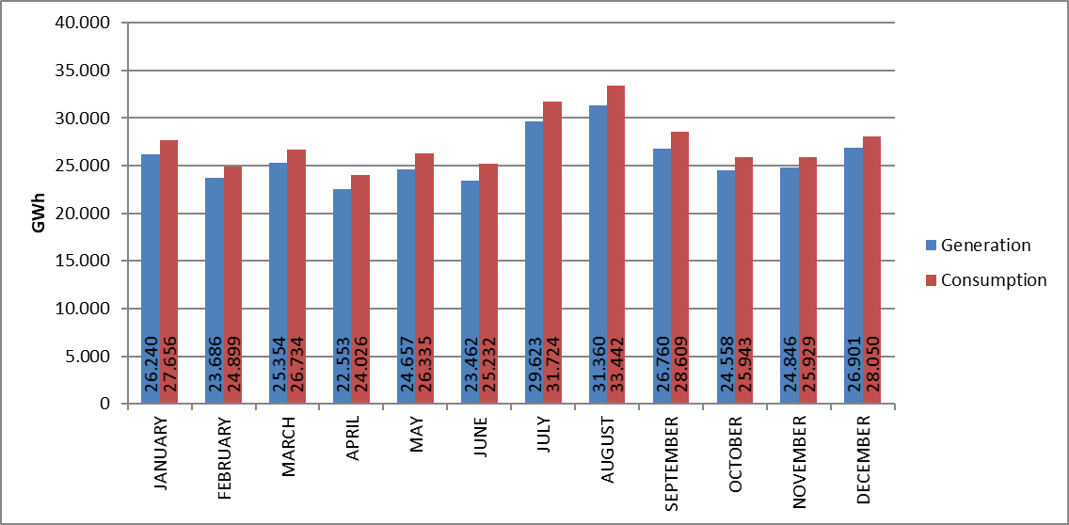
Figure 1.5 shows the distribution of 2023 licensed electricity generation by organizations. Independent generation companies have the highest share in generation with 84,36%. The share of EÜAŞ power plants was realized as 14,21%, while the share of power plants operating under existing contracts in total generation was realized as 1,43%.

Figure 1.5: Distribution of Licensed Electricity Generation by Institutions in 2023 (%)
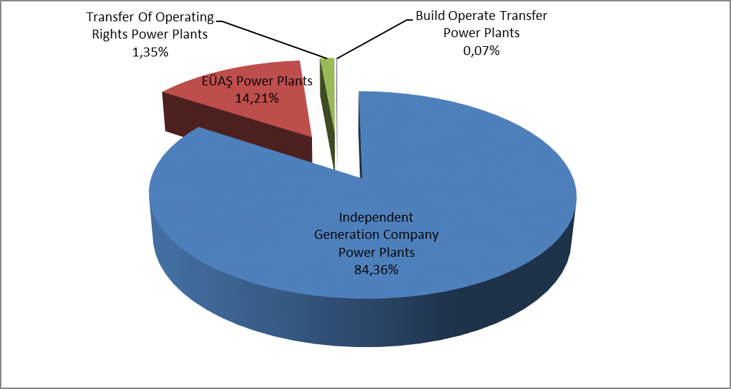
The distribution of licensed electricity generation under public, private and existing contracts is presented in Figure 1.6. In 2022, the total share of public sector in generation (including existing contracts) was 17,65%, while this ratio decreased to 15,64% in 2023. Similarly, the share of independent generation increases from 82,35% in 2022 to 84,36% in 2023.

Figure 1.6: Change of Licensed Electricity Generation as Public-Private by Years (%)
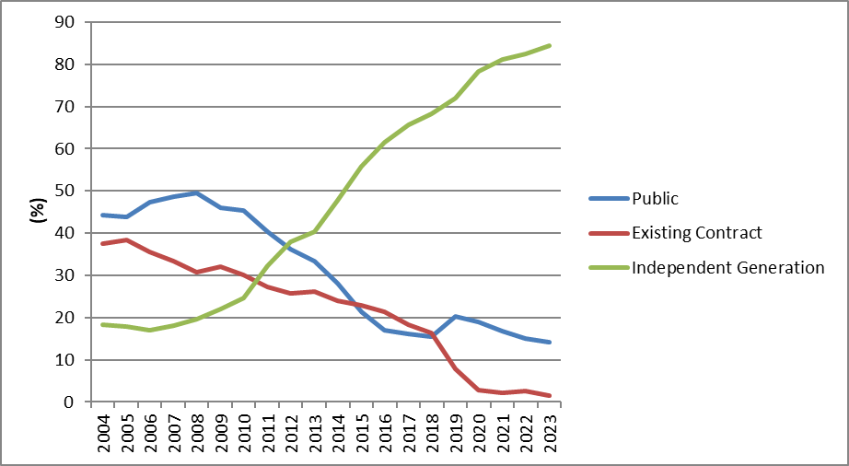
As can be seen in Figure 1.6, the share of independent generation continues to rise. There are two main reasons for this increase. First of all, the majority of new investments are made by independent generation companies. The second reason is the expiration of the contract terms of build and operate power plants.
The distribution of Turkey's licensed electricity generation by source is given in Figure 1.7. The share of imported coal power plants in licensed electricity generation increases from 20,28% in 2022 to 23,27% in 2023. On the other hand, the share of natural gas-fired power plants in licensed electricity generation decreased from 23,61% in 2022 to 22,11% in 2023, hydroelectric power plants from 21,34% to 20,58%, domestic coal (lignite, hard coal and asphaltite) power plants from 16,09% to 14,89%, wind power plants from 11,12% to 10,93% and geothermal power plants from 3,56% to 3,55%.

Figure 1.7: Distribution of Licensed Electricity Generation by Sources in 2023 (%)
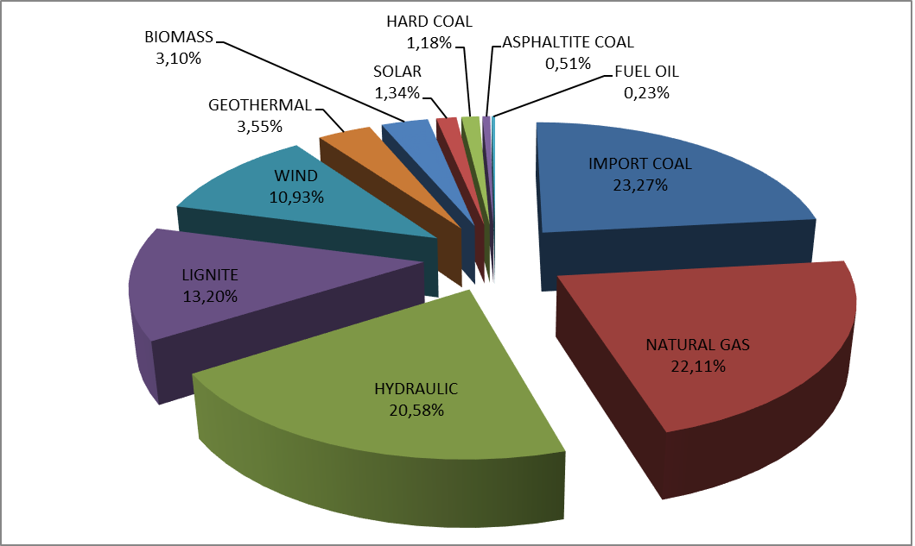
The development of licensed electricity generation by source since 1990 is presented in Figure 1.8. In 2023, electricity generation from renewable energy sources such as geothermal, wind, solar and biomass decreased by 1,81% compared to 2022.

Figure 1.8: Source-Based Development of Licensed Electricity Generation by Years (GWh)
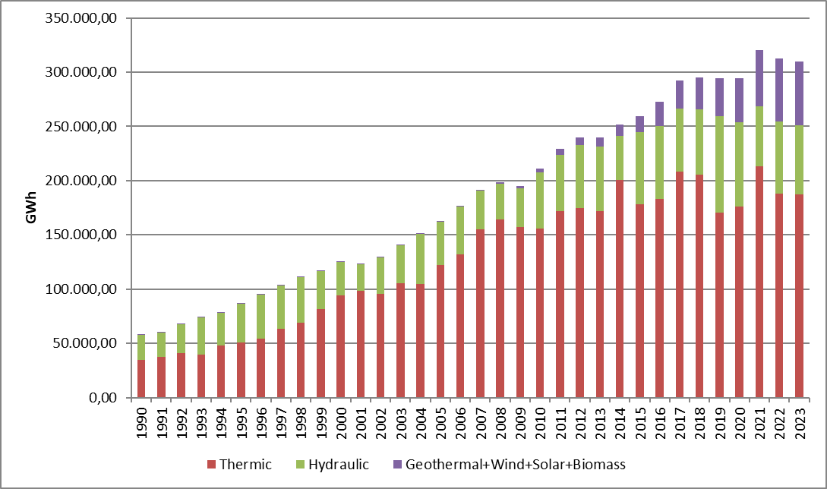
The development of licensed electricity generation in Turkey on a day-by-day basis is shown in Figure 1.9. Licensed electricity generation was highest in August and lowest in April. On a day basis, the highest electricity generation occurred on August 17, 2023 and the lowest on April 21, 2023.

Figure 1.9: Licensed Electricity Generation Per Day in 2023 (MWh)
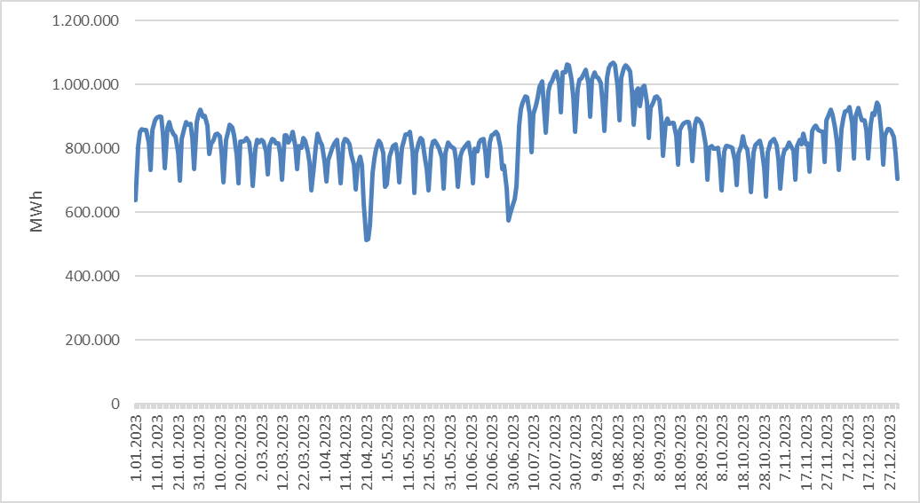

The distribution of licensed electricity generation by province is shown in Table 1.2. In 2023, the highest electricity generation was realized in Adana, Çanakkale, Zonguldak, İzmir, Hatay, Manisa, Balıkesir and Muğla, while the lowest electricity generation was realized in Iğdır, Yozgat, Ağrı, Aksaray, Bartın and Bayburt.

Table 1.2: Licensed Electricity Generation by Provinces (GWh-%)
PROVINCE NAME | Generation (GWh) | Share (%) | PROVINCE NAME | Generation(GWh) | Share (%)
ADANA | 27.861,16 | 8,99 | YALOVA | 1.562,86 | 0,50
ÇANAKKALE | 27.552,07 | 8,89 | ORDU | 1.530,55 | 0,49
ZONGULDAK | 21.462,61 | 6,92 | SİİRT | 1.484,92 | 0,48
İZMİR | 13.425,43 | 4,33 | AFYONKARAHİSAR | 1.309,56 | 0,42
HATAY | 13.170,73 | 4,25 | ERZURUM | 1.286,87 | 0,42
MANİSA | 12.371,65 | 3,99 | RİZE | 1.204,20 | 0,39
BALIKESİR | 10.601,25 | 3,42 | ESKİŞEHİR | 1.182,54 | 0,38
MUĞLA | 10.098,69 | 3,26 | ERZİNCAN | 1.129,67 | 0,36
İSTANBUL | 10.095,76 | 3,26 | KARABÜK | 1.017,19 | 0,33
SAMSUN | 9.788,77 | 3,16 | AMASYA | 897,20 | 0,29
ANKARA | 9.058,40 | 2,92 | MUŞ | 729,92 | 0,24
BURSA | 8.147,01 | 2,63 | KIRŞEHİR | 671,64 | 0,22
KIRIKKALE | 7.979,16 | 2,57 | EDİRNE | 661,31 | 0,21
KIRKLARELİ | 7.661,20 | 2,47 | SİNOP | 620,72 | 0,20
AYDIN | 7.514,99 | 2,42 | ADIYAMAN | 574,88 | 0,19
ELAZIĞ | 6.424,53 | 2,07 | GAZİANTEP | 567,85 | 0,18
KÜTAHYA | 6.139,73 | 1,98 | ARDAHAN | 554,66 | 0,18
KAHRAMANMARAŞ | 5.640,85 | 1,82 | KARS | 534,10 | 0,17
DENİZLİ | 5.497,84 | 1,77 | ÇORUM | 497,90 | 0,16
DİYARBAKIR | 5.446,60 | 1,76 | ISPARTA | 492,06 | 0,16
ANTALYA | 5.255,49 | 1,70 | BİLECİK | 437,90 | 0,14
ARTVİN | 5.233,20 | 1,69 | TUNCELİ | 410,40 | 0,13
KOCAELİ | 4.974,50 | 1,60 | DÜZCE | 389,64 | 0,13
ŞANLIURFA | 4.961,99 | 1,60 | MALATYA | 360,59 | 0,12
SAKARYA | 4.369,27 | 1,41 | UŞAK | 301,96 | 0,10
KONYA | 4.127,31 | 1,33 | VAN | 283,17 | 0,09
SİVAS | 4.045,53 | 1,31 | BURDUR | 246,21 | 0,08
BOLU | 3.007,93 | 0,97 | NİĞDE | 237,18 | 0,08
MERSİN | 2.917,77 | 0,94 | NEVŞEHİR | 218,14 | 0,07
GİRESUN | 2.592,70 | 0,84 | BİTLİS | 207,40 | 0,07
MARDİN | 2.536,49 | 0,82 | KASTAMONU | 180,74 | 0,06
TOKAT | 2.374,69 | 0,77 | BATMAN | 177,94 | 0,06
BİNGÖL | 2.324,40 | 0,75 | ÇANKIRI | 153,45 | 0,05
OSMANİYE | 2.281,52 | 0,74 | HAKKARİ | 134,70 | 0,04
TEKİRDAĞ | 1.906,52 | 0,62 | BAYBURT | 132,53 | 0,04
KAYSERİ | 1.764,88 | 0,57 | BARTIN | 83,91 | 0,03
GÜMÜŞHANE | 1.725,29 | 0,56 | AKSARAY | 83,36 | 0,03
ŞIRNAK | 1.717,49 | 0,55 | AĞRI | 79,43 | 0,03
TRABZON | 1.634,39 | 0,53 | YOZGAT | 73,24 | 0,02
KARAMAN | 1.564,94 | 0,50 | IĞDIR | 40,05 | 0,01
 |  |  | Grand Total | 309.997,21 | 100,00

Figure 1.10 shows the shares of the top 10 companies with the highest share in licensed electricity generation in 2023. As can be seen from the figure, the top 10 companies are EÜAŞ, Eren En.El.Ür.A.Ş. , Enerjisa En.Ür.A.Ş. , Emba En.Ür.A.Ş. , İskenderun En.Ür.Ve Tic.A.Ş. , Cenal En.Ür.A.Ş. , İçdaş En.Ür.Ve Yat. A.Ş. , Atlas En.Ür.San.A.Ş. , Yeniköy Kemerköy El.Ür.Ve Tic.A.Ş. and Hamitabat El.Ür.Ve Tic.A.Ş.

Figure 1.10: First 10 Companies within Electricity Generation in 2023 (%)
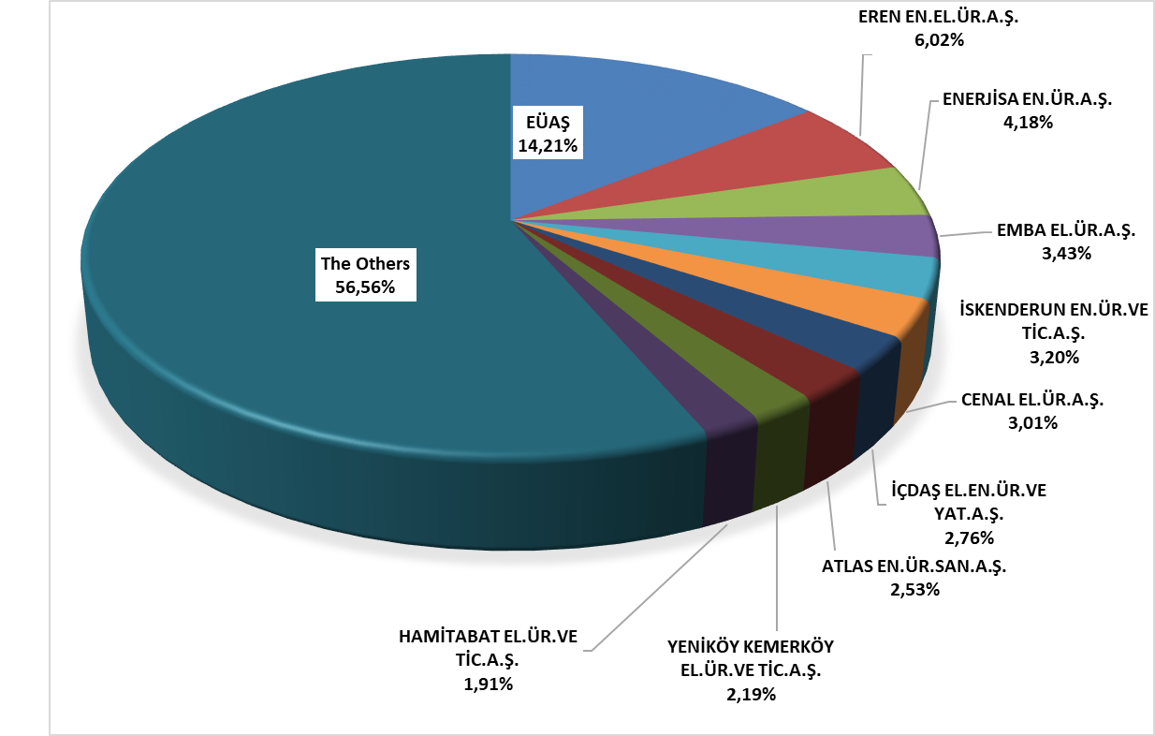

1.3 Licensed Installed Capacity

The distribution of licensed installed capacity by resource types is shown in Figure 1.11. While the share of hydroelectric power plants with dams was 24,46% as of the end of 2022, it increased to 24,56% in 2023, the share of wind power plants increased from 11,88% to 12,16%, and the share of solar power plants increased from 1,54% to 1,73%.
On the other hand, the share of natural gas power plants (including liquid and natural gas-fired power plants) in licensed installed capacity decreased from 26,52% in 2022 to 26,20% in 2023, the share of imported coal-fired power plants from 10,90% to 10,77%, lignite power plants from 10,71% to 10,58%, run-of-river hydroelectric power plants from 8,70% to 8,62%, and geothermal power plants from 1,78% to 1,76%.
The share of renewable energy sources (including hydroelectricity) in total installed capacity increased from 50,28% in 2022 to 50,87% in 2023. The share of total thermal installed capacity decreases from 49,72% in 2022 to 49,13% in 2023.

Figure 1.11: Distribution of Licensed Installed Capacity by Sources at the end of 2023 (%)
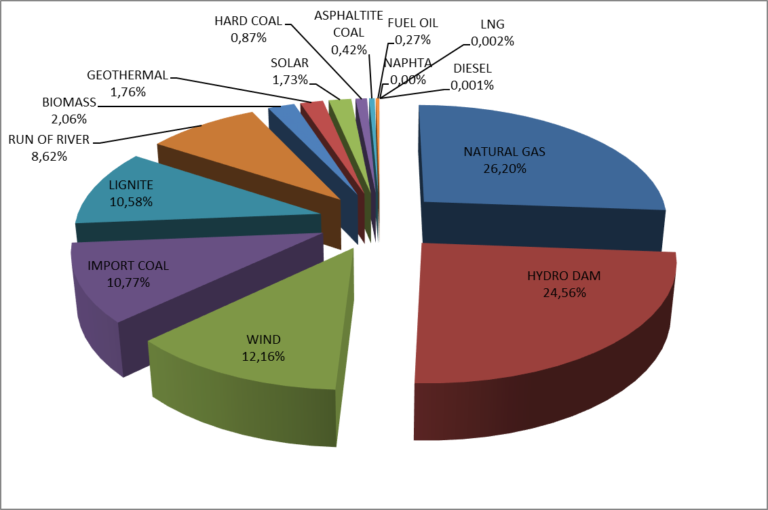

The distribution of licensed installed capacity by organization is shown in Figure 1.12. The share of EÜAŞ power plants in total installed capacity rises from 22,09% in 2022 to 22,21% in 2023.
On the other hand, the share of independent generation companies operating under free market conditions in total installed capacity decreased from 74,37% in 2022 to 74,30% in 2023, and the share of power plants operating under existing contracts decreased from 3,53% to 3,49%.

Figure 1.12: Distribution of Licensed Installed Capacity by Organizations at the end of 2023 (%)
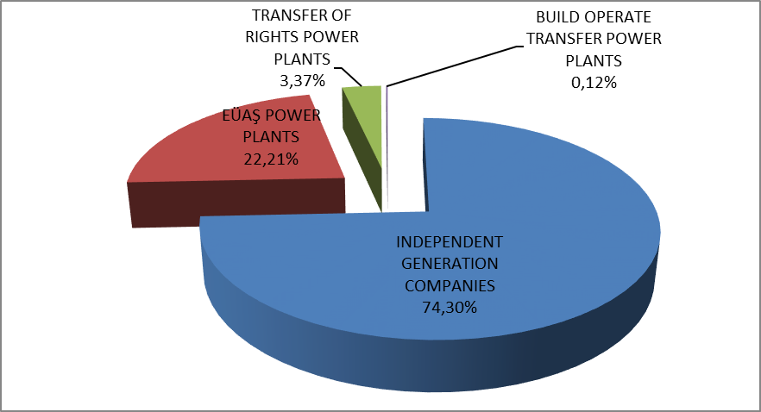

The development of licensed installed capacity by resource since 2000 is presented in Figure 1.13. As can be seen from the figure, the share of geothermal, wind, solar and biomass resources in the installed capacity has increased every year.

Figure 1.13: Development of Licensed Installed Capacity by Source over the Years (MW)
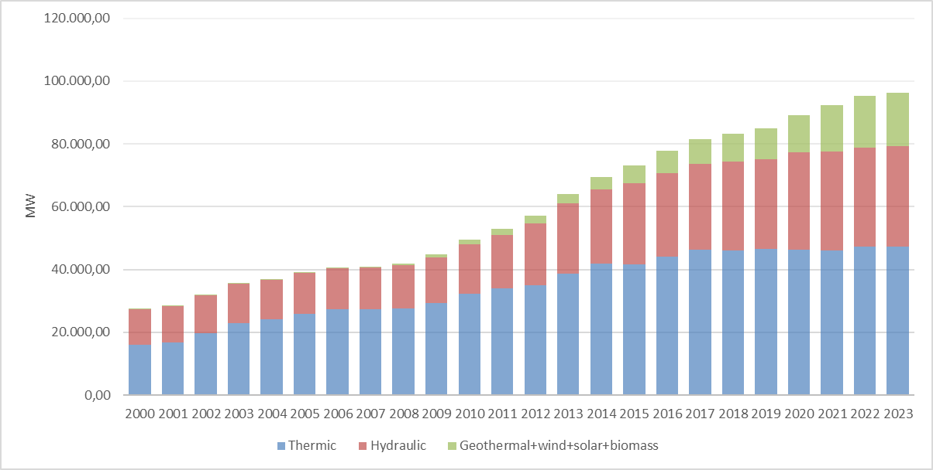
Similar to Figure 1.13, Figure 1.14 shows the development of the share of resources in licensed installed capacity since 2000.

Figure 1.14: The Development of the Share of the Sources within the Installed Capacity by Years (%)
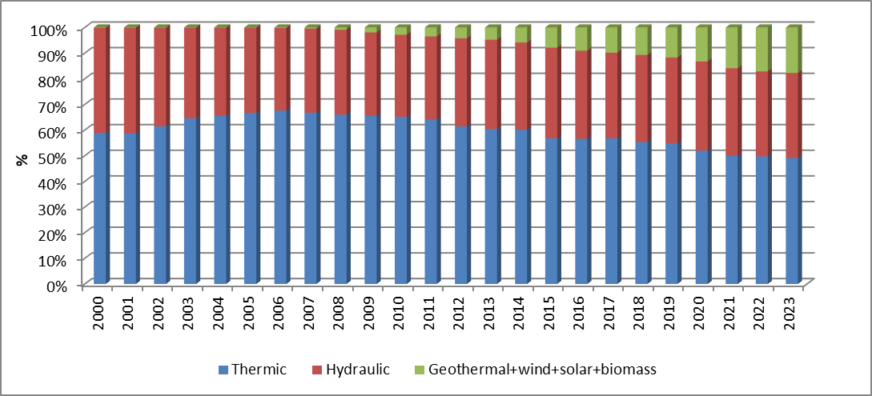
The distribution of licensed installed capacity by province is shown in Table 1.3. In 2023, the provinces with the highest installed capacity were İzmir, Adana, Çanakkale, Kahramanmaraş, İstanbul, Zonguldak, Şanlıurfa and Samsun, while the provinces with the lowest installed capacity were Iğdır, Bartın, Bayburt, Aksaray, Ağrı, Batman, Çankırı and Hakkari.

Table 1.3 Distribution of Licensed Installed Capacity by Province (MW-%)
PROVINCE NAME | Installed Capacity (MW | Share (%) | PROVINCE NAME | Installed Capacity (MW | Share(%)
İzmir | 5.199,83 | 5,40 | Sinop | 612,56 | 0,64
Adana | 5.151,71 | 5,35 | Erzurum | 571,97 | 0,59
Çanakkale | 4.666,25 | 4,85 | Bolu | 537,99 | 0,56
Kahramanmaraş | 4.410,92 | 4,58 | Ordu | 503,97 | 0,52
İstanbul | 3.522,95 | 3,66 | Muş | 462,66 | 0,48
Zonguldak | 3.377,11 | 3,51 | Afyonkarahisar | 447,67 | 0,46
Şanlıurfa | 3.309,72 | 3,44 | Gaziantep | 444,26 | 0,46
Samsun | 3.254,54 | 3,38 | Şırnak | 425,92 | 0,44
Balıkesir | 3.076,16 | 3,19 | Çorum | 402,43 | 0,42
Bursa | 2.982,73 | 3,10 | Yalova | 395,33 | 0,41
Manisa | 2.968,62 | 3,08 | Rize | 366,57 | 0,38
Hatay | 2.887,01 | 3,00 | Kırşehir | 334,90 | 0,35
Sakarya | 2.825,46 | 2,93 | Erzincan | 324,40 | 0,34
Elazığ | 2.467,13 | 2,56 | Amasya | 314,66 | 0,33
Artvin | 2.436,70 | 2,53 | Isparta | 290,65 | 0,30
Ankara | 2.422,70 | 2,52 | Niğde | 277,70 | 0,29
Muğla | 2.315,61 | 2,40 | Adıyaman | 258,64 | 0,27
Diyarbakır | 2.260,86 | 2,35 | Kars | 251,66 | 0,26
Kocaeli | 2.143,70 | 2,23 | Ardahan | 235,90 | 0,24
Kırıkkale | 2.018,52 | 2,10 | Bilecik | 205,18 | 0,21
Kırklareli | 1.900,01 | 1,97 | Karabük | 185,97 | 0,19
Antalya | 1.835,13 | 1,91 | Edirne | 181,01 | 0,19
Denizli | 1.747,89 | 1,81 | Van | 160,42 | 0,17
Aydın | 1.624,88 | 1,69 | Uşak | 158,35 | 0,16
Konya | 1.617,70 | 1,68 | Kastamonu | 140,94 | 0,15
Tekirdağ | 1.516,75 | 1,57 | Burdur | 131,72 | 0,14
Mardin | 1.423,09 | 1,48 | Düzce | 126,16 | 0,13
Bingöl | 1.371,47 | 1,42 | Malatya | 117,74 | 0,12
Kütahya | 1.067,82 | 1,11 | Tunceli | 106,95 | 0,11
Osmaniye | 1.060,89 | 1,10 | Bitlis | 103,05 | 0,11
Mersin | 1.033,05 | 1,07 | Nevşehir | 89,13 | 0,09
Sivas | 1.018,10 | 1,06 | Yozgat | 69,43 | 0,07
Giresun | 907,28 | 0,94 | Hakkari | 67,91 | 0,07
Siirt | 793,91 | 0,82 | Çankırı | 65,92 | 0,07
Kayseri | 706,17 | 0,73 | Batman | 63,24 | 0,07
Gümüşhane | 697,53 | 0,72 | Ağrı | 46,51 | 0,05
Tokat | 686,53 | 0,71 | Aksaray | 40,30 | 0,04
Karaman | 679,19 | 0,71 | Bayburt | 37,68 | 0,04
Eskişehir | 656,26 | 0,68 | Bartın | 34,33 | 0,04
Trabzon | 650,75 | 0,68 | Iğdır | 23,79 | 0,02
 |  |  | Grand Total | 96.308,18 | 100,00

Figure 1.15 shows the shares of the top 10 companies with the highest share in licensed installed capacity by the end of 2023. As can be seen from the figure, the top 10 companies are EÜAŞ, Enerjisa En.Ür.A.Ş., Eren En.El.Ür.A.Ş., Emba El.Ür.A.Ş., İskenderun En.Ür.Ve Tic.A.Ş., Hamitabat El.Ür.Ve Tic.A.Ş., Gebze El.Ür.Ltd.Şti., İzmir El.Ür.Ltd.Şti, Afşin Elbistan El.Ür.Ve Tic.A.Ş. and Cenal El.Ür.A.Ş.

Figure 1.15: Share of the Top 10 Companies in Licensed Installed Capacity at the End of 2023 (%)
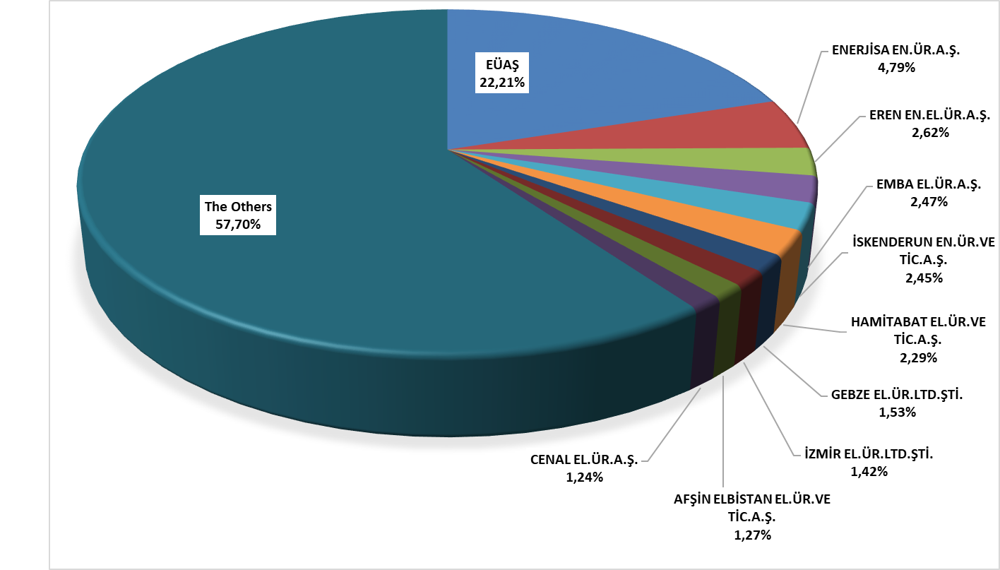

1.4 Unlicensed Generation

In the first paragraph of Article 14 of the Electricity Market Law No. 6446, the generation facilities exempted from the obligation to obtain a license and establish a company are listed as follows:

"a) The generation facility that does not establish a connection with the relief groups and the transmission or distribution system
b) Generation facility based on renewable energy sources with an installed capacity of maximum one megawatt
c) Electricity generation facility established for use in solid waste facilities of municipalities and disposal of treatment plant sludge
d) Microcogeneration facilities and those in the category to be determined by the Board from cogeneration facilities that provide the efficiency value to be determined by the Ministry

e) A generation facility based on renewable energy sources that uses all of the energy it produces without giving it to the transmission or distribution system, whose generation and consumption are at the same measurement point
f) (Additional: 21/3/2018-7103/84 Art.) Market activities carried out within the scope of electricity storage and demand response within the framework of the limits and procedures and principles to be determined by the Board in consultation with the Ministry
g) (Addendum: 19/4/2018-7139/56 Art.) Generation facility based on renewable energy resources established and operated by the General Directorate of State Hydraulic Works or by irrigation unions with the permission of DSİ in order to meet the electricity needs of facilities for agricultural irrigation purposes whose electricity subscription belongs to the General Directorate of State Hydraulic Works or irrigation unions, provided that the installed power is limited to the contract power in the connection agreement of the agricultural irrigation facility and the total contract power of the facilities for more than one facility
h) (Additional: 25/11/2020-7257/35 Art.) (Amended: 5/3/2022-7381/27 Art.) Generation facility based on renewable energy sources, provided that municipalities and their affiliated organizations, industrial facilities and facilities for agricultural irrigation are limited to twice the contract power in the connection agreement and other persons are limited to the contract power in the connection agreement
i) (Addition: 5/3/2022-7381/27 Art.) Renewable energy generation facilities established with the approval of DSİ on immovables for which irrigation unions have operation, maintenance, repair and management responsibility and other immovables under the ownership or disposal of irrigation unions and DSİ, provided that they are limited to the contract power in the connection agreement and operated by irrigation unions

The current status of unlicensed electricity generation applications as of the end of 2023 is shown in Table 1.4.

Table 1.4: Status of Unlicensed Electricity Generation Applications by the End of 2023 (MWe)
Status/Source | Biomass | Solar | Hydraulic | Cogeneration | Microgeneration | Wind
In connection agreement stage | 4,86 | 6.691,75 | 5,08 | 52,51 | 0,05 | 130,77
In invitation letter stage | 7,23 | 10.812,33 | 0,49 | 15,98 |  | 318,03
Rejected | 14,22 | 1.722,84 | 15,32 | 113,32 |  | 82,91

The distribution of unlicensed installed capacity by resources is presented in Table 1.5 and Figure 1.16. The amount of capacity in operation in unlicensed electricity generation, which was 10.028,60 MWe by the end of 2022, increased by 30,03% to 13.040,53 MWe by the end of 2023. Solar power plants will have the highest share in 2023 with 94,58%, followed by natural gas with 3,82% and wind with 0,77%.

Table 1.5: Distribution of Unlicensed Installed Capacity by Resources (MWe-%)
Resource Type | 2022 |  | 2023
Resource Type | Installed Power  (MWe) | Share (%) | Installed Power  (MWe) | Share (%)
Solar | 9.362,05 | 93,35 | 12.333,60 | 94,58
Natural gas | 481,80 | 4,80 | 497,81 | 3,82
Wind | 79,03 | 0,79 | 99,83 | 0,77
Biomass | 93,71 | 0,93 | 94,71 | 0,73
Hydraulic | 12,01 | 0,12 | 14,59 | 0,11
Grand Total | 10.028,60 | 100,00 | 13.040,53 | 100,00

Figure 1.16: Distribution of Unlicensed Installed Capacity by Sources by the End of 2023 (%)
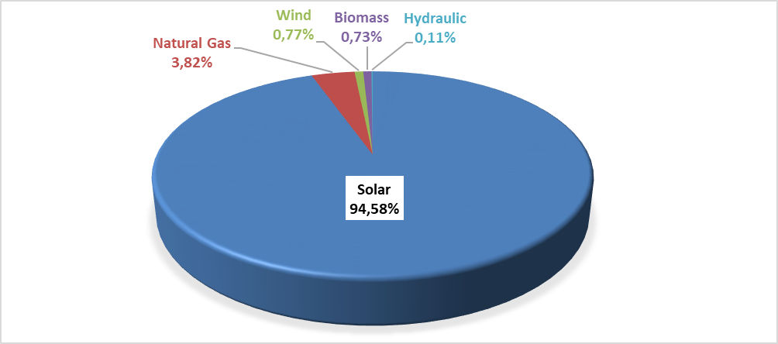

The distribution of unlicensed installed capacity by province is shown in Table 1.6. As in 2022, the highest installed capacity in 2023 is located in Konya with 886,71 MWe. Konya is followed by Ankara with 722,32 MWe, Kayseri with 666,32 MWe, İzmir with 645,50 MWe, Gaziantep with 583,93 MWe, Şanlıurfa with 502,94 MWe and Manisa with 423,64 MWe. Approximately 34% of the total unlicensed installed capacity is located in these 7 provinces.

Table 1.6: Distribution of Unlicensed Installed Capacity by Province (MWe-%)
PROVINCES | 2022 |  | 2023
PROVINCES | Installed Capacity  (MWe) | Share (%) | Installed Capacity  (MWe) | Share (%)
Adana | 247,09 | 2,46 | 308,59 | 2,37
Adıyaman | 140,85 | 1,40 | 146,09 | 1,12
Afyonkarahisar | 326,73 | 3,26 | 406,57 | 3,12
Ağrı | 18,43 | 0,18 | 18,43 | 0,14
Aksaray | 132,02 | 1,32 | 165,01 | 1,27
Amasya | 49,95 | 0,50 | 61,36 | 0,47
Ankara | 564,79 | 5,63 | 722,32 | 5,54
Antalya | 257,15 | 2,56 | 317,38 | 2,43
Ardahan | 4,39 | 0,04 | 4,39 | 0,03
Artvin | 0,02 | 0,00 | 0,02 | 0,00
Aydın | 160,64 | 1,60 | 219,59 | 1,68
Balıkesir | 184,37 | 1,84 | 282,46 | 2,17
Bartın | 6,52 | 0,06 | 15,12 | 0,12
Batman | 23,93 | 0,24 | 29,41 | 0,23
Bayburt | 15,07 | 0,15 | 15,70 | 0,12
Bilecik | 103,75 | 1,03 | 139,36 | 1,07
Bingöl | 31,04 | 0,31 | 35,63 | 0,27
Bitlis | 32,20 | 0,32 | 38,41 | 0,29
Bolu | 27,90 | 0,28 | 41,90 | 0,32
Burdur | 104,60 | 1,04 | 151,59 | 1,16
Bursa | 205,50 | 2,05 | 367,91 | 2,82
Çanakkale | 46,63 | 0,46 | 63,45 | 0,49
Çankırı | 73,20 | 0,73 | 98,66 | 0,76
Çorum | 150,26 | 1,50 | 171,86 | 1,32
Denizli | 241,97 | 2,41 | 368,10 | 2,82
Diyarbakır | 146,88 | 1,46 | 202,64 | 1,55
Düzce | 11,06 | 0,11 | 29,63 | 0,23
Edirne | 17,87 | 0,18 | 26,80 | 0,21
Elazığ | 221,39 | 2,21 | 263,28 | 2,02
Erzincan | 50,91 | 0,51 | 58,19 | 0,45
Erzurum | 108,69 | 1,08 | 117,55 | 0,90
Eskişehir | 186,81 | 1,86 | 242,79 | 1,86
Gaziantep | 397,60 | 3,96 | 583,93 | 4,48
Giresun | 7,29 | 0,07 | 18,31 | 0,14
Gümüşhane | 2,98 | 0,03 | 5,28 | 0,04
Hakkari | 0,21 | 0,00 | 0,44 | 0,00
Hatay | 45,70 | 0,46 | 65,19 | 0,50
Iğdır | 1,89 | 0,02 | 1,89 | 0,01
Isparta | 223,92 | 2,23 | 362,91 | 2,78
İstanbul | 149,57 | 1,49 | 216,19 | 1,66
İzmir | 473,20 | 4,72 | 645,50 | 4,95
Kahramanmaraş | 346,23 | 3,45 | 376,05 | 2,88
Karabük | 14,61 | 0,15 | 29,78 | 0,23
Karaman | 102,85 | 1,03 | 140,39 | 1,08
Kars | 5,74 | 0,06 | 6,74 | 0,05
Kastamonu | 18,53 | 0,18 | 32,34 | 0,25
Kayseri | 518,80 | 5,17 | 666,32 | 5,11
Kırıkkale | 56,02 | 0,56 | 69,25 | 0,53
Kırklareli | 27,35 | 0,27 | 48,34 | 0,37
Kırşehir | 61,60 | 0,61 | 80,29 | 0,62
Kilis | 34,91 | 0,35 | 49,81 | 0,38
Kocaeli | 83,50 | 0,83 | 123,33 | 0,95
Konya | 754,58 | 7,52 | 886,71 | 6,80
Kütahya | 136,25 | 1,36 | 164,62 | 1,26
Malatya | 150,51 | 1,50 | 173,79 | 1,33
Manisa | 317,49 | 3,17 | 423,64 | 3,25
Mardin | 24,87 | 0,25 | 40,59 | 0,31
Mersin | 278,74 | 2,78 | 314,36 | 2,41
Muğla | 125,14 | 1,25 | 156,92 | 1,20
Muş | 13,23 | 0,13 | 20,26 | 0,16
Nevşehir | 162,23 | 1,62 | 176,62 | 1,35
Niğde | 145,85 | 1,45 | 179,71 | 1,38
Ordu | 7,99 | 0,08 | 7,99 | 0,06
Osmaniye | 164,41 | 1,64 | 178,92 | 1,37
Rize | 0,21 | 0,00 | 3,24 | 0,02
Sakarya | 36,11 | 0,36 | 67,80 | 0,52
Samsun | 46,09 | 0,46 | 60,80 | 0,47
Siirt | 9,13 | 0,09 | 11,54 | 0,09
Sinop | 0,86 | 0,01 | 2,91 | 0,02
Sivas | 184,74 | 1,84 | 209,37 | 1,61
Şanlıurfa | 415,81 | 4,15 | 502,94 | 3,86
Şırnak | 22,38 | 0,22 | 26,96 | 0,21
Tekirdağ | 78,52 | 0,78 | 160,66 | 1,23
Tokat | 71,92 | 0,72 | 87,44 | 0,67
Trabzon | 9,35 | 0,09 | 17,64 | 0,14
Tunceli | 1,89 | 0,02 | 3,10 | 0,02
Uşak | 174,66 | 1,74 | 208,25 | 1,60
Van | 39,90 | 0,40 | 49,07 | 0,38
Yalova | 9,46 | 0,09 | 11,54 | 0,09
Yozgat | 164,17 | 1,64 | 201,77 | 1,55
Zonguldak | 17,02 | 0,17 | 38,87 | 0,30
Total | 10.028,60 | 100,00 | 13.040,53 | 100,00

The distribution of gross unlicensed electricity generation by source is given in Table 1.7 and Figure 1.17. While the amount of energy given to the grid within the scope of unlicensed electricity generation in 2022 was 12.673,21 GWh, it increased by 16,76% to 14.796,64 GWh in 2023. 97,62% of this was produced from solar, 1,16% from wind, and 0,59% from biomass.

Table 1.7: Distribution of Unlicensed Electricity Generation by Resources (MWh-%)
Source Type | 2022 |  | 2023 |  | 2022-2023 Change  (%)
Source Type | Unlicensed Generation (GWh) | Share (%) | Unlicensed Generation (GWh) | Share (%) | 2022-2023 Change  (%)
Solar | 12.315,93 | 97,18 | 14.444,62 | 97,62 | 17,28
Biomass | 129,56 | 1,02 | 86,67 | 0,59 | -33,11
Wind | 149,55 | 1,18 | 172,26 | 1,16 | 15,18
Hydraulic | 54,67 | 0,43 | 69,41 | 0,47 | 26,96
Natural gas | 23,50 | 0,19 | 23,69 | 0,16 | 0,81
Total | 12.673,21 | 100,00 | 14.796,64 | 100,00 | 16,76

Figure 1.17: Distribution of Unlicensed Electricity Generation by Sources as of the End of 2023 (%)
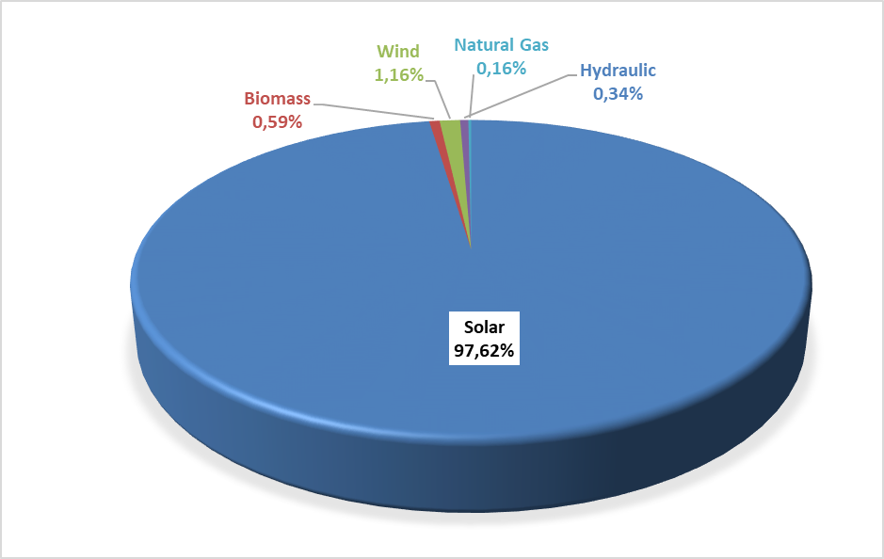

The amount of energy (MWh) given to the system as surplus within the scope of unlicensed electricity generation and the distribution of the energy given to the system by provinces are given in Table 1.8, and the highest generation occurred in Konya in 2023, as in 2022. Konya is followed by Şanlıurfa, Ankara, Kayseri, İzmir, Afyonkarahisar, Manisa and Kahramanmaraş provinces. Approximately 40% of the total surplus unlicensed electricity generation is located in these 8 provinces.

Table 1.8: Distribution of Unlicensed Electricity Generation by Provinces (MWh-%)
PROVINCES | 2022 |  | 2023
PROVINCES | Amount of energy given to the system as surplus (GWh) | Share (%) | Amount of energy given to the system as surplus (GWh) | Share (%)
KONYA | 1.109,49 | 9,05 | 1.134,07 | 8,97
ŞANLIURFA | 689,48 | 5,62 | 707,19 | 5,59
ANKARA | 635,30 | 5,18 | 667,68 | 5,28
KAYSERİ | 623,64 | 5,09 | 623,57 | 4,93
İZMİR | 596,12 | 4,86 | 517,79 | 4,10
AFYONKARAHİSAR | 466,93 | 3,81 | 478,93 | 3,79
MANİSA | 461,23 | 3,76 | 447,32 | 3,54
KAHRAMANMARAŞ | 401,59 | 3,28 | 441,62 | 3,49
ELAZIĞ | 316,62 | 2,58 | 350,97 | 2,78
ESKİŞEHİR | 342,54 | 2,79 | 334,65 | 2,65
GAZİANTEP | 296,68 | 2,42 | 317,52 | 2,51
DENİZLİ | 311,38 | 2,54 | 315,50 | 2,50
MERSİN | 310,82 | 2,54 | 312,88 | 2,47
ISPARTA | 262,83 | 2,14 | 312,28 | 2,47
ANTALYA | 301,41 | 2,46 | 304,68 | 2,41
ADANA | 238,61 | 1,95 | 263,64 | 2,09
ÇORUM | 223,70 | 1,82 | 241,37 | 1,91
NEVŞEHİR | 247,31 | 2,02 | 240,17 | 1,90
AYDIN | 233,32 | 1,90 | 235,73 | 1,86
DİYARBAKIR | 205,40 | 1,68 | 232,13 | 1,84
MALATYA | 209,26 | 1,71 | 230,24 | 1,82
NİĞDE | 221,06 | 1,80 | 225,63 | 1,78
KÜTAHYA | 216,35 | 1,76 | 214,52 | 1,70
BALIKESİR | 210,33 | 1,72 | 212,56 | 1,68
ADIYAMAN | 220,75 | 1,80 | 206,42 | 1,63
MUĞLA | 204,43 | 1,67 | 203,16 | 1,61
ERZURUM | 177,97 | 1,45 | 191,40 | 1,51
AKSARAY | 192,19 | 1,57 | 185,94 | 1,47
UŞAK | 175,84 | 1,43 | 171,40 | 1,36
BURDUR | 141,91 | 1,16 | 152,12 | 1,20
SİVAS | 139,05 | 1,13 | 150,89 | 1,19
KARAMAN | 141,41 | 1,15 | 149,66 | 1,18
BİLECİK | 145,92 | 1,19 | 141,22 | 1,12
YOZGAT | 123,86 | 1,01 | 132,08 | 1,04
OSMANİYE | 129,57 | 1,06 | 130,63 | 1,03
BURSA | 99,46 | 0,81 | 105,71 | 0,84
KIRŞEHİR | 104,28 | 0,85 | 105,63 | 0,84
ÇANKIRI | 100,95 | 0,82 | 102,82 | 0,81
ERZİNCAN | 88,62 | 0,72 | 95,29 | 0,75
KIRIKKALE | 91,42 | 0,75 | 92,94 | 0,74
VAN | 64,15 | 0,52 | 73,16 | 0,58
AMASYA | 61,34 | 0,50 | 68,55 | 0,54
ÇANAKKALE | 64,71 | 0,53 | 64,74 | 0,51
TOKAT | 48,66 | 0,40 | 56,64 | 0,45
BİTLİS | 54,90 | 0,45 | 53,77 | 0,43
KİLİS | 44,87 | 0,37 | 50,67 | 0,40
HATAY | 51,51 | 0,42 | 48,64 | 0,38
SAMSUN | 42,89 | 0,35 | 46,32 | 0,37
MARDİN | 40,51 | 0,33 | 44,22 | 0,35
ŞIRNAK | 42,47 | 0,35 | 42,68 | 0,34
BİNGÖL | 37,98 | 0,31 | 41,72 | 0,33
BATMAN | 35,01 | 0,29 | 37,73 | 0,30
AĞRI | 30,49 | 0,25 | 34,19 | 0,27
BAYBURT | 26,09 | 0,21 | 31,72 | 0,25
KOCAELİ | 29,08 | 0,24 | 31,38 | 0,25
İSTANBUL | 18,90 | 0,15 | 22,42 | 0,18
TEKİRDAĞ | 10,79 | 0,09 | 22,12 | 0,17
KASTAMONU | 13,81 | 0,11 | 18,91 | 0,15
KARABÜK | 18,43 | 0,15 | 18,60 | 0,15
EDİRNE | 12,17 | 0,10 | 15,78 | 0,12
MUŞ | 8,76 | 0,07 | 15,01 | 0,12
SİİRT | 13,31 | 0,11 | 13,83 | 0,11
GİRESUN | 9,45 | 0,08 | 13,49 | 0,11
BOLU | 9,13 | 0,07 | 13,29 | 0,11
SAKARYA | 2,81 | 0,02 | 12,01 | 0,10
KARS | 10,60 | 0,09 | 11,68 | 0,09
RİZE | 12,50 | 0,10 | 10,39 | 0,08
ZONGULDAK | 2,91 | 0,02 | 9,98 | 0,08
ARDAHAN | 6,78 | 0,06 | 6,70 | 0,05
KIRKLARELİ | 4,59 | 0,04 | 4,72 | 0,04
YALOVA | 9,75 | 0,08 | 4,71 | 0,04
DÜZCE | 0,74 | 0,01 | 4,20 | 0,03
GÜMÜŞHANE | 2,92 | 0,02 | 3,31 | 0,03
TRABZON | 1,70 | 0,01 | 2,88 | 0,02
TUNCELİ | 1,99 | 0,02 | 2,87 | 0,02
IĞDIR | 2,77 | 0,02 | 2,53 | 0,02
SİNOP | 0,40 | 0,00 | 2,21 | 0,02
ORDU | 1,61 | 0,01 | 1,88 | 0,01
BARTIN | 0,43 | 0,00 | 1,59 | 0,01
HAKKARİ | 0,03 | 0,00 | 0,34 | 0,00
ARTVİN | 0,00 | 0,00 | 0,01 | 0,00
Grand Total | 12.260,96 | 100,00 | 12.641,57 | 100,00
The distribution of the payment amount made within the scope of unlicensed electricity generation by the end of 2023 is shown in Table 1.9. Sun constitutes 98,64% of the payment amount.

Table 1.9: Distribution of the Amount of Payment Made Within the Scope of Unlicensed Electricity Generation by Resources (TL-%)
Resource Type | 2022 |  | 2023 |  | Change  (%)  2022→2023
Resource Type | Amount of payments made for the amount of surplus energy purchased (TL) | Share (%) | Amount of payments made for the amount of surplus energy purchased (TL) | Share (%) | Change  (%)  2022→2023
Solar | 26.391.834.615,16 | 98,16 | 38.514.042.488,81 | 98,64 | 45,93
Biomass | 277.815.737,06 | 1,03 | 271.566.188,86 | 0,70 | -2,25
Wind | 158.985.360,26 | 0,59 | 202.504.637,51 | 0,52 | 27,37
Hydraulic | 56.936.889,32 | 0,21 | 56.559.527,24 | 0,14 | -0,66
Grand Total | 26.885.572.601,80 | 100,00 | 39.044.672.842,40 | 100,00 | 45,23

1.5 Invoiced Electricity Consumption and Number of Consumers

This section contains information about billed electrical energy consumption. In this context, consumptions that are not included in the invoice (technical and non-technical losses and consumptions that are not accepted as sales) are not included in the data in this section. Therefore, since the generation carried out by legal entities holding a generation license within the scope of Article 7 of the Electricity Market Law to meet the needs of the consumption facilities they own, rent, acquire through financial leasing or for which they have taken over the operating rights, without transferring the energy produced in their facilities to the transmission or distribution system, is not considered as a sale to the final consumer. Electrical energy consumption in this context is not included in the invoiced consumption figures. In addition, the amount of electrical energy that generation facilities draw from the system for their own needs is not included in the invoiced consumption value. In addition, actual consumption data and consumption data in this section may vary due to differences in the billing period.
Data on the amount of consumption invoiced in 2023 is shown in Table 1.10 below. Of the 255,07 TWh of electricity sold, 61,3 TWh, corresponding to 24,04%, is connected to consumers at the transmission voltage level, and 193,7 TWh, corresponding to 75,96%, is connected to the distribution voltage level. sold to consumers.
While 123,7 TWh was sold to eligible consumers, the consumption of subscribers (those who are not free consumers and do not use their free consumer rights and general lighting subscribers) was 131,3 TWh. Accordingly, while the share of eligible consumers in invoiced consumption was 48,5%, the share of subscribers was 51,5%.

Table 1.10: Sales to Eligible and Non-Eligible Consumers in 2023 (GWh)
Consumer Type | Consumption Amount of Consumers Connected from Distribution Voltage Level (GWh) | Consumption Amount of Consumers Connected from Transmission Voltage Level (GWh) | Total (GWh)
Non-Eligible | 130.193,36 | 1.162,32 | 131.355,68
Eligible | 63.548,94 | 60.163,40 | 123.712,34
Grand Total | 193.742,30 | 61.325,71 | 255.068,02

The distribution of consumption across distribution regions is given in Table 1.11. In 2023, the highest consumption was in the Toroslar EDAŞ region with 30,98 TWh, and the lowest consumption was in the Vangölü EDAŞ region with 2,32 TWh. The region with the highest consumption from distribution was Boğaziçi EDAŞ, the region with the lowest was Vangölü EDAŞ, the region with the highest consumption from transmission was Toroslar, and the region with the lowest was Vangölü EDAŞ.

Table 1.11 Distribution of Invoiced Consumption by Distribution Regions in 2023 (GWh-%)
Distribution Regions | Consumption Amount of Consumers Connected from Distribution (GWh) | Consumption Amount of Consumers Connected to Transmission (GWh) | Total (GWh) | Share (%)
TOROSLAR EDAŞ | 16.732,92 | 14.248,21 | 30.981,13 | 12,15
BOĞAZİÇİ EDAŞ | 26.334,25 | 1.968,50 | 28.302,75 | 11,10
GDZ EDAŞ | 15.630,80 | 6.205,45 | 21.836,26 | 8,56
BAŞKENT EDAŞ | 16.037,25 | 3.804,37 | 19.841,62 | 7,78
ULUDAĞ EDAŞ | 13.355,92 | 5.659,33 | 19.015,25 | 7,45
SAKARYA EDAŞ | 10.224,40 | 8.057,44 | 18.281,84 | 7,17
DİCLE EDAŞ | 13.058,68 | 1.292,88 | 14.351,57 | 5,63
İST. AND. YAK. EDAŞ | 12.617,90 | 1.594,70 | 14.212,61 | 5,57
MERAM EDAŞ | 10.907,47 | 2.188,92 | 13.096,39 | 5,13
AKDENİZ EDAŞ | 10.513,66 | 1.215,80 | 11.729,45 | 4,60
TRAKYA EDAŞ | 7.597,70 | 3.575,32 | 11.173,02 | 4,38
OSMANGAZİ EDAŞ | 6.731,67 | 4.371,16 | 11.102,83 | 4,35
ADM EDAŞ | 9.594,64 | 1.039,93 | 10.634,56 | 4,17
YEŞİLIRMAK EDAŞ | 5.292,17 | 1.636,19 | 6.928,36 | 2,72
AKEDAŞ EDAŞ | 3.089,28 | 1.226,39 | 4.315,67 | 1,69
KAYSERİ VE CİVARI ETAŞ | 2.565,88 | 1.472,24 | 4.038,13 | 1,58
ÇORUH EDAŞ | 3.659,99 | 151,34 | 3.811,33 | 1,49
FIRAT EDAŞ | 2.551,88 | 613,17 | 3.165,05 | 1,24
ÇAMLIBEL EDAŞ | 2.498,12 | 511,13 | 3.009,25 | 1,18
ARAS EDAŞ | 2.511,65 | 403,90 | 2.915,56 | 1,14
VANGÖLÜ EDAŞ | 2.236,09 | 89,32 | 2.325,41 | 0,91
Grand Total | 193.742,30 | 61.325,71 | 255.068,02 | 100,00

The distribution of invoiced consumption by consumer type is shown in Table 1.12 and Figure 1.18, with industrial consumption having the highest share with 40,76%. Residential consumption ranks second with 25,95%, and Public and Private Services Sector and Other consumption ranks third with 25,86%. The total electricity consumption used in lighting and agricultural activities was 7,43%.

Table 1.12: Distribution of Invoiced Consumption by Consumer Type as Eligible and Non-Eligible Consumers in 2023 (MWh)
Consumer Type | Consumption Amount (MWh)
Consumer Type | Subscriber | Share  (%) | Free Consumer | Share  (%) | Total | Share  (%)
Industry | 6.790.862,72 | 5,17 | 97.171.367,35 | 78,55 | 103.962.230,07 | 40,76
Household | 66.176.778,97 | 50,38 | 24.191,39 | 0,02 | 66.200.970,36 | 25,95
Public and Private Services and Others | 39.619.259,11 | 30,16 | 26.328.670,93 | 21,28 | 65.947.930,04 | 25,86
Irrigation | 13.337.237,72 | 10,15 | 89.218,54 | 0,07 | 13.426.456,25 | 5,26
Lighting | 5.431.539,24 | 4,13 | 98.890,94 | 0,08 | 5.530.430,18 | 2,17
Grand Total | 131.355.677,76 | 100,00 | 123.712.339,14 | 100,00 | 255.068.016,90 | 100,00

Figure 1.18: Distribution of Invoiced Consumption in 2023 by Consumer Type (%)
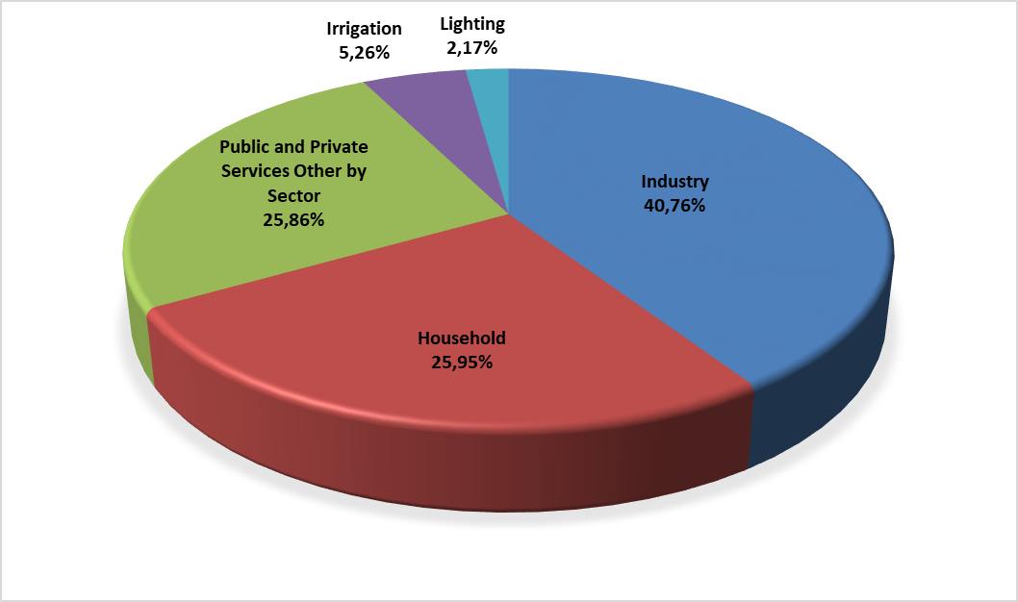

Table 1.13: Development of Invoiced Consumption by Consumer Type by Years (MWh)
Consumer Type | Consumption Amount (MWh)
Consumer Type | 2020 | 2021 | 2022 | 2023
Industry | 99.635.062 | 111.762.705 | 108.369.171 | 103.962.230
Household | 60.437.634 | 61.603.820 | 61.868.288 | 66.200.970
Public and Private Services and Others | 57.328.859 | 60.839.211 | 64.550.205 | 65.947.930
Irrigation | 10.947.411 | 13.497.475 | 13.332.526 | 13.426.456
Lighting | 5.048.410 | 5.353.694 | 5.501.261 | 5.530.430
Grand Total | 233.397.377 | 253.056.905 | 253.621.451 | 255.068.017
The distribution of invoiced consumption by province is shown in Table 1.14. The highest consumption occurred in Istanbul with 42,5 TWh, corresponding to 16,67% of the total consumption. Istanbul is followed by Izmir with a share of 6,44%, Ankara with a share of 5,83%, Bursa with a share of 5,01% and Kocaeli with a share of 4,68%.

Table 1.14: Distribution of Invoiced Consumption by Province (MWh - %)
PROVINCES | Amount of Consumption of Consumers Connected to Distribution (MWh) | Amount of Consumption of Consumers Connected to Transmission (MWh) | Total (MWh) | Share (%)
İSTANBUL (ALL) | 38.952.156,08 | 3.563.203,56 | 42.515.359,65 | 16,67
İSTANBUL (EUROPE) | 26.334.251,77 | 1.968.501,58 | 28.302.753,35 | 11,10
İZMİR | 12.095.078,73 | 4.326.971,08 | 16.422.049,81 | 6,44
ANKARA | 12.439.441,31 | 2.440.494,08 | 14.879.935,39 | 5,83
İSTANBUL (ANATOLIA) | 12.617.904,31 | 1.594.701,98 | 14.212.606,30 | 5,57
BURSA | 7.895.853,71 | 4.890.708,37 | 12.786.562,08 | 5,01
KOCAELİ | 5.775.865,30 | 6.154.002,15 | 11.929.867,45 | 4,68
ANTALYA | 9.093.010,77 | 776.085,20 | 9.869.095,97 | 3,87
GAZİANTEP | 3.503.728,54 | 5.126.473,05 | 8.630.201,59 | 3,38
KONYA | 6.801.252,82 | 1.230.019,01 | 8.031.271,83 | 3,15
ADANA | 4.887.088,37 | 2.778.699,38 | 7.665.787,75 | 3,01
TEKİRDAĞ | 4.569.612,32 | 3.004.139,80 | 7.573.752,11 | 2,97
ŞANLIURFA | 6.087.408,77 | 376.484,54 | 6.463.893,31 | 2,53
MERSİN | 4.723.141,69 | 930.162,97 | 5.653.304,66 | 2,22
MANİSA | 3.535.726,07 | 1.878.479,15 | 5.414.205,22 | 2,12
HATAY | 2.480.203,41 | 2.357.324,78 | 4.837.528,20 | 1,90
MUĞLA | 4.031.427,75 |  | 4.031.427,75 | 1,58
KAYSERİ | 2.559.094,08 | 1.472.242,90 | 4.031.336,98 | 1,58
BALIKESİR | 3.243.398,94 | 707.359,13 | 3.950.758,06 | 1,55
SAKARYA | 2.558.464,00 | 1.288.159,52 | 3.846.623,52 | 1,51
OSMANİYE | 794.205,96 | 2.846.437,97 | 3.640.643,93 | 1,43
SAMSUN | 2.285.829,36 | 1.296.766,29 | 3.582.595,66 | 1,40
DENİZLİ | 2.856.785,93 | 647.832,24 | 3.504.618,16 | 1,37
ESKİŞEHİR | 2.094.949,59 | 1.238.438,26 | 3.333.387,85 | 1,31
KAHRAMANMARAŞ | 2.236.055,94 | 1.004.431,41 | 3.240.487,35 | 1,27
DİYARBAKIR | 2.730.230,95 | 407.037,10 | 3.137.268,05 | 1,23
AYDIN | 2.706.421,50 | 392.093,80 | 3.098.515,31 | 1,21
MARDİN | 2.230.591,84 | 287.600,30 | 2.518.192,14 | 0,99
KIRKLARELİ | 1.716.928,49 | 571.179,46 | 2.288.107,95 | 0,90
BİLECİK | 1.051.588,03 | 1.200.519,79 | 2.252.107,82 | 0,88
AFYONKARAHİSAR | 1.679.334,75 | 299.410,87 | 1.978.745,62 | 0,78
UŞAK | 802.068,85 | 1.027.589,68 | 1.829.658,53 | 0,72
KÜTAHYA | 1.103.726,02 | 605.201,30 | 1.708.927,32 | 0,67
TRABZON | 1.500.713,32 | 50.462,46 | 1.551.175,77 | 0,61
ORDU | 1.241.542,80 | 204.696,60 | 1.446.239,40 | 0,57
MALATYA | 1.035.178,09 | 390.607,70 | 1.425.785,79 | 0,56
ÇANAKKALE | 1.341.893,78 | 61.265,03 | 1.403.158,82 | 0,55
NİĞDE | 1.005.050,69 | 311.556,21 | 1.316.606,90 | 0,52
EDİRNE | 1.311.155,60 | 0,00 | 1.311.155,60 | 0,51
SİVAS | 995.273,12 | 299.104,70 | 1.294.377,82 | 0,51
AKSARAY | 1.040.819,76 | 245.419,39 | 1.286.239,15 | 0,50
DÜZCE | 1.009.493,50 | 275.093,90 | 1.284.587,40 | 0,50
ZONGULDAK | 1.043.537,84 | 237.945,24 | 1.281.483,08 | 0,50
ELAZIĞ | 1.055.685,08 | 222.563,67 | 1.278.248,75 | 0,50
BOLU | 880.572,95 | 340.188,28 | 1.220.761,23 | 0,48
VAN | 1.154.128,19 | 18.738,13 | 1.172.866,32 | 0,46
KASTAMONU | 801.998,18 | 350.803,97 | 1.152.802,15 | 0,45
ADIYAMAN | 853.220,36 | 221.958,59 | 1.075.178,95 | 0,42
BATMAN | 846.111,58 | 209.409,18 | 1.055.520,75 | 0,41
ERZURUM | 942.510,46 | 21.943,24 | 964.453,71 | 0,38
KARAMAN | 766.036,45 | 177.168,38 | 943.204,83 | 0,37
ISPARTA | 876.979,22 | 56.444,40 | 933.423,62 | 0,37
BURDUR | 543.666,91 | 383.267,16 | 926.934,07 | 0,36
TOKAT | 753.203,63 | 167.785,37 | 920.989,00 | 0,36
YALOVA | 874.770,05 |  | 874.770,05 | 0,34
ÇORUM | 805.629,77 | 66.597,31 | 872.227,08 | 0,34
NEVŞEHİR | 839.213,42 | 2.071,40 | 841.284,82 | 0,33
YOZGAT | 756.431,12 | 44.244,58 | 800.675,69 | 0,31
RİZE | 772.639,33 |  | 772.639,33 | 0,30
GİRESUN | 730.887,22 | 12.582,50 | 743.469,72 | 0,29
ŞIRNAK | 684.333,60 |  | 684.333,60 | 0,27
KIRŞEHİR | 455.096,80 | 222.687,56 | 677.784,37 | 0,27
ERZİNCAN | 340.886,02 | 314.322,87 | 655.208,90 | 0,26
KIRIKKALE | 536.625,72 | 112.636,87 | 649.262,59 | 0,25
BARTIN | 331.016,37 | 307.542,62 | 638.558,98 | 0,25
AMASYA | 581.214,24 | 46.486,19 | 627.700,43 | 0,25
KARABÜK | 477.588,08 | 147.811,35 | 625.399,42 | 0,25
ÇANKIRI | 407.042,65 | 207.134,81 | 614.177,46 | 0,24
KİLİS | 344.549,07 | 209.112,89 | 553.661,96 | 0,22
AĞRI | 443.664,89 | 67.637,28 | 511.302,17 | 0,20
SİİRT | 480.005,95 | 12.353,66 | 492.359,61 | 0,19
BİTLİS | 424.772,12 |  | 424.772,12 | 0,17
MUŞ | 347.091,48 | 70.581,57 | 417.673,05 | 0,16
SİNOP | 377.952,08 | 21.644,32 | 399.596,40 | 0,16
ARTVİN | 387.278,60 |  | 387.278,60 | 0,15
GÜMÜŞHANE | 268.466,82 | 88.295,55 | 356.762,37 | 0,14
BİNGÖL | 330.702,92 |  | 330.702,92 | 0,13
KARS | 320.958,64 |  | 320.958,64 | 0,13
HAKKARİ | 310.098,77 |  | 310.098,77 | 0,12
IĞDIR | 226.988,13 |  | 226.988,13 | 0,09
ARDAHAN | 132.079,02 |  | 132.079,02 | 0,05
TUNCELİ | 130.315,84 |  | 130.315,84 | 0,05
BAYBURT | 104.564,77 |  | 104.564,77 | 0,04
Grand Total | 193.742.304,87 | 61.325.712,03 | 255.068.016,90 | 100,00

Table 1.15: Distribution of Invoiced Consumption by Provinces and Consumer Type (MWh)
Province | Consumer Type | Quantity | Share
İSTANBUL | Lighting | 520.920,70 | 0,20%
İSTANBUL | Public and Private Services Sector and Others | 17.268.883,35 | 6,77%
İSTANBUL | Household | 12.887.932,67 | 5,05%
İSTANBUL | Industry | 11.829.296,94 | 4,64%
İSTANBUL | Irrigation | 8.325,99 | 0,00%
İSTANBUL | Province Total | 42.515.359,65 | 16,67%
İZMİR | Lighting | 232.639,71 | 0,09%
İZMİR | Public and Private Services Sector and Others | 4.289.981,19 | 1,68%
İZMİR | Household | 4.627.856,94 | 1,81%
İZMİR | Industry | 6.814.449,93 | 2,67%
İZMİR | Irrigation | 457.122,03 | 0,18%
İZMİR | Province Total | 16.422.049,81 | 6,44%
ANKARA | Lighting | 307.812,65 | 0,12%
ANKARA | Public and Private Services Sector and Others | 5.191.030,52 | 2,04%
ANKARA | Household | 4.835.479,81 | 1,90%
ANKARA | Industry | 4.320.049,67 | 1,69%
ANKARA | Irrigation | 225.562,73 | 0,09%
ANKARA | Province Total | 14.879.935,39 | 5,83%
BURSA | Lighting | 147.609,58 | 0,06%
BURSA | Public and Private Services Sector and Others | 2.319.317,47 | 0,91%
BURSA | Household | 2.404.859,25 | 0,94%
BURSA | Industry | 7.755.282,50 | 3,04%
BURSA | Irrigation | 159.493,27 | 0,06%
BURSA | Province Total | 12.786.562,08 | 5,01%
KOCAELİ | Lighting | 100.196,33 | 0,04%
KOCAELİ | Public and Private Services Sector and Others | 1.579.425,31 | 0,62%
KOCAELİ | Household | 1.450.673,17 | 0,57%
KOCAELİ | Industry | 8.780.763,71 | 3,44%
KOCAELİ | Irrigation | 18.808,93 | 0,01%
KOCAELİ | Province Total | 11.929.867,45 | 4,68%
ANTALYA | Lighting | 212.811,62 | 0,08%
ANTALYA | Public and Private Services Sector and Others | 4.681.975,87 | 1,84%
ANTALYA | Household | 3.273.733,58 | 1,28%
ANTALYA | Industry | 1.455.379,21 | 0,57%
ANTALYA | Irrigation | 245.195,69 | 0,10%
ANTALYA | Province Total | 9.869.095,97 | 3,87%
GAZİANTEP | Lighting | 95.522,03 | 0,04%
GAZİANTEP | Public and Private Services Sector and Others | 1.231.947,60 | 0,48%
GAZİANTEP | Household | 1.590.090,90 | 0,62%
GAZİANTEP | Industry | 5.572.639,28 | 2,18%
GAZİANTEP | Irrigation | 140.001,77 | 0,05%
GAZİANTEP | Province Total | 8.630.201,59 | 3,38%
KONYA | Lighting | 173.537,42 | 0,07%
KONYA | Public and Private Services Sector and Others | 1.791.582,72 | 0,70%
KONYA | Household | 1.598.422,74 | 0,63%
KONYA | Industry | 2.281.959,21 | 0,89%
KONYA | Irrigation | 2.185.769,76 | 0,86%
KONYA | Province Total | 8.031.271,83 | 3,15%
ADANA | Lighting | 134.634,94 | 0,05%
ADANA | Public and Private Services Sector and Others | 1.567.900,11 | 0,61%
ADANA | Household | 2.129.125,79 | 0,83%
ADANA | Industry | 3.631.586,31 | 1,42%
ADANA | Irrigation | 202.540,59 | 0,08%
ADANA | Province Total | 7.665.787,75 | 3,01%
TEKİRDAĞ | Lighting | 64.513,40 | 0,03%
TEKİRDAĞ | Public and Private Services Sector and Others | 921.294,96 | 0,36%
TEKİRDAĞ | Household | 852.521,21 | 0,33%
TEKİRDAĞ | Industry | 5.714.710,71 | 2,24%
TEKİRDAĞ | Irrigation | 20.711,84 | 0,01%
TEKİRDAĞ | Province Total | 7.573.752,11 | 2,97%
ŞANLIURFA | Lighting | 66.071,07 | 0,03%
ŞANLIURFA | Public and Private Services Sector and Others | 790.461,73 | 0,31%
ŞANLIURFA | Household | 1.393.275,87 | 0,55%
ŞANLIURFA | Industry | 695.769,58 | 0,27%
ŞANLIURFA | Irrigation | 3.518.315,06 | 1,38%
ŞANLIURFA | Province Total | 6.463.893,31 | 2,53%
MERSİN | Lighting | 138.189,02 | 0,05%
MERSİN | Public and Private Services Sector and Others | 1.459.715,27 | 0,57%
MERSİN | Household | 1.934.424,92 | 0,76%
MERSİN | Industry | 1.876.364,47 | 0,74%
MERSİN | Irrigation | 244.610,98 | 0,10%
MERSİN | Province Total | 5.653.304,66 | 2,22%
MANİSA | Lighting | 88.091,23 | 0,03%
MANİSA | Public and Private Services Sector and Others | 907.537,99 | 0,36%
MANİSA | Household | 1.215.050,47 | 0,48%
MANİSA | Industry | 2.772.253,08 | 1,09%
MANİSA | Irrigation | 431.272,45 | 0,17%
MANİSA | Province Total | 5.414.205,22 | 2,12%
HATAY | Lighting | 115.388,14 | 0,05%
HATAY | Public and Private Services Sector and Others | 613.953,69 | 0,24%
HATAY | Household | 1.176.700,69 | 0,46%
HATAY | Industry | 2.754.043,76 | 1,08%
HATAY | Irrigation | 177.441,91 | 0,07%
HATAY | Province Total | 4.837.528,20 | 1,90%
MUĞLA | Lighting | 89.835,19 | 0,04%
MUĞLA | Public and Private Services Sector and Others | 1.865.481,16 | 0,73%
MUĞLA | Household | 1.484.596,25 | 0,58%
MUĞLA | Industry | 478.163,12 | 0,19%
MUĞLA | Irrigation | 113.352,03 | 0,04%
MUĞLA | Province Total | 4.031.427,75 | 1,58%
KAYSERİ | Lighting | 116.783,83 | 0,05%
KAYSERİ | Public and Private Services Sector and Others | 706.559,12 | 0,28%
KAYSERİ | Household | 957.336,72 | 0,38%
KAYSERİ | Industry | 2.025.906,81 | 0,79%
KAYSERİ | Irrigation | 224.750,51 | 0,09%
KAYSERİ | Province Total | 4.031.336,98 | 1,58%
BALIKESİR | Lighting | 111.671,81 | 0,04%
BALIKESİR | Public and Private Services Sector and Others | 825.551,07 | 0,32%
BALIKESİR | Household | 1.155.818,14 | 0,45%
BALIKESİR | Industry | 1.705.364,23 | 0,67%
BALIKESİR | Irrigation | 152.352,80 | 0,06%
BALIKESİR | Province Total | 3.950.758,06 | 1,55%
SAKARYA | Lighting | 75.244,23 | 0,03%
SAKARYA | Public and Private Services Sector and Others | 716.624,13 | 0,28%
SAKARYA | Household | 820.427,45 | 0,32%
SAKARYA | Industry | 2.174.147,09 | 0,85%
SAKARYA | Irrigation | 60.180,62 | 0,02%
SAKARYA | Province Total | 3.846.623,52 | 1,51%
OSMANİYE | Lighting | 36.723,68 | 0,01%
OSMANİYE | Public and Private Services Sector and Others | 277.942,33 | 0,11%
OSMANİYE | Household | 407.105,07 | 0,16%
OSMANİYE | Industry | 2.895.375,20 | 1,14%
OSMANİYE | Irrigation | 23.497,65 | 0,01%
OSMANİYE | Province Total | 3.640.643,93 | 1,43%
SAMSUN | Lighting | 121.051,64 | 0,05%
SAMSUN | Public and Private Services Sector and Others | 753.580,85 | 0,30%
SAMSUN | Household | 1.052.577,02 | 0,41%
SAMSUN | Industry | 1.623.280,00 | 0,64%
SAMSUN | Irrigation | 32.106,15 | 0,01%
SAMSUN | Province Total | 3.582.595,66 | 1,40%
DENİZLİ | Lighting | 87.168,03 | 0,03%
DENİZLİ | Public and Private Services Sector and Others | 782.358,48 | 0,31%
DENİZLİ | Household | 798.152,90 | 0,31%
DENİZLİ | Industry | 1.733.357,34 | 0,68%
DENİZLİ | Irrigation | 103.581,41 | 0,04%
DENİZLİ | Province Total | 3.504.618,16 | 1,37%
ESKİŞEHİR | Lighting | 54.990,30 | 0,02%
ESKİŞEHİR | Public and Private Services Sector and Others | 585.917,18 | 0,23%
ESKİŞEHİR | Household | 653.350,60 | 0,26%
ESKİŞEHİR | Industry | 1.730.354,42 | 0,68%
ESKİŞEHİR | Irrigation | 308.775,34 | 0,12%
ESKİŞEHİR | Province Total | 3.333.387,85 | 1,31%
KAHRAMANMARAŞ | Lighting | 77.789,54 | 0,03%
KAHRAMANMARAŞ | Public and Private Services Sector and Others | 448.459,18 | 0,18%
KAHRAMANMARAŞ | Household | 657.414,76 | 0,26%
KAHRAMANMARAŞ | Industry | 1.950.248,95 | 0,76%
KAHRAMANMARAŞ | Irrigation | 106.574,92 | 0,04%
KAHRAMANMARAŞ | Province Total | 3.240.487,35 | 1,27%
DİYARBAKIR | Lighting | 65.100,89 | 0,03%
DİYARBAKIR | Public and Private Services Sector and Others | 753.891,92 | 0,30%
DİYARBAKIR | Household | 1.070.959,22 | 0,42%
DİYARBAKIR | Industry | 703.491,35 | 0,28%
DİYARBAKIR | Irrigation | 543.824,68 | 0,21%
DİYARBAKIR | Province Total | 3.137.268,05 | 1,23%
AYDIN | Lighting | 91.212,64 | 0,04%
AYDIN | Public and Private Services Sector and Others | 918.313,31 | 0,36%
AYDIN | Household | 1.167.488,39 | 0,46%
AYDIN | Industry | 814.314,97 | 0,32%
AYDIN | Irrigation | 107.185,99 | 0,04%
AYDIN | Province Total | 3.098.515,31 | 1,21%
MARDİN | Lighting | 47.850,77 | 0,02%
MARDİN | Public and Private Services Sector and Others | 383.511,60 | 0,15%
MARDİN | Household | 592.073,31 | 0,23%
MARDİN | Industry | 412.407,38 | 0,16%
MARDİN | Irrigation | 1.082.349,08 | 0,42%
MARDİN | Province Total | 2.518.192,14 | 0,99%
KIRKLARELİ | Lighting | 26.669,17 | 0,01%
KIRKLARELİ | Public and Private Services Sector and Others | 291.249,78 | 0,11%
KIRKLARELİ | Household | 286.396,76 | 0,11%
KIRKLARELİ | Industry | 1.646.852,80 | 0,65%
KIRKLARELİ | Irrigation | 36.939,45 | 0,01%
KIRKLARELİ | Province Total | 2.288.107,95 | 0,90%
BİLECİK | Lighting | 24.019,02 | 0,01%
BİLECİK | Public and Private Services Sector and Others | 159.566,34 | 0,06%
BİLECİK | Household | 139.310,25 | 0,05%
BİLECİK | Industry | 1.910.650,65 | 0,75%
BİLECİK | Irrigation | 18.561,56 | 0,01%
BİLECİK | Province Total | 2.252.107,82 | 0,88%
AFYONKARAHİSAR | Lighting | 74.376,31 | 0,03%
AFYONKARAHİSAR | Public and Private Services Sector and Others | 481.580,95 | 0,19%
AFYONKARAHİSAR | Household | 465.310,64 | 0,18%
AFYONKARAHİSAR | Industry | 741.513,83 | 0,29%
AFYONKARAHİSAR | Irrigation | 215.963,89 | 0,08%
AFYONKARAHİSAR | Province Total | 1.978.745,62 | 0,78%
UŞAK | Lighting | 35.212,19 | 0,01%
UŞAK | Public and Private Services Sector and Others | 225.829,56 | 0,09%
UŞAK | Household | 254.116,48 | 0,10%
UŞAK | Industry | 1.268.713,12 | 0,50%
UŞAK | Irrigation | 45.787,18 | 0,02%
UŞAK | Province Total | 1.829.658,53 | 0,72%
KÜTAHYA | Lighting | 54.972,07 | 0,02%
KÜTAHYA | Public and Private Services Sector and Others | 297.066,08 | 0,12%
KÜTAHYA | Household | 344.240,24 | 0,13%
KÜTAHYA | Industry | 997.435,90 | 0,39%
KÜTAHYA | Irrigation | 15.213,02 | 0,01%
KÜTAHYA | Province Total | 1.708.927,32 | 0,67%
TRABZON | Lighting | 117.452,91 | 0,05%
TRABZON | Public and Private Services Sector and Others | 522.853,76 | 0,20%
TRABZON | Household | 679.691,12 | 0,27%
TRABZON | Industry | 230.219,05 | 0,09%
TRABZON | Irrigation | 958,92 | 0,00%
TRABZON | Province Total | 1.551.175,77 | 0,61%
ORDU | Lighting | 94.994,73 | 0,04%
ORDU | Public and Private Services Sector and Others | 330.315,57 | 0,13%
ORDU | Household | 578.119,81 | 0,23%
ORDU | Industry | 442.285,54 | 0,17%
ORDU | Irrigation | 523,74 | 0,00%
ORDU | Province Total | 1.446.239,40 | 0,57%
MALATYA | Lighting | 55.906,54 | 0,02%
MALATYA | Public and Private Services Sector and Others | 383.025,70 | 0,15%
MALATYA | Household | 446.822,25 | 0,18%
MALATYA | Industry | 464.920,66 | 0,18%
MALATYA | Irrigation | 75.110,63 | 0,03%
MALATYA | Province Total | 1.425.785,79 | 0,56%
ÇANAKKALE | Lighting | 51.956,22 | 0,02%
ÇANAKKALE | Public and Private Services Sector and Others | 457.327,08 | 0,18%
ÇANAKKALE | Household | 467.331,03 | 0,18%
ÇANAKKALE | Industry | 371.722,58 | 0,15%
ÇANAKKALE | Irrigation | 54.821,90 | 0,02%
ÇANAKKALE | Province Total | 1.403.158,82 | 0,55%
NİĞDE | Lighting | 39.259,17 | 0,02%
NİĞDE | Public and Private Services Sector and Others | 213.177,31 | 0,08%
NİĞDE | Household | 243.900,12 | 0,10%
NİĞDE | Industry | 593.891,07 | 0,23%
NİĞDE | Irrigation | 226.379,23 | 0,09%
NİĞDE | Province Total | 1.316.606,90 | 0,52%
EDİRNE | Lighting | 38.480,46 | 0,02%
EDİRNE | Public and Private Services Sector and Others | 361.922,55 | 0,14%
EDİRNE | Household | 334.905,56 | 0,13%
EDİRNE | Industry | 445.391,74 | 0,17%
EDİRNE | Irrigation | 130.455,29 | 0,05%
EDİRNE | Province Total | 1.311.155,60 | 0,51%
SİVAS | Lighting | 67.262,68 | 0,03%
SİVAS | Public and Private Services Sector and Others | 306.018,51 | 0,12%
SİVAS | Household | 374.061,40 | 0,15%
SİVAS | Industry | 501.431,86 | 0,20%
SİVAS | Irrigation | 45.603,37 | 0,02%
SİVAS | Province Total | 1.294.377,82 | 0,51%
AKSARAY | Lighting | 36.481,73 | 0,01%
AKSARAY | Public and Private Services Sector and Others | 226.169,66 | 0,09%
AKSARAY | Household | 268.483,63 | 0,11%
AKSARAY | Industry | 361.596,84 | 0,14%
AKSARAY | Irrigation | 393.507,29 | 0,15%
AKSARAY | Province Total | 1.286.239,15 | 0,50%
DÜZCE | Lighting | 34.780,79 | 0,01%
DÜZCE | Public and Private Services Sector and Others | 260.745,99 | 0,10%
DÜZCE | Household | 276.978,03 | 0,11%
DÜZCE | Industry | 701.061,27 | 0,27%
DÜZCE | Irrigation | 11.021,33 | 0,00%
DÜZCE | Province Total | 1.284.587,40 | 0,50%
ZONGULDAK | Lighting | 78.791,14 | 0,03%
ZONGULDAK | Public and Private Services Sector and Others | 321.642,81 | 0,13%
ZONGULDAK | Household | 403.478,97 | 0,16%
ZONGULDAK | Industry | 472.698,96 | 0,19%
ZONGULDAK | Irrigation | 4.871,19 | 0,00%
ZONGULDAK | Province Total | 1.281.483,08 | 0,50%
ELAZIĞ | Lighting | 44.600,36 | 0,02%
ELAZIĞ | Public and Private Services Sector and Others | 356.801,80 | 0,14%
ELAZIĞ | Household | 357.649,88 | 0,14%
ELAZIĞ | Industry | 481.337,12 | 0,19%
ELAZIĞ | Irrigation | 37.859,59 | 0,01%
ELAZIĞ | Province Total | 1.278.248,75 | 0,50%
BOLU | Lighting | 32.399,16 | 0,01%
BOLU | Public and Private Services Sector and Others | 240.223,97 | 0,09%
BOLU | Household | 213.156,11 | 0,08%
BOLU | Industry | 659.926,76 | 0,26%
BOLU | Irrigation | 75.055,23 | 0,03%
BOLU | Province Total | 1.220.761,23 | 0,48%
VAN | Lighting | 75.141,58 | 0,03%
VAN | Public and Private Services Sector and Others | 388.585,73 | 0,15%
VAN | Household | 542.687,82 | 0,21%
VAN | Industry | 162.098,02 | 0,06%
VAN | Irrigation | 4.353,17 | 0,00%
VAN | Province Total | 1.172.866,32 | 0,46%
KASTAMONU | Lighting | 53.606,98 | 0,02%
KASTAMONU | Public and Private Services Sector and Others | 211.901,88 | 0,08%
KASTAMONU | Household | 266.150,14 | 0,10%
KASTAMONU | Industry | 615.093,64 | 0,24%
KASTAMONU | Irrigation | 6.049,51 | 0,00%
KASTAMONU | Province Total | 1.152.802,15 | 0,45%
ADIYAMAN | Lighting | 31.147,48 | 0,01%
ADIYAMAN | Public and Private Services Sector and Others | 212.158,50 | 0,08%
ADIYAMAN | Household | 315.637,47 | 0,12%
ADIYAMAN | Industry | 441.584,78 | 0,17%
ADIYAMAN | Irrigation | 74.650,72 | 0,03%
ADIYAMAN | Province Total | 1.075.178,95 | 0,42%
BATMAN | Lighting | 28.722,48 | 0,01%
BATMAN | Public and Private Services Sector and Others | 328.770,25 | 0,13%
BATMAN | Household | 388.057,99 | 0,15%
BATMAN | Industry | 291.106,25 | 0,11%
BATMAN | Irrigation | 18.863,79 | 0,01%
BATMAN | Province Total | 1.055.520,75 | 0,41%
ERZURUM | Lighting | 70.907,72 | 0,03%
ERZURUM | Public and Private Services Sector and Others | 415.771,62 | 0,16%
ERZURUM | Household | 395.556,06 | 0,16%
ERZURUM | Industry | 78.188,19 | 0,03%
ERZURUM | Irrigation | 4.030,11 | 0,00%
ERZURUM | Province Total | 964.453,71 | 0,38%
KARAMAN | Lighting | 21.170,34 | 0,01%
KARAMAN | Public and Private Services Sector and Others | 183.747,34 | 0,07%
KARAMAN | Household | 163.148,44 | 0,06%
KARAMAN | Industry | 264.269,09 | 0,10%
KARAMAN | Irrigation | 310.869,61 | 0,12%
KARAMAN | Province Total | 943.204,83 | 0,37%
ISPARTA | Lighting | 43.975,05 | 0,02%
ISPARTA | Public and Private Services Sector and Others | 312.468,85 | 0,12%
ISPARTA | Household | 305.697,67 | 0,12%
ISPARTA | Industry | 223.721,21 | 0,09%
ISPARTA | Irrigation | 47.560,85 | 0,02%
ISPARTA | Province Total | 933.423,62 | 0,37%
BURDUR | Lighting | 31.690,81 | 0,01%
BURDUR | Public and Private Services Sector and Others | 171.975,22 | 0,07%
BURDUR | Household | 181.794,49 | 0,07%
BURDUR | Industry | 490.254,12 | 0,19%
BURDUR | Agricultural Activities | 51.219,43 | 0,02%
BURDUR | Province Total | 926.934,07 | 0,36%
TOKAT | Lighting | 55.912,44 | 0,02%
TOKAT | Public and Private Services Sector and Others | 259.689,01 | 0,10%
TOKAT | Household | 353.170,82 | 0,14%
TOKAT | Industry | 242.326,55 | 0,10%
TOKAT | Irrigation | 9.890,18 | 0,00%
TOKAT | Province Total | 920.989,00 | 0,36%
YALOVA | Lighting | 19.959,78 | 0,01%
YALOVA | Public and Private Services Sector and Others | 245.614,66 | 0,10%
YALOVA | Household | 248.832,39 | 0,10%
YALOVA | Industry | 352.034,19 | 0,14%
YALOVA | Irrigation | 8.329,05 | 0,00%
YALOVA | Province Total | 874.770,05 | 0,34%
ÇORUM | Lighting | 46.168,70 | 0,02%
ÇORUM | Public and Private Services Sector and Others | 252.161,78 | 0,10%
ÇORUM | Household | 337.527,75 | 0,13%
ÇORUM | Industry | 208.568,87 | 0,08%
ÇORUM | Irrigation | 27.799,98 | 0,01%
ÇORUM | Province Total | 872.227,08 | 0,34%
NEVŞEHİR | Lighting | 38.235,89 | 0,01%
NEVŞEHİR | Public and Private Services Sector and Others | 265.259,50 | 0,10%
NEVŞEHİR | Household | 227.920,45 | 0,09%
NEVŞEHİR | Industry | 128.882,71 | 0,05%
NEVŞEHİR | Irrigation | 180.986,28 | 0,07%
NEVŞEHİR | Province Total | 841.284,82 | 0,33%
YOZGAT | Lighting | 46.454,13 | 0,02%
YOZGAT | Public and Private Services Sector and Others | 212.979,37 | 0,08%
YOZGAT | Household | 243.767,81 | 0,10%
YOZGAT | Industry | 194.980,08 | 0,08%
YOZGAT | Irrigation | 102.494,30 | 0,04%
YOZGAT | Province Total | 800.675,69 | 0,31%
RİZE | Lighting | 54.591,23 | 0,02%
RİZE | Public and Private Services Sector and Others | 246.984,62 | 0,10%
RİZE | Household | 274.670,57 | 0,11%
RİZE | Industry | 196.381,66 | 0,08%
RİZE | Irrigation | 11,25 | 0,00%
RİZE | Province Total | 772.639,33 | 0,30%
GİRESUN | Lighting | 72.056,99 | 0,03%
GİRESUN | Public and Private Services Sector and Others | 254.027,05 | 0,10%
GİRESUN | Household | 337.869,27 | 0,13%
GİRESUN | Industry | 79.084,91 | 0,03%
GİRESUN | Irrigation | 431,50 | 0,00%
GİRESUN | Province Total | 743.469,72 | 0,29%
ŞIRNAK | Lighting | 21.285,13 | 0,01%
ŞIRNAK | Public and Private Services Sector and Others | 299.326,54 | 0,12%
ŞIRNAK | Household | 254.750,21 | 0,10%
ŞIRNAK | Industry | 30.566,42 | 0,01%
ŞIRNAK | Irrigation | 78.405,30 | 0,03%
ŞIRNAK | Province Total | 684.333,60 | 0,27%
KIRŞEHİR | Lighting | 26.650,48 | 0,01%
KIRŞEHİR | Public and Private Services Sector and Others | 132.746,68 | 0,05%
KIRŞEHİR | Household | 157.069,60 | 0,06%
KIRŞEHİR | Industry | 309.484,72 | 0,12%
KIRŞEHİR | Irrigation | 51.832,88 | 0,02%
KIRŞEHİR | Province Total | 677.784,37 | 0,27%
ERZİNCAN | Lighting | 26.780,79 | 0,01%
ERZİNCAN | Public and Private Services Sector and Others | 150.963,22 | 0,06%
ERZİNCAN | Household | 130.834,44 | 0,05%
ERZİNCAN | Industry | 333.019,13 | 0,13%
ERZİNCAN | Irrigation | 13.611,31 | 0,01%
ERZİNCAN | Province Total | 655.208,90 | 0,26%
KIRIKKALE | Lighting | 28.553,05 | 0,01%
KIRIKKALE | Public and Private Services Sector and Others | 151.108,14 | 0,06%
KIRIKKALE | Household | 190.210,76 | 0,07%
KIRIKKALE | Industry | 273.431,13 | 0,11%
KIRIKKALE | Irrigation | 5.959,51 | 0,00%
KIRIKKALE | Province Total | 649.262,59 | 0,25%
BARTIN | Lighting | 27.647,74 | 0,01%
BARTIN | Public and Private Services Sector and Others | 104.502,23 | 0,04%
BARTIN | Household | 142.491,92 | 0,06%
BARTIN | Industry | 361.934,69 | 0,14%
BARTIN | Irrigation | 1.982,41 | 0,00%
BARTIN | Province Total | 638.558,98 | 0,25%
AMASYA | Lighting | 34.525,04 | 0,01%
AMASYA | Public and Private Services Sector and Others | 176.639,66 | 0,07%
AMASYA | Household | 236.706,02 | 0,09%
AMASYA | Industry | 151.511,61 | 0,06%
AMASYA | Irrigation | 28.318,10 | 0,01%
AMASYA | Province Total | 627.700,43 | 0,25%
KARABÜK | Lighting | 26.296,85 | 0,01%
KARABÜK | Public and Private Services Sector and Others | 140.588,21 | 0,06%
KARABÜK | Household | 163.216,54 | 0,06%
KARABÜK | Industry | 290.247,53 | 0,11%
KARABÜK | Irrigation | 5.050,30 | 0,00%
KARABÜK | Province Total | 625.399,42 | 0,25%
ÇANKIRI | Lighting | 25.680,03 | 0,01%
ÇANKIRI | Public and Private Services Sector and Others | 101.283,03 | 0,04%
ÇANKIRI | Household | 122.020,85 | 0,05%
ÇANKIRI | Industry | 360.562,96 | 0,14%
ÇANKIRI | Irrigation | 4.630,58 | 0,00%
ÇANKIRI | Province Total | 614.177,46 | 0,24%
KİLİS | Lighting | 12.028,24 | 0,00%
KİLİS | Public and Private Services Sector and Others | 168.227,40 | 0,07%
KİLİS | Household | 129.548,45 | 0,05%
KİLİS | Industry | 219.566,34 | 0,09%
KİLİS | Irrigation | 24.291,53 | 0,01%
KİLİS | Province Total | 553.661,96 | 0,22%
AĞRI | Lighting | 36.405,87 | 0,01%
AĞRI | Public and Private Services Sector and Others | 154.372,21 | 0,06%
AĞRI | Household | 237.772,81 | 0,09%
AĞRI | Industry | 79.846,25 | 0,03%
AĞRI | Irrigation | 2.905,03 | 0,00%
AĞRI | Province Total | 511.302,17 | 0,20%
SİİRT | Lighting | 20.996,51 | 0,01%
SİİRT | Public and Private Services Sector and Others | 123.144,12 | 0,05%
SİİRT | Household | 162.596,30 | 0,06%
SİİRT | Industry | 179.672,78 | 0,07%
SİİRT | Irrigation | 5.949,90 | 0,00%
SİİRT | Province Total | 492.359,61 | 0,19%
BİTLİS | Lighting | 31.253,37 | 0,01%
BİTLİS | Public and Private Services Sector and Others | 140.899,29 | 0,06%
BİTLİS | Household | 165.255,65 | 0,06%
BİTLİS | Industry | 27.177,64 | 0,01%
BİTLİS | Irrigation | 60.186,17 | 0,02%
BİTLİS | Province Total | 424.772,12 | 0,17%
MUŞ | Lighting | 31.333,22 | 0,01%
MUŞ | Public and Private Services Sector and Others | 127.976,25 | 0,05%
MUŞ | Household | 177.641,69 | 0,07%
MUŞ | Industry | 75.886,16 | 0,03%
MUŞ | Irrigation | 4.835,72 | 0,00%
MUŞ | Province Total | 417.673,05 | 0,16%
SİNOP | Lighting | 29.311,62 | 0,01%
SİNOP | Public and Private Services Sector and Others | 120.634,03 | 0,05%
SİNOP | Household | 167.780,78 | 0,07%
SİNOP | Industry | 80.748,94 | 0,03%
SİNOP | Irrigation | 1.121,04 | 0,00%
SİNOP | Province Total | 399.596,40 | 0,16%
ARTVİN | Lighting | 37.273,91 | 0,01%
ARTVİN | Public and Private Services Sector and Others | 108.831,71 | 0,04%
ARTVİN | Household | 136.552,65 | 0,05%
ARTVİN | Industry | 104.541,08 | 0,04%
ARTVİN | Irrigation | 79,25 | 0,00%
ARTVİN | Province Total | 387.278,60 | 0,15%
GÜMÜŞHANE | Lighting | 25.203,14 | 0,01%
GÜMÜŞHANE | Public and Private Services Sector and Others | 60.480,52 | 0,02%
GÜMÜŞHANE | Household | 75.070,04 | 0,03%
GÜMÜŞHANE | Industry | 195.330,23 | 0,08%
GÜMÜŞHANE | Irrigation | 678,43 | 0,00%
GÜMÜŞHANE | Province Total | 356.762,37 | 0,14%
BİNGÖL | Lighting | 18.318,58 | 0,01%
BİNGÖL | Public and Private Services Sector and Others | 116.287,61 | 0,05%
BİNGÖL | Household | 134.515,30 | 0,05%
BİNGÖL | Industry | 58.664,73 | 0,02%
BİNGÖL | Irrigation | 2.916,71 | 0,00%
BİNGÖL | Province Total | 330.702,92 | 0,13%
KARS | Lighting | 21.814,01 | 0,01%
KARS | Public and Private Services Sector and Others | 121.552,39 | 0,05%
KARS | Household | 132.240,75 | 0,05%
KARS | Industry | 44.840,06 | 0,02%
KARS | Irrigation | 511,43 | 0,00%
KARS | Province Total | 320.958,64 | 0,13%
HAKKARİ | Lighting | 17.404,19 | 0,01%
HAKKARİ | Public and Private Services Sector and Others | 151.481,19 | 0,06%
HAKKARİ | Household | 139.078,49 | 0,05%
HAKKARİ | Industry | 1.996,50 | 0,00%
HAKKARİ | Irrigation | 138,40 | 0,00%
HAKKARİ | Province Total | 310.098,77 | 0,12%
IĞDIR | Lighting | 21.324,22 | 0,01%
IĞDIR | Public and Private Services Sector and Others | 95.103,20 | 0,04%
IĞDIR | Household | 97.513,39 | 0,04%
IĞDIR | Industry | 11.862,75 | 0,00%
IĞDIR | Irrigation | 1.184,57 | 0,00%
IĞDIR | Province Total | 226.988,13 | 0,09%
ARDAHAN | Lighting | 15.510,04 | 0,01%
ARDAHAN | Public and Private Services Sector and Others | 64.698,83 | 0,03%
ARDAHAN | Household | 50.334,08 | 0,02%
ARDAHAN | Industry | 1.531,87 | 0,00%
ARDAHAN | Irrigation | 4,20 | 0,00%
ARDAHAN | Province Total | 132.079,02 | 0,05%
TUNCELİ | Lighting | 11.234,11 | 0,00%
TUNCELİ | Public and Private Services Sector and Others | 63.254,56 | 0,02%
TUNCELİ | Household | 47.172,48 | 0,02%
TUNCELİ | Industry | 6.883,36 | 0,00%
TUNCELİ | Irrigation | 1.771,32 | 0,00%
TUNCELİ | Province Total | 130.315,84 | 0,05%
BAYBURT | Lighting | 12.883,38 | 0,01%
BAYBURT | Public and Private Services Sector and Others | 43.018,08 | 0,02%
BAYBURT | Household | 46.707,93 | 0,02%
BAYBURT | Industry | 1.739,91 | 0,00%
BAYBURT | Irrigation | 215,46 | 0,00%
BAYBURT | Province Total | 104.564,77 | 0,04%
Grand Total | Grand Total | 255.068.016,90 | 100,00%

The distribution of invoiced consumption by months is shown in Figure 1.19. The highest consumption was in August and the lowest was in April.

Figure 1.19: Distribution of Invoiced Consumption by Month (MWh)
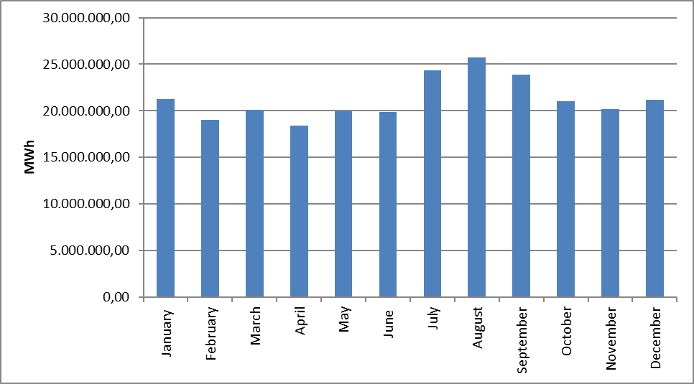
Development of actual consumption over the years is shown in Figure 1.20. Actual consumption has decreased compared to the previous year in 2001, 2009, 2019 and 2022 in the last 22 years. In 2023, it increased by 0,17% compared to the previous year.

Figure 1.20: Development of Actual Consumption over the Years (GWh)
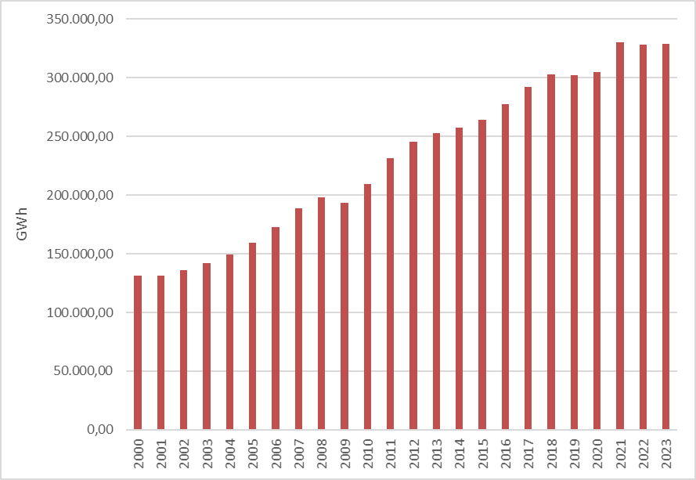

The development of the number of consumers for the years 2021, 2022 and 2023 on the basis of consumer type is shown in Table 1.16. In 2023, 83,46% of the total consumer will be residential consumers.

Table 1.16 Distribution of Number of Consumer by Consumer Type in 2023 (Number-%)
Consumer Type | 2021 |  | 2022 |  | 2023
Consumer Type | Number of Consumers | Share(%) | Number of Consumers | Share(%) | Number of Consumers | Share(%)
Household | 38.892.588 | 82,20 | 40.484.414 | 83,36 | 41.501.522 | 83,46
Public and Private Services Other by Sector | 7.278.067 | 15,38 | 6.984.433 | 14,38 | 7.114.036 | 14,31
Irrigation | 711.497 | 1,50 | 736.877 | 1,52 | 762.774 | 1,53
Lighting | 342.493 | 0,72 | 281.975 | 0,58 | 280.098 | 0,56
Industry | 87.341 | 0,18 | 75.760 | 0,16 | 68.051 | 0,14
Grand Total | 47.311.986 | 100,00 | 48.563.459 | 100,00 | 49.726.481 | 100,00

Table 1.17 shows the distribution of the number of consumers in 2023 on the basis of province and consumer type. The city with the highest number of consumers is Istanbul, followed by Ankara, Izmir, Antalya, Bursa and Konya, respectively. The province with the lowest number of consumers is Bayburt.

Table 1.17 Distribution of the Number of Consumers in 2023 by Province and Consumer Type (Number-%)
Province Name | Consumer Type | Number of Consumers | Share
İSTANBUL | Lighting | 18.664 | 0,04%
İSTANBUL | Public and Private Services Sector and Others | 1.311.041 | 2,64%
İSTANBUL | Household | 7.248.057 | 14,58%
İSTANBUL | Industry | 15.057 | 0,03%
İSTANBUL | Irrigation | 1.938 | 0,00%
İSTANBUL | Province Total | 8.594.757 | 17,28%
ANKARA | Lighting | 13.209 | 0,03%
ANKARA | Public and Private Services Sector and Others | 388.276 | 0,78%
ANKARA | Household | 2.793.020 | 5,62%
ANKARA | Industry | 2.668 | 0,01%
ANKARA | Irrigation | 11.192 | 0,02%
ANKARA | Province Total | 3.208.365 | 6,45%
İZMİR | Lighting | 13.404 | 0,03%
İZMİR | Public and Private Services Sector and Others | 473.114 | 0,95%
İZMİR | Household | 2.334.393 | 4,69%
İZMİR | Industry | 3.181 | 0,01%
İZMİR | Irrigation | 56.695 | 0,11%
İZMİR | Province Total | 2.880.787 | 5,79%
ANTALYA | Lighting | 11.633 | 0,02%
ANTALYA | Public and Private Services Sector and Others | 330.442 | 0,66%
ANTALYA | Household | 1.505.264 | 3,03%
ANTALYA | Industry | 2.878 | 0,01%
ANTALYA | Irrigation | 82.986 | 0,17%
ANTALYA | Province Total | 1.933.203 | 3,89%
BURSA | Lighting | 7.361 | 0,01%
BURSA | Public and Private Services Sector and Others | 290.478 | 0,58%
BURSA | Household | 1.565.485 | 3,15%
BURSA | Industry | 5.436 | 0,01%
BURSA | Irrigation | 13.417 | 0,03%
BURSA | Province Total | 1.882.177 | 3,79%
KONYA | Lighting | 8.314 | 0,02%
KONYA | Public and Private Services Sector and Others | 219.582 | 0,44%
KONYA | Household | 1.084.114 | 2,18%
KONYA | Industry | 2.773 | 0,01%
KONYA | Irrigation | 34.599 | 0,07%
KONYA | Province Total | 1.349.382 | 2,71%
ADANA | Lighting | 5.973 | 0,01%
ADANA | Public and Private Services Sector and Others | 156.194 | 0,31%
ADANA | Household | 1.024.840 | 2,06%
ADANA | Industry | 1.450 | 0,00%
ADANA | Irrigation | 10.663 | 0,02%
ADANA | Province Total | 1.199.120 | 2,41%
MERSİN | Lighting | 7.363 | 0,01%
MERSİN | Public and Private Services Sector and Others | 134.742 | 0,27%
MERSİN | Household | 960.308 | 1,93%
MERSİN | Industry | 1.304 | 0,00%
MERSİN | Irrigation | 52.431 | 0,11%
MERSİN | Province Total | 1.156.148 | 2,33%
KOCAELİ | Lighting | 4.810 | 0,01%
KOCAELİ | Public and Private Services Sector and Others | 127.369 | 0,26%
KOCAELİ | Household | 943.593 | 1,90%
KOCAELİ | Industry | 2.082 | 0,00%
KOCAELİ | Irrigation | 3.191 | 0,01%
KOCAELİ | Province Total | 1.081.045 | 2,17%
BALIKESİR | Lighting | 5.745 | 0,01%
BALIKESİR | Public and Private Services Sector and Others | 167.484 | 0,34%
BALIKESİR | Household | 882.950 | 1,78%
BALIKESİR | Industry | 1.608 | 0,00%
BALIKESİR | Irrigation | 15.129 | 0,03%
BALIKESİR | Province Total | 1.072.916 | 2,16%
SAMSUN | Lighting | 8.909 | 0,02%
SAMSUN | Public and Private Services Sector and Others | 132.476 | 0,27%
SAMSUN | Household | 799.214 | 1,61%
SAMSUN | Industry | 1.322 | 0,00%
SAMSUN | Irrigation | 34.620 | 0,07%
SAMSUN | Province Total | 976.541 | 1,96%
MANİSA | Lighting | 5.337 | 0,01%
MANİSA | Public and Private Services Sector and Others | 145.179 | 0,29%
MANİSA | Household | 747.195 | 1,50%
MANİSA | Industry | 1.125 | 0,00%
MANİSA | Irrigation | 51.453 | 0,10%
MANİSA | Province Total | 950.289 | 1,91%
GAZİANTEP | Lighting | 4.872 | 0,01%
GAZİANTEP | Public and Private Services Sector and Others | 136.529 | 0,27%
GAZİANTEP | Household | 735.757 | 1,48%
GAZİANTEP | Industry | 1.490 | 0,00%
GAZİANTEP | Irrigation | 14.593 | 0,03%
GAZİANTEP | Province Total | 893.241 | 1,80%
HATAY | Lighting | 4.354 | 0,01%
HATAY | Public and Private Services Sector and Others | 103.512 | 0,21%
HATAY | Household | 722.238 | 1,45%
HATAY | Industry | 1.125 | 0,00%
HATAY | Irrigation | 15.861 | 0,03%
HATAY | Province Total | 847.090 | 1,70%
KAYSERİ | Lighting | 9.164 | 0,02%
KAYSERİ | Public and Private Services Sector and Others | 112.702 | 0,23%
KAYSERİ | Household | 713.268 | 1,43%
KAYSERİ | Industry | 2.185 | 0,00%
KAYSERİ | Irrigation | 5.178 | 0,01%
KAYSERİ | Province Total | 842.497 | 1,69%
AYDIN | Lighting | 4.682 | 0,01%
AYDIN | Public and Private Services Sector and Others | 102.864 | 0,21%
AYDIN | Household | 691.138 | 1,39%
AYDIN | Industry | 657 | 0,00%
AYDIN | Irrigation | 26.259 | 0,05%
AYDIN | Province Total | 825.600 | 1,66%
MUĞLA | Lighting | 5.088 | 0,01%
MUĞLA | Public and Private Services Sector and Others | 128.299 | 0,26%
MUĞLA | Household | 613.328 | 1,23%
MUĞLA | Industry | 706 | 0,00%
MUĞLA | Irrigation | 34.234 | 0,07%
MUĞLA | Province Total | 781.655 | 1,57%
ŞANLIURFA | Lighting | 6.285 | 0,01%
ŞANLIURFA | Public and Private Services Sector and Others | 100.099 | 0,20%
ŞANLIURFA | Household | 619.964 | 1,25%
ŞANLIURFA | Industry | 651 | 0,00%
ŞANLIURFA | Irrigation | 29.607 | 0,06%
ŞANLIURFA | Province Total | 756.606 | 1,52%
TEKİRDAĞ | Lighting | 3.301 | 0,01%
TEKİRDAĞ | Public and Private Services Sector and Others | 140.941 | 0,28%
TEKİRDAĞ | Household | 592.766 | 1,19%
TEKİRDAĞ | Industry | 1.681 | 0,00%
TEKİRDAĞ | Irrigation | 1.492 | 0,00%
TEKİRDAĞ | Province Total | 740.181 | 1,49%
DENİZLİ | Lighting | 4.226 | 0,01%
DENİZLİ | Public and Private Services Sector and Others | 96.985 | 0,20%
DENİZLİ | Household | 563.242 | 1,13%
DENİZLİ | Industry | 1.848 | 0,00%
DENİZLİ | Irrigation | 14.684 | 0,03%
DENİZLİ | Province Total | 680.985 | 1,37%
ESKİŞEHİR | Lighting | 2.146 | 0,00%
ESKİŞEHİR | Public and Private Services Sector and Others | 103.409 | 0,21%
ESKİŞEHİR | Household | 561.905 | 1,13%
ESKİŞEHİR | Industry | 713 | 0,00%
ESKİŞEHİR | Irrigation | 10.120 | 0,02%
ESKİŞEHİR | Province Total | 678.293 | 1,36%
TRABZON | Lighting | 3.764 | 0,01%
TRABZON | Public and Private Services Sector and Others | 85.704 | 0,17%
TRABZON | Household | 566.170 | 1,14%
TRABZON | Industry | 349 | 0,00%
TRABZON | Irrigation | 1.220 | 0,00%
TRABZON | Province Total | 657.207 | 1,32%
SAKARYA | Lighting | 3.424 | 0,01%
SAKARYA | Public and Private Services Sector and Others | 83.937 | 0,17%
SAKARYA | Household | 550.862 | 1,11%
SAKARYA | Industry | 1.158 | 0,00%
SAKARYA | Irrigation | 4.357 | 0,01%
SAKARYA | Province Total | 643.738 | 1,29%
DİYARBAKIR | Lighting | 4.780 | 0,01%
DİYARBAKIR | Public and Private Services Sector and Others | 88.663 | 0,18%
DİYARBAKIR | Household | 528.690 | 1,06%
DİYARBAKIR | Industry | 339 | 0,00%
DİYARBAKIR | Irrigation | 6.095 | 0,01%
DİYARBAKIR | Province Total | 628.567 | 1,26%
ORDU | Lighting | 5.136 | 0,01%
ORDU | Public and Private Services Sector and Others | 73.693 | 0,15%
ORDU | Household | 542.366 | 1,09%
ORDU | Industry | 430 | 0,00%
ORDU | Irrigation | 508 | 0,00%
ORDU | Province Total | 622.133 | 1,25%
KAHRAMANMARAŞ | Lighting | 4.086 | 0,01%
KAHRAMANMARAŞ | Public and Private Services Sector and Others | 57.306 | 0,12%
KAHRAMANMARAŞ | Household | 444.458 | 0,89%
KAHRAMANMARAŞ | Industry | 937 | 0,00%
KAHRAMANMARAŞ | Irrigation | 17.901 | 0,04%
KAHRAMANMARAŞ | Province Total | 524.688 | 1,06%
AFYONKARAHİSAR | Lighting | 2.624 | 0,01%
AFYONKARAHİSAR | Public and Private Services Sector and Others | 78.751 | 0,16%
AFYONKARAHİSAR | Household | 403.663 | 0,81%
AFYONKARAHİSAR | Industry | 933 | 0,00%
AFYONKARAHİSAR | Irrigation | 13.435 | 0,03%
AFYONKARAHİSAR | Province Total | 499.406 | 1,00%
ÇANAKKALE | Lighting | 2.730 | 0,01%
ÇANAKKALE | Public and Private Services Sector and Others | 75.677 | 0,15%
ÇANAKKALE | Household | 362.007 | 0,73%
ÇANAKKALE | Industry | 424 | 0,00%
ÇANAKKALE | Irrigation | 8.963 | 0,02%
ÇANAKKALE | Province Total | 449.801 | 0,90%
KÜTAHYA | Lighting | 1.977 | 0,00%
KÜTAHYA | Public and Private Services Sector and Others | 67.664 | 0,14%
KÜTAHYA | Household | 365.355 | 0,73%
KÜTAHYA | Industry | 679 | 0,00%
KÜTAHYA | Agricultural Activities | 3.354 | 0,01%
KÜTAHYA | Province Total | 439.029 | 0,88%
VAN | Lighting | 3.504 | 0,01%
VAN | Public and Private Services Sector and Others | 57.765 | 0,12%
VAN | Household | 373.874 | 0,75%
VAN | Industry | 78 | 0,00%
VAN | Irrigation | 939 | 0,00%
VAN | Province Total | 436.160 | 0,88%
SİVAS | Lighting | 3.685 | 0,01%
SİVAS | Public and Private Services Sector and Others | 50.579 | 0,10%
SİVAS | Household | 370.939 | 0,75%
SİVAS | Industry | 266 | 0,00%
SİVAS | Irrigation | 3.079 | 0,01%
SİVAS | Province Total | 428.548 | 0,86%
ERZURUM | Lighting | 3.660 | 0,01%
ERZURUM | Public and Private Services Sector and Others | 56.300 | 0,11%
ERZURUM | Household | 364.143 | 0,73%
ERZURUM | Industry | 108 | 0,00%
ERZURUM | Irrigation | 494 | 0,00%
ERZURUM | Province Total | 424.705 | 0,85%
MALATYA | Lighting | 4.194 | 0,01%
MALATYA | Public and Private Services Sector and Others | 61.444 | 0,12%
MALATYA | Household | 332.850 | 0,67%
MALATYA | Industry | 195 | 0,00%
MALATYA | Irrigation | 23.440 | 0,05%
MALATYA | Province Total | 422.123 | 0,85%
ZONGULDAK | Lighting | 3.353 | 0,01%
ZONGULDAK | Public and Private Services Sector and Others | 58.095 | 0,12%
ZONGULDAK | Household | 354.415 | 0,71%
ZONGULDAK | Industry | 306 | 0,00%
ZONGULDAK | Irrigation | 1.141 | 0,00%
ZONGULDAK | Province Total | 417.310 | 0,84%
ELAZIĞ | Lighting | 2.945 | 0,01%
ELAZIĞ | Public and Private Services Sector and Others | 56.435 | 0,11%
ELAZIĞ | Household | 333.069 | 0,67%
ELAZIĞ | Industry | 279 | 0,00%
ELAZIĞ | Irrigation | 17.545 | 0,04%
ELAZIĞ | Province Total | 410.273 | 0,83%
ÇORUM | Lighting | 2.931 | 0,01%
ÇORUM | Public and Private Services Sector and Others | 49.142 | 0,10%
ÇORUM | Household | 342.566 | 0,69%
ÇORUM | Industry | 463 | 0,00%
ÇORUM | Irrigation | 5.040 | 0,01%
ÇORUM | Province Total | 400.142 | 0,80%
GİRESUN | Lighting | 2.684 | 0,01%
GİRESUN | Public and Private Services Sector and Others | 42.574 | 0,09%
GİRESUN | Household | 328.979 | 0,66%
GİRESUN | Industry | 285 | 0,00%
GİRESUN | Irrigation | 505 | 0,00%
GİRESUN | Province Total | 375.027 | 0,75%
TOKAT | Lighting | 2.963 | 0,01%
TOKAT | Public and Private Services Sector and Others | 45.497 | 0,09%
TOKAT | Household | 323.342 | 0,65%
TOKAT | Industry | 512 | 0,00%
TOKAT | Irrigation | 1.886 | 0,00%
TOKAT | Province Total | 374.200 | 0,75%
MARDİN | Lighting | 3.032 | 0,01%
MARDİN | Public and Private Services Sector and Others | 54.182 | 0,11%
MARDİN | Household | 272.795 | 0,55%
MARDİN | Industry | 132 | 0,00%
MARDİN | Irrigation | 12.522 | 0,03%
MARDİN | Province Total | 342.663 | 0,69%
KASTAMONU | Lighting | 3.938 | 0,01%
KASTAMONU | Public and Private Services Sector and Others | 38.246 | 0,08%
KASTAMONU | Household | 272.126 | 0,55%
KASTAMONU | Industry | 268 | 0,00%
KASTAMONU | Irrigation | 1.289 | 0,00%
KASTAMONU | Province Total | 315.867 | 0,64%
ISPARTA | Lighting | 2.096 | 0,00%
ISPARTA | Public and Private Services Sector and Others | 43.069 | 0,09%
ISPARTA | Household | 256.738 | 0,52%
ISPARTA | Industry | 329 | 0,00%
ISPARTA | Irrigation | 11.218 | 0,02%
ISPARTA | Province Total | 313.450 | 0,63%
EDİRNE | Lighting | 1.922 | 0,00%
EDİRNE | Public and Private Services Sector and Others | 52.359 | 0,11%
EDİRNE | Household | 242.940 | 0,49%
EDİRNE | Industry | 327 | 0,00%
EDİRNE | Irrigation | 3.678 | 0,01%
EDİRNE | Province Total | 301.226 | 0,61%
YOZGAT | Lighting | 2.181 | 0,00%
YOZGAT | Public and Private Services Sector and Others | 37.595 | 0,08%
YOZGAT | Household | 244.318 | 0,49%
YOZGAT | Industry | 200 | 0,00%
YOZGAT | Irrigation | 3.697 | 0,01%
YOZGAT | Province Total | 287.991 | 0,58%
RİZE | Lighting | 2.266 | 0,00%
RİZE | Public and Private Services Sector and Others | 39.114 | 0,08%
RİZE | Household | 238.274 | 0,48%
RİZE | Industry | 259 | 0,00%
RİZE | Irrigation | 11 | 0,00%
RİZE | Province Total | 279.924 | 0,56%
UŞAK | Lighting | 1.555 | 0,00%
UŞAK | Public and Private Services Sector and Others | 45.137 | 0,09%
UŞAK | Household | 209.076 | 0,42%
UŞAK | Industry | 751 | 0,00%
UŞAK | Irrigation | 7.365 | 0,01%
UŞAK | Province Total | 263.884 | 0,53%
OSMANİYE | Lighting | 1.890 | 0,00%
OSMANİYE | Public and Private Services Sector and Others | 29.607 | 0,06%
OSMANİYE | Household | 230.809 | 0,46%
OSMANİYE | Industry | 141 | 0,00%
OSMANİYE | Irrigation | 1.003 | 0,00%
OSMANİYE | Province Total | 263.450 | 0,53%
AKSARAY | Lighting | 1.661 | 0,00%
AKSARAY | Public and Private Services Sector and Others | 36.156 | 0,07%
AKSARAY | Household | 213.491 | 0,43%
AKSARAY | Industry | 246 | 0,00%
AKSARAY | Irrigation | 8.844 | 0,02%
AKSARAY | Province Total | 260.398 | 0,52%
KIRKLARELİ | Lighting | 1.446 | 0,00%
KIRKLARELİ | Public and Private Services Sector and Others | 41.730 | 0,08%
KIRKLARELİ | Household | 211.478 | 0,43%
KIRKLARELİ | Industry | 428 | 0,00%
KIRKLARELİ | Irrigation | 1.539 | 0,00%
KIRKLARELİ | Province Total | 256.621 | 0,52%
YALOVA | Lighting | 1.061 | 0,00%
YALOVA | Public and Private Services Sector and Others | 35.393 | 0,07%
YALOVA | Household | 207.058 | 0,42%
YALOVA | Industry | 294 | 0,00%
YALOVA | Irrigation | 2.894 | 0,01%
YALOVA | Province Total | 246.700 | 0,50%
NİĞDE | Lighting | 1.415 | 0,00%
NİĞDE | Public and Private Services Sector and Others | 27.818 | 0,06%
NİĞDE | Household | 204.348 | 0,41%
NİĞDE | Industry | 243 | 0,00%
NİĞDE | Irrigation | 10.243 | 0,02%
NİĞDE | Province Total | 244.067 | 0,49%
ADIYAMAN | Lighting | 2.139 | 0,00%
ADIYAMAN | Public and Private Services Sector and Others | 27.152 | 0,05%
ADIYAMAN | Household | 207.146 | 0,42%
ADIYAMAN | Industry | 194 | 0,00%
ADIYAMAN | Irrigation | 6.112 | 0,01%
ADIYAMAN | Province Total | 242.743 | 0,49%
AMASYA | Lighting | 2.549 | 0,01%
AMASYA | Public and Private Services Sector and Others | 34.569 | 0,07%
AMASYA | Household | 199.027 | 0,40%
AMASYA | Industry | 334 | 0,00%
AMASYA | Irrigation | 5.556 | 0,01%
AMASYA | Province Total | 242.035 | 0,49%
DÜZCE | Lighting | 1.682 | 0,00%
DÜZCE | Public and Private Services Sector and Others | 29.246 | 0,06%
DÜZCE | Household | 200.592 | 0,40%
DÜZCE | Industry | 477 | 0,00%
DÜZCE | Irrigation | 539 | 0,00%
DÜZCE | Province Total | 232.536 | 0,47%
BATMAN | Lighting | 1.934 | 0,00%
BATMAN | Public and Private Services Sector and Others | 32.174 | 0,06%
BATMAN | Household | 188.206 | 0,38%
BATMAN | Industry | 119 | 0,00%
BATMAN | Irrigation | 2.580 | 0,01%
BATMAN | Province Total | 225.013 | 0,45%
NEVŞEHİR | Lighting | 1.495 | 0,00%
NEVŞEHİR | Public and Private Services Sector and Others | 33.187 | 0,07%
NEVŞEHİR | Household | 174.960 | 0,35%
NEVŞEHİR | Industry | 413 | 0,00%
NEVŞEHİR | Irrigation | 7.061 | 0,01%
NEVŞEHİR | Province Total | 217.116 | 0,44%
BURDUR | Lighting | 1.430 | 0,00%
BURDUR | Public and Private Services Sector and Others | 30.744 | 0,06%
BURDUR | Household | 158.651 | 0,32%
BURDUR | Industry | 337 | 0,00%
BURDUR | Irrigation | 12.417 | 0,02%
BURDUR | Province Total | 203.579 | 0,41%
BOLU | Lighting | 1.920 | 0,00%
BOLU | Public and Private Services Sector and Others | 23.834 | 0,05%
BOLU | Household | 174.906 | 0,35%
BOLU | Industry | 222 | 0,00%
BOLU | Irrigation | 2.669 | 0,01%
BOLU | Province Total | 203.551 | 0,41%
AĞRI | Lighting | 2.074 | 0,00%
AĞRI | Public and Private Services Sector and Others | 26.394 | 0,05%
AĞRI | Household | 170.975 | 0,34%
AĞRI | Industry | 85 | 0,00%
AĞRI | Irrigation | 322 | 0,00%
AĞRI | Province Total | 199.850 | 0,40%
SİNOP | Lighting | 2.063 | 0,00%
SİNOP | Public and Private Services Sector and Others | 24.707 | 0,05%
SİNOP | Household | 171.385 | 0,34%
SİNOP | Industry | 240 | 0,00%
SİNOP | Irrigation | 1.280 | 0,00%
SİNOP | Province Total | 199.675 | 0,40%
KIRIKKALE | Lighting | 1.127 | 0,00%
KIRIKKALE | Public and Private Services Sector and Others | 18.902 | 0,04%
KIRIKKALE | Household | 159.589 | 0,32%
KIRIKKALE | Industry | 114 | 0,00%
KIRIKKALE | Irrigation | 2.377 | 0,00%
KIRIKKALE | Province Total | 182.109 | 0,37%
ERZİNCAN | Lighting | 1.650 | 0,00%
ERZİNCAN | Public and Private Services Sector and Others | 27.002 | 0,05%
ERZİNCAN | Household | 151.170 | 0,30%
ERZİNCAN | Industry | 82 | 0,00%
ERZİNCAN | Irrigation | 730 | 0,00%
ERZİNCAN | Province Total | 180.634 | 0,36%
KARABÜK | Lighting | 1.465 | 0,00%
KARABÜK | Public and Private Services Sector and Others | 21.034 | 0,04%
KARABÜK | Household | 153.222 | 0,31%
KARABÜK | Industry | 221 | 0,00%
KARABÜK | Irrigation | 2.125 | 0,00%
KARABÜK | Province Total | 178.067 | 0,36%
KARAMAN | Lighting | 896 | 0,00%
KARAMAN | Public and Private Services Sector and Others | 24.808 | 0,05%
KARAMAN | Household | 143.534 | 0,29%
KARAMAN | Industry | 175 | 0,00%
KARAMAN | Irrigation | 4.579 | 0,01%
KARAMAN | Province Total | 173.992 | 0,35%
KIRŞEHİR | Lighting | 1.128 | 0,00%
KIRŞEHİR | Public and Private Services Sector and Others | 22.289 | 0,04%
KIRŞEHİR | Household | 144.338 | 0,29%
KIRŞEHİR | Industry | 126 | 0,00%
KIRŞEHİR | Irrigation | 2.505 | 0,01%
KIRŞEHİR | Province Total | 170.386 | 0,34%
BİLECİK | Lighting | 789 | 0,00%
BİLECİK | Public and Private Services Sector and Others | 22.562 | 0,05%
BİLECİK | Household | 128.896 | 0,26%
BİLECİK | Industry | 564 | 0,00%
BİLECİK | Irrigation | 2.002 | 0,00%
BİLECİK | Province Total | 154.813 | 0,31%
BİNGÖL | Lighting | 1.434 | 0,00%
BİNGÖL | Public and Private Services Sector and Others | 18.839 | 0,04%
BİNGÖL | Household | 133.513 | 0,27%
BİNGÖL | Industry | 72 | 0,00%
BİNGÖL | Irrigation | 890 | 0,00%
BİNGÖL | Province Total | 154.748 | 0,31%
MUŞ | Lighting | 1.651 | 0,00%
MUŞ | Public and Private Services Sector and Others | 19.481 | 0,04%
MUŞ | Household | 131.550 | 0,26%
MUŞ | Industry | 29 | 0,00%
MUŞ | Irrigation | 874 | 0,00%
MUŞ | Province Total | 153.585 | 0,31%
ŞIRNAK | Lighting | 1.639 | 0,00%
ŞIRNAK | Public and Private Services Sector and Others | 20.929 | 0,04%
ŞIRNAK | Household | 126.556 | 0,25%
ŞIRNAK | Industry | 81 | 0,00%
ŞIRNAK | Irrigation | 1.049 | 0,00%
ŞIRNAK | Province Total | 150.254 | 0,30%
BARTIN | Lighting | 1.204 | 0,00%
BARTIN | Public and Private Services Sector and Others | 20.855 | 0,04%
BARTIN | Household | 125.602 | 0,25%
BARTIN | Industry | 88 | 0,00%
BARTIN | Irrigation | 1.379 | 0,00%
BARTIN | Province Total | 149.128 | 0,30%
BİTLİS | Lighting | 1.349 | 0,00%
BİTLİS | Public and Private Services Sector and Others | 19.786 | 0,04%
BİTLİS | Household | 122.607 | 0,25%
BİTLİS | Industry | 84 | 0,00%
BİTLİS | Irrigation | 2.031 | 0,00%
BİTLİS | Province Total | 145.857 | 0,29%
ÇANKIRI | Lighting | 1.271 | 0,00%
ÇANKIRI | Public and Private Services Sector and Others | 13.253 | 0,03%
ÇANKIRI | Household | 128.358 | 0,26%
ÇANKIRI | Industry | 104 | 0,00%
ÇANKIRI | Irrigation | 1.688 | 0,00%
ÇANKIRI | Province Total | 144.674 | 0,29%
ARTVİN | Lighting | 1.532 | 0,00%
ARTVİN | Public and Private Services Sector and Others | 19.521 | 0,04%
ARTVİN | Household | 120.134 | 0,24%
ARTVİN | Industry | 124 | 0,00%
ARTVİN | Irrigation | 455 | 0,00%
ARTVİN | Province Total | 141.766 | 0,29%
KARS | Lighting | 1.087 | 0,00%
KARS | Public and Private Services Sector and Others | 19.835 | 0,04%
KARS | Household | 120.010 | 0,24%
KARS | Industry | 85 | 0,00%
KARS | Irrigation | 200 | 0,00%
KARS | Province Total | 141.217 | 0,28%
SİİRT | Lighting | 1.078 | 0,00%
SİİRT | Public and Private Services Sector and Others | 14.364 | 0,03%
SİİRT | Household | 95.025 | 0,19%
SİİRT | Industry | 64 | 0,00%
SİİRT | Irrigation | 195 | 0,00%
SİİRT | Province Total | 110.726 | 0,22%
GÜMÜŞHANE | Lighting | 1.020 | 0,00%
GÜMÜŞHANE | Public and Private Services Sector and Others | 10.846 | 0,02%
GÜMÜŞHANE | Household | 95.435 | 0,19%
GÜMÜŞHANE | Industry | 91 | 0,00%
GÜMÜŞHANE | Irrigation | 1.660 | 0,00%
GÜMÜŞHANE | Province Total | 109.052 | 0,22%
HAKKARİ | Lighting | 1.058 | 0,00%
HAKKARİ | Public and Private Services Sector and Others | 13.884 | 0,03%
HAKKARİ | Household | 78.228 | 0,16%
HAKKARİ | Industry | 26 | 0,00%
HAKKARİ | Irrigation | 203 | 0,00%
HAKKARİ | Province Total | 93.399 | 0,19%
IĞDIR | Lighting | 793 | 0,00%
IĞDIR | Public and Private Services Sector and Others | 15.483 | 0,03%
IĞDIR | Household | 74.708 | 0,15%
IĞDIR | Industry | 62 | 0,00%
IĞDIR | Irrigation | 132 | 0,00%
IĞDIR | Province Total | 91.178 | 0,18%
KİLİS | Lighting | 658 | 0,00%
KİLİS | Public and Private Services Sector and Others | 13.440 | 0,03%
KİLİS | Household | 64.948 | 0,13%
KİLİS | Industry | 52 | 0,00%
KİLİS | Irrigation | 3.610 | 0,01%
KİLİS | Province Total | 82.708 | 0,17%
TUNCELİ | Lighting | 1.034 | 0,00%
TUNCELİ | Public and Private Services Sector and Others | 8.213 | 0,02%
TUNCELİ | Household | 56.996 | 0,11%
TUNCELİ | Industry | 53 | 0,00%
TUNCELİ | Irrigation | 758 | 0,00%
TUNCELİ | Province Total | 67.054 | 0,13%
ARDAHAN | Lighting | 680 | 0,00%
ARDAHAN | Public and Private Services Sector and Others | 7.330 | 0,01%
ARDAHAN | Household | 56.762 | 0,11%
ARDAHAN | Industry | 20 | 0,00%
ARDAHAN | Irrigation | 2 | 0,00%
ARDAHAN | Province Total | 64.794 | 0,13%
BAYBURT | Lighting | 526 | 0,00%
BAYBURT | Public and Private Services Sector and Others | 8.024 | 0,02%
BAYBURT | Household | 51.255 | 0,10%
BAYBURT | Industry | 14 | 0,00%
BAYBURT | Irrigation | 247 | 0,00%
BAYBURT | Province Total | 60.066 | 0,12%
 | Grand Total | 49.726.481 | 100,00%

1.6 Import and Export

1.6.1 Import
In Figure 1.21, data on electricity imports in 2023 are shown by months. 75.96% of the total electricity import of 5,823,617.91 MWh in 2023 is from Georgia, 22.05% is from Bulgaria, 1.84% is from Greece, Iran, % 0.14 of them were from Iran. While the highest electricity import on a monthly basis was realized in January, the lowest electricity import was realized in October.

Figure 1.21: Electricity Imports (MWh) by Months in 2023
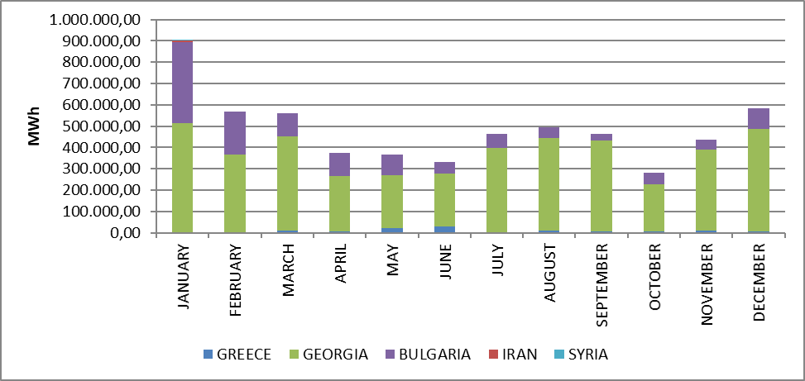

1.6.2 Export

In Figure 1.22, data regarding electricity exports in 2023 are shown by months. 55,56% of the total electricity export of 2.038.079,44 MWh in 2023 will go to Greece, 23,79% will go to Syria, 19,92% will go to Bulgaria and Iran. 0,71% of which was transferred to Iran. While the highest electricity export was realized on a monthly basis in January, the lowest electricity export was realized in May.

Figure 1.22: Electricity Exports by Months in 2023 (MWh)
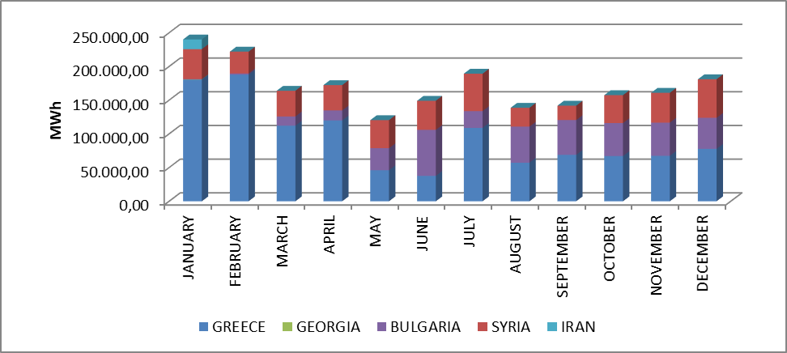

2. WHOLESALE MARKET

In this section, the developments in the wholesale market in 2023 are examined. In this context; Prices, volumes and instructions given in the Day Ahead Market (DAM), Intraday Market (IIP), Forward Electricity Market (FEM) and Balancing Power Market (BPM) are presented. Additionally, changes in the market structure are explained.
Primary Frequency Control (PFC) is to bring the system frequency to a new balance point by automatically increasing or decreasing the active power of the unit with the speed regulator in response to the decrease or increase in the system frequency, by damping the oscillation. PFC backup is provided from generation facilities that are determined to be capable of providing PFC service as a result of PFC performance tests in the Electricity Grid Regulation.
Secondary Frequency Control (SFC) is the act of increasing or decreasing the active power output of the generation facilities participating in the SFC service with signals automatically sent from the National Load Distribution Center, bringing the system frequency to the nominal value and the programmed value of the total electrical energy exchange with neighboring country electricity networks. SFC backup is provided from generation facilities that are determined to be capable of providing SFC service as a result of SFC performance tests in the Electricity Network Regulation.
With the Electricity Market Ancillary Services Regulation published in the Official Gazette dated 26 November 2017 and numbered 30252, participation in PFC and SFC services is no longer mandatory, and PFC and SFC reserves have started to be supplied through tenders on a voluntary basis. Currently, PFC reserves between 200-300 MW and SFC reserves between 700-1100 MW are kept, varying at different times of the day.

  - Day Ahead Market

In the process that started with the Electricity Market Law, it was aimed to create an electricity market that is transparent, reliable, competitive and integrated with the electricity markets of other countries. Many planned steps have been taken in line with this goal, and with each step taken, significant progress has been made to make the electricity market stronger and more dynamic, for market participants to take a more active role in the electricity market, and for market operators to manage and monitor the market in the best possible way.
The first step taken towards the goal of transitioning the electricity market from a single buyer, single seller model to a free and competitive electricity market model is the transition to a 3-time monthly settlement system on July 1, 2006. The next step is the Day Ahead Planning system, which became operational on December 1, 2009. These transition periods are of great importance in making the electricity market stronger and more dynamic. It has been ensured that the parties involved in the operation of the market have transferred the experiences they have gained and the developments they foresee in each transition period to new market models. As a matter of fact, in this context, December 1, 2011 became a milestone for the Turkish Electricity Market and the biggest step was taken for the targeted electricity market and the Day Ahead Market system, which is currently used, was created. With the establishment of the Day Ahead Market, a new dynamism and vision was brought to the Turkish Electricity Market and a transparent and competitive market spirit was instilled.
With the new market structure, the guarantee mechanism has also been put into practice, and within this framework, market participants registered in MFSC have been obliged to provide guarantee to the market operator for the transactions they have made in DAM. In addition to the said regulation, participants were given the opportunity to create portfolios. Finally, if system constraints continue systematically, TEİAŞ is offered the opportunity to switch to regional pricing by taking the constraints into account.
In the following process, subject to the provisions of the Electricity Market Law No. 6446 dated 14.03.2013 and the Turkish Commercial Code No. 6102, the Energy Exchange Istanbul (EXIST) was officially established after the completion of the registration procedures on March 18, 2015.
Within the scope of the Day Ahead Market operated by EPİAŞ, market clearing prices and buying, selling and matching amounts are announced in line with the offers submitted by market participants.
2023 DAM prices along with the weighted average price are given graphically in Figure 2.1.1 and Figure 2.1.2.

Figure 2.1.1: Hourly Development of Weighted Average Market Clearing Price an Market Clearing Price in 2023 (TL/MWh)
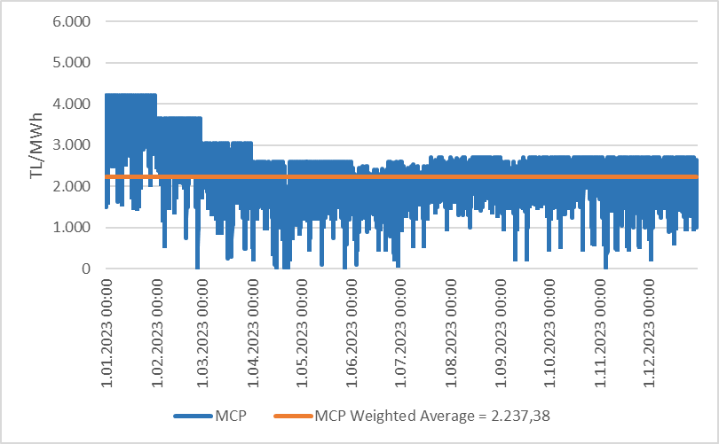

Figure 2.1.2: Organized and Weighted Average MCP in 2023 (TL/MWh)
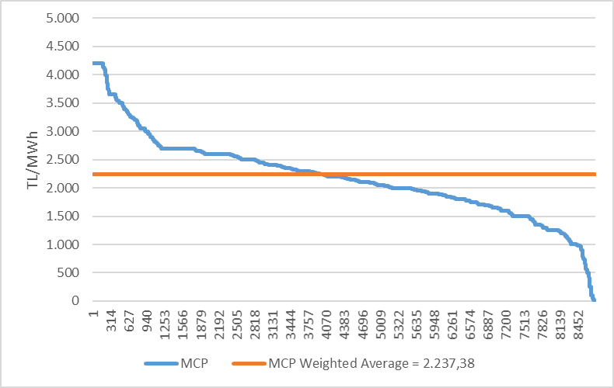
As seen in Figure 2.1.1, prices generally remained above the weighted average market clearing price in the first months of the year, but decreased in the following months. MCP reached its highest value of 4.200,0 TL/MWh for the first time at 17:00 on January 1, 2023. In 2023, the MCP for a total of 10 hours was 0 TL/MWh.
Figure 2.1.3 shows the weighted average market clearing prices in DAM over the years. Compared to 2022, the weighted average of the market clearing price decreased by 11,51% in 2023, reaching 2.237,38 TL/MWh.

Figure 2.1.3: Weighted Average MCP by Years (TL/MWh)
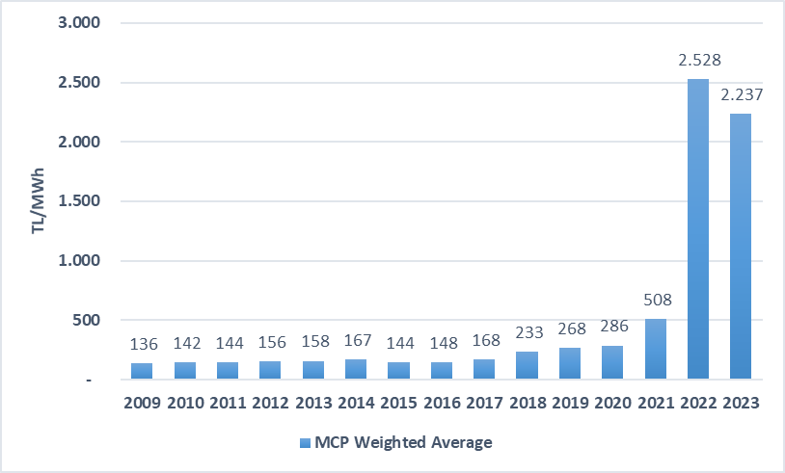
Figure 2.1.4 below shows the monthly weighted average DAM prices for the last two years. In 2023, the highest weighted average price was realized in January with 3.484,81 TL/MWh, and the lowest price was realized in June with 1.657,67 TL/MWh.
In spring and autumn, electricity consumption decreases as the climate becomes milder. In addition, especially with the high rainfall in the spring months, the water revenues of hydroelectric power plants increase and therefore prices are generally low in the spring months.
On the other hand, electricity demand increases due to the use of air conditioning and consumption for agricultural irrigation in the summer months and the need for heating and lighting in the winter months, and an increase in average prices is observed in parallel with the increase in consumption. On the other hand, events taking place around the world may also affect energy prices in our country upwards or downwards.

Figure 2.1.4: Monthly Weighted Average MCP of the Last Two Years (TL/MWh)
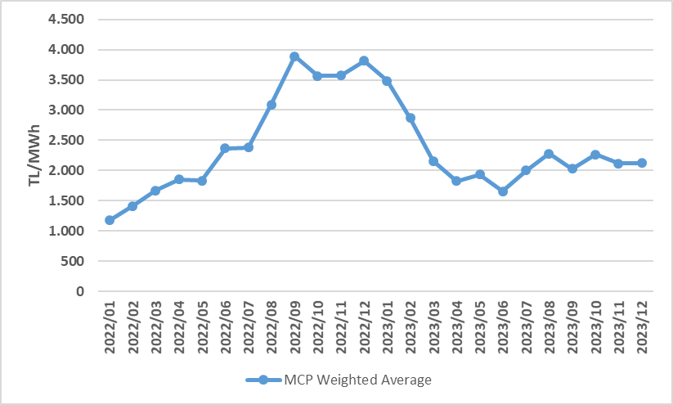
Figure 2.1.5 below shows the DAM matching amounts by month, Figure 2.1.6 shows the distribution of DAM purchase amounts on a company basis and the share of the top 10 companies, and Figure 2.1.7 shows the distribution of sales amounts on a company basis and the share of the top 10 companies.

Figure 2.1.5: Monthly Day-Ahead Market Matching Quantity (MWh)
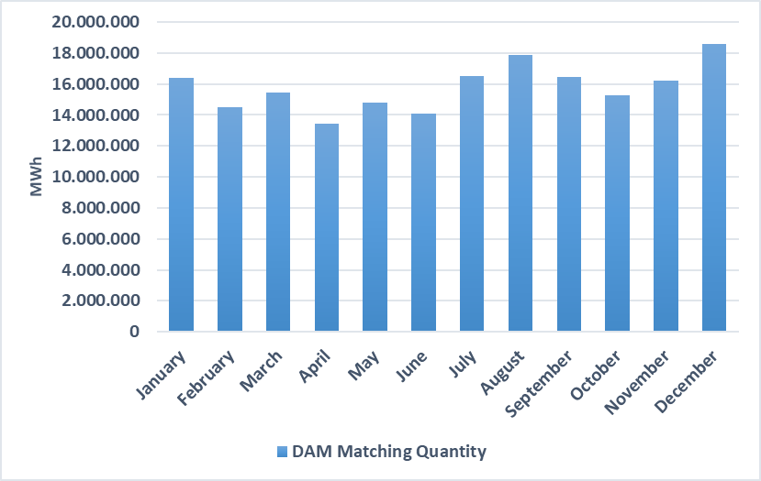

Figure 2.1.6: Share of Top 10 Companies by Purchase Amount in Day-Ahead Market (%)
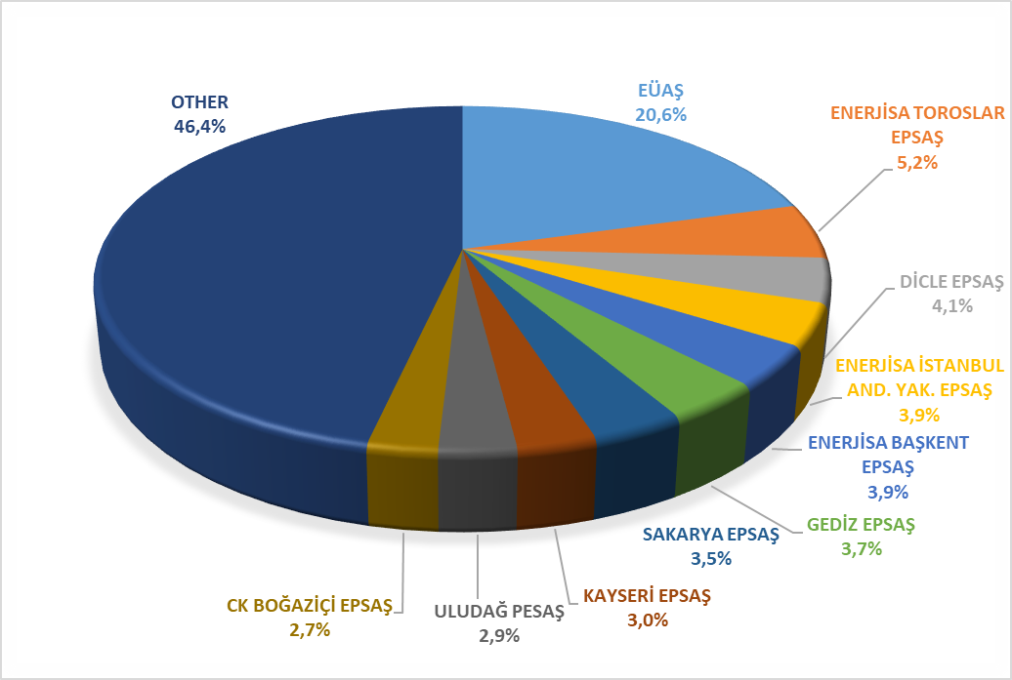

Figure 2.1.7: Share of Top 10 Companies by Sales Amount in the Day Ahead Market (%)
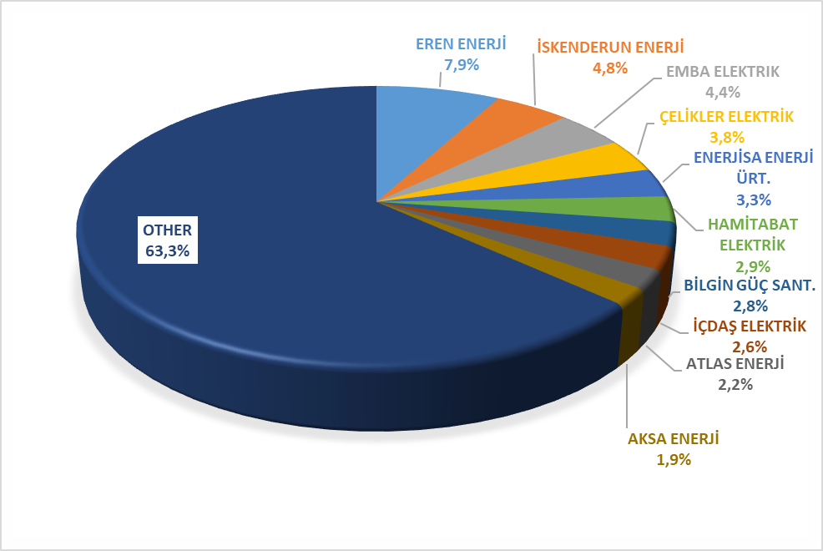
  - Balancing Power Market

Balancing Power Market is operated by TEİAŞ. This section presents data on the monthly development of prices and volumes in BPM. Prices formed in BPM in 2023 are shown on an hourly basis and arranged in Figure 2.2.1 and Figure 2.2.2.

Figure 2.2.1: Hourly System Marginal Price (SMP) (TL/MWh)
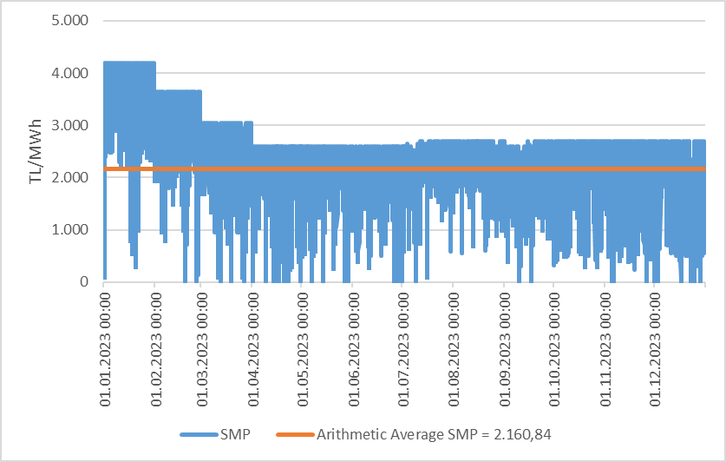

Figure 2.2.2: Organized System Marginal Price (TL/MWh)
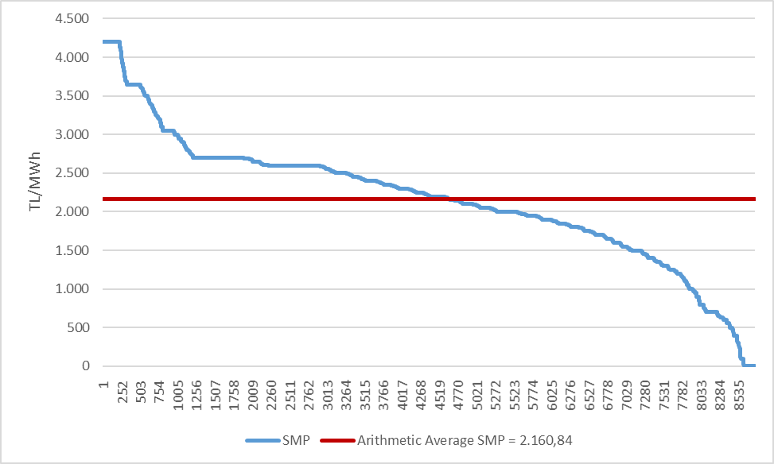
As seen in Figure 2.2.1, the System Marginal Price was generally above the annual average price in the first half of the year and decreased in the second half. The price in DGP reached its highest level of 4.200,0 TL/MWh for the first time at 17:00 on January 1, 2023, and remained at this value for a total of 219 hours during the year. In DGP, the price for 66 hours throughout 2023 was 0 TL/MWh.
The annual average (arithmetic) price in BPM decreased by 15,22% compared to the previous year and became 2.160,84 TL/MWh.
Monthly average (arithmetic) prices in the Balancing Power Market for the last two years are shown in Figure 2.2.3. In 2023, the lowest monthly average SMF value was seen in September with 1.771,53 TL/MWh, and the highest value was in January with 3.401,55 TL/MWh.

Figure 2.2.3: Monthly Arithmetic Average Prices of the Last Two Years in Balancing Power Market (TL/MWh)
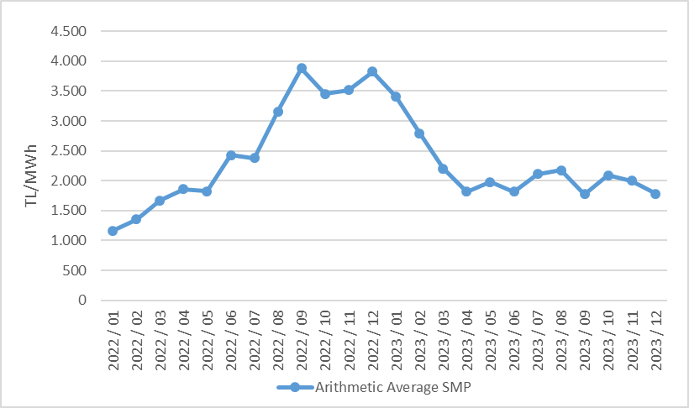

Figure 2.2.4 below shows the monthly volumes in BPM in 2023. It is noteworthy that the sales amounts are much higher than the purchases.

Figure 2.2.4: Monthly Trading Volumes in Balancing Power Market (MWh)
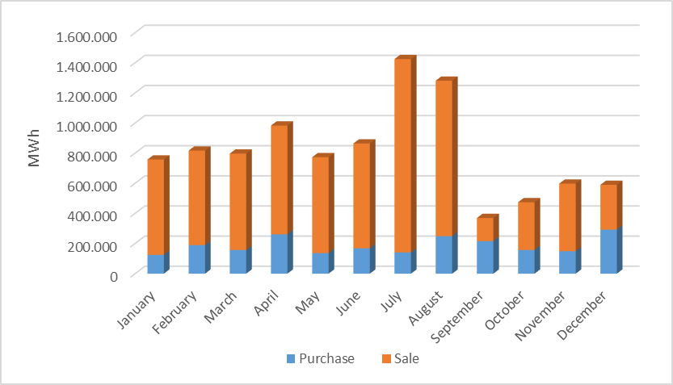
Figure 2.2.5 below shows the distribution of BPM purchase amounts on a company basis and the share of the top 10 companies, and Figure 2.2.6 shows the distribution of BPM sales amounts on a company basis and the share of the top 10 companies.

Figure 2.2.5: Share of Top 10 Companies by Purchase Amount in Balancing Power Market (%)
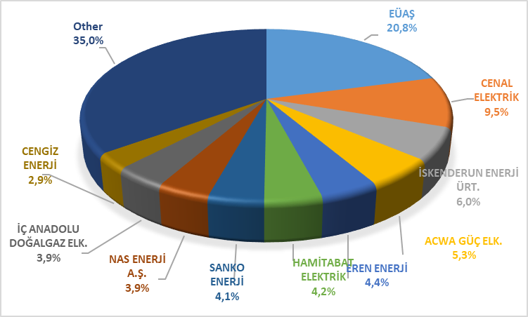

Figure 2.2.6: Share of Top 10 Companies by Sales Amount in Balancing Power Market (%)
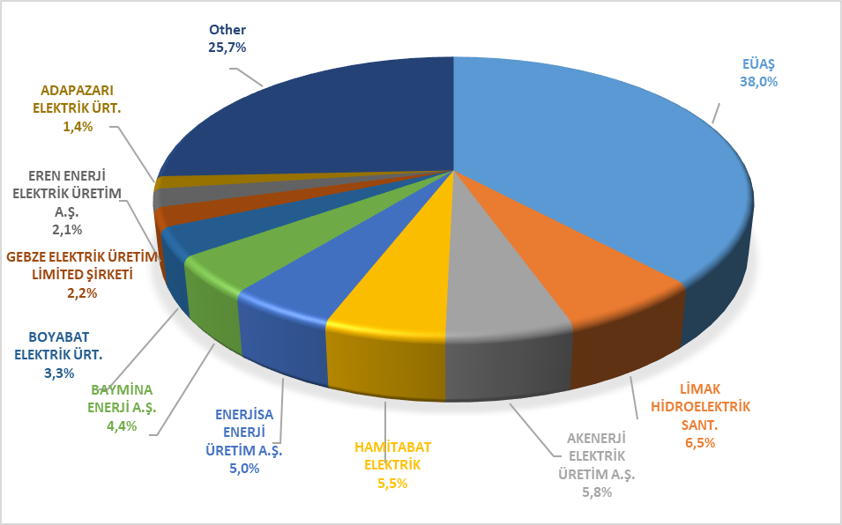
The rates of order volumes given in BPM as of 2023 are shown in Figure 2.2.7 below, and their hourly distribution is shown in Figure 2.2.8. 16% of the instructions are code 1 instructions given due to system constraints, and as of February 2018, since the tender system was introduced in ancillary services, no code 2 instructions were issued.

Figure 2.2.7: Rates of Order Volumes Given in Balancing Power Market in 2023 (%)
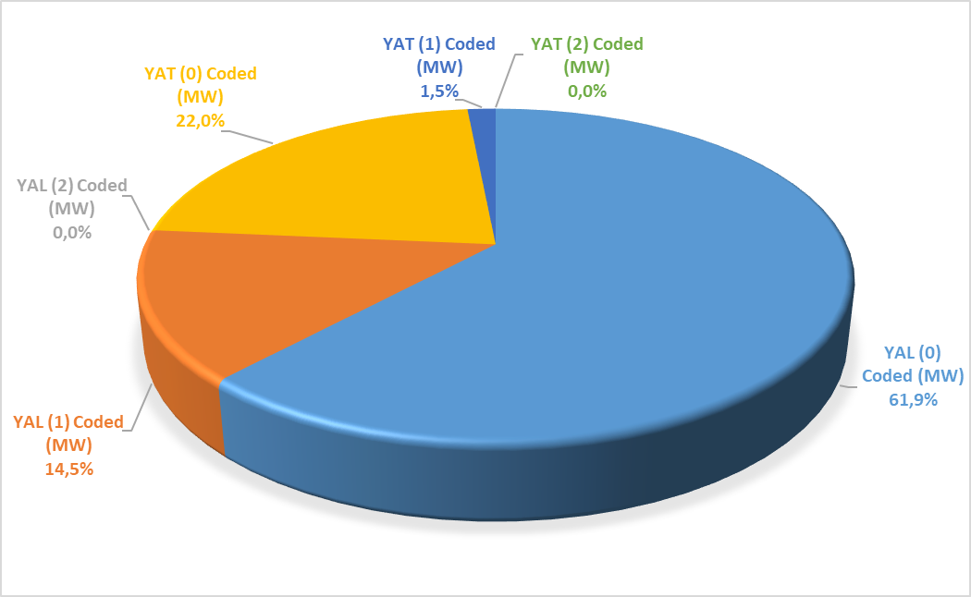

Figure 2.2.8: Hourly Distribution of Orders Given in the Balancing Power Market in 2023 (MW)
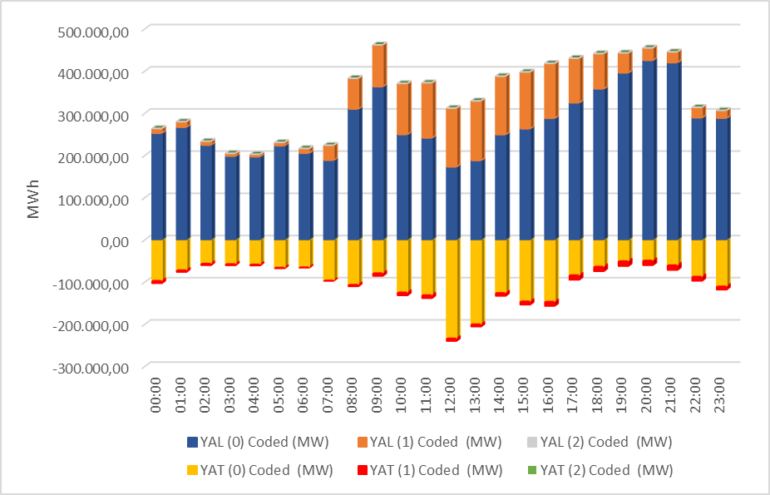
Additional costs arising from those instructions are shown in Table 2.2.1 below. While the additional total cost caused by the instructions given in BPM was 940,07 million TL in 2022, it was 1.315,10 million TL in 2023

Table 2.2.1: Additional Costs of Orders (Million TL)
The monthly development of additional costs arising from code 1 instructions given in 2023 is shown in Figure 2.2.9. The majority of additional costs occurred in June and July.

Figure 2.2.9: Monthly Development of Additional Costs of Orders in 2023 (Million TL)
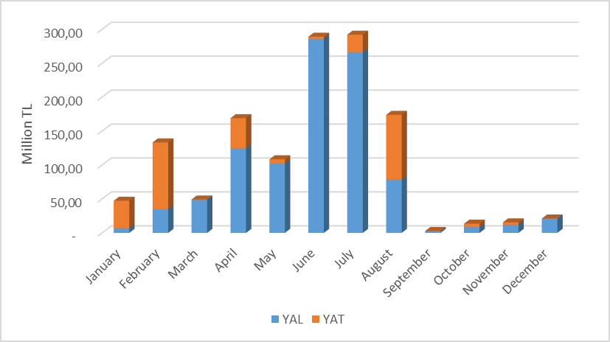

The change in Zero Balance Adjustment Component (ZBAC) over the years is shown in Figure 2.2.10. While ZBAC was realized as 1.117,80 Million TL in 2022, it was realized as 727,68 Million TL in 2023.

Figure 2.2.10: Yearly Development of Zero Balance Adjustment Component in 2023 (TL)
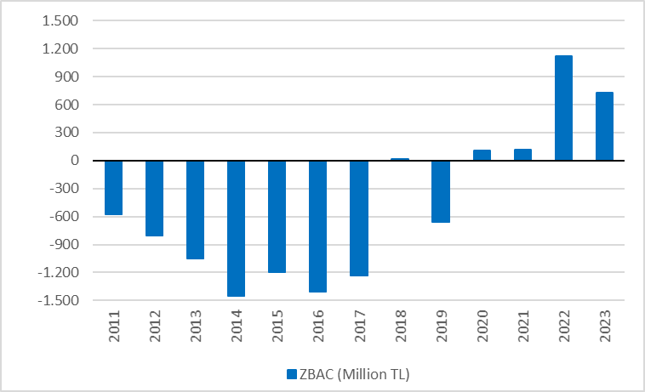

2.3 Intraday Market

Efforts are continuing to ensure that the Turkish Electricity Market is more transparent and effective, financially strong, and integrated with the European Union electricity markets. On July 1, 2015, in order to ensure that participants take a more balanced and effective role in the Turkish electricity market, which is constantly developing and advancing with the goal of a free market, Intraday Market has become operational.
With the Intraday Market, which is added to the already functioning Day Ahead, Ancillary Services and Balancing Power Markets, near real-time trading opportunities are provided and market participants are offered the opportunity to balance their portfolios in the short term.
Figure 2.3.1 below shows the development of the Intraday Market volume and weighted average price in 2023 by months.

Figure 2.3.1: Monthly Development of Trading Volume and Average Price in the Intra-Day Market (MWh – TL/MWh)
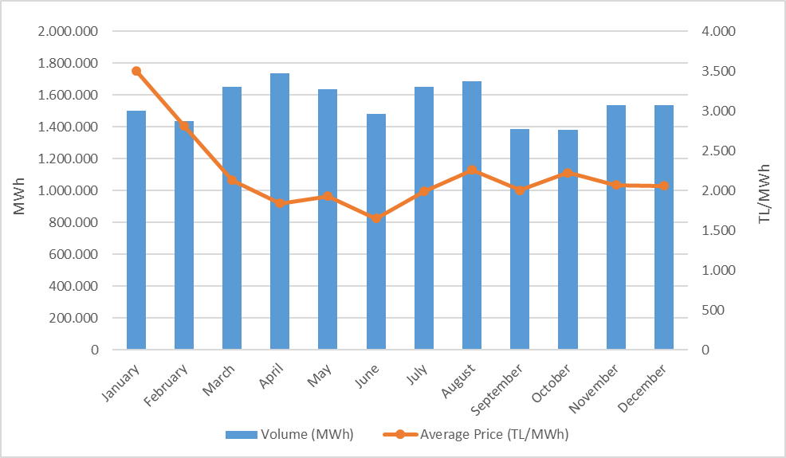
While the Intraday Market volume on a monthly basis was observed to be higher in the second quarter of the year, the highest monthly average price value was realized in January.
Figure 2.3.2 below shows the distribution of IDM purchase amounts on a company basis and the share of the top 10 companies, and Figure 2.3.3 shows the distribution of IDM sales amounts on a company basis and the share of the top 10 companies.

Figure 2.3.2: Share of Top 10 Companies by Purchase Amount in Intra-Day Market (%)
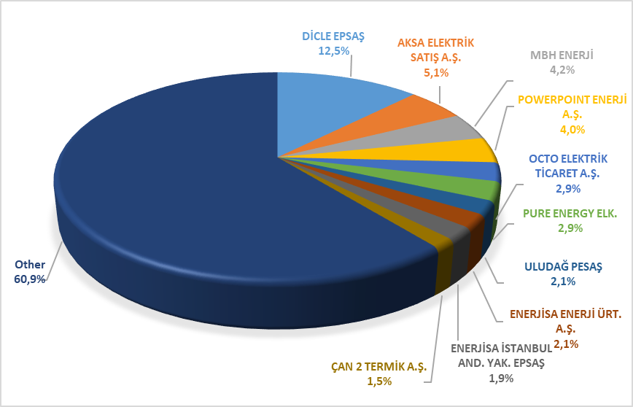

Figure 2.3.3: Share of Top 10 Companies by Sales Amount in Intra-Day Market (%)
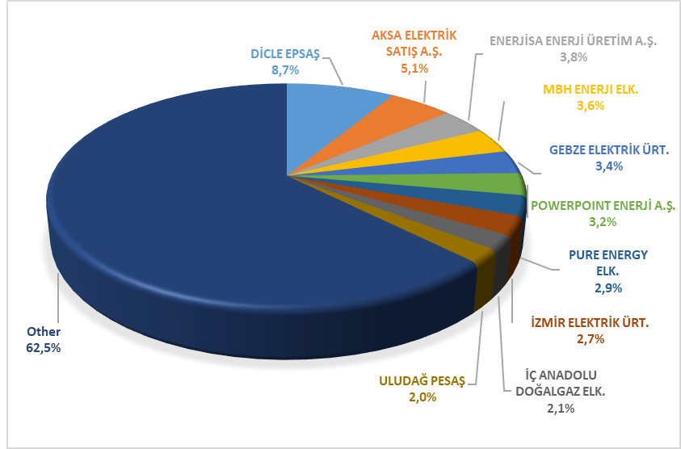

2.4 Bilateral Contracts Market
The structure of the Turkish electricity market is based on bilateral agreements, and other organized markets are designed to complement the market. Within this framework, most of the energy traded in the market is traded through bilateral agreements. Bilateral agreements are made freely between market participants and are not subject to regulation. Dec. in 2023, a large part of the current bilateral agreement volumes are comprised of bilateral agreements signed by private enterprises among themselves. Dec. In addition, distribution companies have energy purchases from EUAS for lost and general lighting purposes within the scope of the bilateral agreement. At the same time, commissioned supply companies can also make part of their energy purchases from EUAS within the scope of a bilateral agreement.
Figure 2.4.1 shows the bilateral agreement volumes on a monthly basis for the years 2020-2021-2022-2023.

Figure 2.4.1: Monthly Bilateral Contracts Volumes by Years (MWh)
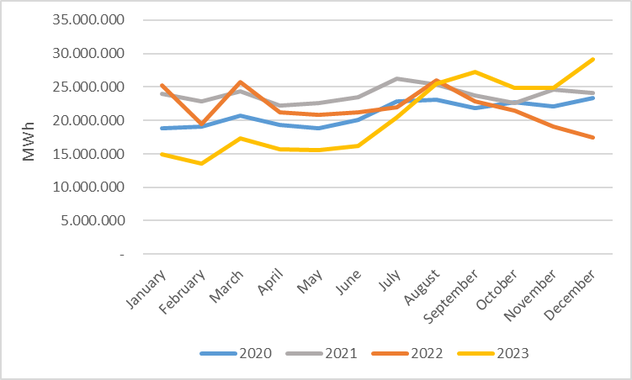
Below, Figure 2.4.2 shows the distribution of Bilateral Agreement purchase amounts by company and the share of the top 10 companies, Figure 2.4.3 shows the distribution of Bilateral Agreement sales amounts by company and the share of the top 10 companies.

Figure 2.4.2: Share of Top 10 Companies by Purchase Amount with Bilateral Contracts (%)
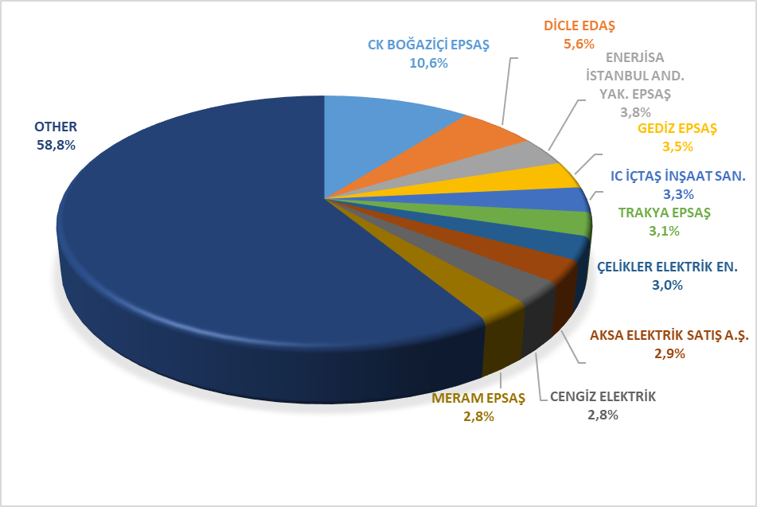

Figure 2.4.3: Share of Top 10 Companies by Sales Amount with Bilateral Contracts (%)
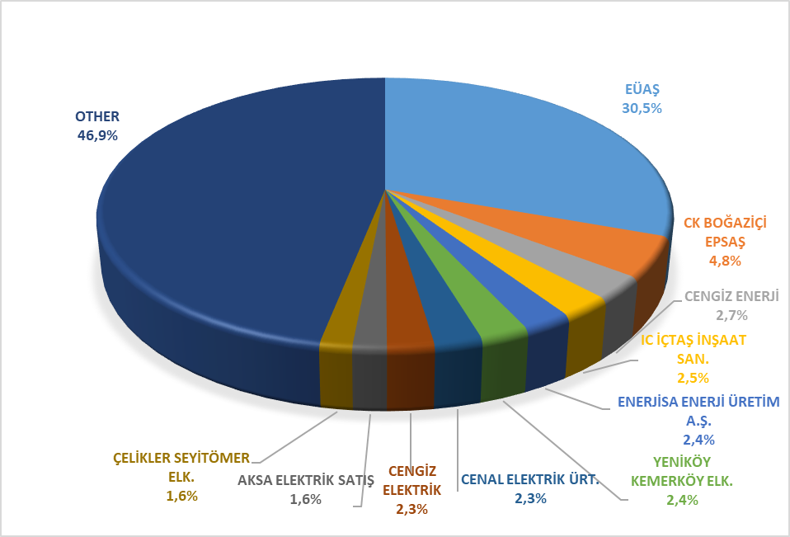

Figure 2.4.4 below shows the change in EUAŞ wholesale sales prices by periods.
The wholesale tariffs of EUAŞ (abolished TETAŞ) are determined by the Decision of the Board and the fulfillment of EUAŞ's obligations arising from existing contracts is taken into account. As can be seen in the figure below, while a single price was announced for the abolished TETAS wholesale tariff before 2017, a separate price was determined for the general lighting price starting from 2017, and for sales to authorized supply companies starting from 9/8/2022. In addition, the price of the third semester in 2018 has been announced to be valid from 1/8/2018. November August 2023 The active energy wholesale tariff for the commissioned supply companies was re-determined during the period with the decisions taken in August and November.

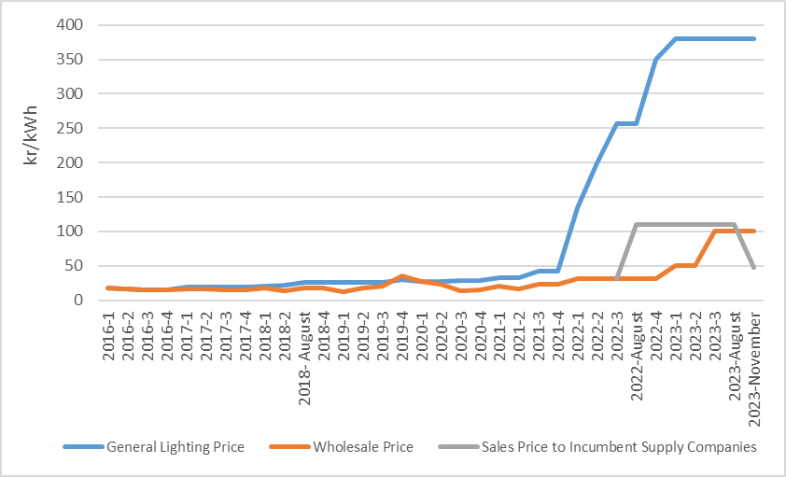
Figure 2.4.4: Wholesale Prices of EÜAŞ Between 2016-2023 (kr/kWh)

  - Renewable Energy Sources Support Mechanism (YEKDEM)

With the "Law No. 6094 on Amendments to the Law on the Use of Renewable Energy Resources for the Purpose of Electrical Energy Generation ", which came into force after being published in the Official Gazette No. 27809 dated January 8, 2011, incentives were regulated for renewable energy resources according to the type of resource and locality rate. In this context, the details of the Renewable Energy Resources Support Mechanism have been determined by the regulation prepared by EMRA.
“Regulation on Certification and Support of Renewable Energy Resources” came into force after being published in the Official Gazette No. 28782 dated 01/10/2013. The Regulation regulates the principles regarding the issuance of Renewable Energy Resource Certificate to generation license holders and the establishment and operation of the RES Support Mechanism (YEKDEM) in order to encourage the generation of electrical energy based on renewable energy sources.
By the Decision of the President dated 1717/09/2020 and numbered 2949, the date on which electricity generation plants based on renewable energy sources must enter into operation to benefit from the prices contained in the schedule I and II attached to the REK Law numbered 5346, determined on the basis of US dollar cents /kWh, has been extended to 30/6/2021 and the deadline for these power plants to benefit from YEKDEM has been set as 31/12/2030. Subsequently, with the amendment made on 2/12/2020 in the REK Law No. 5346, it has been arranged that the prices to be applied in Turkish lira and the procedures and principles for updating the prices to be applied to REK-certified electricity generation facilities that will enter into operation after 30/6/2021 will be determined by the President. In this context, with the Decision of the President dated 29/1/2021 and numbered 3453, a decision was taken on updating the prices and periods to be applied for electricity generation facilities based on renewable energy sources with a SINGLE certificate that will be put into operation from 1/7/2021 to 31/12/2025, as well as the prices that will be applied for electricity generation facilities based on renewable energy sources with a YEK certificate that will be put into operation from 1/7/2021 to 31/12/2025, within the framework of this decision, a price update was made in 3-month periods, and then a new decision was taken on the prices, periods and updating of these prices to be applied for renewable energy-based electricity generation facilities with a YEK Certificate that will be commissioned from 01/05/2023 and published in the Official Gazette 32177 dated 01/07/2021 to 31/12/2030 in accordance with the Decision of the President No. 7189. The prices within the scope of the RES Support Mechanism for 2023, determined in Turkish lira in accordance with the aforementioned decisions, are shown in Table 2.5.1.

Table 2.5.1: Number of Licensed YEKDEM Power Plants by Years
Generation Facility Type Based on Renewable Energy Source | 2023 YEKDEM Price (kr/kWh)
Generation Facility Type Based on Renewable Energy Source | 2023 1st Quarter | April | May | June | July | August | September | October | November | December
Hydroelectric generation facility (with reservoir)* | 101,06 | 107,91 | 144 | 146,23 | 161,22 | 180,09 | 187,9 | 192 | 197,89 | 204,57
Hydroelectric generation facility (River Type)* | 101,06 | 107,91 | 135 | 137,09 | 151,14 | 168,83 | 176,1 | 180 | 185,52 | 191,78
Wind energy based generation facility (Terrestrial)* | 80,86 | 86,34 | 106 | 107,64 | 118,67 | 132,56 | 138,3 | 141,3 | 145,66 | 150,58
Wind energy based generation facility (Offshore)* | 80,86 | 86,34 | 144 | 146,23 | 161,22 | 180,09 | 187,9 | 192 | 197,89 | 204,57
Generation facility based on geothermal energy | 136,43 | 145,68 | 202 | 205,13 | 226,15 | 252,62 | 263,5 | 269,3 | 277,6 | 286,97
Landfill Gas / Resources obtained from by-products resulting from the processing of waste tires | 80,86 | 86,34 | 106 | 107,64 | 118,67 | 132,56 | 138,3 | 141,3 | 145,66 | 150,58
Biomethanization | 136,43 | 145,68 | 173 | 175,68 | 193,68 | 216,35 | 225,7 | 230,7 | 237,74 | 245,76
Thermal Disposal (Municipal wastes, vegetable oil wastes, agricultural wastes without food and feed value, forest products other than industrial wood, industrial waste sludge and treatment sludge) | 126,33 | 134,9 | 134,9 | 136,99 | 151,03 | 168,71 | 176 | 179,9 | 185,39 | 191,65
Solar energy based generation facility | 80,86 | 86,34 | 106 | 107,64 | 118,67 | 132,56 | 138,3 | 141,3 | 145,66 | 150,58
*Within the scope of the decision No. 7189, the relevant facilities after May 2023 are separated according to their nature as in the table.

Table 2.5.2 shows the number of licensed YEKDEM participants by years, and it is observed that the number of participants and installed capacity decreased compared to last year. there are 884 licensed power plants with a total installed capacity of 19.259,2 MW operating within the scope of YEKDEM in 2023.

Table 2.5.2: Number of YEKDEM Participants by Years
Type | 2011 | 2012 | 2013 | 2014 | 2015 | 2016 | 2017 | 2018 | 2019 | 2020 | 2021 | 2022 | 2023
Solar | - | - | - | - | - | - | 2 | 3 | 9 | 17 | 32 | 36 | 36
Hydraulic | 4 | 44 | 14 | 40 | 126 | 388 | 418 | 447 | 463 | 463 | 449 | 426 | 312
Wind | 9 | 22 | 3 | 21 | 60 | 106 | 141 | 151 | 160 | 165 | 204 | 224 | 196
Biomass | 3 | 8 | 15 | 23 | 34 | 42 | 57 | 70 | 100 | 126 | 191 | 293 | 285
Geothermal | 4 | 4 | 6 | 9 | 14 | 20 | 29 | 37 | 45 | 50 | 53 | 57 | 55
Grand Total | 20 | 78 | 38 | 93 | 234 | 556 | 647 | 708 | 777 | 821 | 929 | 1.036 | 884

When we look at the distribution of YEKDEM's installed capacity by source type, it is seen that wind power plants with the highest share with 8.059,0 MW and hydraulic power plants with 7.441,3 MW are in the second place. it is believed that there has been a decrease in the power of hydraulic power plants compared to last year due to the increase in prices on the market until the Presidential decision taken in 2023, both for power plants whose support period has expired and for power plants that have not joined YEKDEM for 2023.

Table 2.5.3: Distribution of YEKDEM Installed Capacity by Resources (MW)*
*In addition, as of the end of 2023, 12.542,72 MW of the 13.040,53 MW of installed capacity excluding natural gas is also traded within the scope of YEKDEM within the scope of unlicensed electricity generation, the details of which are provided in Section 1.4 entitled “Unlicensed Electricity Generation”.
The ratio of the installed capacity under YEKDEM, including unlicensed power plants, to the total installed capacity of Turkey was 30,92% in 2022 and 29,08% in 2023.
Figure 2.5.1 below shows the resource-based distribution of the licensed YEKDEM installed capacity for 2023.

Figure 2.5.1: Distribution of YEKDEM Installed Capacity by Resources in 2023 (%)
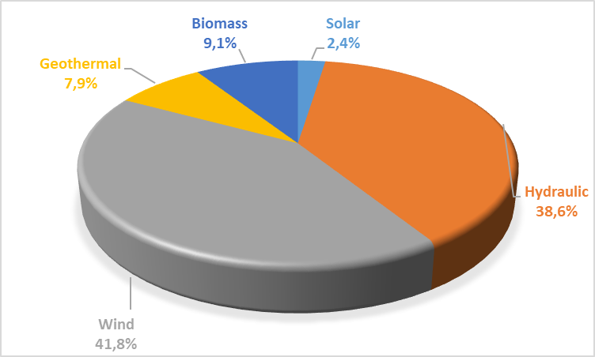

The development of YEKDEM participants' productions over the years is shown in Table 2.5.4. Production within the scope of YEKDEM in 2023, including unlicensed power plants, decreased by approximately 13,58% and it reached to 72,47 TWh.

Table 2.5.4: Yearly Generation of YEKDEM Participants by Years (MWh)*
Type | 2014 | 2015 | 2016 | 2017 | 2018 | 2019 | 2020 | 2021 | 2022 | 2023
Biomass | 957.223 | 1.082.913 | 10.613.594 | 8.992.792 | 2.047.082 | 2.817.209 | 3.730.699 | 5.169.983 | 6.904.471 | 7.459.119
Solar | - | - | - | 24.269 | 39.140 | 159.961 | 375.477 | 1.492.885 | 2.785.749 | 3.757.898
Hydraulic | 1.072.832 | 5.651.215 | 16.212.717 | 17.213.394 | 27.369.727 | 36.961.886 | 29.671.021 | 21.980.145 | 25.250.798 | 14.764.400
Geothermal | 1.436.579 | 2.710.856 | 3.706.765 | 4.503.345 | 5.968.202 | 6.997.209 | 7.816.510 | 8.162.845 | 8.549.919 | 8.023.490
Unlicensed | 29.316 | 223.537 | 1.134.023 | 2.997.551 | 8.078.418 | 9.830.849 | 11.229.723 | 12.149.419 | 12.860.061 | 15.136.167
Wind | 2.378.819 | 8.275.993 | 14.163.403 | 16.765.418 | 19.002.862 | 19.900.973 | 20.658.797 | 25.200.967 | 27.501.640 | 23.327.017
Grand Total | 5.874.769 | 17.944.514 | 45.830.502 | 50.496.769 | 62.505.431 | 76.668.087 | 73.482.227 | 74.156.245 | 83.852.638 | 72.468.092

The distribution of generation within the scope of YEKDEM by resources in 2023 is shown in Figure 2.5.2. The highest generation was obtained from wind and unlicensed energy.

Figure 2.5.2: Distribution of YEKDEM Generation by Resources in 2023 (%)
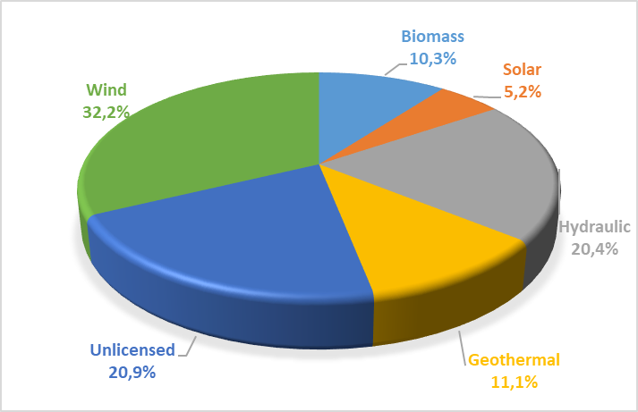
While the ratio of the generation in YEKDEM to the total electricity generation of the country was 25,78% in 2022, this rate decreased to 22,31 % in 2023.
Considering the monthly development of YEKDEM generation in Figure 2.5.3, it is seen that hydraulic production and therefore YEKDEM production increased due to the rainfall in spring months. Wind and unlicensed generation fluctuated throughout the year, while solar generation decreased in winter and increased in summer. The production from other resources was more stable throughout the year.

Figure 2.5.3: Monthly Development of YEKDEM Generation in 2023 (MWh)
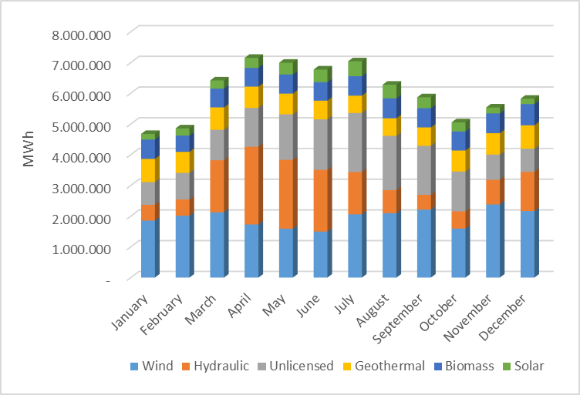

For 2023, the monthly development of the prices to be applied for electricity generation facilities in YEKDEM and DAM prices are shown together in Figure 2.5.4.
It is seen that the prices are approaching each other with the decrease in the PTF price in the second quarter of the year and the updates made in the YEKDEM prices.

Figure 2.5.4: Monthly Development of YEKDEM and DAM Prices in 2023 (TL/MWh)
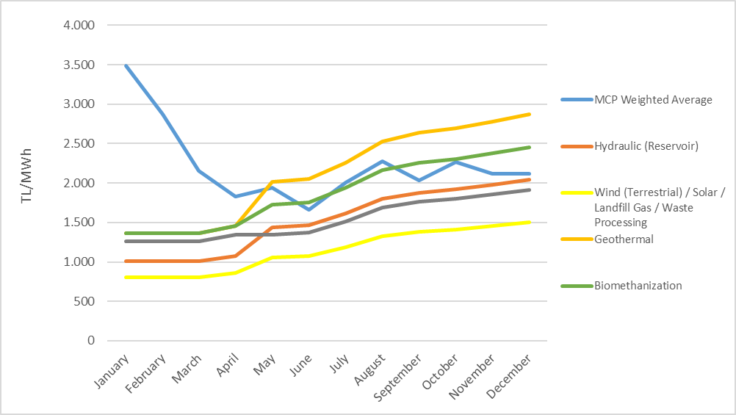
Figure 2.5.5 shows the monthly amounts of payments made within the scope of YEKDEM.

Figure 2.5.5: 2023 Monthly Payment Amount Made within the Scope of YEKDEM (TL)
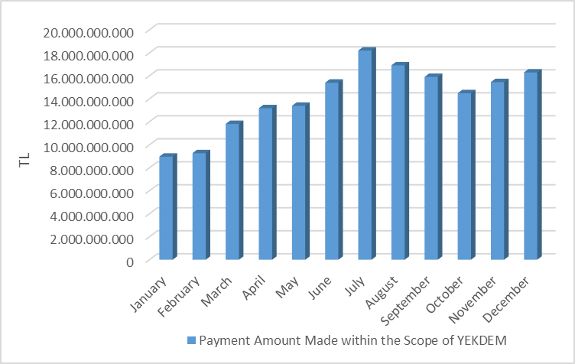
Figure 2.5.6 shows the monthly development of the amount paid to YEKDEM participants in addition to the weighted average PTF per unit amount of energy billed. in 2023, the average cash flow cost returned to positive and was realized as TL 28,06 /MWh this year, while it was TL -317,53/MWh last year.

Figure 2.5.6: 2023 Monthly Development of Average YEKDEM Additional Cost (TL/MWh)
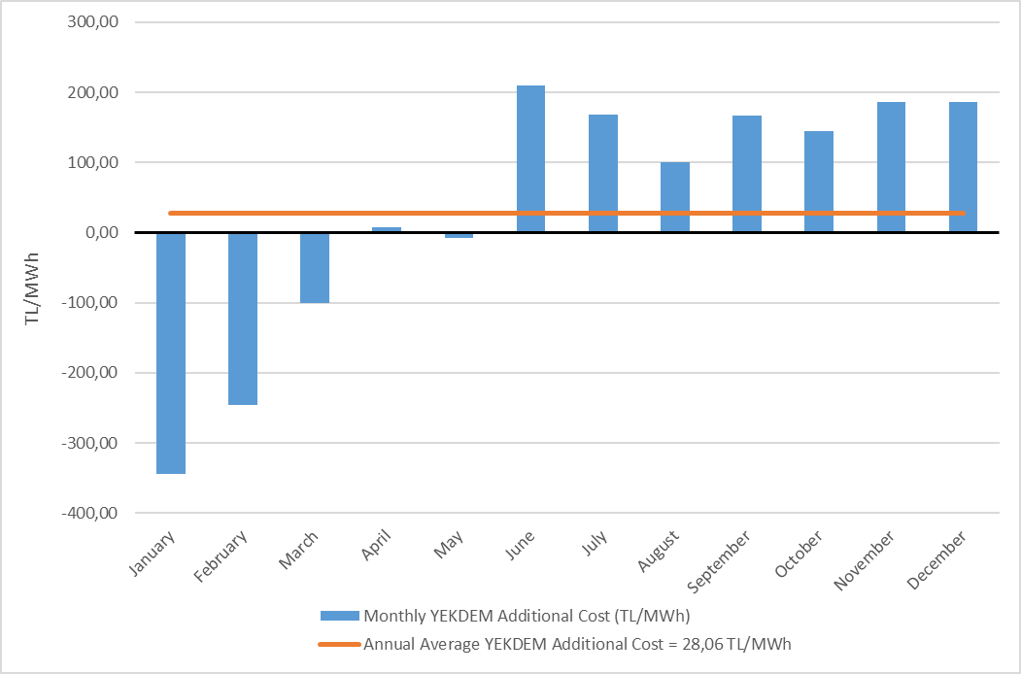

  - Power Futures Market

Power Futures Market operated by EXIST is a market with physical delivery that operates according to the “perpetual trade” method, allows future physical electricity trade and protects market participants from counterparty risk.
In the spot electricity markets, market participants are able to balance their portfolios and make physical optimization. In the Power Futures Market, the market participants have the opportunity to offset the price risk (hedging) and to see price prospects for the future (price discovery). Therefore, spot and Power Futures Markets can be considered as the markets that fulfill the different needs of the market participants and they complement each other in this respect.
Power Futures Market was opened on 1 June 2021 with 6 months and 2 quarter contracts. In addition to standard contracts, the balance of month (BOM) contract, which allows the management of physical positions within the delivery period, provides flexibility to market participants. On October 6, 2021, annual contract and two more quarter contracts were put into operation together.
Figure 2.6.1 below shows the development of the average MCP and Daily Index Prices determined for the contracts 2023 in the Power Futures Market.

Figure 2.6.1: Daily Index Price in PFM vs. MCP (TL/MWh)
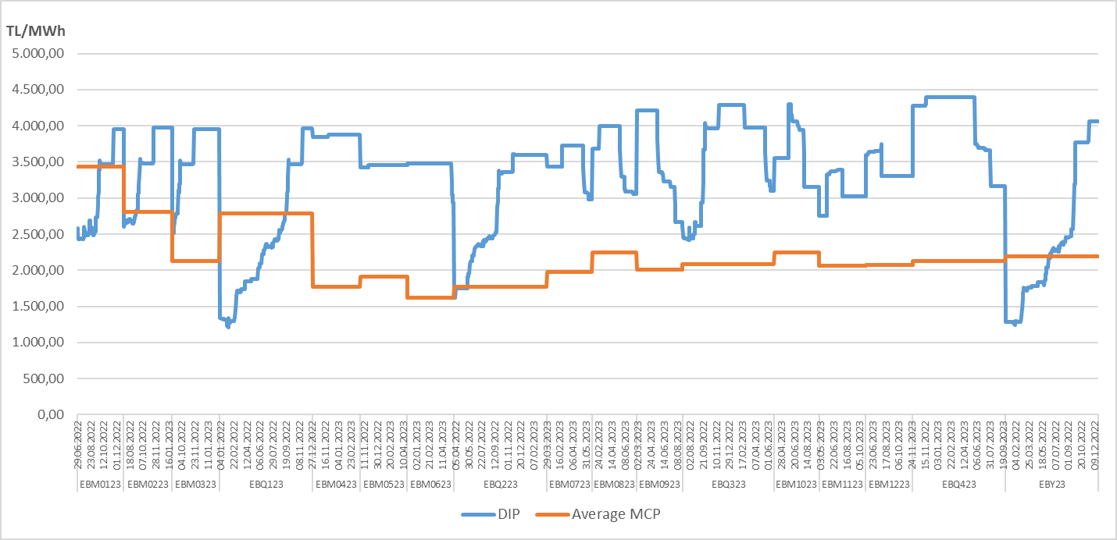

Figure 2.6.2 below shows the last daily indicator prices (GGF) determined for contracts for 2023, the average PTFs realized, and the rate of change of GGFs relative to the average MTF.

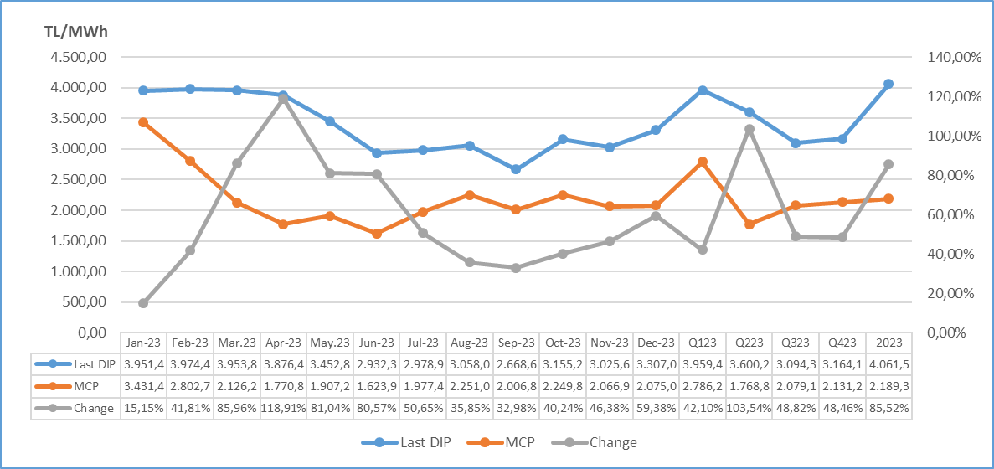
Figure 2.6.2: Last Daily Index Price in PFM vs. MCP (TL/MWh)

In Figure 2.6.3, the matching prices and amounts in 2023 in Power Futures Market are given. There were 11 matches in total. All of the matches were realized as private trade notifications.

Figure 2.6.3: Matching Prices and Amounts in PFM (TL/MWh – MW)
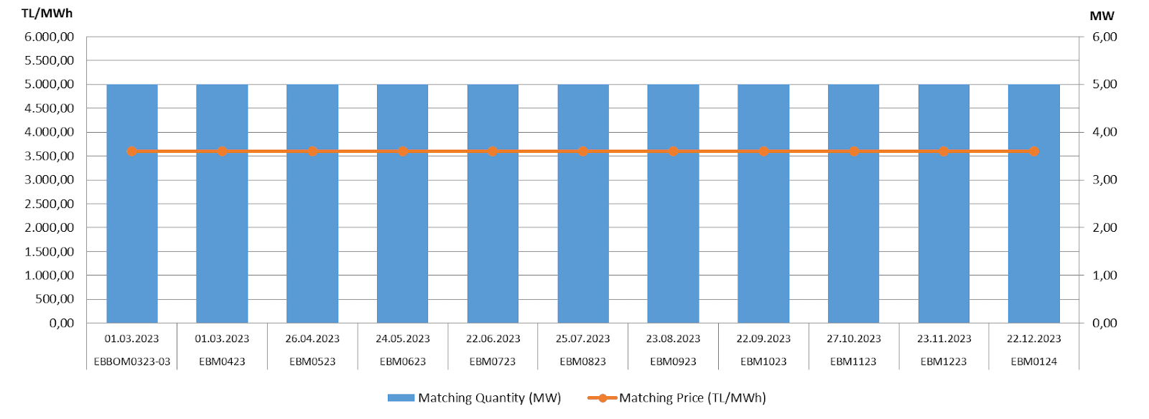
The following Figure 2.6.4 shows the amount of contract-based matches and transaction volume realized in the Electricity Futures Market in 2023. The total amount of matches was realized as 40,2 GWh and the total transaction volume was realized as 144,72 Million TL. the highest matching amount was realized with 3.720 MWh in 5 separate contracts traded in 2023. While there was 1 match in the rest of the month (BOM) contracts, there was no match in the quarterly and annual contracts in 2023.

Figure 2.6.4: Contract Based Match Amounts and Trading Volume (MWh – Million TL)
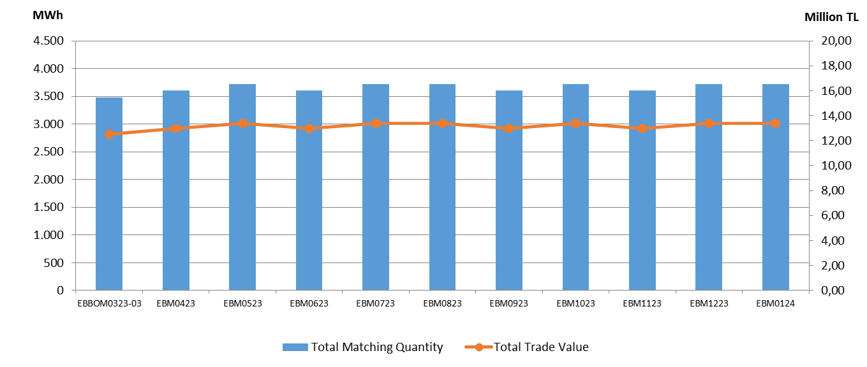
  - Environmental Markets
YEK-G System and Organized YEK-G Market
The REK-G System and the Organized REK-G Market were commissioned on June 1, 2021. Export, redemption, bilateral agreement transactions can be performed by participants in the YEK-G System developed using blockchain technology.
Offers are submitted by the participants to the contract opened in five different types of resources (Hydroelectric, Geothermal, Wind, Solar, Biomass) in the organized YEK-G Market, and matches are made with continuous trading methods.
In order to provide effective and fast service to market participants 24/7, services are provided via the call center and EPİAŞ Help Desk platform. Participants are informed when they first enter the markets, and support is provided quickly to users who have problems with bid entries and other issues.
The data of each transaction performed in the YEK-G system are published on the EPIAS transparency platform. The microsite https://yekgnedir.com, where market participants can access up-to-date information about the YEK-G system and the market, has been put into service.
Within the scope of environmental markets, research and development activities related to the carbon market and the white certificate market are continuing abroad.

Figure 2.7.1: Amount of Export in YEK-G System
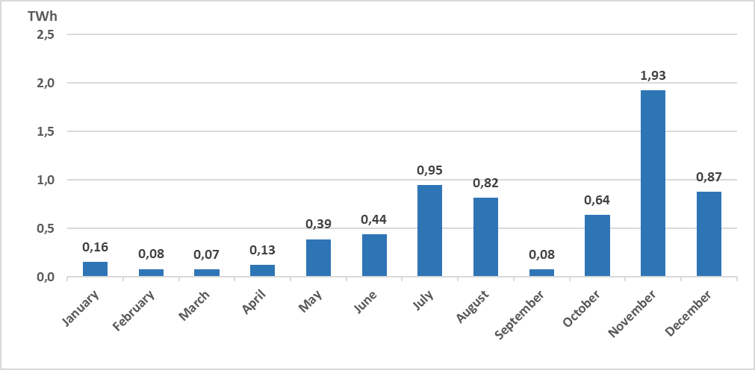
The total export amount in the YEK-G system was realized as 6,54 TWh.

Figure 2.7.2: Amount of Bilateral Contract in YEK-G System
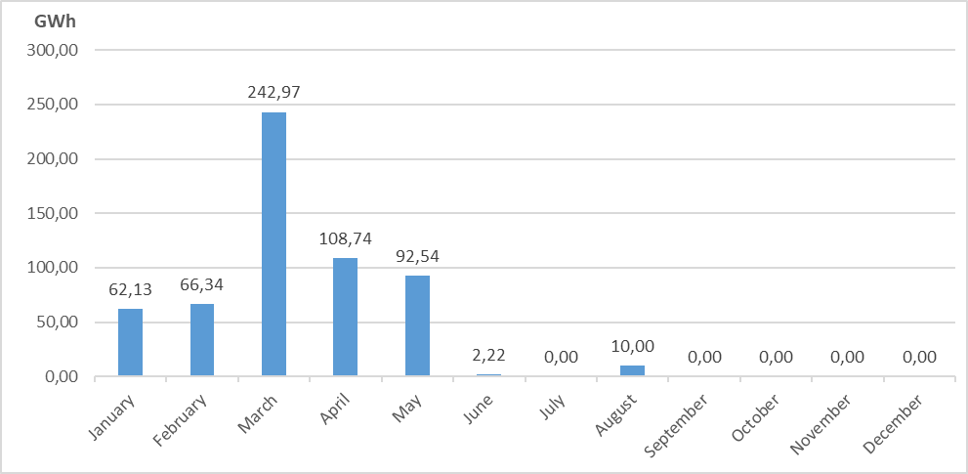

The total amount of bilateral agreement transactions in the YEK-G system was realized as 584,93 GWh.

Figure 2.7.3: Amount of Cancellation in the YEK-G System
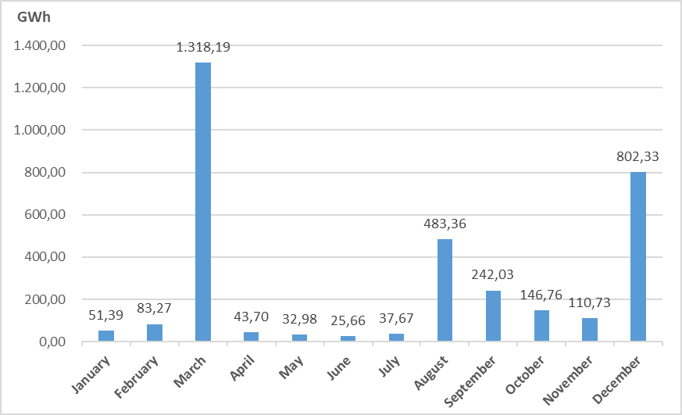

The total amount of redemption transactions in the YEK-G system was realized as 3.378,07 GWh. it is noticeable that the highest redemption amounts are in the month of March and December.

Figure 2.7.4: Amount of Match in Organized YEK-G Market
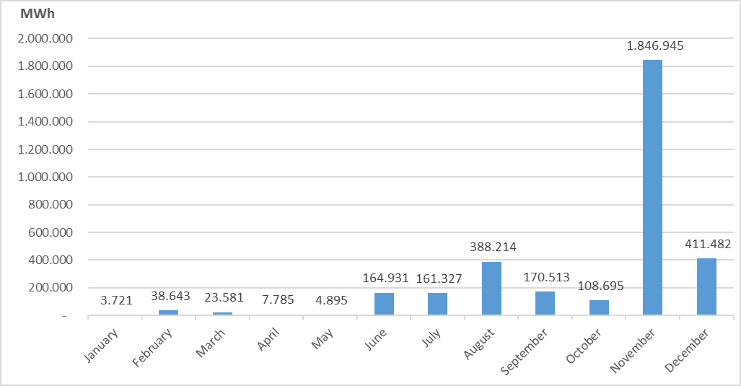
The highest monthly matching amount of the organized YEK-G market was realized in November as 1.846.945 MWh.

Figure 2.7.5: Organized YEK-G Market Annual Weighted Average Price on Contract Basis
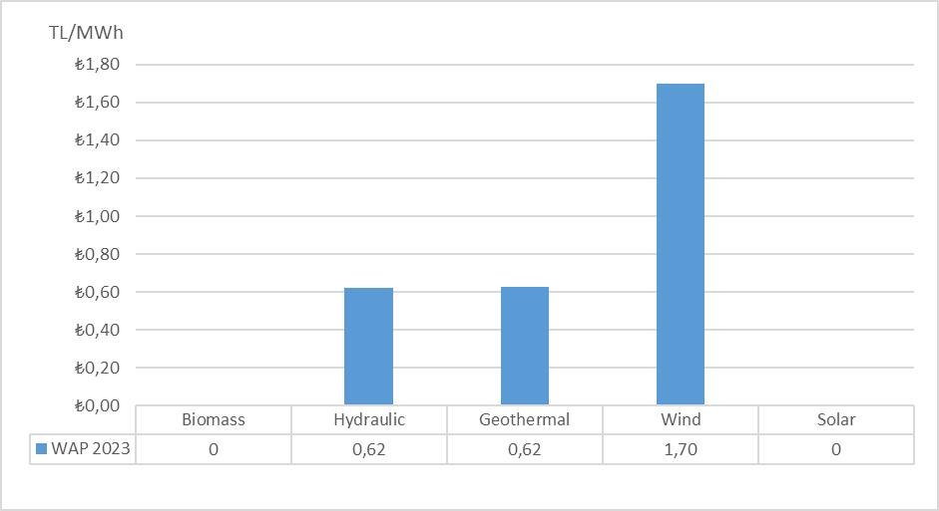

Figure 2.7.6: Organized YEK-G Market Average Price
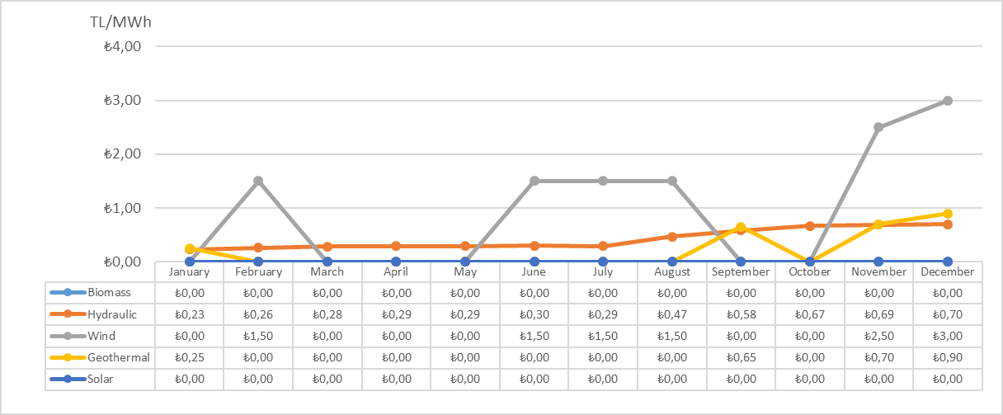

The highest weighted average price of the organized YEK-G market was realized in the Wind contract as 3,00 TL/MWh.

Figure 2.7.7: Organized YEK-G Market Trading Volume
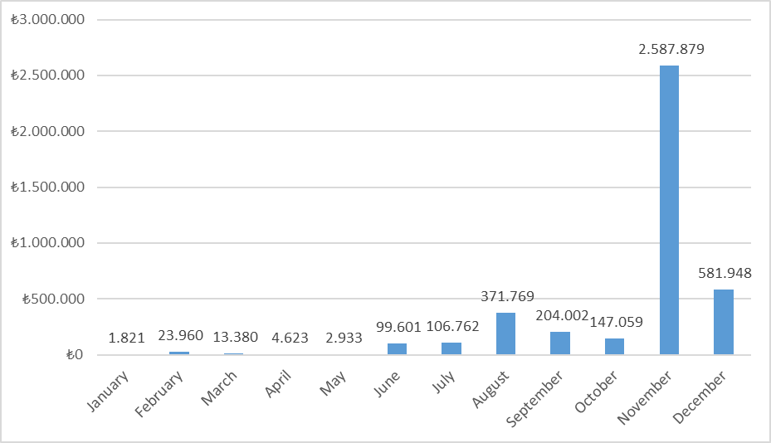

The highest trading volume of the organized YEK-G market was realized in November as 2.587.878,80 TL. A total annual transaction volume of 4.145.737,18 TL was generated. The transaction volume includes the sum of the purchase and sale amounts.
- COMPETITION

The main objective of the Electricity Market Law is to develop competition by creating a free market structure. The main duties of the Authority include identifying anti-competitive behavior and market power in areas open to competition and taking measures to prevent them. EMRA also reduces the free consumer limit at the end of each year for the following year, thereby increasing the number of consumers who can choose their supplier on the demand side. In this framework, the development of negotiable supply and demand in the wholesale market is critical for the establishment of competition.

3.1 Supply Side

The thesis that free electricity markets provide the most efficient investment and generation incentives is supported by theoretical and practical studies. However, due to the low elasticity of demand and the inability of the grid to store energy, regulation may be needed to protect competition and ensure security of supply. Therefore, these issues are regulated in many countries and by the European Union through various market share limits and mechanisms.
The indices used to monitor competition generally measure the concentration on the supply side and the ability of producers to intervene in prices. The HHI index, which is calculated as the sum of the squares of the market shares of all firms in the market, is widely used to measure market concentration. The index can be calculated separately for generation and installed capacity.

Table 3.1: HHI Values with respect to Generation and Installed Capacity
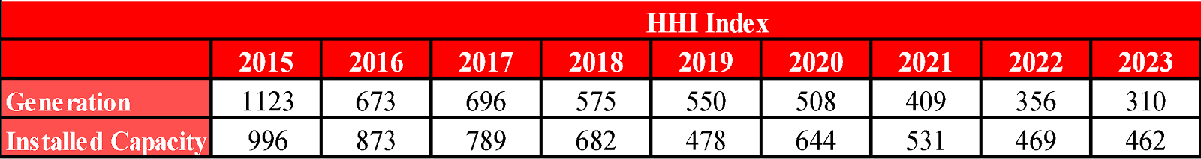
As shown in Table 3.1, the HHI index calculated over both generation and installed capacity decreased in 2023 compared to the previous year.
Table 3.2 shows the sales of supply license holders for final consumption. While the HHI index calculated according to supplier shares was 374,98 in 2022, this value was calculated as 397,52 in 2023.
The ratio of 21 incumbent supply companies' total sales volume to the total sales volume of all supply license holders increased from 71,14% in 2022 to 75,87% in 2023.
As is known, the eligible consumer limit in the electricity market has not yet been reset. In other words, not all consumers in the market qualify as eligible consumers. It is not legally possible for any supplier to sell to non-eligible consumers, except for the authorized supply companies. Therefore, in order to properly evaluate the competitive environment in sales to final consumers, it is important to create an environment where all consumers are eligible consumers and can obtain energy from any supplier they wish.

Table 3.2: Sales, Market Shares and HHI Index of Supply License Owners
Supplier Company | Sale Amount (MWh) | Share (%)
CK BOĞAZİÇİ ELEKTRİK PERAKENDE SATIŞ ANONİM ŞİRKETİ | 17.966.341 | 7,6113
GEDİZ ELEKTRİK PERAKENDE SATIŞ ANONİM ŞİRKETİ | 15.819.858 | 6,7020
ENERJİSA TOROSLAR ELEKTRİK PERAKENDE SATIŞ ANONİM ŞİRKETİ | 15.655.003 | 6,6321
ENERJİSA İSTANBUL ANADOLU YAKASI ELEKTRİK PERAKENDE SATIŞ ANONİM ŞİRKETİ | 14.212.930 | 6,0212
ENERJİSA BAŞKENT ELEKTRİK PERAKENDE SATIŞ ANONİM ŞİRKETİ | 13.204.136 | 5,5938
DİCLE ELEKTRİK PERAKENDE SATIŞ ANONİM ŞİRKETİ | 12.757.976 | 5,4048
SAKARYA ELEKTRİK PERAKENDE SATIŞ ANONİM ŞİRKETİ | 12.541.858 | 5,3133
ULUDAĞ PERAKENDE ELEKTRİK SATIŞ ANONİM ŞİRKETİ | 11.256.103 | 4,7686
MERAM ELEKTRİK PERAKENDE SATIŞ ANONİM ŞİRKETİ | 10.433.526 | 4,4201
AYDEM ELEKTRİK PERAKENDE SATIŞ ANONİM ŞİRKETİ | 9.386.051 | 3,9763
CK AKDENİZ ELEKTRİK PERAKENDE SATIŞ ANONİM ŞİRKETİ | 8.076.790 | 3,4217
KAYSERİ ELEKTRİK PERAKENDE SATIŞ ANONİM ŞİRKETİ | 7.993.572 | 3,3864
YEŞİLIRMAK ELEKTRİK PERAKENDE SATIŞ ANONİM ŞİRKETİ | 5.773.211 | 2,4458
CK ENERJİ ORTAKLIĞI TOPTAN ELEKTRİK SATIŞI ANONİM ŞİRKETİ | 5.578.701 | 2,3634
TRAKYA ELEKTRİK PERAKENDE SATIŞ ANONİM ŞİRKETİ | 4.666.884 | 1,9771
OSMANGAZİ ELEKTRİK PERAKENDE SATIŞ ANONİM ŞİRKETİ | 4.569.514 | 1,9358
AKSA ELEKTRİK SATIŞ ANONİM ŞİRKETİ | 4.413.467 | 1,8697
GAZİANTEP OSB ELEKTRİK ENERJİSİ TEDARİK TOPTAN SATIŞ TİCARET ANONİM ŞİRKETİ | 4.235.643 | 1,7944
AKEDAŞ ELEKTRİK PERAKENDE SATIŞ ANONİM ŞİRKETİ | 3.171.887 | 1,3437
ENERJİSA ELEKTRİK ENERJİSİ TOPTAN SATIŞ ANONİM ŞİRKETİ | 3.060.973 | 1,2968
ŞİŞECAM ENERJİ ANONİM ŞİRKETİ | 2.850.184 | 1,2075
AKSA ÇORUH ELEKTRİK PERAKENDE SATIŞ ANONİM ŞİRKETİ | 2.827.059 | 1,1977
ENKO ENERJİ SANAYİ VE TİCARET ANONİM ŞİRKETİ | 2.631.168 | 1,1147
ARAS ELEKTRİK PERAKENDE SATIŞ ANONİM ŞİRKETİ | 2.390.409 | 1,0127
KOLEN ELEKTRİK TOPTAN SATIŞ İTH. VE İHR. ANONİM ŞİRKETİ | 2.336.444 | 0,9898
AKSA FIRAT ELEKTRİK PERAKENDE SATIŞ ANONİM ŞİRKETİ | 2.308.442 | 0,9780
SOCAR ENERJİ TİCARET ANONİM ŞİRKETİ | 2.247.412 | 0,9521
TÜRKERLER VANGÖLÜ ELEKTRİK PERAKENDE SATIŞ ANONİM ŞİRKETİ | 2.056.182 | 0,8711
CK ÇAMLIBEL ELEKTRİK PERAKENDE SATIŞ ANONİM ŞİRKETİ | 2.014.210 | 0,8533
TOSYALI ELEKTRİK ENERJİSİ TOPTAN SATIŞ İTHALAT İHRACAT ANONİM ŞİRKETİ | 1.764.542 | 0,7475
CENGİZ ELEKTRİK TOPTAN SATIŞ A.Ş. | 1.585.986 | 0,6719
IC İÇTAŞ İNŞAAT SANAYİ VE TİCARET ANONİM ŞİRKETİ | 1.444.826 | 0,6121
CEREAN ENERJİ A.Ş. | 1.429.848 | 0,6057
YETAŞ YILDIRIM ENERJİ TEDARİK A.Ş. | 1.257.954 | 0,5329
ELTEK ELEKTRİK ENERJİSİ İTHALAT İHRACAT VE TOPTAN TİCARET ANONİM ŞİRKETİ | 1.195.477 | 0,5065
ELEKTRİK ÜRETİM ANONİM ŞİRKETİ (EÜAŞ) | 1.164.011 | 0,4931
MERAM ELEKTRİK ENERJİSİ TOPTAN SATIŞ ANONİM ŞİRKETİ | 1.092.909 | 0,4630
OYPOWER ELEKTRİK TİCARETİ VE HİZMETLERİ A.Ş. | 1.084.603 | 0,4595
DOSEN ENERJİ ELEKTRİK TEDARİK VE TOPTAN SATIŞ ANONİM ŞİRKETİ | 974.034 | 0,4126
İPRAGAZ ANONİM ŞİRKETİ | 814.318 | 0,3450
EREN ELEKTRİK ENERJİSİ TOPTAN SATIŞ ANONİM ŞİRKETİ | 808.827 | 0,3427
ERKİM ELEKTRİK ENERJİSİ TİCARET ANONİM ŞİRKETİ | 805.372 | 0,3412
LİMAK ENERJİ TİCARETİ ANONİM ŞİRKETİ | 752.114 | 0,3186
EÇE ENERJİ TİCARETİ ANONİM ŞİRKETİ | 706.710 | 0,2994
YEŞİLYURT ELEKTRİK ENERJİSİ TOPTAN SATIŞ VE İTHALAT İHRACAT ANONİM ŞİRKETİ | 645.963 | 0,2737
BORDO ELEKTRİK ENERJİSİ TOPTAN SATIŞ ANONİM ŞİRKETİ | 624.878 | 0,2647
EKVATOR PERAKENDE ENERJİ TİCARET ANONİM ŞİRKETİ | 619.617 | 0,2625
SELENKA ELEKTRİK ENERJİSİ TOPTAN SATIŞ VE TEDARİK ANONİM ŞİRKETİ | 598.091 | 0,2534
IC İÇTAŞ ELEKTRİK TOPTAN SATIŞ VE TİCARET ANONİM ŞİRKETİ | 560.490 | 0,2374
EKO GRUP ELEKTRİK TİCARET ANONİM ŞİRKETİ | 500.641 | 0,2121
ZORLU ELEKTRİK ENERJİSİ İTHALAT, İHRACAT VE TOPTAN TİCARET ANONİM ŞİRKETİ | 500.582 | 0,2121
RÖNESANS ELEKTRİK ENERJİ TOPTAN SATIŞ ANONİM ŞİRKETİ | 485.119 | 0,2055
AVEL AVRUPA ELEKTRİK ENERJİSİ TOPTAN SATIŞ ANONİM ŞİRKETİ | 479.201 | 0,2030
BATIÇİM ENERJİ TOPTAN SATIŞ ANONİM ŞİRKETİ | 461.541 | 0,1955
OCTO ELEKTRİK TİCARET ANONİM ŞİRKETİ | 422.812 | 0,1791
AŞKALE ÇİMENTO PETROL ENERJİ TİCARET VE SANAYİ ANONİM ŞİRKETİ | 402.852 | 0,1707
TTES ELEKTRİK SATIŞ ANONİM ŞİRKETİ | 378.023 | 0,1601
YYH YILDIZ ENERJİ TEDARİK VE TOPTAN SATIŞ ANONİM ŞİRKETİ | 376.238 | 0,1594
GATES ENERJİ TİCARET ANONİM ŞİRKETİ | 344.481 | 0,1459
VTC ENERJİ ANONİM ŞİRKETİ | 317.370 | 0,1345
REGES ELEKTRİK ENERJİSİ PERAKENDE SATIŞ SANAYİ VE TİCARET LİMİTED ŞİRKETİ | 281.067 | 0,1191
AYCAN TOPTAN ELEKTRİK TİCARET ANONİM ŞİRKETİ | 275.497 | 0,1167
AXPO TURKEY ENERJİ ANONİM ŞİRKETİ | 270.010 | 0,1144
MET TURKEY ENERJİ TİCARET ANONİM ŞİRKETİ | 236.524 | 0,1002
AKO ENERJİ ELEKTRİK TEDARİK TOPTAN VE PERAKENDE SATIŞ TİCARET ANONİM ŞİRKETİ | 235.504 | 0,0998
TURKCELL ENERJİ ÇÖZÜMLERİ VE ELEKTRİK SATIŞ TİCARET ANONİM ŞİRKETİ | 232.294 | 0,0984
FIRAT ENERJİ TOPTAN SATIŞ TİCARET ANONİM ŞİRKETİ | 228.502 | 0,0968
SOYAK ENERJİ TİCARET ANONİM ŞİRKETİ | 209.902 | 0,0889
YKS ELEKTRİK ENERJİSİ TOPTAN SATIŞ DIŞ TİCARET LİMİTED ŞİRKETİ | 208.968 | 0,0885
ELEKTRA ENERJİ TOPTAN SATIŞ VE İTHALAT İHRACAT ANONİM ŞİRKETİ | 170.776 | 0,0723
ENOVA ELEKTRİK ENERJİSİ TOPTAN SATIŞ ANONİM ŞİRKETİ. | 164.636 | 0,0697
DOĞRUDAN ELEKTRİK ENERJİSİ TOPTAN SATIŞ VE TEDARİK ANONİM ŞİRKETİ | 161.322 | 0,0683
NUROL GRUP ELEKTRİK TOPTAN SATIŞ ANONİM ŞİRKETİ | 155.224 | 0,0658
KET KİPAŞ ELEKTRİK ENERJİSİ TOPTAN SATIŞ TİCARET ANONİM ŞİRKETİ | 131.883 | 0,0559
AYEN ELEKTRİK TİCARET ANONİM ŞİRKETİ | 127.626 | 0,0541
VOYTRON ENERJİ ELEKTRİK PERAKENDE SATIŞ ANONİM ŞİRKETİ | 123.294 | 0,0522
DESA ELEKTRİK ENERJİSİ TEDARİK VE TOPTAN SATIŞ TİCARET ANONİM ŞİRKETİ | 106.549 | 0,0451
MİNAS ENERJİ VE TEKNOLOJİ ÇÖZÜMLERİ ANONİM ŞİRKETİ | 101.699 | 0,0431
SEDSAL ELEKTRİK ENERJİSİ TOPTAN SATIŞ LİMİTED ŞİRKETİ | 97.292 | 0,0412
FİDES ELEKTRİK ENERJİSİ TOPTAN ALIŞ SATIŞ ANONİM ŞİRKETİ | 90.260 | 0,0382
EKSİM ELEKTRİK ENERJİSİ İTHALAT, İHRACAT VE TOPTAN SATIŞ ANONİM ŞİRKETİ | 82.032 | 0,0348
KARAFIBER ENERJİ SANAYİ VE TİCARET A.Ş. | 81.587 | 0,0346
MARMARA ELEKTRİK ENERJİSİ İTHALAT İHRACAT VE TOPTAN TİCARET ANONİM ŞİRKETİ | 80.363 | 0,0340
AGE ELEKTRİK ENERJİSİ TOPTAN SATIŞ ANONİM ŞİRKETİ | 70.248 | 0,0298
İSETAŞ İSTANBUL ELEKTRİK TEDARİK ANONİM ŞİRKETİ | 69.556 | 0,0295
TENERA ENERJİ TİCARET ANONİM ŞİRKETİ | 66.798 | 0,0283
AVEM ENERJİ TİCARET ANONİM ŞİRKETİ | 62.802 | 0,0266
METAN DANIŞMANLIK ENERJİ TİCARET VE SANAYİ ANONİM ŞİRKETİ | 62.502 | 0,0265
KGM ENERJİ TİCARET LİMİTED ŞİRKETİ | 61.016 | 0,0258
OKKA ENERJİ ELEKTRİK TEDARİK TOPTAN SATIŞ İTHALAT VE İHRACAT ANONİM ŞİRKETİ | 60.505 | 0,0256
DİLER ELEKTRİK ENERJİSİ TEDARİK TOPTAN SATIŞ ANONİM ŞİRKETİ | 54.512 | 0,0231
MAC ELEKTRİK ENERJİSİ TOPTAN SATIŞ ANONİM ŞİRKETİ | 52.129 | 0,0221
EMY TOPTAN ELEKTRİK TİCARET ANONİM ŞİRKETİ | 49.959 | 0,0212
İSKUR GRUP ELEKTRİK SATIŞ ANONİM ŞİRKETİ | 46.308 | 0,0196
İZETAŞ İZMİR ELEKTRİK TEDARİK ANONİM ŞİRKETİ | 40.139 | 0,0170
HGÇ TOPTAN EL. EN. TİCARET ANONİM ŞİRKETİ | 37.157 | 0,0157
ENJİ ENERJİ YATIRIM DANIŞMANLIK VE MÜHENDİSLİK ANONİM ŞİRKETİ | 36.007 | 0,0153
OZAN FİLO KİRALAMA ANONİM ŞİRKETİ | 35.076 | 0,0149
MAX ELEKTRİK ENERJİSİ TİCARET ANONİM ŞİRKETİ | 34.603 | 0,0147
EPTAŞ ENERJİ TİCARET ANONİM ŞİRKETİ | 33.767 | 0,0143
VOLTAN ELEKTRİK TOPTAN SATIŞ İTHALAT VE İHRACAT ANONİM ŞİRKETİ | 27.805 | 0,0118
ENSAT ELEKTRİK ENERJİSİ TEDARİK TİCARET ANONİM ŞİRKETİ | 24.419 | 0,0103
EREL ERCİYES TEDARİK ELEKTRİK TOPTAN SATIŞ İTHALAT VE İHRACAT ANONİM ŞİRKETİ | 22.923 | 0,0097
SHELL ENERJİ ANONİM ŞİRKETİ | 20.100 | 0,0085
E POWER ENERJİ ANONİM ŞİRKETİ | 18.536 | 0,0079
STATKRAFT ELEKTRİK ENERJİSİ TOPTAN SATIŞ LİMİTED ŞİRKETİ | 18.048 | 0,0076
ÇELİKLER ELEKTRİK ENERJİ TOPTAN SATIŞ ANONİM ŞİRKETİ | 13.452 | 0,0057
İVES ELEKTRİK ENERJİSİ TEDARİK TOPTAN SATIŞ LİMİTED ŞİRKETİ | 12.528 | 0,0053
PURE ENERGY ELEKTRİK TEDARİK ANONİM ŞİRKETİ | 12.302 | 0,0052
ESKO ELEKTRİK ENERJİSİ İTHALAT İHRACAT VE TOPTAN SATIŞ ANONİM ŞİRKETİ | 10.134 | 0,0043
BDC ENERJİ TİCARET ANONİM ŞİRKETİ | 9.038 | 0,0038
HİDİV ELEKTRİK ENERJİSİ TOPTAN SATIŞ ANONİM ŞİRKETİ | 8.309 | 0,0035
ELEN ELEKTRON ENERJİ TİCARET ANONİM ŞİRKETİ | 8.243 | 0,0035
ADEN PERAKENDE ELEKTRİK ENERJİSİ SATIŞ TİCARET LİMİTED ŞİRKETİ | 8.067 | 0,0034
EXPERT DOĞALGAZ VE ELEKTRİK ENERJİSİ TİCARET LİMİTED ŞİRKETİ | 7.118 | 0,0030
ENERJİM PERAKENDE ENERJİ TİCARET ANONİM ŞİRKETİ | 7.062 | 0,0030
DOASAN ENERJİ TOPTAN SATIŞ LİMİTED ŞİRKETİ | 7.013 | 0,0030
HIZLI ELEKTRİK ENERJİSİ TEDARİK TOPTAN SATIŞ ANONİM ŞİRKETİ | 6.822 | 0,0029
ORT ELEKTRİK TOPTAN SATIŞ ANONİM ŞİRKETİ | 6.116 | 0,0026
ANT SÜRDÜRÜLEBİLİR ENERJİ TİCARET ANONİM ŞİRKETİ | 5.918 | 0,0025
AWA ENERJİ SANAYİ VE TİCARET ANONİM ŞİRKETİ | 5.082 | 0,0022
EE ELEKTRİK ENERJİSİ TOPTAN SATIŞ ANONİM ŞİRKETİ | 5.042 | 0,0021
ATA ELEKTRİK ENERJİSİ TOPTAN SATIŞ ANONİM ŞİRKETİ | 4.626 | 0,0020
ARİSTO ENERJİ ANONİM ŞİRKETİ | 3.791 | 0,0016
NEXUS ELEKTRİK ENERJİ TİCARETİ ANONİM ŞİRKETİ | 3.751 | 0,0016
POWERPOINT ENERJİ ANONİM ŞİRKETİ | 3.263 | 0,0014
VOLTE ELEKTRİK ANONİM ŞİRKETİ | 2.492 | 0,0011
EMBA ENERGY ELEKTRİK TİCARET ANONİM ŞİRKETİ | 2.133 | 0,0009
BORNOVA ELEKTRİK ENERJİSİ TEDARİK SATIŞ LİMİTED ŞİRKETİ | 726 | 0,0003
ADB ELEKTRİK ENERJİSİ TOPTAN SATIŞ ANONİM ŞİRKETİ | 544 | 0,0002
ENERA ELEKTRİK SATIŞ ANONİM ŞİRKETİ | 471 | 0,0002
NYK ENERJİ TİCARET ANONİM ŞİRKETİ | 419 | 0,0002
PARLAYAN GAZ VE TOPTAN ELEKTRİK TİCARET LİMİTED ŞİRKETİ | 305 | 0,0001
AKS GRUP ELEKTRİK ENERJİSİ TOPTAN ALIŞ VE SATIŞ LİMİTED ŞİRKETİ | 241 | 0,0001
TRK ELEKTRİK PERAKENDE SATIŞ ANONİM ŞİRKETİ | 157 | 0,0001
İDEAL PERAKENDE ELEKTRİK SATIŞ ANONİM ŞİRKETİ | 37 | 0,0000
FREKANS ELEKTRİK ENERJİSİ TOPTAN SATIŞ İTH. İHR. ANONİM ŞİRKETİ | 12 | 0,0000
Grand Total | 236.048.300 | 100
HHI of Suppliers | 397,52

3.2 Demand Side

Pursuant to paragraph (b) of the sixth paragraph of Article 5 of the Law No. 4628 on the Organization and Duties of the Energy Market Regulatory Authority and the provisions of Article 25 of the Electricity Market Consumer Services Regulation, it was decided to apply the free consumer limit of 1.000 kWh for the year 2023 by the Board Decision dated 29/12/2022 and numbered 11496. The theoretical market openness corresponding to the free consumer limit in question and obtained on the basis of consumer type consumption quantity values has been calculated as 91,9%. The free consumer limit and the corresponding market clearance rate by years are given in Figure 3.1.

Figure 3.1: Eligible Consumer Limit and Market Openness Ratio by Years (kWh-%)
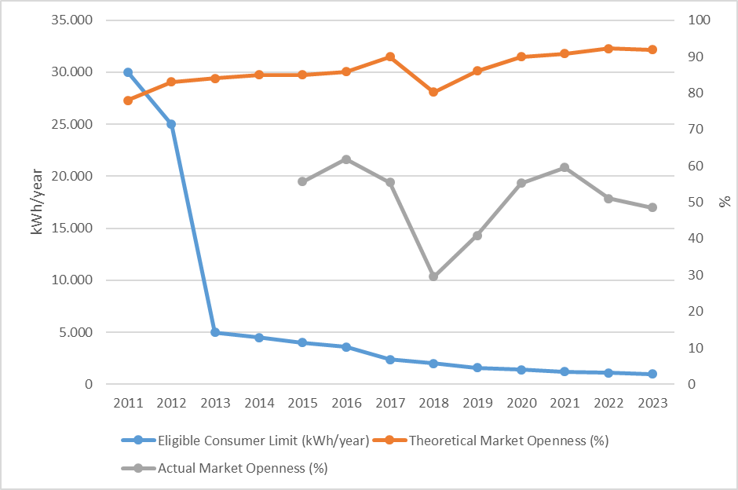
In parallel with the high theoretical market openness rate in 2023, the proportion of consumers using their free consumer rights in total consumption also decreased slightly compared to last year, although it was realized at a close value. The consumption of free consumers in 2023 was realized as 123.71 TWh. This rate corresponds to 48,5% of the total invoiced consumption.
The development of the number of free consumers in 2023 is shown in Figure 3.2.

Figure 3.2: Number of Eligible Consumer by Months in 2023
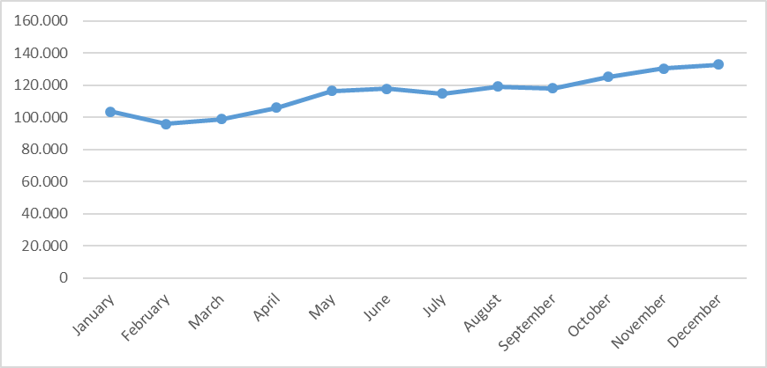
The number of eligible consumers, which was 121 thousand at the end of 2022, increased by approximately 10% to 133 thousand at the end of 2023. This number corresponds to approximately 0,27% of the total number of consumers.
The distribution of eligible consumers and their consumption by distribution regions (including transmission connected eligible consumers) is shown in Figure 3.3.

Figure 3.3: Distribution of Eligible Consumers and Their Consumptions by Distribution Regions in 2023*
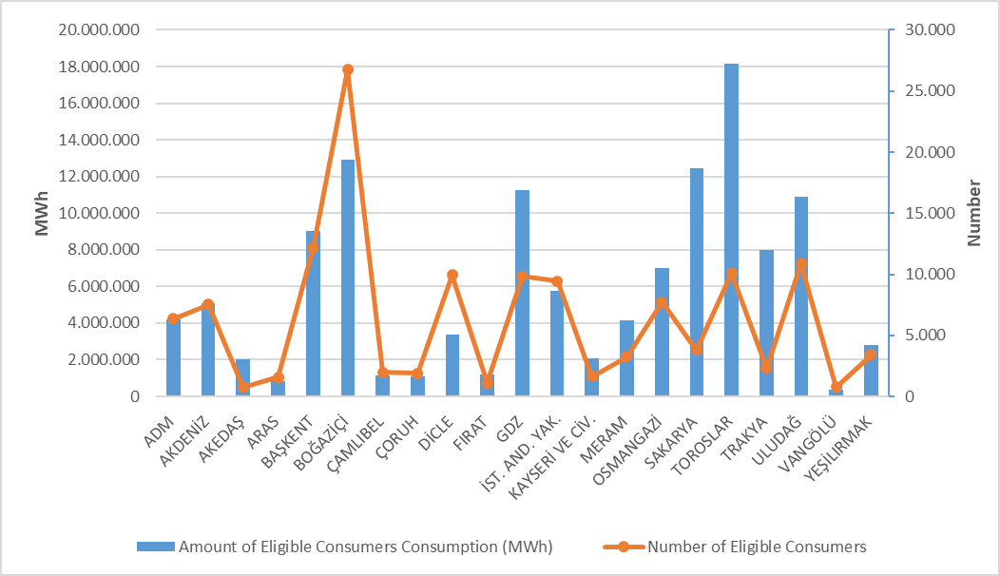
*Transmission connected consumers are distributed by distribution region according to their city of residence
When this distribution is analyzed, it is seen that the highest number of eligible consumers are located in Boğaziçi, Uludağ and Başkent regions.
The distribution of eligible consumers' consumption by distribution regions shows that the five regions with the highest consumption are Toroslar, Sakarya, Boğaziçi, GDZ and Uludağ.
Figure 3.4 below shows the distribution of eligible consumers' consumption by supplier type.

Figure 3.4: Distribution of Eligible Consumer Consumption by Supplier Type (%)
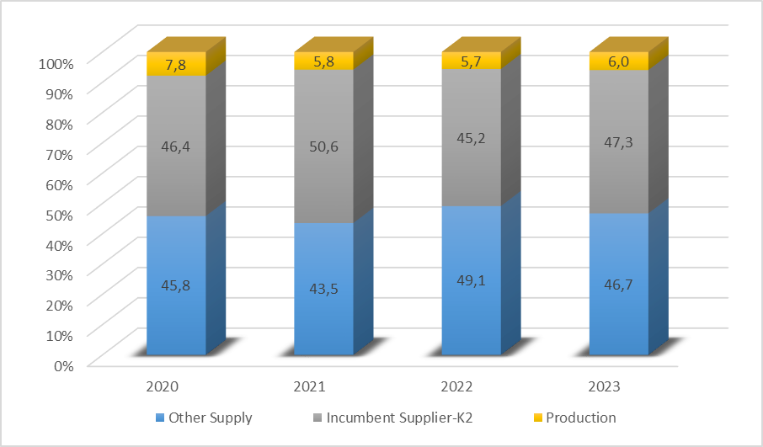
Monthly changes in the number and consumption of eligible consumers who changed their suppliers are shown in Figure 3.5. As can be seen in the figure, the number of eligible consumers who changed their suppliers was the highest in January, while the consumption of eligible consumers who changed their suppliers was the highest in January.

Figure 3.5: Monthly Changes in Number and Consumptions of Eligible Consumers Switching Their Supplier (Number-MWh)
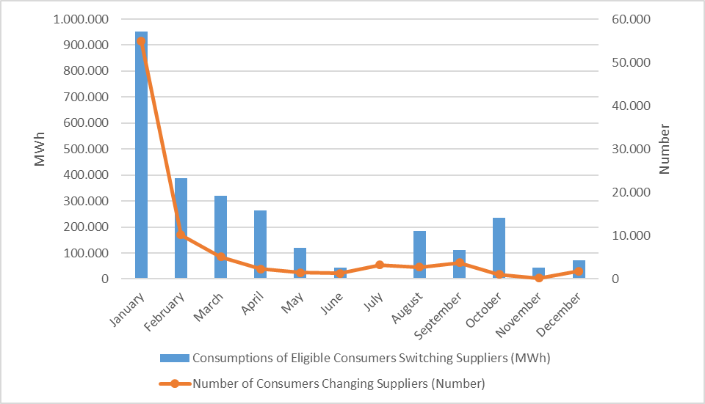
In 2023, the number of eligible consumers who changed their suppliers was 88.168. The total consumption of eligible consumers who switched their suppliers was 2,73 TWh, which corresponds to 1,07% of total invoiced consumption.

Table 3.3 below shows the distribution of eligible consumers' supplier changes by supplier type. It is seen that the majority of the supplier changes were made by consumers who switched to regulated tariffs.

Table 3.3: Distribution of Eligible Consumers' Supplier Changes by Supplier Type in 2023
Former Supplier Type | New Supplier Type |  |  |  | Grand Total
Former Supplier Type | Other  Suppliers | Incumbent  Supplier-K1 | Incumbent  Supplier-K2 | Generation | Grand Total
Other Suppliers | 949 | 21.437 | 1.066 | 30 | 23.482
Incumbent Supplier-K2 | 1.307 | 62.227 | 857 | 18 | 64.409
Generation | 76 | 169 | 30 | 2 | 277
Grand Total | 2.332 | 83.833 | 1.953 | 50 | 88.168

- TRANSMISSON

This section provides summary information on the transmission system and includes tables and figures on the changes in the transmission system over the years.

  - Transmission System

As of the end of 2023, information on the substations in the transmission system is given in Table 4.1 below. As seen in the table, most of the substations in the transmission system are 154 kV voltage level substations. There are 1.370 substations, 802 under TEİAŞ ownership and 568 under private ownership. Transformer capacity has reached 271.423,05 MVA. Of this capacity, 224.268,40 MVA is owned by TEİAŞ and the remaining 47.154,65 MVA is privately owned.

Table 4.1: Transformer Center Information
 | Voltage (kV) | Number of Centers | Number of Transformers | Capacity (MVA)
TEIAS | 380 | 123 | 420 | 90.130,00
TEIAS | 220 | 0 | 0 | 0,00
TEIAS | 154 | 678 | 1.701 | 134.022,15
TEIAS | 66 | 1 | 9 | 116,25
TEIAS | TEİAŞ Total | 802 | 2.130 | 224.268,40
Private Ownership | 380 | 66 | 72 | 11.255,50
Private Ownership | 220 | 0 | 0 | 0,00
Private Ownership | 154 | 499 | 580 | 35.856,65
Private Ownership | 66 | 3 | 3 | 42,50
Private Ownership | Private Total | 568 | 655 | 47.154,65
 | TOTAL | 1.370 | 2.785 | 271.423,05

Of the total 74.667 km of transmission lines, 64,90% are 154 kV lines. Of the remainder, almost all are 380 kV lines, while 220 kV and 66 kV lines are only 204,88 km long.

Table 4.2: TEİAŞ Transmission Lines
 | 2022 | 2023 | Change (%) | 2022 | 2023 | Change  (%)
Voltage (kV) | Number of Lines |  | Change (%) | Length (km) |  | Change  (%)
380 | 335 | 333 | -0,60 | 25.519 | 26.002 | 1,89
220 | 1 | 2 | 100,00 | 85,35 | 85,35 | 0,00
154 | 1.914 | 1.916 | 0,10 | 47.910 | 48.460 | 1,15
66 | 10 | 10 | 0,00 | 119,53 | 119,53 | 0,00
Total | 2.260 | 2.261 | 0,04 | 73.634 | 74.667 | 1,40

Figure 4.1: Change in TEİAŞ Transmission Line Lengths by Years (km)
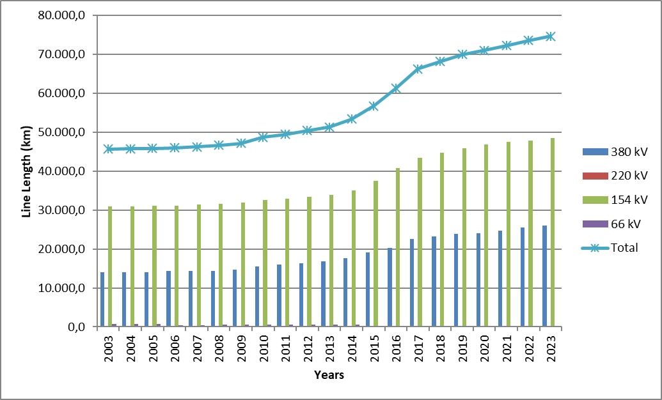

There has been a 63,3% increase in transmission line length in the last 21 years.
  - Transmission System Connection Applications

The table below shows the number and capacity of applications made in 2023 for connection to the transmission system, as well as information on applications accepted, rejected and applications under evaluation.

Table 4.3: Connection Applications to the Transmission System (Number - MW)
 | Connection Application |  | Accepted |  | Rejected |  | In the Evaluation Phase
 | Number | Capacity (MW) | Number | Capacity (MW) | Number | Capacity (MW) | Number | Capacity  (MW)
Licensed Producer | 1.665 | 65.547,17 | 356 | 19.111,77 | 495 | 5.351,00 | 814 | 41.084,40
Unlicensed Producer | 82 | 2.413,20 | 82 | 2.413,20 | 0 | 0,00 | 0 | 0,00
Consumer | 19 | 1.545,10 | 19 | 1545,1 | 0 | 0,00 | 0 | 0,00

In 2023, 1.665 connection applications totaling 65.547,17 MW were made by licensed generators. Of these, 356 applications of 19.111,77 MW were accepted, 495 applications of 5.351,00 MW were rejected, and 814 applications of 41.084,40 MW are under evaluation.
In addition, 82 applications for connection capacity of 2.413,20 MW were made by unlicensed generators, and all of these applications were accepted.
On the other hand, 19 connection applications of 1.545,10 MW were made by consumers, and all of these applications were accepted.

  - Tariffs

The transmission system system utilization and system operation tariffs applied by TEİAŞ to be applied as of 01/01/2023 were determined by the Board Decision dated 29/12/2022 and numbered 11532 on the basis of 15 regions for producers and consumers. In addition, with the Board Decision dated 15/09/2022 and numbered 11228, pursuant to subparagraph (h) of paragraph 7 of Article 5 and subparagraph (e) of paragraph (A) of Article 10 of the Law No. 4628 on the Organization and Duties of the Energy Market Regulatory Authority and the third paragraph of Article 7 of the Electricity Market Tariffs Regulation, the transmission surcharge applied in 2023 was determined as 0,5% (five per thousand) of the transmission tariff of the Turkish Electricity Transmission Corporation.
The system utilization and system operation tariffs applied in 2023 are shown in Table 4.4 for generation and consumption on the basis of 15 regions.

Table 4.4: System Usage and System Operation Tariffs Applied in 2023 (TL/MW Year, TL/MWh)
Region Number | Generation |  |  | Consumption
Region Number | System Usage Tariffs |  | System Operating Tariffs | System Usage Tariffs |  | System Operation Tariffs
Region Number | TL/MW-Yıl | TL/MWh | TL/MWh | TL/MW-Yıl | TL/MWh | TL/MWh
1 | 85.198,34 | 59,92 | 33,33 | 185.597,28 | 58,22 | 34,06
2 | 105.272,27 | 59,92 | 33,33 | 163.958,92 | 58,22 | 34,06
3 | 99.715,10 | 59,92 | 33,33 | 172.646,97 | 58,22 | 34,06
4 | 103.454,60 | 59,92 | 33,33 | 164.601,05 | 58,22 | 34,06
5 | 108.868,93 | 59,92 | 33,33 | 161.209,78 | 58,22 | 34,06
6 | 111.437,09 | 59,92 | 33,33 | 165.867,50 | 58,22 | 34,06
7 | 120.191,34 | 59,92 | 33,33 | 149.754,80 | 58,22 | 34,06
8 | 124.874,37 | 59,92 | 33,33 | 151.032,02 | 58,22 | 34,06
9 | 129.126,18 | 59,92 | 33,33 | 149.207,23 | 58,22 | 34,06
10 | 157.427,48 | 59,92 | 33,33 | 126.180,67 | 58,22 | 34,06
11 | 160.463,64 | 59,92 | 33,33 | 130.244,16 | 58,22 | 34,06
12 | 163.200,02 | 59,92 | 33,33 | 126.271,85 | 58,22 | 34,06
13 | 163.934,29 | 59,92 | 33,33 | 129.493,08 | 58,22 | 34,06
14 | 177.575,83 | 59,92 | 33,33 | 114.564,77 | 58,22 | 34,06
15 | 186.759,42 | 59,92 | 33,33 | 110.738,28 | 58,22 | 34,06

Figure 4.2: Capacity-Based Regional Transmission System Usage Tariffs Applied in 2023 (TL/MW-Year)
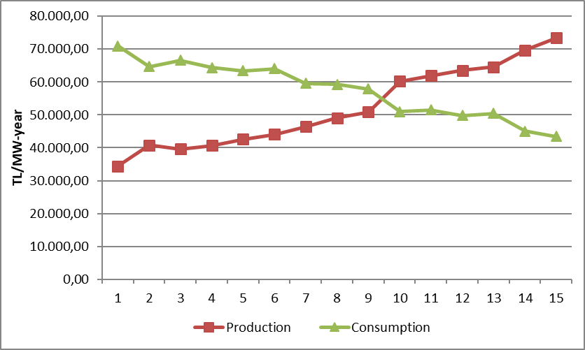

  - Investment Amount

The amounts of investment expenditures made by TEIAŞ are shown in Table 4.5. it is seen that the amount of investment will increase by 64,15% in 2023.

Table 4.5: Comparison of Investment Realizations in 2022 and 2023 (TL-%)
Type of Investment Expenditure | 2022 |  | 2023 |  | Change (%)
Type of Investment Expenditure | Amount (TL) | Share (%) | Amount (TL) | Share(%) | Change (%)
New Line Investment | 5.582.748.000 | 48,76 | 9.138.920.000 | 48,63 | 63,70
New Transformer Investment | 2.625.336.000 | 22,93 | 3.943.230.000 | 20,98 | 50,20
Business Group | 2.509.847.000 | 21,92 | 3.753.988.000 | 19,97 | 49,57
Other | 673.170.000 | 5,88 | 1.951.962.000 | 10,39 | 189,97
Machinery and Equipment | 58.009.000 | 0,51 | 5.879.000 | 0,03 | -89,87
Grand Total | 11.449.110.000 | 100,00 | 18.793.979.000 | 100,00 | 64,15

  - Losses

The transmission system loss (ISP) ratio varies depending on the demand, load flows, temperature and investments in the system. ISK is calculated on an hourly basis, and the change in the annual average over the years is shown in Figure 4.3. The transmission system losses established according to European standards in accordance with the population density, location of supply sources and geographical conditions of our country are at the international performance level.

Figure 4.3: Transmission System Losses (GWh-%)
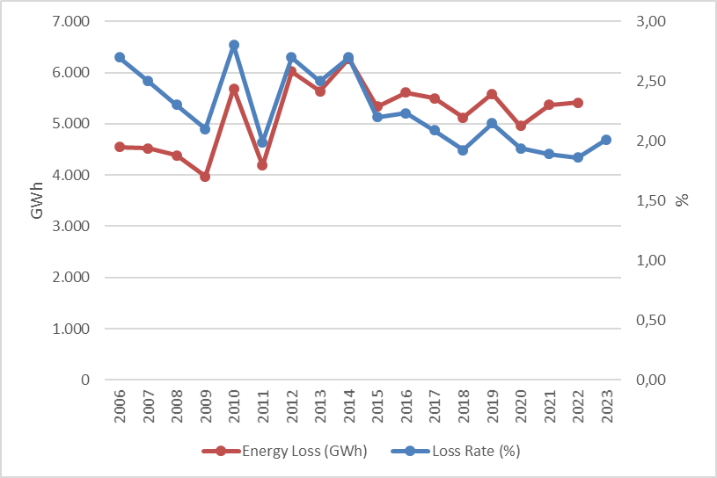

While the transmission system loss rate was 1,86% in 2022, it was realized as 2,01% in 2023.

Figure 4.4: Distribution of Transmission System Losses by Hours (%)
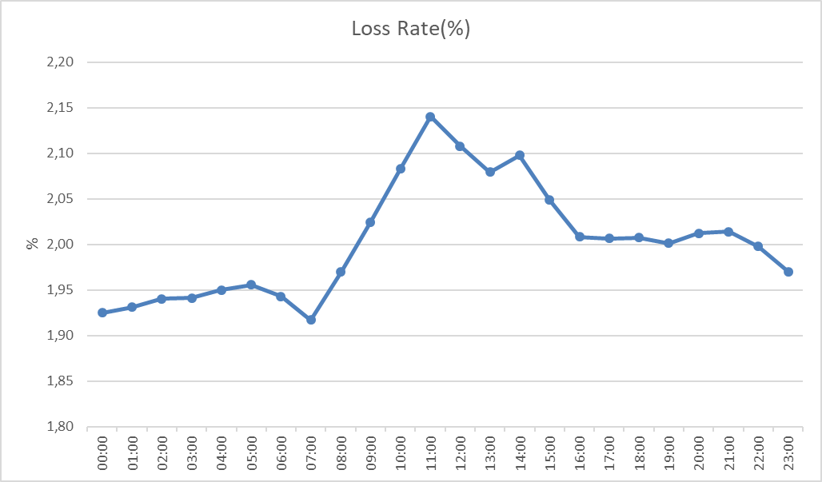
When we look at the development of the transmission system loss according to the hours, it is seen that the highest loss rate is at 11:00.
- DISTRIBUTION

  - Consumer Numbers

As of 2023, the total number of consumers using the distribution system increased by 2,39% compared to the previous year and amounted to 49.725.757

Table 5.1: Number of Consumers Using the Distribution System as of 2021 2022-2023 (Pcs-%)
Distribution Company | Number of Consumers |  |  | 2022-2023  Change (%)
Distribution Company | 2021 | 2022 | 2023 | 2022-2023  Change (%)
BOĞAZİÇİ | 5.309.611 | 5.389.989 | 5.460.069 | 1,30
BAŞKENT | 4.450.518 | 4.523.058 | 4.595.439 | 1,60
TOROSLAR | 4.199.796 | 4.307.920 | 4.441.654 | 3,10
GDZ | 3.642.231 | 3.744.637 | 3.831.022 | 2,31
ULUDAĞ | 3.461.589 | 3.556.627 | 3.651.540 | 2,67
İ.ANADOLU | 3.036.650 | 3.092.666 | 3.134.640 | 1,36
AKDENİZ | 2.317.576 | 2.379.303 | 2.450.218 | 2,98
YEŞİLIRMAK | 2.278.037 | 2.354.514 | 2.440.498 | 3,65
MERAM | 2.281.142 | 2.348.563 | 2.415.291 | 2,84
ADM | 2.127.279 | 2.211.376 | 2.288.225 | 3,48
DİCLE | 2.055.848 | 2.137.973 | 2.213.815 | 3,55
SAKARYA | 2.022.189 | 2.091.199 | 2.160.799 | 3,33
OSMANGAZİ | 1.932.175 | 1.978.602 | 2.035.351 | 2,87
ÇORUH | 1.468.077 | 1.513.140 | 1.562.969 | 3,29
TRAKYA | 1.207.462 | 1.251.249 | 1.298.005 | 3,74
ARAS | 1.095.416 | 1.129.270 | 1.162.437 | 2,94
ÇAMLIBEL | 1.037.499 | 1.060.920 | 1.085.713 | 2,34
FIRAT | 1.059.741 | 1.098.614 | 1.054.181 | -4,04
KAYSERİ VE CİVARI | 788.088 | 818.815 | 847.479 | 3,50
VANGÖLÜ | 775.666 | 802.773 | 828.998 | 3,27
AKEDAŞ | 764.743 | 771.560 | 767.414 | -0,54
Total | 47.311.333 | 48.562.768 | 49.725.757 | 2,39

When we look at Table 5.1, we see that the distribution regions with the highest number of consumers are Boğaziçi with 5,46 million, Başkent with 4,59 million and Toroslar with 4,44 million, respectively.
Figure 5.1 below shows the number of consumers of distribution companies as of the end of 2023 and the total consumption of these consumers in 2023.

Figure 5.1: Number of Consumers and Consumption Amounts as of the End of 2023 (Piece - MWh)
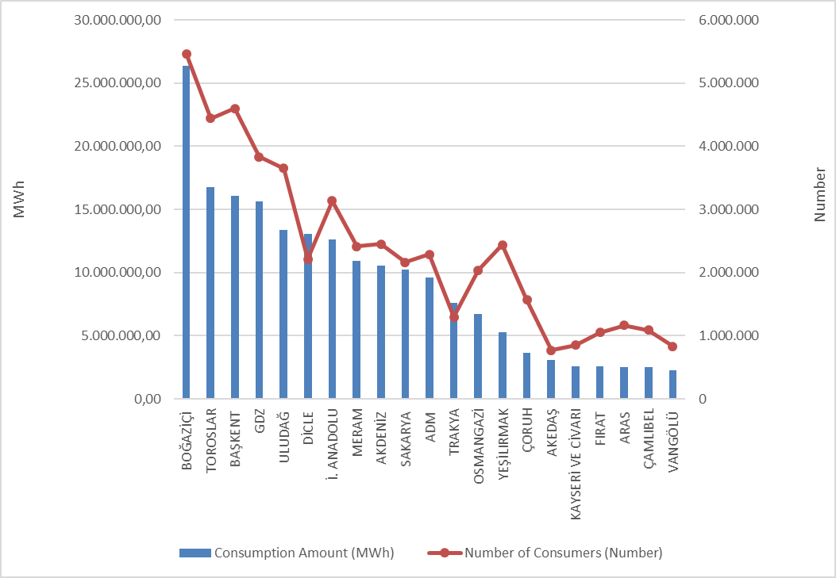

  - Loss Rates

The targeted and realized loss values based on the distribution company are shown in Table 5.2.

Table 5.2: Loss Rates of Distribution Companies (%)
Distribution Company | Actual Loss Rate |  |  | Target Loss Rate | Difference Between Target And Actual Loss Rates
Distribution Company | 2022 | 2023 | 2022-2023 | 2023 | 2023
Distribution Company | 2022 | 2023 | Change | 2023 | 2023
ADM | 5,58% | 5,54% | 0,04% | 6,75% | 1,21%
AKDENİZ | 7,00% | 7,44% | -0,44% | 7,19% | -0,25%
AKEDAŞ | 5,21% | 14,13% | -8,92% | 6,77% | -7,36%
ARAS | 19,31% | 16,61% | 2,70% | 20,13% | 3,52%
AYEDAŞ | 5,05% | 4,74% | 0,31% | 6,53% | 1,79%
BAŞKENT | 5,75% | 5,60% | 0,15% | 6,88% | 1,28%
BOĞAZİÇİ | 6,38% | 6,29% | 0,09% | 7,50% | 1,21%
ÇAMLIBEL | 6,05% | 6,61% | -0,56% | 6,70% | 0,09%
ÇORUH | 6,64% | 6,43% | 0,21% | 7,33% | 0,90%
DİCLE | 43,63% | 42,79% | 0,84% | 46,46% | 3,67%
FIRAT | 8,91% | 10,94% | -2,03% | 9,49% | -1,45%
GDZ | 5,04% | 5,24% | -0,20% | 7,17% | 1,93%
KAYSERİ | 6,67% | 8,09% | -1,42% | 6,86% | -1,23%
MERAM | 6,17% | 5,77% | 0,40% | 6,75% | 0,98%
OSMANGAZİ | 6,31% | 6,94% | -0,63% | 7,10% | 0,16%
SAKARYA | 5,75% | 5,56% | 0,19% | 6,73% | 1,17%
TOROSLAR | 10,62% | 12,06% | -1,44% | 11,45% | -0,61%
TRAKYA | 5,04% | 4,92% | 0,12% | 6,34% | 1,42%
ULUDAĞ | 4,79% | 5,16% | -0,37% | 6,40% | 1,24%
VANGÖLÜ | 35,64% | 32,35% | 3,29% | 42,15% | 9,80%
YEŞİLIRMAK | 6,55% | 6,54% | 0,01% | 7,37% | 0,83%
* The table has been prepared using the data that distribution companies submit to our Institution via the EYDF-29 form via the notification system.

Looking at Table 5.2; All of the 21 distribution companies, except Akdeniz EDAŞ, Akedaş EDAŞ, Fırat EDAŞ, Kayseri EDAŞ and Toroslar EDAŞ, achieved the targeted loss rate for 2023. Due to the earthquake disaster that took place on 6/2/2023 in the Akedaş EDAŞ, Fırat EDAŞ and Toroslar EDAŞ regions, the loss data was significantly increased. It is seen that the distribution companies other than these 3 companies, which were affected, exhibited a generally successful performance in 2023 in terms of loss targets. The highest difference according to the target was realized in the distribution regions of Vangölü EDAŞ (9.80%), Dicle EDAŞ (3.67%) and Aras EDAŞ (3,52%), respectively.

Additionally, as can be seen from Table 5.2, the highest loss rates in 2023, as in 2022, occurred in Dicle EDAŞ (42,79%), Vangölü EDAŞ (32,35%) and Aras EDAŞ (16,61%) regions, respectively.

Actual and targeted loss rates are shown together below.

Figure 5.2: Realized and Targeted Loss Rates in 2023 (%)
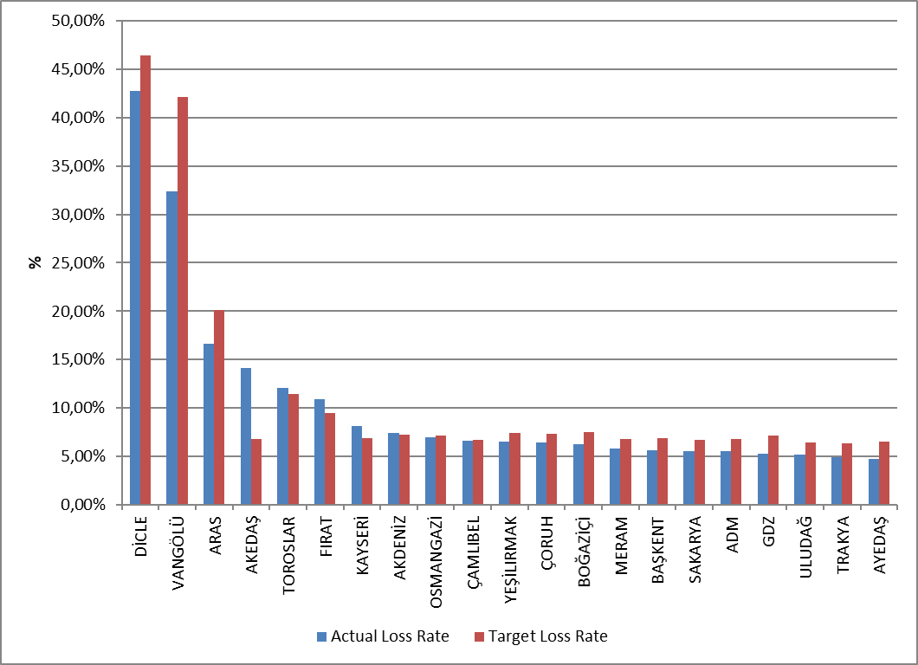

5.3 Employment

As of the end of 2023, 65.501 people will be employed in the electricity distribution sector; 27.200 people work as distribution company permanent personnel, and 38.301 people work as subcontractor company personnel. The table below shows the number of employees by distribution companies. Toroslar EDAŞ was the distribution company with the highest number of employees with 8.284 personnel, and Kayseri ve Civarı EDAŞ was the distribution company with the lowest number of employees with 966 personnel. Toroslar EDAŞ was the distribution company with the highest number of both permanent personnel (4.381) and subcontractor personnel (3.903).

Table 5.3: Number of Employees of Distribution Companies as of the End of 2023 (Number)
Distribution Company | Number of Permanent Employees | Number of Subcontractor Employees | Total
TOROSLAR | 4.381 | 3.903 | 8.284
DİCLE | 3.842 | 3.586 | 7.428
BAŞKENT | 4.130 | 3.021 | 7.151
BOĞAZİÇİ | 632 | 3.634 | 4.266
GDZ | 992 | 2.505 | 3.497
İ. ANADOLU | 1.945 | 1.076 | 3.021
ULUDAĞ | 746 | 2.138 | 2.884
SAKARYA | 1.625 | 1.159 | 2.784
ÇORUH | 389 | 2.325 | 2.714
OSMANGAZİ | 1.196 | 1.505 | 2.701
AKDENİZ | 334 | 2.196 | 2.530
ADM | 811 | 1632 | 2.443
YEŞİLIRMAK | 551 | 1.841 | 2.392
MERAM | 753 | 1.547 | 2.300
ARAS | 734 | 1.496 | 2.230
VANGÖLÜ | 957 | 1.070 | 2.027
FIRAT | 333 | 1.583 | 1.916
ÇAMLIBEL | 256 | 1312 | 1.568
TRAKYA | 897 | 336 | 1.233
AKEDAŞ | 929 | 237 | 1.166
KAYSERİ VE CİVARI | 767 | 199 | 966
Total | 27.200 | 38.301 | 65.501

Figure 5.3: Number of Employees of Distribution Companies at the End of 2023 (Number)
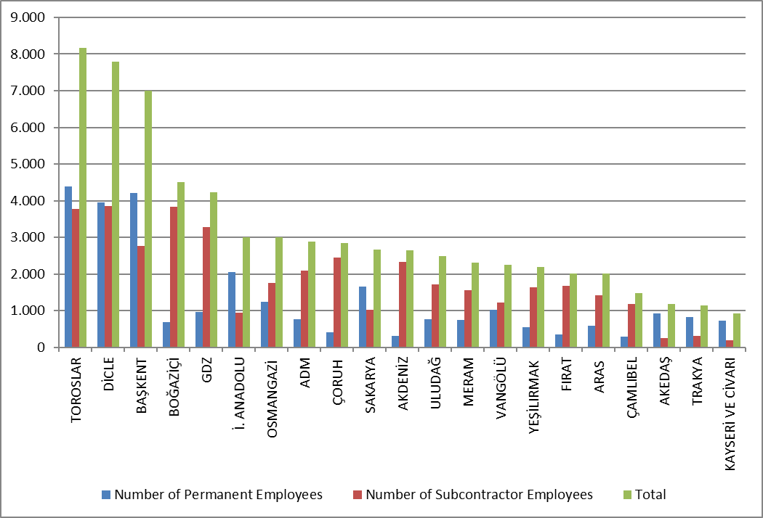

5.4 Information About Network

This section contains basic data about the distribution system. In this context, information on line lengths, transformer capacities and number of transformers at the distribution voltage level is given in the following tables and figures.
As it is known, the electricity network has reached all of Turkey, with exceptions. Except for industrial facilities with large consumption, all small and medium-sized consumers obtain electrical energy through the distribution system. As can be seen from Table 5.4, Türkiye's total distribution line length has reached 1.446.215 km. When looking at line lengths by distribution regions, Toroslar, Başkent, Meram, Yeşilırmak and Dicle distribution regions constitute the top five regions in terms of distribution line length. It can be seen from this list that there is a direct proportion between the distribution line lengths, the width of the distribution area and the prevalence of the distribution network.

Table 5.4: Line Lengths, Number of Transformers and Transformer Capacities by Distribution Companies as of the End of 2023 (km-MVA-Piece)
Distribution Company | Line length (Km) | Transformer Capacity (MVA) | Number of Transformers (Pieces)
ADM | 78.751 | 10.458 | 24.654
AKDENİZ | 72.655 | 9.571 | 21.163
AKEDAŞ | 28.409 | 4.426 | 13.994
ARAS | 60.496 | 3.651 | 15.622
BAŞKENT | 138.591 | 19.129 | 36.542
BOĞAZİÇİ | 55.589 | 20.006 | 16.128
ÇAMLIBEL | 50.600 | 3.329 | 13.959
ÇORUH | 63.626 | 4.991 | 13.283
DİCLE | 86.005 | 16.096 | 72.998
FIRAT | 49.467 | 3.757 | 14.162
GDZ | 84.100 | 17.605 | 36.635
İ. ANADOLU | 35.125 | 9.860 | 8.211
KAYSERİ VE CİVARI | 29.787 | 3.117 | 9.238
MERAM | 126.057 | 14.832 | 67.296
OSMANGAZİ | 53.598 | 8.874 | 30.633
SAKARYA | 67.822 | 9.552 | 19.292
TOROSLAR | 152.239 | 20.605 | 50.281
TRAKYA | 30.663 | 6.248 | 12.815
ULUDAĞ | 54.186 | 12.473 | 28.914
VANGÖLÜ | 42.204 | 3.253 | 13.445
YEŞİLIRMAK | 86.246 | 5.613 | 21.404
Total | 1.446.215 | 207.448 | 540.669
On the other hand, when we look at the distribution regions in terms of transformer capacity, it is seen that Toroslar, Boğaziçi, Başkent, Gdz and Dicle electricity distribution regions are in the top five.

Figure 5.4: Line Lengths and Transformer Capacities by Distribution Companies as of the End Of 2023 (Km-Mva)
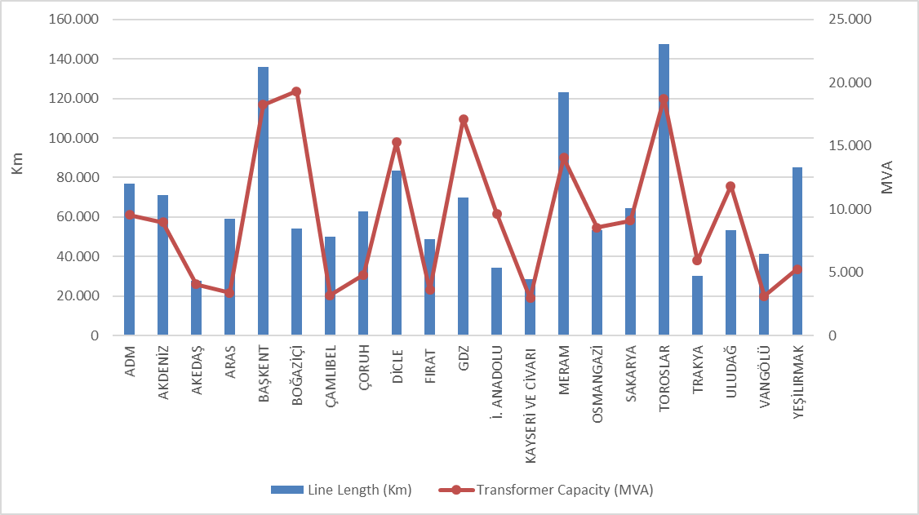
Table 5.5 shows the distribution of distribution lines. As can be seen from the table, the majority of the total distribution lines (76,25%) are overhead lines. The share of underground lines in the total distribution line length is 23,75%. This situation shows that distribution lines are open to external influence. The external impacts mentioned may be natural disasters, climate or human-related. Natural events, especially excessive rainfall and strong winds, can directly or indirectly cause damage to distribution lines.

Table 5.5: The Lengths of Distribution Lines at the end of 2023 (km)
Distribution Companies | Overhead (Km) | Underground (Km) | Total (Km)
ADM | 62.419 | 16.332 | 78.751
AKDENİZ | 52.531 | 20.124 | 72.655
AKEDAŞ | 24.699 | 3.711 | 28.409
ARAS | 51.717 | 8.779 | 60.496
BAŞKENT | 101.071 | 37.520 | 138.591
BOĞAZİÇİ | 15.529 | 40.060 | 55.589
ÇAMLIBEL | 43.540 | 7.060 | 50.600
ÇORUH | 57.349 | 6.278 | 63.626
DİCLE | 72.657 | 13.348 | 86.005
FIRAT | 41.988 | 7.479 | 49.467
GDZ | 63.008 | 21.092 | 84.100
İ. ANADOLU | 12.061 | 23.064 | 35.125
KAYSERİ VE CİVARI | 20.195 | 9.591 | 29.787
MERAM | 98.701 | 27.356 | 126.057
OSMANGAZİ | 43.807 | 9.791 | 53.598
SAKARYA | 45.235 | 22.587 | 67.822
TOROSLAR | 121.911 | 30.327 | 152.239
TRAKYA | 23.972 | 6.691 | 30.663
ULUDAĞ | 39.835 | 14.351 | 54.186
VANGÖLÜ | 37.554 | 4.650 | 42.204
YEŞİLIRMAK | 72.939 | 13.307 | 86.246
Grand Total | 1.102.716 | 343.498 | 1.446.215

Figure 5.5: The Length of Lines on the Basis of Distribution Companies at the end of 2023 (km)
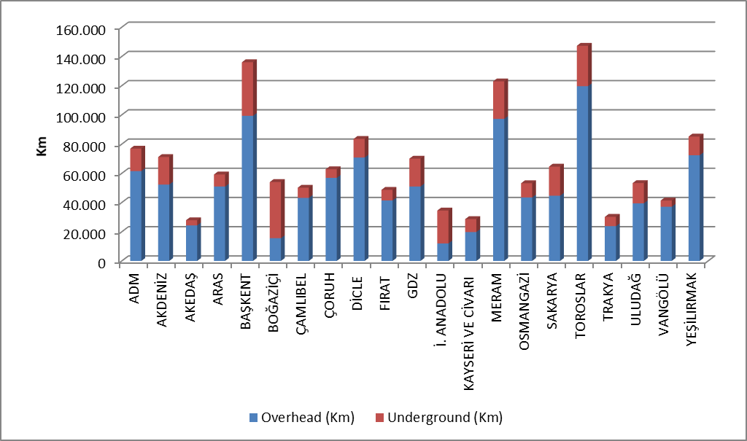
Table 5.6 includes distribution line lengths and transformer capacities by province. According to the table, the first five provinces in terms of distribution line length are; They are Istanbul, Konya, Ankara, Izmir and Antalya.
When we look at the transformer capacities in the distribution system of the provinces, the first five provinces in terms of transformer capacity are; They are Istanbul, Ankara, Izmir, Konya and Antalya.
When we look at the number of transformers in the distribution system of the provinces, the first five provinces in terms of the number of transformers are; These are Konya, Şanlıurfa, Istanbul, İzmir and Ankara.

Table 5.6: Line at Distribution Voltage Level by Province as of the End of 2023 Lengths, Number of Transformers and Transformer Capacities (km-MVA-Piece)
Provinces | Line Length  (Km) | Transformer Capacity  (MVA) | Number of Transformers  (Piece)
ADANA | 37.782 | 5.620 | 13.351
ADIYAMAN | 9.383 | 1.360 | 5.732
AFYONKARAHİSAR | 16.508 | 2.703 | 11.969
AĞRI | 11.286 | 609 | 3.227
AKSARAY | 14.636 | 1.477 | 7.945
AMASYA | 9.321 | 758 | 2.767
ANKARA | 66.644 | 14.043 | 21.273
ANTALYA | 51.334 | 7.368 | 14.734
ARDAHAN | 4.726 | 179 | 1.011
ARTVİN | 7.372 | 779 | 1.752
AYDIN | 23.733 | 3.165 | 7.574
BALIKESİR | 19.469 | 3.516 | 8.816
BARTIN | 7.397 | 450 | 1.506
BATMAN | 6.883 | 1.147 | 3.931
BAYBURT | 3.424 | 188 | 757
BİLECİK | 4.528 | 1.134 | 2.237
BİNGÖL | 7.391 | 514 | 2.094
BİTLİS | 8.206 | 743 | 3.586
BOLU | 10.076 | 871 | 2.990
BURDUR | 9.879 | 834 | 3.142
BURSA | 21.185 | 6.551 | 13.385
ÇANAKKALE | 10.687 | 1.628 | 5.349
ÇANKIRI | 9.922 | 620 | 2.045
ÇORUM | 15.650 | 1.185 | 4.553
DENİZLİ | 24.893 | 3.370 | 7.923
DİYARBAKIR | 21.135 | 4.093 | 14.883
DÜZCE | 9.474 | 899 | 2.284
EDİRNE | 9.660 | 1.185 | 4.374
ELAZIĞ | 15.546 | 1.409 | 4.621
ERZİNCAN | 9.275 | 527 | 2.324
ERZURUM | 19.113 | 1.477 | 5.297
ESKİŞEHİR | 14.496 | 2.821 | 9.948
GAZİANTEP | 25.017 | 4.015 | 10.267
GİRESUN | 16.867 | 1.128 | 3.316
GÜMÜŞHANE | 6.549 | 370 | 1.365
HAKKARİ | 5.403 | 433 | 1.918
HATAY | 29.754 | 3.752 | 10.303
IĞDIR | 5.097 | 259 | 1.227
ISPARTA | 11.442 | 1.368 | 3.287
İSTANBUL | 90.714 | 29.867 | 24.339
İZMİR | 51.762 | 13.371 | 22.709
KAHRAMANMARAŞ | 19.026 | 3.067 | 8.262
KARABÜK | 7.823 | 728 | 1.762
KARAMAN | 9.586 | 979 | 4.968
KARS | 7.574 | 413 | 1.779
KASTAMONU | 21.915 | 968 | 4.850
KAYSERİ | 29.787 | 3.117 | 9.238
KIRIKKALE | 8.374 | 1.104 | 1.767
KIRKLARELİ | 7.352 | 1.178 | 2.792
KIRŞEHİR | 8.377 | 654 | 2.497
KİLİS | 3.756 | 397 | 1.287
KOCAELİ | 24.272 | 5.433 | 8.401
KONYA | 67.853 | 8.639 | 38.331
KÜTAHYA | 10.234 | 1.310 | 3.669
MALATYA | 21.826 | 1.641 | 6.144
MANİSA | 32.338 | 4.234 | 13.926
MARDİN | 12.699 | 2.647 | 12.757
MERSİN | 43.070 | 5.707 | 12.096
MUĞLA | 30.124 | 3.922 | 9.157
MUŞ | 8.905 | 543 | 2.363
NEVŞEHİR | 12.132 | 1.576 | 7.057
NİĞDE | 13.473 | 1.507 | 6.498
ORDU | 23.054 | 1.068 | 4.684
OSMANİYE | 12.860 | 1.115 | 2.977
RİZE | 10.470 | 884 | 2.504
SAKARYA | 23.999 | 2.349 | 5.617
SAMSUN | 29.399 | 2.173 | 7.297
SİİRT | 4.563 | 484 | 1.809
SİNOP | 8.823 | 430 | 2.103
SİVAS | 21.124 | 1.391 | 5.470
ŞANLIURFA | 34.962 | 6.611 | 35.324
ŞIRNAK | 5.762 | 1.115 | 4.294
TEKİRDAĞ | 13.651 | 3.886 | 5.649
TOKAT | 14.895 | 860 | 3.573
TRABZON | 22.369 | 1.829 | 4.346
TUNCELİ | 4.703 | 193 | 1.303
UŞAK | 7.832 | 906 | 2.810
VAN | 19.690 | 1.534 | 5.578
YALOVA | 2.844 | 777 | 1.364
YOZGAT | 14.581 | 1.077 | 4.916
ZONGULDAK | 16.516 | 1.216 | 3.339
Grand Total | 1.446.215 | 207.448 | 540.669

5.5 Quality Indicators

Data on the supply continuity quality of electricity offered by distribution companies has been compiled and data on System Average Interruption Frequency Index (SAIDI) and System Average Interruption Frequency Index (SAIFI) are included in the tables below.

Table 5.7: Notified and Unnotified SAIDI of Distribution Companies in 2022-2023
DISTRIBUTION COMPANY | 2022 |  |  | 2023 |  |  | Change  (%)
DISTRIBUTION COMPANY | Notified SAIDI (min) | Unnotified SAIDI (min) | Total SAIDI (min) | Notified SAIDI (min) | Unnotified SAIDI (min) | Total SAIDI (min) | Change  (%)
VANGÖLÜ | 1.493,5 | 2.585,2 | 4.078,7 | 1.432,9 | 3.291,3 | 4.724,2 | 15,83
DİCLE | 2.062,0 | 3.463,6 | 5.525,6 | 1.518,2 | 2.295,5 | 3.813,7 | -30,98
TOROSLAR | 1.939,8 | 2.518,1 | 4.458,0 | 1.731,9 | 1.909,7 | 3.641,7 | -18,31
ARAS | 1.636,5 | 795,6 | 2.432,1 | 1.771,0 | 814,8 | 2.585,9 | 6,32
YEŞİLIRMAK | 1.057,1 | 908,7 | 1.965,8 | 1.302,6 | 929,6 | 2.232,1 | 13,55
ÇORUH | 973,3 | 1.159,4 | 2.132,7 | 775,3 | 1.291,6 | 2.067,0 | -3,08
AKDENİZ | 780,1 | 1.328,9 | 2.109,0 | 765,0 | 1.269,0 | 2.034,1 | -3,55
FIRAT | 632,0 | 851,7 | 1.483,7 | 651,1 | 1.375,2 | 2.026,3 | 36,57
SAKARYA | 692,8 | 1.267,8 | 1.960,6 | 607,7 | 1.329,2 | 1.936,9 | -1,21
BAŞKENT | 818,0 | 1.260,2 | 2.078,2 | 618,9 | 1.308,6 | 1.927,5 | -7,25
OSMANGAZİ | 550,4 | 1.110,0 | 1.660,3 | 735,7 | 992,9 | 1.728,6 | 4,11
GDZ | 991,8 | 585,1 | 1.576,8 | 932,8 | 770,7 | 1.703,4 | 8,03
ADM | 1.186,8 | 619,5 | 1.806,3 | 824,2 | 746,9 | 1.571,1 | -13,02
ÇAMLIBEL | 654,5 | 885,4 | 1.539,9 | 564,3 | 923,1 | 1.487,4 | -3,41
TRAKYA | 570,2 | 490,2 | 1.060,4 | 513,7 | 585,8 | 1.099,5 | 3,68
BOĞAZİÇİ | 267,8 | 826,2 | 1.094,0 | 236,8 | 815,4 | 1.052,3 | -3,81
MERAM | 635,2 | 614,9 | 1.250,1 | 448,0 | 539,6 | 987,6 | -20,99
ULUDAĞ | 267,3 | 310,1 | 577,3 | 349,7 | 627,8 | 977,6 | 69,33
KAYSERİ VE CİVARI | 448,8 | 370,1 | 819,0 | 377,2 | 420,5 | 797,7 | -2,60
İSTANBUL AN. YK. | 339,3 | 348,2 | 687,5 | 216,7 | 334,5 | 551,2 | -19,83
AKEDAŞ | 462,3 | 1.015,6 | 1.477,9 | 98,9 | 240,1 | 339,0 | -77,06

The table above shows the average outage durations with, without notification and total in 2022 and 2023. In 2023, Aras, Toroslar and Dicle regions took the first three places in reported outages, while Vangölü, Dicle and Toroslar regions took the first place in unnotified outages.
The region with the highest total average outage duration is the Vangölü distribution region with 4.724,2 minutes, followed by the Dicle distribution region with 3.813,7 minutes.

Table 5.8: SAIDI of Distribution Companies in 2023 (min)
DISTRIBUTION COMPANY | External | Security | Force Majeure | Network Operator | Total
VANGÖLÜ | 0,3 | 0,0 | 0,0 | 4.723,9 | 4.724,2
DİCLE | 49,0 | 25,7 | 0,0 | 3.739,0 | 3.813,7
TOROSLAR | 365,6 | 201,7 | 32,4 | 3.042,0 | 3.641,7
ARAS | 19,4 | 0,3 | 6,7 | 2.559,4 | 2.585,9
YEŞİLIRMAK | 113,1 | 48,7 | 0,0 | 2.070,3 | 2.232,1
ÇORUH | 80,1 | 58,7 | 60,2 | 1.868,0 | 2.067,0
AKDENİZ | 84,4 | 152,6 | 0,0 | 1.797,0 | 2.034,1
FIRAT | 21,6 | 517,8 | 12,2 | 1.474,7 | 2.026,3
SAKARYA | 41,4 | 33,8 | 17,0 | 1.844,7 | 1.936,9
BAŞKENT | 348,1 | 17,6 | 0,1 | 1.561,7 | 1.927,5
OSMANGAZİ | 48,5 | 9,8 | 0,1 | 1.670,2 | 1.728,6
GDZ | 40,1 | 14,0 | 0,0 | 1.649,3 | 1.703,4
ADM | 37,7 | 17,8 | 0,0 | 1.515,7 | 1.571,1
ÇAMLIBEL | 20,9 | 2,8 | 0,0 | 1.463,8 | 1.487,4
TRAKYA | 11,3 | 1,9 | 0,0 | 1.086,4 | 1.099,5
BOĞAZİÇİ | 213,3 | 0,3 | 0,0 | 838,7 | 1.052,3
MERAM | 39,2 | 11,7 | 2,1 | 934,6 | 987,6
ULUDAĞ | 29,0 | 25,0 | 4,3 | 919,3 | 977,6
KAYSERİ VE CİVARI | 26,7 | 0,3 | 0,0 | 770,7 | 797,7
İSTANBUL AN.YK. | 49,1 | 1,7 | 0,0 | 500,5 | 551,2
AKEDAŞ | 10,9 | 24,8 | 0,9 | 302,5 | 339,0

The table above shows the distribution of average outage duration by reason. It seems that the highest outage duration is caused by the network operator.
The table below shows the average outage frequency of distribution companies. The highest outage frequency occurred in the Van Lake region with 83,3 interruptions per customer, and the Dicle region comes in second place with 48,9 interruptions per customer.

Table 5.9: SAIFI of Distribution Companies in 2022 and 2023(Number/year)
DISTRIBUTION | 2022 |  |  |  | 2023 |  |  |  | Change (%)
DISTRIBUTION | Notified | Unnotified | Short | Total | Notified | Unnotified | Short | Total | Change (%)
VANGÖLÜ | 4,5 | 35,8 | 0,1 | 40,4 | 4,8 | 77,5 | 1,0 | 83,3 | 106,05
DİCLE | 12,9 | 55,2 | 17,1 | 85,1 | 8,2 | 36,1 | 4,6 | 48,9 | -42,58
ARAS | 6,3 | 15,1 | 20,1 | 41,6 | 6,1 | 14,4 | 25,8 | 46,3 | 11,39
SAKARYA | 3,8 | 29,6 | 4,4 | 38,0 | 3,4 | 29,0 | 7,2 | 39,7 | 4,50
FIRAT | 4,8 | 20,3 | 14,4 | 39,5 | 3,6 | 21,4 | 12,3 | 37,3 | -5,51
OSMANGAZİ | 3,3 | 25,8 | 12,2 | 41,3 | 3,9 | 24,0 | 9,1 | 37,0 | -10,36
YEŞİLIRMAK | 4,9 | 12,0 | 7,7 | 24,6 | 7,0 | 13,6 | 15,9 | 36,5 | 48,06
ÇORUH | 4,6 | 22,7 | 13,3 | 40,5 | 4,9 | 24,8 | 6,7 | 36,5 | -10,07
ÇAMLIBEL | 3,4 | 11,8 | 19,3 | 34,6 | 3,0 | 12,4 | 17,9 | 33,4 | -3,46
AKDENİZ | 4,0 | 15,2 | 5,2 | 24,5 | 3,6 | 17,9 | 6,4 | 27,9 | 14,01
TOROSLAR | 5,3 | 24,8 | 1,4 | 31,4 | 4,7 | 19,5 | 2,3 | 26,5 | -15,50
KAYSERİ VE C. | 2,2 | 10,1 | 10,1 | 22,4 | 1,8 | 10,7 | 13,2 | 25,8 | 14,94
ADM | 4,2 | 13,4 | 6,3 | 23,8 | 3,7 | 15,4 | 5,9 | 25,0 | 5,19
MERAM | 2,9 | 8,4 | 4,8 | 16,1 | 2,0 | 9,5 | 12,0 | 23,5 | 46,00
BAŞKENT | 2,2 | 16,7 | 2,6 | 21,5 | 1,7 | 16,9 | 2,3 | 20,8 | -3,29
TRAKYA | 2,2 | 10,0 | 2,5 | 14,7 | 2,6 | 12,6 | 4,4 | 19,6 | 33,46
GDZ | 4,7 | 10,7 | 1,3 | 16,8 | 5,1 | 12,8 | 1,3 | 19,2 | 14,38
ULUDAĞ | 1,9 | 6,3 | 2,0 | 10,1 | 2,1 | 10,5 | 6,0 | 18,6 | 84,18
BOĞAZİÇİ | 1,9 | 9,7 | 4,6 | 16,1 | 1,8 | 9,6 | 3,2 | 14,6 | -9,54
AKEDAŞ | 2,5 | 26,5 | 12,1 | 41,1 | 0,4 | 5,7 | 2,1 | 8,2 | -80,09
İSTANBUL AN. YK. | 1,0 | 6,9 | 0,7 | 8,6 | 0,7 | 6,7 | 0,7 | 8,1 | -5,59

Table 5.10: SAIFI of Distribution Companies by Reason in 2023 (Number/Year)
DISTRIBUTION COMPANY | External | Security | Short | Force Majeure Reason | Network Operator | Total
VANGÖLÜ | 0,0 | 0,0 | 1,0 | 0,0 | 82,3 | 83,3
DİCLE | 0,7 | 0,2 | 4,6 | 0,0 | 43,4 | 48,9
ARAS | 0,2 | 0,0 | 25,8 | 0,2 | 20,1 | 46,3
SAKARYA | 0,6 | 0,4 | 7,2 | 0,1 | 31,3 | 39,7
FIRAT | 0,3 | 3,7 | 12,3 | 0,1 | 21,0 | 37,3
OSMANGAZİ | 0,8 | 0,1 | 9,1 | 0,0 | 27,0 | 37,0
YEŞİLIRMAK | 1,2 | 0,3 | 15,9 | 0,0 | 19,0 | 36,5
ÇORUH | 1,6 | 0,5 | 6,7 | 0,4 | 27,3 | 36,5
ÇAMLIBEL | 0,4 | 0,2 | 17,9 | 0,0 | 14,9 | 33,4
AKDENİZ | 1,2 | 1,3 | 6,4 | 0,0 | 18,9 | 27,9
TOROSLAR | 1,2 | 0,8 | 2,3 | 0,0 | 22,3 | 26,5
KAYSERİ VE CİVARI | 0,5 | 0,0 | 13,2 | 0,0 | 12,0 | 25,8
ADM | 0,4 | 0,2 | 5,9 | 0,0 | 18,5 | 25,0
MERAM | 0,6 | 0,1 | 12,0 | 0,0 | 10,7 | 23,5
BAŞKENT | 1,0 | 0,1 | 2,3 | 0,0 | 17,4 | 20,8
TRAKYA | 0,1 | 0,0 | 4,4 | 0,0 | 15,0 | 19,6
GDZ | 0,5 | 0,1 | 1,3 | 0,0 | 17,3 | 19,2
ULUDAĞ | 0,4 | 0,2 | 6,0 | 0,0 | 11,9 | 18,6
BOĞAZİÇİ | 2,0 | 0,0 | 3,2 | 0,0 | 9,4 | 14,6
AKEDAŞ | 0,2 | 0,1 | 2,1 | 0,0 | 5,8 | 8,2
İSTANBUL AND. YAK. | 0,3 | 0,0 | 0,7 | 0,0 | 7,2 | 8,1

5.6 Investment Amount of Distribution Companies

With the decision of the Board dated 22/10/2020 and numbered 9639, the "Procedures and Principles for Determination of Electricity Market Distribution System Investments" were approved and entered into force..
With the Board Decision dated 12/11/2020 and numbered 9686, electricity distribution companies will start on 1/1/2021 for IV. It was decided that the Real Reasonable Return Rate, which will be taken into account during the tariff application period, will be determined as 13,11% (before tax). In addition, with the same Board Decision, the amortization period for the fourth implementation period investments of distribution companies was determined as 10 years.
The table below provides information on the actual investment amounts declared by the Distribution Companies for 2021, 2022 and 2023.

Table 5.11: Comparison of Distribution Investment Amounts for 2021-2022-2023 (Current Prices - Million TL-%)
Distribution Company | 2021 | 2022 | 2023 | 2022-2023 Change
ADM | 2.190,8 | 2.544,4 | 1.402,7 | -44,87%
AKDENİZ | 1.136,6 | 2.138,5 | 1.371,9 | -35,85%
AKEDAŞ | 557,7 | 792,5 | 784,6 | -0,99%
ARAS | 968,3 | 2.104,6 | 1.221,2 | -41,98%
İSTANBUL A.Y. | 799,4 | 1.092,4 | 995,4 | -8,88%
BAŞKENT | 2.939,0 | 2.879,6 | 4.147,1 | 44,02%
BOĞAZİÇİ | 2.024,0 | 2.322,9 | 1.885,8 | -18,82%
ÇAMLIBEL | 704,9 | 934,5 | 774,6 | -17,11%
ÇORUH | 756,3 | 1.240,8 | 1.385,0 | 11,62%
DİCLE | 1.556,3 | 2.931,9 | 3.289,7 | 12,21%
FIRAT | 613,5 | 1.094,6 | 1.252,9 | 14,47%
GDZ | 2.103,0 | 2.392,1 | 2.749,3 | 14,93%
KAYSERİ | 870,1 | 739,6 | 759,0 | 2,62%
MERAM | 2.629,0 | 2.389,5 | 3.539,4 | 48,12%
OSMANGAZİ | 1.268,4 | 1.523,5 | 524,5 | -65,57%
SAKARYA | 539,7 | 2.040,0 | 1.093,2 | -46,41%
TOROSLAR | 3.087,3 | 3.463,0 | 4.623,4 | 33,51%
TRAKYA | 1.460,2 | 923,5 | 1.161,2 | 25,75%
ULUDAĞ | 1.185,7 | 727,6 | 1.304,3 | 79,25%
VANGÖLÜ | 859,4 | 1.137,2 | 1.045,9 | -8,03%
YEŞİLIRMAK | 1.424,1 | 1.593,8 | 1.423,3 | -10,69%
TOTAL | 29.673,8 | 37.006,6 | 36.734,6 | -0,73%
* Prepared with unit price amounts and according to June 2023 CPI: 1351.59.
**III. Starting in the Implementation Period and continuing through IV. Investments completed during the Implementation Period are included.
*** The table has been prepared for the investment amounts for the years 2021-2022 and 2023, based on the investment realization declarations submitted by the companies through the notification system.

Total investment realization for 2023 decreased by 0,73% compared to 2022 and reached 36.734 Billion TL (at current prices). The highest investment expenditure for 2023 was realized in the Toroslar region with 4.623 billion TL.

Figure 5.6: Investment Amounts of Distribution Companies in 2023 (Current Prices-Million TL)
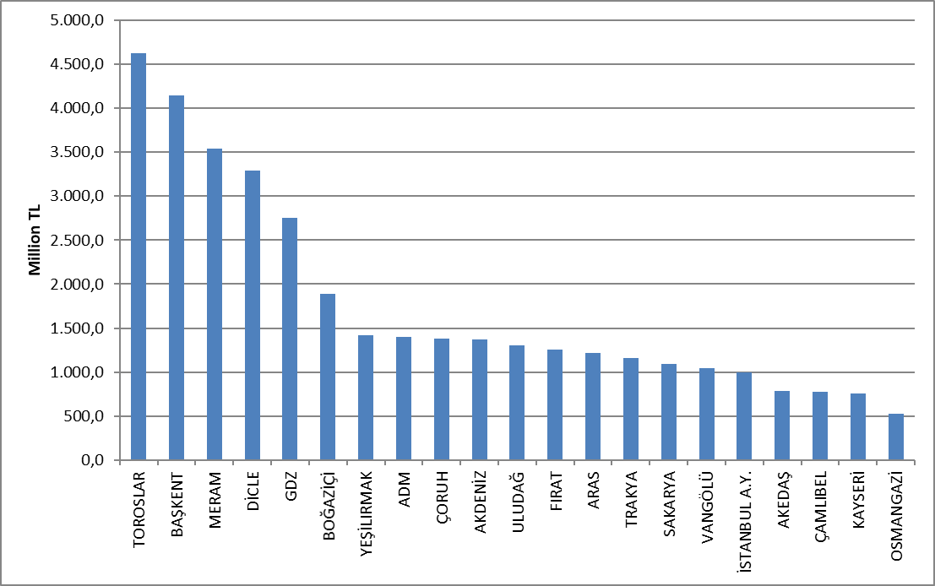

Investment expenditures by investment type in 2023 are shown in the table below. The majority of investments consist of network investments.

Table 5.12: Realized Investment Amounts in 2023 by Investment Types (Tl)
Distribution Company | Investment Type | 2023 Investment Amount (TL) (CPI Jun.2023: 1351.59)
21 EDAŞ | Network Investments | 27.968.272.871
21 EDAŞ | Investments with Legal Obligations | 5.237.619.843
21 EDAŞ | Network Operating System Investments | 2.770.696.444
21 EDAŞ | R&D Project Dissemination Investments | 7.031.286
21 EDAŞ | Other Expenditures Qualifying as Investment Expenditures | 750.977.093
21 EDAŞ | Total | 36.734.597.536

* Prepared with unit price amounts and according to June 2023 CPI: 1351.59.
**III. Starting in the Implementation Period and continuing through IV. Investments completed during the Implementation Period are included.
*** The table has been prepared based on the investment realization declarations submitted by the companies through the notification system.

5.7 Information on Organized Industrial Zones

Data regarding Organized Industrial Zones holding OIZ Distribution Licenses are shown in the table below.

Table 5.13: Information on Organized Industrial Zones
Number of Participants AG | 52.485
Number of Participants OG | 18.367
Number of Total Participants | 70.852
Line Length AG | 4.460
Line Length OG | 9.125
Total Line Length | 13.585
Number of Employees (Electricity Distribution) | 1.071
Number of Transformers | 24.007
Installed Capacity of Transformers (MVA) | 24.569
Annual Peak Value of Previous Year (MW) | 8.317
As of the end of 2023, the total number of participants in Organized Industrial Zones was 70.852, 52.485 of which were low voltage and 18.367 were medium voltage. 1.071 personnel are employed in electricity distribution in OIZ distribution regions.
The total OIZ line length was 13.585 km. There are 24.007 transformers and the total transformer capacity has reached 24.569 MVA. The total of peak values ​​in OIZ regions for the previous year is 8.317 MW.

- PRICING

The Electricity Market Law envisages a market structure based on bilateral agreements. In this market, the price of electrical energy is determined by the mutual agreement of buyers and sellers. Therefore, the prices determined by bilateral agreements are within the knowledge of the relevant parties and are not shared with the public. On the other hand, a significant portion of consumers in the Turkish electricity market obtain energy at regulated prices. For this reason, the changes in regulated prices and price components over the years are important. This section contains data on regulated prices and the changes in the elements that make up the price over the years.
The figure below shows the change in retail energy tariffs (excluding system usage fees, taxes and funds) by tariff groups over the years.

Figure 6.1: Retail Price Excluding Taxes and Funds by Years (Energy+PSH) (kr/kWh)
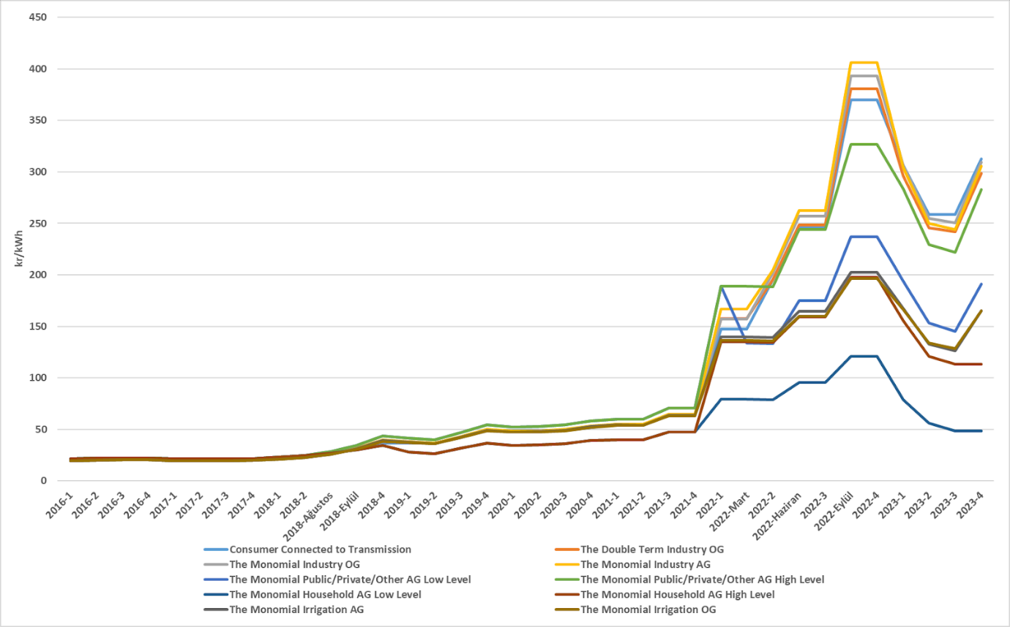
As it is known, transmission and distribution lines must be used to deliver energy from the producer to the consumer. The following shows the change in the distribution fee over the years. The price in question includes the distribution system, transmission system and technical and non-technical loss costs.

Figure 6.2: Change in Network Costs (Distribution, Transmission and Loss) by Years (kr/kWh)
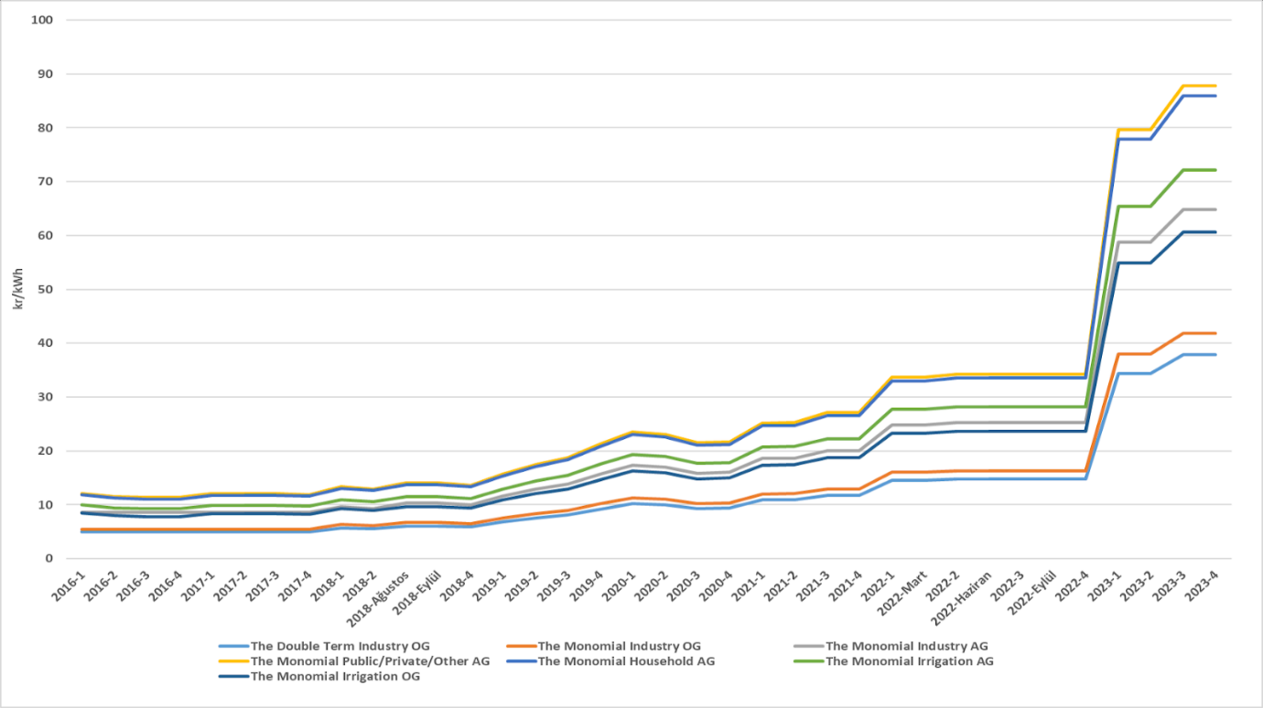
By adding the distribution fee to the energy cost, the unit energy cost before tax is reached. The figure below shows the change in unit energy cost over the years, excluding taxes and funds (Electricity and Gas Consumption Tax and VAT).

Figure 6.3: Change in Electricity Tariffs before Taxes and Funds by Years (kr/kWh)
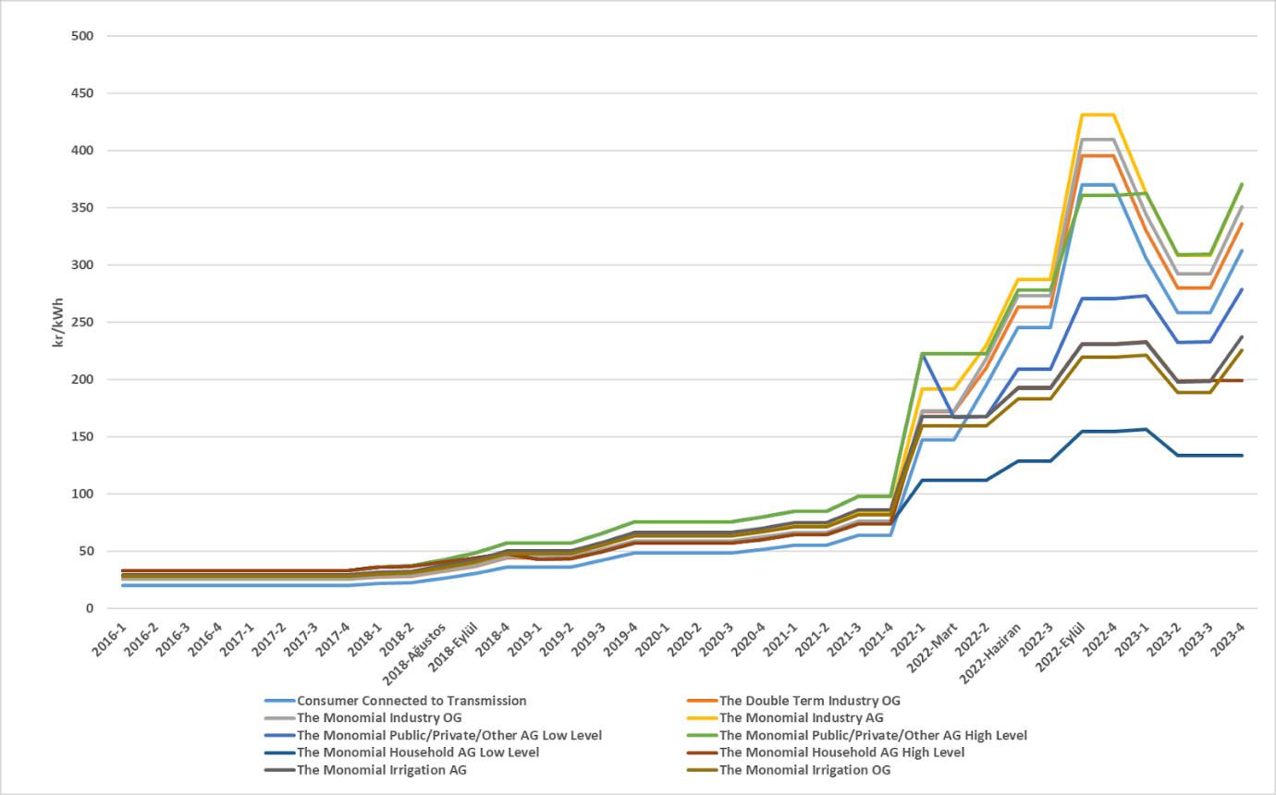
As seen in the figure above, the consumer group with the highest unit energy cost before taxes and funds as of the end of the year is high-level public and private services and other consumer groups. The lowest unit energy cost before taxes and funds belongs to the lower level of the residential consumer group.

Figure 6.4: Share of Items on Household Electricity Invoice in 2023 (%)
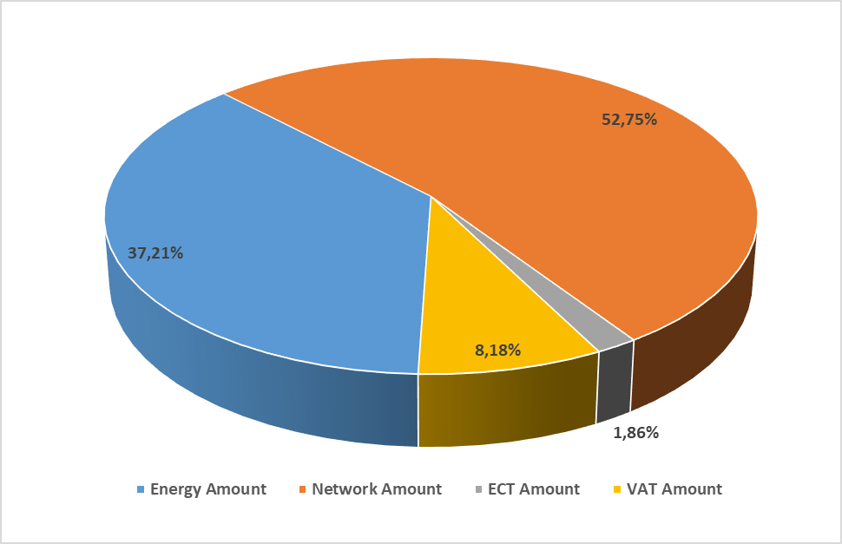
* Single term AG has been prepared using the unit prices belonging to the low-tier residential consumer group and based on the average of the year. As of 10/7/2023, the VAT rate, which was 8%, has been updated to, 10%.

As can be seen in Figure 6.4, the most important item in the bills of consumers in the low-tier residential group, other than the network amount, is the retail energy amount with a share of 37,21%.

Figure 6.5: Share of Prices in the Industrial Electricity Bill of 2023 (%)
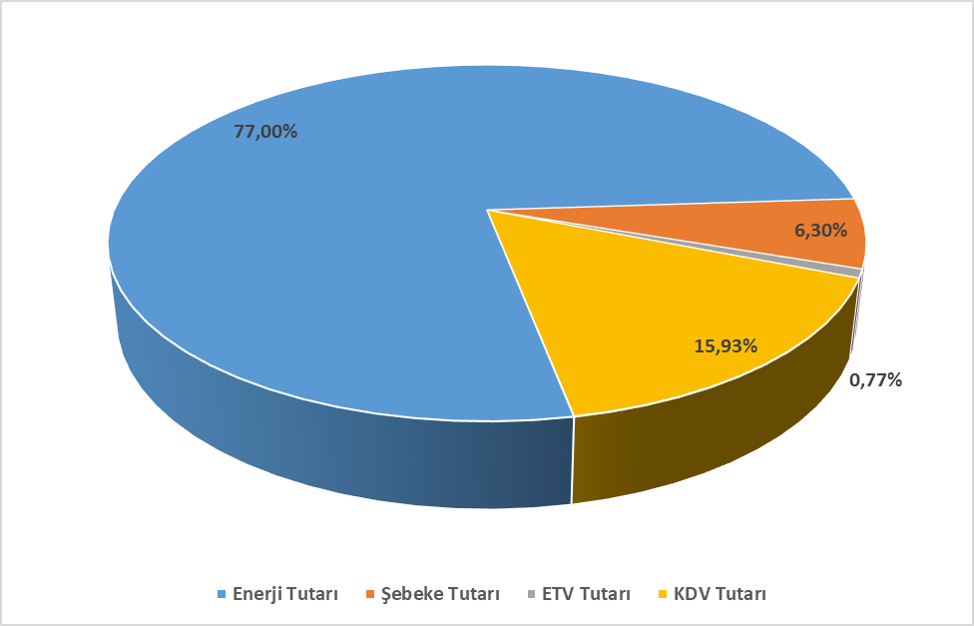
*Prepared using unit prices of the transmission system and industrial MV consumer group and based on the year average. As of 10/7/2023, the VAT rate, which was 18%, has been updated to, 20%.
Looking at the figure 6.5, it can be seen that the share of energy amount in the bill components of consumers in the industrial consumer group is higher, and the share of distribution and/or transmission (network) amount is lower, compared to the bill components of consumers in the low-level residential consumer group in figure 6.4.

The index ranges between 1 and 10.000, with 1 representing a perfectly competitive market structure with low concentration and 10.000 representing a monopoly market structure where is carried out by a single company. If the HHI index is below 1.000, the market is considered to be competitive generation

