

ELECTRICITY MARKET DEVELOPMENT REPORT 2016

This report is published within the scope of Official Statistics Program.

All the information, tables and figures provided in this report are reserved and cannot be used without reference.

REPUBLIC OF TURKEY
ENERGY MARKET REGULATORY AUTHORITY

Strategy Development Department

ANKARA, 2017

Important Notice:
- Licensees may revise their own data submitted before, through correction requests. Therefore, there may be some nonconformity between previous reports and present report published.
- In this report Turkish punctuation rules are adopted for numbers.

MeSSAGE FROM THE PRESIDENT

After 2014 and 2015, which were striving for a number of regulations and other legislations that were put into effect in the framework of the Electricity Market Law numbered 6446, which entered into force in 2013, a significant process was made in 2016 on the light of these regulations as moving towards a more liberal, competitive, transparent and foreseeable structure on the market.
As known, players in the electricity market started to submit notifications related to market activities using electronic signature through the Energy Market Notification System at the beginning of 2015 and data obtained from the notification system was largely used in the preparation of market development reports. In coming years, we are planning to prepare the market development reports in a shorter period and more extensively with the collection of data in the notification system. Apart from our this aim within the scope of our annual report, the aim of publishing fundamental data in the electricity market in the form of monthly reports came into life by the publishment of monthly report of January 2016 and this practice has been carried on vigorously.
We give great importance to collect and analyze the data obtained from the notification system on time and in a accurate manner and to share it with all related parties and the public. In this sense, it is very important that notifications defined in the system are submitted in a timely and complete manner in order to ensure the integrity, consistency and reliability of the data contained in the report.
Once again, I would like to indicate that as EMRA we are open to all kind of constructive opinion and suggestion and I wish the Electricity Market Development Report of 2016 will be useful to all related parties, intitutions and organisations.

Mustafa YILMAZ
President

EXECUTIVE SUMMARY

- Installed Capacity and Peak Demand

  - Installed capacity in 2016 was 77.737 MW increasing by 6,27% compared to previous year.

  - Natural gas power plants share was 32,77 %, dam-hydroelectric power plants share was 25,16 %, riverhydroelectric power plants share was 9,16 %, lignite power plants share was 11,92 % and wind power plants share was 7.39 % of the total installed capacity. The share of renewable energy sources (including hydraulic) within the installed capacity was 43,41 %. The ratio of total thermal installed capacity was 56,59 %.

  - Peak demand reached to 44.734 MW increasing by 3,34%.

- Generation and Consumption

  - Electricity generation reached to 272,56 TWh in 2016, increasing by 4,12 % compared to 2015.

  - Electricity consumption increased by 4,44% compared to 2015 and reached 277,52 TWh.

  - 32,16 % of the generation was from natural gas, 24,7 % from hydraulic, 15,35 % from coal and lignite, 17,52 % from imported coal, 5,69 % from wind and the rest was obtained from other sources.

- Unlicensed Generation

  - In 2016, unlicensed installed capacity reached to 1.048 MW increasing by 191,95 % compared to previous year. 89,81 % of this amount was obtained from solar (photovoltaic) energy.

  - In 2016, the volume of unlicensed generation reached to 1,14 TWh increasing by 410,89 % compared to 2015. 90,64 % of this amount was obtained from solar (photovoltaic) energy.

- Invoiced Consumption

  - In 2016, invoiced electricity consumption reached to 212,33 TWh increasing by 9,78 % compared to previous year. 49,78 TWh of this amount was sold to consumers connected to the transmission voltage level and the remaining 162,55 TWh was sold to consumers connected to the distribution voltage level.

  - In addition, 131,23 TWh of the total amount was consumed by eligible consumers, while the rest 81,10 TWh was consumed by non-eligible consumers.

- Imports and Exports

  - In 2016, electricity imports decreased by 13,64 % to 6,40 TWh.

  - Electricity exports decreased by 51,36 % to 1,44 TWh compared to previous year.

- Day-Ahead Market and Balancing Market

  - In 2016, the Weighted Average Market Clearing Price (MCP) was 148,32 TL/MWh, while the highest MCP value was 1.899,99 TL/MWH (14:00 on 23 December 2016) and the lowest MCP value was 0 TL/MWh.

  - In 2016, the Average System Marginal Price (SMP) was 139,80 TL/MWh. The highest SMP value was 1.899,99 TL/MWh (14:00 on 23 December 2016) while the lowest SMP value was 0 TL/MWh.

  - In 2016, due to the orders in the Balancing Power Market, an additional cost of 878,62 million TL was occured in the electricity market.

- RES Support Mechanism

  - In 2016, the number of participants benefiting from the Renewable Energy Resources Support Mechanism reached to 556. The installed capacity of these participants was 15.083 MW.

  - The electricity generation of RES Support Mechanism participants was 44,69 TWh in 2016, increasing by 250 % compared to 2015. 57,10 % of this amount was obtained from hydraulic, 31,69 % from wind and the rest was obtained from geothermal and biomass.

- Market Openness

  - In 2016, the eligible consumer limit was set at 3600 kWh and the theoretical market openness rate for demand side was calculated as 85,8 %.

  - Eligible consumers’ consumption in 2016 was 131,23 TWh. This proportion corresponds to approximately 61.8% of total invoiced consumption.

  - By the end of 2016, the number of eligible consumers reached 2 million 635 thousands. This number corresponds to 6,42 % of the total number of consumers.

- Transmission

- By the end of 2016, there were 997 transformer centers in the transmission system and 2038 transformers with 180.485 MVA capacity.

- By the end of 2016, the length of transmission lines were 61.269 km.

- In 2016, total investment of the transmission company was 1,9 billion TL.

  - In 2016, the transmission loss rate was 2,23 %.

- Distribution

  - By the end of 2016, the number of consumers using the distribution system was 41,06 millions. The regions with the highest number of consumers were the Boğaziçi with 4,87 millions and the Başkent with 4,1 millions.

  - By the end of 2016, the total invoiced consumption in the distribution regions was realized as 162,55 TWh. The regions with the highest consumption amounts were the Boğaziçi with 23,24 TWh and the Toroslar with 14,34 TWh.

  - The highest loss rates were seen in Dicle with 67,63 %, Vangölü with 56,42 % and Aras with 25,68 %.

  - The lowest loss rates were seen in the distribution regions of Trakya with 5,46 % and Uludağ with 5,57 %.

  - By the end of 2016, 54.412 people were employed in the electricity distribution sector. Of those, 14.984 were employed as permanent staff in distribution companies and 39.428 were employed as subcontractor company personnel.

- By of the end of 2016, there were 436.299 transformers in the distribution system with 148.368 MVA power.

- By the end of 2016, the length of distribution lines were 1.102.508 km. 933.158 km of this number was overhead lines and 169.369 km was underground lines.

- In 2016, the distribution companies invested 4,28 billion TL in current prices. The highest investment expenditure was realized in the regions of Boğaziçi with 546 millions TL and the Başkent with 539 millions TL.

ELECTRICITY MARKET OVERVIEW IN 2016

PARAMETERS | Unit
Licensed Generation* | MWh | 272.563.964,75
Licensed Installed Capacity* | MWe | 77.736,79
Unlicensed Generation** | MWh | 1.137.871,75
Unlicensed Installed Capacity | MWe | 1.048,21
Consumption | MWh | 277.522.012,26
Invoice-based Consumption | MWh | 212.328.766,46
Peak Demand | MW | 44.733,98
Import | MWh | 6.400.129,12
Export | MWh | 1.442.081,65
Weighted Average MCP*** | TL/MWh | 148,32
Weighted Average SMP**** | TL/MWh | 139,80

* Includes the installed capacity and generation values of Independent Generation Companies, Build-Operate, Transfer of Operating Rights and Build-Operate-Transfer Power Plants.

**Unlicensed Generation: Generation in accordance with Article 14 of the Electricity Market Law No. 6446, that is granted to the system as a surplus by those who are exempted from the obligation to obtain license and establish a company.

***MCP: Market Clearing Price
****SMP: System Marginal Price

Contents
1. GENERATION, INSTALLED CAPACITY, UNLICENSED GENERATION, CONSUMPTION, IMPORT AND EXPORT 1
1.1 Overview 1
1.2 Generation 2
1.3 Installed Capacity 10
1.4 Unlicensed Generation 14
1.5 Invoiced Electricity Consumption 23
1.6 Import and Export 31
2. WHOLESALE MARKET 33
1.1 Day-Ahead Market 33
2.2 Balancing Power Market 38
2.3 Intra-Day Market 44
2.4 Bilateral Agreements 45
2.5 RES Support Mechanism 49
3. COMPETITION 54
3.1 Supply Side 54
3.2 Demand Side 59
4. TRANSMISSION 67
4.1 Transmission System 67
4.2 Transmission System Connection Applications 69
4.3 Tariffs 69
4.4 Amount of Investment 72
4.5 Losses 72
5. DISTRIBUTION 74
5.1 Number of Consumers 74
5.2 Ratio of Losses 75
5.3 Employment 77
5.4 Information about Network 78
5.5 Quality Indicators 84
5.6 Investment Amount of Distribution Companies 87
5.7 Information about Organized Industrial Zones (OIZ) 90
6. PRICING 91

List of Tables
Table.1.1: Licensed and Unlicensed Installed Capacity, Peak Demand, Licensed and Unlicensed Electricity Generation, Consumption, Import and Export Data 1
Table.1.2: Distribution of Electricty Generation by Provinces (MWh-%) 8
Table 1.3 Distribution of Installed Capacity by Provinces (MW-%) 13
Table 1.4: The Status of Unlicensed Electricity Generation Applications by the End of 2016 (MW) 15
Table 1.5: Distribution of Unlicensed Installed Capacity by Sources (MW-%) 15
Table 1.6: Distribution of Unlicensed Installed Capacity by Province (MW- %) 17
Table 1.7: Distribution of Unlicensed Electricity Generation by Sources (MWh-%) 19
Table 1.8: Distribution of Unlicensed Electricity Generation by Provinces (MWh-%) 20
Table 1.9: Distribution of the Amount of Payment Made Within the Scope of Unlicensed Electricity Generation by Sources (TL-%) 22
Table 1.10: Sales to Eligible and Non-Eligible Consumers in 2016 (MWh) 23
Table 1.11: Distribution of Invoiced Consumption by Distribution Regions in 2016 (MWh-%) 24
Table 1.12: Distribution of Invoiced Consumption by Consumer Type as Eligible and Non-Eligible Consumers in 2016 (MWh) 25
Table 1.13: Distribution of Invoiced Consumption by Province (MWh - %) 26
Table 1.14: Distribution of Invoiced Consumption by Province and Consumer Type (MWh) 28
Table.2.2.1: Additional Costs of Orders (Million TL) 42
Table 2.5.1: Number of RES Support Mechanism Participants by years 49
Table 2.5.2: Installed Capasity of the RES Support Mechanism Participants by Years (MW) * 50
Table 2.5.3: Yearly Generation of RES Support Mechanism Participants by years (MWh)* 51
Table 3.1: HHI Index by Generation and Capacity 55
Table 3.2: Sales, Market Shares and HHI Index of Supply License Owners 56
Table 3.3: The Monthly Distribution Number of Eligible Consumers Switching Their Supplier Based on Province 64
Table 3.4: Distribution of Eligible Consumers’ Switches by Supplier Type 66
Table 4.1: Transformer Center Information 67
Table 4.2: TEİAŞ Transmission Lines 68
Table 4.3: Connection Applications to the Transmission System (Number-MW) 69
Table 4.4: System Usage and System Operation Tariffs Applied between 01/01/2016 and 20/04/2016 (TL/MW-Year) 70
Table 4.5 System Usage and System Operation Tariffs Applied since 01/05/2016 (TL/MW-Year, TL/MWh) 71
Table 4.6: Comparison of 2015 and 2016 Investment Amount (TL-%) 72
Table 5.1: Number of Consumers Using Distribution System by the end of 2016 (Number-%) 74
Table 5.2: Loss Rates of Distribution Companies (%) 75
Table 5.3: Number of Employees of Distribution Companies (Number) 77
Table 5.4: Line Lengths, Number of Transformers and Transformer Capacities Based on Distribution Companies by end of 2016 (Km-MVA-Number) 79
Table 5.5: The Lengths of Distribution Lines (Km) 80
Table 5.6: Line Lengths at Distribution Voltage Levels, Number of Transformers and Transformer Capacities by Provinces in 2016 (Km-MVA-Number) 82
Table 5.7: Reported and Unreported Customer Average Interruption Duration Indices of Distribution Companies in 2016 (min) 84
Table 5.8: Customer Average Interruption Duration Indices of Distribution Companies by reason in 2016 (min) 85
Table 5.9: Customer Average Interruption Frequency Indices of Distribution Companies in 2015 and 2016(Number/Year) 86
Table 5.10: Distribution Companies’ Customer Average Interruption Frequency Indices of Distribution Companies by Reason in 2016 (Number/Year) 87
Table 5.11: Comparison of Distribution Investmentsin 2015 and 2016 (TL-%) 88
Table 5.12: Realized Investment Amounts by Investment Type in 2016 (TL) 89
Table 5.13: Information About Organized Industrial Zones 90

List of Figures
Figure 1.1: Electric Energy Demand and Rate of Increase by Years (GWh-%) 2
Figure.1.2: Peak Demand and Rate of Increase by Years (MW-%) 3
Figure 1.3: Rate of Increase of Demand and Peak Demand by Year (%) 3
Figure 1.4: Monthly Distribution of Electricity Generation and Consumption in 2016 (GWh) 4
Figure 1.5: Distribution of Electricity Generation in 2016 by Corporations (%) 4
Figure 1.6: The Change of Electricity Generation as Public-Private by Years (%) 5
Figure 1.7: The Distribution of Electricity Generation by Sources in 2016 (%) 6
Figure 1.8: Source-Based Development of Electricity Generation by Years (GWh) 6
Figure 1.9: Daily Electricity Generation in 2016 (MWh) 7
Figure 1.10: Hour-Based Electricity Generation in 2016 (MWh) 7
Figure 1.11: The Share of First 10 Companies within Electricity Generation in 2016 (%) 9
Figure 1.12: Distribution of Installed Capacity by Sources at the End of 2016 (%) 10
Figure 1.13: Distribution of Installed Capacity by Organizations at the End of 2016 (%) 11
Figure 1.14: Distribution of Activated and Deactivated Power Plants’ Installed Capacity in 2016 by Sources 11
Figure 1.15: The Development of Installed Capacity According to Source by Years (MW) 12
Figure 1.16: The Development of the Share of the Sources within the Installed Capacity by Years (%) 12
Figure 1.17: The Share of the First 10 Companies in Installed Capacity at the End of 2016 (%) 14
Figure 1.18: Distribution of Unlicensed Installed Capacity by Sources at the End of 2016 (%) 17
Figure 1.19: Distribution of Unlicensed Electricity Generation by Sources in 2016 (%) 20
Figure 1.20: Distribution of Invoiced Consumption by Consumer Type in 2016 (%) 25
Figure 1.21: Distribution of Invoiced Consumption by Months (MWh) 30
Figure 1.22: Development of Gross Consumption by Years (GWh) 30
Figure 1.23: Electricity Imports in 2016 by Months (MWh) 31
Figure 1.24: Electricity Exports in 2016 by Months (MWh) 32
Figure.2.1.1: Hourly Development of Weighted Average Market Clearing Price in 2016 (TL/MWh) 34
Figure.2.1.2: Weighted Average MCP by Years (TL/MWh) 35
Figure 2.1.3: Monthly Weighted Average MCP of the Last Two Years (TL/MWh) 36
Figure 2.1.4: Monthly Day-Ahead Market Trading Volume (MWh) 37
Figure 2.1.5: The Share of First 10 Buyer Companies in Day-Ahead Market (%) 37
Figure 2.1.6: The Share of First 10 Seller Companies in Balancing Power Market (%) 38
Figure.2.2.1: Per-Hour Based Development of System Marginal Price (TL/MWh) 38
Figure 2.2.2: Monthly Weighted Average Prices of the Last Two Years in Balancing Power Market (TL/MWh) 39
Figure 2.2.3: Monthly Trading Volumes in Balancing Power Market (MWh) 40
Figure 2.2.4: The Share of First 10 Buyer Companies in Balancing Power Market (%) 40
Figure 2.2.5: The Share of First 10 Seller Companies in Balancing Power Market (%) 41
Figure 2.2.6: Rates of Order Volumes Given in Balancing Power Market in 2016 (%) 41
Figure 2.2.7: Distribution of the Orders Given in the Balancing Power Market by Hours in 2016 (MW) 42
Figure.2.2.8: Development of Additional Costs of Orders by Months in 2016 (Million TL) 43
Figure 2.2.9: Development of Zero Balance Adjustment Component by Years (TL) 43
Figure 2.3.1: Monthly Development of Trading Volume and Average Price in the Intra-Day Market (MWh - TL / MWh) 44
Figure 2.3.2: Distribution of Purchases of Intra-Day Market by Companies and the Share of First 10 Companies (%) 45
Figure 2.3.3: Distribution of Sales in Intra-Day Market by Companies and the Share of First 10 Companies (%) 45
Figure 2.4.1: Monthly Bilateral Agreement Volume by Years (MWh) 46
Figure 2.4.2: Distribution of Purchases of Bilateral Agreement by Companies and the Share of First 10 Companies (%) 47
Figure 2.4.3: Distribution of Sales with Bilateral Agreement by Companies and the Share of First 10 Companies (%) 47
Figure 2.4.4: TETAŞ Wholesale Prices Between 2010-2016 (kr / kWh) 48
Figure 2.5.1: Distribution of Installed Capacity by Sources in 2016 (%) 50
Figure 2.5.2: Distribution of Generation in RES Support Mechanism by Sources in 2016 51
Figure 2.5.3: Monthly Development of RES Support Mechanism Generation in 2016 (MWh) 52
Figure 2.5.4: Monthly Development of RES Support Mechanism Feed-in Tariffs and MCP in 2016 (MWh) 52
Figure 2.5.5: Average of RES Support Mechanism and MCP in 2016 (Kr./kWh) 53
Figure 2.5.6: Monthly Payments Made within the Scope of the RES Support Mechanism in 2016 (TL) 53
Figure 3.1: Eligible Consumer Limit and Market Openness Ratio by Years (kWh-%) 60
Figure 3.2: Number of Eligible Consumer by Months in 2016 (Number) 60
Figure 3.3: Distribution of Eligible Consumers by Distribution Regions by end of 2016 (Number) 61
Figure 3.4: Distribution of Eligible Consumers Consumption by Distribution Regions in 2016 (MWh) 62
Figure 3.5: Distribution of Eligible Consumer Consumption by Suppliers Type (%) 62
Figure 3.6: Monthly Changes in Number and Consumptions of Eligible Consumers Switching Their Supplier (Number-MWh) 63
Figure 4.1: Changes in TEİAŞ Transmission Line Lengths by Years (km) 68
Figure 4.2: Regional Transmission System Usage Tariffs Applied between 01.01.2016 and 30.04.2016 (TL/MW-Year) 70
Figure 4.3:Regional Transmission System Usage Tariffs based on Capacity Applied since 01/05/2016 (TL/MW-Year) 72
Figure 4.4: Transmission System Losses (GWh-%) 73
Figure 4.5: Transmission System Losses by Hour (%) 73
Figure 5.1: Number and Consumption of Consumers (Number-MWh) 75
Figure 5.2: Realized and Targeted Loss Rates in 2016 (%) 76
Figure 5.3: Number of Employees of Distribution Companies by Year 2016 (Number) 78
Figure 5.4: Line Lengths and Transformer Capacities on the Basis of 79
Distribution Companies at the end of 2016 (Km-MVA) 79
Figure 5.5: The Length of Lines on the Basis of Distribution Companies at the end of 2016(Km) 81
Figure 5.6: Investment Amounts of Distribution Companies in 2016 (Current Prices-million TL) 89
Figure 6.1: Change in Retail Electric Energy Prices in the Last Five Years (Kr/kWh) 91
Figure 6.2: Change in Network Costs (Distribution, Transmission and Loss) by Years (Kr / kWh) 92
Figure 6.3: Change in Electricity Tariffs Before Taxes and Funds by Years (kr / kWh) 93
Figure 6.4: Share of Items on Residence Electricity Invoice in 2016 (%) 93
Figure 6.5: Share of Items on Industry Electricity Invoice in 2016 (%) 94

ABBREVIATIONS

BPM : Balancing Power Market
EMRA : Energy Market Regulatory Authority
EXIST : Energy Exchange Istanbul
EÜAŞ : Electricity Generation Company
IDM : Intra-Day Market
DAM : Day-Ahead Market
MCP : Market Clearing Price (Day-Ahead Price)
MFSC : Market Financial Settlement Center
SMP : System Marginal Price (Real Time Price)
BO : Build Operate
BOT : Build Operate Transfer
TOR : Transfer of Operating Rights
TEİAŞ : Turkish Electricity Transmission Company
TETAŞ : Turkish Electricity Trading and Contracting Company
RES Support Mechanism : Renewable Energy Sources Support Mechanism

- GENERATION, INSTALLED CAPACITY, UNLICENSED GENERATION, CONSUMPTION, IMPORT AND EXPORT

This section shall examine, licensed electricity generation, installed capacity, unlicensed electricity generation, consumption, export and import data for the year 2016. In addition, interpretetions and comparisons shall be expressed according to the previous years.

1.1 Overview

Table 1.1 shows licensed and unlicensed installed capacity, peak demand, licensed and unlicensed electricity generation, consumption, import and export data by the end of 2016, combined with previous years’ data.

Table.1.1: Licensed and Unlicensed Installed Capacity, Peak Demand, Licensed and Unlicensed Electricity Generation, Consumption, Import and Export Data
 | Unit | 2013 | 2014 | 2015 | Change (%) 2014→2015 | 2016 | Change (%) 2015→2016
Licensed Installed Capacity | MW | 64.007 | 69.520 | 73.146,90 | 5,22 | 77.736,79 | 6,27
Unlicensed Installed Capacity | MW | - | 29,99 | 359,04 | 1097,20 | 1.048,21 | 191,95
Peak Demand | MW | 38.274 | 41.003 | 43.289,00 | 5,58 | 44.733,98 | 3,34
Licensed Generation | GWh | 242.121 | 251.962 | 261.783,30 | 3,90 | 272.563,96 | 4,12
Unlicensed Generation | GWh | - | 3,92 | 222,72 | 5581,63 | 1.137,87 | 410,89
Consumption | GWh | 248.324 | 257.220 | 265.724,40 | 3,31 | 277.522,01 | 4,44
Import | GWh | 7.429 | 7.953 | 7.411,10 | -6,81 | 6.400,13 | -13,64
Export | GWh | 1.227 | 2.696 | 2.964,60 | 9,96 | 1.442,08 | -51,36

As can be seen from the Table, consumption and licensed generation in 2016 increased by 4,44 % and 4,12 % respectively and peak demand and licensed installed capacity increased by 3,34 % and 6,27 % respectively compared to 2015. Unlicensed installed capacity and unlicensed electricity generation had been growing rapidly since 2014.
Compared to the previous year, imports decreased 13,64 % which ended up as 6,40 TWh. On the other hand, exports ended up as 1,44 TWh by decreasing 51,36 %. The ratio between exports and imports was 40 % in 2015 whereas in 2016 it decreased to 22,53 %.

1.2 Generation

Figure 1.1 shows the electricity demand and rate of its increase by years. As seen in the figure, demand for electric energy had increased steadily since 2009, with a decrease especially in the rate of increase from 2011 to 2013. In 2016, the greatest increase in the last 4 years was realized with 5,07 %.

Figure 1.1: Electric Energy Demand and Rate of Increase by Years (GWh-%)
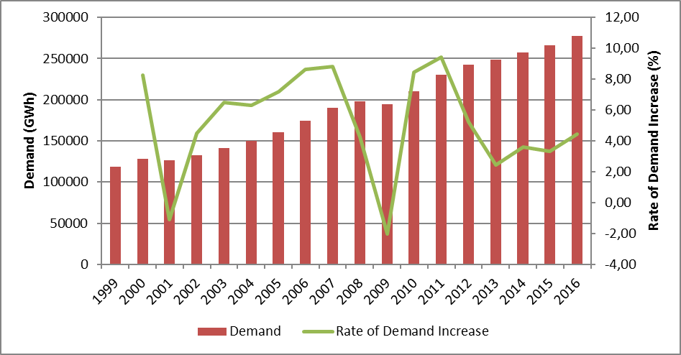
The development of peak demand and its rate of increase are provided in Figure 1.2. The change of peak demand is generally seen as it is in energy demand figure but it is more variable. In year 2016, the increment of peak demand can be seen as 3,34 %.

Figure.1.2: Peak Demand and Rate of Increase by Years (MW-%)
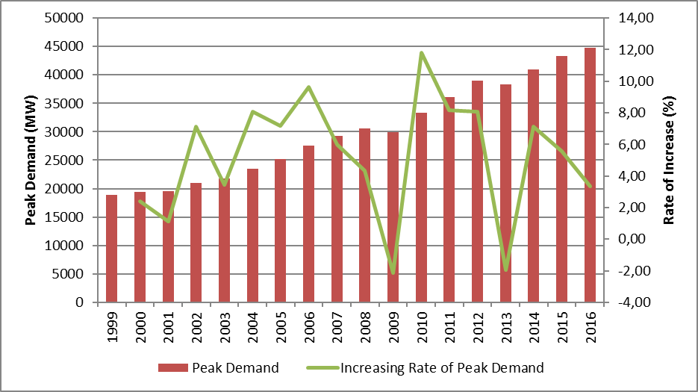

In Figure 1.3, peak demand and its relations with electric energy demand are given. As can be seen from the figure, the rate of increase of electric energy demand and peak demand were happened to be close to each other.

Figure 1.3: Rate of Increase of Demand and Peak Demand by Year (%)
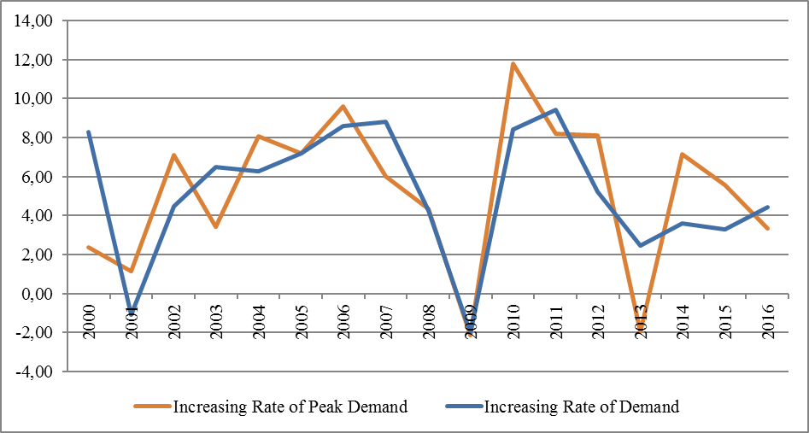

In Figure 1.4, monthly changes of generation and consumption are represented. The highest points of generation and consumption were achieved in August.

Figure 1.4: Monthly Distribution of Electricity Generation and Consumption in 2016 (GWh)
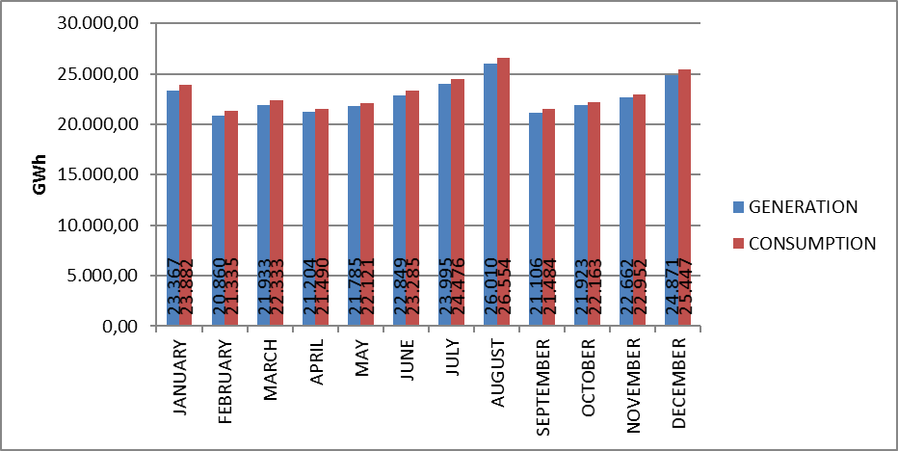
The distribution of electricity generation to companies in 2016 is shown in Figure 1.5. The biggest share in generation belongs to independent power producers with 61,48 %. The share of the power plants of EÜAŞ was 17,09 % and the power plants that were operated under the existing contracts had the share of 21,43 % in the total generation.

Figure 1.5: Distribution of Electricity Generation in 2016 by Corporations (%)
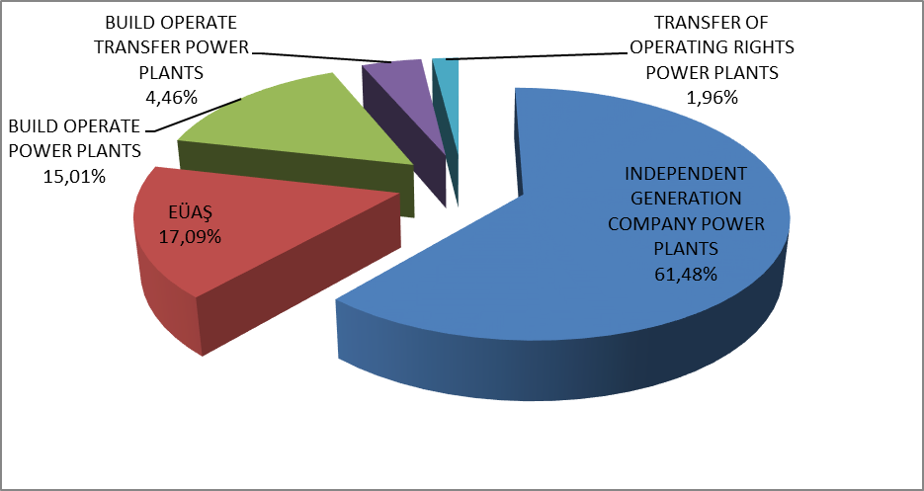
The distribution of generation under private, public and existing contracts are given in Figure 1.6. In 2015 the share of public in generation (including existing contracts) was 44.17%, whereas in 2016 it decreased to 38,52 %. Similarly, in 2015 the share of independent generation was 55,83 % which in 2016 increased to 61,48 %.

Figure 1.6: The Change of Electricity Generation as Public-Private by Years (%)
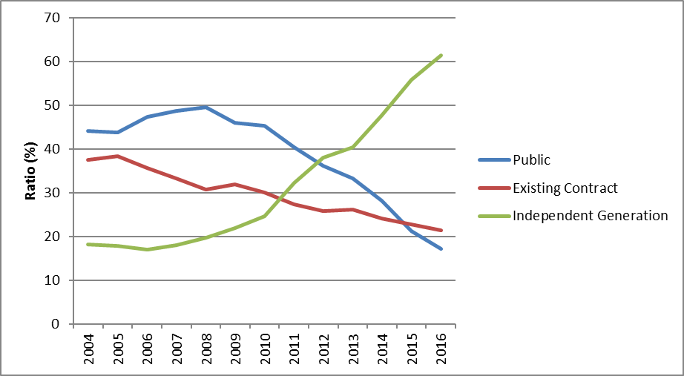

Figure 1.6 reflects the fact that the share of independent generation was still increasing. There are two reasons behind this increment. Firstly, most of the new investments were done by independent power producers. Secondly, due to privatization,the ownership of the existing public power plants were going under private sector.
The distribution of electricity generation by resources is shown in Figure 1.7. The share of natural gas-fired power plants in energy generation was 37,81 % in 2015 which in 2016 decreased to 32,16 %. For the hydroelectric power plants, the share was 25,7 6% which decreased to 24,69 % in 2016. On the other hand, the share of domestic coal (lignite, hard coal and asphaltite) power plants was 13,23 % in 2015, which increased to 16,40 %, in imported coal power plants from 15,22 % to 17,52 %, in wind power plants from 4,45 % to 5,69 %, in geothermal power plants from 1,30 % to 1,77 %.

Figure 1.7: The Distribution of Electricity Generation by Sources in 2016 (%)
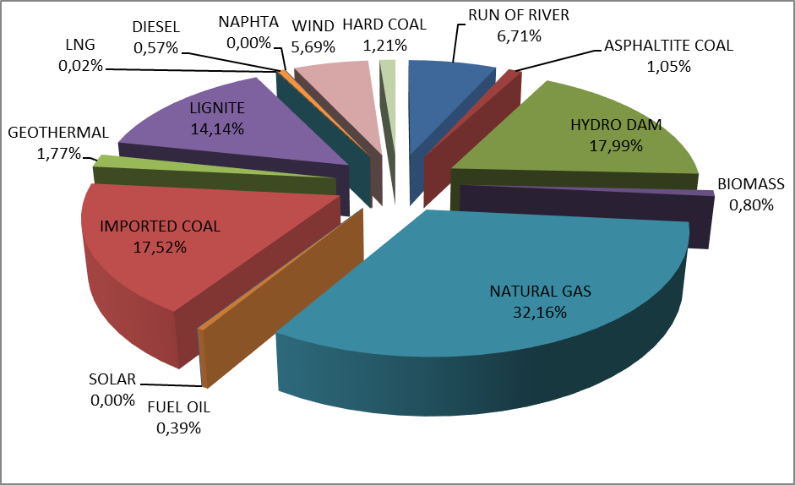

The development of electricity generation on the basis of resources since 1980 is shown in Figure 1.8. As can be seen from the figure, the share in electricity generation of resources like geothermal, wind, solar and biomass had increased every year.

Figure 1.8: Source-Based Development of Electricity Generation by Years (GWh)
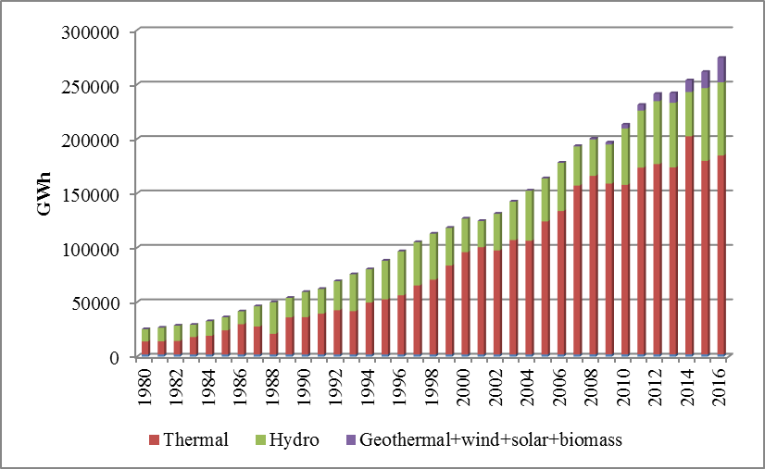
Day-based development of electricity generation in Turkey is shown in Figure 1.9. Electricity generation was at its highest point in August and lowest in February. Considering day-based chart, the highest electricity generation occurred on 10 August 2016, lowest on 12 September 2016.

Figure 1.9: Daily Electricity Generation in 2016 (MWh)
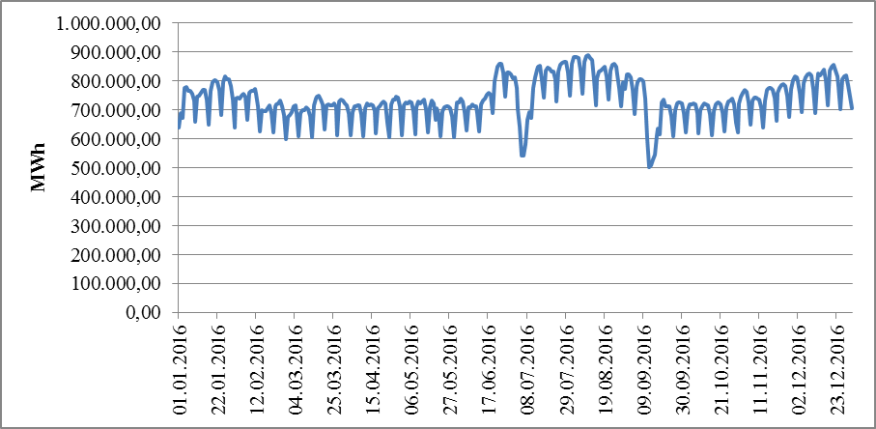

Hour-based electricity generation in Turkey is shown at Figure 1.10. The highest generation was at 12:00 o’clock and the lowest was at 06:00 o’clock.

Figure 1.10: Hour-Based Electricity Generation in 2016 (MWh)
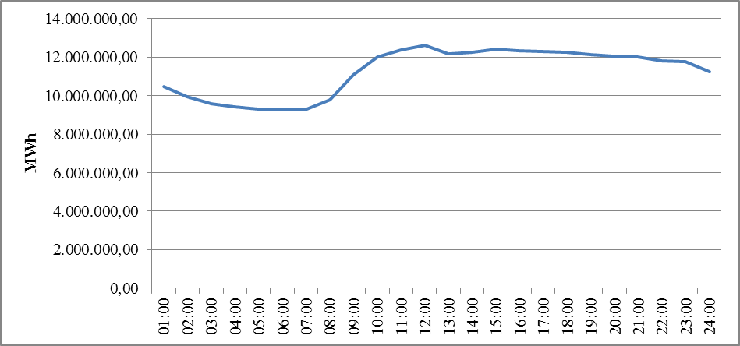
The distribution of electricity generation by provinces is given in Table 1.2. The highest electricity generation was in İzmir, Sakarya, Adana, Hatay and Çanakkale provinces and lowest was in Bartın, Bitlis, Niğde, Yozgat and Aksaray provinces.

Table.1.2: Distribution of Electricty Generation by Provinces (MWh-%)
PROVINCE | Generation (MWh) | Share (%) | PROVINCE | Generation (MWh) | Share (%)
İZMİR | 19.024.552,74 | 6.98 | ERZİNCAN | 1.012.919,32 | 0.37
SAKARYA | 15.854.472,30 | 5.82 | YALOVA | 927.715,32 | 0.34
ADANA | 15.431.048,42 | 5.66 | SİNOP | 847.842,66 | 0.31
HATAY | 14.869.162,30 | 5.46 | ESKİŞEHİR | 840.310,17 | 0.31
ÇANAKKALE | 14.670.802,91 | 5.38 | ORDU | 754.167,40 | 0.28
ZONGULDAK | 13.655.564,86 | 5.01 | ÇORUM | 669.057,42 | 0.25
MUĞLA | 11.919.517,56 | 4.37 | GAZİANTEP | 660.908,47 | 0.24
ANKARA | 10.086.940,52 | 3.70 | KIRŞEHİR | 647.069,58 | 0.24
SAMSUN | 9.587.543,74 | 3.52 | KARABÜK | 634.320,61 | 0.23
ŞANLIURFA | 9.172.684,90 | 3.37 | AMASYA | 596.644,01 | 0.22
BALIKESİR | 9.024.704,61 | 3.31 | MUŞ | 467.457,86 | 0.17
TEKİRDAĞ | 8.659.912,59 | 3.18 | ARDAHAN | 462.657,82 | 0.17
KOCAELİ | 8.646.947,59 | 3.17 | EDİRNE | 453.399,70 | 0.17
İSTANBUL | 8.165.907,51 | 3.00 | AFYONKARAHİSAR | 447.036,16 | 0.16
MANİSA | 8.048.265,75 | 2.95 | TUNCELİ | 353.564,57 | 0.13
ELAZIĞ | 7.108.882,86 | 2.61 | ADIYAMAN | 342.374,39 | 0.13
DİYARBAKIR | 6.448.460,17 | 2.37 | KARS | 330.808,09 | 0.12
KÜTAHYA | 6.006.536,00 | 2.20 | NEVŞEHİR | 303.638,07 | 0.11
KAHRAMANMARAŞ | 5.932.727,83 | 2.18 | DÜZCE | 270.830,17 | 0.10
ARTVİN | 5.251.349,24 | 1.93 | ISPARTA | 267.914,22 | 0.10
DENİZLİ | 5.204.771,62 | 1.91 | BURDUR | 255.060,40 | 0.09
ANTALYA | 4.816.924,13 | 1.77 | BİLECİK | 248.854,68 | 0.09
BURSA | 4.813.757,94 | 1.77 | KONYA | 200.736,47 | 0.07
SİVAS | 4.618.322,60 | 1.69 | BATMAN | 193.018,44 | 0.07
AYDIN | 4.395.096,49 | 1.61 | MALATYA | 171.118,53 | 0.06
MERSİN | 3.293.192,55 | 1.21 | VAN | 156.297,58 | 0.06
ŞIRNAK | 2.963.307,73 | 1.09 | KASTAMONU | 154.498,24 | 0.06
OSMANİYE | 2.571.752,76 | 0.94 | UŞAK | 154.165,93 | 0.06
GİRESUN | 2.293.678,43 | 0.84 | HAKKARİ | 129.169,39 | 0.05
BOLU | 2.143.400,98 | 0.79 | ÇANKIRI | 97.433,72 | 0.04
GÜMÜŞHANE | 1.903.605,31 | 0.70 | BİNGÖL | 95.810,67 | 0.04
KIRIKKALE | 1.772.491,58 | 0.65 | BAYBURT | 86.540,97 | 0.03
TOKAT | 1.696.521,00 | 0.62 | MARDİN | 55.791,36 | 0.02
TRABZON | 1.670.561,61 | 0.61 | IĞDIR | 42.993,31 | 0.02
KAYSERİ | 1.484.294,28 | 0.54 | AKSARAY | 39.278,42 | 0.01
KIRKLARELİ | 1.301.586,47 | 0.48 | YOZGAT | 4.399,38 | 0.00
KARAMAN | 1.231.006,68 | 0.45 | NİĞDE | 645,18 | 0.00
ERZURUM | 1.186.780,84 | 0.44 | BİTLİS | 621,80 | 0.00
SİİRT | 1.161.081,56 | 0.43 | BARTIN | 558,72 | 0.00
RİZE | 1.098.216,66 | 0.40 | Grand Total | 272.563.964,75 | 100.00

In Figure 1.11, 10 companies that have the highest contribution in electricity generation and their share are shown. As can be seen from the figure, first 10 companies were EÜAŞ, Eren Enerji Elektrik Ür.A.Ş., Enerjisa Enerji Ür.A.Ş., Gebze Elektrik Ür.Ltd.Şti., İskenderun Enerji Ür.Ve Tic.A.Ş., İzmir Elektrik Ür.Ltd.Şti., Atlas Enerji Üretim San.A.Ş., İçdaş Elektrik En.Ür.Ve Yat.A.Ş., Yeniköy Kemerköy Elektrik Ür.Ve Tic.A.Ş. and Adapazarı Elektrik Ür.Ltd.Şti. respectively.

Figure 1.11: The Share of First 10 Companies within Electricity Generation in 2016 (%)
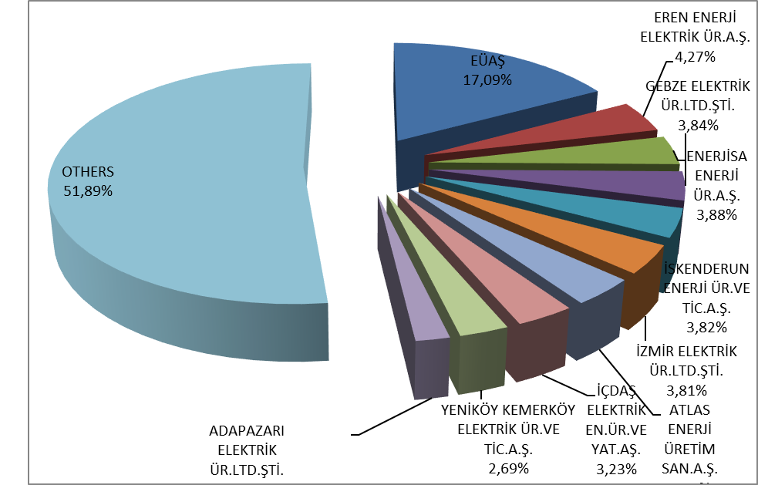

1.3 Installed Capacity

The distribution of installed capacity by fuel types is given in Figure 1.12. By the end of 2015, the share of natural gas power plants in the installed capacity was 34,1 %, whereas decreased to 32,77 % while the share of hydroelectric power plants was 26,08 % which decreased to 25,16 % and the share of hydroelectric power plants was 9,28 %, decreased to 9,16 % in 2016. On the other hand, at the end of 2016, the share of lignite power plants within the total installed capacity had increased from 11,84 % to 11,92 % and for the share of wind power plants from 6,16 % to 7,39 %, the share of renewable energy sources (including hydro) had increased from 42,71 % to 43,41 %, and he share of total thermal installed capacity decreased from 57,29 % to 56,59 % compared to 2015.

Figure 1.12: Distribution of Installed Capacity by Sources at the End of 2016 (%)
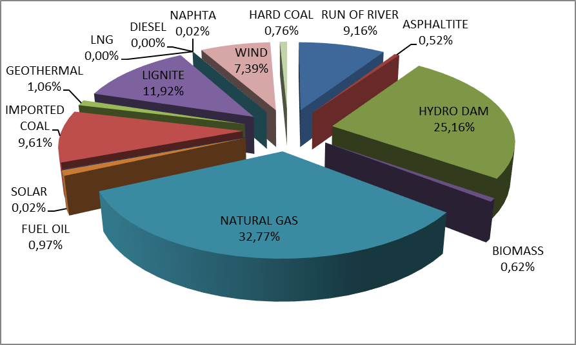
The distribution of installed capacity by organizations is given in Figure 1.13. The share of EÜAŞ power plants within the installed capacity in 2015 was 27,78 %, whereas in 2016 decreased to 25,86 %, the share of power plants that were operated under the existing contracts was 12,29 % which in 2016 decreased to 11,86 %. The share of independent power producers in total installed capacity had increased from 59 % in 2015 to 62,28 % in 2016.

Figure 1.13: Distribution of Installed Capacity by Organizations at the End of 2016 (%)
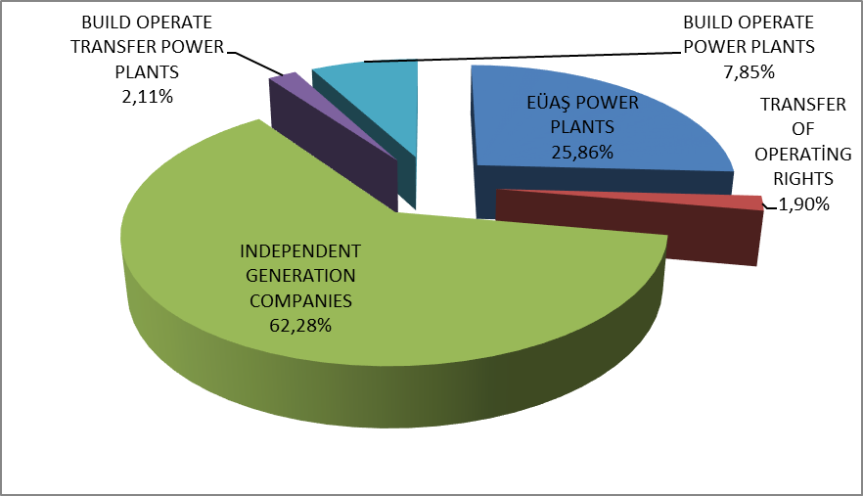

Figure 1.14 shows the distribution of activated and deactivated installed capacity of the power plants by sources in 2016.

Figure 1.14: Distribution of Activated and Deactivated Power Plants’ Installed Capacity in 2016 by Sources
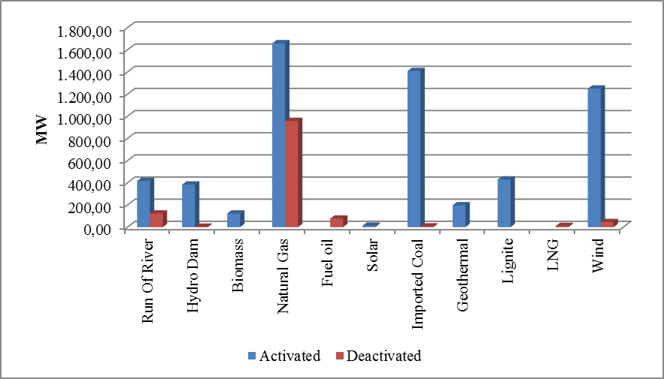

The development of installed capacity since 1980 is given in Figure 1.15. As can be seen from the figure, the share of renewable energy sources, such as geothermal, wind, solar and biomass, had increased year over year.

Figure 1.15: The Development of Installed Capacity According to Source by Years (MW)
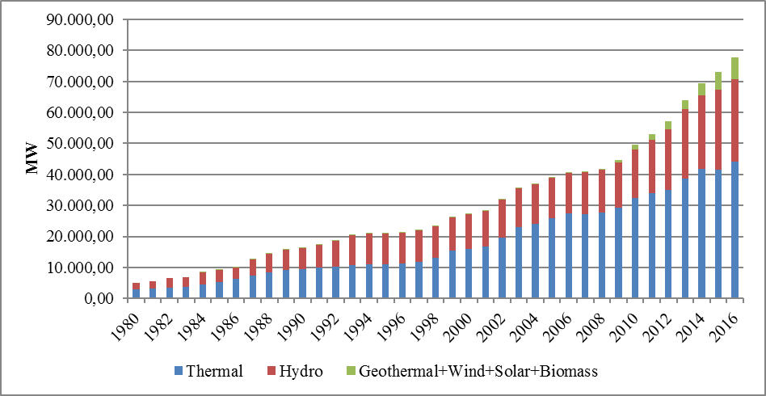
Like in Figure 1.15 the development of sources within the installed capacity since 1980 is given in Figure 1.16.

Figure 1.16: The Development of the Share of the Sources within the Installed Capacity by Years (%)

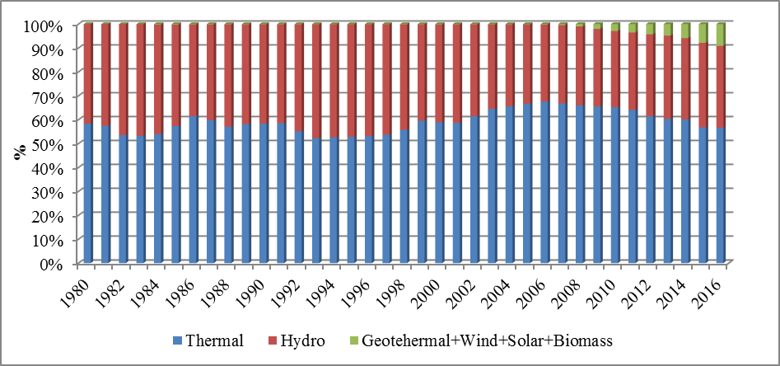
The distribution of installed capacity based on provinces is shown in Table 1.3. The provinces that had the highest installed capacity in 2016 were İzmir, Kahramanmaraş, Adana, Şanlıurfa and Zonguldak, the lowests were Bartın, Bitlis, Ağrı, Niğde and Iğdır respectively.

Table 1.3 Distribution of Installed Capacity by Provinces (MW-%)
PROVINCE | Inst.Cap. (MW) | Share (%) | PROVINCE | Inst.Cap. (MW) | Share (%)
İZMİR | 4.390,82 | 5.65 | BOLU | 410,02 | 0.53
KAHRAMANMARAŞ | 4.233,21 | 5.45 | ORDU | 372,20 | 0.48
ADANA | 3.688,14 | 4.74 | ÇORUM | 362,92 | 0.47
ŞANLIURFA | 3.421,27 | 4.40 | SİİRT | 344,49 | 0.44
ZONGULDAK | 3.330,72 | 4.28 | RİZE | 330,95 | 0.43
SAMSUN | 3.293,66 | 4.24 | KIRŞEHİR | 308,40 | 0.40
BURSA | 2.831,47 | 3.64 | ERZİNCAN | 306,67 | 0.39
HATAY | 2.740,81 | 3.53 | AMASYA | 259,63 | 0.33
İSTANBUL | 2.738,68 | 3.52 | ADIYAMAN | 228,78 | 0.29
BALIKESİR | 2.643,32 | 3.40 | MARDİN | 224,10 | 0.29
SAKARYA | 2.504,29 | 3.22 | AFYONKARAHİSAR | 208,54 | 0.27
ELAZIĞ | 2.444,37 | 3.14 | ISPARTA | 200,54 | 0.26
ÇANAKKALE | 2.287,51 | 2.94 | YALOVA | 194,43 | 0.25
DİYARBAKIR | 2.250,13 | 2.89 | MUŞ | 174,86 | 0.22
MANİSA | 2.130,36 | 2.74 | ARDAHAN | 160,75 | 0.21
MUĞLA | 2.107,10 | 2.71 | KARS | 154,67 | 0.20
ANTALYA | 2.071,56 | 2.66 | KONYA | 152,41 | 0.20
KOCAELİ | 2.064,43 | 2.66 | EDİRNE | 128,00 | 0.16
ANKARA | 1.935,92 | 2.49 | BİLECİK | 126,79 | 0.16
ARTVİN | 1.930,05 | 2.48 | TUNCELİ | 106,95 | 0.14
TEKİRDAĞ | 1.663,45 | 2.14 | DÜZCE | 98,39 | 0.13
KIRKLARELİ | 1.616,58 | 2.08 | BURDUR | 89,45 | 0.12
DENİZLİ | 1.427,45 | 1.84 | NEVŞEHİR | 87,13 | 0.11
OSMANİYE | 1.060,88 | 1.36 | KASTAMONU | 82,15 | 0.11
KÜTAHYA | 1.057,41 | 1.36 | UŞAK | 81,47 | 0.10
MERSİN | 996,88 | 1.28 | KARABÜK | 81,03 | 0.10
AYDIN | 978,72 | 1.26 | VAN | 66,82 | 0.09
KIRIKKALE | 974,70 | 1.25 | MALATYA | 60,66 | 0.08
SİVAS | 908,81 | 1.17 | BATMAN | 57,00 | 0.07
GİRESUN | 810,89 | 1.04 | HAKKARİ | 48,75 | 0.06
GÜMÜŞHANE | 656,30 | 0.84 | BİNGÖL | 47,42 | 0.06
ŞIRNAK | 577,58 | 0.74 | ÇANKIRI | 37,94 | 0.05
KAYSERİ | 564,63 | 0.73 | AKSARAY | 26,63 | 0.03
TRABZON | 554,53 | 0.71 | BAYBURT | 25,71 | 0.03
KARAMAN | 551,57 | 0.71 | YOZGAT | 25,27 | 0.03
ESKİŞEHİR | 548,40 | 0.71 | IĞDIR | 22,58 | 0.03
SİNOP | 547,95 | 0.70 | NİĞDE | 20,78 | 0.03
ERZURUM | 525,02 | 0.68 | AĞRI | 9,50 | 0.01
TOKAT | 479,85 | 0.62 | BİTLİS | 0,60 | 0.00
GAZİANTEP | 471,52 | 0.61 | BARTIN | 0,46 | 0.00
 |  |  | Grand Total | 77.736,79 | 100.00
Figure 1.17 shows the shares of the first 10 companies that had the highest share of installed capacity at the end of 2016.

Figure 1.17: The Share of the First 10 Companies in Installed Capacity at the End of 2016 (%)
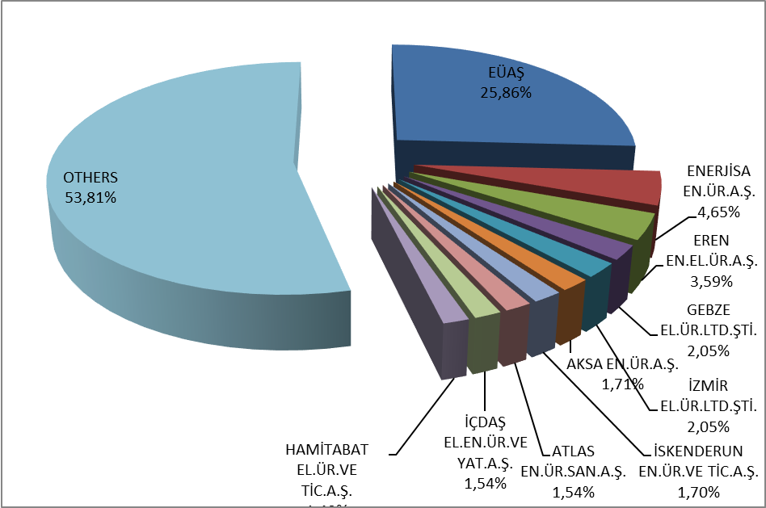

1.4 Unlicensed Generation

In the first sub clause of Article 14 of the Electricity Market Law No. 6446, the production facilities exempted from the license to install and establish a company are as follows;
“a) Generation facilities not connected to emergency generator groups or transmission or distribution systems
b) Generation facilities with the installed power based on maximum one megawatt renewable energy sources
c) Electricity generation facilities of municipalities installed to dispose the sludge of solid waste facilities and of treatment plants
d) Those of micro-cogeneration facilities and cogeneration facilities having the productivity value to be determined by the Ministry, and in the category to be determined by the Board
e) Generation facilities using the entire amount of energy generated without feeding to a transmission or distribution system and having its generation and consumption at the same measurement point, and based upon the renewable energy sources”

The current status of unlicensed electricity generation applications by 2016 is shown in Table 1.4.

Table 1.4: The Status of Unlicensed Electricity Generation Applications by the End of 2016 (MW)
Status | Stream | Biomass | Multifuel | Wave | Nat. gas | Solar  (PV) | Solar (CSP) | Hydro | Geoth. | Wind | Total
Application period for connection agreement has expired |  | 3,62 |  |  | 12,90 | 447,49 |  |  |  | 24,14 | 488,15
Connection agreement done |  | 15,48 | 5,36 |  | 54,82 | 3.317,80 |  | 0,60 |  | 17,70 | 3.411,76
Connection agreement expired |  | 0,50 |  |  |  | 40,63 |  |  |  | 5,33 | 46,46
Under evaluation |  | 27,44 | 19,07 |  | 18,90 | 351,88 |  | 12,61 |  | 1,95 | 431,85
Installed and Activated |  | 36,42 |  |  | 51,85 | 939,19 | 1,22 | 5,78 |  | 13,75 | 1.048,21
Accepted |  | 48,61 | 1,23 |  | 63,16 | 2.215,57 |  | 5,53 |  | 124,62 | 2.458,72
Rejected | 0,50 | 114,66 | 3,46 | 0,40 | 60,97 | 13.600,21 |  | 46,81 | 1,50 | 351,67 | 14.180,17
Grand Total | 0,50 | 246,72 | 29,12 | 0,40 | 262,60 | 20.912,76 | 1,22 | 71,33 | 1,50 | 539,17 | 22.065,31

The distribution of unlicensed installed capacity by sources is given in Table 1.5 and Figure 1.18. Unlisensed installed capacity tripled to 1.048,21 MW in 2016, which was 359,04 MW at the end of 2015. The biggest share, as it was in 2015, belongs to solar power plants with 89,60 % and natural gas with 4,95 % and biomass with 3,47 % are following it.

Table 1.5: Distribution of Unlicensed Installed Capacity by Sources (MW-%)
Resource Type | 2015 |  | 2016
Resource Type | Installed Capacity (MW) | Share (%) | Installed Capacity (MW) | Share (%)
Solar (Photovoltaic) | 292,91 | 81.58 | 939,19 | 89.60
Natural Gas | 36,47 | 10.16 | 51,85 | 4.95
Biomass | 21,44 | 5.97 | 36,42 | 3.47
Wind | 6,02 | 1.68 | 13,75 | 1.31
Hydraulic | 1,7 | 0.47 | 5,78 | 0.55
Solar (Concentrated) | 0,5 | 0.14 | 1,22 | 0.12
Total | 359,04 | 100.00 | 1.048,21 | 100.00

Figure 1.18: Distribution of Unlicensed Installed Capacity by Sources at the End of 2016 (%)
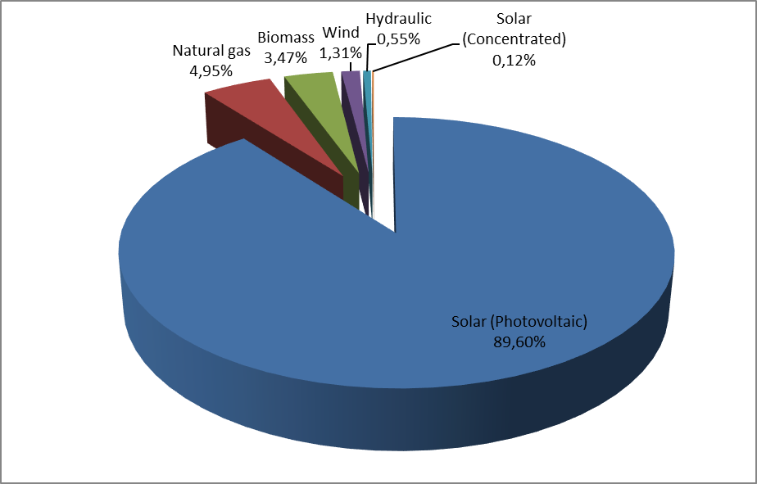
The distribution of unlicensed installed capacity by provinces is shown in Table 1.6. In 2015 the highest installed capacity was in Kayseri with 75,59 MW whereas in 2016 the highest installed capacity is in Konya with 199,24 MW. The following provinces are Konya with 127,41 MW and Ankara with 54,87 MW installed capacity.

Table 1.6: Distribution of Unlicensed Installed Capacity by Province (MW- %)
PROVINCE | 2015 |  | 2016
PROVINCE | Installed Capacity (MW) | Share (%) | Installed Capacity (MW) | Share (%)
KONYA | 53,99 | 15.04 | 199,24 | 19.01
KAYSERİ | 75,59 | 21.05 | 127,41 | 12.15
ANKARA | 27,16 | 7.57 | 54,87 | 5.23
MERSİN | 12,39 | 3.45 | 54,2 | 5.17
ANTALYA | 26,39 | 7.35 | 48,21 | 4.6
BURDUR | 7,93 | 2.21 | 40,75 | 3.89
ISPARTA | 5,48 | 1.53 | 39,23 | 3.74
DENİZLİ | 26,73 | 7.44 | 38,01 | 3.63
MANİSA | 8,95 | 2,49 | 36,79 | 3.51
KAHRAMANMARAŞ | 6,45 | 1.8 | 33,34 | 3.18
NİĞDE | 13,06 | 3.64 | 30,75 | 2.93
AKSARAY | - | - | 29,39 | 2.8
NEVŞEHİR | 1,99 | 0.55 | 29,11 | 2.78
GAZİANTEP | 3,72 | 1.03 | 26,02 | 2.48
AFYONKARAHİSAR | 2,65 | 0.74 | 25,6 | 2.44
ADANA | 9,95 | 2.77 | 24,78 | 2.36
İSTANBUL | 12,14 | 338 | 14,7 | 1.4
ADIYAMAN | 1,7 | 0.47 | 12,13 | 1.16
ÇORUM | 1,56 | 0.43 | 11,43 | 1.09
YOZGAT | - | - | 11,28 | 1.08
KİLİS | 4,26 | 1.19 | 11,26 | 1.07
AYDIN | 1,67 | 0.47 | 11 | 1.05
ŞANLIURFA | 0,5 | 0.14 | 10,57 | 1.01
KARAMAN | 3,74 | 1.04 | 10,02 | 0.96
MALATYA | 9,73 | 2.71 | 9,73 | 0.93
ERZURUM | - | - | 9,44 | 0.9
ESKİŞEHİR | 7,77 | 2.16 | 9,31 | 0.89
BURSA | 1,78 | 0.49 | 8,51 | 0.81
SİVAS | 1,1 | 0.31 | 6,9 | 0.66
İZMİR | 4,95 | 1.38 | 6,61 | 0.63
KOCAELİ | 2,43 | 0.68 | 6,6 | 0.63
UŞAK | 1,2 | 0.33 | 5,3 | 0.51
BALIKESİR | 1,76 | 0.49 | 5,21 | 0.5
OSMANİYE | 0,9 | 0.25 | 5,08 | 0.48
TOKAT | 2,4 | 0.67 | 4,6 | 0.44
SAKARYA | 4,3 | 1.2 | 4,42 | 0.42
MUĞLA | 1,63 | 0.46 | 4,38 | 0.42
DİYARBAKIR | 0,75 | 0.21 | 4,31 | 0.41
ÇANAKKALE | - | - | 3,47 | 0.33
TEKİRDAĞ | 3,15 | 0.88 | 3,15 | 0.3
ZONGULDAK | - | - | 2,48 | 0.24
MUŞ | - | - | 2 | 0.19
BİTLİS | 1 | 0.28 | 1,99 | 0.19
KÜTAHYA | 1 | 0.28 | 1,95 | 0.19
HATAY | 0,85 | 0.24 | 1,81 | 0.17
KIRŞEHİR | - | - | 1,68 | 0.16
KARABÜK | 1 | 0.28 | 1,67 | 0.16
ÇANKIRI | - | - | 1 | 0.1
KIRIKKALE | - | - | 1 | 0.1
DÜZCE | 0,03 | 0.01 | 0,99 | 0.09
SAMSUN | 0,49 | 0.14 | 0,92 | 0.09
AMASYA | 0,71 | 0.2 | 0,71 | 0.07
ELAZIĞ | 0,62 | 0.17 | 0,62 | 0.06
ERZİNCAN | 0,45 | 0.13 | 0,57 | 0.05
VAN | 0,7 | 0.19 | 0,53 | 0.05
MARDİN | - | - | 0,32 | 0.03
BARTIN | 0,25 | 0.07 | 0,25 | 0.02
KASTAMONU | - | - | 0,25 | 0.02
SİİRT | - | - | 0,19 | 0.02
BİLECİK | 0,09 | 0.03 | 0,14 | 0.01
BATMAN | - | - | 0,04 | 0
TUNCELİ | 0,02 | 0.01 | 0,02 | 0
SİNOP | - | - | 0 | 0
Grand Total | 359,04 | 100 | 1.048,21 | 100
The distribution of unlicensed electricity generation by sources is given in Table 1.7 and at Figure 1.19. In 2015, the amount of energy supplied to the grid within the scope of unlicensed electricity generation was 222.724,45 MWh, but it increased to 1.137.871,75 MWh in 2016. 90,64 % came from solar and 8,10 % from biomass.

Table 1.7: Distribution of Unlicensed Electricity Generation by Sources
(MWh-%)
Type of the Source | 2015 |  | 2016
Type of the Source | The amount of energy given to the system as surplus (MWh) | Share  (%) | The amount of energy given to the system as surplus (MWh) | Share  (%)
Solar(PV) | 185.034,44 | 83.08 | 1.031.358,00 | 90.64
Biomass | 37.094,73 | 16.65 | 92.129,90 | 8.10
Wind | 393,88 | 0.18 | 8.268,44 | 0.73
Hydraulic | 201,40 | 0.09 | 6.115,42 | 0.54
Grand Total | 222.724,45 | 100.00 | 1.137.871,75 | 100.00

Figure 1.19: Distribution of Unlicensed Electricity Generation by Sources in 2016 (%)

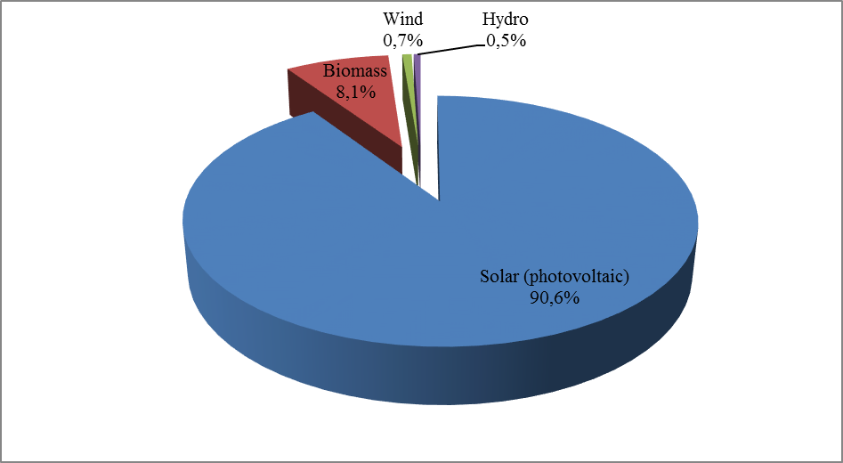

The distribution of energy that is given to the system as a result of unlicensed electricity generation by provinces is shown in Table 1.8. The highest generation was in Kayseri in 2016 as it was in 2015. Konya, Mersin, Denizli, Burdur, Ankara and Antalya were other important provinces in unlicensed electricity generation.

Table 1.8: Distribution of Unlicensed Electricity Generation by Provinces (MWh-%)
PROVINCE | 2015 |  | 2016
PROVINCE | The amount of energy given to the system as surplus (MWh) | Share (%) | The amount of energy given to the system as surplus (MWh) | Share (%)
KAYSERİ | 63.976,57 | 28.72 | 202.559,64 | 17.80
KONYA | 15.726,55 | 7.06 | 197.328,31 | 17.34
MERSİN | 8.946,18 | 4.02 | 97.764,47 | 8.59
DENİZLİ | 20.047,30 | 9.00 | 55.710,74 | 4.90
BURDUR | 3.666,69 | 1.65 | 52.426,64 | 4.61
ANKARA | 14.523,68 | 6.52 | 43.023,20 | 3.78
ANTALYA | 4.313,27 | 1.94 | 38.337,40 | 3.37
NEVŞEHİR | 1.387,59 | 0.62 | 36.121,61 | 3.17
NİĞDE | 10.282,56 | 4.62 | 35.235,40 | 3.10
ISPARTA | 4.589,42 | 2.06 | 33.845,76 | 2.97
KAHRAMANMARAŞ | 5.261,76 | 2.36 | 31.437,52 | 2.76
MALATYA | 17.450,74 | 7.84 | 25.415,35 | 2.23
İZMİR | 5.744,25 | 2.58 | 22.596,65 | 1.99
AFYONKARAHİSAR | 1.044,06 | 0.47 | 22.340,49 | 1.96
GAZİANTEP | 5.729,10 | 2.57 | 20.650,85 | 1.81
AKSARAY | 0,00 | 0.00 | 19.106,17 | 1.68
MANİSA | 51,27 | 0.02 | 18.285,19 | 1.61
ADANA | 3.243,61 | 1.46 | 16.407,35 | 1.44
ESKİŞEHİR | 5.053,55 | 2.27 | 15.475,56 | 1.36
ŞANLIURFA | 379,61 | 0.17 | 14.432,87 | 1.27
KİLİS | 1.156,46 | 0.52 | 14.418,62 | 1.27
KARAMAN | 5.188,15 | 2.33 | 12.837,56 | 1.13
ADIYAMAN | 2.384,07 | 1.07 | 12.170,32 | 1.07
ZONGULDAK | 3.123,24 | 1.40 | 10.657,02 | 0.94
KOCAELİ | 965,16 | 0.43 | 8.459,95 | 0.74
TOKAT | 3.195,07 | 1.43 | 8.315,09 | 0.73
YOZGAT | 0,00 | 0.00 | 8.246,34 | 0.72
AYDIN | 378,73 | 0.17 | 6.843,22 | 0.60
UŞAK | 6.467,26 | 2.90 | 6.565,79 | 0.58
BURSA | 354,52 | 0.16 | 6.382,60 | 0.56
OSMANİYE | 293,91 | 0.13 | 6.202,61 | 0.55
MUĞLA | 803,52 | 0.36 | 5.621,90 | 0.49
ÇORUM | 39,98 | 0.02 | 5.601,44 | 0.49
ELAZIĞ | 655,09 | 0.29 | 3.653,25 | 0.32
KIRIKKALE | 1.861,03 | 0.84 | 2.814,87 | 0.25
BALIKESİR | 863,93 | 0.39 | 2.595,67 | 0.23
HATAY | 319,64 | 0.14 | 2.502,98 | 0.22
BİTLİS | 843,53 | 0.38 | 2.028,45 | 0.18
KÜTAHYA | 68,35 | 0.03 | 1.750,06 | 0.15
SİVAS | 964,99 | 0.43 | 1.565,65 | 0.14
ERZURUM | 29,63 | 0.01 | 1.509,54 | 0.13
İSTANBUL | 40,16 | 0.02 | 1.465,68 | 0.13
MUŞ | 0,00 | 0.00 | 1.195,38 | 0.11
KIRŞEHİR | 0,00 | 0.00 | 1.039,26 | 0.09
EDİRNE | 429,46 | 0.19 | 855,42 | 0.08
DİYARBAKIR | 273,98 | 0.12 | 795,01 | 0.07
TEKİRDAĞ | 132,89 | 0.06 | 644,77 | 0.06
ERZİNCAN | 5,97 | 0.00 | 421,50 | 0.04
MARDİN | 0,00 | 0.00 | 382,00 | 0.03
KARABÜK | 278,93 | 0.13 | 371,15 | 0.03
ÇANKIRI | 0,00 | 0.00 | 265,66 | 0.02
SİİRT | 0,00 | 0.00 | 240,55 | 0.02
AMASYA | 0,00 | 0.00 | 206,59 | 0.02
ÇANAKKALE | 0,00 | 0.00 | 139,00 | 0.01
KIRKLARELİ | 0,00 | 0.00 | 122,16 | 0.01
BARTIN | 123,55 | 0.06 | 116,21 | 0.01
SAMSUN | 1,41 | 0.00 | 110,71 | 0.01
BİLECİK | 49,13 | 0.02 | 69,93 | 0.01
VAN | 0,00 | 0.00 | 64,98 | 0.01
BATMAN | 0,00 | 0.00 | 34,83 | 0.00
SAKARYA | 0,00 | 0.00 | 33,16 | 0.00
TUNCELİ | 14,89 | 0.01 | 23,17 | 0.00
DÜZCE | 0,00 | 0.00 | 22,86 | 0.00
KASTAMONU | 0,00 | 0.00 | 6,30 | 0.00
SİNOP | 0,00 | 0.00 | 1,37 | 0.00
Grand Total | 222.724,45 | 100.00 | 1.137.871,75 | 100.00

The distribution of the amount of payment made within the scope of unlicensed electricity generation by rsources by the end of 2016 is given in Table 1.9. 90 % of the amount of payment, as it is in generation and installed capacity, was made to solar (photovoltaic) power plants.

Table 1.9: Distribution of the Amount of Payment Made Within the Scope of Unlicensed Electricity Generation by Sources (TL-%)
Source Type | 2015 |  | 2016 |  | Change (%)  2015→2016
Source Type | The amount of payment made for the purchased surplus energy (TL) | Share (%) | The amount of payment made for the purchased surplus energy (TL) | Share (%) | Change (%)  2015→2016
Solar (Photovoltaic) | 72.255.335,27 | 83.28 | 427.946.838,22 | 90.65 | 492.27
Biomass | 14.376.479,86 | 16.57 | 40.868.850,06 | 8.66 | 184.28
Wind | 91.887,15 | 0.11 | 1.949.623,01 | 0.41 | 2.021.76
Hydro | 42.938,46 | 0.05 | 1.316.242,55 | 0.28 | 2.965.42
Grand Total | 86.766.640,74 | 100.00 | 472.081.553,85 | 100.00 | 444.08

1.5 Invoiced Electricity Consumption

This part gives information about the consumption of invoiced electric energy. In this sense, the consumption that are not subject to invoicing (technical and non-technical losses and unacceptable consumption), are not included in this section and group of data. Therefore, in the scope of Article 7 of the Electricity Market Law, the production that is made in order to meet the needs of the facilities that are rented, acquired through financial leasing, being inherited the operational right or the energy produced in the premises without leaving the transmission or distribution system, which are done by legal entities that own generation license, are not included in the invoiced consumption data since they are not regarded as a sales to the final consumer. Also, the electric energy that the facilities used for their own need from the system are not included in the invoiced consumption. In addition, real consumption data and consumption data contained in this section may vary due to differences in invoicing period.
The information about invoiced consumption in 2016 is given in Table 1.10. 23,45% of the 212,33 TWh was sold to consumers connected to the transmission voltage level, while the remaining 76,55 % (162,55 TWh) was distributed to consumers connected to the distribution voltage level.
While 131,23 TWh sold to eligible consumers, consumption of non-eligible consumers was 81,10 TWh. The share of eligible consumers’ invoiced consumption was 61,80 %, while non-eligible consumers’ share was 38,20 %.

Table 1.10: Sales to Eligible and Non-Eligible Consumers in 2016 (MWh)
Consumer Type | Consumption Amount of Consumers Connected to the Distribution Voltage Level (MWh) | Consumption Amount of Consumers Connected to Tranmission Voltage Level (MWh) | Total (MWh)
Non-Eligible Consumer | 74.556.571,56 | 6.543.398,54 | 81.099.970,10
Eligible Consumer | 87.991.038,42 | 43.237.757,91 | 131.228.796,33
Grand Total | 162.547.609,98 | 49.781.156,45 | 212.328.766,43

Distribution of consumption by distribution regions is given in Table 1.11. The highest consumption was in Toroslar EDAŞ region with 25,74 TWh and the lowest consumption with 1,78 TWh was in Vangölü EDAŞ region. The region where the highest consumption connected to distribution voltage level was Boğaziçi EDAŞ, whereas the lowest region was Vangölü EDAŞ. In addition the region where the consumption connected to transmission was the highest in Toroslar and the lowest in Çoruh EDAŞ region.

Table 1.11: Distribution of Invoiced Consumption by Distribution Regions in 2016 (MWh-%)
Distribution Regions | Consumption of Consumers Connected to Distribution (MWh) | Consumption of Consumers Connected to Transmission (MWh) | Total (MWh) | Share (%)
TOROSLAR EDAŞ | 14.340.758,45 | 11.399.301,62 | 25.740.060,07 | 12.12
BOĞAZİÇİ EDAŞ | 23.243.975,00 | 1.399.192,32 | 24.643.167,32 | 11.61
GDZ EDAŞ | 13.911.747,51 | 6.613.648,49 | 20.525.396,00 | 9.67
ULUDAĞ EDAŞ | 11.055.906,90 | 5.887.712,07 | 16.943.618,97 | 7.98
BAŞKENT EDAŞ | 14.262.169,65 | 1.993.447,18 | 16.255.616,83 | 7.66
SAKARYA EDAŞ | 8.710.680,24 | 5.980.182,92 | 14.690.863,16 | 6.92
İST. AND. YAK. EDAŞ | 11.089.271,36 | 1.198.219,96 | 12.287.491,32 | 5.79
MERAM EDAŞ | 8.521.898,14 | 1.267.055,22 | 9.788.953,36 | 4.61
AKDENİZ EDAŞ | 7.982.877,68 | 1.327.206,85 | 9.310.084,53 | 4.38
TRAKYA EDAŞ | 6.175.815,43 | 3.081.624,78 | 9.257.440,21 | 4.36
ADM EDAŞ | 8.023.627,75 | 887.885,66 | 8.911.513,41 | 4.20
OSMANGAZİ EDAŞ | 5.976.876,74 | 2.896.920,21 | 8.873.796,95 | 4.18
DİCLE EDAŞ | 6.863.372,74 | 935.381,08 | 7.798.753,82 | 3.67
YEŞİLIRMAK EDAŞ | 4.681.275,97 | 667.237,00 | 5.348.512,97 | 2.52
AKEDAŞ EDAŞ | 3.694.791,80 | 1.331.962,33 | 5.026.754,13 | 2.37
KAYSERİ VE CİVARI ETAŞ | 2.190.597,65 | 1.344.266,93 | 3.534.864,58 | 1.66
ÇORUH EDAŞ | 3.386.983,26 | 44.808,63 | 3.431.791,89 | 1.62
FIRAT EDAŞ | 2.326.574,52 | 910.505,72 | 3.237.080,24 | 1.52
ÇAMLIBEL EDAŞ | 2.239.237,05 | 332.391,91 | 2.571.628,96 | 1.21
ARAS EDAŞ | 2.187.907,33 | 178.757,45 | 2.366.664,78 | 1.11
VANGÖLÜ EDAŞ | 1.681.264,81 | 103.448,15 | 1.784.712,96 | 0.84
Grand Total | 162.547.609,98 | 49.781.156,48 | 212.328.766,46 | 100.00

The distribution of invoiced consumption by consumer type is shown in Figure 1.20 and Table 1.12. The industrial consumption was the first with a share of 42,35 %. The consumption of the commercial sector was the second with 28,65 % and the household consumption was the third with 24,06 %. The total electricity consumption used in lighting and agricultural irrigation was 4,94 %.

Table 1.12: Distribution of Invoiced Consumption by Consumer Type as Eligible and Non-Eligible Consumers in 2016 (MWh)
Consumer Type | The Amount of Consumption (MWh)
Consumer Type | Non Eligible Consumer | Eligible Consumer | Total
Industry | 14.858.398,36 | 75.064.126,43 | 89.922.524,80
Commercial | 12.931.408,23 | 47.903.499,15 | 60.834.907,38
Household | 44.699.423,67 | 6.386.204,27 | 51.085.627,94
Irrıgation | 4.537.650,99 | 1.729.840,27 | 6.267.491,26
Lighting | 4.073.088,85 | 145.126,20 | 4.218.215,04
Grand Total | 81.099.970,10 | 131.228.796,33 | 212.328.766,43

Figure 1.20: Distribution of Invoiced Consumption by Consumer Type in 2016 (%)
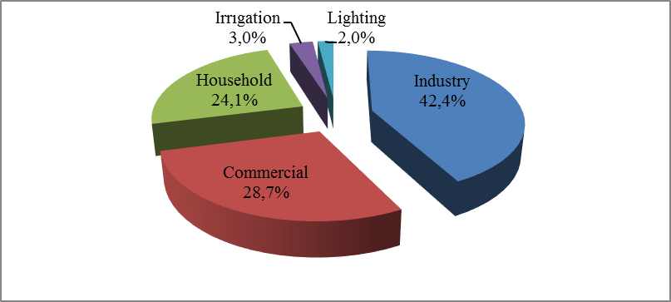
The distribution of invoiced consumption by provinces is shown in Table 1.13. The highest consumption was in Istanbul with 36,93 TWh and corresponded to 17,39 % of total consumption. Following provinces were Izmir with a share of 7,64 %, Ankara with a share of 5,78 %, Bursa with 4,22 % and Kocaeli with 4,64 %.

Table 1.13: Distribution of Invoiced Consumption by Province (MWh - %)
PROVINCE | Consumption of Consumers Connected to Dist. Vol. (MWh) | Consumption of Consumers Connected to Trans.Vol. (MWh) | Total (MWh) | Share (%)
İSTANBUL (AS A WHOLE) | 34.333.246,36 | 2.597.412,28 | 36.930.658,64 | 17.39
İST. EUROPE | 23.243.975,00 | 1.399.192,32 | 24.643.167,32 | 11.61
İZMİR | 10.984.148,10 | 5.248.078,78 | 16.232.226,88 | 7.64
İST. ASIA | 11.089.271,36 | 1.198.219,96 | 12.287.491,32 | 5.79
ANKARA | 10.816.280,12 | 1.462.665,34 | 12.278.945,46 | 5.78
BURSA | 6.678.891,81 | 3.182.410,63 | 9.861.302,44 | 4.64
KOCAELİ | 5.072.026,68 | 3.888.651,70 | 8.960.678,38 | 4.22
ANTALYA | 6.568.362,09 | 665.740,49 | 7.234.102,58 | 3.41
GAZİANTEP | 2.808.978,41 | 3.972.305,16 | 6.781.283,57 | 3.19
ADANA | 4.359.902,11 | 1.829.938,47 | 6.189.840,58 | 2.92
TEKİRDAĞ | 3.639.509,43 | 2.507.801,07 | 6.147.310,50 | 2.90
KONYA | 5.219.863,60 | 634.086,60 | 5.853.950,20 | 2.76
MERSİN | 3.659.852,39 | 879.063,41 | 4.538.915,80 | 2.14
HATAY | 2.594.624,97 | 1.719.932,30 | 4.314.557,27 | 2.03
MANİSA | 2.927.599,41 | 1.365.569,71 | 4.293.169,12 | 2.02
KAHRAMANMARAŞ | 2.878.257,50 | 1.100.545,48 | 3.978.802,98 | 1.87
SAKARYA | 2.074.166,63 | 1.653.255,99 | 3.727.422,62 | 1.76
OSMANİYE | 692.922,15 | 2.966.341,38 | 3.659.263,53 | 1.72
ÇANAKKALE | 1.092.898,50 | 2.440.610,30 | 3.533.508,80 | 1.66
KAYSERİ | 2.184.798,12 | 1.344.266,93 | 3.529.065,05 | 1.66
DENİZLİ | 2.741.756,13 | 532.478,29 | 3.274.234,42 | 1.54
MUĞLA | 2.894.768,05 | 312.849,91 | 3.207.617,96 | 1.51
ŞANLIURFA | 2.595.214,94 | 520.189,37 | 3.115.404,31 | 1.47
BALIKESİR | 2.741.434,93 | 264.691,14 | 3.006.126,07 | 1.42
ESKİŞEHİR | 1.654.574,87 | 1.047.532,32 | 2.702.107,19 | 1.27
SAMSUN | 1.985.945,45 | 502.523,14 | 2.488.468,59 | 1.17
AYDIN | 2.387.103,57 | 42.557,46 | 2.429.661,03 | 1.14
DİYARBAKIR | 1.823.010,89 | 162.565,11 | 1.985.576,00 | 0.94
KIRKLARELİ | 1.386.720,57 | 571.185,86 | 1.957.906,43 | 0.92
AFYONKARAHİSAR | 1.451.279,51 | 163.730,64 | 1.615.010,15 | 0.76
BİLECİK | 1.068.142,39 | 539.303,65 | 1.607.446,04 | 0.76
MALATYA | 1.065.433,47 | 452.056,25 | 1.517.489,72 | 0.71
KÜTAHYA | 1.014.944,66 | 468.872,63 | 1.483.817,29 | 0.70
UŞAK | 787.935,31 | 677.480,97 | 1.465.416,28 | 0.69
TRABZON | 1.325.631,68 | 44.808,63 | 1.370.440,31 | 0.65
ELAZIĞ | 886.700,20 | 458.449,47 | 1.345.149,67 | 0.63
ZONGULDAK | 1.064.037,65 | 216.037,20 | 1.280.074,85 | 0.60
MARDİN | 1.162.829,70 | 103.380,57 | 1.266.210,27 | 0.60
ORDU | 1.150.898,07 | 36.337,99 | 1.187.236,06 | 0.56
ISPARTA | 890.860,88 | 276.439,50 | 1.167.300,38 | 0.55
EDİRNE | 1.149.585,44 | 2.637,85 | 1.152.223,29 | 0.54
SİVAS | 937.200,01 | 162.624,53 | 1.099.824,54 | 0.52
ADIYAMAN | 816.534,30 | 231.416,85 | 1.047.951,15 | 0.49
NİĞDE | 771.279,72 | 266.149,62 | 1.037.429,34 | 0.49
DÜZCE | 782.196,14 | 222.818,86 | 1.005.015,00 | 0.47
BOLU | 782.290,79 | 215.456,37 | 997.747,16 | 0.47
ERZURUM | 827.588,48 | 124.771,78 | 952.360,26 | 0.45
AKSARAY | 844.860,34 | 81.386,37 | 926.246,71 | 0.44
BURDUR | 523.654,71 | 385.026,86 | 908.681,57 | 0.43
VAN | 899.703,71 |  | 899.703,71 | 0.42
TOKAT | 652.635,85 | 147823,82 | 800.459,67 | 0.38
KASTAMONU | 673.478,33 | 113.738,59 | 787.216,92 | 0.37
ÇORUM | 706.942,38 | 73.620,45 | 780.562,83 | 0.37
KARAMAN | 611.312,44 | 143.489,15 | 754.801,59 | 0.36
RİZE | 705.771,38 |  | 705.771,38 | 0.33
NEVŞEHİR | 702.270,80 |  | 702.270,80 | 0.33
BATMAN | 544.711,99 | 140.235,41 | 684.947,40 | 0.32
YOZGAT | 655.200,73 | 21.943,56 | 677.144,29 | 0.32
GİRESUN | 599.953,85 |  | 599.953,85 | 0.28
AMASYA | 512.592,99 | 45.485,25 | 558.078,24 | 0.26
YALOVA | 542.681,66 |  | 542.681,66 | 0.26
KARABÜK | 452.924,42 | 85.234,41 | 538.158,83 | 0.25
KIRŞEHİR | 372.311,26 | 141.943,48 | 514.254,74 | 0.24
KIRIKKALE | 445.656,72 | 64.408,42 | 510.065,14 | 0.24
BARTIN | 449.415,78 |  | 449.415,78 | 0.21
ÇANKIRI | 360.376,61 | 51.363,22 | 411.739,83 | 0.19
MUŞ | 286.536,86 | 103.448,15 | 389.985,01 | 0.18
GÜMÜŞHANE | 389.632,08 |  | 389.632,08 | 0.18
ERZİNCAN | 324.922,84 | 53366,57 | 378.289,41 | 0.18
SİİRT | 364.848,79 | 9.010,62 | 373.859,41 | 0.18
ŞIRNAK | 372.756,44 |  | 372.756,44 | 0.18
ARTVİN | 365.994,28 |  | 365.994,28 | 0.17
SİNOP | 324.897,10 | 9.270,17 | 334.167,27 | 0.16
AĞRI | 326.925,19 | 619,10 | 327.544,29 | 0.15
BİTLİS | 324.969,29 |  | 324.969,29 | 0.15
KARS | 319.922,44 |  | 319.922,44 | 0.15
BİNGÖL | 262.854,17 |  | 262.854,17 | 0.12
KİLİS | 224.478,42 | 31.720,90 | 256.199,32 | 0.12
IĞDIR | 182.266,00 |  | 182.266,00 | 0.09
HAKKARİ | 170.054,95 |  | 170.054,95 | 0.08
ARDAHAN | 115.020,15 |  | 115.020,15 | 0.05
TUNCELİ | 111.586,68 |  | 111.586,68 | 0.05
BAYBURT | 91.262,23 |  | 91.262,23 | 0.04
Grand Total | 162.547.609,98 | 49.781.156,48 | 212.328.766,46 | 100.00

Table 1.14: Distribution of Invoiced Consumption by Province and Consumer Type (MWh)
PROVINCE | Consumer Type |  |  |  |  | Grand Total
PROVINCE | Lighting | Household | Industry | Agricultural Irrigation | Commerce | Grand Total
ADANA | 92.968,09 | 1.622.527,89 | 2.794.993,28 | 157.601,83 | 1.521.749,49 | 6.189.840,58
ADIYAMAN | 24.053,21 | 245.164,21 | 505.674,53 | 4.694,94 | 268.364,26 | 1.047.951,15
AFYONKARAHİSAR | 52.005,48 | 359.914,47 | 470.858,76 | 123.516,80 | 608.714,65 | 1.615.010,15
AĞRI | 16.875,67 | 160.516,80 | 12.158,93 | 88,32 | 137.904,58 | 327.544,29
AKSARAY | 22.742,10 | 189.860,42 | 182.929,62 | 252.016,72 | 278.697,85 | 926.246,71
AMASYA | 29.344,27 | 189.893,95 | 149.624,77 | 19.584,25 | 169.630,99 | 558.078,24
ANKARA | 252.528,13 | 3.768.377,18 | 2.967.998,57 | 134.033,45 | 5.156.008,14 | 12.278.945,46
ANTALYA | 160.918,94 | 2.303.248,91 | 1.055.857,50 | 172.504,56 | 3.541.572,67 | 7.234.102,58
ARDAHAN | 8.897,20 | 46.014,94 | 2.816,99 |  | 57.291,03 | 115.020,15
ARTVİN | 26.283,95 | 115.131,25 | 125.939,68 | 92,19 | 98.547,20 | 365.994,28
AYDIN | 72.846,95 | 866.813,35 | 519.065,13 | 77.188,14 | 893.747,47 | 2.429.661,03
BALIKESİR | 94.426,72 | 817.609,75 | 1.183.967,28 | 45.867,09 | 864.255,23 | 3.006.126,07
BARTIN | 22.298,56 | 121.084,78 | 212.581,59 | 657,58 | 92.793,27 | 449.415,78
BATMAN | 19.574,74 | 229.801,62 | 215.687,90 | 2.941,25 | 216.941,90 | 684.947,40
BAYBURT | 8.268,20 | 41.030,62 | 3.060,94 | 132,43 | 38.770,05 | 91.262,23
BİLECİK | 18.820,07 | 103.094,49 | 1.277.820,37 | 5.230,57 | 202.480,55 | 1.607.446,04
BİNGÖL | 10.284,64 | 103.487,47 | 45.745,41 | 282,46 | 103.054,19 | 262.854,17
BİTLİS | 17.722,16 | 125.326,25 | 22.512,22 | 34.241,93 | 125.166,72 | 324.969,29
BOLU | 27.437,97 | 172.754,36 | 488.793,60 | 1.389,56 | 307.371,67 | 997.747,16
BURDUR | 22.692,57 | 156.107,71 | 542.856,53 | 30.686,36 | 156.338,41 | 908.681,57
BURSA | 109.717,53 | 1.781.249,42 | 5.868.638,27 | 85.755,48 | 2.015.941,74 | 9.861.302,44
ÇANAKKALE | 41.956,48 | 324.829,74 | 2.697.231,81 | 39.667,84 | 429.822,93 | 3.533.508,80
ÇANKIRI | 18.995,09 | 98.004,54 | 190.750,29 | 1.635,29 | 102.354,62 | 411.739,83
ÇORUM | 37.959,53 | 275.436,99 | 232.127,57 | 15.996,34 | 219.042,39 | 780.562,83
DENİZLİ | 70.655,63 | 630.531,22 | 1.817.624,62 | 77.871,10 | 677.551,85 | 3.274.234,42
DİYARBAKIR | 38.390,31 | 635.580,51 | 421.132,68 | 176.096,57 | 714.375,93 | 1.985.576,00
DÜZCE | 28.680,30 | 212.835,39 | 546.771,99 | 510,68 | 216.216,64 | 1.005.015,00
EDİRNE | 30.779,48 | 274.899,77 | 409.348,01 | 102.567,41 | 334.628,62 | 1.152.223,29
ELAZIĞ | 33.883,32 | 270.787,23 | 633.660,72 | 35.463,27 | 371.355,14 | 1.345.149,67
ERZİNCAN | 19.073,46 | 108.756,86 | 100.857,47 | 6.108,21 | 143.493,41 | 378.289,41
ERZURUM | 41.133,79 | 349.175,43 | 178.518,22 | 3.409,37 | 380.123,45 | 952.360,26
ESKİŞEHİR | 44.635,76 | 538.485,83 | 1.338.353,18 | 142.758,45 | 637.873,96 | 2.702.107,19
GAZİANTEP | 71.571,71 | 1.026.467,29 | 4.461.694,17 | 114.105,85 | 1.107.444,55 | 6.781.283,57
GİRESUN | 54.290,84 | 279.644,28 | 65.140,17 | 204,80 | 200.673,76 | 599.953,85
GÜMÜŞHANE | 15.066,75 | 64.470,80 | 246.809,75 | 354,34 | 62.930,44 | 389.632,08
HAKKARİ | 11.712,82 | 71.456,45 | 754,53 | 28,25 | 86.102,91 | 170.054,95
HATAY | 72.198,68 | 1.007.483,70 | 2.249.426,81 | 163.237,82 | 822.210,28 | 4.314.557,27
IĞDIR | 11.213,06 | 82.218,95 | 5.862,26 | 709,56 | 82.262,18 | 182.266,00
ISPARTA | 36.884,29 | 282.530,22 | 464.556,27 | 55.349,08 | 327.980,52 | 1.167.300,38
İST. ASYA | 167.292,23 | 4.136.938,68 | 3.063.932,25 | 713,33 | 4.918.614,84 | 12.287.491,32
İST. AVRUPA | 297.279,02 | 6.764.279,90 | 6.705.904,19 | 3.366,39 | 10.872.337,81 | 24.643.167,32
İZMİR | 206.892,06 | 4.047.017,48 | 7.891.361,56 | 370.084,52 | 3.716.871,25 | 16.232.226,88
KAHRAMANMARAŞ | 55.904,43 | 458.895,74 | 2.855.639,37 | 12.373,39 | 595.990,05 | 3.978.802,98
KARABÜK | 22.540,90 | 144.165,13 | 220.527,50 | 812,47 | 150.112,83 | 538.158,83
KARAMAN | 15.348,15 | 123.387,50 | 217.060,77 | 232.465,32 | 166.539,84 | 754.801,59
KARS | 13.571,08 | 116.341,08 | 71.517,97 | 77,73 | 118.414,59 | 319.922,44
KASTAMONU | 40.238,34 | 201.368,32 | 362.133,27 | 3.498,14 | 179.978,86 | 787.216,92
KAYSERİ | 102.809,25 | 722.649,13 | 1.863.727,43 | 129.062,75 | 710.816,49 | 3.529.065,05
KIRIKKALE | 20.175,47 | 158.739,60 | 167.724,95 | 4.005,08 | 159.420,05 | 510.065,14
KIRKLARELİ | 25.392,93 | 231.364,58 | 1.378.069,98 | 8.689,34 | 314.389,60 | 1.957.906,43
KIRŞEHİR | 20.601,16 | 122.865,28 | 205.776,59 | 26.693,06 | 138.318,66 | 514.254,74
KİLİS | 7.511,81 | 74.321,21 | 39.034,29 | 18.534,21 | 116.797,79 | 256.199,32
KOCAELİ | 93.106,48 | 1.158.311,99 | 6.346.153,20 | 6.609,34 | 1.356.497,37 | 8.960.678,38
KONYA | 141.307,24 | 1.138.372,83 | 1.813.013,87 | 1.325.242,35 | 1.436.013,92 | 5.853.950,20
KÜTAHYA | 41.565,08 | 275.115,65 | 797.186,96 | 5.554,63 | 364.394,98 | 1.483.817,29
MALATYA | 45.761,83 | 377.528,60 | 558.242,81 | 92.595,77 | 443.360,70 | 1.517.489,72
MANİSA | 72.043,95 | 861.327,03 | 2.116.944,87 | 302.597,48 | 940.255,79 | 4.293.169,12
MARDİN | 25.805,10 | 292.156,89 | 288.805,60 | 292.712,91 | 366.729,77 | 1.266.210,27
MERSİN | 88.831,49 | 1.382.852,86 | 1.618.756,13 | 195.967,24 | 1.252.508,07 | 4.538.915,80
MUĞLA | 71.124,77 | 896.202,34 | 712.927,79 | 39.445,53 | 1.487.917,53 | 3.207.617,96
MUŞ | 7.834,67 | 146.225,37 | 116.936,50 | 2.217,03 | 116.771,43 | 389.985,01
NEVŞEHİR | 31.620,06 | 168.112,09 | 149.057,42 | 147.430,52 | 206.050,71 | 702.270,80
NİĞDE | 31.709,02 | 165.821,12 | 502.392,07 | 155.118,15 | 182.388,98 | 1.037.429,34
ORDU | 68.937,22 | 445.229,86 | 352.155,54 | 188,32 | 320.725,11 | 1.187.236,06
OSMANİYE | 24.003,45 | 331.788,95 | 3.030.571,04 | 15.658,91 | 257.241,18 | 3.659.263,53
RİZE | 42.408,43 | 229.004,47 | 226.280,63 | 0,87 | 208.076,97 | 705.771,38
SAKARYA | 59.530,68 | 611.816,05 | 2.379.468,95 | 8.480,33 | 668.126,61 | 3.727.422,62
SAMSUN | 96.423,07 | 799.843,97 | 848.836,69 | 24.814,87 | 718.549,99 | 2.488.468,59
SİİRT | 15.364,14 | 117.095,11 | 132.899,30 | 739,26 | 107.761,59 | 373.859,41
SİNOP | 21.616,89 | 146.463,59 | 72.846,38 | 912,27 | 92.328,13 | 334.167,27
SİVAS | 49.993,17 | 318.070,88 | 396.653,72 | 29.683,25 | 305.423,52 | 1.099.824,54
ŞANLIURFA | 54.045,14 | 841.145,27 | 740.524,49 | 603.243,91 | 876.445,51 | 3.115.404,31
ŞIRNAK | 11.647,21 | 96.575,21 | 103.960,80 | 17.392,51 | 143.180,71 | 372.756,44
TEKİRDAĞ | 48.491,24 | 589.859,94 | 4.693.001,76 | 15.292,34 | 800.665,21 | 6.147.310,50
TOKAT | 39.795,31 | 307.556,69 | 222.746,08 | 331,05 | 230.030,53 | 800.459,67
TRABZON | 78.993,06 | 595.471,77 | 203.622,73 | 575,61 | 491.777,13 | 1.370.440,31
TUNCELİ | 9.327,72 | 38.176,30 | 8.789,68 | 357,62 | 54.935,36 | 111.586,68
UŞAK | 21.687,27 | 195.075,55 | 826.647,22 | 16.519,47 | 405.486,77 | 1.465.416,28
VAN | 18.099,80 | 410.753,93 | 102.969,09 | 1.782,41 | 366.098,47 | 899.703,71
YALOVA | 16.166,35 | 180.320,60 | 148.856,93 | 4.625,51 | 192.712,27 | 542.681,66
YOZGAT | 33.245,59 | 209.178,31 | 165.168,59 | 65.877,69 | 203.674,12 | 677.144,29
ZONGULDAK | 72.384,41 | 405.236,06 | 493.495,50 | 568,25 | 308.390,63 | 1.280.074,85
Grand Total | 4.218.215,04 | 51.085.627,94 | 89.922.524,83 | 6.267.491,26 | 60.834.907,38 | 212.328.766,46

The distribution of invoiced consumption by months is shown in Figure 1.21. The highest consumption was in August, the lowest consumption was in April.

Figure 1.21: Distribution of Invoiced Consumption by Months (MWh)

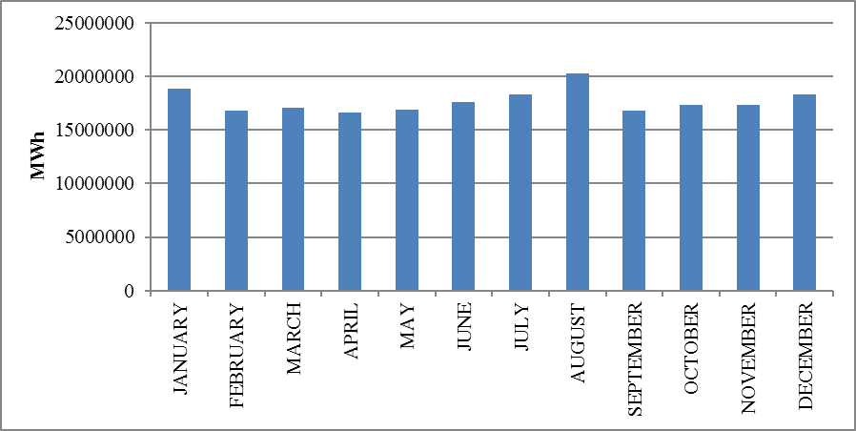

The development of consumption over years is shown in Figure 1.22. The consumption decreased only in 2001 and 2009 compared to the previous years, with the effect of economic crisis. The highest increase rate compared to the previous year was 13,75 % in 1997.

Figure 1.22: Development of Gross Consumption by Years (GWh)
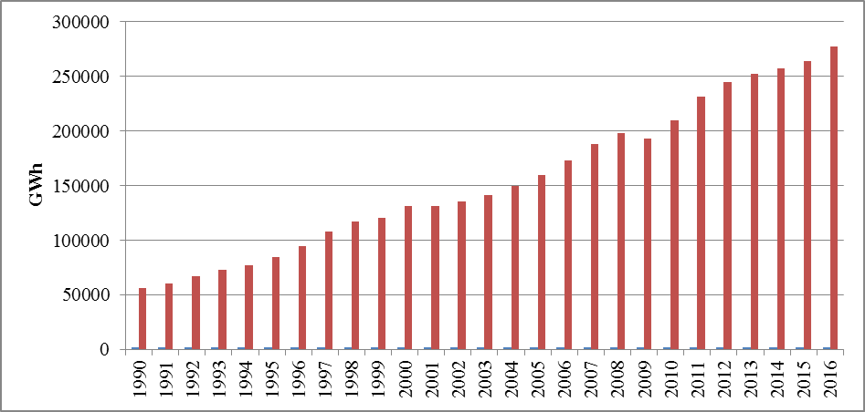

1.6 Import and Export

1.6.1 Import
The data on electricity imports in 2016 by months is shown in Figure 1.23. 71,90 % of the total 6.400.129 MWh electricity imports in 2016 were from Bulgaria, 17,16 % from Georgia, 9,87 % from Iran and 1,06 % from Greece. On the monthly basis, the highest electricity imports were made in December, while the lowest was in April.

Figure 1.23: Electricity Imports in 2016 by Months (MWh)
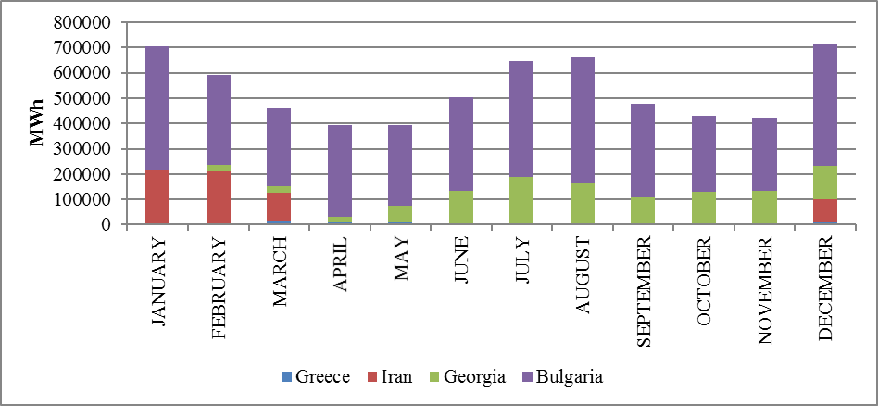

1.6.2 Exports
The data on electricity exports in 2016 by months is shown in Figure 1.24. 99,74 % of the total 1.442.082 MWh electricity exports in 2016 were to Greece, and the remaining 0,26% to Bulgaria, Georgia and Syria. On the monthly basis, the highest electricity exports were made in October and the lowest in May.

Figure 1.24: Electricity Exports in 2016 by Months (MWh)
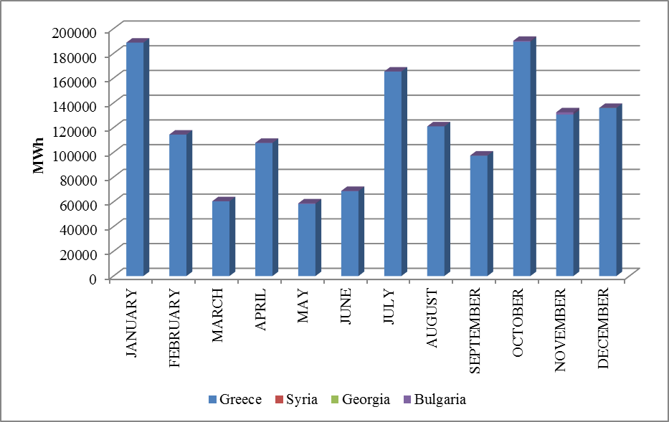

- WHOLESALE MARKET

In this section, the developments that occurred in the wholesale market were examined in the year 2016. In this context; the prices of the Day-Ahead Market (DAM), the Intra-Day Market (IDM) and the Balancing Power Market (BPM) are presented with the volumes and the orders given. Moreover, the changes that occurred in the market structure are explained.

  - Day-Ahead Market

Liberalization process started with Electricity Market Law aimed for creation of an electricity market based on transparency, integrity and competition; and integrated with other countries’ electricity markets. In line with this aim, numerous planned steps were taken and significant progress had been achieved for transforming stronger and more dynamic electricity market in which market participants take an active role and market operators manage and monitor by best means.

First step carried out for transformation of electricity market from a single buyer-single seller model to liberal and competitive model was transition to monthly 3 period financial settlement system on 1 July 2006. Next step was the start of operations for Day-Ahead Planning system on 1 December 2009. These transition periods have great importance regarding to transformation of electricity market into stronger and more dynamic structure. Parties took role in market operations and activities provided significant experience and foresight for new market models from their practices at earlier market stages. 1 December 2011 date became a milestone for Turkish Electricity Market and creation of currently used Day-Ahead Market system has been established which is deemed as biggest step towards formation of targeted electricity market structure. Establishment of Day-Ahead Market stimulated a new dynamism and vision for Turkish Electricity Market and allowed formation of market structure based on values of competition.

With the new market structure, the collateral mechanism has been implemented and in this context, the market participants registered with MFSC must provide a guarantee to the market operator for the transactions they have made in DAM. In addition to this arrangement, it is possible for participants to create portfolios. Lastly, in the event that system constraints continue systematically, TEİAŞ is given the opportunity to switch to regional pricing by considering the constraints.

Following the completion of the registration process on 18 March 2015, the Energy Exchange Istanbul (EXIST) was formally established, under the provisions of the Turkish Commercial Code of the 14.03.2013 dated and numbered 6446 with the Electricity Market Act of 6102.
In accordance with the proposals offered by the market participants in the Day-Ahead Market operated by EXIST, the market exchange prices and the purchase and sales quantities are announced.
The software used on December 1, 2011, which has an outdated software technology and algorithm as part of the Day-Ahead Market transactions, was insufficient to meet the needs and expectations of the sector, the source code was closed to access, due to these facts developing and error handling activities caused external dependence so that a new software needed to be developed by EXIST to respond to the increasing number of market participants, to meet industry expectations and to create a Day-Ahead Market software at the level of advanced market operators, which gave start to "Domestic Day-Ahead Market Project".
The Day-Ahead Market software and optimization model was put into use by market participants as a test on March 18, 2016, while the test process was completed on June 1, 2016, and replaced the old software in the real environment. Thus, market exchange prices are calculated by the software and optimisation infrastructure that uses the technology and knowledge required by the era, developed with EXIST’s own sources since 1 June 2016 delivery day.
The prices of the DAM in 2016 are given in Figure 2.1.1 with the weighted average price.

Figure.2.1.1: Hourly Development of Weighted Average Market Clearing Price in 2016 (TL/MWh)
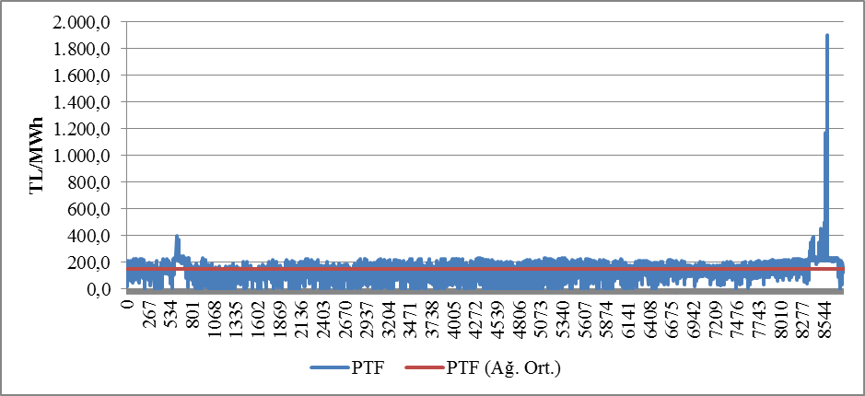
As shown in the figure, the prices were generally observed in the 100-200 TL/MWh range, on the 200-300 TL/MWh band in a very limited time period of the year. The price reached 1.899,99 TL/MWh with the highest value at 14:00 on 23 December 2016. For a total of 92 hours in 2016, MCP was 0 TL/MWh
In Figure 2.1.2, the weighted average MCP is given in Day-Ahead Market by years. In 2016, the weighted average of the MCP increased by 3.02% compared to 2015, as 148,32 TL/MWh.

Figure.2.1.2: Weighted Average MCP by Years (TL/MWh)
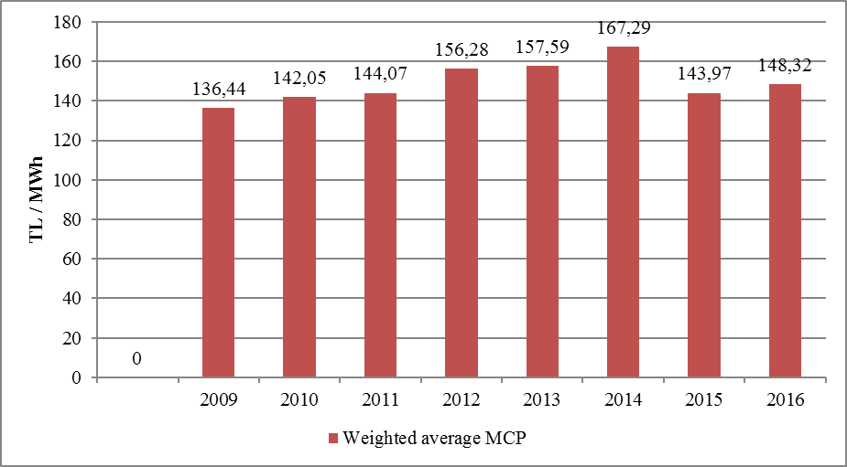
The Figure below shows the monthly weighted average MCP for 2015 and 2016. In the first months of the year 2015, a significant decline can be noticed. In 2015, the average monthly price was the lowest with 103,30 TL/MWh, which took place in April, and the highest value of 179,05 TL/MWh in January. In 2016, the average monthly price was the lowest with 108,96 TL/MWh, which took place in February, and the highest value of 227,96 TL/MWh in December
As shown in tables and figures in the first chapter, monthly electricity consumption falls with the softening of the air during the spring and autumn months. In addition, in the spring months, the water capacity of hydroelectric power plantsincreased and the lowest prices of the year are generally seen in spring time.

On the other hand, due to air conditioning and consumption of agricultural irrigation in the summer months and the need for warming and enlightenment in the winter, electricity demand increases and the increase in the average prices in parallel to the increase in consumption is observed. In particular, due to the natural gas shortage that occurred in December of 2016, the natural gas plants were disabled and the prices came to the level of 2.000 TL/MWh for some hours.

Figure 2.1.3: Monthly Weighted Average MCP of the Last Two Years (TL/MWh)

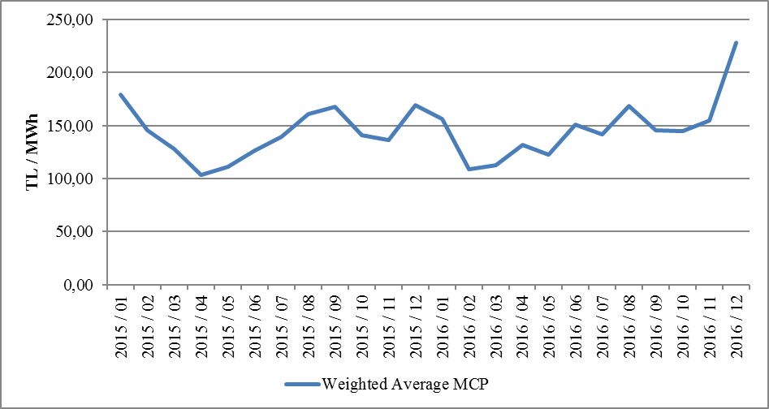
The following figure 2.1.4 shows the trading volume in the DAM by months, the distribution of the quantities of DAM buying in Figure 2.1.5 and the share of the top 10 companies, the distribution of sales quantities in Figure 2.1.6 and the share of the top 10 company.

Figure 2.1.4: Monthly Day-Ahead Market Trading Volume (MWh)
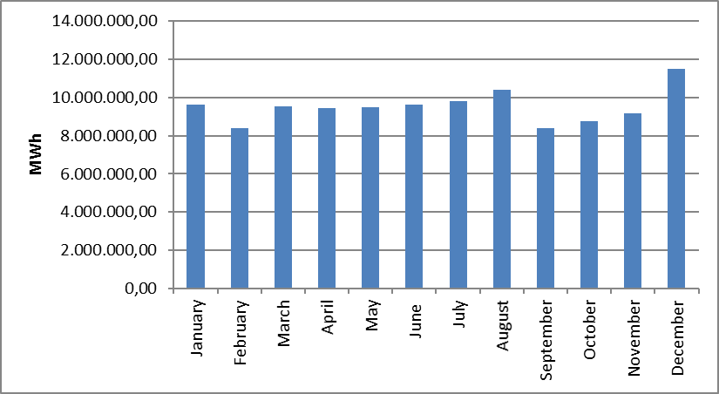

Figure 2.1.5: The Share of First 10 Buyer Companies in Day-Ahead Market (%)

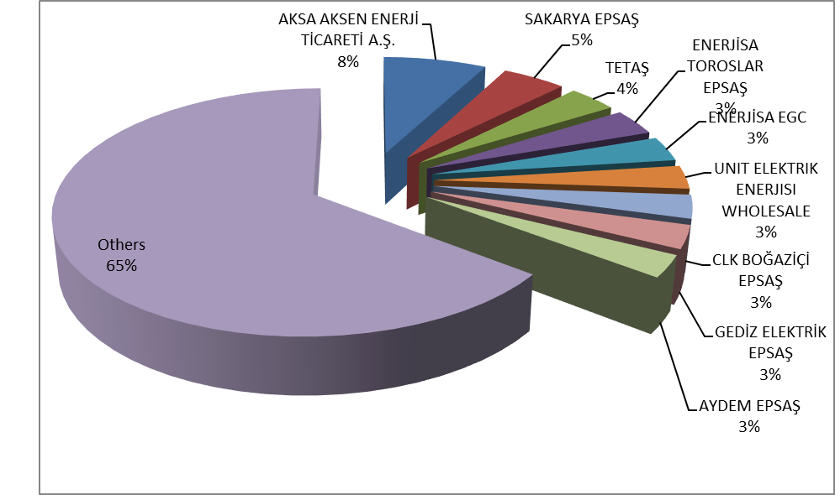

Figure 2.1.6: The Share of First 10 Seller Companies in Balancing Power Market (%)
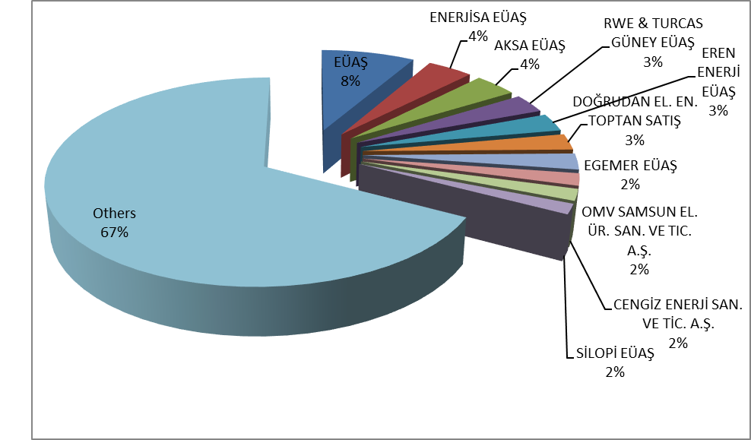

2.2 Balancing Power Market
Balancing Power Market is operated in real time by TEİAŞ. This section provides data on the development of prices and volumes in the BPM. In 2016, the system marginal prices (real time price) at the BPM are shown at Figure 2.2.1 on a per-hour basis. The price curve that occurs in the BPM is similar to the price curve that occurs in the DAM, as seen from the figure.

Figure.2.2.1: Per-Hour Based Development of System Marginal Price (TL/MWh)
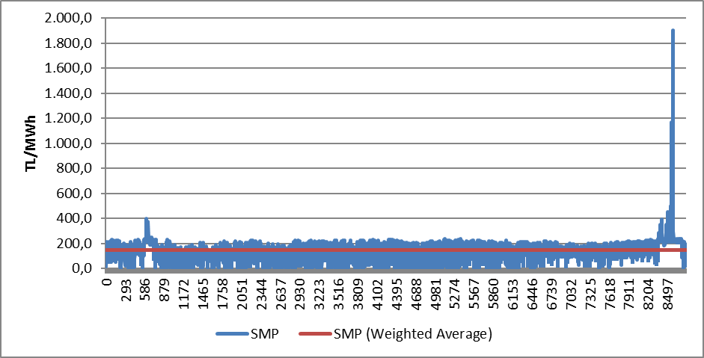

Similar to the prices of the DAM, the prices in the BPM were generally between 100 and 250 TL/MWh. The price was highest on December 23, 2016 at 14:00, 1.899,99 TL/MWh, and it was over 250 TL/MWh for 220 hours. At the BPM, for 328 hours during 2016 years the price was 0 TL/MWh.

The annual weighted average of the price in BPM decreased by 4.16% compared to the previous year as 139,80 TL/MWh.
The monthly weighted average prices of the Balancing Power Market in 2016 are shown in Figure 2.2.2 below. Similar to MCP, SMP was seen in February as the lowest, the highest value was realized in December.

Figure 2.2.2: Monthly Weighted Average Prices of the Last Two Years in Balancing Power Market (TL/MWh)

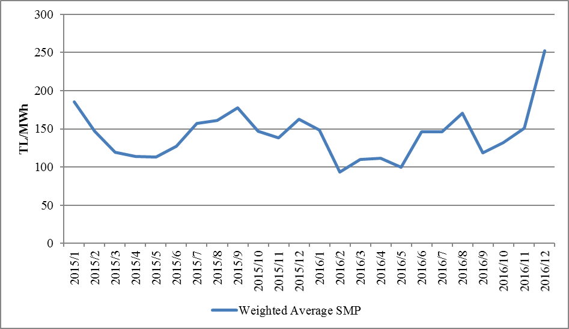

Below Figure 2.2.3 shows monthly trading volumes in BPM in 2016.

Figure 2.2.3: Monthly Trading Volumes in Balancing Power Market (MWh)
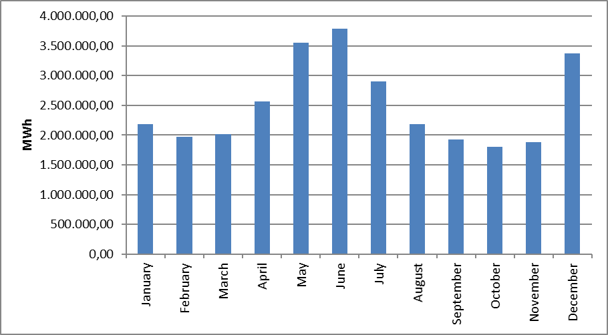
In the following Figure 2.2.4 the distribution of the BPM buying quantities on the basis of the company and the share of the top 10 companies and in Figure 2.2.5, the distribution of BPM sales quantities on company basis and the share of the top 10 companies are shown.

Figure 2.2.4: The Share of First 10 Buyer Companies in Balancing Power Market (%)
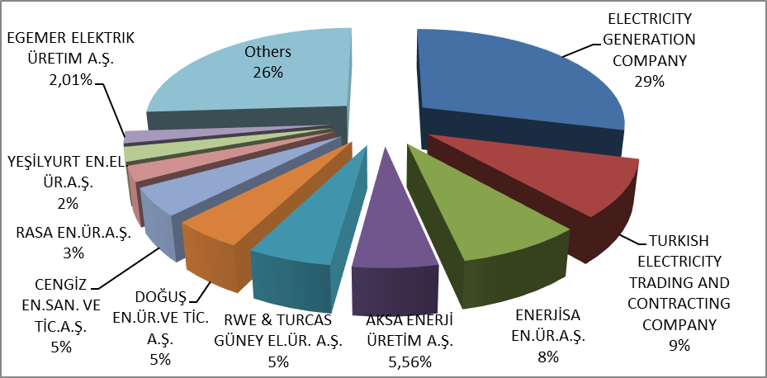

Figure 2.2.5: The Share of First 10 Seller Companies in Balancing Power Market (%)

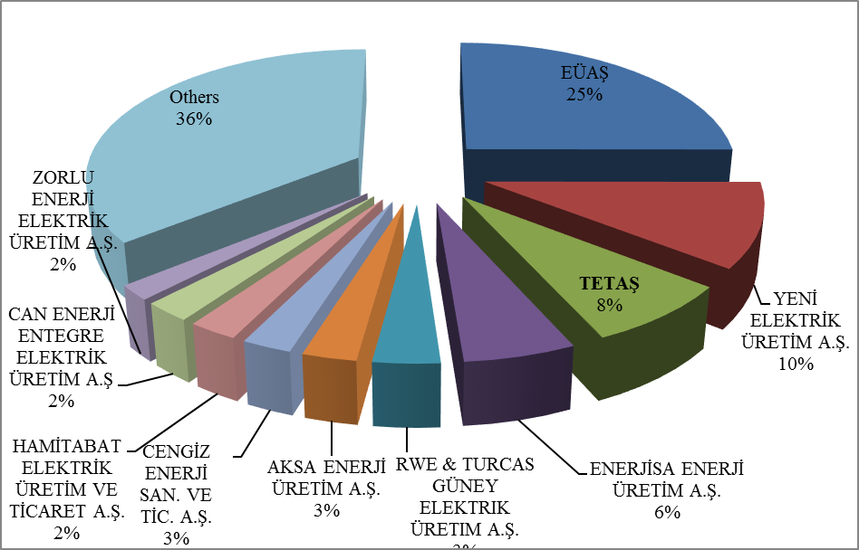
Since 2016, the ratios of the instruction volumes given in the BPM are shown below in Figure 2.2.6, and on a per-hour basis in Figure 2.2.7. -

Figure 2.2.6: Rates of Order Volumes Given in Balancing Power Market in 2016 (%)
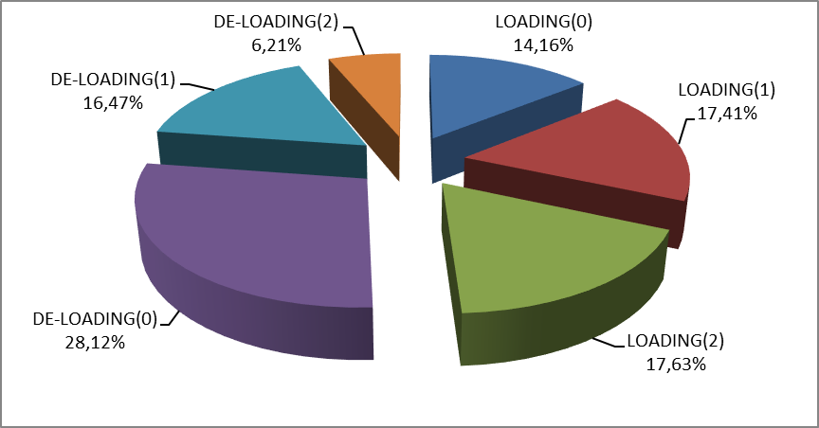
As shown in the figure, the 0-coded orders constitute 42,28% of the total amount. The remaining volume consists of 1 and 2 coded orders produced due to system requirements.

Figure 2.2.7: Distribution of the Orders Given in the Balancing Power Market by Hours in 2016 (MW)

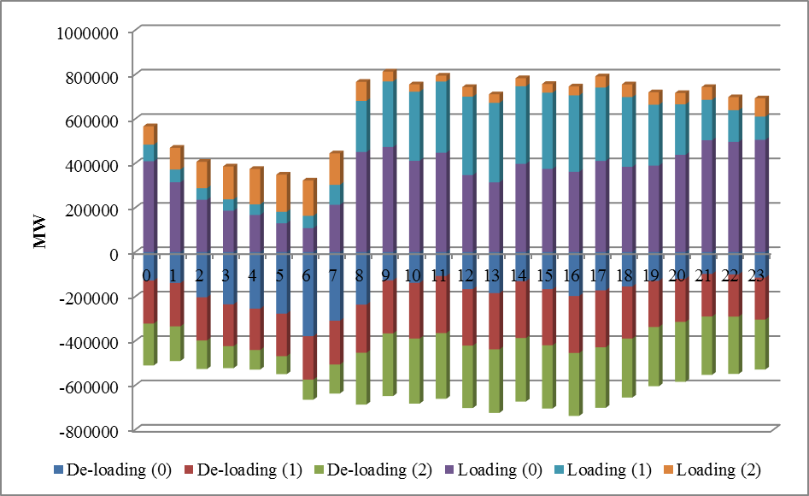

Additional costs arising from those orders are shown in Table 2.2.1 below. In 2016, the orders given in the BPM caused an additional cost of 878,62 million TL. About 60 % of these costs were 1 coded and the remaining 40 % were due to 2 coded orders.

Table.2.2.1: Additional Costs of Orders (Million TL)
Type of Instruction | Grand Total
1 Coded | 524,85
2 Coded | 353,77
Grand Total | 878,62

The development of additional costs occurred due to the given 1 and 2 coded orders by months are shown in Figure 2.2.8 below in 2016.

Figure.2.2.8: Development of Additional Costs of Orders by Months in 2016 (Million TL)
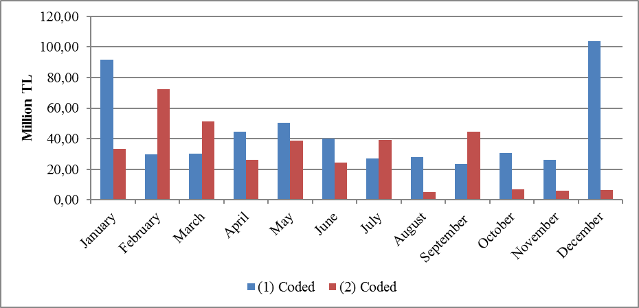
The development of the Zero Balance Adjustment Component (ZBAC), which is the result of the mentioned instructions, is shown in Figure 2.9.9. As seen in the figure, there is an increase in ZBAC over the years. ZBAC has risen about 8 times in the last seven years. ZBAC increased by 17,96 % to 1,41 billion TL compared to the previous year.

Figure 2.2.9: Development of Zero Balance Adjustment Component by Years (TL)
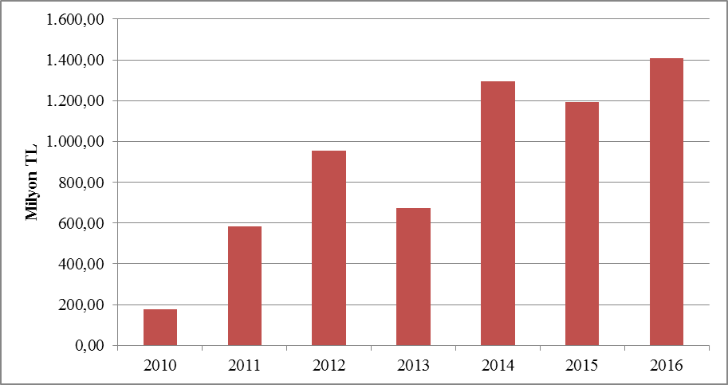

2.3 Intra-Day Market

Efforts are continuing to ensure that the Turkish Electricity Market is more transparent and efficient, financially strong, integrated with the European Union electricity markets. On 1 July 2015, the Intra-Day Market was in operation to ensure that participants in the Turkish electricity market, which is constantly evolving and advancing for free market, play a more balanced and effective role.
Day-Ahead, Ancillary Services and Balancing Power Markets currently in operation, with the addition of Intra-Day Market, provide real-time trading opportunities and offermarket participants the opportunity to manage short-term portfolios.
In Figure 2.3.1 below, the volume of the Intra-Day Market and the weighted average price have been included in the development by month.

Figure 2.3.1: Monthly Development of Trading Volume and Average Price in the Intra-Day Market (MWh - TL / MWh)
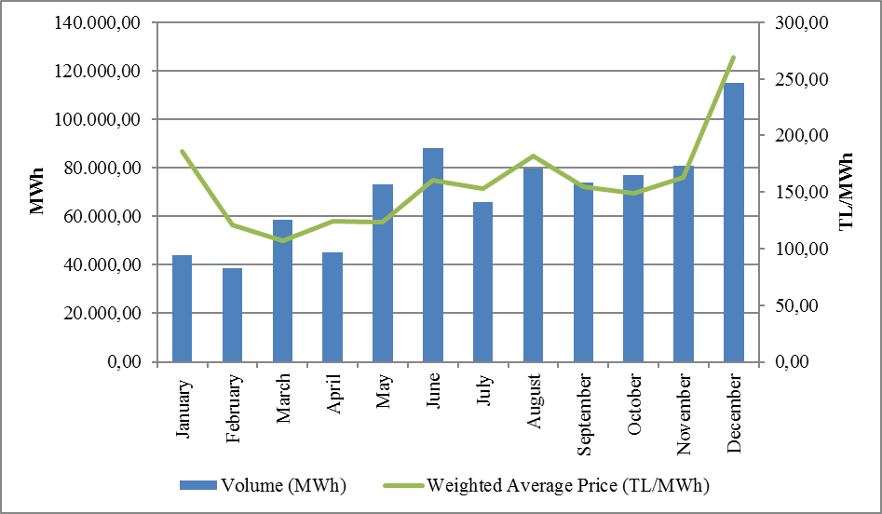
In Figure 2.3.2 the distribution of purchases of IDM on the basis of company and the share of first 10 companies and in Figure 2.3.3, the distribution of sales in IDM on the basis of the company and the share of first 10 companies are shown.

Figure 2.3.2: Distribution of Purchases of Intra-Day Market by Companies and the Share of First 10 Companies (%)
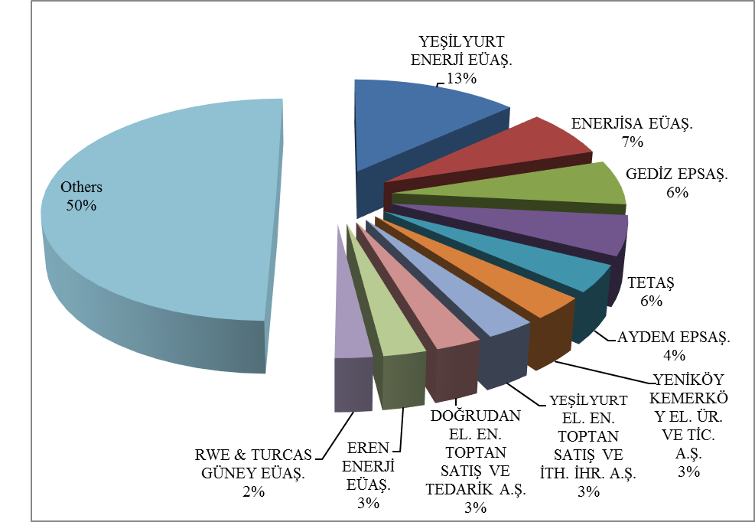

Figure 2.3.3: Distribution of Sales in Intra-Day Market by Companies and the Share of First 10 Companies (%)
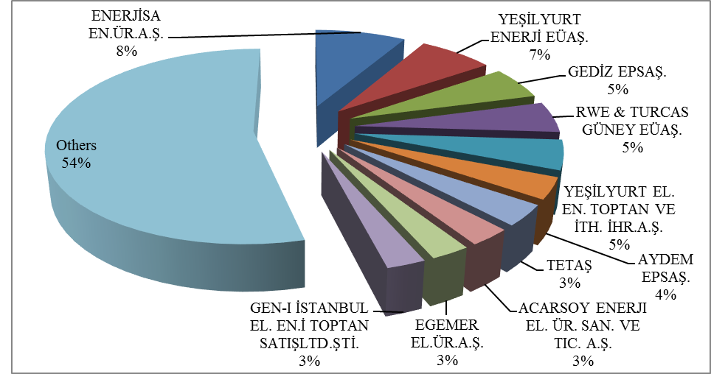

2.4 Bilateral Agreements

Bilateral agreements are based on the construction of the Turkish electricity market, and the other organized markets are designed in the figure complementing the market. Most of the energy traded in the market is traded on bilateral agreements. Bilateral agreements are free between market participants and are not subject to regulation. However, the majority of the existing bilateral agreement volume is the ones signed by TETAŞ with the incumbent supply companies. Distribution companies also have energy purchases from TETAŞ for losses and general lighting purposes under bilateral agreements.
In the following Figure 2.4.1 monthly bilateral agreement volume between 2014-2016 are shown. The volume of bilateral agreements declined in April, May, June and September in 2016 and was on the rise for the rest of the year.

Figure 2.4.1: Monthly Bilateral Agreement Volume by Years (MWh)
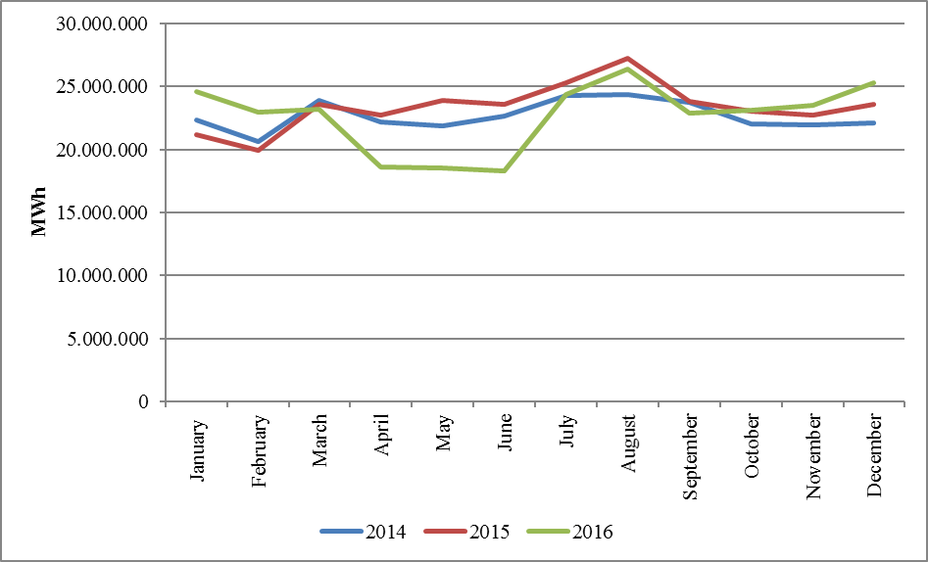
In the following Figure 2.4.2 the distribution of purchases with bilateral agreement on the basis of the company and the share of first 10 companies and in Figure 2.4.3, the distribution of sales with bilateral agreement on the basis of the company and the share of first 10 companies are shown.

Figure 2.4.2: Distribution of Purchases of Bilateral Agreement by Companies and the Share of First 10 Companies (%)
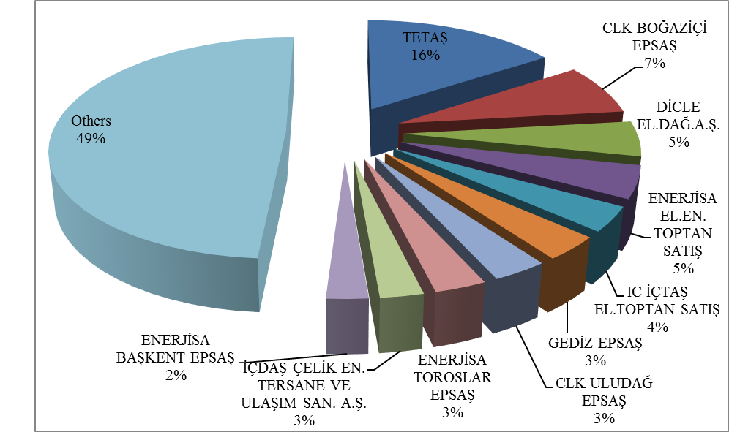

Figure 2.4.3: Distribution of Sales with Bilateral Agreement by Companies and the Share of First 10 Companies (%)
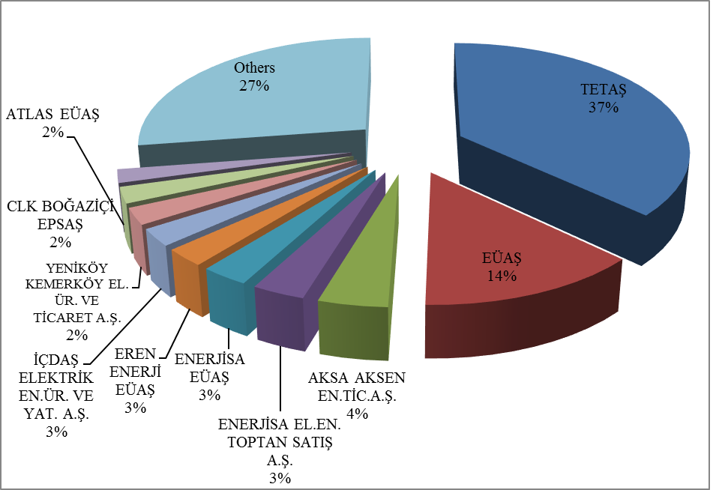
The wholesale tariffs of TETAŞ are determined by Board Decision and it is considered that TETAŞ fulfills its obligations arising from existing contracts. In the following Figure 2.4.4 the change in TETAŞ wholesale prices over periods are shown.

Figure 2.4.4: TETAŞ Wholesale Prices Between 2010-2016 (kr / kWh)
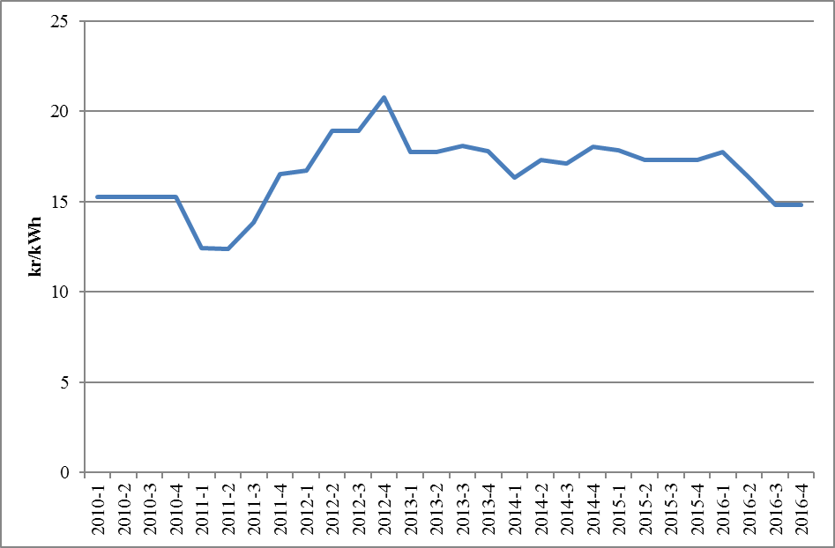
  - RES Support Mechanism

“The Amendment of the Law on “Utilization of Renewable Energy Resources for Generation of Electrical Energy” Law Numbered 6094 published in the Official Gazette dated 08/01/2011 and numbered 27809 provides incentive for renewable energy sources according to the source type and the locality rate. In this context, the regulations prepared by EMRA and the details Mechanism of Supporting Renewable Energy Sources are determined with the regulations prepared by EMRA.
“Regulation on Certification and Support of Renewable Energy Sources” was published in the Official Gazette dated 01/10/2013 and numbered 28782 and came into force. With the Regulation, in order to encourage the generation of electricity based on renewable energy sources, principles regarding the provision of Renewable Energy Source Document and the establishment and operation of RES Support Mechanismissued to the generation license holders.
In the following Table 2.5.1, the number of the RES Support Mechanism participants is given by years. There were 234 companies with a total installed capacity of 5.423,63 MW operating in the scope of the RES Support Mechanism in 2015, while 556 companies with a total installed capacity of 15.082,72 MW in 2016. There was a significant increase in the number of participants and installed capacity in the table compared to the previous year.

Table 2.5.1: Number of RES Support Mechanism Participants by years
Type | 2011 | 2012 | 2013 | 2014 | 2015 | 2016
Hydraulic | 4 | 44 | 14 | 40 | 126 | 388
Wind | 9 | 22 | 3 | 21 | 60 | 106
Biomass | 3 | 8 | 15 | 23 | 34 | 42
Geothermal | 4 | 4 | 6 | 9 | 14 | 20
Total | 20 | 78 | 38 | 93 | 234 | 556

While the numbers and capacities of biomass and geothermal plants increased steadily, the numbers and capacities of wind and hydraulic plants increased considerably over the years. As seen from Table 2.5.2 below, sources based RES Support Mechanism in 2016 when compared to the year 2015, it is seen that hydro plants ncreased by 7.844 MW to 9.960 MW and wind plants increased by 1.588 MW to 4.320 MW.

Table 2.5.2: Installed Capasity of the RES Support Mechanism Participants by Years (MW) *
Type | 2011 | 2012 | 2013 | 2014 | 2015 | 2016
Hydraulic | 21 | 930 | 217 | 598 | 2.116,33 | 9.960,00
Wind | 469 | 685 | 76 | 825 | 2.732,14 | 4.319,83
Geothermal | 72 | 72 | 140 | 228 | 389,92 | 599,16
Biomass | 45 | 73 | 101 | 147 | 185,23 | 203,72
Total | 608 | 1.760 | 534 | 1.798 | 5.423,63 | 15.082,72

* In addition, details are given at "Unlicensed Electricity Generation" in Section 1.3, by the end of 2016, all of unlicensed installed capacity of 1.045,78 MW is covered by RES Support Mechanism.
Share of installed capacity in the scope of the RES Support Mechanism in Turkey's total installed capacity in 2015 was 7.4%, while this share reached to 19,4 % in 2016.
In the following Figure 2.5.1, distribution of installed capacity based on sources in 2016 is given.

Figure 2.5.1: Distribution of Installed Capacity by Sources in 2016 (%)
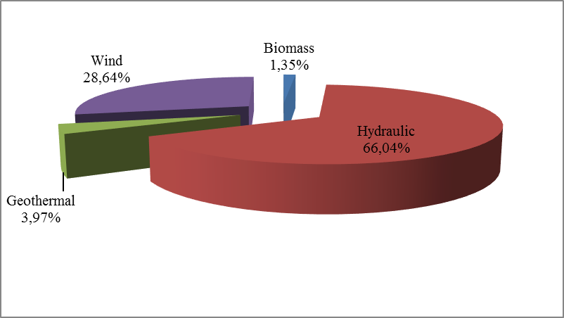
Development of the generation within the scope of RES Support Mechanism is shown at Table 2.5.3 by years. Generation in 2016 increased by almost 250% compared to the previous year, reached to 44,69 TWh.

Table 2.5.3: Yearly Generation of RES Support Mechanism Participants by years (MWh)*
Type | 2012 | 2013 | 2014 | 2015 | 2016
Hydraulic | 2.296.047 | 528.646 | 1.072.832 | 5.683.331 | 25.520.255
Wind | 2.081.745 | 234.000 | 2.378.819 | 8.275.992 | 14.163.403
Geothermal | 487.364 | 857.527 | 1.436.579 | 2.710.856 | 3.706.764
Biomass | 374.002 | 750.715 | 925.516 | 1.050.796 | 1.306.057
Total | 5.239.158 | 2.370.888 | 5.813.746 | 17.720.976 | 44.696.479

* In addition, details are given at "Unlicensed Electricity Generation" in Section 1.3, by the end of 2016, all of the unlicensed generation 1.137.871,75 MWh is covered by RES Support Mechanism.
Distribution of generation in 2016 by source types is shown at Figure 2.5.2. The highest generation was realized byhydro and wind power plants respectively.

Figure 2.5.2: Distribution of Generation in RES Support Mechanism by Sources in 2016
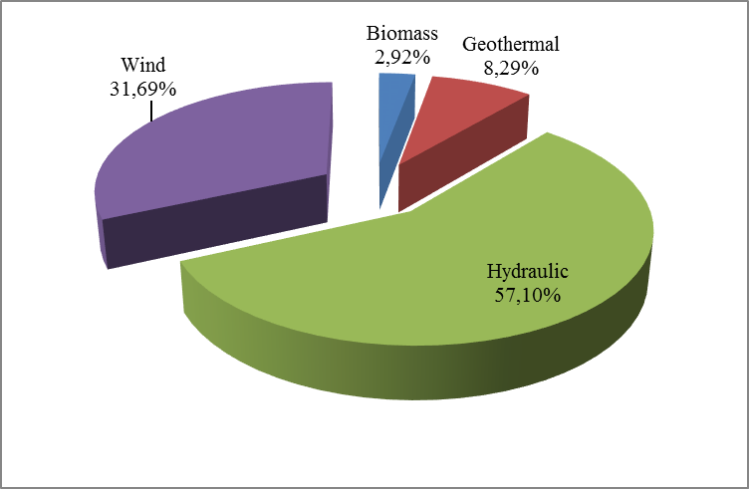
Share of the power plants’ generation within the scope of the RES Support Mechanism in total generation in 2015 was 6,8 %, while this ratio was 16,8 % in 2016.
Monthly development of the 2016 RES Support Mechanism is seen at Figure 2.5.3,. Because of rainfalls in spring, hydraulic generation and therefore the generation of RES Support Mechanism increased. For other sources, more stable generation was realized during the year.

Figure 2.5.3: Monthly Development of RES Support Mechanism Generation in 2016 (MWh)
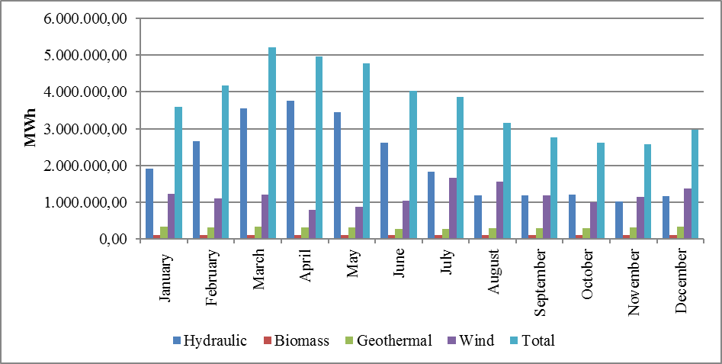
Figure 2.5.4, the monthly weighted average MCP and RES Support Mechanism feed-in tariffs are given for 2016.

Figure 2.5.4: Monthly Development of RES Support Mechanism Feed-in Tariffs and MCP in 2016 (MWh)

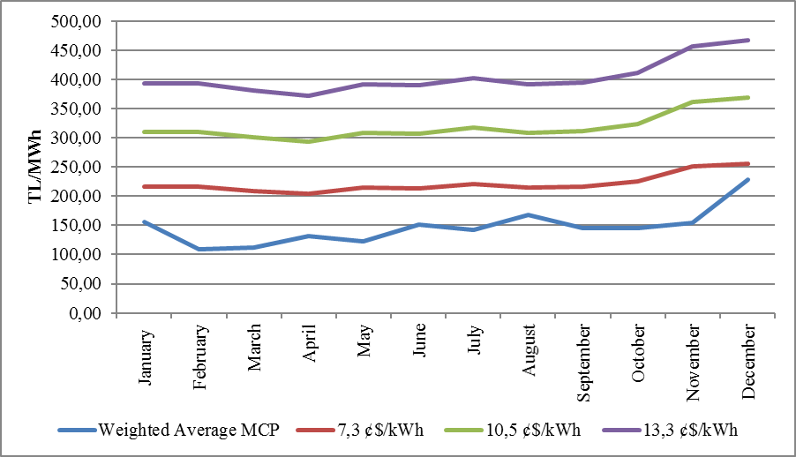
In the following Figure 2.5.5, feed-in tariffs in RES Support Mechanism are shown together with MCP. When the feed-in tariffs applied in the RES Support Mechanism are compared with the monthly average MCP, it is observed that even the lowest incentive amount is realized above the MCP. The difference between the RES Support Mechanism price and the MCP is observed to enlarge in spring months.

Figure 2.5.5: Average of RES Support Mechanism and MCP in 2016 (Kr./kWh)
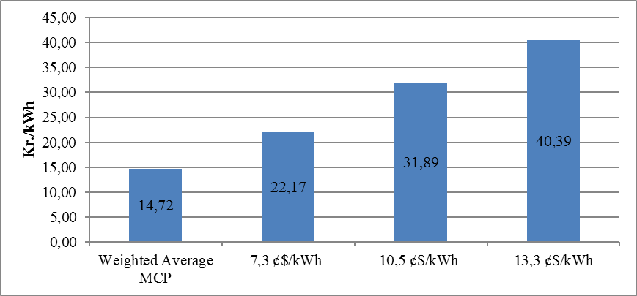
In Figure 2.5.6, monthly development of payments made within the scope of RES Support Mechanism.

Figure 2.5.6: Monthly Payments Made within the Scope of the RES Support Mechanism in 2016 (TL)
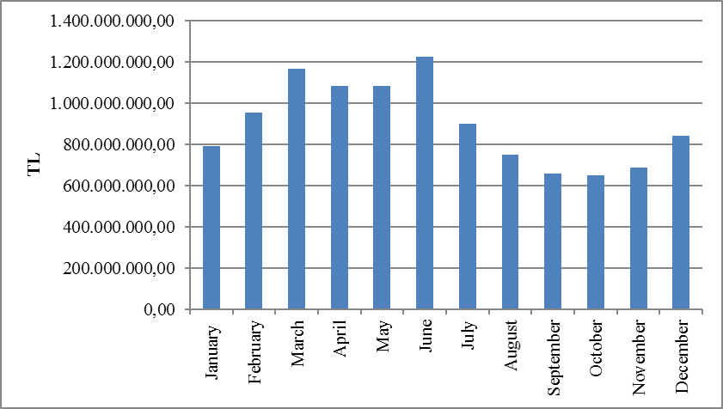

- COMPETITION

The main aim of the Electricity Market Law is to improve competition by creating a open market structure. Among the functions of the Authority,to prevent competition distruptions in the parts of the market open tocompetition by detecting the market power. EMRA also increases the number of consumers who can choose their supplier at the demand side by decreasing the eligible consumer limit for the following year at the end of each year. In this framework, development of supply and demand that open to negotiations on the wholesale market, are critical to the establishment of competition.

3.1 Supply Side

It is considered that open electricity markets provide the most effective investment and generation incentives theoretically and in practice. Nevertheless, it may be necessary to make regulations to ensure competition and supply security because of low level of flexibility of demand and incapability of network about energy storage. For this reason, these issues are also regulated by various countries and the European Union with various market share limits and mechanisms.
The indices used to follow the competition generally measure the supply side concentration in the market and the producers' ability to intervene.The HHI index is used for measuring the market concentration with the addition of squares of market shares. The index can be calculated separately on generation and installed capacity.

Table 3.1: HHI Index by Generation and Capacity
 | HHI Index
 | Generation |  |  | Installed Capacity
Years | 2014 | 2015 | 2016 | 2014 | 2015 | 2016
EÜAŞ and TETAŞ separately | 1416 | 1123 | 673 | 1132 | 996 | 820
EÜAŞ and TETAŞ together | 2748 | 2153 | 1241 | 1918 | 1645 | 1289

As shown in Table 3.1 the HHI index in 2016, which is based on generation and installed capacity, has decreased compared to the previous year. This situation stems from expiration of some existing contracts (build-operate and build-operate-transfer) in TETAŞ’s portfolio. With the completion of privatizations and the continuing expiration of existing contracts, the decrease in these index values is expected to continue.
The suppliers’ sales to end-users suppliers are shown in Table 3.2. The HHI index, which is calculated according to the supplier shares, was 416,64 in 2015. The value of 2016 was calculated as 375,54. The decrease in the index value indicates that the market continues to move towards a competitive market structure. The share of the total sales of the 21 incumbent suppliers in the total sales volume of all the supply licensed companies was 75 % in 2015. Despite decrease to 69,45 % in 2016, it still had a great rate in 2016. It is difficult to evaluate market structure only looking at the HHI index. As known, the limit of the eligible consumer in the electricity market could not reach to zero yet. In other words, not all consumers in the market are eligible consumers. It is not legally possible for any supplier to sell energy to non-eligible consumers, except for incumbent supply companies. Therefore, in order to properly evaluate the competitive environment in the market of sales made to the final consumers, it is important that an environment in which all consumers are eligible and can provide energy from any supplier.

Table 3.2: Sales, Market Shares and HHI Index of Supply License Owners
Supply Company Title | Sales  (MWh) | Share  (%)
CLK BOĞAZİÇİ ELEKTRİK PERAKENDE SATIŞ ANONİM ŞİRKETİ | 16.903.239,74 | 9,07
GEDİZ ELEKTRİK PERAKENDE SATIŞ ANONİM ŞİRKETİ | 12.093.600,33 | 6,49
ENERJİSA TOROSLAR ELEKTRİK PERAKENDE SATIŞ ANONİM ŞİRKETİ | 11.859.085,92 | 6,36
LİMAK ULUDAĞ ELEKTRİK PERAKENDE SATIŞ ANONİM ŞİRKETİ | 9.948.162,06 | 5,34
ENERJİSA BAŞKENT ELEKTRİK PERAKENDE SATIŞ ANONİM ŞİRKETİ | 9.495.847,47 | 5,10
SAKARYA ELEKTRİK PERAKENDE SATIŞ ANONİM ŞİRKETİ | 8.880.960,82 | 4,77
ENERJİSA İSTANBUL ANADOLU YAKASI ELEKTRİK PERAKENDE SATIŞ A.Ş. | 7.571.846,05 | 4,06
AYDEM ELEKTRİK PERAKENDE SATIŞ ANONİM ŞİRKETİ | 7.316.107,83 | 3,93
IC İÇTAŞ ELEKTRİK TOPTAN SATIŞ VE TİCARET ANONİM ŞİRKETİ | 6.990.377,77 | 3,75
MERAM ELEKTRİK PERAKENDE SATIŞ ANONİM ŞİRKETİ | 6.709.351,87 | 3,60
CLK AKDENİZ ELEKTRİK PERAKENDE SATIŞ ANONİM ŞİRKETİ | 6.330.405,23 | 3,40
TRAKYA ELEKTRİK PERAKENDE SATIŞ ANONİM ŞİRKETİ | 6.157.197,56 | 3,30
DİCLE ELEKTRİK PERAKENDE SATIŞ ANONİM ŞİRKETİ | 5.589.981,09 | 3,00
AKSA ELEKTRİK SATIŞ ANONİM ŞİRKETİ | 4.993.302,11 | 2,68
OSMANGAZİ ELEKTRİK PERAKENDE SATIŞ ANONİM ŞİRKETİ | 4.949.544,21 | 2,66
YEŞİLIRMAK ELEKTRİK PERAKENDE SATIŞ ANONİM ŞİRKETİ | 4.186.088,41 | 2,25
ENERJİSA ELEKTRİK ENERJİSİ TOPTAN SATIŞ ANONİM ŞİRKETİ | 4.058.591,60 | 2,18
CENGİZ ELEKTRİK TOPTAN SATIŞ A.Ş. | 2.866.393,31 | 1,54
CLK ÇAMLIBEL ELEKTRİK PERAKENDE SATIŞ ANONİM ŞİRKETİ | 2.461.711,96 | 1,32
ÇORUH ELEKTRİK PERAKENDE SATIŞ ANONİM ŞİRKETİ | 2.447.995,92 | 1,31
AKEDAŞ ELEKTRİK PERAKENDE SATIŞ ANONİM ŞİRKETİ | 2.281.837,53 | 1,22
ZORLU ELEKTRİK ENERJİSİ İTHALAT, İHRACAT VE TOPTAN TİCARET A.Ş. | 2.172.227,10 | 1,17
ÇELİKLER ELEKTRİK ENERJİ TOPTAN SATIŞ ANONİM ŞİRKETİ | 1.985.464,76 | 1,07
FIRAT ELEKTRİK PERAKENDE SATIŞ ANONİM ŞİRKETİ | 1.948.324,46 | 1,05
KAYSERİ ELEKTRİK PERAKENDE SATIŞ ANONİM ŞİRKETİ | 1.555.522,32 | 0,83
BEREKET ELEKTRİK TEDARİK ANONİM ŞİRKETİ | 1.515.271,78 | 0,81
2M ENERJİ TOPTAN ELEKTRİK TİCARET ANONİM ŞİRKETİ | 1.512.760,95 | 0,81
YAĞMUR GROUP ELEKTRİK ENERJİSİ TOPTAN SATIŞ ANONİM ŞİRKETİ | 1.393.320,80 | 0,75
EREN ELEKTRİK ENERJİSİ TOPTAN SATIŞ ANONİM ŞİRKETİ | 1.326.551,02 | 0,71
DOĞUŞ ENERJİ TOPTAN ELEKTRİK TİC.AŞ. | 1.273.976,84 | 0,68
ARAS ELEKTRİK PERAKENDE SATIŞ ANONİM ŞİRKETİ | 1.233.570,87 | 0,66
ENKO ENERJİ SANAYİ VE TİCARET ANONİM ŞİRKETİ | 1.193.325,01 | 0,64
LİMAK ENERJİ TİCARETİ ANONİM ŞİRKETİ | 1.161.746,71 | 0,62
TÜRKERLER VANGÖLÜ ELEKTRİK PERAKENDE SATIŞ ANONİM ŞİRKETİ | 1.055.044,73 | 0,57
ODAŞ ELEKTRİK PERAKENDE SATIŞ ANONİM ŞİRKETİ | 898.438,84 | 0,48
TOSYALI ELEKTRİK ENERJİSİ TOPTAN SATIŞ İTHALAT İHRACAT A.Ş. | 815.933,07 | 0,44
TETAŞ | 778.366,70 | 0,42
TTES ELEKTRİK SATIŞ ANONİM ŞİRKETİ | 739.909,15 | 0,40
D TES ELEKTRİK ENERJİSİ TOPTAN SATIŞ ANONİM ŞİRKETİ | 727.359,68 | 0,39
UNİT ELEKTRİK ENERJİSİ TOPTAN SATIŞ İHRACAT VE İTHALAT A.Ş. | 716.602,34 | 0,38
OMV ENERJİ TİCARET ANONİM ŞİRKETİ | 707.226,99 | 0,38
ZEEMA ELEKTRİK ENERJİSİ TOPTAN SATIŞ ANONİM ŞİRKETİ | 681.275,35 | 0,37
ENERYA ELEKTRİK TİCARET ANONİM ŞİRKETİ | 658.305,97 | 0,35
AYEN ELEKTRİK TİCARET ANONİM ŞİRKETİ | 656.821,29 | 0,35
DOĞRUDAN ELEKTRİK ENERJİSİ TOPTAN SATIŞ VE TEDARİK A.Ş. | 655.218,80 | 0,35
ELTEK ELEKTRİK ENERJİSİ İTHALAT İHRACAT VE TOPTAN TİCARET A.Ş. | 635.833,70 | 0,34
EWE ENERJİ ANONİM ŞİRKETİ | 564.561,17 | 0,30
MERAM ELEKTRİK ENERJİSİ TOPTAN SATIŞ ANONİM ŞİRKETİ | 485.887,65 | 0,26
zKET KİPAŞ ELEKTRİK ENERJİSİ TOPTAN SATIŞ TİCARET ANONİM ŞİRKETİ | 476.022,30 | 0,26
EKSİM ELEKTİRK ENERJİSİ İTHALAT, İHRACAT VE TOPTAN SATIŞ A.Ş. | 442.678,59 | 0,24
ENERJİM PERAKENDE ENERJİ TİCARET ANONİM ŞİRKETİ | 406.002,12 | 0,22
BORDO ELEKTRİK ENERJİSİ TOPTAN SATIŞ ANONİM ŞİRKETİ | 402.171,57 | 0,22
KOLEN ELEKTRİK TOPTAN SATIŞ İTH. VE İHR. ANONİM ŞİRKETİ | 378.870,04 | 0,20
AYCAN TOPTAN ELEKTRİK TİCARET ANONİM ŞİRKETİ | 374.134,81 | 0,20
AXPO TURKEY ENERJİ ANONİM ŞİRKETİ | 371.680,60 | 0,20
RÖNESANS ELEKTRİK ENERJİ TOPTAN SATIŞ ANONİM ŞİRKETİ | 363.490,47 | 0,20
SOYAK ENERJİ TİCARET ANONİM ŞİRKETİ | 362.017,39 | 0,19
FİNA ELEKTRİK ENERJİSİ İTHALAT İHRACAT VE TOPTAN SATIŞ A.Ş. | 359.426,40 | 0,19
AKENERJİ ELEKTRİK ENERJİSİ İTHALAT İHRACAT VE TOPTAN TİCARET A.Ş. | 335.384,43 | 0,18
HNC ENERJİ SANAYİ VE TİCARET ANONİM ŞİRKETİ | 331.144,72 | 0,18
AGE ELEKTRİK ENERJİSİ TOPTAN SATIŞ ANONİM ŞİRKETİ | 317.088,01 | 0,17
BATIÇİM ENERJİ TOPTAN SATIŞ ANONİM ŞİRKETİ | 312.274,06 | 0,17
BOSEN ELEKTRİK ENERJİSİ TOPTAN SATIŞ ANONİM ŞİRKETİ | 303.645,55 | 0,16
YETAŞ YILDIRIM ENERJİ TEDARİK A.Ş. | 298.553,07 | 0,16
MARMARA ELEKTRİK ENERJİSİ İTHALAT İHRACAT VE TOPTAN TİCARET A.Ş. | 294.349,20 | 0,16
OZAN ELEKTRİK ENERJİSİ İTH. İHR. VE TOPTAN TİCARET ANONİM ŞİRKETİ | 291.777,57 | 0,16
NAKSAN ELEKTRİK ENERJİSİ TOPTAN SATIŞ ANONİM ŞİRKETİ | 277.379,31 | 0,15
YEŞİLYURT ELEKTRİK ENERJİSİ TOPTAN SATIŞ VE İTHALAT İHRACAT A.Ş. | 274.641,31 | 0,15
AVEM ELEKTRİK ENERJİSİ TOPTAN SATIŞ ANONİM ŞİRKETİ | 269.431,86 | 0,14
KGM ENERJİ TİCARET LİMİTED ŞİRKETİ | 268.377,69 | 0,14
İPRAGAZ ANONİM ŞİRKETİ | 262.394,83 | 0,14
AKFEN ELEKTRİK ENERJİSİ TOPTAN SATIŞ ANONİM ŞİRKETİ | 249.294,45 | 0,13
YAREN GRUP ELEKTRİK ENERJİSİ TOPTAN SATIŞ ANONİM ŞİRKETİ | 245.311,68 | 0,13
ATA ELEKTRİK ENERJİSİ TOPTAN SATIŞ ANONİM ŞİRKETİ | 242.433,30 | 0,13
BALKAYA ENERJİ TOPTAN SATIŞ ANONİM ŞİRKETİ | 229.695,58 | 0,12
GATES ENERJİ TİCARET ANONİM ŞİRKETİ | 220.629,95 | 0,12
RWE ENERJİ TOPTAN SATIŞ ANONİM ŞİRKETİ | 215.057,74 | 0,12
SÜPER ELEKTRİK ENERJİSİ TOPTAN SATIŞ ANONİM ŞİRKETİ | 214.964,16 | 0,12
AVEL AVRUPA ELEKTRİK ENERJİSİ TOPTAN SATIŞ ANONİM ŞİRKETİ | 214.178,16 | 0,11
HALİS ELEKTRİK ENERJİSİ TOPTAN SATIŞ VE İTH. İHR. ANONİM ŞİRKETİ | 199.340,09 | 0,11
EYYÜPOĞLU MÜH. ELEKTRİK ENERJİSİ TOPTAN SATIŞ LİMİTED ŞİRKETİ | 186.017,70 | 0,10
COREN ELEKTRİK ENERJİSİ İTHALAT İHRACAT VE TOPTAN SATIŞ A.Ş. | 178.089,95 | 0,10
ENERGO PRO GÜNEY ELEKTRİK TOPTAN SATIŞ İTH.İHR. VE TİCARET A.Ş. | 175.809,49 | 0,09
YÜKSEL ELEKTRİK ENERJİSİ TOPTAN SATIŞ.A.Ş. | 167.181,00 | 0,09
BİSEN ELEKTRİK SATIŞ ANONİM ŞİRKETİ | 164.639,18 | 0,09
DOĞAN KENT ELEKTRİK ENERJİSİ TOPTAN SATIŞ ANONİM ŞİRKETİ | 129.076,85 | 0,07
EKO GRUP ELEKTRİK TİCARET ANONİM ŞİRKETİ | 122.969,23 | 0,07
ŞİŞECAM ENERJİ ANONİM ŞİRKETİ | 121.086,40 | 0,06
ELEKTRA ENERJİ TOPTAN SATIŞ VE İTHALAT İHRACAT ANONİM ŞİRKETİ | 111.146,31 | 0,06
FİDES ELEKTRİK ENERJİSİ TOPTAN ALIŞ SATIŞ ANONİM ŞİRKETİ | 110.326,69 | 0,06
EG ELEKTRİK ENERJİSİ TOPTAN SATIŞ ANONİM ŞİRKETİ | 110.052,19 | 0,06
TEKİN ELEKTRİK ENERJİSİ TEDARİK TOPTAN SATIŞ İTHALAT İHRACAT A.Ş. | 106.506,85 | 0,06
OFEN ENERJİ TOPTAN SATIŞ ANONİM ŞİRKETİ | 99.156,35 | 0,05
KİNESİS TOPTAN ELEKTRİK SATIŞI ANONİM ŞİRKETİ | 96.868,59 | 0,05
ÜRÜNDÜL ELEKTRİK ENERJİSİ TOPTAN SATIŞ ANONİM ŞİRKETİ | 86.644,24 | 0,05
ENOVA ELEKTRİK ENERJİSİ TOPTAN SATIŞ ANONİM ŞİRKETİ. | 84.168,38 | 0,05
YKS ELEKTRİK ENERJİSİ TOPTAN SATIŞ DIŞ TİCARET LİMİTED ŞİRKETİ | 79.534,60 | 0,04
CS ULUSLARARASI ELEKTRİK ENERJİSİ TOPTAN SATIŞ A.Ş. | 65.635,87 | 0,04
PROPER ELEKTRİK İTHALAT İHRACAT TOPTAN SATIŞ ANONİM ŞİRKETİ | 63.522,62 | 0,03
TİNMAR ENERJİ TİCARET LİMİTED ŞİRKETİ | 63.062,63 | 0,03
BARA ENERJİ TOPTAN TİCARET ANONİM ŞİRKETİ | 61.933,88 | 0,03
KIVANÇ ELEKTRİK TOPTAN SATIŞ ANONİM ŞİRKETİ | 61.178,03 | 0,03
MAC ELEKTRİK ENERJİSİ TOPTAN SATIŞ ANONİM ŞİRKETİ | 54.170,63 | 0,03
PEKER ELEKTRİK ENERJİSİ TOPTAN SATIŞ ANONİM ŞİRKETİ | 53.344,86 | 0,03
ORTADOĞU ELEKTRİK ENERJİSİ TOPTAN SATIŞ A.Ş. | 49.177,55 | 0,03
HGÇ TOPTAN EL. EN. TİCARET ANONİM ŞİRKETİ | 44.491,55 | 0,02
DOASAN ENERJİ TOPTAN SATIŞ LİMİTED ŞİRKETİ | 44.292,19 | 0,02
ŞEMS ENERJİ ELEKTRİK EN.TOPTAN SATIŞ İTH.İHR.SAN.VE TİC. LTD.ŞTİ. | 43.266,34 | 0,02
İMC ELEKTRİK ENERJİSİ TOPTAN SATIŞ İTHALAT İHRACAT LİMİTED ŞİRKETİ | 42.170,16 | 0,02
ATEK ELEKTRİK ENERJİSİ TOPTAN SATIŞ ANONİM ŞİRKETİ | 41.874,62 | 0,02
SEDSAL ELEKTRİK ENERJİSİ TOPTAN SATIŞ LİMİTED ŞİRKETİ | 39.926,70 | 0,02
TENERA ENERJİ TİCARET ANONİM ŞİRKETİ | 39.612,75 | 0,02
TESAŞ ELEKTRİK ENERJİSİ TOPTAN SATIŞ ANONİM ŞİRKETİ | 35.148,47 | 0,02
CAN ENERJİ TOPTAN ELEKTRİK TİCARET ANONİM ŞİRKETİ | 35.105,99 | 0,02
CFC ELEKTRİK ENERJİSİ TOPTAN SATIŞ ANONİM ŞİRKETİ | 33.078,43 | 0,02
TRANSCAPACİTY ENERJİ ELEKTRİK TOPTAN SATIŞ ANONİM ŞİRKETİ | 32.345,67 | 0,02
EOS ELEKTRİK ENERJİSİ TOPTAN SATIŞ ANONİM ŞİRKETİ | 31.491,77 | 0,02
ESKO ELEKTRİK ENERJİSİ İTHALAT İHRACAT VE TOPTAN SATIŞ A.Ş. | 26.917,29 | 0,01
ADB ELEKTRİK ENERJİSİ TOPTAN SATIŞ LİMİTED ŞİRKETİ | 26.252,33 | 0,01
UZ ENERGY DIŞ TİCARET ANONİM ŞİRKETİ | 25.596,35 | 0,01
PARK TOPTAN ELEKTRİK ENERJİSİ SATIŞ SANAYİ VE TİCARET A.Ş. | 25.123,53 | 0,01
ASYA ELEKTRİK ENERJİSİ TOPTAN SATIŞ ANONİM ŞİRKETİ | 24.179,14 | 0,01
VOLTAN ELEKTRİK TOPTAN SATIŞ İTHALAT VE İHRACAT ANONİM ŞİRKETİ | 24.103,64 | 0,01
ARSET ELEKTRİK TEDARİK ANONİM ŞİRKETİ | 20.718,71 | 0,01
AKS GRUP ELEKTRİK ENERJİSİ TOPTAN ALIŞ VE SATIŞ LİMİTED ŞİRKETİ | 19.488,40 | 0,01
BİR ENERJİ ELEKTRİK TOPTAN SATIŞ İTHALAT İHRACAT ANONİM ŞİRKETİ | 19.359,88 | 0,01
METRO GRUP ELEKTRİK ENERJİSİ TOPTAN SATIŞ ANONİM ŞİRKETİ | 18.181,89 | 0,01
PALPORT ELEKTRİK TİCARET ANONİM ŞİRKETİ | 17.013,91 | 0,01
Pİ ENERJİ ELEKTRİK TOPTAN SATIŞ ANONİM ŞİRKETİ | 13.712,15 | 0,01
TÜRKMEN İN ALTIN ASRI ELEKTRİK ENERJİ TOPTAN SATIŞ A | 11.693,53 | 0,01
EKODAŞ ELEKTRİK İTHALAT İNRACAT VE TOPTAN SATIŞ ANONİM ŞİRKETİ | 10.570,98 | 0,01
ÜNDEM ELEKTRİK ENERJİSİ TOPTAN SATIŞ TİCARET A.Ş. | 10.084,33 | 0,01
SHELL ENERJİ ANONİM ŞİRKETİ | 8.918,61 | 0,00
İÇDAŞ ELEKTRİK ENERJİSİ TOPTAN SATIŞ İTHALAT VE İHRACAT A.Ş. | 6.503,61 | 0,00
FREKANS ELEKTRİK ENERJİSİ TOPTAN SATIŞ İTH. İHR. ANONİM ŞİRKETİ | 6.349,74 | 0,00
ENGİE ENERJİ TİCARET VE PAZARLAMA ANONİM ŞİRKETİ | 5.831,31 | 0,00
BON ELEKTRİK TEDARİK İTHALAT İHRACAT ANONİM ŞİRKETİ | 4.079,48 | 0,00
EAG ELEKTRİK ENERJİSİ TOPTAN SATIŞI ANONİM ŞİRKETİ | 3.780,88 | 0,00
SETEL ELEKTRİK ENERJİSİ İHR.İTH. VE TOPTAN SATIŞ ANONİM ŞİRKETİ | 2.418,68 | 0,00
ADULARYA ELEKTRİK ENERJİSİ TOPTAN SATIŞ ANONİM ŞİRKETİ | 2.005,19 | 0,00
BOSPHORUS GAZ CORPORATİON ANONİM ŞİRKETİ | 1.955,29 | 0,00
YEY ELEKTRİK ENERJİSİ TOPTAN SATIŞ ANONİM ŞİRKETİ | 1.145,31 | 0,00
CELLER ELEKTRİK ENERJİSİ TOPTAN SATIŞ İTHALAT VE İHRACAT A.Ş. | 862,48 | 0,00
NYK ELEKTRİK ENERJİSİ TOPTAN SATIŞ ANONİM ŞİRKETİ | 819,79 | 0,00
İDEAL PERAKENDE ELEKTRİK SATIŞ ANONİM ŞİRKETİ | 348,87 | 0,00
HİDİV ELEKTRİK ENERJİSİ TOPTAN SATIŞ ANONİM ŞİRKETİ | 214,02 | 0,00
ALTES ELEKTRİK ENERJİSİ TOPTAN SATIŞ ANONİM ŞİRKETİ | 140,99 | 0,00
ACTAEL İSTANBUL ENERJİ PAZARLAMA ANONİM ŞİRKETİ | 13,36 | 0,00
GET CAPACİTY ENERJİ TİCARET ANONİM ŞİRKETİ | 5,59 | 0,00
CLK ENERJİ ORTAKLIĞI TOPTAN ELEKTRİK SATIŞI ANONİM ŞİRKETİ | 0,00 | 0,00
ENKA ENERJİ TİCARET ANONİM ŞİRKETİ | 0,00 | 0,00
ENSAT ELEKTRİK ENERJİSİ TEDARİK TİCARET ANONİM ŞİRKETİ | 0,00 | 0,00
PURE ENERGY ELEKTRİK TEDARİK ANONİM ŞİRKETİ | 0,00 | 0,00
SÖNMEZ ENERJİ ELEKTRİK TOPTAN TİCARET ANONİM ŞİRKETİ | 0,00 | 0,00
Total | 186.346.811,82 | 100,00
HHI of Suppliers | 375,54

3.2 Demand Side

According to EMRA Board Decision 24/12/2015 dated and 5967 numbered eligible consumer limit was set as 3600 kWh for 2016. The theoretical market openness corresponding to the eligible consumer limit was calculated as 85,8 %. The eligible consumer limit and the corresponding market openness rate over the years are given in Figure 3.1.

Figure 3.1: Eligible Consumer Limit and Market Openness Ratio by Years (kWh-%)
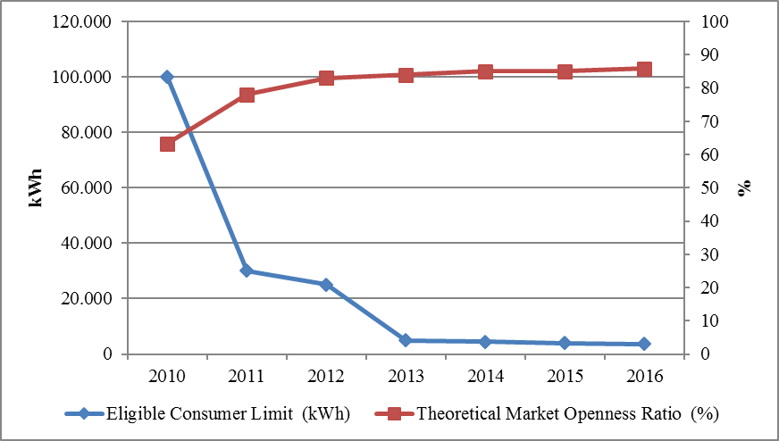
Although the theoretical market openness ratio is high, share of consumers using the their rights coming from eligible consumer status in pratice was observed to be lower. Consumption of eligible consumers in 2016 was 131,23 TWh. This corresponds to approximately 61,8 % of total invoiced consumption.
The development of the number of eligible consumers in 2016 is shown in Figure 3.2.

Figure 3.2: Number of Eligible Consumer by Months in 2016 (Number)
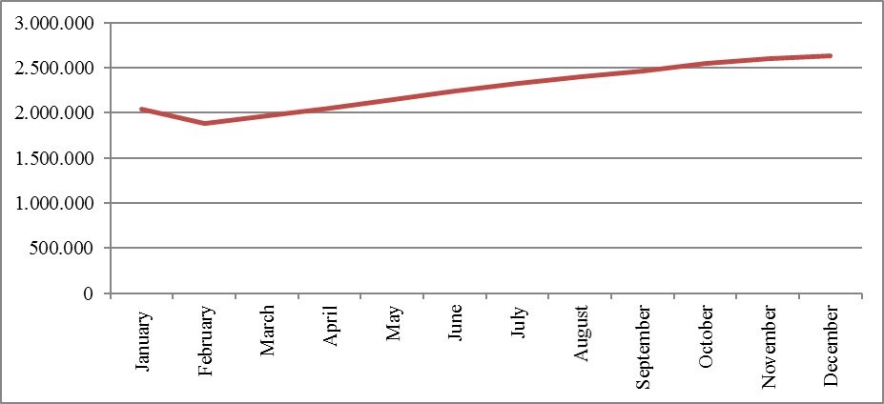
As of January 2016, the number of eligible consumer meters, which was 2.048.000, increased by 28,75 % and reached 2.635.000 by the end of the year. This number corresponds to 6,42 % of the total number of consumer meters.
The number of eligible consumers on the basis of distribution regions is shown in Figure 3.3. When the graph is examined, it is seen that the biggest shares were of Boğaziçi, Gdz, Toroslar and Akdeniz regions respectively. The share of eligible consumers in these four regions was 48,12 % of the total number of eligible consumers in the country.

Figure 3.3: Distribution of Eligible Consumers by Distribution Regions by end of 2016 (Number)
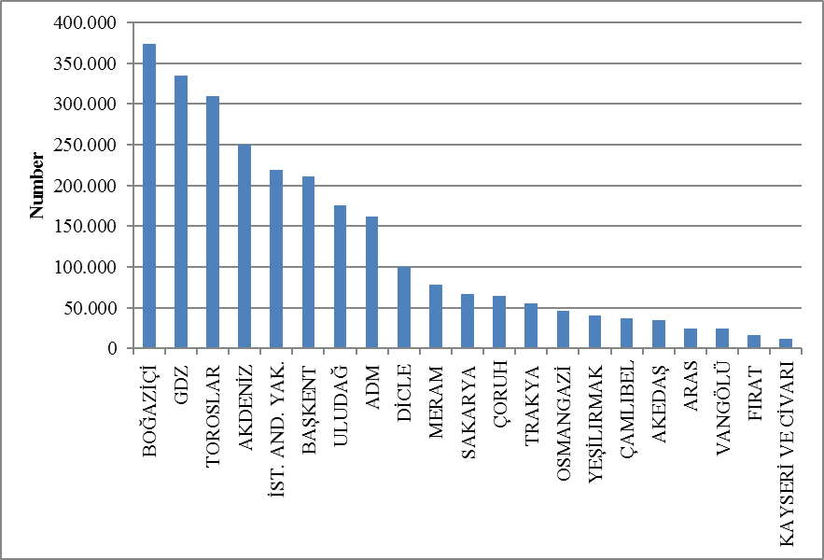
Eligible consumers' consumption on the basis of distribution regions is shown at Figure 3.4. The four regions where eligible consumers had the highest consumption were Boğaziçi, Toroslar,GDZ and Uludağ distribution regions. Total consumption of eligible consumers in these regions constituted 43,74 % of the total eligible consumer consumption in the country.

Figure 3.4: Distribution of Eligible Consumers Consumption by Distribution Regions in 2016 (MWh)

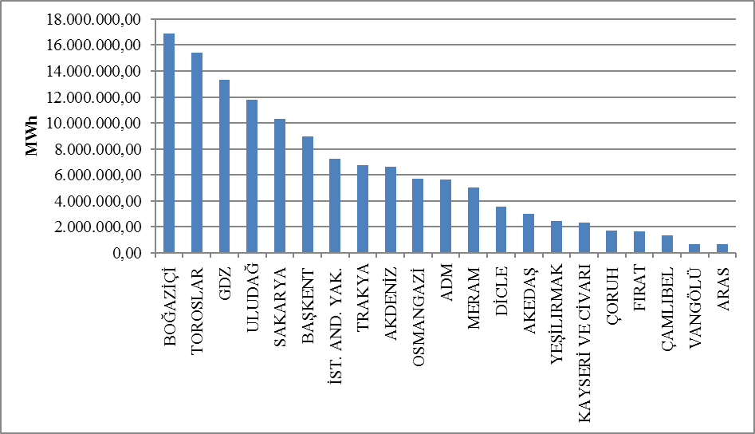

Figure 3.5 below shows the distribution of eligible consumers’consumption by supplier type.

Figure 3.5: Distribution of Eligible Consumer Consumption by Suppliers Type (%)
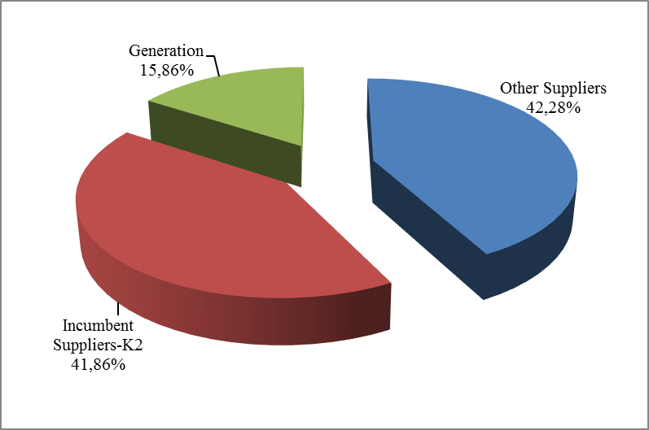
One of the important indicators of the development of competition in the market is the number of eligible consumers switching their suppliers. In this frame, Figure 3.6 shows the monthly changes in the number of consumers and their consumption.

Figure 3.6: Monthly Changes in Number and Consumptions of Eligible Consumers Switching Their Supplier (Number-MWh)
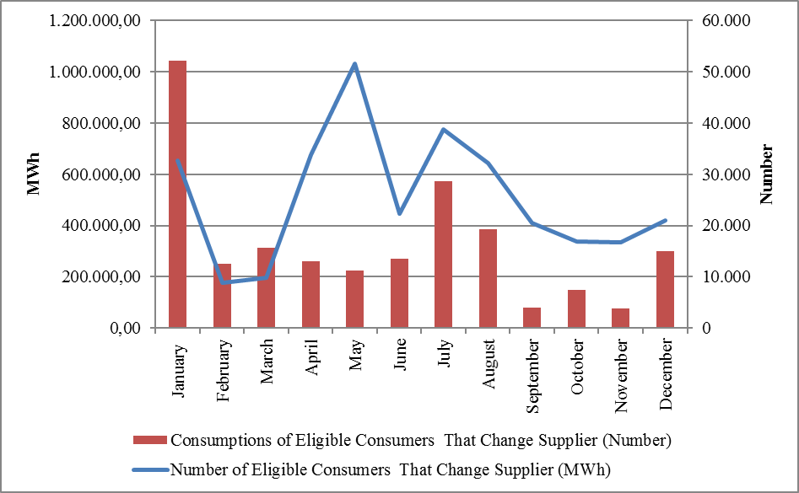

In 2016, the number of eligible consumers switched their suppliers was 304.654. This number corresponds to 11,56 % of the total number of eligible consumers and approximately 0,7 % of the total number of consumers. In addition, the total consumption of eligible consumers switching suppliers was 3,92 TWh, which corresponds to 2,99 % of total invoiced consumption.
In the following Table 3.3 the number of eligible consumers that switch monthly supplier based on provinces is shown.

Table 3.3: The Monthly Distribution Number of Eligible Consumers Switching Their Supplier Based on Province
PROVINCE | January | February | March | April | May | June | July | August | September | October | November | December | Total
ADANA | 878 | 263 | 372 | 1.194 | 1.364 | 675 | 1.442 | 2.086 | 1.323 | 1.053 | 925 | 1.430 | 13.005
ADIYAMAN | 171 | 19 | 19 | 146 | 220 | 53 | 56 | 63 | 14 | 20 | 25 | 33 | 839
AFYONKARAHİSAR | 307 | 82 | 81 | 364 | 329 | 210 | 170 | 226 | 118 | 171 | 154 | 117 | 2.329
AĞRI | 73 | 18 | 2 | 134 | 248 | 27 | 62 | 45 | 28 | 18 | 13 | 30 | 698
AKSARAY | 109 | 46 | 13 | 105 | 337 | 54 | 48 | 60 | 55 | 43 | 48 | 74 | 992
AMASYA | 121 | 23 | 15 | 120 | 351 | 18 | 67 | 504 | 36 | 50 | 28 | 57 | 1.390
ANKARA | 2.693 | 480 | 540 | 2.339 | 2.655 | 957 | 2.185 | 1.570 | 1.513 | 1.407 | 1.289 | 1.503 | 19.131
ANTALYA | 1.460 | 640 | 1.026 | 1.485 | 2.064 | 4.436 | 8.251 | 1.312 | 478 | 452 | 491 | 865 | 22.960
ARDAHAN | 67 | 11 |  | 44 | 115 | 7 | 12 | 29 | 1 | 2 | 2 |  | 290
ARTVİN | 122 | 10 | 20 | 120 | 260 | 25 | 88 | 60 | 50 | 48 | 48 | 39 | 890
AYDIN | 445 | 189 | 131 | 590 | 964 | 151 | 174 | 174 | 68 | 168 | 191 | 241 | 3.486
BALIKESİR | 515 | 110 | 113 | 518 | 1.322 | 329 | 275 | 322 | 249 | 435 | 413 | 284 | 4.885
BARTIN | 76 | 18 | 16 | 86 | 200 | 24 | 46 | 163 | 53 | 45 | 33 | 35 | 795
BATMAN | 71 | 13 | 7 | 168 | 175 | 11 | 41 | 53 | 59 | 36 | 11 | 26 | 671
BAYBURT | 43 | 5 | 8 | 37 | 100 | 1 | 9 | 17 |  | 6 | 26 |  | 252
BİLECİK | 111 | 5 | 17 | 132 | 146 | 52 | 53 | 66 | 57 | 43 | 38 | 30 | 750
BİNGÖL | 46 | 3 | 3 | 79 | 187 | 33 | 68 | 61 | 41 | 59 | 41 | 2 | 623
BİTLİS | 42 | 3 | 8 | 116 | 206 | 15 | 16 | 31 | 2 | 107 | 20 | 20 | 586
BOLU | 223 | 17 | 9 | 107 | 241 | 25 | 61 | 59 | 39 | 26 | 36 | 47 | 890
BURDUR | 135 | 32 | 29 | 114 | 137 | 15 | 31 | 16 | 52 | 3 | 11 | 16 | 591
BURSA | 937 | 216 | 229 | 1.329 | 3.880 | 1.591 | 1.990 | 2.055 | 1.746 | 970 | 1.020 | 794 | 16.757
ÇANAKKALE | 221 | 32 | 81 | 180 | 724 | 148 | 160 | 134 | 79 | 158 | 156 | 168 | 2.241
ÇANKIRI | 138 | 16 | 25 | 81 | 131 | 22 | 31 | 29 | 24 | 44 | 25 | 38 | 604
ÇORUM | 168 | 26 | 19 | 153 | 379 | 11 | 88 | 373 | 59 | 10 | 20 | 36 | 1.342
DENİZLİ | 379 | 292 | 87 | 355 | 807 | 160 | 200 | 153 | 80 | 124 | 147 | 166 | 2.950
DİYARBAKIR | 263 | 35 | 15 | 374 | 468 | 49 | 79 | 135 | 69 | 18 | 122 | 54 | 1.681
DÜZCE | 145 | 177 | 19 | 175 | 162 | 67 | 91 | 51 | 62 | 107 | 112 | 89 | 1.257
EDİRNE | 296 | 75 | 89 | 180 | 284 | 367 | 250 | 259 | 230 | 37 | 53 | 41 | 2.161
ELAZIĞ | 119 | 62 | 31 | 233 | 341 | 89 | 365 | 145 | 148 | 161 | 65 | 49 | 1.808
ERZİNCAN | 120 | 23 | 51 | 116 | 320 | 27 | 39 | 92 | 82 | 68 | 14 | 97 | 1.049
ERZURUM | 320 | 21 | 34 | 318 | 648 | 35 | 94 | 63 | 43 | 29 | 23 | 28 | 1.656
ESKİŞEHİR | 307 | 53 | 53 | 421 | 347 | 461 | 243 | 332 | 133 | 150 | 164 | 165 | 2.829
GAZİANTEP | 267 | 73 | 82 | 609 | 494 | 349 | 561 | 955 | 1.178 | 581 | 447 | 968 | 6.564
GİRESUN | 146 | 42 | 29 | 218 | 355 | 80 | 120 | 372 | 152 | 138 | 158 | 181 | 1.991
GÜMÜŞHANE | 62 | 6 | 32 | 90 | 191 | 17 | 34 | 41 | 29 | 62 | 27 | 6 | 597
HAKKARİ | 20 | 1 | 2 | 78 | 120 | 4 | 5 | 59 | 2 | 71 | 1 | 2 | 365
HATAY | 311 | 49 | 493 | 453 | 868 | 162 | 394 | 256 | 367 | 250 | 236 | 496 | 4.335
IĞDIR | 33 | 4 | 5 | 50 | 124 | 14 | 16 | 5 | 6 | 9 | 2 | 10 | 278
ISPARTA | 267 | 128 | 41 | 156 | 431 | 48 | 119 | 80 | 48 | 52 | 37 | 93 | 1.500
İSTANBUL | 7.023 | 1.682 | 2.290 | 7.885 | 8.182 | 5.612 | 11.543 | 7.002 | 5.738 | 4.123 | 4.878 | 6.569 | 72.527
İZMİR | 2.686 | 1.097 | 1.264 | 2.563 | 2.950 | 1.047 | 1.428 | 1.933 | 1.170 | 1.128 | 1.178 | 1.617 | 20.061
KAHRAMANMARAŞ | 232 | 65 | 16 | 361 | 440 | 101 | 414 | 62 | 81 | 164 | 56 | 162 | 2.154
KARABÜK | 87 | 8 | 18 | 99 | 183 | 44 | 97 | 125 | 54 | 58 | 73 | 47 | 893
KARAMAN | 77 | 82 | 17 | 101 | 227 | 47 | 39 | 40 | 17 | 12 | 63 | 48 | 770
KARS | 140 | 9 | 1 | 128 | 215 | 16 | 28 | 30 | 6 | 4 | 6 | 57 | 640
KASTAMONU | 163 | 14 | 14 | 120 | 232 | 43 | 98 | 123 | 73 | 51 | 28 | 103 | 1.062
KAYSERİ | 367 | 208 | 57 | 407 | 617 | 67 | 137 | 287 | 100 | 68 | 62 | 60 | 2.437
KIRIKKALE | 75 | 11 | 2 | 68 | 170 | 24 | 30 | 44 | 45 | 34 | 45 | 66 | 614
KIRKLARELİ | 367 | 56 | 75 | 145 | 354 | 431 | 286 | 214 | 189 | 20 | 61 | 48 | 2.246
KIRŞEHİR | 111 |  | 2 | 57 | 138 | 13 | 25 | 27 | 29 | 20 | 28 | 30 | 480
KİLİS | 24 | 1 | 4 | 31 | 77 | 37 | 40 | 29 | 99 | 38 | 47 | 72 | 499
KOCAELİ | 967 | 250 | 94 | 531 | 900 | 160 | 210 | 845 | 211 | 321 | 278 | 154 | 4.921
KONYA | 767 | 393 | 197 | 584 | 1.394 | 301 | 1.583 | 571 | 397 | 543 | 353 | 352 | 7.435
KÜTAHYA | 203 | 33 | 55 | 350 | 274 | 246 | 207 | 208 | 101 | 102 | 76 | 52 | 1.907
MALATYA | 230 | 38 | 63 | 322 | 328 | 128 | 210 | 262 | 193 | 229 | 205 | 49 | 2.257
MANİSA | 675 | 310 | 305 | 503 | 1.202 | 152 | 159 | 123 | 98 | 72 | 102 | 154 | 3.855
MARDİN | 143 | 11 | 6 | 153 | 251 | 5 | 21 | 35 | 25 | 22 | 32 | 40 | 744
MERSİN | 745 | 425 | 454 | 906 | 1.085 | 432 | 725 | 1.815 | 812 | 490 | 455 | 982 | 9.326
MUĞLA | 1.019 | 182 | 146 | 630 | 1.096 | 179 | 353 | 393 | 114 | 157 | 232 | 263 | 4.764
MUŞ | 63 | 22 | 25 | 93 | 210 | 12 | 18 | 10 | 3 | 100 | 12 | 21 | 589
NEVŞEHİR | 131 | 35 | 4 | 106 | 176 | 65 | 68 | 133 | 58 | 32 | 44 | 44 | 896
NİĞDE | 136 | 47 | 17 | 122 | 143 | 53 | 77 | 100 | 20 | 28 | 26 | 51 | 820
ORDU | 252 | 28 | 24 | 305 | 609 | 84 | 153 | 335 | 52 | 53 | 34 | 59 | 1.988
OSMANİYE | 116 | 16 | 21 | 140 | 163 | 59 | 119 | 99 | 136 | 85 | 99 | 179 | 1.232
RİZE | 129 | 56 | 53 | 163 | 426 | 144 | 105 | 258 | 107 | 100 | 99 | 97 | 1.737
SAKARYA | 374 | 56 | 79 | 376 | 703 | 336 | 253 | 181 | 121 | 378 | 311 | 177 | 3.345
SAMSUN | 680 | 40 | 52 | 299 | 1.016 | 98 | 238 | 1.148 | 78 | 119 | 80 | 68 | 3.916
SİİRT | 72 | 1 | 3 | 71 | 118 | 7 | 15 | 18 | 11 | 3 | 5 | 6 | 330
SİNOP | 76 | 8 | 19 | 73 | 250 | 10 | 41 | 191 | 10 | 34 | 7 | 6 | 725
SİVAS | 194 | 18 | 10 | 200 | 417 | 47 | 52 | 66 | 50 | 25 | 14 | 35 | 1.128
ŞANLIURFA | 163 | 43 | 23 | 267 | 441 | 38 | 128 | 331 | 41 | 36 | 77 | 76 | 1.664
ŞIRNAK | 24 | 1 | 1 | 95 | 118 | 2 | 16 | 8 | 13 | 1 | 6 | 5 | 290
TEKİRDAĞ | 657 | 70 | 117 | 257 | 642 | 719 | 490 | 610 | 387 | 37 | 87 | 122 | 4.195
TOKAT | 162 | 63 | 47 | 200 | 604 | 48 | 50 | 30 | 115 | 8 | 16 | 16 | 1.359
TRABZON | 416 | 110 | 224 | 444 | 716 | 98 | 230 | 567 | 331 | 300 | 327 | 255 | 4.018
TUNCELİ | 27 | 1 |  | 38 | 87 | 16 | 113 | 33 | 31 | 15 | 32 | 1 | 394
UŞAK | 109 | 31 | 54 | 145 | 212 | 68 | 112 | 152 | 146 | 99 | 112 | 59 | 1.299
VAN | 131 | 4 | 15 | 332 | 342 | 43 | 77 | 85 | 35 | 204 | 42 | 69 | 1.379
YALOVA | 88 | 13 | 17 | 134 | 458 | 98 | 485 | 468 | 95 | 88 | 140 | 68 | 2.152
YOZGAT | 130 | 4 | 8 | 97 | 341 | 124 | 56 | 172 | 113 | 15 | 14 | 47 | 1.121
ZONGULDAK | 221 | 51 | 76 | 281 | 347 | 192 | 170 | 408 | 184 | 176 | 144 | 217 | 2.467
Total | 32.679 | 8.911 | 9.815 | 33.749 | 51.549 | 22.265 | 38.733 | 32.077 | 20.462 | 16.823 | 16.658 | 20.933 | 304.654

In the following Table 3.4 distribution of eligible consumers’ switches by supplier type is shown.

Table 3.4: Distribution of Eligible Consumers’ Switches by Supplier Type
Former Supplier Type | New Supplier Type |  |  |  | Total
Former Supplier Type | Other Supply | Incumbent Supplier-K1 | Incumbent Supplier-K2 | Generation | Total
Other Supply | 70.300 | 35.400 | 27.402 | 3.240 | 136.342
Imcumbent Supplier-K2 | 53.091 | 90.331 | 15.932 | 770 | 160.124
Generation | 6.969 | 625 | 497 | 97 | 8.188
Total | 130.360 | 126.356 | 43.831 | 4.107 | 304.654

- TRANSMISSION

In this section, summary information about the transmission system and changes of transmission system with tables and figures according to the years are given.

  - Transmission System

By the end of 2016, transformer center data included in the transmission system is in the table below. As seen in the table, most of the transformer centers in the system are of 154 kV voltage level. There are 997 transformer centers, 761 in TEİAŞ ownership and 236 in private ownership. The transformer capacity reached to 180.485 MVA. 153.767 MVA of this capacity belongs to private ownership of the remaining part of the TEİAŞ property.

Table 4.1: Transformer Center Information
 | Voltage (kV) | Number of Centers | Number of Transformers | Capacity (MVA)
TEİAŞ Ownership | 380 | 98 | 298 | 61.060
TEİAŞ Ownership | 220 | 1 | 2 | 400
TEİAŞ Ownership | 154 | 653 | 1.342 | 91.915
TEİAŞ Ownership | 66 | 9 | 26 | 392
TEİAŞ Ownership | TEİAŞ Total | 761 | 1.668 | 153.767
Private Ownership | 380 | 20 | 39 | 5.785
Private Ownership | 220 | 0 | 0 | 0
Private Ownership | 154 | 215 | 330 | 20.923
Private Ownership | 66 | 1 | 1 | 10
Private Ownership | Private Total | 236 | 370 | 26.718
 | Grand Total | 997 | 2.038 | 180.485

66,7 % of the 61.269 km total transmission lines are working at 154 kV voltage level. Almost all of the remaining lines are working at 380 kV and the lines at the voltage level of 220 kV and 66 kV are only 137 km.

Table 4.2: TEİAŞ Transmission Lines
 | 2015 | 2016 | 2015 | 2016 | Change (%)
Voltage(kV) | Number of Lines |  | Length (km) |  | Change (%)
380 | 239 | 245 | 19.071 | 20.250 | 6,18
220 | 2 | 1 | 85 | 16 | -81,48
154 | 1.332 | 1.483 | 37.449 | 40.883 | 9,17
66 | 14 | 17 | 140 | 121 | -13,21
Total | 1.587 | 1.746 | 56.744 | 61.269 | 7,97

Figure 4.1: Changes in TEİAŞ Transmission Line Lengths by Years (km)
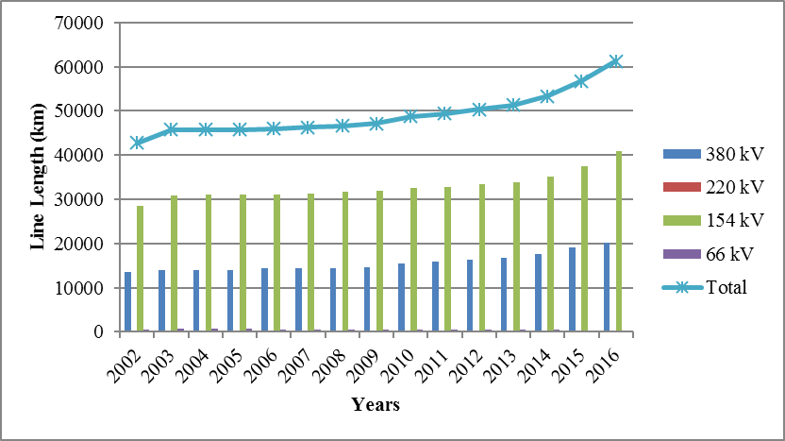
In the last 15 years, there was a 43,3 % increase in transmission line lengths.
  - Transmission System Connection Applications

The table below shows the number of applications and capacity for connection to the transmission system in 2016 with information on acceptance, rejection and evaluation stages are shown.

Table 4.3: Connection Applications to the Transmission System (Number-MW)
 | Connection Application |  | Accepted |  | Rejected |  | In the Evaluation Stage
 | Number | Capacity (MW) | Number | Capacity (MW) | Number | Capacity (MW) | Number | Capacity (MW)
Licensed Producer | 140 | 10.923 | 96 | 3.490 | 10 | 4.987 | 34 | 2.446
Unlicensed Producer | 2 | 9,3 | 2 | 9,3
Consumer | 10 | 360 | 9 | 300 |  |  | 1 | 60

In 2016, a total of 10.932,3 MW connection applications were made by producers. Accepted capacity was 3.499,3 MW. 9,3 MW of this capacity belongs to unlicensed producers and the remaining part belongs to licensed producers. In 2016, the application of the 4.987 MW capacity rejected and the 2.446 MW application was in the evaluation state.
Consumers also applied for a connection capacity of 360 MW and 300 MW of these applications were accepted.

  - Tariffs

Transmission system usage and system operation tariffs applied from 01/01/2016 for producers and consumers in 14 regions by TEİAŞ, determined with EMRA Board Decision dated 28/12/2015 and numbered 5991. System usage and system operation tariffs applied between 01/01/2016 and 30/04/2016 are shown in Table 4.4 for generation and consumption in 14 regions.

Table 4.4: System Usage and System Operation Tariffs Applied between 01/01/2016 and 20/04/2016 (TL/MW-Year)
Region | Generation (*) (**) |  | Consumption (*)
Region | System  Usage Tariffs  (TL/MW-Year) | System  Operation Tariffs (TL/MW-Year) | System  Usage Tariffs (TL/MW-Year) | System  Operation Tariffs (TL/MW-Year)
1 | 23.887,99 | 10.813,65 | 50.193,97 | 10.813,65
2 | 25.268,00 | 10.813,65 | 49.134,46 | 10.813,65
3 | 25.420,34 | 10.813,65 | 49.210,05 | 10.813,65
4 | 25.638,15 | 10.813,65 | 48.881,80 | 10.813,65
5 | 26.379,51 | 10.813,65 | 48.268,80 | 10.813,65
6 | 27.284,14 | 10.813,65 | 47.325,34 | 10.813,65
7 | 27.391,43 | 10.813,65 | 46.488,74 | 10.813,65
8 | 29.299,53 | 10.813,65 | 45.484,58 | 10.813,65
9 | 30.113,17 | 10.813,65 | 44.386,05 | 10.813,65
10 | 32.489,63 | 10.813,65 | 42.897,84 | 10.813,65
11 | 33.762,84 | 10.813,65 | 41.768,89 | 10.813,65
12 | 34.838,68 | 10.813,65 | 40.748,37 | 10.813,65
13 | 35.963,81 | 10.813,65 | 40.035,78 | 10.813,65
14 | 37.952,87 | 10.813,65 | 37.910,13 | 10.813,65
(*) Transmission Surcharge not included.
(**) 50 % discount is applied for generation connections within the scope of temporary article 4 of the Electricity Market Law numbered 6446,

Figure 4.2: Regional Transmission System Usage Tariffs Applied between 01.01.2016 and 30.04.2016 (TL/MW-Year)
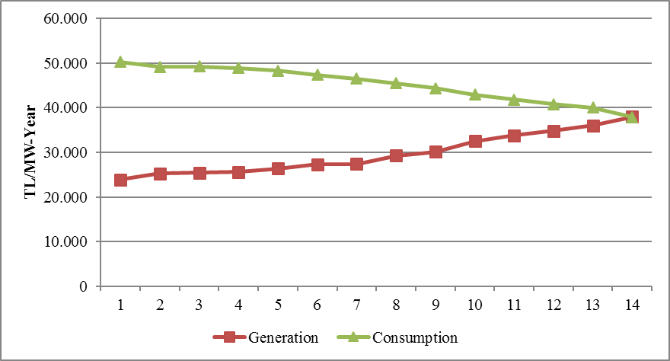
With the Board Decision dated 21/04/2016 and numbered 6234, the new method passed, in which the transmission system usage and system operation tariffs are withdrawn not only from the capacity based calculation but also the energy amount is included in the account. The Board Decision entered into force on May 1, 2016.

Table 4.5 System Usage and System Operation Tariffs Applied since 01/05/2016 (TL/MW-Year, TL/MWh)
Region No | Generation (*) (**) |  |  | Consumption (*)
Region No | System  Usage Tariffs |  | System  Operations  Tariffs | System  Usage Tariffs |  | System  Operations  Tariffs
Region No | TL/MW-Yıl | TL/MWh | TL/MWh | TL/MW-Yıl | TL/MWh | TL/MWh
1 | 13.417,87 | 5,26 | 2,67 | 21.652,12 | 4,37 | 2,67
2 | 14.628,27 | 5,26 | 2,67 | 21.036,20 | 4,37 | 2,67
3 | 14.761,88 | 5,26 | 2,67 | 21.080,14 | 4,37 | 2,67
4 | 14.952,93 | 5,26 | 2,67 | 20.860,25 | 4,37 | 2,67
5 | 15.603,16 | 5,26 | 2,67 | 20.520,71 | 4,37 | 2,67
6 | 16.396,61 | 5,26 | 2,67 | 19.984,51 | 4,37 | 2,67
7 | 16.490,70 | 5,26 | 2,67 | 19.498,17 | 4,37 | 2,67
8 | 18.164,28 | 5,26 | 2,67 | 18.914,43 | 4,37 | 2,67
9 | 18.877,93 | 5,26 | 2,67 | 18.275,81 | 4,37 | 2,67
10 | 20.962,30 | 5,26 | 2,67 | 17.410,68 | 4,37 | 2,67
11 | 22.079,02 | 5,26 | 2,67 | 16.754,39 | 4,37 | 2,67
12 | 23.022,63 | 5,26 | 2,67 | 16.161,14 | 4,37 | 2,67
13 | 24.009,47 | 5,26 | 2,67 | 15.746,89 | 4,37 | 2,67
14 | 25.754,06 | 5,26 | 2,67 | 14.511,19 | 4,37 | 2,67
(*) Transmission Surcharge not included.
(**)50 % discount is applied for generation connections within the scope of temporary article 4 of the Electricity Market Law numbered 6446.

Figure 4.3:Regional Transmission System Usage Tariffs based on Capacity Applied since 01/05/2016 (TL/MW-Year)
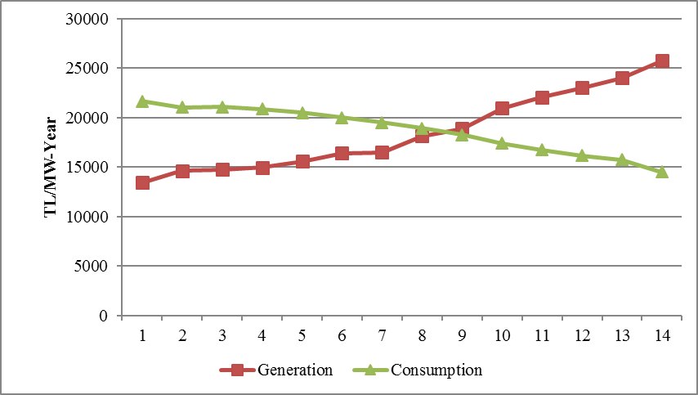

  - Amount of Investment

The amount of investment made by TEİAŞ are shown in table 4.6. It is observed that the investment amount in 2016 declined by 9,98 %.

Table 4.6: Comparison of 2015 and 2016 Investment Amount (TL-%)
 | 2015 |  | 2016 |  | Difference (%)
Investment Payment Type | Amout (TL) | Share (%) | Amount (TL) | Share (%) | Difference (%)
New Transformer Investment | 1.072.908.000 | 50,94 | 931.837.000 | 49,15 | -13,15
New Line Investment | 961.712.000 | 45,66 | 835.355.000 | 44,06 | -13,14
Operational Investment | 33.722.000 | 1,6 | 43.766.000 | 2,31 | 29,78
Machine and Equipment | 32.433.000 | 1,54 | 78.256.000 | 4,13 | 141,29
Other | 5.517.000 | 0,26 | 6.846.000 | 0,36 | 24,09
Total | 2.106.292.000 | 100,00 | 1.896.060.000 | 100,00 | -9,98

  - Losses

The transmission system loss rate changes depending on the demand in the system, load flows, temperature and investments. It is calculated on an hourly basis and the change in annual averages over the years is shown in Figure 4.4. The loss of the transmission system established by European standards in accordance with the population density of our country, the location of the supply sources and the geographical conditions is at the international performance level.

Figure 4.4: Transmission System Losses (GWh-%)
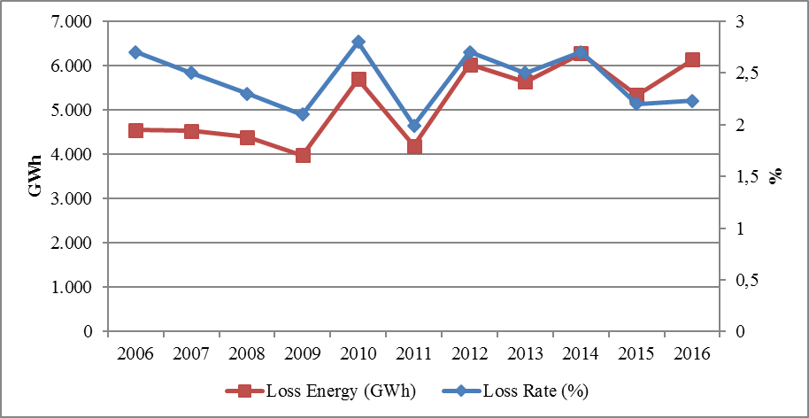

Figure 4.5: Transmission System Losses by Hour (%)

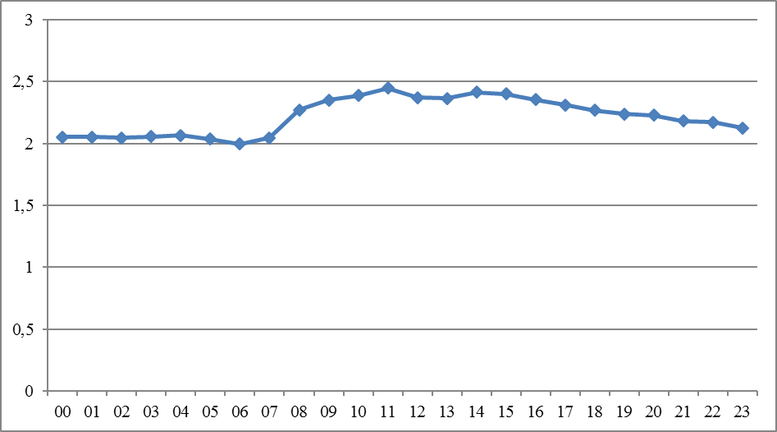

When the graph is analyzed, it is seen that the loss ratio was parallel to the generation amount and considered that it was caused by system constraints.
- DISTRIBUTION

  - Number of Consumers

By 2016, the total number of consumers using the distribution system increased by 3,21 % and reached to 41.055.915.

Table 5.1: Number of Consumers Using Distribution System by the end of 2016 (Number-%)
Distribution Company | Number of Consumers |  | Change (%)
Distribution Company | 2015 | 2016 | Change (%)
BOĞAZİÇİ | 4.732.112 | 4.872.387 | 2,96
BAŞKENT | 3.969.789 | 4.099.788 | 3,27
TOROSLAR | 3.505.182 | 3.669.912 | 4,70
GDZ | 2.971.756 | 3.061.100 | 3,01
ULUDAĞ | 2.893.903 | 2.983.810 | 3,11
İ.ANADOLU | 2.676.318 | 2.751.857 | 2,82
AKDENİZ | 1.941.193 | 2.000.386 | 3,05
MERAM | 1.889.687 | 1.964.377 | 3,95
YEŞİLIRMAK | 1.884.597 | 1.938.042 | 2,84
ADM | 1.778.773 | 1.787.566 | 0,49
DİCLE | 1.588.562 | 1.675.698 | 5,49
OSMANGAZİ | 1.611.585 | 1.661.395 | 3,09
SAKARYA | 1.578.224 | 1.654.546 | 4,84
ÇORUH | 1.237.935 | 1.269.278 | 2,53
TRAKYA | 968.459 | 991.026 | 2,33
ARAS | 906.537 | 935.816 | 3,23
ÇAMLIBEL | 898.618 | 917.913 | 2,15
FIRAT | 858.178 | 888.483 | 3,53
KAYSERİ VE CİVARI | 654.578 | 673.432 | 2,88
AKEDAŞ | 631.557 | 635.620 | 0,64
VANGÖLÜ | 599.921 | 623.483 | 3,93
Total | 39.777.464 | 41.055.915 | 3,21

It is seen from Table 5.1 that the distribution regions with the highest number of consumers were Boğaziçi with 4.87 million, Başkent with 4,1 million and Toroslar with 3,67 million, respectively.
In the following figure, the number of consumers connected to distribution network and the total consumption of these consumers by 2016 are shown.

Figure 5.1: Number and Consumption of Consumers (Number-MWh)
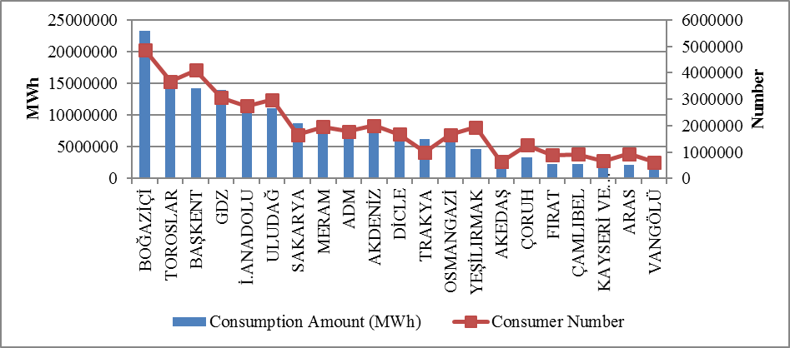
  - Ratio of Losses

In following Table 5.2, targeted and realized loss rates of distribution companies are shown.

Table 5.2: Loss Rates of Distribution Companies (%)
DISTRIBUTION COMPANY | REALIZED LOSS RATES |  |  | TARGETED LOSS RATES | DIFFERENCE OF REALIZED&TARGETED LOSS RATES
DISTRIBUTION COMPANY | 2015 | 2016 | Difference | 2016 | 2016
ARAS | 26,60 | 25,68 | 0,92 | 31,68 | 6,00
DİCLE | 72,17 | 67,63 | 4,54 | 71,62 | 3,99
VANGÖLÜ | 59,70 | 56,42 | 3,28 | 60,16 | 3,74
AKDENİZ | 7,02 | 6,31 | 0,71 | 9,66 | 3,35
ADM | 5,34 | 5,74 | -0,40 | 7,92 | 2,18
OSMANGAZİ | 7,62 | 5,75 | 1,87 | 7,77 | 2,02
ULUDAĞ | 6,94 | 5,57 | 1,37 | 7,55 | 1,98
ÇAMLIBEL | 7,06 | 5,97 | 1,09 | 7,93 | 1,96
TRAKYA | 6,57 | 5,46 | 1,11 | 7,15 | 1,69
KAYSERİ | 5,25 | 5,87 | -0,62 | 7,44 | 1,57
TOROSLAR | 12,50 | 12,12 | 0,38 | 13,59 | 1,47
MERAM | 7,30 | 6,65 | 0,65 | 7,90 | 1,25
GDZ | 7,36 | 7,32 | 0,04 | 8,47 | 1,15
BAŞKENT | 7,00 | 6,98 | 0,02 | 8,00 | 1,02
SAKARYA | 6,68 | 6,58 | 0,10 | 7,42 | 0,84
İST. AND. YAK. | 7,00 | 6,78 | 0,22 | 7,61 | 0,83
YEŞİLIRMAK | 7,90 | 8,20 | -0,30 | 8,50 | 0,30
AKEDAŞ | 4,98 | 7,20 | -2,22 | 7,46 | 0,26
ÇORUH | 9,28 | 9,25 | 0,03 | 9,35 | 0,10
BOĞAZİÇİ | 9,44 | 9,61 | -0,17 | 9,60 | -0,01
FIRAT | 10,44 | 10,56 | -0,12 | 9,74 | -0,82
From Table 5.2, only 2 out of 21 distribution companies could not achieve the targeted loss rate for 2016. The negative deviations from the target in the Boğaziçi region were 0,01 % and 0,82 % in the Fırat region. The other 19 regions achieved a better outcome than the target, and the distribution companies showed a successful performance in terms of their loss targets in 2016. According to the targets, the regions with the highest development were Aras (6 %), Dicle (3,99 %) and Vangölü (3,74 %) regions.
As can be seen from Table 5.2, the highest loss rates in 2016 were in Dicle (67,63%), Vangölü (56,42%) and Aras (25,68%) regions, respectively.
The following Figure 5.2 the realized and targeted loss rates are shown.

Figure 5.2: Realized and Targeted Loss Rates in 2016 (%)
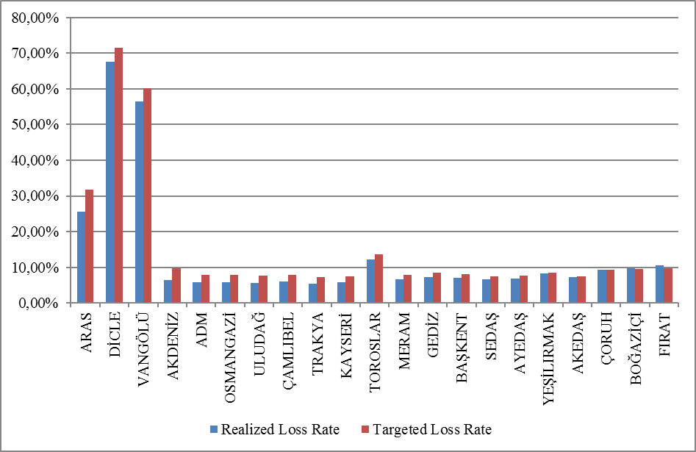

5.3 Employment

By the end of 2016, 54,412 people were employed in electricity distribution sector; 14.984 people were employed as permanent employee and 39.428 people were employed as subcontractor employee. The following figures are based on distribution companies. Boğaziçi EDAŞ had the highest number of employees with a total of 5.785 while the distribution company with the highest number of permanent employee was Dicle EDAŞ with 1.881 people and Boğaziçi EDAŞ with the number of personnel with the highest number of subcontract employee was 5.079. Kayseri EDAŞ was the distribution company with the lowest number of employees with 873 people.

Table 5.3: Number of Employees of Distribution Companies (Number)
Distribution Company | Number of Permanent Employees | Number of Subcontractor Employees | Total
TOROSLAR | 706 | 5.079 | 5.785
BAŞKENT | 1.012 | 3.901 | 4.913
BOĞAZİÇİ | 732 | 3.631 | 4.363
DİCLE | 1.881 | 2.415 | 4.296
ULUDAĞ | 519 | 3.022 | 3.541
GDZ | 658 | 2.530 | 3.188
ADM | 518 | 2.426 | 2.944
İ.ANADOLU | 921 | 1.597 | 2.518
SAKARYA | 1.667 | 705 | 2.372
MERAM | 698 | 1.671 | 2.369
AKDENİZ | 298 | 1.870 | 2.168
ÇORUH | 414 | 1.645 | 2.059
FIRAT | 330 | 1.688 | 2.018
ARAS | 534 | 1.360 | 1.894
YEŞİLIRMAK | 677 | 1.209 | 1.886
OSMANGAZİ | 1.245 | 581 | 1.826
VANGÖLÜ | 648 | 997 | 1.645
ÇAMLIBEL | 232 | 1.320 | 1.552
AKEDAŞ | 365 | 804 | 1.169
TRAKYA | 429 | 604 | 1.033
KAYSERİ VE CİVARI | 500 | 373 | 873
Total | 14.984 | 39.428 | 54.412

Figure 5.3: Number of Employees of Distribution Companies by Year 2016 (Number)
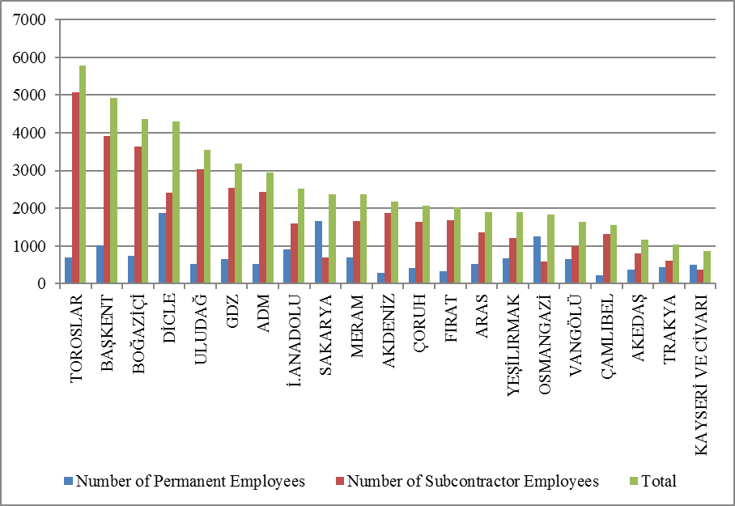

5.4 Information about Network

This section contains basic data on the distribution system. In this context, information on line lengths, transformer capacities and transformer numbers in the distribution voltage level is included in the following tables and figures.
As it is knownalmost whole of Turkey had access to electricity . Except for industrial plants with large consumption, all small and medium-sized consumers provide electric energy through the distribution system. As seen from Table 5-5, the total distribution line length of Turkey reached to 1.102.508 km. When considering the line lengths according to the distribution regions, the distribution regions of Başkent, Toroslar, Meram, Yeşilırmak and Dicle were the first five regions. It is seen that the distribution line lengths have a direct correlation with the size of the distribution region. On the other hand, regarding transformer capacity, it is seen that the electricity distribution regions of Boğaziçi, Başkent, Gdz, Toroslar and Dicle were the top five.

Table 5.4: Line Lengths, Number of Transformers and Transformer Capacities Based on Distribution Companies by end of 2016 (Km-MVA-Number)
Distribution Company | Line Length (Km) | Transformer Capacity (MVA) | Number of Transformers
ADM | 64.594 | 7.420 | 20.157
AKDENİZ | 51.672 | 7.366 | 18.576
AKEDAŞ | 25.058 | 3.180 | 10.919
ARAS | 54.765 | 2.757 | 12.825
BAŞKENT | 109.659 | 12.615 | 30.467
BOĞAZİÇİ | 32.457 | 16.739 | 13.838
ÇAMLIBEL | 45.943 | 2.280 | 11.267
ÇORUH | 56.949 | 2.685 | 11.177
DİCLE | 69.985 | 12.048 | 56.738
FIRAT | 45.890 | 2.568 | 11.524
GDZ | 53.606 | 13.304 | 29.975
İ. ANADOLU | 23.783 | 7.858 | 7.174
KAYSERİ VE CİVARI | 21.488 | 2.354 | 6.998
MERAM | 81.636 | 9.071 | 49.736
OSMANGAZİ | 43.364 | 5.511 | 21.969
SAKARYA | 35.478 | 6.882 | 15.693
TOROSLAR | 84.411 | 12.998 | 41.942
TRAKYA | 19.842 | 4.473 | 10.503
ULUDAĞ | 62.330 | 9.122 | 25.243
VANGÖLÜ | 39.335 | 2.673 | 10.234
YEŞİLIRMAK | 80.263 | 4.464 | 19.344
Total | 1.102.508 | 148.368 | 436.299

Figure 5.4: Line Lengths and Transformer Capacities on the Basis of

Distribution Companies at the end of 2016 (Km-MVA)
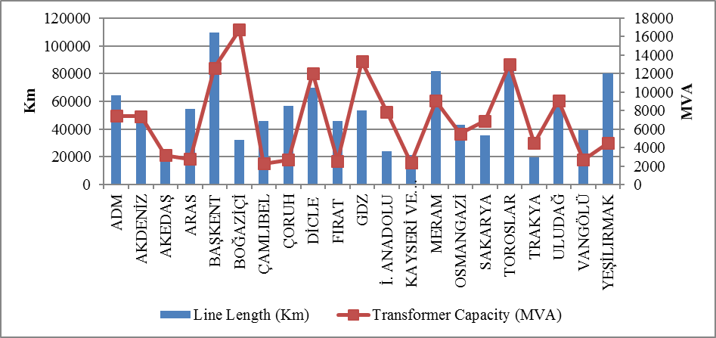
The lengths of distribution lines is shown in Table 5.5. As seen in the table, 84,64 % of the total distribution lines was overhead lines. The share of underground lines in total distribution lines was 15,36 %. This indicates that the distribution lines were open to external influence. The external effects could be natural, climate or human originated, disasters such as extreme precipitations, storms etc. could directly or indirectly damage distribution lines.

Table 5.5: The Lengths of Distribution Lines (Km)
Distribution Company | Overhead (Km) | Underground (Km) | Total (Km)
ADM | 56.995 | 7.599 | 64.594
AKDENİZ | 38.554 | 13.118 | 51.672
AKEDAŞ | 22.610 | 2.448 | 25.058
ARAS | 50.166 | 4.598 | 54.765
BAŞKENT | 91.266 | 18.394 | 109.659
BOĞAZİÇİ | 7.303 | 25.154 | 32.457
ÇAMLIBEL | 42.178 | 3.765 | 45.943
ÇORUH | 54.399 | 2.549 | 56.949
DİCLE | 61.572 | 8.413 | 69.985
FIRAT | 42.325 | 3.565 | 45.890
GDZ | 45.050 | 8.555 | 53.606
İ. ANADOLU | 5.652 | 18.131 | 23.783
KAYSERİ VE CİVARI | 17.598 | 3.890 | 21.488
MERAM | 75.278 | 6.358 | 81.636
OSMANGAZİ | 39.895 | 3.470 | 43.364
SAKARYA | 30.183 | 5.296 | 35.478
TOROSLAR | 76.118 | 8.293 | 84.411
TRAKYA | 16.639 | 3.203 | 19.842
ULUDAĞ | 54.801 | 7.529 | 62.330
VANGÖLÜ | 37.477 | 1.859 | 39.335
YEŞİLIRMAK | 67.100 | 13.163 | 80.263
Total | 933.158 | 169.349 | 1.102.508

Figure 5.5: The Length of Lines on the Basis of Distribution Companies at the end of 2016(Km)
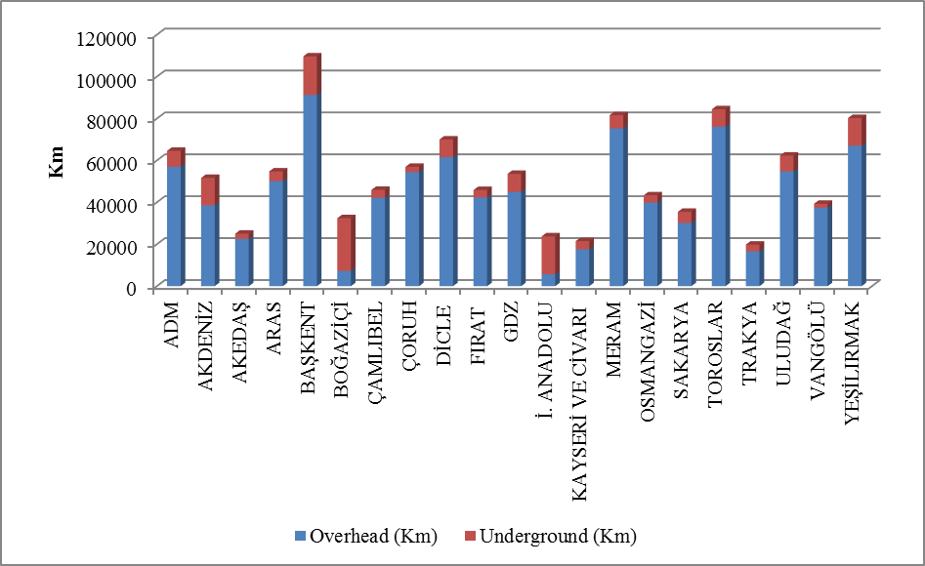

As seen in the figure above, the share of underground line lengths in the Boğaziçi and İstanbul Anadolu Side was higher than the share of overhead lines.
Table 5.6 includes distribution line lengths and transformer capacities. Regarding distribution line lengths was the first five provinces were Ankara, İstanbul, Konya, Antalya and İzmir, respectively.
Regarding the transformer capacities, the first five provinces were İstanbul, İzmir, Ankara, Antalya and Konya, respectively.

Table 5.6: Line Lengths at Distribution Voltage Levels, Number of Transformers and Transformer Capacities by Provinces in 2016 (Km-MVA-Number)
Province | Line Length (Km) | Transformer Capacity (MVA) | Number of Transformers
ADANA | 26.462 | 3.736 | 10.921
ADIYAMAN | 8.519 | 864 | 4.542
AFYONKARAHİSAR | 13.447 | 1.547 | 8.825
AĞRI | 12.517 | 512 | 2.399
AKSARAY | 9.723 | 873 | 5.863
AMASYA | 7.538 | 534 | 2.557
ANKARA | 59.673 | 9.364 | 16.731
ANTALYA | 36.306 | 5.620 | 12.823
ARDAHAN | 4.533 | 107 | 807
ARTVİN | 6.561 | 341 | 1.450
AYDIN | 19.592 | 2.350 | 6.437
BALIKESİR | 25.236 | 2.423 | 7.601
BARTIN | 3.963 | 364 | 1.366
BATMAN | 5.730 | 918 | 3.761
BAYBURT | 2.830 | 141 | 674
BİLECİK | 3.703 | 760 | 1.713
BİNGÖL | 6.305 | 305 | 1.732
BİTLİS | 7.085 | 439 | 2.340
BOLU | 6.992 | 653 | 2.664
BURDUR | 6.492 | 614 | 2.711
BURSA | 22.953 | 4.781 | 11.676
ÇANAKKALE | 10.418 | 1.349 | 4.757
ÇANKIRI | 6.111 | 377 | 1.723
ÇORUM | 14.578 | 907 | 3.955
DENİZLİ | 20.174 | 2.225 | 5.991
DİYARBAKIR | 15.839 | 2.844 | 10.971
DÜZCE | 5.364 | 646 | 1.938
EDİRNE | 6.510 | 942 | 3.742
ELAZIĞ | 11.624 | 877 | 3.629
ERZİNCAN | 6.788 | 414 | 1.968
ERZURUM | 17.041 | 1.011 | 4.330
ESKİŞEHİR | 11.314 | 1.760 | 6.253
GAZİANTEP | 13.371 | 2.198 | 9.623
GİRESUN | 15.167 | 558 | 2.816
GÜMÜŞHANE | 5.339 | 281 | 1.215
HAKKARİ | 7.717 | 326 | 1.508
HATAY | 17.077 | 3.322 | 9.959
IĞDIR | 4.958 | 215 | 1.063
ISPARTA | 8.874 | 1.132 | 3.042
İSTANBUL | 56.240 | 24.597 | 21.012
İZMİR | 31.857 | 10.421 | 18.440
KAHRAMANMARAŞ | 16.539 | 2.316 | 6.377
KARABÜK | 4.314 | 491 | 1.589
KARAMAN | 6.377 | 587 | 3.868
KARS | 6.099 | 356 | 1.584
KASTAMONU | 12.921 | 680 | 4.276
KAYSERİ | 21.488 | 2.354 | 6.998
KIRIKKALE | 11.163 | 422 | 1.424
KIRKLARELİ | 4.860 | 909 | 2.133
KIRŞEHİR | 5.465 | 356 | 1.872
KİLİS | 1.932 | 194 | 872
KOCAELİ | 11.282 | 3.965 | 6.588
KONYA | 43.534 | 5.334 | 27.435
KÜTAHYA | 8.562 | 850 | 2.929
MALATYA | 23.084 | 1.243 | 4.977
MANİSA | 21.749 | 2.883 | 11.535
MARDİN | 10.659 | 2.274 | 10.859
MERSİN | 19.117 | 3.034 | 8.511
MUĞLA | 24.828 | 2.846 | 7.729
MUŞ | 7.413 | 442 | 2.067
NEVŞEHİR | 7.863 | 1.014 | 5.761
NİĞDE | 8.674 | 907 | 4.937
ORDU | 23.615 | 821 | 4.338
OSMANİYE | 6.452 | 514 | 2.056
RİZE | 8.500 | 509 | 2.170
SAKARYA | 11.840 | 1.617 | 4.503
SAMSUN | 26.648 | 1.868 | 6.559
SİİRT | 3.959 | 342 | 1.630
SİNOP | 7.884 | 333 | 1.935
SİVAS | 17.878 | 974 | 4.330
ŞANLIURFA | 28.766 | 5.004 | 26.381
ŞIRNAK | 5.032 | 667 | 3.136
TEKİRDAĞ | 8.471 | 2.623 | 4.628
TOKAT | 14.844 | 638 | 3.079
TRABZON | 21.382 | 996 | 3.526
TUNCELİ | 4.877 | 144 | 1.186
UŞAK | 6.338 | 594 | 2.249
VAN | 17.121 | 1.467 | 4.319
YALOVA | 3.722 | 568 | 1.209
YOZGAT | 13.222 | 669 | 3.858
ZONGULDAK | 11.514 | 917 | 3.358
Total | 1.102.508 | 148.368 | 436.299

5.5 Quality Indicators

Data on the technical quality of the electricity provided by the distribution companies are compiled and the tables below show Customer Average Interruption Duration Index (CAIDI) and Customer Average Interruption Frequency Index (CAIFI).

Table 5.7: Reported and Unreported Customer Average Interruption Duration Indices of Distribution Companies in 2016 (min)
 | 2015 |  |  | 2016 |  |  | Change (%)
Distribution Company | Reported CAIDI (min) | Unreported CAIDI(min) | Total  CAIDI (min) | Reported  CAIDI (min) | Unreported  CAIDI (min) | Total  CAIDI(min) | Change (%)
VANGÖLÜ | 619,0 | 7.175,0 | 7.794,0 | 323,6 | 3.587,8 | 3.911,4 | -49,82
ULUDAĞ | 1.187,7 | 1.185,8 | 2.373,4 | 2.274,0 | 803,7 | 3.077,7 | 29,67
ARAS | 79,1 | 1.620,5 | 1.699,6 | 229,0 | 2.793,5 | 3.022,5 | 77,84
TRAKYA | 277,3 | 2.276,4 | 2.553,8 | 534,2 | 1.493,3 | 2.027,6 | -20,60
YEŞİLIRMAK | 683,7 | 2.214,5 | 2.898,3 | 610,0 | 1.303,9 | 1.913,9 | -33,97
ÇORUH | 70,9 | 1.613,5 | 1.684,5 | 188,2 | 1.646,3 | 1.834,4 | 8,90
MERAM | 1.237,4 | 1.318,0 | 2.555,4 | 788,3 | 1.007,0 | 1.795,3 | -29,74
TOROSLAR | 731,2 | 852,1 | 1.583,3 | 878,6 | 906,2 | 1.784,8 | 12,73
SAKARYA | 475,3 | 1.326,4 | 1.801,7 | 425,6 | 1.145,1 | 1.570,6 | -12,82
BOĞAZİÇİ | 153,1 | 1.380,4 | 1.533,5 | 198,0 | 1.334,5 | 1.532,4 | -0,07
GDZ | 302,1 | 1.595,0 | 1.897,1 | 360,5 | 1.052,5 | 1.413,0 | -25,52
FIRAT | 5,9 | 133,3 | 139,2 | 69,5 | 1.089,5 | 1.158,9 | 732,35
AKEDAŞ | 69,5 | 431,4 | 500,9 | 506,6 | 610,5 | 1.117,1 | 123,00
ADM | 228,5 | 729,7 | 958,2 | 378,4 | 627,9 | 1.006,3 | 5,02
AKDENİZ | 179,2 | 760,1 | 939,2 | 226,5 | 779,2 | 1.005,7 | 7,07
ÇAMLIBEL | 55,2 | 241,9 | 297,1 | 350,4 | 553,0 | 903,4 | 204,07
OSMANGAZİ | 265,7 | 1.047,0 | 1.312,8 | 262,5 | 398,0 | 660,5 | -49,68
İSTANBUL AN. YK. | 219,4 | 289,9 | 509,3 | 291,0 | 328,4 | 619,4 | 21,63
BAŞKENT | 138,6 | 691,9 | 830,5 | 225,2 | 372,6 | 597,9 | -28,01
KAYSERİ VE CİVARI | 190,6 | 658,8 | 849,4 | 180,3 | 212,6 | 392,9 | -53,74
DİCLE | 325,3 | 2.011,3 | 2.336,6 | 0* | 0* | 0* | -
*Dicle distribution region was exempted from the technical quality obligations in 2016 since the loss&theft ratio is over 40% in all the provinces in 2015.

The table above shows the reported, unreported and total Customer Average Interruption Duration Index in 2015 and 2016. While the first three regions were Uludağ, Toroslar and Meram regions according to reported interruptions, Vangölü, Aras and Trakya regions were the first three regarding unreported interruptions.
The highest Customer Average Interruption Duration Index was observed in Vangölü region with 3.911,4 minutes and Uludağ region with 3077,7 minutes. Dicle distribution region was exempt from technical quality obligations in 2016 due to the loss ratio exceeding 40 % in all the districts in 2015.

Table 5.8: Customer Average Interruption Duration Indices of Distribution Companies by reason in 2016 (min)
Distribution Company | External (min) | Security (min) | Force Majeure(min) | Network Operator (min) | Total (min)
VANGÖLÜ | 0,0 | 0,0 | 0,0 | 3.911,4 | 3.911,4
ULUDAĞ | 18,9 | 4,5 |  | 3.054,3 | 3.077,7
ARAS | 0,3 | 0,0 | 981,3 | 2.040,9 | 3.022,5
TRAKYA | 0,0 | 6,1 | 6,0 | 2.015,5 | 2.027,6
YEŞİLIRMAK | 13,4 | 39,2 | 21,8 | 1.839,5 | 1.913,9
ÇORUH | 0,0 | 0,0 | 216,1 | 1.618,4 | 1.834,4
MERAM | 94,8 | 6,2 | 0,0 | 1.694,3 | 1.795,3
TOROSLAR | 13,4 | 50,1 | 2,0 | 1.719,2 | 1.784,8
SAKARYA | 50,9 | 25,8 | 0,0 | 1.493,9 | 1.570,6
BOĞAZİÇİ | 12,6 | 4,6 | 0,0 | 1.515,2 | 1.532,4
GDZ | 31,8 | 0,2 | 0,2 | 1.380,8 | 1.413,0
FIRAT | 0,2 | 0,5 | 85,4 | 1.072,9 | 1.158,9
AKEDAŞ | 14,6 | 2,1 | 15,7 | 1.084,7 | 1.117,1
ADM | 13,4 | 1,0 | 0,0 | 992,0 | 1.006,3
AKDENİZ | 64,0 | 48,9 | 0,0 | 892,8 | 1.005,7
ÇAMLIBEL | 4,6 | 10,4 | 0,0 | 888,4 | 903,4
OSMANGAZİ | 6,7 | 4,7 | 0,0 | 649,1 | 660,5
İSTANBUL AN.Y. | 6,7 | 2,7 | 0,1 | 610,0 | 619,4
BAŞKENT | 14,8 | 16,9 | 0,0 | 566,1 | 597,9
KAYSERİ VE CİVARI | 55,0 | 0,3 | 0,0 | 337,6 | 392,9
DİCLE | 0,0 | 0,0 | 0,0 | 0,0 | 0,0

The table above shows the distribution of CAIDI according to the reasons. It seems that the highest interruption duration was caused by the network operator.
The following table shows the average interruption frequency of distribution companies. The highest CAIFI was 72,9 per customer in the Vangölü region, followed by the Dicle region with 34,4.

Table 5.9: Customer Average Interruption Frequency Indices of Distribution Companies in 2015 and 2016(Number/Year)
 | 2015 |  |  |  | 2016 |  |  |  | Change  (%)
Distribution Company | Reported | Unreported | Short | Total | Reported | Unreported | Short | Total | Change  (%)
VANGÖLÜ | 1,8 | 74,2 | 3,0 | 78,9 | 1,0 | 55,7 | 16,2 | 72,9 | -7,6
SAKARYA | 2,7 | 25,5 | 2,6 | 30,8 | 2,5 | 28,0 | 3,9 | 34,4 | 11,5
TRAKYA | 1,2 | 26,9 | 2,9 | 31,0 | 2,0 | 17,5 | 5,7 | 25,2 | -18,6
AKEDAŞ | 0,9 | 10,0 | 0,0 | 10,8 | 3,7 | 11,4 | 3,1 | 18,1 | 67,4
ARAS | 0,6 | 22,7 | 1,2 | 24,5 | 0,7 | 17,1 | 0,2 | 18,0 | -26,3
YEŞİLIRMAK | 2,3 | 16,1 | 0,2 | 18,6 | 2,8 | 14,7 | 0,3 | 17,8 | -4,6
GDZ | 2,4 | 13,6 | 0,2 | 16,2 | 2,4 | 13,5 | 0,1 | 16,0 | -1,3
ULUDAĞ | 3,7 | 7,7 | 0,4 | 11,8 | 7,8 | 7,7 | 0,4 | 15,9 | 34,0
BOĞAZİÇİ | 0,6 | 12,7 | 0,1 | 13,3 | 0,9 | 13,8 | 0,2 | 15,0 | 12,4
ADM | 1,3 | 8,8 | 0,2 | 10,3 | 1,6 | 13,1 | 0,3 | 15,0 | 46,0
MERAM | 5,2 | 14,2 | 0,0 | 19,3 | 3,3 | 11,2 | 0,0 | 14,5 | -24,8
AKDENİZ | 0,5 | 12,3 | 0,2 | 13,1 | 0,8 | 11,2 | 0,3 | 12,3 | -6,0
TOROSLAR | 2,3 | 10,3 | 0,8 | 13,4 | 2,8 | 9,4 | 0,1 | 12,3 | -8,1
OSMANGAZİ | 1,4 | 16,7 | 0,1 | 18,2 | 1,0 | 10,7 | 0,1 | 11,8 | -35,0
ÇORUH | 0,7 | 9,7 | 0,0 | 10,4 | 1,2 | 10,2 | 0,0 | 11,4 | 9,3
ÇAMLIBEL | 0,6 | 4,0 | 0,0 | 4,6 | 1,7 | 7,9 | 0,1 | 9,8 | 110,6
KAYSERİ VE C. | 2,5 | 5,7 | 0,5 | 8,8 | 0,9 | 4,5 | 1,8 | 7,2 | -18,3
FIRAT | 0,0 | 0,8 | 0,0 | 0,9 | 0,3 | 5,6 | 0,0 | 5,9 | 581,8
İSTANBUL AN. Y. | 0,9 | 4,2 | 0,0 | 5,1 | 1,2 | 4,0 | 0,0 | 5,1 | 0,3
BAŞKENT | 0,5 | 7,3 | 0,1 | 7,9 | 0,7 | 4,0 | 0,0 | 4,7 | -40,4
DİCLE | 2,4 | 37,4 | 1,6 | 41,3 | 0,0 | 0,0 | 0,0 | 0,0 | -100,0

Table 5.10: Distribution Companies’ Customer Average Interruption Frequency Indices of Distribution Companies by Reason in 2016 (Number/Year)
Distribution Company | External | Security | Short | Force Majeure | Network Operator | Total
VANGÖLÜ | 0,00 | 0,00 | 16,21 | 0,00 | 56,72 | 72,93
SAKARYA | 0,95 | 0,25 | 3,90 | 0,00 | 29,29 | 34,38
TRAKYA | 0,00 | 0,05 | 5,71 | 0,09 | 19,38 | 25,24
AKEDAŞ | 0,23 | 0,06 | 3,08 | 0,12 | 14,62 | 18,11
ARAS | 0,20 | 0,00 | 0,23 | 4,38 | 13,23 | 18,05
YEŞİLIRMAK | 0,30 | 0,26 | 0,27 | 0,09 | 16,84 | 17,76
GDZ | 0,45 | 0,00 | 0,09 | 0,00 | 15,45 | 15,99
ULUDAĞ | 0,11 | 0,06 | 0,37 |  | 15,32 | 15,87
BOĞAZİÇİ | 0,12 | 0,03 | 0,19 | 0,00 | 14,65 | 14,99
ADM | 0,20 | 0,03 | 0,28 | 0,00 | 14,47 | 14,98
MERAM | 0,83 | 0,05 | 0,00 | 0,00 | 13,67 | 14,55
AKDENİZ | 0,71 | 0,48 | 0,27 | 0,00 | 10,87 | 12,33
TOROSLAR | 0,10 | 0,22 | 0,11 | 0,00 | 11,85 | 12,28
OSMANGAZİ | 0,00 | 0,03 | 0,14 | 0,00 | 11,67 | 11,84
ÇORUH | 0,00 | 0,00 | 0,00 | 0,37 | 11,04 | 11,41
ÇAMLIBEL | 0,05 | 0,11 | 0,13 | 0,00 | 9,48 | 9,77
KAYSERİ VE CİVARI | 1,19 | 0,02 | 1,77 | 0,00 | 4,20 | 7,18
FIRAT | 0,00 | 0,00 | 0,00 | 0,05 | 5,84 | 5,89
İSTANBUL ANADOLU Y. | 0,07 | 0,02 | 0,01 | 0,00 | 5,04 | 5,14
BAŞKENT | 0,23 | 0,10 | 0,02 | 0,00 | 4,37 | 4,73
DİCLE | 0,00 | 0,00 | 0,00 | 0,00 | 0,00 | 0,00

5.6 Investment Amount of Distribution Companies

With the decision of the Board dated 24/11/2015 and numbered 5885/7, the "Procedures and Principles for Investments in Electricity Market Distribution System" were approved and entered into force.
Electricity distribution companies will start on 01/01/2016 with the Board Decision dated 18/11/2015 and numbered 5875/9 III. It was decided to set the Real Reasonable Rate of Return to be taken into consideration during the implementation period as 12,66 % (real and pre-tax) and the Adjusted Real Reasonable Rate of Return as 11,91 % (real and pre-tax).
With the Board Decision dated 18/11/2015 and numbered 5875/6, the period of redemption for distribution companies and investments in the third implementation period was determined as 10 years.
The following table provides information on the amount of investment made by the Distribution Companies.

Table 5.11: Comparison of Distribution Investmentsin 2015 and 2016 (TL-%)
Distribution Company | 2015 Investment Amount (Current Price-TL) | 2016 Investment Amount (Current Price-TL) | Change (%)
BAŞKENT | 404.658.323 | 546.381.887 | 35,02
TOROSLAR | 344.567.876 | 539.171.945 | 56,48
BOĞAZİÇİ | 354.548.672 | 387.360.048 | 9,25
GDZ | 232.162.356 | 279.279.987 | 20,30
ULUDAĞ | 272.477.874 | 267.302.519 | -1,90
MERAM | 191.299.288 | 264.728.382 | 38,38
İ. ANADOLU | 201.410.665 | 255.157.307 | 26,69
DİCLE | 242.383.320 | 240.374.863 | -0,83
YEŞİLIRMAK | 134.714.408 | 202.870.181 | 50,59
ADM | 199.272.930 | 188.764.144 | -5,27
ARAS | 172.976.419 | 177.308.063 | 2,50
AKDENİZ | 165.391.029 | 176.224.674 | 6,55
TRAKYA | 54.984.537 | 110.154.212 | 100,34
SAKARYA | 85.419.068 | 103.358.272 | 21,00
ÇAMLIBEL | 98.330.539 | 98.318.803 | -0,01
AKEDAŞ | 102.957.497 | 97.474.960 | -5,33
ÇORUH | 60.795.515 | 94.684.661 | 55,74
KAYSERİ VE CİVARI | 49.631.354 | 82.057.581 | 65,33
VANGÖLÜ | 83.858.438 | 80.416.692 | -4,10
FIRAT | 67.605.159 | 71.191.022 | 5,30
OSMANGAZİ | 44.831.955 | 16.911.391 | -62,28
Total | 3.564.277.223 | 4.279.491.594 | 20,07

Total investment made in 2016 increased by 20 % compared to 2015 and reached to 4,28 billion TL at current prices. The highest investment expenditure for 2016, including investment expenditures from 2011-2015, was realized in the Başkent region of 546 million TL and in the Boğaziçi region of 539 million TL.

Figure 5.6: Investment Amounts of Distribution Companies in 2016 (Current Prices-million TL)

Investment expenditures according to investment type in 2016 are shown in the table below. Network investments constitute the majority of the investment.

Table 5.12: Realized Investment Amounts by Investment Type in 2016 (TL)
Investment Type | 2016 Investment Amount (Current Prices-TL)
Network Investments (Investments subject to unit price) | 2.835.881.269
Investments with Environmental, Security and Other Legal Obligations | 441.284.475
Network Operating System Investments | 415.303.517
Other Investment Expenditures | 190.394.125
Network Capacity Increase Investments | 126.429.751
Counter Investment | 102.444.521
Network Improvement Investments | 86.646.570
Network Investments (Other investments) | 23.613.684
Lighting Investments | 20.093.946
New Non-Standard Link Investments | 14.107.365
Yük Dağılım Değişime Bağlı Yatırımlar | 11.814.466
Network Renewal Investments | 11.378.286
New Standard Link Investments | 99.620
Total | 4.279.491.594

5.7 Information about Organized Industrial Zones (OIZ)

The following table shows the data related to OIZ Distribution License Owners.

Table 5.13: Information About Organized Industrial Zones
Number of Participant AG | 48.850
Number of Participant OG | 11.971
Number of Total Participant | 60.821
Line Lenght AG | 3.871
Line Length OG | 7.294
Total Line Length | 11.165
Number of Employee(Electricity Transmission) | 883
Number of Transformer (number) | 16.645
Installed Capacity of Transformer(MVA) | 17.402
Annual puant value of previous year (MW) | 6.590

As of the end of 2016, the total number of participants in Organized Industrial Zones was 48,850 in low voltage and 11.971 in medium voltage. 883 personnel was employed in electricity distribution in OIZ distribution regions.
Total OIZ line length was 11.165 km. Total OIZ Transformer Capacity reached to 17.402 MVA level. The sum of the peak values for the previous year in the OIZ regions was 6.590 MW.

- PRICING

The Electricity Market Law predicts a market structure based on bilateral agreements. The price of electric energy in the market is determined by mutual agreement of buyer and seller. Therefore, the prices determined by bilateral agreements are within the knowledge of related parties and are not shared with public. On the other hand, a significant portion of consumers supply electricity from the regulated prices. For this reason, the change in prices and price components over the years is important. There is data about the changes in the prices and components that constitute the price within the years.
The following table shows the annual change in retail energy tariffs (system fees, excluding tax and funding, retail sale services) by tariff groups.

Figure 6.1: Change in Retail Electric Energy Prices in the Last Five Years (Kr/kWh)
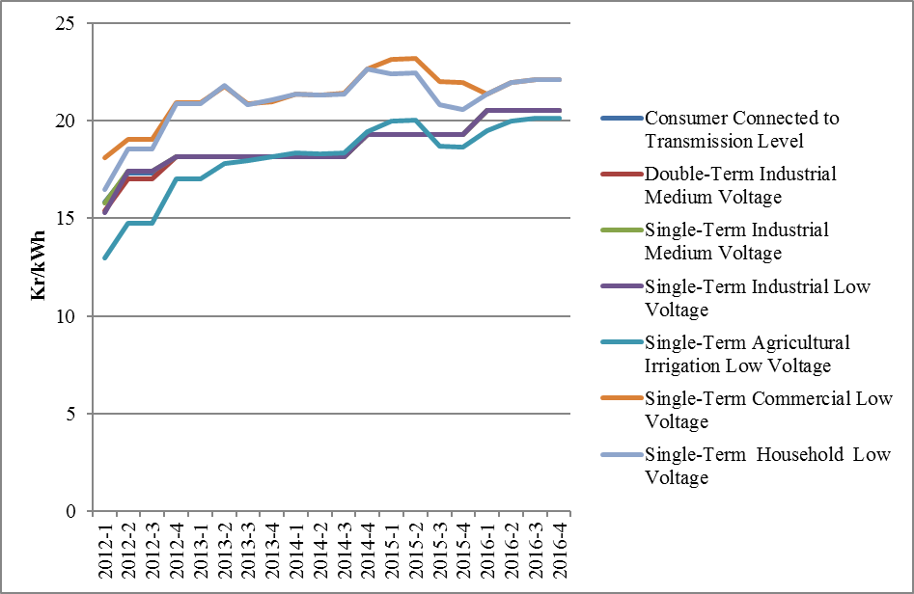

As it is known, it is necessary to use transmission and distribution lines to deliver energy from producer to the consumer. The figure below shows the change in distribution costs by years. Those include distribution, transmission costs and technical and non-technical losses.

Figure 6.2: Change in Network Costs (Distribution, Transmission and Loss) by Years (Kr / kWh)

As a result of the addition of the distribution cost to energy cost, the pre-tax unit energy cost is calculated. The figure below shows the change in unit energy cost by years except for taxes and funds (energy fund, TRT share, electricity and gas consumption tax and VAT).

Figure 6.3: Change in Electricity Tariffs Before Taxes and Funds by Years (kr / kWh)
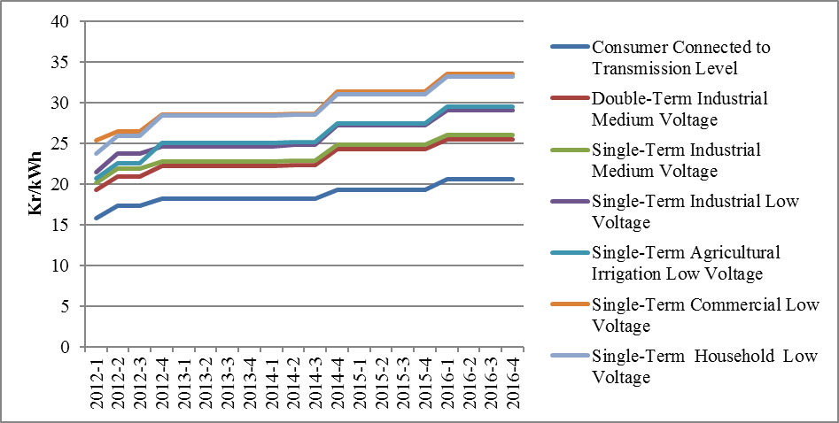

As seen in the figure above, the consumer groups with the highest unit energy costs before taxes and funds were of households and commercials. The lowest unit energy cost before taxes and funds were of the consumers who are connected through the transmission system.

Figure 6.4: Share of Items on Residence Electricity Invoice in 2016 (%)
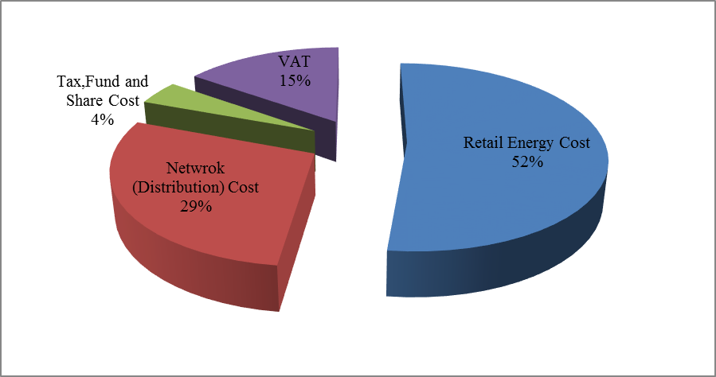
As it can be seen from Figure 6.4, the most important item in the invoices of consumers in the household, excluding the retail energy cost, was the network cost with 29% share.

Figure 6.5: Share of Items on Industry Electricity Invoice in 2016 (%)
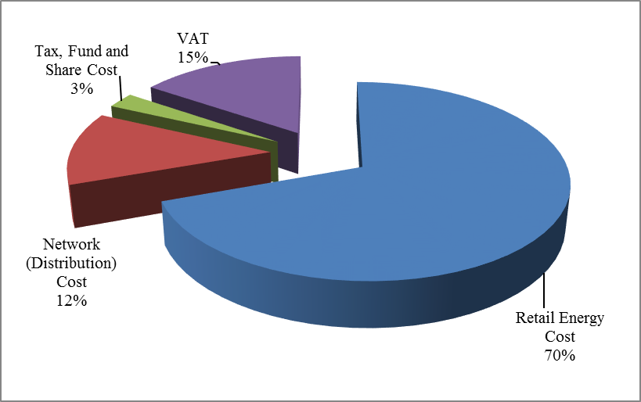

As shown in Figure 6.5, in the invoice components of the consumers in the industrial group compared to the invoice components of the consumers in the households in Figure 6.4; it is seen that the share of retail energy cost was higher and the share of distribution (network) was lower, while VAT, tax, fund and share costs were almost same.

The average feed-in tariffs of RES support mechanism is calculated with using monthly average currency rates that declare by Turkish Republic Central Bank.
The HHI values are evaluated as a competitive market indicator. If HHI is 1000 and below, medium intensity if HHI is between 1000 -1800, and an oligopoly market if HHI is above 1800. In the same way, if the HHI increases by more than 100 points in mergers and acquisitions, it is considered that competitiveness is reduced.
Includes all sales made to eligible and non-eligible consumers for sales volumes of incumbent supply companies.
Including the data about facilities owned by customers.

