

ELECTRICITY MARKET DEVELOPMENT REPORT 2018

All the information, tables and figures provided in this report are reserved and cannot be used without reference.

REPUBLIC OF TURKEY
ENERGY MARKET REGULATORY AUTHORITY

Strategy Development Department

ANKARA, 2019

Important Notice:
- Licensees may revise their own data submitted before, through correction requests. Therefore, there may be some nonconformity between previous reports and present report published.
- In this report Turkish punctuation rules are adopted for numbers.

PRESIDENT’s MeSSAGE

After the period which were striving for a number of regulations and other legislations that were put into effect in the framework of the Electricity Market Law numbered 6446, which entered into force in 2013, a significant process was made in 2018 on the light of these regulations as moving towards a more liberal, competitive, transparent and foreseeable structure on the market.
In recent years the structural arrangements we have made in order to encourage the use of renewable energy sources instead of imported resources in electricity production have continued to show the results. In this context the share of renewable energy source in total electricity generation was 29,50% in 2017, it increased to 32,32% in 2018.
In addition the capacity mechanism to be operated by TEIAS has been established in order to establish and maintain a sufficient and reliable installed power capacity for supply and system security.
Market developments reports, which we submit to our stakeholders by our Institution, are compiled and analyzed from the data submitted to our Agency by using the Energy Market Notification System. It is one of our main objectives to ensure the integrity, consistency and reliability of the data contained in these reports, which are of great importance for accurate and timely sharing with all relevant parties and the public.
Once again, I would like to indicate that as EMRA we are open to all kind of constructive opinion and suggestion and I wish the Electricity Market Development Report of 2018 will be useful to all related parties, institutions and organizations.

Mustafa YILMAZ
President

EXECUTIVE SUMMARY

- Licensed Installed Capacity and Peak Demand

  - Licensed installed capacity in 2018 was 83.187,05 MW increasing by 2,06% compared to previous year.

  - In 2017-2018, licensed installed capacity according to resource type is given below:
Resource Type | 2017  (MW) | Share  (%) | 2018  (MW) | Share  (%) | Change  2017-2018  (%)
NATURAL GAS | 26.311,80 | 32,28 | 25.731,93 | 30,93 | -2,20
HYDRO DAM | 19.746,05 | 24,23 | 20.534,80 | 24,69 | 3,99
LIGNITE | 9.267,12 | 11,37 | 9.597,12 | 11,54 | 3,56
IMPORT COAL | 8.936,35 | 10,96 | 8.938,85 | 10,75 | 0,03
RUN OF RIVER | 7.509,98 | 9,21 | 7.748,90 | 9,32 | 3,18
WIND | 6.482,12 | 7,95 | 6.942,27 | 8,35 | 7,10
GEOTHERMAL | 1.063,73 | 1,31 | 1.282,52 | 1,54 | 20,57
FUEL OIL | 702,77 | 0,86 | 709,21 | 0,85 | 0,92
HARD COAL | 616,15 | 0,76 | 616,15 | 0,74 | 0,00
BIOMASS | 439,72 | 0,54 | 590,92 | 0,71 | 34,39
ASPHALTITE COAL | 405,00 | 0,50 | 405,00 | 0,49 | 0,00
SOLAR | 17,90 | 0,02 | 81,66 | 0,10 | 356,19
NAPHTA | 4,74 | 0,01 | 4,74 | 0,01 | 0,00
LNG | 1,95 | 0,00 | 1,95 | 0,00 | 0,00
DIESEL | 1,04 | 0,00 | 1,04 | 0,00 | 0,00
Total | 81.506,42 | 100,00 | 83.187,05 | 100,00 | 2,06

- While the share of renewable energy sources (including hydraulics) in total installed power in 2017 was 43,26%, it increased to 44,70% in 2018. While the ratio of total installed thermal power was 56.74% in 2017, it decreased to 55.30% in 2018.

- Peak demand reached to 46,159,55 MW decreasing by 3,15%.

- Licensed Electricity Generation and Consumption

  - Licensed electricity generation reached to 295.442,15 GWh in 2018, increasing by 0,97% compared to 2017.

  - In 2017-2018, licensed electricity generation according to resource type is given below:

Resource Type | 2017  (GWh) | Share (%) | 2018  (GWh) | Share (%) | 2017-2018  (%)
NATURAL GAS | 108.837,19 | 37,20 | 91.227,14 | 30,88 | -16,18
IMPORT COAL | 51.172,22 | 17,49 | 62.949,64 | 21,31 | 23,02
HYDRO GAM | 41.269,59 | 14,10 | 40.961,45 | 13,86 | -0,75
LIGNITE | 40.581,02 | 13,87 | 45.055,29 | 15,25 | 11,03
WIND | 17.859,86 | 6,10 | 19.891,37 | 6,73 | 11,37
RUN OF RIVER | 17.124,40 | 5,85 | 18.975,98 | 6,42 | 10,81
GEOTHERMAL | 5.969,48 | 2,04 | 7.611,58 | 2,58 | 27,51
HARD COAL | 3.453,87 | 1,18 | 3.005,55 | 1,02 | -12,98
ASPHALITE COAL | 2.394,64 | 0,82 | 2.328,50 | 0,79 | -2,76
BIOMASS | 1.939,72 | 0,66 | 2.410,00 | 0,82 | 24,24
DIESEL | 1.008,83 | 0,34 | 0,98 | 0,00 | -99,90
FUEL OİL | 957,86 | 0,33 | 957,98 | 0,32 | 0,01
SOLAR | 24,56 | 0,01 | 65,56 | 0,02 | 166,97
LNG | 2,20 | 0,00 | 1,12 | 0,00 | -48,83
Total | 292.595,42 | 100,00 | 295.442,15 | 100,00 | 0,97

  - The share of renewable energy sources (including hydraulic) within the licensed electricity generation was 30,43% in 2018, while it was 28,77% in 2017. The ratio of total thermal installed capacity was 69,57% in 2018, while it was 71,23% in 2017.

  - The amount of consumption reached to 302.772,30 GWh in 2018 which increased by 3,69% compared to 2017.

- Unlicensed Generation

  - In 2018, unlicensed installed capacity reached to 5.310,57 MW increasing by 67,35 % compared to previous year. 94,47% of this amount was obtained from solar (photovoltaic) energy.

  - In 2017-2018, unlicensed installed capacity according to resource type is given below:

Resource Type | 2017 |  | 2018
Resource Type | Installed Capacity  (MWe) | Share  (%) | Installed Capacity  (MWe) | Share  (%)
Solar (Photovoltaic) | 2.978,84 | 93,87 | 5.016,99 | 94,47
Natural Gas | 85,88 | 2,71 | 153,04 | 2,88
Biomass | 66,72 | 2,10 | 79,18 | 1,49
Wind | 32,20 | 1,01 | 51,95 | 0,98
Hydraulic | 8,69 | 0,27 | 8,91 | 0,17
Solar (Concentrated) | 1,00 | 0,03 | 0,50 | 0,01
Total | 3.173,32 | 100,00 | 5.310,57 | 100,00

  - In 2018, amount of unlicensed generation reached to 8.212,41 GWh increasing by 170,92 % compared to previous year. 95,71% of this amount was obtained from solar (photovoltaic) energy.

  - In 2017-2018, unlicensed generation according to resource type is given below:

Resource Type | 2017 |  | 2018
Resource Type | The amount of energy given to the system as surplus (MWh) | Share  (%) | The amount of energy given to the system as surplus (MWh) | Share  (%)
Solar | 2.836.173,49 | 93,56 | 7.859.766,42 | 95,71
Biomass | 138.657,08 | 4,57 | 205.901,95 | 2,51
Wind | 36.954,64 | 1,22 | 111.990,43 | 1,36
Hydraulic | 19.546,21 | 0,64 | 34.750,58 | 0,42
Total | 3.031.331,42 | 100,00 | 8.212.409,37 | 100,00

- Invoiced Consumption

Consumer Type | Consumption Amount of Consumers Connected to the Distribution Voltage Level (MWh) |  | Consumption Amount of Consumers Connected to Transmission Voltage Level (MWh) |  | Total (MWh)
 | 2017 | 2018 | 2017 | 2018 | 2017 | 2018
Non-eligible Consumer | 80.768.336,36 | 147.685.452,79 | 19.685.372,29 | 16.747.847,16 | 100.453.708,65 | 164.433.299,95
Eligible Consumer | 90.762.663,09 | 30.225.373,40 | 34.497.156,39 | 38.951.356,19 | 125.259.819,48 | 69.176.729,59
Grand Total | 171.530.999,45 | 177.910.826,19 | 54.182.528,68 | 55.699.203,35 | 225.713.528,13 | 233.610.029,54

  - In 2018, invoiced electricity consumption reached to 233,61 TWh increasing by 3,49 % compared to previous year. 55,7 TWh of this amount was sold to consumers connected to the transmission voltage level and the remaining 177,91 TWh was sold to consumers connected to the distribution voltage level.

  - In addition, 69,18 TWh of 233,61 TWh was consumed by eligible consumers, while the rest 164,43 TWh was consumed by non-eligible consumers.

- Imports and Exports

  - In 2018, electricity imports decreased by 9,64% to 2,47 TWh compared to previous year.

  - Electricity exports decreased by 6,86% to 3,07 TWh compared to previous year.

- Day-Ahead Market and Balancing Market

  - In 2018, the Weighted Average Market Clearing Price (MCP) increased by 38,65% to 233,101 TL/MWh compared to previous year.

  - The highest MCP value was 375,79 TL/MWh (16:00 on 4 September 2018), while the lowest MCP value was 0 TL/MWh with the date of 17 March 2018.

  - In 2018, the Average System Marginal Price (SMP) increased by 42,27% to 234,436 TL/MWh compared to 2017.

  - The highest SMP was 402,2 TL/MWh (17:00 on 3 September 2018) while the lowest SMP value 0 TL/MWh for seven hours.

  - In 2018, the additional cost incurred by the Balancing Power Market decreased by 86,5% compared to 2017 and amounted to TL 119,67 million.

- RESSUM

  - In 2018, the number of licensed participants benefiting from the Renewable Energy Resources Support Mechanism reached to 708. The installed capacity of these participants was 19.266 MW.

  - In 2018, the electricity generation of RESSUM participants increasing by 23,09 % to 62,61 TWh compared to 2017. 43,67% of this amount was obtained from hydraulic, 30,35% from wind.

  - In 2018, the average price of RESSUM reached to 351,1 TL/MWh increased by 27,83% compared to previous year.

  - In 2018, an additional cost of RESSUM which means additional cost to the weighted average MCP for RESSUM per invoiced unit energy amount, increased by 33,18% to 31,75 TL/ MWh compared to previous year.

- Market Openness

  - In 2018, the eligible consumer limit was set at 2.000 kWh and the theoretical market openness rate for demand side was calculated as 92,6%.

  - Eligible consumers’ consumption in 2018 was 69,18 TWh. In 2017, actual market openness was 55,5% while this proportion decreased to 29,6% in 2018.

  - At the end of 2018, the number of eligible consumers decreased by 96.8% to 146 thousand compared to the end of 2017. This number corresponds to 0.34% of the total number of consumers.

- Transmission

- By the end of 2018, there were 1.161 transformer centers in the transmission system and 2.265 transformers with 205.953 MVA capacity.

- By the end of 2018, the length of transmission lines was 68.204 km.

- In 2018, total investment of the transmission company was 2,92 billion TL.

- In 2018, the transmission loss rate was 1,92 %.

- Distribution

  - By the end of 2018, the number of consumers using the distribution system was 43,65 million. The regions with the highest number of consumers were the Boğaziçi with 5.03 million and the Başkent with 4.2 million.

  - By the end of 2018, the total invoiced consumption in the distribution regions was realized as 177,91 TWh. The regions with the highest consumption amounts were the Boğaziçi with 25,96 TWh and the Toroslar with 15,33 TWh.

  - The highest loss rates were seen in Dicle with 54,94 %, Vangölü with 49,16 % and Aras with 23,55 %.

  - The lowest loss rates were seen in the distribution regions of Uludağ with 4,2 %, Trakya with 4,37% and ADM with 5,53%.

  - By the end of 2018, 54.756 people were employed in the electricity distribution sector. Of those, 22.387 were employed as permanent staff in distribution companies and 32.369 were employed as subcontractor company personnel.

- By the end of 2018, there were 468.755 transformers in the distribution system with 162.367 MVA power.

- By the end of 2018, the length of distribution lines was 1.164.170 km long. 954.411 km of this figure is overhead lines and 209.759 km is underground lines.

- In 2018, the distribution companies invested 4,91 billion TL in current prices. The highest investment expenditure was realized in the regions of Toroslar with 737,8 million TL and the Başkent with 621,1 million TL.

ELECTRICITY MARKET OVERVIEW IN 2018
Parameters | Unit | 2017 | 2018 | Change (%)
Licensed Installed Capacity | MWe | 81.506,42 | 83.187,05 | 2,06
Licensed Generation* | GWh | 292.595,42 | 295.442,15 | 0,97
Highest Peak Demand | MW | 47.660 | 46.160 | 6,54
Lowest Peak Demand | MW | 18.336 | 18.212 | 5,09
Unlicensed Generation** | GWh | 3.031,33 | 8.212,41 | 170,92
Unlicesed Installed Capacity | MWe | 3.173,32 | 5.310,57 | 67,35
RESSUM Generation*** | MWh | 50.530.776 | 62.608.517 | 23,9
RESSUM Amount of Payment | TL | 13.869.601.064,94 | 21.979.237.357 | 58,47
Average RESSUM Price | TL/MWh | 274,66 | 351,1 | 27,83
RESSUM Additional Cost**** | TL/MWh | 23,84 | 31,75 | 33,18
Actual Consumption | GWh | 292.003,54 | 302.772,30 | 3,69
Invoice-Based Consumption | MWh | 225.713.528,13 | 233.610.029,54 | 3,50
Number of Consumer | Adet | 42.383.150 | 43.653.910 | 3,00
Import | GWh | 2.729,06 | 2.466,01 | -9,64
Export | GWh | 3.300,10 | 3.073,60 | -6,86
Weighted Average MCP | TL/MWh | 168,12 | 233,101 | 38,65
Weighted Average SMP | TL/MWh | 164,78 | 234,436 | 42,27

*Licensed Generation: Includes the installed capacity and generation values of Independent Generation Companies, Build-Operate, Transfer of Operating Rights and Build-Operate-Transfer Power Plants.

**Unlicensed Generation: Generation in accordance with Article 14 of the Electricity Market Law No. 6446, that is granted to the system as a surplus by those who are exempted from the obligation to obtain license and a company.

*** RESSUM generation includes unlicensed generation values.

**** RESSUM additional cost: Additional cost to the weighted average MCP for RESSUM per invoiced unit energy amount

Table of Contents
1. LICENSED GENERATION AND INSTALLED CAPACITY, UNLICENSED GENERATION, CONSUMPTION, IMPORT AND EXPORT 17
1.1 Overview 17
1.2 Licensed Generation 18
1.3 Licensed Installed Capacity 26
1.3.1 Capacity Mechanism 32
1.4 Unlicensed Generation 33
1.5 Invoiced Electricity Consumption 44
1.6 Import and Export 56
1.6.1 Import 56
1.6.2 Export 56
2. WHOLESALE MARKET 57
2.1 Day-Ahead Market 58
2.2 Balancing Power Market 64
2.3 Intra-Day Market 70
2.4 Bilateral Agreements 72
2.5 RESSUM 74
3. COMPETITION 80
3.1 Supply Side 80
3.2 Demand Side 84
4. TRANSMISSION 88
4.1 Transmission System 88
4.2 Transmission System Connection Applications 90
4.3 Tariffs 90
4.4 Amount of Investment 92
4.5 Losses 92
5. DISTRIBUTION 93
5.1 Number of Consumers 93
5.2 Ratio of Losses 95
5.3 Employment 97
5.4 Information about Network 99
5.5 Quality Indicators 105
5.6 Investment Amount of Distribution Companies 108
5.7 Information about Organized Industrial Zones (OIZ) 110
6. PRICING 111

List of Tables
Table 1.1: Licensed and Unlicensed Installed Capacity, Peak Demand, Licensed and Unlicensed Electricity Generation, Consumption, Import and Export Data 16
Table 1.2: Distribution of Licensed Electricty Generation by Provinces (MWh-%) 24
Table 1.3 Distribution of Licensed Installed Power by Province (MW-%) 29
Table 1.4: The Status of Unlicensed Electricity Generation Applications by the End of 2018 (MW) 34
Table 1.5: Distribution of Unlicensed Installed Capacity by Sources (MW-%) 35
Table 1.6: Distribution of Unlicensed Installed Capacity by Province (MW- %) 37
Table 1.7: Distribution of Unlicensed Electricity Generation by Sources (MWh-%) 40
Table 1.8: Distribution of Unlicensed Electricity Generation by Provinces (MWh-%) 41
Table 1.9: Distribution of the Amount of Payment Made Within the Scope of Unlicensed Electricity Generation by Sources (TL-%) 44
Table 1.10: Sales to Eligible and Non-Eligible Consumers in 2018 (MWh) 45
Table 1.11: Distribution of Invoiced Consumption by Distribution Regions in 2018 (MWh-%) 46
Table 1.12: Distribution of Invoiced Consumption by Consumer Type as Eligible and Non-Eligible Consumers in 2018 (MWh) 47
Table 1.13: Development of Invoiced Consumption by Consumer Type by Years (MWh) 48
Table 1.14: Distribution of Invoiced Consumption by Province (MWh - %) 49
Table 1.15: Distribution of Invoiced Consumption by Province and Consumer Type (MWh) 52
Table.2.2.1: Additional Costs of Orders (Million TL) 68
Table 2.5.1: Number of RESUM Participants by Years 75
Table 2.5.2: Installed Capacity of the RESUM Participants by Years *(MW) 75
Table 2.5.3: Yearly Generation of RESUM Participants by years (MWh)* 76
Table 3.1: HHI Values by Generation and Capacity 81
Table 3.2: Sales, Market Shares and HHI Values of Supply License Owners 82
Table 3.3: The Distribution of Eligible Consumers’ Switches by Supplier Type 88
Table 4.1: Transformer Center Information 89
Table 4.2: TEİAŞ Transmission Lines 89
Table 4.3: Connection Applications to the Transmission System (Number-MW) 91
Table 4.4: System Usage and System Operation Tariffs (TL/MW-Year) 92
Table 4.5: Comparison of 2017 and 2018 Investment Amount (TL-%) 93
Table 5.1: Number of Consumers Using Distribution System by the end of 2018 (Number-%) 95
Table 5.2: Loss Rates of Distribution Companies (%) 97
Table 5.3: Number of Employees of Distribution Companies (Number) 99
Table 5.4: Line Lengths, Number of Transformers and Transformer Capacities Based on Distribution Companies by end of 2018 (Km-MVA-Number) 101
Table 5.5: The Lengths of Distribution Lines (Km) 102
Table 5.6: Line Lengths at Distribution Voltage Levels, Number of Transformers and Transformer Capacities by Provinces in 2018 (Km-MVA-Number) 104
Table 5.7: Reported and Unreported Customer Average Interruption Duration Indices of Distribution Companies in 2018 (min) 106
Table 5.8: Customer Average Interruption Duration Indices of Distribution Companies by reason in 2018 (min) 107
Table 5.9: Customer Average Interruption Frequency Indices of Distribution Companies in 2017 and 2018 (Number/Year) 108
Table 5.10: Distribution Companies’ Customer Average Interruption Frequency Indices of Distribution Companies by Reason in 2018 (Number/Year) 109
Table 5.11: List of Distribution Investments Comparison in 2017-2018 (TL-%) 110
Table 5.12: Investment Amounts of Distribution Companies in 2018 (Current Prices-million TL) 111
Table 5.13 Information about Organized Industrial Zones 112

List of Figure
Figure1.1: Electric Energy Demand and Rate of Increase by Years (GWh-%) 18
Figure 1.2: Peak Demand and Rate of Increase by Years (MW-%) 19
Figure 1.3: Rate of Increase of Demand and Peak Demand by Year (%) 19
Figure 1.4: Monthly Distribution of Licensed Electricity Generation and Consumption in 2018 (GWh) 20
Figure 1.5: Distribution of Licensed Electricity Generation in 2018 by Corporations (%) 21
Figure 1.6: The Change of Licensed Electricity Generation as Public-Private by Years (%) 21
Figure 1.7: The Distribution of Licensed Electricity Generation by Sources in 2018 (%) 22
Figure 1.8: Source-Based Development of Licensed Electricity Generation by Years (GWh) 23
Figure 1.9: Daily Licensed Electricity Generation in 2018 (MWh) 23
Figure 1.10: Hour-Based Electricity Generation in 2018 (MWh) 24
Figure 1.11: The Share of First 10 Companies within Electricity Generation in 2018 (%) 26
Figure 1.12: Distribution of Licensed Installed Capacity by Sources at the End of 2018 (%) 27
Figure 1.13: Distribution of Licensed Installed Capacity by Organizations at the End of 2018 (%) 28
Figure 1.14: The Development of Licensed Installed Capacity According to Source by Years (MW) 28
Figure 1.15: The Development of the Share of the Sources within the Installed Capacity by Years (%) 29
Figure 1.16: The Share of the First 10 Companies in Installed Capacity at the End of 2018 (%) 31
Figure 1.17: Distribution of Unlicensed Installed Capacity by Sources at the End of 2018 (%) 35
Figure 1.18: Distribution of Unlicensed Electricity Generation by Sources in 2018 (%) 40
Figure 1.19: Distribution of Invoiced Consumption by Consumer Type in 2018 (%) 47
Figure 1.20: Distribution of Invoiced Consumption by Months (MWh) 55
Figure 1.21: Development of Gross Consumption by Years (GWh) 55
Figure 1.22: Electricity Imports in 2018 by Months (MWh) 56
Figure 1.23: Electricity Exports in 2018 by Months (MWh) 57
Figure.2.1.1: Hourly Development of Weighted Average Market Clearing Price in 2018 (TL/MWh) 59
Figure 2.1.2: Organized Weighted Average MCP in 2018 (TL/MWh) 60
Figure 2.1.3: Weighted Average MCP by Years (TL/MWh) 60
Figure 2.1.4: Monthly Weighted Average MCP of the Last Two Years (TL/MWh) 61
Figure 2.1.5: Monthly Day-Ahead Market Trading Volume (MWh) 62
Figure 2.1.6: The Share of Top 10 Buyer Companies in Day-Ahead Market (%) 62
Figure 2.1.7: The Share of Top 10 Seller Companies in Balancing Power Market (%) 63
Figure.2.2.1: Per-Hour Based Development of System Marginal Price (TL/MWh) 64
Figure 2.2.2: Organized Sytem Marginal Price (TL/MWh) 64
Figure 2.2.3: Monthly Weighted Average Prices of the Last Two Years in Balancing Power Market (TL/MWh) 65
Figure 2.2.4: Monthly Trading Volumes in Balancing Power Market (MWh) 66
Figure 2.2.5: The Share of Top 10 Buyer Companies in Balancing Power Market (%) 66
Figure 2.2.6: The Share of Top 10 Seller Companies in Balancing Power Market 67
Figure 2.2.7: Rates of Order Volumes Given in Balancing Power Market in 2018 (%) 67
Figure 2.2.8: Distribution of the Orders Given in the Balancing Power Market by Hours in 2018 (MW) 68
Figure 2.2.9: Development of Additional Costs of Orders by Months in 2018 (Million TL) 69
Figure 2.2.10: Development of Zero Balance Adjustment Component by Years (TL) 69
Figure 2.3.1: Monthly Development of Trading Volume and Average Price in the Intra-Day Market (MWh - TL / MWh) 70
Figure 2.3.2: Distribution of Purchases of Intra-Day Market by Companies and the Share of Top 10 Companies (%) 71
Figure 2.3.3: Distribution of Sales in Intra-Day Market by Companies and the Share of Top 10 Companies (%) 71
Figure 2.4.1: Monthly Bilateral Agreement Volume by Years (MWh) 72
Figure 2.4.2: Distribution of Purchases of Bilateral Agreement by Companies and the Share of Top 10 Companies (%) 73
Figure 2.4.3: Distribution of Sales with Bilateral Agreement by Companies and the Share of Top 10 Companies (%) 73
Figure 2.4.4: TETAŞ Wholesale Prices Between 2011-2018 (kr / kWh) 74
Figure 2.5.1: Distribution of Installed Capacity by Sources in 2018 (%) 76
Figure 2.5.2: Distribution of Generation in RESSUM by Sources in 2018 77
Figure 2.5.3: Monthly Development of RESSUM Generation in 2018 (MWh) 77
Figure 2.5.4: Monthly Development of RESSUM Feed-in Tariffs and MCP in 2018 (MWh) 78
Figure 2.5.5: Average of RESSUM and MCP in 2018 (Kr./kWh) 78
Figure 2.5.6: Monthly Payments Made within the Scope of the RESSUM in 2018 (TL) 78
Figure 2.5.7 Monthly Improvement of Average RESSUM Additional Cost in 2018 (TL/MWh) 79
Figure 3.1: Eligible Consumer Limit and Market Openness Ratio by Years (kWh-%) 85
Figure 3.2: Number of Eligible Consumer by Months in 2018 (Number) 85
Figure 3.3: Distribution of Eligible Consumers by Distribution Regions by end of 2018 86
Figure 3.4: Distribution of Eligible Consumer Consumption by Suppliers Type (%) 87
Figure 3.5: Monthly Changes in Number and Consumptions of Eligible Consumers Switching Their Supplier (Number-MWh) 87
Figure 4.1: Changes in TEİAŞ Transmission Line Lengths by Years (km) 89
Figure 4.2: System Usage and System Operation Tariffs (TL/MW-Year) 92
Figure 4.3: Transmission System Losses (GWh-%) 93
Figure 4.4: Transmission System Losses by Hour (%) 93
Figure 5.1: Number and Consumption of Consumers (Number- MWh) 95
Figure 5.2: Real and Target Loss Rates in 2018 (%) 97
Figure 5.3: Number of Employees of Distribution Companies by Year 2018 99
Figure 5.4: Line Lengths and Transformer Capacities on the Basis of 101
Distribution Companies at the end of 2018 (Km-MVA) 101
Figure 5.5: The Length of Lines on the Basis of Distribution Companies at the end of 2018(Km) 102
Figure 5.6 Investment Amounts of Dıstribution Companies in 2018(Current Prices-TL) 110
Figure 6.1: Change in Retail Electric Energy Prices in the Last Five Years (Kr/kWh) 112
Figure 6.2: Change in Network Costs (Distribution, Transmission and Loss) by Years (Kr / kWh) 112
Figure 6.3: Change in Electricity Tariffs before Taxes and Funds by Years (kr / kWh) 113
Figure 6.4: Share of Items on Residence Electricity Invoice in 2018 (%) 113
Figure 6.5: Share of Items on Industry Electricity Invoice in 2018 (%) 114

ABBREVIATIONS

BPM : Balancing Power Market
EMRA : Energy Market Regulatory Authority
EXIST : Energy Exchange Istanbul
EÜAŞ : Electricity Generation Company
IDM : Intra-Day Market
DAM : Day-Ahead Market
MCP : Market Clearing Price (Day-Ahead Price)
MFSC : Market Financial Settlement Center
SMP : System Marginal Price (Real Time Price)
BO : Build Operate
BOT : Build Operate Transfer
TOR : Transfer of Operating Rights
TEİAŞ : Turkish Electricity Transmission Company
TETAŞ : Turkish Electricity Trading and Contracting Company
RESSUM : Renewable Energy Sources Support Mechanism

1. LICENSED GENERATION AND INSTALLED CAPACITY, UNLICENSED GENERATION, CONSUMPTION, IMPORT AND EXPORT

This section shall examine, licensed electricity generation and installed capacity, unlicensed electricity generation, consumption, export and import data for the year 2018. In addition, interpretations and comparisons shall be expressed according to the previous years.

1.1 Overview

Table 1.1 shows licensed and unlicensed installed capacity, peak demand, licensed and unlicensed electricity generation, consumption, import and export data by the end of 2018, combined with previous years’ data.

Table 1.1: Licensed and Unlicensed Installed Capacity, Peak Demand, Licensed and Unlicensed Electricity Generation, Consumption, Import and Export Data
 | Unit | 2015 | 2016 | 2017 | Change (%) 2016→2017 | 2018 | Change (%) 2017→2018
Licensed Installed Capacity | MW | 73.146,90 | 77.563,44 | 81.506,42 | 5,08 | 83.187,05 | 2,06
Unlicensed Installed Capacity | MW | 359,04 | 1.048,21 | 3.173,32 | 202,74 | 5.310,57 | 67,35
Peak Demand | MW | 43.289,00 | 44.733,98 | 47.659,65 | 6,54 | 46.159,55 | -3,15
Licensed Generation | GWh | 261.783,30 | 272.563,63 | 292.595,42 | 7,35 | 295.442,15 | 0,97
Unlicensed Generation | GWh | 222,72 | 1.137,87 | 3.031,33 | 166,40 | 8.212,41 | 170,92
Consumption | GWh | 265.724,40 | 277.522,01 | 292.003,54 | 5,22 | 302.772,30 | 3,69
Import | GWh | 7.411,10 | 6.400,13 | 2.729,06 | -57,36 | 2.466,01 | -9,64
Export | GWh | 2.964,60 | 1.442,08 | 3.300,10 | 128,84 | 3.073,60 | -6,86

As can be seen from the Table, consumption, licensed generation and licensed installed capacity in 2018 increased by 3,69 %, 0,97 % and 2,06% respectively and peak demand decreased by 3,15 % compared to 2017. Unlicensed installed capacity and electricity generation had been growing rapidly by %67,35 and %170,92 sequentially.
Compared to the previous year, imports decreased 9,64 % which ended up as 2,47 TWh. On the other hand, exports ended up as 3,07 TWh by decreasing 6,86 %. The ratio between exports and imports was 120,92 % in 2017 whereas in 2018 it increased to 124,64%.

1.2 Licensed Generation
Figure 1.1 shows the electricity demand and rate of its increase by years. As seen in the figure, demand for electric energy had increased steadily since 2009, with a decrease especially in the rate of increase from 2011 to 2013. In 2018, electrical energy demand increased by 3.69% compared to the previous year.

Figure1.1: Electric Energy Demand and Rate of Increase by Years (GWh-%)
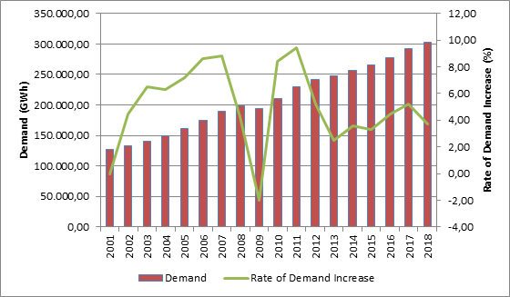

The development of peak demand and its rate of increase are provided in Figure 1.2. The change of peak demand is generally seen as it is in energy demand Figure 1.1, but it is more variable. In 2018, peak demand decreased by 3.15% compared to the previous year.

Figure 1.2: Peak Demand and Rate of Increase by Years (MW-%)
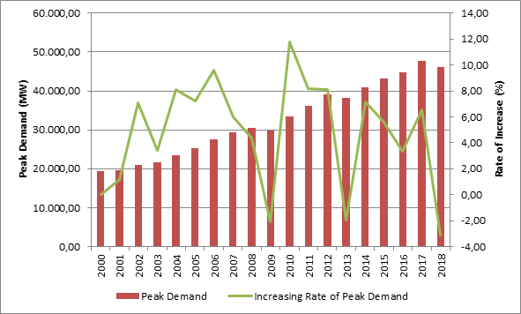

In Figure 1.3, peak demand and its relations with electric energy demand are given. The rate of increase/decrease of electric energy demand and peak demand were happened to be close to each other.

Figure 1.3: Rate of Increase of Demand and Peak Demand by Year (%)
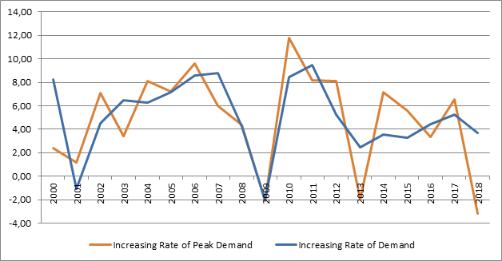
In Figure 1.4, monthly changes of licensed electricity generation and electric consumption are represented. The highest points of generation and consumption were achieved in July.

Figure 1.4: Monthly Distribution of Licensed Electricity Generation and Consumption in 2018 (GWh)
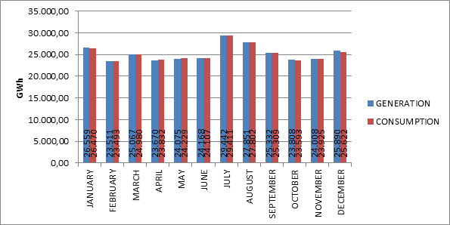

The distribution of licensed electricity generation to companies in 2018 is shown in Figure 1.5. The biggest share in generation belongs to independent power producers with 68,23 %. The share of the power plants of EÜAŞ was 15,49 % and the power plants that were operated under the existing contracts had the share of 16,28 % in the total generation.
Figure 1.5: Distribution of Licensed Electricity Generation in 2018 by Corporations (%)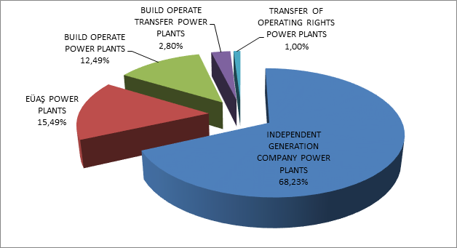

The distribution of licensed electricity generation under private, public and existing contracts are given in Figure 1.6. In 2017 the share of public in generation (including existing contracts) was 34.32%, whereas in 2018 it decreased to 31.77 %. Similarly, in 2017 the share of independent generation was 65.68 % which in 2018 increased to 68.23 %.

Figure 1.6: The Change of Licensed Electricity Generation as Public-Private by Years (%)
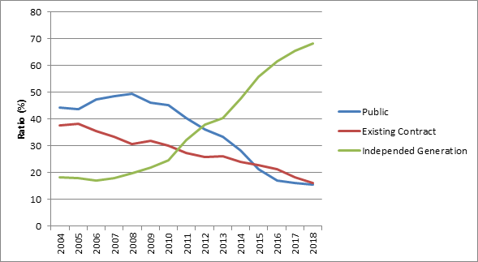

Figure 1.6 reflects the fact that the share of independent generation was still increasing. There are two reasons behind this increment. Firstly, most of the new investments were done by independent power producers. Secondly, due to privatization, the ownership of the existing public power plants was going under private sector.
The distribution of licensed electricity generation by resources is shown in Figure 1.7.While the share of natural gas-fired power plants in licensed electricity generation was 37,18%,it decreased to 30.88% in 2018. On the other hand, while the share of hydroelectric power plants was 19.96% in 2017, it has been 20, 28. While the share of wind power plants was 6.10%, it has been 6.73%, while the share of geothermal power plants was 2.04%, it has been 2.58%,. while the share of domestic coal (lignite, coal and asphaltite) plants was 15,86%, it has been 17,06%, while the share of imported coal plants was 17,49%, it increased to 21,31%.

Figure 1.7: The Distribution of Licensed Electricity Generation by Sources in 2018 (%)

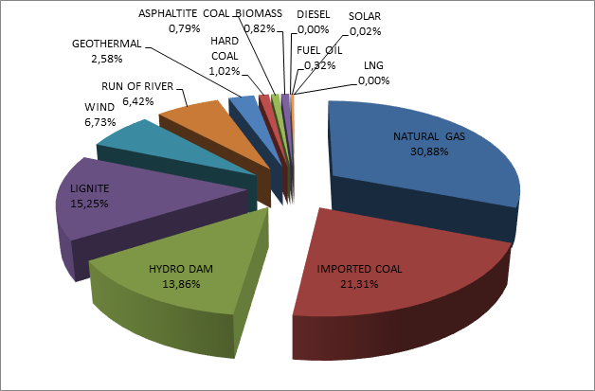

The development of licensed electricity generation on the basis of resources since 1990 is shown in Figure 1.8. As can be seen from the figure, the share in electricity generation of resources like geothermal, wind, solar and biomass had increased every year.

Figure 1.8: Source-Based Development of Licensed Electricity Generation by Years (GWh)

Day-based development of licensed electricity generation in Turkey is shown in Figure 1.9. Licensed electricity generation was at its highest point in August and lowest in June. Considering day-based chart, the highest electricity generation occurred on 2 August 2018, lowest on 16 June 2018.

Figure 1.9: Daily Licensed Electricity Generation in 2018 (MWh)
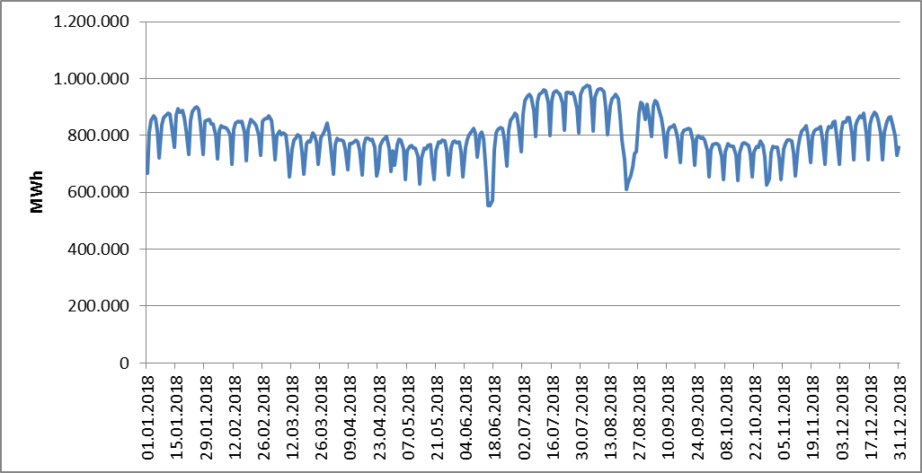

Hour-based licensed electricity generation in Turkey is shown at Figure 1.10. The highest generation was at 19:00 o’clock and the lowest was at 05:00 o’clock.

Figure 1.10: Hour-Based Electricity Generation in 2018 (MWh)
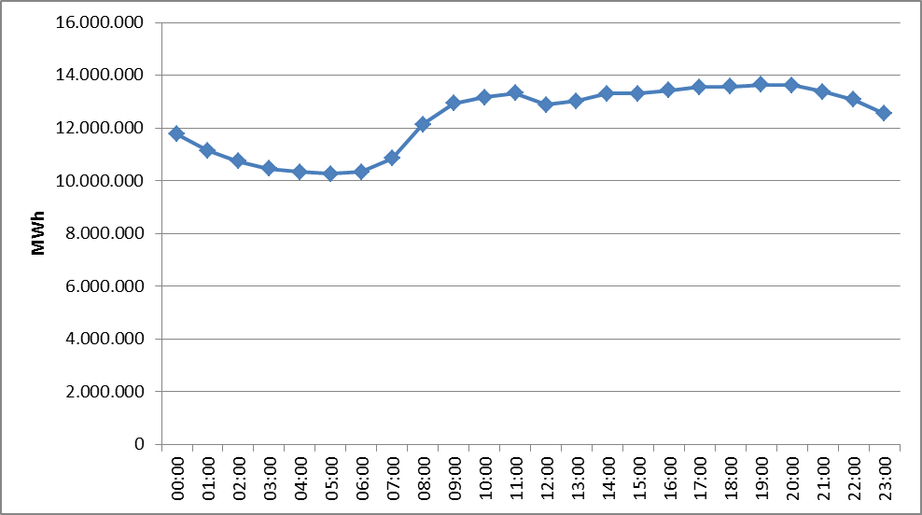
The distribution of licensed electricity generation by provinces is given in Table 1.2. The highest electricity generation in 2018 was in Çanakkale, Zonguldak, İzmir, Adana, Hatay and Sakarya provinces, the lowest was in Ağrı, Yozgat, Niğde, Mardin and Bartın provinces respectively.

Table 1.2: Distribution of Licensed Electricty Generation by Provinces (MWh-%)
PROVINCE | Generation (MWh) | Share (%) | PROVINCE | Generation (MWh) | Share (%)
ÇANAKKALE | 26.310.222,71 | 8,91 | RİZE | 1.057.145,32 | 0,36
ZONGULDAK | 19.568.880,74 | 6,62 | ERZİNCAN | 883.307,01 | 0,30
İZMİR | 18.306.204,58 | 6,20 | ESKİŞEHİR | 769.799,68 | 0,26
ADANA | 18.134.222,89 | 6,14 | SİİRT | 763.380,90 | 0,26
HATAY | 14.963.201,68 | 5,06 | GAZİANTEP | 721.285,99 | 0,24
SAKARYA | 14.277.593,26 | 4,83 | AFYONKARAHİSAR | 677.202,51 | 0,23
MUĞLA | 11.459.060,59 | 3,88 | AMASYA | 668.596,49 | 0,23
ANKARA | 11.377.492,65 | 3,85 | YALOVA | 652.008,37 | 0,22
BALIKESİR | 10.819.862,08 | 3,66 | KARABÜK | 624.396,84 | 0,21
MANİSA | 9.081.420,87 | 3,07 | ADIYAMAN | 580.267,71 | 0,20
KAHRAMANMARAŞ | 8.760.201,26 | 2,97 | ISPARTA | 550.446,67 | 0,19
BURSA | 8.640.282,37 | 2,92 | ÇORUM | 550.395,25 | 0,19
İSTANBUL | 8.411.190,21 | 2,85 | KIRŞEHİR | 533.400,85 | 0,18
KIRIKKALE | 7.617.501,60 | 2,58 | EDİRNE | 532.846,73 | 0,18
SAMSUN | 6.968.643,88 | 2,36 | ARDAHAN | 510.899,03 | 0,17
KÜTAHYA | 6.767.896,44 | 2,29 | SİNOP | 490.054,44 | 0,17
KIRKLARELİ | 6.617.658,69 | 2,24 | MUŞ | 451.217,08 | 0,15
KOCAELİ | 6.032.348,67 | 2,04 | KARS | 369.630,55 | 0,13
ARTVİN | 5.763.737,33 | 1,95 | TUNCELİ | 332.675,19 | 0,11
DENİZLİ | 5.607.379,65 | 1,90 | KONYA | 268.607,59 | 0,09
AYDIN | 5.454.038,33 | 1,85 | DÜZCE | 265.019,24 | 0,09
ELAZIĞ | 5.453.218,41 | 1,85 | NEVŞEHİR | 193.152,10 | 0,07
ŞANLIURFA | 5.389.108,60 | 1,82 | VAN | 170.891,44 | 0,06
DİYARBAKIR | 4.689.420,84 | 1,59 | BİLECİK | 159.052,92 | 0,05
ANTALYA | 4.560.242,68 | 1,54 | MALATYA | 153.682,26 | 0,05
SİVAS | 3.953.887,62 | 1,34 | BURDUR | 151.091,64 | 0,05
MERSİN | 3.335.544,76 | 1,13 | KASTAMONU | 149.490,93 | 0,05
TEKİRDAĞ | 2.830.882,19 | 0,96 | BATMAN | 140.073,76 | 0,05
OSMANİYE | 2.591.669,07 | 0,88 | HAKKARİ | 127.859,05 | 0,04
ŞIRNAK | 2.331.294,78 | 0,79 | UŞAK | 119.022,47 | 0,04
BOLU | 2.305.716,93 | 0,78 | ÇANKIRI | 110.930,05 | 0,04
GİRESUN | 2.129.058,80 | 0,72 | BAYBURT | 96.574,07 | 0,03
GÜMÜŞHANE | 1.539.218,00 | 0,52 | BİTLİS | 65.992,25 | 0,02
TOKAT | 1.522.663,69 | 0,52 | IĞDIR | 58.829,25 | 0,02
TRABZON | 1.488.515,28 | 0,50 | AKSARAY | 46.306,20 | 0,02
KARAMAN | 1.369.964,64 | 0,46 | BARTIN | 27.024,28 | 0,01
BİNGÖL | 1.272.895,13 | 0,43 | MARDİN | 14.601,78 | 0,00
KAYSERİ | 1.266.533,86 | 0,43 | NİĞDE | 10.105,86 | 0,00
ERZURUM | 1.259.617,33 | 0,43 | YOZGAT | 5.939,39 | 0,00
ORDU | 1.158.436,80 | 0,39 | AĞRI | 2.014,77 | 0,00
 |  |  | Grand Total | 295.442.147,78 | 100,00

In Figure 1.11, 10 companies that have the highest contribution in licensed electricity generation in 2017 and their share are shown. As can be seen from the figure, first 10 companies were EÜAŞ, Eren Enerji Elektrik Üretim A.Ş., Enerjisa Enerji Üretim A.Ş., Cenal Elektrik Üretim A.Ş., İskenderun Enerji Üretim ve Ticaret A.Ş. , İzmir Elektrik Üretim Ltd. Şti.., İçdaş Elektrik Enerji Üretim Ve Yat. A.Ş., Gebze Elektrik Üretim Ltd. Şti., Atlas Enerji Üretim San. A.Ş., Yeniköy Kemerköy Elektrik Üretim Ve Tic. A. Ş. .
Figure 1.11: The Share of First 10 Companies within Electricity Generation in 2018 (%)

1.3 Licensed Installed Capacity

Distribution of licensed installed capacity by source types is shown in Figure 1.12. While the share of natural gas power plants (including liquid and natural gas fired power plants) in the licensed power plant as of the end of 2017 was 32,29%, it decreased to 30,93% in 2018. The share of power plants based on imported coal, which was 10.96% in 2017, decreased to 10.75% in 2018.
On the other hand, the share of dams and hydroelectric power plants with 24.21% increased to 24.69% as of 2017 year-end. While the share of lignite plants was 11.36%,it decreased to 11,54%, the share of river-hydroelectric power plants increased from 9.22% to 9.32%, the share of wind farms increased from 7.95% to 8.35% and 1.30% of geothermal power plants increased to 1.54%.

While the share of renewable energy sources (including hydraulics) in total installed power in 2017 was 43.26%, it increased to 44.70% in 2018. While the ratio of total installed thermal power in 2017 was 56.74% in 2017, it decreased to 55.30% in 2018.

Figure 1.12: Distribution of Licensed Installed Capacity by Sources at the End of 2018 (%)

The distribution of the licensed installed power according to organizations is shown in Figure 1.13. The share of EÜAŞ Power Plants in total installed power decreased to 22.23% in 2018, while it was 24.40% in 2017. On the other hand, the share of the power plants operating within the scope of the existing contracts in total installed power increased from 11.40% in 2017 to 13.04% in 2018. The share of free production companies operating in free market conditions increased from 64.20% in 2017 to 64.73% in 2018.

Figure 1.13: Distribution of Licensed Installed Capacity by Organizations at the End of 2018 (%)

The development of the licensed installed capacity since 1990 is given in Figure 1.14. As can be seen from the figure, the share of geothermal, wind, solar and biomass resources in the installed power increased each year.

Figure 1.14: The Development of Licensed Installed Capacity According to Source by Years (MW)

Similar to Figure 1.14, the development of the shares of licensed power resources since 1990 is also included in Figure 1.15.

Figure 1.15: The Development of the Share of the Sources within the Installed Capacity by Years (%)

Distribution of licensed installed capacity by province is shown in Table 1.3. The provinces with the highest installed power in 2018 were İzmir, Kahramanmaraş, Çanakkale, Samsun, Adana, and Şanlıurfa, respectively, and Çankırı, Ağrı, Niğde, Iğdır and Bayburt were the provinces with the lowest installed power.

Table 1.3 Distribution of Licensed Installed Capacity by Province (MW-%)
PROVINCE | Inst. Cap. (MW) | Share (%) | PROVINCE | Inst. Cap. (MW) | Share (%)
İZMİR | 4.342,02 | 5,22 | TUNCELİ | 419,35 | 0,50
KAHRAMANMARAŞ | 4.319,25 | 5,19 | BOLU | 416,14 | 0,50
ÇANAKKALE | 3.963,70 | 4,76 | ERZURUM | 410,66 | 0,49
SAMSUN | 3.893,05 | 4,68 | ÇORUM | 379,70 | 0,46
ADANA | 3.743,75 | 4,50 | SİİRT | 344,49 | 0,41
ŞANLIURFA | 3.429,92 | 4,12 | RİZE | 342,94 | 0,41
ZONGULDAK | 3.319,25 | 3,99 | KONYA | 329,79 | 0,40
İSTANBUL | 2.980,90 | 3,58 | ERZİNCAN | 323,66 | 0,39
BALIKESİR | 2.744,13 | 3,30 | AMASYA | 300,60 | 0,36
HATAY | 2.730,34 | 3,28 | ISPARTA | 290,63 | 0,35
BURSA | 2.586,49 | 3,11 | AFYONKARAHİSAR | 273,08 | 0,33
SAKARYA | 2.524,80 | 3,04 | YALOVA | 245,38 | 0,29
ANKARA | 2.521,48 | 3,03 | ADIYAMAN | 238,87 | 0,29
DİYARBAKIR | 2.253,26 | 2,71 | ARDAHAN | 204,55 | 0,25
MANİSA | 2.238,59 | 2,69 | MUŞ | 182,66 | 0,22
MUĞLA | 2.205,70 | 2,65 | KIRŞEHİR | 179,90 | 0,22
ELAZIĞ | 2.119,95 | 2,55 | EDİRNE | 169,99 | 0,20
KOCAELİ | 2.088,95 | 2,51 | MARDİN | 161,40 | 0,19
ARTVİN | 1.997,96 | 2,40 | KARS | 154,67 | 0,19
KIRIKKALE | 1.954,02 | 2,35 | KARABÜK | 146,25 | 0,18
ANTALYA | 1.762,50 | 2,12 | KASTAMONU | 138,94 | 0,17
KIRKLARELİ | 1.696,13 | 2,04 | DÜZCE | 119,18 | 0,14
DENİZLİ | 1.623,88 | 1,95 | BURDUR | 92,47 | 0,11
TEKİRDAĞ | 1.589,20 | 1,91 | VAN | 86,72 | 0,10
AYDIN | 1.234,80 | 1,48 | BİLECİK | 85,94 | 0,10
KÜTAHYA | 1.069,04 | 1,29 | UŞAK | 80,47 | 0,10
OSMANİYE | 1.054,21 | 1,27 | MALATYA | 71,36 | 0,09
MERSİN | 874,15 | 1,05 | BATMAN | 57,00 | 0,07
SİVAS | 853,51 | 1,03 | YOZGAT | 47,90 | 0,06
GİRESUN | 848,99 | 1,02 | HAKKARİ | 47,71 | 0,06
BİNGÖL | 812,27 | 0,98 | NEVŞEHİR | 40,13 | 0,05
GÜMÜŞHANE | 656,80 | 0,79 | SİNOP | 40,05 | 0,05
TOKAT | 627,12 | 0,75 | BİTLİS | 30,84 | 0,04
KAYSERİ | 604,73 | 0,73 | AKSARAY | 28,89 | 0,03
KARAMAN | 599,52 | 0,72 | BARTIN | 26,41 | 0,03
ŞIRNAK | 577,58 | 0,69 | BAYBURT | 25,70 | 0,03
TRABZON | 575,37 | 0,69 | IĞDIR | 23,78 | 0,03
ESKİŞEHİR | 549,25 | 0,66 | NİĞDE | 22,33 | 0,03
GAZİANTEP | 549,11 | 0,66 | AĞRI | 9,50 | 0,01
ORDU | 478,58 | 0,58 | ÇANKIRI | 2,75 | 0,00
 |  |  | Grand Total | 83.187,05 | 100,00

Figure 1.16 shows the shares of the first 10 companies that had the highest share of licensed installed capacity at the end of 2018. As can be seen from the figure, first 10 companies EÜAŞ, Enerjisa Enerji Üretim A.Ş. , Eren Enerji Elektrik Üretim A.Ş. , Gebze Elektrik Üretim Ltd.Şti., İzmir Elektrik Üretim Ltd.Şti., Afşin Elbistan Elektrik Üretim ve Ticaret A.Ş. Cenal Elektrik Üretim A.Ş., İskenderun Enerji Üretim Ve Ticaret A.Ş. , Hamitabat Elektrik Üretim Ve Ticaret A.Ş. ve Atlas Enerji Üretim Sanayi A.Ş. respectively.

Figure 1.16: The Share of the First 10 Companies in Installed Capacity at the End of 2018 (%)

1.3.1 Capacity Mechanism
In the Official Gazette dated 20.01.2018 and numbered 30307, ​​Electricity Market Capacity Mechanism Regulation was published and entered into force. With this Regulation, it is aimed to establish a capacity mechanism to be operated by TEİAŞ in order to establish an adequate installed power capacity, including the reserve capacity required for supply security in the electricity market, and/or to maintain a reliable installed power capacity for long-term system security.
System Operator TEİAŞ is making capacity payments to the legal entities holding production licenses within the budget determined annually for the establishment and / or maintenance of sufficient installed capacity, including the reserve capacity required for supply security in the electricity market.
Capacity payments to production facilities included in the capacity mechanism are determined based on unit fixed cost components and parameters. The budget in an invoicing period based on capacity payments is distributed on the basis of source type at the capacity payment rate determined for each resource type.
In the next calendar year, the power plant owner who wants to take advantage of the capacity mechanism shall apply to the System Operator at the latest until the fifteenth day of October for each power plant. The application form prepared by the System Operator during the application and the documents proving that the production facilities have the necessary conditions to benefit from the capacity mechanism shall be submitted to the System Operator. System Operator shall evaluate the applications made and evaluate the facilities that will benefit from the capacity mechanism in the next calendar year at the latest day of October and inform the Authority.
(2) Power plants with at least one of the following criteria are not included in the capacity mechanism:
a) Power plants in which the public share exceeds fifty percent;
b) Power plants which have a construction and construction operation transfer agreement and which have been operating / found within the scope of these agreements,
c) The plants established by winning the privatization tender within the scope of the fifth paragraph of Article 18 of the Law entitled Privatization,
ç) Nuclear power generation plants established under international conventions,
d) Power plants that have benefited from or benefit from RESSUM at any time, even if they have completed their incentive periods,
e) Power plants being privatized after the effective date of this Regulation,
f) Power plants with electricity installed capacity less than 50 MWe for power plants based on domestic sources and below 100 MWe for other power plants,
g) Power plants based on domestic sources not more than 13 years old, calculated from the provisional acceptance date of the oldest unit of temporary acceptance date, existing and in operation;
ğ) Non-domestic sources, where the efficiency rate is less than 50% in the results of repeated acceptance by applying to the Ministry or by applying to the Ministry, the efficiency ratio is less than 50% (in the calculation of the efficiency condition of natural gas power plants, the upper thermal value of the natural gas is calculated as 9.155 kCal / m3),
h) Wind and solar based power plants

1.4 Unlicensed Generation

In the first sub clause of Article 14 of the Electricity Market Law No. 6446, the production facilities exempted from the license to install and establish a company are as follows;
“a) Generation facilities not connected to emergency generator groups or transmission or distribution systems
b) Generation facilities with the installed power based on maximum one-megawatt renewable energy sources
c) Electricity generation facilities of municipalities installed to dispose the sludge of solid waste facilities and of treatment plants
d) Those of micro-cogeneration facilities and cogeneration facilities having the productivity value to be determined by the Ministry, and in the category to be determined by the Board
e) (Attachment: 21/3 / 2018-7103 / 84 art.) Market activities carried out within the scope of the limits determined by the Board and electricity storage and demand side participation within the framework of the procedures and principles determined by the Ministry.
f) (Attachment: 19/4 / 2018-7139 / 56 art.) Electricity subscription In order to meet the electricity needs of the agricultural irrigation facilities owned by the General Directorate of State Hydraulic Works, the contract power of the installed power agricultural irrigation plant is production facility based on renewable energy sources established and operated by the General Directorate of State Hydraulic Works, provided that the total

The current status of unlicensed electricity generation applications by 2018 is shown in Table 1.4.

Table 1.4: The Status of Unlicensed Electricity Generation Applications by the End of 2018 (MW)
Status / Source | Stream | Biomass | Multifuel | Wawe | Nat.  gas | Solar  (PV) | Solar  (CSP) | Hydro | Geoth. | Wind | Total
Application period for connection agreement has expired |  | 30,85 |  |  | 65,19 | 646,36 |  | 5,23 |  | 40,22 | 787,84
Connection agreement done |  | 36,16 | 5,71 |  | 81,21 | 1.227,74 |  | 4,38 |  | 55,57 | 1.410,76
Connection agreement expired |  | 3,48 |  |  | 5,05 | 310,97 |  |  |  | 14,17 | 333,67
Under evaluation |  | 6,76 | 1,06 |  | 20,73 | 149,42 |  | 0,57 |  | 23,95 | 202,49
Installed and Activated |  | 79,18 | 13,96 |  | 139,08 | 5.016,99 | 0,50 | 8,91 |  | 51,95 | 5.310,57
Accepted |  | 29,52 | 2,67 |  | 77,15 | 59,14 | 0,08 | 17,47 | 1,80 | 67,98 | 255,79
Rejected | 0,50 | 168,57 | 18,66 | 0,40 | 72,43 | 14.382,58 |  | 59,55 |  | 335,93 | 15.038,62

The distribution of unlicensed installed capacity by sources is given in Table 1.5 and Figure 1.18. Unlicensed installed capacity tripled to 5.310,57 MW increased by 67, 35% in 2018, which was 3.173,32 MW at the end of 2017. The biggest share, as it was in 2017, belongs to solar power plants with 94,48 % and natural gas with 2,88 % and biomass with 1,49 % are following it.

Table 1.5: Distribution of Unlicensed Installed Capacity by Sources (MW-%)
Resource Type | 2017 |  | 2018
Resource Type | Installed Capacity  (MWe) | Share  (%) | Installed Capacity  (MWe) | Share  (%)
Solar (Photovoltaic) | 2.978,84 | 93,87 | 5.016,99 | 94,47
Natural Gas | 85,88 | 2,71 | 153,04 | 2,88
Biomass | 66,72 | 2,10 | 79,18 | 1,49
Wind | 32,20 | 1,01 | 51,95 | 0,98
Hyraulic | 8,69 | 0,27 | 8,91 | 0,17
Solar (Concentrated) | 1,00 | 0,03 | 0,50 | 0,01
Total | 3.173,32 | 100,00 | 5.310,57 | 100,00

Figure 1.17: Distribution of Unlicensed Installed Capacity by Sources at the End of 2018 (%)
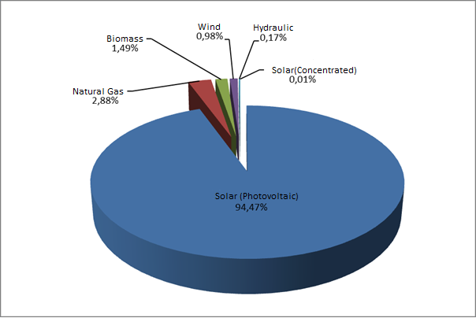

The distribution of unlicensed installed capacity by provinces is shown in Table 1.6. As it was in 2017, the highest installed capacity belongs to Konya with 503,23 MW in 2018. After Konya, the following sequences are Kayseri with 310,15 MW, Ankara with 307,09 MW, Şanlıurfa with 254,81 MW, Kahramanmaraş with 207,30 MW, Afyonkarahisar with 206,99 MW, and İzmir with 178,41 MW respectively. Approximately 37% of the total unlicensed installed capacity is in these seven provinces. In addition, in 2018, Bingöl, Yalova, Ardahan and Iğdır additional 4 provinces have established an unlicensed electricity installed capacity.

Table 1.6: Distribution of Unlicensed Installed Capacity by Province (MW- %)
PROVINCE | 2017 |  | 2018
PROVINCE | Installed Capacity  (MWe) | Share (%) | Installed Capacity  (MWe) | Share (%)
KONYA | 437,61 | 13,79 | 503,23 | 9,48
KAYSERİ | 279,64 | 8,81 | 310,15 | 5,84
ANKARA | 158,78 | 5,00 | 307,09 | 5,78
ŞANLIURFA | 73,75 | 2,32 | 254,81 | 4,80
KAHRAMANMARAŞ | 88,15 | 2,78 | 207,30 | 3,90
AFYONKARAHİSAR | 134,67 | 4,24 | 206,99 | 3,90
İZMİR | 56,67 | 1,79 | 178,41 | 3,36
MERSİN | 114,37 | 3,60 | 177,70 | 3,35
ELAZIĞ | 81,08 | 2,56 | 162,61 | 3,06
ESKİŞEHİR | 72,86 | 2,30 | 157,11 | 2,96
DENİZLİ | 69,27 | 2,18 | 145,67 | 2,74
ANTALYA | 117,89 | 3,71 | 139,43 | 2,63
GAZİANTEP | 93,37 | 2,94 | 135,39 | 2,55
NEVŞEHİR | 79,12 | 2,49 | 130,40 | 2,46
AYDIN | 59,04 | 1,86 | 122,90 | 2,31
ADANA | 81,41 | 2,57 | 122,03 | 2,30
ISPARTA | 83,21 | 2,62 | 108,28 | 2,04
MANİSA | 62,60 | 1,97 | 102,01 | 1,92
KÜTAHYA | 41,19 | 1,30 | 99,37 | 1,87
NİĞDE | 84,09 | 2,65 | 98,45 | 1,85
ADIYAMAN | 53,80 | 1,70 | 98,38 | 1,85
MALATYA | 34,41 | 1,08 | 96,54 | 1,82
MUĞLA | 51,42 | 1,62 | 95,51 | 1,80
BALIKESİR | 61,33 | 1,93 | 89,31 | 1,68
AKSARAY | 76,01 | 2,40 | 85,65 | 1,61
ERZURUM | 50,40 | 1,59 | 83,37 | 1,57
UŞAK | 68,80 | 2,17 | 80,31 | 1,51
ÇORUM | 30,47 | 0,96 | 76,09 | 1,43
SİVAS | 44,28 | 1,40 | 72,73 | 1,37
KARAMAN | 49,24 | 1,55 | 67,13 | 1,26
OSMANİYE | 38,27 | 1,21 | 66,83 | 1,26
BURDUR | 50,28 | 1,58 | 64,34 | 1,21
YOZGAT | 27,83 | 0,88 | 60,25 | 1,13
ÇANKIRI | 5,99 | 0,19 | 48,79 | 0,92
BURSA | 21,48 | 0,68 | 48,07 | 0,91
BİLECİK | 5,05 | 0,16 | 47,89 | 0,90
KIRŞEHİR | 26,58 | 0,84 | 46,36 | 0,87
İSTANBUL | 38,02 | 1,20 | 42,68 | 0,80
KIRIKKALE | 25,82 | 0,81 | 39,93 | 0,75
ERZİNCAN | 21,69 | 0,68 | 38,67 | 0,73
SAMSUN | 7,63 | 0,24 | 35,41 | 0,67
DİYARBAKIR | 4,65 | 0,15 | 31,74 | 0,60
AMASYA | 13,76 | 0,43 | 29,63 | 0,56
ÇANAKKALE | 11,10 | 0,35 | 21,66 | 0,41
TOKAT | 15,14 | 0,48 | 17,82 | 0,34
HATAY | 6,34 | 0,20 | 17,10 | 0,32
KOCAELİ | 8,42 | 0,27 | 15,01 | 0,28
BİTLİS | 3,49 | 0,11 | 14,47 | 0,27
BATMAN | 0,04 | 0,00 | 13,04 | 0,25
VAN | 1,42 | 0,04 | 13,02 | 0,25
BAYBURT | 5,03 | 0,16 | 12,02 | 0,23
KİLİS | 11,26 | 0,35 | 11,84 | 0,22
SAKARYA | 8,79 | 0,28 | 10,79 | 0,20
KARABÜK | 8,64 | 0,27 | 10,64 | 0,20
TEKİRDAĞ | 3,15 | 0,10 | 6,30 | 0,12
SİİRT | 0,19 | 0,01 | 4,65 | 0,09
KASTAMONU | 0,25 | 0,01 | 3,55 | 0,07
KARS | 2,76 | 0,09 | 3,26 | 0,06
BOLU | 2,25 | 0,07 | 3,24 | 0,06
BİNGÖL | 0,00 | 0,00 | 2,75 | 0,05
ZONGULDAK | 2,48 | 0,08 | 2,48 | 0,05
MUŞ | 2,16 | 0,07 | 2,46 | 0,05
MARDİN | 0,42 | 0,01 | 1,97 | 0,04
YALOVA | 0,00 | 0,00 | 1,41 | 0,03
EDİRNE | 0,84 | 0,03 | 1,34 | 0,03
ARDAHAN | 0,00 | 0,00 | 1,10 | 0,02
DÜZCE | 1,01 | 0,03 | 1,03 | 0,02
ORDU | 0,98 | 0,03 | 0,98 | 0,02
TUNCELİ | 0,97 | 0,03 | 0,98 | 0,02
IĞDIR | 0,00 | 0,00 | 0,50 | 0,01
BARTIN | 0,25 | 0,01 | 0,25 | 0,00
Grand Total | 3.173,32 | 100,00 | 5.310,57 | 100,00

The distribution of unlicensed electricity generation by sources is given in Table 1.7 and at Figure 1.19. In 2017, the amount of energy supplied to the grid within the scope of unlicensed electricity generation was 3.031.331,42 MWh, it increased to 8.212.409,37 MWh in 2018. 95,71% came from solar, 2,51% from biomass, and 1,78% includes wind and hydraulic.

Table 1.7: Distribution of Unlicensed Electricity Generation by Sources
(MWh-%)
Resource Type | 2017 |  | 2018
Resource Type | The amount of energy given to the system as surplus (MWh) | Share  (%) | The amount of energy given to the system as surplus (MWh) | Share  (%)
Solar | 2.836.173,49 | 93,56 | 7.859.766,42 | 95,71
Biomass | 138.657,08 | 4,57 | 205.901,95 | 2,51
Wınd | 36.954,64 | 1,22 | 111.990,43 | 1,36
Hydro | 19.546,21 | 0,64 | 34.750,58 | 0,42
Grand Total | 3.031.331,42 | 100,00 | 8.212.409,37 | 100,00

Figure 1.18: Distribution of Unlicensed Electricity Generation by Sources in 2018 (%)

The distribution of energy that is given to the system as a result of unlicensed electricity generation by provinces is shown in Table 1.8. The highest generation was in Konya in 2017, and in 2018 the highest generation was in Konya as well. Kayseri, Afyonkarahisar, Ankara, İzmir, Şanlıurfa, Kahramanmaraş and Manisa were other important provinces in unlicensed electricity generation.

Table 1.8: Distribution of Unlicensed Electricity Generation by Provinces (MWh-%)
PROVINCE | 2017 |  | 2018
PROVINCE | The amount of energy given to the system as surplus  (MWh) | Share (%) | The amount of energy given to the system as surplus  (MWh) | Share (%)
KONYA | 541.727,99 | 17,87 | 888.600,28 | 10,82
KAYSERİ | 396.470,72 | 13,08 | 540.201,26 | 6,58
ANKARA | 100.849,57 | 3,33 | 402.315,34 | 4,90
AFYONKARAHİSAR | 103.910,00 | 3,43 | 353.577,81 | 4,31
ŞANLIURFA | 58.423,03 | 1,93 | 339.330,44 | 4,13
KAHRAMANMARAŞ | 67.322,36 | 2,22 | 279.416,57 | 3,40
İZMİR | 41.081,94 | 1,36 | 278.481,18 | 3,39
MANİSA | 54.552,84 | 1,80 | 273.496,96 | 3,33
ESKİŞEHİR | 79.240,86 | 2,61 | 272.137,10 | 3,31
MERSİN | 147.460,17 | 4,86 | 271.346,16 | 3,30
GAZİANTEP | 95.426,10 | 3,15 | 230.401,38 | 2,81
ELAZIĞ | 26.415,91 | 0,87 | 226.578,79 | 2,76
NEVŞEHİR | 65.813,63 | 2,17 | 215.690,55 | 2,63
DENİZLİ | 88.831,00 | 2,93 | 212.330,59 | 2,59
ANTALYA | 98.080,69 | 3,24 | 207.955,46 | 2,53
AYDIN | 60.395,15 | 1,99 | 199.122,76 | 2,42
ISPARTA | 77.065,63 | 2,54 | 178.442,77 | 2,17
NİĞDE | 87.890,84 | 2,90 | 165.216,86 | 2,01
KÜTAHYA | 27.236,19 | 0,90 | 155.470,28 | 1,89
AKSARAY | 99.666,31 | 3,29 | 155.317,70 | 1,89
ADANA | 45.561,10 | 1,50 | 153.446,68 | 1,87
ADIYAMAN | 47.402,32 | 1,56 | 152.986,85 | 1,86
MUĞLA | 44.997,60 | 1,48 | 152.188,11 | 1,85
BALIKESİR | 32.648,35 | 1,08 | 144.146,86 | 1,76
MALATYA | 37.943,06 | 1,25 | 132.066,33 | 1,61
UŞAK | 47.828,89 | 1,58 | 128.761,19 | 1,57
KARAMAN | 43.901,46 | 1,45 | 119.868,76 | 1,46
SİVAS | 27.762,07 | 0,92 | 118.887,18 | 1,45
ÇORUM | 21.580,88 | 0,71 | 108.632,39 | 1,32
BURDUR | 78.965,94 | 2,60 | 103.005,83 | 1,25
YOZGAT | 33.855,04 | 1,12 | 99.304,24 | 1,21
OSMANİYE | 21.162,10 | 0,70 | 93.669,12 | 1,14
ERZURUM | 33.059,16 | 1,09 | 90.065,36 | 1,10
BURSA | 26.982,25 | 0,89 | 84.220,71 | 1,03
KIRŞEHİR | 17.120,66 | 0,56 | 78.742,91 | 0,96
BİLECİK | 6.340,18 | 0,21 | 65.846,90 | 0,80
ERZİNCAN | 1.375,06 | 0,05 | 64.736,27 | 0,79
KIRIKKALE | 24.234,15 | 0,80 | 61.375,82 | 0,75
ÇANKIRI | 2.702,09 | 0,09 | 42.539,27 | 0,52
DİYARBAKIR | 3.447,94 | 0,11 | 39.789,57 | 0,48
AMASYA | 6.071,22 | 0,20 | 36.960,88 | 0,45
SAMSUN | 1.079,20 | 0,04 | 32.289,79 | 0,39
TOKAT | 15.248,30 | 0,50 | 31.448,56 | 0,38
HATAY | 5.287,67 | 0,17 | 27.216,01 | 0,33
ÇANAKKALE | 8.723,72 | 0,29 | 25.446,36 | 0,31
KOCAELİ | 16.105,48 | 0,53 | 20.325,34 | 0,25
BAYBURT | 7.142,70 | 0,24 | 19.809,40 | 0,24
KİLİS | 19.729,09 | 0,65 | 18.692,35 | 0,23
KARABÜK | 2.691,64 | 0,09 | 14.646,60 | 0,18
BATMAN | 879,82 | 0,03 | 12.783,57 | 0,16
ZONGULDAK | 10.767,44 | 0,36 | 11.426,60 | 0,14
RİZE | 3.850,21 | 0,13 | 9.851,57 | 0,12
BİTLİS | 3.271,21 | 0,11 | 7.965,73 | 0,10
SİİRT | 263,58 | 0,01 | 7.934,43 | 0,10
İSTANBUL | 4.787,38 | 0,16 | 7.112,91 | 0,09
YALOVA | 0,00 | 0,00 | 5.657,31 | 0,07
KASTAMONU | 120,00 | 0,00 | 5.170,35 | 0,06
BİNGÖL | 0,00 | 0,00 | 4.765,92 | 0,06
BOLU | 322,89 | 0,01 | 4.597,16 | 0,06
KARS | 0,00 | 0,00 | 4.545,97 | 0,06
EDİRNE | 1.911,34 | 0,06 | 4.341,68 | 0,05
TEKİRDAĞ | 545,96 | 0,02 | 3.978,74 | 0,05
ORDU | 872,05 | 0,03 | 3.513,06 | 0,04
MUŞ | 3.089,95 | 0,10 | 2.792,71 | 0,03
MARDİN | 857,39 | 0,03 | 2.037,46 | 0,02
TUNCELİ | 22,34 | 0,00 | 1.785,41 | 0,02
GÜMÜŞHANE | 0,00 | 0,00 | 1.661,77 | 0,02
ARDAHAN | 0,00 | 0,00 | 1.437,48 | 0,02
VAN | 421,78 | 0,01 | 1.433,22 | 0,02
KIRKLARELİ | 0,00 | 0,00 | 442,12 | 0,01
DÜZCE | 336,52 | 0,01 | 389,45 | 0,00
SAKARYA | 121,93 | 0,00 | 151,51 | 0,00
BARTIN | 77,55 | 0,00 | 85,28 | 0,00
SİNOP | 1,82 | 0,00 | 2,14 | 0,00
Grand Total | 3.031.331,42 | 100,00 | 8.212.409,37 | 100,00

The distribution of the amount of payment made within the scope of unlicensed electricity generation by resources by the end of 2018 is given in Table 1.9. 96,48 % of the amount of payment was made to solar power plants.

Table 1.9: Distribution of the Amount of Payment Made Within the Scope of Unlicensed Electricity Generation by Sources (TL-%)
Resource Type | 2017 |  | 2018 |  | Change (%)  2017→2018
Resource Type | The amount of payment made for the purchased surplus energy (TL) | Share (%) | The amount of payment made for the purchased surplus energy (TL) | Share (%) | Change (%)  2017→2018
Solar | 1.394.788.180,86 | 94,12 | 5.161.639.212,83 | 96,48 | 270,07
Biomass | 71.776.216,62 | 4,84 | 134.929.718,77 | 2,52 | 87,99
Wind | 10.038.095,17 | 0,68 | 41.487.589,52 | 0,78 | 313,30
Hydro | 5.259.414,79 | 0,35 | 12.131.327,19 | 0,23 | 130,66
Grand Total | 1.481.861.907,44 | 100,00 | 5.350.187.848,31 | 100,00 | 261,04

1.5 Invoiced Electricity Consumption

This part gives information about the consumption of invoiced electric energy. In this sense, the consumption that are not subject to invoicing (technical and non-technical losses and unacceptable consumption), are not included in this section and dataset. Therefore, in the scope of Article 7 of the Electricity Market Law, the production that is made in order to meet the needs of the facilities that are rented, acquired through financial leasing, being inherited the operational right or the energy produced in the premises without leaving the transmission or distribution system, which are done by legal entities that own generation license, are not included in the invoiced consumption data since they are not regarded as a sales to the final consumer. Also, the electric energy that the facilities used for their own need from the system are not included in the invoiced consumption. In addition, real consumption data and consumption data contained in this section may vary due to differences in invoicing period.
The information about invoiced consumption in 2018 is given in Table 1.10. 23,84% of the 233,61 TWh was sold to consumers connected to the transmission voltage level with 55,70 TWh, while the remaining 76,16 % (177,91 TWh) was distributed to consumers connected to the distribution voltage level.
While 69,17 TWh sold to eligible consumers, consumption of non-eligible consumers was 164,43 TWh. The share of eligible consumers’ invoiced consumption was 29,62 %, while non-eligible consumers’ share was 70,38 %.

Table 1.10: Sales to Eligible and Non-Eligible Consumers in 2018 (MWh)
Consumer Type | Consumption Amount of Consumers Connected to the Distribution Voltage Level (MWh) | Consumption Amount of Consumers Connected to the Transmission Voltage Level (MWh) | Total (MWh)
Non-Eligible Consumer | 147.685.452,79 | 16.747.847,16 | 164.433.299,95
Eligible Consumer | 30.225.373,40 | 38.951.356,19 | 69.176.729,59
Grand Total | 177.910.826,19 | 55.699.203,35 | 233.610.029,54

Distribution of consumption by distribution regions is given in Table 1.11. The highest consumption was in Toroslar EDAŞ region with 27,52 TWh and the lowest consumption with 1,97 TWh was in Vangölü EDAŞ region. The region where the highest consumption connected to distribution voltage level was Boğaziçi EDAŞ, whereas the lowest region was Vangölü EDAŞ. In addition, the region where the consumption connected to transmission was the highest in Toroslar and the lowest in Çoruh EDAŞ region.

Table 1.11: Distribution of Invoiced Consumption by Distribution Regions in 2018 (MWh-%)
Distribution Regions | Consumption of Consumers Connected to Distribution (MWh) | Consumption of Consumers Connected to Transmission (MWh) | Total (MWh) | Share (%)
TOROSLAR EDAŞ | 15.327.680,68 | 12.190.165,26 | 27.517.845,94 | 11,78
BOĞAZİÇİ EDAŞ | 25.958.517,34 | 1.465.658,34 | 27.424.175,68 | 11,74
GDZ EDAŞ | 14.827.527,09 | 6.265.710,33 | 21.093.237,42 | 9,03
ULUDAĞ EDAŞ | 12.116.127,37 | 6.662.150,36 | 18.778.277,73 | 8,04
BAŞKENT EDAŞ | 15.216.716,88 | 3.298.388,90 | 18.515.105,78 | 7,93
SAKARYA EDAŞ | 9.072.742,57 | 6.921.062,59 | 15.993.805,16 | 6,85
İST. AND. YAK. EDAŞ | 11.818.912,08 | 1.209.031,09 | 13.027.943,17 | 5,58
DİCLE EDAŞ | 10.140.239,92 | 1.060.375,10 | 11.200.615,02 | 4,79
MERAM EDAŞ | 8.892.519,08 | 1.571.986,85 | 10.464.505,94 | 4,48
AKDENİZ EDAŞ | 9.074.363,66 | 1.288.509,01 | 10.362.872,67 | 4,44
TRAKYA EDAŞ | 6.637.491,06 | 3.411.300,67 | 10.048.791,73 | 4,30
OSMANGAZİ EDAŞ | 6.330.630,54 | 3.585.829,34 | 9.916.459,88 | 4,24
ADM EDAŞ | 8.836.235,84 | 998.233,46 | 9.834.469,30 | 4,21
YEŞİLIRMAK EDAŞ | 4.945.764,21 | 1.352.205,09 | 6.297.969,30 | 2,70
AKEDAŞ EDAŞ | 3.576.137,48 | 1.560.110,40 | 5.136.247,88 | 2,20
ÇORUH EDAŞ | 3.622.402,48 | 71.285,00 | 3.693.687,48 | 1,58
KAYSERİ EDAŞ | 2.336.403,14 | 1.321.350,48 | 3.657.753,62 | 1,57
FIRAT EDAŞ | 2.512.622,54 | 751.338,65 | 3.263.961,19 | 1,40
ÇAMLIBEL EDAŞ | 2.497.145,64 | 411.547,10 | 2.908.692,74 | 1,25
ARAS EDAŞ | 2.319.765,46 | 183.277,27 | 2.503.042,73 | 1,07
VANGÖLÜ EDAŞ | 1.850.881,15 | 119.688,06 | 1.970.569,21 | 0,84
Grand Total | 177.910.826,19 | 55.699.203,35 | 233.610.029,54 | 100,00

The distribution of invoiced consumption by consumer type is shown in Figure 1.20 and Table 1.12. The industrial consumption was the first with a share of 41,52 %. The consumption of the commercial sector was the second with 29,23 % and the household consumption was the third with 23,45 %. The total electricity consumption used in lighting and agricultural irrigation was 5,81 %.

Table 1.12: Distribution of Invoiced Consumption by Consumer Type as Eligible and Non-Eligible Consumers in 2018 (MWh)
Consumer Type | Consumption Amount(MWh)
Consumer Type | Non-Eligible Consumer | Share  (%) | Eligible Consumer | Share  (%) | Total | Share  (%)
Industry | 49.104.564,12 | 29,86 | 47.891.284,07 | 69,23 | 96.995.848,19 | 41,52
Commercial | 51.769.098,88 | 31,48 | 16.520.154,79 | 23,88 | 68.289.253,67 | 29,23
Household | 50.145.851,17 | 30,50 | 4.624.128,39 | 6,68 | 54.769.979,56 | 23,45
Irrigation | 8.675.761,25 | 5,28 | 123.383,98 | 0,18 | 8.799.145,22 | 3,77
Lighting | 4.738.024,53 | 2,88 | 17.778,36 | 0,03 | 4.755.802,89 | 2,04
Grand Total | 164.433.299,95 | 100,00 | 69.176.729,59 | 100,00 | 233.610.029,54 | 100,00

Figure 1.19: Distribution of Invoiced Consumption by Consumer Type in 2018 (%)

Table 1.13: Development of Invoiced Consumption by Consumer Type by Years (MWh)
Consumer Type | Consumption Amount (MWh)
Consumer Type | 2016 | 2017 | 2018
Industy | 89.951.150,54 | 94.965.625,60 | 96.995.848,19
Commercial | 60.853.719,65 | 66.454.453,03 | 68.289.253,67
Household | 51.090.263,33 | 53.531.710,78 | 54.769.979,56
Irrigation | 6.307.604,94 | 6.537.064,52 | 8.799.145,22
Lighting | 4.218.466,49 | 4.341.372,83 | 4.755.802,89
Grand Total | 212.421.204,94 | 225.830.226,76 | 233.610.029,54

The distribution of invoiced consumption by provinces is shown in Table 1.14. The highest consumption was in Istanbul with 40,45 TWh and corresponded to 17,32 % of total consumption. Following provinces were Izmir with a share of 7,04 %, Ankara with a share of 6,12 %, Bursa with 5,06 % and Kocaeli with 4,39 %.

Table 1.14: Distribution of Invoiced Consumption by Province (MWh - %)
PROVINCE | Consumption of Consumers Connected to Dist. Vol. (MWh) | Consumption of Consumers Connected to Trans.Vol. (MWh) | Total (MWh) | Share (%)
İSTANBUL (TOTAL) | 37.777.429,42 | 2.674.689,43 | 40.452.118,85 | 17,32
İSTANBUL (EUROPEAN SIDE) | 25.958.517,34 | 1.465.658,34 | 27.424.175,68 | 11,74
İZMİR | 11.590.067,15 | 4.866.829,45 | 16.456.896,60 | 7,04
ANKARA | 11.723.699,11 | 2.581.524,98 | 14.305.224,09 | 6,12
İSTANBUL (ANATOLIAN SIDE) | 11.818.912,08 | 1.209.031,09 | 13.027.943,17 | 5,58
BURSA | 7.229.082,79 | 4.592.523,17 | 11.821.605,96 | 5,06
KOCAELİ | 5.185.867,55 | 5.078.740,07 | 10.264.607,62 | 4,39
ANTALYA | 7.546.354,20 | 728.933,34 | 8.275.287,54 | 3,54
GAZİANTEP | 3.079.916,26 | 4.399.340,49 | 7.479.256,75 | 3,20
ADANA | 4.719.828,13 | 1.986.976,25 | 6.706.804,38 | 2,87
TEKİRDAĞ | 3.843.979,59 | 2.807.679,90 | 6.651.659,49 | 2,85
KONYA | 5.409.806,16 | 941.317,96 | 6.351.124,12 | 2,72
ŞANLIURFA | 4.375.686,31 | 373.559,61 | 4.749.245,92 | 2,03
MANİSA | 3.237.459,94 | 1.398.880,88 | 4.636.340,82 | 1,98
HATAY | 2.801.410,62 | 1.769.786,40 | 4.571.197,02 | 1,96
MERSİN | 3.820.627,01 | 614.290,81 | 4.434.917,82 | 1,90
OSMANİYE | 665.887,00 | 3.383.944,11 | 4.049.831,11 | 1,73
KAHRAMANMARAŞ | 2.721.815,91 | 1.315.152,88 | 4.036.968,79 | 1,73
SAKARYA | 2.227.306,31 | 1522862,71 | 3.750.169,02 | 1,61
KAYSERİ | 2.330.239,32 | 1.321.350,48 | 3.651.589,80 | 1,56
MUĞLA | 3.315.656,24 | 320.134,86 | 3.635.791,10 | 1,56
DENİZLİ | 3.036.637,89 | 487.336,78 | 3.523.974,67 | 1,51
BALIKESİR | 3.014.119,81 | 312.737,93 | 3.326.857,74 | 1,42
SAMSUN | 2.054.856,25 | 1.149.339,38 | 3.204.195,63 | 1,37
ÇANAKKALE | 1.240.762,47 | 1.756.889,26 | 2.997.651,73 | 1,28
ESKİŞEHİR | 1.858.207,07 | 1.127.205,58 | 2.985.412,65 | 1,28
DİYARBAKIR | 2.405.792,87 | 346.977,13 | 2.752.770,00 | 1,18
AYDIN | 2.483.941,71 | 190.761,82 | 2.674.703,53 | 1,14
KIRKLARELİ | 1.720.519,34 | 598.730,49 | 2.319.249,83 | 0,99
BİLECİK | 1.103.115,14 | 781.193,10 | 1.884.308,24 | 0,81
AFYONKARAHİSAR | 1.514.608,34 | 275.561,33 | 1.790.169,67 | 0,77
MARDİN | 1.611.184,60 | 143.037,34 | 1.754.221,94 | 0,75
MALATYA | 1.133.603,34 | 521.944,45 | 1.655.547,79 | 0,71
UŞAK | 820.699,71 | 817.512,66 | 1.638.212,37 | 0,70
KÜTAHYA | 1.034.000,27 | 584356,67 | 1.618.356,94 | 0,69
TRABZON | 1.451.247,15 | 49256,27 | 1.500.503,42 | 0,64
SİVAS | 1.073.060,53 | 257259,17 | 1.330.319,70 | 0,57
ORDU | 1.215.513,96 | 47.609,53 | 1.263.123,49 | 0,54
ZONGULDAK | 1.027.625,23 | 160.630,30 | 1.188.255,53 | 0,51
ISPARTA | 979.663,77 | 205.904,53 | 1.185.568,30 | 0,51
ELAZIĞ | 950.281,34 | 229.394,20 | 1.179.675,54 | 0,50
ADIYAMAN | 854.321,58 | 244.957,52 | 1.099.279,10 | 0,47
NİĞDE | 819.625,33 | 275.549,37 | 1.095.174,70 | 0,47
EDİRNE | 1.072.992,12 | 4.890,28 | 1.077.882,40 | 0,46
DÜZCE | 829.562,86 | 206.417,66 | 1.035.980,52 | 0,44
AKSARAY | 877.351,16 | 157.767,41 | 1.035.118,57 | 0,44
VAN | 945.469,12 | 19.359,84 | 964.828,96 | 0,41
BOLU | 830.005,84 | 113.042,15 | 943.047,99 | 0,40
KASTAMONU | 685.403,91 | 244.261,48 | 929.665,39 | 0,40
BURDUR | 548.345,70 | 353.671,14 | 902.016,84 | 0,39
BATMAN | 702.699,27 | 185.315,30 | 888.014,57 | 0,38
ERZURUM | 879.855,59 |  | 879.855,59 | 0,38
ÇORUM | 777.905,44 | 86.490,11 | 864.395,55 | 0,37
TOKAT | 726.277,62 | 120.852,35 | 847.129,97 | 0,36
KARAMAN | 631.308,42 | 182.766,16 | 814.074,58 | 0,35
NEVŞEHİR | 762.025,12 |  | 762.025,12 | 0,33
RİZE | 750.591,41 |  | 750.591,41 | 0,32
YOZGAT | 703.971,31 | 33.435,58 | 737.406,89 | 0,32
GİRESUN | 661.846,04 |  | 661.846,04 | 0,28
YALOVA | 632.162,31 |  | 632.162,31 | 0,27
ŞIRNAK | 600.351,17 |  | 600.351,17 | 0,26
AMASYA | 550.734,17 | 48.483,23 | 599.217,40 | 0,26
KIRIKKALE | 486.251,22 | 84.204,04 | 570.455,26 | 0,24
KARABÜK | 468.778,11 | 97.085,60 | 565.863,71 | 0,24
ÇANKIRI | 375.257,83 | 120.681,84 | 495.939,67 | 0,21
ERZİNCAN | 324.171,11 | 145.900,65 | 470.071,76 | 0,20
BARTIN | 449.701,45 | 10.000,66 | 459.702,11 | 0,20
SİİRT | 444.525,70 | 11485,72 | 456.011,42 | 0,20
AĞRI | 381.845,93 | 37.376,62 | 419.222,55 | 0,18
KIRŞEHİR | 392.402,90 | 14.585,95 | 406.988,85 | 0,17
MUŞ | 303.793,36 | 100.328,22 | 404.121,58 | 0,17
ARTVİN | 396.163,20 |  | 396.163,20 | 0,17
GÜMÜŞHANE | 362.554,68 | 22.028,73 | 384.583,41 | 0,16
SİNOP | 346.754,38 | 20282,84 | 367.037,22 | 0,16
BİTLİS | 357.185,85 |  | 357.185,85 | 0,15
KARS | 318.278,44 |  | 318.278,44 | 0,14
BİNGÖL | 305.535,17 |  | 305.535,17 | 0,13
KİLİS | 240.011,66 | 35.827,20 | 275.838,86 | 0,12
HAKKARİ | 244.432,82 |  | 244.432,82 | 0,10
IĞDIR | 192.274,05 |  | 192.274,05 | 0,08
ARDAHAN | 124.466,45 |  | 124.466,45 | 0,05
TUNCELİ | 123.202,69 |  | 123.202,69 | 0,05
BAYBURT | 98.873,89 |  | 98.873,89 | 0,04
Grand Total | 177.910.826,19 | 55.699.203,35 | 233.610.029,54 | 100,00

Table 1.15: Distribution of Invoiced Consumption by Province and Consumer Type (MWh)
PROVINCE | Lighting | Household | Industry | Agricultural Irrigation | Commerce | Grand Total | Share (%)
ADANA | 107.779,16 | 1.706.348,39 | 3.148.643,27 | 140.867,36 | 1.603.166,20 | 6.706.804,38 | 2,87
ADIYAMAN | 29.391,49 | 268.092,08 | 466.066,53 | 63.286,95 | 272.442,05 | 1.099.279,10 | 0,47
AFYONKARAHİSAR | 59.946,43 | 376.838,74 | 724.148,68 | 142.651,25 | 486.584,57 | 1.790.169,67 | 0,77
AĞRI | 20.628,96 | 188.868,09 | 53.043,17 | 230,29 | 156.452,03 | 419.222,55 | 0,18
AKSARAY | 28.059,19 | 212.031,97 | 270.209,54 | 253.001,76 | 271.816,11 | 1.035.118,57 | 0,44
AMASYA | 30.901,03 | 201.159,07 | 157.435,71 | 23.002,71 | 186.718,87 | 599.217,40 | 0,26
ANKARA | 257.946,46 | 3.951.312,28 | 4.228.945,71 | 158.091,14 | 5.708.928,50 | 14.305.224,09 | 6,12
ANTALYA | 172.512,24 | 2.392.589,89 | 1.133.113,47 | 174.467,30 | 4.402.604,64 | 8.275.287,54 | 3,54
ARDAHAN | 9.633,91 | 42.751,18 | 2.069,41 | 0,00 | 70.011,95 | 124.466,45 | 0,05
ARTVİN | 32.324,24 | 121.034,35 | 126.859,36 | 161,43 | 115.783,82 | 396.163,20 | 0,17
AYDIN | 80.509,37 | 930.143,08 | 628.096,38 | 72.793,63 | 963.161,09 | 2.674.703,53 | 1,14
BALIKESİR | 103.156,34 | 931.875,07 | 1.246.818,79 | 42.661,91 | 1.002.345,63 | 3.326.857,74 | 1,42
BARTIN | 25.123,01 | 126.425,67 | 199.381,04 | 751,43 | 108.020,96 | 459.702,11 | 0,20
BATMAN | 23.151,25 | 293.966,20 | 279.119,67 | 26.298,74 | 265.478,72 | 888.014,57 | 0,38
BAYBURT | 10.495,34 | 40.589,37 | 4.958,29 | 143,01 | 42.687,88 | 98.873,89 | 0,04
BİLECİK | 20.370,95 | 118.610,43 | 1.599.571,44 | 4.636,77 | 141.118,65 | 1.884.308,24 | 0,81
BİNGÖL | 12.469,50 | 117.777,66 | 63.113,36 | 451,66 | 111.722,99 | 305.535,17 | 0,13
BİTLİS | 24.849,68 | 131.277,41 | 28.057,72 | 38.165,75 | 134.835,30 | 357.185,85 | 0,15
BOLU | 28.152,37 | 180.743,35 | 383.162,50 | 1.427,83 | 349.561,95 | 943.047,99 | 0,40
BURDUR | 25.251,05 | 150.370,49 | 513.151,12 | 35.401,02 | 177.843,15 | 902.016,84 | 0,39
BURSA | 134.891,08 | 1.959.862,76 | 7.279.275,18 | 82.629,31 | 2.364.947,62 | 11.821.605,96 | 5,06
ÇANAKKALE | 44.183,10 | 370.429,77 | 2.046.043,43 | 35.264,81 | 501.730,61 | 2.997.651,73 | 1,28
ÇANKIRI | 23.081,87 | 108.419,07 | 260.450,00 | 2.296,88 | 101.691,86 | 495.939,67 | 0,21
ÇORUM | 41.603,86 | 294.892,89 | 238.138,36 | 22.634,79 | 267.125,65 | 864.395,55 | 0,37
DENİZLİ | 79.521,31 | 672.112,56 | 1.929.623,01 | 73.020,57 | 769.697,23 | 3.523.974,67 | 1,51
DİYARBAKIR | 50.024,27 | 755.962,69 | 644.455,46 | 496.074,28 | 806.253,31 | 2.752.770,00 | 1,18
DÜZCE | 29.673,25 | 226.872,32 | 532.869,33 | 658,70 | 245.906,92 | 1.035.980,52 | 0,44
EDİRNE | 31.217,40 | 267.152,95 | 319.196,59 | 113.194,88 | 347.120,59 | 1.077.882,40 | 0,46
ELAZIĞ | 36.183,05 | 283.253,08 | 397.421,57 | 43.665,58 | 419.152,27 | 1.179.675,54 | 0,50
ERZİNCAN | 20.012,89 | 117.713,06 | 168.956,12 | 11.931,77 | 151.457,92 | 470.071,76 | 0,20
ERZURUM | 49.197,69 | 362.683,36 | 66.654,56 | 2.199,75 | 399.120,23 | 879.855,59 | 0,38
ESKİŞEHİR | 49.113,11 | 555.277,72 | 1.574.864,43 | 176.879,97 | 629.277,42 | 2.985.412,65 | 1,28
GAZİANTEP | 79.115,80 | 1.181.216,57 | 4.936.336,02 | 125.881,44 | 1.156.706,92 | 7.479.256,75 | 3,20
GİRESUN | 62.314,92 | 296.857,77 | 75.616,15 | 280,44 | 226.776,75 | 661.846,04 | 0,28
GÜMÜŞHANE | 20.042,76 | 67.781,18 | 227.175,32 | 415,60 | 69.168,55 | 384.583,41 | 0,16
HAKKARİ | 11.547,33 | 109.124,04 | 3.226,88 | 47,18 | 120.487,38 | 244.432,82 | 0,10
HATAY | 87.371,26 | 1.161.012,37 | 2.187.331,12 | 206.563,49 | 928.918,78 | 4.571.197,02 | 1,96
IĞDIR | 14.182,67 | 80.293,66 | 6.048,54 | 832,96 | 90.916,23 | 192.274,05 | 0,08
ISPARTA | 40.572,11 | 269.702,45 | 438.418,17 | 56.790,42 | 380.085,14 | 1.185.568,30 | 0,51
İSTANBUL | 513.804,28 | 11.684.879,25 | 10.264.977,68 | 5.934,62 | 17.982.523,02 | 40.452.118,85 | 17,32
İZMİR | 230.094,27 | 4.209.803,25 | 7.370.266,79 | 384.751,79 | 4.261.980,50 | 16.456.896,60 | 7,04
KAHRAMANMARAŞ | 63.848,15 | 543.425,39 | 2.606.978,84 | 70.377,10 | 752.339,30 | 4.036.968,79 | 1,73
KARABÜK | 25.207,03 | 142.881,86 | 241.732,56 | 1.131,91 | 154.910,36 | 565.863,71 | 0,24
KARAMAN | 17.351,27 | 132.295,08 | 263.615,79 | 226.390,11 | 174.422,33 | 814.074,58 | 0,35
KARS | 14.509,04 | 106.766,88 | 55.356,23 | 153,43 | 141.492,87 | 318.278,44 | 0,14
KASTAMONU | 46.872,96 | 224.802,32 | 441.399,60 | 4.354,37 | 212.236,14 | 929.665,39 | 0,40
KAYSERİ | 110.895,78 | 776.304,66 | 1.807.275,58 | 164.328,09 | 792.785,69 | 3.651.589,80 | 1,56
KIRIKKALE | 22.709,14 | 162.983,39 | 212.290,92 | 3.876,56 | 168.595,25 | 570.455,26 | 0,24
KIRKLARELİ | 29.634,30 | 236.474,45 | 1.698.767,92 | 8.297,80 | 346.075,37 | 2.319.249,83 | 0,99
KIRŞEHİR | 22.145,31 | 133.350,23 | 88.426,54 | 25.177,51 | 137.889,26 | 406.988,85 | 0,17
KİLİS | 10.109,11 | 105.036,43 | 42.735,39 | 18.670,78 | 99.287,15 | 275.838,86 | 0,12
KOCAELİ | 90.936,36 | 1.222.315,12 | 7.320.666,93 | 5.038,72 | 1.625.650,49 | 10.264.607,62 | 4,39
KONYA | 151.806,84 | 1.240.866,17 | 2.039.728,88 | 1.346.091,68 | 1.572.630,55 | 6.351.124,12 | 2,72
KÜTAHYA | 46.171,69 | 305.933,61 | 948.553,55 | 6.071,32 | 311.626,78 | 1.618.356,94 | 0,69
MALATYA | 53.480,50 | 412.151,83 | 642.439,99 | 96.531,39 | 450.944,08 | 1.655.547,79 | 0,71
MANİSA | 80.672,22 | 937.316,30 | 2.204.596,39 | 305.796,76 | 1.107.959,15 | 4.636.340,82 | 1,98
MARDİN | 17.323,11 | 372.147,37 | 377.236,06 | 604.010,99 | 383.504,43 | 1.754.221,94 | 0,75
MERSİN | 104.094,75 | 1.364.994,94 | 1.353.472,02 | 178.180,65 | 1.434.175,46 | 4.434.917,82 | 1,90
MUĞLA | 81.856,22 | 1.010.289,25 | 734.822,41 | 42.317,76 | 1.766.505,45 | 3.635.791,10 | 1,56
MUŞ | 19.683,72 | 144.373,66 | 113.069,57 | 1.765,54 | 125.229,09 | 404.121,58 | 0,17
NEVŞEHİR | 34.224,89 | 179.947,31 | 157.348,44 | 160.030,46 | 230.474,02 | 762.025,12 | 0,33
NİĞDE | 32.849,89 | 181.839,29 | 502.662,65 | 167.256,21 | 210.566,66 | 1.095.174,70 | 0,47
ORDU | 72.949,16 | 464.784,16 | 374.925,56 | 264,98 | 350.199,63 | 1.263.123,49 | 0,54
OSMANİYE | 28.486,08 | 309.173,88 | 3.444.287,33 | 16.187,09 | 251.696,72 | 4.049.831,11 | 1,73
RİZE | 50.184,66 | 242.077,68 | 235.649,05 | 3,57 | 222.676,45 | 750.591,41 | 0,32
SAKARYA | 63.963,14 | 665.820,65 | 2.224.727,39 | 9.195,41 | 786.462,44 | 3.750.169,02 | 1,61
SAMSUN | 102.495,07 | 846.888,04 | 1.447.994,86 | 36.773,11 | 770.044,54 | 3.204.195,63 | 1,37
SİİRT | 20.104,51 | 134.110,77 | 174.208,19 | 9.363,88 | 118.224,06 | 456.011,42 | 0,20
SİNOP | 24.826,03 | 151.656,28 | 87.350,87 | 1.359,96 | 101.844,08 | 367.037,22 | 0,16
SİVAS | 54.474,84 | 326.995,96 | 571.712,44 | 39.294,20 | 337.842,26 | 1.330.319,70 | 0,57
ŞANLIURFA | 58.689,38 | 986.730,83 | 685.984,06 | 2.030.013,58 | 987.828,08 | 4.749.245,92 | 2,03
ŞIRNAK | 16.956,79 | 196.190,54 | 21.223,48 | 46.460,07 | 319.520,30 | 600.351,17 | 0,26
TEKİRDAĞ | 77.491,30 | 579.582,59 | 5.177.472,74 | 14.812,24 | 802.300,62 | 6.651.659,49 | 2,85
TOKAT | 44.295,36 | 315.066,72 | 216.410,59 | 6.963,37 | 264.393,94 | 847.129,97 | 0,36
TRABZON | 95.765,93 | 626.741,24 | 219.632,95 | 799,64 | 557.563,67 | 1.500.503,42 | 0,64
TUNCELİ | 10.090,51 | 43.191,91 | 9.426,16 | 1.121,32 | 59.372,79 | 123.202,69 | 0,05
UŞAK | 29.142,92 | 215.196,89 | 1.151.374,91 | 19.440,75 | 223.056,90 | 1.638.212,37 | 0,70
VAN | 49.344,62 | 410.002,39 | 109.730,39 | 2.620,52 | 393.131,03 | 964.828,96 | 0,41
YALOVA | 18.013,34 | 205.145,06 | 186.486,02 | 6.331,59 | 216.186,30 | 632.162,31 | 0,27
YOZGAT | 37.139,86 | 210.447,75 | 164.852,94 | 101.338,07 | 223.628,27 | 737.406,89 | 0,32
ZONGULDAK | 74.606,90 | 385.573,18 | 415.912,13 | 511,60 | 311.651,73 | 1.188.255,53 | 0,51
Grand Total | 4.755.802,89 | 54.769.979,56 | 96.995.848,19 | 8.799.145,22 | 68.289.253,67 | 233.610.029,54 | 100,00

The distribution of invoiced consumption by months is shown in Figure 1.21. The highest consumption was in July, the lowest consumption was in April.

Figure 1.20: Distribution of Invoiced Consumption by Months (MWh)
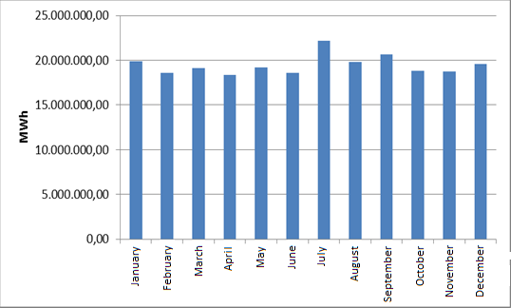

The development of consumption over years is shown in Figure 1.22. The consumption decreased only in 2001 and 2009 compared to the previous years, with the effect of economic crisis. The highest increase rate compared to the previous year was 13,75 % in 1997. In 2018, the rate of increase was 3.69% compared to the previous year.

Figure 1.21: Development of Gross Consumption by Years (GWh)
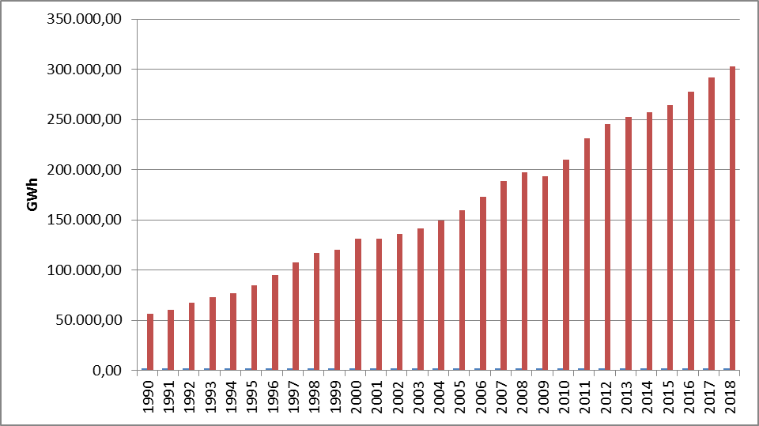

1.6 Import and Export

1.6.1 Import
The data on electricity imports in 2018 by months is shown in Figure 1.23. 83,29 % of the total 2.466.009,25 MWh electricity imports in 2018 were from Bulgaria, 16,27 % from Georgia, and 0,44 % from Greece. On the monthly basis, the highest electricity imports were made in May, while the lowest was in March.

Figure 1.22: Electricity Imports in 2018 by Months (MWh)
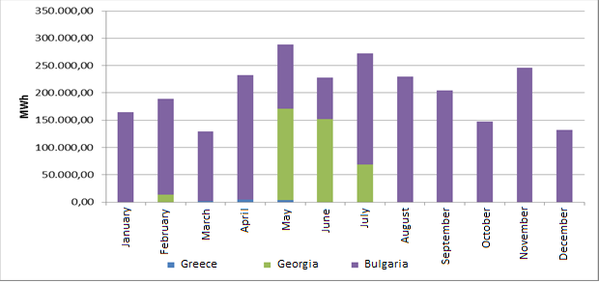

1.6.2 Export
The data on electricity exports in 2018 by months is shown in Figure 1.24. 94,71 % of the total 3.073.600,77 MWh electricity exports in 2018 were to Greece, and the remaining 5,29% to Bulgaria and Georgia. On the monthly basis, the highest electricity exports were made in December and the lowest in April.

Figure 1.23: Electricity Exports in 2018 by Months (MWh)
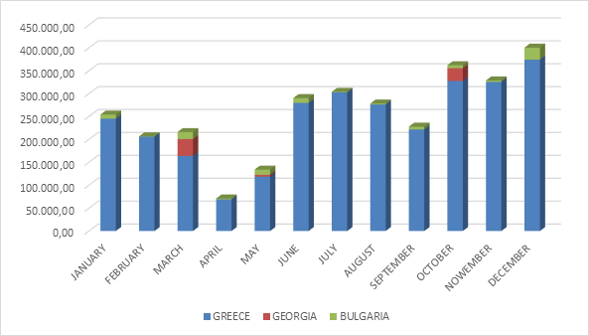

2. WHOLESALE MARKET

In this section, the developments that occurred in the wholesale market were examined in the year 2018. In this context; the prices of the Day-Ahead Market (DAM), the Intra-Day Market (IDM) and the Balancing Power Market (BPM) are presented with the volumes and the orders given. Moreover, the changes that occurred in the market structure are explained.
Primary Frequency Control (PFC) brings the system frequency to a new equilibrium point by automatically increasing or decreasing the unit active power with the speed regulator in response to the decrease or rise of the system frequency. PFK reserve is obtained from production facilities determined to be capable of providing PFK services as a result of PFK performance tests in Electricity Network Regulation.
Secondary Frequency Control (SFK) brings the system frequency to the nominal value and to the programmed value of the total electrical energy exchange with neighboring country electricity networks by increasing or decreasing the active power output of the production facilities participating in the SFK service by the signals sent automatically from the National Load Dispatch Center. SFK reserve is provided by the production facilities which are determined to be capable of providing SFK services as a result of the SFK performance tests in the Electricity Network Regulation.
Pursuant to the Electricity Market Ancillary Services Regulation published on the Official Gazette dated 26 November 2017 and numbered 30252, participation in PFK and SFK services has ceased to be compulsory and PFK and SFK reserves have been procured on a voluntary basis. Currently, between 200-300 MW PFK reserve and 700-1100 MW SFK reserve are kept at different times of the day.

2.1 Day-Ahead Market
Liberalization process started with Electricity Market Law aimed for creation of an electricity market based on transparency, integrity and competition; and integrated with other countries’ electricity markets. In line with this aim, numerous planned steps were taken and significant progress had been achieved for transforming stronger and more dynamic electricity market in which market participants take an active role and market operators manage and monitor by best means.
First step carried out for transformation of electricity market from a single buyer-single seller model to liberal and competitive model was transition to monthly 3 period financial settlement system on 1 July 2006. Next step was the start of operations for Day-Ahead Planning system on 1 December 2009. These transition periods have great importance regarding to transformation of electricity market into stronger and more dynamic structure. Parties took role in market operations and activities provided significant experience and foresight for new market models from their practices at earlier market stages. 1 December 2011 date became a milestone for Turkish Electricity Market and creation of currently used Day-Ahead Market system has been established which is deemed as biggest step towards formation of targeted electricity market structure. Establishment of Day-Ahead Market stimulated a new dynamism and vision for Turkish Electricity Market and allowed formation of market structure based on values of competition.
With the new market structure, the collateral mechanism has been implemented and in this context, the market participants registered with MFSC must provide a guarantee to the market operator for the transactions they have made in DAM. In addition to this arrangement, it is possible for participants to create portfolios. Lastly, in the event that system constraints continue systematically, TEİAŞ is given the opportunity to switch to regional pricing by considering the constraints.
Following the completion of the registration process on 18 March 2015, the Energy Exchange Istanbul (EXIST) was formally established, under the provisions of the Turkish Commercial Code of the 14.03.2013 dated and numbered 6446 with the Electricity Market Act of 6102.
In accordance with the proposals offered by the market participants in the Day-Ahead Market operated by EXIST, the market exchange prices and the purchase and sales quantities are announced.
For the year 2018, prices of DAM are given in Figure 2.1.1 and 2.1.2.

Figure.2.1.1: Hourly Development of Weighted Average Market Clearing Price in 2018 (TL/MWh)
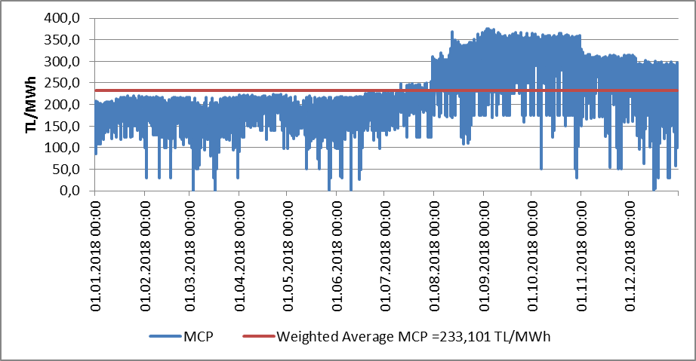

Figure 2.1.2: Organized Weighted Average MCP in 2018 (TL/MWh)
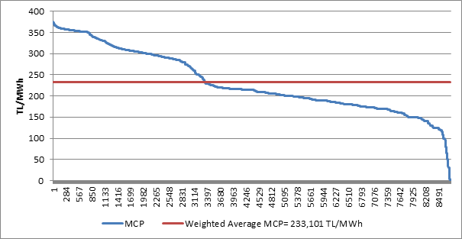

As shown in the figures, the prices were generally in the range of 150-350 TL / MWh. The highest value of the price reached 375,79 TL / MWh on 4 September 2018 at 16:00. On 17 March 2018, PTF was reached as 0 TL / MWh for a total of four hours.
In Figure 2.1.3, the weighted average MCP is given in Day-Ahead Market by years. In 2018, the weighted average of the MCP increased by 38,65% compared to 2017 and reached 233,101 TL/MWh.

Figure 2.1.3: Weighted Average MCP by Years (TL/MWh)
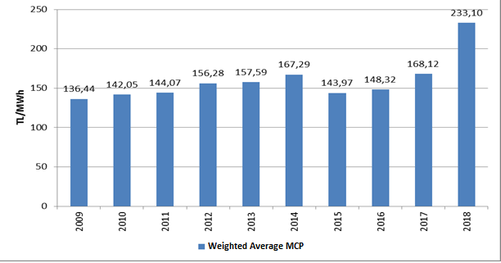

Figure 2.1.4 shows the monthly weighted average MCP for 2017 and 2018. In 2018, the average monthly price was the highest value of 331,813 TL/MWh in September, and the lowest value of 160,782 TL/MWh in March.
As shown in tables and figures in the first chapter, monthly electricity consumption falls with the softening of the air during the spring and autumn months. In addition, in the spring months, the water capacity of hydroelectric power plants increased and the lowest prices of the year are generally seen in spring time.
On the other hand, due to air conditioning and consumption of agricultural irrigation in the summer months and the need for warming and enlightenment in the winter, electricity demand increases and the increase in the average prices in parallel to the increase in consumption is observed.

Figure 2.1.4: Monthly Weighted Average MCP of the Last Two Years (TL/MWh)
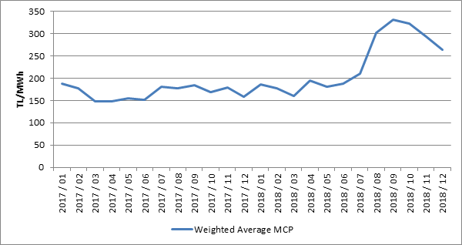

The following figure 2.1.5 shows the trading volume in the DAM by months, the distribution of the quantities of DAM buying in Figure 2.1.6 and the share of the top 10 companies, the distribution of sales quantities in Figure 2.1.7 and the share of the top 10 company.

Figure 2.1.5: Monthly Day-Ahead Market Trading Volume (MWh)
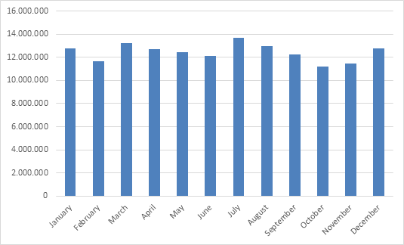

Figure 2.1.6: The Share of Top 10 Buyer Companies in Day-Ahead Market (%)
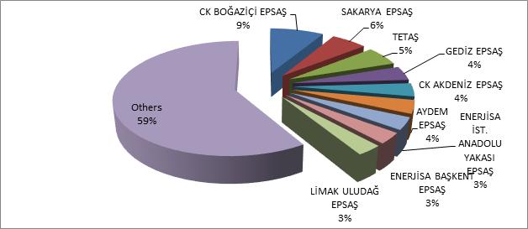

Figure 2.1.7: The Share of Top 10 Seller Companies in Balancing Power Market (%)
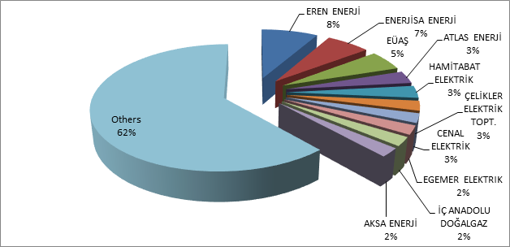

2.2 Balancing Power Market

Balancing Power Market is operated in real time by TEİAŞ. This section provides data on the development of prices and volumes in the BPM. In 2018, the system marginal prices (real time price) at the BPM are shown at Figure 2.2.1 on a per-hour basis. Also, Figure 2.2.2 provides the organized system marginal prices.

Figure.2.2.1: Per-Hour Based Development of System Marginal Price (TL/MWh)
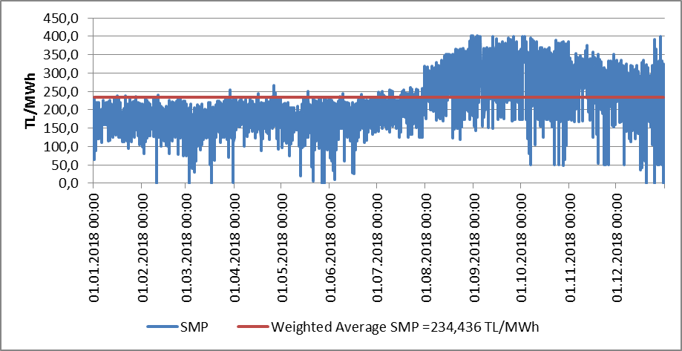

Figure 2.2.2: Organized Sytem Marginal Price (TL/MWh)
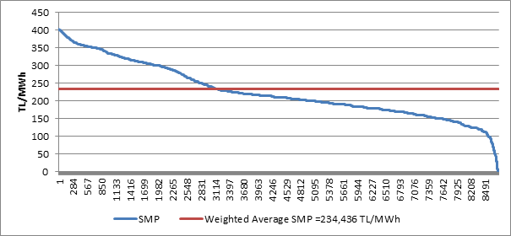

Similar to the prices of the DAM, the prices in the BPM were generally between 100 and 350 TL/MWh. The price was highest on 3 September 2018 at 17:00 with 402,2 TL/MWh, and it was over 400 TL/MWh for 37 hours. At the BPM, the price was 0 TL/MWh for 7 hours during 2018.

The annual weighted average of the price in BPM was 234,436 TL/MWh, increased by 42,27% compared to the previous year.
The monthly weighted average prices of the Balancing Power Market in 2018 are shown in Figure 2.2.3 below. SMP was seen in March as the lowest with the value of 168,079 TL/MWh, and the highest value was realized in September with the value of 329,17 TL/MWh.

Figure 2.2.3: Monthly Weighted Average Prices of the Last Two Years in Balancing Power Market (TL/MWh)

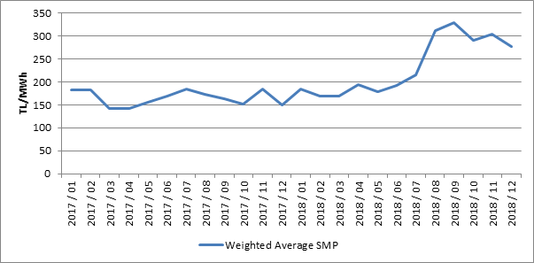

Below Figure 2.2.4 shows monthly trading volumes in BPM in 2018.

Figure 2.2.4: Monthly Trading Volumes in Balancing Power Market (MWh)
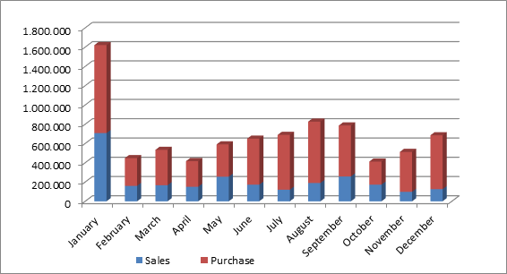
In the following Figure 2.2.5 the distribution of the BPM buying quantities on the basis of the company and the share of the top 10 buyer companies and in Figure 2.2.6, the distribution of BPM sales quantities on company basis and the share of the top 10 companies are shown.

Figure 2.2.5: The Share of Top 10 Buyer Companies in Balancing Power Market (%)
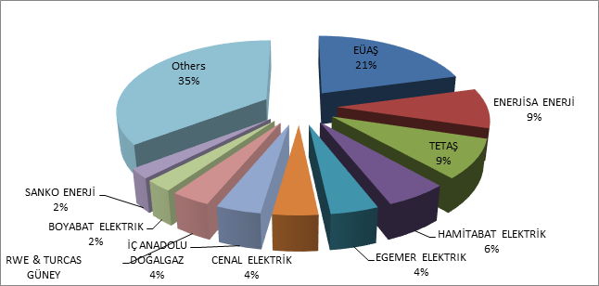

Figure 2.2.6: The Share of Top 10 Seller Companies in Balancing Power Market
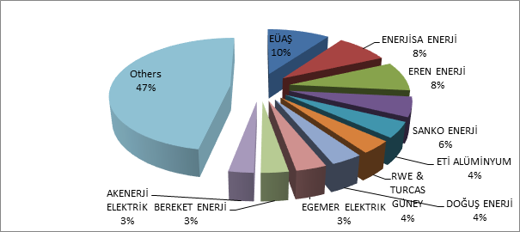
The ratios of orders given in the BPM in 2018 are shown below in Figure 2.2.7, and on a per-hour basis in Figure 2.2.8. Loading orders constitute 73% of the total amount.

Figure 2.2.7: Rates of Order Volumes Given in Balancing Power Market in 2018 (%)

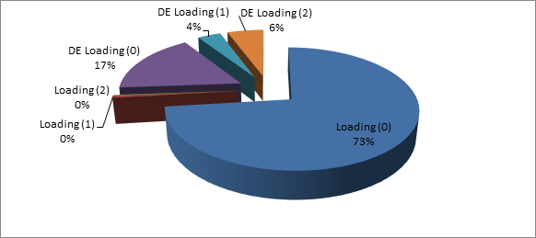
As shown in the figure, the 0-coded orders constitute 57% of the total amount. The remaining volume consists of 1 and 2 coded orders produced due to system requirements.

Figure 2.2.8: Distribution of the Orders Given in the Balancing Power Market by Hours in 2018 (MW)
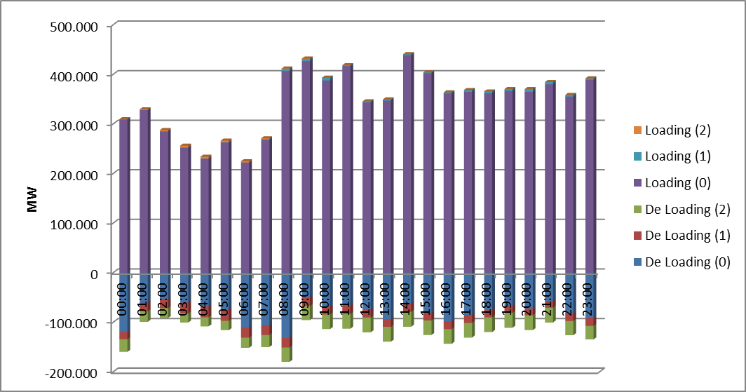

Additional costs arising from those orders are shown in Table 2.2.1 below. In 2018, the orders given in the BPM caused an additional cost of 119,67 million TL which is 86.5% less than previous year. About 66% of these costs were 1 coded and the remaining 34% were 2 coded orders.

Table.2.2.1: Additional Costs of Orders (Million TL)
Type of Instruction | Loading | DE-Loading | Grand Total
1 Coded | 3,18 | 75,66 | 78,84
2 Coded | 2,52 | 38,31 | 40,83
Grand Total | 5,69 | 113,98 | 119,67

The development of additional costs occurred due to the given 1 and 2 coded orders in 2018 are shown in Figure 2.2.9 below.

Figure 2.2.9: Development of Additional Costs of Orders by Months in 2018 (Million TL)
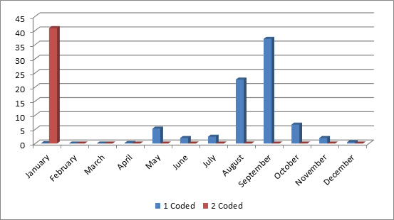

The development of the Zero Balance Adjustment Component (ZBAC) is shown in Figure 2.2.10. ZBAC decreased by 75,97 % to 297 million TL compared to the previous year.

Figure 2.2.10: Development of Zero Balance Adjustment Component by Years (TL)
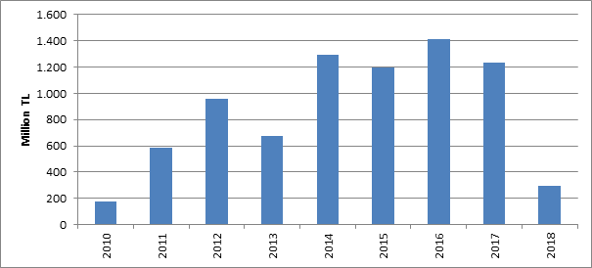

2.3 Intra-Day Market

Efforts are continuing to ensure that the Turkish Electricity Market is more transparent and efficient, financially strong, integrated with the European Union electricity markets. On 1 July 2015, the Intra-Day Market was in operation to ensure that participants in the Turkish electricity market, which is constantly evolving and advancing for free market, playing more balanced and effective role.
Day-Ahead, Ancillary Services and Balancing Power Markets currently in operation, with the addition of Intra-Day Market, provide real-time trading opportunities and offermarket participants the opportunity to manage short-term portfolios.
In Figure 2.3.1 below, monthly volume of the Intra-Day Market and the weighted average price in 2018 is given.

Figure 2.3.1: Monthly Development of Trading Volume and Average Price in the Intra-Day Market (MWh - TL / MWh)
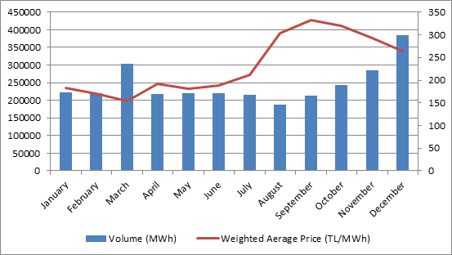

In Figure 2.3.2 the distribution of purchases of IDM on the basis of company and the share of first 10 companies and in Figure 2.3.3, the distribution of sales in IDM on the basis of the company and the share of top 10 seller companies are shown.

Figure 2.3.2: Distribution of Purchases of Intra-Day Market by Companies and the Share of Top 10 Companies (%)
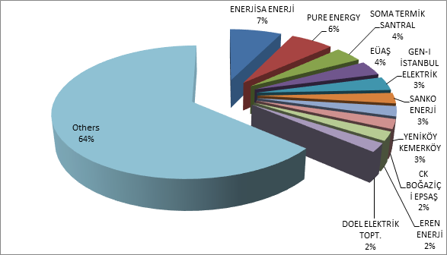

Figure 2.3.3: Distribution of Sales in Intra-Day Market by Companies and the Share of Top 10 Companies (%)
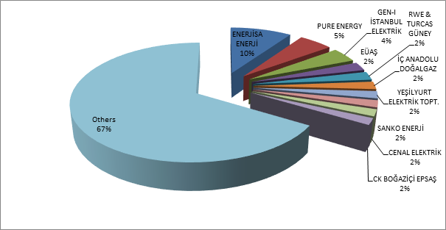

2.4 Bilateral Agreements

Bilateral agreements are based on the construction of the Turkish electricity market, and the other organized markets are designed in the figure complementing the market. Most of the energy traded in the market is traded on bilateral agreements. Bilateral agreements are free between market participants and are not subject to regulation. However, the majority of the existing bilateral agreement volume is the ones signed by TETAŞ with the incumbent supply companies. Also, distribution companies have energy purchases from TETAŞ for losses and general lighting purposes under bilateral agreements.
In the Figure 2.4.1 monthly bilateral agreement volumes in 2016-2018 are shown.

Figure 2.4.1: Monthly Bilateral Agreement Volume by Years (MWh)
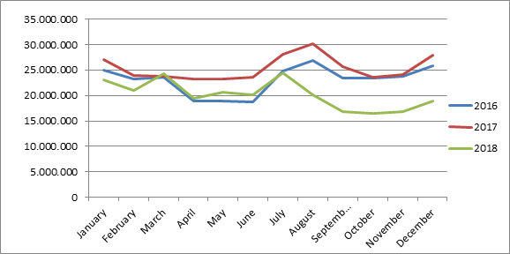

In the following Figure 2.4.2 the distribution of purchases with bilateral agreement on the basis of the company and the share of top 10 buyer companies and in Figure 2.4.3, the distribution of sales with bilateral agreement on the basis of the company and the share of top 10 seller companies are shown.

Figure 2.4.2: Distribution of Purchases of Bilateral Agreement by Companies and the Share of Top 10 Companies (%)
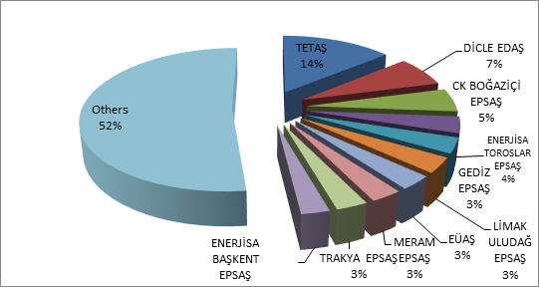

Figure 2.4.3: Distribution of Sales with Bilateral Agreement by Companies and the Share of Top 10 Companies (%)
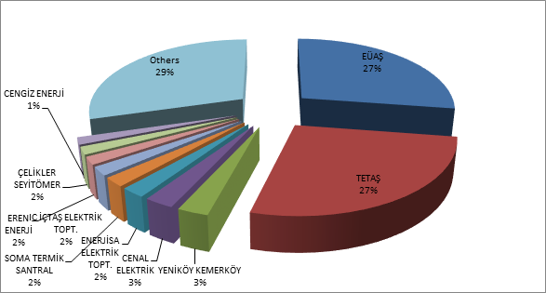
The wholesale tariffs of TETAŞ are determined by Board Decision and it is considered that TETAŞ fulfills its obligations arising from existing contracts.
While the single price for the tariff TETAŞ wholesale tariff was announced, a separate price was determined for the general lighting cost since 2017. In the Figure 2.4.4 the change in TETAŞ wholesale prices over periods are shown.

Figure 2.4.4: TETAŞ Wholesale Prices Between 2011-2018 (kr / kWh)
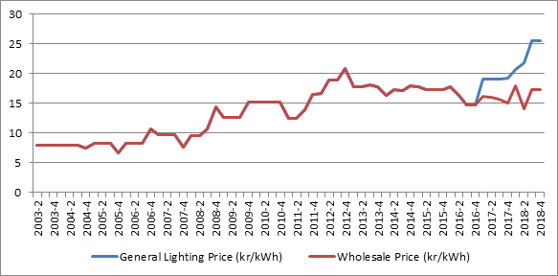

2.5 RESSUM

“The Amendment of the Law on “Utilization of Renewable Energy Resources for Generation of Electrical Energy” Law Numbered 6094 published in the Official Gazette 08/01/2011 dated and 27809 numbered provide incentive for renewable energy sources according to the source type and the locality rate. In this context, the regulations prepared by EMRA and the details Mechanism of Supporting Renewable Energy Sources are determined with the regulations prepared by EMRA.
Regulation on Certification and Support of Renewable Energy Sources” was published in the Official Gazette dated 01/10/2013 and numbered 28782 and came into force. With the Regulation, in order to encourage the generation of electricity based on renewable energy sources, principles regarding the provision of Renewable Energy Source Document and the establishment and operation of RESSUM issued to the generation license holders.
In the following Table 2.5.1, the number of the RES Support participants is given by years. In 2018, there were 708 companies with a total installed capacity of 19.266,29 MW operating in the scope of the RES Support.

Table 2.5.1: Number of RESSUM Participants by Years
Type | 2011 | 2012 | 2013 | 2014 | 2015 | 2016 | 2017 | 2018
Solar | - | - | - | - | - | - | 2 | 3
Hydraulic | 4 | 44 | 14 | 40 | 126 | 388 | 418 | 447
Wind | 9 | 22 | 3 | 21 | 60 | 106 | 141 | 151
Biomass | 3 | 8 | 15 | 23 | 34 | 42 | 57 | 70
Geothermal | 4 | 4 | 6 | 9 | 14 | 20 | 29 | 37
Total | 20 | 78 | 38 | 93 | 234 | 556 | 647 | 708

When the numbers are examined from Table 2.5.1, hydraulic plants had the highest share with 11.706,41 MW and wind plants following it with 6.199,99 MW.
Type | 2011 | 2012 | 2013 | 2014 | 2015 | 2016 | 2017 | 2018
Solar | - | - | - | - | - | - | 12,90 | 13,90
Hydraulic | 21 | 930 | 217 | 598 | 2.116,33 | 9.960,00 | 11.096,26 | 11.706,41
Wind | 469 | 685 | 76 | 825 | 2.732,14 | 4.319,83 | 5.238,70 | 6.199,99
Geothermal | 72 | 72 | 140 | 228 | 389,92 | 599,16 | 752,11 | 996,78
Biomass | 45 | 73 | 101 | 147 | 185,23 | 203,72 | 299,97 | 349,21
Total | 608 | 1.760 | 534 | 1.798 | 5.423,63 | 15.082,72 | 17.399,94 | 19.266,29

Table 2.5.2: Installed Capacity of the RESSUM Participants by Years *(MW)

In addition, by the end of 2018, 5.310,37 MW of unlicensed installed capacity (natural gas plants excluded) are covered by RESSUM. Details are given at "Unlicensed Electricity Generation" in Section 1.3,
Share of installed capacity in the scope of the RES Support in Turkey's total installed capacity in 2017 was 24,28%, while this share reached to 27,60% in 2018.
In the following Figure 2.5.1, distribution of installed capacity based on sources in 2018 is given.

Figure 2.5.1: Distribution of Installed Capacity by Sources in 2018 (%)
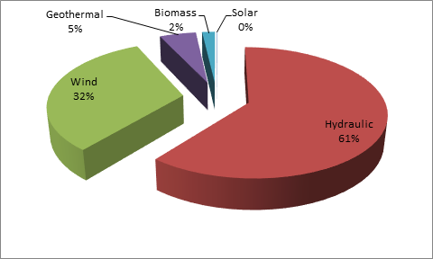
Development of the generation within the scope of RESSUM is shown at Table 2.5.3. Generation in 2018 increased by 23,9% and reached to 62,6 TWh.

Table 2.5.3: Yearly Generation of RESSUM Participants by years (MWh)*
Type | 2012 | 2013 | 2014 | 2015 | 2016 | 2017 | 2018
Solar | - | - | - | - | - | 24.268 | 39.140
Unlicensed | - | - | - | 222.724 | 1.134.024 | 3.031.558 | 8.212.478
Hydraulic | 2.296.047 | 528.646 | 1.072.832 | 5.683.331 | 25.520.255 | 24.417.133 | 27.338.752
Wind | 2.081.745 | 234.000 | 2.378.819 | 8.275.992 | 14.163.403 | 16.765.418 | 19.002.863
Geothermal | 487.364 | 857.527 | 1.436.579 | 2.710.856 | 3.706.764 | 4.503.345 | 5.968.202
Biomass | 374.002 | 750.715 | 925.516 | 1.050.796 | 1.306.057 | 1.789.053 | 2.047.082
Total | 5.239.158 | 2.370.888 | 5.813.746 | 17.943.699 | 45.830.503 | 50.530.776 | 62.608.517

Distribution of generation in 2018 by source types is shown at Figure 2.5.2. The highest generation was obtained from hydro and wind power plants respectively.

Figure 2.5.2: Distribution of Generation in RESSUM by Sources in 2018
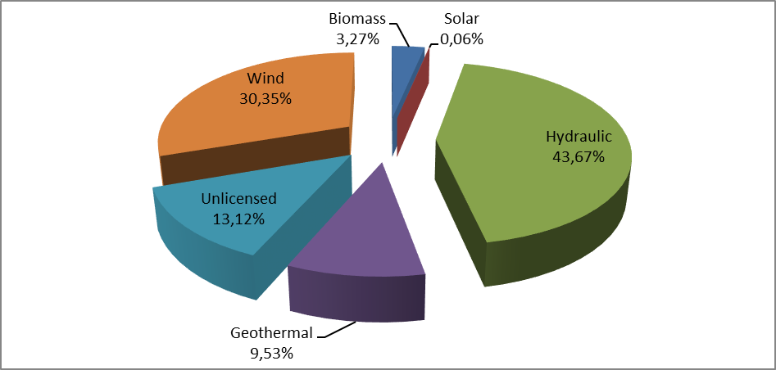
Share of the generation within the scope of the RESSUM in total generation was 21,19% in 2018, while this ratio was 17,26 % in 2017.
Monthly development of the 2018 RESSUM is seen at Figure 2.5.3. Because of rainfalls in spring, hydraulic generation and therefore the generation of RESUM increased. For other sources, more stable generation was realized during the year.

Figure 2.5.3: Monthly Development of RESSUM Generation in 2018 (MWh)
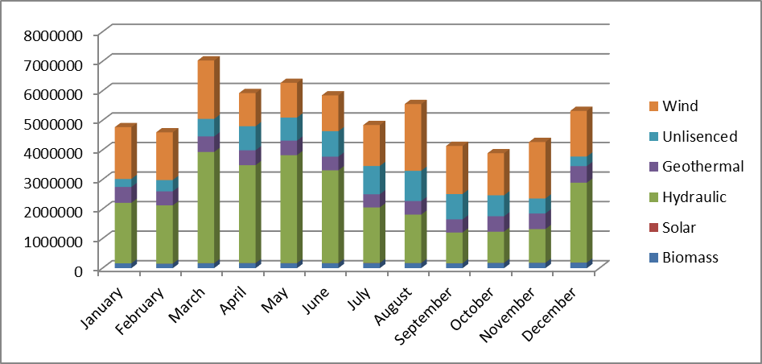

Figure 2.5.4, the monthly weighted average MCP and RESSUM feed-in tariffs are given for 2018.

Figure 2.5.4: Monthly Development of RESSUM Feed-in Tariffs and MCP in 2018 (MWh)
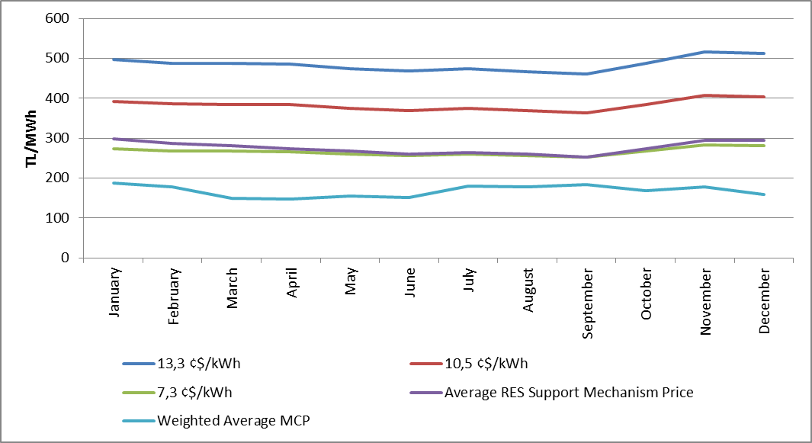
In the following Figure 2.5.5, feed-in tariffs in RESSUM are shown together with MCP. When the feed-in tariffs for RESSUM are compared with the monthly average MCP, it is observed that even the lowest incentive amount is realized above the MCP. The difference between the RESSUM price and the MCP is observed to enlarge in spring months.

Figure 2.5.5: Average of RESSUM and MCP in 2018 (Kr./kWh)
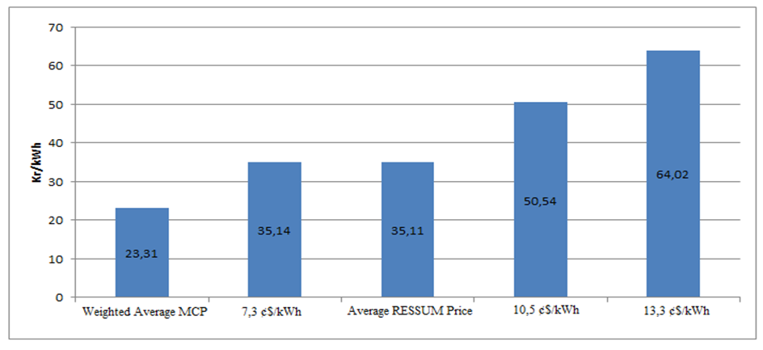
In Figure 2.5.6, monthly development of payments made within the scope of RESSUM.

Figure 2.5.6: Monthly Payments Made within the Scope of the RESSUM in 2018 (TL)

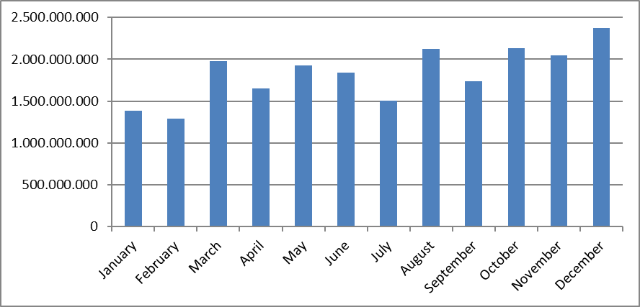
Figure given below shows the improvement of monthly additional cost of RESSUM per invoiced unit energy amount. In 2018, RESSUM additional cost increased by 33,18% compared to previous year and reached to 31,75 TL/MWh.

Figure 2.5.7 Monthly Improvement of Average RESSUM Additional Cost in 2018 (TL/MWh)
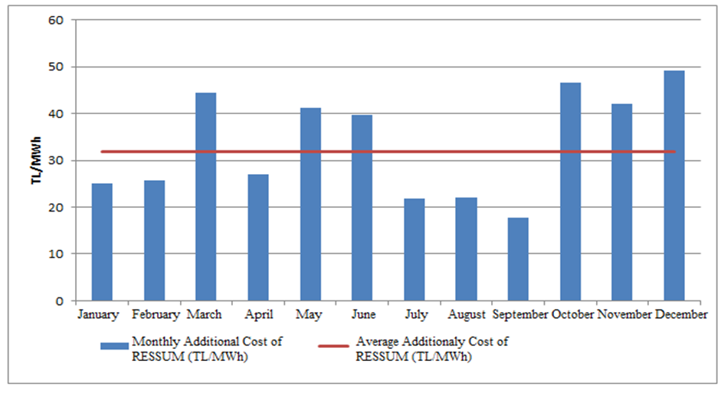

3. COMPETITION
The main aim of the Electricity Market Law is to improve competition by creating an open market structure. Among the functions of the Authority, to prevent competition disruptions in the parts of the market open to competition by detecting the market power. EMRA also increases the number of consumers who can choose their supplier at the demand side by decreasing the eligible consumer limit for the following year at the end of each year. In this framework, development of supply and demand that open to negotiations on the wholesale market, are critical to the establishment of competition.

3.1 Supply Side

It is considered that open electricity markets provide the most effective investment and generation incentives theoretically and in practice. Nevertheless, it may be necessary to make regulations to ensure competition and supply security because of low level of flexibility of demand and incapability of network about energy storage. For this reason, these issues are also regulated by various countries and the European Union with various market share limits and mechanisms.
The indices used to follow the competition generally measure the supply side concentration in the market and the producers' ability to intervene. The HHI is used for measuring the market concentration with the addition of squares of market shares. The index can be calculated separately on generation and installed capacity.

Table 3.1: HHI Values by Generation and Capacity
 | HHI Values
 | Generation |  |  |  |  | Installed Cpacity
Years | 2014 | 2015 | 2016 | 2017 | 2018 | 2014 | 2015 | 2016 | 2017 | 2018
EÜAŞ and TETAŞ Separetely | 1416 | 1123 | 673 | 696 | 575 | 1132 | 996 | 873 | 789 | 682
EÜAŞ and TETAŞ Together | 2748 | 2153 | 1241 | 1276 | 1028 | 1918 | 1645 | 1483 | 1345 | 1184

As shown in Table 3.1 the HHI in 2018, which is based on generation and installed capacity, has decreased compared to the previous year. In addition, HHI which is depending on generation has slightly increased. With the completion of privatizations and the continuing expiration of existing contracts, the decrease in these index values is expected to continue.
The sales of supplier license holders to end-users are shown in Table 3.2. The HHI, which is calculated according to the supplier shares, was 437,5 in 2017. The value of 2018 was calculated as 494,3. Relevant rise of index value results from the share of the total sales of the 21 incumbent suppliers in the total sales volume of all the supply licensed companies was 84,96% in 2018, whereas 79,37 % in 2017.
As known, the limit of the eligible consumer in the electricity market could not reach to zero yet. In other words, not all consumers in the market are eligible consumers. It is not legally possible for any supplier to sell energy to non-eligible consumers, except for incumbent supply companies. Therefore, in order to properly evaluate the competitive environment in the market of sales made to the final consumers, it is important that an environment in which all consumers are eligible and can provide energy from any supplier.

Table 3.2: Sales, Market Shares and HHI Values of Supply License Owners
Supply Company Title | Sales (MWh) | Share (%)
CK BOĞAZİÇİ ELEKTRİK PERAKENDE SATIŞ ANONİM ŞİRKETİ | 22.952.192,84 | 10,88
ENERJİSA TOROSLAR ELEKTRİK PERAKENDE SATIŞ ANONİM ŞİRKETİ | 16.377.086,44 | 7,77
GEDİZ ELEKTRİK PERAKENDE SATIŞ ANONİM ŞİRKETİ | 14.226.324,48 | 6,75
SAKARYA ELEKTRİK PERAKENDE SATIŞ ANONİM ŞİRKETİ | 13.564.449,53 | 6,43
ENERJİSA BAŞKENT ELEKTRİK PERAKENDE SATIŞ ANONİM ŞİRKETİ | 13.417.284,71 | 6,36
LİMAK ULUDAĞ ELEKTRİK PERAKENDE SATIŞ ANONİM ŞİRKETİ | 12.558.497,12 | 5,95
ENERJİSA İSTANBUL ANADOLU YAKASI ELEKTRİK PERAKENDE SATIŞ A.Ş. | 11.758.692,87 | 5,58
DİCLE ELEKTRİK PERAKENDE SATIŞ ANONİM ŞİRKETİ | 9.416.719,31 | 4,47
CK AKDENİZ ELEKTRİK PERAKENDE SATIŞ ANONİM ŞİRKETİ | 8.938.740,13 | 4,24
MERAM ELEKTRİK PERAKENDE SATIŞ ANONİM ŞİRKETİ | 8.557.865,85 | 4,06
AYDEM ELEKTRİK PERAKENDE SATIŞ ANONİM ŞİRKETİ | 8.129.416,33 | 3,85
OSMANGAZİ ELEKTRİK PERAKENDE SATIŞ ANONİM ŞİRKETİ | 7.016.556,75 | 3,33
TRAKYA ELEKTRİK PERAKENDE SATIŞ ANONİM ŞİRKETİ | 6.809.500,47 | 3,23
YEŞİLIRMAK ELEKTRİK PERAKENDE SATIŞ ANONİM ŞİRKETİ | 5.039.234,11 | 2,39
DOEL ELEKTRİK ENERJİSİ TOPTAN SATIŞ ANONİM ŞİRKETİ | 4.216.501,19 | 2,00
AKEDAŞ ELEKTRİK PERAKENDE SATIŞ ANONİM ŞİRKETİ | 4.059.616,28 | 1,92
CK ÇAMLIBEL ELEKTRİK PERAKENDE SATIŞ ANONİM ŞİRKETİ | 3.912.233,80 | 1,86
KAYSERİ ELEKTRİK PERAKENDE SATIŞ ANONİM ŞİRKETİ | 3.515.562,56 | 1,67
AKSA ELEKTRİK SATIŞ ANONİM ŞİRKETİ | 3.212.890,77 | 1,52
ÇORUH ELEKTRİK PERAKENDE SATIŞ ANONİM ŞİRKETİ | 3.064.614,60 | 1,45
FIRAT ELEKTRİK PERAKENDE SATIŞ ANONİM ŞİRKETİ | 2.429.052,13 | 1,15
GAZİANTEP OSB ELEKTRİK ENERJİSİ TEDARİK TOPTAN SATIŞ TİCARET A.Ş. | 2.089.653,63 | 0,99
ARAS ELEKTRİK PERAKENDE SATIŞ ANONİM ŞİRKETİ | 2.056.715,27 | 0,98
TÜRKERLER VANGÖLÜ ELEKTRİK PERAKENDE SATIŞ ANONİM ŞİRKETİ | 1.374.863,32 | 0,65
VOYTRON ENERJİ ELEKTRİK PERAKENDE SATIŞ ANONİM ŞİRKETİ | 1.275.762,54 | 0,60
KOLEN ELEKTRİK TOPTAN SATIŞ İTH. VE İHR. ANONİM ŞİRKETİ | 1.074.432,48 | 0,51
TOSYALI ELEKTRİK ENERJİSİ TOPTAN SATIŞ İTHALAT İHRACAT A.Ş. | 1.049.186,17 | 0,50
ZORLU ELEKTRİK ENERJİSİ İTHALAT, İHRACAT VE TOPTAN TİCARET A.Ş. | 1.037.630,11 | 0,49
CENGİZ ELEKTRİK TOPTAN SATIŞ A.Ş. | 920.966,69 | 0,44
IC İÇTAŞ ELEKTRİK TOPTAN SATIŞ VE TİCARET ANONİM ŞİRKETİ | 906.854,39 | 0,43
BEREKET ELEKTRİK TEDARİK ANONİM ŞİRKETİ | 818.210,13 | 0,39
TTES ELEKTRİK SATIŞ ANONİM ŞİRKETİ | 813.668,24 | 0,39
OMV ENERJİ TİCARET ANONİM ŞİRKETİ | 807.324,11 | 0,38
CK ENERJİ ORTAKLIĞI TOPTAN ELEKTRİK SATIŞI ANONİM ŞİRKETİ | 745.950,39 | 0,35
EREN ELEKTRİK ENERJİSİ TOPTAN SATIŞ ANONİM ŞİRKETİ | 738.284,35 | 0,35
ENKO ENERJİ SANAYİ VE TİCARET ANONİM ŞİRKETİ | 669.308,39 | 0,32
TURKCELL ENERJİ ÇÖZÜMLERİ VE ELEKTRİK SATIŞ TİCARET A.Ş. | 661.652,73 | 0,31
ELEKTRİK ÜRETİM ANONİM ŞİRKETİ | 640.058,54 | 0,30
TÜRKİYE ELEKTRİK TİCARET VE TAAHHÜT ANONİM ŞİRKETİ | 626.015,31 | 0,30
OYAK ELEKTRİK ENERJİSİ TOPTAN SATIŞ ANONİM ŞİRKETİ | 594.684,39 | 0,28
ŞİŞECAM ENERJİ ANONİM ŞİRKETİ | 574.909,05 | 0,27
İPRAGAZ ANONİM ŞİRKETİ | 538.275,68 | 0,26
YEŞİLYURT ELEKTRİK ENERJİSİ TOPTAN SATIŞ VE İTHALAT İHRACAT A.Ş. | 461.757,16 | 0,22
MERAM ELEKTRİK ENERJİSİ TOPTAN SATIŞ ANONİM ŞİRKETİ | 453.288,41 | 0,21
GATES ENERJİ TİCARET ANONİM ŞİRKETİ | 452.205,73 | 0,21
BORDO ELEKTRİK ENERJİSİ TOPTAN SATIŞ ANONİM ŞİRKETİ | 348.808,81 | 0,17
FİNA ELEKTRİK ENERJİSİ İTHALAT İHRACAT VE TOPTAN SATIŞ A.Ş. | 287.982,04 | 0,14
RÖNESANS ELEKTRİK ENERJİ TOPTAN SATIŞ ANONİM ŞİRKETİ | 286.543,45 | 0,14
KET KİPAŞ ELEKTRİK ENERJİSİ TOPTAN SATIŞ TİCARET ANONİM ŞİRKETİ | 283.136,69 | 0,13
EWE ENERJİ ANONİM ŞİRKETİ | 278.868,19 | 0,13
VTC ENERJİ ANONİM ŞİRKETİ | 276.168,58 | 0,13
ÇELİKLER ELEKTRİK ENERJİ TOPTAN SATIŞ ANONİM ŞİRKETİ | 267.611,31 | 0,13
AVEL AVRUPA ELEKTRİK ENERJİSİ TOPTAN SATIŞ ANONİM ŞİRKETİ | 259.563,40 | 0,12
SOYAK ENERJİ TİCARET ANONİM ŞİRKETİ | 252.800,58 | 0,12
MARMARA ELEKTRİK ENERJİSİ İTHALAT İHRACAT VE TOPTAN TİCARET A.Ş. | 250.681,16 | 0,12
EKSİM ELEKTRİK ENERJİSİ İTHALAT, İHRACAT VE TOPTAN SATIŞ A.Ş. | 238.091,80 | 0,11
ELTEK ELEKTRİK ENERJİSİ İTHALAT İHRACAT VE TOPTAN TİCARET A.Ş. | 228.460,68 | 0,11
ELEKTRA ENERJİ TOPTAN SATIŞ VE İTHALAT İHRACAT ANONİM ŞİRKETİ | 199.982,11 | 0,09
EOS ELEKTRİK ENERJİSİ TOPTAN SATIŞ ANONİM ŞİRKETİ | 198.491,92 | 0,09
OZAN ELEKTRİK ENERJİSİ İTH. İHR. VE TOPTAN TİCARET ANONİM ŞİRKETİ | 187.057,56 | 0,09
AYEN ELEKTRİK TİCARET ANONİM ŞİRKETİ | 178.640,45 | 0,08
ENOVA ELEKTRİK ENERJİSİ TOPTAN SATIŞ ANONİM ŞİRKETİ. | 141.360,68 | 0,07
BATIÇİM ENERJİ TOPTAN SATIŞ ANONİM ŞİRKETİ | 138.132,48 | 0,07
YAĞMUR GROUP ELEKTRİK ENERJİSİ TOPTAN SATIŞ ANONİM ŞİRKETİ | 136.922,95 | 0,06
DOĞRUDAN ELEKTRİK ENERJİSİ TOPTAN SATIŞ VE TEDARİK A.Ş. | 131.486,93 | 0,06
FIRAT ENERJİ TOPTAN SATIŞ TİCARET ANONİM ŞİRKETİ | 118.244,13 | 0,06
DOĞUŞ ENERJİ TOPTAN ELEKTRİK TİC.AŞ. | 114.308,88 | 0,05
DEDELİ ELEKTRİK ENERJİSİ TOPTAN TİCARET A.Ş. | 113.512,00 | 0,05
KGM ENERJİ TİCARET LİMİTED ŞİRKETİ | 106.678,15 | 0,05
ENERJİM PERAKENDE ENERJİ TİCARET ANONİM ŞİRKETİ | 106.412,27 | 0,05
YKS ELEKTRİK ENERJİSİ TOPTAN SATIŞ DIŞ TİCARET LİMİTED ŞİRKETİ | 105.333,03 | 0,05
UZ ENERGY DIŞ TİCARET ANONİM ŞİRKETİ | 89.130,26 | 0,04
ÜRÜNDÜL ELEKTRİK ENERJİSİ TOPTAN SATIŞ ANONİM ŞİRKETİ | 82.882,11 | 0,04
İÇDAŞ ELEKTRİK ENERJİSİ TOPTAN SATIŞ İTHALAT VE İHRACAT A.Ş. | 70.777,99 | 0,03
ORTADOĞU ELEKTRİK ENERJİSİ TOPTAN SATIŞ A.Ş. | 66.143,78 | 0,03
ATA ELEKTRİK ENERJİSİ TOPTAN SATIŞ ANONİM ŞİRKETİ | 62.004,37 | 0,03
AGE ELEKTRİK ENERJİSİ TOPTAN SATIŞ ANONİM ŞİRKETİ | 56.083,32 | 0,03
AVEM ELEKTRİK ENERJİSİ TOPTAN SATIŞ ANONİM ŞİRKETİ | 51.212,81 | 0,02
TENERA ENERJİ TİCARET ANONİM ŞİRKETİ | 51.046,59 | 0,02
GROUP TRANS ENERJİ TİCARET ANONİM ŞİRKETİ | 50.998,53 | 0,02
FİDES ELEKTRİK ENERJİSİ TOPTAN ALIŞ SATIŞ ANONİM ŞİRKETİ | 46.475,06 | 0,02
MAC ELEKTRİK ENERJİSİ TOPTAN SATIŞ ANONİM ŞİRKETİ | 39.291,09 | 0,02
SEDSAL ELEKTRİK ENERJİSİ TOPTAN SATIŞ LİMİTED ŞİRKETİ | 38.207,33 | 0,02
AYCAN TOPTAN ELEKTRİK TİCARET ANONİM ŞİRKETİ | 37.302,43 | 0,02
EAG ELEKTRİK ENERJİSİ TOPTAN SATIŞI ANONİM ŞİRKETİ | 34.913,14 | 0,02
DOASAN ENERJİ TOPTAN SATIŞ LİMİTED ŞİRKETİ | 33.846,99 | 0,02
ENGİE ENERJİ TİCARET VE PAZARLAMA ANONİM ŞİRKETİ | 30.835,03 | 0,01
AKS GRUP ELEKTRİK ENERJİSİ TOPTAN ALIŞ VE SATIŞ LİMİTED ŞİRKETİ | 30.802,25 | 0,01
BALKAYA ENERJİ TOPTAN SATIŞ ANONİM ŞİRKETİ | 27.594,28 | 0,01
CFC ELEKTRİK ENERJİSİ TOPTAN SATIŞ ANONİM ŞİRKETİ | 22.775,91 | 0,01
ENSAT ELEKTRİK ENERJİSİ TEDARİK TİCARET ANONİM ŞİRKETİ | 22.730,99 | 0,01
TESAŞ ELEKTRİK ENERJİSİ TOPTAN SATIŞ ANONİM ŞİRKETİ | 21.093,75 | 0,01
CAN ENERJİ TOPTAN ELEKTRİK TİCARET ANONİM ŞİRKETİ | 18.294,41 | 0,01
SHELL ENERJİ ANONİM ŞİRKETİ | 16.791,84 | 0,01
TEKİN ELEKTRİK ENERJİSİ TEDARİK TOPTAN SATIŞ İTHALAT İHRACAT A.Ş. | 12.267,43 | 0,01
YETAŞ YILDIRIM ENERJİ TEDARİK A.Ş. | 11.150,82 | 0,01
BON ELEKTRİK TEDARİK İTHALAT İHRACAT ANONİM ŞİRKETİ | 10.598,86 | 0,01
KIVANÇ ELEKTRİK TOPTAN SATIŞ ANONİM ŞİRKETİ | 10.546,48 | 0,01
METRO GRUP ELEKTRİK ENERJİSİ TOPTAN SATIŞ ANONİM ŞİRKETİ | 8.937,73 | 0,00
HGÇ TOPTAN EL. EN. TİCARET ANONİM ŞİRKETİ | 8.697,38 | 0,00
AKFEN ELEKTRİK ENERJİSİ TOPTAN SATIŞ ANONİM ŞİRKETİ | 7.569,76 | 0,00
BOSEN ELEKTRİK ENERJİSİ TOPTAN SATIŞ ANONİM ŞİRKETİ | 6.892,93 | 0,00
DESA ELEKTRİK ENERJİSİ TEDARİK VE TOPTAN SATIŞ TİCARET A.Ş. | 6.203,33 | 0,00
TRANSPOWER ENERJİ ELEKTRİK TOPTAN SATIŞ ANONİM ŞİRKETİ | 4.927,60 | 0,00
İMC ELEKTRİK ENERJİSİ TOPTAN SATIŞ İTHALAT İHRACAT LİMİTED ŞİRKETİ | 3.669,02 | 0,00
İDEAL PERAKENDE ELEKTRİK SATIŞ ANONİM ŞİRKETİ | 3.585,79 | 0,00
HALİS ELEKTRİK ENERJİSİ TOPTAN SATIŞ VE İTH. İHR. ANONİM ŞİRKETİ | 3.337,67 | 0,00
SARI PERAKENDE ENERJİ SATIŞ VE TİCARET ANONİM ŞİRKETİ | 1.582,67 | 0,00
HİDİV ELEKTRİK ENERJİSİ TOPTAN SATIŞ ANONİM ŞİRKETİ | 1.308,53 | 0,00
ÜNDEM ELEKTRİK ENERJİSİ TOPTAN SATIŞ TİCARET A.Ş. | 1.308,22 | 0,00
NYK ELEKTRİK ENERJİSİ TOPTAN SATIŞ ANONİM ŞİRKETİ | 1.247,17 | 0,00
AKENERJİ ELEKTRİK ENERJİSİ İTHALAT İHRACAT VE TOPTAN TİCARET A.Ş. | 1.112,26 | 0,00
PARK TOPTAN ELEKTRİK ENERJİSİ SATIŞ SANAYİ VE TİCARET A.Ş. | 774,12 | 0,00
ADB ELEKTRİK ENERJİSİ TOPTAN SATIŞ LİMİTED ŞİRKETİ | 686,26 | 0,00
SETEL ELEKTRİK ENERJİSİ İHR.İTH. VE TOPTAN SATIŞ ANONİM ŞİRKETİ | 468,55 | 0,00
ALEN ALARKO ENERJİ TİCARET ANONİM ŞİRKETİ | 233,87 | 0,00
Total | 210.898.310,43 | 100
HHI of Suppliers | 494,3

3.2 Demand Side

Eligible consumer limit have been determined as 2.000 kWh for 2018 in the sixth sub clause of Article 5 of Law No. 4628 on the Organization and Duties of the Energy Market Regulatory Authority and the provisions of Article 25 of the Electricity Market Consumer Services Regulation by 30/11/2017 dated and 7474 numbered the board resolution. The theoretical market openness corresponding to the eligible consumer limit was calculated as 92,6%. The eligible consumer limit and the corresponding market openness rate over the years are given in Figure 3.1.

Figure 3.1: Eligible Consumer Limit and Market Openness Ratio by Years (kWh-%)
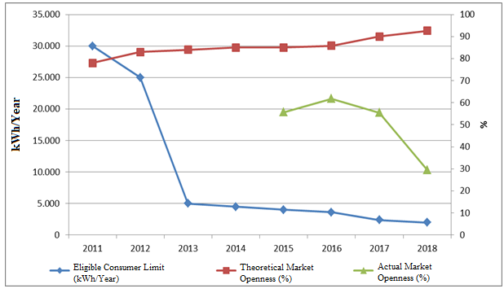
Although the theoretical market openness ratio is high, share of consumers using their rights coming from eligible consumer status in pratice was observed to be lower. Consumption of eligible consumers in 2018 was 69,18 TWh, which corresponds to approximately 29,6 % of total invoiced consumption.
The development of the number of eligible consumers in 2018 is shown in Figure 3.2.

Figure 3.2: Number of Eligible Consumer by Months in 2018 (Number)
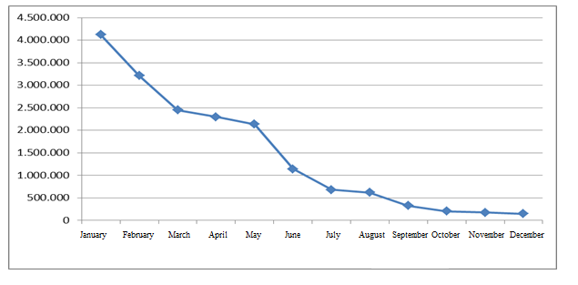

As of January 2017, the number of eligible consumer meters was 4 millions 579 thousands, which were decreased by 96,8 % and reached to 146 thousands by the end of 2018. This number corresponds to 0,34 % of the total number of consumer meters.
The number of eligible consumers on the basis of distribution regions is shown in Figure 3.3. When the graph is examined, it is seen that the biggest shares were of Boğaziçi, Osmangazi and Uludağ regions respectively.

Figure 3.3: Distribution of Eligible Consumers by Distribution Regions by end of 2018
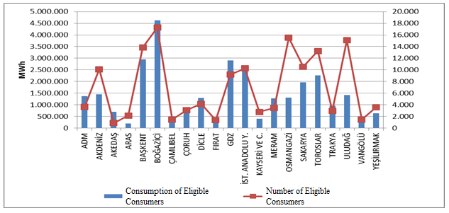
When the figure examined according to distribution region, the four regions where eligible consumers had the highest consumption were Boğaziçi, Başkent, GDZ and İstanbul Anatolian Side distribution regions.
Figure 3.4 below shows the distribution of eligible consumers’ consumption by supplier type. In 2018, the share of incumbent suppliers was decreased compared to 2017, and the share of other suppliers was increased.

Figure 3.4: Distribution of Eligible Consumer Consumption by Suppliers Type (%)
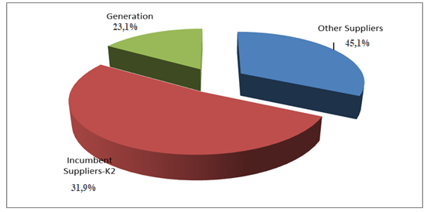
Figure 3.5 shows the monthly changes in the number of consumers switching supplier and their consumption.

Figure 3.5: Monthly Changes in Number and Consumptions of Eligible Consumers Switching Their Supplier (Number-MWh)
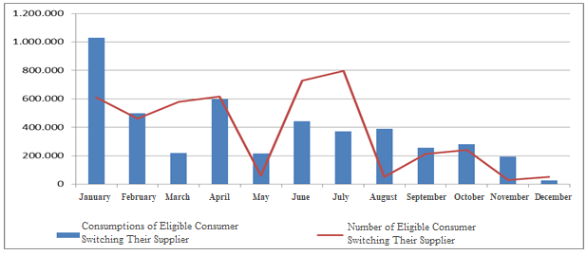
In 2018, the number of eligible consumers switched their suppliers was 4.4 million. 4.2 million of which is consumers switching to regulated tariffs. The total consumption of eligible consumers switching suppliers was 7,44 TWh, which corresponds to 3,3 % of total invoiced consumption.
In the following Table 3.3 distribution of eligible consumers’ switches by supplier type is shown.

Table 3.3: The Distribution of Eligible Consumers’ Switches by Supplier Type
Former Supplier Type | New Supplier Type |  |  |  | Total
Former Supplier Type | Other Supply | Incumbent  Supplier-K1 | Incumbent  Supplier-K2 | Generation | Total
Other Supplier | 23.166 | 191.837 | 2.503 | 772 | 218.278
Incumbent  Supplier-K2 | 9.738 | 4.203.509 | 4.209 | 236 | 4.217.692
Generation | 201 | 5.588 | 185 | 2.946 | 8.920
Total | 33.105 | 4.400.934 | 6.897 | 3.954 | 4.444.890

4. TRANSMISSION
In this section, summary information about the transmission system and changes of transmission system with tables and figures according to the years are given.

4.1 Transmission System

Transformer center in the transmission system by the end of 2018 is shown in the Table 4.1. As seen in the table, most of the transformer centers in the system are of 154 kV voltage level. There are 1.161 transformer centers, 734 in TEİAŞ ownership and 427 in private ownership. The transformer capacity reached to 205.593 MVA. 173.660 MVA of this capacity belongs to TEİAŞ ownership, and the remaining which is 32.293 MVA belongs to private ownership.

Table 4.1: Transformer Center Information
 | Voltage (kV) | Number of Centers | Number of Transformers | Capacity (MVA)
TEİAŞ  Ownership | 380 | 107 | 345 | 71.240
TEİAŞ  Ownership | 220 | 1 | 2 | 400
TEİAŞ  Ownership | 154 | 618 | 1.444 | 101.654
TEİAŞ  Ownership | 66 | 8 | 24 | 366
TEİAŞ  Ownership | TEİAŞ Total | 734 | 1.815 | 173.660
Private  Ownership | 380 | 54 | 47 | 7.195
Private  Ownership | 220 | 0 | 0 | 0
Private  Ownership | 154 | 372 | 402 | 25.085
Private  Ownership | 66 | 1 | 1 | 13
Private  Ownership | Private Total | 427 | 450 | 32.293
 | TOTAL | 1.161 | 2.265 | 205.953

65,62 % of the 68.204 km total transmission lines are working at 154 kV voltage level. Almost all of the remaining lines are working at 380 kV and the lines at the voltage level of 220 kV and 66 kV are only 195 km.

Table 4.2: TEİAŞ Transmission Lines
 | 2017 | 2018 | Change (%) | 2017 | 2018 | Change (%)
Voltage (kV) | Number of Lines |  | Change (%) | Length (km) |  | Change (%)
380 | 270 | 283 | 4,81 | 22.596 | 23.249 | 2,89
220 | 1 | 2 | 100,00 | 85 | 85 | 0,00
154 | 1.587 | 1.709 | 7,69 | 43.495 | 44.760 | 2,91
66 | 17 | 10 | -41,18 | 110 | 110 | 0,00
Total | 1.875 | 2.004 | 6,88 | 66.286 | 68.204 | 2,89

Figure 4.1: Changes in TEİAŞ Transmission Line Lengths by Years (km)
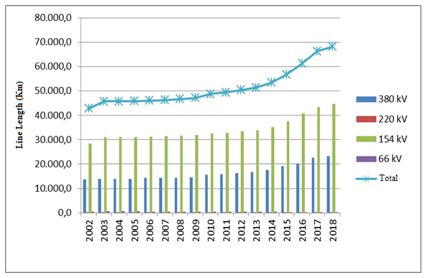

In the last 15 years, there was a 48,98% increase in transmission line lengths.

4.2 Transmission System Connection Applications

The table below shows the number of applications and capacity for connection to the transmission system in 2018 with information on acceptance, rejection and evaluation stages are shown.

Table 4.3: Connection Applications to the Transmission System (Number-MW)
 | Connection Application |  | Acccepted |  | Rejected |  | In the Evaluation Stage
 | Number | Capacity (MW) | Number | Capacity  (MW) | Number | Capacity  (MW) | Number | Capacity  (MW)
Licensed Producer | 190 | 3.141,40 | 184 | 3.043,20 |  |  | 6 | 98,20
Consumer | 45 | 2.703,82 | 40 | 2.150,82 | 3 | 38,00 | 2 | 515,00

In 2018, a total of 3.141,40 MW connection applications were made by producers and 3.043,20 of these applications accepted. In addition, 98,20 MW application is still in evaluation stage.
Consumers’ application was for 2.703,82 MW capacities. 2.150,82 MW of these applications were accepted, 38,00 MW rejected and the remaining of 515,00 MW is still in evaluation stage.

4.3 Tariffs
From 01/01/2018, transmission system system operation and system operating tariffs implemented for manufacturers and consumers in 14 regions by TEİAŞ, have been determined by 7612-2 numbered and 28/12/2017 dated the Board Resolution. Also, transmission surcharge is determined as 0.5% of the transmission tariff of TEİAŞ in the seventh sub clause of article 5 and (A) sub clause of article 10 of the Organization and Duties Law no: 4628 by 7328 numbered and 05/10/2017 dated the Board Resolution.

System use and system operation tariffs implemented in 2018 are shown in Table 4.4 for production and consumption in 14 regions.

Table 4.4: System Usage and System Operation Tariffs (TL/MW-Year)
Region | Generation (*) (**) |  |  | Consumption (*)
Region | System Usage Tariffs |  | System  Operation  Tariffs | System Usage Tariffs |  | System  Operation Tarifss
Region | TL/MW-Year | TL/MWh | TL/MWh | TL/MW-Year | TL/MWh | TL/MWh
1 | 24.053,17 | 5,51 | 2,50 | 43.127,63 | 4,88 | 2,60
2 | 26.222,96 | 5,51 | 2,50 | 41.900,79 | 4,88 | 2,60
3 | 26.462,47 | 5,51 | 2,50 | 41.988,33 | 4,88 | 2,60
4 | 26.804,96 | 5,51 | 2,50 | 41.550,33 | 4,88 | 2,60
5 | 27.970,58 | 5,51 | 2,50 | 40.897,92 | 4,88 | 2,60
6 | 29.392,94 | 5,51 | 2,50 | 39.805,99 | 4,88 | 2,60
7 | 29.561,60 | 5,51 | 2,50 | 38.837,28 | 4,88 | 2,60
8 | 32.561,70 | 5,51 | 2,50 | 37.674,57 | 4,88 | 2,60
9 | 33.840,99 | 5,51 | 2,50 | 36.402,54 | 4,88 | 2,60
10 | 37.577,48 | 5,51 | 2,50 | 34.679,34 | 4,88 | 2,60
11 | 39.579,35 | 5,51 | 2,50 | 33.372,11 | 4,88 | 2,60
12 | 41.270,89 | 5,51 | 2,50 | 32.190,45 | 4,88 | 2,60
13 | 43.039,91 | 5,51 | 2,50 | 31.365,32 | 4,88 | 2,60
14 | 46.167,30 | 5,51 | 2,50 | 28.904,00 | 4,88 | 2,60
(*) Transmission Surcharge not included.
(**) 50 % discount is applied for generation connections within the scope of temporary article 4 of the
Electricity Market Law numbered 6446.

Figure 4.2: System Usage and System Operation Tariffs (TL/MW-Year)
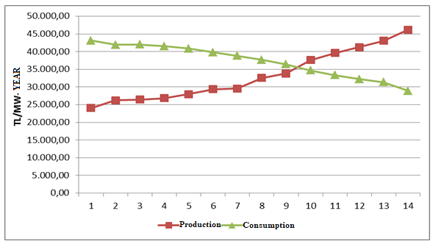

4.4 Amount of Investment
The amount of investment made by TEİAŞ is shown in table 4.5. It is observed that the investment amount in 2018 increased by 12,13 %.

Table 4.5: Comparison of 2017 and 2018 Investment Amount (TL-%)
 | 2017 |  | 2018 |  | Change (%)
Investment Payment Type | Amount (TL) | Share (%) | Amount (TL) | Share (%) | Change (%)
New Transformer Investment | 1.242.394.000 | 47,68 | 1.599.019.000 | 54,73 | 28,70
New Line Investment | 1.134.077.000 | 43,52 | 1.037.280.000 | 35,50 | -8,54
Operational Investment | 111.203.109 | 4,27 | 160.744.000 | 5,50 | 44,55
Machine and Equipment | 113.517.017 | 4,36 | 108.324.000 | 3,71 | -4,57
Other | 4.658.226 | 0,18 | 16.540.100 | 0,57 | 255,07
Total | 2.605.849.352 | 100,00 | 2.921.907.100 | 100,00 | 12,13

4.5 Losses
The transmission system loss rate changes depending on the demand in the system, load flows, temperature and investments. It is calculated on an hourly basis and the change in annual averages over the years is shown in Figure 4.3. The loss of the transmission system established by European standards in accordance with the population density of our country, the location of the supply sources and the geographical conditions is at the international performance level.

Figure 4.3: Transmission System Losses (GWh-%)
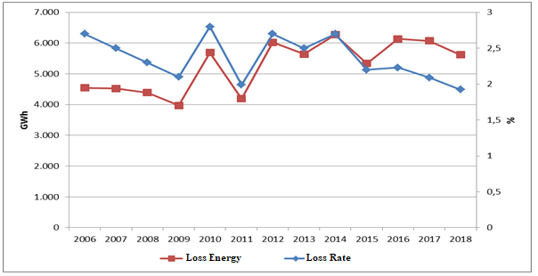

Figure 4.4: Transmission System Losses by Hour (%)
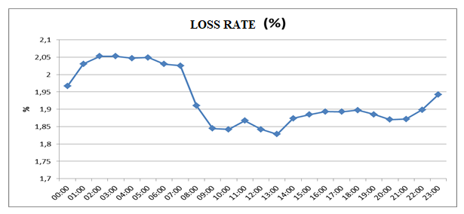
When the development of the loss of transmission system according to hours was observed, the rate of loss was inversely proportional to the amount of production.

5. DISTRIBUTION

5.1 Number of Consumers
By 2018, the total number of consumers using the distribution system was increased by 3,00 % and reached to 43.653.337.

Table 5.1: Number of Consumers Using Distribution System by the end of 2018 (Number-%)
Distribution Company | Number of Consumers |  |  | 2017-2018  Change (%)
Distribution Company | 2016 | 2017 | 2018 | 2017-2018  Change (%)
BOĞAZİÇİ | 4.734.220 | 4.910.115 | 5.029.273 | 2,43
BAŞKENT | 4.099.788 | 4.218.812 | 4.199.135 | -0,47
TOROSLAR | 3.669.912 | 3.805.358 | 3.877.734 | 1,90
GDZ | 3.061.100 | 3.165.847 | 3.312.515 | 4,63
ULUDAĞ | 2.983.810 | 3.092.199 | 3.189.831 | 3,16
İ.ANATOLİAN | 2.751.857 | 2.834.800 | 2.854.123 | 0,68
AKDENİZ | 2.000.386 | 2.076.167 | 2.163.700 | 4,22
MERAM | 1.964.293 | 2.027.866 | 2.094.254 | 3,27
YEŞİLIRMAK | 1.938.042 | 1.998.388 | 2.073.523 | 3,76
ADM | 1.787.566 | 1.834.517 | 1.902.358 | 3,70
DİCLE | 1.650.043 | 1.757.417 | 1.838.929 | 4,64
SAKARYA | 1.654.546 | 1.742.528 | 1.831.677 | 5,12
OSMANGAZİ | 1.661.395 | 1.720.217 | 1.786.452 | 3,85
ÇORUH | 1.269.278 | 1.303.909 | 1.359.781 | 4,28
TRAKYA | 991.026 | 1.042.995 | 1.089.247 | 4,43
ARAS | 935.816 | 963.072 | 1.002.743 | 4,12
ÇAMLIBEL | 917.913 | 946.381 | 974.544 | 2,98
FIRAT | 888.483 | 917.488 | 957.081 | 4,32
KAYSERİ | 673.432 | 695.210 | 718.723 | 3,38
AKEDAŞ | 635.620 | 678.775 | 713.348 | 5,09
VANGÖLÜ | 623.483 | 650.555 | 684.366 | 5,20
TOTAL | 40.892.009 | 42.382.616 | 43.653.337 | 3,00

It is seen from Table 5.1 that the distribution regions with the highest number of consumers were Boğaziçi with 5.03 million, Başkent with 4.2 million and Toroslar with 3.88 million.
In the following figure, the number of consumers connected to distribution network and the total consumption of these consumers by 2018 are shown.

Figure 5.1: Number and Consumption of Consumers (Number- MWh)
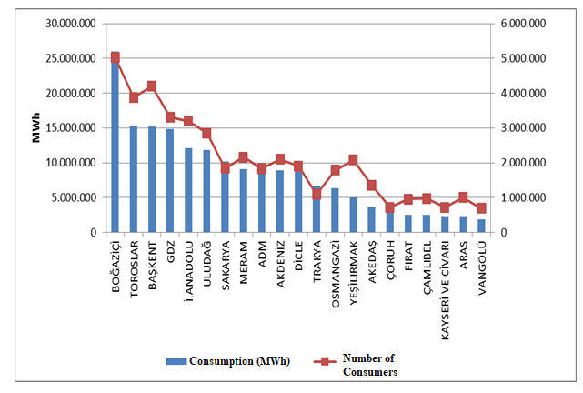

5.2 Ratio of Losses
In following Table 5.2, targeted and realized loss rates of distribution companies are shown.

Distribution Company | REALIZED LOSS RATES |  |  | TARGETED LOSS RATES | DIFFERENCE OF REALIZED&TARGETED LOSS RATES
Distribution Company | 2017 | 2018 | 2017-2018  Change | 2018 | 2018
DİCLE | 64,82 | 54,94 | 9,88 | 69,2 | 14,26
VANGÖLÜ | 53,3 | 49,16 | 4,14 | 57,27 | 8,11
ARAS | 24,55 | 23,55 | 1 | 25,65 | 2,10
TOROSLAR | 11,35 | 11,85 | -0,5 | 12,34 | 0,49
FIRAT | 10,95 | 10,32 | 0,63 | 10,47 | 0,15
ÇORUH | 8,11 | 7,85 | 0,26 | 9,02 | 1,17
YEŞİLIRMAK | 7,43 | 7,63 | -0,2 | 8,06 | 0,43
GDZ | 7,25 | 6,63 | 0,62 | 7,84 | 1,21
OSMANGAZİ | 6,97 | 6,41 | 0,56 | 7,55 | 1,14
BOĞAZİÇİ | 6,74 | 6,04 | 0,7 | 7,98 | 1,94
AKDENİZ | 6,67 | 5,78 | 0,89 | 7,63 | 1,85
ÇAMLIBEL | 6,59 | 5,08 | 1,51 | 7,55 | 2,47
SAKARYA | 6,41 | 6,52 | -0,11 | 7,34 | 0,82
İST.ANT. SİDE | 6,1 | 6,04 | 0,06 | 7,5 | 1,46
BAŞKENT | 6,05 | 6,11 | -0,06 | 7,64 | 1,53
KAYSERİ | 6,03 | 6,57 | -0,54 | 7 | 0,43
MERAM | 5,77 | 6,69 | -0,92 | 7,66 | 0,97
AKEDAŞ | 5,48 | 7,28 | -1,8 | 7,2 | -0,08
ADM | 5,26 | 5,53 | -0,27 | 7,15 | 1,62
TRAKYA | 5,09 | 4,37 | 0,72 | 7,12 | 2,75
ULUDAĞ | 4,14 | 4,2 | -0,06 | 7,2 | 3,00

Table 5.2: Loss Rates of Distribution Companies (%)

When Table 5.2 is examined, 21 of all distribution companies except Akedaş achieved the targeted loss rate for 2018. According to the targets, the regions with the highest development were Dicle (14,27%) ,Vangölü (8,11%) and Aras (2,1%) regions.
Also, as can be seen from Table 5.2, the highest loss rates in 2018 were in Dicle (54,94%), Vangölü (49,16%) and Aras (%23,55) regions, as it was in 2017.
The following Figure 5.2 the realized and targeted loss rates are shown.

Figure 5.2: Real and Target Loss Rates in 2018 (%)
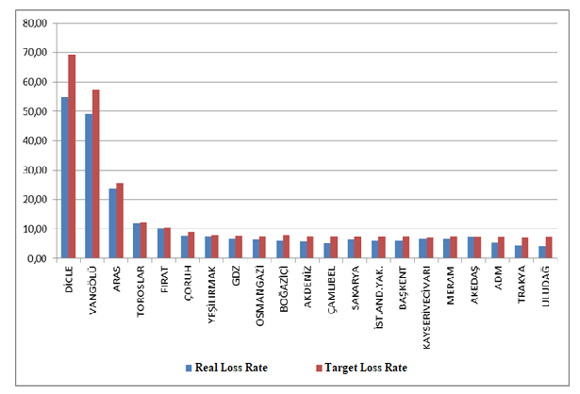

5.3 Employment

By the end of 2018, 54.756 people were employed in electricity distribution sector; 22.387 people were employed as permanent employee and 32.369 people were employed as subcontractor employee. Dicle EDAŞ had the highest number of employees with a total of 5.955 while the distribution company with the highest number of permanent employee was Toroslar EDAŞ with 3.599 people, and Dicle EDAŞ with the number of personnel with the highest number of subcontract employee was 3.349. Kayseri EDAŞ was the distribution company with the lowest number of employees with 892 people.

Table 5.3: Number of Employees of Distribution Companies (Number)
Distribution Company | Number of Permanent Employees | Number of Subcontractor Employees | Total
DİCLE | 2.606 | 3.349 | 5.955
TOROSLAR | 3.599 | 1.897 | 5.496
BAŞKENT | 3.457 | 1.641 | 5.098
BOĞAZİÇİ | 715 | 4.123 | 4.838
GDZ | 739 | 2.381 | 3.120
ULUDAĞ | 484 | 2.302 | 2.786
İ.ANATOLİAN | 1.704 | 933 | 2.637
ADM | 558 | 1.993 | 2.551
MERAM | 722 | 1.790 | 2.512
SAKARYA | 1.617 | 643 | 2.260
YEŞİLIRMAK | 596 | 1.534 | 2.130
FIRAT | 306 | 1.648 | 1.954
VANGÖLÜ | 725 | 1.228 | 1.953
AKDENİZ | 269 | 1.668 | 1.937
ARAS | 462 | 1.319 | 1.781
OSMANGAZİ | 1.203 | 510 | 1.713
ÇORUH | 386 | 1.280 | 1.666
ÇAMLIBEL | 214 | 1.024 | 1.238
AKEDAŞ | 528 | 664 | 1.192
TRAKYA | 795 | 252 | 1.047
KAYSERİ ve CİVARI | 702 | 190 | 892
Total | 22.387 | 32.369 | 54.756

Figure 5.3: Number of Employees of Distribution Companies by Year 2018
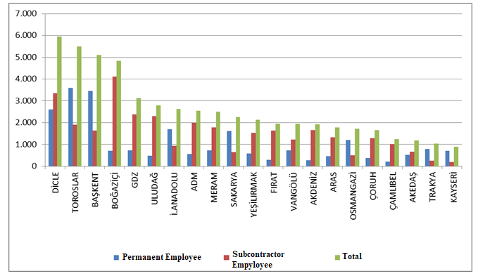

5.4 Information about Network

This section contains basic data on the distribution system. In this context, information on line lengths, transformer capacities and transformer numbers in the distribution voltage level is included in the following tables and figures.
As it is known, almost whole of Turkey has access to electricity. Except for industrial plants with large consumption, all small and medium-sized consumers provide electric energy through the distribution system. As seen from Table 5.4, the total distribution line length of Turkey reached to 1.164.170 km. When considering the line lengths according to the distribution regions, the distribution regions of Başkent, Toroslar, Meram, Yeşilırmak and Dicle were the first five regions. It is seen that the distribution line lengths have a direct correlation with the size of the distribution region.
On the other hand, regarding transformer capacity, it is seen that the electricity distribution regions of Boğaziçi, Toroslar, Gdz, Başkent and Dicle were the top five respectively.

Table 5.4: Line Lengths, Number of Transformers and Transformer Capacities Based on Distribution Companies by end of 2018 (Km-MVA-Number)
Distribution Company |  | Transformer Capacity  (MVA) | Number of Transformers
Distribution Company | Line Length (Km) | Transformer Capacity  (MVA) | Number of Transformers
ADM | 67.706 | 8.167 | 21.623
AKDENİZ | 65.174 | 7.307 | 18.963
AKEDAŞ | 26.300 | 3.406 | 11.991
ARAS | 56.627 | 2.978 | 13.585
BAŞKENT | 111.968 | 14.474 | 32.438
BOĞAZİÇİ | 47.369 | 17.747 | 14.752
ÇAMLIBEL | 45.629 | 2.549 | 12.083
ÇORUH | 59.014 | 3.073 | 12.062
DİCLE | 73.779 | 12.131 | 62.086
FIRAT | 47.239 | 3.136 | 12.358
GDZ | 55.999 | 14.421 | 32.140
İ. ANATOLİAN | 24.340 | 8.870 | 7.563
KAYSERİ VE CİVARI | 24.376 | 2.505 | 7.583
MERAM | 86.297 | 11.198 | 54.517
OSMANGAZİ | 46.374 | 6.469 | 23.974
SAKARYA | 36.784 | 7.705 | 16.806
TOROSLAR | 90.673 | 15.092 | 45.702
TRAKYA | 24.700 | 4.901 | 11.139
ULUDAĞ | 49.764 | 8.726 | 24.589
VANGÖLÜ | 40.860 | 2.816 | 10.927
YEŞİLIRMAK | 83.199 | 4.697 | 21.874
Total | 1.164.170 | 162.367 | 468.755

Figure 5.4: Line Lengths and Transformer Capacities on the Basis of

Distribution Companies at the end of 2018 (Km-MVA)
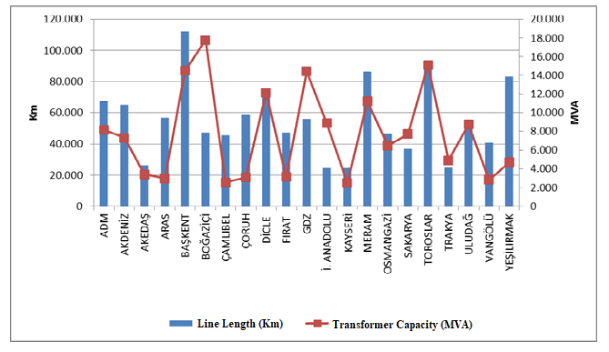
The lengths of distribution lines are shown in Table 5.5. As seen in the table, 81,98 % of the total distribution lines was overhead lines. The share of underground lines in total distribution lines was 18,02 %. This indicates that the distribution lines were open to external influence. The external effects could be natural, climate or human originated disasters such as extreme precipitations, storms etc. could directly or indirectly damage distribution lines.

Table 5.5: The Lengths of Distribution Lines (Km)
Distribution Company | Overhead(Km) | Underground (Km) | Total (Km)
ADM | 58.759 | 8.947 | 67.706
AKDENİZ | 50.273 | 14.901 | 65.174
AKEDAŞ | 23.463 | 2.836 | 26.300
ARAS | 51.481 | 5.147 | 56.627
BAŞKENT | 90.479 | 21.488 | 111.968
BOĞAZİÇİ | 11.915 | 35.454 | 47.369
ÇAMLIBEL | 40.491 | 5.138 | 45.629
ÇORUH | 54.308 | 4.706 | 59.014
DİCLE | 64.706 | 9.073 | 73.779
FIRAT | 43.229 | 4.010 | 47.239
GDZ | 45.730 | 10.269 | 55.999
İ. ANATOLİAN | 5.609 | 18.731 | 24.340
KAYSERİ VE CİVARI | 18.400 | 5.976 | 24.376
MERAM | 77.996 | 8.302 | 86.297
OSMANGAZİ | 40.958 | 5.416 | 46.374
SAKARYA | 30.782 | 6.001 | 36.784
TOROSLAR | 78.364 | 12.308 | 90.673
TRAKYA | 20.711 | 3.989 | 24.700
ULUDAĞ | 38.671 | 11.093 | 49.764
VANGÖLÜ | 38.675 | 2.185 | 40.860
YEŞİLIRMAK | 69.410 | 13.789 | 83.199
TOTAL | 954.411 | 209.759 | 1.164.170

Figure 5.5: The Length of Lines on the Basis of Distribution Companies at the end of 2018(Km)
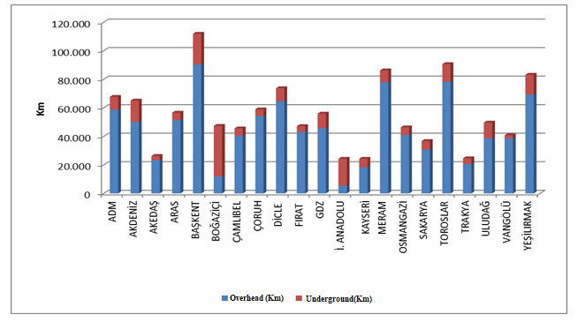
As seen in the figure above, the share of underground line lengths in the Boğaziçi and İstanbul Anatolian Side was higher than the share of overhead lines.
Table 5.6 includes distribution line lengths and transformer capacities. Regarding distribution line lengths was the first five provinces were İstanbul, Ankara, Konya, Antalya and İzmir, respectively.
Regarding the transformer capacities, the first five provinces were İstanbul, İzmir, Ankara, Konya and Antalya, respectively.
Regarding the number of transformers, the first five provinces were Konya, Şanlıurfa, İstanbul, İzmir and Ankara, respectively.

Table 5.6: Line Lengths at Distribution Voltage Levels, Number of Transformers and Transformer Capacities by Provinces in 2018 (Km-MVA-Number)
Provinces | Line Length  (Km) | Transformer Capacity(MVA) | Number of Transformers  (Number)
ADANA | 27.785 | 4.310 | 11.842
ADIYAMAN | 9.253 | 914 | 5.029
AFYONKARAHİSAR | 14.152 | 1.734 | 9.312
AĞRI | 12.982 | 545 | 2.495
AKSARAY | 10.163 | 1.121 | 6.427
AMASYA | 8.086 | 578 | 2.876
ANKARA | 60.157 | 10.697 | 18.045
ANTALYA | 45.398 | 5.614 | 13.105
ARDAHAN | 4.773 | 128 | 904
ARTVİN | 6.878 | 349 | 1.590
AYDIN | 20.472 | 2.677 | 6.956
BALIKESİR | 18.167 | 2.390 | 7.735
BARTIN | 4.109 | 394 | 1.407
BATMAN | 5.953 | 924 | 3.898
BAYBURT | 2.949 | 148 | 703
BİLECİK | 3.987 | 851 | 1.887
BİNGÖL | 6.530 | 355 | 1.783
BİTLİS | 7.416 | 485 | 2.585
BOLU | 7.075 | 708 | 2.744
BURDUR | 9.322 | 678 | 2.874
BURSA | 19.092 | 4.638 | 11.036
ÇANAKKALE | 9.860 | 1.125 | 4.628
ÇANKIRI | 6.469 | 422 | 1.810
ÇORUM | 14.809 | 930 | 4.695
DENİZLİ | 21.272 | 2.422 | 6.523
DİYARBAKIR | 18.166 | 3.167 | 12.547
DÜZCE | 5.558 | 708 | 2.029
EDİRNE | 7.942 | 1.032 | 3.972
ELAZIĞ | 12.035 | 1.146 | 4.034
ERZİNCAN | 6.978 | 454 | 2.078
ERZURUM | 17.575 | 1.084 | 4.591
ESKİŞEHİR | 12.229 | 2.154 | 7.090
GAZİANTEP | 14.910 | 2.659 | 10.588
GİRESUN | 15.788 | 628 | 3.024
GÜMÜŞHANE | 6.294 | 327 | 1.275
HAKKARİ | 8.080 | 362 | 1.677
HATAY | 18.152 | 3.612 | 10.599
IĞDIR | 5.077 | 238 | 1.128
ISPARTA | 10.455 | 1.016 | 2.984
İSTANBUL | 71.709 | 26.617 | 22.315
İZMİR | 34.406 | 11.041 | 19.847
KAHRAMANMARAŞ | 17.047 | 2.492 | 6.962
KARABÜK | 4.468 | 547 | 1.665
KARAMAN | 6.681 | 757 | 4.130
KARS | 6.292 | 381 | 1.686
KASTAMONU | 13.386 | 883 | 4.512
KAYSERİ | 24.376 | 2.505 | 7.583
KIRIKKALE | 11.336 | 467 | 1.487
KIRKLARELİ | 6.164 | 933 | 2.268
KIRŞEHİR | 5.687 | 460 | 2.138
KİLİS | 2.172 | 237 | 1.010
KOCAELİ | 11.854 | 4.430 | 7.204
KONYA | 46.273 | 6.423 | 29.959
KÜTAHYA | 9.020 | 967 | 3.200
MALATYA | 23.679 | 1.471 | 5.339
MANİSA | 21.592 | 3.380 | 12.293
MARDİN | 11.368 | 2.208 | 11.607
MERSİN | 20.734 | 3.621 | 9.392
MUĞLA | 25.962 | 3.068 | 8.144
MUŞ | 7.742 | 454 | 2.207
NEVŞEHİR | 8.336 | 1.290 | 6.342
NİĞDE | 9.157 | 1.148 | 5.521
ORDU | 24.476 | 882 | 4.753
OSMANİYE | 6.920 | 653 | 2.271
RİZE | 9.225 | 583 | 2.258
SAKARYA | 12.297 | 1.859 | 4.829
SAMSUN | 27.783 | 1.950 | 7.360
SİİRT | 4.162 | 370 | 1.698
SİNOP | 8.044 | 357 | 2.190
SİVAS | 18.808 | 1.074 | 4.630
ŞANLIURFA | 29.636 | 4.644 | 28.760
ŞIRNAK | 4.494 | 818 | 3.576
TEKİRDAĞ | 10.593 | 2.936 | 4.899
TOKAT | 13.496 | 711 | 3.224
TRABZON | 20.830 | 1.187 | 3.915
TUNCELİ | 4.994 | 164 | 1.202
UŞAK | 6.986 | 763 | 2.485
VAN | 17.622 | 1.515 | 4.458
YALOVA | 2.646 | 573 | 1.190
YOZGAT | 13.325 | 764 | 4.229
ZONGULDAK | 12.044 | 1.065 | 3.512
TOTAL | 1.164.170 | 162.367 | 468.755

5.5 Quality Indicators

Data on the technical quality of the electricity provided by the distribution companies are compiled and the tables below show Customer Average Interruption Duration Index (CAIDI) and Customer Average Interruption Frequency Index (CAIFI).

Table 5.7: Reported and Unreported Customer Average Interruption Duration Indices of Distribution Companies in 2018 (min)
 | 2017 |  |  | 2018 |  |  | Change (%)
DISTRIBUTION COMPANY | Reported CAIDI  (min) | Unreported CAIDI  (min) | Total CAIDI  (min) | Reported  CAIDI (min) | Unreported  CAIDI  (min) | Total  CAIDI  (min) | Change (%)
VANGÖLÜ | 658,4 | 5.952,9 | 6.611,3 | 934,5 | 9.196,9 | 10.131,3 | 53,24
BOĞAZİÇİ | 215,1 | 1.129,4 | 1.344,5 | 240,3 | 3.767,5 | 4.007,7 | 198,09
FIRAT | 212,6 | 1.666,8 | 1.879,4 | 199,1 | 2.281,8 | 2.480,9 | 32,00
ULUDAĞ | 473,7 | 500,1 | 973,8 | 628,5 | 1.538,6 | 2.167,1 | 122,55
MERAM | 1.064,8 | 1.330,8 | 2.395,6 | 832,3 | 1.063,2 | 1.895,5 | -20,88
TOROSLAR | 577,3 | 1.384,5 | 1.961,8 | 571,9 | 1.238,0 | 1.809,9 | -7,74
TRAKYA | 548,0 | 1.470,3 | 2.018,3 | 556,0 | 1.205,3 | 1.761,4 | -12,73
SAKARYA | 508,7 | 1.247,1 | 1.755,9 | 415,4 | 1.295,7 | 1.711,1 | -2,55
AKEDAŞ | 435,9 | 616,3 | 1.052,3 | 635,4 | 882,3 | 1.517,6 | 44,23
GDZ | 410,5 | 1.203,2 | 1.613,7 | 384,1 | 1.125,7 | 1.509,8 | -6,44
ÇORUH | 242,8 | 850,5 | 1.093,2 | 326,7 | 1.106,1 | 1.432,8 | 31,06
ARAS | 269,6 | 2.562,5 | 2.832,1 | 250,3 | 1.086,2 | 1.336,5 | -52,81
YEŞİLIRMAK | 477,9 | 746,3 | 1.224,2 | 591,3 | 729,8 | 1.321,0 | 7,91
ÇAMLIBEL | 506,0 | 960,4 | 1.466,3 | 478,1 | 823,5 | 1.301,6 | -11,23
BAŞKENT | 205,2 | 363,8 | 569,1 | 325,5 | 961,1 | 1.286,6 | 126,08
DİCLE | 10,9 | 1.691,8 | 1.702,7 | 429,8 | 842,0 | 1.271,9 | -25,30
OSMANGAZİ | 274,2 | 473,2 | 747,4 | 291,2 | 779,6 | 1.070,8 | 43,26
ADM | 432,8 | 691,5 | 1.124,2 | 277,1 | 770,5 | 1.047,7 | -6,81
AKDENİZ | 302,3 | 785,3 | 1.087,7 | 313,5 | 688,1 | 1.001,6 | -7,91
KAYSERİ | 210,7 | 203,4 | 414,1 | 329,5 | 258,8 | 588,3 | 42,08
İSTANBUL AN. SİDE | 178,6 | 377,5 | 556,2 | 183,6 | 232,2 | 415,8 | -25,24

The table above shows the reported, unreported and total Customer Average Interruption Duration Index in 2017 and 2018. While the first three regions were Meram, Vangölü and Akedaş regions according to reported interruptions, Vangölü, Boğaziçi and Fırat regions were the first three regarding unreported interruptions.
The highest Customer Average Interruption Duration Index was observed in Vangölü region with 10.131,3 minutes and Boğaziçi region with 4.007,7 minutes.

Table 5.8: Customer Average Interruption Duration Indices of Distribution Companies by reason in 2018 (min)

DISTRIBUTION COMPANY | External | Security | Force Major | Network Operator | Total
VANGÖLÜ | 0,0 | 0,0 | 0,0 | 10.131,3 | 10.131,3
BOĞAZİÇİ | 48,3 | 43,9 | 0,0 | 3.915,5 | 4.007,7
FIRAT | 13,3 | 1,8 | 2,6 | 2.463,2 | 2.480,9
ULUDAĞ | 91,9 | 21,3 | 0,0 | 2.054,0 | 2.167,1
MERAM | 91,2 | 4,2 | 18,9 | 1.781,2 | 1.895,5
TOROSLAR | 35,7 | 49,2 | 0,0 | 1.725,1 | 1.809,9
TRAKYA | 11,1 | 16,3 | 0,6 | 1.733,3 | 1.761,4
SAKARYA | 47,6 | 9,5 | 0,0 | 1.654,0 | 1.711,1
AKEDAŞ | 21,4 | 51,0 | 9,0 | 1.436,3 | 1.517,6
GDZ | 14,8 | 1,3 | 0,0 | 1.493,7 | 1.509,8
ÇORUH | 16,8 | 0,1 | 0,0 | 1.415,9 | 1.432,8
ARAS | 3,0 | 0,3 | 546,0 | 787,2 | 1.336,5
YEŞİLIRMAK | 32,1 | 13,6 | 5,5 | 1.269,8 | 1.321,0
ÇAMLIBEL | 2,0 | 1,0 | 0,0 | 1.298,5 | 1.301,6
BAŞKENT | 55,0 | 65,6 | 0,0 | 1.166,0 | 1.286,6
DİCLE | 8,0 | 0,2 | 0,0 | 1.263,6 | 1.271,9
OSMANGAZİ | 10,4 | 0,6 | 0,0 | 1.059,7 | 1.070,8
ADM | 28,7 | 9,9 | 0,0 | 1.009,1 | 1.047,7
AKDENİZ | 24,0 | 30,3 | 0,0 | 947,3 | 1.001,6
KAYSERİ VE CİVARI | 44,0 | 0,5 | 1,2 | 542,6 | 588,3
İSTANBUL ANT.SİDE | 17,1 | 5,8 | 0,0 | 393,0 | 415,8

The table above shows the distribution of CAIDI according to the reasons. It seems that the highest interruption duration was caused by the network operator.
The following table shows the average interruption frequency of distribution companies. The highest Customer Average Interruption Duration was 78,4 per customer in the Vangölü region, followed by the Sakarya region with 37,7 (Customer/Year).

Table 5.9: Customer Average Interruption Frequency Indices of Distribution Companies in 2017 and 2018 (Number/Year)
DISTRIBUTION COMPANY | 2017 |  |  |  | 2018 |  |  |  | Change (%)
DISTRIBUTION COMPANY | Reported | Unreported | Short | Total | Reported | Unreported | Short | Total | Change (%)
VANGÖLÜ | 1,7 | 50,1 | 0,4 | 52,2 | 2,9 | 75,0 | 0,5 | 78,4 | 50,13
SAKARYA | 2,7 | 30,1 | 3,6 | 36,3 | 2,3 | 31,6 | 3,8 | 37,7 | 3,70
DİCLE | 0,2 | 30,9 | 0,0 | 31,1 | 2,9 | 28,4 | 3,5 | 34,8 | 12,03
BOĞAZİÇİ | 0,8 | 11,8 | 0,0 | 12,6 | 0,9 | 27,7 | 4,5 | 33,1 | 163,01
AKEDAŞ | 3,4 | 11,6 | 2,6 | 17,5 | 4,5 | 23,8 | 4,8 | 33,0 | 88,48
ULUDAĞ | 1,7 | 5,0 | 0,5 | 7,3 | 2,9 | 17,0 | 3,9 | 23,8 | 226,94
TRAKYA | 2,0 | 19,7 | 4,7 | 26,4 | 2,0 | 16,4 | 3,2 | 21,6 | -18,23
ADM | 1,8 | 13,3 | 0,0 | 15,1 | 1,2 | 16,8 | 1,7 | 19,7 | 30,84
OSMANGAZİ | 1,2 | 13,0 | 0,0 | 14,2 | 1,4 | 17,3 | 0,2 | 18,9 | 32,61
GDZ | 1,8 | 13,9 | 0,0 | 15,8 | 1,7 | 15,7 | 0,5 | 17,9 | 13,62
ÇAMLIBEL | 1,8 | 12,2 | 0,3 | 14,4 | 1,7 | 11,1 | 4,7 | 17,5 | 21,73
FIRAT | 0,7 | 9,0 | 0,0 | 9,7 | 0,9 | 15,6 | 0,2 | 16,7 | 71,94
MERAM | 4,4 | 12,4 | 0,0 | 16,8 | 4,3 | 11,8 | 0,1 | 16,1 | -3,77
YEŞİLIRMAK | 2,2 | 12,0 | 0,4 | 14,6 | 2,4 | 11,7 | 0,8 | 14,9 | 2,39
KAYSERİ | 1,7 | 4,0 | 2,9 | 8,6 | 2,2 | 5,4 | 6,4 | 14,0 | 62,68
ÇORUH | 1,2 | 9,3 | 0,5 | 11,0 | 1,4 | 10,3 | 1,2 | 12,9 | 17,13
AKDENİZ | 1,0 | 10,4 | 0,5 | 11,9 | 1,1 | 9,4 | 1,2 | 11,7 | -2,15
BAŞKENT | 0,7 | 3,8 | 0,1 | 4,7 | 1,1 | 9,4 | 0,3 | 10,8 | 130,94
TOROSLAR | 1,6 | 10,5 | 0,1 | 12,2 | 1,6 | 8,3 | 0,1 | 10,0 | -17,89
ARAS | 0,9 | 17,5 | 0,1 | 18,5 | 0,8 | 9,0 | 0,1 | 10,0 | -46,17
İSTANBUL ANT. SİDE | 0,6 | 3,9 | 0,1 | 4,6 | 0,8 | 3,2 | 0,1 | 4,1 | -11,70

Table 5.10: Distribution Companies’ Customer Average Interruption Frequency Indices of Distribution Companies by Reason in 2018 (Number/Year)
DISTRIBUTION COMPANY | External | Security | Short | Force Majeure | Network Operator | Total
VANGÖLÜ | 0,0 | 0,0 | 0,5 | 0,0 | 77,9 | 78,4
SAKARYA | 0,8 | 0,2 | 3,8 | 0,0 | 32,9 | 37,7
DİCLE | 0,1 | 0,0 | 3,5 | 0,0 | 31,2 | 34,8
BOĞAZİÇİ | 0,3 | 0,2 | 4,5 | 0,0 | 28,0 | 33,1
AKEDAŞ | 0,5 | 0,2 | 4,8 | 0,0 | 27,6 | 33,0
ULUDAĞ | 0,6 | 0,1 | 3,9 | 0,0 | 19,3 | 23,8
TRAKYA | 0,1 | 0,0 | 3,2 | 0,0 | 18,3 | 21,6
ADM | 0,4 | 0,1 | 1,7 | 0,0 | 17,5 | 19,7
OSMANGAZİ | 0,2 | 0,0 | 0,2 | 0,0 | 18,5 | 18,9
GDZ | 0,2 | 0,0 | 0,5 | 0,0 | 17,2 | 17,9
ÇAMLIBEL | 0,0 | 0,0 | 4,7 | 0,0 | 12,8 | 17,5
FIRAT | 0,1 | 0,0 | 0,2 | 0,0 | 16,4 | 16,7
MERAM | 0,9 | 0,0 | 0,1 | 0,1 | 15,0 | 16,1
YEŞİLIRMAK | 0,5 | 0,2 | 0,8 | 0,1 | 13,4 | 14,9
KAYSERİ | 0,8 | 0,0 | 6,4 | 0,0 | 6,8 | 14,0
ÇORUH | 0,1 | 0,0 | 1,2 | 0,0 | 11,5 | 12,9
AKDENİZ | 0,3 | 0,2 | 1,2 | 0,0 | 10,0 | 11,7
BAŞKENT | 0,4 | 0,4 | 0,3 | 0,0 | 9,7 | 10,8
TOROSLAR | 0,2 | 0,4 | 0,1 | 0,0 | 9,4 | 10,0
ARAS | 0,0 | 0,0 | 0,1 | 3,4 | 6,4 | 10,0
İSTANBUL ANT. SİDE | 0,2 | 0,0 | 0,1 | 0,0 | 3,7 | 4,1

5.6 Investment Amount of Distribution Companies
With the decision of the Board 24/11/2015 dated and 5885/7 numbered, the "Procedures and Principles for Investments in Electricity Market Distribution System" were approved and entered into force.
Electricity distribution companies started on 01/01/2016 with the Board Resolution 18/11/2015 dated and 5875/9 numbered. It was decided to set the Real Reasonable Rate of Return to be taken into consideration during the implementation period as 12,66 % (real and pre-tax) and the Adjusted Real Reasonable Rate of Return as 11,91 % (real and pre-tax).
With the Board Decision 18/11/2015 dated and 5875/6 numbered, the period of redemption for distribution companies and investments in the third implementation period was determined as 10 years.
The following table provides information about the amount of investment made by the Distribution Companies.

Table 5.11: List of Distribution Investments Comparison in 2017-2018 (TL-%)
DISTRIBUTION COMPANY | 2017 | 2018 | 2017-2018 Change  (%)
ADM | 303,7 | 183,8 | -39,5
AKDENİZ | 237,1 | 156,6 | -34,0
AKEDAŞ | 169,6 | 79,5 | -53,2
ARAS | 224,6 | 140,0 | -37,6
İSTANBUL ANT.S.EDAŞ | 296,5 | 234,7 | -20,8
BAŞKENT | 699,9 | 621,1 | -11,3
BOĞAZİÇİ | 449,5 | 384,0 | -14,6
ÇAMLIBEL | 147,0 | 111,9 | -23,9
ÇORUH | 208,1 | 142,6 | -31,5
DİCLE | 457,5 | 277,2 | -39,4
FIRAT | 187,7 | 144,4 | -23,1
GDZ | 420,1 | 254,2 | -39,5
KAYSERİ | 188,9 | 154,0 | -18,5
MERAM | 346,7 | 332,3 | -4,2
OSMANGAZİ | 492,3 | 54,8 | -88,9
SAKARYA | 168,6 | 151,6 | -10,1
TOROSLAR | 811,9 | 737,8 | -9,1
TRAKYA | 172,1 | 79,7 | -53,7
ULUDAĞ | 276,0 | 270,9 | -1,8
VANGÖLÜ | 179,8 | 122,5 | -31,8
YEŞİLIRMAK | 406,6 | 275,4 | -32,3
Total | 6.844,3 | 4.908,9 | -28,3
*The unit price is calculated according to the June CPI: 357,44
** Investments starting in the II. Implementation Period and complemented in the III. Implementation Period are included.
*** The tables are prepared on the basis of the declarations made by the companies via the notification system.
In 2018, total investment realized as 4,91 billion TL (at current prices) with a decrease of 28.3% compared to 2017. The highest investment expenditure for the year 2018 was in the Başkent regions with 621,1 Million TL and in Toroslar with 737,8 Million TL.

Figure 5.6 Investment Amounts of Dıstribution Companies in 2018(Current Prices-TL)
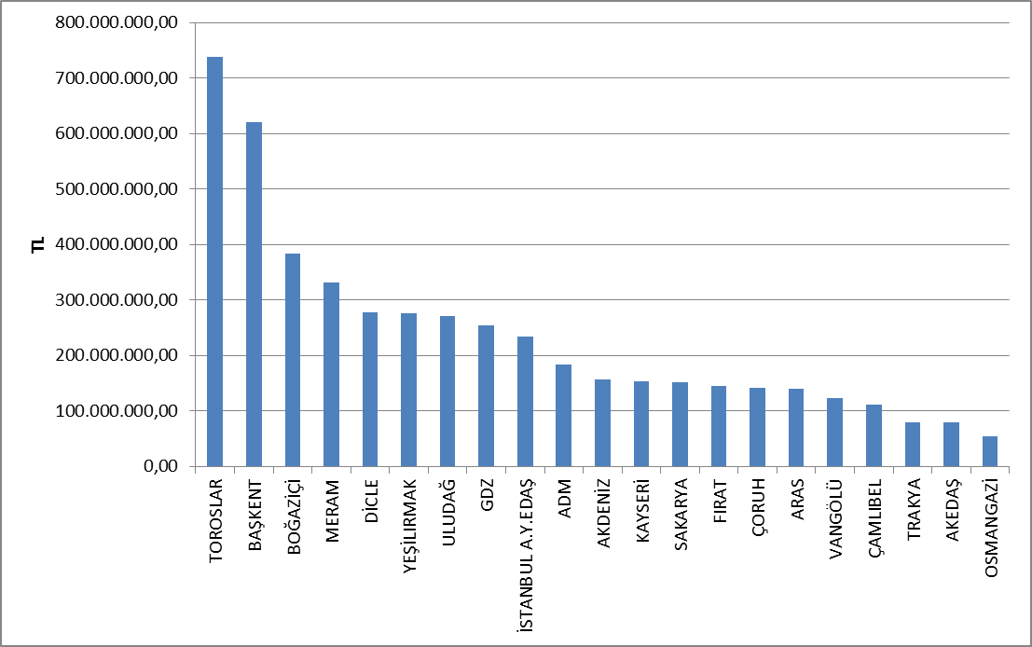
The investment expenditures realized according to the type of investment in 2018 are shown in the table below. The majority of investments are network investments.

Table 5.12: Investment Amounts of Distribution Companies by Investment Type in 2018 (Current Prices-million TL)
Distribution Company | Investment Type | 2018 Investment Amount  (CPI June.2018:357,44)
21 EDAŞ | Network Investments | 3.749.020.044,37
21 EDAŞ | Investments with Environmental, Security and Other Legal Obligations | 593.281.560,63
21 EDAŞ | Network Operating System Investments | 365.115.533,59
21 EDAŞ | Counter Investment | 145.241.295,08
21 EDAŞ | Network Investments (Other investments) | 56.273.280,24
21 EDAŞ | Total | 4.908.931.713,91
*The unit price is calculated according to the June CPI: 357,44
** Investments starting in the II. Implementation Period and complemented in the III. Implementation Period are included.
*** The tables are prepared on the basis of the declarations made by the companies via the notification system.

5.7 Information about Organized Industrial Zones (OIZ)

The following table shows the data related to OIZ Distribution License Owners.

Table 5.13 Information about Organized Industrial Zones

Number of Participant AG | 46.000
Number of Participant OG | 13.130
Number of Total Participant | 59.130
Line Lenght AG | 4.934
Line Length OG | 18.732
Total Line Length | 23.666
Number of Employee (Electricity Transmission) | 797
Number of Transformer (number) | 17.724
Installed Capacity of Transformer (MVA) | 18.606
Annual puant value of previous year (MW) | 6.441

As of the end of 2018, the total number of participants in Organized Industrial Zones was 46.000 in low voltage,and 13.130 in medium voltage. 797 personnel was employed in electricity distribution in OIZ distribution regions.
Total OIZ line length was 23.666 km. Total OIZ Transformer Capacity reached to 18.606 MVA level. The sum of the peak values for the previous year in the OIZ regions was 6.441 MW.

6. PRICING

The Electricity Market Law predicts a market structure based on bilateral agreements. The price of electric energy in the market is determined by mutual agreement of buyer and seller. Therefore, the prices determined by bilateral agreements are within the knowledge of related parties and are not shared with public. On the other hand, a significant portion of consumers supply electricity from the regulated prices. For this reason, the change in prices and price components over the years is important. There is data about the changes in the prices and components that constitute the price within the years.
The following table shows the annual change in retail energy tariffs (system fees, excluding tax and funding, retail sale services) by tariff groups.

Figure 6.1: Change in Retail Electric Energy Prices in the Last Five Years (Kr/kWh)
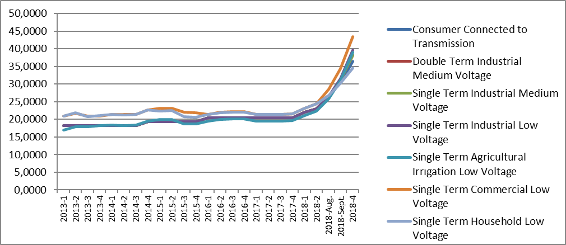
As it is known, it is necessary to use transmission and distribution lines to deliver energy from producer to the consumer. The figure below shows the change in distribution costs by years. Those include distribution, transmission costs and technical and non-technical losses.

Figure 6.2: Change in Network Costs (Distribution, Transmission and Loss) by Years (Kr / kWh)
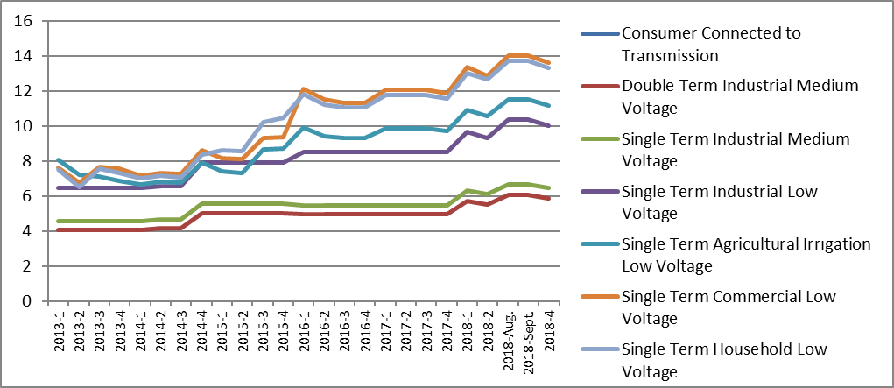
As a result of the addition of the distribution cost to energy cost, the pre-tax unit energy cost is calculated. The figure below shows the change in unit energy cost by years except for taxes and funds (energy fund, TRT share, electricity and gas consumption tax and VAT).

Figure 6.3: Change in Electricity Tariffs before Taxes and Funds by Years (kr / kWh)
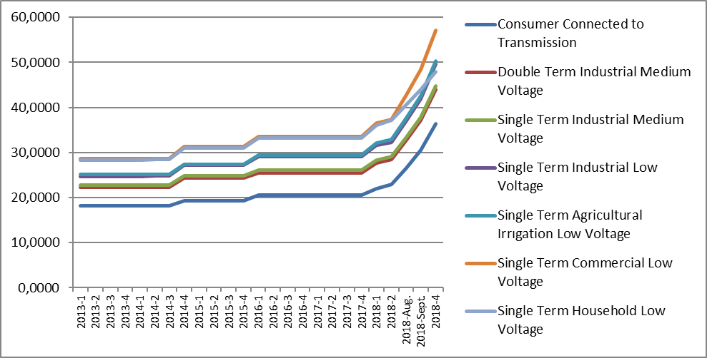

As seen in the figure above, the consumer groups with the highest unit energy costs before taxes and funds were of households and commercials. The lowest unit energy cost before taxes and funds were of the consumers who are connected through the transmission system.

Figure 6.4: Share of Items on Residence Electricity Invoice in 2018 (%)
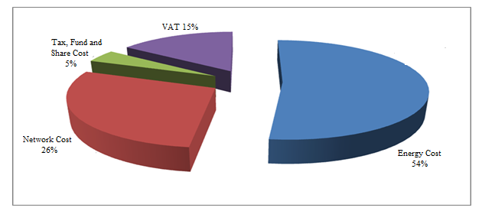
As it can be seen from Figure 6.4, the most important item in the invoices of consumers in the household, excluding the retail energy cost, was the network cost with 26% share.

Figure 6.5: Share of Items on Industry Electricity Invoice in 2018 (%)
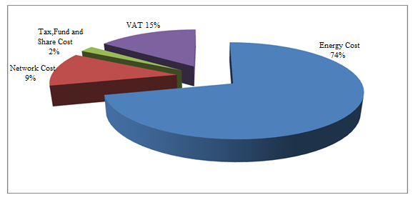

As shown in Figure 6.5, in the invoice components of the consumers in the industrial group compared to the invoice components of the consumers in the households in Figure 6.4; it is seen that the share of retail energy cost was higher and the share of distribution (network) was lowe.

The average feed-in tariffs of RESSUM is calculated with monthly average currency rates declared by Turkish Republic Central Bank.
The HHI values are evaluated as a competitive market indicator. If HHI is under 1000 the market is competitive, medium intensity if HHI is between 1000 -1800, and an oligopoly market if HHI is above 1800. In the same way, if the HHI increases by more than 100 points in mergers and acquisitions, it is considered that competitiveness is reduced.
Includes all sales made to eligible and non-eligible consumers for sales volumes of incumbent supply companies.
Including the data about facilities owned by customers.

