

ELECTRICITY MARKET DEVELOPMENT REPORT 2019

All the information, tables and figures provided in this report are reserved and cannot be used without reference.

REPUBLIC OF TURKEY
ENERGY MARKET REGULATORY AUTHORITY

Strategy Development Department

ANKARA, 2020

Important Notice:
- Licensees may revise their own data submitted before, through correction requests. Therefore, there may be some nonconformity between previous reports and present report published.
- In this report Turkish punctuation rules are adopted for numbers.

This report is published within the scope of Official Statistics Program.

PRESIDENT’s MeSSAGE

After the period which were striving for a number of regulations and other legislations that were put into effect in the framework of the Electricity Market Law numbered 6446, which entered into force in 2013, a significant process was made in 2019 on the light of these regulations as moving towards a more liberal, competitive, transparent and foreseeable structure on the market.
The structural arrangements we have made in recent years to encourage the use of renewable energy sources instead of imported resources in electricity production continued to show the results. In this context, the share of renewable energy sources, which was 30,67% in total electricity generation in 2018, increased to 42,10% in 2019.
Market developments reports, which we submit to our stakeholders by our Institution, are compiled and analyzed from the data submitted to our Agency by using the Energy Market Notification System. It is one of our main objectives to ensure the integrity, consistency and reliability of the data contained in these reports, which are of great importance for accurate and timely sharing with all relevant parties and the public.
Once again, I would like to indicate that as EMRA we are open to all kind of constructive opinion and suggestion and I wish the Electricity Market Development Report of 2019 will be useful to all related parties, institutions and organizations.

Mustafa YILMAZ
President

EXECUTIVE SUMMARY

- Licensed Installed Capacity and Peak Demand

  - Licensed installed capacity in 2019 was 84.957,72 MW increasing by 2,13% compared to previous year.

  - In 2018-2019, licensed installed capacity according to resource type is given below:

Resource Type | 2018  (MW) | Share  (%) | 2019  (MW) | Share  (%) | Change 2018-2019(%)
NATURAL GAS | 25.731,93 | 30,93 | 25.935,41 | 30,53 | 0,79
HYDRO DAM | 20.534,80 | 24,69 | 20.642,51 | 24,30 | 0,52
LIGNITE | 9.597,12 | 11,54 | 10.101,03 | 11,89 | 5,25
IMPORT COAL | 8.938,85 | 10,75 | 8.966,85 | 10,55 | 0,31
RUN OF RIVER | 7.748,90 | 9,32 | 7.851,85 | 9,24 | 1,33
WIND | 6.942,27 | 8,35 | 7.520,33 | 8,85 | 8,33
GEOTHERMAL | 1.282,52 | 1,54 | 1.514,69 | 1,78 | 18,10
HARD COAL | 616,15 | 0,74 | 810,77 | 0,95 | 31,59
BIOMASS | 590,92 | 0,71 | 725,92 | 0,85 | 22,85
ASPHALTITE COAL | 405 | 0,49 | 405,00 | 0,48 | 0,00
FUEL OİL | 709,21 | 0,85 | 305,93 | 0,36 | -56,86
SOLAR | 81,66 | 0,10 | 169,70 | 0,20 | 107,81
NAPHTA | 4,74 | 0,01 | 4,74 | 0,01 | -0,08
LNG | 1,95 | 0,00 | 1,95 | 0,00 | 0,00
DIESEL | 1,04 | 0,00 | 1,04 | 0,00 | 0,00
Total | 83.187,05 | 100,00 | 84.957,72 | 100,00 | 2,13

- While the share of renewable energy sources (including hydraulics) in total installed power was 44,70% by the end of 2018, it increased to 45,23% in 2019. The ratio of total installed thermal power decreased from 55,30% in 2018 to 54,77% in 2019.

- Peak demand reached to 45.324,35 MW decreasing by 1,81%.

- Licensed Electricity Generation and Consumption

- The amount of licensed electricity generation in 2019 decreased by 0,59% compared to 2018 and became 294.251,32 GWh.
- In 2018-2019 , licensed electricity generation according to resource type is given below:

Resource Type | 2018  (GWh) | Share  (%) | 2019  (GWh) | Share  (%) | Change 2018-2019(%)
HYDRO GAM | 59.902,04 | 20,24 | 88.850,17 | 30,20 | 48,33
IMPORT COAL | 62.988,54 | 21,28 | 60.381,27 | 20,52 | -4,14
NATURAL GAS | 91.639,14 | 30,96 | 56.522,71 | 19,21 | -38,32
LIGNITE | 45.087,00 | 15,23 | 46.893,73 | 15,94 | 4,01
WIND | 19.827,00 | 6,70 | 21.636,28 | 7,35 | 9,13
GEOTHERMAL | 7.430,98 | 2,51 | 8.929,73 | 3,03 | 20,17
BIOMASS | 3.240,96 | 1,09 | 4.266,32 | 1,45 | 31,64
HARD COAL | 2.844,58 | 0,96 | 3.518,87 | 1,20 | 23,70
ASPHALITE COAL | 2.328,50 | 0,79 | 2.323,95 | 0,79 | -0,20
FUEL OİL | 328,89 | 0,11 | 732,92 | 0,25 | 122,84
SOLAR | 385,86 | 0,13 | 194,37 | 0,07 | -49,63
DIESEL | 0,22 | 0,00 | 1,00 | 0,00 | 349,30
Total | 296.003,71 | 100,00 | 294.251,32 | 100,00 | -0,59

- The share of renewable energy sources (including hydraulics) in total licensed electricity generation was 30,67% in 2018 and 42,10% in 2019. The ratio of the total installed thermal power was 69,33% in 2018 and 57,90% in 2019.
- Consumption decreased by 0,26% compared to 2018 and reached 301.982,70 GWh.

- Unlicensed Generation

- The unlicensed installed power increased by 18,81% in 2019 compared to the previous year and became 6.309.27 MW. 92,33% of this amount consists of power plants based on solar energy.

- In 2018-2019, unlicensed installed capacity according to resource type is given below:

Resource Type | 2018 |  | 2019
Resource Type | Installed Capacity  (MWe) | Share  (%) | Installed Capacity  (MWe) | Share  (%)
Solar | 5.016,99 | 94,47 | 5.825,46 | 92,33
Natural Gas | 153,04 | 2,88 | 328,66 | 5,21
Biomass | 79,18 | 1,49 | 75,67 | 1,20
Wind | 51,95 | 0,98 | 70,83 | 1,12
Hydraulic | 8,91 | 0,17 | 8,65 | 0,14
Total | 5.310,57 | 100,00 | 6.309,27 | 100,00

- The unlicensed production amount increased by 19,68% in 2019 compared to 2018 and reached 9.829,45 GWh. 95,90% of this amount was obtained from solar energy.

- In 2018-2019, unlicensed generation according to resource type is given below:

Resource Type | 2018 |  | 2019
Resource Type | The amount of energy given to the system as surplus (MWh) | Share  (%) | The amount of energy given to the system as surplus (MWh) | Share  (%)
Solar | 7.860.576,89 | 95,71 | 9.425.965,29 | 95,90
Biomass | 205.901,95 | 2,51 | 255.486,79 | 2,60
Wind | 111.542,03 | 1,36 | 113.558,01 | 1,16
Hydraulic | 34.750,58 | 0,42 | 34.437,65 | 0,34
Total | 8.212.771,44 | 100,00 | 9.829.447,73 | 100,00

- Invoiced Consumption

Consumer Type | Consumption Amount of Consumers Connected to the Distribution Voltage level (MWh) |  | Consumption Amount of Consumers Connected to Transmission Voltage Level (MWh) |  | Total (MWh)
 | 2018 | 2019 | 2018 | 2019 | 2018 | 2019
Non-Eligible Consumer | 147.685.452,79 | 134.409.689,21 | 16.747.847,16 | 1.278.906,46 | 164.433.299,95 | 135.688.595,67
Eligible Consumer | 30.225.373,40 | 41.494.792,25 | 38.951.356,19 | 52.414.525,73 | 69.176.729,59 | 93.909.317,98
Total | 177.910.826,19 | 175.904.481,46 | 55.699.203,35 | 53.693.432,19 | 233.610.029,54 | 229.597.913,65

- Electricity consumption, which was invoiced in 2019, decreased by 1,72% compared to the previous year and reached 229,6 TWh. 53,7 TWh of this amount was sold to consumers at the transmission voltage level, while the remaining 175,9 TWh was sold to consumers at the distribution voltage level.

- In addition, 93,9 TWh of 229,6 TWh consumption was consumed by free consumers and 135,7 TWh by non-eligible consumers.

- Import and Export

  - In 2019, electricity imports decreased by 10,32% compared to the previous year and reached 2,21 TWh.

  - Electricity exports decreased by 9,27% compared to the previous year and reached 2,79 TWh.

- Day-Ahead Market and Balancing Market

  - In 2019, the weighted average Market Clearing Price (PTF) increased by 15,18% compared to 2018 and became 268,48 TL / MWh.

  - The highest PTF value was realized on June 27, 2019 at 15:00 with 500,00 TL / MWh. In 2019, PTF was realized as 0 TL / MWh for a total of 52 hours.

  - In 2019, the average System Marginal Price (SMF) increased by 7,28% compared to 2018 and reached 250,25 TL / MWh.

  - The highest SMF value was 487,15 TL / MWh at 18:00 on November 11, 2019 and the lowest SMF value was 0 TL / MWh for 365 hours in total.

  - The additional cost caused by the instructions given in Day-Ahead Market in 2019 increased by 423% compared to 2018 and reached 625,8 million TL.

- RESSUM

  - In 2019, the number of licensed participants benefiting from the Renewable Energy Resources Support Mechanism reached to 777. The installed capacity of these participants was 20.921,5 MW.

  - In 2019, the electricity generation of RESSUM participants increasing by 22,5% to 76,69 TWh compared to 2018. 48,2% of this amount was obtained from hydraulic, 26% from wind.

  - The average price of YEKDEM in 2019 was 495,6 TL / MWh with an increase of 41,16% compared to 2018.

  - In 2019, an additional cost of RESSUM which means additional cost to the weighted average MCP for RESSUM per invoiced unit energy amount, increased by 139% to 75,89 TL/ MWh compared to previous year.

- Market Openness

  - The eligible consumer limit for 2019 was set at 1.600 kWh, and the theoretical market openness rate on the demand side corresponding to this limit was calculated as 95,4%.

  - Eligible consumers' consumption in 2019 was 93,9 TWh. While the actual market opening was 29,6% in 2018, this rate increased to 40,9% in 2019.

  - At the end of 2019, the number of eligible consumers increased by 132% compared to the end of 2018 and reached 339.000 . This number corresponds to 0,76% of the total number of consumers.

- Transmission

  - By the end of 2019, there were 1.212 transformer centers in the transmission system and 2.376 transformers with 216.066 MVA capacity.

  - As of the end of 2019, the length of the transmission lines was 70.024 km.

  - In 2019, TL 2,72 billion was invested by the transmission company.

  - In 2019, The transmission system loss rate was 2,15%.

- Distribution

  - By the end of 2019, the number of consumers using the distribution system was 44,96 million. The regions with the highest number of consumers were the Boğaziçi with 5,13 million and the Başkent with 4,28 million.

  - By the end of 2018, the total invoiced consumption in the distribution regions was realized as 175,90 TWh. The regions with the highest consumption amounts were the Boğaziçi with 24,78 TWh and the Toroslar with 15,49 TWh.

  - The highest loss rates were seen in Dicle with 51,32%, Vangölü with 47,56% and Aras with 21,64%.

  - The lowest loss rates were seen in the distribution regions of Uludağ with 4,82%, Trakya with 4,49% and Çamlıbel with 4,75%.

  - By the end of 2019, 56.903 people were employed in the electricity distribution sector. Of those, 24.211 were employed as permanent staff in distribution companies and 32.692 were employed as subcontractor company personnel.

  - By the end of 2019, there were 485.933 transformers in the distribution system with 169.060 MVA power.

  - By the end of 2019, the length of distribution lines was 1.190.169 km. 966.979 km of this figure is overhead lines and 223.190 km is underground lines.

  - In 2019, the distribution companies invested 7,24 billion TL in current prices. The highest investment expenditure was realized in the regions of Osmangazi with 1,26 billion TL and the Boğaziçi with 720,4 million TL.

Electricity Market Overview in 2019
Parameters | Unit | 2018 | 2019 | Change (%)
Licensed Installed Capacity | MWe | 83.187,05 | 84.957,72 | 2,13
Liscensed Generation* | GWh | 296.003,71 | 294.251,32 | -0,59
Highest Peak Demand | MW | 46.160 | 45.324 | -1,81
Lowest Peak Demand | MW | 18.212 | 18.300 | 0,48
Unlicensed Generation** | GWh | 8.212,77 | 9.829,45 | 19,68
Unlicense Installed Capacity | MWe | 5.310,57 | 6.309,27 | 18,81
RESSUM Generation*** | MWh | 62.608.517 | 76.687.980 | 22,49
RESSUM Amount of Payment | TL | 21.979.237.357 | 38.012.077.764 | 72,95
Average RESSUM Price | TL/MWh | 351,1 | 495,6 | 41,16
RESSUM Additional Cost**** | TL/MWh | 31,75 | 75,89 | 139,02
Actual Consumption | GWh | 302.772,30 | 301.982,70 | -0,26
Invoice-Based Consumption | MWh | 233.610.029,54 | 229.597.913,65 | -1,72
Number of Consumer | Number | 43.653.910 | 44.958.924 | 2,99
Import | GWh | 2.466,01 | 2.211,51 | -10,32
Export | GWh | 3.073,60 | 2.788,67 | -9,27
Weighted Average MCP | TL/MWh | 233,101 | 268,48 | 15,18
Weighted Average SMP | TL/MWh | 233,26 | 250,25 | 7,28

* Licensed Generation: Includes the installed capacity and generation values of Independent Generation Companies, Build-Operate, Transfer of Operating Rights and Build-Operate-Transfer Power Plants.
**Unlicensed Generation: Generation in accordance with Article 14 of the Electricity Market Law No. 6446, that is granted to the system as a surplus by those who are exempted from the obligation to obtain license and a company.
*** RESSUM generation includes unlicensed generation values.
**** RESSUM additional cost: Additional cost to the weighted average MCP for RESSUM per invoiced unit energy amount.

CONTENTS
1. LICENSED GENERATION AND INSTALLED CAPACITY, UNLICENSED GENERATION, CONSUMPTION, IMPORT AND EXPORT 16
1.1 Overview 16
1.2 Licensed Generation 17
1.3 Licensed Installed Capacity 25
1.4 Unlicensed Generation 29
1.5 Invoiced Electricity Consumption 38
1.6 Import and Export 47
2. WHOLESALE MARKET 49
2.1 Day-Ahead Market 49
2.2 Balancing Power Market 55
2.3 Intra-Day Market 61
2.4 Bilateral Agreements 63
2.5 RESSUM 66
3. COMPETITION 72
3.1 Supply Side 72
3.2 Demand Side 76
4. TRANSMISSION 80
4.1 Transmission System 80
4.2 Transmission System Connection Applications 82
4.3 Tariffs 82
4.4 Amount of Investment 84
4.5 Losses 84
5. DISTRIBUTION 86
5.1 Number of Consumers 86
5.2 Ratio of Losses 87
5.3 Employment 89
5.4 Information about Network 91
5.5 Quality Indicators 97
5.6 Investment Amount of Distribution Companies 101
5.7 Information about Organized Industrial Zones (OIZ) 104
6. PRICING 105

List of Table
Table 1.1: Licensed and Unlicensed Installed Capacity, Peak Demand, Licensed and Unlicensed Electricity Generation, Consumption, Import and Export Data 16
Table 1.2: Distribution of Licensed Electricty Generation by Provinces(MWh-%) 22
Table 1.3 Distribution of Licensed Installed Capacity by Province (MW-%) 27
Table 1.4: The Status of Unlicensed Electricity Generation Applications by the End of 2019(MWe) 30
Table 1.5: Distribution of Unlicensed Installed Capacity by Sources (MWe-%) 31
Table 1.6: Distribution of Unlicensed Installed Capacity by Province (MWe-%) 32
Table 1.7: Distribution of Unlicensed Electricity Generation by Sources (MWh-%) 34
Table 1.8: Distribution of Unlicensed Electricity Generation by Provinces (MWh-%) 35
Table 1.9: Distribution of the Amount of Payment Made Within the Scope of Unlicensed Electricity Generation by Sources (TL-%) 37
Table 1.10: Sales to Eligible and Non-Eligible Consumers in 2019 (MWh) 38
Table 1.11: Distribution of Invoiced Consumption by Distribution Regions in 2019 (MWh-%) 39
Table 1.12: Distribution of Invoiced Consumption by Consumer Type as Eligible and Non-Eligible Consumers in 2019 (MWh) 40
Table 1.13: Development of Invoiced Consumption by Consumer Type by Years (MWh) 41
Table 1.14: Distribution of Invoiced Consumption by Province (MWh - %) 41
Table 1.15: Distribution of Invoiced Consumption by Province and Consumer (MWh) 44
Table 2.2.1: Additional Costs of Orders (Million TL) 59
Table 2.5.1: Number of RESSUM Participants by Years 66
Table 2.5.2: Distribution of Generation in RESSUM by Sources in 2019 (MW)* 67
Table 2.5.3: Yearly Generation of RESSUM Participants by years (MWh)* 68
Table 3.1: HHI Values by Generation and Capacity 72
Table 3.2: Sales, Market Shares and HHI Values of Supply License Owners 73
Table 3.3: The Distribution of Eligible Consumers Switches by Supplier Type 79
Table 4.1: Transformer Center Information 80
Table 4.2: TEİAŞ Transmission Lines 81
Table 4.3: Connection Applications to the Transmission System (Number-MW) 82
Table 4.4: System Usage and System Operation Tariffs Applied in 2019 (TL/MW-Year, TL/MWh) 83
Table 4.5: Comparison of 2018 and 2019 Investment Amount (TL-%) 84
Table 5.1: Number of Consumers Using Distribution System by the end of 2019 (Number-%) 86
Table 5.2: Loss Rates of Distribution Companies (%) 88
Table 5.3: Number of Employees of Distribution Companies (Number) 90
Table 5.4: Line Lengths, Number of Transformers and Transformer Capacities Based on Distribution Companies by end of 2019 (km-MVA-Number) 92
Table 5.5: The Lengths of Distribution Lines (Km) 94
Table 5.6: Line Lengths at Distribution Voltage Levels, Number of Transformers and Transformer Capacities by Provinces in 2019 (Km-MVA-Number) 95
Table 5.7: Reported and Unreported System Average Interruption Duration Indices of Distribution Companies in 2018-2019 (min) 98
Table 5.8: System Average Interruption Duration Indices of Distribution Companies by reason in 2019 (min) 99
Table 5.9: System Average Interruption Frequency Indices of Distribution Companies in 2018 and 2019 (Number/Year) 100
Table 5.10: Distribution Companies’ System Average Interruption Frequency Indices of Distribution Companies by Reason in 2019 (Number/Year) 101
Table 5.11: List Of Distribution Investments Comparison in 2018-2019 (Current Prices - Million TL-%) 102
Table 5.12: Investment Amounts of Distribution Companies in 2019 (TL) 103
Table 5.13: Information about Organized Industrial Zones 104

List of Figure

Figure 1.1: Electric Energy Demand and Rate of Increase by Years (GWh-%) 17
Figure 1.2: Peak Demand and Rate of Increase by Years (MW-%) 17
Figure 1.3: Rate of Increase of Demand and Peak Demand by Year (%) 18
Figure 1.4: Monthly Distribution of Licensed Electricity Generation and Consumption in 2019 (GWh) 18
Figure 1.5: Distribution of Licensed Electricity Generation in 2019 by Corporations(%) 19
Figure 1.6: Change of Licensed Electricity Generation as Public-Private by Years (%) 19
Figure 1.7: The Distribution of Licensed Electricity Generation by Sources in 2019 (%) 20
Figure 1.8: Source-Based Development of Licensed Electricity Generation by Years (GWh) 21
Figure 1.9: Daily Licensed Electricity Generation in 2019 (MWh) 21
Figure 1.10: Hour-Based Electricity Generation in 2019 (MWh) 22
Figure 1.11: The share of First 10 Companies within Electricity Generation in 2019 (%) 24
Figure 1.12: Distribution of Licensed Installed Capacity by Sources at the End of 2019 (%) 25
Figure 1.13: Distribution of Licensed Installed Capacity by Organizations at the End of 2019 (%) 26
Figure 1.14: The Development of Licensed Installed Capacity According to Source by Years (MW) 26
Figure 1.15: The Development of the Share of the Sources within the Installed Capacity by Years (%) 27
Figure 1.16: The Share of the First 10 Companies in Installed Capacity at the End of 2019 (%) 29
Figure 1.17: Distribution of Unlicensed Installed Capacity by Sources at the End of 2019 (%) 31
Figure 1.18: Distribution of Unlicensed Electricity Generation by Sources in 2019 (%) 34
Figure 1.19: Distribution of Invoiced Consumption by Consumer Type in 2019 (%) 40
Figure 1.20: Distribution of Invoiced Consumption by Months (MWh) 46
Figure 1.21: Development of Gross Consumption by Years (GWh) 46
Figure 1.22: Electricity Imports in 2019 by Months (MWh) 47
Figure 1.23: Electricity Exports in 2019 by Months (MWh) 48
Figure 2.1.1: Hourly Development of Weighted Average Market Clearing Price in 2019 (TL/MWh) 51
Figure 2.1.2: Organized and Weighted Average MCP in 2019 (TL/MWh) 51
Figure 2.1.3: Weighted Average MCP by Years (TL/MWh) 52
Figure 2.1.4: Monthly Weighted Average MCP of the Last Two Years (TL/MWh) 53
Figure 2.1.5: Monthly Day-Ahead Market Trading Volume (MWh) 53
Figure 2.1.6: The Share of Top 10 Buyer Companies in Day-Ahead Market (%) 54
Figure 2.1.7: The Share of Top 10 Seller Companies in Day-Ahead Market (%) 54
Figure 2.2.1: Per-Hour Based Development of System Marginal Price (TL/MWh) 55
Figure 2.2.2: Organized Sytem Marginal Price (TL/MWh) 55
Figure 2.2.3: Monthly Weighted Average Prices of the Last Two Years in Balancing Power Market (TL/MWh) 56
Figure 2.2.4: Monthly Trading Volumes in Balancing Power Market (MWh) 57
Figure 2.2.5: The Share of Top 10 Buyer Companies in Balancing Power Market (%) 57
Figure 2.2.6: The Share of Top 10 Seller Companies in Balancing Power Market (%) 58
Figure 2.2.7: Rates of Order Volumes Given in Balancing Power Market in 2019 (%) 58
Figure 2.2.8: Distribution of the Orders Given in the Balancing Power Market by Hours in 2019 (MW) 59
Figure 2.2.9: Development of Additional Costs of Orders by Months in 2019 (Million TL) 60
Figure 2.2.10: Development of Zero Balance Adjustment Component by Years (TL) 60
Figure 2.3.1: Monthly Development of Trading Volume and Average Price in the Intra-Day Market (MWh – TL/MWh) 61
Figure 2.3.2: Distribution of Purchases of Intra-Day Market by Companies and the Share of Top 10 Companies (%) 62
Figure 2.3.3: Distribution of Sales in Intra-Day Market by Companies and the Share of Top 10 Companies (%) 62
Figure 2.4.1: Monthly Bilateral Agreement Volume by Years (MWh) 63
Figure 2.4.2: Distribution of Purchases of Bilateral Agreement by Companies and the Share of Top 10 Companies (%) 64
Figure 2.4.3: Distribution of Sales with Bilateral Agreement by Companies and the Share of Top 10 Companies (%) 64
Below is the change in the wholesale prices of EÜAŞ in Figure 2.4.4. 65
Figure 2.4.4: TETAŞ Wholesale Prices Between 2011-2019 (kr/kWh) 65
Figure 2.5.1: Distribution of RESSUM Installed Capacity to Resources in 2019 (%) 67
Figure 2.5.2: Distribution of Generation in RESSUM by Sources in 2019 (%) 68
Figure 2.5.3: Monthly Development of RESSUM Generation in 2019 (MWh) 69
Figure 2.5.4: Monthly Development of RESSUM Feed-in Tariffs and MCP in 2019 (TL/MWh) 70
Figure 2.5.5:Average of RESSUM and MCP in 2019 (kr/kWh) 70
Figure 2.5.6: Monthly Payments Made within the Scope of the RESSUM in 2019 (TL) 71
Figure 2.5.7: Monthly Improvement of Average RESSUM Additional Cost in 2019 (TL/MWh) 71
Figure 3.1: Eligible Consumer Limit and Market Openness Ratio by Years (kWh-%) 76
Figure 3.2: Number of Eligible Consumer by Months in 2019 (Number) 77
Figure 3.3: Distribution of Eligible Consumers by Distribution Regions by end of 2019 77
Figure 3.5 below shows the distribution of eligible consumer consumption by supplier type. 78
Figure 3.4: Distribution of Eligible Consumer Consumption by Suppliers Type (%) 78
Figure 3.5: Monthly Changes in Number and Consumptions of Eligible Consumers Switching Their Supplier (Number-MWh) 79
Figure 4.1: Changes in TEİAŞ Transmission Line Lengths by Years (km) 81
Figure 4.2: Capacity Based Regional Transmission System Usage Tariffs Applied in 2019 (TL/MW-Year) 83
Figure 4.3: Transmission System Losses (GWh-%) 84
Figure 5.1: Number and Consumption of Consumers (Number- MWh) 87
In the figure below, the actual and targeted loss rates are shown together. 89
Figure 5.2: Real and Target Loss Rates in 2019 (%) 89
Figure 5.3: Number of Employees of Distribution Companies by Year 2019 91
Figure 5.4: Line Lengths and Transformer Capacities on the Basis of Distribution Companies at the end of 2019 (km-MVA) 93
Figure 5.5: The Length of Lines on the Basis of Distribution Companies at the end of 2019 (km) 94
Figure 5.6: Investment Amounts of Dıstribution Companies in 2019 (Current Prices-TL) 103
Figure 6.1: Retail Price Excluding Taxes and Funds by Years (Energy+PSH) (kr/kWh) 105
Figure 6.3: Change in Electricity Tariffs before Taxes and Funds by Years (kr/kWh) 106
Figure 6.4: Share of Items on Residence Electricity Invoice in 2019 (%) 107
Figure 6.5: Share of Items on Industry Electricity Invoice in 2019 (%) 107

ABBREVIATIONS TABLE
BPM : Balancing Power Market
EMRA : Energy Market Regulatory Authority
EXIST : Energy Exchange Istanbul
EÜAŞ : Electricity Generation Company
IDM : Intra-Day Market
DAM : Day-Ahead Market
MCP : Market Clearing Price (Day-Ahead Price)
SMP : System Marginal Price (Real Time Price)
BO : Build Operate
BOT : Build Operate Transfer
TEİAŞ : Turkish Electricity Transmission Company
TETAŞ : Turkish Electricity Trading and Contracting Company
RESSUM : Renewable Energy Sources Support Mechanism

1. LICENSED GENERATION AND INSTALLED CAPACITY, UNLICENSED GENERATION, CONSUMPTION, IMPORT AND EXPORT

This section shall examine, licensed electricity generation and installed capacity, unlicensed electricity generation, consumption, export and import data for the year 2019. In addition, interpretations and comparisons shall be expressed according to the previous years.

  - Overview

Table 1.1 shows licensed and unlicensed installed capacity, peak demand, licensed and unlicensed electricity generation, consumption, import and export data by the end of 2019, combined with previous years’ data. .

Table 1.1: Licensed and Unlicensed Installed Capacity, Peak Demand, Licensed and Unlicensed Electricity Generation, Consumption, Import and Export Data
 | Unit | 2016 | 2017 | 2018 | Change (%) 2017-2018 | 2019 | Change (%) 2018-2019
Licensed Installed Capacity | MW | 77.563,44 | 81.506,42 | 83.187,05 | 2,06 | 84.957,72 | 2,13
Unlicensed Installed Capacity | MW | 1.048,21 | 3.173,32 | 5.310,57 | 67,35 | 6.309,27 | 18,81
Peak Demand | MW | 44.733,98 | 47.659,65 | 46.159,55 | -3,15 | 45.324,35 | -1,81
Licensed Generation | GWh | 272.563,63 | 292.595,42 | 296.003,71 | 1,16 | 294.251,32 | -0,59
Unlicensed Generation | GWh | 1.137,87 | 3.031,33 | 8.212,77 | 170,93 | 9.829,45 | 19,68
Consumption | GWh | 277.522,01 | 292.003,54 | 302.772,30 | 3,69 | 301.982,70 | -0,26
Import | GWh | 6.400,13 | 2.729,06 | 2.466,01 | -9,64 | 2.211,51 | -10,32
Export | GWh | 1.442,08 | 3.300,10 | 3.073,60 | -6,86 | 2.788,67 | -9,27

When the table is analyzed, compared to 2018, licensed installed capacity, unlicensed installed capacity and unlicensed generation increased by 2,13%, 18,81% and 19,68% respectively, and licensed generation, consumption and peak demand decreased 0,59%, 0,26% and 1,81% respectively.
Imports decreased by 10,32% compared to the previous year and reached 2,21 TWh. Exports also decreased by 9,27%, reaching 2,79 TWh. While the ratio of exports to imports was 124,64% in 2018, it increased to 126,10% in 2019.

1.2 Licensed Generation

Figure 1.1 shows the electricity energy demand and increase rate over the years. As seen in the figure, the demand for electricity has decreased by 0,26% in 2019 for the second time in the last 19 years after 2009.

Figure 1.1: Electric Energy Demand and Rate of Increase by Years (GWh-%)
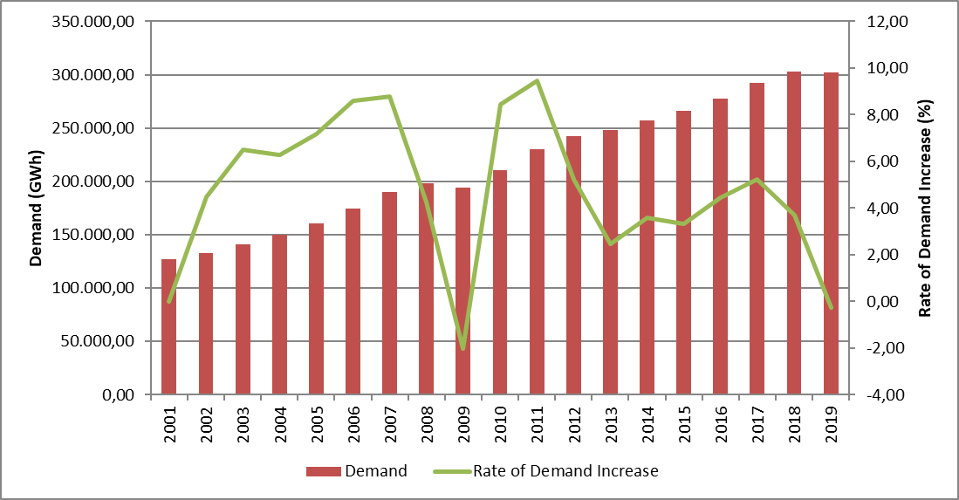
The development and increase rate of peak demand is presented in Figure 1.2. The change in peak demand generally occurred in the figure similar to energy demand, but it is more variable. It is seen that peak demand decreased by 1,81% in 2019 compared to the previous year.

Figure 1.2: Peak Demand and Rate of Increase by Years (MW-%)
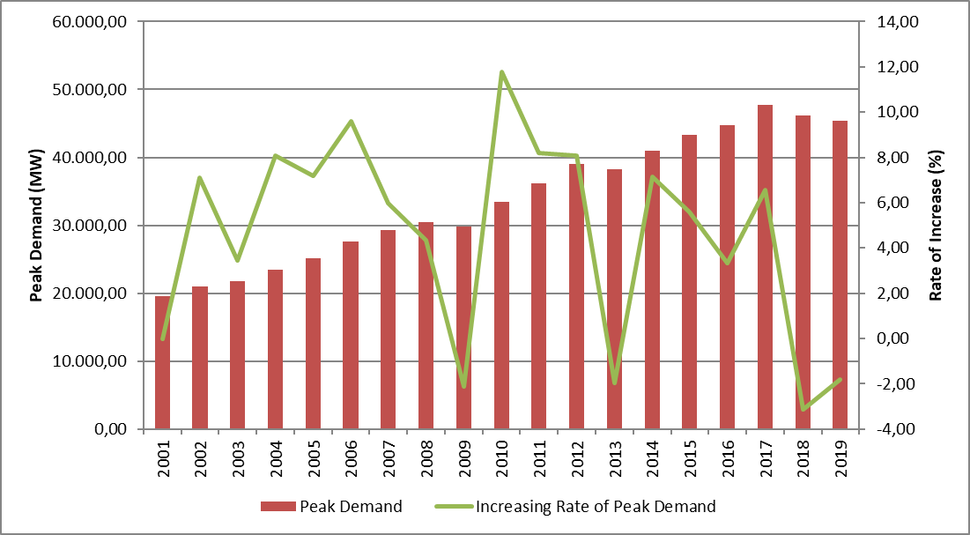
Figure 1.3 shows the relationship between peak demand and electrical energy demand over the years. As can be seen from the figure, the increase rates of electricity demand and peak demand were generally close to each other.

Figure 1.3: Rate of Increase of Demand and Peak Demand by Year (%)
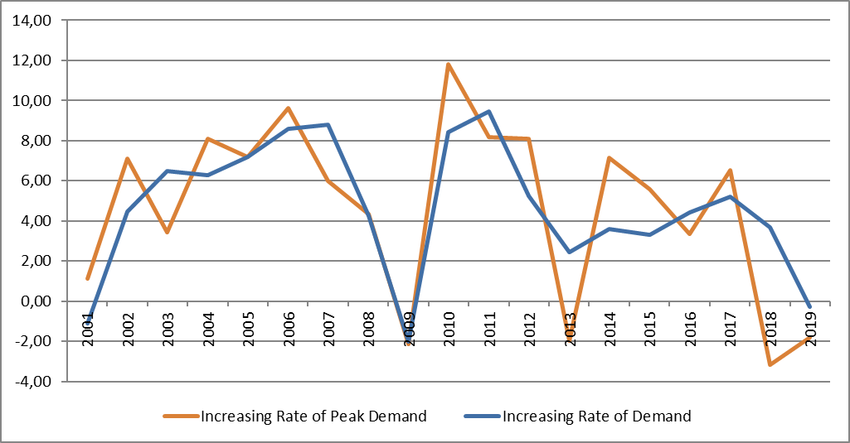

Figure 1.4 shows the licensed electricity generation and monthly change in electricity consumption. Monthly licensed electricity generation and consumption reached their highest values in July.

Figure 1.4: Monthly Distribution of Licensed Electricity Generation and Consumption in 2019 (GWh)
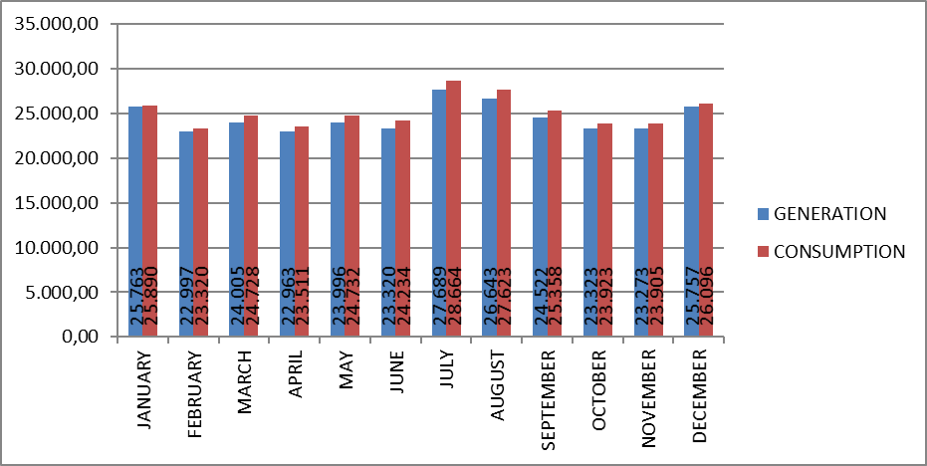
Distribution of licensed electricity generation by organizations in 2019 is shown in Figure 1.5. Independent generation companies have the highest share in production with 71,94%. The share of EÜAŞ power plants was 20,17%, and the share of power plants operating under existing contracts in total production was 7,89%.

Figure 1.5: Distribution of Licensed Electricity Generation in 2019 by Corporations(%)
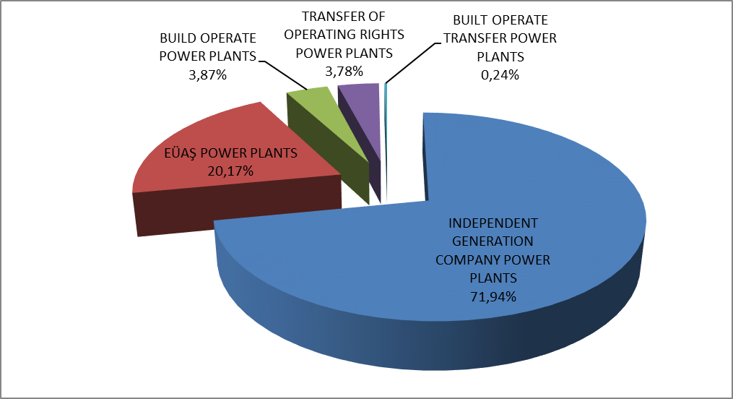

The distribution of licensed electricity production under public, private and existing contracts is given in Figure 1.6. While the total share of the public sector in production (including existing contracts) was 31,77% in 2018, this rate decreased to 28,06% in 2019. The share of independent generation, which was 68,23% in 2018, increased to 71,94% in 2019.

Figure 1.6: Change of Licensed Electricity Generation as Public-Private by Years (%)
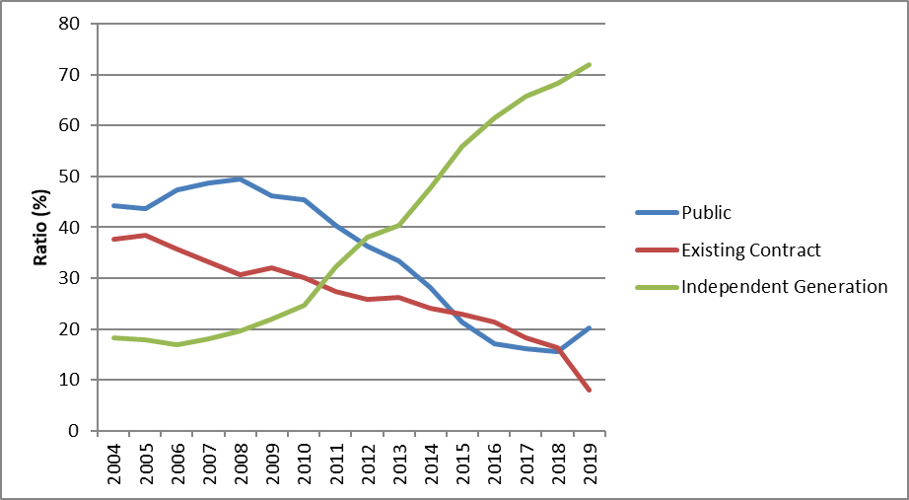

As seen in Figure 1.6, the share of independent generation was still increasing. There are two main reasons behind this increment. First of all, most of the new investments were done by independent power producers. The second reason is that some of the existing contracts have expired and the ownership of the power plants under these contracts has been transferred to the private sector.
The distribution of licensed electricity generation by resources is shown in Figure 1.7. While the share of natural gas-fired power plants in licensed electricity generation in 2018 was 30,88%, it decreased to 19,21% in 2019, while the share of imported coal plants decreased from 21,31% to 20,52%. On the other hand, the share of hydroelectric power plants increased from 20,28% in 2018 to 30,20%, the share of wind power plants from 6,73% to 7,35%, the share of geothermal plants from 2,58% to 3,03%, The share of domestic coal (lignite, hard coal and asphaltite) power plants increased from 17,06% to 17,92%.

Figure 1.7: The Distribution of Licensed Electricity Generation by Sources in 2019 (%)
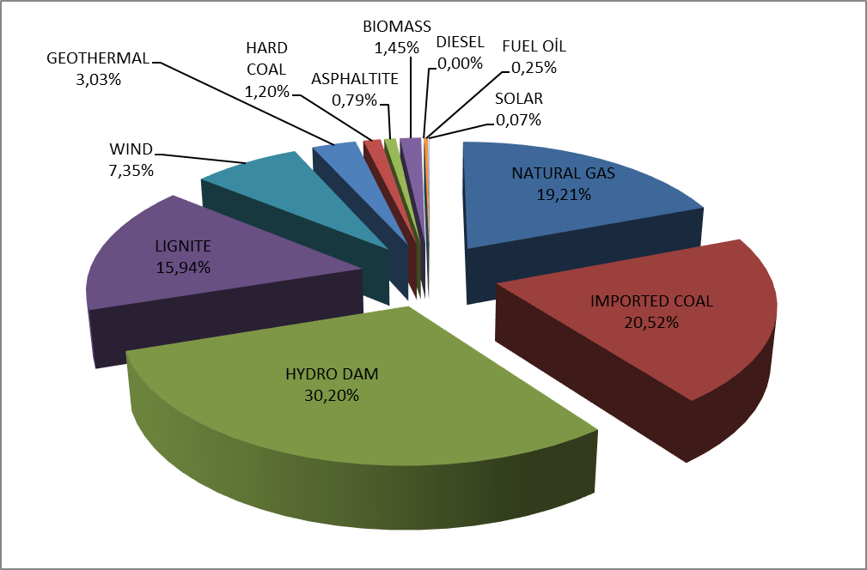
The development of licensed electricity generation on the basis of resources since 1990 is shown in Figure 1.8. As can be seen from the figure, the share of renewable energy sources such as geothermal, wind, solar and biomass in electricity generation has increased every year.

Figure 1.8: Source-Based Development of Licensed Electricity Generation by Years (GWh)
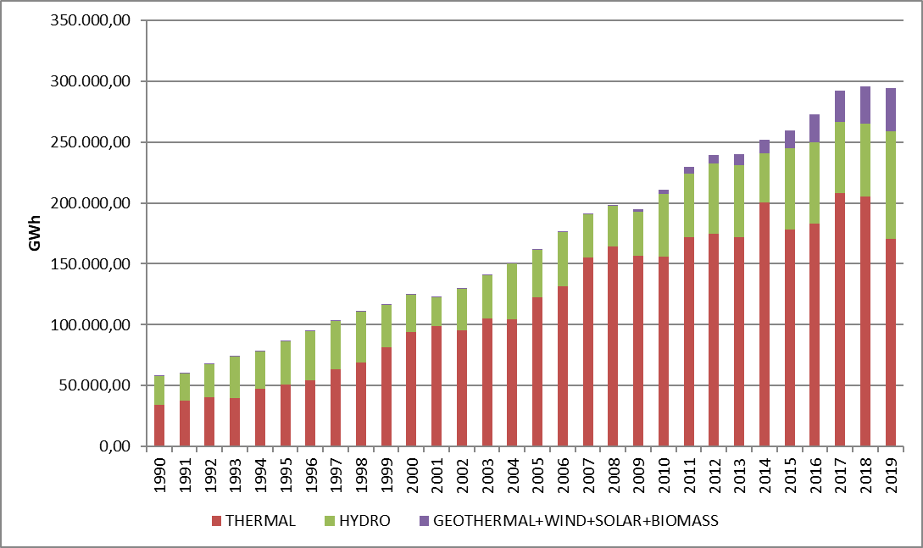

Day-based development of licensed electricity generation in Turkey is shown in Figure 1.9. Licensed electricity production was highest in July and lowest in February. When we look at the basis of day, electricity production was the highest on August 1, 2019 and the lowest on June 4, 2019.

Figure 1.9: Daily Licensed Electricity Generation in 2019 (MWh)
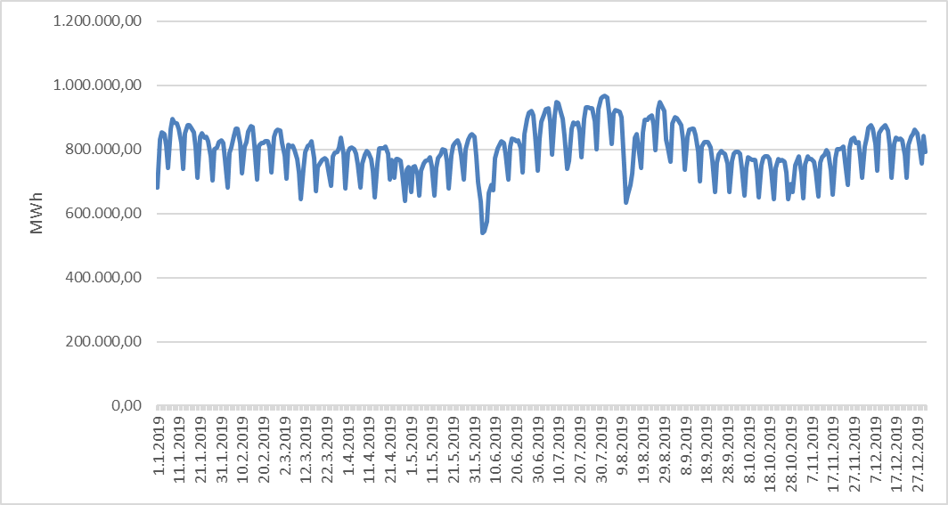
Hour-based licensed electricity generation in Turkey is shown at Figure 1.10. Licensed electricity generation occurred in the highest 20:00 time zone and the lowest in the 06:00 time zone.

Figure 1.10: Hour-Based Electricity Generation in 2019 (MWh)
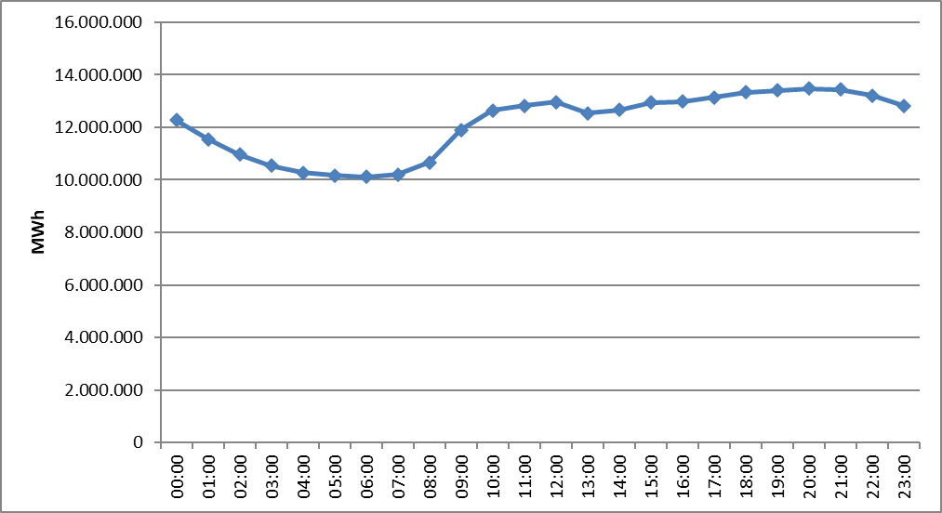
The distribution of licensed electricity generation by province is shown in Table 1.2. In 2019, the highest electricity production was realized in Çanakkale, Zonguldak, Adana, Hatay, İzmir and Muğla provinces, the lowest electricity production was in Çankırı, Niğde, Bartın, Aksaray, Iğdır and Mardin provinces respectively .

Table 1.2: Distribution of Licensed Electricty Generation by Provinces(MWh-%)
PROVINCE | Generation (MWh) | Share (%) | PROVINCE | Generation (MWh) | Share (%)
ÇANAKKALE | 26.276.480,43 | 8,93 | ERZURUM | 1.129.280,44 | 0,38
ZONGULDAK | 21.765.735,48 | 7,40 | ERZİNCAN | 1.112.545,49 | 0,38
ADANA | 17.528.487,17 | 5,96 | GAZİANTEP | 987.552,11 | 0,34
HATAY | 13.619.870,93 | 4,63 | RİZE | 947.324,81 | 0,32
İZMİR | 13.253.332,04 | 4,50 | ADIYAMAN | 935.087,59 | 0,32
MUĞLA | 12.268.248,10 | 4,17 | YALOVA | 888.531,73 | 0,30
MANİSA | 11.978.433,23 | 4,07 | AMASYA | 883.577,55 | 0,30
ŞANLIURFA | 11.278.452,57 | 3,83 | ESKİŞEHİR | 809.562,03 | 0,28
ELAZIĞ | 10.398.271,93 | 3,53 | AFYONKARAHİSAR | 799.602,23 | 0,27
KAHRAMANMARAŞ | 10.024.163,98 | 3,41 | KONYA | 789.658,95 | 0,27
BALIKESİR | 9.279.597,04 | 3,15 | KARABÜK | 774.535,05 | 0,26
ANKARA | 9.084.115,16 | 3,09 | SİNOP | 685.864,28 | 0,23
DİYARBAKIR | 8.906.176,87 | 3,03 | ÇORUM | 661.169,00 | 0,22
BURSA | 7.322.483,15 | 2,49 | MUŞ | 653.271,62 | 0,22
İSTANBUL | 7.198.655,21 | 2,45 | EDİRNE | 536.323,08 | 0,18
KIRIKKALE | 6.598.889,23 | 2,24 | ISPARTA | 536.299,92 | 0,18
AYDIN | 6.166.954,56 | 2,10 | KIRŞEHİR | 506.932,89 | 0,17
SAMSUN | 6.163.576,39 | 2,09 | ARDAHAN | 503.812,67 | 0,17
KÜTAHYA | 6.039.178,51 | 2,05 | TUNCELİ | 462.606,04 | 0,16
DENİZLİ | 5.329.725,78 | 1,81 | KARS | 338.646,68 | 0,12
ARTVİN | 4.986.400,50 | 1,69 | DÜZCE | 333.817,07 | 0,11
ANTALYA | 4.772.134,21 | 1,62 | MALATYA | 286.083,87 | 0,10
MERSİN | 4.289.587,79 | 1,46 | BATMAN | 254.153,96 | 0,09
OSMANİYE | 4.255.404,14 | 1,45 | VAN | 236.709,26 | 0,08
SİVAS | 4.207.986,71 | 1,43 | BURDUR | 222.680,77 | 0,08
KOCAELİ | 3.975.359,80 | 1,35 | KASTAMONU | 199.720,16 | 0,07
KIRKLARELİ | 3.845.439,27 | 1,31 | NEVŞEHİR | 194.799,63 | 0,07
BİNGÖL | 2.713.885,57 | 0,92 | BİLECİK | 173.251,27 | 0,06
KARAMAN | 2.623.987,33 | 0,89 | HAKKARİ | 150.308,05 | 0,05
TOKAT | 2.442.341,28 | 0,83 | UŞAK | 130.403,54 | 0,04
BOLU | 2.383.624,61 | 0,81 | YOZGAT | 104.810,16 | 0,04
ŞIRNAK | 2.362.640,30 | 0,80 | BİTLİS | 104.176,02 | 0,04
SAKARYA | 2.094.517,11 | 0,71 | BAYBURT | 84.078,63 | 0,03
GİRESUN | 2.049.159,36 | 0,70 | MARDİN | 70.955,00 | 0,02
TEKİRDAĞ | 1.915.105,86 | 0,65 | IĞDIR | 62.818,71 | 0,02
KAYSERİ | 1.660.500,83 | 0,56 | AKSARAY | 53.894,77 | 0,02
GÜMÜŞHANE | 1.526.451,84 | 0,52 | BARTIN | 28.507,76 | 0,01
ORDU | 1.350.859,52 | 0,46 | NİĞDE | 20.780,00 | 0,01
TRABZON | 1.345.476,09 | 0,46 | ÇANKIRI | 15.299,24 | 0,01
SİİRT | 1.300.196,71 | 0,44 | Grand Total | 294.251.318,65 | 100,00

Figure 1.11 shows the shares of the top 10 companies with the highest share in licensed electricity production in 2019. As can be seen from the figure, the top 10 companies were respectively EÜAŞ, Eren Enerji Elektrik Üretim A.Ş. , Enerjisa Energy Production Inc. , Cenal Elektrik Üretim A.Ş. , İçdaş Electric Energy Generation and Investment Inc. , Atlas Energy Production Industry Inc. , Yeniköy Kemerköy Elektrik Üretim Ve Ticaret A.Ş. , İskenderun Energy Production and Trade Inc. , Soma Thermal Power Plant Electricity Generation Inc. ve Park Termik Elektrik San.Ve Tic.A.Ş.

Figure 1.11: The share of First 10 Companies within Electricity Generation in 2019 (%)
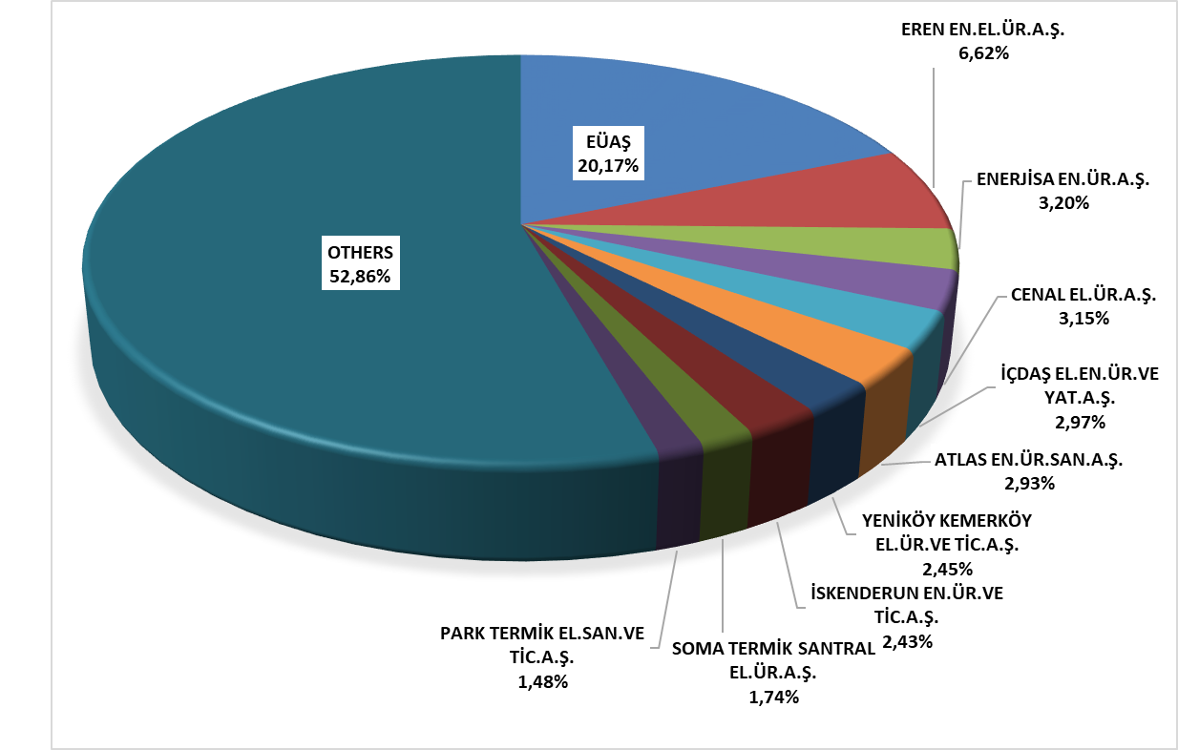

1.3 Licensed Installed Capacity

The distribution of licensed installed capacity by resource types is shown in Figure 1.12. As of the end of 2018, the share of natural gas power plants (including liquid and natural gas fired power plants) within the licensed installed capacity was 30,93% in 2019, to 30,53%, the share of power plants based on imported coal, which is 10,75%, to 10,55%, the share of dam-hydroelectric power plants which is 24,69% to 24,30%, the share of river-hydroelectric power plants which is 9,32% to 9,24% It decreased.
On the other hand, the share of lignite power plants, which was 11,54% within the licensed installed power as of the end of 2018, increased to 11,89% in 2019, the share of wind power plants from 8,35% to 8,85%, and geothermal power plants with 1,54% share increased to 1,78%.
While the share of renewable energy sources (including hydraulics) in total installed capacity in 2018 was 44,70%, it increased to 45,23% in 2019. While the ratio of total installed thermal capacity was 55,30% in 2018, it decreased to 54,57% in 2019.

Figure 1.12: Distribution of Licensed Installed Capacity by Sources at the End of 2019 (%)
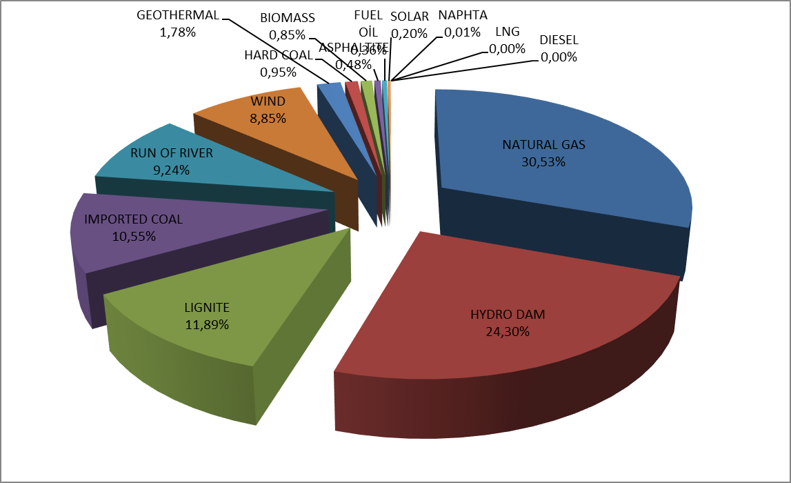
The distribution of the licensed installed power according to organizations is shown in Figure 1.13. The share of EÜAŞ Power Plants in total installed capacity increased to 23,05% in 2019, while it was 22,23% in 2018, the share of free production companies operating under free market conditions increased to 72,72% in 2019, while it was 64,73% in 2018.
On the other hand, the share of power plants operating under existing contracts in total installed capacity decreased to 4,23% in 2019, while it was 13,04% in 2018.

Figure 1.13: Distribution of Licensed Installed Capacity by Organizations at the End of 2019 (%)
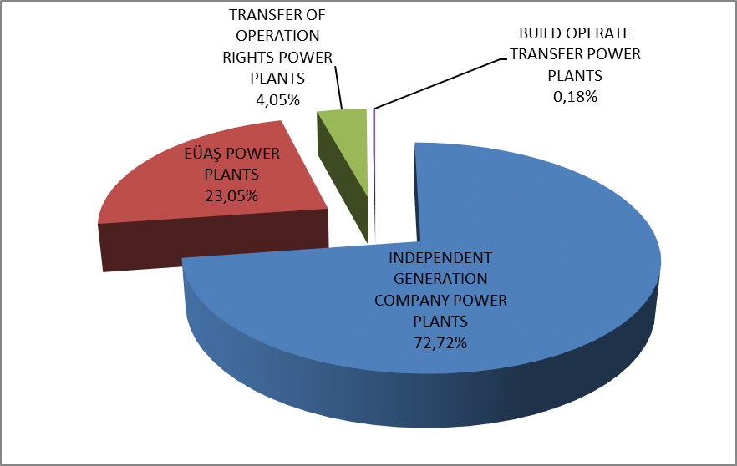

The development of licensed installed capacity on the basis of resources since 2000 is given in Figure 1.14. As can be seen from the figure, the share of geothermal, wind, solar and biomass resources within the installed capacity has increased every year.

Figure 1.14: The Development of Licensed Installed Capacity According to Source by Years (MW)
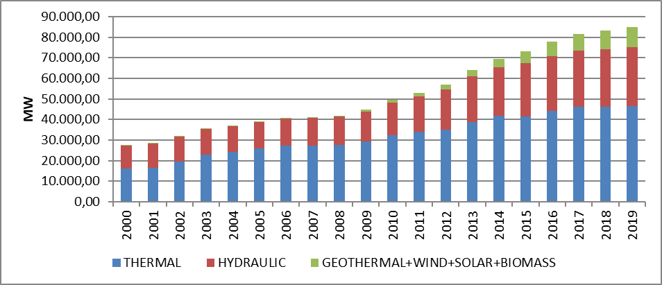
Similar to Figure 1.14, the development of the shares of licensed power resources since 2000 is also included in Figure 1.15.

Figure 1.15: The Development of the Share of the Sources within the Installed Capacity by Years (%)
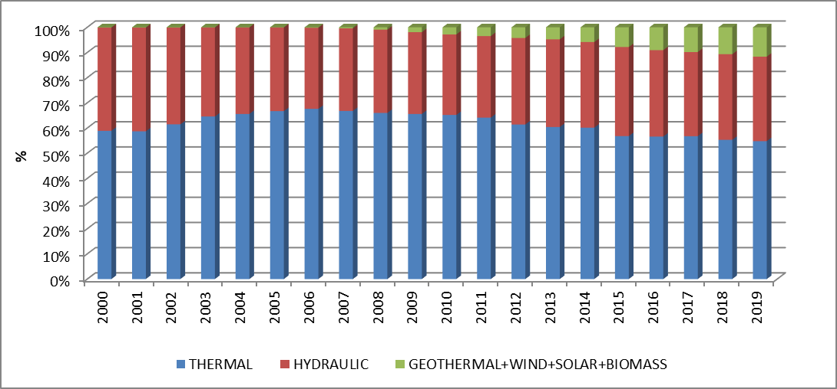

The distribution of licensed installed capacity by province is shown in Table 1.3. In 2019, the provinces with the highest installed power were İzmir, Kahramanmaraş, Çanakkale, Adana, Şanlıurfa and Samsun respectively, and the provinces with the lowest installed power were Ağrı, Çankırı, Bartın, Iğdır, Bayburt and Aksaray.

Table 1.3 Distribution of Licensed Installed Capacity by Province (MW-%)
PROVINCE | Inst. Cap. (MW) | Share (%) | PROVINCE | Inst. Cap. (MW) | Share (%)
İZMİR | 5.072,54 | 5,97 | BOLU | 416,14 | 0,49
KAHRAMANMARAŞ | 4.347,39 | 5,12 | ŞIRNAK | 405,64 | 0,48
ÇANAKKALE | 4.180,59 | 4,92 | KONYA | 399,60 | 0,47
ADANA | 3.729,55 | 4,39 | ÇORUM | 388,65 | 0,46
ŞANLIURFA | 3.426,92 | 4,03 | RİZE | 354,23 | 0,42
SAMSUN | 3.387,56 | 3,99 | SİİRT | 344,49 | 0,41
ZONGULDAK | 3.370,25 | 3,97 | AFYONKARAHİSAR | 342,32 | 0,40
BALIKESİR | 2.828,07 | 3,33 | ERZİNCAN | 316,27 | 0,37
MANİSA | 2.812,22 | 3,31 | AMASYA | 314,66 | 0,37
İSTANBUL | 2.757,23 | 3,25 | KIRŞEHİR | 308,40 | 0,36
HATAY | 2.727,45 | 3,21 | YALOVA | 245,38 | 0,29
BURSA | 2.607,03 | 3,07 | ADIYAMAN | 238,87 | 0,28
SAKARYA | 2.537,81 | 2,99 | ARDAHAN | 235,90 | 0,28
ELAZIĞ | 2.460,83 | 2,90 | ISPARTA | 191,19 | 0,23
ANKARA | 2.370,75 | 2,79 | MUŞ | 182,66 | 0,21
DİYARBAKIR | 2.252,26 | 2,65 | MARDİN | 165,35 | 0,19
MUĞLA | 2.219,35 | 2,61 | KARS | 154,67 | 0,18
KOCAELİ | 2.030,37 | 2,39 | KARABÜK | 148,43 | 0,17
KIRIKKALE | 1.953,02 | 2,30 | EDİRNE | 143,08 | 0,17
ANTALYA | 1.872,61 | 2,20 | DÜZCE | 121,49 | 0,14
ARTVİN | 1.785,02 | 2,10 | KASTAMONU | 110,61 | 0,13
DENİZLİ | 1.687,77 | 1,99 | TUNCELİ | 106,95 | 0,13
KIRKLARELİ | 1.618,67 | 1,91 | VAN | 100,91 | 0,12
TEKİRDAĞ | 1.556,50 | 1,83 | BİLECİK | 96,74 | 0,11
AYDIN | 1.194,90 | 1,41 | BURDUR | 95,86 | 0,11
OSMANİYE | 1.064,28 | 1,25 | NEVŞEHİR | 87,13 | 0,10
KÜTAHYA | 1.063,43 | 1,25 | UŞAK | 81,67 | 0,10
SİVAS | 973,51 | 1,15 | MALATYA | 81,36 | 0,10
MERSİN | 924,15 | 1,09 | BATMAN | 57,00 | 0,07
GİRESUN | 847,88 | 1,00 | YOZGAT | 50,70 | 0,06
BİNGÖL | 817,70 | 0,96 | HAKKARİ | 48,75 | 0,06
ERZURUM | 784,53 | 0,92 | AYDIN | 44,00 | 0,05
TOKAT | 660,38 | 0,78 | NİĞDE | 39,61 | 0,05
GÜMÜŞHANE | 656,80 | 0,77 | BİTLİS | 32,25 | 0,04
TRABZON | 596,72 | 0,70 | AKSARAY | 28,88 | 0,03
KAYSERİ | 590,61 | 0,70 | BAYBURT | 25,70 | 0,03
SİNOP | 559,95 | 0,66 | IĞDIR | 23,79 | 0,03
KARAMAN | 549,52 | 0,65 | BARTIN | 19,56 | 0,02
GAZİANTEP | 534,34 | 0,63 | ÇANKIRI | 9,75 | 0,01
ESKİŞEHİR | 490,23 | 0,58 | AĞRI | 9,50 | 0,01
ORDU | 488,90 | 0,58 | Grand Total | 84.957,72 | 100,00

Figure 1.16 shows the shares of the first 10 companies that had the highest share of licensed installed capacity at the end of 2019. As can be seen from the figure, first 10 companies were EÜAŞ, Eren Enerji Elektrik Üretim A.Ş., Enerjisa Enerji Üretim A.Ş. , Gebze Elektrik Üretim Ltd.Şti., İzmir Elektrik Üretim Ltd.Şti., Afşin Elbistan Elektrik Üretim ve Ticaret A.Ş. , Cenal Elektrik Üretim A.Ş., İskenderun Enerji Üretim Ve Ticaret A.Ş. , Hamitabat Elektrik Üretim Ve Ticaret A.Ş. and Atlas Enerji Üretim Sanayi A.Ş. respectively.

Figure 1.16: The Share of the First 10 Companies in Installed Capacity at the End of 2019 (%)
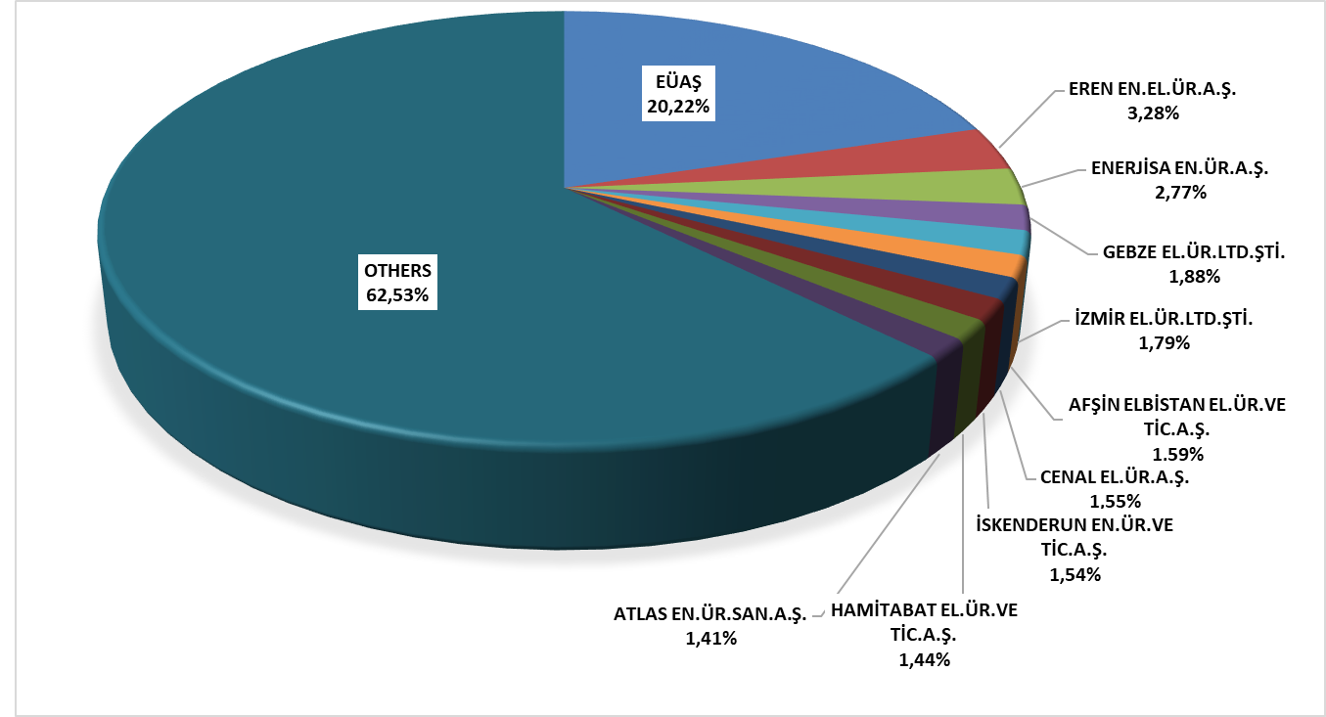

1.4 Unlicensed Generation

In the first sub clause of Article 14 of the Electricity Market Law No. 6446, the production facilities exempted from the license to install and establish a company are as follows;

“a) Generation facilities not connected to emergency generator groups or transmission or distribution systems
b) Generation facilities with the installed power based on maximum one-megawatt renewable energy sources
c) Electricity generation facilities of municipalities installed to dispose the sludge of solid waste facilities and of treatment plants
d) Those of micro-cogeneration facilities and cogeneration facilities having the productivity value to be determined by the Ministry, and in the category to be determined by the Board
e) (Attachment: 21/3 / 2018-7103 / 84 art.) Market activities carried out within the scope of the limits determined by the Board and electricity storage and demand side participation within the framework of the procedures and principles determined by the Ministry.
f) (Attachment: 19/4 / 2018-7139 / 56 art.) Electricity subscription In order to meet the electricity needs of the agricultural irrigation facilities owned by the General Directorate of State Hydraulic Works, the contract power of the installed power agricultural irrigation plant is production facility based on renewable energy sources established and operated by the General Directorate of State Hydraulic Works, provided that the total

The current status of unlicensed electricity generation applications by 2019 is shown in Table 1.4.

Table 1.4: The Status of Unlicensed Electricity Generation Applications by the End of 2019(MWe)
Status/Source | Stream | Biomass | Multifuel | Wave | Natural gas | Solar  (PV) | Solar  (CSP) | Hydro | Geoth. | Oil derivative | Wind | Total
Application period for connection agreement has expired |  | 35,35 | 6,80 |  | 84,55 | 683,67 | 0,10 | 8,78 |  |  | 39,34 | 858,58
Connection agreement done |  | 31,48 | 5,71 |  | 47,06 | 774,25 | 0,80 | 2,90 |  |  | 52,04 | 914,23
Connection agrement expired |  | 8,31 |  |  | 4,20 | 211,89 |  | 11,78 |  |  | 21,66 | 257,84
Under evaluation |  | 2,12 |  |  | 12,00 | 377,31 | 17,46 | 1,55 |  |  | 9,96 | 420,40
Installed and Activated |  | 75,67 | 9,92 |  | 318,74 | 5.824,96 | 0,50 | 8,65 |  |  | 70,83 | 6.309,27
Accepted |  | 26,24 | 1,23 |  | 73,33 | 254,22 | 2,69 | 4,28 |  | 4,43 | 53,62 | 420,05
Rejected | 0,50 | 188,40 | 6,00 | 0,40 | 101,45 | 13.564,57 | 2,04 | 63,41 | 0,13 |  | 349,39 | 14.276,29

The distribution of unlicensed installed capacity by sources is given in Table 1.5 and Figure 1.18. The amount of capacity that entered the facility, which was 5.310,57 MWe as of the end of 2018, increased by 18,81% and reached 6.309,27 MWe as of the end of 2019. As in 2018, the highest share belongs to solar power plants with 92,33% in 2019, followed by natural gas with 5,21% and biomass with 1,20%.

Table 1.5: Distribution of Unlicensed Installed Capacity by Sources (MWe-%)
Resource Type | 2018 |  | 2019
Resource Type | Installed Capacity  (MWe) | Share  (%) | Installed Capacity  (MWe) | Share  (%)
Solar | 5.017,49 | 94,48 | 5.825,46 | 92,33
Natural gas | 153,04 | 2,88 | 328,66 | 5,21
Biomass | 79,18 | 1,49 | 75,67 | 1,20
Wind | 51,95 | 0,98 | 70,83 | 1,12
Hyraulic | 8,91 | 0,17 | 8,65 | 0,14
Grand Total | 5.310,57 | 100,00 | 6.309,27 | 100,00

Figure 1.17: Distribution of Unlicensed Installed Capacity by Sources at the End of 2019 (%)
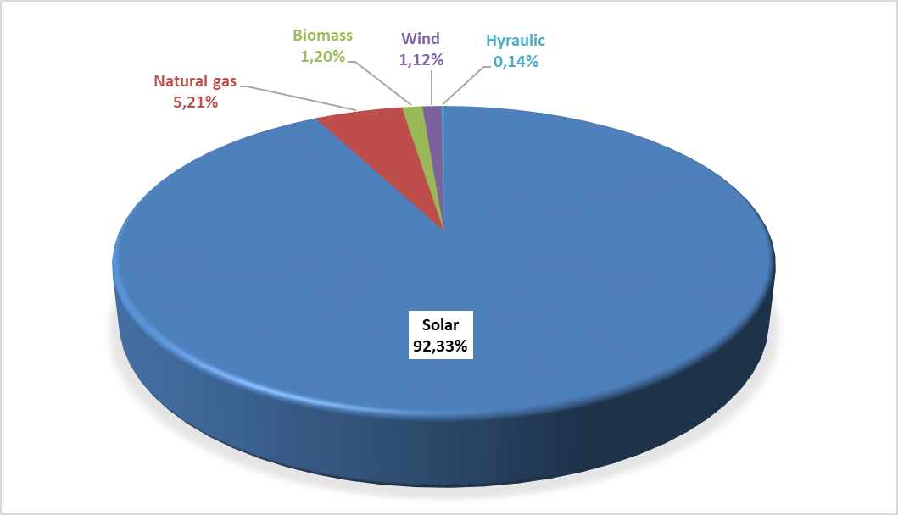
Distribution of unlicensed installed capacity by province is shown in Table 1.6. As it was in 2018, it is located in Konya with the highest installed power 503,19 MWe in 2019. Konya is followed by Ankara with 362,29 MWe, Şanlıurfa with 341,99 MWe, Kayseri with 317,72 MWe, İzmir with 274,75 MWe, Afyonkarahisar with 232,15 MWe, and Kahramanmaraş with 220,19 MWe. Approximately 36% of the total unlicensed installed power is in these 7 provinces. In addition, unlicensed electricity installed power started to operate in 6 additional provinces in Giresun, Şırnak, Ağrı, Kırklareli, Rize and Gümüşhane in 2019.

Table 1.6: Distribution of Unlicensed Installed Capacity by Province (MWe-%)
PROVINCE | 2018 |  | 2019
PROVINCE | Installed Capacity  (MWe) | Share (%) | Installed Capacity  (MWe) | Share (%)
KONYA | 503,23 | 9,48 | 503,19 | 7,98
ANKARA | 307,09 | 5,78 | 362,29 | 5,74
ŞANLIURFA | 254,81 | 4,80 | 341,99 | 5,42
KAYSERİ | 310,15 | 5,84 | 317,72 | 5,04
İZMİR | 178,41 | 3,36 | 274,75 | 4,35
AFYONKARAHİSAR | 206,99 | 3,90 | 232,15 | 3,68
KAHRAMANMARAŞ | 207,30 | 3,90 | 220,19 | 3,49
MANİSA | 102,01 | 1,92 | 216,73 | 3,44
MERSİN | 177,70 | 3,35 | 191,60 | 3,04
ESKİŞEHİR | 157,11 | 2,96 | 175,12 | 2,78
ELAZIĞ | 162,61 | 3,06 | 168,61 | 2,67
DENİZLİ | 145,67 | 2,74 | 165,56 | 2,62
ANTALYA | 139,43 | 2,63 | 155,66 | 2,47
ISPARTA | 108,28 | 2,04 | 152,81 | 2,42
ADANA | 122,03 | 2,30 | 151,27 | 2,40
GAZİANTEP | 135,39 | 2,55 | 145,99 | 2,31
NEVŞEHİR | 130,40 | 2,46 | 133,57 | 2,12
AYDIN | 122,90 | 2,31 | 121,52 | 1,93
KÜTAHYA | 99,37 | 1,87 | 116,64 | 1,85
BALIKESİR | 89,31 | 1,68 | 110,17 | 1,75
ADIYAMAN | 98,38 | 1,85 | 109,21 | 1,73
ÇORUM | 76,09 | 1,43 | 104,86 | 1,66
MALATYA | 96,54 | 1,82 | 102,84 | 1,63
MUĞLA | 95,51 | 1,80 | 102,73 | 1,63
NİĞDE | 98,45 | 1,85 | 100,31 | 1,59
ERZURUM | 83,37 | 1,57 | 98,13 | 1,56
UŞAK | 80,31 | 1,51 | 91,84 | 1,46
AKSARAY | 85,65 | 1,61 | 88,82 | 1,41
BİLECİK | 47,89 | 0,90 | 77,01 | 1,22
SİVAS | 72,73 | 1,37 | 76,89 | 1,22
OSMANİYE | 66,83 | 1,26 | 72,01 | 1,14
BURSA | 48,07 | 0,91 | 70,54 | 1,12
KARAMAN | 67,13 | 1,26 | 69,18 | 1,10
BURDUR | 64,34 | 1,21 | 66,14 | 1,05
YOZGAT | 60,25 | 1,13 | 63,65 | 1,01
DİYARBAKIR | 31,74 | 0,60 | 58,35 | 0,92
İSTANBUL | 42,68 | 0,80 | 52,06 | 0,83
ÇANKIRI | 48,79 | 0,92 | 51,25 | 0,81
KIRIKKALE | 39,93 | 0,75 | 49,15 | 0,78
KIRŞEHİR | 46,36 | 0,87 | 46,14 | 0,73
ERZİNCAN | 38,67 | 0,73 | 42,24 | 0,67
SAMSUN | 35,41 | 0,67 | 41,84 | 0,66
AMASYA | 29,63 | 0,56 | 38,17 | 0,60
ÇANAKKALE | 21,66 | 0,41 | 31,79 | 0,50
VAN | 13,02 | 0,25 | 29,07 | 0,46
TEKİRDAĞ | 6,30 | 0,12 | 28,31 | 0,45
TOKAT | 17,82 | 0,34 | 21,85 | 0,35
KİLİS | 11,84 | 0,22 | 21,30 | 0,34
BİTLİS | 14,47 | 0,27 | 20,83 | 0,33
BİNGÖL | 2,75 | 0,05 | 20,55 | 0,33
BATMAN | 13,04 | 0,25 | 18,78 | 0,30
ŞIRNAK |  |  | 18,00 | 0,29
MARDİN | 1,97 | 0,04 | 17,51 | 0,28
HATAY | 17,10 | 0,32 | 17,14 | 0,27
SAKARYA | 10,79 | 0,20 | 16,90 | 0,27
KOCAELİ | 15,01 | 0,28 | 16,22 | 0,26
KARABÜK | 10,64 | 0,20 | 12,62 | 0,20
BAYBURT | 12,02 | 0,23 | 11,99 | 0,19
KASTAMONU | 3,55 | 0,07 | 8,63 | 0,14
BOLU | 3,24 | 0,06 | 8,31 | 0,13
DÜZCE | 1,03 | 0,02 | 6,99 | 0,11
SİİRT | 4,65 | 0,09 | 6,64 | 0,11
EDİRNE | 1,34 | 0,03 | 6,58 | 0,10
KARS | 3,26 | 0,06 | 5,74 | 0,09
BARTIN | 0,25 | 0,00 | 5,25 | 0,08
AĞRI |  |  | 4,95 | 0,08
KIRKLARELİ |  |  | 4,50 | 0,07
YALOVA | 1,41 | 0,03 | 3,83 | 0,06
MUŞ | 2,46 | 0,05 | 3,30 | 0,05
ZONGULDAK | 2,48 | 0,05 | 2,48 | 0,04
ORDU | 0,98 | 0,02 | 2,10 | 0,03
RİZE |  |  | 1,59 | 0,03
GİRESUN |  |  | 1,40 | 0,02
ARDAHAN | 1,10 | 0,02 | 1,10 | 0,02
TUNCELİ | 0,98 | 0,02 | 0,86 | 0,01
GÜMÜŞHANE |  |  | 0,80 | 0,01
IĞDIR | 0,50 | 0,01 | 0,50 | 0,01
Grand Total | 5.310,57 | 100,00 | 6.309,27 | 100,00
The distribution of unlicensed electricity generation by source is given in Table 1.7 and Figure 1.19. While the amount of energy supplied to the grid within the scope of unlicensed electricity generation in 2018 was 8.212.771,44 MWh, it increased by 19,68% and reached 9.829.447,73 MWh in 2019. 95,90% of this was produced from the solar, 2,60% from biomass, 1,50% from wind and hydraulic.

Table 1.7: Distribution of Unlicensed Electricity Generation by Sources (MWh-%)
Resource Type | 2018 |  | 2019
Resource Type | The amount of energy supplied to the system as surplus (MWh) | Share  (%) | The amount of energy supplied to the system as surplus (MWh) | Oran  (%)
Solar | 7.860.576,89 | 95,71 | 9.425.965,29 | 95,90
Biomass | 205.901,95 | 2,51 | 255.486,79 | 2,60
Wind | 111.542,03 | 1,36 | 113.558,01 | 1,16
Hyraulic | 34.750,58 | 0,42 | 34.437,65 | 0,34
Grand Total | 8.212.771,44 | 100,00 | 9.829.447,73 | 100,00

Figure 1.18: Distribution of Unlicensed Electricity Generation by Sources in 2019 (%)
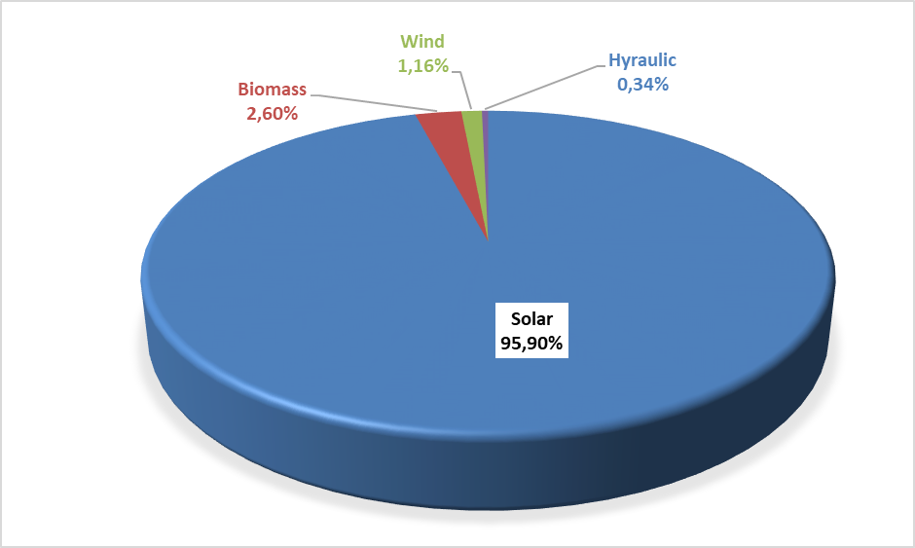
The distribution of unlicensed electricity generation and energy delivered to the system by provinces is given in Table 1.8, and the highest production was realized in Konya in 2019 as in 2018. Apart from Konya, Şanlıurfa, Kayseri, Ankara, Afyonkarahisar, Kahramanmaraş, İzmir and Eskişehir are the provinces that rank first among unlicensed electricity generation.

Table 1.8: Distribution of Unlicensed Electricity Generation by Provinces (MWh-%)
PROVINCE | 2018 |  | 2019
PROVINCE | The amount of energy supplied to the system as surplus (MWh) | Share (%) | The amount of energy supplied to the system as surplus (MWh) | Share (%)
ADANA | 153.446,68 | 1,87 | 174.316,68 | 1,77
ADIYAMAN | 152.986,85 | 1,86 | 173.433,60 | 1,76
AFYONKARAHİSAR | 353.577,81 | 4,31 | 392.648,19 | 3,99
AĞRI | 0,00 | 0,00 | 3.126,83 | 0,03
AKSARAY | 155.317,70 | 1,89 | 164.770,05 | 1,68
AMASYA | 36.960,88 | 0,45 | 47.396,72 | 0,48
ANKARA | 402.315,34 | 4,90 | 501.259,77 | 5,10
ANTALYA | 207.955,46 | 2,53 | 224.706,12 | 2,29
ARDAHAN | 1.437,48 | 0,02 | 1.914,49 | 0,02
AYDIN | 199.122,76 | 2,42 | 244.196,94 | 2,48
BALIKESİR | 144.146,86 | 1,76 | 167.088,16 | 1,70
BARTIN | 85,28 | 0,00 | 82,00 | 0,00
BATMAN | 12.783,57 | 0,16 | 27.919,40 | 0,28
BAYBURT | 19.809,40 | 0,24 | 21.958,16 | 0,22
BİLECİK | 65.846,90 | 0,80 | 106.646,38 | 1,08
BİNGÖL | 4.765,92 | 0,06 | 13.850,98 | 0,14
BİTLİS | 7.965,73 | 0,10 | 28.411,53 | 0,29
BOLU | 4.597,16 | 0,06 | 3.838,49 | 0,04
BURDUR | 103.005,83 | 1,25 | 114.423,06 | 1,16
BURSA | 84.220,71 | 1,03 | 97.251,79 | 0,99
ÇANAKKALE | 25.446,36 | 0,31 | 29.917,61 | 0,30
ÇANKIRI | 42.539,27 | 0,52 | 84.179,08 | 0,86
ÇORUM | 108.632,39 | 1,32 | 144.446,40 | 1,47
DENİZLİ | 212.330,59 | 2,59 | 262.195,53 | 2,67
DİYARBAKIR | 39.789,57 | 0,48 | 98.140,83 | 1,00
DÜZCE | 389,45 | 0,00 | 403,54 | 0,00
EDİRNE | 4.341,68 | 0,05 | 7.265,19 | 0,07
ELAZIĞ | 226.578,79 | 2,76 | 288.706,65 | 2,94
ERZİNCAN | 64.736,27 | 0,79 | 79.887,29 | 0,81
ERZURUM | 90.065,36 | 1,10 | 144.324,24 | 1,47
ESKİŞEHİR | 272.137,10 | 3,31 | 352.373,70 | 3,58
GAZİANTEP | 230.401,38 | 2,81 | 244.262,17 | 2,49
GİRESUN | 0,00 | 0,00 | 183,73 | 0,00
GÜMÜŞHANE | 1.661,77 | 0,02 | 1.934,08 | 0,02
HATAY | 27.216,01 | 0,33 | 25.684,87 | 0,26
IĞDIR | 0,00 | 0,00 | 96,16 | 0,00
ISPARTA | 178.442,77 | 2,17 | 203.612,64 | 2,07
İSTANBUL | 7.112,91 | 0,09 | 7.253,93 | 0,07
İZMİR | 278.668,88 | 3,39 | 367.263,94 | 3,74
KAHRAMANMARAŞ | 279.416,57 | 3,40 | 314.882,98 | 3,20
KARABÜK | 14.646,60 | 0,18 | 14.757,35 | 0,15
KARAMAN | 119.868,76 | 1,46 | 124.818,84 | 1,27
KARS | 4.545,97 | 0,06 | 6.671,85 | 0,07
KASTAMONU | 5.170,35 | 0,06 | 11.905,09 | 0,12
KAYSERİ | 540.201,26 | 6,58 | 566.861,17 | 5,77
KIRIKKALE | 61.375,82 | 0,75 | 71.981,69 | 0,73
KIRKLARELİ | 442,12 | 0,01 | 647,04 | 0,01
KIRŞEHİR | 78.742,91 | 0,96 | 86.398,11 | 0,88
KİLİS | 18.692,35 | 0,23 | 24.082,42 | 0,25
KOCAELİ | 20.325,34 | 0,25 | 23.810,20 | 0,24
KONYA | 888.600,28 | 10,82 | 896.102,75 | 9,12
KÜTAHYA | 155.470,28 | 1,89 | 189.037,54 | 1,92
MALATYA | 132.066,33 | 1,61 | 168.782,43 | 1,72
MANİSA | 273.671,33 | 3,33 | 343.813,97 | 3,50
MARDİN | 2.037,46 | 0,02 | 13.388,43 | 0,14
MERSİN | 271.346,16 | 3,30 | 294.345,92 | 2,99
MUĞLA | 152.188,11 | 1,85 | 177.302,71 | 1,80
MUŞ | 2.792,71 | 0,03 | 3.076,30 | 0,03
NEVŞEHİR | 215.690,55 | 2,63 | 232.842,69 | 2,37
NİĞDE | 165.216,86 | 2,01 | 175.482,54 | 1,79
ORDU | 3.513,06 | 0,04 | 4.846,23 | 0,05
OSMANİYE | 93.669,12 | 1,14 | 102.742,72 | 1,05
RİZE | 9.851,57 | 0,12 | 9.144,81 | 0,09
SAKARYA | 151,51 | 0,00 | 166,73 | 0,00
SAMSUN | 32.289,79 | 0,39 | 37.439,79 | 0,38
SİİRT | 7.934,43 | 0,10 | 8.768,70 | 0,09
SİNOP | 2,14 | 0,00 | 4,45 | 0,00
SİVAS | 118.887,18 | 1,45 | 130.142,41 | 1,32
ŞANLIURFA | 339.330,44 | 4,13 | 569.672,72 | 5,80
ŞIRNAK | 0,00 | 0,00 | 29.908,76 | 0,30
TEKİRDAĞ | 3.978,74 | 0,05 | 6.242,69 | 0,06
TOKAT | 31.448,56 | 0,38 | 38.956,91 | 0,40
TUNCELİ | 1.785,41 | 0,02 | 1.885,08 | 0,02
UŞAK | 128.761,19 | 1,57 | 150.707,85 | 1,53
VAN | 1.433,22 | 0,02 | 18.160,17 | 0,18
YALOVA | 5.657,31 | 0,07 | 8.876,13 | 0,09
YOZGAT | 99.304,24 | 1,21 | 108.463,77 | 1,10
ZONGULDAK | 11.426,60 | 0,14 | 10.954,92 | 0,11
Grand Total | 8.212.771,44 | 100,00 | 9.829.447,73 | 100,00

The distribution of the amount of payments made within the scope of unlicensed electricity production as of the end of 2019 by sources is shown in Table 1.9. 96,56% of the amount of payment was made to solar power plants.

Table 1.9: Distribution of the Amount of Payment Made Within the Scope of Unlicensed Electricity Generation by Sources (TL-%)
Resource Type | 2018 |  | 2019 |  | Change (%)  2018→2019
Resource Type | Amount of payments made for the amount of surplus energy purchased (TL) | Share (%) | Amount of payments made for the amount of surplus energy purchased (TL) | Share(%) | Change (%)  2018→2019
Solar | 5.162.235.719,38 | 96,48 | 7.149.487.954,90 | 96,56 | 38,50
Biomass | 134.929.718,77 | 2,52 | 193.082.601,11 | 2,61 | 43,10
Wind | 41.137.703,88 | 0,77 | 47.248.620,77 | 0,64 | 14,85
Hyraulic | 12.131.327,19 | 0,23 | 14.298.255,13 | 0,19 | 17,86
Grand Total | 5.350.434.469,22 | 100,00 | 7.404.117.431,91 | 100,00 | 38,38

1.5 Invoiced Electricity Consumption

This part gives information about the invoiced electricity consumption. In this context, the consumption that is not included in the invoice (technical and non-technical losses and the sales that are not accepted as sales) are not included in the data in this section. Therefore, as the production realized by the legal entities holding generation license within the scope of Article 7 of the Electricity Market Law without transferring the energy produced in their facilities to the transmission or distribution system, is not considered as sales to the final consumer, Electricity consumption is not included in the invoiced consumption figures. In addition, the amount of electricity generated by the generation facilities from the system for their own needs is not included in the invoiced consumption value. In addition, the actual consumption data and consumption data in this section may vary due to differences in the billing period.
Data on the consumption amount invoiced in 2019 is shown in Table 1.10 below. 53,69 TWh, which corresponds to 23,39% of the electricity sold for 229,59 TWh, is connected to consumers from the transmission voltage level, while 175,90 TWh, which corresponds to 76,61%, is connected to the distribution voltage level sold to consumers.
While selling 93,91 TWh to eligible consumers, the consumption of subscribers (non-eligible and non-eligible consumers) was 135,69 TWh. Accordingly, while the share of eligible consumers in invoiced consumption was 40,90%, the share of subscribers was 59,10%.

Table 1.10: Sales to Eligible and Non-Eligible Consumers in 2019 (MWh)
Consumer Type | Consumption Amount of Consumers Connected to the Distribution Voltage Level (MWh) | Consumption Amount of Consumers Connected to the Transmission Voltage Level (MWh) | Total (MWh)
Non-Eligible Consumer | 134.409.689,21 | 1.278.906,46 | 135.688.595,67
Eligible Consumer | 41.494.792,25 | 52.414.525,73 | 93.909.317,98
Grand Total | 175.904.481,46 | 53.693.432,19 | 229.597.913,65

The distribution of consumption to distribution regions is given in Table 1.11. In 2019, the highest consumption occurred in Toroslar EDAŞ region with 27,72 TWh, and the lowest consumption was in Vangölü EDAŞ region with 2,01 TWh. The region with the highest consumption from distribution was Boğaziçi EDAŞ, the region with the lowest was Vangölü EDAŞ, the region with the highest consumption from transmission was Toroslar, and the region with the lowest was Çoruh EDAŞ.

Table 1.11: Distribution of Invoiced Consumption by Distribution Regions in 2019 (MWh-%)
Distribution Regions | Consumption of Consumers Connected to Distribution (MWh) | Consumption of Consumers Connected to Transmission (MWh) | Total (MWh) | Share (%)
TOROSLAR EDAŞ | 15.491.122,23 | 12.230.979,06 | 27.722.101,29 | 12,07
BOĞAZİÇİ EDAŞ | 24.776.729,50 | 1.709.701,28 | 26.486.430,78 | 11,54
GDZ EDAŞ | 14.562.324,07 | 5.308.340,48 | 19.870.664,55 | 8,65
ULUDAĞ EDAŞ | 12.205.877,63 | 6.314.848,58 | 18.520.726,21 | 8,07
BAŞKENT EDAŞ | 14.931.034,90 | 3.296.137,24 | 18.227.172,14 | 7,94
SAKARYA EDAŞ | 8.943.945,22 | 6.654.818,81 | 15.598.764,03 | 6,79
İST. AND. YAK. EDAŞ | 11.736.923,31 | 1.295.148,53 | 13.032.071,84 | 5,68
DİCLE EDAŞ | 9.877.577,99 | 1.107.841,16 | 10.985.419,15 | 4,78
AKDENİZ EDAŞ | 9.374.702,77 | 1.035.324,16 | 10.410.026,93 | 4,53
MERAM EDAŞ | 8.812.615,72 | 1.494.693,11 | 10.307.308,83 | 4,49
TRAKYA EDAŞ | 6.746.166,74 | 3.279.420,94 | 10.025.587,68 | 4,37
OSMANGAZİ EDAŞ | 6.230.047,96 | 3.524.052,84 | 9.754.100,80 | 4,25
ADM EDAŞ | 8.888.744,26 | 705.462,64 | 9.594.206,90 | 4,18
YEŞİLIRMAK EDAŞ | 4.809.911,38 | 1.218.791,49 | 6.028.702,87 | 2,63
AKEDAŞ EDAŞ | 3.459.645,44 | 1.576.099,22 | 5.035.744,66 | 2,19
ÇORUH EDAŞ | 3.628.642,45 | 75.413,72 | 3.704.056,17 | 1,61
KAYSERİ VE CİVARI ETAŞ | 2.266.135,08 | 1.356.199,61 | 3.622.334,69 | 1,58
FIRAT EDAŞ | 2.513.933,20 | 727.689,59 | 3.241.622,79 | 1,41
ÇAMLIBEL EDAŞ | 2.379.867,35 | 356.045,42 | 2.735.912,77 | 1,19
ARAS EDAŞ | 2.355.985,59 | 330.706,16 | 2.686.691,75 | 1,17
VANGÖLÜ EDAŞ | 1.912.548,67 | 95.718,15 | 2.008.266,82 | 0,87
Grand Total | 175.904.481,46 | 53.693.432,19 | 229.597.913,65 | 100,00

Distribution of invoiced consumption by consumer type is shown in Table 1.12 and Figure 1.20, and the industry consumption has the highest share with 41,14%. Commercial consumption was the second with 28,38% and household consumption was the third with 24,56%. The total electricity consumption used in lighting and agricultural irrigation was 5,92%.

Table 1.12: Distribution of Invoiced Consumption by Consumer Type as Eligible and Non-Eligible Consumers in 2019 (MWh)
Consumer Type | Consumption Amount (MWh)
Consumer Type | Non-Eligible Consumer | Share  (%) | Eligible Consumer | Share  (%) | Total | Share  (%)
Industry | 22.006.655,22 | 16,22 | 72.456.043,56 | 77,16 | 94.462.698,78 | 41,14
Commercial | 44.486.226,14 | 32,79 | 20.664.163,12 | 22,00 | 65.150.389,26 | 28,38
Household | 56.219.053,60 | 41,43 | 170.721,62 | 0,18 | 56.389.775,22 | 24,56
Irrigation | 7.949.887,45 | 5,86 | 603.479,99 | 0,64 | 8.553.367,43 | 3,72
Lighting | 5.026.773,26 | 3,70 | 14.909,70 | 0,02 | 5.041.682,96 | 2,20
Grand Total | 135.688.595,67 | 100,00 | 93.909.317,98 | 100,00 | 229.597.913,65 | 100,00

Figure 1.19: Distribution of Invoiced Consumption by Consumer Type in 2019 (%)
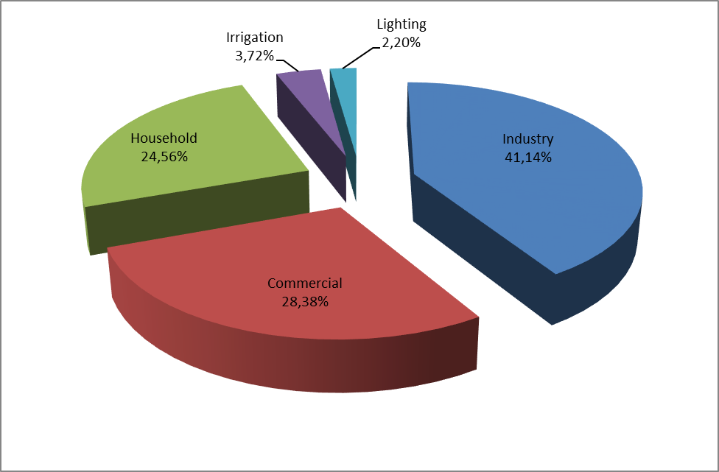

Table 1.13: Development of Invoiced Consumption by Consumer Type by Years (MWh)
Consumer Type | Consumption Amount (MWh)
Consumer Type | 2017 | 2018 | 2019
Industry | 94.965.625,60 | 96.995.848,19 | 94.462.698,78
Commercial | 66.454.453,03 | 68.289.253,67 | 65.150.389,26
Household | 53.531.710,78 | 54.769.979,56 | 56.389.775,22
Irrigation | 6.537.064,52 | 8.799.145,22 | 8.553.367,43
Lighting | 4.341.372,83 | 4.755.802,89 | 5.041.682,96
Grand Total | 225.830.226,76 | 233.610.029,54 | 229.597.913,65

Distribution of invoiced consumption by provinces is shown in Table 1.14. The highest consumption was realized in Istanbul with 39,52 TWh and corresponds to 17,21% of the total consumption. İzmir is followed by İzmir with a share of 6,76%, Ankara with a share of 6,14%, Bursa with a share of 5,15% and Kocaeli with a share of 4,34%.

Table 1.14: Distribution of Invoiced Consumption by Province (MWh - %)
PROVINCE | Consumption of Consumers Connected to Dist. Vol. (MWh) | Consumption of Consumers Connected to Trans.Vol. (MWh) | Total (MWh) | Share (%)
İSTANBUL (TOTAL) | 36.513.652,81 | 3.004.849,81 | 39.518.502,62 | 17,21
İSTANBUL (EUROPEAN SIDE) | 24.776.729,50 | 1.709.701,28 | 26.486.430,78 | 11,54
İZMİR | 11.432.868,20 | 4.078.226,26 | 15.511.094,46 | 6,76
ANKARA | 11.471.015,29 | 2.622.211,89 | 14.093.227,18 | 6,14
İSTANBUL (ANATOLIAN SIDE) | 11.736.923,31 | 1.295.148,53 | 13.032.071,84 | 5,68
BURSA | 7.281.420,28 | 4.532.129,00 | 11.813.549,28 | 5,15
KOCAELİ | 5.038.637,59 | 4.931.762,58 | 9.970.400,17 | 4,34
ANTALYA | 7.906.461,17 | 702.477,85 | 8.608.939,02 | 3,75
GAZİANTEP | 3.136.072,10 | 4.821.684,16 | 7.957.756,26 | 3,47
TEKİRDAĞ | 4.071.557,09 | 2.802.395,04 | 6.873.952,13 | 2,99
ADANA | 4.695.223,47 | 2.059.571,93 | 6.754.795,40 | 2,94
KONYA | 5.346.598,46 | 836.320,68 | 6.182.919,14 | 2,69
ŞANLIURFA | 4.316.692,50 | 379.491,60 | 4.696.184,10 | 2,05
MERSİN | 3.936.827,88 | 668.682,16 | 4.605.510,04 | 2,01
HATAY | 2.768.678,71 | 1.621.377,76 | 4.390.056,47 | 1,91
MANİSA | 3.129.455,87 | 1.230.114,22 | 4.359.570,09 | 1,90
KAHRAMANMARAŞ | 2.664.246,50 | 1.238.617,36 | 3.902.863,86 | 1,70
OSMANİYE | 702.091,50 | 3.007.638,90 | 3.709.730,40 | 1,62
SAKARYA | 2.273.108,51 | 1363303,49 | 3.636.412,00 | 1,58
KAYSERİ | 2.260.093,11 | 1.356.199,61 | 3.616.292,72 | 1,58
MUĞLA | 3.431.535,57 | 26.409,14 | 3.457.944,71 | 1,51
DENİZLİ | 2.962.491,85 | 475.084,79 | 3.437.576,64 | 1,50
BALIKESİR | 2.940.513,78 | 437.062,17 | 3.377.575,95 | 1,47
SAMSUN | 2.011.389,59 | 1.021.283,44 | 3.032.673,03 | 1,32
ESKİŞEHİR | 1.899.141,35 | 1.109.691,58 | 3.008.832,93 | 1,31
AYDIN | 2.494.716,85 | 203.968,71 | 2.698.685,56 | 1,18
DİYARBAKIR | 2.224.058,86 | 372.371,69 | 2.596.430,55 | 1,13
ÇANAKKALE | 1.242.704,83 | 1.345.657,41 | 2.588.362,24 | 1,13
KIRKLARELİ | 1.534.744,60 | 473.037,46 | 2.007.782,06 | 0,87
AFYONKARAHİSAR | 1.542.386,63 | 266.045,52 | 1.808.432,15 | 0,79
BİLECİK | 997.197,16 | 799.036,57 | 1.796.233,73 | 0,78
MARDİN | 1.570.708,74 | 161.198,29 | 1.731.907,03 | 0,75
UŞAK | 795.120,30 | 861.277,68 | 1.656.397,98 | 0,72
MALATYA | 1.132.100,22 | 498.878,21 | 1.630.978,43 | 0,71
TRABZON | 1.436.659,37 | 48801,4 | 1.485.460,77 | 0,65
KÜTAHYA | 996.202,52 | 488001,49 | 1.484.204,01 | 0,65
SİVAS | 1.014.283,02 | 233411,93 | 1.247.694,95 | 0,54
ORDU | 1.181.496,54 | 49.891,59 | 1.231.388,13 | 0,54
ELAZIĞ | 949.607,24 | 228.811,38 | 1.178.418,62 | 0,51
ZONGULDAK | 1.004.405,41 | 165.156,86 | 1.169.562,27 | 0,51
EDİRNE | 1.139.865,05 | 3.988,44 | 1.143.853,49 | 0,50
ADIYAMAN | 795.398,94 | 337.481,86 | 1.132.880,80 | 0,49
NİĞDE | 818.820,23 | 290.711,31 | 1.109.531,54 | 0,48
AKSARAY | 890.888,87 | 160.182,05 | 1.051.070,92 | 0,46
ISPARTA | 932.072,33 | 75.138,19 | 1.007.210,52 | 0,44
DÜZCE | 835.751,39 | 162.006,36 | 997.757,75 | 0,43
VAN | 978.509,69 | 17.224,96 | 995.734,65 | 0,43
BOLU | 796.447,73 | 197.746,38 | 994.194,11 | 0,43
KASTAMONU | 727.647,61 | 241.260,42 | 968.908,03 | 0,42
ERZURUM | 890.031,38 |  | 890.031,38 | 0,39
BATMAN | 694.038,62 | 182.730,54 | 876.769,16 | 0,38
KARAMAN | 627.734,64 | 195.023,16 | 822.757,80 | 0,36
ÇORUM | 731.235,26 | 80.048,82 | 811.284,08 | 0,35
TOKAT | 715.588,68 | 92.896,61 | 808.485,29 | 0,35
BURDUR | 536.169,26 | 257.708,12 | 793.877,38 | 0,35
YALOVA | 741.238,74 |  | 741.238,74 | 0,32
RİZE | 736.909,16 |  | 736.909,16 | 0,32
NEVŞEHİR | 734.986,27 |  | 734.986,27 | 0,32
YOZGAT | 656.037,62 | 29.736,88 | 685.774,50 | 0,30
GİRESUN | 684.198,37 |  | 684.198,37 | 0,30
ERZİNCAN | 319.653,94 | 292.350,23 | 612.004,17 | 0,27
ŞIRNAK | 592.328,55 |  | 592.328,55 | 0,26
AMASYA | 542.992,80 | 46.550,89 | 589.543,69 | 0,26
KARABÜK | 465.385,44 | 98.313,16 | 563.698,60 | 0,25
KIRIKKALE | 487.468,04 | 69.649,63 | 557.117,67 | 0,24
SİİRT | 479.750,73 | 12.049,04 | 491.799,77 | 0,21
ÇANKIRI | 370.268,77 | 85.140,14 | 455.408,91 | 0,20
ARTVİN | 452.895,29 |  | 452.895,29 | 0,20
AĞRI | 409.817,53 | 38.355,93 | 448.173,46 | 0,20
BARTIN | 404.844,32 | 14.405,14 | 419.249,46 | 0,18
KIRŞEHİR | 393.587,25 | 12.455,91 | 406.043,16 | 0,18
MUŞ | 312.891,88 | 78.493,19 | 391.385,07 | 0,17
SİNOP | 342.797,20 | 21.016,75 | 363.813,95 | 0,16
BİTLİS | 360.460,45 |  | 360.460,45 | 0,16
GÜMÜŞHANE | 317.980,25 | 26.612,32 | 344.592,57 | 0,15
KARS | 308.077,29 |  | 308.077,29 | 0,13
BİNGÖL | 305.989,05 |  | 305.989,05 | 0,13
KİLİS | 252.228,57 | 52.024,15 | 304.252,72 | 0,13
HAKKARİ | 260.686,65 |  | 260.686,65 | 0,11
IĞDIR | 199.596,15 |  | 199.596,15 | 0,09
ARDAHAN | 128.263,76 |  | 128.263,76 | 0,06
TUNCELİ | 126.236,69 |  | 126.236,69 | 0,05
BAYBURT | 100.545,53 |  | 100.545,53 | 0,04
Grand Total | 175.904.481,46 | 53.693.432,19 | 229.597.913,65 | 100,00

Table 1.15: Distribution of Invoiced Consumption by Province and Consumer (MWh)
PROVINCE | Lighting | Household | Industry | Agricultural Irrigation | Commerce | Grand Total | Share  (%)
ADANA | 122.793,47 | 1.798.730,97 | 3.090.183,06 | 160.591,73 | 1.582.496,17 | 6.754.795,40 | 2,94
ADIYAMAN | 31.479,37 | 476.826,21 | 417.591,92 | 18.539,80 | 188.443,50 | 1.132.880,80 | 0,49
AFYONKARAHİSAR | 63.539,57 | 390.732,52 | 698.134,76 | 182.559,94 | 473.465,35 | 1.808.432,15 | 0,79
AĞRI | 34.357,71 | 198.170,07 | 52.192,68 | 82,03 | 163.370,97 | 448.173,46 | 0,20
AKSARAY | 30.127,02 | 220.070,77 | 267.759,16 | 274.714,09 | 258.399,89 | 1.051.070,92 | 0,46
AMASYA | 29.465,12 | 203.974,00 | 159.074,86 | 21.995,99 | 175.033,72 | 589.543,69 | 0,26
ANKARA | 295.387,58 | 4.057.097,57 | 4.276.587,76 | 174.251,22 | 5.289.903,06 | 14.093.227,18 | 6,14
ANTALYA | 186.214,15 | 2.594.769,55 | 1.112.640,20 | 180.281,31 | 4.535.033,82 | 8.608.939,02 | 3,75
ARDAHAN | 12.292,76 | 44.341,10 | 1.787,44 | 4,17 | 69.838,30 | 128.263,76 | 0,06
ARTVİN | 34.829,65 | 122.825,18 | 159.732,30 | 156,51 | 135.351,65 | 452.895,29 | 0,20
AYDIN | 83.798,33 | 970.413,22 | 618.438,34 | 78.761,94 | 947.273,72 | 2.698.685,56 | 1,18
BALIKESİR | 100.140,62 | 924.598,87 | 1.306.243,02 | 93.030,93 | 953.562,51 | 3.377.575,95 | 1,47
BARTIN | 25.738,51 | 126.710,64 | 165.290,86 | 1.380,29 | 100.129,17 | 419.249,46 | 0,18
BATMAN | 26.105,52 | 291.050,77 | 278.231,50 | 5.304,15 | 276.077,22 | 876.769,16 | 0,38
BAYBURT | 12.364,74 | 41.429,76 | 3.725,73 | 224,24 | 42.801,07 | 100.545,53 | 0,04
BİLECİK | 21.825,15 | 121.720,67 | 1.513.125,85 | 12.268,52 | 127.293,54 | 1.796.233,73 | 0,78
BİNGÖL | 14.632,61 | 122.600,32 | 49.228,01 | 780,83 | 118.747,27 | 305.989,05 | 0,13
BİTLİS | 27.677,52 | 128.350,36 | 23.933,67 | 46.238,55 | 134.260,36 | 360.460,45 | 0,16
BOLU | 28.957,27 | 186.081,66 | 449.640,36 | 46.753,68 | 282.761,15 | 994.194,11 | 0,43
BURDUR | 27.695,26 | 152.929,43 | 405.310,10 | 46.426,56 | 161.516,03 | 793.877,38 | 0,35
BURSA | 126.061,66 | 1.969.089,31 | 7.260.805,16 | 125.251,54 | 2.332.341,62 | 11.813.549,28 | 5,15
ÇANAKKALE | 34.685,06 | 365.223,93 | 1.651.600,43 | 46.279,37 | 490.573,45 | 2.588.362,24 | 1,13
ÇANKIRI | 23.523,85 | 106.680,54 | 225.357,73 | 2.896,00 | 96.950,80 | 455.408,91 | 0,20
ÇORUM | 42.660,33 | 299.888,94 | 200.482,02 | 24.054,87 | 244.197,91 | 811.284,08 | 0,35
DENİZLİ | 82.967,45 | 691.710,49 | 1.814.825,91 | 93.738,77 | 754.334,02 | 3.437.576,64 | 1,50
DİYARBAKIR | 47.337,66 | 826.460,05 | 673.676,15 | 256.951,55 | 792.005,15 | 2.596.430,55 | 1,13
DÜZCE | 30.307,59 | 231.951,40 | 494.192,39 | 6.248,00 | 235.058,38 | 997.757,75 | 0,43
EDİRNE | 34.613,74 | 259.817,34 | 352.135,19 | 117.755,31 | 379.531,92 | 1.143.853,49 | 0,50
ELAZIĞ | 38.591,69 | 292.762,27 | 368.886,87 | 40.748,83 | 437.428,96 | 1.178.418,62 | 0,51
ERZİNCAN | 24.348,68 | 119.210,51 | 311.947,13 | 10.419,62 | 146.078,23 | 612.004,17 | 0,27
ERZURUM | 66.129,02 | 368.187,78 | 58.379,86 | 3.642,54 | 393.692,18 | 890.031,38 | 0,39
ESKİŞEHİR | 50.864,11 | 576.454,09 | 1.548.147,70 | 210.463,48 | 622.903,54 | 3.008.832,93 | 1,31
GAZİANTEP | 87.018,09 | 1.242.754,60 | 5.349.676,81 | 109.909,46 | 1.168.397,30 | 7.957.756,26 | 3,47
GİRESUN | 66.125,81 | 305.010,23 | 74.024,54 | 257,47 | 238.780,32 | 684.198,37 | 0,30
GÜMÜŞHANE | 22.417,76 | 70.267,03 | 186.668,17 | 566,38 | 64.673,23 | 344.592,57 | 0,15
HAKKARİ | 12.764,32 | 114.743,16 | 2.788,93 | 41,04 | 130.349,20 | 260.686,65 | 0,11
HATAY | 98.083,78 | 1.227.820,28 | 1.941.193,73 | 176.141,14 | 946.817,54 | 4.390.056,47 | 1,91
IĞDIR | 16.717,20 | 83.812,36 | 7.551,89 | 969,93 | 90.544,76 | 199.596,15 | 0,09
ISPARTA | 39.471,02 | 273.296,41 | 301.603,35 | 59.458,65 | 333.381,09 | 1.007.210,52 | 0,44
İSTANBUL | 534.736,61 | 11.624.263,93 | 10.838.820,91 | 9.516,25 | 16.511.164,92 | 39.518.502,62 | 17,21
İZMİR | 227.812,64 | 4.165.095,53 | 6.643.921,07 | 393.409,08 | 4.080.856,14 | 15.511.094,46 | 6,76
KAHRAMANMARAŞ | 74.633,83 | 780.196,15 | 2.514.049,09 | 38.622,56 | 495.362,22 | 3.902.863,86 | 1,70
KARABÜK | 25.935,90 | 147.046,97 | 241.150,37 | 2.837,71 | 146.727,64 | 563.698,60 | 0,25
KARAMAN | 18.712,54 | 135.940,29 | 278.234,55 | 215.908,31 | 173.962,10 | 822.757,80 | 0,36
KARS | 18.900,33 | 108.311,77 | 40.524,31 | 261,43 | 140.079,45 | 308.077,29 | 0,13
KASTAMONU | 49.174,65 | 229.594,42 | 480.230,82 | 4.009,77 | 205.898,36 | 968.908,03 | 0,42
KAYSERİ | 115.760,69 | 804.754,07 | 1.801.990,13 | 168.033,05 | 725.754,78 | 3.616.292,72 | 1,58
KIRIKKALE | 24.009,28 | 165.501,84 | 195.861,17 | 4.562,91 | 167.182,48 | 557.117,67 | 0,24
KIRKLARELİ | 26.939,39 | 221.790,01 | 1.389.995,83 | 11.607,43 | 357.449,40 | 2.007.782,06 | 0,87
KIRŞEHİR | 23.146,63 | 134.735,59 | 84.259,34 | 26.570,81 | 137.330,79 | 406.043,16 | 0,18
KİLİS | 11.154,39 | 112.674,64 | 61.158,76 | 17.892,44 | 101.372,48 | 304.252,72 | 0,13
KOCAELİ | 93.420,54 | 1.275.678,25 | 7.058.809,05 | 13.638,37 | 1.528.853,97 | 9.970.400,17 | 4,34
KONYA | 161.868,51 | 1.281.967,02 | 1.942.076,34 | 1.317.439,81 | 1.479.567,46 | 6.182.919,14 | 2,69
KÜTAHYA | 48.241,55 | 309.333,13 | 826.539,25 | 9.412,22 | 290.677,86 | 1.484.204,01 | 0,65
MALATYA | 53.792,30 | 420.335,92 | 620.578,48 | 83.269,95 | 453.001,79 | 1.630.978,43 | 0,71
MANİSA | 84.549,42 | 940.759,68 | 2.065.479,58 | 333.805,92 | 934.975,49 | 4.359.570,09 | 1,90
MARDİN | 37.335,25 | 374.054,32 | 409.054,89 | 541.303,17 | 370.159,40 | 1.731.907,03 | 0,75
MERSİN | 116.228,95 | 1.488.495,14 | 1.405.073,74 | 185.305,63 | 1.410.406,57 | 4.605.510,04 | 2,01
MUĞLA | 82.055,40 | 1.089.164,01 | 529.029,48 | 45.071,70 | 1.712.624,13 | 3.457.944,71 | 1,51
MUŞ | 23.209,49 | 144.927,22 | 90.713,00 | 2.379,93 | 130.155,43 | 391.385,07 | 0,17
NEVŞEHİR | 35.984,16 | 188.138,12 | 127.127,73 | 146.466,07 | 237.270,18 | 734.986,27 | 0,32
NİĞDE | 35.535,65 | 189.492,97 | 505.724,16 | 166.942,85 | 211.835,91 | 1.109.531,54 | 0,48
ORDU | 75.165,25 | 477.554,14 | 314.335,08 | 498,37 | 363.835,30 | 1.231.388,13 | 0,54
OSMANİYE | 31.501,50 | 333.455,11 | 3.067.824,20 | 16.302,51 | 260.647,09 | 3.709.730,40 | 1,62
RİZE | 49.697,52 | 244.260,59 | 222.768,79 | 15,38 | 220.166,88 | 736.909,16 | 0,32
SAKARYA | 66.848,04 | 704.597,03 | 2.105.124,15 | 38.154,37 | 721.688,41 | 3.636.412,00 | 1,58
SAMSUN | 104.380,65 | 858.115,23 | 1.277.994,35 | 33.047,77 | 759.135,03 | 3.032.673,03 | 1,32
SİİRT | 19.979,09 | 133.248,35 | 217.537,58 | 7.162,35 | 113.872,40 | 491.799,77 | 0,21
SİNOP | 25.251,91 | 153.073,28 | 76.249,14 | 1.091,14 | 108.148,49 | 363.813,95 | 0,16
SİVAS | 66.498,28 | 329.537,04 | 491.614,81 | 38.678,52 | 321.366,30 | 1.247.694,95 | 0,54
ŞANLIURFA | 52.702,24 | 1.044.945,00 | 797.346,34 | 1.864.579,03 | 936.611,49 | 4.696.184,10 | 2,05
ŞIRNAK | 16.416,99 | 184.199,89 | 26.906,65 | 26.765,09 | 338.039,93 | 592.328,55 | 0,26
TEKİRDAĞ | 57.999,24 | 555.736,11 | 5.351.576,68 | 18.396,75 | 890.243,35 | 6.873.952,13 | 2,99
TOKAT | 56.009,39 | 318.406,49 | 178.193,39 | 6.723,24 | 249.152,78 | 808.485,29 | 0,35
TRABZON | 97.805,85 | 628.460,21 | 212.949,26 | 938,06 | 545.307,39 | 1.485.460,77 | 0,65
TUNCELİ | 10.359,55 | 45.059,96 | 8.917,91 | 1.208,38 | 60.690,89 | 126.236,69 | 0,05
UŞAK | 32.619,23 | 220.086,68 | 1.160.107,81 | 31.412,60 | 212.171,65 | 1.656.397,98 | 0,72
VAN | 58.895,78 | 427.153,19 | 102.079,61 | 3.053,07 | 404.553,00 | 995.734,65 | 0,43
YALOVA | 14.327,23 | 207.552,56 | 294.584,75 | 6.742,91 | 218.031,29 | 741.238,74 | 0,32
YOZGAT | 51.985,59 | 212.725,84 | 128.505,89 | 87.879,65 | 204.677,53 | 685.774,50 | 0,30
ZONGULDAK | 75.990,80 | 380.793,15 | 404.884,83 | 2.310,44 | 305.583,06 | 1.169.562,27 | 0,51
Grand Total | 5.041.682,96 | 56.389.775,22 | 94.462.698,78 | 8.553.367,43 | 65.150.389,26 | 229.597.913,65 | 100,00

The distribution of invoiced consumption by months is shown in Figure 1.21. The highest consumption was in July, the lowest consumption was in February.

Figure 1.20: Distribution of Invoiced Consumption by Months (MWh)
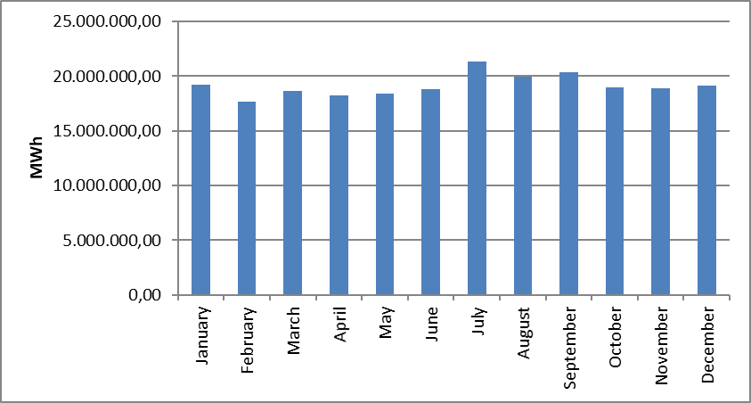

The development of consumption over years is shown in Figure 1.22. The consumption decreased in the last 20 years in 2001, 2009 and 2019 compared to the previous year. The decrease rate in 2019 compared to the previous year was 0,26%.

Figure 1.21: Development of Gross Consumption by Years (GWh)
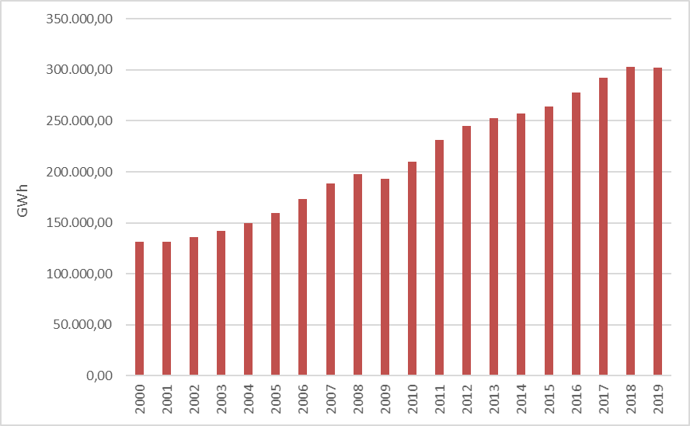

1.6 Import and Export

1.6.1 Import

The data on electricity imports in 2019 by months is shown in Figure 1.23. 88,66% of the total 2.211.506,39 MWh electricity imports in 2019 were from Bulgaria, 11,17% from Georgia and 0,17% from Greece. On a monthly basis, the highest electricity import was in November, while the lowest electricity import was in April.

Figure 1.22: Electricity Imports in 2019 by Months (MWh)
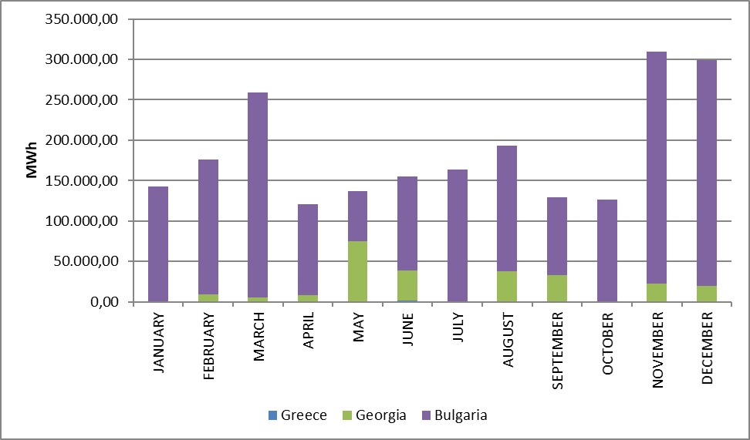

1.6.2 Export

The data on electricity exports in 2019 by months is shown in Figure 1.24. 95,66% of the total 2.788.667,28 MWh electricity exports in 2019 was made to Greece, and the remaining 4,34% to Bulgaria and Georgia. On a monthly basis, the highest electricity export was realized in May, while the lowest electricity import was realized in June.

Figure 1.23: Electricity Exports in 2019 by Months (MWh)
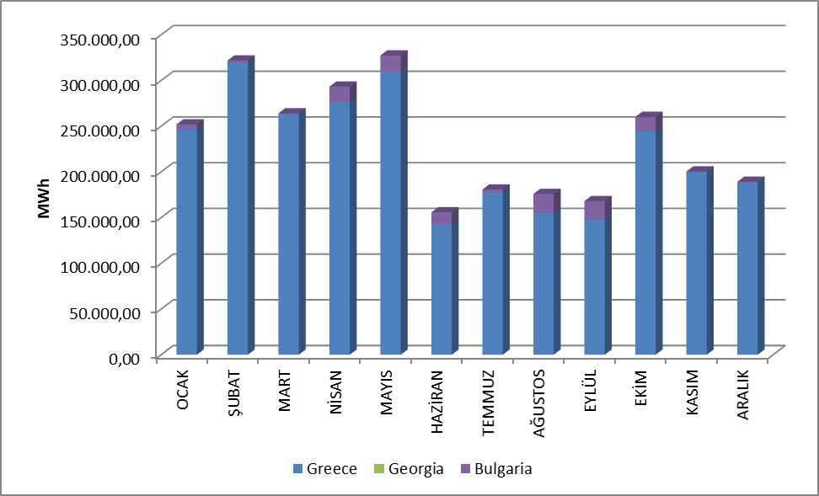

- WHOLESALE MARKET

In this section, the developments that occurred in the wholesale market were examined in the year 2019. In this context; the prices of the Day-Ahead Market (DAM), the Intra-Day Market (IDM) and the Balancing Power Market (BPM) are presented with the volumes and the orders given. Moreover, the changes that occurred in the market structure are explained.
Primary Frequency Control (PFC) brings the system frequency to a new equilibrium point by automatically increasing or decreasing the unit active power with the speed regulator in response to the decrease or rise of the system frequency. PFK reserve is obtained from production facilities determined to be capable of providing PFK services as a result of PFK performance tests in Electricity Network Regulation.
Secondary Frequency Control (SFK) brings the system frequency to the nominal value and to the programmed value of the total electrical energy exchange with neighboring country electricity networks by increasing or decreasing the active power output of the production facilities participating in the SFK service by the signals sent automatically from the National Load Dispatch Center. SFK reserve is provided by the production facilities which are determined to be capable of providing SFK services as a result of the SFK performance tests in the Electricity Network Regulation.
Pursuant to the Electricity Market Ancillary Services Regulation published on the Official Gazette dated 26 November 2017 and numbered 30252, participation in PFK and SFK services has ceased to be compulsory and PFK and SFK reserves have been procured on a voluntary basis. Currently, between 200-300 MW PFK reserve and 700-1100 MW SFK reserve are kept at different times of the day.

  - Day-Ahead Market

In the process that started with the Electricity Market Law, it was aimed to create an electricity market that is transparent, reliable, competitive and integrated with the electricity markets of other countries. In line with this goal, many planned steps have been taken, and significant progress has been made in each step taken to make the electricity market stronger and more dynamic, for market participants to take a more active role in the electricity market, and for those who operate the market to manage and follow the market in the best way.
First step carried out for transformation of electricity market from a single buyer-single seller model to liberal and competitive model was transition to monthly 3 period financial settlement system on 1 July 2006. Next step was the start of operations for Day-Ahead Planning system on 1 December 2009. These transition periods have great importance regarding to transformation of electricity market into stronger and more dynamic structure. Parties took role in market operations and activities provided significant experience and foresight for new market models from their practices at earlier market stages. 1 December 2011 date became a milestone for Turkish Electricity Market and creation of currently used Day-Ahead Market system has been established which is deemed as biggest step towards formation of targeted electricity market structure. Establishment of Day-Ahead Market stimulated a new dynamism and vision for Turkish Electricity Market and allowed formation of market structure based on values of competition.
With the new market structure, the collateral mechanism has been implemented and in this context, the market participants registered with MFSC must provide a guarantee to the market operator for the transactions they have made in DAM. In addition to this arrangement, it is possible for participants to create portfolios. Lastly, in the event that system constraints continue systematically, TEİAŞ is given the opportunity to switch to regional pricing by considering the constraints.
Following the completion of the registration process on 18 March 2015, the Energy Exchange Istanbul (EXIST) was formally established, under the provisions of the Turkish Commercial Code of the 14.03.2013 dated and numbered 6446 with the Electricity Market Act of 6102.
In accordance with the proposals offered by the market participants in the Day-Ahead Market operated by EXIST, the market exchange prices and the purchase and sales quantities are announced.
For the year 2019, prices of DAM are given in Figure 2.1.1 and 2.1.2.

Figure 2.1.1: Hourly Development of Weighted Average Market Clearing Price in 2019 (TL/MWh)
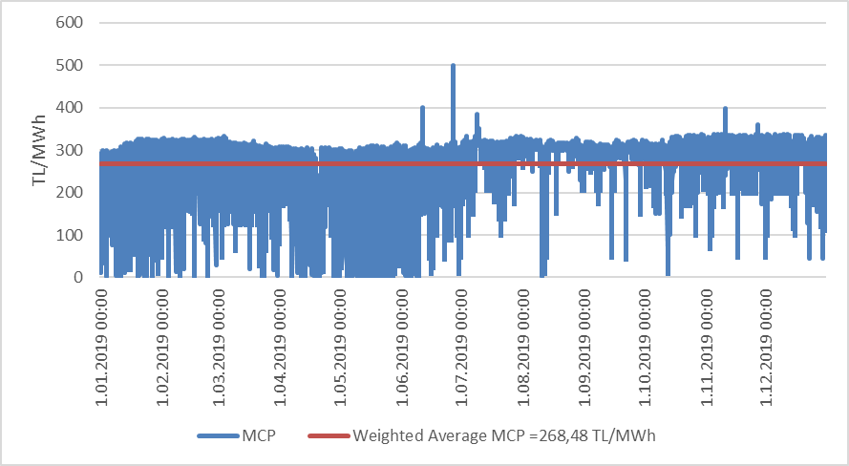

Figure 2.1.2: Organized and Weighted Average MCP in 2019 (TL/MWh)
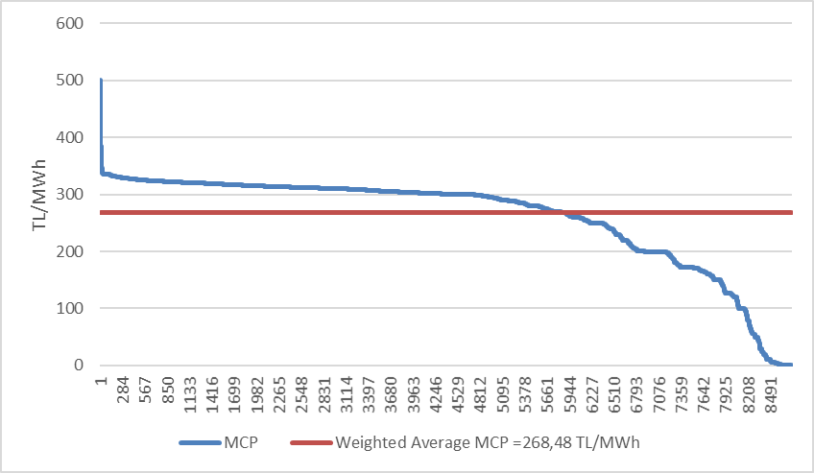
As seen in the figures, prices have generally been in the range of 150-350 TL / MWh. The price reached its highest value of 500.00 TL / MWh on June 27, 2019 at 15:00. In 2019, MCP was 0 TL / MWh for a total of 52 hours.
In Figure 2.1.3, the weighted average MCP is given in Day-Ahead Market by years. In 2019, the weighted average of the MCP increased by 15,18% compared to 2018 and reached 268,48 TL/MWh.

Figure 2.1.3: Weighted Average MCP by Years (TL/MWh)
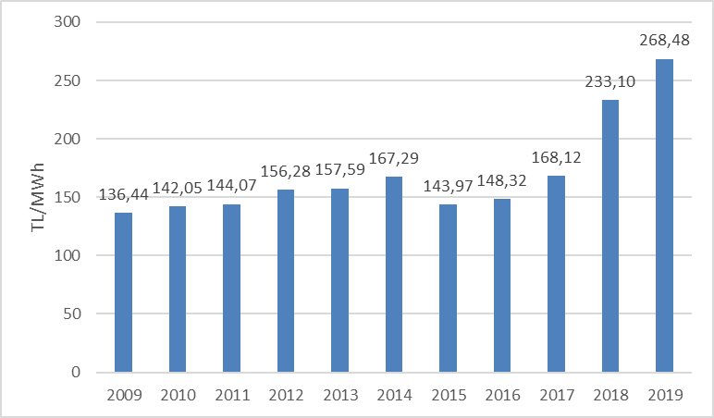
In Figure 2.1.4 below, monthly weighted average Day-Ahead Market prices for the last two years are shown. In 2019, the highest value was seen in July with 307,986 TL / MWh and the lowest value was in April with 195,023 TL / MWh.
Electricity consumption on a monthly basis decreases in the spring and autumn months with the temperate climate. In addition, the water revenues of hydroelectric power plants increase with the high precipitation especially in spring, and the lowest prices of the year are generally in spring.
On the other hand, due to the consumption of air conditioning and agricultural irrigation in the summer months, the need for warming and enlightenment in the winter months, electricity demand increases and in parallel with the increase in consumption, the average prices also increase.

Figure 2.1.4: Monthly Weighted Average MCP of the Last Two Years (TL/MWh)
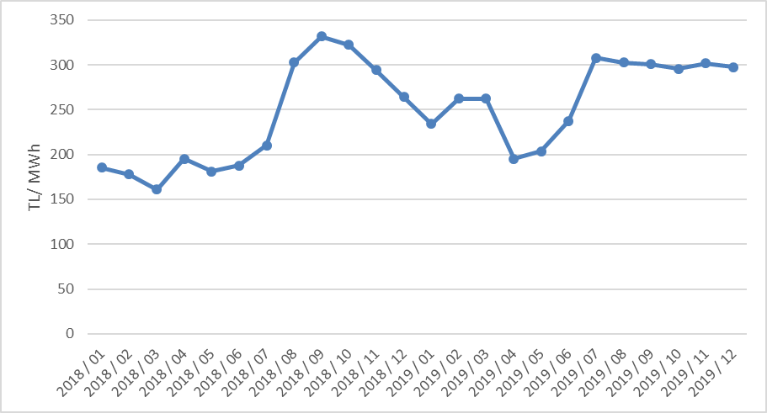
The following figure 2.1.5 shows the trading volume in the DAM by months, the distribution of the quantities of DAM buying in Figure 2.1.6 and the share of the top 10 companies, the distribution of sales quantities in Figure 2.1.7 and the share of the top 10 company.

Figure 2.1.5: Monthly Day-Ahead Market Trading Volume (MWh)
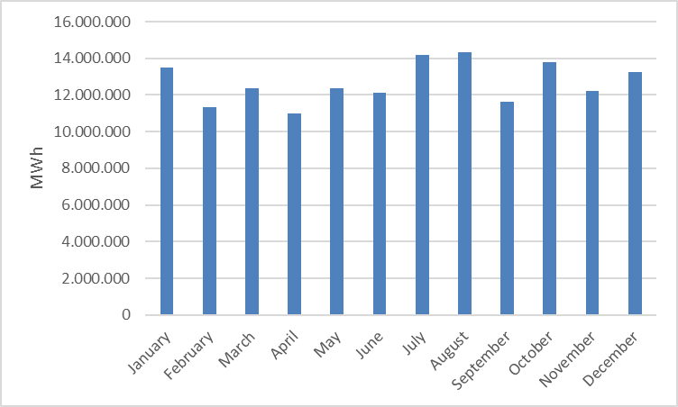

Figure 2.1.6: The Share of Top 10 Buyer Companies in Day-Ahead Market (%)
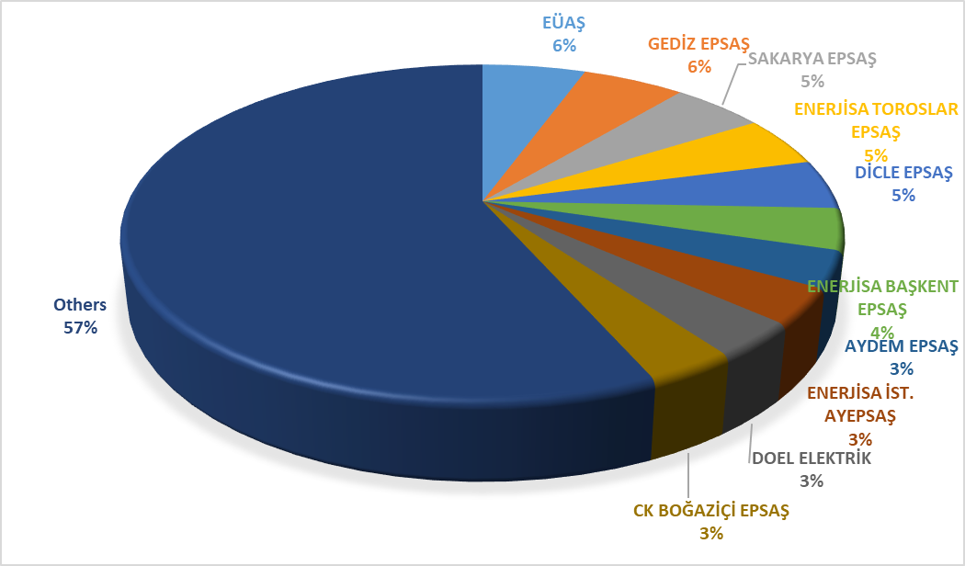

Figure 2.1.7: The Share of Top 10 Seller Companies in Day-Ahead Market (%)
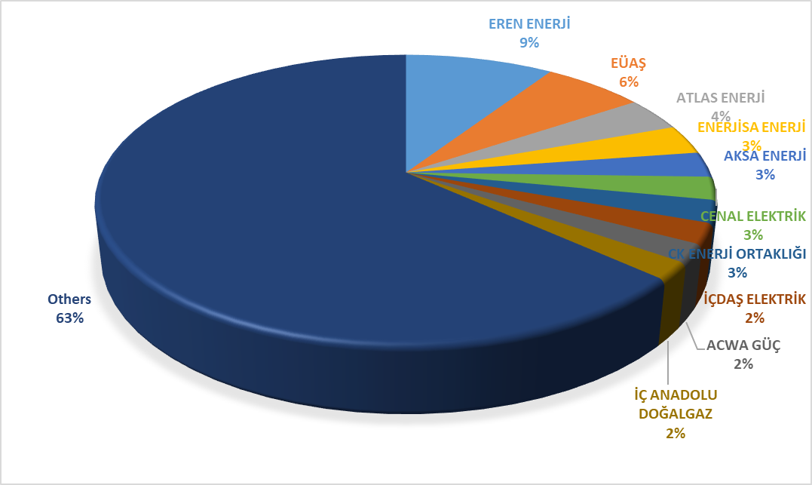

2.2 Balancing Power Market

Balancing Power Market is operated in real time by TEİAŞ. This section provides data on the development of prices and volumes in the BPM. In 2019, the system marginal prices (real time price) at the BPM are shown at Figure 2.2.1 on a per-hour basis. Also, Figure 2.2.2 provides the organized system marginal prices.

Figure 2.2.1: Per-Hour Based Development of System Marginal Price (TL/MWh)
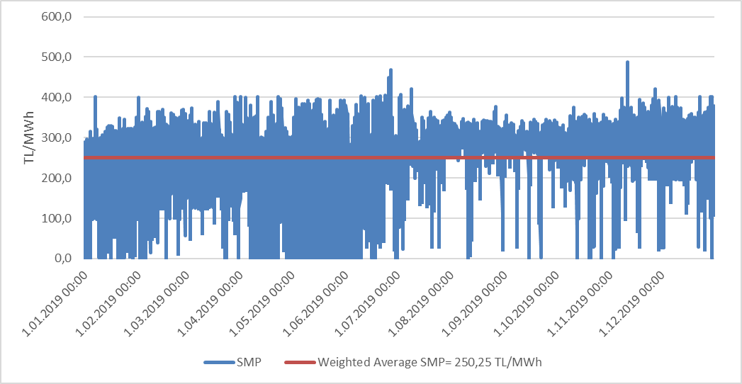

Figure 2.2.2: Organized Sytem Marginal Price (TL/MWh)
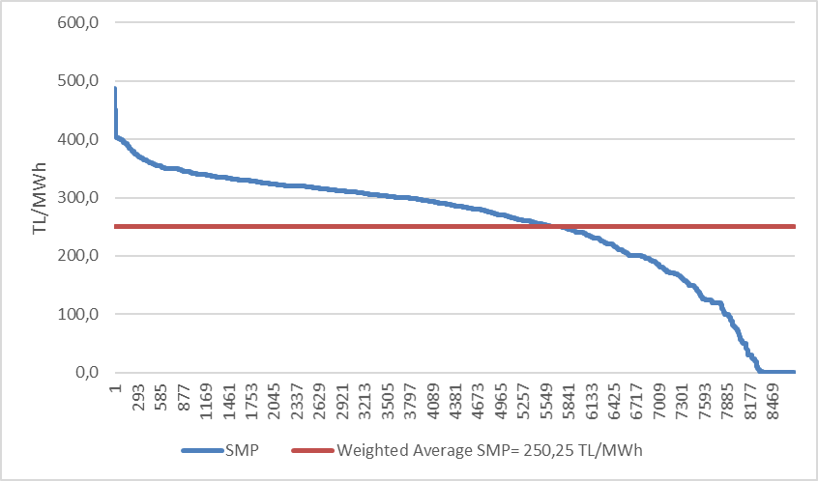

Similar to the prices of the DAM, the prices in the BPM were generally between 150 and 350 TL/MWh. The price was highest on 11 November 2019 at 18:00 with 487,15 TL/MWh, and it was over 400 TL/MWh for 86 hours. At the BPM, the price was 0 TL/MWh for 365 hours during 2019.

The annual weighted average of the price in BPM was 250,25 TL/MWh, increased by 7,28% compared to the previous year.
Monthly weighted average prices in the Balancing Power Market for the last two years are shown in Figure 2.2.3 below. In 2019, SMF was seen as the lowest 185,314 TL / MWh in January and the highest value was in November with 301,284 TL / MWh.

Figure 2.2.3: Monthly Weighted Average Prices of the Last Two Years in Balancing Power Market (TL/MWh)
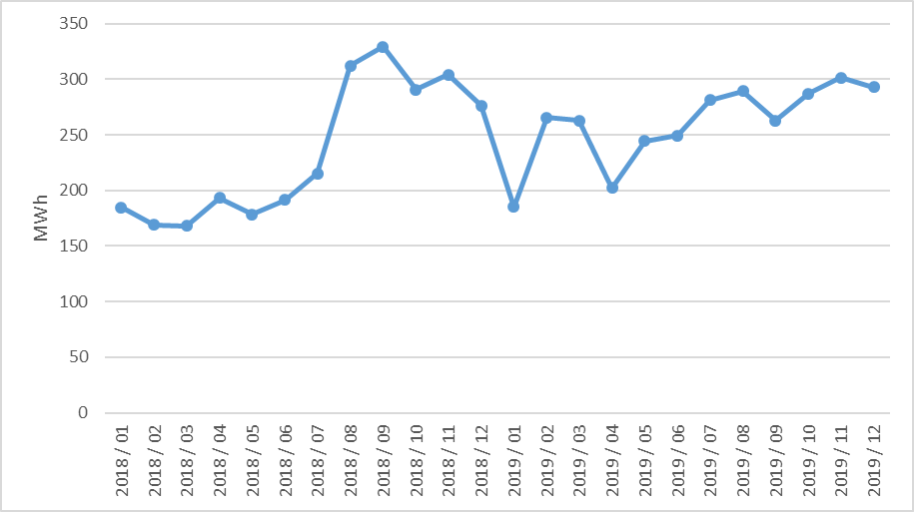

Below Figure 2.2.4 shows monthly trading volumes in BPM in 2019.

Figure 2.2.4: Monthly Trading Volumes in Balancing Power Market (MWh)
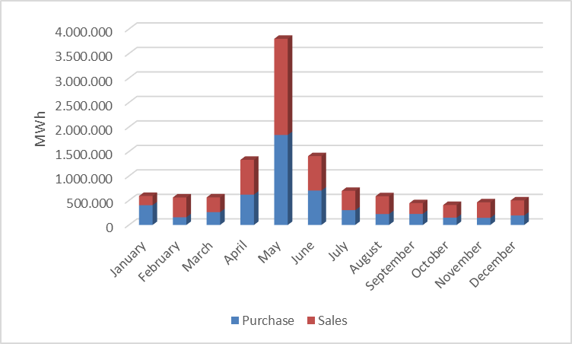
In the following Figure 2.2.5 the distribution of the BPM buying quantities on the basis of the company and the share of the top 10 buyer companies and in Figure 2.2.6, the distribution of BPM sales quantities on company basis and the share of the top 10 companies are shown.

Figure 2.2.5: The Share of Top 10 Buyer Companies in Balancing Power Market (%)
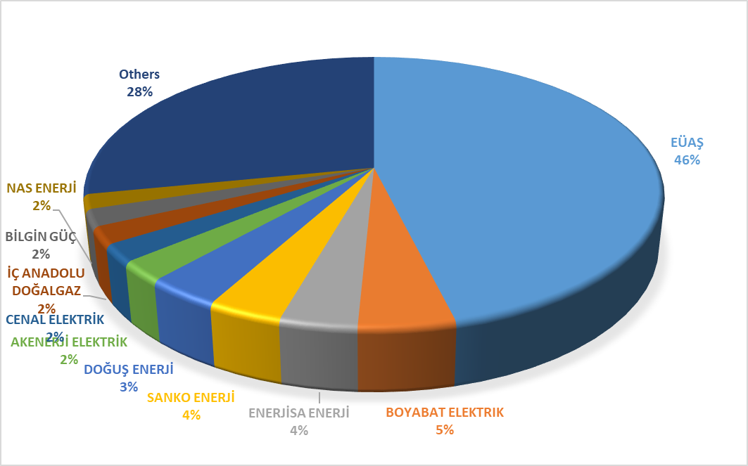

Figure 2.2.6: The Share of Top 10 Seller Companies in Balancing Power Market (%)
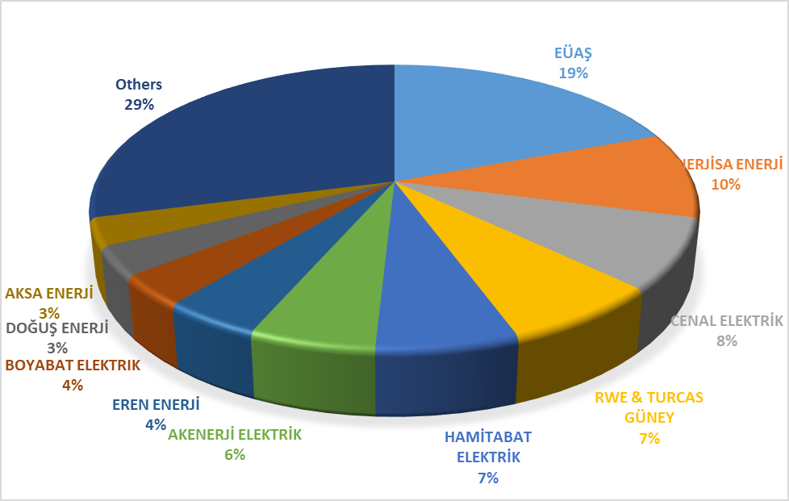
As of 2019, the rates of instruction volumes given in DGP are shown in Figure 2.2.7 below and their distribution on hourly basis is shown in Figure 2.2.8. 28% of the instructions were 1 coded, given due to system constraints. As of February 2018, since the procurement system was implemented in the side services, there were no 2 coded instructions.

Figure 2.2.7: Rates of Order Volumes Given in Balancing Power Market in 2019 (%)
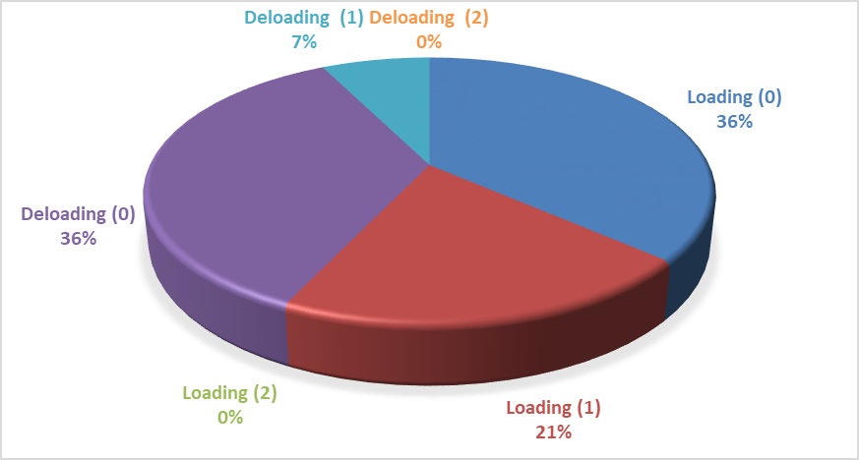

Figure 2.2.8: Distribution of the Orders Given in the Balancing Power Market by Hours in 2019 (MW)
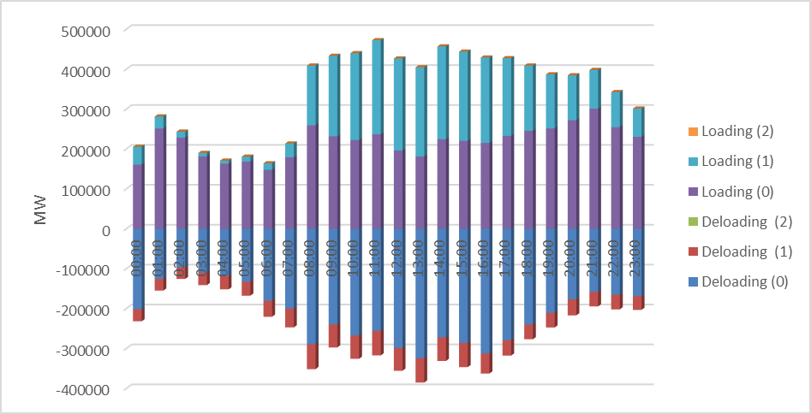

Additional costs arising from those instructions are shown in Table 2.2.1 below. While the additional cost caused by the instructions given in DGP was 119.67 million TL in 2018, it was 625.8 million TL in 2019. All of these costs are caused by 1 coded instructions, and since there are no 2 codes, no costs occurred.

Table 2.2.1: Additional Costs of Orders (Million TL)
Type of Instruction | Loading | DE-Loading | Total
1 Coded | 434,9 | 190,9 | 625,8

The development of additional costs on a monthly basis in 2019 is shown in Figure 2.2.9 below. The majority of the Additional Costs was in April, May and June.

Figure 2.2.9: Development of Additional Costs of Orders by Months in 2019 (Million TL)
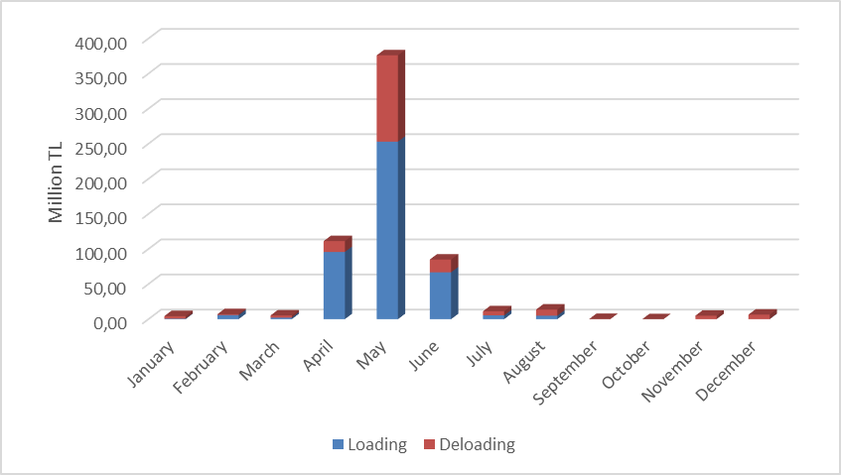
The change of the Zero Balance Adjustment Amount (ZBAC) by years is shown in Figure 2.2.10. ZBAC is realized as 654 million TL in 2019.

Figure 2.2.10: Development of Zero Balance Adjustment Component by Years (TL)

2.3 Intra-Day Market

Efforts are continuing to ensure that the Turkish Electricity Market is more transparent and efficient, financially strong, integrated with the European Union electricity markets. On 1 July 2015, the Intra-Day Market was in operation to ensure that participants in the Turkish electricity market, which is constantly evolving and advancing for free market, playing more balanced and effective role.
Day-Ahead, Ancillary Services and Balancing Power Markets currently in operation, with the addition of Intra-Day Market, provide real-time trading opportunities and offermarket participants the opportunity to manage short-term portfolios.
In Figure 2.3.1 below, monthly volume of the Intra-Day Market and the weighted average price in 2019 is given.

Figure 2.3.1: Monthly Development of Trading Volume and Average Price in the Intra-Day Market (MWh – TL/MWh)
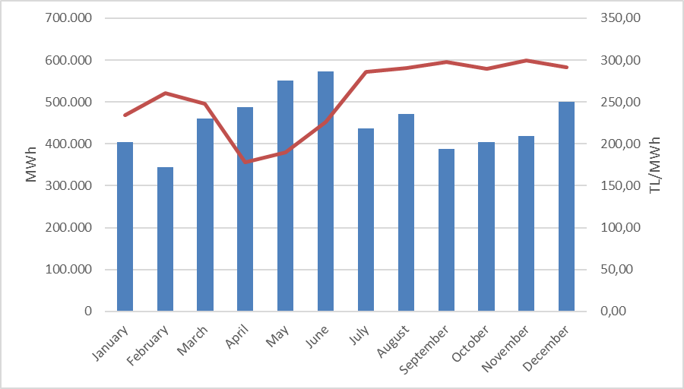
In Figure 2.3.2 the distribution of purchases of IDM on the basis of company and the share of first 10 companies and in Figure 2.3.3, the distribution of sales in IDM on the basis of the company and the share of top 10 seller companies are shown.

Figure 2.3.2: Distribution of Purchases of Intra-Day Market by Companies and the Share of Top 10 Companies (%)
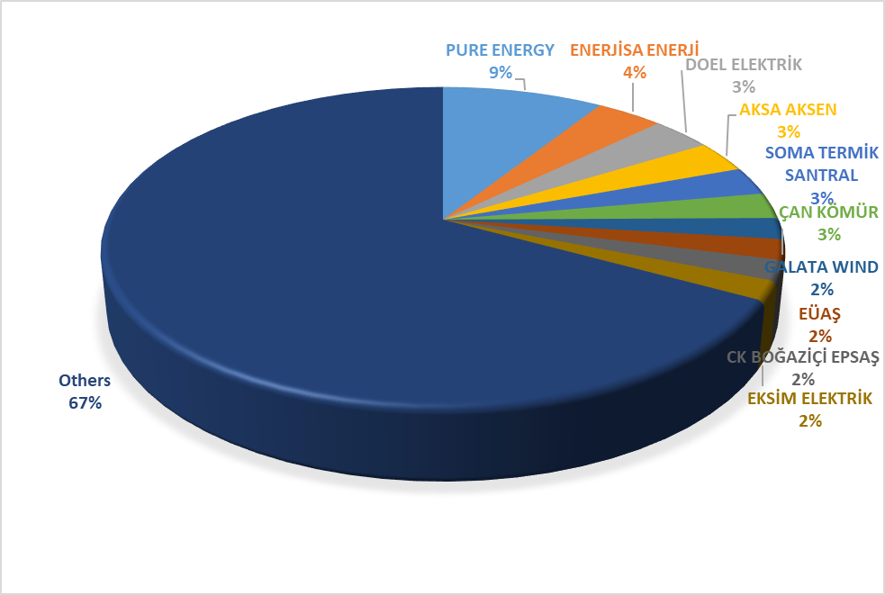

Figure 2.3.3: Distribution of Sales in Intra-Day Market by Companies and the Share of Top 10 Companies (%)
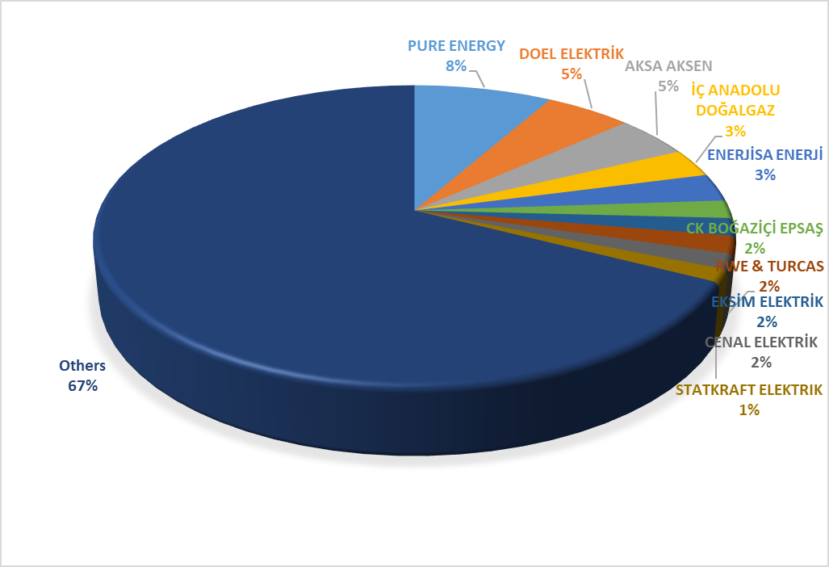

2.4 Bilateral Agreements

Bilateral agreements are based on the construction of the Turkish electricity market, and the other organized markets are designed in the figure complementing the market. Most of the energy traded in the market is traded on bilateral agreements. Bilateral agreements are not subjected to regulation. However, the majority of the existing bilateral agreement volume is the ones signed by TETAŞ with the incumbent supply companies. Also, distribution companies have energy purchases from TETAŞ for losses and general lighting purposes under bilateral agreements.
In the Figure 2.4.1 monthly bilateral agreement volumes in 2017-2019 are shown.

Figure 2.4.1: Monthly Bilateral Agreement Volume by Years (MWh)
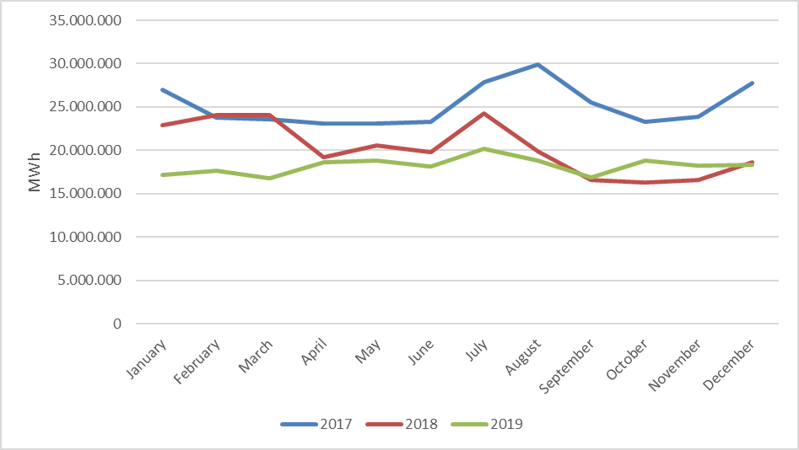

In the following Figure 2.4.2 the distribution of purchases with bilateral agreement on the basis of the company and the share of top 10 buyer companies and in Figure 2.4.3, the distribution of sales with bilateral agreement on the basis of the company and the share of top 10 seller companies are shown.

Figure 2.4.2: Distribution of Purchases of Bilateral Agreement by Companies and the Share of Top 10 Companies (%)
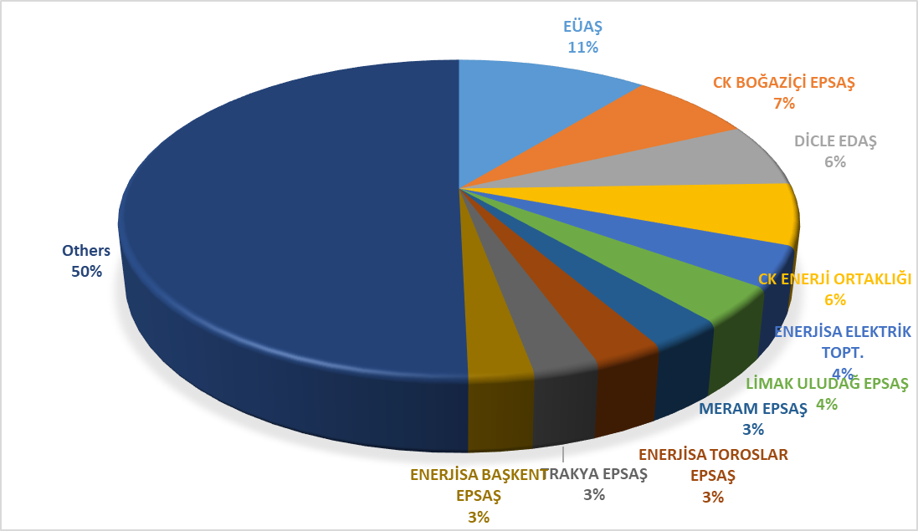

Figure 2.4.3: Distribution of Sales with Bilateral Agreement by Companies and the Share of Top 10 Companies (%)
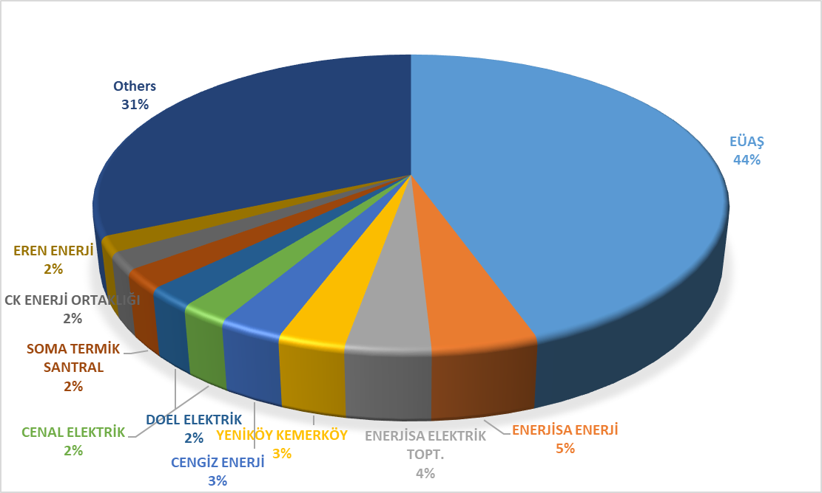

The wholesale tariffs of TETAŞ are determined by Board Decision and it is considered that TETAŞ fulfills its obligations arising from existing contracts.
While the single price for the tariff TETAŞ wholesale tariff was announced, a separate price was determined for the general lighting cost since 2017.

Below is the change in the wholesale prices of EÜAŞ in Figure 2.4.4.

Figure 2.4.4: TETAŞ Wholesale Prices Between 2011-2019 (kr/kWh)

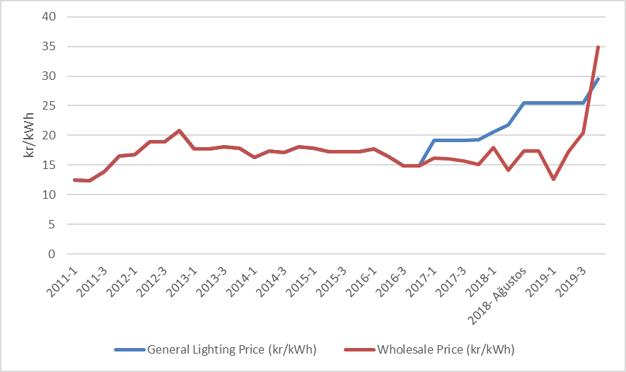

  - RESSUM

“The Amendment of the Law on “Utilization of Renewable Energy Resources for Generation of Electrical Energy” Law Numbered 6094 published in the Official Gazette 08/01/2011 dated and 27809 numbered provide incentive for renewable energy sources according to the source type and the locality rate. In this context, the regulations prepared by EMRA and the details Mechanism of Supporting Renewable Energy Sources are determined with the regulations prepared by EMRA.
Regulation on Certification and Support of Renewable Energy Sources” was published in the Official Gazette dated 01/10/2013 and numbered 28782 and came into force. With the Regulation, in order to encourage the generation of electricity based on renewable energy sources, principles regarding the provision of Renewable Energy Source Document and the establishment and operation of RESSUM issued to the generation license holders.
In the following Table 2.5.1, the number of the RES Support participants is given by years. In 2018, there were 777 companies with a total installed capacity of 20.921,5 MW operating in the scope of the RES Support.

Table 2.5.1: Number of RESSUM Participants by Years
Type | 2011 | 2012 | 2013 | 2014 | 2015 | 2016 | 2017 | 2018 | 2019
Solar | - | - | - | - | - | - | 2 | 3 | 9
Hydraulic | 4 | 44 | 14 | 40 | 126 | 388 | 418 | 447 | 463
Wind | 9 | 22 | 3 | 21 | 60 | 106 | 141 | 151 | 160
Biomass | 3 | 8 | 15 | 23 | 34 | 42 | 57 | 70 | 100
Geothermal | 4 | 4 | 6 | 9 | 14 | 20 | 29 | 37 | 45
Total | 20 | 78 | 38 | 93 | 234 | 556 | 647 | 708 | 777

When we look at the distribution of RESSUM installed power by source type, it is seen that hydraulic power plants have the highest share with 12.588.5 MW, and wind power plants take second place with 6.495.6 MW.

Table 2.5.2: Distribution of Generation in RESSUM by Sources in 2019 (MW)*
Type | 2011 | 2012 | 2013 | 2014 | 2015 | 2016 | 2017 | 2018 | 2019
Solar | - | - | - | - | - | - | 12,9 | 13,9 | 81,7
Hydraulic | 21 | 930 | 217 | 598 | 2.116,3 | 9.960,0 | 11.096,3 | 11.706,4 | 12.588,5
Wind | 469 | 685 | 76 | 825 | 2.732,1 | 4.319,8 | 5.238,7 | 6.200,0 | 6.495,6
Geothermal | 72 | 72 | 140 | 228 | 389,9 | 599,2 | 752,1 | 996,8 | 1.252,7
Biomass | 45 | 73 | 101 | 147 | 185,2 | 203,7 | 300,0 | 349,2 | 503,1
Total | 608 | 1.760 | 534 | 1.798 | 5.423,6 | 15.082,7 | 17.399,9 | 19.266,3 | 20.921,5

* In addition, by the end of 2019, 6.309,27 MW of unlicensed installed capacity (natural gas plants excluded) are covered by RESSUM. Details are given at "Unlicensed Electricity Generation" in Section 1.3,
Share of installed capacity in the scope of the RES Support in Turkey's total installed capacity in 2018 was 27,77%, while this share reached to 29,84% in 2019.
In the following Figure 2.5.1, distribution of installed capacity based on sources in 2019 is given.

Figure 2.5.1: Distribution of RESSUM Installed Capacity to Resources in 2019 (%)
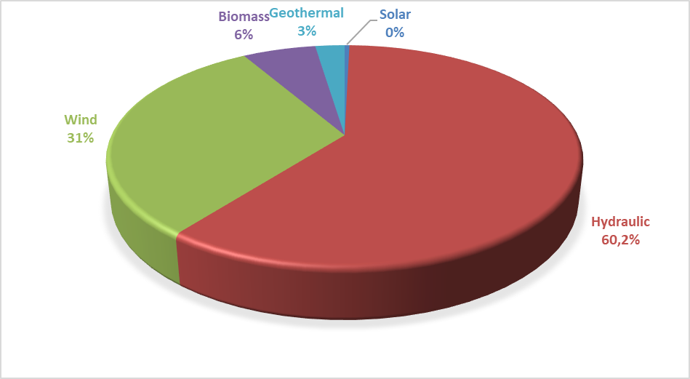
The development of RESSUM participants' productions over the years is shown in Table 2.5.3. YEKDEM production in 2019, including unlicensed plants, increased by 22.5% compared to the previous year and reached 76.69 TWh.

Table 2.5.3: Yearly Generation of RESSUM Participants by years (MWh)*
Type | 2013 | 2014 | 2015 | 2016 | 2017 | 2018 | 2019
Solar | - | - | - | - | 24.268 | 39.140 | 159.961
Unlicensed | - | - | 222.724 | 1.134.024 | 3.031.558 | 8.212.478 | 9.829.448
Hydraulic | 528.646 | 1.072.832 | 5.683.331 | 25.520.255 | 24.417.133 | 27.338.752 | 36.987.680
Wind | 234.000 | 2.378.819 | 8.275.992 | 14.163.403 | 16.765.418 | 19.002.863 | 19.900.973
Geothermal | 857.527 | 1.436.579 | 2.710.856 | 3.706.764 | 4.503.345 | 5.968.202 | 6.997.209
Biomass | 750.715 | 925.516 | 1.050.796 | 1.306.057 | 1.789.053 | 2.047.082 | 2.817.209
Total | 2.370.888 | 5.813.746 | 17.943.699 | 45.830.503 | 50.530.776 | 62.608.517 | 76.692.480

The distribution of generation within the scope of RESSUM in 2019 is shown in Figure 2.5.2. The highest generation was obtained from hydraulic and wind, respectively.

Figure 2.5.2: Distribution of Generation in RESSUM by Sources in 2019 (%)
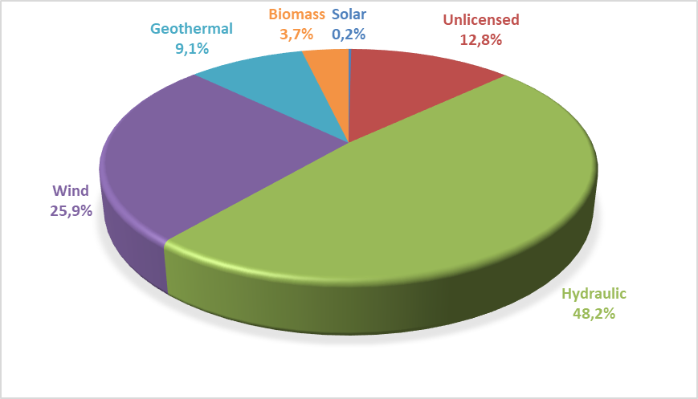
While the ratio of the generation in RESSUM to the total electricity generation of the country was 20.6% in 2018, the rate has increased to 25.2% in 2019.
Considering the monthly development of RESSUM generation in Figure 2.5.3, it is seen that hydraulic production and therefore RESSUM production increased with the rains in spring. From other sources, a more stable production was realized throughout the year.

Figure 2.5.3: Monthly Development of RESSUM Generation in 2019 (MWh)
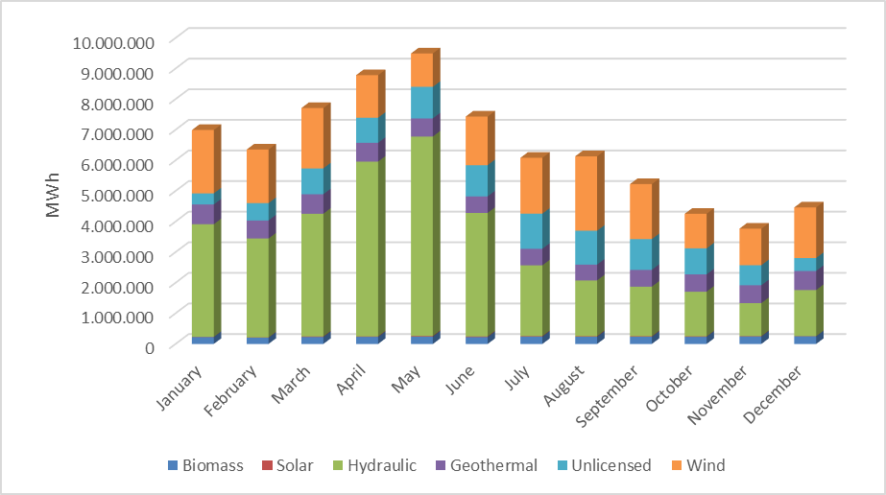
In Figure 2.5.4, the monthly course of the weighted average MCP prices formed in 2019 RESSUM and DAM are shown together. When the incentive prices applied in RESSUM are compared with the monthly average MCP prices, it is observed that even the lowest incentive amount is above the MCP price, in the spring months, the difference between RESSUM price and MCP price has been observed.

Figure 2.5.4: Monthly Development of RESSUM Feed-in Tariffs and MCP in 2019 (TL/MWh)
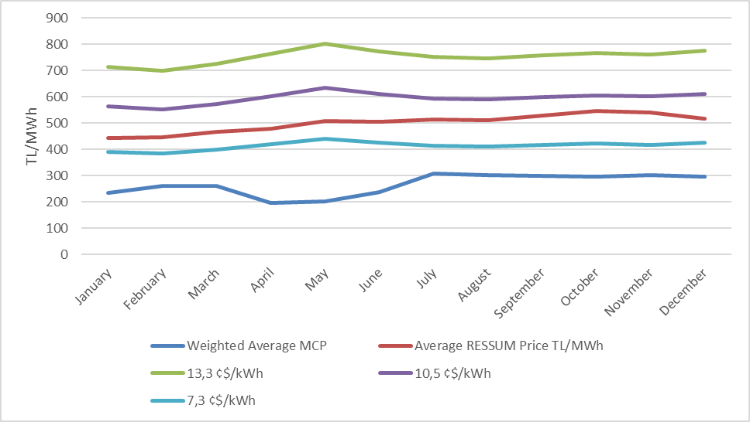

In Figure 2.5.5, RESSUM prices for different source types and Average RESSUM Price and DAM price in 2019 are shown together.

Figure 2.5.5:Average of RESSUM and MCP in 2019 (kr/kWh)
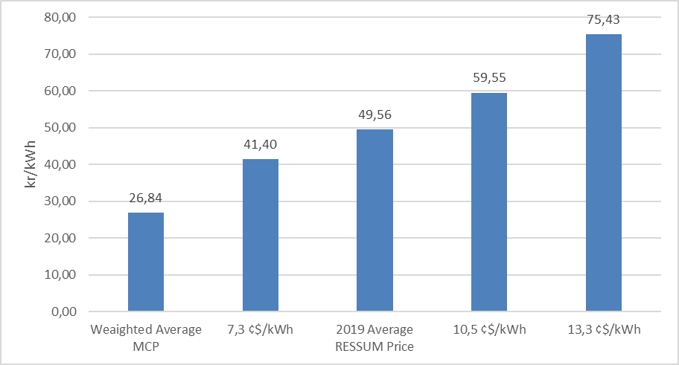

In Figure 2.5.6, monthly development of payments made within the scope of RESSUM is shown.

Figure 2.5.6: Monthly Payments Made within the Scope of the RESSUM in 2019 (TL)
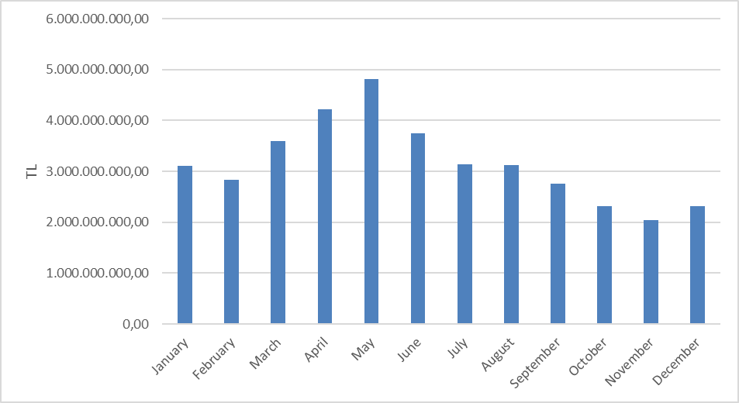
Figure given below shows the improvement of monthly additional cost of RESSUM per invoiced unit energy amount. In 2019, RESSUM additional cost increased by 139% compared to previous year and reached to 75,89 TL/MWh.

Figure 2.5.7: Monthly Improvement of Average RESSUM Additional Cost in 2019 (TL/MWh)

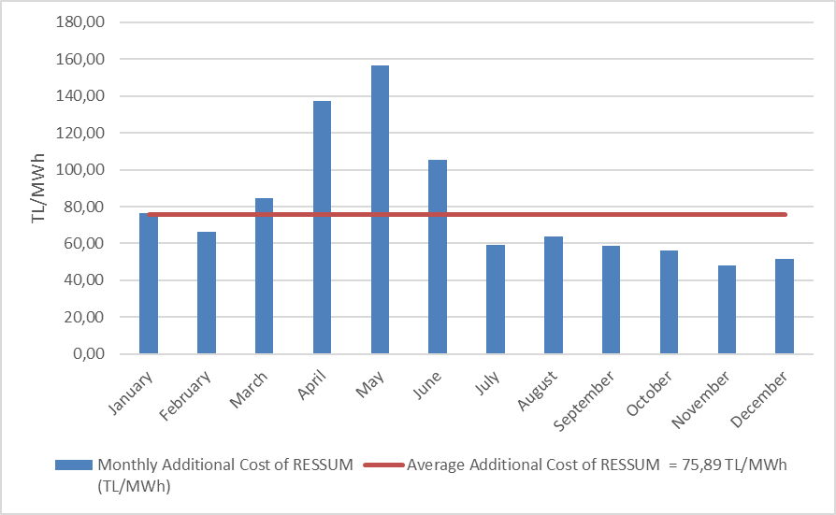
- COMPETITION

The main purpose of the Electricity Market Law is to develop competition by creating a free market structure. The main duties of the institution include determining anti-competitive behaviour and market power in areas open to competition and taking preventive measures. EMRA also reduces the eligible consumer limit for the next year at the end of each year, ensuring that the number of consumers who can choose their supplier on the demand side increases. In this framework, the development of open negotiation supply and demand in the wholesale market is critical in establishing competition.

3.1 Supply Side

It is considered that open electricity markets provide the most effective investment and generation incentives is supported by theoretical and practical studies. However, there may be a need for regulation regarding the protection of competition and ensuring the security of supply due to reasons such as very low demand elasticity and the network not being able to store energy. For this reason, these issues are regulated by various market share limits and mechanisms in many countries and by the European Union.

The indices used to follow the competition generally measure the supply side concentration in the market and the producers' ability to intervene. The HHI is used for measuring the market concentration with the addition of squares of market shares. The index can be calculated separately on generation and installed capacity.

Table 3.1: HHI Values by Generation and Capacity
 | HHI Index
 | 2014 | 2015 | 2016 | 2017 | 2018 | 2019
Generation | 1416 | 1123 | 673 | 696 | 575 | 550
Installed Capacity | 1132 | 996 | 873 | 789 | 682 | 599

As shown in Table 3.1, there was a decrease in the HHI index calculated on both production and installed power compared to the previous year in 2019.
The sales of the supply license holders for final consumption are included in Table 3.2. While the HHI index, which is calculated according to the supplier shares, was 494.3 in 2018, this value was calculated as 413.6 in 2019. The decrease in the index value is due to the decrease in the total sales amount of 21 companies in charge of the total sales in the total sales amount of companies with all supply licenses, from 84.96% in 2018 to 76.37% in 2019.
As it is known, the eligible consumer limit in the electricity market has not been reset yet. In other words, not all consumers in the market are eligible for eligible consumers. It is not legally possible for any supplier to sell, except for supplier companies that are assigned to non-eligible consumers. Therefore, it is important to create an environment where all consumers are eligible consumers and can supply energy from the supplier they wish to correctly evaluate the competitive environment in sales to end consumers.

Table 3.2: Sales, Market Shares and HHI Values of Supply License Owners
Supplier Company | Sales (MWh) | Share (%)
CK BOĞAZİÇİ ELEKTRİK PERAKENDE SATIŞ ANONİM ŞİRKETİ | 19.480.796 | 9,27
ENERJİSA TOROSLAR ELEKTRİK PERAKENDE SATIŞ ANONİM ŞİRKETİ | 13.949.496 | 6,63
GEDİZ ELEKTRİK PERAKENDE SATIŞ ANONİM ŞİRKETİ | 13.015.475 | 6,19
ENERJİSA BAŞKENT ELEKTRİK PERAKENDE SATIŞ ANONİM ŞİRKETİ | 11.973.962 | 5,70
DİCLE ELEKTRİK PERAKENDE SATIŞ ANONİM ŞİRKETİ | 11.422.603 | 5,43
LİMAK ULUDAĞ ELEKTRİK PERAKENDE SATIŞ ANONİM ŞİRKETİ | 11.260.606 | 5,36
SAKARYA ELEKTRİK PERAKENDE SATIŞ ANONİM ŞİRKETİ | 10.734.388 | 5,11
ENERJİSA İSTANBUL ANADOLU YAKASI EPSAŞ | 10.120.756 | 4,81
AYDEM ELEKTRİK PERAKENDE SATIŞ ANONİM ŞİRKETİ | 8.161.461 | 3,88
CK AKDENİZ ELEKTRİK PERAKENDE SATIŞ ANONİM ŞİRKETİ | 7.593.310 | 3,61
MERAM ELEKTRİK PERAKENDE SATIŞ ANONİM ŞİRKETİ | 7.560.614 | 3,60
OSMANGAZİ ELEKTRİK PERAKENDE SATIŞ ANONİM ŞİRKETİ | 6.251.859 | 2,97
AKSA ELEKTRİK SATIŞ ANONİM ŞİRKETİ | 6.171.027 | 2,94
CK ENERJİ ORTAKLIĞI TOPTAN ELEKTRİK SATIŞI ANONİM ŞİRKETİ | 6.170.506 | 2,93
TRAKYA ELEKTRİK PERAKENDE SATIŞ ANONİM ŞİRKETİ | 5.720.583 | 2,72
KAYSERİ ELEKTRİK PERAKENDE SATIŞ ANONİM ŞİRKETİ | 5.429.020 | 2,58
YEŞİLIRMAK ELEKTRİK PERAKENDE SATIŞ ANONİM ŞİRKETİ | 4.394.087 | 2,09
GAZİANTEP OSB ELEKTRİK ENERJİSİ TEDARİK TOPTAN SATIŞ TİC. A.Ş. | 3.668.041 | 1,74
AKEDAŞ ELEKTRİK PERAKENDE SATIŞ ANONİM ŞİRKETİ | 3.567.136 | 1,70
ÇORUH ELEKTRİK PERAKENDE SATIŞ ANONİM ŞİRKETİ | 2.746.527 | 1,31
MERAM ELEKTRİK ENERJİSİ TOPTAN SATIŞ ANONİM ŞİRKETİ | 2.205.593 | 1,05
IC İÇTAŞ ELEKTRİK TOPTAN SATIŞ VE TİCARET ANONİM ŞİRKETİ | 2.045.951 | 0,97
FIRAT ELEKTRİK PERAKENDE SATIŞ ANONİM ŞİRKETİ | 1.934.031 | 0,92
CK ÇAMLIBEL ELEKTRİK PERAKENDE SATIŞ ANONİM ŞİRKETİ | 1.932.461 | 0,92
ARAS ELEKTRİK PERAKENDE SATIŞ ANONİM ŞİRKETİ | 1.899.377 | 0,90
DOEL ELEKTRİK ENERJİSİ TOPTAN SATIŞ ANONİM ŞİRKETİ | 1.791.266 | 0,85
KOLEN ELEKTRİK TOPTAN SATIŞ İTH. VE İHR. ANONİM ŞİRKETİ | 1.780.425 | 0,85
ZORLU ELEKTRİK ENERJİSİ İTHALAT, İHRACAT VE TOPTAN TİC. A.Ş. | 1.693.327 | 0,81
CENGİZ ELEKTRİK TOPTAN SATIŞ A.Ş. | 1.618.812 | 0,77
ELEKTRİK ÜRETİM ANONİM ŞİRKETİ (EÜAŞ) | 1.563.882 | 0,74
SOCAR ENERJİ TİCARET ANONİM ŞİRKETİ | 1.534.601 | 0,73
OMV ENERJİ TİCARET ANONİM ŞİRKETİ | 1.528.449 | 0,73
TOSYALI ELEKTRİK ENERJİSİ TOPTAN SATIŞ İTHALAT İHRACAT A.Ş. | 1.461.269 | 0,70
TÜRKERLER VANGÖLÜ ELEKTRİK PERAKENDE SATIŞ ANONİM ŞİRKETİ | 1.425.805 | 0,68
ŞİŞECAM ENERJİ ANONİM ŞİRKETİ | 1.393.571 | 0,66
NYK ELEKTRİK ENERJİSİ TOPTAN SATIŞ ANONİM ŞİRKETİ | 1.025.501 | 0,49
ENERJİSA ELEKTRİK ENERJİSİ TOPTAN SATIŞ ANONİM ŞİRKETİ | 1.005.248 | 0,48
TURKCELL ENERJİ ÇÖZÜMLERİ VE ELEKTRİK SATIŞ TİCARET A.Ş. | 967.574 | 0,46
TTES ELEKTRİK SATIŞ ANONİM ŞİRKETİ | 965.223 | 0,46
FİNA ELEKTRİK ENERJİSİ İTHALAT İHRACAT VE TOPTAN SATIŞ A.Ş. | 937.395 | 0,45
ELTEK ELEKTRİK ENERJİSİ İTHALAT İHRACAT VE TOPTAN TİCARET A.Ş. | 846.409 | 0,40
EREN ELEKTRİK ENERJİSİ TOPTAN SATIŞ ANONİM ŞİRKETİ | 796.156 | 0,38
OYAK ELEKTRİK ENERJİSİ TOPTAN SATIŞ ANONİM ŞİRKETİ | 680.628 | 0,32
ENKO ENERJİ SANAYİ VE TİCARET ANONİM ŞİRKETİ | 679.663 | 0,32
İPRAGAZ ANONİM ŞİRKETİ | 618.939 | 0,29
YEŞİLYURT ELEKTRİK ENERJİSİ TOPTAN SATIŞ VE İTHALAT İHRACAT A.Ş. | 489.079 | 0,23
VTC ENERJİ ANONİM ŞİRKETİ | 484.100 | 0,23
BORDO ELEKTRİK ENERJİSİ TOPTAN SATIŞ ANONİM ŞİRKETİ | 481.484 | 0,23
EÇE ENERJİ TİCARETİ ANONİM ŞİRKETİ | 391.682 | 0,19
RÖNESANS ELEKTRİK ENERJİ TOPTAN SATIŞ ANONİM ŞİRKETİ | 385.115 | 0,18
UŞAK OSB ELEKTRİK ENERJİSİ TED. TOPTAN SATIŞ İTH. VE İHRACAT A.Ş. | 265.453 | 0,13
AVEL AVRUPA ELEKTRİK ENERJİSİ TOPTAN SATIŞ ANONİM ŞİRKETİ | 251.574 | 0,12
YETAŞ YILDIRIM ENERJİ TEDARİK A.Ş. | 234.645 | 0,11
DOĞRUDAN ELEKTRİK ENERJİSİ TOPTAN SATIŞ VE TEDARİK A.Ş. | 233.952 | 0,11
ÇELİKLER ELEKTRİK ENERJİ TOPTAN SATIŞ ANONİM ŞİRKETİ | 226.427 | 0,11
GATES ENERJİ TİCARET ANONİM ŞİRKETİ | 223.084 | 0,11
ELEKTRA ENERJİ TOPTAN SATIŞ VE İTHALAT İHRACAT ANONİM ŞİRKETİ | 207.193 | 0,10
KET KİPAŞ ELEKTRİK ENERJİSİ TOPTAN SATIŞ TİCARET ANONİM ŞİRKETİ | 206.413 | 0,10
EOS ELEKTRİK ENERJİSİ TOPTAN SATIŞ ANONİM ŞİRKETİ | 199.413 | 0,09
EKSİM ELEKTRİK ENERJİSİ İTHALAT, İHRACAT VE TOPTAN SATIŞ A.Ş. | 182.863 | 0,09
BATIÇİM ENERJİ TOPTAN SATIŞ ANONİM ŞİRKETİ | 177.112 | 0,08
SOYAK ENERJİ TİCARET ANONİM ŞİRKETİ | 175.061 | 0,08
YKS ELEKTRİK ENERJİSİ TOPTAN SATIŞ DIŞ TİCARET LİMİTED ŞİRKETİ | 153.410 | 0,07
FIRAT ENERJİ TOPTAN SATIŞ TİCARET ANONİM ŞİRKETİ | 140.781 | 0,07
ENOVA ELEKTRİK ENERJİSİ TOPTAN SATIŞ ANONİM ŞİRKETİ. | 129.051 | 0,06
AYEN ELEKTRİK TİCARET ANONİM ŞİRKETİ | 127.887 | 0,06
MARMARA ELEKTRİK ENERJİSİ İTHALAT İHRACAT VE TOPTAN TİCARET A.Ş. | 102.657 | 0,05
OZAN ELEKTRİK ENERJİSİ İTH. İHR. VE TOPTAN TİCARET ANONİM ŞİRKETİ | 92.929 | 0,04
ENERJİM PERAKENDE ENERJİ TİCARET ANONİM ŞİRKETİ | 79.623 | 0,04
SELENKA ELEKTRİK ENERJİSİ TOPTAN SATIŞ VE TEDARİK ANONİM ŞİRKETİ | 77.422 | 0,04
VOYTRON ENERJİ ELEKTRİK PERAKENDE SATIŞ ANONİM ŞİRKETİ | 66.022 | 0,03
AGE ELEKTRİK ENERJİSİ TOPTAN SATIŞ ANONİM ŞİRKETİ | 65.536 | 0,03
SEDSAL ELEKTRİK ENERJİSİ TOPTAN SATIŞ LİMİTED ŞİRKETİ | 61.798 | 0,03
AXPO TURKEY ENERJİ ANONİM ŞİRKETİ | 56.203 | 0,03
MAC ELEKTRİK ENERJİSİ TOPTAN SATIŞ ANONİM ŞİRKETİ | 53.604 | 0,03
STANDART DOĞALGAZ TİCARET VE ELEKTRİK ENERJİSİ TEDARİK A.Ş. | 52.647 | 0,03
KGM ENERJİ TİCARET LİMİTED ŞİRKETİ | 50.726 | 0,02
ENGİE ENERJİ TİCARET VE PAZARLAMA ANONİM ŞİRKETİ | 50.320 | 0,02
FİDES ELEKTRİK ENERJİSİ TOPTAN ALIŞ SATIŞ ANONİM ŞİRKETİ | 38.565 | 0,02
DESA ELEKTRİK ENERJİSİ TEDARİK VE TOPTAN SATIŞ TİCARET A.Ş. | 33.832 | 0,02
PURE ENERGY ELEKTRİK TEDARİK ANONİM ŞİRKETİ | 30.902 | 0,01
AVEM ELEKTRİK ENERJİSİ TOPTAN SATIŞ ANONİM ŞİRKETİ | 30.242 | 0,01
TENERA ENERJİ TİCARET ANONİM ŞİRKETİ | 28.971 | 0,01
ADB ELEKTRİK ENERJİSİ TOPTAN SATIŞ LİMİTED ŞİRKETİ | 28.613 | 0,01
ORT ELEKTRİK TOPTAN SATIŞ ANONİM ŞİRKETİ | 22.246 | 0,01
ESKO ELEKTRİK ENERJİSİ İTHALAT İHRACAT VE TOPTAN SATIŞ A.Ş. | 21.868 | 0,01
AKS GRUP ELEKTRİK ENERJİSİ TOPTAN ALIŞ VE SATIŞ LİMİTED ŞİRKETİ | 18.894 | 0,01
SHELL ENERJİ ANONİM ŞİRKETİ | 16.928 | 0,01
ENSAT ELEKTRİK ENERJİSİ TEDARİK TİCARET ANONİM ŞİRKETİ | 14.764 | 0,01
HGÇ TOPTAN EL. EN. TİCARET ANONİM ŞİRKETİ | 11.953 | 0,01
EKO GRUP ELEKTRİK TİCARET ANONİM ŞİRKETİ | 11.009 | 0,01
ELPADA ELEKTRİK ENERJİSİ TOPTAN SATIŞ ANONİM ŞİRKETİ | 9.774 | 0,00
ATA ELEKTRİK ENERJİSİ TOPTAN SATIŞ ANONİM ŞİRKETİ | 8.025 | 0,00
EE ELEKTRİK ENERJİSİ TOPTAN SATIŞ ANONİM ŞİRKETİ | 6.093 | 0,00
AYCAN TOPTAN ELEKTRİK TİCARET ANONİM ŞİRKETİ | 5.945 | 0,00
İVES ELEKTRİK ENERJİSİ TEDARİK TOPTAN SATIŞ LİMİTED ŞİRKETİ | 3.460 | 0,00
ÜRÜNDÜL ELEKTRİK ENERJİSİ TOPTAN SATIŞ ANONİM ŞİRKETİ | 1.442 | 0,00
İDEAL PERAKENDE ELEKTRİK SATIŞ ANONİM ŞİRKETİ | 809 | 0,00
DOASAN ENERJİ TOPTAN SATIŞ LİMİTED ŞİRKETİ | 625 | 0,00
SETEL ELEKTRİK ENERJİSİ İHR.İTH. VE TOPTAN SATIŞ ANONİM ŞİRKETİ | 518 | 0,00
Pİ ENERJİ ELEKTRİK TOPTAN SATIŞ ANONİM ŞİRKETİ | 241 | 0,00
İMC ELEKTRİK ENERJİSİ TOPTAN SATIŞ İTHALAT İHRACAT LİMİTED ŞİRKETİ | 149 | 0,00
HİDİV ELEKTRİK ENERJİSİ TOPTAN SATIŞ ANONİM ŞİRKETİ | 10 | 0,00
Total | 210.244.955 | 100
HHI of Suppliers | 413.6

3.2 Demand Side

In accordance with the paragraph (b) of the sixth paragraph of Article 5 of the Law on the Organization and Duties of the Energy Market Regulatory Authority numbered 4628 and the 25th article of the Electricity Market Consumer Services Regulation, the eligible consumer for the year 2019 It was decided to apply the limit to 1600 kWh. The theoretical market openness corresponding to the eligible consumer limit was calculated as 95.4%. The free consumer limit and the corresponding market openness rate over the years are given in Figure 3.1.

Figure 3.1: Eligible Consumer Limit and Market Openness Ratio by Years (kWh-%)
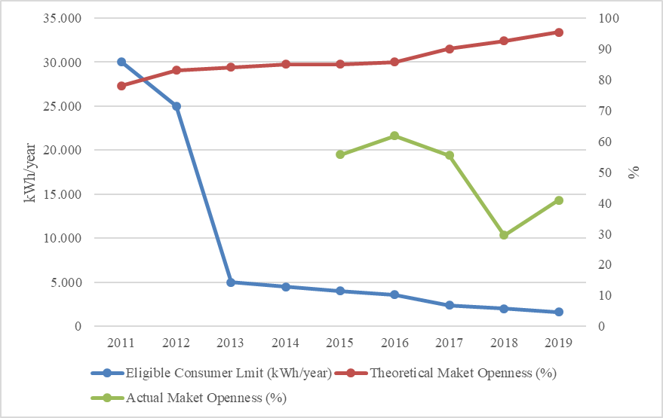

Although the theoretical market openness rate is high, the rate of consumers using the eligible consumer right in total consumption was lower. Eligible consumers' consumption in 2019 was 93.9 TWh. This rate corresponds to 40.9% of the total invoiced consumption.

The development of the number of eligible consumers in 2019 is shown in Figure 3.2.

Figure 3.2: Number of Eligible Consumer by Months in 2019 (Number)
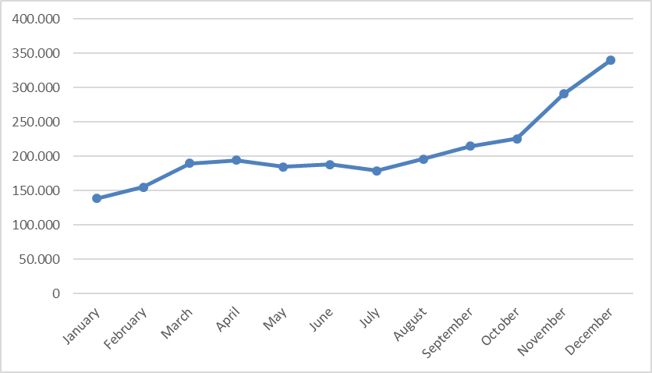
The number of eligible consumers, which was 146.000 as of the end of 2018, increased by 132% at the end of 2019 and reached 339.000. This number corresponds to approximately 0.76% of the total number of consumers.
Distribution of eligible consumers and their consumption by distribution regions (excluding eligible consumers from transmission) is shown in Figure 3.3. When the distribution in question is analyzed, it is seen that the most free consumers are located in the Boğaziçi, Osmangazi and Uludağ regions.

Figure 3.3: Distribution of Eligible Consumers by Distribution Regions by end of 2019
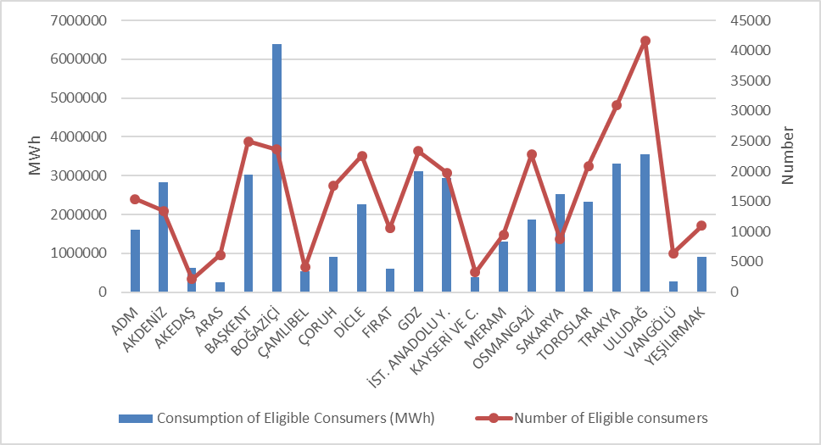
Considering the distribution of the consumption of eligible consumers on the basis of distribution regions, Boğaziçi, Uludağ, Trakya and GDZ constitute the four regions with the highest consumption.

Figure 3.5 below shows the distribution of eligible consumer consumption by supplier type.

Figure 3.4: Distribution of Eligible Consumer Consumption by Suppliers Type (%)
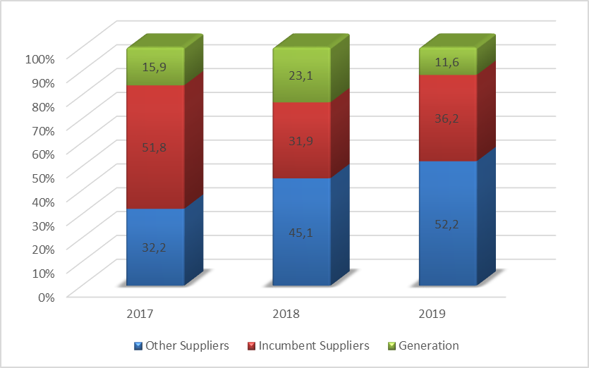
The numbers and consumption of eligible consumers switched their suppliers on a monthly basis are shown in Figure 3.6.

Figure 3.5: Monthly Changes in Number and Consumptions of Eligible Consumers Switching Their Supplier (Number-MWh)
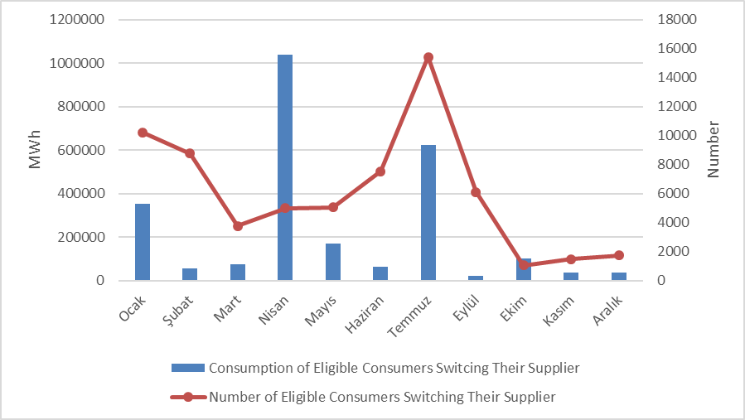
The number of eligible consumers switched their suppliers in 2019 was 66,135 and their consumption was 2.57 TWh, which corresponds to 1.12% of the total invoiced consumption.
Table 3.3 below shows the distribution of eligible consumers' supplier changes by supplier type. It is seen that the majority of supplier changes are consumers who switch to the tariffs.

Table 3.3: The Distribution of Eligible Consumers Switches by Supplier Type
Former Supplier Type | New Supplier Type |  |  |  | Total
Former Supplier Type | Other Supply | Incumbent Supplier-K1 | Incumbent Supplier-K2 | Generation | Total
Other Supplier | 1.113 | 35.893 | 945 | 1.237 | 39.188
Incumbent Supplier-K2 | 571 | 24.042 | 150 | 15 | 24.778
Generation | 119 | 1.962 | 32 | 56 | 2.169
Total | 1.803 | 61.897 | 1.127 | 1.308 | 66.135

4. TRANSMISSION

In this section, summary information about the transmission system and changes of transmission system with tables and figures according to the years are given.

  - Transmission System

Transformer center in the transmission system by the end of 2019 is shown in the Table 4.1. As seen in the table, most of the transformer centers in the system are of 154 kV voltage level. There are 1.212 transformer centers, 752 in TEİAŞ ownership and 460 in private ownership. The transformer capacity reached to 216.066 MVA. 181.824 MVA of this capacity belongs to TEİAŞ ownership, and the remaining which is 34.242 MVA belongs to private ownership.

Table 4.1: Transformer Center Information
 | Voltage (kV) | Number of Centers | Number of Transformers | Capacity (MVA)
TEİAŞ  Ownership | 380 | 115 | 362 | 75.015
TEİAŞ  Ownership | 220 | 1 | 2 | 400
TEİAŞ  Ownership | 154 | 630 | 1.490 | 106.100
TEİAŞ  Ownership | 66 | 6 | 21 | 309
TEİAŞ  Ownership | TEİAŞ Total | 752 | 1.875 | 181.824
Private Ownership | 380 | 53 | 46 | 7.045
Private Ownership | 220 | 0 | 0 | 0
Private Ownership | 154 | 406 | 454 | 27.184
Private Ownership | 66 | 1 | 1 | 13
Private Ownership | Private Total | 460 | 501 | 34.242
 | TOTAL | 1.212 | 2.376 | 216.066

65,53% of the transmission lines, which are 70.024 km in total, constitute lines with a voltage level of 154 kV. The remaining part is almost all of the lines at 380 kV voltage level, and lines at 220 kV and 66 kV voltage level are only 195 km.

Table 4.2: TEİAŞ Transmission Lines
 | 2018 | 2019 | Change (%) | 2018 | 2019 | Change (%)
Voltage (kV) | Number of Lines |  | Change (%) | Length (km) |  | Change (%)
380 | 283 | 288 | 1,77 | 23.249 | 23.940 | 2,97
220 | 2 | 2 | 0,00 | 85 | 85 | 0,00
154 | 1.709 | 1.712 | 0,18 | 44.760 | 45.889 | 2,52
66 | 10 | 11 | 10,00 | 110 | 110 | 0,00
Total | 2.004 | 2.013 | 0,45 | 68.204 | 70.024 | 2,67

Figure 4.1: Changes in TEİAŞ Transmission Line Lengths by Years (km)
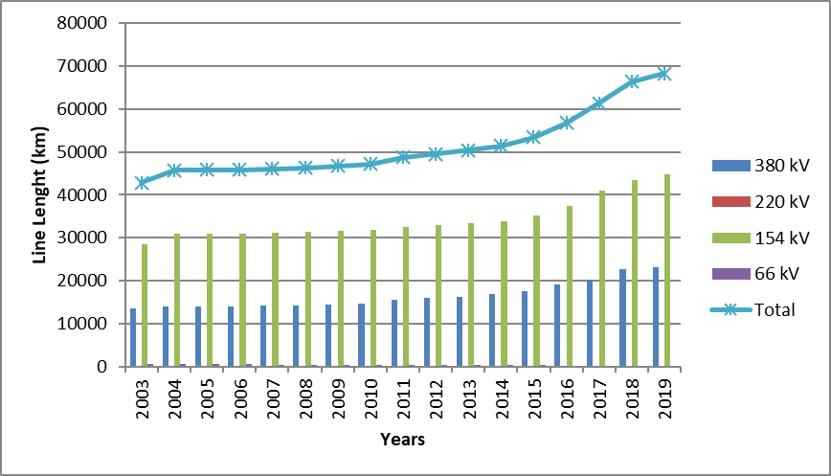

In the last 15 years, there was a 52,86% increase in transmission line lengths.
  - Transmission System Connection Applications

The table below shows the number and capacity of applications made in 2019 for connection to the transmission system, as well as information about applications accepted, rejected and in the evaluation stage.

Table 4.3: Connection Applications to the Transmission System (Number-MW)
 | Connection Application |  | Acccepted |  | Rejected |  | In the Evaluation Stage
 | Number | Capacity (MW) | Number | Capacity (MW) | Number | Capacity (MW) | Number | Capacity  (MW)
Licensed Producers | 88 | 1.813,12 | 88 | 1.813,12 | 0 | 0,00 | 0 | 0,00
Unlicensed Producers | 7 | 58,26 | 6 | 48,66 | 0 | 0,00 | 1 | 9,60
Consumer | 16 | 1.087,00 | 15 | 837,00 | 0 | 0,00 | 1 | 250,00

In 2019, a total of 1.813.12 MW connection applications were made by licensed producers and all of these applications were made.
In addition, applications for connection capacity of 58,26 MW have been made by unlicensed producers, 48,66 MW of these applications have been accepted, and 1 application of 9,60 MW is in the evaluation stage.
On the other hand, a connection capacity application of 1.087,00 MW has been made by consumers, 837,00 MW of these applications have been accepted and the remaining 250,00 MW is still under evaluation.
  - Tariffs

Transmission system system usage and system operation tariffs applied by TEİAŞ to be implemented as of 01/01/2019 have been determined by the Board Decision dated 20/12/2018 and numbered 8272 for manufacturers and consumers on 14 regions basis. In addition, with the Decision No. 8121, dated 12/10/2018, in accordance with subparagraph (h) of sub-paragraph (h) and sub-paragraph (e) of sub-paragraph (a) of Article 5 of the Law on the Organization and Duties of the Energy Market Regulatory Authority No. 4628 2019 in the applied transmission surcharge, Turkey Electricity transmission Corporation 0,5% of the company's transmission tariffs ratio is determined.
System use and system operation tariffs implemented in 2019 are shown in Table 4.4 for production and consumption in 14 regions.

Table 4.4: System Usage and System Operation Tariffs Applied in 2019 (TL/MW-Year, TL/MWh)
Region No. | Generation (*) (**) |  |  | Consumption (*)
Region No. | System Usage Tariffs |  | System  Operation  Tariffs | System Usage Tariffs |  | System  Operation  Tariffs
Region No. | TL/MW-Year | TL/MWh | TL/MWh | TL/MW-Year | TL/MWh | TL/MWh
1 | 31.888,23 | 7,17 | 1,40 | 56.389,88 | 6,50 | 1,46
2 | 34.764,81 | 7,17 | 1,40 | 54.785,77 | 6,50 | 1,46
3 | 35.082,33 | 7,17 | 1,40 | 54.900,23 | 6,50 | 1,46
4 | 35.536,39 | 7,17 | 1,40 | 54.327,54 | 6,50 | 1,46
5 | 37.081,69 | 7,17 | 1,40 | 53.474,50 | 6,50 | 1,46
6 | 38.967,37 | 7,17 | 1,40 | 52.046,79 | 6,50 | 1,46
7 | 39.190,97 | 7,17 | 1,40 | 50.780,19 | 6,50 | 1,46
8 | 43.168,32 | 7,17 | 1,40 | 49.259,94 | 6,50 | 1,46
9 | 44.864,33 | 7,17 | 1,40 | 47.596,74 | 6,50 | 1,46
10 | 49.817,94 | 7,17 | 1,40 | 45.343,64 | 6,50 | 1,46
11 | 52.741,90 | 7,17 | 1,40 | 43.634,42 | 6,50 | 1,46
12 | 54.714,44 | 7,17 | 1,40 | 42.089,39 | 6,50 | 1,46
13 | 57.059,70 | 7,17 | 1,40 | 41.010,52 | 6,50 | 1,46
14 | 61.205,80 | 7,17 | 1,40 | 37.792,32 | 6,50 | 1,46
(*) Transmission Surcharge is not included.
(**) 50 % discount is applied for generation connections within the scope of temporary article 4 of the
Electricity Market Law numbered 6446.

Figure 4.2: Capacity Based Regional Transmission System Usage Tariffs Applied in 2019 (TL/MW-Year)
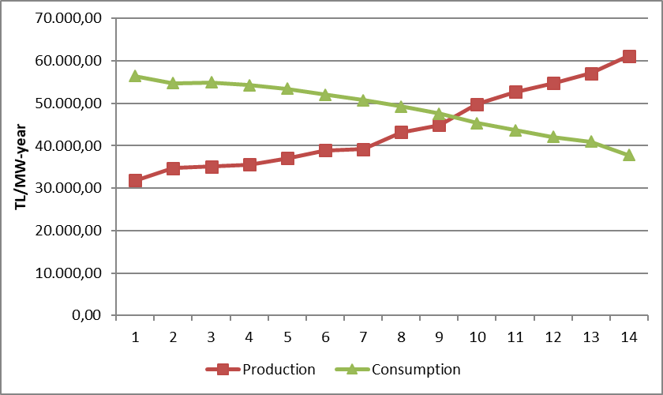
  - Amount of Investment

The amount of investment made by TEİAŞ is shown in table 4.5. It is observed that the amount of investment decreased by 6,82% in 2019.

Table 4.5: Comparison of 2018 and 2019 Investment Amount (TL-%)
 | 2018 |  | 2019 |  | Change (%)
Investment Payment Type | Amount (TL) | Share (%) | Amount (TL) | Share (%) | Change (%)
New Transformer Investment | 1.599.019.000 | 54,73 | 1.545.469.910 | 56,76 | -3,35
New Line Investment | 1.037.280.000 | 35,50 | 822.659.320 | 30,21 | -20,69
Operational Investment | 160.744.000 | 5,50 | 208.307.000 | 7,65 | 29,59
Machine and Equipment | 108.324.000 | 3,71 | 146.318.000 | 5,37 | 35,07
Other | 16.540.100 | 0,57 | 0 | 0,00 | -100,00
Total | 2.921.907.100 | 100,00 | 2.722.754.230 | 100,00 | -6,82

  - Losses

The transmission system loss (TSL) rate varies depending on the demand, load flows, temperature and investments in the system. It is calculated hourly and the annual average change over the years is shown in Figure 4.3. The transmission system losses established according to European standards in accordance with the population density of our country, the location of the supply sources and geographical conditions are at the level of international performance.

Figure 4.3: Transmission System Losses (GWh-%)
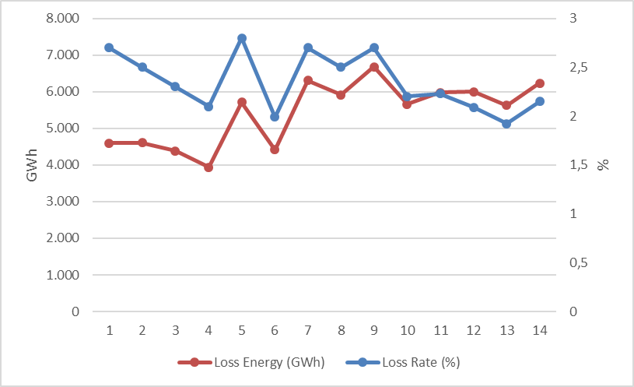
Figure 4.4: Transmission System Loses by Hour(%)
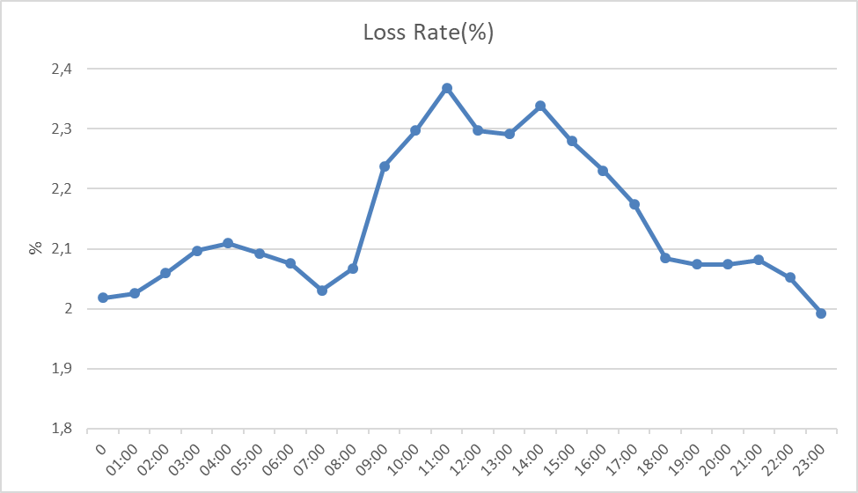
Considering the development of transmission system loss according to hours, it is seen that the highest loss rate is at 11:00.
- DISTRIBUTION

  - Number of Consumers

By 2019, the total number of consumers using the distribution system increased by 2,99% compared to the previous year and reached 44.958.326.

Table 5.1: Number of Consumers Using Distribution System by the end of 2019 (Number-%)
Distribution Company | Number of Consumers |  |  | 2018-2019  Change (%)
Distribution Company | 2017 | 2018 | 2019 | 2018-2019  Change (%)
BOĞAZİÇİ | 4.910.115 | 5.029.273 | 5.134.980 | 2,10
BAŞKENT | 4.218.812 | 4.199.135 | 4.278.785 | 1,90
TOROSLAR | 3.805.358 | 3.877.734 | 3.997.925 | 3,10
GDZ | 3.165.847 | 3.312.515 | 3.421.183 | 3,28
ULUDAĞ | 3.092.199 | 3.189.831 | 3.285.323 | 2,99
İST. ANATOLIAN | 2.834.800 | 2.854.123 | 2.928.586 | 2,61
AKDENİZ | 2.076.167 | 2.163.700 | 2.220.744 | 2,64
MERAM | 2.027.866 | 2.094.254 | 2.169.733 | 3,60
YEŞİLIRMAK | 1.998.388 | 2.073.523 | 2.147.103 | 3,55
ADM | 1.834.517 | 1.902.358 | 1.966.146 | 3,35
DİCLE | 1.757.417 | 1.838.929 | 1.934.641 | 5,20
SAKARYA | 1.742.528 | 1.831.677 | 1.905.188 | 4,01
OSMANGAZİ | 1.720.217 | 1.786.452 | 1.839.538 | 2,97
ÇORUH | 1.303.909 | 1.359.781 | 1.389.748 | 2,20
TRAKYA | 1.042.995 | 1.089.247 | 1.125.936 | 3,37
ARAS | 963.072 | 1.002.743 | 1.029.869 | 2,71
ÇAMLIBEL | 946.381 | 974.544 | 1.005.503 | 3,18
FIRAT | 917.488 | 957.081 | 977.424 | 2,13
KAYSERİ VE CİVARI | 695.210 | 718.723 | 748.858 | 4,19
AKEDAŞ | 678.775 | 713.348 | 740.416 | 3,79
VANGÖLÜ | 650.555 | 684.366 | 710.697 | 3,85
Total | 42.382.616 | 43.653.337 | 44.958.326 | 2,99

When we look at Table 5.1, it is seen that the distribution regions with the highest number of consumers are Boğaziçi with 5,13 million, Başkent with 4,28 million and Toroslar with 4 million, respectively.
In the following figure, the number of consumers connected to distribution network and the total consumption of these consumers by 2019 are shown.

Figure 5.1: Number and Consumption of Consumers (Number- MWh)
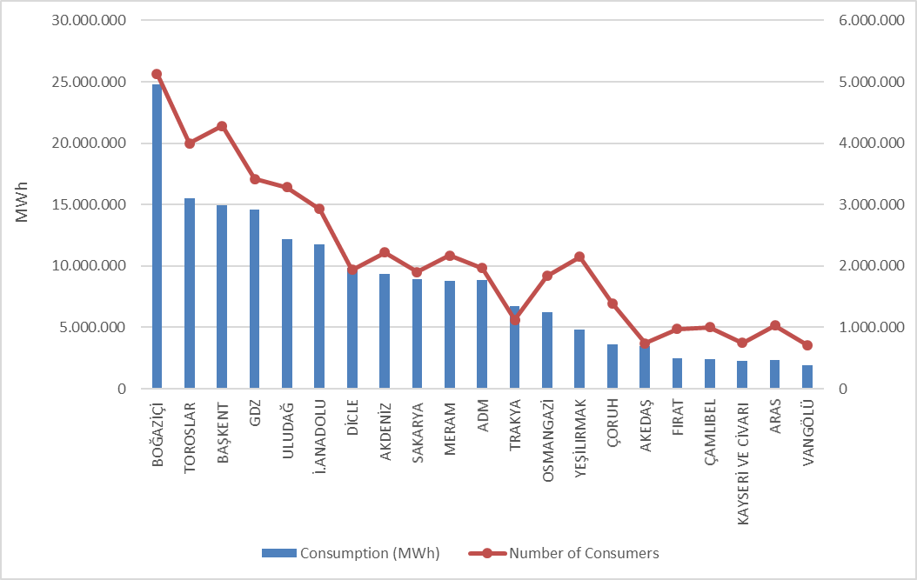

  - Ratio of Losses

The targeted and realized loss values on the basis of the distribution company are shown in Table 5.2.

Table 5.2: Loss Rates of Distribution Companies (%)
Distribution Company | REALIZED LOSS RATES |  |  | TARGETED LOSS RATES | DIFFERENCE OF REALIZED&TARGETED LOSS RATES
Distribution Company | 2018 | 2019 | 2018-2019  Change | 2019 | 2019
DİCLE | 54,94 | 51,32 | 3,62 | 65,99 | 14,67
VANGÖLÜ | 49,16 | 47,56 | 1,60 | 54,74 | 7,18
ARAS | 23,55 | 21,64 | 1,91 | 24,97 | 3,33
ÇAMLIBEL | 5,08 | 4,75 | 0,33 | 7,31 | 2,56
TRAKYA | 4,37 | 4,49 | -0,12 | 6,87 | 2,38
İST. ANATOLIAN | 6,04 | 5,05 | 0,99 | 7,31 | 2,26
ULUDAĞ | 4,20 | 4,82 | -0,62 | 6,73 | 1,91
BAŞKENT | 6,11 | 5,89 | 0,22 | 7,33 | 1,44
AKDENİZ | 5,78 | 5,91 | -0,13 | 7,31 | 1,40
SAKARYA | 6,52 | 5,96 | 0,56 | 7,28 | 1,32
ÇORUH | 7,85 | 7,38 | 0,47 | 8,68 | 1,30
ADM | 5,53 | 5,63 | -0,10 | 6,72 | 1,09
MERAM | 6,69 | 6,22 | 0,47 | 7,30 | 1,08
KAYSERİ VE CİVARI | 6,57 | 6,02 | 0,55 | 6,94 | 0,92
OSMANGAZİ | 6,41 | 6,61 | -0,20 | 7,43 | 0,82
YEŞİLIRMAK | 7,63 | 7,13 | 0,50 | 7,94 | 0,81
AKEDAŞ | 5,51 | 6,46 | -0,95 | 7,08 | 0,62
FIRAT | 10,32 | 9,93 | 0,39 | 10,53 | 0,60
GDZ | 6,63 | 7,55 | -0,92 | 7,66 | 0,11
TOROSLAR | 11,85 | 11,76 | 0,09 | 11,74 | -0,02
BOĞAZİÇİ | 6,59 | 7,96 | -1,37 | 7,63 | -0,33

When Table 5.2 is examined, 21 of all distribution companies except Toroslar and Boğaziçi, achieved the targeted loss rate for 2019, and distribution companies performed successfully in 2019 in terms of loss targets. According to the target, the highest development occurred in Dicle (14,67%), Vangölü (7,18%) and Aras (3,33%) distribution regions, respectively.
In addition, as can be seen from Table 5.2, the highest loss rates in 2019 were realized in Dicle 51,32%, Vangölü (47,56%) and Aras (21,64%) regions, respectively.

In the figure below, the actual and targeted loss rates are shown together.

Figure 5.2: Real and Target Loss Rates in 2019 (%)
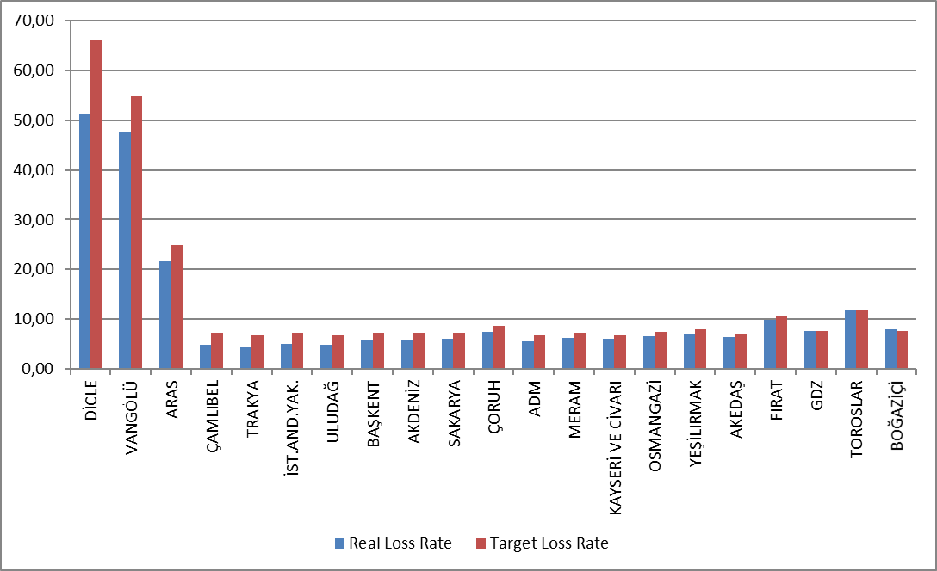

5.3 Employment

By the end of 2019, 56.903 people are employed in the electricity distribution sector; 24.211 people work as distribution company staff and 32.692 people work as subcontractor staff. The table below shows the number of employees by distribution companies. While Dicle EDAŞ had the highest number of employees with a total of 7.098 employees, the distribution company with the highest number of permanent staff was Toroslar EDAŞ with 3.781 personnel, and the region with the highest number of subcontractors was Dicle EDAŞ with 3.574 personnel. Kayseri and its Vicinity EDAŞ, on the other hand, became the distribution company with the lowest number of employees with 913 personnel.

Table 5.3: Number of Employees of Distribution Companies (Number)
Distribution Company | Number of Permanent Employees | Number of Subcontractor Employees | Total
DİCLE | 3.524 | 3.574 | 7.098
TOROSLAR | 3.781 | 1.933 | 5.714
BAŞKENT | 3.630 | 1.779 | 5.409
BOĞAZİÇİ | 693 | 3.866 | 4.559
GDZ | 771 | 2.956 | 3.727
ULUDAĞ | 463 | 2.001 | 2.464
İST. ANATOLIAN | 1.862 | 937 | 2.799
ADM | 581 | 2.346 | 2.927
MERAM | 707 | 1.723 | 2.430
SAKARYA | 1.608 | 488 | 2.096
YEŞİLIRMAK | 590 | 1.494 | 2.084
FIRAT | 280 | 1.405 | 1.685
VANGÖLÜ | 854 | 1.219 | 2.073
AKDENİZ | 261 | 1.751 | 2.012
ARAS | 497 | 1.519 | 2.016
OSMANGAZİ | 1.231 | 580 | 1.811
ÇORUH | 335 | 1.365 | 1.700
ÇAMLIBEL | 211 | 913 | 1.124
AKEDAŞ | 781 | 385 | 1.166
TRAKYA | 823 | 273 | 1.096
KAYSERİ VE CİVARI | 728 | 185 | 913
Total | 24.211 | 32.692 | 56.903

Figure 5.3: Number of Employees of Distribution Companies by Year 2019
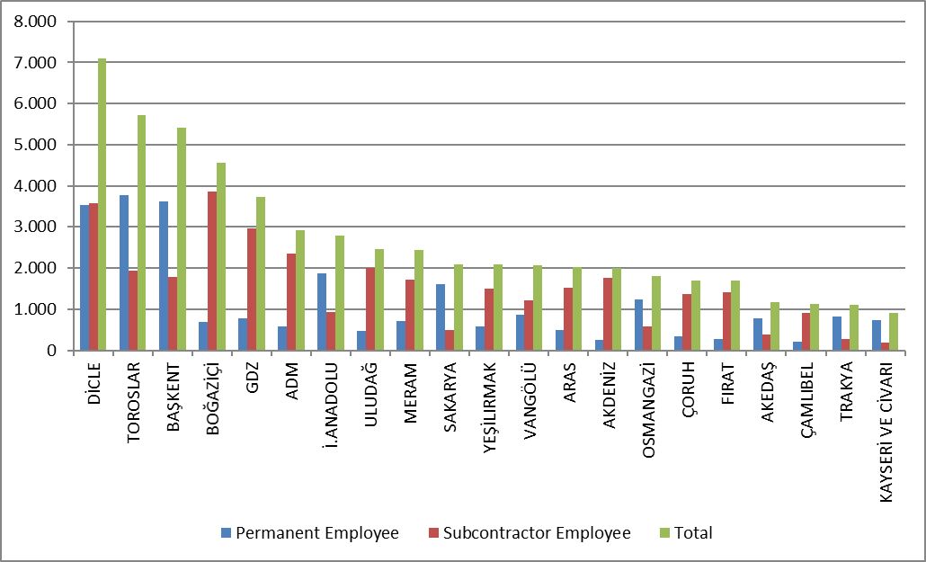

5.4 Information about Network

This section contains basic data on the distribution system. In this context, information on line lengths, transformer capacities and transformer numbers in the distribution voltage level is included in the following tables and figures.
As it is known, the power grid has reached all exceptions except Turkey. Except for the industrial facilities with large consumption, all small and medium consumers supply electrical energy through the distribution system. Table 5.4 Turkey can be seen that the total length of distribution lines reached 1.190.169 km. Considering the line lengths by distribution regions, Başkent, Toroslar, Meram, Yeşilırmak and Dicle distribution regions constitute the first five regions in terms of distribution line length. It is also seen from this order that there is a correct ratio between the distribution line lengths and the width of the distribution region and the distribution network.
On the other hand, when looking at the distribution regions in terms of transformer capacity, it is seen that the Boğaziçi, Toroslar, Başkent, Gdz and Dicle electricity distribution regions are in the top five.

Table 5.4: Line Lengths, Number of Transformers and Transformer Capacities Based on Distribution Companies by end of 2019 (km-MVA-Number)

Distribution Company | Line Length (Km) | Transformer Capacity  (MVA) | Number of Transformers
ADM | 69.538 | 8.263 | 21.888
AKDENİZ | 66.755 | 7.670 | 19.471
AKEDAŞ | 26.524 | 3.804 | 12.440
ARAS | 56.971 | 3.043 | 13.734
BAŞKENT | 113.814 | 15.327 | 33.530
BOĞAZİÇİ | 47.138 | 17.850 | 14.682
ÇAMLIBEL | 46.638 | 2.621 | 12.457
ÇORUH | 59.404 | 3.239 | 12.376
DİCLE | 75.984 | 12.494 | 65.368
FIRAT | 47.812 | 3.286 | 12.635
GDZ | 57.804 | 15.151 | 33.214
İST. ANATOLIAN | 24.715 | 8.640 | 7.767
KAYSERİ VE CİVARI | 25.220 | 2.579 | 7.840
MERAM | 89.877 | 11.707 | 56.990
OSMANGAZİ | 49.472 | 7.407 | 25.698
SAKARYA | 37.386 | 7.908 | 17.169
TOROSLAR | 93.053 | 15.821 | 47.267
TRAKYA | 28.538 | 5.140 | 11.431
ULUDAĞ | 50.798 | 9.648 | 25.875
VANGÖLÜ | 38.839 | 2.692 | 11.954
YEŞİLIRMAK | 83.892 | 4.770 | 22.147
Total | 1.190.169 | 169.060 | 485.933

Figure 5.4: Line Lengths and Transformer Capacities on the Basis of Distribution Companies at the end of 2019 (km-MVA)
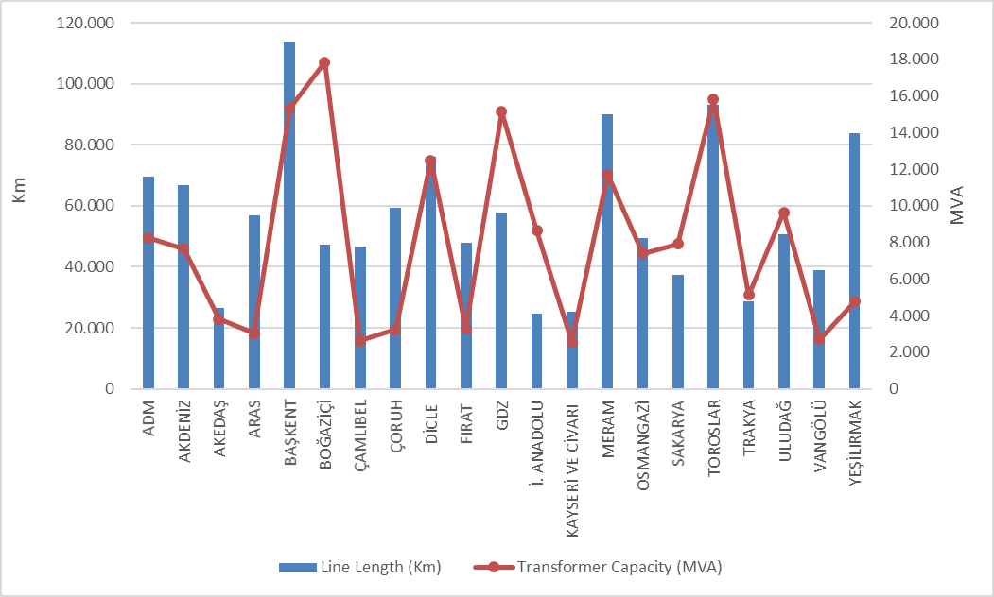

The lengths of distribution lines can be seen in Table 5.5. As can be seen from the table, overhead lines constitute 81,25% of the total distribution lines. The share of underground lines within the total distribution lines is 18,75%. This shows that the distribution lines are open to external influence. The mentioned external effects may be natural disasters, climate or human. In particular, natural events such as heavy rains and heavy winds can directly or indirectly cause damage to the distribution lines.

Table 5.5: The Lengths of Distribution Lines (Km)
Distribution Company | Overhead (km) | Underground (km) | Total (km)
ADM | 59.861 | 9.676 | 69.538
AKDENİZ | 51.189 | 15.566 | 66.755
AKEDAŞ | 23.587 | 2.937 | 26.524
ARAS | 51.723 | 5.249 | 56.971
BAŞKENT | 91.441 | 22.373 | 113.814
BOĞAZİÇİ | 10.754 | 36.384 | 47.138
ÇAMLIBEL | 40.994 | 5.643 | 46.638
ÇORUH | 54.711 | 4.693 | 59.404
DİCLE | 66.148 | 9.836 | 75.984
FIRAT | 43.643 | 4.169 | 47.812
GDZ | 46.745 | 11.059 | 57.804
İST. ANATOLIAN | 5.595 | 19.120 | 24.715
KAYSERİ VE CİVARI | 18.913 | 6.307 | 25.220
MERAM | 80.897 | 8.980 | 89.877
OSMANGAZİ | 42.012 | 7.460 | 49.472
SAKARYA | 31.084 | 6.302 | 37.386
TOROSLAR | 79.710 | 13.343 | 93.053
TRAKYA | 23.686 | 4.851 | 28.538
ULUDAĞ | 38.851 | 11.947 | 50.798
VANGÖLÜ | 35.493 | 3.346 | 38.839
YEŞİLIRMAK | 69.943 | 13.949 | 83.892
Total | 966.979 | 223.190 | 1.190.169

Figure 5.5: The Length of Lines on the Basis of Distribution Companies at the end of 2019 (km)
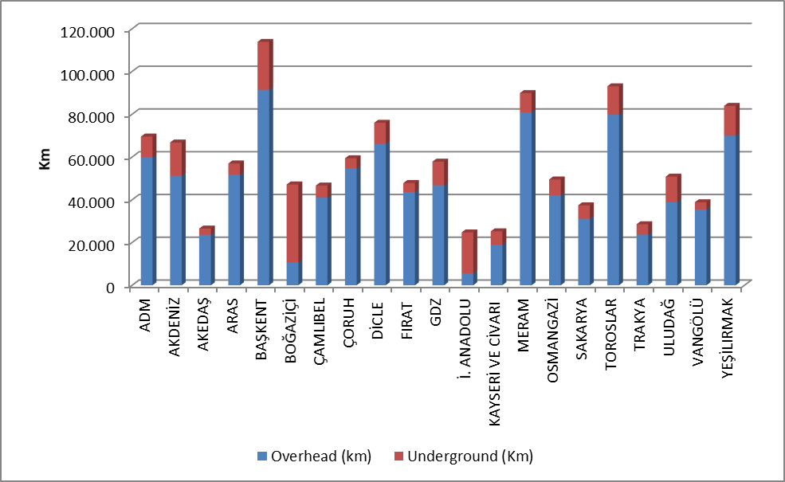
As can be seen in the above figure, the share of underground line lengths in Boğaziçi and Istanbul Anatolian Side regions, where the population is dense, is higher than the share of overhead lines.
Table 5.6 shows the distribution line lengths and transformer capacities by provinces. According to the table, the first five provinces in the distribution line length ranking; Istanbul, Ankara, Konya, Antalya and Izmir.
Considering the transformer capacities in the distribution system of the provinces, the first five provinces in terms of transformer capacity; Istanbul, Izmir, Ankara, Konya and Antalya.
Considering the number of transformers in the distribution system of the provinces, the first five provinces in terms of the number of transformers; Konya, Şanlıurfa, İstanbul, İzmir and Ankara.

Table 5.6: Line Lengths at Distribution Voltage Levels, Number of Transformers and Transformer Capacities by Provinces in 2019 (Km-MVA-Number)
Provinces | Line Length  (km) | Transformer Capacity  (MVA) | Number of Transformers
ADANA | 28.331 | 4.469 | 12.278
ADIYAMAN | 9.358 | 1.001 | 5.185
AFYONKARAHİSAR | 15.365 | 2.122 | 10.043
AĞRI | 13.028 | 545 | 2.493
AKSARAY | 10.597 | 1.177 | 6.856
AMASYA | 8.148 | 587 | 2.916
ANKARA | 61.439 | 11.397 | 18.868
ANTALYA | 46.668 | 5.881 | 13.439
ARDAHAN | 4.792 | 129 | 911
ARTVİN | 6.973 | 386 | 1.681
AYDIN | 21.121 | 2.702 | 7.050
BALIKESİR | 18.378 | 2.537 | 8.015
BARTIN | 4.186 | 402 | 1.423
BATMAN | 6.069 | 942 | 3.945
BAYBURT | 2.997 | 148 | 706
BİLECİK | 4.291 | 936 | 1.992
BİNGÖL | 6.672 | 391 | 1.825
BİTLİS | 7.289 | 514 | 2.828
BOLU | 7.155 | 730 | 2.785
BURDUR | 9.384 | 714 | 2.933
BURSA | 19.627 | 5.286 | 11.779
ÇANAKKALE | 10.096 | 1.205 | 4.857
ÇANKIRI | 6.593 | 508 | 1.915
ÇORUM | 14.875 | 935 | 4.728
DENİZLİ | 21.765 | 2.451 | 6.598
DİYARBAKIR | 18.916 | 3.207 | 12.940
DÜZCE | 5.658 | 729 | 2.055
EDİRNE | 9.043 | 1.055 | 4.015
ELAZIĞ | 12.179 | 1.194 | 4.129
ERZİNCAN | 7.034 | 474 | 2.119
ERZURUM | 17.671 | 1.118 | 4.659
ESKİŞEHİR | 13.120 | 2.412 | 7.638
GAZİANTEP | 15.331 | 2.790 | 10.887
GİRESUN | 15.809 | 676 | 3.070
GÜMÜŞHANE | 6.220 | 316 | 1.286
HAKKARİ | 4.921 | 337 | 1.623
HATAY | 18.613 | 3.746 | 10.881
IĞDIR | 5.103 | 244 | 1.148
ISPARTA | 10.703 | 1.075 | 3.099
İSTANBUL | 71.853 | 26.490 | 22.449
İZMİR | 35.530 | 11.585 | 20.567
KAHRAMANMARAŞ | 17.165 | 2.803 | 7.255
KARABÜK | 4.518 | 557 | 1.681
KARAMAN | 7.114 | 782 | 4.299
KARS | 6.346 | 384 | 1.698
KASTAMONU | 13.462 | 850 | 4.566
KAYSERİ | 25.220 | 2.579 | 7.840
KIRIKKALE | 11.468 | 518 | 1.584
KIRKLARELİ | 6.829 | 987 | 2.359
KIRŞEHİR | 5.894 | 486 | 2.182
KİLİS | 2.245 | 252 | 1.065
KOCAELİ | 12.110 | 4.540 | 7.398
KONYA | 48.161 | 6.726 | 31.431
KÜTAHYA | 9.347 | 1.126 | 3.428
MALATYA | 23.893 | 1.533 | 5.457
MANİSA | 22.274 | 3.566 | 12.647
MARDİN | 11.632 | 2.278 | 11.972
MERSİN | 21.496 | 3.843 | 9.792
MUĞLA | 26.652 | 3.109 | 8.240
MUŞ | 8.451 | 489 | 2.269
NEVŞEHİR | 8.625 | 1.311 | 6.427
NİĞDE | 9.486 | 1.225 | 5.795
ORDU | 24.658 | 893 | 4.768
OSMANİYE | 7.037 | 721 | 2.364
RİZE | 9.611 | 628 | 2.334
SAKARYA | 12.463 | 1.910 | 4.931
SAMSUN | 28.116 | 1.996 | 7.537
SİİRT | 4.167 | 383 | 1.695
SİNOP | 8.094 | 359 | 2.198
SİVAS | 19.322 | 1.053 | 4.783
ŞANLIURFA | 30.425 | 4.802 | 31.005
ŞIRNAK | 4.775 | 882 | 3.811
TEKİRDAĞ | 12.666 | 3.098 | 5.057
TOKAT | 13.742 | 743 | 3.314
TRABZON | 20.791 | 1.233 | 4.005
TUNCELİ | 5.068 | 168 | 1.224
UŞAK | 7.349 | 811 | 2.597
VAN | 18.178 | 1.352 | 5.234
YALOVA | 2.697 | 620 | 1.224
YOZGAT | 13.573 | 826 | 4.360
ZONGULDAK | 12.150 | 1.096 | 3.493
Total | 1.190.169 | 169.060 | 485.933

5.5 Quality Indicators

Data on the technical quality of the electricity provided by the distribution companies are compiled and the tables below show System Average Interruption Duration Index (SAIDI) and System Average Interruption Frequency Index (SAIFI).

Table 5.7: Reported and System Average Interruption Duration Indices of Distribution Companies in 2018-2019 (min)
 | 2018 |  |  | 2019 |  |  | Change (%)
DISTRIBUTION COMPANY | Reported SAIDI  (min) | Unreported SAIDI  (min) | Total SAIDI  (min) | Reported  SAIDI (min) | Unreported  SAIDI  (min) | Total  SAIDI  (min) | Change (%)
TOROSLAR | 571,9 | 1.238,0 | 1.809,9 | 916,9 | 2.816,3 | 3.733,2 | 106,27
VANGÖLÜ | 934,5 | 9.196,9 | 10.131,3 | 367,5 | 2.553,4 | 2.920,9 | -71,17
DİCLE | 429,8 | 842,0 | 1.271,9 | 676,4 | 1.756,7 | 2.433,1 | 91,30
OSMANGAZİ | 291,2 | 779,6 | 1.070,8 | 598,3 | 1.702,2 | 2.300,5 | 114,84
ARAS | 250,3 | 1.086,2 | 1.336,5 | 442,0 | 1.815,9 | 2.257,9 | 68,94
BAŞKENT | 325,5 | 961,1 | 1.286,6 | 523,8 | 1.681,3 | 2.205,1 | 71,39
YEŞİLIRMAK | 591,3 | 729,8 | 1.321,0 | 552,8 | 1.466,6 | 2.019,4 | 52,87
ÇORUH | 326,7 | 1.106,1 | 1.432,8 | 622,0 | 1.390,1 | 2.012,1 | 40,43
FIRAT | 199,1 | 2.281,8 | 2.480,9 | 324,4 | 1.439,2 | 1.763,6 | -28,91
MERAM | 832,3 | 1.063,2 | 1.895,5 | 722,4 | 1.030,7 | 1.753,0 | -7,52
BOĞAZİÇİ | 240,3 | 3.767,5 | 4.007,7 | 271,0 | 1.457,4 | 1.728,4 | -56,87
TRAKYA | 556,0 | 1.205,3 | 1.761,4 | 824,0 | 862,0 | 1.686,0 | -4,28
SAKARYA | 415,4 | 1.295,7 | 1.711,1 | 420,3 | 1.204,3 | 1.624,7 | -5,05
AKDENİZ | 313,5 | 688,1 | 1.001,6 | 398,3 | 1.146,8 | 1.545,2 | 54,27
GDZ | 384,1 | 1.125,7 | 1.509,8 | 523,5 | 926,7 | 1.450,2 | -3,95
AKEDAŞ | 635,4 | 882,3 | 1.517,6 | 353,1 | 880,9 | 1.233,9 | -18,69
ÇAMLIBEL | 478,1 | 823,5 | 1.301,6 | 462,7 | 713,9 | 1.176,6 | -9,60
ADM | 277,1 | 770,5 | 1.047,7 | 231,7 | 826,8 | 1.058,5 | 1,03
ULUDAĞ | 628,5 | 1.538,6 | 2.167,1 | 365,7 | 507,3 | 873,0 | -59,72
İST. ANATOLIAN | 183,6 | 232,2 | 415,8 | 278,7 | 468,4 | 747,1 | 79,68
KAYSERİ VE CİVARI | 329,5 | 258,8 | 588,3 | 169,4 | 494,1 | 663,5 | 12,78

The table above shows the reported, unreported and total System Average Interruption Duration Index in 2017 and 2018. While the first three regions were Toroslar, Trakya and Meram regions according to reported interruptions, Vangölü, Toroslar and Aras regions were the first three regarding unreported interruptions. One of the most important reasons for the increase in the average interruption times and numbers in many distribution companies compared to the previous year is the integration between the supply continuity recording system and supply continuity remote monitoring systems and other systems (CBS, MBS, AYS etc.), more accurate record keeping is considered.
The region with the highest average total interruption period was Toroslar with 3.733,2 minutes, and Vangölü region with the second place was 2.920,9 minutes.

Table 5.8: System Average Interruption Duration Indices of Distribution Companies by reason in 2019 (min)
DISTRIBUTION COMPANY | External | Security | Force Major | Network Operator | Total
TOROSLAR | 43,2 | 91,1 | 0,0 | 3.599,0 | 3.733,2
VANGÖLÜ | 0,5 | 4,7 | 0,0 | 2.915,7 | 2.920,9
DİCLE | 12,0 | 7,1 | 0,0 | 2.414,0 | 2.433,1
OSMANGAZİ | 11,1 | 1,7 | 5,3 | 2.282,5 | 2.300,5
ARAS | 0,6 | 0,2 | 734,9 | 1.522,3 | 2.257,9
BAŞKENT | 21,6 | 50,3 | 0,0 | 2.133,3 | 2.205,1
YEŞİLIRMAK | 41,3 | 3,0 | 0,0 | 1.975,1 | 2.019,4
ÇORUH | 30,8 | 103,4 | 10,0 | 1.867,9 | 2.012,1
FIRAT | 18,7 | 2,7 | 160,5 | 1.581,8 | 1.763,6
MERAM | 111,9 | 13,0 | 12,4 | 1.615,7 | 1.753,0
BOĞAZİÇİ | 109,1 | 14,1 | 0,0 | 1.605,2 | 1.728,4
TRAKYA | 5,3 | 0,0 | 0,0 | 1.680,8 | 1.686,0
SAKARYA | 38,9 | 71,5 | 31,4 | 1.483,0 | 1.624,7
AKDENİZ | 56,2 | 84,1 | 0,0 | 1.404,9 | 1.545,2
GDZ | 12,9 | 3,2 | 0,0 | 1.434,1 | 1.450,2
AKEDAŞ | 13,6 | 11,9 | 0,0 | 1.208,4 | 1.233,9
ÇAMLIBEL | 0,4 | 1,6 | 0,0 | 1.174,6 | 1.176,6
ADM | 4,6 | 6,5 | 0,0 | 1.047,5 | 1.058,5
ULUDAĞ | 26,4 | 2,2 | 0,0 | 844,4 | 873,0
İST. ANATOLIAN | 8,5 | 4,5 | 0,0 | 734,2 | 747,1
KAYSERİ VE CİVARI | 10,7 | 0,1 | 67,8 | 584,9 | 663,5

The table above shows the distribution of the average downtime by reason. It is seen that the highest downtime is due to the network operator.
The following table shows the average interruption frequency of distribution companies. The highest System Average Interruption Duration was 67,1 per customer in the Dicle region, followed by the Vangölü region with 37,7 (Customer/Year).

Table 5.9: System Average Interruption Frequency Indices of Distribution Companies in 2018 and 2019 (Number/Year)
DISTRIBUTION COMPANY | 2018 |  |  |  | 2019 |  |  |  | Change (%)
DISTRIBUTION COMPANY | Reported | Unreported | Short | Total | Reported | Unreported | Short | Total | Change (%)
DİCLE | 2,9 | 28,4 | 3,5 | 34,8 | 3,7 | 39,5 | 24,0 | 67,1 | 92,90
VANGÖLÜ | 2,9 | 75,0 | 0,5 | 78,4 | 0,9 | 20,2 | 27,1 | 48,2 | -38,55
SAKARYA | 2,3 | 31,6 | 3,8 | 37,7 | 2,3 | 30,7 | 3,7 | 36,7 | -2,75
OSMANGAZİ | 1,4 | 17,3 | 0,2 | 18,9 | 2,1 | 21,0 | 6,1 | 29,2 | 54,26
AKEDAŞ | 4,5 | 23,8 | 4,8 | 33,0 | 2,6 | 19,6 | 6,3 | 28,4 | -13,82
TOROSLAR | 1,6 | 8,3 | 0,1 | 10,0 | 2,7 | 24,4 | 0,9 | 28,0 | 179,85
AKDENİZ | 1,1 | 9,4 | 1,2 | 11,7 | 1,4 | 21,6 | 3,7 | 26,7 | 128,22
BOĞAZİÇİ | 0,9 | 27,7 | 4,5 | 33,1 | 1,6 | 17,7 | 6,8 | 26,0 | -21,31
BAŞKENT | 1,1 | 9,4 | 0,3 | 10,8 | 1,6 | 21,8 | 2,2 | 25,5 | 136,37
KAYSERİ VE C. | 2,2 | 5,4 | 6,4 | 14,0 | 1,2 | 11,4 | 10,1 | 22,7 | 62,04
FIRAT | 0,9 | 15,6 | 0,2 | 16,7 | 2,4 | 18,9 | 1,1 | 22,5 | 34,85
ÇORUH | 1,4 | 10,3 | 1,2 | 12,9 | 2,5 | 17,4 | 1,3 | 21,2 | 64,31
YEŞİLIRMAK | 2,4 | 11,7 | 0,8 | 14,9 | 2,1 | 15,6 | 2,2 | 19,9 | 33,60
ARAS | 0,8 | 9,0 | 0,1 | 10,0 | 1,2 | 18,4 | 0,2 | 19,8 | 98,27
TRAKYA | 2,0 | 16,4 | 3,2 | 21,6 | 2,8 | 13,2 | 3,1 | 19,2 | -11,14
ADM | 1,2 | 16,8 | 1,7 | 19,7 | 1,0 | 15,9 | 1,1 | 17,9 | -9,02
GDZ | 1,7 | 15,7 | 0,5 | 17,9 | 3,0 | 12,6 | 0,5 | 16,1 | -10,12
MERAM | 4,3 | 11,8 | 0,1 | 16,1 | 4,4 | 11,6 | 0,0 | 16,0 | -0,44
ULUDAĞ | 2,9 | 17,0 | 3,9 | 23,8 | 2,3 | 8,3 | 3,0 | 13,6 | -42,96
ÇAMLIBEL | 1,7 | 11,1 | 4,7 | 17,5 | 1,6 | 9,6 | 0,8 | 12,0 | -31,15
İSTANBUL AN. SIDE | 0,8 | 3,2 | 0,1 | 4,1 | 1,1 | 9,6 | 0,5 | 11,1 | 170,93

Table 5.10: Distribution Companies’ System Average Interruption Frequency Indices of Distribution Companies by Reason in 2019 (Number/Year)
DISTRIBUTION COMPANY | External | Security | Short | Force Major | Network Operator | Total
DİCLE | 0,2 | 0,1 | 24,0 | 0,0 | 42,8 | 67,1
VANGÖLÜ | 0,0 | 0,0 | 27,1 | 0,0 | 21,1 | 48,2
SAKARYA | 0,8 | 0,3 | 3,7 | 0,2 | 31,7 | 36,7
OSMANGAZİ | 0,1 | 0,0 | 6,1 | 0,0 | 22,9 | 29,2
AKEDAŞ | 0,5 | 0,2 | 6,3 | 0,0 | 21,5 | 28,4
TOROSLAR | 0,3 | 0,7 | 0,9 | 0,0 | 26,2 | 28,0
AKDENİZ | 0,7 | 0,6 | 3,7 | 0,0 | 21,7 | 26,7
BOĞAZİÇİ | 1,1 | 0,1 | 6,8 | 0,0 | 18,0 | 26,0
BAŞKENT | 0,2 | 0,3 | 2,2 | 0,0 | 22,8 | 25,5
KAYSERİ VE CİVARI | 0,1 | 0,0 | 10,1 | 0,0 | 12,4 | 22,7
FIRAT | 0,2 | 0,0 | 1,1 | 1,7 | 19,5 | 22,5
ÇORUH | 0,3 | 0,4 | 1,3 | 0,1 | 19,1 | 21,2
YEŞİLIRMAK | 0,3 | 0,0 | 2,2 | 0,0 | 17,3 | 19,9
ARAS | 0,0 | 0,0 | 0,2 | 7,4 | 12,2 | 19,8
TRAKYA | 0,0 | 0,0 | 3,1 | 0,0 | 16,0 | 19,2
ADM | 0,1 | 0,2 | 1,1 | 0,0 | 16,6 | 17,9
GDZ | 0,1 | 0,0 | 0,5 | 0,0 | 15,5 | 16,1
MERAM | 1,4 | 0,1 | 0,0 | 0,1 | 14,4 | 16,0
ULUDAĞ | 0,2 | 0,0 | 3,0 | 0,0 | 10,3 | 13,6
ÇAMLIBEL | 0,0 | 0,0 | 0,8 | 0,0 | 11,2 | 12,0
İST. ANATOLIAN | 0,1 | 0,0 | 0,5 | 0,0 | 10,5 | 11,1

5.6 Investment Amount of Distribution Companies

With the decision of the Board dated 24/11/2015 and numbered 5885/7, "Procedures and Principles Regarding Electricity Market Distribution System Investments" was approved and entered into force. The said Procedures and Principles were amended by Board Decisions dated 28/11/2016 and numbered 6623, dated 21/09/2017 and numbered 7296, 08/11/2018 and numbered 8168.
With the Board Decision No. 5875-9 dated 18/11/2015, electricity distribution companies will start on 01/01/2016. It was decided to determine the Real Reasonable Return Rate to be taken into consideration during the implementation period as 12,66% (real and before tax) and to apply the Adjusted Real Reasonable Return Rate as 11,91% (real and before tax).
Subsequently, with the Board Decision dated 7/12/2018 and numbered 7501-12 due to the changes in economic and financial parameters, the real reasonable rate of return will cover the years 2018-2020. It has been decided to apply as 13,61% (before real and tax).
With the Board Decision No. 5875-6 dated 18/11/2015, the redemption period that will be valid for the distribution companies and the third implementation period investments has been determined as 10 years.
The table below contains information on the actual investment amounts declared by the Distribution Companies.

Table 5.11: List Of Distribution Investments Comparison in 2018-2019 (Current Prices - Million TL-%)
Distribution Company | 2018 | 2019 | 2018-2019 Change  (%)
ADM | 212,6 | 315,8 | 48,52
AKDENİZ | 181,2 | 262,2 | 44,71
AKEDAŞ | 91,9 | 93,9 | 2,08
ARAS | 162,1 | 199,5 | 23,09
İSTANBUL A.Y.EDAŞ | 271,6 | 248,8 | -8,39
BAŞKENT | 718,7 | 582,3 | -18,98
BOĞAZİÇİ | 444,3 | 720,4 | 62,14
ÇAMLIBEL | 129,5 | 130,2 | 0,56
ÇORUH | 165,0 | 124,5 | -24,55
DİCLE | 320,8 | 633,8 | 97,58
FIRAT | 167,1 | 105,0 | -37,15
GDZ | 294,2 | 500,5 | 70,14
KAYSERİ | 178,2 | 120,4 | -32,42
MERAM | 384,6 | 462,8 | 20,33
OSMANGAZİ | 63,4 | 1.265,9 | 1.896,64
SAKARYA | 175,5 | 111,1 | -36,70
TOROSLAR | 853,8 | 649,1 | -23,97
TRAKYA | 92,2 | 288,1 | 212,53
ULUDAĞ | 313,5 | 156,9 | -49,95
VANGÖLÜ | 141,8 | 127,4 | -10,12
YEŞİLIRMAK | 318,6 | 143,3 | -55,03
TOTAL | 5.680,6 | 7.241,9 | 27,49
* The unit price is calculated according to the June CPI: 413,63
** Investments starting in the II. Implementation Period and complemented in the III. Implementation Period are included.
*** For 2018 investment amounts, the Table was prepared based on the investment realization statements submitted by the companies through the notification system.
****For the investment amounts for 2019, the Table was prepared based on the investment forecast statements submitted by the companies via the notification system.

Total investment realized for 2019 increased by 27,49% compared to 2018 and reached TL 7,24 billion (at current prices). The highest investment expenditure for 2019 was in Osmangazi with 1,3 Billion TL and in Boğaziçi with 720,4 Million TL.

Figure 5.6: Investment Amounts of Dıstribution Companies in 2019 (Current Prices-TL)
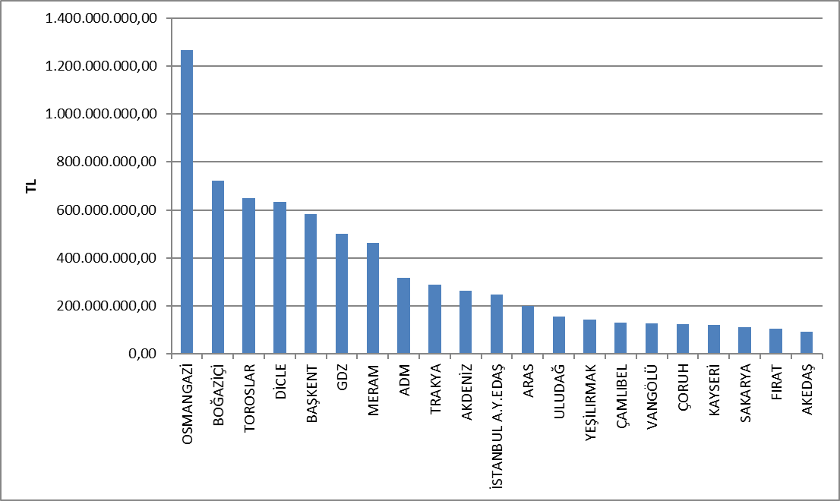

Investment expenditures made by investment type in 2019 are shown in the Table below. The majority of investments are network investments.

Table 5.12: Investment Amounts of Distribution Companies in 2019 (TL)
Distribution Company | Investment Type | 2019 Investment Amount(TL)  (CPI June.2019:413,63)
21 EDAŞ | Network Investments | 5.371.932.490
21 EDAŞ | Investments with Environmental, Security and Other Legal Obligations | 972.146.638
21 EDAŞ | Network Operating System Investments | 585.332.040
21 EDAŞ | Counter Investment | 223.498.793
21 EDAŞ | Other Expenditures as Investment Spending | 89.087.174
21 EDAŞ | Total | 7.241.997.135
*The unit price is calculated according to the June CPI: 413,63
** Investments starting in the II. Implementation Period and complemented in the III. Implementation Period are included.
*** The tables are prepared on the basis of the declarations made by the companies via the notification system.

5.7 Information about Organized Industrial Zones (OIZ)

The following table shows the data related to OIZ Distribution License Owners.

Table 5.13: Information about Organized Industrial Zones
Number of Participant AG | 47.529
Number of Participant OG | 13.548
Number of Total Participant | 61.077
Line Lenght AG | 3.854
Line Length OG | 8.306
Total Line Length | 12.160
Number of Employee (Electricity Transmission) | 832
Number of Transformer (number) | 18.967
Installed Capacity of Transformer (MVA) | 19.383
Annual puant value of previous year (MW) | 6.783

As of the end of 2019, the total number of participants was 61.077 in the Organized Industrial Zones, 47.529 in low voltage and 13.548 in medium voltage. 832 personnel are employed in electricity distribution in OIZ distribution regions.

Total OIZ line length was 12.160 km. Total OSB Transformer capacity has reached 19.383 MVA. The sum of the peak values for the previous year in the OIZ regions is 6.783 MW.
- PRICING

The Electricity Market Law provides for a market structure based on bilateral agreements. The price of electricity in the market in question is determined by mutual agreement of buyers and shooters. Therefore, the prices determined by bilateral agreements are within the knowledge of the relevant parties and are not shared with the public. On the other hand a significant portion of consumer electricity market in Turkey is to provide energy from subject to price regulation. Therefore, it is important to change the regulated prices and price components over the years. This section contains data on regulated prices and changes in the components of the price over the years.
In the Figure below, there is a change of retail energy tariffs (including system fees, tax and funds, including PSH) according to tariff groups by years.

Figure 6.1: Retail Price Excluding Taxes and Funds by Years (Energy+PSH) (kr/kWh)
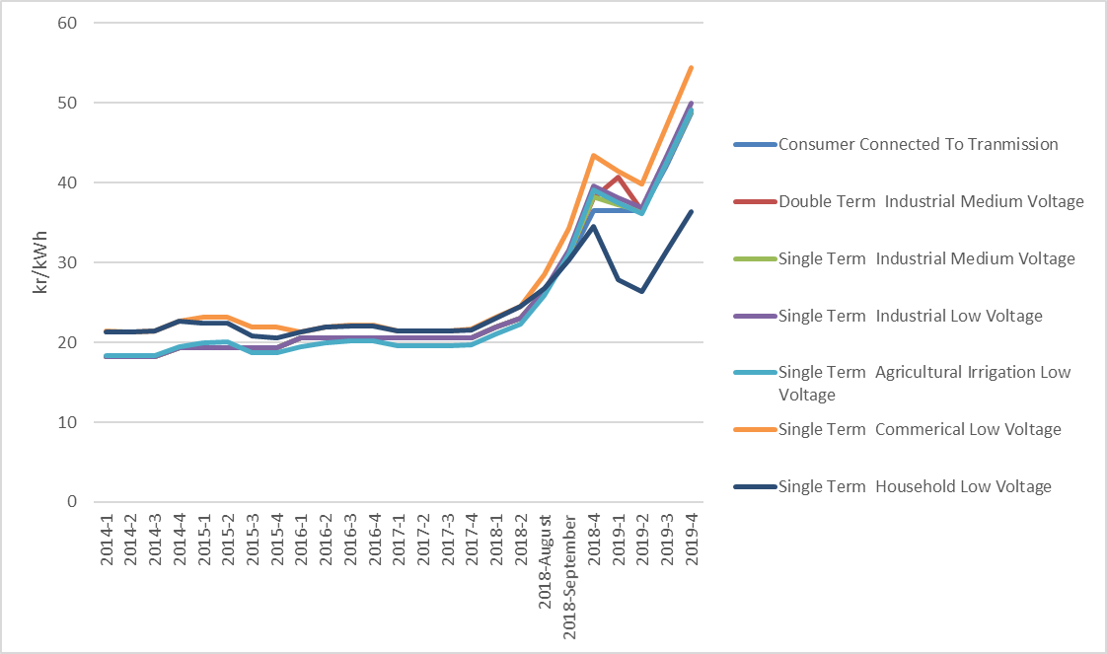

As it is known, transmission and distribution lines must be used to deliver energy from power plants to the consumer. The figure below shows the change of distribution price over the years. Distribution, transmission and technical and non-technical loss costs are included in network cost.
Figure 6.2: Change in Network Costs (Distribution, Transmission and Loss) by Years (kr/kWh) 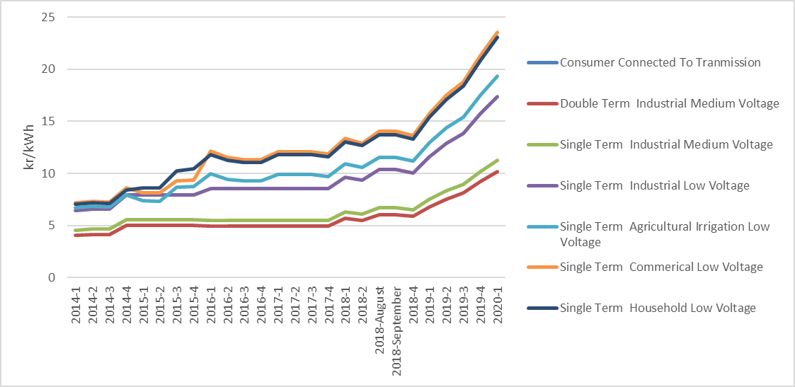
As a result of adding the distribution price to the energy cost, the unit energy price before tax is reached. The figure below shows the change of unit energy cost by years, excluding taxes and funds (energy fund, TRT share, electricity and gas consumption tax and VAT).

Figure 6.3: Change in Electricity Tariffs before Taxes and Funds by Years (kr/kWh)
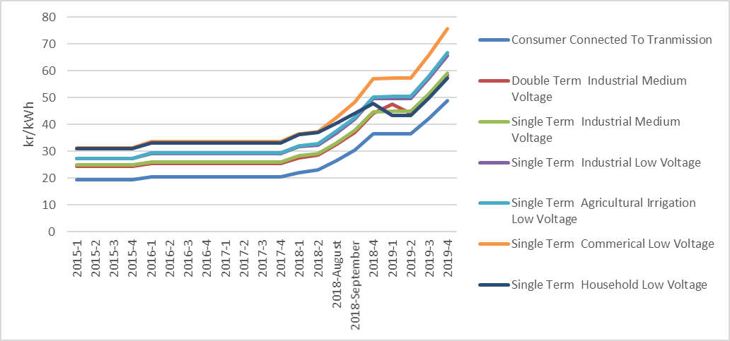

As seen in the figure above, the consumer group with the highest unit energy price before taxes and funds was commercials. The lowest unit energy price before taxes and funds was the consumers connected to the transmission system.

Figure 6.4: Share of Items on Residence Electricity Invoice in 2019 (%)
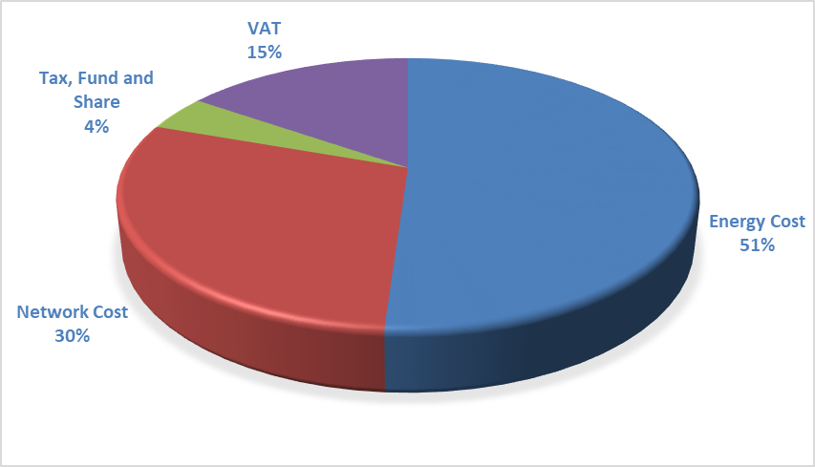

As can be seen from Figure 6.4, the most important item out of the retail energy amount is the network amount with 30% share from the components in the invoices of consumers in the residential group.

Figure 6.5: Share of Items on Industry Electricity Invoice in 2019 (%)
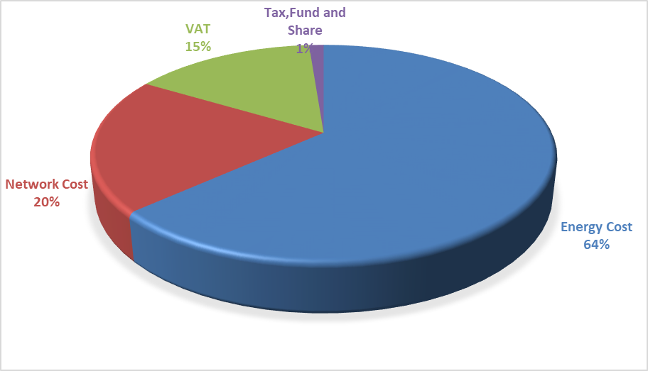
As Figure 6.5 and Figure 6.4 compared, industrial consumers have a higher share of retail energy amount and a lower share of distribution (network) in the invoice components of the industrial group compared to households.

Monthly average exchange rates of Central Bank is used for calculating the average RESSUM Price.
The HHI values are evaluated as a competitive market indicator. If HHI is under 1000 the market is competitive, medium intensity if HHI is between 1000 -1800, and an oligopoly market if HHI is above 1800. In the same way, if the HHI increases by more than 100 points in mergers and acquisitions, it is considered that competitiveness is reduced.
Includes all sales made to eligible and non-eligible consumers for sales volumes of incumbent supply companies.
Including the data about facilities owned by customers.

