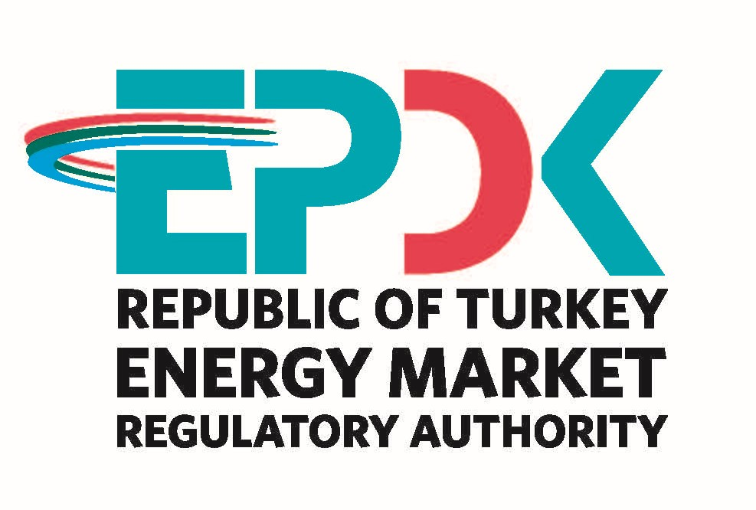

ELECTRICITY MARKET
SECTOR REPORT 2021

All the information, tables and figures provided in this report are reserved and cannot be used without reference.

REPUBLIC OF TURKEY ENERGY MARKET REGULATORY AUTHORITY
Strategy Development Department

ANKARA, 2022

Important Reminder: Licensees can make corrections to the data they previously submitted to the Authority by requesting correction within the framework of the relevant provisions of the Energy Market Notification Regulation. For this reason, there may be data differences between the published reports.
* In this report, Turkish punctuation rules are adopted for numbers.
*This report is published under the Official Statistics Programme.
THE MESSAGE OF THE PRESIDENT
After the period in which secondary regulations were emphasized within the framework of the Electricity Market Law No. 6446, efforts were made for many regulations and other legislation that came into force. In 2021, significant progress has been made in transforming the market into a structure that operates in more liberal, competitive, transparent and predictable manner in the light of regulations.
Electricity demand, which is one of the most important indicators of economic growth, has experienced great fluctuations due to the measures taken to prevent the Covid-19 pandemic. The effect of the measures taken in this context to slow down the economic activity was also seen in electricity demand as of the end of the year. Turkey has been one of the countries that was least affected by the pandemic with an increase of 7,89 percent in electricity demand in 2021.
Structural arrangements that we have made in recent years to encourage the use of renewable energy sources instead of imported sources in electricity production continued to show their results despite the developments experienced during and as a result of the Covid-19 pandemic in the markets. In this context, the share of renewable energy sources, which was 51,4% in 2020, including unlicensed electricity, increased to 53,34% in 2021. In addition, despite the pandemic conditions, two new products were put into service in our country's electricity market in 2021, namely the Forward Electricity Market (VEP) and the Renewable Energy Source Guarantee (YEK-G) System and the Organized YEK-G Market. Thus, we aim to become a center of attraction for other markets in the region with the deepening and increasing attraction of the electricity market day by day. Despite the intention and effort of many countries to establish an energy exchange in our region, the size of our energy market provides us with an economy of scale advantage. The recent increase in our energy demand at a rate that cannot be compared to other countries in our region also strengthens our dynamism.
Market developments reports, which we submit to our stakeholders by our Institution, are compiled and analyzed from the data submitted to our Authority by using the Energy Market Notification System, mainly. It is one of our main objectives to ensure the integrity, consistency and reliability of the data contained in these reports, which are of great importance to be shared accurately and timely with all relevant parties and the public.
While underlining that we, as EMRA, are open to all kinds of constructive opinions and suggestions, I would like to thank all our sector stakeholders for their devoted work during the pandemic process, and I hope that the Electricity Market Sector Report for 2021 will be beneficial to all relevant parties, institutions and organizations.

Mustafa YILMAZ
President

EXECUTIVE SUMMARY
- Number of Licenses in Electricity Market in 2021
License Type | License Application | Grant of License | Expired License | License Revocation | Number of Licenses at Operation at the end of the Term
Distribution License | - | - | - | - | 21
Transmission License | - | - | - | - | 1
OIZ Distribution License | 7 | 9 | 1 | - | 187
OIZ Generation License | - | - | - | - | 3
Pre-License | 100 | 133 | 233 | - | 228
Market Operation License | - | - | - | - | 2
Supply License | 22 | 21 | 1 | 1 | 233
Generation License | 141 | 189 | 71 | 3 | 1.891
Total | 270 | 352 | 306 | 4 | 2.566

- Distribution of Pre-License and Generation License by the end of 2021

Resource Type | Pre-License |  | Production License
Resource Type | License Number | Installed Power Assigned to License (MWe) | License Number | Installed Power Assigned to License (MWe)
Hydraulic | 62 | 3.246,29 | 781 | 33.195,08
Wind | 49 | 2.922,69 | 280 | 12.462,61
Geothermal | 11 | 313,76 | 65 | 1.827,63
Biomass | 103 | 548,317 | 339 | 2.625,35
Solar |  |  | 37 | 1.468,81
Import Coal |  |  | 15 | 12.754,80
Domestic Coal | 2 | 274,83 | 25 | 11.784,50
Coal |  |  | 16 | 1.235,17
Fuel-oil |  |  | 21 | 992,506
Natural Gas |  |  | 275 | 26.567,06
Uranium |  |  | 1 | 4.800,00
Other Thermal | 1 | 5,3 | 36 | 872,051
Grand Total | 228 | 7.311,19 | 1.891 | 110.585,57

- Installed Capacity and Production by Resources by the end of 2021

Resource Type | Total Installed Capacity* (MW) | Share  (%) | Total Production*  (MWh) | Share  (%)
Hydraulic | 31.492,58 | 31,55 | 55.695.231,65 | 16,80
Natural Gas | 25.964,56 | 26,01 | 108.438.726,84 | 32,71
Wind | 10.606,98 | 10,63 | 31.137.427,23 | 9,39
Lignite | 10.119,92 | 10,14 | 43.400.430,26 | 13,09
Import Coal | 8.993,80 | 9,01 | 54.888.840,62 | 16,56
Solar | 7.815,63 | 7,83 | 13.294.280,97 | 4,01
Geothermal | 1.676,17 | 1,68 | 10.770.879,81 | 3,25
Biomass | 1.644,52 | 1,65 | 7.616.648,91 | 2,30
Hard Coal | 840,77 | 0,84 | 3.539.791,50 | 1,07
Asphaltite | 405,00 | 0,41 | 2.372.954,47 | 0,72
Fuel-oil | 251,93 | 0,25 | 336.644,04 | 0,10
Naphta | 4,74 | 0,00 | 0,00 | 0,00
LNG | 1,95 | 0,00 | 0,00 | 0,00
Diesel | 1,04 | 0,00 | 78,33 | 0,00
Total | 99.819,57 | 100,00 | 331.491.934,64 | 100,00
*Licensed and unlicensed power plants are included.

- Licensed Installed Capacity and Peak Demand

- In 2021, Licensed installed capacity was 92.272,58 MW increased by 3,60% compared to previous year.

- In 2020-2021, licensed installed capacity according to resource type is given below:

Resource Type | 2020  (MW) | Share  (%) | 2021  (MW) | Share  (%) | Change  2020-2021 (%)
Natural Gas | 25.639,26 | 28,80 | 25.501,51 | 27,64 | -0,54
Hydro Dam | 22.925,03 | 25,70 | 23.280,37 | 25,23 | 1,55
Wind | 8.761,57 | 9,80 | 10.533,90 | 11,42 | 20,23
Lignite | 10.119,92 | 11,40 | 10.119,92 | 10,97 | 0,00
Import Coal | 8.986,85 | 10,10 | 8.993,80 | 9,75 | 0,08
River | 8.050,23 | 9,00 | 8.198,23 | 8,88 | 1,84
Geothermal | 1.613,19 | 1,80 | 1.676,17 | 1,82 | 3,90
Biomass | 1.031,88 | 1,20 | 1.555,41 | 1,69 | 50,74
Solar | 409,80 | 0,50 | 907,85 | 0,98 | 121,53
Hard Coal | 810,77 | 0,90 | 840,77 | 0,91 | 3,70
Asphaltite Coal | 405,00 | 0,50 | 405,00 | 0,44 | 0,00
Fuel-oil | 305,93 | 0,30 | 251,93 | 0,27 | -17,65
Naphta | 4,74 | 0,00 | 4,74 | 0,01 | 0,00
LNG | 1,95 | 0,00 | 1,95 | 0,00 | 0,00
Diesel | 1,04 | 0,00 | 1,04 | 0,00 | 0,00
Total | 89.067,13 | 100,00 | 92.272,58 | 100,01 | 3,60

While the share of renewable energy resources (including hydraulic) in total installed power was 48% by the end of 2020, it increased to 50,02% in 2021 and while the ratio of total installed thermal power was 52% in 2020, it decreased to 49,98% in 2021.

- Peak demand reached to 56,304 MW increasing by 12,94 %.

- Licensed Electricity Generation

- The amount of licensed electricity generation in 2021 increased by 8,57% compared to 2020 and reached 319.275,22 GWh.

- In 2020-2021, licensed electricity generation according to resource type is given below:

Resource Type | 2020  (GWh) | Share  (%) | 2021  (GWh) | Share  (%) | Change  2020-2021 (%)
Natural Gas | 69.277,54 | 23,60 | 108.394,45 | 33,95 | 56,46
Hydraulic | 78.087,88 | 26,60 | 55.656,34 | 17,43 | -28,73
Import Coal | 62.466,47 | 21,20 | 54.888,84 | 17,19 | -12,13
Lignite | 38.163,85 | 13,00 | 43.400,43 | 13,59 | 13,72
Wind | 24.561,36 | 8,40 | 30.990,13 | 9,71 | 26,17
Geothermal | 9.929,41 | 3,40 | 10.770,88 | 3,37 | 8,47
Biomass | 5.228,50 | 1,80 | 7.371,77 | 2,31 | 40,99
Hard Coal | 3.415,83 | 1,20 | 3.539,79 | 1,11 | 3,63
Asphaltite Coal | 2.222,88 | 0,80 | 2.372,95 | 0,74 | 6,75
Solar | 416,98 | 0,10 | 1.552,91 | 0,49 | 272,42
Fuel Oil | 313,04 | 0,10 | 336,64 | 0,11 | 7,54
Diesel | 1,00 | 0,00 | 0,08 | 0,00 | -92,17
Total | 294.084,73 | 100,00 | 319.275,22 | 100,00 | 8,57

While the share of renewable energy resources (including hydraulic) in total licensed electricity generation was 40,3% by the end of 2020, it decreased to 33,31% in 2021 and while the ratio of total installed thermal power was 59,7% in 2020, it increased to 66,69% in 2021.

- Unlicensed Installed Capacity

- In 2021, unlicensed installed capacity increased by 10,60% compared to previous year and reached 7.546,99 MW. Solar power plants constitute 91,53% of this amount.

- The development of unlicensed installed capacity by resources in 2020 and 2021 is shown below:

Resource Type | 2020 |  | 2021 |  | Change  2020-2021  (%)
Resource Type | Installed Capacity  (MWe) | Share  (%) | Installed Capacity (MWe) | Share  (%) | Change  2020-2021  (%)
Solar | 6.257,61 | 91,71 | 6.907,78 | 91,53 | 10,39
Natural Gas | 402,67 | 5,90 | 463,05 | 6,14 | 14,99
Biomass | 83,71 | 1,23 | 89,11 | 1,18 | 6,45
Wind | 70,83 | 1,04 | 73,08 | 0,97 | 3,17
Hydraulic | 8,65 | 0,13 | 13,98 | 0,19 | 61,64
Total | 6.823,47 | 100,00 | 7.546,99 | 100,00 | 10,60

- Unlicensed Generation

- In 2021, unlicensed generation increased by 6,27% compared to previous year and reached 11.950,26 GWh. Solar power plants constitute 96,62% of this amount.

- In 2020-2021, unlicensed installed generation according to resource type is given below:

Resource Type | 2020 |  | 2021 |  | Change  2020-2021 (%)
Resource Type | The amount of energy that given to system as a surplus (GWh) | Share  (%) | The amount of energy that given to system as a surplus (GWh) | Share  (%) | Change  2020-2021 (%)
Solar | 10.825,50 | 96,27 | 11.546,36 | 96,62 | 6,66
Biomass | 273,45 | 2,43 | 250,86 | 2,10 | -8,26
Wind | 119,47 | 1,06 | 118,94 | 1,00 | -0,44
Hydraulic | 27,07 | 0,24 | 34,11 | 0,29 | 26,03
Total | 11.245,48 | 100,00 | 11.950,26 | 100,00 | 6,27

- Invoiced and Actual Consumption
Consumer Type | Consumption Amount of Consumers Connected to the Distribution Voltage (GWh) |  | Consumption Amount of Consumers Connected to the Transmission Voltage (GWh) |  | Total (GWh)
Consumer Type | 2020 | 2021 | 2020 | 2021 | 2020 | 2021
Non-eligible | 103.709,28 | 101.722,38 | 808,04 | 606,32 | 104.517,32 | 102.328,70
Eligible | 73.676,50 | 87.551,18 | 55.242,79 | 63.154,02 | 128.919,29 | 150.705,20
Total | 177.385,78 | 189.273,56 | 56.050,83 | 63.760,35 | 233.436,61 | 253.033,90

- Electricity consumption, which was invoiced in 2021, increased by 8,4% compared to the previous year and reached to 253.033,9 GWh. 63.760,35 GWh of this amount was sold to consumers at the transmission voltage level, while the remaining 189.273,56 GWh was sold to consumers at the distribution voltage level.

- Besides, 150.705,2 GWh of 253.033,9 GWh consumption was consumed by eligible consumers and 102.328,7 GWh by non-eligible consumers.

- In 2021, Actual consumption was increased by 7,73% compared to 2020 and it reached to 328.405 GWh.

- Import and Export

- In 2021, electricity import increased by 23,34% compared to previous year and it reached to 2,33 TWh.

- In 2021, electricity import increased by 68,56% compared to previous year and it reached to 4,19 TWh.

- Day-Ahead Market and Balancing Power Market

- In 2021, the weighted average Market Clearing Price (MCP) increased by 77,65% compared to 2020 and it became 507,852 TL/MWh.

- The highest MCP value was in December with 1.217 TL/MWh.

- In 2021, the average System Marginal Price (SMP) increased by 83,19% compared to 2020 and it became 498,80 TL/MWh.

- The highest SMP value was 1.217 TL/MWh in December and the lowest SMP value was 0 TL/MWh for a total of 8 hours.

- The additional cost caused by the instructions given in Balancing Power Market (BPM) in 2021 increased by 113,58% compared to 2020 and it reached to 259,44 million TL.

- YEKDEM

- In 2021, the number of power plants benefiting from the Renewable Energy Resources Support Mechanism reached to 929 and the installed capacity of these participants was 21.622,4 MW.

- In 2021, the electricity generation of YEKDEM participants increased by 0,92% compared to 2020 and it reached to 74,16 TWh. Of this amount, 33,98% was obtained from wind and 29,64% from hydroelectricity.

- The average price of YEKDEM increased by 23,82% compared to 2020 and it became 828,55 TL/MWh.

- In 2021, the additional cost of YEKDEM decreased by 13,37% compared to the previous year and became 93,99 TL/MWh.

- Market Openness

- The eligible consumer limit for 2021 was set to 1.200 kWh, and the theoretical market openness rate on the demand side corresponding to this limit was calculated as 97,2%.

- Eligible consumers' consumption in 2021 was 150,71 TWh. While the actual market openness was 58,3% in 2020, this rate increased to 59,56% in 2021.

- At the end of 2021, the number of eligible consumers decreased by 64% compared to 2020 and it became 364.000. This number corresponds to 0,77% of the total number of consumers.

- Transmission

- By the end of 2021, there were 1.245 transformer centers in the transmission system and 2.591 transformers with 249.049 MVA capacity.

- By the end of 2021, the length of the transmission lines was 72.272 km.

- In 2021, 6,43 billion TL was invested by the transmission company.

- In 2021, the transmission system loss rate was 1,89%.

- Distribution

- By the end of 2021, the number of consumers using the distribution system was 47,31 million. The regions with the highest number of consumers were the Boğaziçi with 5,3 million and the Başkent with 4,45 million.

- By the end of 2021, the total invoiced consumption in the distribution regions was 189,27 TWh. The regions with the highest consumption amounts were the Boğaziçi with 25,5 TWh and the Toroslar with 16,6 TWh.

- The highest loss rates were seen in Dicle with 46,19%, Vangölü with 38,07% and Aras with 20,8%.

- The lowest loss rates were seen in Uludağ with 5,23%, Trakya with 5,31% and Çamlıbel with 5,42%.

- By the end of 2021, 63.502 people were employed in the electricity distribution sector. 26.272 of those were employed as permanent staff in distribution companies and the remaining 37.230 were employed as subcontractor company personnel.

- By the end of 2021, there were 508.880 transformers in the distribution system with 187.939 MVA power.

- By the end of 2021, the length of distribution lines was 1.363.320, of which 1.062.990 km was overhead lines and 300.329 km was underground lines.

- In 2021, 14,72 billion TL investment was made by distribution companies at current prices. The highest investment expenditures were realized in Toroslar with 1,49 Billion TL and Başkent with 1,35 Billion TL.

Electricity Market Overview in 2021
Parameters | Unit | 2019 | 2020 | 2021 | Change  2020-2021 (%)
Licensed Installed Capacity* | MWe | 84.960 | 89.067 | 92.273 | 3,60
Licensed Generation* | GWh | 294.251 | 294.084 | 319.275 | 8,57
Highest Peak Demand | MW | 45.324 | 49.852 | 56.304 | 12,94
Lowest Peak Demand | MW | 18.300 | 15.690 | 20.611 | 31,36
Unlicensed Installed Capacity | MW | 6.309 | 6.823 | 7.547 | 10,61
Unlicensed Generation Purchased Surplus** | GWh | 9.825 | 11.246 | 11.950 | 6,26
Gross Unlicensed Generation** | GWh | 10.000 | 11.348 | 12.217 | 7,66
YEKDEM Generation*** | MWh | 76.668.087 | 73.482.227 | 74.156.245 | 0,92
YEKDEM Payment Amount | TL | 38.012.077.764 | 49.169.699.528 | 61.442.093.854 | 24,96
Actual Consumption | GWh | 301.983 | 304.836 | 329.634 | 8,13
Invoiced Consumption | GWh | 229.598 | 233.437 | 253.034 | 8,40
Number of Consumers | Number | 44.958.924 | 46.077.742 | 47.311.976 | 2,68
Import | GWh | 2.212 | 1.888 | 2.329 | 23,34
Export | GWh | 2.789 | 2.484 | 4.187 | 68,56
Average YEKDEM Price | TL/MWh | 495,80 | 669,14 | 828,55 | 23,82
YEKDEM Additional Cost**** | TL/MWh | 75,90093988 | 120,65 | 93,82 | -22,24
Weighted Average MCP | TL/MWh | 268,50 | 285,87 | 507,852 | 77,65
Weighted Average SMP | TL/MWh | 250,30 | 282,47 | 577,492 | 104,44

*Licensed Generation: Includes the installed capacity and generation values of Independent Generation Companies, Build-Operate, Transfer of Operating Rights and Build-Operate-Transfer Power Plants.

**Unlicensed Generation: Generation in accordance with Article 14 of the Electricity Market Law No. 6446, that is granted to the system as a surplus by those who are exempted from the obligation to obtain license and a company.
***YEKDEM generation includes unlicensed generation values.

****YEKDEM Additional Cost: Additional cost to the weighted average MCP for YEKDEM per invoiced unit energy amount.

Contents
1. LICENSED GENERATION AND INSTALLED CAPACITY, UNLICENSED GENERATION, INVOICED AND ACTUAL CONSUMPTION, IMPORT AND EXPORT 18
1.1 Overview 18
1.2 Licensed Generation 19
1.3 Licensed Installed Capacity 26
1.4 Unlicensed Generation 30
1.5 Invoiced Electricity Consumption and Number of Consumers 39
1.6 Import and Export 60
2. WHOLESALE MARKET 62
2.1 Day-Ahead Market 62
2.2 Balancing Power Market 68
2.3 Intra-Day Market 74
2.4 Bilateral Agreements 76
2.5 Renewable Energy Sources Support Mechanism (YEKDEM) 78
2.6 Power Futures Market 85
2.7 Environmental Markets 88
3. COMPETITION 93
3.1 Supply Side 93
3.2 Demand Side 98
4. TRANSMISSION 103
1.1 Transmission System 103
1.2 Transmission System Connection Applications 105
1.3 Tariffs 105
4.4 Amount of Investment 107
4.5 Losses 107
5. DISTRIBUTION 109
5.1 Number of Consumers 109
5.2 Loss Rates 110
5.3 Employement 112
5.4 Information About Network 114
5.5 Quality Indicators 119
5.6 Investment Amount of Distribution Companies 122
5.7 Information about Organized Industrial Zones (OIZ) 125
6. PRICING 126
Table List
Table 1.1: Licensed and Unlicensed Installed Capacity, Peak Demand, Licensed and Unlicensed Electricity Generation, Consumption, Import and Export Data 18
Table 1.2: Licensed Electricity Generation by Provinces (GWh-%) 24
Table 1.3: Distribution of Licensed Installed Capacity by Province (MW-%) 29
Table 1.4: The Status of Unlicensed Electricity Generation Applications at the End of 2021 (MWe) 31
Table 1.5: Distribution of Unlicensed Installed Capacity by Resources (MWe-%) 32
Table 1.6: Distribution of Unlicensed Installed Capacity by Province (MWe-%) 33
Table 1.7: Distribution of Unlicensed Electricity Generation by Resources (MWh-%) 35
Table 1.8: Distribution of Unlicensed Electricity Generation by Provinces (MWh-%) 36
Table 1.9: Distribution of the Amount of Payment Made Within the Scope of Unlicensed Electricity Generation by Resources (TL-%) 39
Table 1.10: Sales to Eligible and Non-Eligible Consumers in 2021 (GWh) 40
Table 1.11: Distribution of Invoiced Consumption by Distribution Regions in 2021 (MWh-%) 40
Table 1.12: Distribution of Invoiced Consumption by Consumer Type as Eligible and Non-Eligible Consumers in 2021 (MWh) 41
Table 1.13 Development of Invoiced Consumption by Consumer Type by Years (MWh) 42
Table 1.14: Distribution of Invoiced Consumption by Province (MWh - %) 43
Table 1.15: Distribution of Invoiced Consumption by Province and Consumer Type (MWh) 45
Table 2.2.1: Additional Costs of Orders (Million TL) 72
Table 2.5.1: Number of Licensed YEKDEM Power Plants by Years 79
Table 2.5.2: Number of YEKDEM Participants by Years 80
Table 2.5.3: Distribution of YEKDEM Installed Capacity by Resources (MW)* 80
Table 2.5.4: Yearly Generation of YEKDEM Participants by Years (MWh)* 81
Table 3.1: HHI Values with respect to Generation and Installed Capacity 93
Table 3.2: Sales, Market Shares and HHI Index of Supply License Owners 94
Table 3.3: Distribution of Eligible Consumers' Supplier Changes by Supplier Type 102
Table 4.1: Transformer Center Information 103
Table 4.2: TEİAŞ Transmission Lines 104
Table 4.3: Connection Applications to the Transmission System (Number - MW) 105
Table 4.4: System Usage and System Operation Tariffs Applied in 2021 (TL/MW-Year, TL/MWh) 106
Table 4.5: Comparison of 2020 and 2021 Investment Amount (TL-%) 107
Table 5.1: Number of Consumers Using Distribution System by the end of 2021 (Number-%) 109
Table 5.2: Loss Rates of Distribution Companies (%) 111
Table 5.3: Number of Employees of Distribution Companies in 2021 113
Table 5.4: Line Lengths, Number of Transformers and Transformer Capacities Based on Distribution Companies at the end of 2021 (km-MVA-Number) 114
Table 5.5: The Lengths of Distribution Lines at the end of 2021 (km) 115
Table 5.6: Line Lengths at Distribution Voltage Levels, Number of Transformers and Transformer Capacities by Provinces at the end of 2021 (km-MVA-Number) 117
Table 5.7: Reported and Unreported System Average Interruption Duration Indices of Distribution Companies in 2020-2021 (min.) 119
Table 5.8: System Average Interruption Duration Indices of Distribution Companies by Reason in 2021 (min.) 120
Table 5.9: System Average Interruption Frequency Indices of Distribution Companies in 2020 and 2021 (Number/Year) 121
Table 5.10: Distribution Companies’ System Average Interruption Frequency Indices for per Consumer by Reason in 2021 (Number/Year) 122
Table 5.11: Comparison of Distribution Investment Amounts in 2019-2020-2021 (Current Prices - Million TL-%) 123
Table 5.12: Realized Investment Amounts in 2021 by Investment Types (TL) 124
Table 5.13: Information about Organized Industrial Zones 125

Figure List
Figure 1.1: Electric Energy Demand and Rate of Increase by Years (GWh-%) 19
Figure 1.2: Peak Demand and Increase Rate Over Years (MW-%) 19
Figure 1.3: Rate of Increase of Electrical Energy Demand and Peak Demand by Year (%) 20
Figure 1.4: Monthly Distribution of Licensed Electricity Generation and Consumption in 2021 (GWh) 20
Figure 1.5: Distribution of Licensed Electricity Generation by Corporations in 2021 (%) 21
Figure 1.6: Change of Licensed Electricity Generation as Public-Private by Years (%) 21
Figure 1.7: Distribution of Licensed Electricity Generation by Sources in 2021 (%) 22
Figure 1.8: Source-Based Development of Licensed Electricity Generation by Years (GWh) 23
Figure 1.9: Licensed Electricity Generation Per Day in 2021 (MWh) 23
Figure 1.10: First 10 Companies within Electricity Generation in 2021 (%) 25
Figure 1.11: Distribution of Licensed Installed Capacity by Sources at the end of 2021 (%) 26
Figure 1.12: Distribution of Licensed Installed Capacity by Organizations at the end of 2021 (%) 27
Figure 1.13: The Development of Licensed Installed Capacity by Source over the Years (MW) 28
Figure 1.14: The Development of the Share of the Sources within the Installed Capacity by Years (%) 28
Figure 1.15: The Share of the First 10 Companies in Installed Capacity at the End of 2021 (%) 30
Figure 1.16: Distribution of Unlicensed Installed Capacity by Sources at the End of 2021 (%) 32
Figure 1.17: Distribution of Unlicensed Electricity Generation by Resources in 2021 (%) 36
Figure 1.18: Distribution of Invoiced Consumption by Consumer Type in 2021 (%) 42
Figure 1.19: Distribution of Invoiced Consumption by Months (MWh) 47
Figure 1.20: Development of Actual Consumption by Years (GWh) 47
Figure 1.21: Electricity Imports in 2021 by Months (MWh) 60
Figure 1.22: Electricity Exports in 2021 by Months (MWh) 61
Figure 2.1.1: Hourly Development of Weighted Average Market Clearing Price and Market Clearing Price in 2021 (TL/MWh) 64
Figure 2.1.2: Organized and Weighted Average MCP in 2021 (TL/MWh) 64
Figure 2.1.3: Weighted Average MCP by Years (TL/MWh) 65
Figure 2.1.4: Monthly Weighted Average MCP of the Last Two Years (TL/MWh) 66
Figure 2.1.5: Monthly Day-Ahead Market Trading Volume (MWh) 66
Figure 2.1.6: Share of Top 10 Companies by Purchase Amount in Day-Ahead Market (%) 67
Figure 2.1.7: Share of Top 10 Companies by Sales Amount in the Day Ahead Market (%) 67
Figure 2.2.1: Hourly System Marginal Price (SMP) (TL/MWh) 68
Figure 2.2.2: Organized System Marginal Price (TL/MWh) 68
Figure 2.2.3: Monthly Weighted Average Prices of the Last Two Years in Balancing Power Market (TL/MWh) 69
Figure 2.2.4: Monthly Trading Volumes in Balancing Power Market (MWh) 70
Figure 2.2.5: Share of Top 10 Companies by Purchase Amount in Balancing Power Market (%) 70
Figure 2.2.6: Share of Top 10 Companies by Sales Amount in Balancing Power Market (%) 71
Figure 2.2.7: Rates of Order Volumes Given in Balancing Power Market in 2021 (%) 71
Figure 2.2.8: Hourly Distribution of Orders Given in the Balancing Power Market in 2021 (MW) 72
Figure 2.2.9: Monthly Development of Additional Costs of Orders in 2021 (Million TL) 73
Figure 2.2.10: Yearly Development of Zero Balance Adjustment Component (TL) 73
Figure 2.3.1: Monthly Development of Trading Volume and Average Price in the Intra-Day Market (MWh – TL/MWh) 74
Figure 2.3.2: Share of Top 10 Companies by Purchase Amount in Intra-Day Market (%) 75
Figure 2.3.3: Share of Top 10 Companies by Sales Amount in Intra-Day Market (%) 75
Figure 2.4.1: Monthly Bilateral Agreements Volumes by Years (MWh) 76
Figure 2.4.2: Share of Top 10 Companies by Purchase Amount with Bilateral Agreements (%) 77
Figure 2.4.3: Share of Top 10 Companies by Sales Amount with Bilateral Agreements (%) 77
Figure 2.4.4 Wholesale Prices of EÜAŞ Between 2014-2021 (kr/kWh) 78
Figure 2.5.1: Distribution of YEKDEM Installed Capacity by Resources in 2021 (%) 81
Figure 2.5.2: Distribution of YEKDEM Generation by Resources in 2021 (%) 82
Figure 2.5.3: Monthly Development of YEKDEM Generation in 2021 (MWh) 83
Figure 2.5.4: Monthly Development of YEKDEM and DAM Prices in 2021 (TL/MWh) 83
Figure 2.5.5: Average of YEKDEM and MCP in 2021 (kr/kWh) 84
Figure 2.5.6: Monthly Payments Made within the Scope of the YEKDEM in 2021 (TL) 84
Figure 2.5.7: Monthly Improvement of Average YEKDEM Additional Cost in 2021 (TL/MWh) 85
Figure 2.6.1: Daily Index Price in PFM vs. MCP (TL/MWh) 86
Figure 2.6.2: Last Daily Index Price in PFM vs. MCP (TL/MWh) 87
Figure 2.6.3: Matching Prices and Amounts in PFM (TL/MWh – MW) 87
Figure 2.6.4: Contract Based Match Amounts and Trading Volume (MWh – Million TL) 88
Figure 2.7.1: Amount of Issue in YEK-G System 89
Figure 3.1: Eligible Consumer Limit and Market Openness Ratio by Years (kWh-%) 99
Figure 3.2: Number of Eligible Consumer by Months in 2021 99
Figure 3.3: Distribution of Eligible Consumers and Their Consumptions by Distribution Regions in 2021 100
Figure 3.4: Distribution of Eligible Consumer Consumption by Supplier Type (%) 101
Figure 3.5: Monthly Changes in Number and Consumptions of Eligible Consumers Switching Their Supplier (Number-MWh) 101
Figure 4.1: Changes in TEİAŞ Transmission Line Lengths by Years (km) 104
Figure 4.2: Capacity Based Regional Transmission System Usage Tariffs Applied in 2021 (TL/MW-Year) 106
Figure 4.3: Transmission System Losses (GWh-%) 108
Figure 5.1: Number of Consumers and Consumption Amounts (Number - MWh) 110
Figure 5.2: Realized and Targeted Loss Rates in 2021 (%) 112
Figure 5.3: Number of Employees of Distribution Companies by the end of 2021 113
Figure 5.4: Line Lengths and Transformer Capacities on the Basis of Distribution Companies at the end of 2021 (km-MVA) 115
Figure 5.5: The Length of Lines on the Basis of Distribution Companies at the end of 2021 (km) 116
Figure 5.6: Investment Amounts of Distribution Companies in 2021 (Current Prices-Million TL) 124
Figure 6.1: Retail Price Excluding Taxes and Funds by Years (Energy+PSH) (kr/kWh) 126
Figure 6.2: Change in Network Costs (Distribution, Transmission and Loss) by Years (kr/kWh) 127
Figure 6.3: Change in Electricity Tariffs before Taxes and Funds by Years (kr/kWh) 127
Figure 6.4: Share of Items on Household Electricity Invoice in 2021 (%) 128
Figure 6.5: 2021 Yılı Sanayi Elektrik Faturasında Yer alan Bedellerin Payı (%) 128

ABBREVIATIONS TABLE

BO : Build Operate
BOT : Build Operate Transfer
BPM : Balancing Power Market
CPI : Consumer Price Index
DAM : Day-Ahead Market
DIP : Daily Index Price
EMRA : Energy Market Regulatory Authority
EPİAŞ : Energy Exchange Istanbul
EÜAŞ : Electricity Generation Company
IDM : Intra-Day Market
MCP : Market Clearing Price (Day-Ahead Price)
PFM : Power Futures Market
SMP : System Marginal Price (Real Time Price)
TEİAŞ : Turkish Electricity Transmission Company
TETAŞ : Turkish Electricity Trading and Contracting Company Inc.
YEKDEM : Renewable Energy Sources Support Mechanism
YEK-G System : Renewable Energy Resource Guarantee System

- LICENSED GENERATION AND INSTALLED CAPACITY, UNLICENSED GENERATION, INVOICED AND ACTUAL CONSUMPTION, IMPORT AND EXPORT

In this section, there are evaluations on the licensed and unlicensed electricity generation and installed capacity, invoiced and actual consumption, import and export data for 2021. In addition, determinations have been made regarding the changes in the data over the years.

1.1 Overview

Table 1.1 shows the licensed and unlicensed installed capacity, peak demand, licensed and unlicensed electricity generation, invoiced and actual consumption, import and export data by the end of 2021, combined with previous years’ data.

Table 1.1: Licensed and Unlicensed Installed Capacity, Peak Demand, Licensed and Unlicensed Electricity Generation, Consumption, Import and Export Data
 | Unit | 2018 | 2019 | 2020 | Change (%) 2019-2020 | 2021 | Change (%) 2020-2021
Licensed Installed Capacity | MW | 83.187 | 84.960 | 89.067 | 2,1 | 92.273 | 3,6
Unlicensed Installed Capacity | MW | 5.311 | 6.309 | 6.823 | 18,8 | 7.547 | 10,6
Peak Demand | MW | 49.516 | 49.281 | 49.852 | -0,5 | 56.304 | 12,9
Licensed Generation | GWh | 295.402 | 294.251 | 294.085 | -0,4 | 319.275 | 8,6
Unlicensed Generation | GWh | 8.213 | 9.825 | 11.245 | 19,7 | 11.950 | 6,3
Invoiced Consumption | GWh | 233.610 | 229.598 | 233.437 | -1,7 | 253.034 | 8,4
Actual Consumption | GWh | 302.772 | 301.983 | 304.836 | -0,3 | 329.634 | 8,1
Import | GWh | 2.466 | 2.212 | 1.888 | -10,3 | 2.329 | 23,3
Export | GWh | 3.074 | 2.789 | 2.484 | -9,3 | 4.187 | 68,6

When the table is examined, it is seen that the licensed and unlicensed installed capacity, peak demand, licensed and unlicensed generation, invoiced and actual consumption, imports and exports in 2021, compared to 2020, increased by 3,6% , 10,6% , 12,9% , 8,6% , 6,3% , 8,4% , 8,1% , 23,3% and 68,6% respectively.
While the ratio of exports to imports was 131,5 % in 2020, it increased to 179,8% in 2021.

1.2 Licensed Generation

Figure 1.1 shows the electric energy demand and the rate of increase over the years. As it seen in the figure, electric energy demand in 2021 increased by 8,13% compared to the previous year.

Figure 1.1: Electric Energy Demand and Rate of Increase by Years (GWh-%)
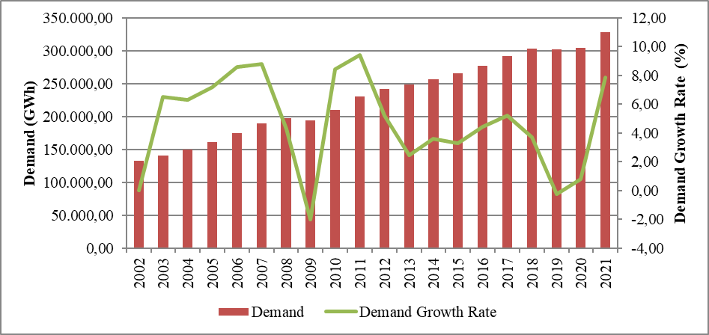
The development and increase rate of peak demand is presented in Figure 1.2. The change in peak demand is generally similar to energy demand, but it is more variable. It is seen that peak demand increased by 12,94% in 2021 compared to the previous year.

Figure 1.2: Peak Demand and Increase Rate Over Years (MW-%)
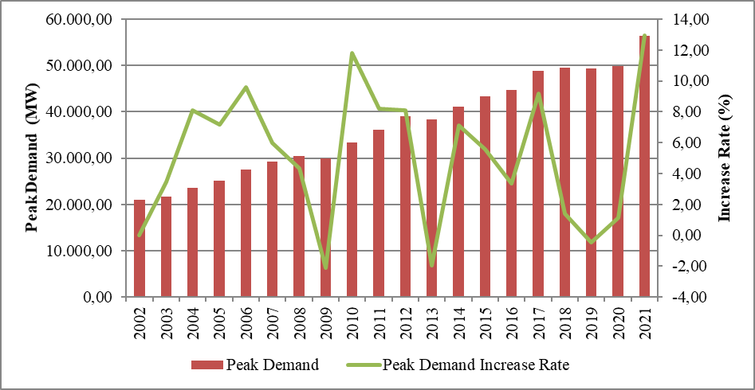
Figure 1.3 shows the relationship between peak demand and electrical energy demand over the years. As can be seen from the figure, the increase rates of electrical energy demand and peak demand were generally close to each other.

Figure 1.3: Rate of Increase of Electrical Energy Demand and Peak Demand by Year (%)
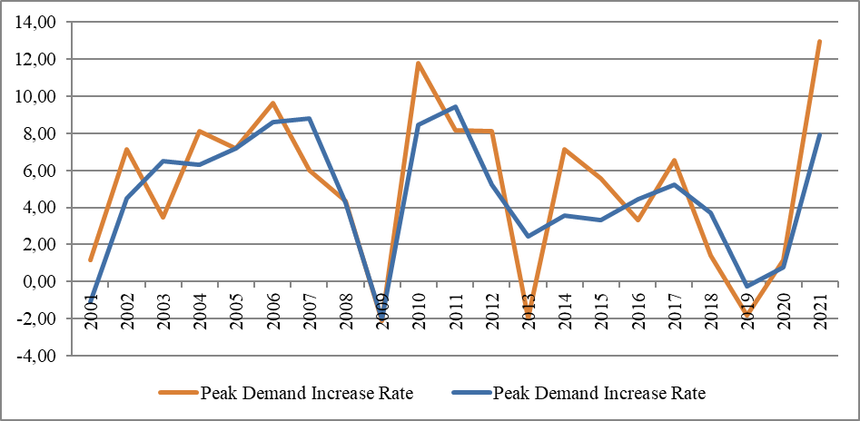
Figure 1.4 shows the licensed electricity generation and monthly change in electricity consumption. Monthly licensed electricity generation and consumption reached their highest values in August.

Figure 1.4: Monthly Distribution of Licensed Electricity Generation and Consumption in 2021 (GWh)
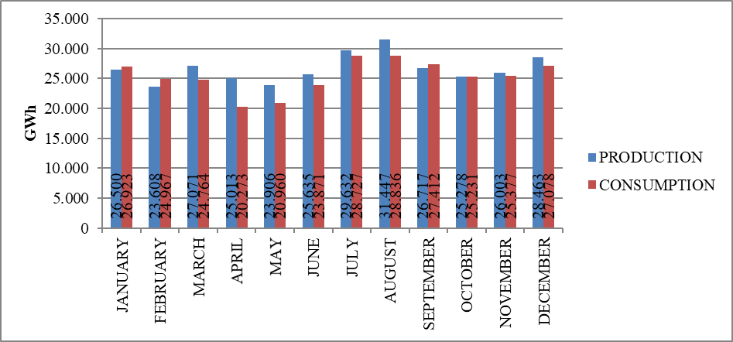
Distribution of licensed electricity generation by organizations in 2021 is shown in Figure 1.5. Independent generation companies had the highest share in production with 81,12%. The share of EÜAŞ power plants was 16,69% and the share of power plants operating under existing contracts in total production was 2,19%.

Figure 1.5: Distribution of Licensed Electricity Generation by Corporations in 2021 (%)
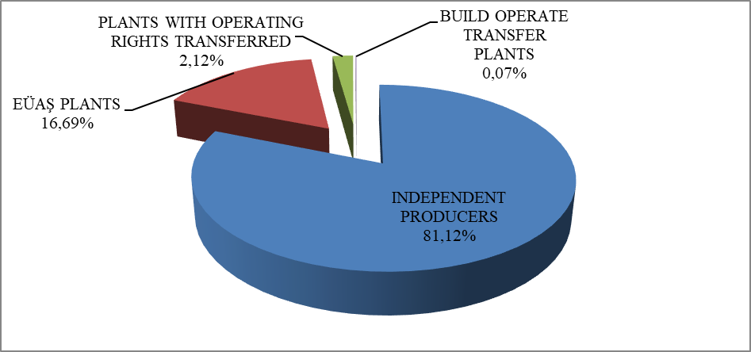

The distribution of licensed electricity generation within the scope of public, private and existing contracts is given in Figure 1.6. While the total share of the public sector in production (including existing contracts) was 21,8% in 2020, this rate decreased to 18,88 % in 2021. On the other hand, the share of independent generation, which was 78,2% in 2020, increased to 81,12% in 2021.

Figure 1.6: Change of Licensed Electricity Generation as Public-Private by Years (%)
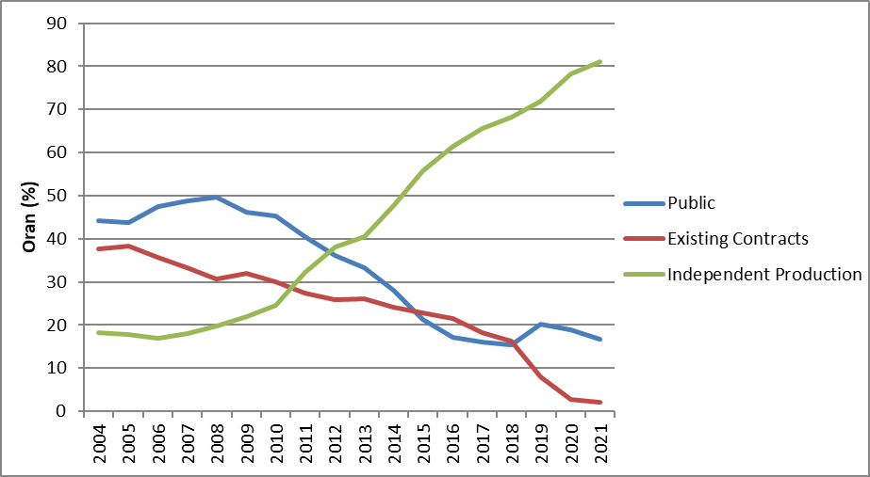
As seen in Figure 1.6, the increase in the share of independent generation continues. There are two main reasons for this increase. First of all, most of the new investments are made by independent power producers. Second reason is that existing contracts of build-operate power plants have expired.
The distribution of licensed electricity generation by resources is shown in Figure 1.7. While the share of natural gas-fired power plants in licensed electricity generation in 2020 was 23,56%, it increased to 33,95% in 2021. Also, the share of domestic coal (lignite, hard coal and asphaltite) power plants increased from %14,89 to 15,45% and the share of wind power plants increased from 8,35% to 9,71%. On the other hand, while the share of hydroelectric power plants in 2020 was 26,55%, it decreased to 17,43% in 2021. Also, the share of imported coal power plants decreased from 21,24% to 17,19% and the share of geothermal power plants decreased from 3,38% to 3,37%.

Figure 1.7: Distribution of Licensed Electricity Generation by Sources in 2021 (%)
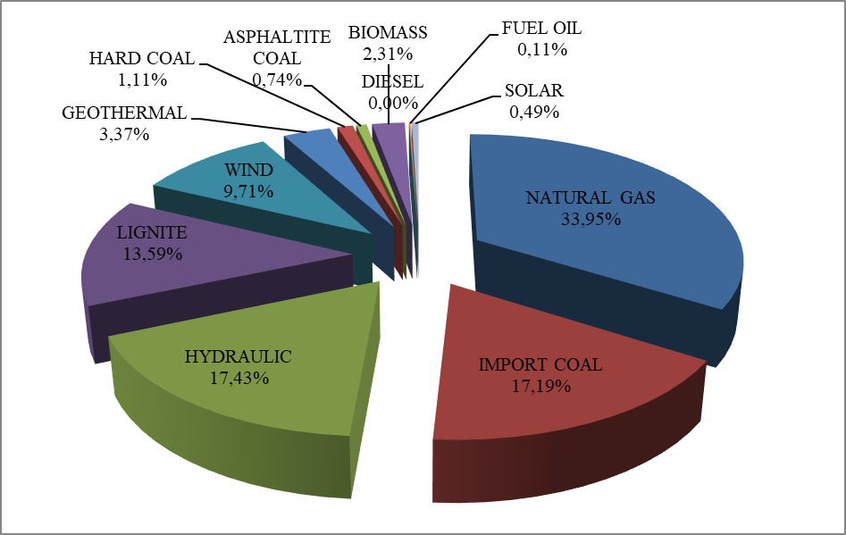

The development of licensed electricity generation on the basis of resources since 1990 is shown in Figure 1.8. As can be seen from the figure, the share of renewable energy sources such as geothermal, wind, solar and biomass in electricity generation has increased every year.

Figure 1.8: Source-Based Development of Licensed Electricity Generation by Years (GWh)
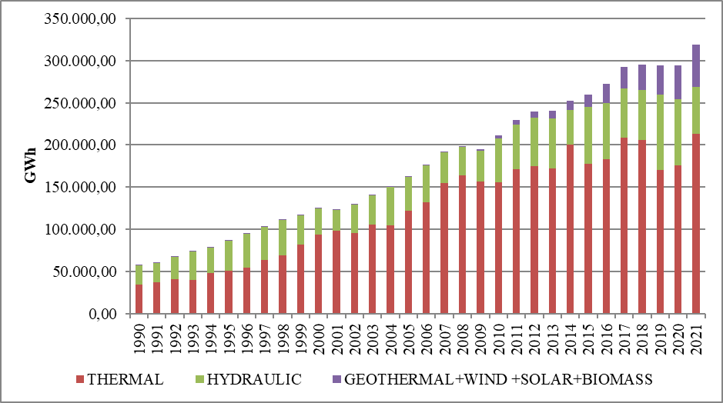
The day-based development of licensed electricity generation in Turkey is shown in Figure 1.9. Licensed electricity generation was highest in August and lowest in May. When it considered on a daily basis, the highest electricity generation was on August 4, 2021, and the lowest on May 13, 2021.

Figure 1.9: Licensed Electricity Generation Per Day in 2021 (MWh)
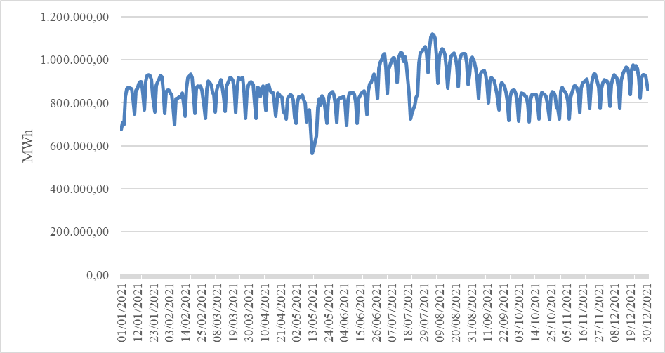
The distribution of licensed electricity generation by province is shown in Table 1.2. In 2020, the highest electricity production was realized in Çanakkale, İzmir, Zonguldak, Adana, Balıkesir, Hatay and Manisa provinces, while the lowest electricity production was in Ağrı, Yozgat, Çankırı, Aksaray, Iğdır, Bayburt and Bartın provinces respectively.

Table 1.2: Licensed Electricity Generation by Provinces (GWh-%)
PROVINCE | Generation (GWh) | Share (%) | Province | Generation (GWh) | Share (%)
ÇANAKKALE | 27.072,86 | 8,48 | TRABZON | 1.306,53 | 0,41
İZMİR | 19.936,41 | 6,24 | YALOVA | 1.158,35 | 0,36
ZONGULDAK | 16.749,25 | 5,25 | MUŞ | 1.078,84 | 0,34
ADANA | 15.432,20 | 4,83 | GÜMÜŞHANE | 1.048,12 | 0,33
BALIKESİR | 15.320,94 | 4,80 | RİZE | 1.010,91 | 0,32
HATAY | 14.792,53 | 4,63 | GAZİANTEP | 895,75 | 0,28
MANİSA | 13.335,44 | 4,18 | ORDU | 884,20 | 0,28
BURSA | 12.702,86 | 3,98 | ERZURUM | 859,60 | 0,27
MUĞLA | 12.050,22 | 3,77 | KARABÜK | 737,68 | 0,23
SAMSUN | 10.890,88 | 3,41 | SİNOP | 729,59 | 0,23
İSTANBUL | 10.656,97 | 3,34 | ERZİNCAN | 667,06 | 0,21
KIRIKKALE | 10.013,28 | 3,14 | ESKİŞEHİR | 657,09 | 0,21
KIRKLARELİ | 9.073,92 | 2,84 | AMASYA | 649,93 | 0,20
KAHRAMANMARAŞ | 8.487,12 | 2,66 | KIRŞEHİR | 629,90 | 0,20
ANKARA | 8.340,93 | 2,61 | EDİRNE | 537,27 | 0,17
SAKARYA | 8.012,38 | 2,51 | ADIYAMAN | 531,56 | 0,17
DENİZLİ | 7.448,06 | 2,33 | ÇORUM | 499,19 | 0,16
KOCAELİ | 7.137,94 | 2,24 | ISPARTA | 471,24 | 0,15
AYDIN | 6.862,20 | 2,15 | KARS | 460,95 | 0,14
TEKİRDAĞ | 6.369,89 | 2,00 | ARDAHAN | 424,44 | 0,13
ANTALYA | 6.184,47 | 1,94 | DÜZCE | 351,34 | 0,11
ELAZIĞ | 5.548,30 | 1,74 | BİLECİK | 299,49 | 0,09
ŞANLIURFA | 5.429,57 | 1,70 | VAN | 268,66 | 0,08
DİYARBAKIR | 5.123,82 | 1,60 | TUNCELİ | 224,88 | 0,07
KÜTAHYA | 4.178,10 | 1,31 | MALATYA | 208,69 | 0,07
ARTVİN | 3.923,90 | 1,23 | NEVŞEHİR | 205,41 | 0,06
SİVAS | 3.631,73 | 1,14 | UŞAK | 191,25 | 0,06
MERSİN | 3.287,35 | 1,03 | BURDUR | 185,32 | 0,06
OSMANİYE | 2.788,15 | 0,87 | BİTLİS | 169,03 | 0,05
BOLU | 2.547,40 | 0,80 | KASTAMONU | 148,38 | 0,05
ŞIRNAK | 2.450,00 | 0,77 | BATMAN | 135,89 | 0,04
BİNGÖL | 2.082,63 | 0,65 | NİĞDE | 108,12 | 0,03
KONYA | 2.053,73 | 0,64 | HAKKARİ | 106,66 | 0,03
MARDİN | 2.020,73 | 0,63 | BARTIN | 67,67 | 0,02
KARAMAN | 1.798,66 | 0,56 | BAYBURT | 55,87 | 0,02
GİRESUN | 1.652,16 | 0,52 | IĞDIR | 49,57 | 0,02
KAYSERİ | 1.534,12 | 0,48 | AKSARAY | 47,69 | 0,01
SİİRT | 1.438,72 | 0,45 | ÇANKIRI | 35,59 | 0,01
AFYONKARAHİSAR | 1.419,41 | 0,44 | YOZGAT | 31,15 | 0,01
TOKAT | 1.359,32 | 0,43 | AĞRI | 7,80 | 0,00
 |  |  | Total | 319.275,22 | 100,00

Figure 1.10 shows the top 10 companies with the highest share in licensed electricity generation in 2021. As shown in the figure, the top 10 companies are EÜAŞ, Enerjisa En.Ür.A.Ş. , Eren En.El.Ür.A.Ş. , Cenal El.Ür.A.Ş. , İskenderun En.Ür.Ve Tic.A.Ş. , Atlas En.Ür.San.A.Ş. , Hamitabat El.Ür.Ve Tic.A.Ş. , İçdaş El.En.Ür.Ve Yat. A.Ş , Yeniköy Kemerköy El.Ür.Ve Tic.A.Ş. and Habaş Sinai ve Tıbbi Gazlar İstihsal End. A.Ş. respectively.

Figure 1.10: First 10 Companies within Electricity Generation in 2021 (%)
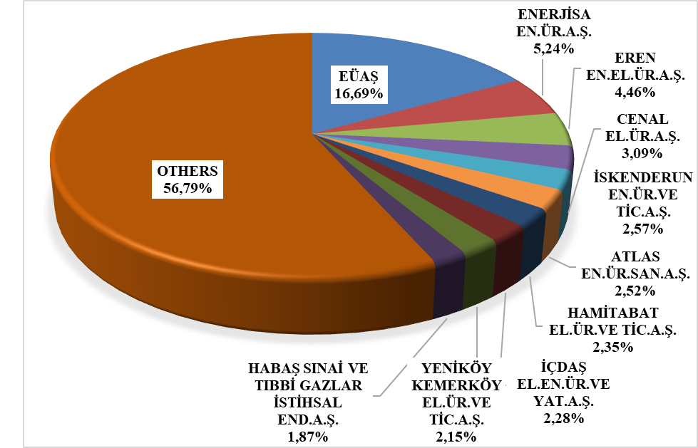

1.3 Licensed Installed Capacity

Distribution of licensed installed power by resource types is shown in Figure 1.11. While the share of natural gas power plants (including liquid and natural gas fired power plants) within the licensed installed capacity was 28,79% at the end of 2020, it decreased to 27,64% in 2021, the share of dam-hydroelectric power plants decreased from 25,74% to 25,23% and the share of river-hydroelectric power plants decreased from 9,04% to 8,88%. Also, while the share of power plants based on import coal decreased from 10,09% to 9,75%, the share of lignite power plants decreased from 11,36 % to 10,97%.
On the other hand, the share of wind power plants, which was 9,84% in licensed installed capacity, increased to 11,42% and the share of geothermal power plants increased from 1,81% to 1,82% in 2021.
While the share of renewable energy sources (including hydraulic) in the total installed capacity was 48% at the end of 2020, it increased to 50,02% in 2021. While the rate of thermal installed capacity was 52% in 2020, it decreased to 49,98% in 2021.

Figure 1.11: Distribution of Licensed Installed Capacity by Sources at the end of 2021 (%)
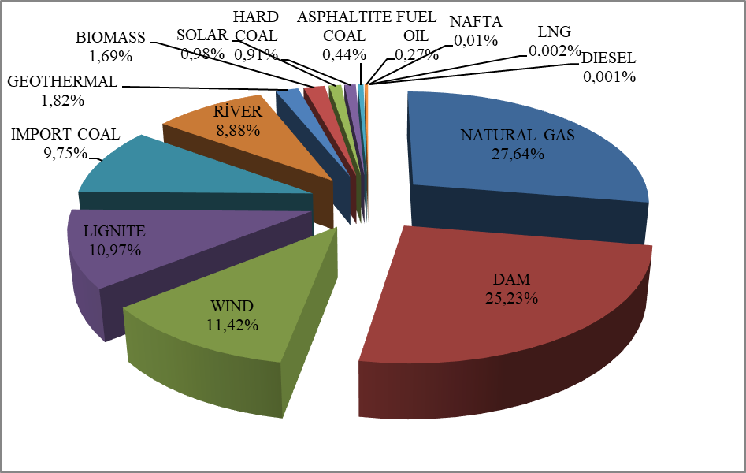
The distribution of the licensed installed power according to organizations is shown in Figure 1.12. In 2021, the share of EÜAŞ power plants in total installed capacity, %24,05 in 2020, decreased to 23,10%. Also, the share of power plants operating under existing contracts in total installed capacity decreased from 4,21% to 3,33% compared to the previous year.
On the other hand, while the share of independent generation companies operating under free market conditions was 72,62% in 2020, it increased to 73,57% in 2021.

Figure 1.12: Distribution of Licensed Installed Capacity by Organizations at the end of 2021 (%)
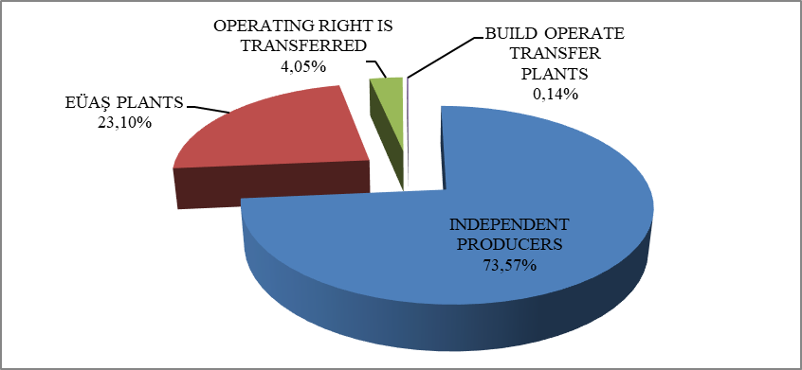

The development of licensed installed capacity based on resources since 2000 is shown in Figure 1.13. As shown in the figure, the share of geothermal, wind, solar and biomass resources in installed capacity has increased every year.

Figure 1.13: The Development of Licensed Installed Capacity by Source over the Years (MW)
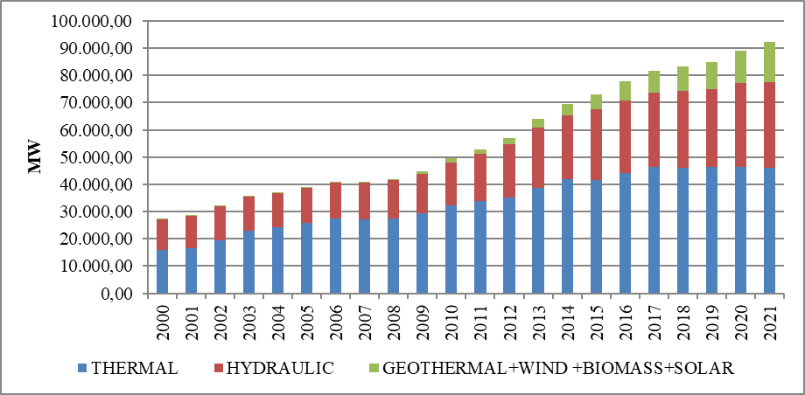

Similar to Figure 1.13, the development of the shares of resources in licensed installed power since 2000 is also given in Figure 1.14.

Figure 1.14: The Development of the Share of the Sources within the Installed Capacity by Years (%)
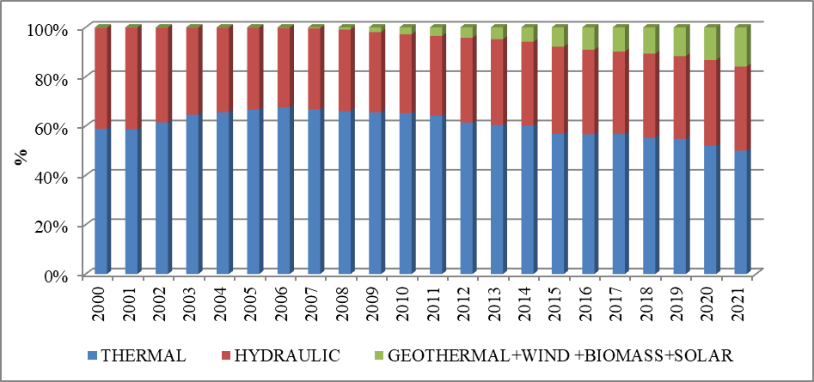
The distribution of licensed installed capacity by province is shown in Table 1.3. In 2021, the provinces that have highest installed power were İzmir, Çanakkale, Kahramanmaraş, Adana, Zonguldak and İstanbul and the provinces that have lowest installed power were Çankırı, Ağrı, Iğdır, Bayburt, Aksaray and Bartın respectively.

Table 1.3: Distribution of Licensed Installed Capacity by Province (MW-%)
PROVINCE | Installed  Capacity (MW) | Share (%) | PROVINCE | Installed Capacity (MW) | Share (%)
İZMİR | 5.414,32 | 5,87 | ERZURUM | 571,97 | 0,62
ÇANAKKALE | 4.517,47 | 4,90 | ESKİŞEHİR | 555,82 | 0,60
KAHRAMANMARAŞ | 4.407,29 | 4,78 | GAZİANTEP | 545,88 | 0,59
ADANA | 3.765,39 | 4,08 | BOLU | 505,10 | 0,55
ZONGULDAK | 3.377,11 | 3,66 | ORDU | 501,73 | 0,54
İSTANBUL | 3.305,41 | 3,58 | MUŞ | 462,66 | 0,50
ŞANLIURFA | 3.295,80 | 3,57 | ŞIRNAK | 418,45 | 0,45
SAMSUN | 3.234,44 | 3,51 | AFYONKARAHİSAR | 413,49 | 0,45
BALIKESİR | 3.071,55 | 3,33 | ÇORUM | 402,43 | 0,44
MANİSA | 2.932,19 | 3,18 | RİZE | 364,73 | 0,40
HATAY | 2.827,01 | 3,06 | ERZİNCAN | 324,40 | 0,35
BURSA | 2.823,25 | 3,06 | YALOVA | 322,43 | 0,35
SAKARYA | 2.703,51 | 2,93 | KIRŞEHİR | 322,09 | 0,35
ELAZIĞ | 2.463,22 | 2,67 | AMASYA | 314,66 | 0,34
ANKARA | 2.463,12 | 2,67 | ISPARTA | 290,65 | 0,31
MUĞLA | 2.291,60 | 2,48 | ADIYAMAN | 258,64 | 0,28
DİYARBAKIR | 2.260,86 | 2,45 | KARS | 251,66 | 0,27
KOCAELİ | 2.097,50 | 2,27 | ARDAHAN | 235,90 | 0,26
ARTVİN | 2.060,40 | 2,23 | VAN | 209,00 | 0,23
KIRIKKALE | 1.993,67 | 2,16 | BİLECİK | 184,38 | 0,20
KIRKLARELİ | 1.890,69 | 2,05 | KARABÜK | 179,85 | 0,19
ANTALYA | 1.844,08 | 2,00 | EDİRNE | 157,31 | 0,17
DENİZLİ | 1.751,91 | 1,90 | DÜZCE | 124,91 | 0,14
AYDIN | 1.502,03 | 1,63 | BURDUR | 122,46 | 0,13
TEKİRDAĞ | 1.496,16 | 1,62 | KASTAMONU | 121,73 | 0,13
MARDİN | 1.373,53 | 1,49 | MALATYA | 117,74 | 0,13
BİNGÖL | 1.323,34 | 1,43 | TUNCELİ | 106,95 | 0,12
KÜTAHYA | 1.067,82 | 1,16 | UŞAK | 91,42 | 0,10
OSMANİYE | 1.064,28 | 1,15 | NEVŞEHİR | 89,13 | 0,10
KONYA | 1.032,89 | 1,12 | NİĞDE | 60,55 | 0,07
MERSİN | 1.001,88 | 1,09 | BATMAN | 60,12 | 0,07
SİVAS | 980,09 | 1,06 | HAKKARİ | 58,17 | 0,06
GİRESUN | 949,57 | 1,03 | YOZGAT | 55,93 | 0,06
SİİRT | 793,91 | 0,86 | BİTLİS | 53,05 | 0,06
TOKAT | 681,73 | 0,74 | BARTIN | 34,33 | 0,04
GÜMÜŞHANE | 679,33 | 0,74 | AKSARAY | 33,51 | 0,04
KARAMAN | 676,85 | 0,73 | BAYBURT | 31,26 | 0,03
TRABZON | 650,75 | 0,71 | IĞDIR | 23,79 | 0,03
KAYSERİ | 608,84 | 0,66 | AĞRI | 19,91 | 0,02
SİNOP | 581,06 | 0,63 | ÇANKIRI | 18,57 | 0,02
 |  |  | Total | 92.272,58 | 100,00

Figure 1.15 shows the first 10 companies that had the highest share of licensed installed capacity at the end of 2021. As shown in the figure, the first 10 companies are EÜAŞ, Enerjisa En.Ür.A.Ş., Eren En.El.Ür.A.Ş., Gebze El.Ür.Ltd.Şti., İzmir El.Ür.Ltd.Şti., Afşin Elbistan El.Ür.Ve Tic.A.Ş., Cenal El.Ür.A.Ş., İskenderun En.Ür.Ve Tic.A.Ş., Akenerji El.Ür.A.Ş. and Hamitabat Elektrik Üretim Ve Ticaret A.Ş. respectively.

Figure 1.15: The Share of the First 10 Companies in Installed Capacity at the End of 2021 (%)
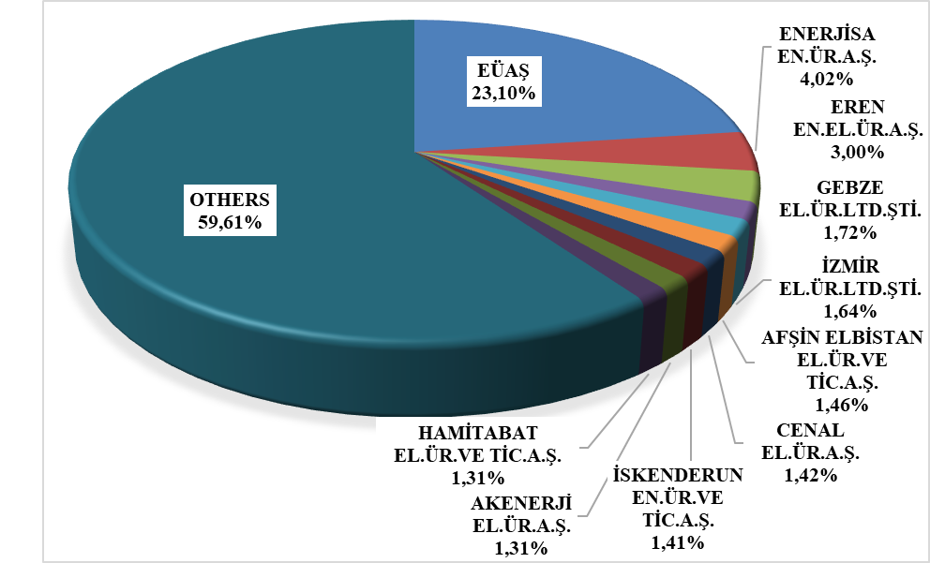

1.4 Unlicensed Generation

In the first subclause of Article 14 of the Electricity Market Law No. 6446, the generation facilities exempted from the obligations of obtaining license and incorporating are as follows;

“a) Generation facilities not connected to emergency generator groups or transmission or distribution systems
b) Generation facilities with the installed power based on maximum one-megawatt renewable energy sources
c) Electricity generation facilities of municipalities installed to dispose the sludge of solid waste facilities and of treatment plants
d) Those of micro-cogeneration facilities and cogeneration facilities having the productivity value to be determined by the Ministry, and in the category to be determined by the Board
d) A generation facility based on renewable energy sources, which uses all of the energy it produces without giving it to the transmission or distribution system, and whose production and consumption are at the same measurement point
e) (Attachment: 21/3 / 2018-7103 / 84 art.) Market activities carried out within the scope of the limits determined by the Board and electricity storage and demand side participation within the framework of the procedures and principles determined by the Ministry.
f) (Attachment: 19/4 / 2018-7139 / 56 art.) Electricity subscription in order to meet the electricity needs of the agricultural irrigation facilities owned by the General Directorate of State Hydraulic Works, the contract power of the installed power agricultural irrigation plant is production facility based on renewable energy sources established and operated by the General Directorate of State Hydraulic Works, provided that the total
g) (Attachment:25/11/2020-7257/35 art.) Generation facility based on renewable energy resources, provided that it is limited to the contract power in the connection agreement”

The current status of unlicensed electricity generation applications by the end of 2021 is shown in Table 1.4.

Table 1.4: The Status of Unlicensed Electricity Generation Applications at the End of 2021 (MWe)
Status\Source | Biomass | Solar | Hydraulic | Geothermal | Cogeneration | Microgeneration | Wind
In connection agreement stage | 13,19 | 1.799,69 | 0,78 |  | 91,84 | 83,73 | 120,36
In invitation letter stage | 8,69 | 1.160,00 | 5,03 | 0,40 | 43,30 | 11,79 | 49,99
Rejected | 11,59 | 811,78 | 14,26 | 0,40 | 113,02 | 31,46 | 43,68
Began operating | 82,47 | 7.529,51 | 17,28 |  | 402,67 | 340,11 | 66,78
Distribution of unlicensed installed capacity by resources is shown in Table 1.5 and Figure 1.16. The amount of capacity that entered the facility, which was 6.823,47 MWe at the end of 2020, increased by 10,6% and reached to 7.546,99 MWe in 2021. As in 2020, the highest share belongs to solar power plants with 91,53% in 2021, followed by natural gas with 6,14% and biomass with 1,18%.

Table 1.5: Distribution of Unlicensed Installed Capacity by Resources (MWe-%)
Resource Type | 2020 |  | 2021
Resource Type | Installed Capacity  (MWe) | Share  (%) | Installed Capacity  (MWe) | Share  (%)
Solar | 6.257,61 | 91,71 | 6.907,78 | 91,53
Natural Gas | 402,67 | 5,90 | 463,05 | 6,14
Biomass | 83,71 | 1,23 | 89,11 | 1,18
Wind | 70,83 | 1,04 | 73,08 | 0,97
Hydraulic | 8,65 | 0,13 | 13,98 | 0,19
Total | 6.823,47 | 100,00 | 7.546,99 | 100,00

Figure 1.16: Distribution of Unlicensed Installed Capacity by Sources at the End of 2021 (%)
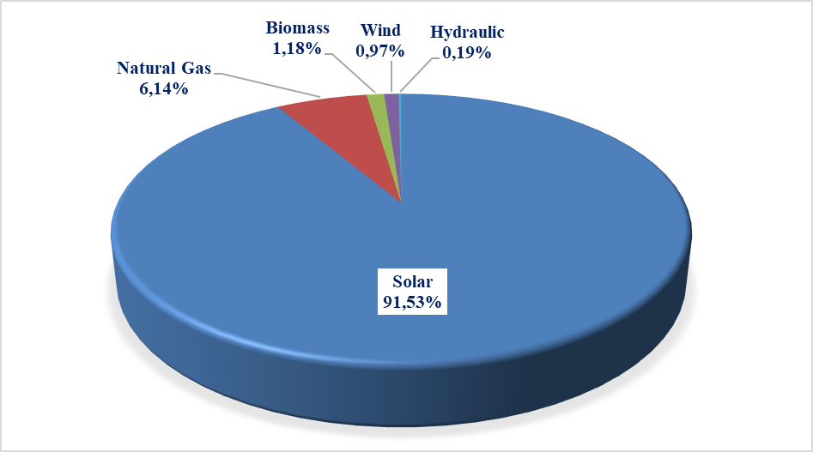

Unlicensed installed capacity by province is shown in Table 1.6. As in the previous year, the highest installed capacity in 2021 was in Konya with 575,33 MWe. Konya was followed by Ankara with 438,04 MWe, Şanlıurfa with 382,16 MWe, Kayseri with 354,84 MWe, İzmir with 341,57 MWe, Kahramanmaraş with 284,30 MWe, Afyonkarahisar with 252,52 MWe. Approximately 35% of the total unlicensed installed capacity was in these 7 provinces.

Table 1.6: Distribution of Unlicensed Installed Capacity by Province (MWe-%)
PROVINCE | 2020 |  | 2021
PROVINCE | Installed Capacity  (MWe) | Share (%) | Installed Capacity  (MWe) | Share (%)
KONYA | 548,36 | 8,04 | 575,33 | 7,62
ANKARA | 404,76 | 5,93 | 438,04 | 5,80
ŞANLIURFA | 368,72 | 5,40 | 382,16 | 5,06
KAYSERİ | 329,85 | 4,83 | 354,84 | 4,70
İZMİR | 309,34 | 4,53 | 341,57 | 4,53
KAHRAMANMARAŞ | 243,96 | 3,58 | 284,30 | 3,77
AFYONKARAHİSAR | 241,45 | 3,54 | 252,52 | 3,35
GAZİANTEP | 173,76 | 2,55 | 251,77 | 3,34
MANİSA | 228,74 | 3,35 | 245,69 | 3,26
MERSİN | 204,37 | 3,00 | 220,57 | 2,92
ANTALYA | 168,68 | 2,47 | 201,90 | 2,68
ISPARTA | 166,31 | 2,44 | 182,65 | 2,42
DENİZLİ | 178,39 | 2,61 | 181,69 | 2,41
ESKİŞEHİR | 175,12 | 2,57 | 180,10 | 2,39
ELAZIĞ | 170,61 | 2,50 | 173,31 | 2,30
ADANA | 159,68 | 2,34 | 172,46 | 2,29
NEVŞEHİR | 139,76 | 2,05 | 147,56 | 1,96
BALIKESİR | 123,34 | 1,81 | 137,92 | 1,83
UŞAK | 104,66 | 1,53 | 135,81 | 1,80
ÇORUM | 117,82 | 1,73 | 131,61 | 1,74
AYDIN | 123,05 | 1,80 | 131,53 | 1,74
MALATYA | 114,20 | 1,67 | 127,71 | 1,69
ADIYAMAN | 111,98 | 1,64 | 122,97 | 1,63
KÜTAHYA | 118,59 | 1,74 | 118,93 | 1,58
NİĞDE | 106,04 | 1,55 | 114,28 | 1,51
BURSA | 88,74 | 1,30 | 110,53 | 1,46
MUĞLA | 104,38 | 1,53 | 104,38 | 1,38
İSTANBUL | 77,63 | 1,14 | 103,21 | 1,37
ERZURUM | 95,13 | 1,39 | 102,89 | 1,36
DİYARBAKIR | 63,63 | 0,93 | 97,54 | 1,29
AKSARAY | 90,78 | 1,33 | 92,31 | 1,22
BİLECİK | 85,31 | 1,25 | 87,11 | 1,15
OSMANİYE | 77,29 | 1,13 | 85,64 | 1,13
SİVAS | 78,29 | 1,15 | 80,78 | 1,07
YOZGAT | 67,27 | 0,99 | 77,97 | 1,03
BURDUR | 70,40 | 1,03 | 75,98 | 1,01
KARAMAN | 69,65 | 1,02 | 72,19 | 0,96
ÇANKIRI | 56,18 | 0,82 | 60,36 | 0,80
KIRŞEHİR | 51,13 | 0,75 | 58,25 | 0,77
KIRIKKALE | 50,36 | 0,74 | 52,62 | 0,70
ERZİNCAN | 43,04 | 0,63 | 45,93 | 0,61
SAMSUN | 43,33 | 0,64 | 43,33 | 0,57
AMASYA | 40,89 | 0,60 | 42,63 | 0,56
TEKİRDAĞ | 35,12 | 0,51 | 39,43 | 0,52
ÇANAKKALE | 34,97 | 0,51 | 38,95 | 0,52
VAN | 34,07 | 0,50 | 35,56 | 0,47
KOCAELİ | 19,30 | 0,28 | 35,00 | 0,46
BİTLİS | 28,18 | 0,41 | 30,33 | 0,40
KİLİS | 24,10 | 0,35 | 29,10 | 0,39
HATAY | 19,28 | 0,28 | 28,24 | 0,37
SAKARYA | 23,11 | 0,34 | 25,05 | 0,33
TOKAT | 22,81 | 0,33 | 24,64 | 0,33
MARDİN | 17,75 | 0,26 | 23,89 | 0,32
BİNGÖL | 22,50 | 0,33 | 23,50 | 0,31
BATMAN | 19,02 | 0,28 | 23,25 | 0,31
ŞIRNAK | 18,00 | 0,26 | 21,88 | 0,29
AĞRI | 14,55 | 0,21 | 16,04 | 0,21
BAYBURT | 11,99 | 0,18 | 14,87 | 0,20
KARABÜK | 12,82 | 0,19 | 14,53 | 0,19
BOLU | 9,91 | 0,15 | 13,98 | 0,19
KASTAMONU | 8,63 | 0,13 | 12,67 | 0,17
BARTIN | 5,25 | 0,08 | 10,37 | 0,14
EDİRNE | 8,58 | 0,13 | 9,93 | 0,13
KIRKLARELİ | 6,86 | 0,10 | 9,85 | 0,13
SİİRT | 6,64 | 0,10 | 8,68 | 0,12
DÜZCE | 6,99 | 0,10 | 8,64 | 0,11
TRABZON | - | - | 6,02 | 0,08
ZONGULDAK | 2,63 | 0,04 | 6,02 | 0,08
MUŞ | 3,99 | 0,06 | 5,99 | 0,08
KARS | 5,74 | 0,08 | 5,74 | 0,08
GİRESUN | 2,66 | 0,04 | 5,05 | 0,07
ARDAHAN | 2,37 | 0,03 | 4,39 | 0,06
YALOVA | 3,83 | 0,06 | 3,83 | 0,05
ORDU | 2,64 | 0,04 | 3,25 | 0,04
RİZE | 1,59 | 0,02 | 2,49 | 0,03
IĞDIR | 0,50 | 0,01 | 1,89 | 0,03
GÜMÜŞHANE | 0,80 | 0,01 | 1,72 | 0,02
TUNCELİ | 0,86 | 0,01 | 0,86 | 0,01
SİNOP | 0,46 | 0,01 | 0,46 | 0,01
Total | 6.823,47 | 100,00 | 7.546,99 | 100,00

The distribution of unlicensed electricity generation by resources is given in Table 1.7 and Figure 1.17. While the amount of energy supplied to the grid within the scope of unlicensed electricity generation was 11,245,481.50 MWh in 2020, it increased by 6,27% to 11,950,263.73 MWh in 2021. 96,62% of this was produced from the sun, 2,10% from biomass, and 1,29% from wind and hydraulics.

Table 1.7: Distribution of Unlicensed Electricity Generation by Resources (MWh-%)
Resource Type | 2020 |  | 2021
Resource Type | The amount of energy supplied to the system as surplus (MWh) | Share  (%) | The amount of energy supplied to the system as surplus (MWh) | Share  (%)
Solar | 10.825.501,82 | 96,27 | 11.546.355,03 | 96,62
Biomass | 273.446,13 | 2,43 | 250.861,61 | 2,10
Wind | 119.466,89 | 1,06 | 118.935,99 | 1,00
Hydraulic | 27.066,66 | 0,24 | 34.111,11 | 0,29
Grand Total | 11.245.481,50 | 100,00 | 11.950.263,73 | 100,00

Figure 1.17: Distribution of Unlicensed Electricity Generation by Resources in 2021 (%)
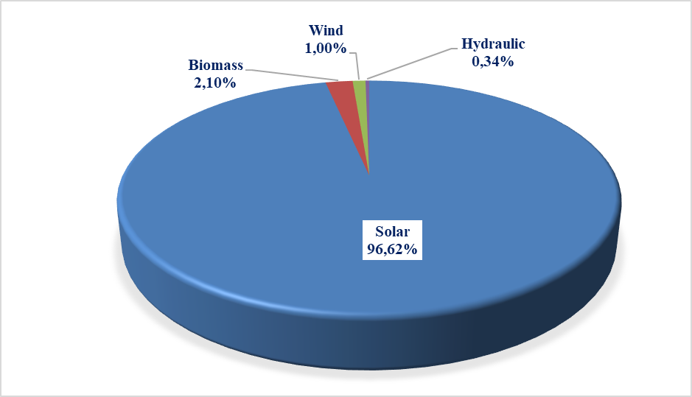

The distribution of the energy supplied to the system by unlicensed electricity production by provinces is given in Table 1.8. The highest production was also in Konya in 2021. Apart from Konya, Şanlıurfa, Ankara, Kayseri, İzmir, Afyonkarahisar and Kahramanmaraş were the provinces that took place near the top in unlicensed electricity generation. Approximately 37% of the total unlicensed electricity production was in these 7 provinces.

Table 1.8: Distribution of Unlicensed Electricity Generation by Provinces (MWh-%)
PROVINCES | 2020 |  | 2021
PROVINCES | The amount of energy supplied to the system as surplus  (MWh) | Share  (%) | The amount of energy supplied to the system as surplus (MWh) | Share (%)
KONYA | 951.272,71 | 8,46 | 1.069.879,96 | 8,95
ŞANLIURFA | 654.198,16 | 5,82 | 728.216,66 | 6,09
ANKARA | 622.015,21 | 5,53 | 622.001,43 | 5,20
KAYSERİ | 586.980,66 | 5,22 | 608.291,31 | 5,09
İZMİR | 460.513,43 | 4,10 | 504.632,84 | 4,22
AFYONKARAHİSAR | 444.492,50 | 3,95 | 453.402,81 | 3,79
KAHRAMANMARAŞ | 347.107,64 | 3,09 | 399.025,85 | 3,34
MANİSA | 381.797,74 | 3,40 | 379.345,80 | 3,17
MERSİN | 328.021,88 | 2,92 | 350.554,60 | 2,93
ESKİŞEHİR | 358.066,85 | 3,18 | 343.424,88 | 2,87
ELAZIĞ | 303.053,75 | 2,69 | 330.106,67 | 2,76
DENİZLİ | 305.223,03 | 2,71 | 308.486,80 | 2,58
GAZİANTEP | 267.375,61 | 2,38 | 295.287,97 | 2,47
ANTALYA | 265.937,56 | 2,36 | 277.873,26 | 2,33
AYDIN | 257.967,13 | 2,29 | 261.434,74 | 2,19
ISPARTA | 241.990,22 | 2,15 | 251.860,71 | 2,11
NEVŞEHİR | 237.493,78 | 2,11 | 249.401,78 | 2,09
ADANA | 204.527,18 | 1,82 | 233.330,65 | 1,95
NİĞDE | 207.217,71 | 1,84 | 230.100,22 | 1,93
ADIYAMAN | 202.740,85 | 1,80 | 225.906,71 | 1,89
ÇORUM | 200.290,17 | 1,78 | 223.170,10 | 1,87
KÜTAHYA | 219.884,48 | 1,96 | 219.046,66 | 1,83
MALATYA | 256.006,82 | 2,28 | 208.629,45 | 1,75
MUĞLA | 198.534,10 | 1,77 | 199.434,03 | 1,67
BALIKESİR | 189.543,60 | 1,69 | 194.458,34 | 1,63
AKSARAY | 177.301,18 | 1,58 | 183.039,59 | 1,53
ERZURUM | 160.575,58 | 1,43 | 168.882,05 | 1,41
UŞAK | 165.885,16 | 1,48 | 167.525,46 | 1,40
DİYARBAKIR | 112.874,49 | 1,00 | 153.426,20 | 1,28
KARAMAN | 126.708,46 | 1,13 | 148.124,32 | 1,24
BİLECİK | 133.571,13 | 1,19 | 146.279,64 | 1,22
SİVAS | 133.150,51 | 1,18 | 135.339,75 | 1,13
BURDUR | 127.234,81 | 1,13 | 134.278,56 | 1,12
OSMANİYE | 119.955,54 | 1,07 | 132.268,07 | 1,11
YOZGAT | 117.486,17 | 1,04 | 121.170,04 | 1,01
KIRŞEHİR | 88.129,22 | 0,78 | 101.579,27 | 0,85
ÇANKIRI | 100.270,03 | 0,89 | 98.347,79 | 0,82
BURSA | 88.808,44 | 0,79 | 93.626,48 | 0,78
KIRIKKALE | 94.964,49 | 0,84 | 93.207,71 | 0,78
ERZİNCAN | 82.199,93 | 0,73 | 86.088,52 | 0,72
VAN | 54.093,99 | 0,48 | 65.711,63 | 0,55
ÇANAKKALE | 61.579,62 | 0,55 | 62.935,86 | 0,53
AMASYA | 58.979,46 | 0,52 | 59.062,47 | 0,49
BİTLİS | 41.133,10 | 0,37 | 52.756,75 | 0,44
KİLİS | 44.065,81 | 0,39 | 46.942,00 | 0,39
TOKAT | 43.516,55 | 0,39 | 46.690,30 | 0,39
BİNGÖL | 38.090,69 | 0,34 | 42.879,23 | 0,36
SAMSUN | 45.005,16 | 0,40 | 42.588,08 | 0,36
ŞIRNAK | 35.026,94 | 0,31 | 42.341,30 | 0,35
HATAY | 31.086,01 | 0,28 | 40.940,84 | 0,34
MARDİN | 32.705,45 | 0,29 | 40.094,78 | 0,34
BATMAN | 33.078,41 | 0,29 | 36.164,74 | 0,30
AĞRI | 26.553,82 | 0,24 | 30.646,91 | 0,26
KOCAELİ | 22.390,84 | 0,20 | 26.964,89 | 0,23
BAYBURT | 22.557,77 | 0,20 | 23.062,94 | 0,19
ZONGULDAK | 14.895,33 | 0,13 | 17.331,47 | 0,15
KARABÜK | 17.116,83 | 0,15 | 16.002,74 | 0,13
SİİRT | 10.954,34 | 0,10 | 14.060,86 | 0,12
KASTAMONU | 14.969,79 | 0,13 | 13.520,54 | 0,11
MUŞ | 5.689,48 | 0,05 | 11.122,95 | 0,09
KARS | 10.057,79 | 0,09 | 10.690,97 | 0,09
EDİRNE | 10.130,13 | 0,09 | 10.360,66 | 0,09
YALOVA | 9.355,92 | 0,08 | 10.034,15 | 0,08
İSTANBUL | 7.693,51 | 0,07 | 9.761,62 | 0,08
RİZE | 7.919,92 | 0,07 | 9.240,44 | 0,08
TEKİRDAĞ | 6.515,54 | 0,06 | 8.233,09 | 0,07
GİRESUN | 2.712,83 | 0,02 | 7.855,55 | 0,07
ARDAHAN | 2.925,45 | 0,03 | 5.413,61 | 0,05
BOLU | 4.130,58 | 0,04 | 5.014,02 | 0,04
GÜMÜŞHANE | 1.945,05 | 0,02 | 2.929,11 | 0,02
TUNCELİ | 2.054,53 | 0,02 | 2.106,10 | 0,02
ORDU | 2.729,33 | 0,02 | 1.713,25 | 0,01
TRABZON | 2,44 | 0,00 | 1.237,34 | 0,01
SAKARYA | 756,74 | 0,01 | 1.183,93 | 0,01
KIRKLARELİ | 637,13 | 0,01 | 874,77 | 0,01
IĞDIR | 563,64 | 0,01 | 805,91 | 0,01
DÜZCE | 344,04 | 0,00 | 293,34 | 0,00
BARTIN | 97,60 | 0,00 | 119,69 | 0,00
SİNOP | 52,05 | 0,00 | 82,56 | 0,00
ARTVİN | - | - | 4,68 | 0,00
Grand Total | 11.245.481,50 | 100,00 | 11.950.263,73 | 100,00

The distribution of the amount of payments made within the scope of unlicensed electricity production by resources by the end of 2021 is given in Table 1.9. 97,07% of the amount of payment was made to solar power plants.

Table 1.9: Distribution of the Amount of Payment Made Within the Scope of Unlicensed Electricity Generation by Resources (TL-%)
Resource Type | 2020 |  | 2021 |  | Change (%)  2020→2021
Resource Type | Amount of payments made for the amount of surplus energy purchased (TL) | Share (%) | Amount of payments made for the amount of surplus energy purchased (TL) | Share (%) | Change (%)  2020→2021
Solar | 10.048.892.854,64 | 96,83 | 13.071.796.612,50 | 97,07 | 30,08
Biomass | 254.517.281,12 | 2,45 | 293.409.784,89 | 2,18 | 15,28
Wind | 60.837.578,10 | 0,59 | 78.983.193,27 | 0,59 | 29,83
Hydraulic | 13.520.863,75 | 0,13 | 22.372.517,11 | 0,17 | 65,47
Grand Total | 10.377.768.577,61 | 100,00 | 13.466.562.107,77 | 100,00 | 29,76

1.5 Invoiced Electricity Consumption and Number of Consumers

This section comprises information about invoiced electricity consumption. The consumption that is not subject to the invoice (technical and non-technical losses and the sales that are not accepted as sales) are not included in the data in this section. Therefore, as the production done by the legal entities holding generation license within the scope of Article 7 of the Electricity Market Law without transferring the energy produced in their facilities to the transmission or distribution system, is not considered as sales to the final consumer, electricity consumption is not included in the invoiced consumption figures. Besides, the amount of electricity generated by the generation facilities from the system for their own needs is not included in the invoiced consumption value. In addition, the actual consumption data and consumption data in this section may vary due to differences in the billing period.
Invoiced consumption data of 2021 is given in Table 1.10 below. In 2021, 253.03 TWh of electricity was sold. 74,8% of total sales which corresponds to 189,27 TWh was sold to consumers connected to the distribution voltage level and the remaining 25,2% of total sales which corresponds to 63,76 TWh was sold to consumers connected to the transmission voltage level.
While 150,7 TWh was sold to eligible consumers, consumption of non-eligible (non-eligible and those who do not use the right of being eligible consumer) consumers was 102,3 TWh. Accordingly, while the share of eligible consumers in invoiced consumption was 59,56%, the share of non-eligible consumers was 40,44%.

Table 1.10: Sales to Eligible and Non-Eligible Consumers in 2021 (GWh)
Consumer Type | Consumption Amount of Consumers Connected to the Distribution Voltage Level (GWh) | Consumption Amount of Consumers Connected to the Transmission Voltage Level (GWh) | Total (GWh)
Non-Eligible | 101.722,38 | 606,32 | 102.328,70
Eligible | 87.551,18 | 63.154,02 | 150.705,20
Total | 189.273,56 | 63.760,34 | 253.033,90

The distribution of consumption according to distribution regions is given in Table 1.11. In 2021, the highest consumption was in Toroslar EDAŞ region with 32,05 TWh, the lowest consumption was in Vangölü EDAŞ region with 2,2 TWh. The region with the highest consumption from distribution was Boğaziçi EDAŞ, the region with the lowest was Vangölü EDAŞ. The region with the highest consumption from transmission was Toroslar and the region with the lowest consumption was Çoruh EDAŞ.
.

Table 1.11: Distribution of Invoiced Consumption by Distribution Regions in 2021 (MWh-%)
Distribution Regions | Consumption of Consumers Connected to Distribution (MWh) | Consumption of Consumers Connected to Transmission (MWh) | Total (MWh) | Share (%)
TOROSLAR EDAŞ | 16.615.108,70 | 15.434.809,03 | 32.049.917,73 | 12,67
BOĞAZİÇİ EDAŞ | 25.502.508,09 | 1.930.256,22 | 27.432.764,31 | 10,84
GDZ EDAŞ | 15.898.330,05 | 4.983.669,07 | 20.881.999,12 | 8,25
ULUDAĞ EDAŞ | 12.809.123,86 | 7.413.040,55 | 20.222.164,41 | 7,99
BAŞKENT EDAŞ | 15.411.570,58 | 4.219.180,45 | 19.630.751,03 | 7,76
SAKARYA EDAŞ | 9.733.549,01 | 7.910.159,34 | 17.643.708,35 | 6,97
DİCLE EDAŞ | 12.581.263,12 | 1.242.431,70 | 13.823.694,82 | 5,46
İST. AND. YAK. EDAŞ | 11.853.531,07 | 1.528.462,87 | 13.381.993,94 | 5,29
MERAM EDAŞ | 10.500.643,69 | 1.946.047,61 | 12.446.691,30 | 4,92
OSMANGAZİ EDAŞ | 6.926.976,73 | 4.649.954,27 | 11.576.931,00 | 4,58
TRAKYA EDAŞ | 7.279.688,63 | 3.777.094,80 | 11.056.783,43 | 4,37
AKDENİZ EDAŞ | 9.277.200,94 | 1.269.436,59 | 10.546.637,53 | 4,17
ADM EDAŞ | 9.555.976,30 | 799.612,65 | 10.355.588,95 | 4,09
YEŞİLIRMAK EDAŞ | 5.207.222,02 | 1.569.287,27 | 6.776.509,29 | 2,68
AKEDAŞ EDAŞ | 3.933.266,54 | 1.487.144,87 | 5.420.411,41 | 2,14
KAYSERİ VE CİVARI ETAŞ | 2.482.867,94 | 1.648.542,88 | 4.131.410,82 | 1,63
ÇORUH EDAŞ | 3.778.050,51 | 83.240,70 | 3.861.291,21 | 1,53
FIRAT EDAŞ | 2.710.846,58 | 880.276,66 | 3.591.123,24 | 1,42
ÇAMLIBEL EDAŞ | 2.680.456,56 | 513.217,26 | 3.193.673,82 | 1,26
ARAS EDAŞ | 2.458.852,94 | 364.873,40 | 2.823.726,34 | 1,12
VANGÖLÜ EDAŞ | 2.076.522,57 | 109.607,29 | 2.186.129,86 | 0,86
Grand Total | 189.273.556,41 | 63.760.345,48 | 253.033.901,89 | 100,00

Distribution of invoiced consumption by consumer type is given in Table 1.12 and Figure 1.18. In 2021, industry consumption had the highest share with 44,09%. Commercial consumption was the second with 24,25% and household consumption was the third with 24,24%. The total electricity consumption used in lighting and agricultural irrigation was 7,42%.

Table 1.12: Distribution of Invoiced Consumption by Consumer Type as Eligible and Non-Eligible Consumers in 2021 (MWh)
Consumer Type | Consumption Amount (MWh)
Consumer Type | Non-Eligible Consumer | Share  (%) | Eligible Consumer | Share  (%) | Total | Share  (%)
Industry | 6.486.647,37 | 6,95 | 105.086.346,39 | 69,73 | 111.572.993,76 | 44,09
Commercial | 18.846.192,01 | 22,17 | 42.514.792,46 | 28,21 | 61.360.984,47 | 24,25
Household | 61.244.341,21 | 57,36 | 93.573,52 | 0,06 | 61.337.914,72 | 24,24
Irrigation | 10.495.563,59 | 8,76 | 2.863.629,14 | 1,90 | 13.359.192,73 | 5,28
Lighting | 5.255.958,15 | 4,76 | 146.858,06 | 0,10 | 5.402.816,21 | 2,14
Grand Total | 102.328.702,33 | 100,00 | 150.705.199,56 | 100,00 | 253.033.901,89 | 100,00

Figure 1.18: Distribution of Invoiced Consumption by Consumer Type in 2021 (%)
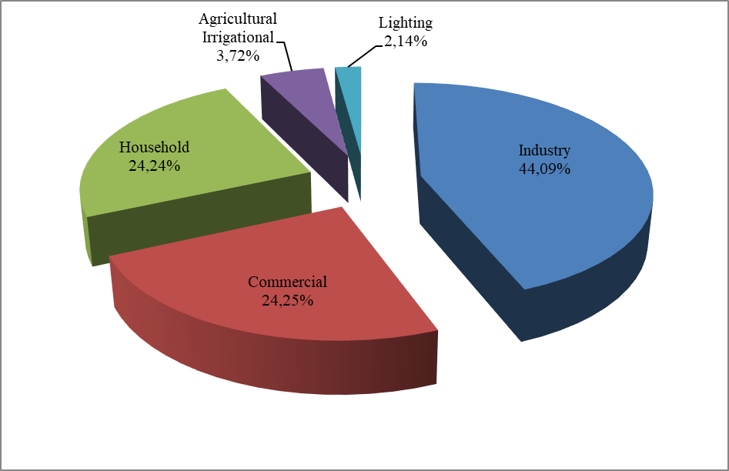

Table 1.13 Development of Invoiced Consumption by Consumer Type by Years (MWh)
Consumer Type | Consumption Amount (MWh)
Consumer Type | 2018 | 2019 | 2020 | 2021
Industry | 96.995.771 | 94.462.699 | 99.767.341 | 111.572.994
Commercial | 68.289.254 | 65.150.389 | 57.633.482 | 61.360.984
Household | 54.769.980 | 56.389.775 | 60.133.988 | 61.337.915
Irrigation | 8.799.145 | 8.553.367 | 10.805.968 | 13.359.193
Lighting | 4.755.803 | 5.041.683 | 5.095.836 | 5.402.816
Total | 233.609.953 | 229.597.914 | 233.436.615 | 253.033.902

Distribution of invoiced consumption by provinces is given in Table 1.14. The highest consumption was in Istanbul with 40,81 TWh which corresponds to 16,13% of the total consumption. İstanbul was followed by İzmir with a 6,4% share, Ankara with a 5,73% share, Bursa with a 4,99% share and Kocaeli with a 4,44% share.

Table 1.14: Distribution of Invoiced Consumption by Province (MWh - %)
PROVINCE | Amount of Consumption of Consumers Connected to Distribution (MWh) | Amount of Consumption of Consumers Connected to Transmission (MWh) | Total (MWh) | Share (%)
İSTANBUL (TÜMÜ) | 37.356.039,16 | 3.458.719,09 | 40.814.758,25 | 16,13
İSTANBUL (AVRUPA) | 25.502.508,09 | 1.930.256,22 | 27.432.764,31 | 10,84
İZMİR | 12.440.319,70 | 3.758.202,01 | 16.198.521,71 | 6,40
ANKARA | 11.870.323,83 | 2.617.388,47 | 14.487.712,30 | 5,73
İSTANBUL (ANADOLU) | 11.853.531,07 | 1.528.462,87 | 13.381.993,94 | 5,29
BURSA | 7.513.199,65 | 5.111.936,80 | 12.625.136,45 | 4,99
KOCAELİ | 5.540.719,72 | 5.683.045,17 | 11.223.764,89 | 4,44
GAZİANTEP | 3.340.001,42 | 5.349.582,40 | 8.689.583,82 | 3,43
ANTALYA | 7.753.364,83 | 801.276,75 | 8.554.641,58 | 3,38
ADANA | 4.876.877,47 | 2.888.784,66 | 7.765.662,13 | 3,07
KONYA | 6.543.422,57 | 1.124.183,52 | 7.667.606,09 | 3,03
TEKİRDAĞ | 4.215.941,99 | 3.175.604,87 | 7.391.546,86 | 2,92
ŞANLIURFA | 5.866.406,86 | 431.467,40 | 6.297.874,26 | 2,49
HATAY | 3.001.986,67 | 2.370.414,85 | 5.372.401,52 | 2,12
MERSİN | 4.288.605,85 | 936.511,50 | 5.225.117,35 | 2,06
MANİSA | 3.458.010,34 | 1.225.467,06 | 4.683.477,40 | 1,85
OSMANİYE | 753.425,64 | 3.653.875,12 | 4.407.300,76 | 1,74
SAKARYA | 2.451.119,70 | 1.686.253,94 | 4.137.373,64 | 1,64
KAHRAMANMARAŞ | 3.035.842,96 | 1094942,48 | 4.130.785,44 | 1,63
KAYSERİ | 2.476.793,44 | 1.648.542,88 | 4.125.336,32 | 1,63
BALIKESİR | 3.129.167,40 | 640.499,25 | 3.769.666,65 | 1,49
DENİZLİ | 3.220.435,50 | 525.355,67 | 3.745.791,17 | 1,48
MUĞLA | 3.626.493,04 |  | 3.626.493,04 | 1,43
SAMSUN | 2.156.821,36 | 1.331.301,37 | 3.488.122,73 | 1,38
ESKİŞEHİR | 2.051.432,15 | 1.267.231,24 | 3.318.663,39 | 1,31
DİYARBAKIR | 2.685.192,28 | 421.091,67 | 3.106.283,95 | 1,23
ÇANAKKALE | 1.354.139,05 | 1.660.604,50 | 3.014.743,55 | 1,19
AYDIN | 2.709.047,76 | 274.256,98 | 2.983.304,74 | 1,18
KIRKLARELİ | 2.016.679,13 | 598.969,03 | 2.615.648,16 | 1,03
MARDİN | 2.184.051,37 | 175.751,63 | 2.359.803,00 | 0,93
BİLECİK | 1.223.580,42 | 1.099.858,90 | 2.323.439,32 | 0,92
AFYONKARAHİSAR | 1.725.770,20 | 327.134,43 | 2.052.904,63 | 0,81
UŞAK | 862.538,20 | 1156783,31 | 2.019.321,51 | 0,80
KÜTAHYA | 1.063.655,77 | 798.946,39 | 1.862.602,16 | 0,74
MALATYA | 1.204.376,15 | 588.472,51 | 1.792.848,66 | 0,71
SİVAS | 1.179.996,11 | 345.973,18 | 1.525.969,29 | 0,60
TRABZON | 1.471.556,55 | 52.293,71 | 1.523.850,26 | 0,60
ORDU | 1.304.497,56 | 67.218,69 | 1.371.716,25 | 0,54
ELAZIĞ | 1.052.760,73 | 291.804,15 | 1.344.564,88 | 0,53
NİĞDE | 974.621,90 | 362.856,94 | 1.337.478,84 | 0,53
ADIYAMAN | 897.423,58 | 392.202,39 | 1.289.625,97 | 0,51
ZONGULDAK | 1.007.511,98 | 219.411,64 | 1.226.923,62 | 0,48
AKSARAY | 988.883,08 | 232.014,09 | 1.220.897,17 | 0,48
BOLU | 849.173,50 | 319.656,99 | 1.168.830,49 | 0,46
KASTAMONU | 787.763,63 | 343.639,54 | 1.131.403,17 | 0,45
DÜZCE | 892.536,08 | 221.203,24 | 1.113.739,32 | 0,44
VAN | 1.066.825,77 | 19.701,82 | 1.086.527,59 | 0,43
EDİRNE | 1.047.067,50 | 2.520,90 | 1.049.588,40 | 0,41
ISPARTA | 952.562,07 | 86.443,56 | 1.039.005,63 | 0,41
KARAMAN | 768.046,90 | 213.036,74 | 981.083,64 | 0,39
BURDUR | 571.274,04 | 381.716,28 | 952.990,32 | 0,38
BATMAN | 746.224,93 | 203.297,46 | 949.522,39 | 0,38
ERZURUM | 908.448,34 | 11.300,49 | 919.748,83 | 0,36
ÇORUM | 810.148,11 | 86.240,61 | 896.388,72 | 0,35
TOKAT | 762.595,10 | 130.212,49 | 892.807,59 | 0,35
BARTIN | 378.101,35 | 496.672,37 | 874.773,72 | 0,35
YALOVA | 812.617,77 |  | 812.617,77 | 0,32
NEVŞEHİR | 801.897,75 |  | 801.897,75 | 0,32
YOZGAT | 743.939,85 | 37.031,59 | 780.971,44 | 0,31
RİZE | 771.137,62 |  | 771.137,62 | 0,30
GİRESUN | 717.640,37 | 9.842,91 | 727.483,28 | 0,29
KARABÜK | 483.357,58 | 195.322,33 | 678.679,91 | 0,27
ERZİNCAN | 343.524,87 | 296.063,78 | 639.588,65 | 0,25
ŞIRNAK | 634.337,65 |  | 634.337,65 | 0,25
AMASYA | 571.142,29 | 60.506,44 | 631.648,73 | 0,25
KIRIKKALE | 486.291,75 | 131.842,06 | 618.133,81 | 0,24
ÇANKIRI | 398.220,44 | 214904,04 | 613.124,48 | 0,24
KİLİS | 354.211,66 | 235.640,50 | 589.852,16 | 0,23
AĞRI | 426.368,07 | 57.509,13 | 483.877,20 | 0,19
SİİRT | 465.050,04 | 10.823,54 | 475.873,58 | 0,19
KIRŞEHİR | 423.771,49 | 13.956,32 | 437.727,81 | 0,17
ARTVİN | 435.898,14 |  | 435.898,14 | 0,17
MUŞ | 330.874,06 | 89.905,47 | 420.779,53 | 0,17
GÜMÜŞHANE | 381.817,83 | 21.104,08 | 402.921,91 | 0,16
BİTLİS | 394.119,88 |  | 394.119,88 | 0,16
SİNOP | 364.612,70 | 24.020,16 | 388.632,86 | 0,15
KARS | 322.025,72 |  | 322.025,72 | 0,13
BİNGÖL | 320.151,14 |  | 320.151,14 | 0,13
HAKKARİ | 284.702,85 |  | 284.702,85 | 0,11
IĞDIR | 217.613,21 |  | 217.613,21 | 0,09
TUNCELİ | 133.558,55 |  | 133.558,55 | 0,05
ARDAHAN | 131.560,96 |  | 131.560,96 | 0,05
BAYBURT | 109.311,77 |  | 109.311,77 | 0,04
Grand Total | 189.273.556,41 | 63.760.345,48 | 253.033.901,89 | 100,00

Table 1.15: Distribution of Invoiced Consumption by Province and Consumer Type (MWh)
Province | Lighting | Household | Industry | Agricultural Irrigation | Commercial | Grand | Share  (%)
ADANA | 128.882 | 1.905.074 | 4.047.205 | 202.339 | 1.482.163 | 7.765.662 | 3,07
ADIYAMAN | 29.811 | 304.880 | 630.641 | 75.767 | 248.527 | 1.289.626 | 0,51
AFYONKARAHİSAR | 72.075 | 435.334 | 851.693 | 248.001 | 445.803 | 2.052.905 | 0,81
AĞRI | 32.234 | 226.833 | 65.657 | 1.483 | 157.671 | 483.877 | 0,19
AKSARAY | 34.432 | 246.492 | 325.782 | 377.994 | 236.197 | 1.220.897 | 0,48
AMASYA | 31.436 | 222.744 | 172.358 | 38.582 | 166.528 | 631.649 | 0,25
ANKARA | 301.372 | 4.347.818 | 4.998.143 | 221.093 | 4.619.286 | 14.487.712 | 5,73
ANTALYA | 203.106 | 2.818.385 | 1.503.842 | 235.288 | 3.794.021 | 8.554.642 | 3,38
ARDAHAN | 14.146 | 49.182 | 714 | 4 | 67.515 | 131.561 | 0,05
ARTVİN | 35.816 | 140.440 | 143.217 | 110 | 116.316 | 435.898 | 0,17
AYDIN | 89.395 | 1.089.567 | 754.441 | 123.485 | 926.416 | 2.983.305 | 1,18
BALIKESİR | 106.680 | 1.061.000 | 1.689.213 | 137.475 | 775.299 | 3.769.667 | 1,49
BARTIN | 26.563 | 135.713 | 616.039 | 1.539 | 94.920 | 874.774 | 0,35
BATMAN | 29.507 | 333.720 | 295.784 | 19.949 | 270.563 | 949.522 | 0,38
BAYBURT | 12.923 | 46.117 | 1.498 | 332 | 48.441 | 109.312 | 0,04
BİLECİK | 23.307 | 133.601 | 2.020.571 | 18.684 | 127.277 | 2.323.439 | 0,92
BİNGÖL | 17.781 | 133.794 | 54.783 | 1.730 | 112.063 | 320.151 | 0,13
BİTLİS | 27.839 | 139.119 | 32.042 | 53.882 | 141.237 | 394.120 | 0,16
BOLU | 29.148 | 209.022 | 614.315 | 73.833 | 242.512 | 1.168.830 | 0,46
BURDUR | 29.462 | 169.260 | 537.284 | 64.160 | 152.825 | 952.990 | 0,38
BURSA | 139.112 | 2.186.125 | 7.976.630 | 143.861 | 2.179.409 | 12.625.136 | 4,99
ÇANAKKALE | 48.172 | 424.813 | 2.011.699 | 56.497 | 473.564 | 3.014.744 | 1,19
ÇANKIRI | 25.187 | 116.059 | 375.590 | 5.702 | 90.587 | 613.124 | 0,24
ÇORUM | 44.247 | 324.547 | 250.808 | 35.724 | 241.063 | 896.389 | 0,35
DENİZLİ | 80.920 | 758.413 | 1.990.394 | 115.611 | 800.454 | 3.745.791 | 1,48
DİYARBAKIR | 61.645 | 864.097 | 674.277 | 769.774 | 736.491 | 3.106.284 | 1,23
DÜZCE | 31.770 | 264.974 | 586.866 | 9.845 | 220.285 | 1.113.739 | 0,44
EDİRNE | 32.707 | 275.294 | 380.458 | 20.165 | 340.965 | 1.049.588 | 0,41
ELAZIĞ | 42.371 | 316.712 | 466.119 | 48.879 | 470.485 | 1.344.565 | 0,53
ERZİNCAN | 26.114 | 132.410 | 309.533 | 16.343 | 155.189 | 639.589 | 0,25
ERZURUM | 67.232 | 393.444 | 40.961 | 6.901 | 411.211 | 919.749 | 0,36
ESKİŞEHİR | 52.730 | 625.506 | 1.800.856 | 287.586 | 551.986 | 3.318.663 | 1,31
GAZİANTEP | 94.685 | 1.366.878 | 5.985.788 | 143.828 | 1.098.405 | 8.689.584 | 3,43
GİRESUN | 68.107 | 339.737 | 77.365 | 353 | 241.922 | 727.483 | 0,29
GÜMÜŞHANE | 24.571 | 77.489 | 238.303 | 902 | 61.656 | 402.922 | 0,16
HAKKARİ | 14.116 | 126.341 | 3.204 | 108 | 140.934 | 284.703 | 0,11
HATAY | 115.879 | 1.345.225 | 2.929.348 | 200.614 | 781.335 | 5.372.402 | 2,12
IĞDIR | 18.360 | 94.409 | 5.335 | 2.043 | 97.465 | 217.613 | 0,09
ISPARTA | 41.797 | 292.993 | 339.963 | 59.749 | 304.503 | 1.039.006 | 0,41
İSTANBUL (ANADOLU) | 209.010 | 4.683.517 | 3.646.147 | 3.987 | 4.839.333 | 13.381.994 | 5,29
İSTANBUL (AVRUPA) | 344.532 | 7.907.430 | 8.770.506 | 6.236 | 10.404.061 | 27.432.764 | 10,84
İZMİR | 235.576 | 4.652.996 | 6.907.076 | 468.330 | 3.934.544 | 16.198.522 | 6,40
KAHRAMANMARAŞ | 69.119 | 620.741 | 2.794.305 | 89.937 | 556.684 | 4.130.785 | 1,63
KARABÜK | 26.758 | 155.225 | 362.466 | 3.881 | 130.349 | 678.680 | 0,27
KARAMAN | 20.737 | 150.631 | 303.592 | 304.569 | 201.555 | 981.084 | 0,39
KARS | 19.455 | 125.338 | 3.465 | 630 | 173.139 | 322.026 | 0,13
KASTAMONU | 51.184 | 255.517 | 618.181 | 5.550 | 200.972 | 1.131.403 | 0,45
KAYSERİ | 117.701 | 893.032 | 2.225.971 | 218.770 | 669.863 | 4.125.336 | 1,63
KIRIKKALE | 25.338 | 174.160 | 263.124 | 5.373 | 150.139 | 618.134 | 0,24
KIRKLARELİ | 31.628 | 414.049 | 1.755.224 | 2.066 | 412.682 | 2.615.648 | 1,03
KIRŞEHİR | 24.594 | 146.208 | 90.643 | 43.181 | 133.101 | 437.728 | 0,17
KİLİS | 12.103 | 114.411 | 247.654 | 21.775 | 193.909 | 589.852 | 0,23
KOCAELİ | 99.165 | 1.401.266 | 8.284.062 | 17.494 | 1.421.779 | 11.223.765 | 4,44
KONYA | 169.296 | 1.431.548 | 2.505.799 | 1.892.141 | 1.668.823 | 7.667.606 | 3,03
KÜTAHYA | 53.074 | 330.004 | 1.196.810 | 12.356 | 270.358 | 1.862.602 | 0,74
MALATYA | 61.519 | 447.703 | 722.668 | 95.439 | 465.521 | 1.792.849 | 0,71
MANİSA | 87.028 | 1.046.896 | 2.166.651 | 417.018 | 965.884 | 4.683.477 | 1,85
MARDİN | 43.961 | 466.901 | 432.554 | 1.094.115 | 322.272 | 2.359.803 | 0,93
MERSİN | 128.570 | 1.652.591 | 1.915.862 | 241.405 | 1.286.690 | 5.225.117 | 2,06
MUĞLA | 82.769 | 1.322.459 | 486.982 | 94.667 | 1.639.616 | 3.626.493 | 1,43
MUŞ | 27.910 | 159.448 | 103.846 | 3.444 | 126.131 | 420.780 | 0,17
NEVŞEHİR | 36.931 | 208.179 | 143.956 | 182.800 | 230.031 | 801.898 | 0,32
NİĞDE | 37.307 | 220.707 | 657.110 | 210.798 | 211.558 | 1.337.479 | 0,53
ORDU | 87.838 | 534.452 | 424.349 | 596 | 324.481 | 1.371.716 | 0,54
OSMANİYE | 33.795 | 365.910 | 3.716.889 | 27.023 | 263.685 | 4.407.301 | 1,74
RİZE | 51.745 | 276.040 | 235.619 | 11 | 207.723 | 771.138 | 0,30
SAKARYA | 68.081 | 777.655 | 2.542.235 | 53.737 | 695.665 | 4.137.374 | 1,64
SAMSUN | 115.713 | 950.359 | 1.695.239 | 40.335 | 686.477 | 3.488.123 | 1,38
SİİRT | 21.259 | 137.367 | 182.718 | 7.745 | 126.785 | 475.874 | 0,19
SİNOP | 26.914 | 166.353 | 86.822 | 2.002 | 106.542 | 388.633 | 0,15
SİVAS | 65.310 | 356.225 | 738.044 | 47.041 | 319.348 | 1.525.969 | 0,60
ŞANLIURFA | 70.635 | 1.069.234 | 697.851 | 3.655.892 | 804.261 | 6.297.874 | 2,49
ŞIRNAK | 20.759 | 195.074 | 39.534 | 77.814 | 301.157 | 634.338 | 0,25
TEKİRDAĞ | 106.175 | 406.786 | 5.657.447 | 9.208 | 1.211.931 | 7.391.547 | 2,92
TOKAT | 53.824 | 346.312 | 233.498 | 9.202 | 249.972 | 892.808 | 0,35
TRABZON | 105.127 | 671.132 | 243.765 | 1.167 | 502.659 | 1.523.850 | 0,60
TUNCELİ | 11.232 | 48.293 | 9.347 | 1.874 | 62.813 | 133.559 | 0,05
UŞAK | 34.903 | 239.226 | 1.480.659 | 48.684 | 215.849 | 2.019.322 | 0,80
VAN | 67.998 | 484.481 | 178.955 | 4.737 | 350.356 | 1.086.528 | 0,43
YALOVA | 19.731 | 236.443 | 336.205 | 7.595 | 212.643 | 812.618 | 0,32
YOZGAT | 44.869 | 228.211 | 195.203 | 104.513 | 208.176 | 780.971 | 0,31
ZONGULDAK | 76.009 | 393.846 | 475.242 | 3.844 | 277.983 | 1.226.924 | 0,48
Grand Total | 5.402.816 | 61.337.915 | 111.572.994 | 13.359.193 | 61.360.984 | 253.033.902 | 100,00
The distribution of invoiced consumption by months is shown in Figure 1.19. The highest consumption was in August and the lowest consumption was in February.

Figure 1.19: Distribution of Invoiced Consumption by Months (MWh)
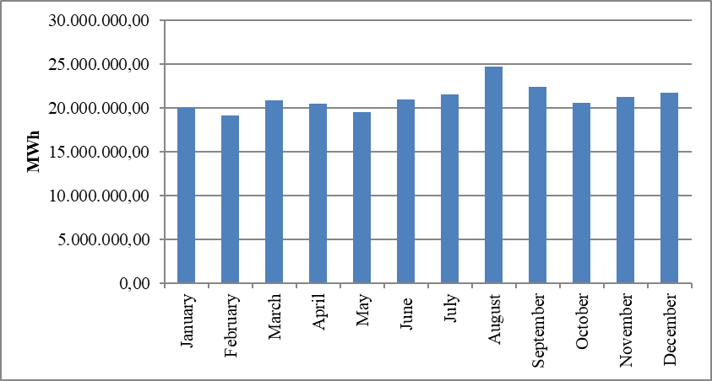

The distribution of actual consumption by years is shown in Figure 1.20. Considering last 20 years, actual consumption decreased in 2001, 2009 and 2019 compared to previous year. In 2021, it increased by 8,13% compared to previous year.

Figure 1.20: Development of Actual Consumption by Years (GWh)
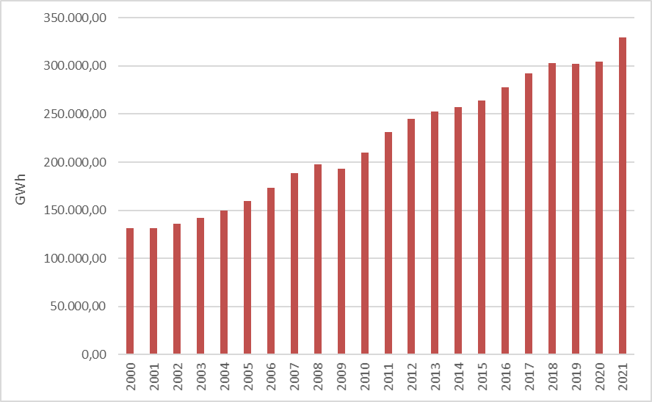

The distribution of the number of consumers in 2021 by consumer type is shown in Table 1.16. Household consumer constitutes 82,27% of the total consumer.

Table 1.16: Distribution of Number of Consumer by Consumer Type in 2021 (Number-%)
Consumer Type | Number of Consumer | Share (%)
Lighting | 342.259 | 0,72
Household | 38.925.290 | 82,27
Industry | 87.134 | 0,18
Agricultural Irrigation | 710.843 | 1,50
Commercial | 7.246.450 | 15,32
Total | 47.311.976 | 100,00

Table 1.17 also shows the distribution of the number of consumers in 2021 by province and consumer type. The province with the highest number of consumers is Istanbul, followed by Ankara, İzmir, Antalya, Bursa and Konya respectively. The province with the lowest number of consumers is Bayburt.

Table 1.17: Distribution of Number of Consumer in 2021 by Province and Consumer Type in 2021 (Number-%)
Province | Consumer Type | Number of Consumer | Share (%)
İSTANBUL | Lighting | 21.370 | 0,05
 | Household | 7.007.264 | 14,81
 | Industry | 16.937 | 0,04
 | Agricultural Irrigation | 2.222 | 0,01
 | Commercial | 1.298.514 | 2,75
 | Province Total | 8.346.307 | 17,64
ANKARA | Lighting | 15.221 | 0,03
 | Household | 2.695.187 | 5,70
 | Industry | 4.494 | 0,01
 | Agricultural Irrigation | 10.768 | 0,02
 | Commercial | 383.681 | 0,81
 | Province Total | 3.109.351 | 6,57
İZMİR | Lighting | 14.582 | 0,03
 | Household | 2.216.337 | 4,69
 | Industry | 3.601 | 0,01
 | Agricultural Irrigation | 55.094 | 0,12
 | Commercial | 447.280 | 0,95
 | Province Total | 2.736.894 | 5,79
ANTALYA | Lighting | 13.346 | 0,03
 | Household | 1.410.038 | 2,98
 | Industry | 2.999 | 0,01
 | Agricultural Irrigation | 76.676 | 0,16
 | Commercial | 321.523 | 0,68
 | Province Total | 1.824.582 | 3,86
BURSA | Lighting | 8.760 | 0,02
 | Household | 1.396.879 | 2,95
 | Industry | 6.883 | 0,02
 | Agricultural Irrigation | 12.444 | 0,03
 | Commercial | 354.881 | 0,75
 | Province Total | 1.779.847 | 3,76
KONYA | Lighting | 11.290 | 0,02
 | Household | 1.005.252 | 2,13
 | Industry | 6.363 | 0,01
 | Agricultural Irrigation | 28.279 | 0,06
 | Commercial | 223.379 | 0,47
 | Province Total | 1.274.563 | 2,69
ADANA | Lighting | 6.478 | 0,01
 | Household | 956.449 | 2,02
 | Industry | 2.328 | 0,01
 | Agricultural Irrigation | 10.146 | 0,02
 | Commercial | 176.615 | 0,37
 | Province Total | 1.152.016 | 2,44
MERSİN | Lighting | 8.370 | 0,02
 | Household | 879.272 | 1,86
 | Industry | 1.725 | 0,00
 | Agricultural Irrigation | 50.691 | 0,11
 | Commercial | 150.966 | 0,32
 | Province Total | 1.091.024 | 2,31
BALIKESİR | Lighting | 7.210 | 0,02
 | Household | 831.696 | 1,76
 | Industry | 2.938 | 0,01
 | Agricultural Irrigation | 13.528 | 0,03
 | Commercial | 168.689 | 0,36
 | Province Total | 1.024.061 | 2,16
KOCAELİ | Lighting | 5.728 | 0,01
 | Household | 876.522 | 1,85
 | Industry | 2.096 | 0,00
 | Agricultural Irrigation | 2.786 | 0,01
 | Commercial | 128.218 | 0,27
 | Province Total | 1.015.350 | 2,15
SAMSUN | Lighting | 11.580 | 0,02
 | Household | 735.102 | 1,55
 | Industry | 2.049 | 0,00
 | Agricultural Irrigation | 32.668 | 0,07
 | Commercial | 127.388 | 0,27
 | Province Total | 908.787 | 1,92
MANİSA | Lighting | 6.524 | 0,01
 | Household | 708.462 | 1,50
 | Industry | 1.280 | 0,00
 | Agricultural Irrigation | 49.196 | 0,10
 | Commercial | 139.923 | 0,30
 | Province Total | 905.385 | 1,91
HATAY | Lighting | 5.014 | 0,01
 | Household | 686.028 | 1,45
 | Industry | 1.602 | 0,00
 | Agricultural Irrigation | 15.656 | 0,03
 | Commercial | 106.715 | 0,23
 | Province Total | 815.015 | 1,72
GAZİANTEP | Lighting | 5.577 | 0,01
 | Household | 647.089 | 1,37
 | Industry | 2.790 | 0,01
 | Agricultural Irrigation | 13.499 | 0,03
 | Commercial | 146.252 | 0,31
 | Province Total | 815.207 | 1,72
KAYSERİ | Lighting | 8.329 | 0,02
 | Household | 661.021 | 1,40
 | Industry | 2.581 | 0,01
 | Agricultural Irrigation | 4.592 | 0,01
 | Commercial | 106.715 | 0,23
 | Province Total | 783.238 | 1,66
AYDIN | Lighting | 5.398 | 0,01
 | Household | 650.163 | 1,37
 | Industry | 753 | 0,00
 | Agricultural Irrigation | 24.448 | 0,05
 | Commercial | 95.691 | 0,20
 | Province Total | 776.453 | 1,64
MUĞLA | Lighting | 5.962 | 0,01
 | Household | 561.071 | 1,19
 | Industry | 282 | 0,00
 | Agricultural Irrigation | 28.586 | 0,06
 | Commercial | 101.660 | 0,22
 | Province Total | 697.561 | 1,47
ŞANLIURFA | Lighting | 5.769 | 0,01
 | Household | 550.256 | 1,16
 | Industry | 806 | 0,00
 | Agricultural Irrigation | 32.248 | 0,07
 | Commercial | 116.401 | 0,25
 | Province Total | 705.480 | 1,49
TEKİRDAĞ | Lighting | 3.004 | 0,01
 | Household | 576.897 | 1,22
 | Industry | 1.369 | 0,00
 | Agricultural Irrigation | 1.190 | 0,00
 | Commercial | 116.791 | 0,25
 | Province Total | 699.251 | 1,48
ESKİŞEHİR | Lighting | 2.754 | 0,01
 | Household | 530.327 | 1,12
 | Industry | 705 | 0,00
 | Agricultural Irrigation | 8.764 | 0,02
 | Commercial | 99.549 | 0,21
 | Province Total | 642.099 | 1,36
DENİZLİ | Lighting | 5.134 | 0,01
 | Household | 532.724 | 1,13
 | Industry | 2.271 | 0,01
 | Agricultural Irrigation | 13.171 | 0,03
 | Commercial | 92.058 | 0,20
 | Province Total | 645.358 | 1,36
TRABZON | Lighting | 5.581 | 0,01
 | Household | 517.559 | 1,09
 | Industry | 377 | 0,00
 | Agricultural Irrigation | 1.075 | 0,00
 | Commercial | 91.830 | 0,19
 | Province Total | 616.422 | 1,30
DİYARBAKIR | Lighting | 4.441 | 0,01
 | Household | 501.070 | 1,06
 | Industry | 243 | 0,00
 | Agricultural Irrigation | 5.272 | 0,01
 | Commercial | 87.899 | 0,19
 | Province Total | 598.925 | 1,27
SAKARYA | Lighting | 4.363 | 0,01
 | Household | 504.611 | 1,07
 | Industry | 1.398 | 0,00
 | Agricultural Irrigation | 3.546 | 0,01
 | Commercial | 81.841 | 0,17
 | Province Total | 595.759 | 1,26
ORDU | Lighting | 7.095 | 0,02
 | Household | 494.390 | 1,05
 | Industry | 784 | 0,00
 | Agricultural Irrigation | 423 | 0,00
 | Commercial | 76.889 | 0,16
 | Province Total | 579.581 | 1,23
KAHRAMANMARAŞ | Lighting | 5.308 | 0,01
 | Household | 401.742 | 0,85
 | Industry | 1.623 | 0,00
 | Agricultural Irrigation | 16.802 | 0,04
 | Commercial | 96.850 | 0,21
 | Province Total | 522.325 | 1,10
AFYONKARAHİSAR | Lighting | 3.731 | 0,01
 | Household | 379.505 | 0,80
 | Industry | 934 | 0,00
 | Agricultural Irrigation | 12.796 | 0,03
 | Commercial | 75.357 | 0,16
 | Province Total | 472.323 | 1,00
MALATYA | Lighting | 5.240 | 0,01
 | Household | 353.046 | 0,75
 | Industry | 1.082 | 0,00
 | Agricultural Irrigation | 22.806 | 0,05
 | Commercial | 84.031 | 0,18
 | Province Total | 466.205 | 0,99
ÇANAKKALE | Lighting | 3.448 | 0,01
 | Household | 327.512 | 0,69
 | Industry | 474 | 0,00
 | Agricultural Irrigation | 8.251 | 0,02
 | Commercial | 87.313 | 0,19
 | Province Total | 426.998 | 0,90
KÜTAHYA | Lighting | 3.229 | 0,01
 | Household | 347.287 | 0,73
 | Industry | 683 | 0,00
 | Agricultural Irrigation | 3.039 | 0,01
 | Commercial | 65.781 | 0,14
 | Province Total | 420.019 | 0,89
SİVAS | Lighting | 4.791 | 0,01
 | Household | 347.276 | 0,73
 | Industry | 308 | 0,00
 | Agricultural Irrigation | 2.933 | 0,01
 | Commercial | 54.102 | 0,11
 | Province Total | 409.410 | 0,87
ZONGULDAK | Lighting | 4.883 | 0,01
 | Household | 339.672 | 0,72
 | Industry | 275 | 0,00
 | Agricultural Irrigation | 870 | 0,00
 | Commercial | 65.739 | 0,14
 | Province Total | 411.439 | 0,87
VAN | Lighting | 4.940 | 0,01
 | Household | 340.943 | 0,72
 | Industry | 382 | 0,00
 | Agricultural Irrigation | 1.032 | 0,00
 | Commercial | 59.549 | 0,13
 | Province Total | 406.846 | 0,86
ERZURUM | Lighting | 3.791 | 0,01
 | Household | 340.710 | 0,72
 | Industry | 120 | 0,00
 | Agricultural Irrigation | 369 | 0,00
 | Commercial | 54.346 | 0,12
 | Province Total | 399.336 | 0,84
ÇORUM | Lighting | 4.159 | 0,01
 | Household | 322.488 | 0,68
 | Industry | 480 | 0,00
 | Agricultural Irrigation | 4.441 | 0,01
 | Commercial | 47.223 | 0,10
 | Province Total | 378.791 | 0,80
ELAZIĞ | Lighting | 4.045 | 0,01
 | Household | 286.679 | 0,61
 | Industry | 180 | 0,00
 | Agricultural Irrigation | 16.398 | 0,04
 | Commercial | 78.282 | 0,17
 | Province Total | 385.584 | 0,82
TOKAT | Lighting | 4.013 | 0,01
 | Household | 306.427 | 0,65
 | Industry | 576 | 0,00
 | Agricultural Irrigation | 1.609 | 0,00
 | Commercial | 45.493 | 0,10
 | Province Total | 358.118 | 0,76
GİRESUN | Lighting | 4.063 | 0,01
 | Household | 300.942 | 0,64
 | Industry | 255 | 0,00
 | Agricultural Irrigation | 491 | 0,00
 | Commercial | 44.821 | 0,10
 | Province Total | 350.572 | 0,74
MARDİN | Lighting | 2.741 | 0,01
 | Household | 245.595 | 0,52
 | Industry | 161 | 0,00
 | Agricultural Irrigation | 12.248 | 0,03
 | Commercial | 55.156 | 0,12
 | Province Total | 315.901 | 0,67
KASTAMONU | Lighting | 5.445 | 0,01
 | Household | 255.789 | 0,54
 | Industry | 345 | 0,00
 | Agricultural Irrigation | 1.210 | 0,00
 | Commercial | 40.867 | 0,09
 | Province Total | 303.656 | 0,64
ISPARTA | Lighting | 2.718 | 0,01
 | Household | 242.658 | 0,51
 | Industry | 414 | 0,00
 | Agricultural Irrigation | 10.362 | 0,02
 | Commercial | 43.096 | 0,09
 | Province Total | 299.248 | 0,63
EDİRNE | Lighting | 1.769 | 0,00
 | Household | 239.842 | 0,51
 | Industry | 284 | 0,00
 | Agricultural Irrigation | 3.224 | 0,01
 | Commercial | 40.851 | 0,09
 | Province Total | 285.970 | 0,60
YOZGAT | Lighting | 3.057 | 0,01
 | Household | 229.769 | 0,49
 | Industry | 301 | 0,00
 | Agricultural Irrigation | 3.443 | 0,01
 | Commercial | 38.283 | 0,08
 | Province Total | 274.853 | 0,58
RİZE | Lighting | 3.291 | 0,01
 | Household | 220.379 | 0,47
 | Industry | 276 | 0,00
 | Agricultural Irrigation | 10 | 0,00
 | Commercial | 42.523 | 0,09
 | Province Total | 266.479 | 0,56
OSMANİYE | Lighting | 2.189 | 0,01
 | Household | 211.077 | 0,45
 | Industry | 210 | 0,00
 | Agricultural Irrigation | 983 | 0,00
 | Commercial | 38.137 | 0,08
 | Province Total | 252.596 | 0,53
UŞAK | Lighting | 2.098 | 0,00
 | Household | 196.677 | 0,42
 | Industry | 877 | 0,00
 | Agricultural Irrigation | 6.831 | 0,01
 | Commercial | 43.635 | 0,09
 | Province Total | 250.118 | 0,53
ADIYAMAN | Lighting | 2.907 | 0,01
 | Household | 192.188 | 0,41
 | Industry | 220 | 0,00
 | Agricultural Irrigation | 5.849 | 0,01
 | Commercial | 41.272 | 0,09
 | Province Total | 242.436 | 0,51
AKSARAY | Lighting | 2.304 | 0,01
 | Household | 195.564 | 0,41
 | Industry | 273 | 0,00
 | Agricultural Irrigation | 7.905 | 0,02
 | Commercial | 37.167 | 0,08
 | Province Total | 243.213 | 0,51
KIRKLARELİ | Lighting | 2.013 | 0,00
 | Household | 192.251 | 0,41
 | Industry | 277 | 0,00
 | Agricultural Irrigation | 9.476 | 0,02
 | Commercial | 28.631 | 0,06
 | Province Total | 232.648 | 0,49
NİĞDE | Lighting | 1.328 | 0,00
 | Household | 186.797 | 0,40
 | Industry | 371 | 0,00
 | Agricultural Irrigation | 1.133 | 0,00
 | Commercial | 32.626 | 0,07
 | Province Total | 222.255 | 0,47
YALOVA | Lighting | 1.168 | 0,00
 | Household | 193.949 | 0,41
 | Industry | 356 | 0,00
 | Agricultural Irrigation | 2.570 | 0,01
 | Commercial | 32.693 | 0,07
 | Province Total | 230.736 | 0,49
AMASYA | Lighting | 3.163 | 0,01
 | Household | 184.557 | 0,39
 | Industry | 360 | 0,00
 | Agricultural Irrigation | 4.882 | 0,01
 | Commercial | 34.642 | 0,07
 | Province Total | 227.604 | 0,48
DÜZCE | Lighting | 2.225 | 0,01
 | Household | 181.622 | 0,38
 | Industry | 479 | 0,00
 | Agricultural Irrigation | 470 | 0,00
 | Commercial | 30.018 | 0,06
 | Province Total | 214.814 | 0,45
NEVŞEHİR | Lighting | 2.006 | 0,00
 | Household | 162.650 | 0,34
 | Industry | 489 | 0,00
 | Agricultural Irrigation | 6.769 | 0,01
 | Commercial | 32.846 | 0,07
 | Province Total | 204.760 | 0,43
BATMAN | Lighting | 1.778 | 0,00
 | Household | 169.075 | 0,36
 | Industry | 177 | 0,00
 | Agricultural Irrigation | 2.494 | 0,01
 | Commercial | 31.979 | 0,07
 | Province Total | 205.503 | 0,43
BOLU | Lighting | 2.986 | 0,01
 | Household | 165.345 | 0,35
 | Industry | 250 | 0,00
 | Agricultural Irrigation | 2.133 | 0,01
 | Commercial | 25.619 | 0,05
 | Province Total | 196.333 | 0,42
BURDUR | Lighting | 1.858 | 0,00
 | Household | 148.869 | 0,32
 | Industry | 450 | 0,00
 | Agricultural Irrigation | 11.975 | 0,03
 | Commercial | 30.605 | 0,07
 | Province Total | 193.757 | 0,41
AĞRI | Lighting | 2.885 | 0,01
 | Household | 161.147 | 0,34
 | Industry | 103 | 0,00
 | Agricultural Irrigation | 111 | 0,00
 | Commercial | 26.106 | 0,06
 | Province Total | 190.352 | 0,40
SİNOP | Lighting | 3.096 | 0,01
 | Household | 154.223 | 0,33
 | Industry | 290 | 0,00
 | Agricultural Irrigation | 1.116 | 0,00
 | Commercial | 24.575 | 0,05
 | Province Total | 183.300 | 0,39
KARABÜK | Lighting | 2.331 | 0,01
 | Household | 148.482 | 0,31
 | Industry | 270 | 0,00
 | Agricultural Irrigation | 1.910 | 0,00
 | Commercial | 21.390 | 0,05
 | Province Total | 174.383 | 0,37
KIRIKKALE | Lighting | 1.425 | 0,00
 | Household | 150.709 | 0,32
 | Industry | 138 | 0,00
 | Agricultural Irrigation | 2.306 | 0,01
 | Commercial | 18.585 | 0,04
 | Province Total | 173.163 | 0,37
ERZİNCAN | Lighting | 2.185 | 0,01
 | Household | 140.656 | 0,30
 | Industry | 103 | 0,00
 | Agricultural Irrigation | 663 | 0,00
 | Commercial | 25.215 | 0,05
 | Province Total | 168.822 | 0,36
KARAMAN | Lighting | 1.361 | 0,00
 | Household | 134.140 | 0,28
 | Industry | 197 | 0,00
 | Agricultural Irrigation | 4.043 | 0,01
 | Commercial | 25.448 | 0,05
 | Province Total | 165.189 | 0,35
KIRŞEHİR | Lighting | 1.711 | 0,00
 | Household | 133.156 | 0,28
 | Industry | 163 | 0,00
 | Agricultural Irrigation | 2.255 | 0,01
 | Commercial | 23.528 | 0,05
 | Province Total | 160.813 | 0,34
BİLECİK | Lighting | 1.210 | 0,00
 | Household | 122.152 | 0,26
 | Industry | 581 | 0,00
 | Agricultural Irrigation | 1.896 | 0,00
 | Commercial | 21.846 | 0,05
 | Province Total | 147.685 | 0,31
BARTIN | Lighting | 1.936 | 0,00
 | Household | 120.020 | 0,25
 | Industry | 125 | 0,00
 | Agricultural Irrigation | 1.333 | 0,00
 | Commercial | 21.035 | 0,04
 | Province Total | 144.449 | 0,31
MUŞ | Lighting | 2.273 | 0,01
 | Household | 118.866 | 0,25
 | Industry | 303 | 0,00
 | Agricultural Irrigation | 735 | 0,00
 | Commercial | 22.929 | 0,05
 | Province Total | 145.106 | 0,31
BİNGÖL | Lighting | 2.055 | 0,00
 | Household | 123.892 | 0,26
 | Industry | 126 | 0,00
 | Agricultural Irrigation | 817 | 0,00
 | Commercial | 17.981 | 0,04
 | Province Total | 144.871 | 0,31
ŞIRNAK | Lighting | 1.904 | 0,00
 | Household | 121.870 | 0,26
 | Industry | 119 | 0,00
 | Agricultural Irrigation | 1.603 | 0,00
 | Commercial | 13.243 | 0,03
 | Province Total | 138.739 | 0,29
ÇANKIRI | Lighting | 1.561 | 0,00
 | Household | 115.922 | 0,25
 | Industry | 80 | 0,00
 | Agricultural Irrigation | 933 | 0,00
 | Commercial | 19.523 | 0,04
 | Province Total | 138.019 | 0,29
KARS | Lighting | 1.598 | 0,00
 | Household | 109.640 | 0,23
 | Industry | 98 | 0,00
 | Agricultural Irrigation | 180 | 0,00
 | Commercial | 21.916 | 0,05
 | Province Total | 133.432 | 0,28
ARTVİN | Lighting | 2.243 | 0,01
 | Household | 109.537 | 0,23
 | Industry | 122 | 0,00
 | Agricultural Irrigation | 370 | 0,00
 | Commercial | 19.430 | 0,04
 | Province Total | 131.702 | 0,28
BİTLİS | Lighting | 2.163 | 0,01
 | Household | 101.578 | 0,22
 | Industry | 229 | 0,00
 | Agricultural Irrigation | 1.735 | 0,00
 | Commercial | 27.433 | 0,06
 | Province Total | 133.138 | 0,28
GÜMÜŞHANE | Lighting | 1.593 | 0,00
 | Household | 88.821 | 0,19
 | Industry | 101 | 0,00
 | Agricultural Irrigation | 1.467 | 0,00
 | Commercial | 10.926 | 0,02
 | Province Total | 102.908 | 0,22
SİİRT | Lighting | 1.017 | 0,00
 | Household | 84.084 | 0,18
 | Industry | 62 | 0,00
 | Agricultural Irrigation | 181 | 0,00
 | Commercial | 14.611 | 0,03
 | Province Total | 99.955 | 0,21
IĞDIR | Lighting | 1.460 | 0,00
 | Household | 70.535 | 0,15
 | Industry | 82 | 0,00
 | Agricultural Irrigation | 175 | 0,00
 | Commercial | 13.734 | 0,03
 | Province Total | 85.986 | 0,18
HAKKARİ | Lighting | 982 | 0,00
 | Household | 68.559 | 0,15
 | Industry | 59 | 0,00
 | Agricultural Irrigation | 86 | 0,00
 | Commercial | 15.693 | 0,03
 | Province Total | 85.379 | 0,18
KİLİS | Lighting | 825 | 0,00
 | Household | 53.329 | 0,11
 | Industry | 86 | 0,00
 | Agricultural Irrigation | 3.235 | 0,01
 | Commercial | 16.547 | 0,04
 | Province Total | 74.022 | 0,16
TUNCELİ | Lighting | 1.126 | 0,00
 | Household | 53.162 | 0,11
 | Industry | 58 | 0,00
 | Agricultural Irrigation | 711 | 0,00
 | Commercial | 8.042 | 0,02
 | Province Total | 63.099 | 0,13
ARDAHAN | Lighting | 940 | 0,00
 | Household | 53.358 | 0,11
 | Industry | 24 | 0,00
 | Agricultural Irrigation | 2 | 0,00
 | Commercial | 7.756 | 0,02
 | Province Total | 62.080 | 0,13
BAYBURT | Lighting | 814 | 0,00
 | Household | 46.904 | 0,10
 | Industry | 19 | 0,00
 | Agricultural Irrigation | 208 | 0,00
 | Commercial | 8.077 | 0,02
 | Province Total | 56.022 | 0,12
 | Grand Total | 47.311.976 | 100,00

1.6 Import and Export

1.6.1 Import

The data on electricity imports in 2021 is shown in Figure 1.21 on the basis of months. Of the total 2.328.978 MWh electricity imported in 2021, 53,79% was from Georgia, 45,33% from Bulgaria, 0,88% from Greece and 0,01% from Iraq. On a monthly basis, the highest electricity import was in December, while the lowest electricity import was in January.

Figure 1.21: Electricity Imports in 2021 by Months (MWh)
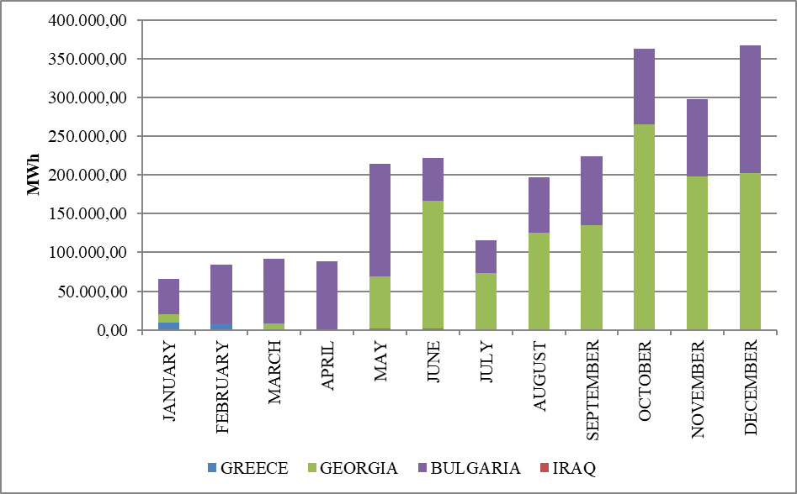

1.6.2 Export

The data on electricity exports in 2021 is shown in Figure 1.22 on the basis of months. 69,38% of the total electricity exports (4,187,062 MWh) was to Greece, 15,49% to Iraq, 6,27% to Bulgaria, 4,96% to Syria, and the remaining 3,90% was exported to Georgia in 2021. On a monthly basis, the highest electricity export was in September, while the lowest electricity export was in January.

Figure 1.22: Electricity Exports in 2021 by Months (MWh)
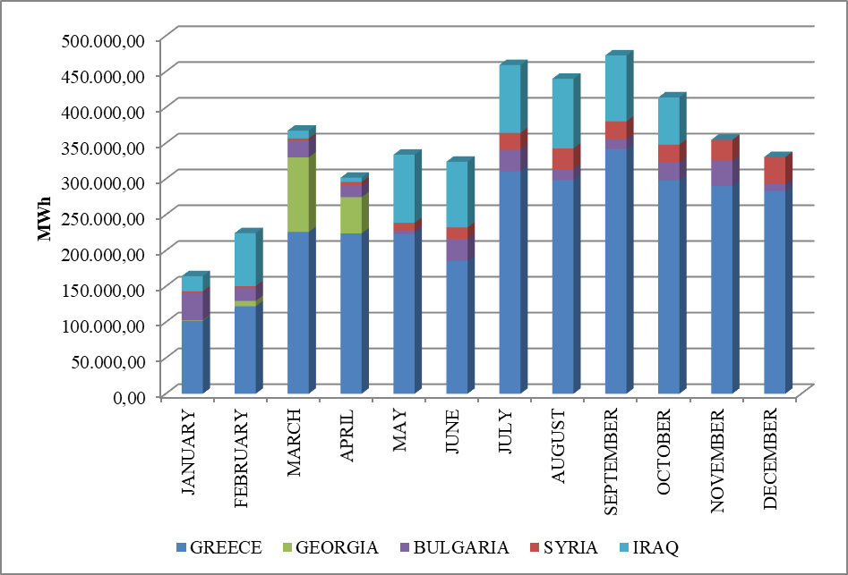

- WHOLESALE MARKET

In this section, the developments that occurred in the wholesale market in 2021 were analyzed. In this context, the prices of the Day-Ahead Market (DAM), the Intra-Day Market (IDM) and the Balancing Power Market (BPM) are presented with the volumes and the orders given. In addition, the changes that occurred in the market structure are explained.
Primary Frequency Control (PFC) brings the system frequency to a new equilibrium point by automatically increasing or decreasing the unit active power with the speed regulator in response to the decrease or rise of the system frequency. PFC reserve is obtained from production facilities determined to be capable of providing PFC services as a result of PFC performance tests in Electricity Network Regulation.
Secondary Frequency Control (SFC) brings the system frequency to the nominal value and to the programmed value of the total electrical energy exchange with neighboring country electricity networks by increasing or decreasing the active power output of the production facilities participating in the SFC service by the signals sent automatically from the National Load Dispatch Center. SFC reserve is provided by the production facilities which are determined to be capable of providing SFC services as a result of the SFC performance tests in the Electricity Network Regulation.
Pursuant to the Electricity Market Ancillary Services Regulation published on the Official Gazette dated 26 November 2017 and numbered 30252, participation in PFC and SFC services has ceased to be compulsory and PFC and SFC reserves have been procured on a voluntary basis. Currently, between 200-300 MW PFC reserve and 700-1100 MW SFC reserve are kept at different times of the day.

  - Day-Ahead Market

In the process that started with the Electricity Market Law, it was aimed to create an electricity market that is transparent, reliable, competitive and integrated with the electricity markets of other countries. In line with this goal, many planned steps have been taken, and significant progress has been made in each step taken to make the electricity market stronger and more dynamic, for market participants to take a more active role in the electricity market, and for those who operate the market to manage and follow the market in the best way.
First step carried out for transformation of electricity market from a single buyer-single seller model to liberal and competitive model was transition to monthly 3 period financial settlement system on 1 July 2006. Next step was the start of operations for Day-Ahead Planning system on 1 December 2009. These transition periods have great importance regarding to transformation of electricity market into stronger and more dynamic structure. Parties took role in market operations and activities provided significant experience and foresight for new market models from their practices at earlier market stages. 1 December 2011 date became a milestone for Turkish Electricity Market and creation of currently used Day-Ahead Market system has been established which is deemed as biggest step towards formation of targeted electricity market structure. Establishment of Day-Ahead Market stimulated a new dynamism and vision for Turkish Electricity Market and allowed formation of market structure based on values of competition.
With the new market structure, the collateral mechanism has been implemented and, in this context, the market participants registered with MFSC must provide a guarantee to the market operator for the transactions they have made in DAM. In addition to this arrangement, it is possible for participants to create portfolios. Lastly, in the event that system constraints continue systematically, TEİAŞ is given the opportunity to switch to regional pricing by considering the constraints.
Following the completion of the registration process on 18 March 2015, the Energy Exchange Istanbul (EXIST) was formally established, under the provisions of the Turkish Commercial Code of the 14.03.2013 dated and numbered 6446 with the Electricity Market Act of 6102.
In accordance with the proposals offered by the market participants in the Day-Ahead Market operated by EPİAŞ, the market exchange prices, and the purchase and sales quantities are announced.
For the year 2021, prices of DAM are given in Figure 2.1.1 and Figure 2.1.2 with the weighted average price.

Figure 2.1.1: Hourly Development of Weighted Average Market Clearing Price and Market Clearing Price in 2021 (TL/MWh)

Figure 2.1.2: Organized and Weighted Average MCP in 2021 (TL/MWh)
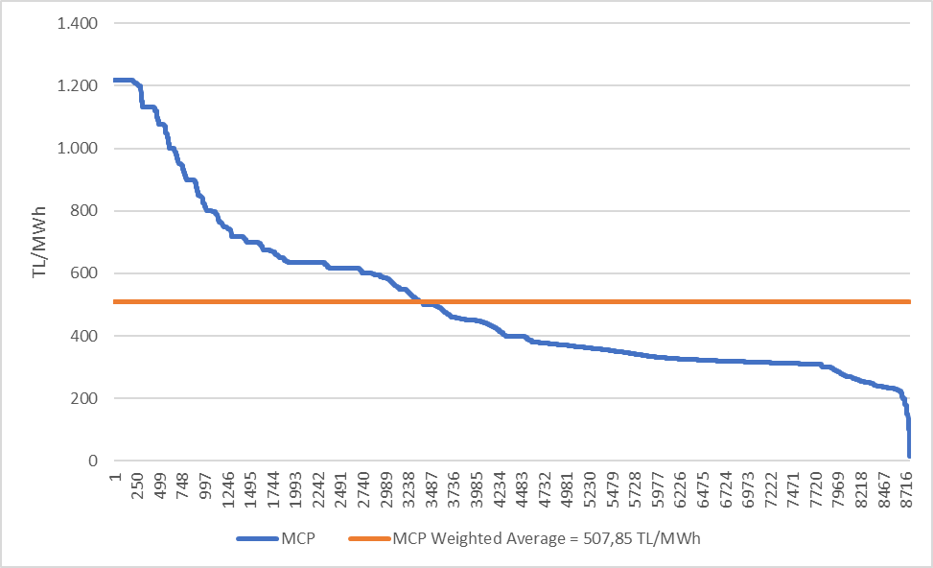
As shown in Figure 2.1.1, prices were generally below the weighted average market clearing price in the first months of the year, but increased in the following months. The price reached its highest value of 1.217 TL/MWh on December 1, 2021 at 08:00. The lowest value was observed on April 4 and October 24 with 15.4 TL/MWh.
In Figure 2.1.3, the weighted average MCP is given in Day-Ahead Market by years. In 2021, the weighted average of the MCP increased by 77,65% compared to 2020 and it reached to 507,85 TL/MWh.

Figure 2.1.3: Weighted Average MCP by Years (TL/MWh)
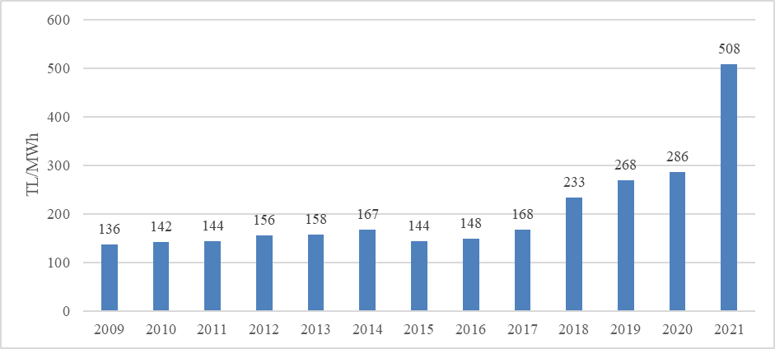

In Figure 2.1.4 below, monthly weighted average Day-Ahead Market prices for the last two years are shown. In 2021, the highest value was seen in December with 1.014,9 TL/MWh and the lowest value was in February with 288,367 TL/MWh.
Electricity consumption on a monthly basis decreases in the spring and autumn months with the temperate climate. In addition, the water revenues of hydroelectric power plants increase with the high precipitation especially in spring, and the lowest prices of the year are generally in spring.
On the other hand, due to the consumption of air conditioning and agricultural irrigation in the summer, the need for warming and lightening in the winter, electricity demand increases and in parallel with the increase in consumption, the average prices also increase.

Figure 2.1.4: Monthly Weighted Average MCP of the Last Two Years (TL/MWh)
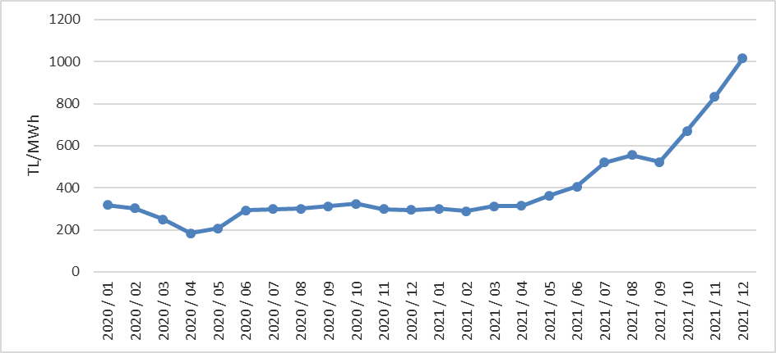

The following Figure 2.1.5 shows the trading volume in the DAM by months. The distribution of DAM purchase amounts by company and the share of the top 10 companies are shown in Figure 2.1.6, the distribution of sales amounts and the share of the top 10 companies are shown in Figure 2.1.7.

Figure 2.1.5: Monthly Day-Ahead Market Trading Volume (MWh)
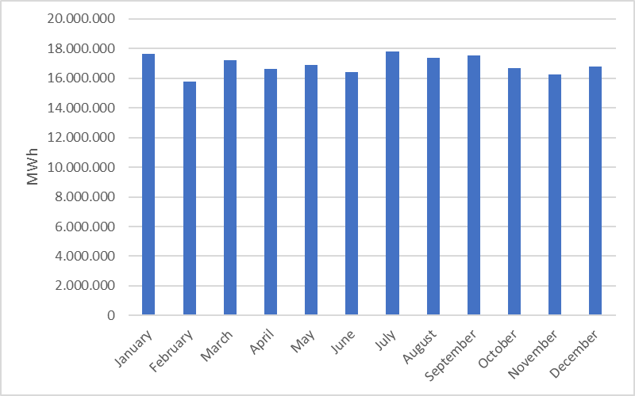

Figure 2.1.6: Share of Top 10 Companies by Purchase Amount in Day-Ahead Market (%)
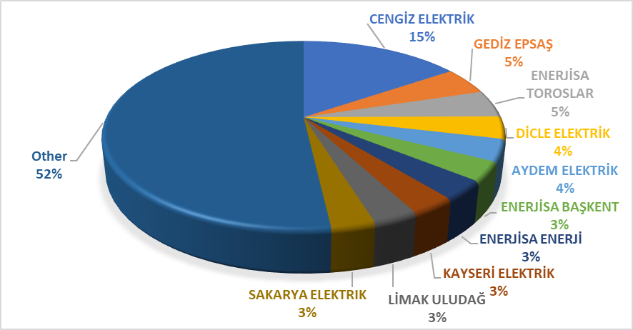

Figure 2.1.7: Share of Top 10 Companies by Sales Amount in the Day Ahead Market (%)
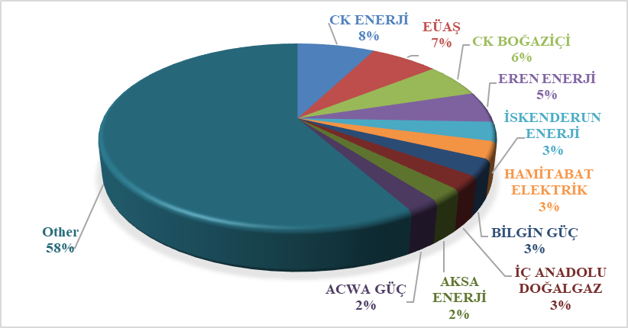

2.2 Balancing Power Market

Balancing Power Market is operated by TEİAŞ. In this section, data on the development of prices and volumes in BPM are presented. The system marginal prices in BPM in 2021 are shown in Figure 2.2.1 and Figure 2.2.2.

Figure 2.2.1: Hourly System Marginal Price (SMP) (TL/MWh)

Figure 2.2.2: Organized System Marginal Price (TL/MWh)
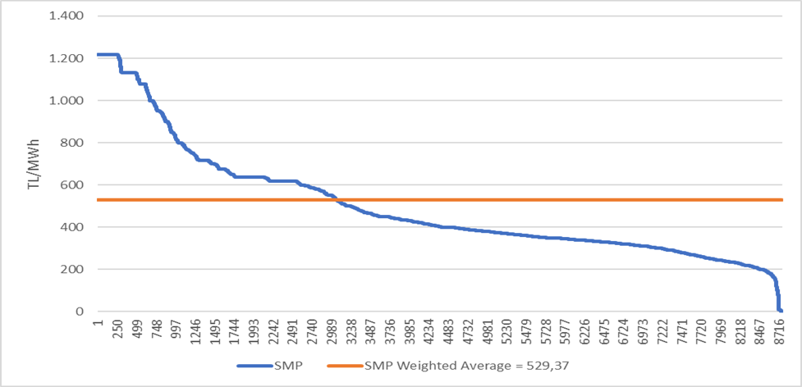
As seen in Figure 2.2.1, the highest price in BPM was 1.217 TL/MWh on December 1, 2021 at 08:00 and remained at this value throughout the month. During the year, prices was over 1000 TL/MWh for 697 hours. Also, the price was 0 TL/MWh for 8 hours.
The annual weighted average of the price in BPM increased by 87,41% and reached to 529,37 TL/MWh.
Monthly weighted average prices in the Balancing Power Market for the last two years are shown in Figure 2.2.3 below. In 2021, the lowest value of SMP took place in April with 134,7 TL/MWh and the highest value was in December with 1.056,0 TL/MWh.

Figure 2.2.3: Monthly Weighted Average Prices of the Last Two Years in Balancing Power Market (TL/MWh)
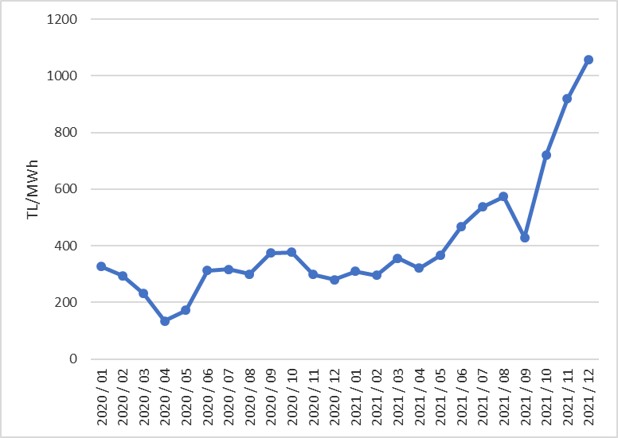

Figure 2.2.4 shows the monthly trading volumes in BPM in 2021.

Figure 2.2.4: Monthly Trading Volumes in Balancing Power Market (MWh)
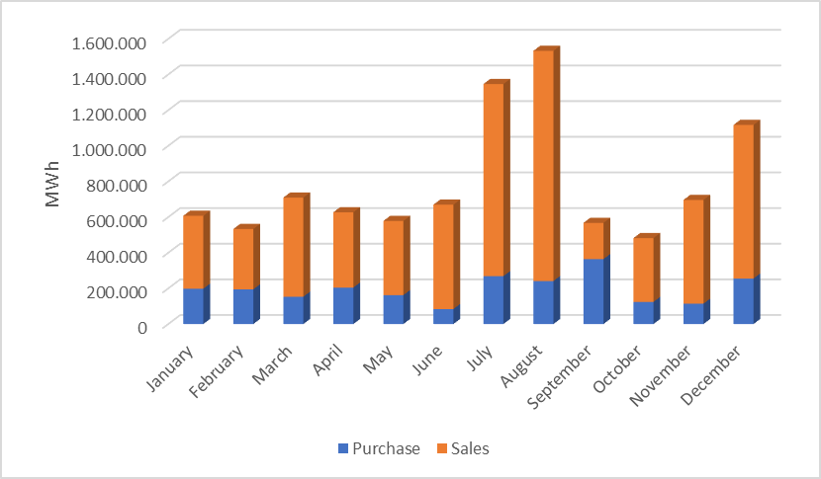

The following Figure 2.2.5 shows the distribution of BPM purchase amounts by company and the share of the top 10 companies, and Figure 2.2.6 shows the distribution of sales amounts in BPM and the share of the top 10 companies.

Figure 2.2.5: Share of Top 10 Companies by Purchase Amount in Balancing Power Market (%)
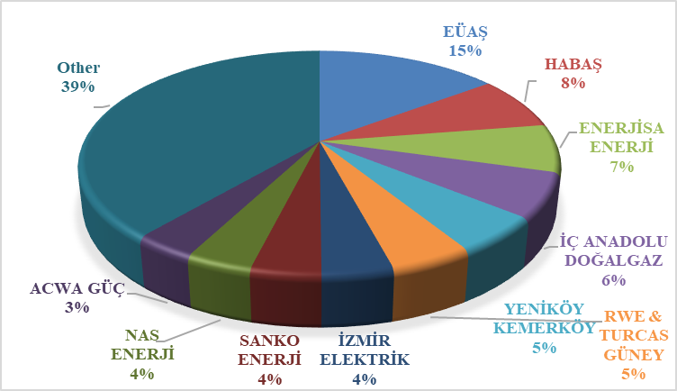

Figure 2.2.6: Share of Top 10 Companies by Sales Amount in Balancing Power Market (%)
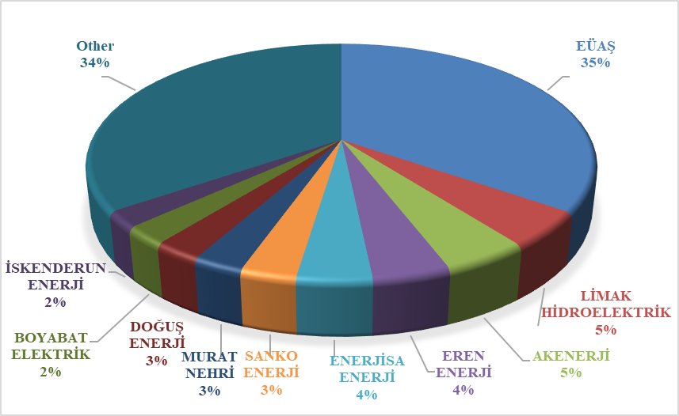

As of 2021, the rates of instruction volumes given in DGP are shown in Figure 2.2.7. 7% of the instructions were 1 coded, given due to system constraints. As of February 2018, since the auction system was implemented in the ancillary services, there were no 2 coded.

Figure 2.2.7: Rates of Order Volumes Given in Balancing Power Market in 2021 (%)
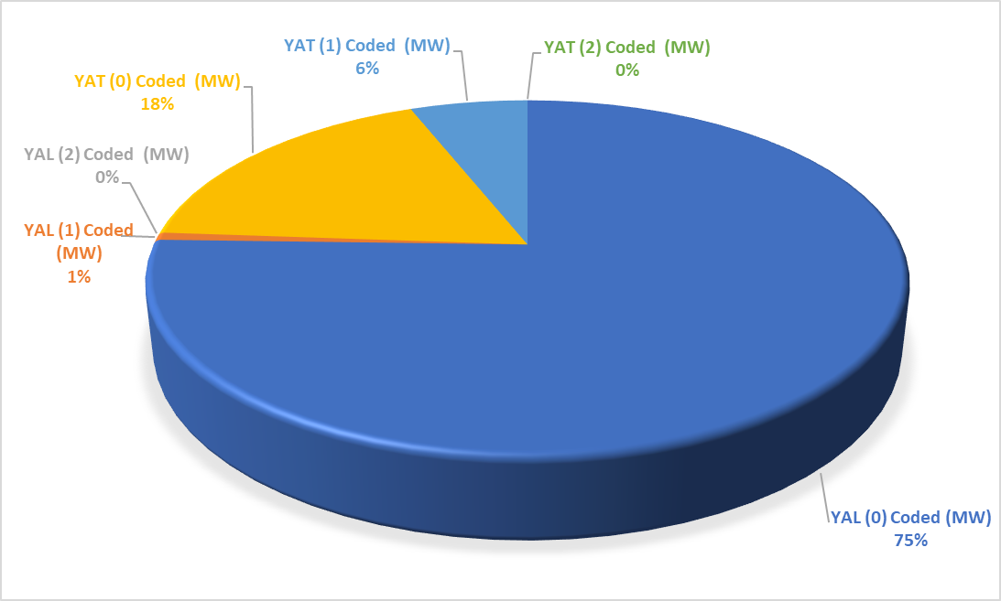
The distribution of instruction on hourly basis is shown in Figure 2.2.8.

Figure 2.2.8: Hourly Distribution of Orders Given in the Balancing Power Market in 2021 (MW)
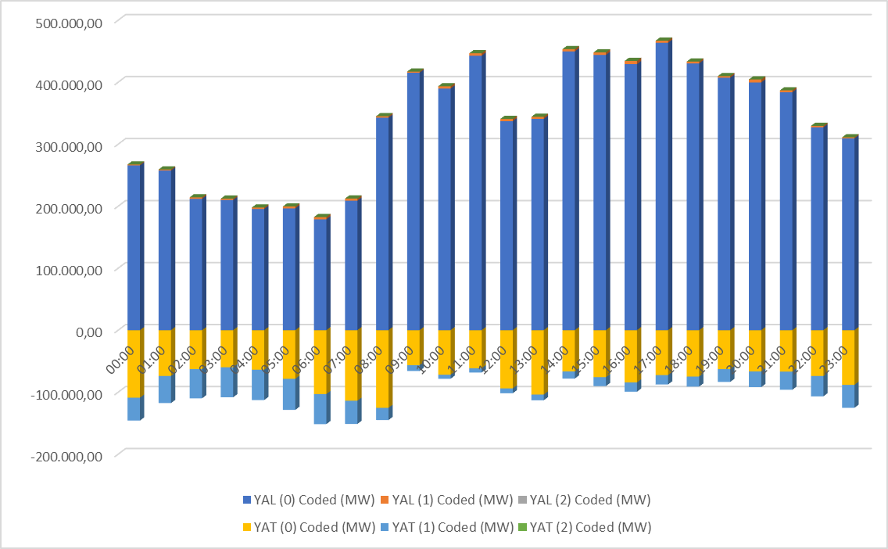

Additional costs arising from those instructions are shown in Table 2.2.1 below. While the additional cost caused by the instructions given in BPM was 121,47 million TL in 2020, it was 259,44 million TL in 2021. All of these costs resulted from 1 coded instruction, and since the 2 coded instructions were not occured, there are no costs.

Table 2.2.1: Additional Costs of Orders (Million TL)
The development of additional costs that occurred due to the 1 coded instruction was shown on a monthly basis in Figure 2.2.9 below. The majority of the additional costs was in July, August and September in 2021.

Figure 2.2.9: Monthly Development of Additional Costs of Orders in 2021 (Million TL)
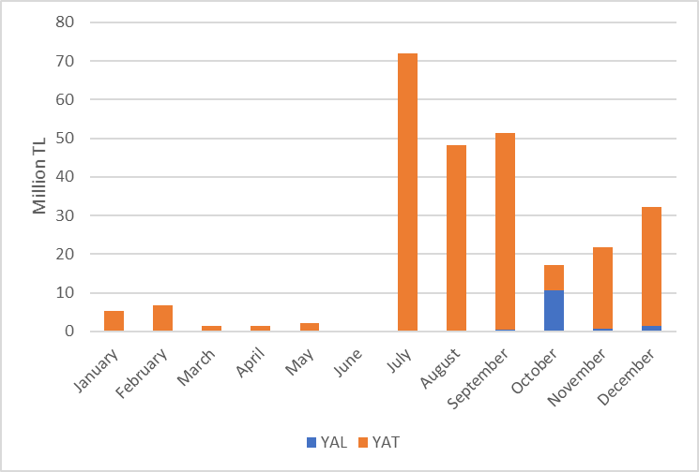

The change of the Zero Balance Adjustment Amount (ZBAC) by years is shown in Figure 2.2.10. While ZBAC was 106,14 million TL in 2020, it was 120,08 million TL in 2021.

Figure 2.2.10: Yearly Development of Zero Balance Adjustment Component (TL)
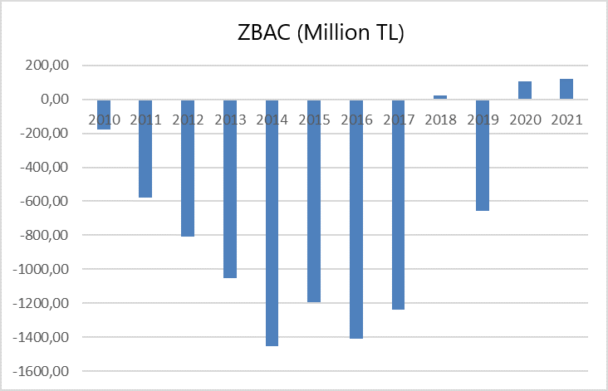

2.3 Intra-Day Market

Efforts are continuing to ensure that the Turkish Electricity Market is more transparent and efficient, financially strong, integrated with the European Union electricity markets. On 1 July 2015, the Intra-Day Market was in operation to ensure that participants in the Turkish electricity market, which is constantly evolving and advancing for free market, playing more balanced and effective role.
Day-Ahead, Ancillary Services and Balancing Power Markets that is currently in operation, with the addition of Intra-Day Market, provide real-time trading opportunities and offer market participants the opportunity to manage short-term portfolios.
In Figure 2.3.1 below, monthly volume of the Intra-Day Market and the weighted average price in 2021 is given.

Figure 2.3.1: Monthly Development of Trading Volume and Average Price in the Intra-Day Market (MWh – TL/MWh)
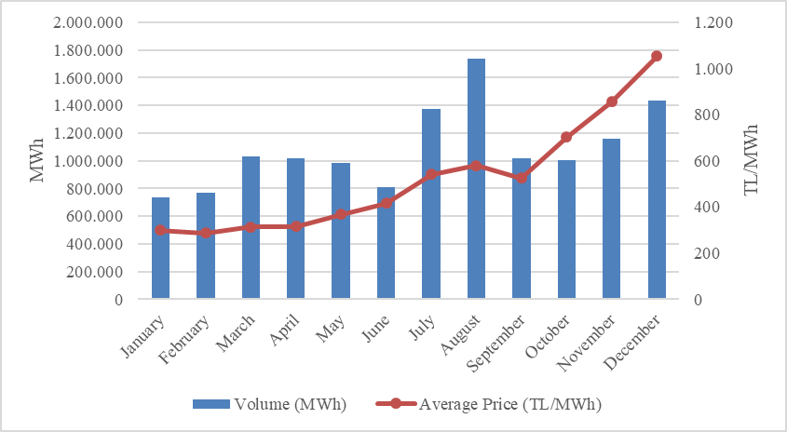
In Figure 2.3.2 below, the distribution of purchases of IDM on the basis of company and the share of first 10 companies, and in Figure 2.3.3, the distribution of sales in IDM on the basis of the company and the share of top 10 seller companies are shown.

Figure 2.3.2: Share of Top 10 Companies by Purchase Amount in Intra-Day Market (%)
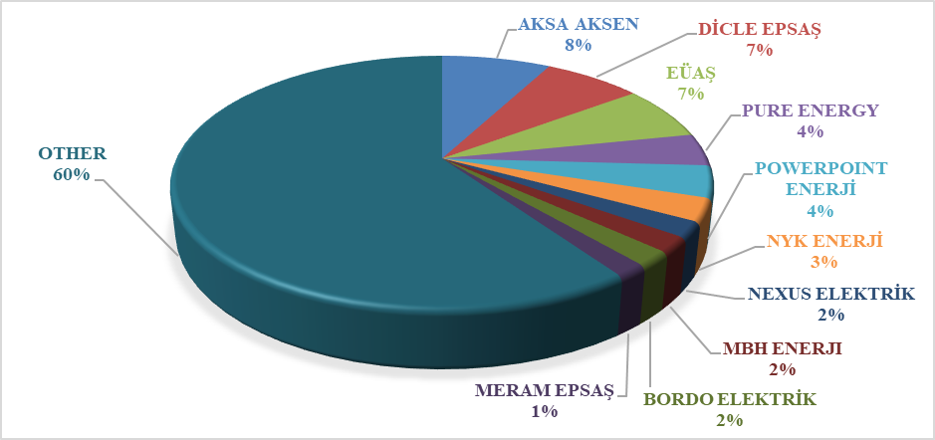

Figure 2.3.3: Share of Top 10 Companies by Sales Amount in Intra-Day Market (%)
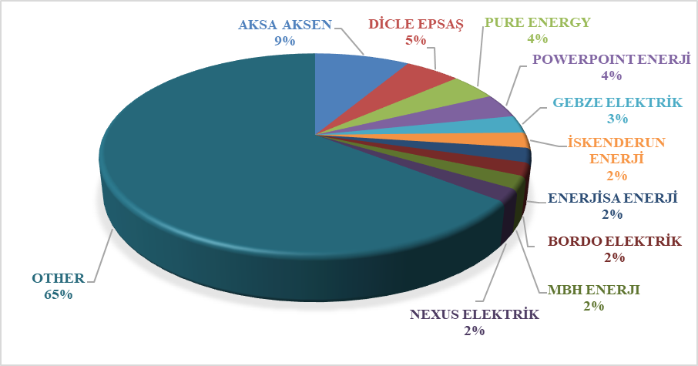

2.4 Bilateral Agreements

The structure of the Turkish electricity market is based on Bilateral Agreements and other organized markets are designed to complement the market. In this framework, most of the energy traded in the market is traded through Bilateral Agreements. Bilateral Agreements are made freely between market participants and are not regulated. However, Bilateral Agreements signed between EÜAŞ (annulled TETAŞ) and commissioned supply companies are the majority of the existing bilateral agreement volume in the framework of transitional contracts. Additionally, distribution companies have energy purchases from EÜAŞ (annulled TETAŞ) for losses and general lighting purposes under Bilateral Agreements.
In Figure 2.4.1, monthly Bilateral Agreements volumes in 2019-2020-2021 are shown.

Figure 2.4.1: Monthly Bilateral Agreements Volumes by Years (MWh)
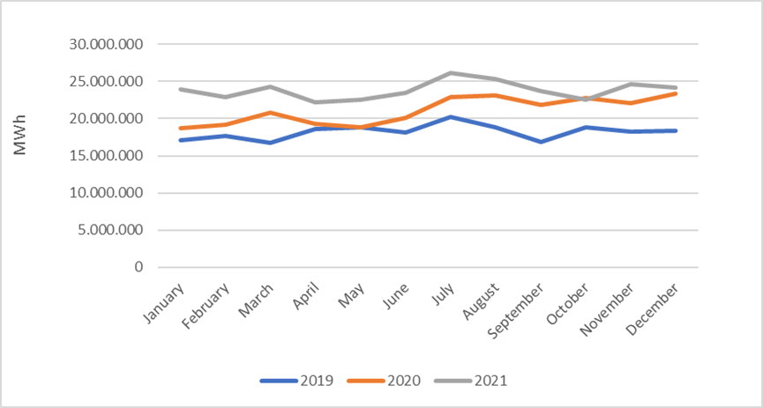

In Figure 2.4.2 the distribution of purchases with Bilateral Agreements on the basis of the company and the share of top 10 companies, and in Figure 2.4.3 the distribution of sales with Bilateral Agreements on the basis of the company and the share of top 10 companies are shown.

Figure 2.4.2: Share of Top 10 Companies by Purchase Amount with Bilateral Agreements (%)
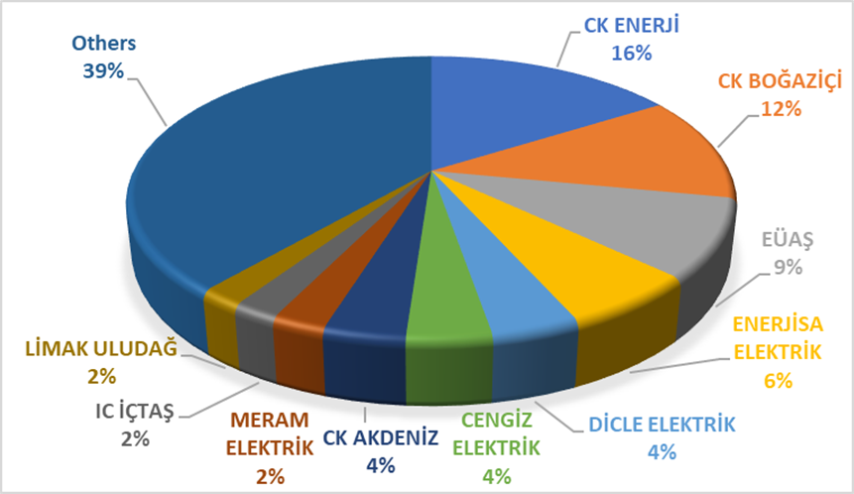

Figure 2.4.3: Share of Top 10 Companies by Sales Amount with Bilateral Agreements (%)
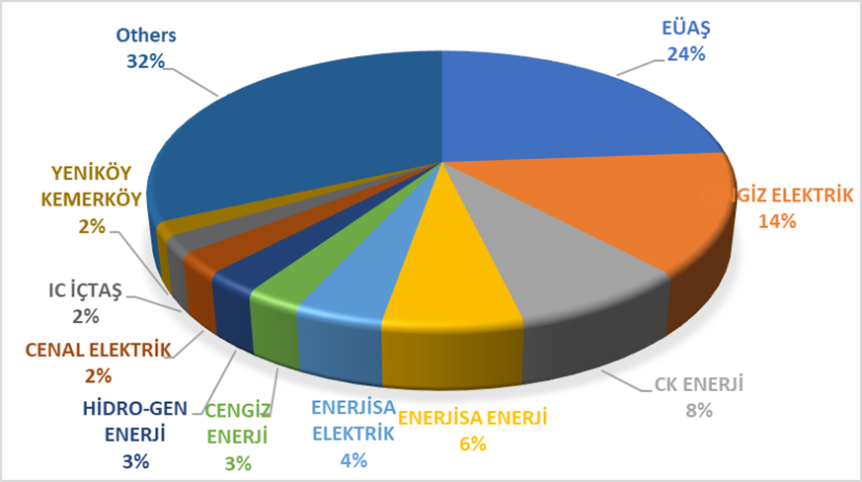
The wholesale tariffs of EÜAŞ (abolished TETAŞ) are determined by the Board Decision and the fulfillment of the obligations of EÜAŞ arising from existing contracts is taken into account. While a single price was announced for wholesale tariff of EÜAŞ previously, a separate price has been determined for the general lighting price since 2017.
Figure 2.4.4 shows the change in the wholesale prices of EÜAŞ between 2014 and 2021.

Figure 2.4.4 Wholesale Prices of EÜAŞ Between 2014-2021 (kr/kWh)
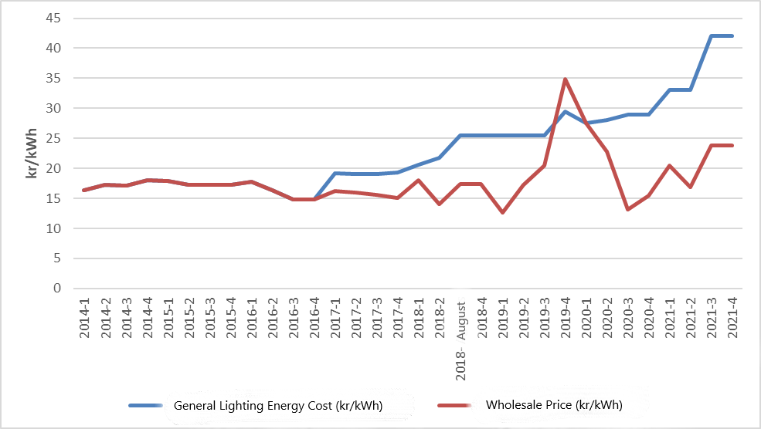

  - Renewable Energy Sources Support Mechanism (YEKDEM)

“The Amendment of the Law on “Utilization of Renewable Energy Resources for Generation of Electrical Energy” Law Numbered 6094 published in the Official Gazette 08/01/2011 dated and 27809 numbered provide incentive for renewable energy sources according to the source type and the locality rate. In this context, the regulations prepared by EMRA and the details Mechanism of Supporting Renewable Energy Sources are determined with the regulations prepared by EMRA.
“Regulation on Certification and Support of Renewable Energy Sources” was published in the Official Gazette dated 01/10/2013 and numbered 28782 and came into force. With the Regulation, in order to encourage the generation of electricity based on renewable energy sources, principles regarding the provision of Renewable Energy Source Document and the establishment and operation of YEKDEM issued to the generation license holders.
With the Presidential Decision dated 17/09/2020 and numbered 2949, within the scope of the YEK Support Mechanism of electricity generation plants based on renewable energy sources, it is attached to the YEK Law No. 5346, which is determined on the basis of USD cent/kWh. In order to benefit from the prices in Tables I and II, the date on which they should enter into operation has been extended to 30/6/2021, and the deadline for these power plants to benefit from YEKDEM has been determined as 30/12/2030. Subsequently, with the amendment made in the YEK Law No. 5346 on 2/12/2020, the prices to be applied in Turkish Lira within the scope of YEKDEM for the electricity generation facilities with YEK certificate that will be put into operation after 30/6/2021 and the procedures and principles regarding the updating of the prices will be determined by the President. In this context, with the President's Decision dated 29/1/2021 and numbered 3453, a decision was taken regarding the prices and periods to be applied for electricity generation facilities based on renewable energy sources with YEK certificate, which will be put into operation from 1/7/2021 to 31/12/2025, as well as updating the prices. In this context, the prices within the scope of the new YEK Support Mechanism determined in Turkish Lira are shown in Table 2.5.1. The prices in this table are updated on a quarterly basis, starting from 1/1/2021 and on a resource basis. It is updated every year in January, April, July and October, the first of which is on 1/4/2021, in accordance with the procedure determined in the Presidential Decision No. 3453.

Table 2.5.1: Number of Licensed YEKDEM Power Plants by Years
Type of Production Facility Based on Renewable Energy Source |  | YEK Support Mechanism Price  (TL/kWh) | YEK Support Mechanism Price Implementation Period  (year) | Local Content Price  (TL/kWh) | Local Content Price Implementation Period  (year)
a. Hydroelectric production facility |  | 40,00 | 10 | 8,00 | 5
b. Production facility based on wind energy |  | 32,00 | 10 | 8,00 | 5
c. Production facility based on geothermal energy |  | 54,00 | 10 | 8,00 | 5
d. Production facility based on biomass | Resources obtained from the waste products of the processing of landfill gas or waste tires. | 32,00 | 10 | 8,00 | 5
d. Production facility based on biomass | Biomethanization | 54,00 | 10 | 8,00 | 5
d. Production facility based on biomass | Thermal Disposal  (Municipal wastes, vegetable oil wastes, agricultural wastes without food and feed value, forest products other than industrial wood, industrial waste sludge and treatment sludge) | 50,00 | 10 | 8,00 | 5
e. Production facility based on solar energy |  | 32,00 | 10 | 8,00 | 5

In Table 2.5.1, the number of the RES Support participants is given by years. The increment in participant number and installed capacity continues. In 2021, there were 929 companies with a total installed capacity of 21.622,4 MW which operates in the scope of the RES Support.

Table 2.5.2: Number of YEKDEM Participants by Years
Type | 2011 | 2012 | 2013 | 2014 | 2015 | 2016 | 2017 | 2018 | 2019 | 2020 | 2021
Solar | - | - | - | - | - | - | 2 | 3 | 9 | 17 | 32
Hydraulic | 4 | 44 | 14 | 40 | 126 | 388 | 418 | 447 | 463 | 463 | 449
Wind | 9 | 22 | 3 | 21 | 60 | 106 | 141 | 151 | 160 | 165 | 204
Biomass | 3 | 8 | 15 | 23 | 34 | 42 | 57 | 70 | 100 | 126 | 191
Geothermal | 4 | 4 | 6 | 9 | 14 | 20 | 29 | 37 | 45 | 50 | 53
Grand Total | 20 | 78 | 38 | 93 | 234 | 556 | 647 | 708 | 777 | 821 | 929

When the installed capacity of YEKDEM by resources is considered, it is seen that hydraulic power plants have the highest share with 12.227,8 MW and the wind power plants have the second-highest share with 6.750,4 MW.

Table 2.5.3: Distribution of YEKDEM Installed Capacity by Resources (MW)*
Type | 2011 | 2012 | 2013 | 2014 | 2015 | 2016 | 2017 | 2018 | 2019 | 2020 | 2021
Solar | - | - | - | - | - | - | 12,9 | 13,9 | 81,7 | 162,7 | 305,9
Hydraulic | 21,0 | 930,0 | 217,0 | 598,0 | 2.116,3 | 9.960,0 | 11.096,3 | 11.706,4 | 12.588,5 | 12.434,7 | 12.227,8
Wind | 469,0 | 685,0 | 76,0 | 825,0 | 2.732,1 | 4.319,8 | 5.238,7 | 6.200,0 | 6.495,6 | 6.440,0 | 6.750,4
Geothermal | 72,0 | 72,0 | 140,0 | 228,0 | 389,9 | 599,2 | 752,1 | 996,8 | 1.252,7 | 1.437,5 | 1.465,0
Biomass | 45,0 | 73,0 | 101,0 | 147,0 | 185,2 | 203,7 | 300,0 | 349,2 | 503,1 | 671,2 | 873,3
Grand Total | 608,0 | 1.760,0 | 534,0 | 1.798,0 | 5.423,6 | 15.082,7 | 17.399,9 | 19.266,3 | 20.921,5 | 21.146,1 | 21.622,4

* In addition, by the end of 2021, 7.083,94 MW of the 7.546,99 MW unlicensed installed capacity (natural gas plants excluded) are provided by YEKDEM. Details are given in Section 1.3 titled "Unlicensed Electricity Generation".
While the ratio of installed capacity, including unlicensed power plants, within the scope of YEKDEM to Turkey’s total installed capacity was 22,07% in 202, this rate increased to 28,76% in 2021.
In Figure 2.5.1, the distribution of installed capacity based on resources in 2021 is given.

Figure 2.5.1: Distribution of YEKDEM Installed Capacity by Resources in 2021 (%)
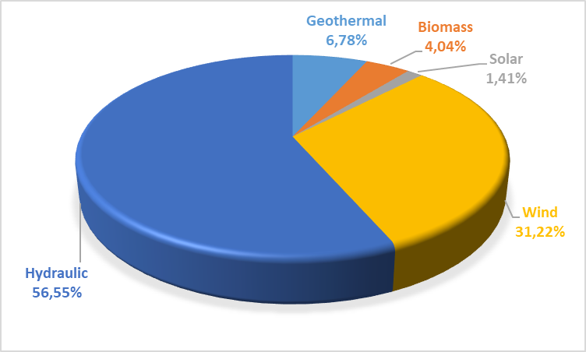

The development of YEKDEM participants' productions over the years is shown in Table 2.5.4. Production within the scope of YEKDEM in 2021, including unlicensed power plants, increased by approximately 0,92% and it reached to 74,16 TWh.

Table 2.5.4: Yearly Generation of YEKDEM Participants by Years (MWh)*
Type | 2013 | 2014 | 2015 | 2016 | 2017 | 2018 | 2019 | 2020 | 2021
Solar | - | - | - | - | 24.269 | 39.140 | 159.961 | 375.476 | 1.492.885
Unlicensed | 884 | 29.316 | 223.537 | 1.134.023 | 2.997.551 | 8.078.418 | 9.830.849 | 11.229.723 | 12.149.419
Hydraulic | 528.427 | 1.072.832 | 5.651.215 | 16.212.717 | 17.213.394 | 27.369.727 | 36.961.886 | 29.671.021 | 21.980.145
Wind | 223.243 | 2.378.819 | 8.275.992 | 14.163.402 | 16.765.418 | 19.002.863 | 19.900.973 | 20.658.797 | 25.200.967
Geothermal | 857.527 | 1.436.579 | 2.710.856 | 3.706.764 | 4.503.345 | 5.968.202 | 6.997.209 | 7.816.509 | 8.162.845
Biomass | 750.715 | 957.223 | 1.082.913 | 10.613.594 | 8.992.792 | 2.047.082 | 2.817.209 | 3.730.699 | 5.169.983
Grand Total | 2.360.795 | 5.874.769 | 17.944.514 | 45.830.502 | 50.496.769 | 62.505.431 | 76.668.087 | 73.482.227 | 74.156.245

The distribution of generation within the scope of YEKDEM by resources in 2021 is shown in Figure 2.5.2. The highest generation was obtained from wind and hydraulic, respectively.

Figure 2.5.2: Distribution of YEKDEM Generation by Resources in 2021 (%)
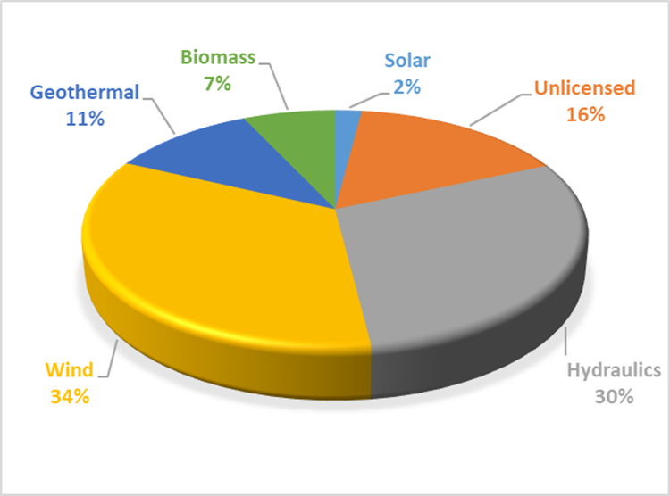

While the ratio of the generation in YEKDEM to the total electricity generation of the country was 24,07 % in 2020, this rate decreased to 22,37 % in 2021.
Considering the monthly development of YEKDEM generation in Figure 2.5.3, it is seen that hydraulic production and therefore YEKDEM production increased due to the rainfall in spring months. The production from other resources was more stable throughout the year.

Figure 2.5.3: Monthly Development of YEKDEM Generation in 2021 (MWh)
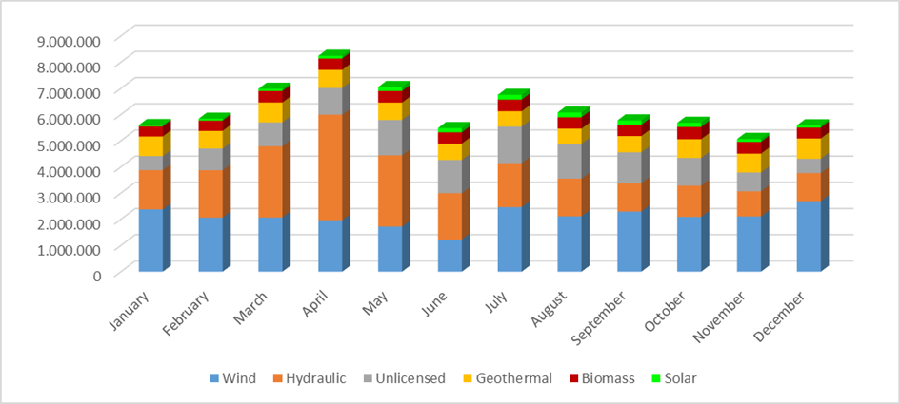
Figure 2.5.4 the monthly course of the weighted average MCP prices formed in 2021 YEKDEM and DAM are shown together. When the incentive prices applied in YEKDEM are compared with the monthly average MCP prices, it is observed that even the lowest incentive price is above the MCP price in the spring months.

Figure 2.5.4: Monthly Development of YEKDEM and DAM Prices in 2021 (TL/MWh)
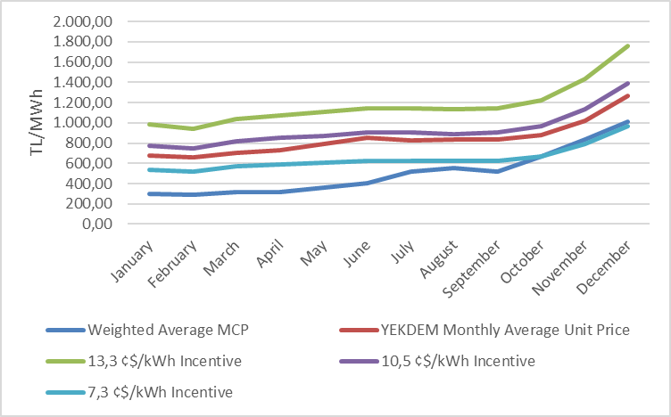
Figure 2.5.5 shows incentive amounts of the YEKDEM power plants, average YEKDEM price and average DAM price in 2021.

Figure 2.5.5: Average of YEKDEM and MCP in 2021 (kr/kWh)
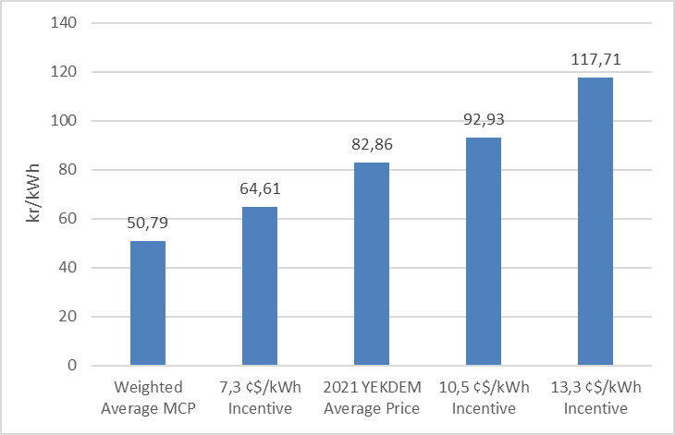

Monthly development of payments made within the scope of YEKDEM is shown in Figure 2.5.6.

Figure 2.5.6: Monthly Payments Made within the Scope of the YEKDEM in 2021 (TL)
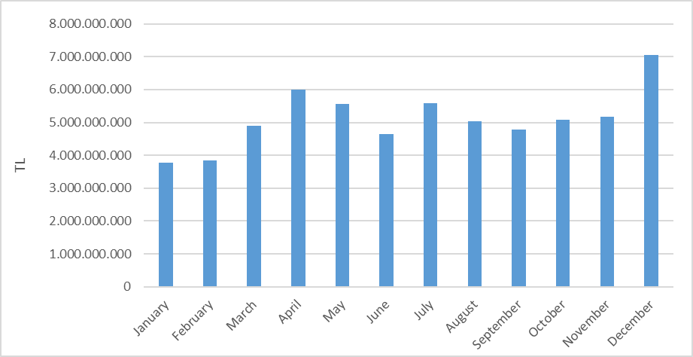
Figure given below shows the improvement of monthly additional cost of YEKDEM per invoiced unit energy. In 2021, the additional cost of YEKDEM which was 93.99 TL/MWh decreased by 13,37% compared to the previous year.

Figure 2.5.7: Monthly Improvement of Average YEKDEM Additional Cost in 2021 (TL/MWh)
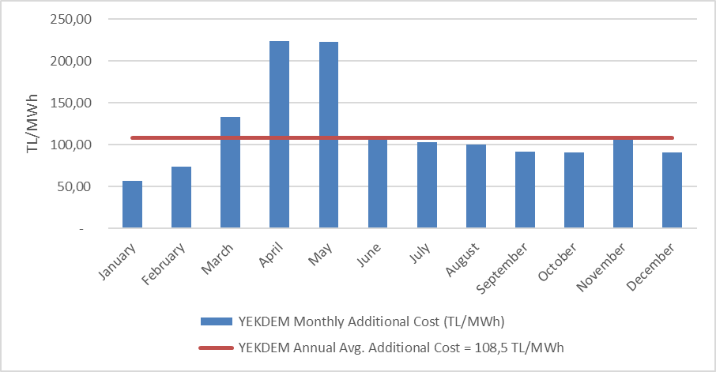

  - Power Futures Market

Power Futures Market operated by EXIST is a market with physical delivery that operates according to the “perpetual trade” method, allows future physical electricity trade and protects market participants from counterparty risk.
In the spot electricity markets, market participants are able to balance their portfolios and make physical optimization. In the Power Futures Market, the market participants have the opportunity to offset the price risk (hedging) and to see price prospects for the future (price discovery). Therefore, spot and Power Futures Markets can be considered as the markets that fulfill the different needs of the market participants and they complement each other in this respect.
Power Futures Market was opened on 1 June 2021 with 6 months and 2 quarter contracts. In addition to standard contracts, the balance of month (BOM) contract, which allows the management of physical positions within the delivery period, provides flexibility to market participants. On October 6, 2021, annual contract and two more quarter contracts were put into operation together.
In Figure 2.6.1 below, the development of the average MCP and Daily Index Prices determined for the contracts for 2021 in the Power Futures Market as of June 1 is given.

Figure 2.6.1: Daily Index Price in PFM vs. MCP (TL/MWh)
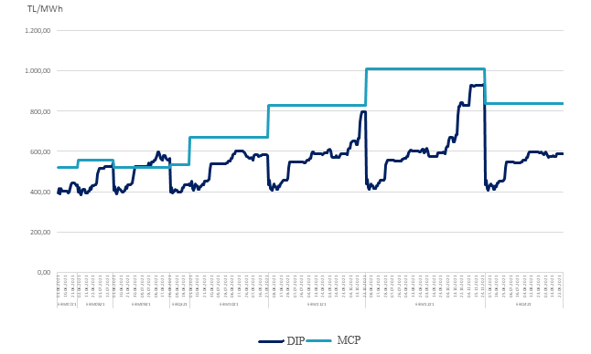

Figure 2.6.2 below shows the difference between the last Daily Index Prices for the contracts in 2021 and the average MCP.

Figure 2.6.2: Last Daily Index Price in PFM vs. MCP (TL/MWh)

In Figure 2.6.3, the matching pricse and amounts in 2021 in Power Futures Market are given. There were 50 matches in total.

Figure 2.6.3: Matching Prices and Amounts in PFM (TL/MWh – MW)

In Figure 2.6.4 below, the contract-based match amount and trading volume in Power Futures Market in 2021 are given. The total match amount was 662,37 GWh, and the total trading volume was 1.27 Billion TL. The highest match was in EBY22 (year 2022) contract with 600.060 MWh. While there were 3 matches in the balance of month (BOM) contracts, there was no match in the quarterly contracts in 2021.

Figure 2.6.4: Contract Based Match Amounts and Trading Volume (MWh – Million TL)

  - Environmental Markets

YEK-G System and Organized YEK-G Market

The YEK-G System and the Organized YEK-G Market became operational on June 1, 2021. In the YEK-G System developed using Blockchain technology, participants can execute issue, cancellation and bilateral agreement transactions.
In the Organized YEK-G Market, offers are submitted by the participants to the contract in five different resource types (Hydroelectric, Geothermal, Wind, Solar, Biomass) and matches are made with perpetual trade methods.
In order to verify the cancellation notification made by market participants, YEK-G Portal was put into operation.
English language option has been introduced to YEK-G System ve YEK-G Portal.
In order to provide 24/7 effective and fast service to market participants, service is provided via the call center and EXIST Help Desk Platform.
The data of each transaction performed in the YEK-G system is published on the EXIST Transparency Platform.
The https://yekgnedir.com micro site, which contains information about YEK-G System and the Organized YEK-G market, has been put into service.
Foreign research and development studies regarding the carbon market and white certificate market continue within the scope of environmental markets,

Figure 2.7.1: Amount of Issue in YEK-G System

Total amount of issue in YEK-G system in 2021 was 10,28 TWh.

Figure 2.7.2: Amount of Bilateral Agreements in YEK-G System

Total amount of bilateral agreements in YEK-G System in 2021 was 290,59 GWh

Figure 2.7.3: Amount of Cancellation in YEK-G System

Total amount of cancellation in YEK-G System in 2021 was 290,50 GWh.

Figure 2.7.4: Amount of Match in Organized YEK-G Market

The highest monthly matching amount of the Organized YEK-G market was 959.265 MWh in December.

Figure 2.7.5: Organized YEK-G Market Annual Weighted Average Price on Contract Basis
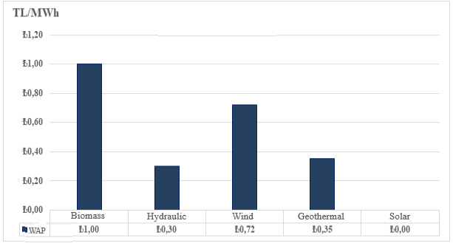
Figure 2.7.6: Organized YEK-G Market Average Price

The highest weighted average price of the organized YEK-G market was 5,00 TL/MWh in the biomass contract in June.

Figure 2.7.7: Organized YEK-G Market Trading Volume
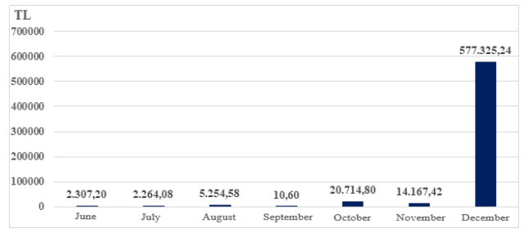

The highest trading volume of the organized YEK-G market was 577.325,24 TL in December. A total trading volume was 622.043,92 TL. The trading volume includes the sum of the purchase and sale amounts.
- COMPETITION

The main purpose of the Electricity Market Law is to develop competition by creating a free market structure. The main duties of the institution include determining anti-competitive behavior and market power in areas open to competition and taking preventive measures. EMRA also reduces the eligible consumer limit for the next year at the end of each year, ensuring that the number of consumers who can choose their supplier on the demand side increases. In this framework, the development of open negotiation supply and demand in the wholesale market is critical in establishing competition.

3.1 Supply Side

It is considered that open electricity markets provide the most effective investment and generation incentives is supported by theoretical and practical studies. However, there may be a need for regulation regarding the protection of competition and ensuring the security of supply due to reasons such as very low demand elasticity and the network not being able to store energy. For this reason, these issues are regulated by various market share limits and mechanisms in many countries and by the European Union.
The indices used to follow the competition generally measure the supply side concentration in the market and the producers' ability to intervene. The HHI is used for measuring the market concentration with the addition of squares of market shares. The index can be calculated separately on generation and installed capacity.

Table 3.1: HHI Values with respect to Generation and Installed Capacity
 | HHI Index
 | 2015 | 2016 | 2017 | 2018 | 2019 | 2020 | 2021
Generation | 1.123 | 673 | 696 | 575 | 550 | 508 | 409
Installed Capacity | 996 | 873 | 789 | 682 | 478 | 644 | 531
As shown in Table 3.1, in 2021, there was a decrease in the HHI index calculated on both production and installed power compared to the previous year.
The sales of the supply license holders for final consumption are included in Table 3.2. While the HHI index, which is calculated according to the supplier shares, was 371,1 in 2020, this value was calculated as 366,1 in 2021.
The ratio of the total sales amount of 21 incumbent supply companies to the total sales amount of all companies holding supply licenses increased from 72,07% in 2020 to 72,35% in 2021.
As it is known, the eligible consumer limit in the electricity market has not been reset yet. In other words, not all consumers in the market are eligible consumers. It is not legally possible for any supplier to sell, except for supplier companies that are assigned to non-eligible consumers. Therefore, it is important to create an environment, where all consumers are eligible consumers and can supply energy from the supplier, they wish in order to evaluate the competitive environment in sales to end consumers, properly.

Table 3.2: Sales, Market Shares and HHI Index of Supply License Owners

Supplier Company | Sale Amount (MWh) | Share (%)
CK BOĞAZİÇİ ELEKTRİK PERAKENDE SATIŞ ANONİM ŞİRKETİ | 19.349.612.109 | 8,30
ENERJİSA TOROSLAR ELEKTRİK PERAKENDE SATIŞ ANONİM ŞİRKETİ | 13.812.788.786 | 5,93
GEDİZ ELEKTRİK PERAKENDE SATIŞ ANONİM ŞİRKETİ | 13.320.508.397 | 5,71
LİMAK ULUDAĞ ELEKTRİK PERAKENDE SATIŞ ANONİM ŞİRKETİ | 12.052.540.181 | 5,17
DİCLE ELEKTRİK PERAKENDE SATIŞ ANONİM ŞİRKETİ | 11.524.593.036 | 4,94
SAKARYA ELEKTRİK PERAKENDE SATIŞ ANONİM ŞİRKETİ | 11.517.684.254 | 4,94
ENERJİSA İSTANBUL ANADOLU YAKASI ELEKTRİK PERAKENDE SATIŞ ANONİM ŞİRKETİ | 10.983.228.174 | 4,71
ENERJİSA BAŞKENT ELEKTRİK PERAKENDE SATIŞ ANONİM ŞİRKETİ | 10.914.104.143 | 4,68
AYDEM ELEKTRİK PERAKENDE SATIŞ ANONİM ŞİRKETİ | 9.959.859.179 | 4,27
MERAM ELEKTRİK PERAKENDE SATIŞ ANONİM ŞİRKETİ | 8.183.945.924 | 3,51
KAYSERİ ELEKTRİK PERAKENDE SATIŞ ANONİM ŞİRKETİ | 7.095.150.884 | 3,04
CK AKDENİZ ELEKTRİK PERAKENDE SATIŞ ANONİM ŞİRKETİ | 7.040.122.995 | 3,02
CK ENERJİ ORTAKLIĞI TOPTAN ELEKTRİK SATIŞI ANONİM ŞİRKETİ | 7.010.254.795 | 3,01
AKSA ELEKTRİK SATIŞ ANONİM ŞİRKETİ | 6.175.009.276 | 2,65
OSMANGAZİ ELEKTRİK PERAKENDE SATIŞ ANONİM ŞİRKETİ | 5.872.664.703 | 2,52
ENERJİSA ELEKTRİK ENERJİSİ TOPTAN SATIŞ ANONİM ŞİRKETİ | 5.676.941.899 | 2,44
TRAKYA ELEKTRİK PERAKENDE SATIŞ ANONİM ŞİRKETİ | 5.387.575.657 | 2,31
YEŞİLIRMAK ELEKTRİK PERAKENDE SATIŞ ANONİM ŞİRKETİ | 5.232.972.259 | 2,24
ARAS ELEKTRİK PERAKENDE SATIŞ ANONİM ŞİRKETİ | 4.128.875.152 | 1,77
GAZİANTEP OSB ELEKTRİK ENERJİSİ TEDARİK TOPTAN SATIŞ TİCARET ANONİM ŞİRKETİ | 4.062.570.141 | 1,74
AKEDAŞ ELEKTRİK PERAKENDE SATIŞ ANONİM ŞİRKETİ | 3.819.316.191 | 1,64
MERAM ELEKTRİK ENERJİSİ TOPTAN SATIŞ ANONİM ŞİRKETİ | 3.371.540.394 | 1,45
ÇORUH ELEKTRİK PERAKENDE SATIŞ ANONİM ŞİRKETİ | 2.542.868.964 | 1,09
SOCAR ENERJİ TİCARET ANONİM ŞİRKETİ | 2.231.225.094 | 0,96
TÜRKERLER VANGÖLÜ ELEKTRİK PERAKENDE SATIŞ ANONİM ŞİRKETİ | 2.039.546.457 | 0,87
AKSA FIRAT ELEKTRİK PERAKENDE SATIŞ ANONİM ŞİRKETİ | 1.974.359.930 | 0,85
CENGİZ ELEKTRİK TOPTAN SATIŞ A.Ş. | 1.917.054.355 | 0,82
CK ÇAMLIBEL ELEKTRİK PERAKENDE SATIŞ ANONİM ŞİRKETİ | 1.889.033.299 | 0,81
OMV ENERJİ TİCARET ANONİM ŞİRKETİ | 1.864.662.121 | 0,80
ZORLU ELEKTRİK ENERJİSİ İTHALAT, İHRACAT VE TOPTAN TİCARET ANONİM ŞİRKETİ | 1.629.824.290 | 0,70
ADANA OSB ELEKTRİK ENERJİSİ TEDARİK TOPTAN SATIŞ ANONİM ŞİRKETİ | 1.622.001.467 | 0,70
TOSYALI ELEKTRİK ENERJİSİ TOPTAN SATIŞ İTHALAT İHRACAT ANONİM ŞİRKETİ | 1.576.693.543 | 0,68
FİNA ELEKTRİK ENERJİSİ İTHALAT İHRACAT VE TOPTAN SATIŞ ANONİM ŞİRKETİ | 1.407.260.584 | 0,60
YETAŞ YILDIRIM ENERJİ TEDARİK A.Ş. | 1.365.765.147 | 0,59
KOLEN ELEKTRİK TOPTAN SATIŞ İTH. VE İHR. ANONİM ŞİRKETİ | 1.360.547.347 | 0,58
ELEKTRİK ÜRETİM ANONİM ŞİRKETİ (EÜAŞ) | 1.290.299.044 | 0,55
TURKCELL ENERJİ ÇÖZÜMLERİ VE ELEKTRİK SATIŞ TİCARET ANONİM ŞİRKETİ | 1.273.509.749 | 0,55
IC İÇTAŞ ELEKTRİK TOPTAN SATIŞ VE TİCARET ANONİM ŞİRKETİ | 1.138.005.399 | 0,49
DOSEN ENERJİ ELEKTRİK TEDARİK VE TOPTAN SATIŞ ANONİM ŞİRKETİ | 1.132.067.191 | 0,49
OYAK ELEKTRİK ENERJİSİ TOPTAN SATIŞ ANONİM ŞİRKETİ | 1.043.550.001 | 0,45
EREN ELEKTRİK ENERJİSİ TOPTAN SATIŞ ANONİM ŞİRKETİ | 1.030.288.468 | 0,44
ENKO ENERJİ SANAYİ VE TİCARET ANONİM ŞİRKETİ | 1.006.912.652 | 0,43
TTES ELEKTRİK SATIŞ ANONİM ŞİRKETİ | 940.023.412 | 0,40
ŞİŞECAM ENERJİ ANONİM ŞİRKETİ | 845.919.577 | 0,36
ELTEK ELEKTRİK ENERJİSİ İTHALAT İHRACAT VE TOPTAN TİCARET ANONİM ŞİRKETİ | 781.568.762 | 0,34
AXPO TURKEY ENERJİ ANONİM ŞİRKETİ | 765.308.122 | 0,33
İPRAGAZ ANONİM ŞİRKETİ | 742.802.883 | 0,32
YEŞİLYURT ELEKTRİK ENERJİSİ TOPTAN SATIŞ VE İTHALAT İHRACAT ANONİM ŞİRKETİ | 674.762.233 | 0,29
ZEYTİN ELEKTRİK ENERJİ TİCARETİ LİMİTED ŞİRKETİ | 603.703.270 | 0,26
BORDO ELEKTRİK ENERJİSİ TOPTAN SATIŞ ANONİM ŞİRKETİ | 581.985.503 | 0,25
EKSİM ELEKTRİK ENERJİSİ İTHALAT, İHRACAT VE TOPTAN SATIŞ ANONİM ŞİRKETİ | 549.245.502 | 0,24
SELENKA ELEKTRİK ENERJİSİ TOPTAN SATIŞ VE TEDARİK ANONİM ŞİRKETİ | 548.410.574 | 0,24
NYK ENERJİ TİCARET ANONİM ŞİRKETİ | 522.879.582 | 0,22
EÇE ENERJİ TİCARETİ ANONİM ŞİRKETİ | 501.730.986 | 0,22
EKVATOR PERAKENDE ENERJİ TİCARET ANONİM ŞİRKETİ | 482.776.147 | 0,21
ENGİE ENERJİ TİCARET VE PAZARLAMA ANONİM ŞİRKETİ | 469.634.469 | 0,20
SEDSAL ELEKTRİK ENERJİSİ TOPTAN SATIŞ LİMİTED ŞİRKETİ | 423.589.508 | 0,18
BATIÇİM ENERJİ TOPTAN SATIŞ ANONİM ŞİRKETİ | 420.887.082 | 0,18
YYH YILDIZ ENERJİ TEDARİK VE TOPTAN SATIŞ ANONİM ŞİRKETİ | 401.939.801 | 0,17
AVEL AVRUPA ELEKTRİK ENERJİSİ TOPTAN SATIŞ ANONİM ŞİRKETİ | 398.615.593 | 0,17
VTC ENERJİ ANONİM ŞİRKETİ | 359.098.878 | 0,15
DOĞRUDAN ELEKTRİK ENERJİSİ TOPTAN SATIŞ VE TEDARİK ANONİM ŞİRKETİ | 342.227.835 | 0,15
RÖNESANS ELEKTRİK ENERJİ TOPTAN SATIŞ ANONİM ŞİRKETİ | 301.297.182 | 0,13
OZAN ELEKTRİK ENERJİSİ İTH. İHR. VE TOPTAN TİCARET ANONİM ŞİRKETİ | 274.202.078 | 0,12
STANDART DOĞALGAZ TİCARET VE ELEKTRİK ENERJİSİ TEDARİK ANONİM ŞİRKETİ | 234.883.206 | 0,10
GATES ENERJİ TİCARET ANONİM ŞİRKETİ | 218.012.043 | 0,09
FIRAT ENERJİ TOPTAN SATIŞ TİCARET ANONİM ŞİRKETİ | 198.025.756 | 0,08
SOYAK ENERJİ TİCARET ANONİM ŞİRKETİ | 195.831.789 | 0,08
ELEKTRA ENERJİ TOPTAN SATIŞ VE İTHALAT İHRACAT ANONİM ŞİRKETİ | 182.240.411 | 0,08
ENOVA ELEKTRİK ENERJİSİ TOPTAN SATIŞ ANONİM ŞİRKETİ. | 178.062.375 | 0,08
VOYTRON ENERJİ ELEKTRİK PERAKENDE SATIŞ ANONİM ŞİRKETİ | 146.147.464 | 0,06
YKS ELEKTRİK ENERJİSİ TOPTAN SATIŞ DIŞ TİCARET LİMİTED ŞİRKETİ | 131.960.943 | 0,06
İVES ELEKTRİK ENERJİSİ TEDARİK TOPTAN SATIŞ LİMİTED ŞİRKETİ | 116.627.046 | 0,05
MARMARA ELEKTRİK ENERJİSİ İTHALAT İHRACAT VE TOPTAN TİCARET ANONİM ŞİRKETİ | 116.545.358 | 0,05
ENERJİSA MÜŞTERİ ÇÖZÜMLERİ ANONİM ŞİRKETİ | 104.586.990 | 0,04
FİDES ELEKTRİK ENERJİSİ TOPTAN ALIŞ SATIŞ ANONİM ŞİRKETİ | 98.383.460 | 0,04
AYEN ELEKTRİK TİCARET ANONİM ŞİRKETİ | 96.406.662 | 0,04
EMY TOPTAN ELEKTRİK TİCARET ANONİM ŞİRKETİ | 91.191.666 | 0,04
DİLER ELEKTRİK ENERJİSİ TEDARİK TOPTAN SATIŞ ANONİM ŞİRKETİ | 85.402.539 | 0,04
DESA ELEKTRİK ENERJİSİ TEDARİK VE TOPTAN SATIŞ TİCARET ANONİM ŞİRKETİ | 73.504.177 | 0,03
KGM ENERJİ TİCARET LİMİTED ŞİRKETİ | 69.395.004 | 0,03
AGE ELEKTRİK ENERJİSİ TOPTAN SATIŞ ANONİM ŞİRKETİ | 68.809.671 | 0,03
DAK ELEKTRİK TİCARET ANONİM ŞİRKETİ | 67.076.563 | 0,03
AVEM ENERJİ TİCARET ANONİM ŞİRKETİ | 63.611.053 | 0,03
EKO GRUP ELEKTRİK TİCARET ANONİM ŞİRKETİ | 63.283.605 | 0,03
MAX ELEKTRİK ENERJİSİ TİCARET ANONİM ŞİRKETİ | 61.238.560 | 0,03
PURE ENERGY ELEKTRİK TEDARİK ANONİM ŞİRKETİ | 58.644.012 | 0,03
TENERA ENERJİ TİCARET ANONİM ŞİRKETİ | 48.968.221 | 0,02
HGÇ TOPTAN EL. EN. TİCARET ANONİM ŞİRKETİ | 43.076.404 | 0,02
LİMAK ENERJİ TİCARETİ ANONİM ŞİRKETİ | 42.909.176 | 0,02
MAC ELEKTRİK ENERJİSİ TOPTAN SATIŞ ANONİM ŞİRKETİ | 42.267.667 | 0,02
ENERJİM PERAKENDE ENERJİ TİCARET ANONİM ŞİRKETİ | 38.615.326 | 0,02
KET KİPAŞ ELEKTRİK ENERJİSİ TOPTAN SATIŞ TİCARET ANONİM ŞİRKETİ | 35.194.726 | 0,02
ÇELİKLER ELEKTRİK ENERJİ TOPTAN SATIŞ ANONİM ŞİRKETİ | 34.487.926 | 0,01
EPTAŞ ENERJİ TİCARET ANONİM ŞİRKETİ | 32.610.864 | 0,01
ADB ELEKTRİK ENERJİSİ TOPTAN SATIŞ LİMİTED ŞİRKETİ | 31.855.528 | 0,01
AYCAN TOPTAN ELEKTRİK TİCARET ANONİM ŞİRKETİ | 31.276.941 | 0,01
HIZLI ELEKTRİK ENERJİSİ TEDARİK TOPTAN SATIŞ ANONİM ŞİRKETİ | 31.195.432 | 0,01
EE ELEKTRİK ENERJİSİ TOPTAN SATIŞ ANONİM ŞİRKETİ | 25.322.704 | 0,01
OKKA ENERJİ ELEKTRİK TEDARİK TOPTAN SATIŞ İTHALAT VE İHRACAT ANONİM ŞİRKETİ | 24.259.442 | 0,01
ENSAT ELEKTRİK ENERJİSİ TEDARİK TİCARET ANONİM ŞİRKETİ | 20.118.921 | 0,01
BORNOVA ELEKTRİK ENERJİSİ TEDARİK SATIŞ LİMİTED ŞİRKETİ | 17.036.327 | 0,01
SHELL ENERJİ ANONİM ŞİRKETİ | 16.561.912 | 0,01
EREL ERCİYES TEDARİK ELEKTRİK TOPTAN SATIŞ İTHALAT VE İHRACAT ANONİM ŞİRKETİ | 15.729.173 | 0,01
STATKRAFT ELEKTRİK ENERJİSİ TOPTAN SATIŞ LİMİTED ŞİRKETİ | 14.194.679 | 0,01
UZ ENERGY DIŞ TİCARET ANONİM ŞİRKETİ | 11.716.755 | 0,01
ENERGO PRO GÜNEY ELEKTRİK TOPTAN SATIŞ İTHALAT İHRACAT VE TİCARET ANONİM ŞİRKETİ | 10.373.781 | 0,00
ORT ELEKTRİK TOPTAN SATIŞ ANONİM ŞİRKETİ | 9.774.428 | 0,00
FREKANS ELEKTRİK ENERJİSİ TOPTAN SATIŞ İTH. İHR. ANONİM ŞİRKETİ | 7.170.427 | 0,00
MİNAS ENERJİ VE TEKNOLOJİ ÇÖZÜMLERİ ANONİM ŞİRKETİ | 6.872.141 | 0,00
EMBA ENERGY ELEKTRİK TİCARET ANONİM ŞİRKETİ | 6.509.624 | 0,00
EFOM ENERJİ TOPTAN SATIŞ ANONİM ŞİRKETİ | 6.480.004 | 0,00
ATA ELEKTRİK ENERJİSİ TOPTAN SATIŞ ANONİM ŞİRKETİ | 4.953.092 | 0,00
DOASAN ENERJİ TOPTAN SATIŞ LİMİTED ŞİRKETİ | 3.397.334 | 0,00
AWA ENERJİ SANAYİ VE TİCARET ANONİM ŞİRKETİ | 3.062.215 | 0,00
NEXUS ELEKTRİK ENERJİ TİCARETİ ANONİM ŞİRKETİ | 3.047.227 | 0,00
ELEN ELEKTRON ENERJİ TİCARET ANONİM ŞİRKETİ | 2.520.446 | 0,00
CAN ENERJİ TOPTAN ELEKTRİK TİCARET ANONİM ŞİRKETİ | 2.274.392 | 0,00
TRK ELEKTRİK PERAKENDE SATIŞ ANONİM ŞİRKETİ | 2.017.055 | 0,00
İSETAŞ İSTANBUL ELEKTRİK TEDARİK ANONİM ŞİRKETİ | 1.293.566 | 0,00
AKS GRUP ELEKTRİK ENERJİSİ TOPTAN ALIŞ VE SATIŞ LİMİTED ŞİRKETİ | 1.165.683 | 0,00
TÜRKMEN İN ALTIN ASRI ELEKTRİK ENERJİ TOPTAN SATIŞ A | 935.874 | 0,00
SETEL ELEKTRİK ENERJİSİ İHR.İTH. VE TOPTAN SATIŞ ANONİM ŞİRKETİ | 467.329 | 0,00
İDEAL PERAKENDE ELEKTRİK SATIŞ ANONİM ŞİRKETİ | 343.136 | 0,00
ESKO ELEKTRİK ENERJİSİ İTHALAT İHRACAT VE TOPTAN SATIŞ ANONİM ŞİRKETİ | 329.088 | 0,00
POWERPOINT ENERJİ ANONİM ŞİRKETİ | 53.488 | 0,00
MONTFORT ENERJİ LİMİTED ŞİRKETİ | 0 | 0,00
ZORLU TRADE ELEKTRİK TOPTAN SATIŞ ANONİM ŞİRKETİ | 0 | 0,00
Grand Total | 233.110.251.416 | 100,00
HHI of Suppliers | 366,1

3.2 Demand Side

In accordance with the paragraph (b) of the sixth paragraph of Article 5 of the Law on the Organization and Duties of the Energy Market Regulatory Authority numbered 4628 and the 25th article of the Electricity Market Consumer Services Regulation,
it was decided to apply the eligible consumer limit as 1.200 kWh for 2021. The theoretical market openness corresponding to the eligible consumer limit was calculated as 97,2%. The eligible consumer limit and the corresponding market openness rate over the years are given in Figure 3.1.

Figure 3.1: Eligible Consumer Limit and Market Openness Ratio by Years (kWh-%)
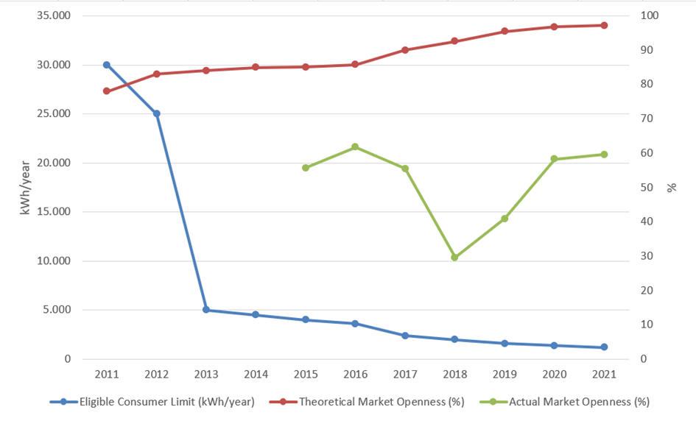
In parallel with the high theoretical market openness rate in 2021, the rate of consumers, using their right of eligible consumer, in total consumption was also higher. The consumption of eligible consumers in 2021 was 150,71 TWh. This rate corresponds to 59,56% of the total invoiced consumption.

The development of the number of eligible consumers in 2021 is shown in Figure 3.2.

Figure 3.2: Number of Eligible Consumer by Months in 2021
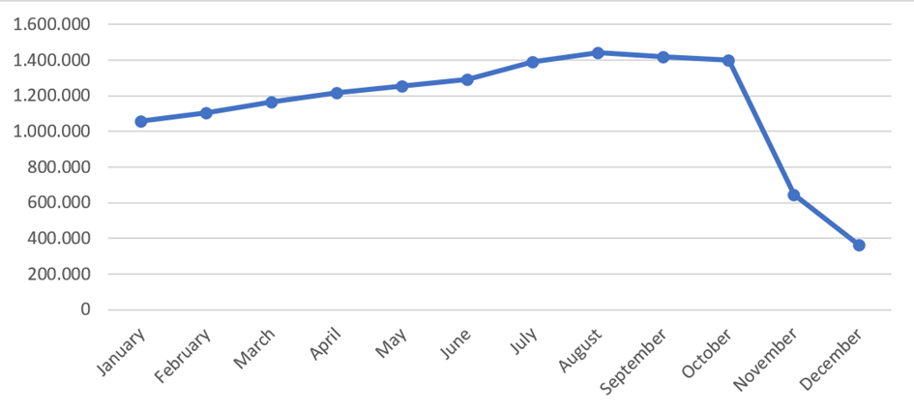
The number of eligible consumers, which was 1 million 24 thousand by the end of 2020, decreased by 64% at the end of 2021 to 364,000. This number corresponds to approximately 0,77% of the total number of consumers.
The distribution of eligible consumers and their consumption by distribution regions (excluding eligible consumers connected by transmission) is shown in Figure 3.3. When the distribution is analyzed, it is seen that the highest number of eligible consumers is in Meram, Toroslar and Başkent regions.

Figure 3.3: Distribution of Eligible Consumers and Their Consumptions by Distribution Regions in 2021
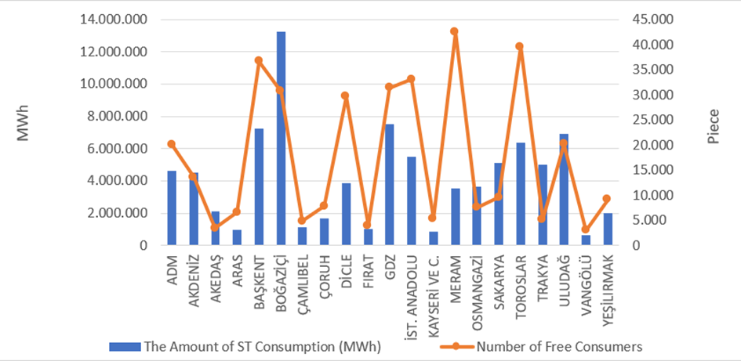

Considering the distribution of the consumption of eligible consumers on the basis of distribution regions, Boğaziçi, GDZ, Başkent and Uludağ constitute the four regions with the highest consumption.
Figure 3.4 shows the distribution of eligible consumer consumption by supplier type.

Figure 3.4: Distribution of Eligible Consumer Consumption by Supplier Type (%)
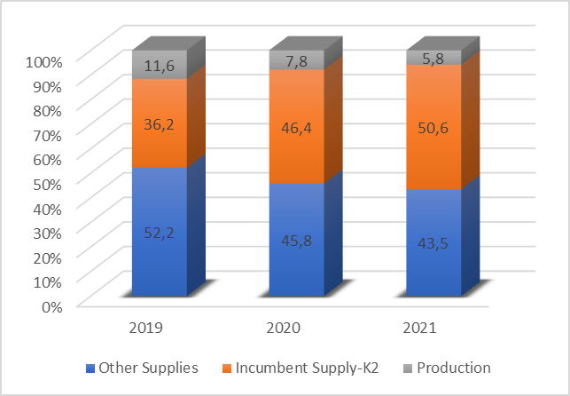
The number of eligible consumers which switched their suppliers and their consumption on a monthly basis are shown in Figure 3.5.

Figure 3.5: Monthly Changes in Number and Consumptions of Eligible Consumers Switching Their Supplier (Number-MWh)
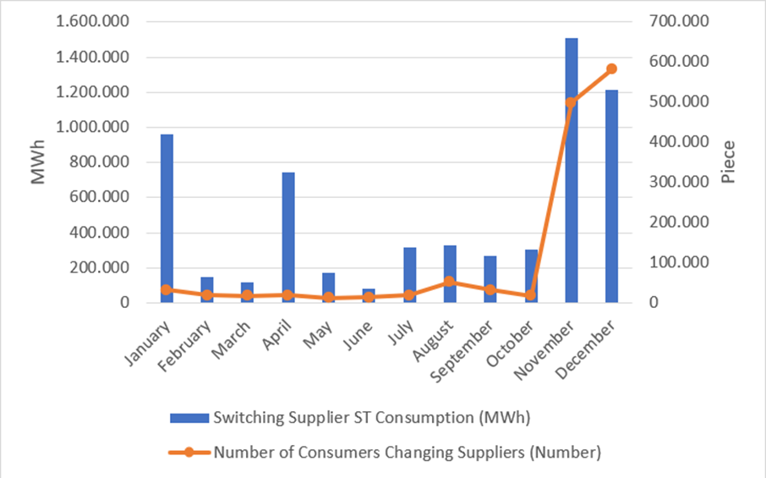
The number of eligible consumers switched their suppliers in 2021 was 1.315.535 and their total consumption was 6,16 TWh., which corresponds to 2,44% of total invoiced consumption.
Table 3.3 shows the distribution of eligible consumers' supplier changes by supplier type. It is seen that majority of supplier changes were consumers who switched to regulated tariffs.

Table 3.3: Distribution of Eligible Consumers' Supplier Changes by Supplier Type
Former Supplier Type | New Supplier Type |  |  |  | Grand Total
Former Supplier Type | Other Supply | Incumbent Supplier-K1 | Incumbent Supplier-K2 | Generation | Grand Total
Other Supply | 4.376 | 60.640 | 8.987 | 113 | 74.116
Incumbent Supplier-K2 | 21.275 | 1.168.201 | 48.085 | 193 | 1.237.754
Generation | 1.647 | 958 | 1.022 | 38 | 3.665
Grand Total | 27.298 | 1.229.799 | 58.094 | 344 | 1.315.535

- TRANSMISSION

In this section, summary information about the transmission system and changes of transmission system with tables and figures by the years are given.

  - Transmission System

The information about transformer center in the transmission system by the end of 2021 is shown in Table 4.1. As shown in the table, most of the transformer centers in the system are of 154 kV voltage level. There are 1.245 transformer centers, of which 737 are in TEİAŞ ownership and 508 are in private ownership. Transformer capacity reached to 249.050 MVA. 207.516 MVA of this capacity is in TEİAŞ ownership and the remaining 41.534 MVA is in private ownership.

Table 4.1: Transformer Center Information
 | Voltage (kV) | Number of Centers | Number of Transformers | Capacity (MVA)
TEİAŞ | 380 | 117 | 392 | 82.765
TEİAŞ | 220 | 0 | 0 | 0
TEİAŞ | 154 | 617 | 1.600 | 124.492
TEİAŞ | 66 | 3 | 17 | 259
TEİAŞ | TEİAŞ Total | 737 | 2.009 | 207.516
Private Ownership | 380 | 55 | 57 | 9.198
Private Ownership | 220 | 0 | 0 | 0
Private Ownership | 154 | 450 | 524 | 32.323
Private Ownership | 66 | 3 | 1 | 13
Private Ownership | Private Total | 508 | 582 | 41.534
 | TOTAL | 1.245 | 2.591 | 249.050

%65,75 of the transmission lines, which are 72.272 km in total, constitute lines with a voltage level of 154 kV. Almost all the remaining part is at 380 kV voltage level, and lines at 220 kV and 66 kV voltage level are only 99,03 km.

Table 4.2: TEİAŞ Transmission Lines
 | 2020 | 2021 | Change (%) | 2020 | 2021 | Change (%)
Voltage (kV) | Number of Lines |  | Change (%) | Length (km) |  | Change (%)
380 | 299 | 315 | 5,35 | 24.029 | 24.653 | 2,60
220 | 2 | 0 | -100,00 | 85 | 0 | -100,00
154 | 1.779 | 1.851 | 4,05 | 46.874 | 47.520 | 1,38
66 | 14 | 12 | -14,29 | 110 | 99,03 | -9,97
Total | 2.094 | 2.178 | 4,01 | 71.098 | 72.272 | 1,65

Figure 4.1: Changes in TEİAŞ Transmission Line Lengths by Years (km)

In the last 18 years, there was a 58% increase in the length of transmission lines.
  - Transmission System Connection Applications

The table below shows the number and capacity of applications made in 2021 for connection to the transmission system, as well as information about applications accepted, rejected and in the evaluation stage.

Table 4.3: Connection Applications to the Transmission System (Number - MW)
 | Connection Application |  | Accepted |  | Rejected |  | In the Evaluation Phase
 | Number | Capacity (MW) | Number | Capacity (MW) | Number | Capacity (MW) | Number | Capacity (MW)
Licensed Producers | 217 | 3.778,42 | 215 | 3.642,42 | 0 | 0,00 | 2 | 136,00
Unlicensed Producers | 7 | 177,99 | 7 | 177,99 | 0 | 0,00 | 0 | 0,00
Consumer | 24 | 2.479,55 | 23 | 2.382,55 | 0 | 0,00 | 1 | 97,00

In 2021, a total 3.778,42 MW connection applications were made by licensed producers. 215 applications of 3.642,42 MW were accepted, and 2 applications of 136 MW were in evaluation phase.
In addition, 7 connection capacity applications of 177,99 MW were made by unlicensed producers and all of these applications were accepted.
On the other hand, a connection capacity application of 2.479,55 MW was made by consumers, and 2.382,55 MW of these applications were accepted and the remaining 97 MW were still in evaluation phase.

  - Tariffs

Transmission system usage and system operation tariffs applied by TEİAŞ to be implemented as of 01/01/2021 have been determined by the Board Decision dated 30/12/2020 and numbered 9958 for manufacturers and consumers on 15 regions basis. In addition, in accordance with subparagraph (h) of paragraph 7 of article 5 of the Law on the Organization and Duties of the Energy Market Regulatory Authority No. 4628 with its Decision dated 24/09/2020 and numbered 9575, and subparagraph (e) of paragraph (A) of article 10, 2021 The transmission surcharge applied in the year was determined as 0.5% (five per thousand) of the transmission tariff of the Turkish Electricity Transmission Corporation.
The system usage and system operation tariffs applied in 2021 are shown in Table 4.4 for production and consumption on the basis of 14 regions.

Table 4.4: System Usage and System Operation Tariffs Applied in 2021 (TL/MW-Year, TL/MWh)
Region No. | Production |  |  | Consumption
Region No. | System Usage Tariffs |  | System Operation Tariffs | System Usage Tariffs |  | System Operation Tariffs
Region No. | TL/MW-Year | TL/MWh | TL/MWh | TL/MW-Year | TL/MWh | TL/MWh
1 | 37.124,78 | 9,07 | 6,33 | 68.698,64 | 8,28 | 6,45
2 | 42.084,84 | 9,07 | 6,33 | 64.602,79 | 8,28 | 6,45
3 | 41.854,10 | 9,07 | 6,33 | 65.098,57 | 8,28 | 3,08
4 | 42.400,29 | 9,07 | 6,33 | 64.163,33 | 8,28 | 3,08
5 | 44.429,98 | 9,07 | 6,33 | 63.136,00 | 8,28 | 3,08
6 | 46.311,51 | 9,07 | 6,33 | 62.685,82 | 8,28 | 3,08
7 | 47.695,87 | 9,07 | 6,33 | 59.725,91 | 8,28 | 3,08
8 | 51.460,52 | 9,07 | 6,33 | 58.695,83 | 8,28 | 3,08
9 | 53.456,93 | 9,07 | 6,33 | 57.022,15 | 8,28 | 3,08
10 | 61.327,06 | 9,07 | 6,33 | 52.243,29 | 8,28 | 3,08
11 | 63.748,61 | 9,07 | 6,33 | 51.441,97 | 8,28 | 3,08
12 | 65.877,12 | 9,07 | 6,33 | 49.654,92 | 8,28 | 3,08
13 | 67.973,12 | 9,07 | 6,33 | 49.308,28 | 8,28 | 3,08
14 | 73.043,03 | 9,07 | 6,33 | 44.625,15 | 8,28 | 3,08
15 | 76.819,46 | 9,07 | 6,33 | 43.280,42 | 8,28 | 3,08

Figure 4.2: Capacity Based Regional Transmission System Usage Tariffs Applied in 2021 (TL/MW-Year)
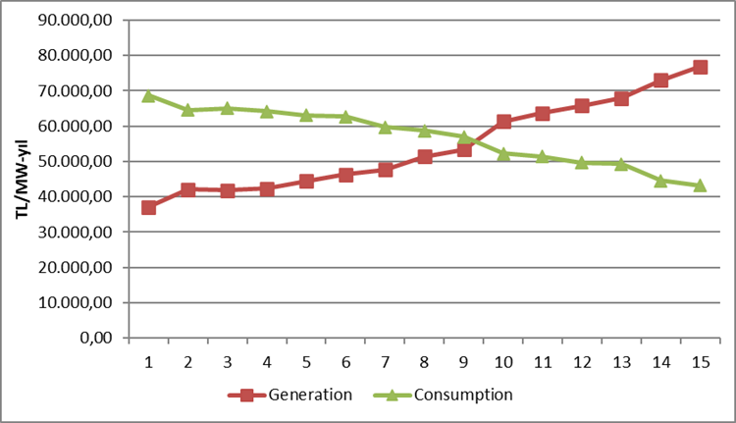
  - Amount of Investment

The amount of investment made by TEİAŞ is shown in Table 4.5. It is observed that the amount of investment increased by 189,46% in 2021.

Table 4.5: Comparison of 2020 and 2021 Investment Amount (TL-%)
Investment Payment Type | 2020 |  | 2021 |  | Change (%)
Investment Payment Type | Amount (TL) | Share (%) | Amount (TL) | Share (%) | Change (%)
New Transformer Investment | 1.544.105.000 | 45,47 | 1.496.369.000 | 23,26 | -3,09
New Line Investment | 777.377.000 | 22,89 | 2.411.611.000 | 37,48 | 210,22
Operational Investment | 954.486.000 | 28,1 | 2.319.440.000 | 36,05 | 143
Machine and Equipment | 49.664.000 | 1,46 | 14.453.000 | 0,22 | -70,9
Communication System Information Infrastructure | 65.082.000 | 1,92 | 185.452.000 | 2,88 | 184,95
Etudes | 5.521.000 | 0,16 | 7.210.000 | 0,11 | 30,59
Total | 3.396.235.000 | 100 | 6.434.535.000 | 100 | 189,46

  - Losses

The transmission system loss (TSL) rate varies depending on the demand, load flows, temperature, and investments in the system. It is calculated hourly and the annual average change over the years is shown in Figure 4.3. The transmission system losses established according to European standards in accordance with the population density of our country, the location of the supply sources and geographical conditions are at the level of international performance.
While the transmission system loss was 1,94% in 2020, it was 1,89% in 2021.

Figure 4.3: Transmission System Losses (GWh-%)
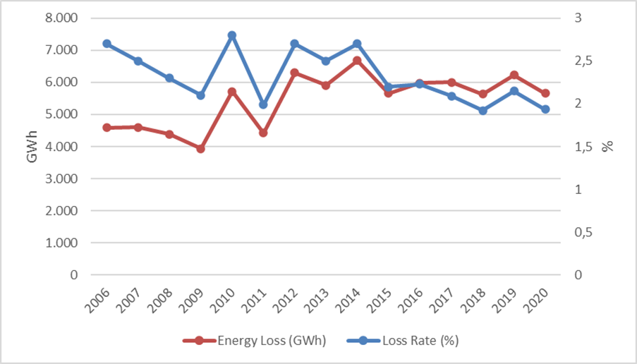

Figure 4.4: Transmission System Losses by Hour (%)
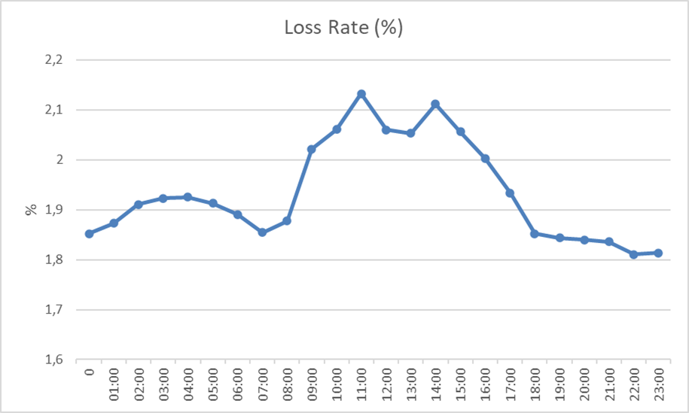

Considering the development of transmission system loss according to hours, it is seen that the highest loss rate is at 03:00.
- DISTRIBUTION

  - Number of Consumers

The total number of consumers using the distribution system increased by 2,67% compared to previous year and it reached 47.311.976 in 2021.

Table 5.1: Number of Consumers Using Distribution System by the end of 2021 (Number-%)
Distribution Company | Number of Consumers |  |  | Change  2020-2021  (%)
Distribution Company | 2019 | 2020 | 2021 | Change  2020-2021  (%)
BOĞAZİÇİ | 5.134.980 | 5.206.237 | 5.309.628 | 1,99
BAŞKENT | 4.278.785 | 4.364.492 | 4.450.587 | 1,97
TOROSLAR | 3.997.925 | 4.095.347 | 4.199.880 | 2,55
GDZ | 3.421.183 | 3.524.199 | 3.642.279 | 3,35
ULUDAĞ | 3.285.323 | 3.380.111 | 3.461.642 | 2,41
İ.ANADOLU | 2.928.586 | 2.986.337 | 3.036.679 | 1,69
AKDENİZ | 2.220.744 | 2.261.116 | 2.317.587 | 2,50
MERAM | 2.169.733 | 2.227.181 | 2.281.186 | 2,42
YEŞİLIRMAK | 2.147.103 | 2.206.997 | 2.278.063 | 3,22
ADM | 1.966.146 | 2.021.409 | 2.127.291 | 5,24
DİCLE | 1.934.641 | 1.993.050 | 2.055.864 | 3,15
SAKARYA | 1.905.188 | 1.963.823 | 2.022.256 | 2,98
OSMANGAZİ | 1.839.538 | 1.888.406 | 1.932.244 | 2,32
ÇORUH | 1.389.748 | 1.431.106 | 1.468.083 | 2,58
TRAKYA | 1.125.936 | 1.168.941 | 1.207.476 | 3,30
ARAS | 1.029.869 | 1.059.704 | 1.095.423 | 3,37
FIRAT | 977.424 | 1.012.087 | 1.059.759 | 4,71
ÇAMLIBEL | 1.005.503 | 1.017.033 | 1.037.517 | 2,01
KAYSERİ VE CİVARI | 748.858 | 770.120 | 788.102 | 2,33
VANGÖLÜ | 710.697 | 745.985 | 775.669 | 3,98
AKEDAŞ | 740.416 | 758.175 | 764.761 | 0,87
Total | 44.958.326 | 46.081.856 | 47.311.976 | 2,67

When Table 5.1 is considered, it is seen that the distribution regions with the highest number of consumers are Boğaziçi with 5.31 million, Başkent with 4.45 million and Toroslar with 4.2 million.
Figure 5.1 shows the number of consumers connected to distribution network and the total consumption of these consumers in 2021.

Figure 5.1: Number of Consumers and Consumption Amounts (Number - MWh)

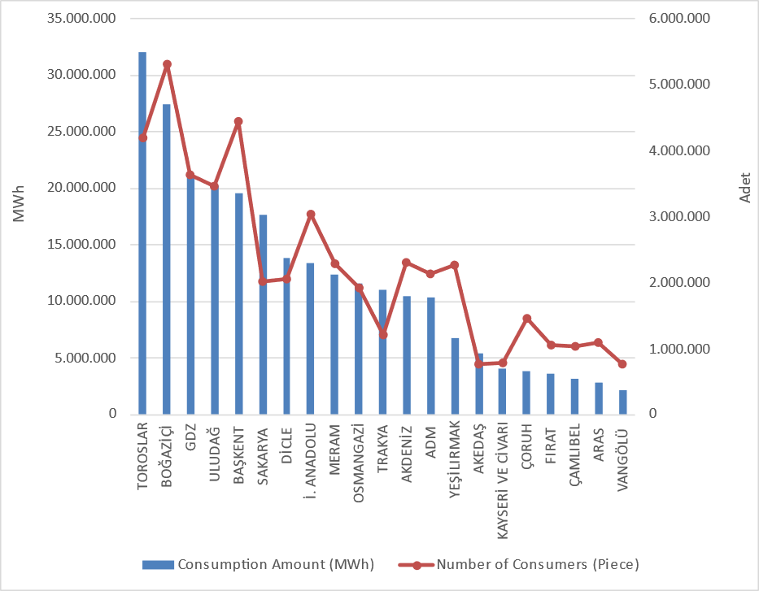

  - Loss Rates

The targeted and actual loss values on the basis of the distribution company is shown in Table 5.2.

Table 5.2: Loss Rates of Distribution Companies (%)
Distribution Company | ACTUAL LOSS RATE |  |  | TARGET LOSS RATE | DIFFERENCE BETWEEN TARGET AND ACTUAL LOSS RATES
Distribution Company | 2020 | 2021 | Change  2020-2021 | 2021 | 2021
ADM | 6,18% | 6,18% | 0,00% | 6,49% | 0,31%
AKDENİZ | 7,08% | 7,67% | -0,59% | 6,80% | -0,87%
AKEDAŞ | 6,10% | 5,62% | 0,48% | 6,67% | 1,05%
ARAS | 20,56% | 20,08% | 0,48% | 22,53% | 2,45%
BAŞKENT | 6,18% | 6,69% | -0,51% | 6,76% | 0,07%
BOĞAZİÇİ | 7,64% | 7,23% | 0,41% | 7,30% | 0,07%
ÇAMLIBEL | 7,57% | 5,42% | 2,15% | 6,49% | 1,07%
ÇORUH | 7,33% | 6,80% | 0,53% | 7,62% | 0,82%
DİCLE | 46,32% | 46,19% | 0,13% | 55,36% | 9,17%
FIRAT | 9,81% | 9,34% | 0,47% | 10,19% | 0,85%
GDZ | 6,43% | 6,36% | 0,07% | 7,32% | 0,96%
AYEDAŞ | 5,40% | 6,22% | -0,82% | 6,62% | 0,40%
KAYSERİ | 6,08% | 6,56% | -0,48% | 6,90% | 0,34%
MERAM | 6,05% | 5,76% | 0,29% | 6,86% | 1,10%
OSMANGAZİ | 6,54% | 6,91% | -0,37% | 7,08% | 0,17%
SAKARYA | 5,93% | 5,95% | -0,02% | 6,90% | 0,95%
TOROSLAR | 11,37% | 11,65% | -0,28% | 11,43% | -0,22%
TRAKYA | 5,59% | 5,31% | 0,28% | 6,08% | 0,77%
ULUDAĞ | 5,86% | 5,23% | 0,63% | 5,94% | 0,71%
VANGÖLÜ | 44,57% | 38,07% | 6,50% | 48,48% | 10,41%
YEŞİLIRMAK | 7,28% | 6,89% | 0,39% | 7,45% | 0,56%

When Table 5.2 is analyzed; all distribution companies except Akdeniz EDAŞ and Toroslar EDAŞ achieved the targeted loss rate for 2021 and the distribution companies performed successfully in 2021 in terms of loss targets. Considering to the aim, the highest development occurred in Vangölü EDAŞ (10,41%), Dicle EDAŞ (9,17%) and Aras EDAŞ (2,45%) distribution regions.
In addition, as shown in Table 5.2, in 2021, the highest loss rates were in Dicle EDAŞ (46,19%), Vangölü EDAŞ (38,07%) ve Aras EDAŞ (20,08%) regions respectively.
In the figure below, the realized and targeted loss rates are shown together.

Figure 5.2: Realized and Targeted Loss Rates in 2021 (%)
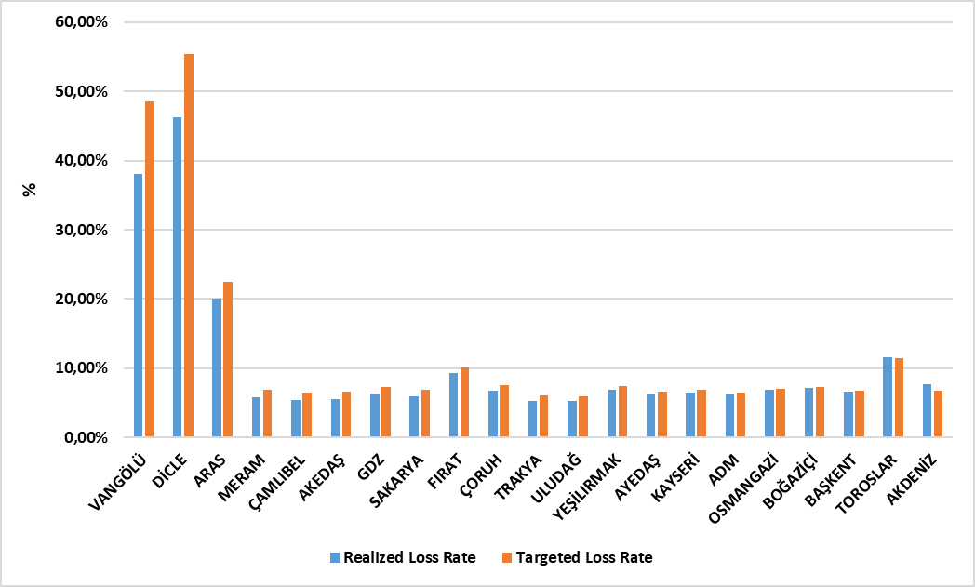

5.3 Employement

By the end of 2021, 63.502 people are employed in the electricity distribution sector; 26.272 people work as permanent staff, 37.230 people work as subcontractor staff. The table below shows the number of employees by distribution companies. While Dicle EDAŞ has the highest total number of employees with 7.667 and the highest number of subcontractor staff with 4.185, Toroslar EDAŞ has the highest number of permanent staff with 4.309. Kayseri ve Civarı EDAŞ, on the other hand, has the lowest number of employees with 935 personnel.

Table 5.3: Number of Employees of Distribution Companies in 2021
Distribution Company | Number of Permanent Employees | Number of Subcontractor Employees | Total
DİCLE | 3.482 | 4.185 | 7.667
TOROSLAR | 4.309 | 2.956 | 7.265
BAŞKENT | 4.054 | 2.281 | 6.335
BOĞAZİÇİ | 708 | 3.539 | 4.247
GDZ | 875 | 3.354 | 4.229
İ. ANADOLU | 2028 | 1.113 | 3.141
ULUDAĞ | 748 | 2190 | 2.938
SAKARYA | 1670 | 1.059 | 2.729
ÇORUH | 375 | 2.215 | 2.590
ADM | 710 | 1.863 | 2.573
MERAM | 738 | 1.575 | 2.313
VANGÖLÜ | 1.027 | 1.211 | 2.238
AKDENİZ | 263 | 1.951 | 2.214
OSMANGAZİ | 1.246 | 956 | 2.202
FIRAT | 314 | 1.833 | 2.147
YEŞİLIRMAK | 495 | 1.645 | 2.140
ARAS | 535 | 1.394 | 1.929
ÇAMLIBEL | 256 | 1.138 | 1.394
AKEDAŞ | 876 | 272 | 1.148
TRAKYA | 824 | 304 | 1.128
KAYSERİ VE CİVARI | 739 | 196 | 935
Grand Total | 26.272 | 37.230 | 63.502

Figure 5.3: Number of Employees of Distribution Companies by the end of 2021
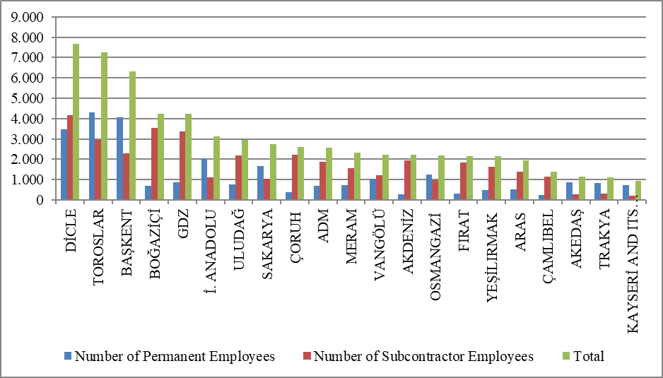

5.4 Information About Network

This section includes basic data on the distribution system. In this context, information about line lengths, transformer capacities and transformer numbers in the distribution voltage level is included in the following tables and figures.
As it is known, the electricity network has reached the whole of Turkey, with exceptions. Except for the industrial facilities with high consumption, all small and medium-sized consumers obtain electrical energy through the distribution system. As it shown in Table 5.4, total distribution line length of Turkey has reached 1.363.320 km. Considering the line lengths by distribution regions, Toroslar, Başkent, Meram, Yeşilırmak and Dicle distribution regions constitute the first five regions in terms of distribution line length. It is also seen from this order that there is a direct proportion between the distribution line lengths and the width of the distribution region and the distribution network.

Table 5.4: Line Lengths, Number of Transformers and Transformer Capacities Based on Distribution Companies at the end of 2021 (km-MVA-Number)
Distribution Company | Line Length (Km) | Transformer Capacity (MVA) | Number of Transformers
ADM | 73.276 | 9.194 | 23.399
AKDENİZ | 69.568 | 8.485 | 20.366
AKEDAŞ | 27.186 | 3.881 | 12.974
ARAS | 58.048 | 3.071 | 13.904
BAŞKENT | 132.981 | 17.421 | 35.008
BOĞAZİÇİ | 52.827 | 18.925 | 15.478
ÇAMLIBEL | 48.957 | 2.967 | 13.314
ÇORUH | 61.489 | 4.676 | 12.971
DİCLE | 81.593 | 14.772 | 69.192
FIRAT | 47.002 | 3.384 | 13.465
GDZ | 64.375 | 16.177 | 34.773
İ. ANADOLU | 33.580 | 9.154 | 7.866
KAYSERİ VE CİVARI | 27.453 | 2.844 | 8.495
MERAM | 120.893 | 13.221 | 61.727
OSMANGAZİ | 51.383 | 8.132 | 28.216
SAKARYA | 62.815 | 8.660 | 18.003
TOROSLAR | 143.346 | 17.754 | 46.492
TRAKYA | 29.586 | 5.627 | 12.087
ULUDAĞ | 52.697 | 11.360 | 27.462
VANGÖLÜ | 40.529 | 3.023 | 12.816
YEŞİLIRMAK | 83.736 | 5.211 | 20.872
Total | 1.363.320 | 187.940 | 508.880
On the other hand, considering the distribution regions in terms of transformer capacity, it is seen that the Boğaziçi, Toroslar, Başkent, Gdz and Dicle electricity distribution regions are in the top five.

Figure 5.4: Line Lengths and Transformer Capacities on the Basis of Distribution Companies at the end of 2021 (km-MVA)
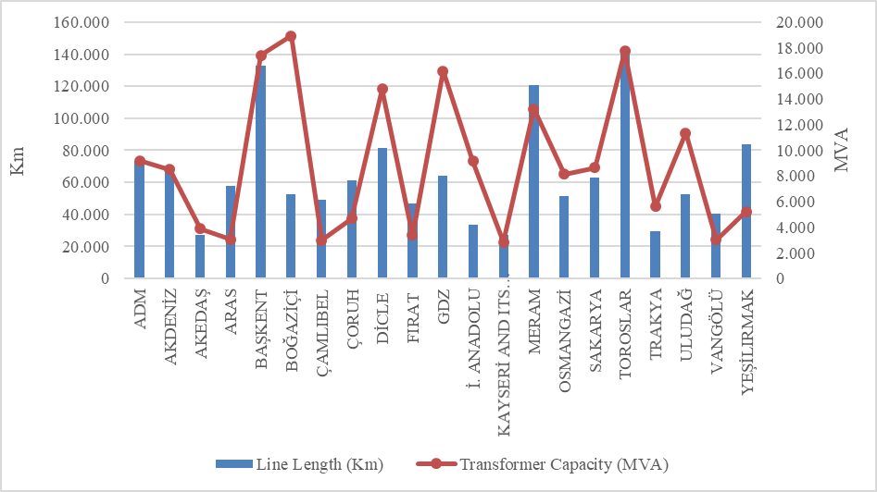

The lengths of distribution lines can be seen in Table 5.5. As shown in the table, overhead lines are 77,97% of the total distribution lines. The share of underground lines within the total distribution lines is 22,03%. This shows that the distribution lines are vulnerable to external conditions. The mentioned external conditions may be natural disasters, climate, or human. In particular, natural events such as heavy rains and heavy winds can directly or indirectly cause damage to the distribution lines.

Table 5.5: The Lengths of Distribution Lines at the end of 2021 (km)
Distribution Company | Overhead(Km) | Underground (Km) | Total (Km)
ADM | 60.739 | 12.537 | 73.276
AKDENİZ | 52.412 | 17.156 | 69.568
AKEDAŞ | 23.944 | 3.242 | 27.186
ARAS | 50.160 | 7.888 | 58.048
BAŞKENT | 98.636 | 34.345 | 132.981
BOĞAZİÇİ | 15.274 | 37.553 | 52.827
ÇAMLIBEL | 42.515 | 6.442 | 48.957
ÇORUH | 56.086 | 5.403 | 61.489
DİCLE | 69.479 | 12.114 | 81.593
FIRAT | 40.473 | 6.530 | 47.002
GDZ | 48.013 | 16.362 | 64.375
İ. ANADOLU | 12.017 | 21.563 | 33.580
KAYSERİ VE CİVARI | 19.480 | 7.973 | 27.453
MERAM | 96.409 | 24.484 | 120.893
OSMANGAZİ | 42.827 | 8.555 | 51.383
SAKARYA | 44.306 | 18.508 | 62.815
TOROSLAR | 118.147 | 25.199 | 143.346
TRAKYA | 23.881 | 5.704 | 29.586
ULUDAĞ | 39.348 | 13.350 | 52.697
VANGÖLÜ | 36.548 | 3.982 | 40.529
YEŞİLIRMAK | 72.299 | 11.437 | 83.736
Grand Total | 1.062.990 | 300.329 | 1.363.320

Figure 5.5: The Length of Lines on the Basis of Distribution Companies at the end of 2021 (km)
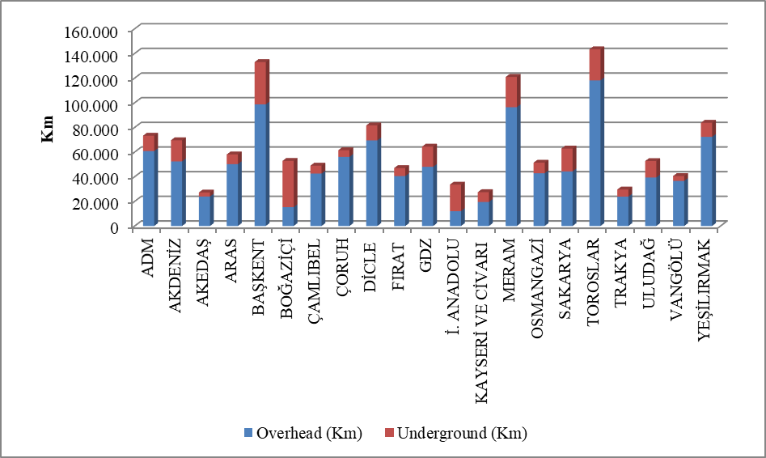
Table 5.6 shows the distribution line lengths and transformer capacities by provinces. According to the table, the first five provinces in the distribution line length ranking; İstanbul, Konya, Ankara, Antalya and Mersin.
Considering the transformer capacities in the distribution system of the provinces, the first five provinces in terms of transformer capacity; İstanbul, Ankara, İzmir, Konya and Antalya.Considering the number of transformers in the distribution system of the provinces, the first five provinces in terms of the number of transformers; Konya, Şanlıurfa, İstanbul, İzmir and Ankara.

Table 5.6: Line Lengths at Distribution Voltage Levels, Number of Transformers and Transformer Capacities by Provinces at the end of 2021 (km-MVA-Number)
Province | Line Length  (km) | Transformer Capacity  (MVA) | Number of Transformers
ADANA | 35.817 | 5.021 | 12.441
ADIYAMAN | 9.015 | 1.125 | 5.352
AFYONKARAHİSAR | 15.866 | 2.402 | 11.061
AĞRI | 10.681 | 525 | 2.826
AKSARAY | 14.179 | 1.347 | 7.447
AMASYA | 9.184 | 686 | 2.713
ANKARA | 63.511 | 12.929 | 20.147
ANTALYA | 48.944 | 6.515 | 14.118
ARDAHAN | 4.529 | 151 | 916
ARTVİN | 7.261 | 755 | 1.821
AYDIN | 22.248 | 2.831 | 7.349
BALIKESİR | 19.107 | 3.214 | 8.533
BARTIN | 7.261 | 449 | 1.483
BATMAN | 6.487 | 1.128 | 4.005
BAYBURT | 3.341 | 167 | 678
BİLECİK | 4.448 | 1.051 | 2.137
BİNGÖL | 7.102 | 463 | 1.986
BİTLİS | 7.787 | 631 | 3.229
BOLU | 9.731 | 760 | 2.853
BURDUR | 9.642 | 766 | 3.037
BURSA | 20.392 | 5.926 | 12.476
ÇANAKKALE | 10.430 | 1.511 | 5.157
ÇANKIRI | 9.398 | 537 | 1.952
ÇORUM | 15.193 | 1.113 | 4.476
DENİZLİ | 22.955 | 2.838 | 7.427
DİYARBAKIR | 20.136 | 3.726 | 13.841
DÜZCE | 9.120 | 790 | 2.161
EDİRNE | 9.240 | 1.100 | 4.175
ELAZIĞ | 14.638 | 1.262 | 4.409
ERZİNCAN | 9.045 | 426 | 2.079
ERZURUM | 18.264 | 1.172 | 4.647
ESKİŞEHİR | 13.681 | 2.624 | 8.785
GAZİANTEP | 23.126 | 3.330 | 9.568
GİRESUN | 16.284 | 1.086 | 3.242
GÜMÜŞHANE | 6.392 | 342 | 1.321
HAKKARİ | 5.198 | 392 | 1.816
HATAY | 27.712 | 2.958 | 9.175
IĞDIR | 4.858 | 240 | 1.100
ISPARTA | 10.982 | 1.204 | 3.211
İSTANBUL | 86.407 | 28.079 | 23.344
İZMİR | 39.976 | 12.353 | 21.526
KAHRAMANMARAŞ | 18.171 | 2.756 | 7.622
KARABÜK | 7.624 | 655 | 1.756
KARAMAN | 9.061 | 884 | 4.585
KARS | 7.329 | 390 | 1.658
KASTAMONU | 21.515 | 926 | 4.722
KAYSERİ | 27.453 | 2.844 | 8.495
KIRIKKALE | 7.883 | 698 | 1.688
KIRKLARELİ | 7.148 | 1.077 | 2.593
KIRŞEHİR | 8.143 | 584 | 2.375
KİLİS | 3.466 | 348 | 1.173
KOCAELİ | 21.981 | 5.023 | 7.834
KONYA | 65.132 | 7.606 | 34.480
KÜTAHYA | 9.845 | 1.225 | 3.538
MALATYA | 20.706 | 1.475 | 5.802
MANİSA | 24.399 | 3.824 | 13.247
MARDİN | 12.170 | 2.516 | 12.275
MERSİN | 40.957 | 5.157 | 11.319
MUĞLA | 28.074 | 3.525 | 8.623
MUŞ | 8.759 | 522 | 2.308
NEVŞEHİR | 11.559 | 1.450 | 6.709
NİĞDE | 12.818 | 1.351 | 6.131
ORDU | 22.175 | 1.008 | 4.545
OSMANİYE | 12.268 | 940 | 2.816
RİZE | 10.086 | 815 | 2.426
SAKARYA | 21.982 | 2.087 | 5.155
SAMSUN | 28.507 | 1.997 | 7.057
SİİRT | 4.391 | 442 | 1.731
SİNOP | 8.677 | 406 | 2.081
SİVAS | 20.452 | 1.237 | 5.206
ŞANLIURFA | 33.017 | 5.921 | 33.246
ŞIRNAK | 5.391 | 1.038 | 4.094
TEKİRDAĞ | 13.199 | 3.450 | 5.319
TOKAT | 14.427 | 817 | 3.490
TRABZON | 21.466 | 1.679 | 4.161
TUNCELİ | 4.556 | 184 | 1.268
UŞAK | 7.543 | 831 | 2.695
VAN | 18.786 | 1.478 | 5.463
YALOVA | 2.768 | 708 | 1.296
YOZGAT | 14.077 | 913 | 4.618
ZONGULDAK | 15.788 | 1.226 | 3.260
Total | 1.363.320 | 187.940 | 508.880

5.5 Quality Indicators

Data on the technical quality of supply continuity of the electricity provided by the distribution companies are compiled. The tables below show System Average Interruption Duration Index (SAIDI) and System Average Interruption Frequency Index (SAIFI).

Table 5.7: Reported and Unreported System Average Interruption Duration Indices of Distribution Companies in 2020-2021 (min.)
Distribution Company | 2020 |  |  | 2021 |  |  | Change  (%)
Distribution Company | Reported SAIDI  (min) | Unreported SAIDI  (min) | Total SAIDI  (min) | Reported  SAIDI (min) | Unreported  SAIDI  (min) | Total  SAIDI  (min) | Change  (%)
TOROSLAR | 1.007,8 | 2.842,8 | 3.850,6 | 1.402,8 | 2.464,1 | 3.866,9 | 0,42
DİCLE | 873,9 | 1.952,3 | 2.826,2 | 1.145,1 | 2.510,0 | 3.655,1 | 29,33
VANGÖLÜ | 572,2 | 3.905,8 | 4.478,0 | 1.107,6 | 2.020,5 | 3.128,1 | -30,15
BAŞKENT | 520,1 | 1.295,4 | 1.815,5 | 799,4 | 1.615,9 | 2.415,3 | 33,04
SAKARYA | 372,6 | 1.295,4 | 1.668,0 | 637,6 | 1.341,1 | 1.978,7 | 18,63
ÇORUH | 514,7 | 1.583,2 | 2.097,8 | 680,2 | 1.276,9 | 1.957,1 | -6,71
ARAS | 621,9 | 871,8 | 1.493,7 | 506,2 | 1.449,7 | 1.955,9 | 30,95
AKDENİZ | 668,7 | 924,0 | 1.592,7 | 676,7 | 1.166,6 | 1.843,3 | 15,73
YEŞİLIRMAK | 425,8 | 851,3 | 1.277,1 | 751,6 | 1.078,9 | 1.830,5 | 43,33
ÇAMLIBEL | 515,6 | 1.365,9 | 1.881,5 | 706,1 | 998,5 | 1.704,6 | -9,40
FIRAT | 435,9 | 1.102,8 | 1.538,7 | 499,4 | 1.150,9 | 1.650,3 | 7,25
AKEDAŞ | 253,7 | 833,9 | 1.087,6 | 248,8 | 1.401,5 | 1.650,3 | 51,74
OSMANGAZİ | 497,8 | 1.285,2 | 1.783,0 | 400,8 | 1.086,1 | 1.486,8 | -16,61
MERAM | 683,7 | 1.005,6 | 1.689,3 | 718,7 | 697,3 | 1.416,0 | -16,18
BOĞAZİÇİ | 215,5 | 829,9 | 1.045,4 | 320,3 | 909,7 | 1.230,0 | 17,66
ADM | 417,2 | 662,0 | 1.079,1 | 503,5 | 716,1 | 1.219,7 | 13,02
GDZ | 557,9 | 650,9 | 1.208,8 | 473,2 | 731,4 | 1.204,5 | -0,35
TRAKYA | 439,8 | 793,8 | 1.233,6 | 481,4 | 572,6 | 1.054,0 | -14,56
KAYSERİ VE CİVARI | 174,1 | 503,6 | 677,8 | 461,4 | 484,5 | 945,9 | 39,56
ULUDAĞ | 295,7 | 429,4 | 725,1 | 289,1 | 475,1 | 764,2 | 5,39
İSTANBUL AN. YK. | 168,3 | 354,0 | 522,3 | 315,3 | 394,6 | 709,8 | 35,90

The table above shows the reported, unreported, and total System Average Interruption Duration Index in 2020 and 2021. While the first three regions were Toroslar, Dicle and Van Gölü, regions according to reported interruptions; Dicle, Toroslar and Van Gölü regions were the first three regarding unreported interruptions.
The region with the highest average total interruption period was Toroslar with 3.866,9 minutes and Dicle distribution region took the second place with 3.655,1 minutes.

Table 5.8: System Average Interruption Duration Indices of Distribution Companies by Reason in 2021 (min.)
Distribution Company | Exogenous | Security | Force Majeure | Network Operator | Total
TOROSLAR | 67,3 | 204,4 | 0,0 | 3.595,2 | 3.866,9
DİCLE | 40,2 | 3,3 | 0,0 | 3.611,7 | 3.655,1
VANGÖLÜ | 0,0 | 3,6 | 0,0 | 3.124,4 | 3.128,1
BAŞKENT | 32,9 | 47,3 | 0,0 | 2.335,1 | 2.415,3
SAKARYA | 38,7 | 40,9 | 85,1 | 1.814,0 | 1.978,7
ÇORUH | 53,5 | 338,5 | 44,3 | 1.520,8 | 1.957,1
ARAS | 15,7 | 0,4 | 0,0 | 1.939,8 | 1.955,9
AKDENİZ | 126,7 | 271,4 | 6,3 | 1.438,9 | 1.843,3
YEŞİLIRMAK | 30,2 | 8,0 | 0,0 | 1.792,2 | 1.830,5
ÇAMLIBEL | 24,5 | 48,4 | 0,0 | 1.631,7 | 1.704,6
FIRAT | 55,1 | 47,2 | 32,1 | 1.515,9 | 1.650,3
AKEDAŞ | 21,1 | 6,9 | 27,8 | 1.594,5 | 1.650,3
OSMANGAZİ | 22,2 | 11,2 | 21,8 | 1.431,7 | 1.486,8
MERAM | 65,7 | 14,6 | 42,1 | 1.293,5 | 1.416,0
BOĞAZİÇİ | 63,5 | 1,2 | 0,0 | 1.165,4 | 1.230,0
ADM | 25,0 | 27,7 | 0,0 | 1.167,0 | 1.219,7
GDZ | 41,9 | 12,5 | 0,0 | 1.150,1 | 1.204,5
TRAKYA | 7,5 | 0,5 | 0,0 | 1.046,0 | 1.054,0
KAYSERİ VE CİVARI | 22,7 | 0,1 | 0,0 | 923,1 | 945,9
ULUDAĞ | 31,4 | 16,1 | 1,3 | 715,4 | 764,2
İSTANBUL AN. YK. | 13,8 | 4,9 | 0,0 | 691,1 | 709,8

The table above shows the distribution of the average downtime by reason. It is seen that the highest downtime was due to the network operator.
The following table shows the average interruption frequency of distribution companies. The highest customer average interruption duration was 115,9 Number/Year per customer in Van Lake region, followed by the Dicle region with 57,5 Number/Year.

Table 5.9: System Average Interruption Frequency Indices of Distribution Companies in 2020 and 2021 (Number/Year)
Distribution Company | 2020 |  |  |  | 2021 |  |  |  | Change  (%)
Distribution Company | Reported | Unreported | Short | Total | Reported | Unreported | Short | Total | Change  (%)
DİCLE | 7,2 | 41,7 | 8,6 | 57,5 | 6,6 | 40,9 | 4,9 | 52,4 | -8,87
OSMANGAZİ | 1,9 | 25,0 | 19,1 | 46,1 | 3,7 | 22,7 | 20,7 | 47,1 | 2,12
VANGÖLÜ | 2,3 | 76,5 | 37,1 | 115,9 | 3,3 | 33,5 | 7,1 | 43,9 | -62,13
FIRAT | 3,6 | 27,4 | 9,8 | 40,8 | 4,3 | 28,6 | 10,9 | 43,9 | 7,61
SAKARYA | 1,9 | 30,9 | 5,1 | 37,9 | 3,1 | 30,9 | 6,0 | 39,9 | 5,37
AKEDAŞ | 1,1 | 20,7 | 10,2 | 31,9 | 1,8 | 23,2 | 12,1 | 37,1 | 16,28
ÇAMLIBEL | 2,6 | 18,6 | 23,3 | 44,4 | 3,6 | 14,2 | 18,9 | 36,7 | -17,48
ARAS | 2,1 | 11,0 | 4,1 | 17,2 | 2,2 | 22,6 | 11,6 | 36,4 | 111,16
ÇORUH | 3,1 | 28,4 | 2,2 | 33,6 | 3,1 | 25,3 | 4,4 | 32,8 | -2,55
YEŞİLIRMAK | 2,0 | 12,8 | 7,6 | 22,3 | 3,4 | 15,5 | 10,6 | 29,5 | 32,28
TOROSLAR | 3,0 | 30,5 | 2,0 | 35,5 | 3,8 | 24,7 | 0,8 | 29,3 | -17,48
AKDENİZ | 5,3 | 13,0 | 5,8 | 24,1 | 3,6 | 15,8 | 4,6 | 24,0 | -0,60
BAŞKENT | 1,5 | 17,5 | 1,7 | 20,7 | 2,2 | 18,1 | 3,0 | 23,2 | 11,79
KAYSERİ VE C. | 1,1 | 15,6 | 12,2 | 28,9 | 1,9 | 10,2 | 10,1 | 22,1 | -23,36
BOĞAZİÇİ | 1,4 | 14,2 | 6,8 | 22,4 | 1,8 | 11,9 | 8,2 | 21,9 | -2,16
ADM | 1,7 | 13,3 | 2,6 | 17,5 | 2,0 | 14,2 | 4,9 | 21,1 | 20,35
GDZ | 3,7 | 12,0 | 1,5 | 17,2 | 3,4 | 12,8 | 2,2 | 18,4 | 7,07
MERAM | 4,4 | 12,4 | 0,1 | 17,0 | 4,1 | 10,7 | 2,1 | 16,9 | -0,48
TRAKYA | 1,7 | 9,8 | 2,2 | 13,8 | 2,2 | 11,0 | 2,1 | 15,3 | 10,32
ULUDAĞ | 2,6 | 8,1 | 2,4 | 13,0 | 2,1 | 8,0 | 2,1 | 12,3 | -5,74
İSTANBUL AN. Y. | 0,7 | 6,7 | 0,4 | 7,8 | 1,0 | 7,6 | 0,5 | 9,1 | 16,67

Table 5.10: Distribution Companies’ System Average Interruption Frequency Indices for per Consumer by Reason in 2021 (Number/Year)
Distribution Company | Exogenous | Security | Short | Force Majeure | Network Operator | Toplam
DİCLE | 0,6 | 0,0 | 4,9 | 0,0 | 46,9 | 52,4
OSMANGAZİ | 0,3 | 0,1 | 20,7 | 0,4 | 25,6 | 47,1
VANGÖLÜ | 0,0 | 0,0 | 7,1 | 0,0 | 36,8 | 43,9
FIRAT | 1,4 | 1,1 | 10,9 | 0,8 | 29,7 | 43,9
SAKARYA | 0,6 | 0,3 | 6,0 | 0,9 | 32,2 | 39,9
AKEDAŞ | 0,5 | 0,1 | 12,1 | 0,2 | 24,3 | 37,1
ÇAMLIBEL | 0,4 | 0,2 | 18,9 | 0,0 | 17,1 | 36,7
ARAS | 0,1 | 0,0 | 11,6 | 0,0 | 24,7 | 36,4
ÇORUH | 0,9 | 2,7 | 4,4 | 0,3 | 24,5 | 32,8
YEŞİLIRMAK | 0,3 | 0,1 | 10,6 | 0,0 | 18,6 | 29,5
TOROSLAR | 0,4 | 0,7 | 0,8 | 0,0 | 27,4 | 29,3
AKDENİZ | 1,7 | 1,1 | 4,6 | 0,1 | 16,5 | 24,0
BAŞKENT | 0,3 | 0,2 | 3,0 | 0,0 | 19,8 | 23,2
KAYSERİ VE CİVARI | 0,3 | 0,0 | 10,1 | 0,0 | 11,7 | 22,1
BOĞAZİÇİ | 0,5 | 0,0 | 8,2 | 0,0 | 13,2 | 21,9
ADM | 0,3 | 0,1 | 4,9 | 0,0 | 15,8 | 21,1
GDZ | 0,8 | 0,1 | 2,2 | 0,0 | 15,3 | 18,4
MERAM | 1,3 | 0,1 | 2,1 | 0,3 | 13,0 | 16,9
TRAKYA | 0,1 | 0,0 | 2,1 | 0,0 | 13,0 | 15,3
ULUDAĞ | 0,4 | 0,1 | 2,1 | 0,0 | 9,7 | 12,3
İSTANBUL AND. YAK. | 0,1 | 0,1 | 0,5 | 0,0 | 8,4 | 9,1

5.6 Investment Amount of Distribution Companies

With the Board Decision No. 9639 dated 22/10/2020, "Procedures and Principles Regarding Electricity Market Distribution System Investments" was approved and entered into force.
With the Board Decision dated 12/11/2020 and numbered 9686, it was decided to determine the Real Reasonable Return Rate as 13,11% (before tax) to taken into account in the fourth tariff implementation period of electricity distribution companies, which would start on 1/1/2021. In addition, with the same Board Decision, the redemption period for the fourth implementation period investments of distribution companies was determined as 10 years.
The table below contains information about the realized investment amounts approved by the Board for 2019, realized investment amounts decleared for 2020 and the investment forecasts declared for 2021.

Table 5.11: Comparison of Distribution Investment Amounts in 2019-2020-2021 (Current Prices - Million TL-%)
Distribution Company | 2019 | 2020 | 2021 | Change  2020-2021  (%)
ADM | 449,5 | 340,9 | 847,2 | 148,55%
AKDENİZ | 325,6 | 405,1 | 447,4 | 10,44%
AKEDAŞ | 123,5 | 107,3 | 274,3 | 155,55%
ARAS | 181,2 | 246,0 | 503,0 | 104,45%
İSTANBUL A.Y. | 322,1 | 330,6 | 550,8 | 66,60%
BAŞKENT | 758,6 | 956,3 | 1.352,8 | 41,46%
BOĞAZİÇİ | 983,4 | 823,5 | 1.176,8 | 42,91%
ÇAMLIBEL | 166,4 | 219,2 | 359,3 | 63,91%
ÇORUH | 166,7 | 275,1 | 350,3 | 27,35%
DİCLE | 615,2 | 861,1 | 1.348,2 | 56,56%
FIRAT | 124,5 | 195,2 | 357,7 | 83,24%
GDZ | 668,9 | 629,3 | 1.042,2 | 65,62%
KAYSERİ | 159,4 | 166,6 | 294,1 | 76,52%
MERAM | 612,5 | 706,3 | 1.028,0 | 45,55%
OSMANGAZİ | 1.435,4 | 540,6 | 561,2 | 3,80%
SAKARYA | 159,0 | 241,1 | 518,5 | 115,08%
TOROSLAR | 787,1 | 1.016,8 | 1.486,2 | 46,17%
TRAKYA | 384,9 | 228,4 | 631,0 | 176,31%
ULUDAĞ | 194,1 | 512,2 | 402,7 | -21,37%
VANGÖLÜ | 163,4 | 163,5 | 613,1 | 274,93%
YEŞİLIRMAK | 195,4 | 426,5 | 574,2 | 34,62%
TOTAL | 8.976,7 | 9.391,7 | 14.719,1 | 56,72%
* The unit price is calculated according to the June 2021 CPI: 547,48.
** Investments starting in the II. Implementation Period and complemented in the III. Implementation Period are included.
*** The table has been prepared based on the investment realization statements of the companies approved by the Board for the investment amounts in 2019.
****The table has been prepared based on the investment realization statements submitted by the companies through the notification system for the investment amounts in 2020.
*****The table has been prepared based on the investment estimation statements submitted by the companies through the notification system for the investment amounts in 2021.

Total investment realization for 2021 increased by 56,72% compared to 2020 and reached 14,72 billion TL (at current prices). The highest investment expenditures for 2021 were realized in Toroslar with 1,49 billion TL and Başkent with 1,35 billion TL.

Figure 5.6: Investment Amounts of Distribution Companies in 2021 (Current Prices-Million TL)
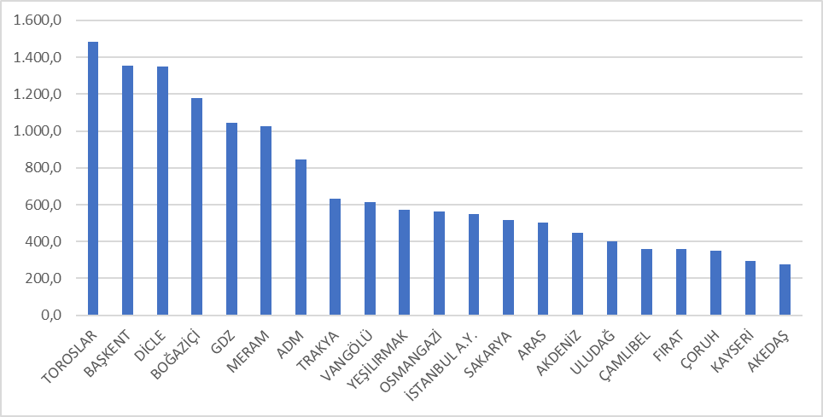

Investment expenditures by investment type in 2021 are shown in the table below. Majority of investments was the network investments.

Table 5.12: Realized Investment Amounts in 2021 by Investment Types (TL)
Distribution Company | Investment Type | 2021 Investment Amount (TL)  (CPI June 2021:547,48)
21 EDAŞ | Network Investments | 11.452.407.704
21 EDAŞ | Investments with Environmental, Security and Other Legal Obligations | 1.712.680.394
21 EDAŞ | Network Operating System Investments | 1.273.392.470
21 EDAŞ | R&D Project Investments | 5.804.375
21 EDAŞ | Other Expenditures as Investment Spending | 274.812.694
21 EDAŞ | Grand Total | 14.719.097.637
* The unit price is calculated according to the June 2021 CPI: 547,48.
** Investments starting in the II. Implementation Period and complemented in the III. Implementation Period are included.

***The tables are prepared on the basis of the declarations made by the companies via the notification system.

5.7 Information about Organized Industrial Zones (OIZ)

The following table shows the data related to OIZ Distribution License Owners.

Table 5.13: Information about Organized Industrial Zones
Number of Participants AG | 50.778
Number of Participants OG | 15.659
Number of Total Participants | 66.437
Line Length AG | 4.519
Line Length OG | 7.874
Total Line Length | 12.393
Number of Employees (Electricity Distribution) | 957
Number of Transformers | 21.003
Installed Capacity of Transformers (MVA) | 22.372
Annual Peak Value of Previous Year (MW) | 6.857

As of the end of 2021, the total number of participants in Organized Industrial Zones was 66.437, of which 50.778 participants were in low voltage and 15.659 in medium voltage. 957 personnel were employed in electricity distribution in OIZ distribution regions.

Total OIZ line length was 12.393 km. Total OIZ Transformer capacity has reached 22.372 MVA with 21.003. The sum of the peak values for the previous year in the OIZ regions was 6.857 MW.

- PRICING

The Electricity Market Law foresee a market structure based on bilateral agreements. In this market the price of electricity determined by mutual agreement of buyers and sellers. Therefore, the prices determined by bilateral agreements are within the knowledge of relevant parties and are not shared with the public. On the other hand a significant portion of consumers provide energy from regulated price in Turkish Electricity Market. Therefore, yearly changes regulated prices and price components are very important. This section contains data on regulated prices and the changes in price components over the years.
In the Figure below, there is a change of retail energy tariffs (including system fees, tax and funds, including PSH) with respect to tariff groups by years.

Figure 6.1: Retail Price Excluding Taxes and Funds by Years (Energy+PSH) (kr/kWh)
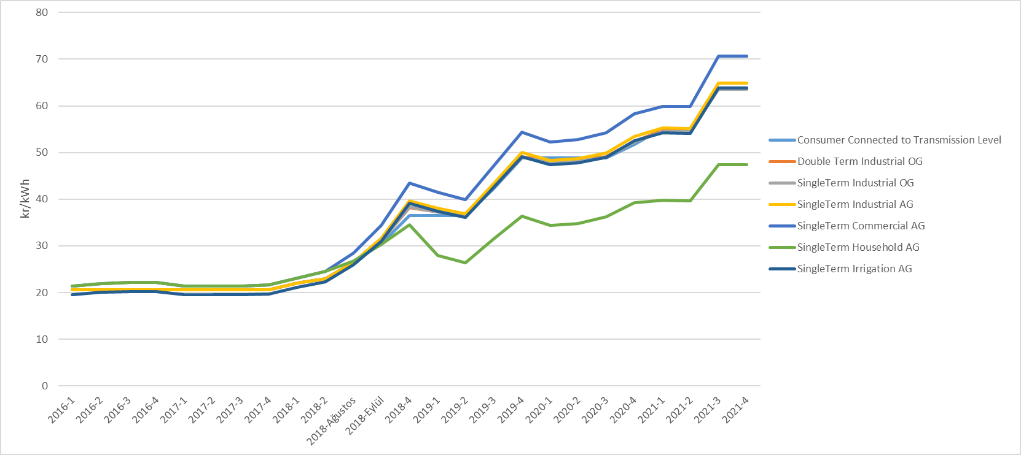

As it is known, transmission and distribution lines must be used to deliver energy from power plants to the consumer. The figure below shows the change in the distribution price over the years. The price in question includes distribution, transmission, and technical and non-technical loss costs.

Figure 6.2: Change in Network Costs (Distribution, Transmission and Loss) by Years (kr/kWh)
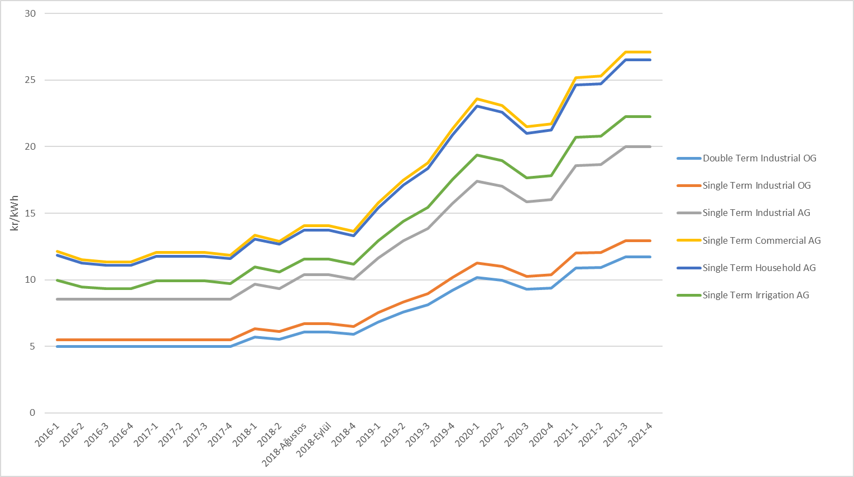
As a result of adding the distribution cost to the energy cost, the pre-tax unit energy cost is reached. The figure below shows the change in unit energy cost by years, excluding taxes and funds (energy fund, TRT share, electricity and gas consumption tax and VAT).

Figure 6.3: Change in Electricity Tariffs before Taxes and Funds by Years (kr/kWh)
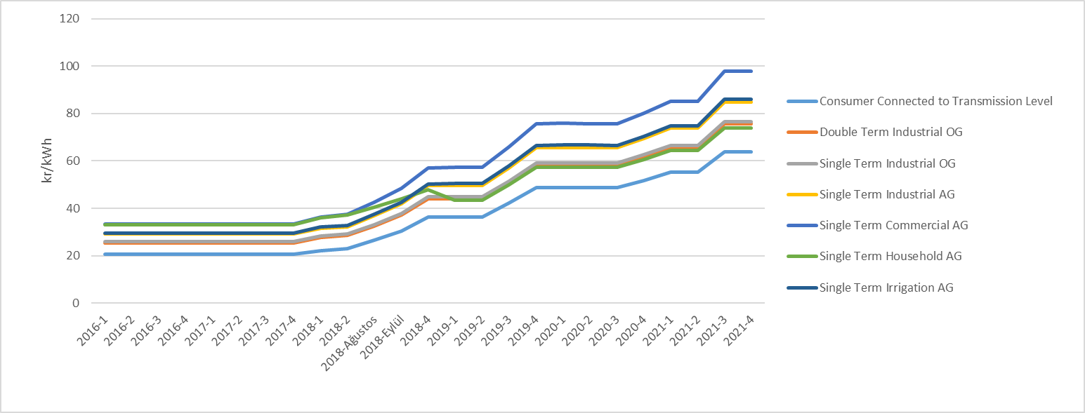
As seen in the figure above, the consumer group with the highest unit energy price before taxes and funds was commercials. The lowest unit energy price before taxes and funds was the consumers connected to the transmission system.

Figure 6.4: Share of Items on Household Electricity Invoice in 2021 (%)
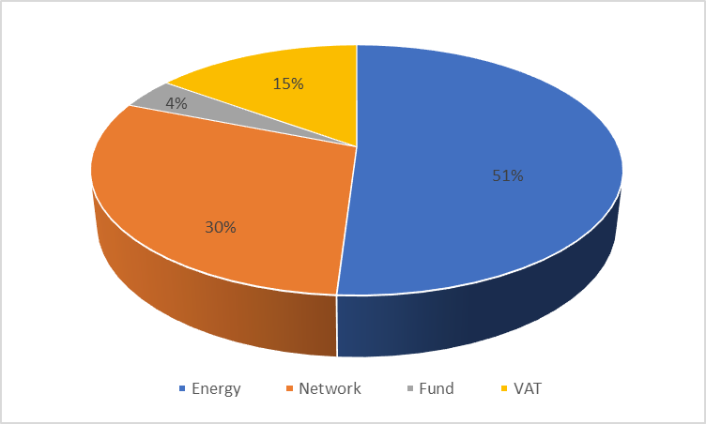
As can be seen from Figure 6.4, the most important item out of the retail energy amount is the network amount with 30% share from the components in the invoices of consumers in the residential group.

Figure 6.5: 2021 Yılı Sanayi Elektrik Faturasında Yer alan Bedellerin Payı (%)
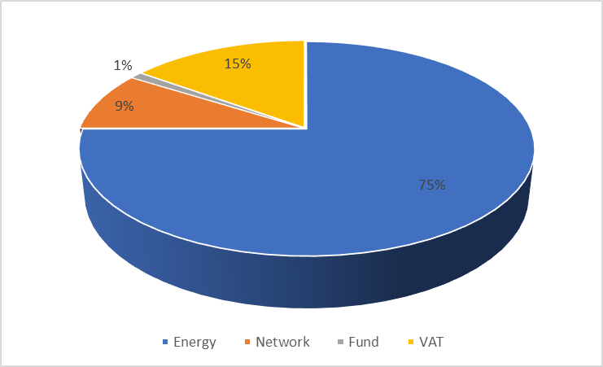
As Figure 6.5 and Figure 6.4 compared, industrial consumers have a higher share of retail energy amount and a lower share of distribution (network) in the invoice components of the industrial group compared to households.

Monthly average exchange rates of Central Bank is used for calculating the average YEKDEM Price.
The HHI values are evaluated as a competitive market indicator. If HHI is under 1000 the market is competitive, medium intensity if HHI is between 1000 -1800, and an oligopoly market if HHI is above 1800. In the same way, if the HHI increases by more than 100 points in mergers and acquisitions, it is considered that competitiveness is reduced.
Includes all sales made to eligible and non-eligible consumers for sales volumes of incumbent supply companies. Sales by production companies to eligible consumers are not included.
Including the data about facilities owned by customers.

