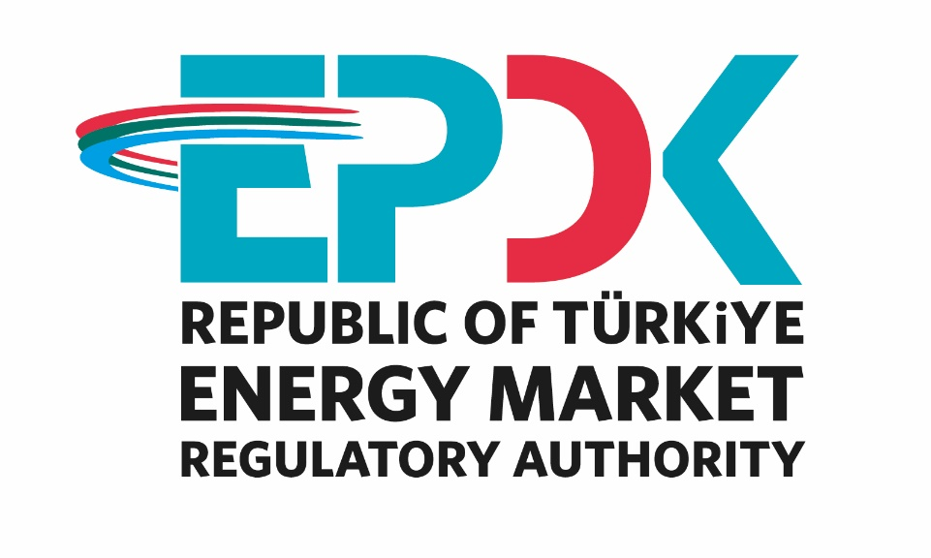

ELECTRICITY MARKET
SECTOR REPORT 2024

All the information, tables and figures provided in this report are reserved and cannot be used without reference.

REPUBLIC OF TÜRKİYE
ENERGY MARKET REGULATORY AUTHORITY

Strategy Development Department

ANKARA, 2025

Important Reminder: Licensee companies can make corrections to the data they previously submitted to the Authority by requesting a correction of the notification within the framework of the relevant provisions of the Energy Market Notification Regulation. For this reason, there may be data differences between the published reports.

*This report is published under the Official Statistics Programme.

The message of the president

Under the Electricity Market Law 6446, following a period in which secondary regulations were emphasized and efforts were made for many regulations and other legislation that entered into force, significant progress was made in 2024 to transform the market into a structure that operates in a more liberal, competitive, transparent and predictable manner in the light of these regulations.
In this context, the share of renewable energy sources in total installed electricity capacity, including unlicensed, increased from 56,28% in 2023 to 59,37% in 2024. In addition, in 2024, the licensing procedures for electricity generation facilities with storage continued. Through these facilities, it is aimed both to increase the installed capacity based on wind and solar energy and to expand the installation of electricity storage systems.
On the other hand, following the inclusion of aggregation as an activity under Law 6446 at the end of 2022, the “Regulation on Aggregation Activity in the Electricity Market” was drafted and entered into force in 2024, with the aim of enabling aggregators to carry out market transactions on behalf of grid users, manage generation or consumption schedules, and contribute to system balance. Moreover, by allowing consumers to participate on the demand side, the regulation aims to enhance system flexibility. In this context, the necessary secondary legislation was also finalized within the year. With the commencement of implementation and the observation of its benefits, aggregation is expected to play an increasingly significant role in the coming periods.
The market development reports that we present to our stakeholders are largely compiled and analyzed from the data submitted to our Authority using the Energy Market Notification System. One of our main objectives is to ensure the integrity, consistency and reliability of the data in these reports, which are of great importance to be shared with all relevant parties and the public in an accurate and timely manner.
While underlining once again that we, as EMRA, are open to all kinds of constructive opinions and suggestions, I would like to thank all our sector stakeholders for their devoted work in the forward-looking development process of our country's energy market under all circumstances, and I hope that the 2024 Electricity Market Development Report will be beneficial to all relevant persons, institutions and organizations.

Mustafa YILMAZ
President

EXECUTIVE SUMMARY

- Number of Licenses in Electricity Market in 2024
License Type | License Application | Grant of License | Expired License | License Revocation | Number of Licenses at Operation at the end of the Term
Distribution License | - | - | - | - | 21
ED Distribution License | 2 |  |  |  | -
Transmission License | - | - | - | - | 1
OIZ Distribution License | 7 | 7 | - | - | 211
OIZ Generation License | - | - | - | - | 3
Pre-License | 29 | 158 | 148 | 2 | 825
Market Operation License | - | - | - | - | 2
Supply License | 73 | 60 | 5 | 3 | 388
Generation License | 43 | 85 | 69 | 11 | 1.904
Total | 154 | 310 | 222 | 16 | 3.333

- Distribution of Pre-License and Generation License by the end of 2024
Resource Type | Pre-License |  | Generation License
Resource Type | License Number | Installed Power Assigned to License (MWe) | License Number | Installed Power Assigned to License (MWe)
Hydraulic | 58 | 2.472,04 | 782 | 33.727,50
Wind | 296 | 19.885,51 | 309 | 15.575,59
Geothermal | 13 | 247,08 | 69 | 1.944,63
Biomass | 20 | 180,61 | 342 | 2.532,61
Solar | 431 | 14.920,66 | 55 | 2.518,81
Import Coal |  |  | 13 | 10.341,80
Domestic Coal |  |  | 22 | 10.165,97
Coal | 3 | 38,41 | 16 | 604,88
Fuel-oil |  |  | 20 | 986,11
Natural Gas | 1 | 2,00 | 240 | 25.047,45
Uranium |  |  | 1 | 4.800,00
Other Thermal | 3 | 26,00 | 35 | 865,75
Grand Total | 825 | 37.772,31 | 1.904 | 109.111,1

Installed Capacity and Production by Resources by the end of 2024
RESOURCE TYPE | TOTAL INSTALLED CAPACITY* (MW) | SHARE (%) | TOTAL GENERATION* (GWh) | SHARE (%)
HYDRAULIC | 32.202,96 | 27,78 | 74.881,58 | 21,57
WIND | 12.862,79 | 11,09 | 36.628,89 | 10,55
SOLAR | 19.909,68 | 17,17 | 25.894,53 | 7,46
BIOMASS | 2.122,94 | 1,83 | 10.162,56 | 2,93
GEOTHERMAL | 1.733,51 | 1,50 | 11.241,52 | 3,24
RENEWABLE | 68.831,87 | 59,37 | 158.809,10 | 45,74
IMPORT COAL | 10.455,80 | 9,02 | 75.408,27 | 21,72
NATURAL GAS | 24.917,12 | 21,49 | 64.927,63 | 18,70
LIGNITE | 10.229,19 | 8,82 | 42.055,09 | 12,11
HARD COAL | 840,77 | 0,73 | 4.131,66 | 1,19
ASPHALTITE | 405,00 | 0,35 | 1.153,81 | 0,33
FUEL OIL | 251,93 | 0,22 | 727,68 | 0,21
NAPHTHA | 4,74 | 0,00 | 0,00 | 0,00
LNG | 1,95 | 0,00 | 0,00 | 0,00
DIESEL | 1,04 | 0,00 | 0,00 | 0,00
THERMIC | 47.107,53 | 40,63 | 188.404,15 | 54,26
TOTAL | 115.939,40 | 100,00 | 347.213,24 | 100,00

*Licensed and unlicensed power plants are included.

- Licensed Installed Capacity and Peak Demand

  - In 2024, licensed installed capacity increased by 1,16% compared to the previous year and reached 97.354,09 MW.

  - The development of licensed installed capacity by resource in 2023-2024 is shown below:

Resource Type | 2023 Value (MW) | Share (%) | 2024 Value (MW) | Share (%) | 2023-2024 Change (%)
DAM | 23.650,21 | 24,57 | 23.868,83 | 24,52 | 0,92
WIND | 11.706,67 | 12,16 | 12.744,61 | 13,09 | 8,87
RIVER | 8.297,26 | 8,62 | 8.315,78 | 8,54 | 0,22
BIOMASS | 1.988,69 | 2,07 | 2.035,69 | 2,09 | 2,36
GEOTHERMAL | 1.653,43 | 1,72 | 2.007,58 | 2,06 | 21,42
SOLAR | 1.691,34 | 1,76 | 1.733,51 | 1,78 | 2,49
RENEWABLE | 48.987,60 | 50,90 | 50.706,00 | 52,08 | 3,51
NATURAL GAS | 25.178,90 | 26,16 | 24.470,30 | 25,14 | -2,81
IMPORT COAL | 10.373,80 | 10,78 | 10.455,80 | 10,74 | 0,79
LIGNITE | 10.193,96 | 10,59 | 10.216,56 | 10,49 | 0,22
HARD COAL | 840,77 | 0,87 | 840,77 | 0,86 | 0,00
ASPHALTITE COAL | 405,00 | 0,42 | 405,00 | 0,42 | 0,00
FUEL OIL | 251,93 | 0,26 | 251,93 | 0,26 | 0,00
NAPHTHA | 4,74 | 0,00 | 4,74 | 0,00 | 0,00
LNG | 1,95 | 0,00 | 1,95 | 0,00 | 0,00
DİESEL | 1,04 | 0,00 | 1,04 | 0,00 | 0,00
THERMIC | 47.252,08 | 49,10 | 46.648,09 | 47,92 | -1,28
Grand Total | 96.239,68 | 100,00 | 97.354,09 | 100,00 | 1,16

The share of renewable energy sources (including hydropower) in total licensed installed capacity was 50,90% in 2023 and 52,08% in 2024, while the share of total thermal installed capacity was 49,10% in 2023 and 47,92% in 2024.

  - Peak demand increased by 6,46% to 58.712,36 MW.

- Licensed Electricity Generation

  - In 2024, the amount of licensed electricity generation increased by 4,85% compared to 2023 to 326.843,63 GWh.

  - In 2023-2024, licensed electricity generation according to resource type is given below:

Resource Type | 2023 Value (GWh) | Share (%) | 2024 Value (GWh) | Share (%) | 2023-2024 Change (%)
Hydraulic | 63.929,22 | 20,51 | 74.827,95 | 22,89 | 17,05
Wind | 33.867,57 | 10,86 | 36.486,18 | 11,16 | 7,73
Geothermal | 11.102,08 | 3,56 | 11.241,52 | 3,44 | 1,26
Biomass | 9.815,16 | 3,15 | 10.077,51 | 3,08 | 2,67
Solar | 4.387,62 | 1,41 | 5.831,41 | 1,78 | 32,91
Renewable | 123.101,65 | 39,49 | 138.464,57 | 42,36 | 12,48
Import Coal | 72.719,40 | 23,33 | 75.408,27 | 23,07 | 3,70
Natural Gas | 68.353,08 | 21,93 | 64.902,54 | 19,86 | -5,05
Lignite | 41.735,31 | 13,39 | 42.055,09 | 12,87 | 0,77
Hard Coal | 3.752,68 | 1,20 | 4.131,66 | 1,26 | 10,10
Fuel Oil | 464,87 | 0,15 | 727,68 | 0,22 | 56,53
Asphaltite Coal | 1.589,00 | 0,51 | 1.153,81 | 0,35 | -27,39
Diesel | 2,06 | 0,00 | 0,00 | 0,00 | -100,00
Thermic | 188.616,40 | 60,51 | 188.379,06 | 57,64 | -0,13
Grand Total | 311.718,05 | 100,00 | 326.843,63 | 100,00 | 4,85

The share of renewable energy resources (including hydroelectricity) in total licensed electricity generation increased from 39,49% in 2023 to 42,36% in 2024. The share of thermal resources decreased from 60,51% in 2023 to 57,64% in 2024.

- Unlicensed Installed Capacity

  - In 2024, unlicensed installed capacity increased by 29,44% compared to the previous year and reached 18.585,32 MW. Solar power plants account for 96,32% of this amount.

  - The development of unlicensed installed capacity by resource in 2023-2024 is shown below:

Source Type | 2023 |  | 2024 |  | 2023-2024 Change (%)
Source Type | Installed Capacity (MWe) | Share (%) | Installed Capacity (MWe) | Share (%) | 2023-2024 Change (%)
Solar | 13.725,53 | 95,59 | 17.902,10 | 96,32 | 30,43
Natural gas | 435,23 | 3,03 | 446,82 | 2,40 | 2,66
Wind | 96,50 | 0,67 | 118,18 | 0,64 | 22,47
Biomass | 86,30 | 0,60 | 87,24 | 0,47 | 1,09
Hydraulics | 14,97 | 0,10 | 18,35 | 0,10 | 22,63
Lignite | - | - | 12,63 | 0,07 | -
Grand Total | 14.358,53 | 100,00 | 18.585,32 | 100,00 | 29,44

- Unlicensed Generation

  - In 2024, the gross unlicensed generation amount increased by 37,66% compared to 2023 and reached 20.369,61 GWh. Of this amount, 98,50% was obtained from solar energy.

  - The development of gross unlicensed generation by resource in 2023-2024 is shown below:

Source Type | 2023 |  | 2024 |  | 2022-2023  Change (%)
Source Type | Unlicensed Generation (GWh) | Share (%) | Unlicensed Generation (GWh) | Share (%) | 2022-2023  Change (%)
Solar | 14.444,62 | 97,62 | 20.063,12 | 98,50 | 38,90
Wind | 172,26 | 1,16 | 142,72 | 0,70 | -17,15
Biomass | 86,67 | 0,59 | 85,06 | 0,42 | -1,86
Hydraulics | 69,41 | 0,47 | 53,64 | 0,26 | -22,72
Natural Gas | 23,69 | 0,16 | 25,08 | 0,12 | 5,89
Grand Total | 14.796,64 | 100,00 | 20.369,61 | 100,00 | 37,66

- Invoiced and Actual Consumption
Consumer Type | Consumption Amount of Consumers Connected to the Distribution Voltage (GWh) |  | Consumption Amount of Consumers Connected to the Transmission Voltage (GWh) |  | Total (GWh)
Consumer Type | 2023 | 2024 | 2023 | 2024 | 2023 | 2024
Non-eligible | 130.194,82 | 134.486,06 | 1.165,59 | 1.560,52 | 131.360,40 | 136.046,58
Eligible | 63.549,46 | 72.812,39 | 68.934,65 | 70.185,53 | 132.484,11 | 142.997,91
Grand Total | 193.744,28 | 207.298,45 | 70.100,24 | 71.746,05 | 263.844,51 | 279.044,49

  - In 2024, invoiced electricity consumption increased by 5,76% compared to the previous year and amounted to 279.044,49 GWh. Of this amount, 71.746,05 GWh was sold to consumers connected at transmission voltage level and the remaining 207.298,45 GWh was sold to consumers connected at distribution voltage level.

  - In addition, 142.997,91 GWh of the 279.044,49 GWh consumption was sold to eligible consumers and 136.046,58 GWh to subscribers.

  - In 2024, actual consumption increased by 4,82% compared to 2023 and amounted to 346.208 GWh.

- Import and Export
  - In 2024, electricity imports decreased by 53,30% year-on-year to 2,72 TWh.

  - In 2024, electricity exports by 82,78% compared to the previous year and amounted to 3,72 TWh.

- DAM and Balancing Power Market

- In 2024, the weighted average Market Clearing Price (MCP) increased by 1,64% compared to 2023 and became 2.273,73 TL/MWh.

- The highest hourly MCP value was calculated as 3.000 TL/MWh, and the highest daily arithmetic MCP average was calculated as 2.959,17 TL/MWh.

  - In 2024, the average System Marginal Price (SMP) increased by 0,84% ​​compared to 2023 and became 2.178,93TL/MWh.

  - The highest SMP value was 3.000 TL/MWh for a total of 719 hours, and the lowest SMP value was 0 TL/MWh for a total of 106 hours.
  - The additional cost caused by the instructions given in Balancing Power Market (BPM) in 2024 decreased by 44,1% compared to 2023 and amounted to 734,77 million TL.

- YEKDEM

  - In 2024, the number of power plants benefiting from the YEK Support Mechanism (YEKDEM) was 782 and the operating power of these participants was 17.476,2 MW.

  - In 2024, the generation of YEKDEM participants, including unlicensed power plants, increased by 1,79% compared to the previous year to 73,42 TWh. Of this amount, 27,9% was generated from wind, 18,6% from hydroelectricity and 27,7% from unlicensed plants.

  - In 2024, the average YEKDEM price increased by 37,93% compared to 2023 to 3.222,18 TL/MWh.

  - In 2024, the average YEKDEM cost increased from 28,06 TL/MWh last year to 251,40 TL/MWh this year.

- Market Openness

  - The eligible consumer limit for 2024 was set as 950 kWh and the theoretical market openness rate on the demand side corresponding to this limit was calculated as 93,6%.

  - The consumption of subscribers who are eligible as eligible consumers and use this right in 2024 was realized as 142,99 TWh. While the actual market openness rate was 48,5% in 2023, this rate increased to 51,25% in 2024.

  - At the end of 2024, the number of consumers exercising the right of eligible consumer increased by 40,98% compared to the end of 2023 and reached 187 thousand 627 value. This number corresponds to 0,37% of the total number of consumers.

- Transmission

  - By the end of 2024, there are 1.400 substations and 2.833 transformers with a capacity of 278.153 MVA in the transmission system.

  - By the end of 2024, the length of transmission lines is 75.731,77 km.

  - 26,63 billion TL was invested by the transmission company in 2024.

  - In 2024, the transmission system loss rate was realized as 2,05%.

- Distribution

  - By the end of 2024, the number of consumers using the distribution system was 50,69 million. The regions with the highest number of consumers were Boğaziçi with 5,5 million and Başkent with 4,7 million.

  - As of the end of 2024, total invoiced consumption in the regions of distribution companies amounted to 207,29 TWh. The regions with the highest consumption amounts were Boğaziçi with 27,33 TWh and Toroslar with 20,06 TWh.

  - The highest loss rates were realized in Dicle with 37,62%, Van Gölü with 25,04% and Aras with 14,53%.

  - The lowest loss rates were realized in AKEDAŞ (3,63%), Istanbul Anatolian Side (4,36 %) and Thrace (4,91%) distribution regions.

  - By the end of 2024, 65.477 people were employed in the electricity distribution sector. Of these, 26.846 were permanent employees of the distribution company and 38.631were subcontracted employees.

  - By the end of 2024, there are 557.438 transformers with a capacity of 218.588 MVA in the distribution system.

  - By the end of 2024, the length of distribution lines is 1.491.396 km. Of this figure, 1.127.411 km are overhead lines and 363.985 km are underground lines.

  - In 2024, distribution companies invested 52,46 billion TL at current prices. The highest investment expenditures were realized in Meram and Dicle regions with TL 5,08 billion and TL 4,58 billion, respectively.

Electricity Market Overview in 2024
Topic Title | Unit | 2022 | 2023 | 2024 | 2023-2024 Change (%)
Licensed Installed Capacity | MW | 95.067 | 96.240 | 97.354 | 1,16
Licensed Generation* | GWh | 312.658 | 311.718 | 326.843 | 4,85
Highest Peak Demand | MW | 52.286 | 55.150 | 58.712 | 6,46
Lowest Peak Demand | MW | 19.451 | 19.337 | 19.201 | -0,71
Unlicensed Installed Capacity | MW | 10.499 | 14.359 | 18.585 | 29,44
Amount of Unlicensed Generation Purchased in Surplus ** | GWh | 12.261 | 12.642 | 14.542 | 15,03
Gross Unlicensed Generation Amount** | GWh | 12.673 | 14.797 | 20.370 | 37,66
YEKDEM Generation*** | GWh | 83.853 | 72.128 | 73.420 | 1,79
YEKDEM Payment Amount | Million TL | 131.456 | 169.294 | 238.327 | 40,78
Actual Consumption**** | GWh | 328.035 | 330.301 | 346.208 | 4,82
Invoiced Consumption | GWh | 253.621 | 263.845 | 279.044 | 5,76
Number of Consumers | Number | 48.563.459 | 49.726.545 | 50.693.630 | 1,94
Imports | GWh | 6.414 | 5.824 | 2.720 | -53,30
Export | GWh | 3.710 | 2.038 | 3.725 | 82,78
Average YEKDEM price | TL/MWh | 1.567,70 | 2.336,12 | 3.222,18 | 37,93
YEKDEM Additional Cost***** | TL/MWh | -317,53 | 28,06 | 251,40 | 795,94
Weighted Average MCP | TL/MWh | 2.528,12 | 2.237,38 | 2.273,73 | 1,64
Arithmetic Average SMP | TL/MWh | 2.548,65 | 2.160,84 | 2.178,93 | 0,84
*Licensed Generation: Includes installed capacity and generation values of independent generation companies, EÜAŞ, Transfer of Operating Rights and Build-Operate-Transfer plants. Transfer of Operating Rights refers to privatized EÜAŞ power plants.
**Unlicensed Generation: Within the scope of Article 14 of the Electricity Market Law No. 6446, it is the generation given to the system as surplus by persons exempt from the obligation to obtain a license and establish a company.
***YEKDEM Generation includes unlicensed generation value.
****Actual Consumption = Licensed Generation + Gross Unlicensed Generation + Import - Export
*****YEKDEM Cost: The amount paid to YEKDEM users in addition to the weighted average MCP per unit of energy billed.

CONTENTS
EXECUTIVE SUMMARY ii
CONTENTS xi
TABLE LIST xii
LIST OF FIGURES xiv
ABBREVIATIONS TABLE xvii
1. LICENSED GENERATION AND INSTALLED CAPACITY, UNLICENSED GENERATION, INVOICED AND ACTUAL CONSUMPTION, IMPORT AND EXPORT 18
1.1 Overview 18
1.2 Licensed Generation 19
1.3 Licensed Installed Capacity 25
1.4 Unlicensed Generation 29
1.5 Invoiced Electricity Consumption and Number of Consumers 37
1.6 Import and Export 67
2. WHOLESALE MARKET 69
2.1 Day Ahead Market 69
2.2 Balancing Power Market 73
2.3 Intraday Market 79
2.4 Bilateral Contracts Market 81
2.5 Renewable Energy Sources Support Mechanism (RES-SM) 84
2.6 Power Futures Market 90
2.7 Environmental Markets 92
3. COMPETITION 97
3.1 Supply Side 97
3.2 Demand Side 103
4. TRANSMISSON 107
4.1 Transmission System 107
4.2 Transmission System Connection Applications 109
4.3 Tariffs 109
4.4 Investment Amount 111
4.5 Losses 111
5. DISTRIBUTION 113
5.1 Consumer Numbers 113
5.2 Loss Rates 114
5.3 Employment 116
5.4 Information About Network 118
5.5 Quality Indicators 123
5.6 Investment Amount of Distribution Companies 126
5.7 Information on Organized Industrial Zones 128
6. PRICING 129

TABLE LIST
Table 1.1: Licensed and Unlicensed Installed Capacity, Peak Demand, Licensed and Unlicensed Electricity Generation, Consumption, Import and Export Data 18
Table 1.2: Licensed Electricity Generation by Provinces (GWh-%) 23
Table 1.3 Distribution of Licensed Installed Capacity by Province (MW-%) 27
Table 1.4: Status of Unlicensed Electricity Generation Applications by the End of 2024 (MWe) 30
Table 1.5: Distribution of Unlicensed Installed Capacity by Resources (MWe-%) 31
Table 1.6: Distribution of Unlicensed Installed Capacity by Province (MWe-%) 32
Table 1.7: Distribution of Unlicensed Electricity Generation by Resources (MWh-%) 34
Table 1.8: Distribution of Unlicensed Electricity Generation by Provinces (MWh-%) 35
Table 1.9: Distribution of the Amount of Payment Made Within the Scope of Unlicensed Electricity Generation by Resources (TL-%) 37
Table 1.10: Sales to Eligible and Non-Eligible Consumers in 2024 (GWh) 38
Table 1.11 Distribution of Invoiced Consumption by Distribution Regions in 2024 (GWh-%) 39
Table 1.12: Distribution of Invoiced Consumption by Consumer Type as Eligible and Non-Eligible Consumers in 2024 (MWh) 40
Table 1.13: Development of Invoiced Consumption by Consumer Type by Years (MWh) 40
Table 1.14: Distribution of Invoiced Consumption by Province (MWh - %) 41
Table 1.15: Distribution of Invoiced Consumption by Provinces and Consumer Type (MWh) 43
Table 1.16 Distribution of Number of Consumer by Consumer Type in 2024 (Number-%) 55
Table 1.17 Distribution of the Number of Consumers in 2024 by Province and Consumer Type (Number-%) 55
Table 2.2.1: Additional Costs of Orders (Million TL) 78
Table 2.5.1: RES-SM Prices of 2024 Year 84
Table 2.5.2: Number of Licensed RES-SM Power Plants by Years 85
Table 2.5.3: Distribution of RES-SM Installed Capacity by Resources (MW)* 86
Table 2.5.4: Yearly Generation of RES-SM Participants by Years (MWh)* 87
Table 3.1: HHI Values with respect to Generation and Installed Capacity 98
Table 3.2: Sales, Market Shares and HHI Index of Supply License Owners 98
Table 3.3: Distribution of Eligible Consumers' Supplier Changes by Supplier Type in 2024 106
Table 4.1: Transformer Center Information 107
Table 4.2: TEİAŞ Transmission Lines 108
Table 4.3: Connection Applications to the Transmission System (Number - MW) 109
Table 4.4: System Usage and System Operation Tariffs Applied in 2024 (TL/MW Year, TL/MWh) 110
Table 4.5: Comparison of Investment Realizations in 2023 and 2024 (TL-%) 111
Table 5.1: Number of Consumers Using the Distribution System as of 2022-2023-2024 (Pcs-%) 113
Table 5.2: Loss Rates of Distribution Companies (%) 114
Table 5.3: Number of Employees of Distribution Companies as of the End of 2024 (Number) 117
Table 5.4: Line Lengths, Number of Transformers and Transformer Capacities by Distribution Companies as of the End of 2024 (km-MVA-number) 118
Table 5.5: The Lengths of Distribution Lines at the end of 2024 (km) 119
Table 5.6: Line at Distribution Voltage Level by Province as of the End of 2024 Lengths, Number of Transformers and Transformer Capacities (km-MVA-number) 121
Table 5.7: Notified and Unnotified SAIDI of Distribution Companies in 2023-2024 123
Table 5.8: SAIDI of Distribution Companies in 2024 (min) 124
Table 5.9: SAIFI of Distribution Companies in 2023 and 2024 (Number/year) 125
Table 5.10: SAIFI of Distribution Companies by Reason in 2024 (Number/Year) 125
Table 5.11: Comparison of Distribution Investment Amounts for 2022-2023-2024 (Current Prices - Million TL-%) 126
Table 5.12: Realized Investment Amounts in 2024 by Investment Types (Tl) 128
Table 5.13: Information on Organized Industrial Zones 128

LIST OF FIGURES
Figure 1.1: Electric Energy Demand and Rate of Increase by Years (GWh-%) 19
Figure 1.2: Peak Demand and Increase Rate Over Years (MW-%) 19
Figure 1.3 Rate of Increase of Electrical Energy Demand and Peak Demand by Year (%) 20
Figure 1.4: Monthly Distribution of Licensed Electricity Generation and Consumption in 2024 (GWh) 20
Figure 1.5: Distribution of Licensed Electricity Generation by Institutions in 2024 (%) 21
Figure 1.6: Change of Licensed Electricity Generation as Public-Private by Years (%) 21
Figure 1.7: Distribution of Licensed Electricity Generation by Sources in 2024 (%) 22
Figure 1.8: Source-Based Development of Licensed Electricity Generation by Years (GWh) 22
Figure 1.9: Licensed Electricity Generation Per Day in 2024 (MWh) 23
Figure 1.10: First 10 Companies within Electricity Generation in 2024 (%) 24
Figure 1.11: Distribution of Licensed Installed Capacity by Sources at the end of 2024 (%) 25
Figure 1.12: Distribution of Licensed Installed Capacity by Organizations at the end of 2024 (%) 26
Figure 1.13: Development of Licensed Installed Capacity by Source over the Years (MW) 26
Figure 1.14: The Development of the Share of the Sources within the Installed Capacity by Years (%) 27
Figure 1.15: Share of the Top 10 Companies in Licensed Installed Capacity at the End of 2024 (%) 29
Figure 1.16: Distribution of Unlicensed Installed Capacity by Sources by the End of 2024 (%) 31
Figure 1.17: Distribution of Unlicensed Electricity Generation by Sources as of the End of 2024 (%) 34
Figure 1.18: Distribution of Invoiced Consumption in 2024 by Consumer Type (%) 40
Figure 1.19: Distribution of Invoiced Consumption by Month (MWh) 54
Figure 1.20: Electricity Imports (MWh) by Months in 2024 67
Figure 1.21: Electricity Exports by Months in 2024 (MWh) 68
Figure 2.1.1: Hourly Development of Weighted Average Market Clearing Price and Market Clearing Price in 2024 (TL/MWh) 69
Figure 2.1.2: Organized and Weighted Average MCP in 2024 (TL/MWh) 70
Figure 2.1.3: Weighted Average MCP by Years (TL/MWh) 70
Figure 2.1.4: Monthly Weighted Average MCP of the Last Two Years (TL/MWh) 71
Figure 2.1.5: Monthly Day-Ahead Market Matching Quantity (MWh) 72
Figure 2.1.6: Share of Top 10 Companies by Purchase Amount in Day-Ahead Market (%) 72
Figure 2.1.7: Share of Top 10 Companies by Sales Amount in the Day Ahead Market (%) 73
Figure 2.2.1: Hourly System Marginal Price (SMP) (TL/MWh) 73
Figure 2.2.2: Organized System Marginal Price (TL/MWh) 74
Figure 2.2.3: Monthly Arithmetic Average Prices of the Last Two Years in Balancing Power Market (TL/MWh) 75
Figure 2.2.4: Monthly Trading Volumes in Balancing Power Market (MWh) 75
Figure 2.2.5: Share of Top 10 Companies by Purchase Amount in Balancing Power Market (%) 76
Figure 2.2.6: Share of Top 10 Companies by Sales Amount in Balancing Power Market (%) 76
Figure 2.2.7: Rates of Order Volumes Given in Balancing Power Market in 2024 (%) 77
Figure 2.2.8: Hourly Distribution of Orders Given in the Balancing Power Market in 2024 (MW) 77
Figure 2.2.9: Monthly Development of Additional Costs of Orders in 2024 (Million TL) 78
Figure 2.2.10: Yearly Development of Zero Balance Adjustment Component in 2024 (Million TL) 78
Figure 2.3.1: Monthly Development of Trading Volume and Average Price in the Intra-Day Market (MWh – TL/MWh) 79
Figure 2.3.2: Share of Top 10 Companies by Purchase Amount in Intra-Day Market (%) 80
Figure 2.3.3: Share of Top 10 Companies by Sales Amount in Intra-Day Market (%) 80
Figure 2.4.1: Monthly Bilateral Contracts Volumes by Years (MWh) 81
Figure 2.4.2: Share of Top 10 Companies by Purchase Amount with Bilateral Contracts (%) 82
Figure 2.4.3: Share of Top 10 Companies by Sales Amount with Bilateral Contracts (%) 82
Figure 2.4.4: Wholesale Prices of EUAS Between 2016-2024 (kr/kWh) 83
Figure 2.5.1: Distribution of RES-SM Installed Capacity by Resources in 2024 (%) 86
Figure 2.5.2: Distribution of RES-SM Generation by Resources in 2024 (%) 87
Figure 2.5.3: Monthly Development of RES-SM Generation in 2024 (MWh) 88
Figure 2.5.4: Monthly Development of RES-SM and DAM Prices in 2024 (TL/MWh) 88
Figure 2.5.5: 2024 Monthly Payment Amount Made within the Scope of RES-SM (TL) 89
Figure 2.5.6: 2024 Monthly Development of Average RES-SM Additional Cost (TL/MWh) 89
Figure 2.6.1: Daily Index Price in PFM vs. MCP (TL/MWh) 90
Figure 2.6.2: Last Daily Index Price in PFM vs. MCP (TL/MWh) 91
Figure 2.6.3: Matching Prices and Amounts in PFM (TL/MWh – MW) 91
Figure 2.6.4: Contract Based Match Amounts and Trading Volume (MWh – Million TL) 92
Figure 2.7.1: Amount of Export in YEK-G System 93
Figure 2.7.2: Amount of Bilateral Contract in YEK-G System 93
Figure 2.7.3: Amount of Cancellation in the YEK-G System 94
Figure 2.7.4: Amount of Match in Organized YEK-G Market 94
Figure 2.7.5: Organized YEK-G Market Annual Weighted Average Price on Contract Basis 95
Figure 2.7.6: Organized YEK-G Market Average Price 95
Figure 2.7.7: Organized YEK-G Market Trading Volume 96
Figure 3.1: Eligible Consumer Limit and Market Openness Ratio by Years (kWh-%) 103
Figure 3.2: Number of Eligible Consumer by Months in 2024 104
Figure 3.3: Distribution of Eligible Consumers and Their Consumptions by Distribution Regions in 2024* 104
Figure 3.4: Distribution of Eligible Consumer Consumption by Supplier Type (%) 105
Figure 3.5: Monthly Changes in Number and Consumptions of Eligible Consumers Switching Their Supplier (Number-MWh) 105
Figure 4.1: Change in TEİAŞ Transmission Line Lengths by Years (km) 108
Figure 4.2: Capacity-Based Regional Transmission System Usage Tariffs Applied in 2024 (TL/MW-Year) 110
Figure 4.3: Transmission System Losses (GWh-%) 111
Figure 5.1: Number of Consumers and Consumption Amounts as of the End of 2024 (Piece - MWh) 114
Figure 5.2: Realized and Targeted Loss Rates in 2024 (%) 116
Figure 5.3: Number of Employees of Distribution Companies at the End of 2024 (Number) 117
Figure 5.4: Line Lengths and Transformer Capacities by Distribution Companies as of the End Of 2024 (km-MVA) 119
Figure 5.5: The Length of Lines on the Basis of Distribution Companies at the end of 2024 (km) 120
Figure 5.6: Investment Amounts of Distribution Companies in 2024 (Current Prices-Million TL) 127
Figure 6.1: Retail Price Excluding Taxes and Funds by Years (Energy+PSH) (kr/kWh) 129
Figure 6.2: Change in Network Costs (Distribution, Transmission and Loss) by Years (kr/kWh) 130
Figure 6.3: Change in Electricity Tariffs before Taxes and Funds by Years (kr/kWh) 131
Figure 6.4: Share of Items on Household Electricity Invoice in 2024 (%) 132
Figure 6.5: Share of Prices in the Industrial Electricity Bill of 2024 (%) 133

ABBREVIATIONS TABLE

BPM: Balancing Power Market
EMRA: Energy Market Regulatory Authority
EPİAŞ: Energy Markets Operation Inc.
EÜAŞ: Electricity Generation Company
DIP: Daily Index Price
DAM: Day-Ahead Market
MCP: Market Clearing Price (Day-Ahead Price)
SMP: System Marginal Price (Real Time Price)
PFM: Power Futures Market
BO: Build-Operate
BOT: Build-Operate-Transfer
TEİAŞ: Turkish Electricity Transmission Company
TETAŞ: Turkish Electricity Trading and Contracting Company Inc.
YEKDEM: Renewable Energy Resources Support Mechanism
YEK-G System: Renewable Energy Resource Guarantee (YEK-G) System
ECT: Electricity Consumption Tax
- LICENSED GENERATION AND INSTALLED CAPACITY, UNLICENSED GENERATION, INVOICED AND ACTUAL CONSUMPTION, IMPORT AND EXPORT

This section includes assessments on licensed and unlicensed electricity installed capacity, licensed and unlicensed electricity generation, invoiced and actual consumption, import and export data for 2024. In addition, determinations have been made regarding the change in these data over the years.

  - Overview
Table 1.1 shows the data for licensed and unlicensed installed capacity, peak demand, licensed and unlicensed electricity generation, billed and actual consumption, imports, and exports as of the end of 2024, along with values from previous years.

Table 1.1: Licensed and Unlicensed Installed Capacity, Peak Demand, Licensed and Unlicensed Electricity Generation, Consumption, Import and Export Data
 | Unit | 2021 | 2022 | 2023 | Change (%) 2022-2023 | 2024 | Change (%) 2023-2024
Licensed Installed Capacity | MW | 92.273 | 95.067 | 96.240 | 1,2 | 97.354 | 1,16
Unlicensed Installed Capacity | MW | 7.547 | 10.499 | 14.359 | 36,8 | 18.585 | 29,44
Peak Demand | MW | 56.304 | 52.286 | 55.150 | 5,5 | 58.712 | 6,46
Licensed Generation | GWh | 320.081 | 312.658 | 311.718 | -0,3 | 326.843 | 4,85
Unlicensed Generation | GWh | 12.217 | 12.673 | 14.797 | 16,8 | 20.370 | 37,66
Invoiced Consumption | GWh | 253.057 | 253.621 | 263.845 | 4,0 | 279.044 | 5,76
Actual Consumption | GWh | 330.440 | 328.035 | 330.301 | 0,7 | 346.208 | 4,82
Import | GWh | 2.329 | 6.414 | 5.824 | -9,2 | 2.720 | -53,30
Export | GWh | 4.187 | 3.710 | 2.038 | -45,1 | 3.725 | 82,78

When examining the table, it can be seen that compared to 2023, in 2024, the licensed and unlicensed installed capacity, peak demand, licensed and unlicensed generation, invoiced and actual consumption, and exports increased by 1,16% , 29,44% , 6,46% , 4,85% , 37,66% , 5,76% , 4,82% and 82,78% respectively. On the other hand, imports decreased by 53,30% .
While the ratio of exports to imports was 34,99 % in 2023, it increased to 136,95% in 2024.
  - Licensed Generation

Figure 1.1 shows the electricity demand and its rate of increase over the years. As seen in the figure, electricity demand has decreased in 2009, 2019 and 2022 compared to the previous year in the last 23 years. In 2024, it increased by 4,82% compared to the previous year.

Figure 1.1: Electric Energy Demand and Rate of Increase by Years (GWh-%)
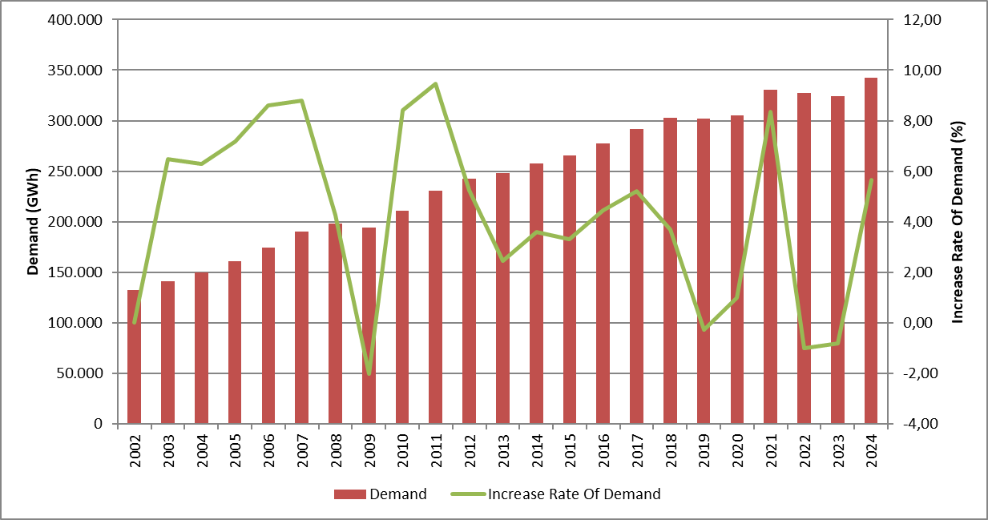

The development and growth rate of peak demand is presented in Figure 1.2. In 2024, peak demand increased by 6,46% compared to the previous year and reached 58.712,36 MW.

Figure 1.2: Peak Demand and Increase Rate Over Years (MW-%)
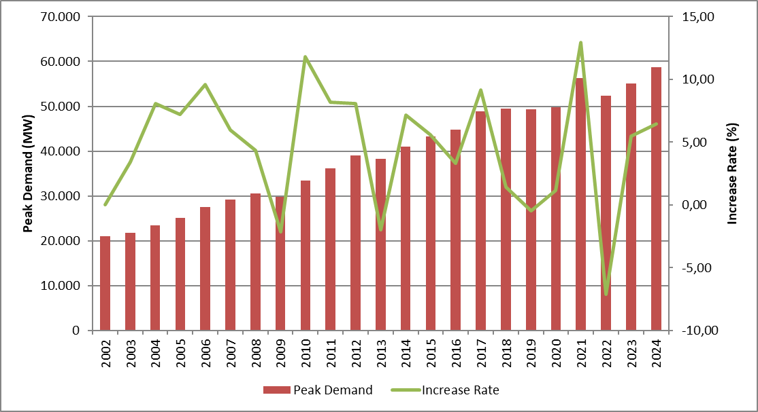
Figure 1.3 shows the relationship between peak demand and electricity demand by years.

Figure 1.3 Rate of Increase of Electrical Energy Demand and Peak Demand by Year (%)
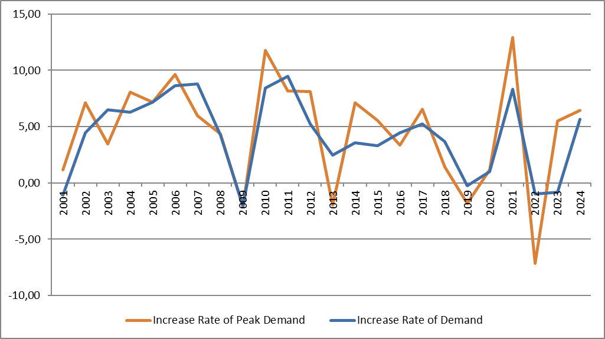
Figure 1.4 shows the monthly changes in licensed electricity generation and electricity consumption. Monthly generation and consumption reached their highest values in July.

Figure 1.4: Monthly Distribution of Licensed Electricity Generation and Consumption in 2024 (GWh)
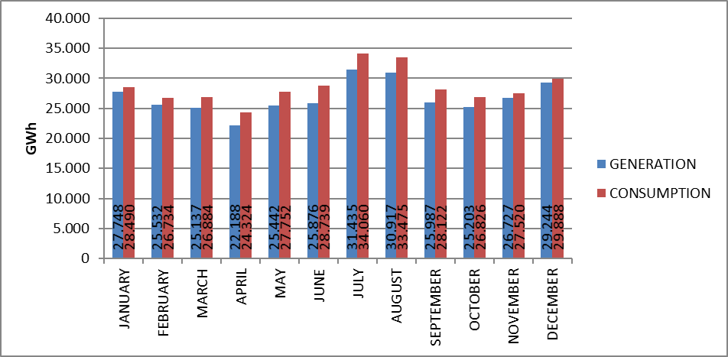
Figure 1.5 shows the distribution of 2024 licensed electricity generation by organizations. Independent generation companies have the highest share in generation with 81,57%. The share of EÜAŞ power plants was realized as 16,74%, while the share of power plants operating under existing contracts in total generation was realized as 1,69%.

Figure 1.5: Distribution of Licensed Electricity Generation by Institutions in 2024 (%)
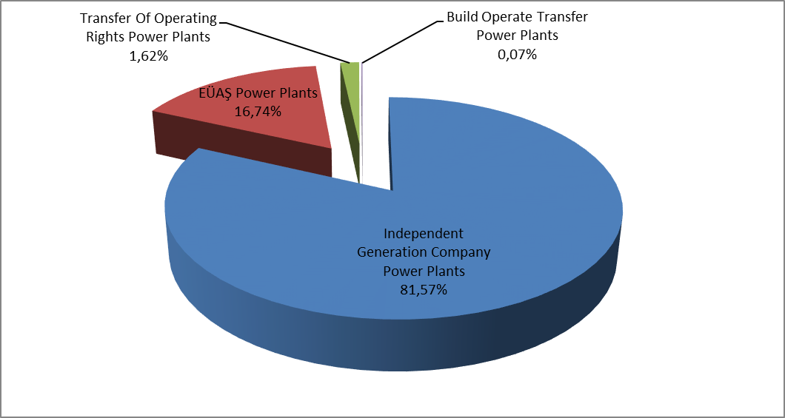
The distribution of licensed electricity generation under public, private and existing contracts is presented in Figure 1.6. In 2023, the total share of public sector in generation (including existing contracts) was 15,64%, while this ratio increased to 18,09% in 2024. Similarly, the share of independent generation decreased from 84,36% in 2023 to 81,91% in 2024.

Figure 1.6: Change of Licensed Electricity Generation as Public-Private by Years (%)
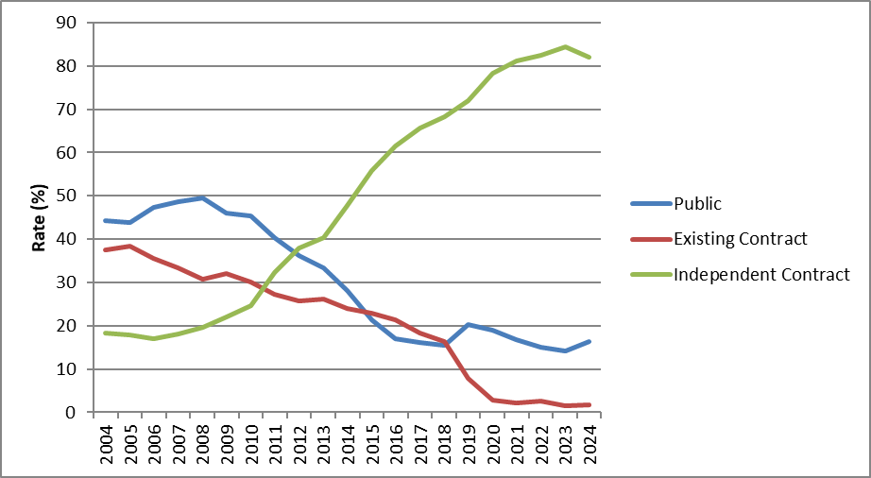
As can be seen in Figure 1.6, the share of independent generation decreased in 2024.
The distribution of Turkey's licensed electricity generation by source is given in Figure 1.7. The share of hydroelectric power plants in licensed electricity generation increases from 20,45% in 2023 to 22,89% in 2024, wind power plants from 11,04% to 11,16% . On the other hand, the share of imported coal power plants decreased from 23,57% in 2023 to 23,07% in 2024, natural gas-fired power plants in licensed electricity generation decreased from 21,90% to 19,86%, domestic coal (lignite, hard coal and asphaltite) power plants from 14,98% to 14,48% ,geothermal power plants from 3,61% to 3,44%.

Figure 1.7: Distribution of Licensed Electricity Generation by Sources in 2024 (%)
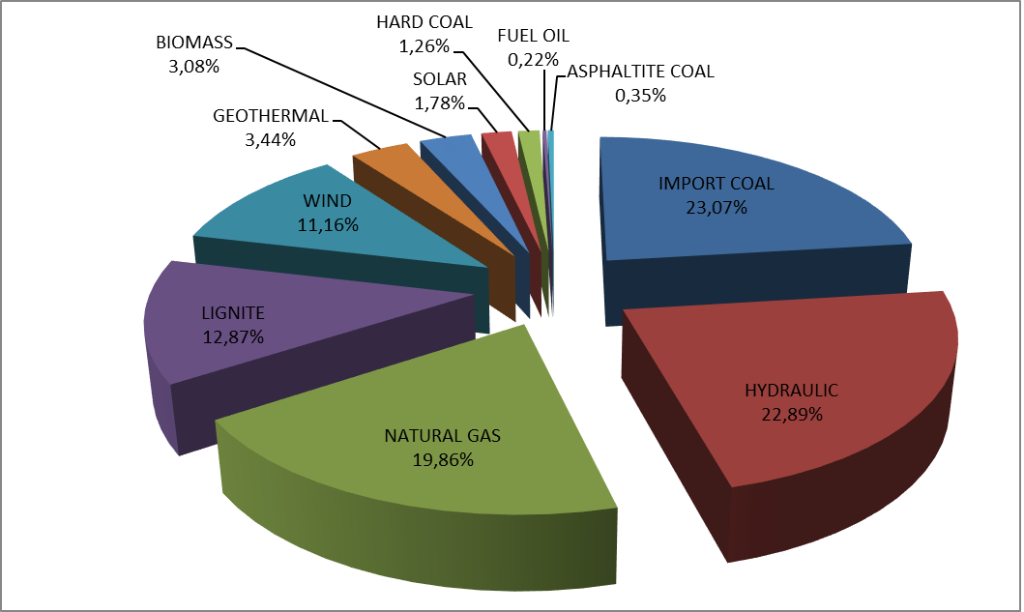
The development of licensed electricity generation by source since 1990 is presented in Figure 1.8. In 2024, electricity generation from renewable energy sources such as geothermal, wind, solar and biomass decreased by 7,54% compared to 2023.

Figure 1.8: Source-Based Development of Licensed Electricity Generation by Years (GWh)
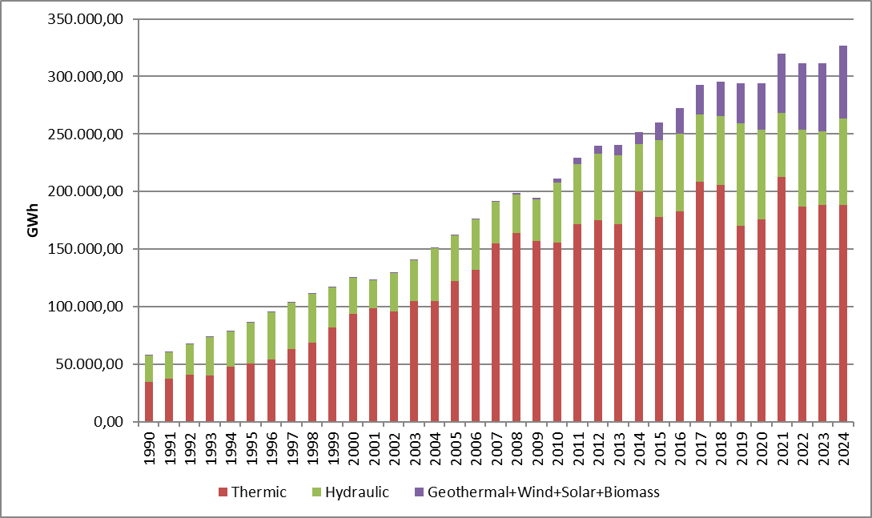
The development of licensed electricity generation in Turkey on a day-by-day basis is shown in Figure 1.9. Licensed electricity generation was highest in July and lowest in April. On a day basis, the highest electricity generation occurred on July 23, 2024 and the lowest on April 11, 2024.

Figure 1.9: Licensed Electricity Generation Per Day in 2024 (MWh)
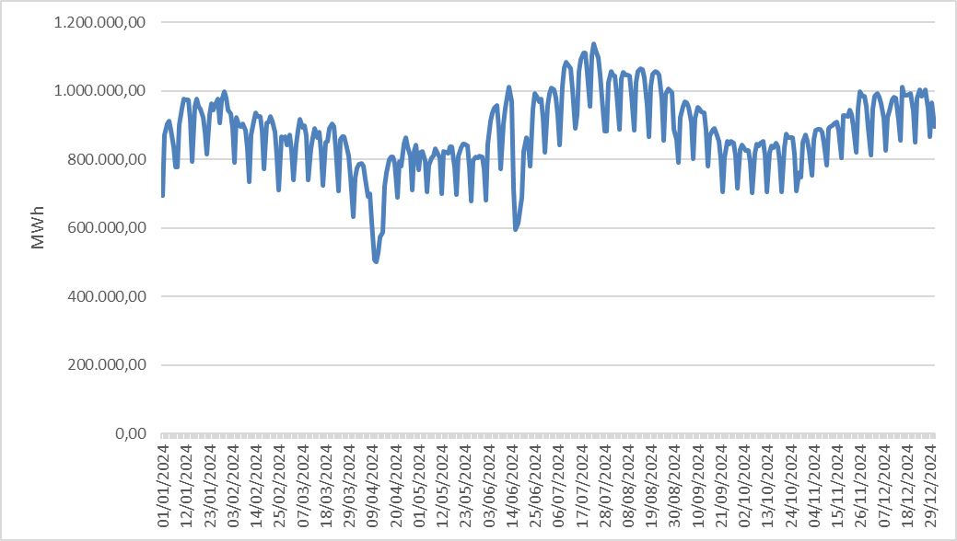
The distribution of licensed electricity generation by province is shown in Table 1.2. In 2024, the highest electricity generation was realized in Çanakkale, Adana, Zonguldak, İzmir, Hatay, Manisa, Balıkesir and Muğla, while the lowest electricity generation was realized in Iğdır, Bartın, Aksaray, Yozgat, Ağrı, Bayburt, Çankırı and Hakkari.

Table 1.2: Licensed Electricity Generation by Provinces (GWh-%)
PROVINCE NAME | Generation (GWh) | Share (%) | PROVINCE NAME | Generation (GWh) | Share (%)
ÇANAKKALE | 30.409,28 | 9,3 | ERZURUM | 1.454,48 | 0,45
ADANA | 26.841,27 | 8,21 | TRABZON | 1.449,45 | 0,44
ZONGULDAK | 22.361,22 | 6,84 | ŞIRNAK | 1.350,42 | 0,41
İZMİR | 14.018,21 | 4,29 | ESKİŞEHİR | 1.348,15 | 0,41
HATAY | 13.927,75 | 4,26 | GÜMÜŞHANE | 1.315,94 | 0,4
MANİSA | 12.363,87 | 3,78 | MUŞ | 1.282,75 | 0,39
BALIKESİR | 11.449,69 | 3,5 | RİZE | 1.210,40 | 0,37
MUĞLA | 10.280,46 | 3,15 | KARABÜK | 1.070,64 | 0,33
ARTVİN | 9.110,62 | 2,79 | ERZİNCAN | 1.056,56 | 0,32
SAMSUN | 8.927,47 | 2,73 | ORDU | 976,38 | 0,3
ANKARA | 8.820,14 | 2,7 | GAZİANTEP | 731,09 | 0,22
İSTANBUL | 8.813,08 | 2,7 | SİNOP | 712,14 | 0,22
ELAZIĞ | 8.201,02 | 2,51 | KARS | 686,76 | 0,21
KAHRAMANMARAŞ | 8.043,16 | 2,46 | KIRŞEHİR | 677,06 | 0,21
BURSA | 7.631,82 | 2,34 | NİĞDE | 676,07 | 0,21
AYDIN | 7.482,71 | 2,29 | ADIYAMAN | 646,79 | 0,2
ŞANLIURFA | 7.479,55 | 2,29 | AMASYA | 643,05 | 0,2
KIRKLARELİ | 7.470,97 | 2,29 | ARDAHAN | 623,12 | 0,19
DİYARBAKIR | 7.310,90 | 2,24 | EDİRNE | 617,81 | 0,19
KIRIKKALE | 7.126,02 | 2,18 | UŞAK | 456,63 | 0,14
DENİZLİ | 6.075,60 | 1,86 | ISPARTA | 444,57 | 0,14
KÜTAHYA | 5.409,66 | 1,66 | BİLECİK | 435,11 | 0,13
ANTALYA | 5.239,95 | 1,6 | VAN | 396,06 | 0,12
KOCAELİ | 5.015,20 | 1,53 | ÇORUM | 372,79 | 0,11
KONYA | 4.343,16 | 1,33 | TUNCELİ | 357,76 | 0,11
MARDİN | 4.181,45 | 1,28 | MALATYA | 351,62 | 0,11
SİVAS | 4.089,48 | 1,25 | BURDUR | 289,21 | 0,09
SAKARYA | 3.543,67 | 1,08 | DÜZCE | 273,69 | 0,08
BİNGÖL | 3.218,26 | 0,98 | BİTLİS | 257,95 | 0,08
TEKİRDAĞ | 2.964,84 | 0,91 | KASTAMONU | 225,18 | 0,07
MERSİN | 2.908,29 | 0,89 | BATMAN | 212,84 | 0,07
OSMANİYE | 2.745,65 | 0,84 | NEVŞEHİR | 211,5 | 0,06
SİİRT | 2.604,29 | 0,8 | HAKKARİ | 195,41 | 0,06
BOLU | 2.363,59 | 0,72 | ÇANKIRI | 145,66 | 0,04
KAYSERİ | 1.929,23 | 0,59 | BAYBURT | 123,18 | 0,04
TOKAT | 1.856,02 | 0,57 | AĞRI | 115,63 | 0,04
GİRESUN | 1.814,43 | 0,56 | YOZGAT | 101,18 | 0,03
KARAMAN | 1.698,66 | 0,52 | AKSARAY | 90,75 | 0,03
YALOVA | 1.575,66 | 0,48 | BARTIN | 75,86 | 0,02
AFYONKARAHİSAR | 1.479,90 | 0,45 | IĞDIR | 55,79 | 0,02
 |  |  | Grand Total | 326.843,63 | 100

Figure 1.10 shows the shares of the top 10 companies with the highest share in licensed electricity generation in 2024. As can be seen from the figure, the top 10 companies are EÜAŞ, Eren En.El.Ür.A.Ş. , Enerjisa En.Ür.A.Ş. , Emba En.Ür.A.Ş. , Cenal En.Ür.A.Ş. , İçdaş En.Ür.Ve Yat. , İskenderun En.Ür.Ve Tic.A.Ş. , A.Ş. , Atlas En.Ür.San.A.Ş. , Yeniköy Kemerköy El.Ür.Ve Tic.A.Ş. and Hamitabat El.Ür.Ve Tic.A.Ş.

Figure 1.10: First 10 Companies within Electricity Generation in 2024 (%)
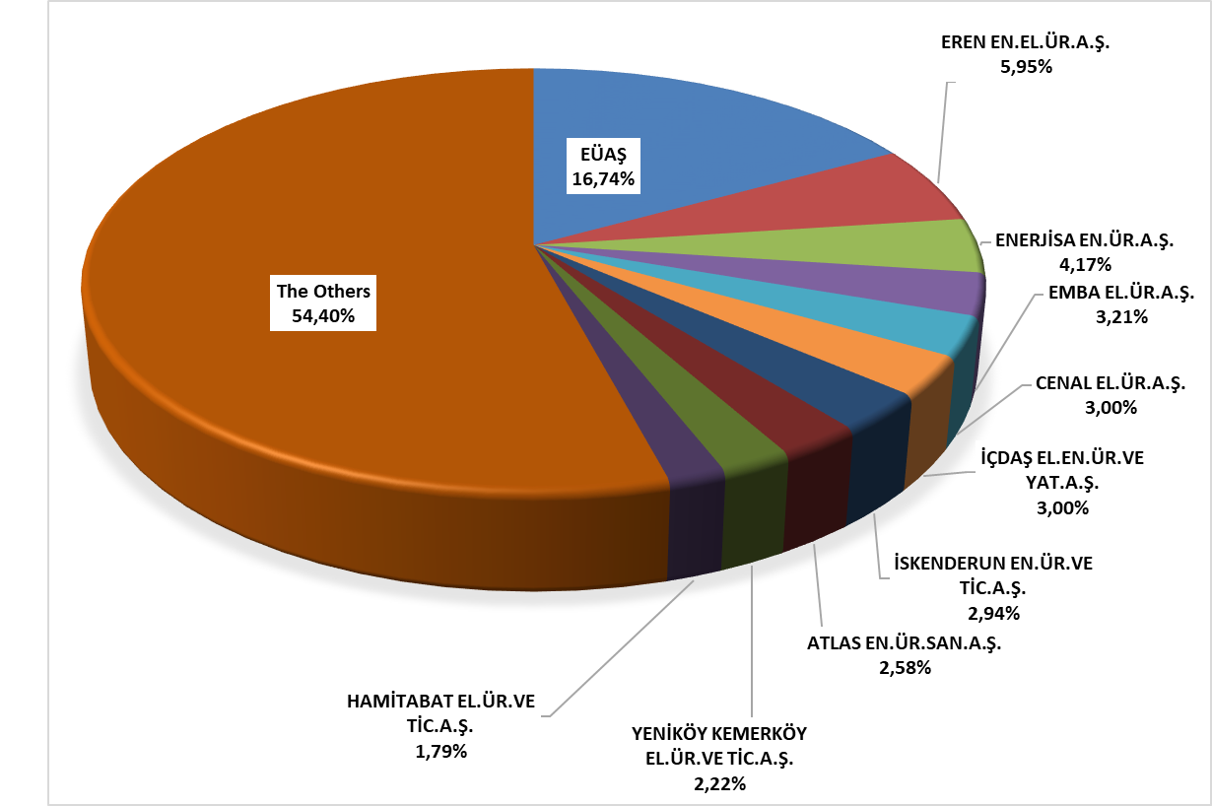

1.3 Licensed Installed Capacity

The distribution of licensed installed capacity by resource types is shown in Figure 1.11. While the share of wind power plants 12,16% as of the end of 2023, it increased to 13,09% in 2024, the share of solar power plants increased from 1,72% to 2,06%, and the share of geothermal power plants increased from 1,76% to 1,78%.
On the other hand, the share of natural gas power plants (including liquid and natural gas-fired power plants) in licensed installed capacity decreased from 26,16% in 2023 to 25,14% in 2024, the share of hydroelectric power plants from 24,57% to 24,52%, the share of imported coal-fired power plants from 10,78% to 10,74%, lignite power plants from 10,59% to 10,49%, run-of-river hydroelectric power plants from 8,62% to 8,54% .
The share of renewable energy sources (including hydroelectricity) in total installed capacity increased from 50,90% in 2023 to 52,08% in 2024. The share of total thermal installed capacity decreases from 49,10% in 2023 to 47,92% in 2024.

Figure 1.11: Distribution of Licensed Installed Capacity by Sources at the end of 2024 (%)
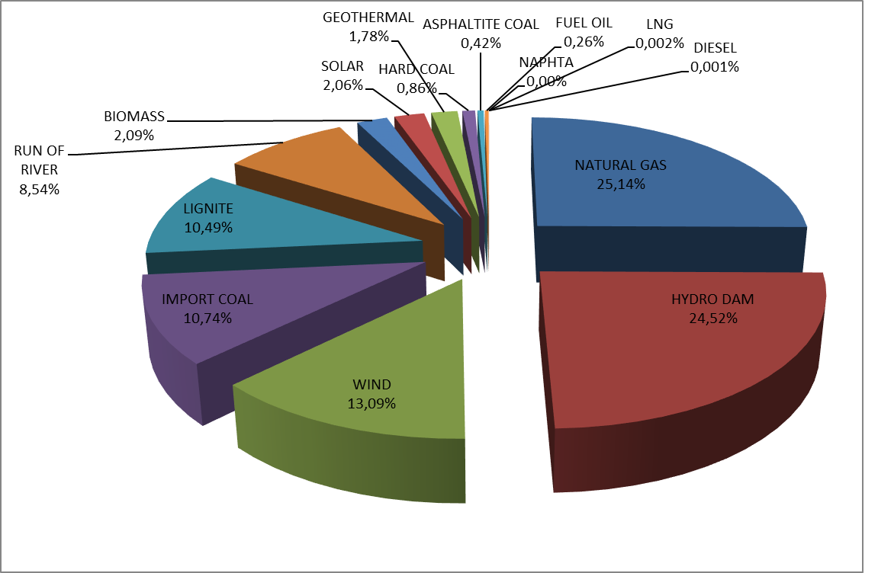

The distribution of licensed installed capacity by organization is shown in Figure 1.12. The share of EÜAŞ power plants in total installed capacity decreased from 22,21% in 2023 to 22,16% in 2024.
On the other hand, the share of independent generation companies operating under free market conditions in total installed capacity increased from 74,30% in 2023 to 74,39% in 2024, and the share of power plants operating under existing contracts increased from 3,49% to 4,17%.

Figure 1.12: Distribution of Licensed Installed Capacity by Organizations at the end of 2024 (%)
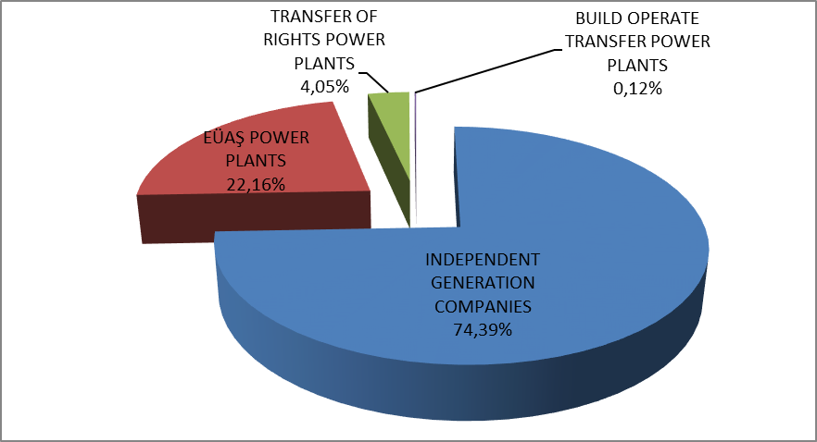

The development of licensed installed capacity by resource since 2000 is presented in Figure 1.13. As can be seen from the figure, the share of geothermal, wind, solar and biomass resources in the installed capacity has increased every year.

Figure 1.13: Development of Licensed Installed Capacity by Source over the Years (MW)
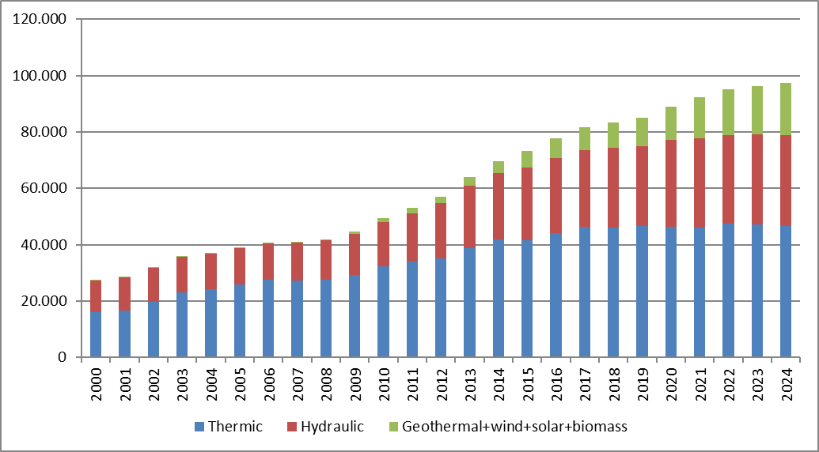
Similar to Figure 1.13, Figure 1.14 shows the development of the share of resources in licensed installed capacity since 2000.

Figure 1.14: The Development of the Share of the Sources within the Installed Capacity by Years (%)
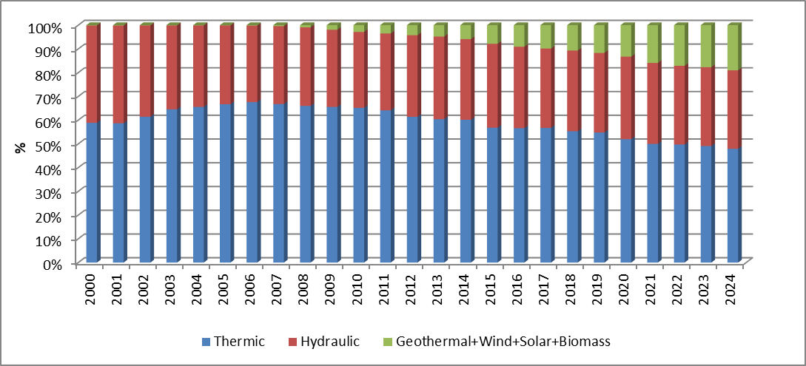

The distribution of licensed installed capacity by province is shown in Table 1.3. In 2024, the provinces with the highest installed capacity were İzmir, Adana, Çanakkale, Kahramanmaraş, İstanbul, Zonguldak, Şanlıurfa and Balıkesir, while the provinces with the lowest installed capacity were Iğdır, Bartın, Bayburt, Aksaray, Ağrı, Batman, Çankırı and Hakkari.

Table 1.3 Distribution of Licensed Installed Capacity by Province (MW-%)
Province Name | Installed Capacity (MW) | Share (%) | Province Name | Installed Capacity (MW) | Share (%)
İzmir | 5.249,61 | 5,39 | Sinop | 612,56 | 0,63
Adana | 5.244,77 | 5,39 | Erzurum | 571,97 | 0,59
Çanakkale | 4.804,81 | 4,94 | Ordu | 543,97 | 0,56
Kahramanmaraş | 4.411,92 | 4,53 | Muş | 462,66 | 0,48
İstanbul | 3.548,71 | 3,65 | Afyonkarahisar | 460,47 | 0,47
Zonguldak | 3.377,11 | 3,47 | Bolu | 457,99 | 0,47
Şanlıurfa | 3.262,93 | 3,35 | Şırnak | 444,52 | 0,46
Balıkesir | 3.112,30 | 3,20 | Gaziantep | 418,51 | 0,43
Bursa | 3.102,51 | 3,19 | Çorum | 402,43 | 0,41
Hatay | 3.091,81 | 3,18 | Yalova | 395,33 | 0,41
Samsun | 3.020,08 | 3,10 | Rize | 366,00 | 0,38
Manisa | 2.995,62 | 3,08 | Kırşehir | 336,40 | 0,35
Sakarya | 2.968,06 | 3,05 | Erzincan | 324,40 | 0,33
Artvin | 2.629,85 | 2,70 | Amasya | 318,16 | 0,33
Elazığ | 2.507,13 | 2,58 | Isparta | 290,65 | 0,30
Ankara | 2.466,10 | 2,53 | Niğde | 281,86 | 0,29
Muğla | 2.338,21 | 2,40 | Bilecik | 263,98 | 0,27
Diyarbakır | 2.263,86 | 2,33 | Adıyaman | 258,64 | 0,27
Kocaeli | 2.152,30 | 2,21 | Kars | 251,66 | 0,26
Kırıkkale | 2.028,41 | 2,08 | Ardahan | 235,90 | 0,24
Kırklareli | 1.946,01 | 2,00 | Karabük | 185,97 | 0,19
Antalya | 1.835,13 | 1,89 | Edirne | 185,01 | 0,19
Konya | 1.689,57 | 1,74 | Uşak | 171,55 | 0,18
Aydın | 1.641,55 | 1,69 | Van | 160,42 | 0,16
Denizli | 1.569,72 | 1,61 | Kastamonu | 140,94 | 0,14
Tekirdağ | 1.498,77 | 1,54 | Bitlis | 135,25 | 0,14
Mardin | 1.423,09 | 1,46 | Burdur | 131,72 | 0,14
Bingöl | 1.372,54 | 1,41 | Düzce | 126,16 | 0,13
Kütahya | 1.109,02 | 1,14 | Malatya | 120,86 | 0,12
Osmaniye | 1.060,89 | 1,09 | Tunceli | 106,95 | 0,11
Mersin | 1.036,79 | 1,06 | Yozgat | 99,43 | 0,10
Sivas | 1.024,10 | 1,05 | Nevşehir | 89,13 | 0,09
Giresun | 907,28 | 0,93 | Hakkari | 67,91 | 0,07
Siirt | 793,91 | 0,82 | Çankırı | 65,92 | 0,07
Karaman | 728,19 | 0,75 | Batman | 63,24 | 0,06
Kayseri | 700,49 | 0,72 | Ağrı | 61,31 | 0,06
Gümüşhane | 697,53 | 0,72 | Aksaray | 41,72 | 0,04
Tokat | 689,08 | 0,71 | Bayburt | 37,68 | 0,04
Eskişehir | 656,26 | 0,67 | Bartın | 34,33 | 0,04
Trabzon | 650,75 | 0,67 | Iğdır | 23,79 | 0,02
 |  |  | Grand Total | 97.354,09 | 100,00

Figure 1.15 shows the shares of the top 10 companies with the highest share in licensed installed capacity by the end of 2024. As can be seen from the figure, the top 10 companies are EÜAŞ, Eren En.El.Ür.A.Ş. , Enerjisa En.Ür.A.Ş. , Kalyon Güneş En.Ür.A.Ş. , Gebze El.Ür.Ltd.Şti. , Habaş Sinai Ve Tıbbi Gazlar İstihsal End.A.Ş. , İzmir El.Ür.Ltd.Şti. , Bilgin Güç Santr.En.Ür.A.Ş. ,İskenderun En.Ür.Ve Tic.A.Ş. and Afşin Elbistan El.Ür.Ve Tic.A.Ş.
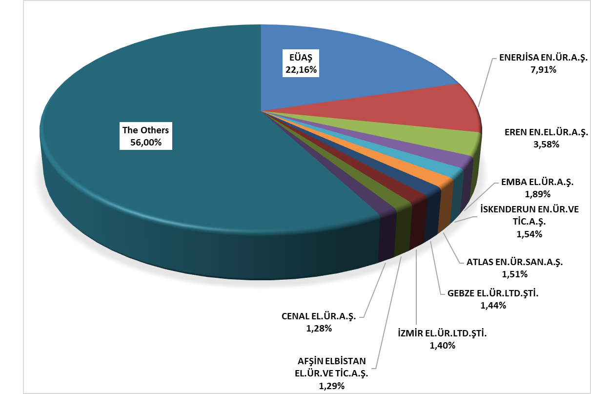

Figure 1.15: Share of the Top 10 Companies in Licensed Installed Capacity at the End of 2024 (%)

1.4 Unlicensed Generation

In the first paragraph of Article 14 of the Electricity Market Law No. 6446, the generation facilities exempted from the obligation to obtain a license and establish a company are listed as follows:

"a) The generation facility that does not establish a connection with the relief groups and the transmission or distribution system
b) Generation facility based on renewable energy sources with an installed capacity of maximum one megawatt
c) Electricity generation facility established for use in solid waste facilities of municipalities and disposal of treatment plant sludge
d) Microcogeneration facilities and those in the category to be determined by the Board from cogeneration facilities that provide the efficiency value to be determined by the Ministry
e) A generation facility based on renewable energy sources that uses all of the energy it produces without giving it to the transmission or distribution system, whose generation and consumption are at the same measurement point
f) (Additional: 21/3/2018-7103/84 Art.) Market activities carried out within the scope of electricity storage and demand response within the framework of the limits and procedures and principles to be determined by the Board in consultation with the Ministry
g) (Addendum: 19/4/2018-7139/56 Art.) Generation facility based on renewable energy resources established and operated by the General Directorate of State Hydraulic Works or by irrigation unions with the permission of DSİ in order to meet the electricity needs of facilities for agricultural irrigation purposes whose electricity subscription belongs to the General Directorate of State Hydraulic Works or irrigation unions, provided that the installed power is limited to the contract power in the connection agreement of the agricultural irrigation facility and the total contract power of the facilities for more than one facility
h) (Additional: 25/11/2020-7257/35 Art.) (Amended: 5/3/2022-7381/27 Art.) Generation facility based on renewable energy sources, provided that municipalities and their affiliated organizations, industrial facilities and facilities for agricultural irrigation are limited to twice the contract power in the connection agreement and other persons are limited to the contract power in the connection agreement
i) (Addition: 5/3/2022-7381/27 Art.) Renewable energy generation facilities established with the approval of DSİ on immovables for which irrigation unions have operation, maintenance, repair and management responsibility and other immovables under the ownership or disposal of irrigation unions and DSİ, provided that they are limited to the contract power in the connection agreement and operated by irrigation unions

The current status of unlicensed electricity generation applications as of the end of 2024 is shown in Table 1.4.

Table 1.4: Status of Unlicensed Electricity Generation Applications by the End of 2024 (MWe)
Status/Source | Biomass | Solar | Hydraulic | Cogeneration | Microgeneration | Wind
In connection agreement stage | 6,99 | 9.272,44 | 3,27 | 30,60 | 0,05 | 346,69
In invitation letter stage | 6,14 | 10.558,54 | 6,67 | 764,10 |  | 318,69
Rejected | 27,71 | 2.669,85 | 18,15 | 115,64 |  | 121,94

The distribution of unlicensed installed capacity by resources is presented in Table 1.5 and Figure 1.16. The amount of capacity in operation in unlicensed electricity generation, which was 14.358,53 MWe by the end of 2023, increased by 29,44% to 18.585,32 MWe by the end of 2024. Solar power plants will have the highest share in 2024 with 96,32 %, followed by natural gas with 2,40% and wind with 0,64%.

Table 1.5: Distribution of Unlicensed Installed Capacity by Resources (MWe-%)
Resource Type | 2023 |  | 2024
Resource Type | Installed Power  (MWe) | Share (%) | Installed Power  (MWe) | Share (%)
Solar | 13.725,53 | 95,59 | 17.902,10 | 96,32
Natural gas | 435,23 | 3,03 | 446,82 | 2,40
Wind | 96,50 | 0,67 | 118,18 | 0,64
Biomass | 86,30 | 0,60 | 87,24 | 0,47
Hydraulic | 14,97 | 0,10 | 18,35 | 0,10
Lignite | - | - | 12,63 | 0,07
Grand Total | 14.358,53 | 100,00 | 18.585,32 | 100,00

Figure 1.16: Distribution of Unlicensed Installed Capacity by Sources by the End of 2024 (%)
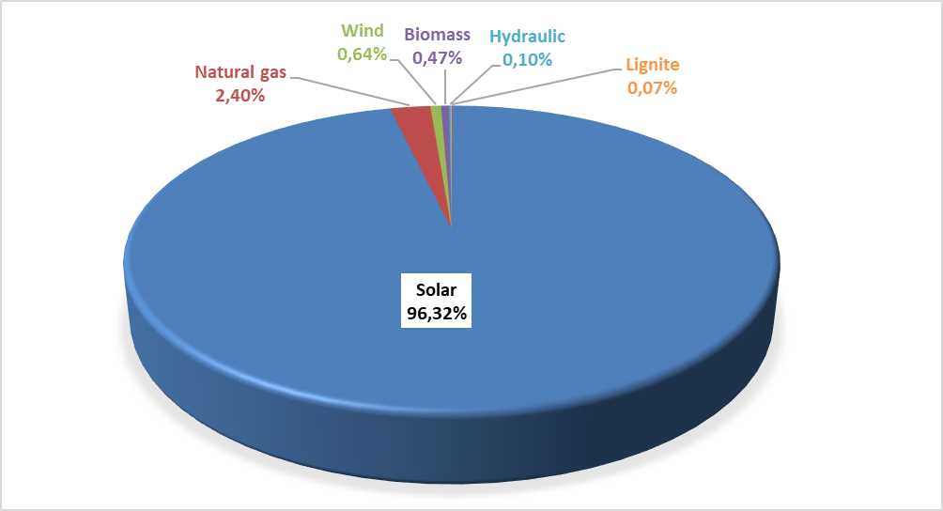

The distribution of unlicensed installed capacity by province is shown in Table 1.6. As in 2023, the highest installed capacity in 2024 is located in Konya with 1.229,06 MWe. Konya is followed by Gaziantep with 1.032,69 MWe, Ankara with 968,51 MWe, İzmir with 848,18 MWe, Kayseri with 825,79 MWe, Şanlıurfa with 750,87 MWe and Manisa with 660,53 MWe. Approximately 34% of the total unlicensed installed capacity is located in these 7 provinces.

Table 1.6: Distribution of Unlicensed Installed Capacity by Province (MWe-%)
Provinces | 2023 |  | 2024
Provinces | Installed Capacity  (MWe) | Share (%) | Installed Capacity  (MWe) | Share (%)
Adana | 469,28 | 3,27 | 547,30 | 2,94
Adıyaman | 171,85 | 1,20 | 177,17 | 0,95
Afyonkarahisar | 422,00 | 2,94 | 545,75 | 2,94
Ağrı | 30,28 | 0,21 | 45,29 | 0,24
Aksaray | 168,17 | 1,17 | 193,98 | 1,04
Amasya | 75,32 | 0,52 | 122,66 | 0,66
Ankara | 746,53 | 5,20 | 968,51 | 5,21
Antalya | 385,16 | 2,68 | 533,78 | 2,87
Ardahan | 6,43 | 0,04 | 6,82 | 0,04
Artvin | 0,02 | 0,00 | 0,02 | 0,00
Aydın | 215,68 | 1,50 | 242,06 | 1,30
Balıkesir | 279,45 | 1,95 | 332,02 | 1,79
Bartın | 15,12 | 0,11 | 17,69 | 0,10
Batman | 35,62 | 0,25 | 60,02 | 0,32
Bayburt | 37,83 | 0,26 | 50,90 | 0,27
Bilecik | 124,93 | 0,87 | 169,87 | 0,91
Bingöl | 35,63 | 0,25 | 42,75 | 0,23
Bitlis | 38,74 | 0,27 | 61,08 | 0,33
Bolu | 56,14 | 0,39 | 71,48 | 0,38
Burdur | 181,24 | 1,26 | 236,92 | 1,27
Bursa | 421,99 | 2,94 | 533,62 | 2,87
Çanakkale | 59,56 | 0,41 | 77,25 | 0,42
Çankırı | 101,45 | 0,71 | 146,93 | 0,79
Çorum | 220,53 | 1,54 | 267,64 | 1,44
Denizli | 340,14 | 2,37 | 516,33 | 2,78
Diyarbakır | 205,81 | 1,43 | 236,28 | 1,27
Düzce | 44,64 | 0,31 | 62,95 | 0,34
Edirne | 25,00 | 0,17 | 40,03 | 0,22
Elazığ | 328,40 | 2,29 | 357,17 | 1,92
Erzincan | 87,61 | 0,61 | 108,16 | 0,58
Erzurum | 218,13 | 1,52 | 332,63 | 1,79
Eskişehir | 334,16 | 2,33 | 376,95 | 2,03
Gaziantep | 695,59 | 4,84 | 1.032,69 | 5,56
Giresun | 19,08 | 0,13 | 31,62 | 0,17
Gümüşhane | 8,23 | 0,06 | 13,66 | 0,07
Hakkari | 0,44 | 0,00 | 0,54 | 0,00
Hatay | 66,79 | 0,47 | 79,87 | 0,43
Iğdır | 5,99 | 0,04 | 7,33 | 0,04
Isparta | 405,17 | 2,82 | 503,30 | 2,71
İstanbul | 220,81 | 1,54 | 269,13 | 1,45
İzmir | 663,58 | 4,62 | 848,18 | 4,56
Kahramanmaraş | 495,69 | 3,45 | 543,92 | 2,93
Karabük | 29,86 | 0,21 | 30,39 | 0,16
Karaman | 138,39 | 0,96 | 155,83 | 0,84
Kars | 14,32 | 0,10 | 15,52 | 0,08
Kastamonu | 32,88 | 0,23 | 45,48 | 0,24
Kayseri | 653,73 | 4,55 | 825,79 | 4,44
Kırıkkale | 70,24 | 0,49 | 103,82 | 0,56
Kırklareli | 42,44 | 0,30 | 60,69 | 0,33
Kırşehir | 80,29 | 0,56 | 84,01 | 0,45
Kilis | 51,43 | 0,36 | 62,78 | 0,34
Kocaeli | 163,73 | 1,14 | 198,18 | 1,07
Konya | 1.049,33 | 7,31 | 1.229,06 | 6,61
Kütahya | 180,72 | 1,26 | 246,61 | 1,33
Malatya | 212,66 | 1,48 | 234,76 | 1,26
Manisa | 443,11 | 3,09 | 660,53 | 3,55
Mardin | 40,28 | 0,28 | 65,36 | 0,35
Mersin | 338,67 | 2,36 | 449,88 | 2,42
Muğla | 158,55 | 1,10 | 185,10 | 1,00
Muş | 20,70 | 0,14 | 22,29 | 0,12
Nevşehir | 176,62 | 1,23 | 213,74 | 1,15
Niğde | 179,71 | 1,25 | 247,50 | 1,33
Ordu | 9,31 | 0,06 | 9,58 | 0,05
Osmaniye | 238,87 | 1,66 | 278,16 | 1,50
Rize | 3,25 | 0,02 | 8,01 | 0,04
Sakarya | 108,20 | 0,75 | 145,35 | 0,78
Samsun | 71,43 | 0,50 | 140,39 | 0,76
Siirt | 10,59 | 0,07 | 43,29 | 0,23
Sinop | 8,98 | 0,06 | 10,43 | 0,06
Sivas | 128,10 | 0,89 | 181,69 | 0,98
Şanlıurfa | 497,11 | 3,46 | 750,87 | 4,04
Şırnak | 27,09 | 0,19 | 28,89 | 0,16
Tekirdağ | 157,73 | 1,10 | 230,68 | 1,24
Tokat | 57,76 | 0,40 | 75,78 | 0,41
Trabzon | 17,86 | 0,12 | 22,82 | 0,12
Tunceli | 3,10 | 0,02 | 4,35 | 0,02
Uşak | 253,42 | 1,76 | 335,02 | 1,80
Van | 51,21 | 0,36 | 75,56 | 0,41
Yalova | 11,54 | 0,08 | 18,62 | 0,10
Yozgat | 122,47 | 0,85 | 228,05 | 1,23
Zonguldak | 38,64 | 0,27 | 48,22 | 0,26
Grand Total | 14.358,53 | 100,00 | 18.585,32 | 100,00

The distribution of gross unlicensed electricity generation by source is given in Table 1.7 and Figure 1.17. While the amount of energy given to the grid within the scope of unlicensed electricity generation in 2023 was 14.796,64 GWh, it increased by 37,66% to 20.369,61 GWh in 2024. 98,50% of this was produced from solar, 0,70% from wind, and 0,42% from biomass.

Table 1.7: Distribution of Unlicensed Electricity Generation by Resources (MWh-%)
Source Type | 2023 |  | 2024 |  | 2023-2024 Change (%)
Source Type | Unlicensed Generation (GWh) | Share (%) | Unlicensed Generation (GWh) | Share (%) | 2023-2024 Change (%)
Solar | 14.444,62 | 97,62 | 20.063,12 | 98,50 | 38,90
Wind | 172,26 | 1,16 | 142,72 | 0,70 | -17,15
Biomass | 86,67 | 0,59 | 85,06 | 0,42 | -1,86
Hydraulic | 69,41 | 0,47 | 53,64 | 0,26 | -22,72
Natural Gas | 23,69 | 0,16 | 25,08 | 0,12 | 5,89
Grand Total | 14.796,64 | 100,00 | 20.369,61 | 100,00 | 37,66

Figure 1.17: Distribution of Unlicensed Electricity Generation by Sources as of the End of 2024 (%)
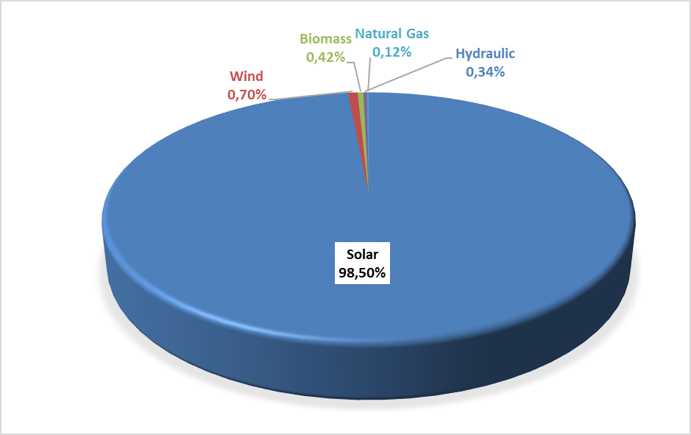

The amount of energy (MWh) given to the system as surplus within the scope of unlicensed electricity generation and the distribution of the energy given to the system by provinces are given in Table 1.8, and the highest generation occurred in Konya in 2024, as in 2023. Konya is followed by Ankara, Şanlıurfa, Kayseri, İzmir, Manisa, Afyonkarahisar and Kahramanmaraş provinces. Approximately 40% of the total surplus unlicensed electricity generation is located in these 8 provinces.

Table 1.8: Distribution of Unlicensed Electricity Generation by Provinces (MWh-%)
Provinces | 2023 |  | 2024
Provinces | Amount of energy given to the system as surplus (GWh) | Share (%) | Amount of energy given to the system as surplus (GWh) | Share (%)
ADANA | 263,64 | 2,09 | 290,58 | 2,00
ADIYAMAN | 206,42 | 1,63 | 212,51 | 1,46
AFYONKARAHİSAR | 478,93 | 3,79 | 524,90 | 3,61
AĞRI | 34,19 | 0,27 | 43,39 | 0,30
AKSARAY | 185,94 | 1,47 | 156,31 | 1,07
AMASYA | 68,55 | 0,54 | 105,76 | 0,73
ANKARA | 667,68 | 5,28 | 768,27 | 5,28
ANTALYA | 304,73 | 2,41 | 375,47 | 2,58
ARDAHAN | 6,70 | 0,05 | 7,03 | 0,05
ARTVİN | 0,01 | 0,00 | 0,02 | 0,00
AYDIN | 235,73 | 1,86 | 269,10 | 1,85
BALIKESİR | 212,56 | 1,68 | 257,96 | 1,77
BARTIN | 1,59 | 0,01 | 3,17 | 0,02
BATMAN | 37,73 | 0,30 | 47,72 | 0,33
BAYBURT | 31,72 | 0,25 | 47,46 | 0,33
BİLECİK | 141,22 | 1,12 | 159,53 | 1,10
BİNGÖL | 41,72 | 0,33 | 49,16 | 0,34
BİTLİS | 53,77 | 0,43 | 51,30 | 0,35
BOLU | 13,29 | 0,11 | 21,84 | 0,15
BURDUR | 152,12 | 1,20 | 173,19 | 1,19
BURSA | 105,71 | 0,84 | 148,86 | 1,02
ÇANAKKALE | 64,74 | 0,51 | 77,97 | 0,54
ÇANKIRI | 102,82 | 0,81 | 117,67 | 0,81
ÇORUM | 241,37 | 1,91 | 283,92 | 1,95
DENİZLİ | 315,50 | 2,50 | 369,20 | 2,54
DİYARBAKIR | 232,13 | 1,84 | 267,36 | 1,84
DÜZCE | 4,20 | 0,03 | 11,22 | 0,08
EDİRNE | 15,78 | 0,12 | 21,31 | 0,15
ELAZIĞ | 350,97 | 2,78 | 363,67 | 2,50
ERZİNCAN | 95,29 | 0,75 | 104,24 | 0,72
ERZURUM | 191,40 | 1,51 | 281,89 | 1,94
ESKİŞEHİR | 334,65 | 2,65 | 371,07 | 2,55
GAZİANTEP | 317,52 | 2,51 | 389,40 | 2,68
GİRESUN | 13,49 | 0,11 | 23,59 | 0,16
GÜMÜŞHANE | 3,31 | 0,03 | 7,58 | 0,05
HAKKARİ | 0,34 | 0,00 | 0,27 | 0,00
HATAY | 48,64 | 0,38 | 56,29 | 0,39
IĞDIR | 2,53 | 0,02 | 3,11 | 0,02
ISPARTA | 312,32 | 2,47 | 404,02 | 2,78
İSTANBUL | 22,42 | 0,18 | 31,26 | 0,21
İZMİR | 517,79 | 4,10 | 641,38 | 4,41
KAHRAMANMARAŞ | 441,62 | 3,49 | 440,35 | 3,03
KARABÜK | 18,60 | 0,15 | 28,81 | 0,20
KARAMAN | 149,66 | 1,18 | 152,39 | 1,05
KARS | 11,68 | 0,09 | 13,56 | 0,09
KASTAMONU | 18,91 | 0,15 | 27,91 | 0,19
KAYSERİ | 623,57 | 4,93 | 665,46 | 4,58
KIRIKKALE | 92,94 | 0,74 | 100,38 | 0,69
KIRKLARELİ | 4,72 | 0,04 | 8,83 | 0,06
KIRŞEHİR | 105,63 | 0,84 | 96,86 | 0,67
KİLİS | 50,67 | 0,40 | 57,76 | 0,40
KOCAELİ | 31,38 | 0,25 | 37,12 | 0,26
KONYA | 1.134,07 | 8,97 | 1.403,31 | 9,65
KÜTAHYA | 214,52 | 1,70 | 252,13 | 1,73
MALATYA | 230,24 | 1,82 | 240,32 | 1,65
MANİSA | 447,32 | 3,54 | 575,55 | 3,96
MARDİN | 44,22 | 0,35 | 57,53 | 0,40
MERSİN | 312,88 | 2,47 | 330,16 | 2,27
MUĞLA | 203,16 | 1,61 | 231,17 | 1,59
MUŞ | 15,01 | 0,12 | 14,20 | 0,10
NEVŞEHİR | 240,17 | 1,90 | 217,72 | 1,50
NİĞDE | 225,63 | 1,78 | 239,11 | 1,64
ORDU | 1,88 | 0,01 | 2,58 | 0,02
OSMANİYE | 130,63 | 1,03 | 136,00 | 0,94
RİZE | 10,39 | 0,08 | 7,32 | 0,05
SAKARYA | 12,01 | 0,10 | 27,37 | 0,19
SAMSUN | 46,32 | 0,37 | 67,02 | 0,46
SİİRT | 13,83 | 0,11 | 18,73 | 0,13
SİNOP | 2,21 | 0,02 | 3,14 | 0,02
SİVAS | 150,89 | 1,19 | 159,33 | 1,10
ŞANLIURFA | 707,19 | 5,59 | 763,15 | 5,25
ŞIRNAK | 42,68 | 0,34 | 46,14 | 0,32
TEKİRDAĞ | 22,12 | 0,17 | 37,15 | 0,26
TOKAT | 56,64 | 0,45 | 58,97 | 0,41
TRABZON | 2,88 | 0,02 | 6,79 | 0,05
TUNCELİ | 2,87 | 0,02 | 3,98 | 0,03
UŞAK | 171,40 | 1,36 | 198,30 | 1,36
VAN | 73,16 | 0,58 | 81,71 | 0,56
YALOVA | 4,71 | 0,04 | 0,77 | 0,01
YOZGAT | 132,08 | 1,04 | 177,42 | 1,22
ZONGULDAK | 9,98 | 0,08 | 15,18 | 0,10
Grand Total | 12.641,66 | 100,00 | 14.541,58 | 100,00

The distribution of the payment amount made within the scope of unlicensed electricity generation by the end of 2024 is shown in Table 1.9. Sun constitutes 98,86% of the payment amount.

Table 1.9: Distribution of the Amount of Payment Made Within the Scope of Unlicensed Electricity Generation by Resources (TL-%)
Resource Type | 2023 |  | 2024 |  | Change (%)  2023→2024
Resource Type | Amount of payments made for the amount of surplus energy purchased (TL) | Share (%) | Amount of payments made for the amount of surplus energy purchased (TL) | Share (%) | Change (%)  2023→2024
Solar | 38.514.348.603,18 | 98,64 | 57.922.098.225,82 | 98,86 | 50,39
Biomass | 271.555.599,61 | 0,70 | 366.301.543,26 | 0,63 | 34,89
Wind | 202.508.181,80 | 0,52 | 265.762.377,08 | 0,45 | 31,24
Hydraulic | 56.559.527,24 | 0,14 | 35.749.641,63 | 0,06 | -36,79
Grand Total | 39.044.971.911,83 | 100,00 | 58.589.911.787,79 | 100,00 | 50,06

1.5 Invoiced Electricity Consumption and Number of Consumers

This section contains information about billed electrical energy consumption. In this context, consumptions that are not included in the invoice (technical and non-technical losses and consumptions that are not accepted as sales) are not included in the data in this section. Therefore, since the generation carried out by legal entities holding a generation license within the scope of Article 7 of the Electricity Market Law to meet the needs of the consumption facilities they own, rent, acquire through financial leasing or for which they have taken over the operating rights, without transferring the energy produced in their facilities to the transmission or distribution system, is not considered as a sale to the final consumer. Electrical energy consumption in this context is not included in the invoiced consumption figures. In addition, the amount of electrical energy that generation facilities draw from the system for their own needs is not included in the invoiced consumption value. In addition, actual consumption data and consumption data in this section may vary due to differences in the billing period.
Data on the amount of consumption invoiced in 2024 is shown in Table 1.10 below. Of the 279,04 TWh of electricity sold, 71,7 TWh, corresponding to 25,71%, is connected to consumers at the transmission voltage level, and 207,3 TWh, corresponding to 74,29%, is connected to the distribution voltage level. sold to consumers.
While 142,99 TWh was sold to eligible consumers, the consumption of subscribers (those who are not free consumers and do not use their free consumer rights and general lighting subscribers) was 136,05 TWh. Accordingly, while the share of eligible consumers in invoiced consumption was 51,25%, the share of subscribers was 48,75%.

Table 1.10: Sales to Eligible and Non-Eligible Consumers in 2024 (GWh)
Consumer Type | Consumption Amount of Consumers Connected from Distribution Voltage Level (GWh) | Consumption Amount of Consumers Connected from Transmission Voltage Level (GWh) | Total (GWh)
Non-Eligible | 134.486,06 | 1.560,52 | 136.046,58
Eligible | 72.812,39 | 70.185,53 | 142.997,91
Grand Total | 207.298,45 | 71.746,05 | 279.044,49

The distribution of consumption across distribution regions is given in Table 1.11. In 2024, the highest consumption was in the Toroslar EDAŞ region with 36,9 TWh, and the lowest consumption was in the Van Gölü EDAŞ region with 2,65 TWh. The region with the highest consumption from distribution was Boğaziçi EDAŞ, the region with the lowest was Van Gölü EDAŞ, the region with the highest consumption from transmission was Toroslar, and the region with the lowest was Van Gölü EDAŞ.

Table 1.11 Distribution of Invoiced Consumption by Distribution Regions in 2024 (GWh-%)
Distribution Regions | Consumption Amount of Consumers Connected from Distribution (GWh) | Consumption Amount of Consumers Connected to Transmission (GWh) | Total (GWh) | Share (%)
TOROSLAR EDAŞ | 20.057,26 | 16.843,24 | 36.900,50 | 13,22
BOĞAZİÇİ EDAŞ | 27.327,62 | 1.947,27 | 29.274,89 | 10,49
GDZ EDAŞ | 16.953,99 | 6.365,98 | 23.319,97 | 8,36
BAŞKENT EDAŞ | 16.978,15 | 5.718,32 | 22.696,47 | 8,13
SAKARYA EDAŞ | 10.598,46 | 10.856,72 | 21.455,17 | 7,69
ULUDAĞ EDAŞ | 14.104,34 | 6.419,10 | 20.523,44 | 7,35
MERAM EDAŞ | 11.960,93 | 3.279,86 | 15.240,78 | 5,46
İST. AND. YAK. EDAŞ | 13.397,75 | 1.510,71 | 14.908,46 | 5,34
AKDENİZ EDAŞ | 11.429,94 | 1.366,32 | 12.796,27 | 4,59
DİCLE EDAŞ | 11.172,17 | 1.337,07 | 12.509,23 | 4,48
ADM EDAŞ | 10.586,86 | 1.188,63 | 11.775,49 | 4,22
OSMANGAZİ EDAŞ | 7.197,19 | 4.372,83 | 11.570,02 | 4,15
TRAKYA EDAŞ | 7.997,18 | 3.560,35 | 11.557,53 | 4,14
YEŞİLIRMAK EDAŞ | 5.725,41 | 1.658,33 | 7.383,74 | 2,65
AKEDAŞ EDAŞ | 4.262,04 | 1.833,38 | 6.095,42 | 2,18
KAYSERİ and CİVARI ETAŞ | 2.872,27 | 1.498,40 | 4.370,67 | 1,57
ÇORUH EDAŞ | 3.785,93 | 194,15 | 3.980,08 | 1,43
FIRAT EDAŞ | 3.018,59 | 883,40 | 3.901,99 | 1,40
ÇAMLIBEL EDAŞ | 2.667,15 | 530,65 | 3.197,80 | 1,15
ARAS EDAŞ | 2.660,39 | 280,14 | 2.940,53 | 1,05
VAN GÖLÜ EDAŞ | 2.544,83 | 101,20 | 2.646,03 | 0,95
Grand Total | 207.298,45 | 71.746,05 | 279.044,49 | 100,00

The distribution of invoiced consumption by consumer type is shown in Table 1.12 and Figure 1.18, with industrial consumption having the highest share with 40,84%. Residential consumption ranks second with 26,91%, and Public and Private Services Sector and Other consumption ranks third with 25,75%. The total electricity consumption used in lighting and agricultural activities was 6,50%.

Table 1.12: Distribution of Invoiced Consumption by Consumer Type as Eligible and Non-Eligible Consumers in 2024 (MWh)
Consumer Type | Consumption Amount (MWh)
Consumer Type | Subscriber | Share  (%) | Eligible Consumer | Share  (%) | Total | Share  (%)
Industry | 5.589.636,85 | 4,11 | 108.359.658,49 | 75,78 | 113.949.295,35 | 40,84
Household | 75.066.924,38 | 55,18 | 24.837,39 | 0,02 | 75.091.761,77 | 26,91
Public and Private Services and Others | 37.418.299,92 | 27,50 | 34.438.009,58 | 24,08 | 71.856.309,51 | 25,75
Irrigation | 12.330.600,79 | 9,06 | 80.322,96 | 0,06 | 12.410.923,75 | 4,45
Lighting | 5.641.117,45 | 4,15 | 95.085,64 | 0,07 | 5.736.203,09 | 2,06
Grand Total | 136.046.579,39 | 100,00 | 142.997.914,07 | 100,00 | 279.044.493,46 | 100,00

Figure 1.18: Distribution of Invoiced Consumption in 2024 by Consumer Type (%)
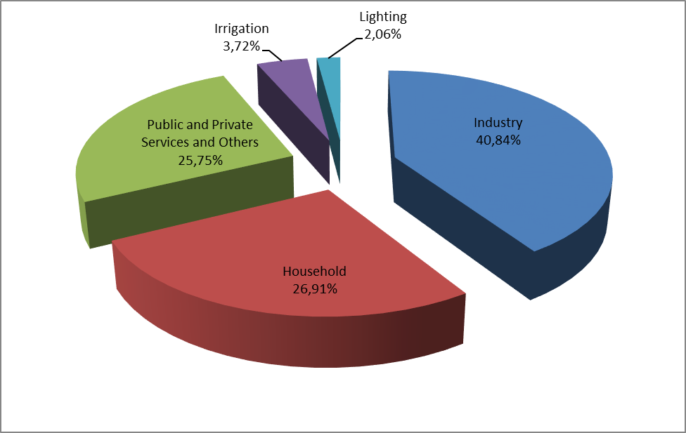

Table 1.13: Development of Invoiced Consumption by Consumer Type by Years (MWh)
Consumer Type | Consumption Amount (MWh)
Consumer Type | 2021 | 2022 | 2023 | 2024
Industry | 111.762.705 | 108.369.171 | 112.737.523 | 113.949.295
Household | 61.603.820 | 61.868.288 | 66.201.077 | 75.091.762
Public and Private Services and Others | 60.839.211 | 64.550.205 | 65.948.465 | 71.856.310
Irrigation | 13.497.475 | 13.332.526 | 13.426.458 | 12.410.924
Lighting | 5.353.694 | 5.501.261 | 5.530.992 | 5.736.203
Grand Total | 253.056.905 | 253.621.451 | 263.844.515 | 279.044.493

The distribution of invoiced consumption by province is shown in Table 1.14. The highest consumption occurred in Istanbul with 44,2 TWh, corresponding to 15,83% of the total consumption. Istanbul is followed by Izmir with a share of 6,29%, Ankara with a share of 5,77%, Kocaeli with a share of 5,14% and Bursa with a share of 4,85%.

Table 1.14: Distribution of Invoiced Consumption by Province (MWh - %)
Provinces | Amount of Consumption of Consumers Connected to Distribution (MWh) | Amount of Consumption of Consumers Connected to Transmission (MWh) | Total (GWh) | Share (%)
İSTANBUL (ALL) | 40.725,37 | 3.457,98 | 44.183,35 | 15,83
İSTANBUL (EUROPE) | 27.327,62 | 1.947,27 | 29.274,89 | 10,49
İZMİR | 12.978,90 | 4.580,60 | 17.559,50 | 6,29
ANKARA | 13.221,04 | 2.889,51 | 16.110,55 | 5,77
İSTANBUL (ANATOLIA) | 13.397,75 | 1.510,71 | 14.908,46 | 5,34
KOCAELİ | 5.925,76 | 8.412,88 | 14.338,65 | 5,14
BURSA | 8.281,05 | 5.244,34 | 13.525,39 | 4,85
ANTALYA | 9.934,30 | 1.017,85 | 10.952,15 | 3,92
KONYA | 7.425,87 | 2.264,65 | 9.690,52 | 3,47
GAZİANTEP | 4.086,53 | 5.050,09 | 9.136,62 | 3,27
HATAY | 3.533,12 | 4.918,45 | 8.451,57 | 3,03
ADANA | 5.645,67 | 2.783,75 | 8.429,42 | 3,02
TEKİRDAĞ | 4.756,61 | 3.056,28 | 7.812,88 | 2,80
MERSİN | 5.387,23 | 1.424,40 | 6.811,63 | 2,44
MANİSA | 3.975,09 | 1.785,39 | 5.760,48 | 2,06
ŞANLIURFA | 4.781,77 | 346,65 | 5.128,42 | 1,84
KAHRAMANMARAŞ | 3.099,72 | 1.503,30 | 4.603,02 | 1,65
SAKARYA | 2.725,27 | 1.823,62 | 4.548,90 | 1,63
MUĞLA | 4.507,87 | 4,38 | 4.512,25 | 1,62
KAYSERİ | 2.865,72 | 1.498,40 | 4.364,12 | 1,56
BALIKESİR | 3.484,40 | 759,40 | 4.243,81 | 1,52
DENİZLİ | 3.036,66 | 815,39 | 3.852,05 | 1,38
SAMSUN | 2.501,51 | 1.320,12 | 3.821,62 | 1,37
ESKİŞEHİR | 2.295,61 | 1.252,08 | 3.547,69 | 1,27
OSMANİYE | 1.014,03 | 2.433,64 | 3.447,67 | 1,24
AYDIN | 3.042,33 | 368,85 | 3.411,18 | 1,22
DİYARBAKIR | 2.786,11 | 391,15 | 3.177,26 | 1,14
KIRKLARELİ | 1.868,37 | 493,74 | 2.362,11 | 0,85
BİLECİK | 1.038,72 | 1.228,70 | 2.267,43 | 0,81
ZONGULDAK | 1.092,57 | 1.107,22 | 2.199,79 | 0,79
AFYONKARAHİSAR | 1.878,19 | 272,80 | 2.150,99 | 0,77
MALATYA | 1.344,44 | 497,38 | 1.841,81 | 0,66
ÇANAKKALE | 1.412,44 | 415,36 | 1.827,80 | 0,66
KÜTAHYA | 1.127,47 | 676,97 | 1.804,43 | 0,65
UŞAK | 857,20 | 942,27 | 1.799,48 | 0,64
MARDİN | 1.420,68 | 375,15 | 1.795,82 | 0,64
TRABZON | 1.583,40 | 44,49 | 1.627,89 | 0,58
ELAZIĞ | 1.174,24 | 386,02 | 1.560,25 | 0,56
ORDU | 1.320,02 | 217,05 | 1.537,07 | 0,55
ADIYAMAN | 1.162,32 | 330,08 | 1.492,40 | 0,53
NİĞDE | 1.129,79 | 347,14 | 1.476,93 | 0,53
AKSARAY | 1.142,70 | 288,21 | 1.430,91 | 0,51
SİVAS | 1.060,49 | 340,80 | 1.401,29 | 0,50
EDİRNE | 1.372,20 | 10,33 | 1.382,54 | 0,50
VAN | 1.305,05 | 17,60 | 1.322,65 | 0,47
DÜZCE | 1.025,71 | 277,97 | 1.303,68 | 0,47
BOLU | 921,71 | 342,24 | 1.263,95 | 0,45
KARABÜK | 505,41 | 676,89 | 1.182,30 | 0,42
BATMAN | 950,55 | 211,31 | 1.161,86 | 0,42
KASTAMONU | 839,87 | 309,35 | 1.149,22 | 0,41
ERZURUM | 977,02 | 113,13 | 1.090,14 | 0,39
KARAMAN | 832,16 | 184,26 | 1.016,42 | 0,36
TOKAT | 810,92 | 151,03 | 961,95 | 0,34
ISPARTA | 892,31 | 52,09 | 944,40 | 0,34
NEVŞEHİR | 933,87 | 1,75 | 935,61 | 0,34
YALOVA | 926,45 |  | 926,45 | 0,33
ÇORUM | 852,71 | 66,40 | 919,11 | 0,33
BURDUR | 603,33 | 296,38 | 899,72 | 0,32
YOZGAT | 802,29 | 38,82 | 841,11 | 0,30
RİZE | 822,33 |  | 822,33 | 0,29
GİRESUN | 772,69 | 13,95 | 786,65 | 0,28
ŞIRNAK | 722,98 |  | 722,98 | 0,26
KIRIKKALE | 582,75 | 128,61 | 711,35 | 0,25
BARTIN | 334,49 | 368,14 | 702,63 | 0,25
AMASYA | 644,33 | 46,29 | 690,61 | 0,25
KIRŞEHİR | 496,54 | 193,85 | 690,39 | 0,25
ÇANKIRI | 402,03 | 238,60 | 640,63 | 0,23
KİLİS | 390,67 | 232,91 | 623,58 | 0,22
AĞRI | 467,34 | 73,45 | 540,79 | 0,19
SİİRT | 510,08 | 12,80 | 522,88 | 0,19
BİTLİS | 506,03 |  | 506,03 | 0,18
MUŞ | 387,06 | 83,60 | 470,66 | 0,17
ERZİNCAN | 365,41 | 93,56 | 458,97 | 0,16
SİNOP | 406,84 | 8,48 | 415,32 | 0,15
ARTVİN | 378,09 |  | 378,09 | 0,14
GÜMÜŞHANE | 229,43 | 135,70 | 365,13 | 0,13
BİNGÖL | 361,54 |  | 361,54 | 0,13
KARS | 347,63 |  | 347,63 | 0,12
HAKKARİ | 346,69 |  | 346,69 | 0,12
IĞDIR | 251,20 |  | 251,20 | 0,09
ARDAHAN | 139,37 |  | 139,37 | 0,05
TUNCELİ | 138,38 |  | 138,38 | 0,05
BAYBURT | 112,42 |  | 112,42 | 0,04
Grand Total | 207.298,45 | 71.746,05 | 279.044,49 | 100,00

Table 1.15: Distribution of Invoiced Consumption by Provinces and Consumer Type (MWh)
Province | Consumer Type | Quantity | Share
İSTANBUL | Lighting | 520.237,81 | 0,19%
İSTANBUL | Public and Private Services Sector and Others | 18.167.347,54 | 6,51%
İSTANBUL | Household | 13.812.679,39 | 4,95%
İSTANBUL | Industry | 11.671.492,75 | 4,18%
İSTANBUL | Irrigation | 11.593,25 | 0,00%
İSTANBUL | Province Total | 44.183.350,75 | 15,83%
İZMİR | Lighting | 233.270,91 | 0,08%
İZMİR | Public and Private Services Sector and Others | 4.620.746,81 | 1,66%
İZMİR | Household | 5.274.782,07 | 1,89%
İZMİR | Industry | 6.877.842,66 | 2,46%
İZMİR | Irrigation | 552.853,68 | 0,20%
İZMİR | Province Total | 17.559.496,13 | 6,29%
ANKARA | Lighting | 318.073,28 | 0,11%
ANKARA | Public and Private Services Sector and Others | 5.703.230,29 | 2,04%
ANKARA | Household | 5.060.541,65 | 1,81%
ANKARA | Industry | 4.749.924,89 | 1,70%
ANKARA | Irrigation | 278.780,35 | 0,10%
ANKARA | Province Total | 16.110.550,47 | 5,77%
KOCAELİ | Lighting | 106.725,27 | 0,04%
KOCAELİ | Public and Private Services Sector and Others | 1.718.026,66 | 0,62%
KOCAELİ | Household | 1.633.913,77 | 0,59%
KOCAELİ | Industry | 10.858.716,67 | 3,89%
KOCAELİ | Irrigation | 21.266,25 | 0,01%
KOCAELİ | Province Total | 14.338.648,63 | 5,14%
BURSA | Lighting | 151.213,74 | 0,05%
BURSA | Public and Private Services Sector and Others | 2.533.872,47 | 0,91%
BURSA | Household | 2.620.066,04 | 0,94%
BURSA | Industry | 8.027.769,29 | 2,88%
BURSA | Irrigation | 192.465,08 | 0,07%
BURSA | Province Total | 13.525.386,61 | 4,85%
ANTALYA | Lighting | 223.050,93 | 0,08%
ANTALYA | Public and Private Services Sector and Others | 4.950.128,43 | 1,77%
ANTALYA | Household | 3.772.868,66 | 1,35%
ANTALYA | Industry | 1.716.982,46 | 0,62%
ANTALYA | Irrigation | 289.122,11 | 0,10%
ANTALYA | Province Total | 10.952.152,59 | 3,92%
KONYA | Lighting | 180.766,03 | 0,06%
KONYA | Public and Private Services Sector and Others | 1.927.068,43 | 0,69%
KONYA | Household | 1.729.980,56 | 0,62%
KONYA | Industry | 3.304.560,06 | 1,18%
KONYA | Irrigation | 2.548.142,14 | 0,91%
KONYA | Province Total | 9.690.517,23 | 3,47%
GAZİANTEP | Lighting | 100.492,40 | 0,04%
GAZİANTEP | Public and Private Services Sector and Others | 1.477.826,14 | 0,53%
GAZİANTEP | Household | 1.909.645,03 | 0,68%
GAZİANTEP | Industry | 5.495.807,84 | 1,97%
GAZİANTEP | Irrigation | 152.852,40 | 0,05%
GAZİANTEP | Province Total | 9.136.623,81 | 3,27%
HATAY | Lighting | 121.439,82 | 0,04%
HATAY | Public and Private Services Sector and Others | 921.626,90 | 0,33%
HATAY | Household | 1.905.859,68 | 0,68%
HATAY | Industry | 5.326.853,29 | 1,91%
HATAY | Irrigation | 175.793,21 | 0,06%
HATAY | Province Total | 8.451.572,90 | 3,03%
ADANA | Lighting | 139.956,25 | 0,05%
ADANA | Public and Private Services Sector and Others | 1.828.743,27 | 0,66%
ADANA | Household | 2.619.120,46 | 0,94%
ADANA | Industry | 3.623.372,07 | 1,30%
ADANA | Irrigation | 218.227,67 | 0,08%
ADANA | Province Total | 8.429.419,72 | 3,02%
TEKİRDAĞ | Lighting | 66.740,07 | 0,02%
TEKİRDAĞ | Public and Private Services Sector and Others | 980.919,22 | 0,35%
TEKİRDAĞ | Household | 931.570,60 | 0,33%
TEKİRDAĞ | Industry | 5.807.922,31 | 2,08%
TEKİRDAĞ | Irrigation | 25.731,05 | 0,01%
TEKİRDAĞ | Province Total | 7.812.883,24 | 2,80%
MERSİN | Lighting | 145.016,33 | 0,05%
MERSİN | Public and Private Services Sector and Others | 1.685.839,71 | 0,60%
MERSİN | Household | 2.319.441,19 | 0,83%
MERSİN | Industry | 2.369.733,11 | 0,85%
MERSİN | Irrigation | 291.599,46 | 0,10%
MERSİN | Province Total | 6.811.629,79 | 2,44%
MANİSA | Lighting | 87.982,96 | 0,03%
MANİSA | Public and Private Services Sector and Others | 976.745,20 | 0,35%
MANİSA | Household | 1.396.341,17 | 0,50%
MANİSA | Industry | 2.739.829,71 | 0,98%
MANİSA | Irrigation | 559.577,10 | 0,20%
MANİSA | Province Total | 5.760.476,14 | 2,06%
ŞANLIURFA | Lighting | 71.238,23 | 0,03%
ŞANLIURFA | Public and Private Services Sector and Others | 812.269,80 | 0,29%
ŞANLIURFA | Household | 1.635.905,99 | 0,59%
ŞANLIURFA | Industry | 647.396,75 | 0,23%
ŞANLIURFA | Irrigation | 1.961.611,06 | 0,70%
ŞANLIURFA | Province Total | 5.128.421,83 | 1,84%
KAHRAMANMARAŞ | Lighting | 84.695,34 | 0,03%
KAHRAMANMARAŞ | Public and Private Services Sector and Others | 636.099,47 | 0,23%
KAHRAMANMARAŞ | Household | 1.060.744,60 | 0,38%
KAHRAMANMARAŞ | Industry | 2.712.472,92 | 0,97%
KAHRAMANMARAŞ | Irrigation | 109.006,34 | 0,04%
KAHRAMANMARAŞ | Province Total | 4.603.018,67 | 1,65%
SAKARYA | Lighting | 80.942,99 | 0,03%
SAKARYA | Public and Private Services Sector and Others | 778.927,40 | 0,28%
SAKARYA | Household | 947.821,29 | 0,34%
SAKARYA | Industry | 2.673.660,01 | 0,96%
SAKARYA | Irrigation | 67.543,32 | 0,02%
SAKARYA | Province Total | 4.548.895,01 | 1,63%
MUĞLA | Lighting | 91.868,25 | 0,03%
MUĞLA | Public and Private Services Sector and Others | 2.062.092,54 | 0,74%
MUĞLA | Household | 1.749.010,41 | 0,63%
MUĞLA | Industry | 474.487,41 | 0,17%
MUĞLA | Irrigation | 134.792,09 | 0,05%
MUĞLA | Province Total | 4.512.250,70 | 1,62%
KAYSERİ | Lighting | 129.164,31 | 0,05%
KAYSERİ | Public and Private Services Sector and Others | 799.647,48 | 0,29%
KAYSERİ | Household | 1.072.901,37 | 0,38%
KAYSERİ | Industry | 2.078.726,03 | 0,74%
KAYSERİ | Irrigation | 283.679,10 | 0,10%
KAYSERİ | Province Total | 4.364.118,29 | 1,56%
BALIKESİR | Lighting | 118.194,35 | 0,04%
BALIKESİR | Public and Private Services Sector and Others | 923.098,32 | 0,33%
BALIKESİR | Household | 1.273.192,75 | 0,46%
BALIKESİR | Industry | 1.765.869,60 | 0,63%
BALIKESİR | Irrigation | 163.451,56 | 0,06%
BALIKESİR | Province Total | 4.243.806,58 | 1,52%
DENİZLİ | Lighting | 90.610,36 | 0,03%
DENİZLİ | Public and Private Services Sector and Others | 863.355,49 | 0,31%
DENİZLİ | Household | 897.248,99 | 0,32%
DENİZLİ | Industry | 1.861.220,43 | 0,67%
DENİZLİ | Irrigation | 139.618,45 | 0,05%
DENİZLİ | Province Total | 3.852.053,73 | 1,38%
SAMSUN | Lighting | 128.678,19 | 0,05%
SAMSUN | Public and Private Services Sector and Others | 842.340,72 | 0,30%
SAMSUN | Household | 1.154.719,07 | 0,41%
SAMSUN | Industry | 1.645.230,20 | 0,59%
SAMSUN | Irrigation | 50.655,23 | 0,02%
SAMSUN | Province Total | 3.821.623,42 | 1,37%
ESKİŞEHİR | Lighting | 53.595,07 | 0,02%
ESKİŞEHİR | Public and Private Services Sector and Others | 610.326,50 | 0,22%
ESKİŞEHİR | Household | 700.580,57 | 0,25%
ESKİŞEHİR | Industry | 1.760.758,09 | 0,63%
ESKİŞEHİR | Irrigation | 422.430,24 | 0,15%
ESKİŞEHİR | Province Total | 3.547.690,46 | 1,27%
OSMANİYE | Lighting | 38.667,75 | 0,01%
OSMANİYE | Public and Private Services Sector and Others | 328.570,69 | 0,12%
OSMANİYE | Household | 529.139,79 | 0,19%
OSMANİYE | Industry | 2.529.773,93 | 0,91%
OSMANİYE | Irrigation | 21.515,29 | 0,01%
OSMANİYE | Province Total | 3.447.667,45 | 1,24%
AYDIN | Lighting | 92.450,44 | 0,03%
AYDIN | Public and Private Services Sector and Others | 1.039.985,77 | 0,37%
AYDIN | Household | 1.371.926,31 | 0,49%
AYDIN | Industry | 767.086,15 | 0,27%
AYDIN | Irrigation | 139.732,96 | 0,05%
AYDIN | Province Total | 3.411.181,63 | 1,22%
DİYARBAKIR | Lighting | 69.854,69 | 0,03%
DİYARBAKIR | Public and Private Services Sector and Others | 796.072,37 | 0,29%
DİYARBAKIR | Household | 1.219.748,27 | 0,44%
DİYARBAKIR | Industry | 680.485,81 | 0,24%
DİYARBAKIR | Irrigation | 411.101,72 | 0,15%
DİYARBAKIR | Province Total | 3.177.262,87 | 1,14%
KIRKLARELİ | Lighting | 27.469,80 | 0,01%
KIRKLARELİ | Public and Private Services Sector and Others | 341.405,04 | 0,12%
KIRKLARELİ | Household | 312.943,41 | 0,11%
KIRKLARELİ | Industry | 1.638.603,28 | 0,59%
KIRKLARELİ | Irrigation | 41.686,86 | 0,01%
KIRKLARELİ | Province Total | 2.362.108,40 | 0,85%
BİLECİK | Lighting | 22.904,99 | 0,01%
BİLECİK | Public and Private Services Sector and Others | 171.337,64 | 0,06%
BİLECİK | Household | 150.585,41 | 0,05%
BİLECİK | Industry | 1.900.991,62 | 0,68%
BİLECİK | Irrigation | 21.607,05 | 0,01%
BİLECİK | Province Total | 2.267.426,71 | 0,81%
ZONGULDAK | Lighting | 79.943,66 | 0,03%
ZONGULDAK | Public and Private Services Sector and Others | 340.274,24 | 0,12%
ZONGULDAK | Household | 431.140,91 | 0,15%
ZONGULDAK | Industry | 1.342.311,54 | 0,48%
ZONGULDAK | Irrigation | 6.117,06 | 0,00%
ZONGULDAK | Province Total | 2.199.787,42 | 0,79%
AFYONKARAHİSAR | Lighting | 73.625,04 | 0,03%
AFYONKARAHİSAR | Public and Private Services Sector and Others | 527.342,53 | 0,19%
AFYONKARAHİSAR | Household | 515.464,34 | 0,18%
AFYONKARAHİSAR | Industry | 708.996,67 | 0,25%
AFYONKARAHİSAR | Irrigation | 325.560,18 | 0,12%
AFYONKARAHİSAR | Province Total | 2.150.988,77 | 0,77%
MALATYA | Lighting | 60.410,28 | 0,02%
MALATYA | Public and Private Services Sector and Others | 475.027,52 | 0,17%
MALATYA | Household | 638.918,07 | 0,23%
MALATYA | Industry | 587.536,05 | 0,21%
MALATYA | Irrigation | 79.922,41 | 0,03%
MALATYA | Province Total | 1.841.814,32 | 0,66%
ÇANAKKALE | Lighting | 55.219,81 | 0,02%
ÇANAKKALE | Public and Private Services Sector and Others | 508.437,47 | 0,18%
ÇANAKKALE | Household | 512.670,55 | 0,18%
ÇANAKKALE | Industry | 689.465,65 | 0,25%
ÇANAKKALE | Irrigation | 62.005,82 | 0,02%
ÇANAKKALE | Province Total | 1.827.799,29 | 0,66%
KÜTAHYA | Lighting | 53.222,76 | 0,02%
KÜTAHYA | Public and Private Services Sector and Others | 329.556,11 | 0,12%
KÜTAHYA | Household | 371.784,14 | 0,13%
KÜTAHYA | Industry | 1.030.346,99 | 0,37%
KÜTAHYA | Irrigation | 19.524,46 | 0,01%
KÜTAHYA | Province Total | 1.804.434,46 | 0,65%
UŞAK | Lighting | 35.491,55 | 0,01%
UŞAK | Public and Private Services Sector and Others | 237.588,00 | 0,09%
UŞAK | Household | 278.127,14 | 0,10%
UŞAK | Industry | 1.185.048,26 | 0,42%
UŞAK | Irrigation | 63.222,34 | 0,02%
UŞAK | Province Total | 1.799.477,29 | 0,64%
MARDİN | Lighting | 52.753,82 | 0,02%
MARDİN | Public and Private Services Sector and Others | 357.655,56 | 0,13%
MARDİN | Household | 712.185,05 | 0,26%
MARDİN | Industry | 451.245,30 | 0,16%
MARDİN | Irrigation | 221.984,52 | 0,08%
MARDİN | Province Total | 1.795.824,26 | 0,64%
TRABZON | Lighting | 116.816,17 | 0,04%
TRABZON | Public and Private Services Sector and Others | 566.136,85 | 0,20%
TRABZON | Household | 721.280,51 | 0,26%
TRABZON | Industry | 222.360,27 | 0,08%
TRABZON | Irrigation | 1.295,36 | 0,00%
TRABZON | Province Total | 1.627.889,16 | 0,58%
ELAZIĞ | Lighting | 47.285,96 | 0,02%
ELAZIĞ | Public and Private Services Sector and Others | 418.330,17 | 0,15%
ELAZIĞ | Household | 390.503,22 | 0,14%
ELAZIĞ | Industry | 663.855,72 | 0,24%
ELAZIĞ | Irrigation | 40.279,74 | 0,01%
ELAZIĞ | Province Total | 1.560.254,82 | 0,56%
ORDU | Lighting | 104.168,99 | 0,04%
ORDU | Public and Private Services Sector and Others | 367.717,48 | 0,13%
ORDU | Household | 617.848,33 | 0,22%
ORDU | Industry | 446.734,90 | 0,16%
ORDU | Irrigation | 597,77 | 0,00%
ORDU | Province Total | 1.537.067,47 | 0,55%
ADIYAMAN | Lighting | 33.651,40 | 0,01%
ADIYAMAN | Public and Private Services Sector and Others | 311.832,19 | 0,11%
ADIYAMAN | Household | 604.438,95 | 0,22%
ADIYAMAN | Industry | 464.876,22 | 0,17%
ADIYAMAN | Irrigation | 77.606,05 | 0,03%
ADIYAMAN | Province Total | 1.492.404,81 | 0,53%
NİĞDE | Lighting | 40.424,76 | 0,01%
NİĞDE | Public and Private Services Sector and Others | 231.826,17 | 0,08%
NİĞDE | Household | 270.237,40 | 0,10%
NİĞDE | Industry | 655.393,67 | 0,23%
NİĞDE | Irrigation | 279.052,79 | 0,10%
NİĞDE | Province Total | 1.476.934,79 | 0,53%
AKSARAY | Lighting | 38.852,01 | 0,01%
AKSARAY | Public and Private Services Sector and Others | 261.503,73 | 0,09%
AKSARAY | Household | 294.997,14 | 0,11%
AKSARAY | Industry | 398.834,42 | 0,14%
AKSARAY | Irrigation | 436.718,95 | 0,16%
AKSARAY | Province Total | 1.430.906,25 | 0,51%
SİVAS | Lighting | 71.745,03 | 0,03%
SİVAS | Public and Private Services Sector and Others | 318.742,17 | 0,11%
SİVAS | Household | 401.309,78 | 0,14%
SİVAS | Industry | 561.744,96 | 0,20%
SİVAS | Irrigation | 47.747,54 | 0,02%
SİVAS | Province Total | 1.401.289,48 | 0,50%
EDİRNE | Lighting | 37.304,86 | 0,01%
EDİRNE | Public and Private Services Sector and Others | 400.593,86 | 0,14%
EDİRNE | Household | 370.576,40 | 0,13%
EDİRNE | Industry | 436.894,60 | 0,16%
EDİRNE | Irrigation | 137.165,88 | 0,05%
EDİRNE | Province Total | 1.382.535,59 | 0,50%
VAN | Lighting | 75.267,44 | 0,03%
VAN | Public and Private Services Sector and Others | 442.127,15 | 0,16%
VAN | Household | 616.403,85 | 0,22%
VAN | Industry | 184.332,92 | 0,07%
VAN | Irrigation | 4.514,23 | 0,00%
VAN | Province Total | 1.322.645,59 | 0,47%
DÜZCE | Lighting | 36.477,56 | 0,01%
DÜZCE | Public and Private Services Sector and Others | 256.854,22 | 0,09%
DÜZCE | Household | 312.158,52 | 0,11%
DÜZCE | Industry | 685.522,48 | 0,25%
DÜZCE | Irrigation | 12.666,04 | 0,00%
DÜZCE | Province Total | 1.303.678,83 | 0,47%
BOLU | Lighting | 33.720,94 | 0,01%
BOLU | Public and Private Services Sector and Others | 254.971,09 | 0,09%
BOLU | Household | 237.519,66 | 0,09%
BOLU | Industry | 657.519,00 | 0,24%
BOLU | Irrigation | 80.221,46 | 0,03%
BOLU | Province Total | 1.263.952,15 | 0,45%
KARABÜK | Lighting | 27.703,83 | 0,01%
KARABÜK | Public and Private Services Sector and Others | 154.994,91 | 0,06%
KARABÜK | Household | 173.098,79 | 0,06%
KARABÜK | Industry | 818.735,61 | 0,29%
KARABÜK | Irrigation | 7.766,64 | 0,00%
KARABÜK | Province Total | 1.182.299,77 | 0,42%
BATMAN | Lighting | 35.962,53 | 0,01%
BATMAN | Public and Private Services Sector and Others | 363.730,05 | 0,13%
BATMAN | Household | 463.739,15 | 0,17%
BATMAN | Industry | 282.154,26 | 0,10%
BATMAN | Irrigation | 16.275,55 | 0,01%
BATMAN | Province Total | 1.161.861,53 | 0,42%
KASTAMONU | Lighting | 55.623,80 | 0,02%
KASTAMONU | Public and Private Services Sector and Others | 238.153,84 | 0,09%
KASTAMONU | Household | 283.995,41 | 0,10%
KASTAMONU | Industry | 561.125,68 | 0,20%
KASTAMONU | Irrigation | 10.316,38 | 0,00%
KASTAMONU | Province Total | 1.149.215,12 | 0,41%
ERZURUM | Lighting | 70.166,60 | 0,03%
ERZURUM | Public and Private Services Sector and Others | 406.014,47 | 0,15%
ERZURUM | Household | 434.514,40 | 0,16%
ERZURUM | Industry | 174.931,34 | 0,06%
ERZURUM | Irrigation | 4.516,51 | 0,00%
ERZURUM | Province Total | 1.090.143,32 | 0,39%
KARAMAN | Lighting | 22.662,73 | 0,01%
KARAMAN | Public and Private Services Sector and Others | 179.525,62 | 0,06%
KARAMAN | Household | 177.346,11 | 0,06%
KARAMAN | Industry | 271.800,58 | 0,10%
KARAMAN | Irrigation | 365.088,72 | 0,13%
KARAMAN | Province Total | 1.016.423,77 | 0,36%
TOKAT | Lighting | 58.715,26 | 0,02%
TOKAT | Public and Private Services Sector and Others | 280.565,26 | 0,10%
TOKAT | Household | 384.182,41 | 0,14%
TOKAT | Industry | 224.833,69 | 0,08%
TOKAT | Irrigation | 13.656,29 | 0,00%
TOKAT | Province Total | 961.952,91 | 0,34%
ISPARTA | Lighting | 45.965,19 | 0,02%
ISPARTA | Public and Private Services Sector and Others | 316.479,77 | 0,11%
ISPARTA | Household | 326.963,63 | 0,12%
ISPARTA | Industry | 204.521,35 | 0,07%
ISPARTA | Irrigation | 50.467,29 | 0,02%
ISPARTA | Province Total | 944.397,23 | 0,34%
NEVŞEHİR | Lighting | 39.874,26 | 0,01%
NEVŞEHİR | Public and Private Services Sector and Others | 307.419,92 | 0,11%
NEVŞEHİR | Household | 247.546,25 | 0,09%
NEVŞEHİR | Industry | 126.233,92 | 0,05%
NEVŞEHİR | Irrigation | 214.537,53 | 0,08%
NEVŞEHİR | Province Total | 935.611,89 | 0,34%
YALOVA | Lighting | 21.150,80 | 0,01%
YALOVA | Public and Private Services Sector and Others | 264.904,26 | 0,09%
YALOVA | Household | 275.766,15 | 0,10%
YALOVA | Industry | 355.474,51 | 0,13%
YALOVA | Irrigation | 9.149,81 | 0,00%
YALOVA | Province Total | 926.445,54 | 0,33%
ÇORUM | Lighting | 47.489,24 | 0,02%
ÇORUM | Public and Private Services Sector and Others | 270.027,72 | 0,10%
ÇORUM | Household | 357.824,69 | 0,13%
ÇORUM | Industry | 206.908,27 | 0,07%
ÇORUM | Irrigation | 36.864,87 | 0,01%
ÇORUM | Province Total | 919.114,78 | 0,33%
BURDUR | Lighting | 33.594,72 | 0,01%
BURDUR | Public and Private Services Sector and Others | 195.521,04 | 0,07%
BURDUR | Household | 196.304,60 | 0,07%
BURDUR | Industry | 405.894,85 | 0,15%
BURDUR | Irrigation | 68.400,25 | 0,02%
BURDUR | Province Total | 899.715,45 | 0,32%
YOZGAT | Lighting | 48.172,70 | 0,02%
YOZGAT | Public and Private Services Sector and Others | 220.700,82 | 0,08%
YOZGAT | Household | 262.087,26 | 0,09%
YOZGAT | Industry | 190.464,06 | 0,07%
YOZGAT | Irrigation | 119.686,18 | 0,04%
YOZGAT | Province Total | 841.111,01 | 0,30%
RİZE | Lighting | 56.061,66 | 0,02%
RİZE | Public and Private Services Sector and Others | 280.132,86 | 0,10%
RİZE | Household | 289.769,80 | 0,10%
RİZE | Industry | 196.348,04 | 0,07%
RİZE | Irrigation | 14,94 | 0,00%
RİZE | Province Total | 822.327,30 | 0,29%
GİRESUN | Lighting | 75.915,63 | 0,03%
GİRESUN | Public and Private Services Sector and Others | 271.648,13 | 0,10%
GİRESUN | Household | 352.055,13 | 0,13%
GİRESUN | Industry | 86.530,90 | 0,03%
GİRESUN | Irrigation | 495,31 | 0,00%
GİRESUN | Province Total | 786.645,10 | 0,28%
ŞIRNAK | Lighting | 22.512,40 | 0,01%
ŞIRNAK | Public and Private Services Sector and Others | 288.647,99 | 0,10%
ŞIRNAK | Household | 325.497,03 | 0,12%
ŞIRNAK | Industry | 28.230,94 | 0,01%
ŞIRNAK | Irrigation | 58.092,36 | 0,02%
ŞIRNAK | Province Total | 722.980,72 | 0,26%
KIRIKKALE | Lighting | 30.472,25 | 0,01%
KIRIKKALE | Public and Private Services Sector and Others | 171.488,86 | 0,06%
KIRIKKALE | Household | 204.620,30 | 0,07%
KIRIKKALE | Industry | 298.137,25 | 0,11%
KIRIKKALE | Irrigation | 6.635,18 | 0,00%
KIRIKKALE | Province Total | 711.353,85 | 0,25%
BARTIN | Lighting | 27.903,10 | 0,01%
BARTIN | Public and Private Services Sector and Others | 110.755,12 | 0,04%
BARTIN | Household | 153.494,49 | 0,06%
BARTIN | Industry | 408.370,11 | 0,15%
BARTIN | Irrigation | 2.110,95 | 0,00%
BARTIN | Province Total | 702.633,77 | 0,25%
AMASYA | Lighting | 36.490,83 | 0,01%
AMASYA | Public and Private Services Sector and Others | 195.979,51 | 0,07%
AMASYA | Household | 259.200,94 | 0,09%
AMASYA | Industry | 153.265,87 | 0,05%
AMASYA | Irrigation | 45.675,46 | 0,02%
AMASYA | Province Total | 690.612,61 | 0,25%
KIRŞEHİR | Lighting | 27.530,40 | 0,01%
KIRŞEHİR | Public and Private Services Sector and Others | 148.502,33 | 0,05%
KIRŞEHİR | Household | 168.670,63 | 0,06%
KIRŞEHİR | Industry | 279.310,25 | 0,10%
KIRŞEHİR | Irrigation | 66.377,04 | 0,02%
KIRŞEHİR | Province Total | 690.390,65 | 0,25%
ÇANKIRI | Lighting | 26.206,33 | 0,01%
ÇANKIRI | Public and Private Services Sector and Others | 105.331,11 | 0,04%
ÇANKIRI | Household | 130.228,50 | 0,05%
ÇANKIRI | Industry | 372.898,21 | 0,13%
ÇANKIRI | Irrigation | 5.970,24 | 0,00%
ÇANKIRI | Province Total | 640.634,39 | 0,23%
KİLİS | Lighting | 12.896,33 | 0,00%
KİLİS | Public and Private Services Sector and Others | 192.713,09 | 0,07%
KİLİS | Household | 147.564,27 | 0,05%
KİLİS | Industry | 246.008,26 | 0,09%
KİLİS | Irrigation | 24.401,81 | 0,01%
KİLİS | Province Total | 623.583,77 | 0,22%
AĞRI | Lighting | 36.525,36 | 0,01%
AĞRI | Public and Private Services Sector and Others | 164.119,47 | 0,06%
AĞRI | Household | 253.389,22 | 0,09%
AĞRI | Industry | 84.313,24 | 0,03%
AĞRI | Irrigation | 2.442,17 | 0,00%
AĞRI | Province Total | 540.789,45 | 0,19%
SİİRT | Lighting | 23.572,74 | 0,01%
SİİRT | Public and Private Services Sector and Others | 141.188,01 | 0,05%
SİİRT | Household | 186.391,18 | 0,07%
SİİRT | Industry | 168.624,52 | 0,06%
SİİRT | Irrigation | 3.104,81 | 0,00%
SİİRT | Province Total | 522.881,25 | 0,19%
BİTLİS | Lighting | 32.454,95 | 0,01%
BİTLİS | Public and Private Services Sector and Others | 186.788,42 | 0,07%
BİTLİS | Household | 181.840,08 | 0,07%
BİTLİS | Industry | 42.330,08 | 0,02%
BİTLİS | Irrigation | 62.617,85 | 0,02%
BİTLİS | Province Total | 506.031,38 | 0,18%
MUŞ | Lighting | 33.817,69 | 0,01%
MUŞ | Public and Private Services Sector and Others | 144.882,49 | 0,05%
MUŞ | Household | 199.734,52 | 0,07%
MUŞ | Industry | 87.152,32 | 0,03%
MUŞ | Irrigation | 5.076,89 | 0,00%
MUŞ | Province Total | 470.663,91 | 0,17%
ERZİNCAN | Lighting | 29.010,24 | 0,01%
ERZİNCAN | Public and Private Services Sector and Others | 159.447,58 | 0,06%
ERZİNCAN | Household | 143.864,55 | 0,05%
ERZİNCAN | Industry | 111.726,85 | 0,04%
ERZİNCAN | Irrigation | 14.924,24 | 0,01%
ERZİNCAN | Province Total | 458.973,46 | 0,16%
SİNOP | Lighting | 30.694,46 | 0,01%
SİNOP | Public and Private Services Sector and Others | 128.653,31 | 0,05%
SİNOP | Household | 184.168,36 | 0,07%
SİNOP | Industry | 66.595,64 | 0,02%
SİNOP | Irrigation | 5.210,78 | 0,00%
SİNOP | Province Total | 415.322,54 | 0,15%
ARTVİN | Lighting | 38.174,03 | 0,01%
ARTVİN | Public and Private Services Sector and Others | 113.483,59 | 0,04%
ARTVİN | Household | 143.760,83 | 0,05%
ARTVİN | Industry | 82.584,41 | 0,03%
ARTVİN | Irrigation | 87,05 | 0,00%
ARTVİN | Province Total | 378.089,91 | 0,14%
GÜMÜŞHANE | Lighting | 25.808,71 | 0,01%
GÜMÜŞHANE | Public and Private Services Sector and Others | 68.238,31 | 0,02%
GÜMÜŞHANE | Household | 80.767,56 | 0,03%
GÜMÜŞHANE | Industry | 189.428,87 | 0,07%
GÜMÜŞHANE | Irrigation | 889,05 | 0,00%
GÜMÜŞHANE | Province Total | 365.132,50 | 0,13%
BİNGÖL | Lighting | 18.975,11 | 0,01%
BİNGÖL | Public and Private Services Sector and Others | 124.344,47 | 0,04%
BİNGÖL | Household | 148.062,28 | 0,05%
BİNGÖL | Industry | 65.991,26 | 0,02%
BİNGÖL | Irrigation | 4.169,19 | 0,00%
BİNGÖL | Province Total | 361.542,31 | 0,13%
KARS | Lighting | 22.002,94 | 0,01%
KARS | Public and Private Services Sector and Others | 126.741,05 | 0,05%
KARS | Household | 147.264,87 | 0,05%
KARS | Industry | 51.207,54 | 0,02%
KARS | Irrigation | 415,94 | 0,00%
KARS | Province Total | 347.632,34 | 0,12%
HAKKARİ | Lighting | 17.676,19 | 0,01%
HAKKARİ | Public and Private Services Sector and Others | 149.657,02 | 0,05%
HAKKARİ | Household | 175.123,74 | 0,06%
HAKKARİ | Industry | 4.139,40 | 0,00%
HAKKARİ | Irrigation | 94,23 | 0,00%
HAKKARİ | Province Total | 346.690,58 | 0,12%
IĞDIR | Lighting | 21.314,90 | 0,01%
IĞDIR | Public and Private Services Sector and Others | 105.129,25 | 0,04%
IĞDIR | Household | 111.343,28 | 0,04%
IĞDIR | Industry | 12.218,13 | 0,00%
IĞDIR | Irrigation | 1.199,13 | 0,00%
IĞDIR | Province Total | 251.204,69 | 0,09%
ARDAHAN | Lighting | 15.679,43 | 0,01%
ARDAHAN | Public and Private Services Sector and Others | 66.554,37 | 0,02%
ARDAHAN | Household | 56.455,65 | 0,02%
ARDAHAN | Industry | 674,36 | 0,00%
ARDAHAN | Irrigation | 5,78 | 0,00%
ARDAHAN | Province Total | 139.369,59 | 0,05%
TUNCELİ | Lighting | 11.790,07 | 0,00%
TUNCELİ | Public and Private Services Sector and Others | 65.606,45 | 0,02%
TUNCELİ | Household | 52.663,54 | 0,02%
TUNCELİ | Industry | 7.040,10 | 0,00%
TUNCELİ | Irrigation | 1.275,39 | 0,00%
TUNCELİ | Province Total | 138.375,56 | 0,05%
BAYBURT | Lighting | 13.953,07 | 0,01%
BAYBURT | Public and Private Services Sector and Others | 44.072,23 | 0,02%
BAYBURT | Household | 51.619,71 | 0,02%
BAYBURT | Industry | 2.501,66 | 0,00%
BAYBURT | Irrigation | 274,28 | 0,00%
BAYBURT | Province Total | 112.420,96 | 0,04%
 | Grand Total | 279.044.493,46 | 100,00%

The distribution of invoiced consumption by months is shown in Figure 1.19. The highest consumption was in August and the lowest was in April.

Figure 1.19: Distribution of Invoiced Consumption by Month (MWh)
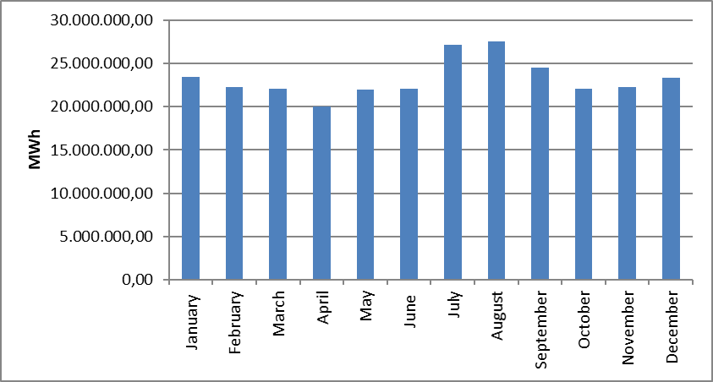
The development of the number of consumers for the years 2022, 2023 and 2024 on the basis of consumer type is shown in Table 1.16. In 2024, 83,47% of the total consumer will be residential consumers.

Table 1.16 Distribution of Number of Consumer by Consumer Type in 2024 (Number-%)
Consumer Type | 2022 |  | 2023 |  | 2024
Consumer Type | Number of Consumers | Share (%) | Number of Consumers | Share (%) | Number of Consumers | Share (%)
Household | 40.484.414 | 83,36 | 41.501.522 | 83,46 | 42.311.778 | 83,47
Public and Private Services Other by Sector | 6.984.433 | 14,38 | 7.114.036 | 14,31 | 7.248.942 | 14,30
Irrigation | 736.877 | 1,52 | 762.774 | 1,53 | 781.721 | 1,54
Lighting | 281.975 | 0,58 | 280.098 | 0,56 | 284.654 | 0,56
Industry | 75.760 | 0,16 | 68.115 | 0,14 | 66.535 | 0,13
Grand Total | 48.563.459 | 100,00 | 49.726.545 | 100,00 | 50.693.630 | 100,00

Table 1.17 shows the distribution of the number of consumers in 2024 on the basis of province and consumer type. The city with the highest number of consumers is Istanbul, followed by Ankara, Izmir, Antalya, Bursa and Konya, respectively. The province with the lowest number of consumers is Bayburt.

Table 1.17 Distribution of the Number of Consumers in 2024 by Province and Consumer Type (Number-%)
Province Name | Consumer Type | Number of Consumers | Share
İSTANBUL | Lighting | 18.837 | 0,04%
İSTANBUL | Public and Private Services Sector and Others | 1.320.275 | 2,60%
İSTANBUL | Household | 7.325.912 | 14,45%
İSTANBUL | Industry | 14.145 | 0,03%
İSTANBUL | Irrigation | 2.018 | 0,00%
İSTANBUL | Province Total | 8.681.187 | 17,12%
ANKARA | Lighting | 13.419 | 0,03%
ANKARA | Public and Private Services Sector and Others | 391.757 | 0,77%
ANKARA | Household | 2.832.697 | 5,59%
ANKARA | Industry | 2.385 | 0,00%
ANKARA | Irrigation | 11.201 | 0,02%
ANKARA | Province Total | 3.251.459 | 6,41%
İZMİR | Lighting | 13.604 | 0,03%
İZMİR | Public and Private Services Sector and Others | 482.175 | 0,95%
İZMİR | Household | 2.375.279 | 4,69%
İZMİR | Industry | 3.064 | 0,01%
İZMİR | Irrigation | 57.618 | 0,11%
İZMİR | Province Total | 2.931.740 | 5,78%
ANTALYA | Lighting | 11.902 | 0,02%
ANTALYA | Public and Private Services Sector and Others | 336.333 | 0,66%
ANTALYA | Household | 1.558.902 | 3,08%
ANTALYA | Industry | 2.889 | 0,01%
ANTALYA | Irrigation | 84.196 | 0,17%
ANTALYA | Province Total | 1.994.222 | 3,93%
BURSA | Lighting | 7.530 | 0,01%
BURSA | Public and Private Services Sector and Others | 300.694 | 0,59%
BURSA | Household | 1.597.091 | 3,15%
BURSA | Industry | 5.469 | 0,01%
BURSA | Irrigation | 13.738 | 0,03%
BURSA | Province Total | 1.924.522 | 3,80%
KONYA | Lighting | 8.562 | 0,02%
KONYA | Public and Private Services Sector and Others | 223.802 | 0,44%
KONYA | Household | 1.105.131 | 2,18%
KONYA | Industry | 2.867 | 0,01%
KONYA | Irrigation | 36.501 | 0,07%
KONYA | Province Total | 1.376.863 | 2,72%
ADANA | Lighting | 6.052 | 0,01%
ADANA | Public and Private Services Sector and Others | 161.000 | 0,32%
ADANA | Household | 1.044.644 | 2,06%
ADANA | Industry | 1.298 | 0,00%
ADANA | Irrigation | 10.814 | 0,02%
ADANA | Province Total | 1.223.808 | 2,41%
MERSİN | Lighting | 7.496 | 0,01%
MERSİN | Public and Private Services Sector and Others | 138.143 | 0,27%
MERSİN | Household | 990.383 | 1,95%
MERSİN | Industry | 1.257 | 0,00%
MERSİN | Irrigation | 53.036 | 0,10%
MERSİN | Province Total | 1.190.315 | 2,35%
KOCAELİ | Lighting | 4.937 | 0,01%
KOCAELİ | Public and Private Services Sector and Others | 130.792 | 0,26%
KOCAELİ | Household | 972.466 | 1,92%
KOCAELİ | Industry | 2.186 | 0,00%
KOCAELİ | Irrigation | 3.316 | 0,01%
KOCAELİ | Province Total | 1.113.697 | 2,20%
BALIKESİR | Lighting | 5.872 | 0,01%
BALIKESİR | Public and Private Services Sector and Others | 172.323 | 0,34%
BALIKESİR | Household | 898.842 | 1,77%
BALIKESİR | Industry | 1.576 | 0,00%
BALIKESİR | Irrigation | 15.748 | 0,03%
BALIKESİR | Province Total | 1.094.361 | 2,16%
SAMSUN | Lighting | 9.033 | 0,02%
SAMSUN | Public and Private Services Sector and Others | 136.008 | 0,27%
SAMSUN | Household | 823.903 | 1,63%
SAMSUN | Industry | 1.353 | 0,00%
SAMSUN | Irrigation | 35.638 | 0,07%
SAMSUN | Province Total | 1.005.935 | 1,98%
MANİSA | Lighting | 5.419 | 0,01%
MANİSA | Public and Private Services Sector and Others | 149.208 | 0,29%
MANİSA | Household | 760.848 | 1,50%
MANİSA | Industry | 1.131 | 0,00%
MANİSA | Irrigation | 52.405 | 0,10%
MANİSA | Province Total | 969.011 | 1,91%
GAZİANTEP | Lighting | 5.041 | 0,01%
GAZİANTEP | Public and Private Services Sector and Others | 140.536 | 0,28%
GAZİANTEP | Household | 772.198 | 1,52%
GAZİANTEP | Industry | 1.046 | 0,00%
GAZİANTEP | Irrigation | 14.934 | 0,03%
GAZİANTEP | Province Total | 933.755 | 1,84%
KAYSERİ | Lighting | 7.938 | 0,02%
KAYSERİ | Public and Private Services Sector and Others | 116.101 | 0,23%
KAYSERİ | Household | 733.291 | 1,45%
KAYSERİ | Industry | 2.184 | 0,00%
KAYSERİ | Irrigation | 5.499 | 0,01%
KAYSERİ | Province Total | 865.013 | 1,71%
AYDIN | Lighting | 4.778 | 0,01%
AYDIN | Public and Private Services Sector and Others | 106.632 | 0,21%
AYDIN | Household | 706.990 | 1,39%
AYDIN | Industry | 637 | 0,00%
AYDIN | Irrigation | 27.281 | 0,05%
AYDIN | Province Total | 846.318 | 1,67%
MUĞLA | Lighting | 5.264 | 0,01%
MUĞLA | Public and Private Services Sector and Others | 133.973 | 0,26%
MUĞLA | Household | 638.886 | 1,26%
MUĞLA | Industry | 663 | 0,00%
MUĞLA | Irrigation | 34.828 | 0,07%
MUĞLA | Province Total | 813.614 | 1,60%
ŞANLIURFA | Lighting | 6.586 | 0,01%
ŞANLIURFA | Public and Private Services Sector and Others | 105.481 | 0,21%
ŞANLIURFA | Household | 652.946 | 1,29%
ŞANLIURFA | Industry | 653 | 0,00%
ŞANLIURFA | Irrigation | 29.734 | 0,06%
ŞANLIURFA | Province Total | 795.400 | 1,57%
TEKİRDAĞ | Lighting | 3.403 | 0,01%
TEKİRDAĞ | Public and Private Services Sector and Others | 145.744 | 0,29%
TEKİRDAĞ | Household | 610.021 | 1,20%
TEKİRDAĞ | Industry | 1727 | 0,00%
TEKİRDAĞ | Irrigation | 1.545 | 0,00%
TEKİRDAĞ | Province Total | 762.440 | 1,50%
HATAY | Lighting | 4.421 | 0,01%
HATAY | Public and Private Services Sector and Others | 90.035 | 0,18%
HATAY | Household | 613.352 | 1,21%
HATAY | Industry | 612 | 0,00%
HATAY | Irrigation | 15.612 | 0,03%
HATAY | Province Total | 724.032 | 1,43%
DENİZLİ | Lighting | 4.285 | 0,01%
DENİZLİ | Public and Private Services Sector and Others | 99.492 | 0,20%
DENİZLİ | Household | 576.097 | 1,14%
DENİZLİ | Industry | 1.698 | 0,00%
DENİZLİ | Irrigation | 15.378 | 0,03%
DENİZLİ | Province Total | 696.950 | 1,37%
ESKİŞEHİR | Lighting | 2.163 | 0,00%
ESKİŞEHİR | Public and Private Services Sector and Others | 105.779 | 0,21%
ESKİŞEHİR | Household | 577.086 | 1,14%
ESKİŞEHİR | Industry | 726 | 0,00%
ESKİŞEHİR | Irrigation | 10.719 | 0,02%
ESKİŞEHİR | Province Total | 696.473 | 1,37%
TRABZON | Lighting | 3.913 | 0,01%
TRABZON | Public and Private Services Sector and Others | 86.955 | 0,17%
TRABZON | Household | 582.072 | 1,15%
TRABZON | Industry | 643 | 0,00%
TRABZON | Irrigation | 1.269 | 0,00%
TRABZON | Province Total | 674.852 | 1,33%
SAKARYA | Lighting | 3.518 | 0,01%
SAKARYA | Public and Private Services Sector and Others | 86.477 | 0,17%
SAKARYA | Household | 571.960 | 1,13%
SAKARYA | Industry | 1.150 | 0,00%
SAKARYA | Irrigation | 4.727 | 0,01%
SAKARYA | Province Total | 667.832 | 1,32%
DİYARBAKIR | Lighting | 4.924 | 0,01%
DİYARBAKIR | Public and Private Services Sector and Others | 91.861 | 0,18%
DİYARBAKIR | Household | 553.256 | 1,09%
DİYARBAKIR | Industry | 1010 | 0,00%
DİYARBAKIR | Irrigation | 6.275 | 0,01%
DİYARBAKIR | Province Total | 657.326 | 1,30%
ORDU | Lighting | 5.238 | 0,01%
ORDU | Public and Private Services Sector and Others | 75.367 | 0,15%
ORDU | Household | 557.229 | 1,10%
ORDU | Industry | 428 | 0,00%
ORDU | Irrigation | 546 | 0,00%
ORDU | Province Total | 638.808 | 1,26%
KAHRAMANMARAŞ | Lighting | 4.321 | 0,01%
KAHRAMANMARAŞ | Public and Private Services Sector and Others | 53.298 | 0,11%
KAHRAMANMARAŞ | Household | 434.712 | 0,86%
KAHRAMANMARAŞ | Industry | 917 | 0,00%
KAHRAMANMARAŞ | Irrigation | 18.605 | 0,04%
KAHRAMANMARAŞ | Province Total | 511.853 | 1,01%
AFYONKARAHİSAR | Lighting | 2.634 | 0,01%
AFYONKARAHİSAR | Public and Private Services Sector and Others | 81.075 | 0,16%
AFYONKARAHİSAR | Household | 412.431 | 0,81%
AFYONKARAHİSAR | Industry | 960 | 0,00%
AFYONKARAHİSAR | Irrigation | 13.804 | 0,03%
AFYONKARAHİSAR | Province Total | 510.904 | 1,01%
ÇANAKKALE | Lighting | 2.777 | 0,01%
ÇANAKKALE | Public and Private Services Sector and Others | 78.770 | 0,16%
ÇANAKKALE | Household | 369.200 | 0,73%
ÇANAKKALE | Industry | 453 | 0,00%
ÇANAKKALE | Irrigation | 9.191 | 0,02%
ÇANAKKALE | Province Total | 460.391 | 0,91%
MALATYA | Lighting | 4.362 | 0,01%
MALATYA | Public and Private Services Sector and Others | 63.805 | 0,13%
MALATYA | Household | 361.546 | 0,71%
MALATYA | Industry | 173 | 0,00%
MALATYA | Irrigation | 23.966 | 0,05%
MALATYA | Province Total | 453.852 | 0,90%
VAN | Lighting | 3.562 | 0,01%
VAN | Public and Private Services Sector and Others | 63.249 | 0,12%
VAN | Household | 383.600 | 0,76%
VAN | Industry | 78 | 0,00%
VAN | Irrigation | 971 | 0,00%
VAN | Province Total | 451.460 | 0,89%
KÜTAHYA | Lighting | 1.985 | 0,00%
KÜTAHYA | Public and Private Services Sector and Others | 68.808 | 0,14%
KÜTAHYA | Household | 370.180 | 0,73%
KÜTAHYA | Industry | 668 | 0,00%
KÜTAHYA | Irrigation | 3.491 | 0,01%
KÜTAHYA | Province Total | 445.132 | 0,88%
SİVAS | Lighting | 3.763 | 0,01%
SİVAS | Public and Private Services Sector and Others | 51.495 | 0,10%
SİVAS | Household | 379.196 | 0,75%
SİVAS | Industry | 279 | 0,00%
SİVAS | Irrigation | 3195 | 0,01%
SİVAS | Province Total | 437.928 | 0,86%
ERZURUM | Lighting | 3.724 | 0,01%
ERZURUM | Public and Private Services Sector and Others | 57.885 | 0,11%
ERZURUM | Household | 372.798 | 0,74%
ERZURUM | Industry | 134 | 0,00%
ERZURUM | Irrigation | 529 | 0,00%
ERZURUM | Province Total | 435.070 | 0,86%
ELAZIĞ | Lighting | 2.993 | 0,01%
ELAZIĞ | Public and Private Services Sector and Others | 57.329 | 0,11%
ELAZIĞ | Household | 345.752 | 0,68%
ELAZIĞ | Industry | 291 | 0,00%
ELAZIĞ | Irrigation | 18.033 | 0,04%
ELAZIĞ | Province Total | 424.398 | 0,84%
ZONGULDAK | Lighting | 3.346 | 0,01%
ZONGULDAK | Public and Private Services Sector and Others | 57.828 | 0,11%
ZONGULDAK | Household | 359.885 | 0,71%
ZONGULDAK | Industry | 298 | 0,00%
ZONGULDAK | Irrigation | 1.188 | 0,00%
ZONGULDAK | Province Total | 422.545 | 0,83%
ÇORUM | Lighting | 2.986 | 0,01%
ÇORUM | Public and Private Services Sector and Others | 50.157 | 0,10%
ÇORUM | Household | 347.916 | 0,69%
ÇORUM | Industry | 485 | 0,00%
ÇORUM | Irrigation | 5.285 | 0,01%
ÇORUM | Province Total | 406.829 | 0,80%
GİRESUN | Lighting | 2.745 | 0,01%
GİRESUN | Public and Private Services Sector and Others | 43.652 | 0,09%
GİRESUN | Household | 338.734 | 0,67%
GİRESUN | Industry | 251 | 0,00%
GİRESUN | Irrigation | 510 | 0,00%
GİRESUN | Province Total | 385.892 | 0,76%
TOKAT | Lighting | 2.971 | 0,01%
TOKAT | Public and Private Services Sector and Others | 45.752 | 0,09%
TOKAT | Household | 333.349 | 0,66%
TOKAT | Industry | 508 | 0,00%
TOKAT | Irrigation | 2.049 | 0,00%
TOKAT | Province Total | 384.629 | 0,76%
MARDİN | Lighting | 3.074 | 0,01%
MARDİN | Public and Private Services Sector and Others | 56.418 | 0,11%
MARDİN | Household | 284.022 | 0,56%
MARDİN | Industry | 120 | 0,00%
MARDİN | Irrigation | 12.560 | 0,02%
MARDİN | Province Total | 356.194 | 0,70%
ISPARTA | Lighting | 2.118 | 0,00%
ISPARTA | Public and Private Services Sector and Others | 43.757 | 0,09%
ISPARTA | Household | 263.422 | 0,52%
ISPARTA | Industry | 321 | 0,00%
ISPARTA | Irrigation | 11.521 | 0,02%
ISPARTA | Province Total | 321.139 | 0,63%
KASTAMONU | Lighting | 3.953 | 0,01%
KASTAMONU | Public and Private Services Sector and Others | 38.396 | 0,08%
KASTAMONU | Household | 276.242 | 0,54%
KASTAMONU | Industry | 250 | 0,00%
KASTAMONU | Irrigation | 1.332 | 0,00%
KASTAMONU | Province Total | 320.173 | 0,63%
EDİRNE | Lighting | 1.950 | 0,00%
EDİRNE | Public and Private Services Sector and Others | 53.459 | 0,11%
EDİRNE | Household | 247.194 | 0,49%
EDİRNE | Industry | 331 | 0,00%
EDİRNE | Irrigation | 3.777 | 0,01%
EDİRNE | Province Total | 306.711 | 0,61%
YOZGAT | Lighting | 2.209 | 0,00%
YOZGAT | Public and Private Services Sector and Others | 38.321 | 0,08%
YOZGAT | Household | 249.791 | 0,49%
YOZGAT | Industry | 190 | 0,00%
YOZGAT | Irrigation | 3.791 | 0,01%
YOZGAT | Province Total | 294.302 | 0,58%
RİZE | Lighting | 2.311 | 0,00%
RİZE | Public and Private Services Sector and Others | 40.029 | 0,08%
RİZE | Household | 243.914 | 0,48%
RİZE | Industry | 236 | 0,00%
RİZE | Irrigation | 11 | 0,00%
RİZE | Province Total | 286.501 | 0,57%
UŞAK | Lighting | 1.570 | 0,00%
UŞAK | Public and Private Services Sector and Others | 46.232 | 0,09%
UŞAK | Household | 214.146 | 0,42%
UŞAK | Industry | 760 | 0,00%
UŞAK | Irrigation | 7.599 | 0,01%
UŞAK | Province Total | 270.307 | 0,53%
AKSARAY | Lighting | 1.712 | 0,00%
AKSARAY | Public and Private Services Sector and Others | 37.041 | 0,07%
AKSARAY | Household | 219.597 | 0,43%
AKSARAY | Industry | 237 | 0,00%
AKSARAY | Irrigation | 8.952 | 0,02%
AKSARAY | Province Total | 267.539 | 0,53%
OSMANİYE | Lighting | 1.940 | 0,00%
OSMANİYE | Public and Private Services Sector and Others | 29.034 | 0,06%
OSMANİYE | Household | 234.556 | 0,46%
OSMANİYE | Industry | 125 | 0,00%
OSMANİYE | Irrigation | 1.019 | 0,00%
OSMANİYE | Province Total | 266.674 | 0,53%
KIRKLARELİ | Lighting | 1.502 | 0,00%
KIRKLARELİ | Public and Private Services Sector and Others | 42.688 | 0,08%
KIRKLARELİ | Household | 215.434 | 0,42%
KIRKLARELİ | Industry | 430 | 0,00%
KIRKLARELİ | Irrigation | 1.620 | 0,00%
KIRKLARELİ | Province Total | 261.674 | 0,52%
YALOVA | Lighting | 1.094 | 0,00%
YALOVA | Public and Private Services Sector and Others | 36.743 | 0,07%
YALOVA | Household | 213.033 | 0,42%
YALOVA | Industry | 295 | 0,00%
YALOVA | Irrigation | 2.985 | 0,01%
YALOVA | Province Total | 254.150 | 0,50%
NİĞDE | Lighting | 1.492 | 0,00%
NİĞDE | Public and Private Services Sector and Others | 28.785 | 0,06%
NİĞDE | Household | 207.473 | 0,41%
NİĞDE | Industry | 262 | 0,00%
NİĞDE | Irrigation | 10.649 | 0,02%
NİĞDE | Province Total | 248.661 | 0,49%
AMASYA | Lighting | 2.579 | 0,01%
AMASYA | Public and Private Services Sector and Others | 35.390 | 0,07%
AMASYA | Household | 203.951 | 0,40%
AMASYA | Industry | 353 | 0,00%
AMASYA | Irrigation | 5.899 | 0,01%
AMASYA | Province Total | 248.172 | 0,49%
DÜZCE | Lighting | 1.727 | 0,00%
DÜZCE | Public and Private Services Sector and Others | 29.746 | 0,06%
DÜZCE | Household | 207.441 | 0,41%
DÜZCE | Industry | 483 | 0,00%
DÜZCE | Irrigation | 575 | 0,00%
DÜZCE | Province Total | 239.972 | 0,47%
BATMAN | Lighting | 2.061 | 0,00%
BATMAN | Public and Private Services Sector and Others | 33.584 | 0,07%
BATMAN | Household | 198.417 | 0,39%
BATMAN | Industry | 127 | 0,00%
BATMAN | Irrigation | 2612 | 0,01%
BATMAN | Province Total | 236.801 | 0,47%
ADIYAMAN | Lighting | 2.260 | 0,00%
ADIYAMAN | Public and Private Services Sector and Others | 25.358 | 0,05%
ADIYAMAN | Household | 195.054 | 0,38%
ADIYAMAN | Industry | 170 | 0,00%
ADIYAMAN | Irrigation | 6.269 | 0,01%
ADIYAMAN | Province Total | 229.111 | 0,45%
NEVŞEHİR | Lighting | 1.540 | 0,00%
NEVŞEHİR | Public and Private Services Sector and Others | 33.952 | 0,07%
NEVŞEHİR | Household | 178.904 | 0,35%
NEVŞEHİR | Industry | 388 | 0,00%
NEVŞEHİR | Irrigation | 7.178 | 0,01%
NEVŞEHİR | Province Total | 221.962 | 0,44%
BURDUR | Lighting | 1.447 | 0,00%
BURDUR | Public and Private Services Sector and Others | 31.741 | 0,06%
BURDUR | Household | 161.567 | 0,32%
BURDUR | Industry | 324 | 0,00%
BURDUR | Irrigation | 12.347 | 0,02%
BURDUR | Province Total | 207.426 | 0,41%
BOLU | Lighting | 1.991 | 0,00%
BOLU | Public and Private Services Sector and Others | 23.961 | 0,05%
BOLU | Household | 178.252 | 0,35%
BOLU | Industry | 197 | 0,00%
BOLU | Irrigation | 2.837 | 0,01%
BOLU | Province Total | 207.238 | 0,41%
SİNOP | Lighting | 2.096 | 0,00%
SİNOP | Public and Private Services Sector and Others | 25.394 | 0,05%
SİNOP | Household | 176.253 | 0,35%
SİNOP | Industry | 239 | 0,00%
SİNOP | Irrigation | 1383 | 0,00%
SİNOP | Province Total | 205.365 | 0,41%
AĞRI | Lighting | 2.124 | 0,00%
AĞRI | Public and Private Services Sector and Others | 27.065 | 0,05%
AĞRI | Household | 175.626 | 0,35%
AĞRI | Industry | 88 | 0,00%
AĞRI | Irrigation | 354 | 0,00%
AĞRI | Province Total | 205.257 | 0,40%
ERZİNCAN | Lighting | 1.694 | 0,00%
ERZİNCAN | Public and Private Services Sector and Others | 27.876 | 0,05%
ERZİNCAN | Household | 157.030 | 0,31%
ERZİNCAN | Industry | 72 | 0,00%
ERZİNCAN | Irrigation | 759 | 0,00%
ERZİNCAN | Province Total | 187.431 | 0,37%
KIRIKKALE | Lighting | 1.121 | 0,00%
KIRIKKALE | Public and Private Services Sector and Others | 19.108 | 0,04%
KIRIKKALE | Household | 161.679 | 0,32%
KIRIKKALE | Industry | 121 | 0,00%
KIRIKKALE | Irrigation | 2404 | 0,00%
KIRIKKALE | Province Total | 184.433 | 0,36%
KARABÜK | Lighting | 1.469 | 0,00%
KARABÜK | Public and Private Services Sector and Others | 20.950 | 0,04%
KARABÜK | Household | 154.881 | 0,31%
KARABÜK | Industry | 212 | 0,00%
KARABÜK | Irrigation | 2.309 | 0,00%
KARABÜK | Province Total | 179.821 | 0,35%
KARAMAN | Lighting | 946 | 0,00%
KARAMAN | Public and Private Services Sector and Others | 24.812 | 0,05%
KARAMAN | Household | 146.005 | 0,29%
KARAMAN | Industry | 179 | 0,00%
KARAMAN | Irrigation | 4.887 | 0,01%
KARAMAN | Province Total | 176.829 | 0,35%
KIRŞEHİR | Lighting | 1.137 | 0,00%
KIRŞEHİR | Public and Private Services Sector and Others | 22.178 | 0,04%
KIRŞEHİR | Household | 147.055 | 0,29%
KIRŞEHİR | Industry | 126 | 0,00%
KIRŞEHİR | Irrigation | 2.586 | 0,01%
KIRŞEHİR | Province Total | 173.082 | 0,34%
BİNGÖL | Lighting | 1483 | 0,00%
BİNGÖL | Public and Private Services Sector and Others | 19.747 | 0,04%
BİNGÖL | Household | 136.325 | 0,27%
BİNGÖL | Industry | 79 | 0,00%
BİNGÖL | Irrigation | 934 | 0,00%
BİNGÖL | Province Total | 158.568 | 0,31%
BİLECİK | Lighting | 795 | 0,00%
BİLECİK | Public and Private Services Sector and Others | 23.106 | 0,05%
BİLECİK | Household | 131.755 | 0,26%
BİLECİK | Industry | 568 | 0,00%
BİLECİK | Irrigation | 2050 | 0,00%
BİLECİK | Province Total | 158.274 | 0,31%
MUŞ | Lighting | 1.673 | 0,00%
MUŞ | Public and Private Services Sector and Others | 20.676 | 0,04%
MUŞ | Household | 134.747 | 0,27%
MUŞ | Industry | 26 | 0,00%
MUŞ | Irrigation | 900 | 0,00%
MUŞ | Province Total | 158.022 | 0,31%
ŞIRNAK | Lighting | 1.626 | 0,00%
ŞIRNAK | Public and Private Services Sector and Others | 21.951 | 0,04%
ŞIRNAK | Household | 133.098 | 0,26%
ŞIRNAK | Industry | 97 | 0,00%
ŞIRNAK | Irrigation | 1.076 | 0,00%
ŞIRNAK | Province Total | 157.848 | 0,31%
BİTLİS | Lighting | 1.382 | 0,00%
BİTLİS | Public and Private Services Sector and Others | 22.803 | 0,04%
BİTLİS | Household | 125.735 | 0,25%
BİTLİS | Industry | 81 | 0,00%
BİTLİS | Irrigation | 2.143 | 0,00%
BİTLİS | Province Total | 152.144 | 0,30%
BARTIN | Lighting | 1.240 | 0,00%
BARTIN | Public and Private Services Sector and Others | 20.786 | 0,04%
BARTIN | Household | 127.193 | 0,25%
BARTIN | Industry | 78 | 0,00%
BARTIN | Irrigation | 1.388 | 0,00%
BARTIN | Province Total | 150.685 | 0,30%
ÇANKIRI | Lighting | 1.269 | 0,00%
ÇANKIRI | Public and Private Services Sector and Others | 13.428 | 0,03%
ÇANKIRI | Household | 130.881 | 0,26%
ÇANKIRI | Industry | 100 | 0,00%
ÇANKIRI | Irrigation | 1.725 | 0,00%
ÇANKIRI | Province Total | 147.403 | 0,29%
KARS | Lighting | 1.117 | 0,00%
KARS | Public and Private Services Sector and Others | 20.121 | 0,04%
KARS | Household | 124.239 | 0,25%
KARS | Industry | 80 | 0,00%
KARS | Irrigation | 206 | 0,00%
KARS | Province Total | 145.763 | 0,29%
ARTVİN | Lighting | 1.595 | 0,00%
ARTVİN | Public and Private Services Sector and Others | 19.861 | 0,04%
ARTVİN | Household | 122.241 | 0,24%
ARTVİN | Industry | 147 | 0,00%
ARTVİN | Irrigation | 457 | 0,00%
ARTVİN | Province Total | 144.301 | 0,28%
SİİRT | Lighting | 1.108 | 0,00%
SİİRT | Public and Private Services Sector and Others | 14.700 | 0,03%
SİİRT | Household | 98.416 | 0,19%
SİİRT | Industry | 54 | 0,00%
SİİRT | Irrigation | 199 | 0,00%
SİİRT | Province Total | 114.477 | 0,23%
GÜMÜŞHANE | Lighting | 1.068 | 0,00%
GÜMÜŞHANE | Public and Private Services Sector and Others | 11.101 | 0,02%
GÜMÜŞHANE | Household | 98.317 | 0,19%
GÜMÜŞHANE | Industry | 87 | 0,00%
GÜMÜŞHANE | Irrigation | 1.772 | 0,00%
GÜMÜŞHANE | Province Total | 112.345 | 0,22%
HAKKARİ | Lighting | 1.090 | 0,00%
HAKKARİ | Public and Private Services Sector and Others | 14.478 | 0,03%
HAKKARİ | Household | 80.379 | 0,16%
HAKKARİ | Industry | 25 | 0,00%
HAKKARİ | Irrigation | 211 | 0,00%
HAKKARİ | Province Total | 96.183 | 0,19%
IĞDIR | Lighting | 815 | 0,00%
IĞDIR | Public and Private Services Sector and Others | 16.119 | 0,03%
IĞDIR | Household | 76.911 | 0,15%
IĞDIR | Industry | 72 | 0,00%
IĞDIR | Irrigation | 169 | 0,00%
IĞDIR | Province Total | 94.086 | 0,19%
KİLİS | Lighting | 670 | 0,00%
KİLİS | Public and Private Services Sector and Others | 13.870 | 0,03%
KİLİS | Household | 68.977 | 0,14%
KİLİS | Industry | 38 | 0,00%
KİLİS | Irrigation | 3.849 | 0,01%
KİLİS | Province Total | 87.404 | 0,17%
TUNCELİ | Lighting | 1.056 | 0,00%
TUNCELİ | Public and Private Services Sector and Others | 8.376 | 0,02%
TUNCELİ | Household | 58.489 | 0,12%
TUNCELİ | Industry | 54 | 0,00%
TUNCELİ | Irrigation | 771 | 0,00%
TUNCELİ | Province Total | 68.746 | 0,14%
ARDAHAN | Lighting | 695 | 0,00%
ARDAHAN | Public and Private Services Sector and Others | 7.498 | 0,01%
ARDAHAN | Household | 58.367 | 0,12%
ARDAHAN | Industry | 10 | 0,00%
ARDAHAN | Irrigation | 2 | 0,00%
ARDAHAN | Province Total | 66.572 | 0,13%
BAYBURT | Lighting | 551 | 0,00%
BAYBURT | Public and Private Services Sector and Others | 8.257 | 0,02%
BAYBURT | Household | 53.988 | 0,11%
BAYBURT | Industry | 11 | 0,00%
BAYBURT | Irrigation | 261 | 0,00%
BAYBURT | Province Total | 63.068 | 0,12%
 | Grand Total | 50.693.630 | 100,00%

1.6 Import and Export

1.6.1 Import

In Figure 1.20, data on electricity imports in 2024 are shown by months. %70,80% of the total electricity import of 2.719.748,60 MWh in 2024 is from Georgia, %21,20% is from Bulgaria, 8% is from Greece. While the highest electricity import on a monthly basis was realized in August, the lowest electricity import was realized in November.

Figure 1.20: Electricity Imports (MWh) by Months in 2024
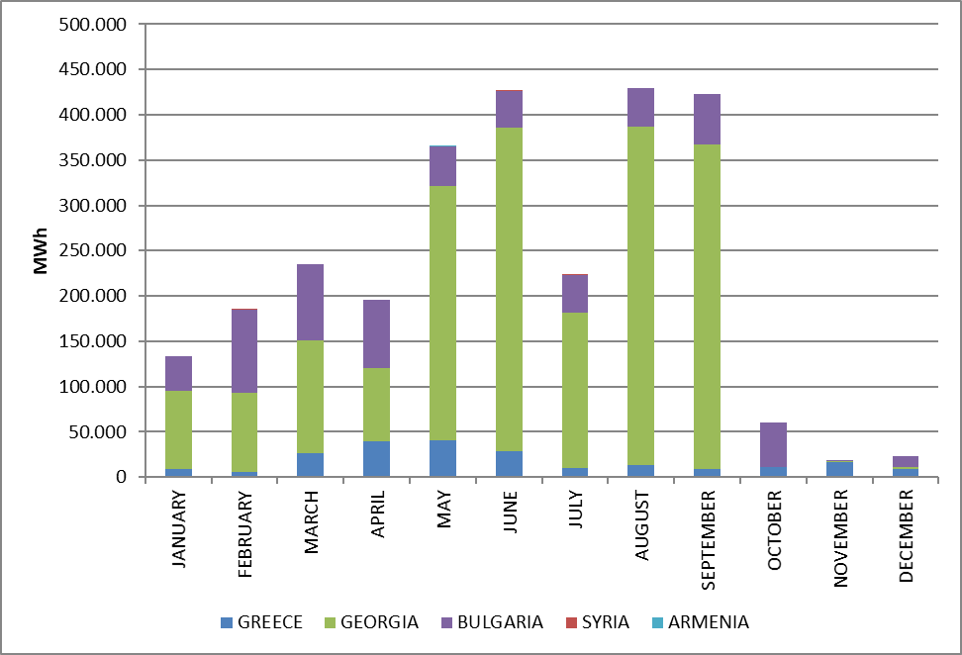

1.6.2 Export

In Figure 1.21, data regarding electricity exports in 2024 are shown by months. 30,95% of the total electricity export of 3.725.099,98 MWh in 2024 will go to Iraq, 29,70% will go to Bulgaria, 20,21% will go to Syria and 19,08% will go to Greece. While the highest electricity export was realized on a monthly basis in December, the lowest electricity export was realized in March.

Figure 1.21: Electricity Exports by Months in 2024 (MWh)
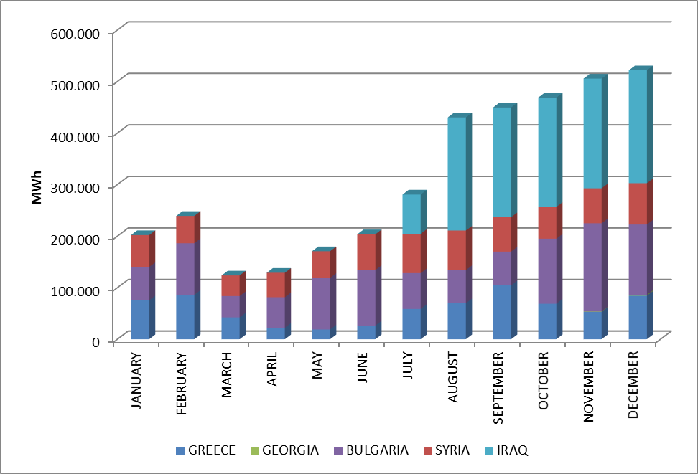

2. WHOLESALE MARKET

In this section, the developments in the wholesale market in 2024 are examined. In this context; Prices, volumes and instructions given in the Day Ahead Market (DAM), Intraday Market (IIP), Forward Electricity Market (FEM) and Balancing Power Market (BPM) are presented. Additionally, changes in the market structure are explained.

  - Day Ahead Market

Within the scope of the Day Ahead Market operated by EPİAŞ, market clearing prices and buying, selling and matching amounts are announced in line with the offers submitted by market participants.
2024 DAM prices along with the weighted average price are given graphically in Figure 2.1.1 and Figure 2.1.2.

Figure 2.1.1: Hourly Development of Weighted Average Market Clearing Price and Market Clearing Price in 2024 (TL/MWh)
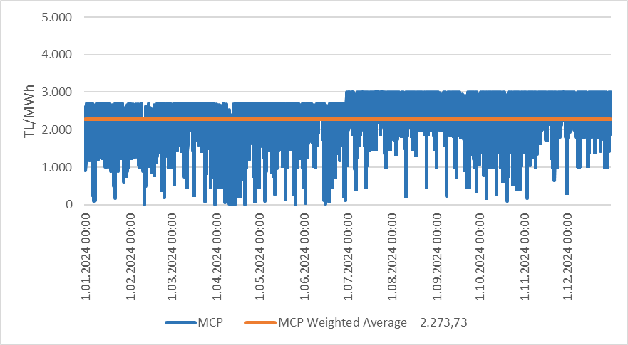

Figure 2.1.2: Organized and Weighted Average MCP in 2024 (TL/MWh)
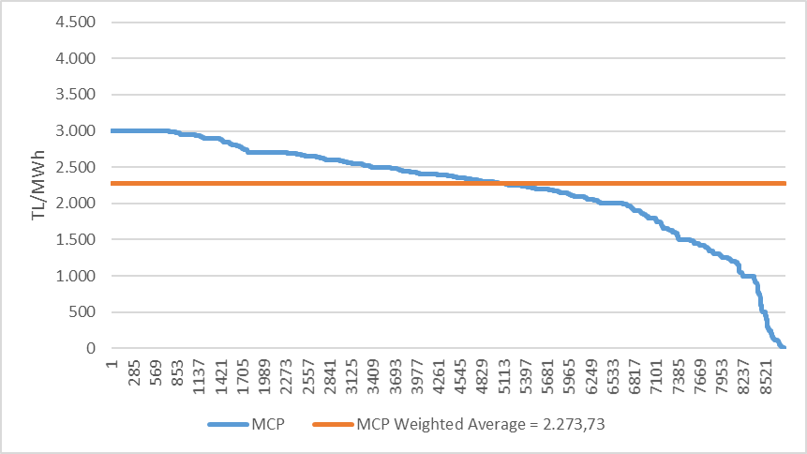
As seen in Figure 2.1.1, prices were generally above the weighted average market clearing price on an hourly basis throughout the year, while approximately 42% of the time they were below the weighted average market clearing price. MCP reached its highest value of 3.000,0 TL/MWh for the first time at 17:00 on July 1, 2024. In 2024, the MCP for a total of 4 hours was 0 TL/MWh.
Figure 2.1.3 shows the weighted average market clearing prices in DAM over the years. Compared to 2023, the weighted average of the market clearing price increased by 1,64% in 2024, reaching 2.273,73 TL/MWh.

Figure 2.1.3: Weighted Average MCP by Years (TL/MWh)
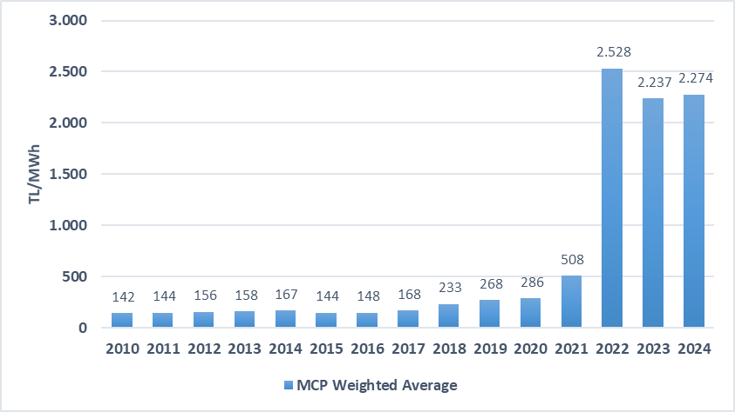
Figure 2.1.4 below shows the monthly weighted average DAM prices for the last two years. In 2024, the highest weighted average price was realized in July with 2.609,11 TL/MWh, and the lowest price was realized in April with 1.813,71 TL/MWh.
In spring and autumn, electricity consumption decreases as the climate becomes milder. In addition, with the high rainfall that occurs especially in spring, the amount of electricity produced by hydroelectric power plants increases, and therefore prices are generally low in spring months.
On the other hand, electricity demand increases due to the use of air conditioning and consumption for agricultural irrigation in the summer months and the need for heating and lighting in the winter months, and an increase in average prices is observed in parallel with the increase in consumption. On the other hand, events taking place around the world may also affect energy prices in our country upwards or downwards.

Figure 2.1.4: Monthly Weighted Average MCP of the Last Two Years (TL/MWh)
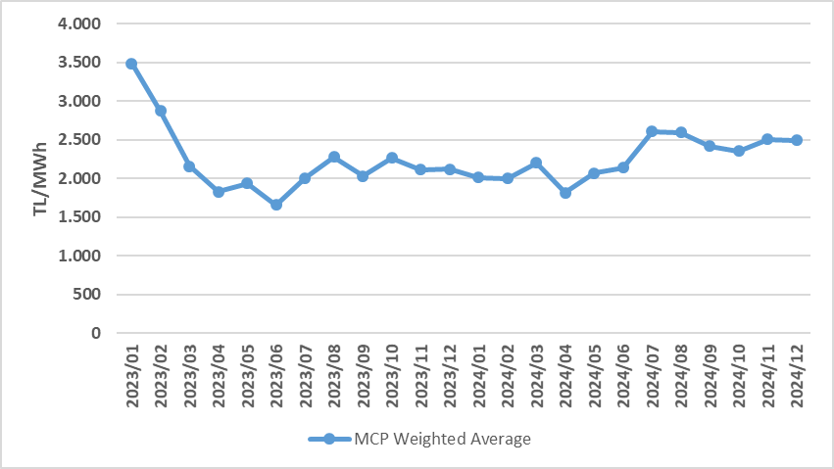
Figure 2.1.5 below shows the DAM matching amounts by month, Figure 2.1.6 shows the distribution of DAM purchase amounts by company and the share of the first 10 companies in purchase, and Figure 2.1.7 shows the distribution of sales amounts by company and the share of the first 10 companies in sales.

Figure 2.1.5: Monthly Day-Ahead Market Matching Quantity (MWh)
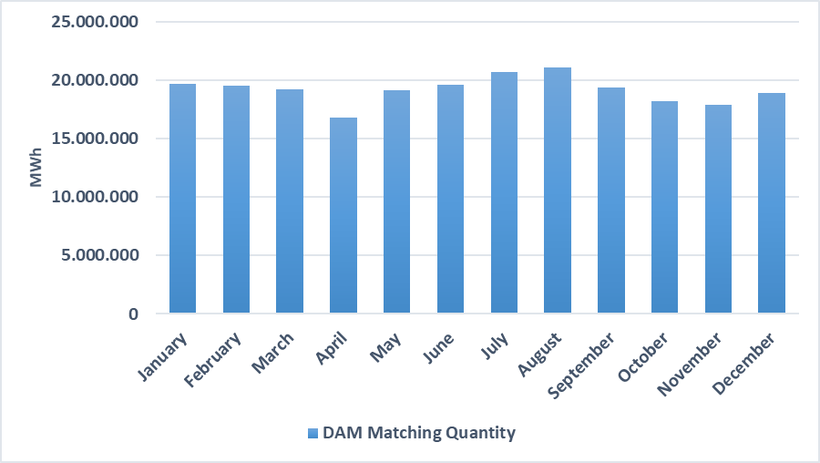

Figure 2.1.6: Share of Top 10 Companies by Purchase Amount in Day-Ahead Market (%)
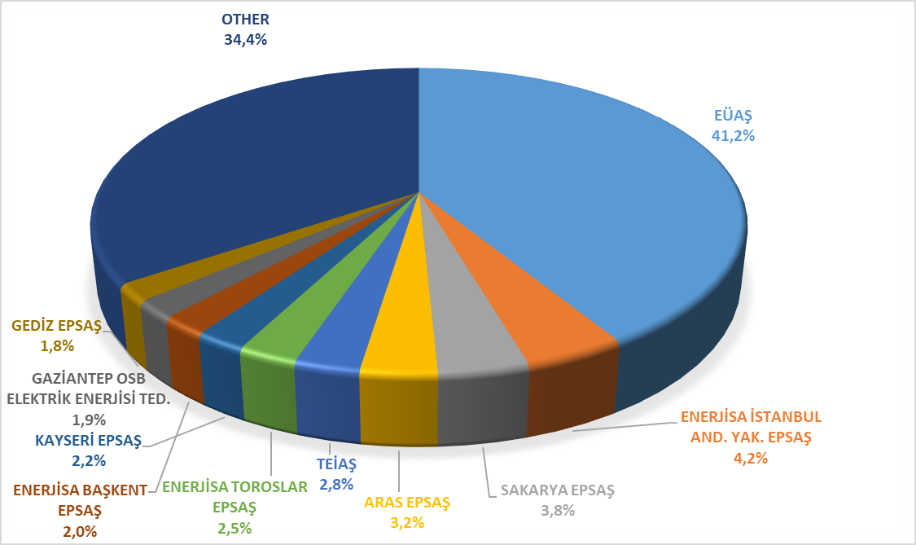

Figure 2.1.7: Share of Top 10 Companies by Sales Amount in the Day Ahead Market (%)
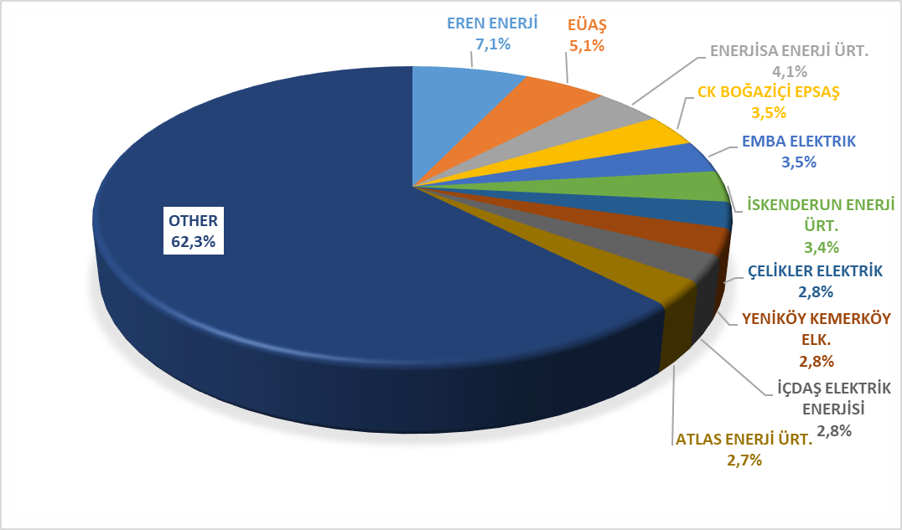
  - Balancing Power Market

Balancing Power Market is operated by TEİAŞ. This section presents data on the monthly development of prices and volumes in BPM. Prices formed in BPM in 2024 are shown on an hourly basis and arranged in Figure 2.2.1 and Figure 2.2.2.

Figure 2.2.1: Hourly System Marginal Price (SMP) (TL/MWh)
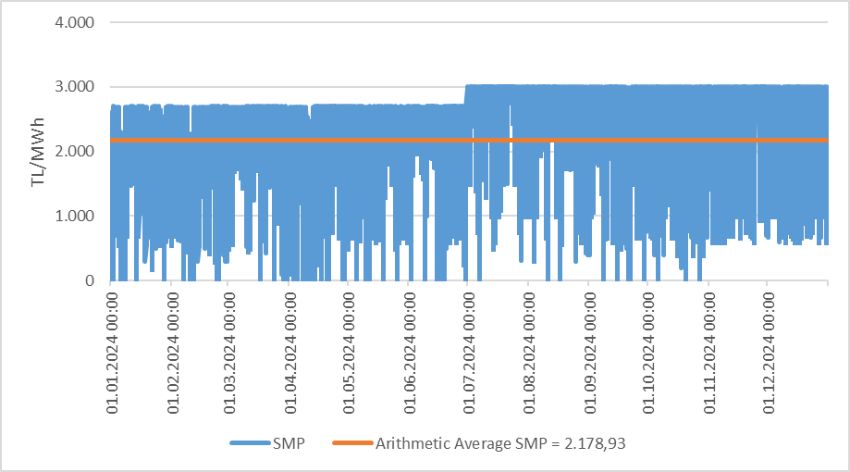

Figure 2.2.2: Organized System Marginal Price (TL/MWh)
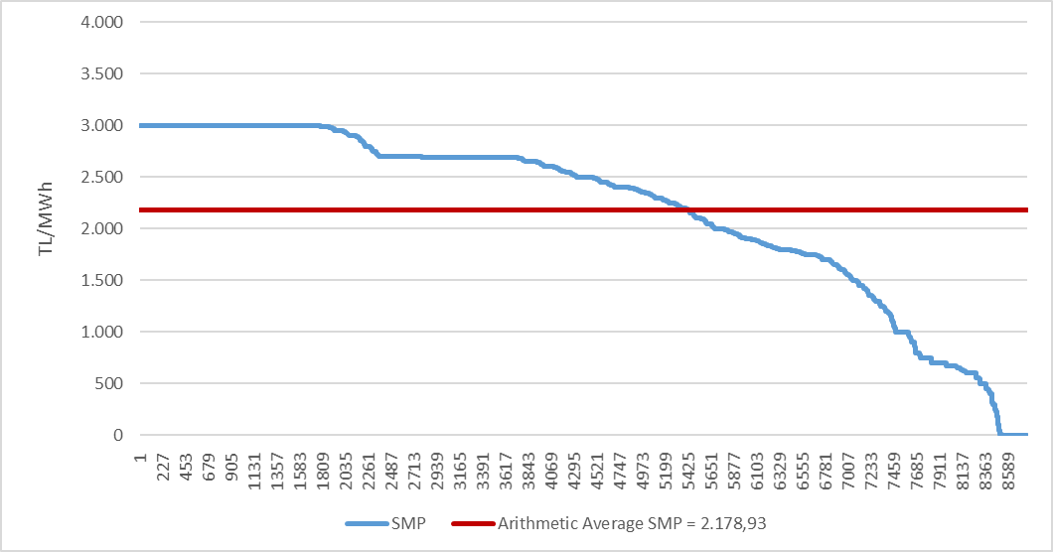

As seen in Figure 2.2.1, prices were generally above the arithmetic average system marginal price on an hourly basis, while they were below the average price in approximately 38% of the time. It is also understood that prices increased relatively in the second half of the year compared to the first half. The price in DGP reached its highest level of 3.000,0 TL/MWh for the first time at 17:00 on July 1, 2024, and remained at this value for a total of 719 hours during the year. In DGP, the price for 106 hours throughout 2024 was 0 TL/MWh.
The annual average (arithmetic) price in BPM increased by 0,84% compared to the previous year and became 2.178,93 TL/MWh.
Monthly average (arithmetic) prices in the Balancing Power Market for the last two years are shown in Figure 2.2.3. In 2024, the lowest monthly average SMP value was seen in April with 1.780,95 TL/MWh, and the highest value was in July with 2.619,88 TL/MWh.

Figure 2.2.3: Monthly Arithmetic Average Prices of the Last Two Years in Balancing Power Market (TL/MWh)
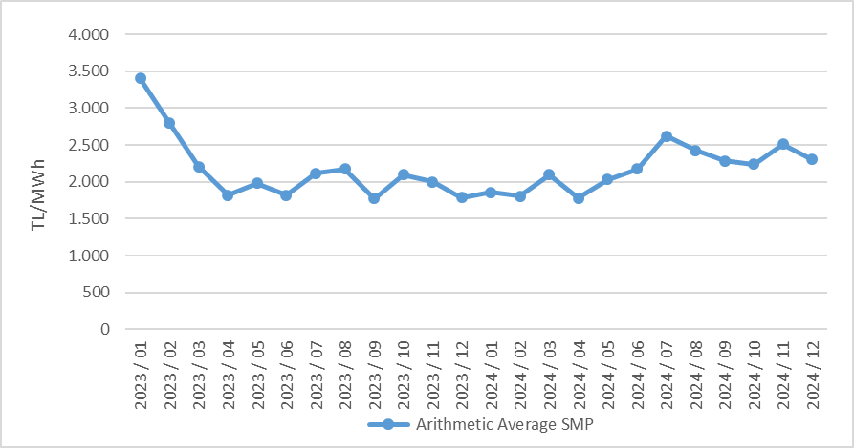

Figure 2.2.4 below shows the monthly volumes in BPM in 2024. It is noteworthy that the sales amounts are much higher than the purchases.

Figure 2.2.4: Monthly Trading Volumes in Balancing Power Market (MWh)
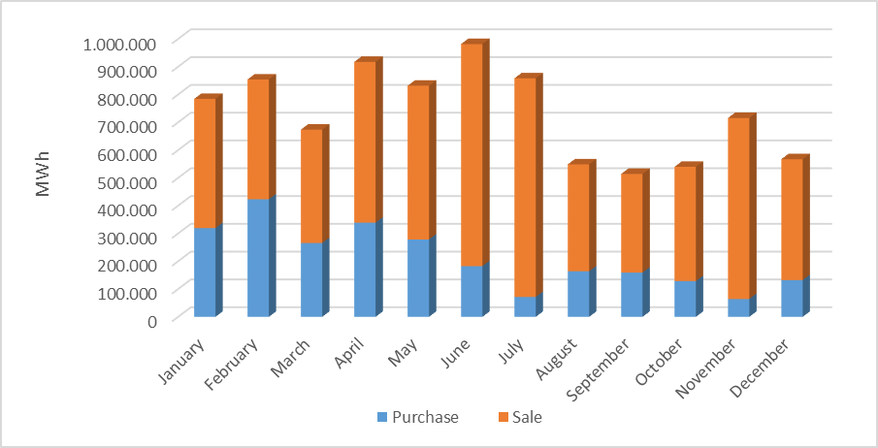
Figure 2.2.5 below shows the distribution of BPM purchase amounts on a company basis and the share of the top 10 companies, and Figure 2.2.6 shows the distribution of BPM sales amounts on a company basis and the share of the top 10 companies.

Figure 2.2.5: Share of Top 10 Companies by Purchase Amount in Balancing Power Market (%)
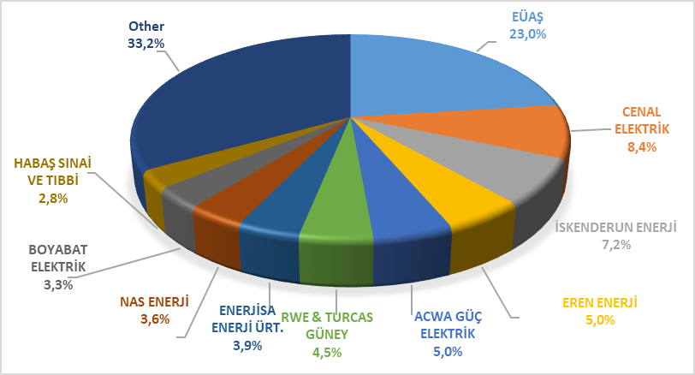

Figure 2.2.6: Share of Top 10 Companies by Sales Amount in Balancing Power Market (%)
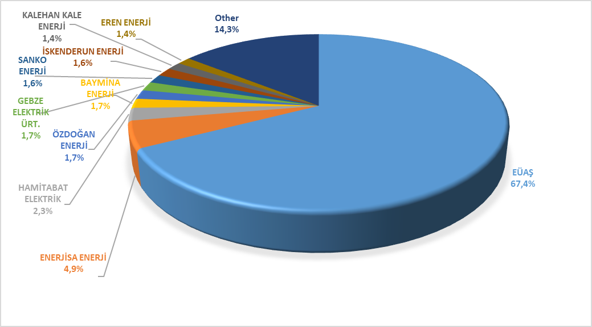
The rates of order volumes given in BPM as of 2024 are shown in Figure 2.2.7 below, and their hourly distribution is shown in Figure 2.2.8. 12,6% of the instructions are code 1 instructions given due to system constraints, and as of February 2018, since the tender system was introduced in ancillary services, no code 2 instructions were issued.

Figure 2.2.7: Rates of Order Volumes Given in Balancing Power Market in 2024 (%)
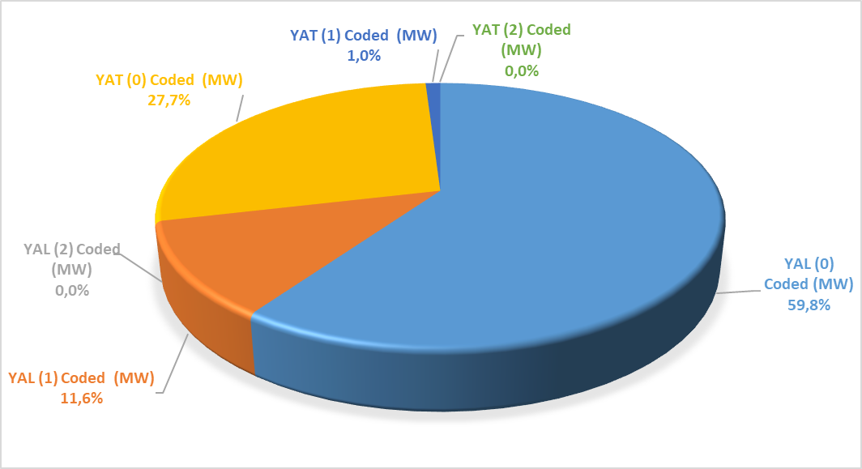

Figure 2.2.8: Hourly Distribution of Orders Given in the Balancing Power Market in 2024 (MW)
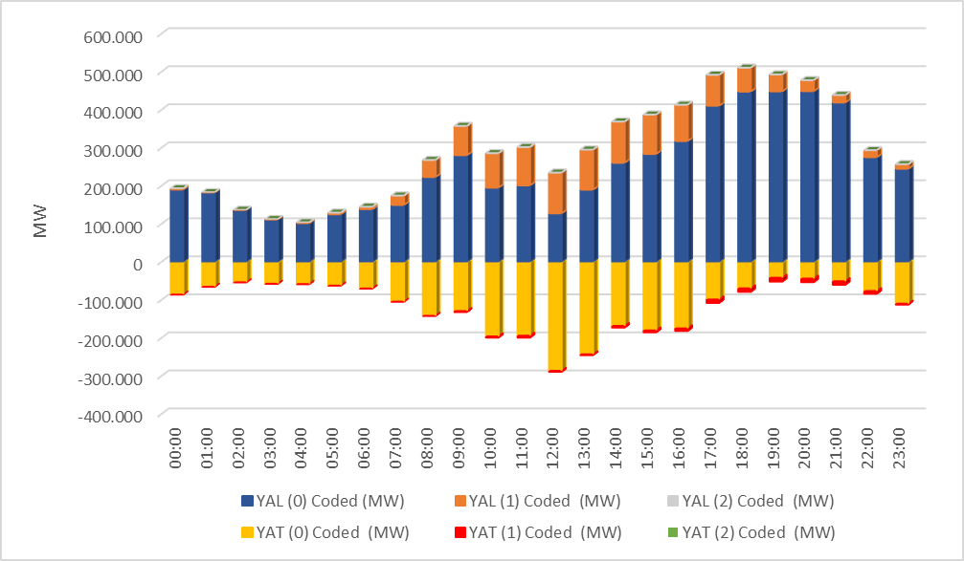
Additional costs arising from those instructions are shown in Table 2.2.1 below. While the additional total cost caused by the instructions given in BPM was 1.315,10 million TL in 2023, it was 734,77 million TL in 2024

Table 2.2.1: Additional Costs of Orders (Million TL)
The monthly development of additional costs arising from code 1 instructions given in 2024 is shown in Figure 2.2.9. The majority of additional costs occurred in May and June.

Figure 2.2.9: Monthly Development of Additional Costs of Orders in 2024 (Million TL)
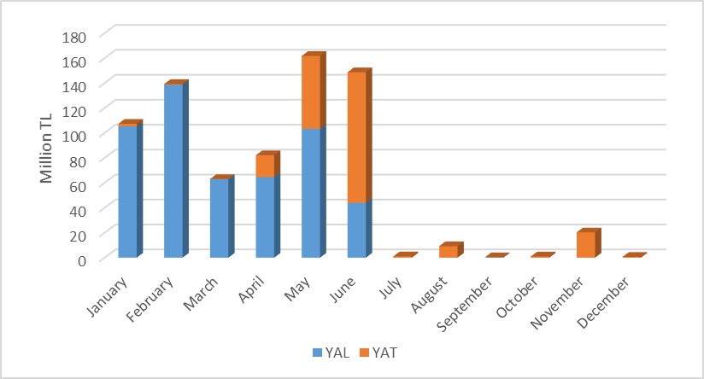
The change in Zero Balance Adjustment Component (ZBAC) over the years is shown in Figure 2.2.10. While ZBAC was realized as 727,68 Million TL in 2023, it was realized as 1.036,73 Million TL in 2024.

Figure 2.2.10: Yearly Development of Zero Balance Adjustment Component in 2024 (Million TL)
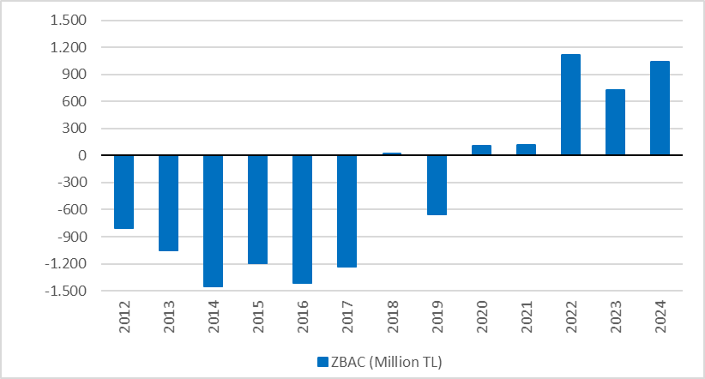

2.3 Intraday Market

Efforts are continuing to ensure that the Turkish Electricity Market is more transparent and effective, financially strong, and integrated with the European Union electricity markets. On July 1, 2015, in order to ensure that participants take a more balanced and effective role in the Turkish electricity market, which is constantly developing and advancing with the goal of a free market, Intraday Market has become operational.
With the Intraday Market, which is added to the already functioning Day Ahead, Ancillary Services and Balancing Power Markets, near real-time trading opportunities are provided and market participants are offered the opportunity to balance their portfolios in the short term.
Figure 2.3.1 below shows the development of the Intraday Market volume and weighted average price in 2024 by months.

Figure 2.3.1: Monthly Development of Trading Volume and Average Price in the Intra-Day Market (MWh – TL/MWh)
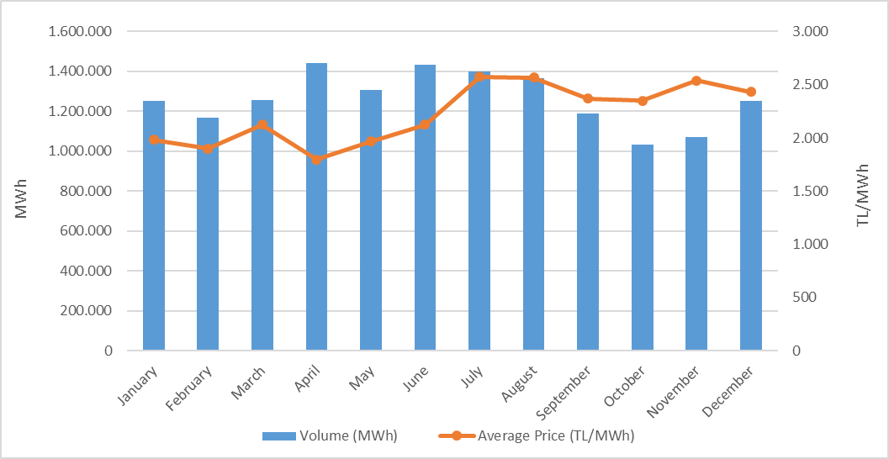
While the Intraday Market volume on a monthly basis was observed to be higher in the second quarter of the year, the highest monthly average price value was realized in July.
Figure 2.3.2 below shows the distribution of IDM purchase amounts on a company basis and the share of the top 10 companies, and Figure 2.3.3 shows the distribution of IDM sales amounts on a company basis and the share of the top 10 companies.

Figure 2.3.2: Share of Top 10 Companies by Purchase Amount in Intra-Day Market (%)
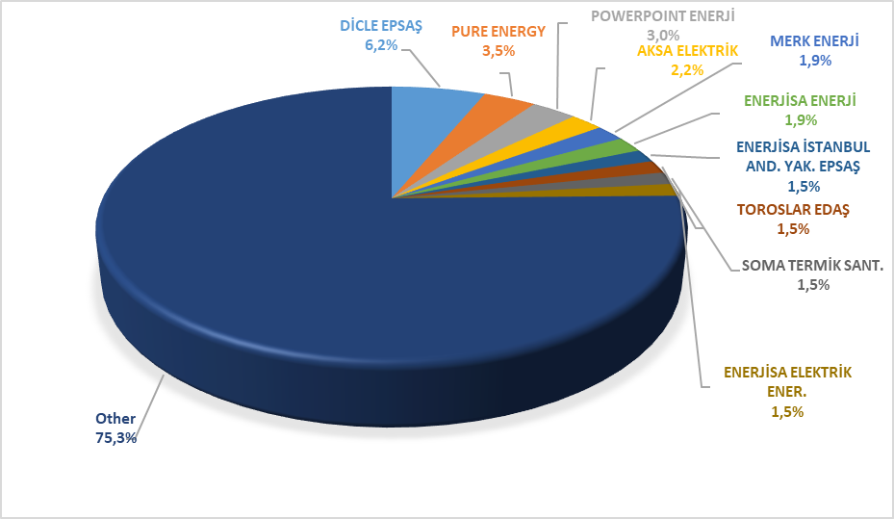

Figure 2.3.3: Share of Top 10 Companies by Sales Amount in Intra-Day Market (%)
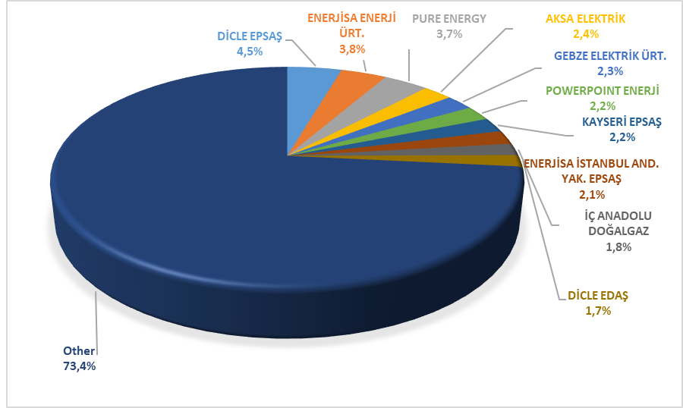

2.4 Bilateral Contracts Market
Bilateral agreements have an important place in the Turkish electricity market structure in terms of the development of competition. Therefore, it has always been aimed to increase the number of eligible consumers and the use of this right, and the market structure has been designed based on the principle of competition. Accordingly, most of the energy traded in the market was traded through bilateral agreements in the current year. Bilateral agreements are made freely between market participants and are not subject to regulation. In 2024, a large part of the current bilateral agreement volumes are comprised of bilateral agreements signed by private enterprises among themselves. In addition, distribution companies have energy purchases from EUAS for lost and general lighting purposes within the scope of the bilateral agreement. At the same time, commissioned supply companies can also make part of their energy purchases from EUAS within the scope of a bilateral agreement.
Figure 2.4.1 shows the bilateral agreement volumes on a monthly basis for the years 2020-2024.

Figure 2.4.1: Monthly Bilateral Contracts Volumes by Years (MWh)
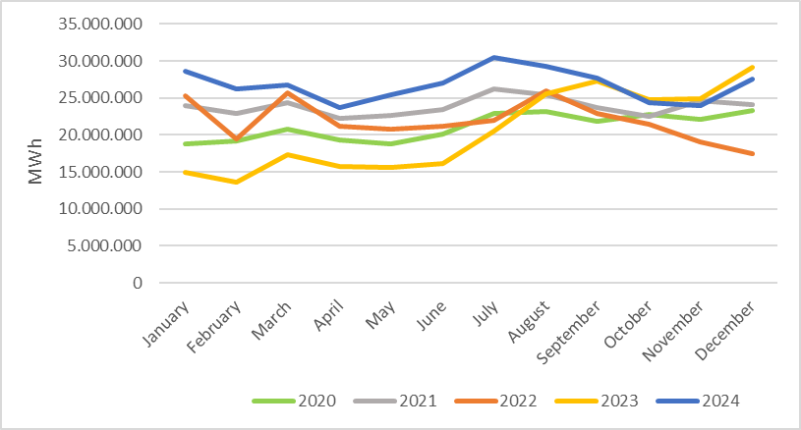
Below, Figure 2.4.2 shows the distribution of Bilateral Agreement purchase amounts by company and the share of the top 10 companies, Figure 2.4.3 shows the distribution of Bilateral Agreement sales amounts by company and the share of the top 10 companies.

Figure 2.4.2: Share of Top 10 Companies by Purchase Amount with Bilateral Contracts (%)
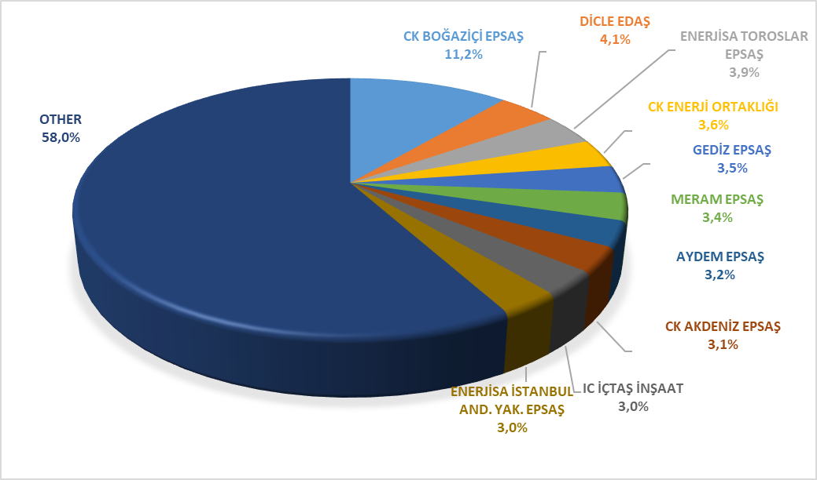

Figure 2.4.3: Share of Top 10 Companies by Sales Amount with Bilateral Contracts (%)
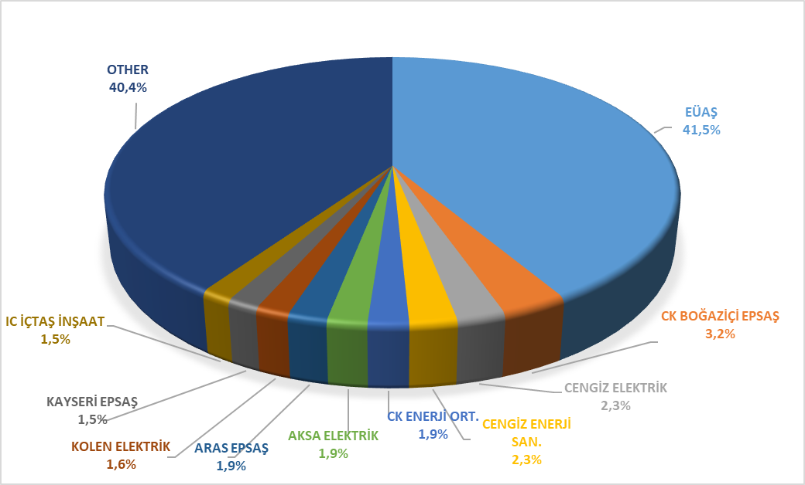

Figure 2.4.4 below shows the change in EUAŞ wholesale sales prices by periods.
The wholesale tariffs of EUAŞ (abolished TETAŞ) are determined by the Decision of the Board and the fulfillment of EUAŞ's obligations arising from existing contracts is taken into account. As can be seen in the figure below, while a single price was announced for the abolished TETAS wholesale tariff before 2017, a separate price was determined for the general lighting price starting from 2017, and for sales to authorized supply companies starting from 9/8/2022. In addition, the price of the third semester in 2018 has been announced to be valid from 1/8/2018. November August 2023 The active energy wholesale tariff for the commissioned supply companies was re-determined during the period with the decisions taken in August and November. The decision taken in November 2023 continued to be implemented throughout 2024.

Figure 2.4.4: Wholesale Prices of EUAS Between 2016-2024 (kr/kWh)
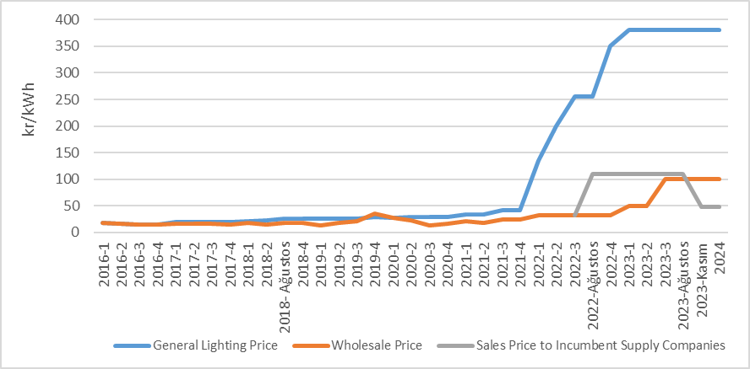

  - Renewable Energy Sources Support Mechanism (RES-SM)

With the amendment made on 2/12/2020 in the RES Law No. 5346, it has been arranged that the prices to be applied in Turkish lira and the procedures and principles for updating the prices to be applied to RES-certified electricity generation facilities that will enter into operation after 30/6/2021 will be determined by the President. In this context, with the Decision of the President dated 29/1/2021 and numbered 3453, a decision was taken on updating the prices and periods to be applied for electricity generation facilities based on renewable energy sources with a RES certificate that will be put into operation from 1/7/2021 to 31/12/2025, as well as the prices that will be applied for electricity generation facilities based on renewable energy sources with a RES certificate that will be put into operation from 1/7/2021 to 31/12/2025, within the framework of this decision, a price update was made in 3-month periods. Then, based on the Presidential Decree No. 7189 published in the Official Gazette dated 01/05/2023 and numbered 32177, a new decision was taken regarding the prices, periods and updating of these prices to be applied for electricity generation facilities based on renewable energy resources with RES Certificates to be put into operation from 01/07/2021 to 31/12/2030. The prices within the scope of the RES Support Mechanism for 2024, determined in Turkish lira in accordance with the aforementioned decisions, are shown in Table 2.5.1.

Table 2.5.1: RES-SM Prices of 2024 Year
Type of Production Facility Based on Renewable Energy Source | RES-SM Prices of 2024 (TL kr/kWh)
Type of Production Facility Based on Renewable Energy Source | Janu. | Febr. | March | April | May | June | July | August | Sept. | Oct. | Nove. | Dece.
Hydroelectric production facility (with reservoir)* | 209,56 | 215,37 | 222,03 | 231,44 | 235,06 | 238,39 | 241,78 | 245,27 | 252,02 | 256,59 | 258,32 | 259,10
Hydroelectric production facility (River Type)* | 196,46 | 201,91 | 208,16 | 216,98 | 220,37 | 223,49 | 226,67 | 229,94 | 236,27 | 240,55 | 242,17 | 242,90
Wind energy based production facility (Terrestrial)* | 154,26 | 158,54 | 163,45 | 170,38 | 173,04 | 175,49 | 177,98 | 180,55 | 185,52 | 188,88 | 190,15 | 190,72
Wind energy based production facility (Offshore)* | 209,56 | 215,37 | 222,03 | 231,44 | 235,06 | 238,39 | 241,78 | 245,27 | 252,02 | 256,59 | 258,32 | 259,10
Production facility based on geothermal energy | 293,98 | 302,14 | 311,49 | 324,69 | 329,77 | 334,45 | 339,20 | 344,10 | 353,58 | 359,99 | 362,41 | 363,50
Landfill Gas / Resources obtained from by-products resulting from the processing of waste tires | 154,26 | 158,54 | 163,45 | 170,38 | 173,04 | 175,49 | 177,98 | 180,55 | 185,52 | 188,88 | 190,15 | 190,72
Biomethanization | 251,76 | 258,74 | 266,75 | 278,05 | 282,40 | 286,40 | 290,47 | 294,67 | 302,78 | 308,27 | 310,35 | 311,29
Thermal Disposal (Municipal wastes, vegetable oil wastes, agricultural wastes without food and feed value, forest products other than industrial wood, industrial waste sludge and treatment sludge) | 196,33 | 201,78 | 208,02 | 216,84 | 220,23 | 223,35 | 226,52 | 229,79 | 236,12 | 240,40 | 242,02 | 242,75
Solar energy based production facility | 154,26 | 158,54 | 163,45 | 170,38 | 173,04 | 175,49 | 177,98 | 180,55 | 185,52 | 188,88 | 190,15 | 190,72
Electricity storage facility integrated with wind or solar energy based production facility | 181,91 | 186,96 | 192,75 | 200,92 | 204,06 | 206,95 | 209,89 | 212,92 | 218,78 | 222,75 | 224,25 | 224,93
Pumped storage hydroelectric production facility | 293,98 | 302,14 | 311,49 | 324,69 | 329,77 | 334,45 | 339,20 | 344,10 | 353,58 | 359,99 | 362,41 | 363,50
Wave or current energy based production facility | 196,46 | 201,91 | 208,16 | 216,98 | 220,37 | 223,49 | 226,67 | 229,94 | 236,27 | 240,55 | 242,17 | 242,90

*Within the scope of the decision No. 7189, the relevant facilities after May 2023 are separated according to their nature as in the table.

Table 2.5.2 shows the number of licensed RES-SM participants by years, and it is observed that the number of participants and installed capacity decreased compared to last year. there are 782 licensed power plants with a total installed capacity of 17.476,2 MW operating within the scope of RES-SM in 2024.

Table 2.5.2: Number of Licensed RES-SM Power Plants by Years
Type | 2012 | 2013 | 2014 | 2015 | 2016 | 2017 | 2018 | 2019 | 2020 | 2021 | 2022 | 2023 | 2024
Solar | - | - | - | - | - | 2 | 3 | 9 | 17 | 32 | 36 | 36 | 36
Hydraulic | 44 | 14 | 40 | 126 | 388 | 418 | 447 | 463 | 463 | 449 | 426 | 312 | 255
Wind | 22 | 3 | 21 | 60 | 106 | 141 | 151 | 160 | 165 | 204 | 224 | 196 | 169
Biomass | 8 | 15 | 23 | 34 | 42 | 57 | 70 | 100 | 126 | 191 | 293 | 285 | 271
Geothermal | 4 | 6 | 9 | 14 | 20 | 29 | 37 | 45 | 50 | 53 | 57 | 55 | 51
Total | 78 | 38 | 93 | 234 | 556 | 647 | 708 | 777 | 821 | 929 | 1.036 | 884 | 782

The distribution of RES-SM installed capacity by resource type shows that wind power plants have the highest share with 7.316,7 MW, followed by hydroelectric power plants with 6.597,5 MW. It is assessed that there has been a partial decrease in the capacity of wind and hydraulic power plants compared to last year due to both the plants whose support period has expired and the plants that did not participate in RES-SM for 2024 as the prices in the free market are expected to be higher from time to time in 2024.

Table 2.5.3: Distribution of RES-SM Installed Capacity by Resources (MW)*
*In addition, as of the end of 2024, 18.125,87 MW of the 18.585,32 MW of installed capacity excluding natural gas is also traded within the scope of RES-SM within the scope of unlicensed electricity generation, the details of which are provided in Section 1.4 entitled “Unlicensed Electricity Generation”.
The ratio of the installed capacity under RES-SM, including unlicensed power plants, to the total installed capacity of Turkey was 29,08% in 2023 and 30,71% in 2024.

Figure 2.5.1 below shows the resource-based distribution of the licensed RES-SM installed capacity for 2024.

Figure 2.5.1: Distribution of RES-SM Installed Capacity by Resources in 2024 (%)
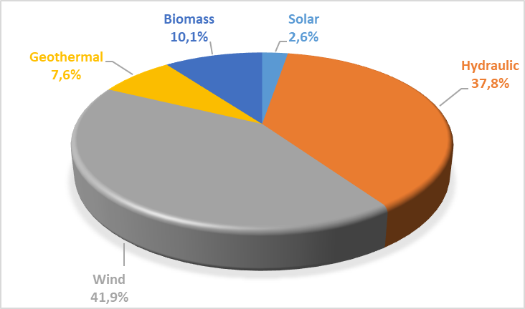
The development of RES-SM participants generations over the years is shown in Table 2.5.4. Generation within the scope of RES-SM in 2024, including unlicensed power plants, increased by approximately 1,79% and it reached to 73,42 TWh.

Table 2.5.4: Yearly Generation of RES-SM Participants by Years (MWh)*
Type | 2017 | 2018 | 2019 | 2020 | 2021 | 2022 | 2023 | 2024
Biomass | 8.992.792 | 2.047.082 | 2.817.209 | 3.730.699 | 5.169.983 | 6.904.471 | 7.459.119 | 8.026.052
Solar | 24.269 | 39.140 | 159.961 | 375.477 | 1.492.885 | 2.785.749 | 3.757.898 | 3.793.986
Hydraulic | 17.213.394 | 27.369.727 | 36.961.886 | 29.671.021 | 21.980.145 | 25.250.798 | 14.764.400 | 13.620.805
Geothermal | 4.503.345 | 5.968.202 | 6.997.209 | 7.816.510 | 8.162.845 | 8.549.919 | 8.023.490 | 7.151.623
Unlicensed | 2.997.551 | 8.078.418 | 9.830.849 | 11.229.723 | 12.149.419 | 12.860.061 | 14.796.640 | 20.369.618
Wind | 16.765.418 | 19.002.862 | 19.900.973 | 20.658.797 | 25.200.967 | 27.501.640 | 23.327.017 | 20.458.468
Total | 50.496.769 | 62.505.431 | 76.668.087 | 73.482.227 | 74.156.245 | 83.852.638 | 72.128.564 | 73.420.552

The distribution of generation within the scope of RES-SM by resources in 2024 is shown in Figure 2.5.2. The highest generation was obtained from wind and unlicensed energy.

Figure 2.5.2: Distribution of RES-SM Generation by Resources in 2024 (%)
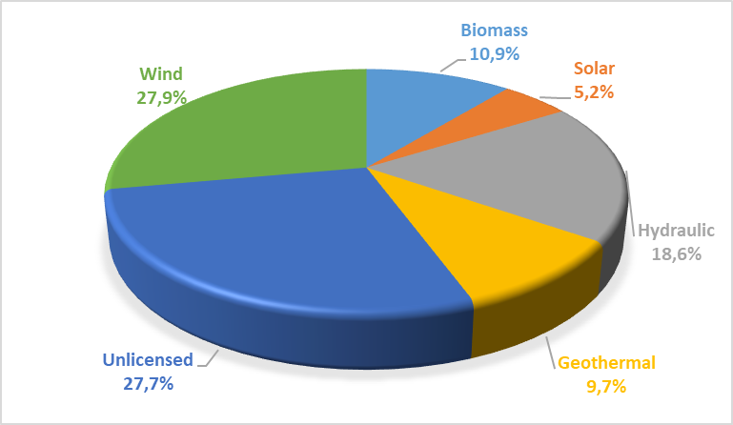
While the ratio of the generation in RES-SM to the total electricity generation of the country was 22,49% in 2023, this rate decreased to 21,48 % in 2024.
Considering the monthly development of RES-SM generation in Figure 2.5.3, it is seen that hydraulic generation and therefore RES-SM generation increased due to the rainfall in spring months. Wind and unlicensed generation fluctuated throughout the year, while solar generation decreased in winter and increased in summer. The generation from other resources was more stable throughout the year.

Figure 2.5.3: Monthly Development of RES-SM Generation in 2024 (MWh)
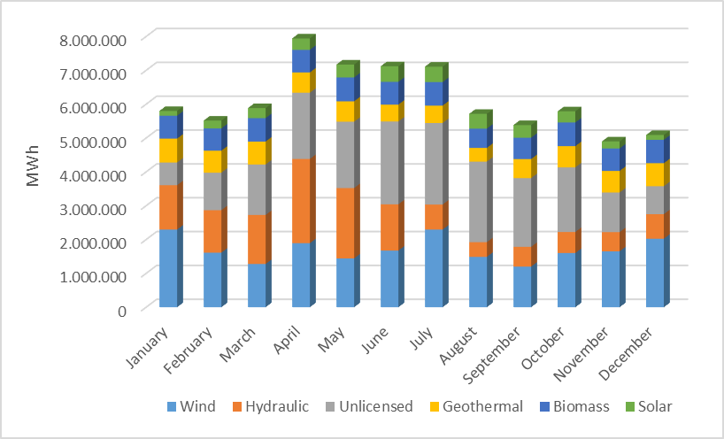

For 2024, the monthly development of the prices to be applied for electricity generation facilities in RES-SM and DAM prices are shown together in Figure 2.5.4.
With the partial increase in PTF prices in the second half of the year and the periodic updates made in RES-SM prices, it is observed that prices in reservoir hydroelectricity are approaching each other, while prices in geothermal and biomethanization facility types are above the weighted average PTF price.

Figure 2.5.4: Monthly Development of RES-SM and DAM Prices in 2024 (TL/MWh)
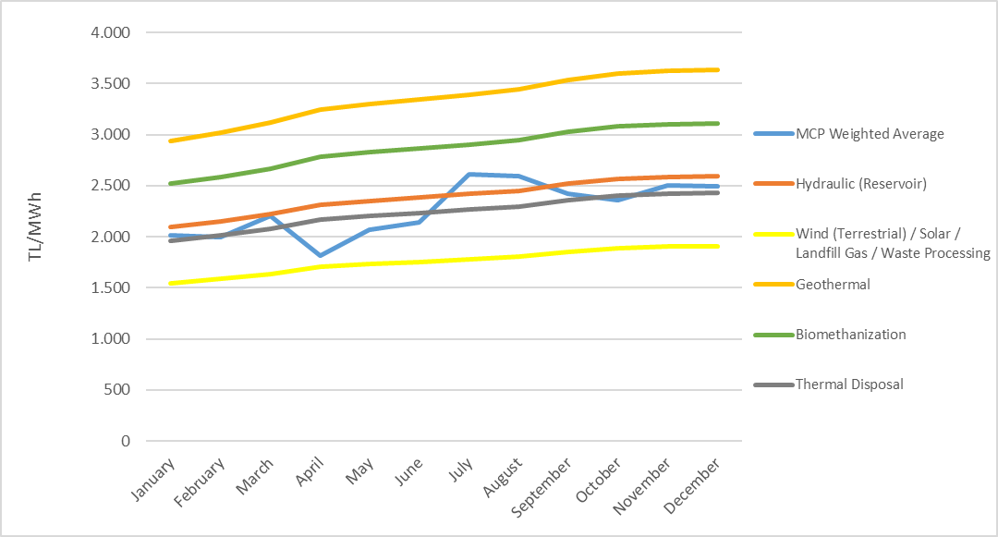
Figure 2.5.5 shows the monthly amounts of payments made within the scope of RES-SM.

Figure 2.5.5: 2024 Monthly Payment Amount Made within the Scope of RES-SM (TL)
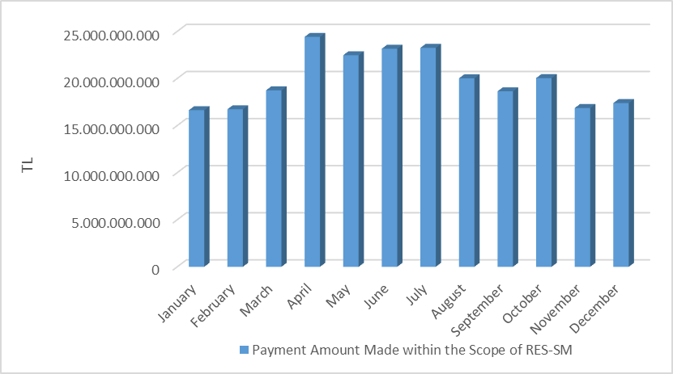
Figure 2.5.6 shows the monthly development of the amount paid to RES-SM participants in addition to the weighted average PTF per unit of energy billed. In 2024, the average YEKDEM cost remained positive, being 28,06 TL/MWh last year and 251,40 TL/MWh this year.

Figure 2.5.6: 2024 Monthly Development of Average RES-SM Additional Cost (TL/MWh)
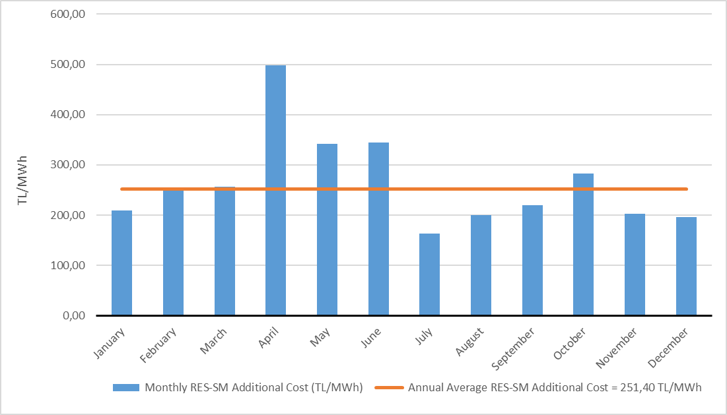

  - Power Futures Market

Power Futures Market operated by EXIST is a market with physical delivery that operates according to the “perpetual trade” method, allows future physical electricity trade and protects market participants from counterparty risk.
In the spot electricity markets, market participants are able to balance their portfolios and make physical optimization. In the Power Futures Market, the market participants have the opportunity to offset the price risk (hedging) and to see price prospects for the future (price discovery). Therefore, spot and Power Futures Markets can be considered as the markets that fulfill the different needs of the market participants and they complement each other in this respect.
Power Futures Market was opened on 1 June 2021 with 6 months and 2 quarter contracts. In addition to standard contracts, the balance of month (BOM) contract, which allows the management of physical positions within the delivery period, provides flexibility to market participants. On October 6, 2021, annual contract and two more quarter contracts were put into operation together.
Figure 2.6.1 below shows the development of the average MCP and Daily Index Prices determined for the contracts 2024 in the Power Futures Market.

Figure 2.6.1: Daily Index Price in PFM vs. MCP (TL/MWh)
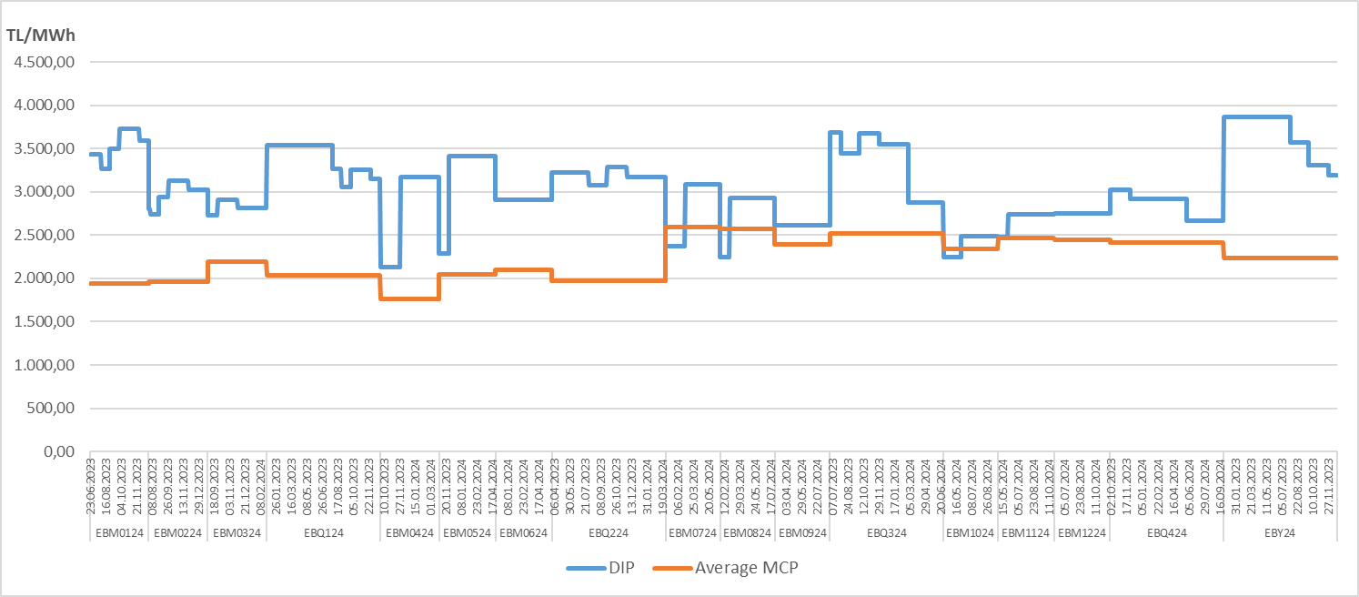

Figure 2.6.2 below shows the last daily indicator prices (GGF) determined for contracts for 2024, the average PTFs realized, and the rate of change of GGFs relative to the average MTF.

Figure 2.6.2: Last Daily Index Price in PFM vs. MCP (TL/MWh)
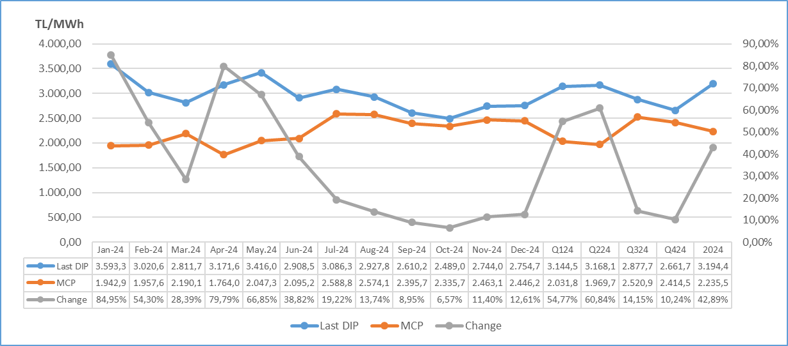

In Figure 2.6.3, the matching prices and amounts in 2024 in Power Futures Market are given. There were 5 matches in total. All of the matches were realized as private trade notifications.

Figure 2.6.3: Matching Prices and Amounts in PFM (TL/MWh – MW)
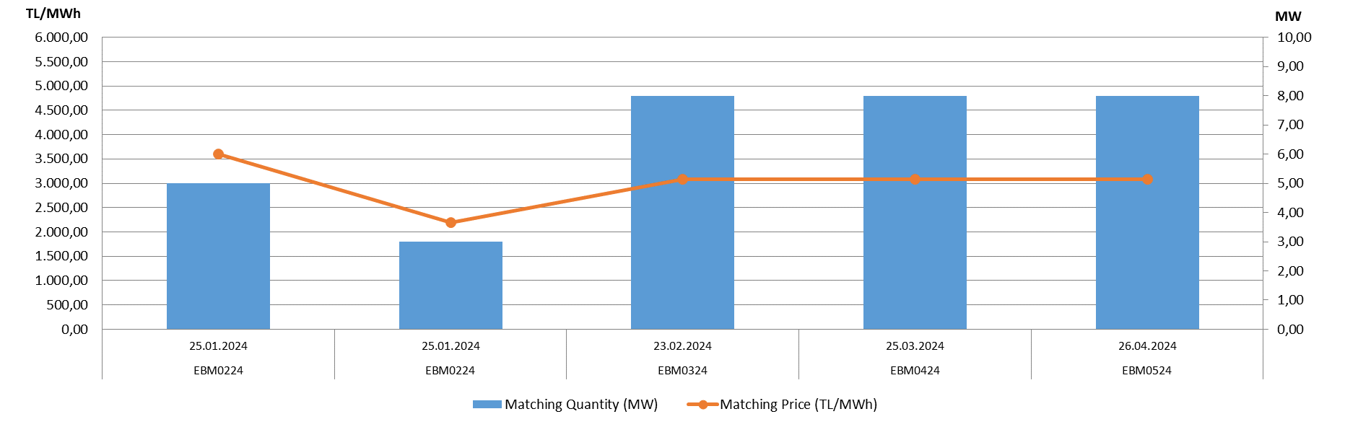
The following Figure 2.6.4 shows the amount of contract-based matches and transaction volume realized in the Electricity Futures Market in 2024. The total amount of matches was realized as 23,23 GWh and the total transaction volume was realized as 71,4 Million TL. the highest matching amount was realized with 5.952 MWh in 2 separate contracts traded in 2024. While there was no match in the quarterly and annual contracts in 2024.

Figure 2.6.4: Contract Based Match Amounts and Trading Volume (MWh – Million TL)
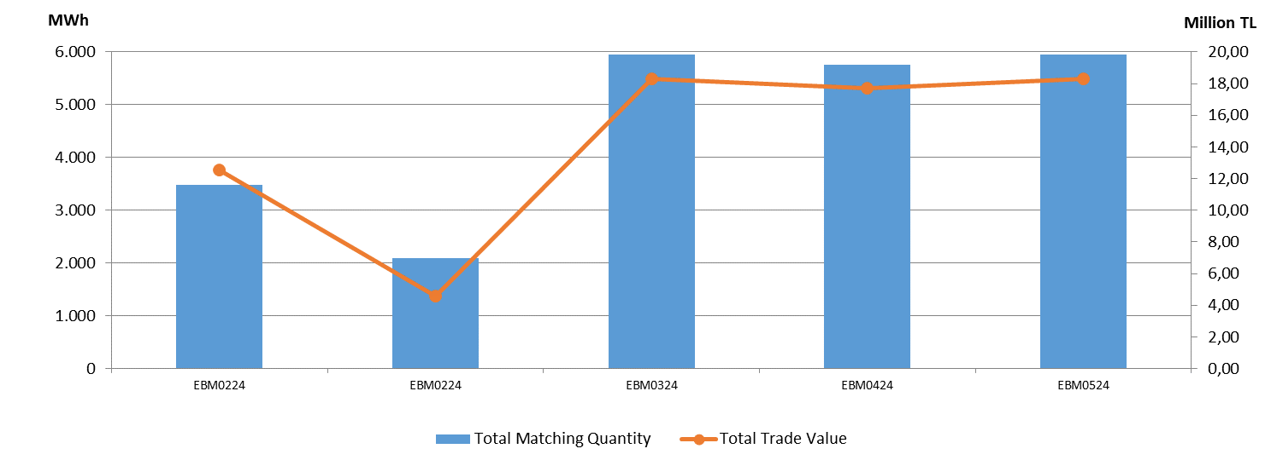
  - Environmental Markets
YEK-G System and Organized YEK-G Market
The REK-G System and the Organized REK-G Market were commissioned on June 1, 2021. Export, redemption, bilateral agreement transactions can be performed by participants in the YEK-G System developed using blockchain technology.
Offers are submitted by the participants to the contract opened in five different types of resources (Hydroelectric, Geothermal, Wind, Solar, Biomass) in the organized YEK-G Market, and matches are made with continuous trading methods.
In order to provide effective and fast service to market participants 24/7, services are provided via the call center and EPİAŞ Help Desk platform. Participants are informed when they first enter the markets, and support is provided quickly to users who have problems with bid entries and other issues.
The data of each transaction performed in the YEK-G system are published on the EPIAS transparency platform. The microsite https://yekgnedir.epias.com.tr, where market participants can access up-to-date information about the YEK-G system and the market, has been put into service.
Within the scope of environmental markets, research and development activities related to the carbon market and the white certificate market are continuing abroad.

Figure 2.7.1: Amount of Export in YEK-G System
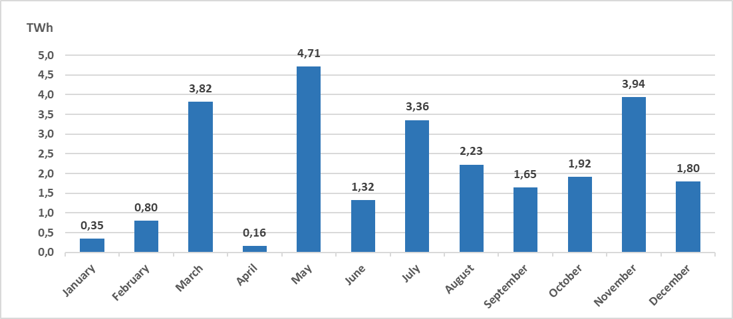
The total export amount in the YEK-G system was realized as 26,05 TWh.

Figure 2.7.2: Amount of Bilateral Contract in YEK-G System
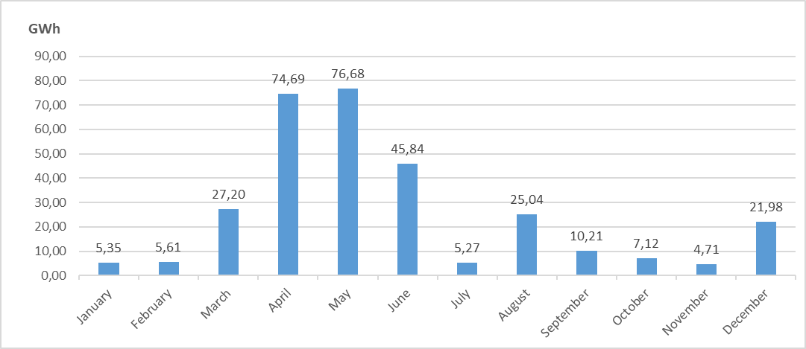
The total amount of bilateral agreement transactions in the YEK-G system was realized as 309,68 GWh.

Figure 2.7.3: Amount of Cancellation in the YEK-G System
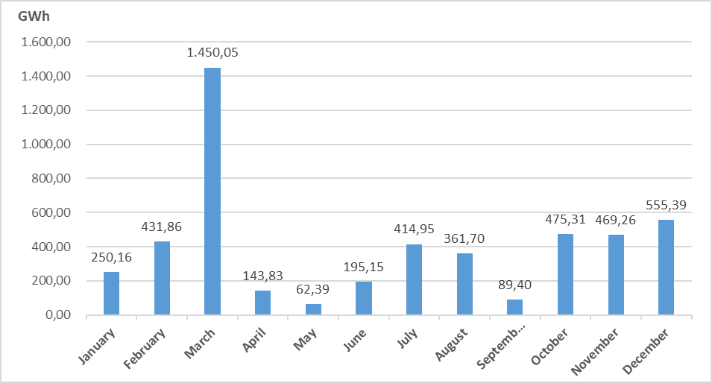

The total amount of redemption transactions in the YEK-G system was realized as 4.899,45 GWh. it is noticeable that the highest redemption amounts are in the month of March and December.

Figure 2.7.4: Amount of Match in Organized YEK-G Market
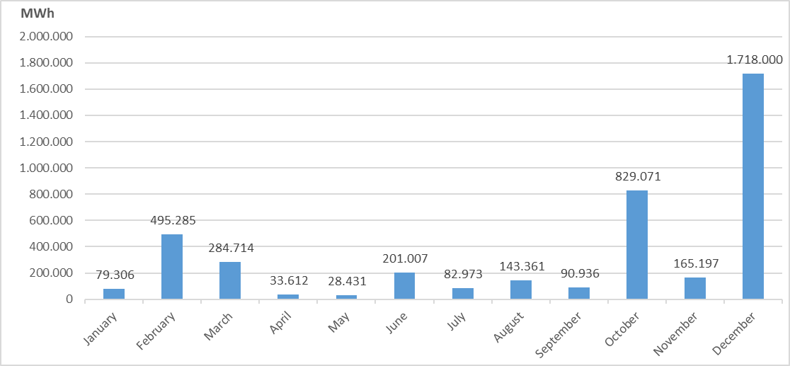
The highest monthly matching amount of the organized YEK-G market was realized in December as 1.718.000 MWh.

Figure 2.7.5: Organized YEK-G Market Annual Weighted Average Price on Contract Basis
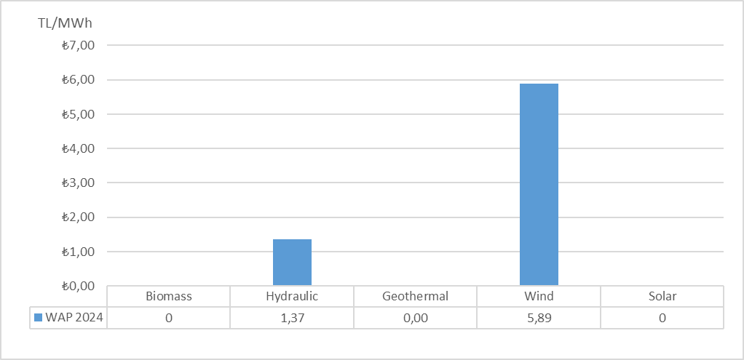

Figure 2.7.6: Organized YEK-G Market Average Price
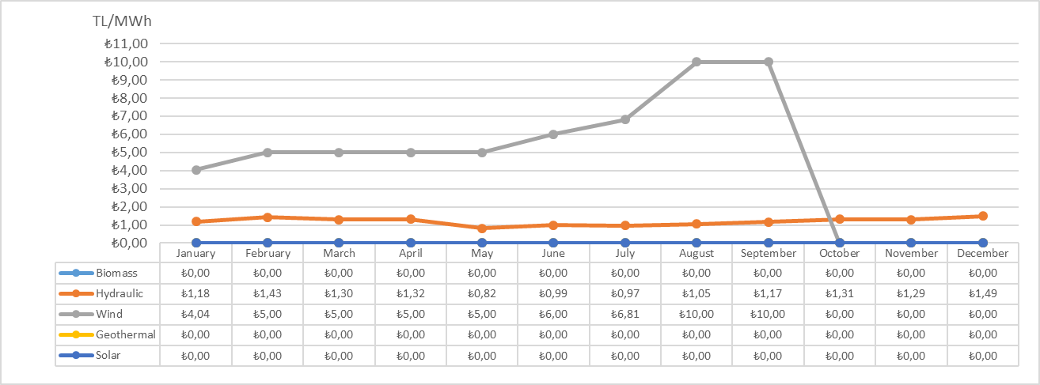

The highest weighted average price of the organized YEK-G market was realized in the Wind contract as 10,00 TL/MWh.

Figure 2.7.7: Organized YEK-G Market Trading Volume
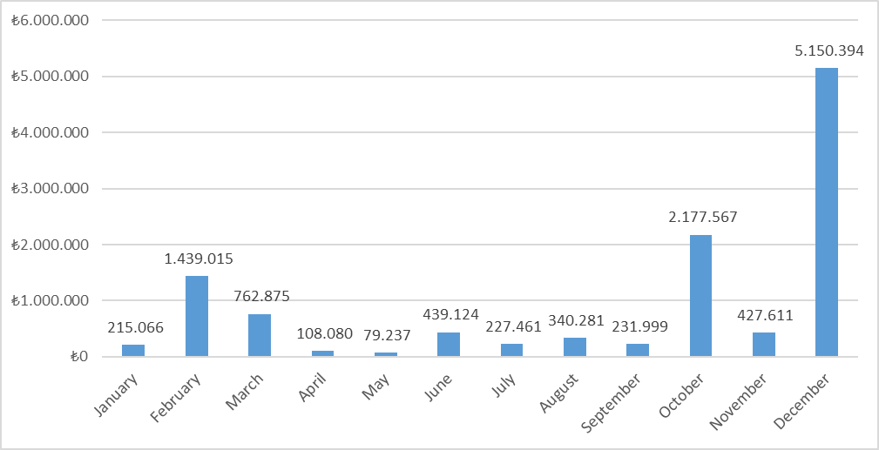

The highest trading volume of the organized YEK-G market was realized in December as 5.150.394 TL. A total annual transaction volume of 11.598.709,82 TL was generated. The transaction volume includes the sum of the purchase and sale amounts.
- COMPETITION

The main objective of the Electricity Market Law is to develop competition by creating a free market structure. The main duties of the Authority include identifying anti-competitive behavior and market power in areas open to competition and taking measures to prevent them. EMRA also reduces the free consumer limit at the end of each year for the following year, thereby increasing the number of consumers who can choose their supplier on the demand side. In this framework, the development of negotiable supply and demand in the wholesale market is critical for the establishment of competition.

3.1 Supply Side

The thesis that free electricity markets provide the most efficient investment and generation incentives is supported by theoretical and practical studies. However, due to the low elasticity of demand and the inability of the grid to store energy, regulation may be needed to protect competition and ensure security of supply. Therefore, these issues are regulated in many countries and by the European Union through various market share limits and mechanisms.
The indices used to monitor competition generally measure the concentration on the supply side and the ability of producers to intervene in prices. The HHI index, which is calculated as the sum of the squares of the market shares of all firms in the market, is widely used to measure market concentration. The index can be calculated separately for generation and installed capacity.

Table 3.1: HHI Values with respect to Generation and Installed Capacity
As shown in Table 3.1, there was an increase in generation in 2024 compared to the previous year, and a decrease in the HHI index calculated based on installed capacity.
Table 3.2 shows the sales of supply license holders for final consumption. While the HHI index calculated according to supplier shares was 397,52 in 2023, this value was calculated as 395,16 in 2024.
The ratio of 21 incumbent supply companies' total sales volume to the total sales volume of all supply license holders increased from 75,87% in 2023 to 75,24% in 2024.
As is known, the eligible consumer limit in the electricity market has not yet been reset. In other words, not all consumers in the market qualify as eligible consumers. It is not legally possible for any supplier to sell to non-eligible consumers, except for the authorized supply companies. Therefore, in order to properly evaluate the competitive environment in sales to final consumers, it is important to create an environment where all consumers are eligible consumers and can obtain energy from any supplier they wish.

Table 3.2: Sales, Market Shares and HHI Index of Supply License Owners
Supplier Company | Sale Amount (MWh) | Share (%)
ENERJİSA TOROSLAR ELEKTRİK PERAKENDE SATIŞ ANONİM ŞİRKETİ | 18.580.878 | 7,4426
CK BOĞAZİÇİ ELEKTRİK PERAKENDE SATIŞ ANONİM ŞİRKETİ | 18.221.265 | 7,2986
ENERJİSA İSTANBUL ANADOLU YAKASI ELEKTRİK PERAKENDE SATIŞ ANONİM ŞİRKETİ | 16.397.597 | 6,5681
GEDİZ ELEKTRİK PERAKENDE SATIŞ ANONİM ŞİRKETİ | 15.141.749 | 6,0651
SAKARYA ELEKTRİK PERAKENDE SATIŞ ANONİM ŞİRKETİ | 13.945.171 | 5,5858
ENERJİSA BAŞKENT ELEKTRİK PERAKENDE SATIŞ ANONİM ŞİRKETİ | 13.689.580 | 5,4834
DİCLE ELEKTRİK PERAKENDE SATIŞ ANONİM ŞİRKETİ | 13.469.592 | 5,3953
ULUDAĞ PERAKENDE ELEKTRİK SATIŞ ANONİM ŞİRKETİ | 11.921.630 | 4,7752
MERAM ELEKTRİK PERAKENDE SATIŞ ANONİM ŞİRKETİ | 9.833.725 | 3,9389
AYDEM ELEKTRİK PERAKENDE SATIŞ ANONİM ŞİRKETİ | 9.090.641 | 3,6413
CK AKDENİZ ELEKTRİK PERAKENDE SATIŞ ANONİM ŞİRKETİ | 8.861.284 | 3,5494
KAYSERİ ELEKTRİK PERAKENDE SATIŞ ANONİM ŞİRKETİ | 7.261.628 | 2,9087
YEŞİLIRMAK ELEKTRİK PERAKENDE SATIŞ ANONİM ŞİRKETİ | 6.954.525 | 2,7857
CK ENERJİ ORTAKLIĞI TOPTAN ELEKTRİK SATIŞI ANONİM ŞİRKETİ | 5.221.929 | 2,0917
AKSA ELEKTRİK SATIŞ ANONİM ŞİRKETİ | 5.195.211 | 2,0810
OSMANGAZİ ELEKTRİK PERAKENDE SATIŞ ANONİM ŞİRKETİ | 4.995.657 | 2,0010
GAZİANTEP OSB ELEKTRİK ENERJİSİ TEDARİK TOPTAN SATIŞ TİCARET ANONİM ŞİRKETİ | 4.425.755 | 1,7727
AKEDAŞ ELEKTRİK PERAKENDE SATIŞ ANONİM ŞİRKETİ | 3.841.146 | 1,5386
TRAKYA ELEKTRİK PERAKENDE SATIŞ ANONİM ŞİRKETİ | 3.137.955 | 1,2569
KOLEN ELEKTRİK TOPTAN SATIŞ İTH. VE İHR. ANONİM ŞİRKETİ | 3.136.464 | 1,2563
AKSA ÇORUH ELEKTRİK PERAKENDE SATIŞ ANONİM ŞİRKETİ | 2.985.309 | 1,1958
TOSYALI ELEKTRİK ENERJİSİ TOPTAN SATIŞ İTHALAT İHRACAT ANONİM ŞİRKETİ | 2.901.368 | 1,1622
AKSA FIRAT ELEKTRİK PERAKENDE SATIŞ ANONİM ŞİRKETİ | 2.642.194 | 1,0583
ARAS ELEKTRİK PERAKENDE SATIŞ ANONİM ŞİRKETİ | 2.635.153 | 1,0555
ERKİM ELEKTRİK ENERJİSİ TİCARET ANONİM ŞİRKETİ | 2.570.201 | 1,0295
SOCAR ENERJİ TİCARET ANONİM ŞİRKETİ | 2.361.215 | 0,9458
ENERJİSA ELEKTRİK ENERJİSİ TOPTAN SATIŞ ANONİM ŞİRKETİ | 2.286.818 | 0,9160
CK ÇAMLIBEL ELEKTRİK PERAKENDE SATIŞ ANONİM ŞİRKETİ | 2.118.317 | 0,8485
TÜRKERLER VAN GÖLÜ ELEKTRİK PERAKENDE SATIŞ ANONİM ŞİRKETİ | 2.106.505 | 0,8438
ŞİŞECAM ENERJİ ANONİM ŞİRKETİ | 2.105.893 | 0,8435
MET TURKEY ENERJİ TİCARET ANONİM ŞİRKETİ | 1.733.235 | 0,6943
CENGİZ ELEKTRİK TOPTAN SATIŞ A.Ş. | 1.716.210 | 0,6874
ENKO ENERJİ SANAYİ VE TİCARET ANONİM ŞİRKETİ | 1.520.815 | 0,6092
İPRAGAZ ANONİM ŞİRKETİ | 1.363.275 | 0,5461
DİLER ELEKTRİK ENERJİSİ TEDARİK TOPTAN SATIŞ ANONİM ŞİRKETİ | 1.292.438 | 0,5177
ELTEK ELEKTRİK ENERJİSİ İTHALAT İHRACAT VE TOPTAN TİCARET ANONİM ŞİRKETİ | 1.268.764 | 0,5082
IC İÇTAŞ İNŞAAT SANAYİ VE TİCARET ANONİM ŞİRKETİ | 1.174.085 | 0,4703
ELEKTRİK ÜRETİM ANONİM ŞİRKETİ (EÜAŞ) | 1.156.071 | 0,4631
YETAŞ YILDIRIM ENERJİ TEDARİK A.Ş. | 1.140.328 | 0,4568
CEREAN ENERJİ A.Ş. | 1.134.505 | 0,4544
MERAM ELEKTRİK ENERJİSİ TOPTAN SATIŞ ANONİM ŞİRKETİ | 948.699 | 0,3800
DOSEN ENERJİ ELEKTRİK TEDARİK VE TOPTAN SATIŞ ANONİM ŞİRKETİ | 877.923 | 0,3517
EREN ELEKTRİK ENERJİSİ TOPTAN SATIŞ ANONİM ŞİRKETİ | 797.401 | 0,3194
OCTO ELEKTRİK TİCARET ANONİM ŞİRKETİ | 773.713 | 0,3099
EÇE ENERJİ TİCARETİ ANONİM ŞİRKETİ | 770.321 | 0,3086
REGES ELEKTRİK ENERJİSİ PERAKENDE SATIŞ SANAYİ VE TİCARET LİMİTED ŞİRKETİ | 707.600 | 0,2834
IC TOPTAN ENERJİ TİCARET ANONİM ŞİRKETİ | 680.191 | 0,2725
SELENKA ELEKTRİK ENERJİSİ TOPTAN SATIŞ VE TEDARİK ANONİM ŞİRKETİ | 670.181 | 0,2684
OYPOWER ELEKTRİK TİCARETİ VE HİZMETLERİ A.Ş. | 652.616 | 0,2614
YEŞİLYURT ELEKTRİK ENERJİSİ TOPTAN SATIŞ VE İTHALAT İHRACAT ANONİM ŞİRKETİ | 621.057 | 0,2488
AVEL AVRUPA ELEKTRİK ENERJİSİ TOPTAN SATIŞ ANONİM ŞİRKETİ | 598.940 | 0,2399
MOSEDAŞ MANİSA ORGANİZE SANAYİ BÖLGESİ ELEKTRİK VE DOĞAL GAZ TEDARİK TOPTAN SATIŞ ANONİM ŞİRKETİ | 575.091 | 0,2304
BORDO ELEKTRİK ENERJİSİ TOPTAN SATIŞ ANONİM ŞİRKETİ | 533.819 | 0,2138
RÖNESANS ELEKTRİK ENERJİ TOPTAN SATIŞ ANONİM ŞİRKETİ | 525.930 | 0,2107
EKVATOR PERAKENDE ENERJİ TİCARET ANONİM ŞİRKETİ | 505.337 | 0,2024
TTES ELEKTRİK SATIŞ ANONİM ŞİRKETİ | 476.043 | 0,1907
AŞKALE ÇİMENTO PETROL ENERJİ TİCARET VE SANAYİ ANONİM ŞİRKETİ | 451.414 | 0,1808
AYCAN TOPTAN ELEKTRİK TİCARET ANONİM ŞİRKETİ | 428.244 | 0,1715
EKO GRUP ELEKTRİK TİCARET ANONİM ŞİRKETİ | 413.248 | 0,1655
LİMAK ENERJİ TİCARETİ ANONİM ŞİRKETİ | 400.446 | 0,1604
BATIÇİM ENERJİ TOPTAN SATIŞ ANONİM ŞİRKETİ | 400.099 | 0,1603
YYH YILDIZ ENERJİ TEDARİK VE TOPTAN SATIŞ ANONİM ŞİRKETİ | 379.523 | 0,1520
DESA ELEKTRİK ENERJİSİ TEDARİK VE TOPTAN SATIŞ TİCARET ANONİM ŞİRKETİ | 276.281 | 0,1107
TURKCELL ENERJİ ÇÖZÜMLERİ VE ELEKTRİK SATIŞ TİCARET ANONİM ŞİRKETİ | 256.940 | 0,1029
GATES ENERJİ TİCARET ANONİM ŞİRKETİ | 244.281 | 0,0978
FIRAT ENERJİ TOPTAN SATIŞ TİCARET ANONİM ŞİRKETİ | 211.885 | 0,0849
AXPO TURKEY ENERJİ ANONİM ŞİRKETİ | 210.467 | 0,0843
SOYAK ENERJİ TİCARET ANONİM ŞİRKETİ | 192.358 | 0,0770
ELEKTRA ENERJİ TOPTAN SATIŞ VE İTHALAT İHRACAT ANONİM ŞİRKETİ | 185.621 | 0,0744
YKS ELEKTRİK ENERJİSİ TOPTAN SATIŞ DIŞ TİCARET ANONİM ŞİRKETİ | 168.420 | 0,0675
ENOVA ELEKTRİK ENERJİSİ TOPTAN SATIŞ ANONİM ŞİRKETİ. | 167.806 | 0,0672
NUROL GRUP ELEKTRİK TOPTAN SATIŞ ANONİM ŞİRKETİ | 152.744 | 0,0612
DOĞRUDAN ELEKTRİK ENERJİSİ TOPTAN SATIŞ VE TEDARİK ANONİM ŞİRKETİ | 122.664 | 0,0491
AYEN ELEKTRİK TİCARET ANONİM ŞİRKETİ | 119.554 | 0,0479
ADEN PERAKENDE ELEKTRİK ENERJİSİ SATIŞ TİCARET LİMİTED ŞİRKETİ | 117.654 | 0,0471
ZENERGY ENERJİ ANONİM ŞİRKETİ | 116.521 | 0,0467
KET KİPAŞ ELEKTRİK ENERJİSİ TOPTAN SATIŞ TİCARET ANONİM ŞİRKETİ | 116.397 | 0,0466
VOYTRON ENERJİ ELEKTRİK PERAKENDE SATIŞ ANONİM ŞİRKETİ | 108.758 | 0,0436
AKO ENERJİ ELEKTRİK TEDARİK TOPTAN VE PERAKENDE SATIŞ TİCARET ANONİM ŞİRKETİ | 107.533 | 0,0431
MAX ELEKTRİK ENERJİSİ TİCARET ANONİM ŞİRKETİ | 104.619 | 0,0419
VTC ENERJİ ANONİM ŞİRKETİ | 104.242 | 0,0418
İZETAŞ İZMİR ELEKTRİK TEDARİK ANONİM ŞİRKETİ | 104.190 | 0,0417
MİNAS ENERJİ VE TEKNOLOJİ ÇÖZÜMLERİ ANONİM ŞİRKETİ | 95.769 | 0,0384
İSETAŞ İSTANBUL ELEKTRİK TEDARİK ANONİM ŞİRKETİ | 93.876 | 0,0376
MARMARA ELEKTRİK ENERJİSİ İTHALAT İHRACAT VE TOPTAN TİCARET ANONİM ŞİRKETİ | 81.667 | 0,0327
METAN DANIŞMANLIK ENERJİ TİCARET VE SANAYİ ANONİM ŞİRKETİ | 75.041 | 0,0301
EKSİM ELEKTRİK ENERJİSİ İTHALAT, İHRACAT VE TOPTAN SATIŞ ANONİM ŞİRKETİ | 74.695 | 0,0299
KARAFIBER ENERJİ SANAYİ VE TİCARET A.Ş. | 70.869 | 0,0284
İSKUR GRUP ELEKTRİK SATIŞ ANONİM ŞİRKETİ | 69.082 | 0,0277
VAGUS ENERJİ ÇÖZÜMLERİ ANONİM ŞİRKETİ | 67.501 | 0,0270
AGE ELEKTRİK ENERJİSİ TOPTAN SATIŞ ANONİM ŞİRKETİ | 63.831 | 0,0256
OKKA ENERJİ ELEKTRİK TEDARİK TOPTAN SATIŞ İTHALAT VE İHRACAT ANONİM ŞİRKETİ | 61.359 | 0,0246
E POWER ENERJİ ANONİM ŞİRKETİ | 57.641 | 0,0231
YEŞİLYURT DC ENERJİ TİCARET ANONİM ŞİRKETİ | 57.593 | 0,0231
TENERA ENERJİ TİCARET ANONİM ŞİRKETİ | 56.360 | 0,0226
MAC ELEKTRİK ENERJİSİ TOPTAN SATIŞ ANONİM ŞİRKETİ | 56.344 | 0,0226
KGM ENERJİ TİCARET LİMİTED ŞİRKETİ | 55.960 | 0,0224
EMY TOPTAN ELEKTRİK TİCARET ANONİM ŞİRKETİ | 52.567 | 0,0211
SEDSAL ELEKTRİK ENERJİSİ TOPTAN SATIŞ LİMİTED ŞİRKETİ | 50.937 | 0,0204
AYCAN GROUP BKA ENERJİ PERAKENDE SATIŞ ANONİM ŞİRKETİ | 49.014 | 0,0196
ENJİ ENERJİ YATIRIM DANIŞMANLIK VE MÜHENDİSLİK ANONİM ŞİRKETİ | 47.782 | 0,0191
HGÇ TOPTAN EL. EN. TİCARET ANONİM ŞİRKETİ | 44.612 | 0,0179
EPTAŞ ENERJİ TİCARET ANONİM ŞİRKETİ | 39.546 | 0,0158
FİDES ELEKTRİK ENERJİSİ TOPTAN ALIŞ SATIŞ ANONİM ŞİRKETİ | 38.694 | 0,0155
ANT SÜRDÜRÜLEBİLİR ENERJİ TİCARET ANONİM ŞİRKETİ | 32.416 | 0,0130
PREMİUM ENERJİ ÇÖZÜMLERİ SANAYİ VE TİCARET ANONİM ŞİRKETİ | 31.734 | 0,0127
ECOGREEN ELEKTRİK ENERJİ ÜRETİM ANONİM ŞİRKETİ | 29.441 | 0,0118
HİDİV ELEKTRİK ENERJİSİ TOPTAN SATIŞ ANONİM ŞİRKETİ | 24.958 | 0,0100
STATKRAFT ELEKTRİK ENERJİSİ TOPTAN SATIŞ LİMİTED ŞİRKETİ | 24.834 | 0,0099
ENSAT ELEKTRİK ENERJİSİ TEDARİK TİCARET ANONİM ŞİRKETİ | 23.507 | 0,0094
SHELL ENERJİ ANONİM ŞİRKETİ | 22.151 | 0,0089
BDC ENERJİ TİCARET ANONİM ŞİRKETİ | 20.043 | 0,0080
PURE ENERGY ELEKTRİK TEDARİK ANONİM ŞİRKETİ | 14.856 | 0,0060
VOLTE ELEKTRİK ANONİM ŞİRKETİ | 14.566 | 0,0058
AVEM ENERJİ TİCARET ANONİM ŞİRKETİ | 14.415 | 0,0058
EREL ERCİYES TEDARİK ELEKTRİK TOPTAN SATIŞ İTHALAT VE İHRACAT ANONİM ŞİRKETİ | 14.333 | 0,0057
İVES ELEKTRİK ENERJİSİ TEDARİK TOPTAN SATIŞ LİMİTED ŞİRKETİ | 13.075 | 0,0052
ZORLU ELEKTRİK ENERJİSİ İTHALAT, İHRACAT VE TOPTAN TİCARET ANONİM ŞİRKETİ | 12.768 | 0,0051
SÖZÜM ENERJİ ELEKTRİK TİCARETİ ANONİM ŞİRKETİ | 11.820 | 0,0047
ELEN ELEKTRON ENERJİ TİCARET ANONİM ŞİRKETİ | 9.202 | 0,0037
EXPERT DOĞALGAZ VE ELEKTRİK ENERJİSİ TİCARET LİMİTED ŞİRKETİ | 9.185 | 0,0037
ÇELİKLER ELEKTRİK ENERJİ TOPTAN SATIŞ ANONİM ŞİRKETİ | 9.080 | 0,0036
DOASAN ENERJİ TOPTAN SATIŞ LİMİTED ŞİRKETİ | 7.993 | 0,0032
ATA ELEKTRİK ENERJİSİ TOPTAN SATIŞ ANONİM ŞİRKETİ | 6.553 | 0,0026
DENİZLİ OSB ELEKTRİK ENERJİSİ TEDARİK TOPTAN SATIŞ TİCARET ANONİM ŞİRKETİ | 5.823 | 0,0023
ORT ELEKTRİK TOPTAN SATIŞ ANONİM ŞİRKETİ | 5.564 | 0,0022
ARİSTO ENERJİ ANONİM ŞİRKETİ | 3.128 | 0,0013
BIGPRO ENERJİ TİCARET ANONİM ŞİRKETİ | 3.078 | 0,0012
POWERPOINT ENERJİ ANONİM ŞİRKETİ | 3.047 | 0,0012
KEY PERAKENDE ELEKTRİK ENERJİSİ ANONİM ŞİRKETİ | 2.971 | 0,0012
GETİR ENERJİ ELEKTRİK TİCARET LİMİTED ŞİRKETİ | 2.477 | 0,0010
EMBA ENERGY ELEKTRİK TİCARET ANONİM ŞİRKETİ | 2.264 | 0,0009
NEXUS ELEKTRİK ENERJİ TİCARETİ ANONİM ŞİRKETİ | 2.113 | 0,0008
EAG ELEKTRİK ENERJİSİ TOPTAN SATIŞI ANONİM ŞİRKETİ | 1.580 | 0,0006
THENETA ENERJİ ANONİM ŞİRKETİ | 1.474 | 0,0006
NYK ENERJİ TİCARET ANONİM ŞİRKETİ | 342 | 0,0001
PARLAYAN GAZ VE TOPTAN ELEKTRİK TİCARET LİMİTED ŞİRKETİ | 303 | 0,0001
TRK ELEKTRİK PERAKENDE SATIŞ ANONİM ŞİRKETİ | 159 | 0,0001
İDEAL PERAKENDE ELEKTRİK SATIŞ ANONİM ŞİRKETİ | 30 | 0,00001
ENERA ELEKTRİK SATIŞ ANONİM ŞİRKETİ | 25 | 0,00001
FREKANS ELEKTRİK ENERJİSİ TOPTAN SATIŞ İTH. İHR. ANONİM ŞİRKETİ | 12 | 0,000005
ESKO ELEKTRİK ENERJİSİ İTHALAT İHRACAT VE TOPTAN SATIŞ ANONİM ŞİRKETİ | 10 | 0,000004
Grand Total | 249.654.917 | 100,00
HHI of Suppliers | 395,16

3.2 Demand Side

Pursuant to paragraph (b) of the sixth paragraph of Article 5 of the Law No. 4628 on the Organization and Duties of the Energy Market Regulatory Authority and the provisions of Article 25 of the Electricity Market Consumer Services Regulation, it was decided to apply the free consumer limit of 950 kWh for the year 2024 by the Board Decision dated 28/12/2023 and numbered 12295. The theoretical market openness corresponding to the free consumer limit in question and obtained on the basis of consumer type consumption quantity values has been calculated as 93,59%. The free consumer limit and the corresponding market clearance rate by years are given in Figure 3.1.

Figure 3.1: Eligible Consumer Limit and Market Openness Ratio by Years (kWh-%)
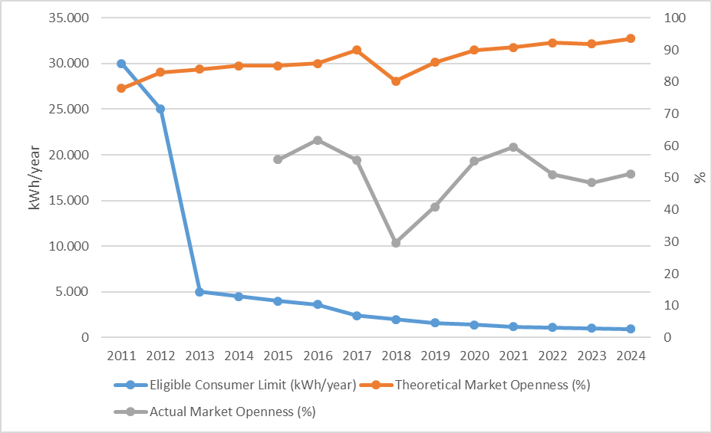

In 2024, in parallel with the high theoretical market openness rate, the share of eligible consumers in total consumption was realized at a similar level, albeit slightly higher compared to the previous year. The consumption of eligible consumers in 2024 was realized as 142,99 TWh. This corresponds to 51,25% of the total invoiced consumption.
The development of the number of free consumers in 2024 is shown in Figure 3.2.

Figure 3.2: Number of Eligible Consumer by Months in 2024
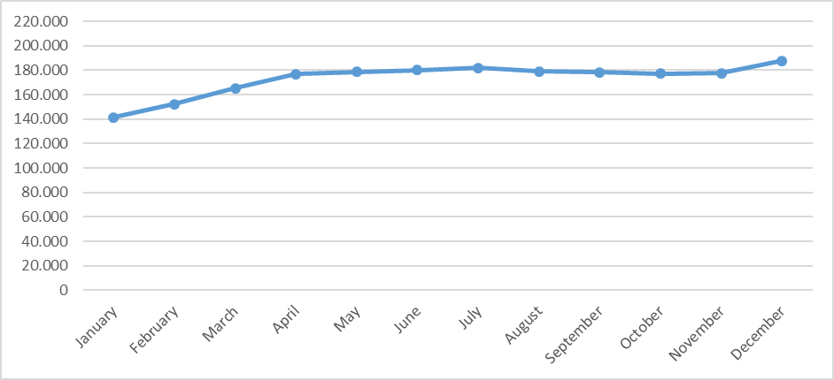
The number of eligible consumers, which was about 133 thousand at the end of 2023, increased by 40,98% to 187.627 value at the end of 2024. This number corresponds to 0,37% of the total number of consumers.
The distribution of eligible consumers and their consumption by distribution regions (including transmission connected eligible consumers) is shown in Figure 3.3.

Figure 3.3: Distribution of Eligible Consumers and Their Consumptions by Distribution Regions in 2024*
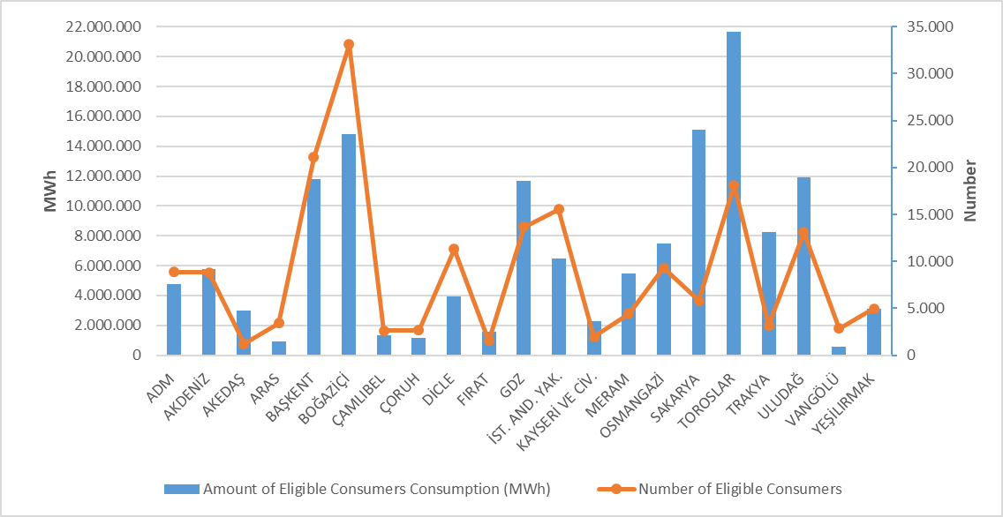
*Transmission connected consumers are distributed by distribution region according to their city of residence
When this distribution is analyzed, it is seen that the highest number of eligible consumers are located in Boğaziçi, Başkent and Toroslar regions.
The distribution of eligible consumers' consumption by distribution regions shows that the five regions with the highest consumption are Toroslar, Sakarya, Boğaziçi, Uludağ and Başkent.
Figure 3.4 below shows the distribution of eligible consumers' consumption by supplier type.

Figure 3.4: Distribution of Eligible Consumer Consumption by Supplier Type (%)
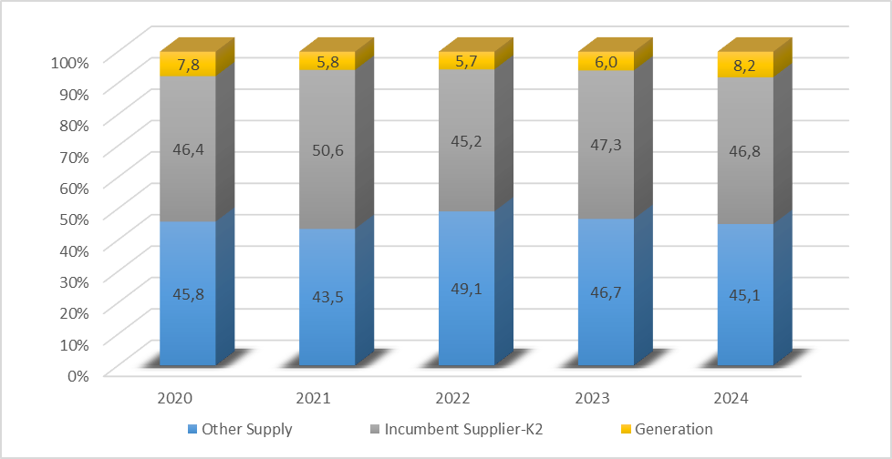
Monthly changes in the number and consumption of eligible consumers who changed their suppliers are shown in Figure 3.5. As can be seen in the figure, the number of eligible consumers who changed their suppliers was the highest in November, while the consumption of eligible consumers who changed their suppliers was the highest in November.

Figure 3.5: Monthly Changes in Number and Consumptions of Eligible Consumers Switching Their Supplier (Number-MWh)
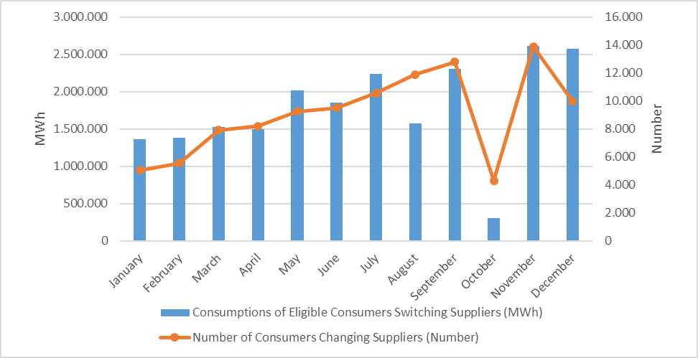
In 2024, the number of eligible consumers who changed their suppliers was 108.991. The total consumption of eligible consumers who switched their suppliers was 21,3 TWh, which corresponds to 7,62% of total invoiced consumption.

Table 3.3 below shows the distribution of eligible consumers' supplier changes by supplier type. It is seen that the majority of the supplier changes were made by consumers who switched to regulated tariffs.

Table 3.3: Distribution of Eligible Consumers' Supplier Changes by Supplier Type in 2024
Former Supplier Type | New Supplier Type |  |  |  | Grand Total
Former Supplier Type | Other Supply | Incumbent Supplier-K1 | Incumbent Supplier-K2 | Generation | Grand Total
Other Supply | 11.418 | 24.282 | 14.417 | 707 | 50.824
Incumbent Supplier-K2 | 13.580 | 24.080 | 19.624 | 66 | 57.350
Generation | 417 | 229 | 165 | 6 | 817
Grand Total | 25.415 | 48.591 | 34.206 | 779 | 108.991

- TRANSMISSON

This section provides summary information on the transmission system and includes tables and figures on the changes in the transmission system over the years.

  - Transmission System

As of the end of 2024, information on the substations in the transmission system is given in Table 4.1 below. As seen in the table, most of the substations in the transmission system are 154 kV voltage level substations. There are 1.400 substations, 807 under TEİAŞ ownership and 593 under private ownership. Transformer capacity has reached 278.153 MVA. Of this capacity, 226.995 MVA is owned by TEİAŞ and the remaining 51.157 MVA is privately owned.

Table 4.1: Transformer Center Information
 | Voltage (kV) | Number of Centers | Number of Transformers | Capacity (MVA)
TEİAŞ | 380 | 124 | 417 | 89.930
TEİAŞ | 220 | 0 | 0 | 0
TEİAŞ | 154 | 682 | 1.710 | 136.949
TEİAŞ | 66 | 1 | 9 | 116
TEİAŞ | TEİAŞ Total | 807 | 2.136 | 226.995
Private Ownership | 380 | 66 | 74 | 11.666
Private Ownership | 220 | 0 | 0 | 0
Private Ownership | 154 | 524 | 620 | 39.449
Private Ownership | 66 | 3 | 3 | 43
Private Ownership | Private Total | 593 | 697 | 51.157
 | TOTAL | 1.400 | 2.833 | 278.153

Of the total 75.731,77 km of transmission lines, 64,82% are 154 kV lines. Of the remainder, almost all are 380 kV lines, while 220 kV and 66 kV lines are only 204,88 km long.

Table 4.2: TEİAŞ Transmission Lines
Voltage (kV) | 2023 | 2024 | Change (%) | 2023 | 2024 | Change (%)
Voltage (kV) | Number of Lines |  | Change (%) | Length (km) |  | Change (%)
380 | 333 | 334 | 0,30 | 26.002,25 | 26.436,94 | 1,67
220 | 2 | 2 | 0,00 | 85,35 | 85,35 | 0,00
154 | 1.916 | 1.940 | 1,25 | 48.459,69 | 49.089,95 | 1,30
66 | 10 | 10 | 0,00 | 119,53 | 119,53 | 0,00
Total | 2.261 | 2.286 | 1,11 | 74.666,82 | 75.731,77 | 1,43

Figure 4.1: Change in TEİAŞ Transmission Line Lengths by Years (km)
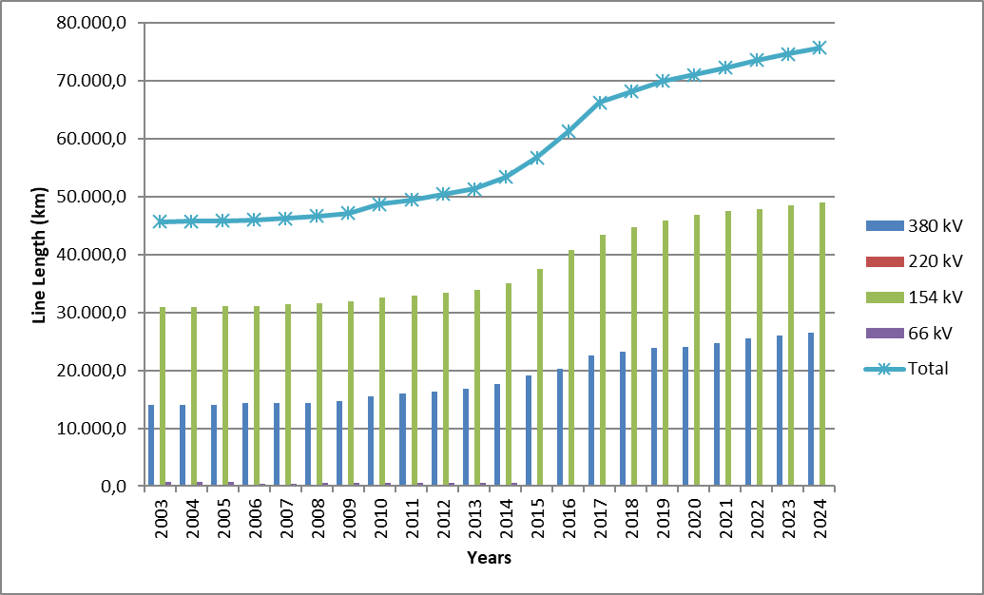

There has been a 65,63% increase in transmission line length in the last 22 years.
  - Transmission System Connection Applications

The table below shows the number and capacity of applications made in 2024 for connection to the transmission system, as well as information on applications accepted, rejected and applications under evaluation.

Table 4.3: Connection Applications to the Transmission System (Number - MW)
 | Connection Application |  | Accepted |  | Rejected |  | In the Evaluation Phase
 | Number | Capacity (MW) | Number | Capacity (MW) | Number | Capacity (MW) | Number | Capacity  (MW)
Licensed Producer | 15 | 854,54 | 12 | 788,64 | 0 | 0,00 | 3 | 65,90
Unlicensed Producer | 95 | 4.580,00 | 95 | 4.580,00 | 0 | 0,00 | 0 | 0,00
Consumer | 19 | 1.189,01 | 19 | 1.189,01 | 0 | 0,00 | 0 | 0,00

In 2024, 15 connection applications totaling 854,54 MW were made by licensed generators. Of these, 12 applications of 788,64 MW were accepted and 3 applications of 65,90 MW are under evaluation.
In addition, 95 applications for connection capacity of 4.580 MW were made by unlicensed generators, and all of these applications were accepted.
On the other hand, 19 connection applications of 1.189,01 MW were made by consumers, and all of these applications were accepted.

  - Tariffs

The transmission system system utilization and system operation tariffs applied by TEİAŞ to be applied as of 01/01/2024 were determined by the Board Decision dated 28/12/2023 and numbered 12316 on the basis of 15 regions for producers and consumers. In addition, with the Board Decision dated 14/09/2023 and numbered 12069, pursuant to subparagraph (h) of paragraph 7 of Article 5 and subparagraph (e) of paragraph (A) of Article 10 of the Law No. 4628 on the Organization and Duties of the Energy Market Regulatory Authority and the third paragraph of Article 7 of the Electricity Market Tariffs Regulation, the transmission surcharge applied in 2024 was determined as 0,5% (five per thousand) of the transmission tariff of the Turkish Electricity Transmission Corporation.
The system utilization and system operation tariffs applied in 2024 are shown in Table 4.4 for generation and consumption on the basis of 15 regions.

Table 4.4: System Usage and System Operation Tariffs Applied in 2024 (TL/MW Year, TL/MWh)
Region Number | Generation |  |  | Consumption
Region Number | System Usage Tariffs |  | System Operating Tariffs | System Usage Tariffs |  | System Operating Tariffs
Region Number | TL/MW-Year | TL/MWh | TL/MWh | TL/MW-Year | TL/MWh | TL/MWh
1 | 140.107,30 | 66,87 | 43,99 | 305.120,84 | 65,54 | 44,95
2 | 174.430,07 | 66,87 | 43,99 | 268.458,17 | 65,54 | 44,95
3 | 163.826,09 | 66,87 | 43,99 | 285.063,91 | 65,54 | 44,95
4 | 169.307,26 | 66,87 | 43,99 | 275.366,80 | 65,54 | 44,95
5 | 179.705,97 | 66,87 | 43,99 | 264.934,34 | 65,54 | 44,95
6 | 182.409,15 | 66,87 | 43,99 | 274.911,80 | 65,54 | 44,95
7 | 201.014,53 | 66,87 | 43,99 | 245.149,63 | 65,54 | 44,95
8 | 204.157,18 | 66,87 | 43,99 | 253.727,67 | 65,54 | 44,95
9 | 211.804,04 | 66,87 | 43,99 | 247.006,98 | 65,54 | 44,95
10 | 264.717,40 | 66,87 | 43,99 | 205.637,67 | 65,54 | 44,95
11 | 269.495,01 | 66,87 | 43,99 | 212.997,42 | 65,54 | 44,95
12 | 270.093,94 | 66,87 | 43,99 | 207.181,61 | 65,54 | 44,95
13 | 267.088,35 | 66,87 | 43,99 | 217.807,69 | 65,54 | 44,95
14 | 291.849,80 | 66,87 | 43,99 | 188.454,03 | 65,54 | 44,95
15 | 307.014,30 | 66,87 | 43,99 | 182.095,23 | 65,54 | 44,95

Figure 4.2: Capacity-Based Regional Transmission System Usage Tariffs Applied in 2024 (TL/MW-Year)
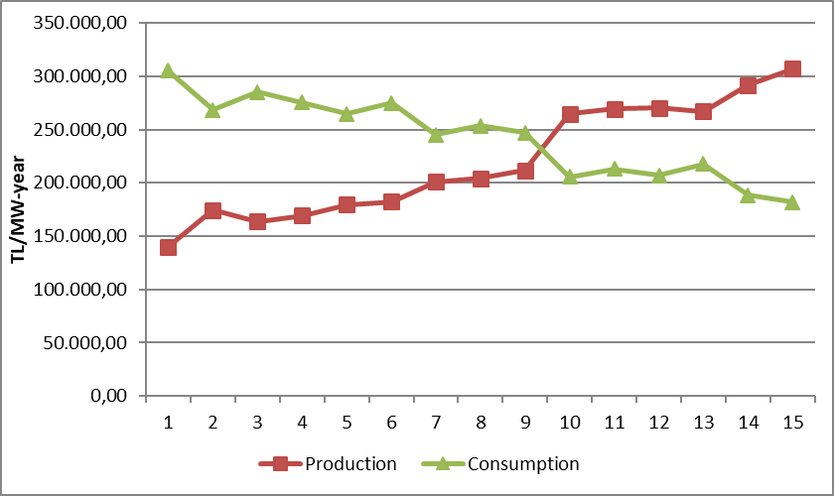
  - Investment Amount

The amounts of investment expenditures made by TEIAŞ are shown in Table 4.5. it is seen that the amount of investment will increase by 41,72% in 2024.

Table 4.5: Comparison of Investment Realizations in 2023 and 2024 (TL-%)
Type of Investment Expenditure | 2023 |  | 2024 |  | Change (%)
Type of Investment Expenditure | Amount (Billion TL) | Share (%) | Amount (Billion TL) | Share (%) | Change (%)
New Line Investment | 9.139 | 48,63 | 11.790 | 44,27 | 29,01
New Transformer Investment | 3.943 | 20,98 | 4.740 | 17,80 | 20,21
Business Group | 3.754 | 19,97 | 6.548 | 24,59 | 74,44
Other | 1.952 | 10,39 | 3.483 | 13,08 | 78,43
Machinery and Equipment | 6 | 0,03 | 74 | 0,28 | 1.151,32
Grand Total | 18.794 | 100,00 | 26.635 | 100,00 | 41,72

  - Losses

The transmission system loss (ISP) ratio varies depending on the demand, load flows, temperature and investments in the system. ISK is calculated on an hourly basis, and the change in the annual average over the years is shown in Figure 4.3. The transmission system losses established according to European standards in accordance with the population density, location of supply sources and geographical conditions of our country are at the international performance level.

Figure 4.3: Transmission System Losses (GWh-%)
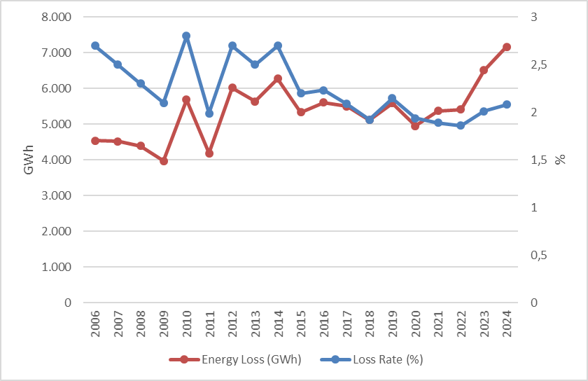

While the transmission system loss rate was 2,01% in 2023, it was realized as 2,05% in 2024.

Figure 4.4: Distribution of Transmission System Losses by Hours (%)
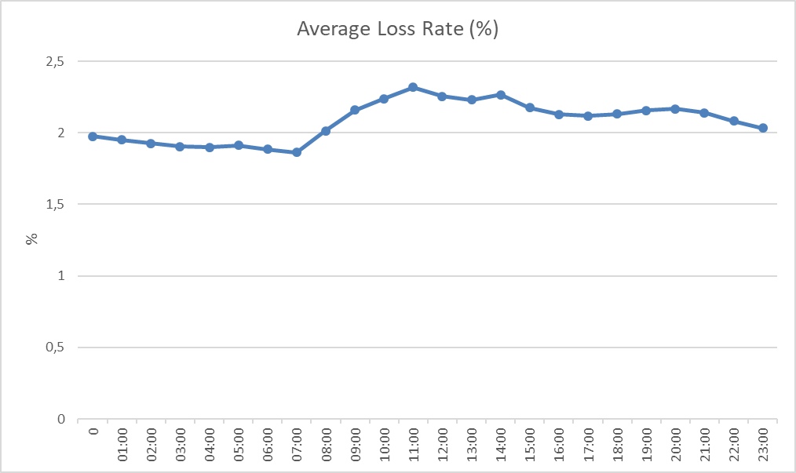
When we look at the development of the transmission system loss according to the hours, it is seen that the highest loss rate is at 11:00.
- DISTRIBUTION

  - Consumer Numbers

As of 2024, the total number of consumers using the distribution system increased by 1,94% compared to the previous year and amounted to 50.692.800.

Table 5.1: Number of Consumers Using the Distribution System as of 2022-2023-2024 (Pcs-%)
Distribution Company | Number of Consumers |  |  | 2023-2024  Change (%)
Distribution Company | 2022 | 2023 | 2024 | 2023-2024  Change (%)
BOĞAZİÇİ | 5.389.989 | 5.460.069 | 5.506.776 | 0,86
BAŞKENT | 4.523.058 | 4.595.439 | 4.656.421 | 1,33
TOROSLAR | 4.307.920 | 4.441.654 | 4.425.873 | -0,36
GDZ | 3.744.637 | 3.831.022 | 3.900.687 | 1,82
ULUDAĞ | 3.556.627 | 3.651.540 | 3.733.362 | 2,24
İ.ANADOLU | 3.092.666 | 3.134.640 | 3.174.361 | 1,27
AKDENİZ | 2.379.303 | 2.450.218 | 2.522.766 | 2,96
YEŞİLIRMAK | 2.354.514 | 2.440.498 | 2.505.080 | 2,65
MERAM | 2.348.563 | 2.415.291 | 2.464.872 | 2,05
ADM | 2.211.376 | 2.288.225 | 2.356.862 | 3,00
DİCLE | 2.137.973 | 2.213.815 | 2.318.031 | 4,71
SAKARYA | 2.091.199 | 2.160.799 | 2.228.654 | 3,14
OSMANGAZİ | 1.978.602 | 2.035.351 | 2.081.016 | 2,24
ÇORUH | 1.513.140 | 1.562.969 | 1.603.884 | 2,62
TRAKYA | 1.251.249 | 1.298.005 | 1.330.800 | 2,53
ARAS | 1.129.270 | 1.162.437 | 1.197.239 | 2,99
ÇAMLIBEL | 1.060.920 | 1.085.713 | 1.111.805 | 2,40
FIRAT | 1.098.614 | 1.054.181 | 1.105.543 | 4,87
KAYSERİ and CİVARI | 818.815 | 847.479 | 870.023 | 2,66
VAN GÖLÜ | 802.773 | 828.998 | 857.806 | 3,48
AKEDAŞ | 771.560 | 767.414 | 740.939 | -3,45
Grand Total | 48.562.768 | 49.725.757 | 50.692.800 | 1,94

When we look at Table 5.1, we see that the distribution regions with the highest number of consumers are Boğaziçi with 5,5 million, Başkent with 4,6 million and Toroslar with 4,4 million, respectively.
Figure 5.1 below shows the number of consumers of distribution companies as of the end of 2024 and the total consumption of these consumers in 2024.

Figure 5.1: Number of Consumers and Consumption Amounts as of the End of 2024 (Piece - MWh)
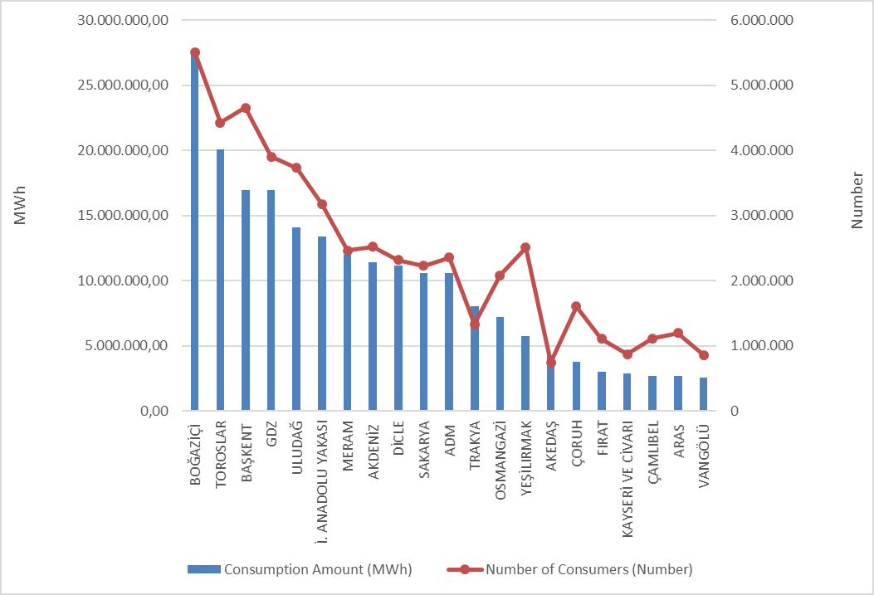

  - Loss Rates

The targeted and realized loss values based on the distribution company are shown in Table 5.2.

Table 5.2: Loss Rates of Distribution Companies (%)
Distribution Company | Actual Loss Rate |  |  | Target Loss Rate | Difference Between Target And Actual Loss Rates
Distribution Company | 2023 | 2024 | 2023-2024 Change | 2024 | 2024
ADM | 5,54% | 5,51% | -0,03% | 6,74% | 1,23%
AKDENİZ | 7,44% | 8,06% | 0,62% | 7,38% | -0,68%
AKEDAŞ | 14,13% | 3,63% | -10,50% | 8,43% | 4,80%
ARAS | 16,61% | 14,53% | -2,08% | 19,38% | 4,85%
AYEDAŞ | 4,74% | 4,36% | -0,38% | 6,53% | 2,17%
BAŞKENT | 5,60% | 5,05% | -0,55% | 6,85% | 1,80%
BOĞAZİÇİ | 6,29% | 6,17% | -0,12% | 7,28% | 1,11%
ÇAMLIBEL | 6,61% | 7,21% | 0,60% | 6,91% | -0,30%
ÇORUH | 6,43% | 6,35% | -0,08% | 7,30% | 0,95%
DİCLE | 42,79% | 37,62% | -5,17% | 43,98% | 6,36%
FIRAT | 10,94% | 8,82% | -2,12% | 9,78% | 0,96%
GDZ | 5,24% | 5,41% | 0,17% | 6,74% | 1,33%
KAYSERİ and CİVARI | 8,09% | 5,92% | -2,17% | 6,97% | 1,05%
MERAM | 5,77% | 5,71% | -0,06% | 6,74% | 1,03%
OSMANGAZİ | 6,94% | 6,98% | 0,04% | 7,04% | 0,06%
SAKARYA | 5,56% | 5,73% | 0,17% | 6,69% | 0,96%
TOROSLAR | 12,06% | 9,09% | -2,97% | 11,41% | 2,32%
TRAKYA | 4,92% | 4,91% | -0,01% | 6,41% | 1,50%
ULUDAĞ | 5,16% | 5,02% | -0,14% | 6,39% | 1,37%
VANGÖLÜ | 32,35% | 25,04% | -7,31% | 38,39% | 13,35%
YEŞİLIRMAK | 6,54% | 6,18% | -0,36% | 7,26% | 1,08%
* The table has been prepared using the data that distribution companies submit to our Institution via the EYDF-29 form via the notification system.

Looking at Table 5.2; All of the 21 distribution companies, except Akdeniz EDAŞ and Çamlıbel EDAŞ achieved the targeted loss rate for 2024. Due to the earthquake disaster that took place on 6/2/2023 in the Akedaş EDAŞ, Fırat EDAŞ and Toroslar EDAŞ regions, the loss data was significantly increased. It is seen that the distribution companies other than these 3 companies, which were affected, exhibited a generally successful performance in 2024 in terms of loss targets. The highest difference according to the target was realized in the distribution regions of Van Gölü EDAŞ (13,35%), Dicle EDAŞ (6,36%) and Aras EDAŞ (4,85%), respectively.

Additionally, as can be seen from Table 5.2, the highest loss rates in 2024, as in 2023, occurred in Dicle EDAŞ (37,62%), Van Gölü EDAŞ (25,04%) and Aras EDAŞ (14,53%) regions, respectively.

Actual and targeted loss rates are shown together below.

Figure 5.2: Realized and Targeted Loss Rates in 2024 (%)
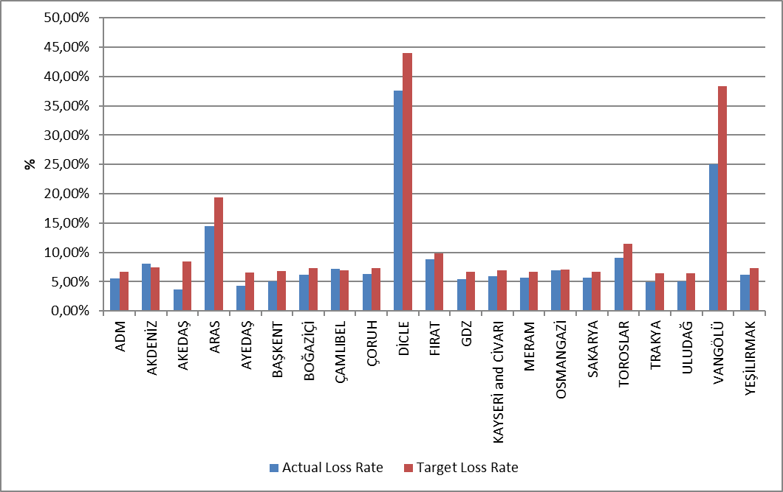

5.3 Employment

As of the end of 2024, 65.477 people will be employed in the electricity distribution sector; 26.846 people work as distribution company permanent personnel, and 38.631 people work as subcontractor company personnel. The table below shows the number of employees by distribution companies. Dicle EDAŞ was the distribution company with the highest number of employees with 7.446 personnel, and Kayseri and Civarı EDAŞ was the distribution company with the lowest number of employees with 943 personnel. Toroslar EDAŞ was the distribution company with the highest number of both permanent personnel (4.179) and Boğaziçi EDAŞ with subcontractor personnel (3.599).

Table 5.3: Number of Employees of Distribution Companies as of the End of 2024 (Number)
Distribution Company | Number of Permanent Employees | Number of Subcontractor Employees | Total
DİCLE | 3.847 | 3.599 | 7.446
TOROSLAR | 4.179 | 2.648 | 6.827
BAŞKENT | 3.887 | 2.269 | 6.156
BOĞAZİÇİ | 632 | 4.293 | 4.925
GDZ | 1020 | 2.464 | 3.484
ULUDAĞ | 934 | 2.272 | 3.206
AKDENİZ | 361 | 2.486 | 2.847
OSMANGAZİ | 1153 | 1.629 | 2.782
İSTANBUL AND. YAK. | 1743 | 922 | 2.665
AKEDAŞ | 1067 | 1.576 | 2.643
SAKARYA | 1410 | 1.223 | 2.633
YEŞİLIRMAK | 724 | 1904 | 2.628
ADM | 796 | 1.691 | 2.487
MERAM | 748 | 1.586 | 2.334
ÇORUH | 399 | 1.843 | 2.242
ARAS | 762 | 1.474 | 2.236
FIRAT | 350 | 1.750 | 2.100
VAN GÖLÜ | 884 | 1151 | 2.035
ÇAMLIBEL | 251 | 1.382 | 1.633
TRAKYA | 900 | 325 | 1.225
KAYSERİ and CİVARI | 799 | 144 | 943
Grand Total | 26.846 | 38.631 | 65.477

Figure 5.3: Number of Employees of Distribution Companies at the End of 2024 (Number)
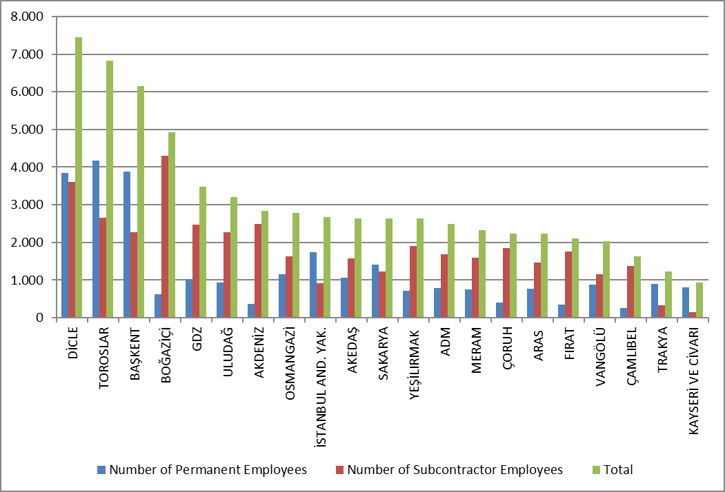

5.4 Information About Network

This section contains basic data about the distribution system. In this context, information on line lengths, transformer capacities and number of transformers at the distribution voltage level is given in the following tables and figures.
As it is known, the electricity network has reached all of Turkey, with exceptions. Except for industrial facilities with large consumption, all small and medium-sized consumers obtain electrical energy through the distribution system. As can be seen from Table 5.4, Türkiye's total distribution line length has reached 1.491.396 km. When looking at line lengths by distribution regions, Toroslar, Başkent, Meram, Gdz and Dicle distribution regions constitute the top five regions in terms of distribution line length. It can be seen from this list that there is a direct proportion between the distribution line lengths, the width of the distribution area and the prevalence of the distribution network.

Table 5.4: Line Lengths, Number of Transformers and Transformer Capacities by Distribution Companies as of the End of 2024 (km-MVA-number)
Distribution Company | Line Length (km) | Transformer Capacity (MVA) | Number of Transformers (number)
ADM | 80.210 | 11.111 | 25.549
AKDENİZ | 74.834 | 10.333 | 21.899
AKEDAŞ | 30.083 | 4.883 | 14.834
ARAS | 61.645 | 3.919 | 15.985
BAŞKENT | 141.402 | 19.790 | 37.707
BOĞAZİÇİ | 56.558 | 20.449 | 16.537
ÇAMLIBEL | 51.231 | 3.549 | 14.292
ÇORUH | 64.950 | 5.205 | 13.507
DİCLE | 88.932 | 16.726 | 73.971
FIRAT | 50.839 | 4.017 | 14.514
GDZ | 92.341 | 18.220 | 37.467
İSTANBUL AND. YAK. | 34.913 | 10.353 | 8.448
KAYSERİ and CİVARI | 30.824 | 3.264 | 9.659
MERAM | 131.210 | 15.858 | 69.953
OSMANGAZİ | 54.173 | 9.351 | 31.848
SAKARYA | 69.576 | 10.109 | 20.186
TOROSLAR | 157.468 | 22.493 | 52.573
TRAKYA | 31.146 | 6.634 | 13.183
ULUDAĞ | 55.047 | 13.001 | 29.640
VAN GÖLÜ | 46.263 | 3.343 | 13.748
YEŞİLIRMAK | 87.752 | 5.980 | 21.938
Grand Total | 1.491.396 | 218.588 | 557.438

On the other hand, when we look at the distribution regions in terms of transformer capacity, it is seen that Toroslar, Boğaziçi, Başkent, Gdz and Dicle electricity distribution regions are in the top five.

Figure 5.4: Line Lengths and Transformer Capacities by Distribution Companies as of the End Of 2024 (km-MVA)
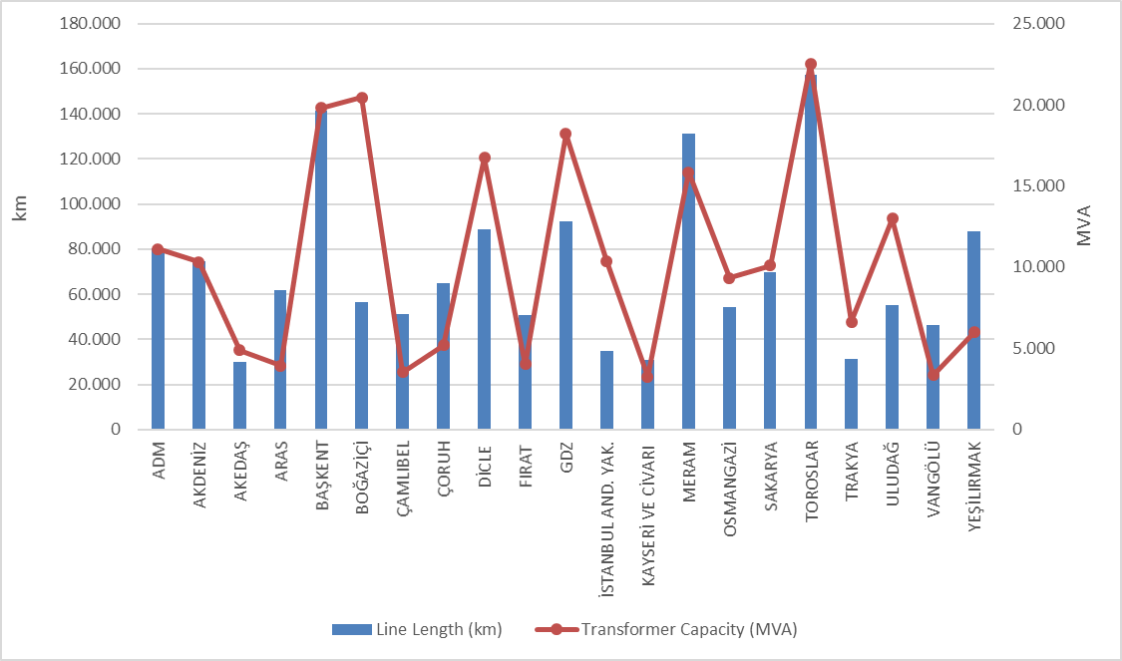

Table 5.5 shows the distribution of distribution lines. As can be seen from the table, the majority of the total distribution lines (75,59%) are overhead lines. The share of underground lines in the total distribution line length is 24,41%. This situation shows that distribution lines are open to external influence. The external impacts mentioned may be natural disasters, climate or human-related. Natural events, especially excessive rainfall and strong winds, can directly or indirectly cause damage to distribution lines.

Table 5.5: The Lengths of Distribution Lines at the end of 2024 (km)
Distribution Company | Overhead (Km) | Underground (Km) | Total (Km)
ADM | 62.979 | 17.230 | 80.210
AKDENİZ | 53.051 | 21.783 | 74.834
AKEDAŞ | 25.763 | 4.319 | 30.083
ARAS | 52.494 | 9.151 | 61.645
BAŞKENT | 101.703 | 39.699 | 141.402
BOĞAZİÇİ | 15.480 | 41.078 | 56.558
ÇAMLIBEL | 44.059 | 7.172 | 51.231
ÇORUH | 58.304 | 6.646 | 64.950
DİCLE | 74.277 | 14.655 | 88.932
FIRAT | 42.711 | 8.128 | 50.839
GDZ | 69.796 | 22.544 | 92.341
İ. ANADOLU | 11.753 | 23.160 | 34.913
KAYSERİ and CİVARI | 20.499 | 10.325 | 30.824
MERAM | 100.937 | 30.274 | 131.210
OSMANGAZİ | 44.313 | 9.860 | 54.173
SAKARYA | 45.607 | 23.968 | 69.576
TOROSLAR | 125.928 | 31.540 | 157.468
TRAKYA | 24.003 | 7.143 | 31.146
ULUDAĞ | 40.084 | 14.963 | 55.047
VAN GÖLÜ | 39.731 | 6.532 | 46.263
YEŞİLIRMAK | 73.937 | 13.814 | 87.752
Grand Total | 1.127.411 | 363.985 | 1.491.396

Figure 5.5: The Length of Lines on the Basis of Distribution Companies at the end of 2024 (km)
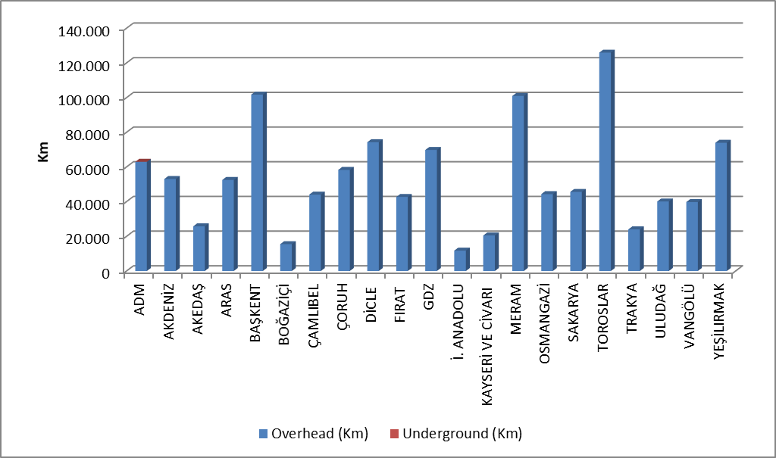
Table 5.6 includes distribution line lengths and transformer capacities by province. According to the table, the first five provinces in terms of distribution line length are: İstanbul, Konya, Ankara, İzmir and Antalya.
When we look at the transformer capacities in the distribution system of the provinces, the first five provinces in terms of transformer capacity are: İstanbul, Ankara, İzmir, Konya and Antalya.
When we look at the number of transformers in the distribution system of the provinces, the first five provinces in terms of the number of transformers are: Konya, Şanlıurfa, İstanbul, İzmir and Ankara.

Table 5.6: Line at Distribution Voltage Level by Province as of the End of 2024 Lengths, Number of Transformers and Transformer Capacities (km-MVA-number)
Provinces | Line Length (Km) | Transformer Capacity (MVA) | Number of Transformers (number)
ADANA | 38.910 | 6.013 | 13.852
ADIYAMAN | 9.762 | 1.449 | 6.036
AFYONKARAHİSAR | 16.695 | 2.847 | 12.471
AĞRI | 11.540 | 645 | 3.324
AKSARAY | 15.112 | 1.549 | 8.177
AMASYA | 9.453 | 839 | 2.853
ANKARA | 68.523 | 14.830 | 22.145
ANTALYA | 52.976 | 7.943 | 15.252
ARDAHAN | 4.764 | 174 | 1.013
ARTVİN | 7.532 | 838 | 1.789
AYDIN | 24.272 | 3.387 | 7.711
BALIKESİR | 19.775 | 3.653 | 8.995
BARTIN | 7.537 | 478 | 1.545
BATMAN | 7.105 | 1.175 | 3.895
BAYBURT | 3.478 | 210 | 796
BİLECİK | 4.657 | 1.188 | 2.300
BİNGÖL | 7.533 | 519 | 2.127
BİTLİS | 8.820 | 782 | 3.730
BOLU | 10.177 | 921 | 3.072
BURDUR | 10.174 | 888 | 3.229
BURSA | 21.605 | 6.856 | 13.798
ÇANAKKALE | 10.775 | 1.679 | 5.441
ÇANKIRI | 10.125 | 701 | 2.088
ÇORUM | 15.884 | 1.264 | 4.692
DENİZLİ | 25.297 | 3.632 | 8.353
DİYARBAKIR | 21.936 | 4.173 | 15.057
DÜZCE | 9.658 | 954 | 2.360
EDİRNE | 9.796 | 1.230 | 4.434
ELAZIĞ | 16.006 | 1.524 | 4.736
ERZİNCAN | 9.359 | 598 | 2.302
ERZURUM | 19.577 | 1.604 | 5.458
ESKİŞEHİR | 14.591 | 2.922 | 10.409
GAZİANTEP | 26.382 | 4.552 | 10.845
GİRESUN | 17.115 | 1.155 | 3.360
GÜMÜŞHANE | 6.727 | 388 | 1.383
HAKKARİ | 5.990 | 442 | 1.943
HATAY | 30.764 | 4.154 | 10.831
IĞDIR | 5.207 | 268 | 1.292
ISPARTA | 11.684 | 1.503 | 3.418
İSTANBUL | 91.471 | 30.802 | 24.985
İZMİR | 57.480 | 13.723 | 23.149
KAHRAMANMARAŞ | 20.320 | 3.434 | 8.798
KARABÜK | 7.871 | 711 | 1.777
KARAMAN | 10.137 | 1.083 | 5.126
KARS | 7.720 | 421 | 1.800
KASTAMONU | 22.042 | 1.010 | 4.935
KAYSERİ | 30.824 | 3.264 | 9.659
KIRIKKALE | 8.532 | 827 | 1.854
KIRKLARELİ | 7.485 | 1.262 | 2.899
KIRŞEHİR | 8.613 | 680 | 2.575
KİLİS | 3.907 | 433 | 1.338
KOCAELİ | 25.247 | 5.782 | 8.932
KONYA | 70.665 | 9.211 | 40.024
KÜTAHYA | 10.266 | 1.384 | 3.745
MALATYA | 22.561 | 1.768 | 6.325
MANİSA | 34.860 | 4.497 | 14.318
MARDİN | 12.955 | 2.720 | 13.067
MERSİN | 44.237 | 6.131 | 12.585
MUĞLA | 30.640 | 4.093 | 9.485
MUŞ | 9.569 | 555 | 2.378
NEVŞEHİR | 12.537 | 1.690 | 7.239
NİĞDE | 14.148 | 1.646 | 6.812
ORDU | 23.376 | 1.153 | 4.787
OSMANİYE | 13.268 | 1.210 | 3.122
RİZE | 10.613 | 904 | 2.533
SAKARYA | 24.495 | 2.452 | 5.822
SAMSUN | 30.112 | 2.269 | 7.473
SİİRT | 4.657 | 548 | 1.869
SİNOP | 8.927 | 454 | 2.133
SİVAS | 21.342 | 1.430 | 5.601
ŞANLIURFA | 36.220 | 6.938 | 35.710
ŞIRNAK | 6.058 | 1.172 | 4.373
TEKİRDAĞ | 13.865 | 4.141 | 5.850
TOKAT | 15.068 | 904 | 3.635
TRABZON | 22.963 | 1.920 | 4.442
TUNCELİ | 4.739 | 205 | 1.326
UŞAK | 7.964 | 1.010 | 2.923
VAN | 21.884 | 1.563 | 5.697
YALOVA | 2.892 | 813 | 1.406
YOZGAT | 14.821 | 1.215 | 5.056
ZONGULDAK | 16.772 | 1.231 | 3.363
Grand Total | 1.491.396 | 218.588 | 557.438

5.5 Quality Indicators

Data on the supply continuity quality of electricity offered by distribution companies has been compiled and data on System Average Interruption Frequency Index (SAIDI) and System Average Interruption Frequency Index (SAIFI) are included in the tables below.

Table 5.7: Notified and Unnotified SAIDI of Distribution Companies in 2023-2024
Distribution Company | 2023 |  |  | 2024 |  |  | Change  (%)
Distribution Company | Notified SAIDI (min) | Unnotified SAIDI (min) | Total SAIDI (min) | Notified SAIDI (min) | Unnotified SAIDI (min) | Total SAIDI (min) | Change  (%)
VAN GÖLÜ | 1.432,9 | 3.291,3 | 4.724,2 | 1.942,6 | 4.998,6 | 6.941,2 | 46,93
DİCLE | 1.518,2 | 2.295,5 | 3.813,7 | 2.232,3 | 3.605,3 | 5.837,7 | 53,07
TOROSLAR | 1.731,9 | 1.909,7 | 3.641,7 | 1.587,1 | 2.004,7 | 3.591,8 | -1,37
ARAS | 1.771,0 | 814,8 | 2.585,9 | 1.136,8 | 1.450,3 | 2.587,1 | 0,05
ÇORUH | 775,3 | 1.291,6 | 2.067,0 | 755,6 | 1.501,6 | 2.257,2 | 9,21
AKDENİZ | 765,0 | 1.269,0 | 2.034,1 | 979,8 | 1.223,0 | 2.202,8 | 8,30
FIRAT | 651,1 | 1.375,2 | 2.026,3 | 788,0 | 1.243,1 | 2.031,1 | 0,24
AKEDAŞ | 98,9 | 240,1 | 339,0 | 482,6 | 1.473,4 | 1.956,0 | 476,97
YEŞİLIRMAK | 1.302,6 | 929,6 | 2.232,1 | 957,9 | 937,7 | 1.895,7 | -15,07
SAKARYA | 607,7 | 1.329,2 | 1.936,9 | 576,8 | 1.266,1 | 1.842,9 | -4,85
ADM | 824,2 | 746,9 | 1.571,1 | 843,8 | 871,2 | 1.715,0 | 9,16
GDZ | 932,8 | 770,7 | 1.703,4 | 731,7 | 882,9 | 1.614,6 | -5,21
OSMANGAZİ | 735,7 | 992,9 | 1.728,6 | 513,5 | 951,2 | 1.464,8 | -15,26
ÇAMLIBEL | 564,3 | 923,1 | 1.487,4 | 625,2 | 837,5 | 1.462,7 | -1,67
BAŞKENT | 618,9 | 1.308,6 | 1.927,5 | 421,0 | 938,7 | 1.359,6 | -29,46
TRAKYA | 513,7 | 585,8 | 1.099,5 | 614,2 | 515,2 | 1.129,4 | 2,72
ULUDAĞ | 349,7 | 627,8 | 977,6 | 553,7 | 557,4 | 1.111,1 | 13,66
BOĞAZİÇİ | 236,8 | 815,4 | 1.052,3 | 197,0 | 790,4 | 987,4 | -6,17
MERAM | 448,0 | 539,6 | 987,6 | 434,5 | 517,4 | 951,8 | -3,62
KAYSERİ and CİVARI | 377,2 | 420,5 | 797,7 | 370,8 | 307,5 | 678,3 | -14,96
İSTANBUL AN. YK. | 216,7 | 334,5 | 551,2 | 168,5 | 314,9 | 483,4 | -12,31

The table above shows the average outage durations with, without notification and total in 2023 and 2024. In 2024, Dicle, Van Gölü, Toroslar regions took the first three places in notified outages, while Van Gölü, Dicle and Toroslar regions took the first place in unnotified outages.
The region with the highest total average outage duration is the Van Gölü distribution region with 6.941,2 minutes, followed by the Dicle distribution region with 5.837,7 minutes.

Table 5.8: SAIDI of Distribution Companies in 2024 (min)
Distribution Company | External | Security | Force Majeure | Network Operator | Total
VAN GÖLÜ | 11,7 | 46,7 | 0,0 | 6.882,8 | 6.941,2
DİCLE | 70,8 | 45,8 | 6,1 | 5.715,0 | 5.837,7
TOROSLAR | 393,3 | 202,5 | 0,0 | 2.996,0 | 3.591,8
ARAS | 17,7 | 0,7 | 37,9 | 2.531,0 | 2.587,1
ÇORUH | 73,3 | 166,7 | 11,9 | 2.005,4 | 2.257,2
AKDENİZ | 70,4 | 188,7 | 58,1 | 1.885,6 | 2.202,8
FIRAT | 43,3 | 322,1 | 41,2 | 1.624,6 | 2.031,1
AKEDAŞ | 68,0 | 34,4 | 0,0 | 1.853,7 | 1.956,0
YEŞİLIRMAK | 44,8 | 7,7 | 0,0 | 1.843,2 | 1.895,7
SAKARYA | 26,8 | 35,1 | 0,0 | 1.781,0 | 1.842,9
ADM | 39,0 | 13,5 | 0,0 | 1.662,5 | 1.715,0
GDZ | 23,8 | 13,6 | 0,0 | 1.577,2 | 1.614,6
OSMANGAZİ | 38,2 | 6,6 | 1,2 | 1.418,8 | 1.464,8
ÇAMLIBEL | 1,8 | 0,0 | 0,0 | 1.460,9 | 1.462,7
BAŞKENT | 188,5 | 22,3 | 0,0 | 1.148,8 | 1.359,6
TRAKYA | 12,1 | 0,6 | 21,7 | 1.095,0 | 1.129,4
ULUDAĞ | 29,4 | 13,6 | 0,0 | 1.068,0 | 1.111,1
BOĞAZİÇİ | 299,5 | 0,1 | 0,0 | 687,8 | 987,4
MERAM | 25,3 | 7,5 | 11,6 | 907,4 | 951,8
KAYSERİ and CİVARI | 15,1 | 0,5 | 0,0 | 662,7 | 678,3
İSTANBUL AN.YK. | 62,7 | 1,3 | 0,0 | 419,4 | 483,4

The table above shows the distribution of average outage duration by reason. It seems that the highest outage duration is caused by the network operator.
The table below shows the average outage frequency of distribution companies. The highest outage frequency per customer occurred in the Van Gölü region with 135,8 number/year, and the Dicle region comes in second place with 72,3 number/year.

Table 5.9: SAIFI of Distribution Companies in 2023 and 2024 (Number/year)
Distribution Company | 2023 |  |  |  | 2024 |  |  |  | Change  (%)
Distribution Company | Notified | Unnotified | Short | Total | Notified | Unnotified | Short | Total | Change  (%)
VAN GÖLÜ | 4,8 | 77,5 | 1,0 | 83,3 | 6,5 | 122,7 | 6,5 | 135,8 | 62,99
DİCLE | 8,2 | 36,1 | 4,6 | 48,9 | 12,8 | 54,4 | 5,1 | 72,3 | 47,89
ARAS | 6,1 | 14,4 | 25,8 | 46,3 | 5,4 | 15,7 | 39,3 | 60,4 | 30,48
AKEDAŞ | 0,4 | 5,7 | 2,1 | 8,2 | 2,3 | 37,3 | 12,5 | 52,1 | 536,31
FIRAT | 3,6 | 21,4 | 12,3 | 37,3 | 4,3 | 26,7 | 15,4 | 46,4 | 24,29
YEŞİLIRMAK | 7,0 | 13,6 | 15,9 | 36,5 | 5,6 | 12,6 | 22,1 | 40,3 | 10,42
OSMANGAZİ | 3,9 | 24,0 | 9,1 | 37,0 | 2,7 | 24,9 | 9,9 | 37,5 | 1,23
SAKARYA | 3,4 | 29,0 | 7,2 | 39,7 | 3,3 | 27,6 | 6,3 | 37,2 | -6,26
ÇAMLIBEL | 3,0 | 12,4 | 17,9 | 33,4 | 3,1 | 10,5 | 18,3 | 31,9 | -4,30
ÇORUH | 4,9 | 24,8 | 6,7 | 36,5 | 4,6 | 22,4 | 4,4 | 31,5 | -13,68
TOROSLAR | 4,7 | 19,5 | 2,3 | 26,5 | 4,4 | 22,0 | 4,8 | 31,2 | 17,75
MERAM | 2,0 | 9,5 | 12,0 | 23,5 | 2,0 | 9,3 | 16,5 | 27,8 | 17,96
ADM | 3,7 | 15,4 | 5,9 | 25,0 | 4,5 | 16,9 | 4,0 | 25,4 | 1,38
AKDENİZ | 3,6 | 17,9 | 6,4 | 27,9 | 4,5 | 15,1 | 5,7 | 25,3 | -9,13
ULUDAĞ | 2,1 | 10,5 | 6,0 | 18,6 | 3,4 | 10,4 | 5,9 | 19,7 | 6,26
BAŞKENT | 1,7 | 16,9 | 2,3 | 20,8 | 1,4 | 15,5 | 2,5 | 19,3 | -7,31
KAYSERİ and C. | 1,8 | 10,7 | 13,2 | 25,8 | 1,7 | 7,0 | 10,5 | 19,2 | -25,49
TRAKYA | 2,6 | 12,6 | 4,4 | 19,6 | 3,7 | 11,7 | 3,2 | 18,7 | -4,32
GDZ | 5,1 | 12,8 | 1,3 | 19,2 | 3,8 | 12,3 | 0,5 | 16,5 | -13,78
BOĞAZİÇİ | 1,8 | 9,6 | 3,2 | 14,6 | 1,2 | 9,9 | 3,3 | 14,5 | -0,99
İSTANBUL AN. YK. | 0,7 | 6,7 | 0,7 | 8,1 | 0,5 | 6,7 | 1,3 | 8,5 | 4,50

Table 5.10: SAIFI of Distribution Companies by Reason in 2024 (Number/Year)
Distribution Company | External | Security | Short | Force Majeure Reason | Network Operator | Total
VAN GÖLÜ | 0,1 | 0,2 | 6,5 | 0,0 | 128,9 | 135,8
DİCLE | 0,9 | 0,6 | 5,1 | 0,0 | 65,7 | 72,3
ARAS | 0,1 | 0,0 | 39,3 | 0,1 | 21,0 | 60,4
AKEDAŞ | 1,6 | 0,3 | 12,5 | 0,0 | 37,7 | 52,1
FIRAT | 1,0 | 6,4 | 15,4 | 0,6 | 23,0 | 46,4
YEŞİLIRMAK | 0,7 | 0,1 | 22,1 | 0,0 | 17,4 | 40,3
OSMANGAZİ | 0,5 | 0,1 | 9,9 | 0,0 | 27,0 | 37,5
SAKARYA | 0,3 | 0,3 | 6,3 | 0,0 | 30,2 | 37,2
ÇAMLIBEL | 0,0 | 0,0 | 18,3 | 0,0 | 13,6 | 31,9
ÇORUH | 1,5 | 1,6 | 4,4 | 0,0 | 23,9 | 31,5
TOROSLAR | 1,6 | 0,7 | 4,8 | 0,0 | 24,1 | 31,2
MERAM | 0,4 | 0,0 | 16,5 | 0,1 | 10,8 | 27,8
ADM | 0,4 | 0,1 | 4,0 | 0,0 | 20,8 | 25,4
AKDENİZ | 0,9 | 1,3 | 5,7 | 0,3 | 17,1 | 25,3
ULUDAĞ | 0,4 | 0,1 | 5,9 | 0,0 | 13,4 | 19,7
BAŞKENT | 0,9 | 0,1 | 2,5 | 0,0 | 15,8 | 19,3
KAYSERİ and CİVARI | 0,2 | 0,0 | 10,5 | 0,0 | 8,5 | 19,2
TRAKYA | 0,1 | 0,0 | 3,2 | 0,0 | 15,3 | 18,7
GDZ | 0,3 | 0,1 | 0,5 | 0,0 | 15,7 | 16,5
BOĞAZİÇİ | 2,9 | 0,0 | 3,3 | 0,0 | 8,3 | 14,5
İSTANBUL AND. YAK. | 0,3 | 0,0 | 1,3 | 0,0 | 6,9 | 8,5

5.6 Investment Amount of Distribution Companies

With the decision of the Board dated 22/10/2020 and numbered 9639, the "Procedures and Principles for Determination of Electricity Market Distribution System Investments" were approved and entered into force.
With the Board Decision dated 12/11/2020 and numbered 9686, electricity distribution companies will start on 1/1/2021 for IV. It was decided that the Real Reasonable Return Rate, which will be taken into account during the tariff application period, will be determined as 13,11% (before tax). In addition, with the same Board Decision, the amortization period for the fourth implementation period investments of distribution companies was determined as 10 years.
The table below provides information on the actual investment amounts declared by the Distribution Companies for 2022, 2023 and 2024.

Table 5.11: Comparison of Distribution Investment Amounts for 2022-2023-2024 (Current Prices - Million TL-%)
Distribution Company | 2022 | 2023 | 2024 | 2023-2024 Change
ADM | 4.366,11 | 3.177,64 | 1.739,84 | -45,25%
AKDENİZ | 3.669,56 | 3.224,23 | 3.271,86 | 1,48%
AKEDAŞ | 1.359,88 | 1.892,20 | 3.423,99 | 80,95%
ARAS | 3.611,50 | 2.759,72 | 2.103,54 | -23,78%
İSTANBUL A.Y. | 1.874,61 | 2.263,08 | 1.488,14 | -34,24%
BAŞKENT | 4.941,31 | 9.351,36 | 4.163,61 | -55,48%
BOĞAZİÇİ | 3.986,04 | 4.191,90 | 4.017,12 | -4,17%
ÇAMLIBEL | 1.603,53 | 1.830,33 | 1.684,51 | -7,97%
ÇORUH | 2.129,12 | 3.274,82 | 1.132,68 | -65,41%
DİCLE | 5.031,18 | 7.740,91 | 4.584,92 | -40,77%
FIRAT | 1.878,28 | 2.959,22 | 1.152,82 | -61,04%
GDZ | 4.104,70 | 6.230,91 | 2.330,64 | -62,60%
KAYSERİ and CİVARI | 1.269,19 | 1.802,53 | 1.130,58 | -37,28%
MERAM | 4.100,39 | 8.091,33 | 5.077,50 | -37,25%
OSMANGAZİ | 2.614,36 | 979,21 | 1.403,08 | 43,29%
SAKARYA | 3.500,59 | 2.675,03 | 2.372,27 | -11,32%
TOROSLAR | 6.015,79 | 10.553,95 | 4.186,73 | -60,33%
TRAKYA | 1.584,68 | 2.736,54 | 763,3 | -72,11%
ULUDAĞ | 1.248,59 | 3.047,69 | 2.653,05 | -12,95%
VAN GÖLÜ | 1.951,47 | 2.335,60 | 2.109,99 | -9,66%
YEŞİLIRMAK | 2.734,85 | 3.373,86 | 1.674,97 | -50,35%
TOTAL | 63.575,73 | 84.492,08 | 52.465,12 | -37,91%
* Prepared with unit price amounts and according to June 2024 CPI: 2319,29 .
**III. Starting in the Implementation Period and continuing through IV. Investments completed during the Implementation Period are included.
*** The table has been prepared for the investment amounts for the years 2022-2023 and 2024, based on the investment realization declarations submitted by the companies through the notification system.

Total investment realization for 2024 decreased by 37,91% compared to 2023 and reached 52,46 Billion TL (at current prices). The highest investment expenditure for 2024 was realized in the Meram region with 5,08 billion TL.

Figure 5.6: Investment Amounts of Distribution Companies in 2024 (Current Prices-Million TL)

Investment expenditures by investment type in 2024 are shown in the table below. The majority of investments consist of network investments.

Table 5.12: Realized Investment Amounts in 2024 by Investment Types (Tl)
Distribution Company | Investment Type | 2024 Investment Amount (Million TL) (CPI June 2024: 2319,29 )
21 EDAŞ | Network Investments | 40.972,43
21 EDAŞ | Investments with Legal Obligations | 7.608,80
21 EDAŞ | Network Operating System Investments | 3.023,71
21 EDAŞ | R&D Project Dissemination Investments | 37,92
21 EDAŞ | Other Expenditures Qualifying as Investment Expenditures | 822,27
21 EDAŞ | Grand Total | 52.465,12
* Prepared with unit price amounts and according to June 2024 CPI: 2319,29.
**III. Starting in the Implementation Period and continuing through IV. Investments completed during the Implementation Period are included.
*** The table has been prepared based on the investment realization declarations submitted by the companies through the notification system.

5.7 Information on Organized Industrial Zones

Data regarding Organized Industrial Zones holding OIZ Distribution Licenses are shown in the table below.

Table 5.13: Information on Organized Industrial Zones
Number of Participants AG | 53.236
Number of Participants OG | 18.995
Number of Total Participants | 72.231
Line Length AG | 4.575
Line Length OG | 9.643
Total Line Length | 14.218
Number of Employees (Electricity Distribution) | 1.049
Number of Transformers | 25.154
Installed Capacity of Transformers (MVA) | 27.920
Annual Peak Value of Previous Year (MW) | 8.814

As of the end of 2024, the total number of participants in Organized Industrial Zones was 72.231, 53.236 of which were low voltage and 18.995 were medium voltage. 1.049 personnel are employed in electricity distribution in OIZ distribution regions.
The total OIZ line length was 14.218 km. There are 25.154 transformers and the total transformer capacity has reached 27.920 MVA. The total of peak values ​​in OIZ regions for the previous year is 8.814 MW.

- PRICING

The Electricity Market Law envisages a market structure based on bilateral agreements. In this market, the price of electrical energy is determined by the mutual agreement of buyers and sellers. Therefore, the prices determined by bilateral agreements are within the knowledge of the relevant parties and are not shared with the public. On the other hand, a significant portion of consumers in the Turkish electricity market obtain energy at regulated prices. For this reason, the changes in regulated prices and price components over the years are important. This section contains data on regulated prices and the changes in the elements that make up the price over the years.
The figure below shows the change in retail energy tariffs (excluding system usage fees, taxes and funds) by tariff groups over the years.

Figure 6.1: Retail Price Excluding Taxes and Funds by Years (Energy+PSH) (kr/kWh)
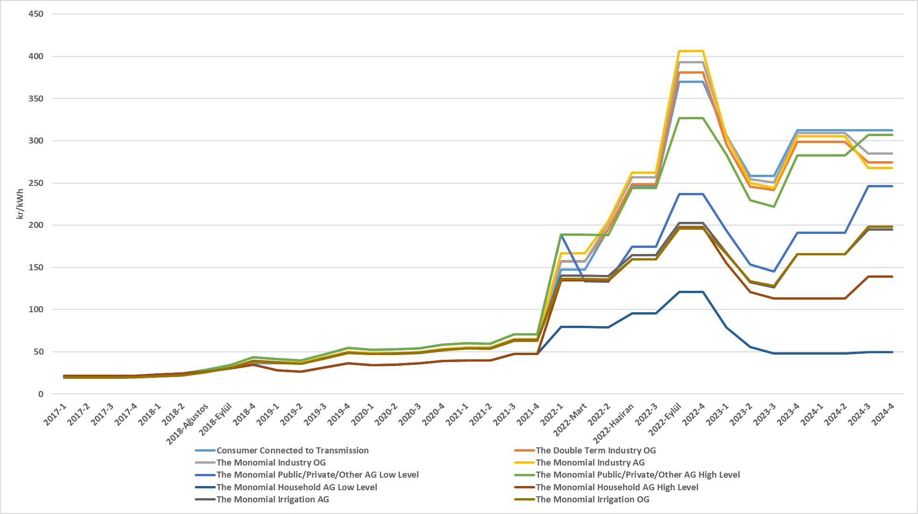
As it is known, transmission and distribution lines must be used to deliver energy from the producer to the consumer. The following shows the change in the distribution fee over the years. The price in question includes the distribution system, transmission system and technical and non-technical loss costs.

Figure 6.2: Change in Network Costs (Distribution, Transmission and Loss) by Years (kr/kWh)
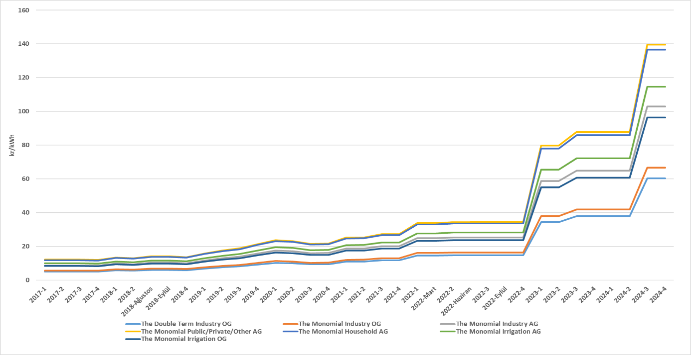
By adding the distribution fee to the energy cost, the unit energy cost before tax is reached. The figure below shows the change in unit energy cost over the years, excluding taxes and funds (Electricity and Gas Consumption Tax and VAT).

Figure 6.3: Change in Electricity Tariffs before Taxes and Funds by Years (kr/kWh)
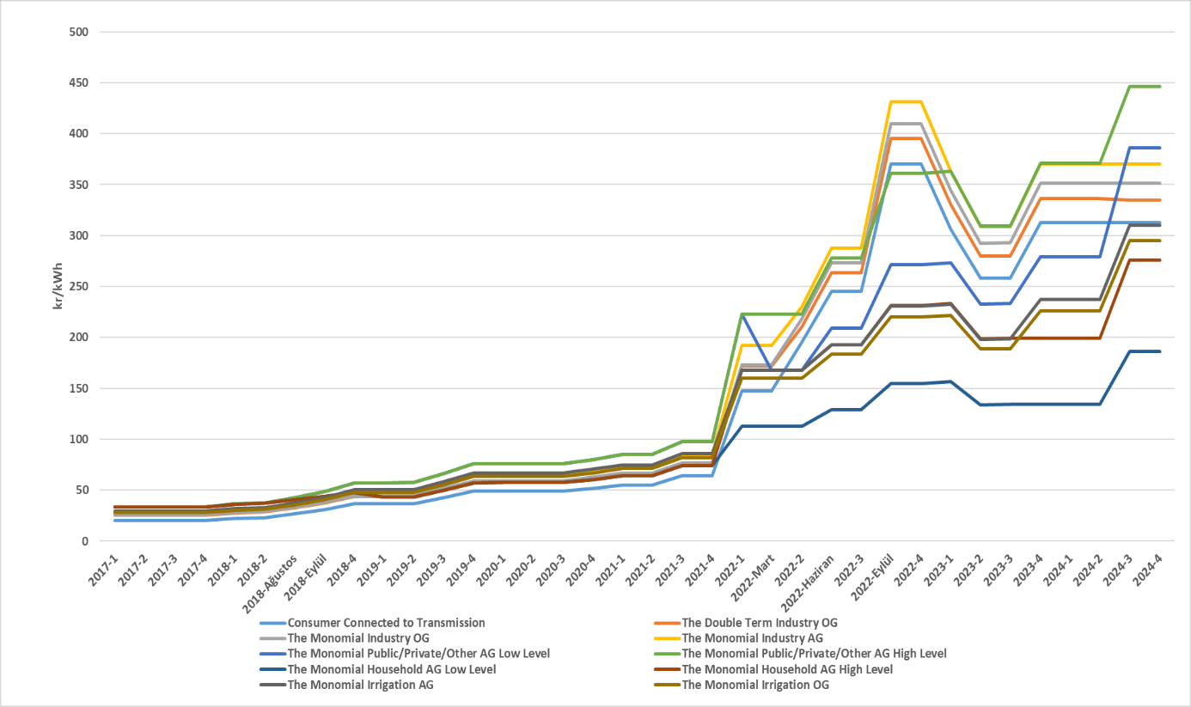
As seen in the figure above, the consumer group with the highest unit energy cost before taxes and funds as of the end of the year is high-level public and private services and other consumer groups. The lowest unit energy cost before taxes and funds belongs to the lower level of the residential consumer group.

Figure 6.4: Share of Items on Household Electricity Invoice in 2024 (%)
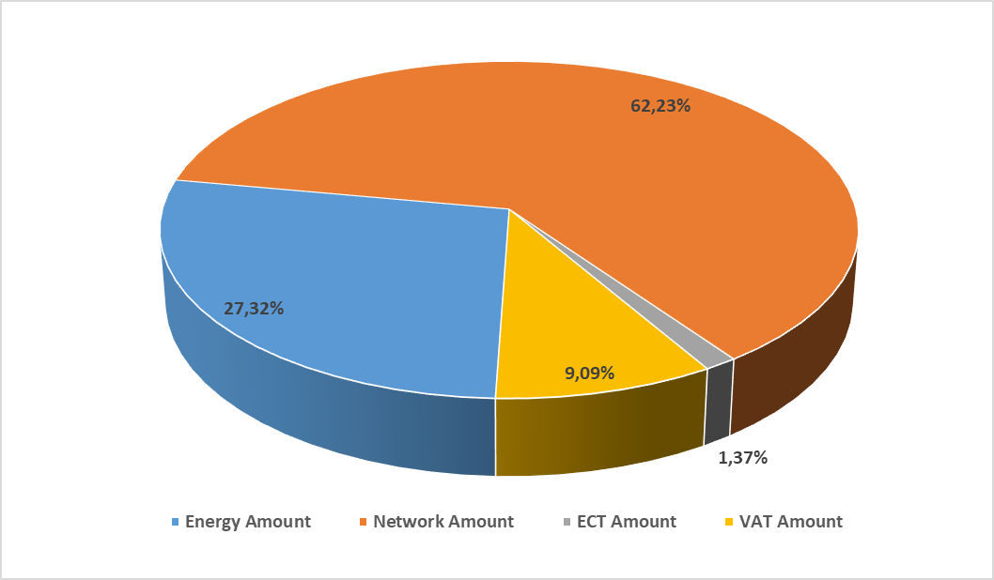
* Single term AG has been prepared using the unit prices belonging to the low-tier residential consumer group and based on the average of the year.

As can be seen in Figure 6.4, the most important item in the bills of consumers in the low-tier residential group, other than the network amount, is the retail energy amount with a share of 27,32%. The reason why the network amount share for this group remains high compared to other subscriber groups and/or other components is that the energy amount remains low compared to the energy production cost with the low-priced sales of EUAS and the VAT rate is applied as 10% in the residential subscriber group.

Figure 6.5: Share of Prices in the Industrial Electricity Bill of 2024 (%)
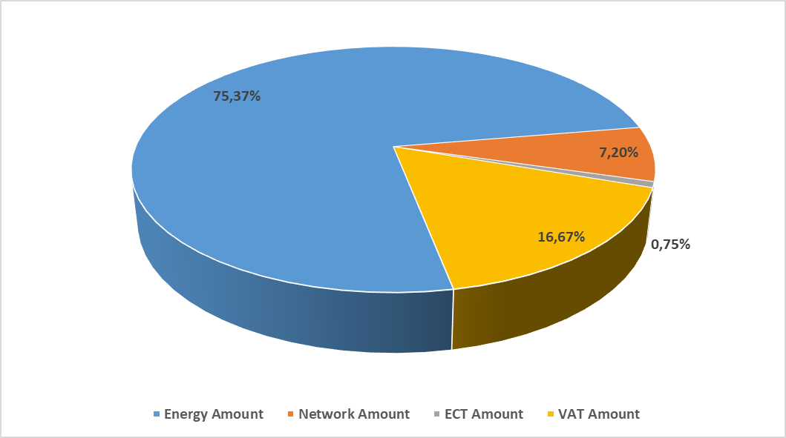
*Prepared using unit prices of the transmission system and industrial MV consumer group and based on the year average.
Looking at the figure 6.5, it can be seen that the share of energy amount in the bill components of consumers in the industrial consumer group is higher, and the share of distribution and/or transmission (network) amount is lower, compared to the bill components of consumers in the low-level residential consumer group in figure 6.4.

The index ranges between 1 and 10.000, with 1 representing a perfectly competitive market structure with low concentration and 10.000 representing a monopoly market structure where is carried out by a single company. If the HHI index is below 1.000, the market is considered to be competitive generation

